Qualitative Comparison of Pathfinder Gas Granular Simulation to Imagery from a Subscale, Reduced Pressure Plume Surface Interaction Ground Test

J. S. West

NASA Marshall Space Flight Center, Huntsville, AL 35808, USA

William Krolick and Peter Liever

CFD Research Corporation, Jacobs Space Exploration Group, NASA Marshall Space Flight Center, Huntsville, AL, 35808, USA

Abstract
NASA’s Game Changing Development Program, funded by NASA’s Space Technology Mission Directorate, the development of simulation capability for the prediction of extra-terrestrial Plume Surface Interaction (PSI) environments has been undertaken by the Fluid Dynamics Branch at NASA/MSFC. The PSI Project, planned to be completed over a four year period, contains a Predictive Simulation Capability (PSC) Element focused on creating simulation capability for the reliable and accurate prediction of PSI in Martian (~600 Pa) and Lunar (vacuum) ambient environments. In addition to the PSC Element, the PSI Project also contains a companion Ground Testing Element for development of focused datasets for validation of predictive capability as well as a Flight-focused Instrumentation Element. This paper describes the first Pathfinder three-dimensional, transient simulation of the test configuration used to acquire erosion and cratering test data as part of the Physics Focused Ground Test conducted by the PSI Project in FY2021. This first pathfinder simulation was conducted using the Loci/GGFS (Gas Granular Flow Solver), a computational fluid dynamics tool developed in part with funding provided by the PSI Project. Crater growth and ejecta flow paths from the pathfinder simulation is compared to raw high-speed imagery PFGT results of the crater growth. There is significant similarity of test and simulation to warrant expending resources on a more rigorous quantitative Validation Assessment.

introduction
NASA’s exploration goals require the development of landers for the Moon and Mars. To make safe and efficient landings, these systems are likely to require retro-propulsion, or the use of rocket engines to decelerate the landers to a soft touchdown on the surface. The environments arising from the interaction of rocket plumes with lunar and planetary regolith during descent and landing, as well as ascent from the surface, is a significant risk to propulsive landers[1,2]. These environments are characterized by plume flow physics, erosion (or cratering) physics, and ejecta dynamics. Each of these pose risks to landing systems, several which have been experienced or observed in flight. Plume impingement effects on the lander can threaten lander stability and produce elevated convective heating during powered descent and landing. Cratering, or erosion, can lead to destabilization of the lander upon touchdown and potentially violate lander tilt requirements. Extensive and shallow cratering was observed post-flight for the Apollo lunar landers, and deep cratering was observed post-flight for the InSight Mars lander. Ejecta dynamics can lead to loss of instrumentation or function, damage to the lander and any surrounding infrastructure, and obscure visibility for radar and other optical ranging systems.

The NASA Game Changing Development Program’s Plume-Surface Interaction (PSI) Project is a multi-year effort aimed at developing an integrated modeling, simulation, and testing approach to the prediction of physics associated with the exhaust plume, erosion and cratering, and ejecta from the landing site to help engineers protect the lander and to evaluate the PSI risks for favorable landing sites. Under this effort, progressively validated tools and new ground test data will be produced to reduce design uncertainty due to landing environments and to support development of mitigation strategies. Flight instrumentation specifically for in-situ PSI data will be tested in relevant environments. With many near-term exploration objectives focused on the Moon, this project prioritizes the capability to predict PSI environments for airless bodies, which requires the ability to model both rarefied and continuum flows.

These activities are designed to support the PSI Project goal of developing an integrated modeling, simulation, instrumentation capability, and testing approach to PSI definition in the areas of plume flow physics, erosion physics and ejecta dynamics, closing the identified gaps in physics modeling that are first order to accurate prediction.

The PSI Project is divided into three technical elements to accomplish the activities described above. These are the Predictive Simulation Capability (PSC) Element[3], the Ground Testing Element and the Flight Focused Instrumentation element. In order to further explain the PSC Element, a description of the Plume Surface Interaction topic is helpful.

A simplified sketch of a generic Plume Surface Interaction is shown in Figure 1. The description will begin at the rocket nozzle exit plane and generally follow plume flow path. The lander vehicle base is depicted by the heavy gray line at the top of the figure. The small blue items attached to the vehicle base represent multiple items including the Reaction Control System and various sensors and instrumentation. Each of the two landing propulsion rocket nozzles is depicted by two outwardly diverging lines creating a downward opening cone. Rocket effluent exits the two nozzles and is depicted by solid purple curves beginning at the nozzle exit and proceeding to the soil surface. The deforming and/or eroding soil surface is depicted by the solid red curve at the bottom of the figure. The plume flow impinges on the soil surface and flows outboard from the impingement point. Between the two rocket nozzles, the flow moving outboard from their respective impingement locations collide and stagnate, which directs plume flow upwards between the two plumes towards the lander vehicle base. The plume flow between the two nozzles is depicted by the purple curves located between the two nozzles.

The plumes impinging on the soil surface creates an impingement environment on the soil surface consisting of impingement pressure and shear stress. Under the forcing by the impingement environment, the soil surface begins to deform and/or erode after a threshold impingement environment intensity is reached. As the soil surface changes, the impingement environment imposed on the soil by the plume is affected, potentially increasing or decreasing the degree of soil deformation/erosion depending on specific details of the PSI in consideration. Any eroded soil is accelerated by the plume flow in each direction taken by the plume after impingement on the soil. This includes soil transported upwards between the two rocket nozzles towards the lander base as well as outboard from the lander vehicle. Any habitat structure or assets within range of the ejected soil (ejecta) may experience an adverse environment consisting of both impingement pressure as well as impacts by soil particulate.

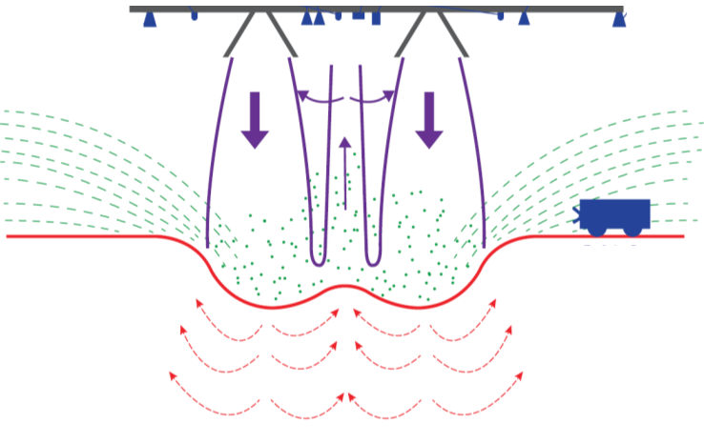
Figure 1. Depiction of a generic Plume Surface Interaction. Lander vehicle base represented by gray line at top. Deforming and/or eroding soil surface represented by the solid red line. Soil internal flow represented by dashed red arrows. Plume boundaries and flow directions shown in purple. Ejected soil represented by dashed green lines. Surface habitat infrastructure represented by the wheeled vehicle in blue on the right.

Since modern landers are likely to cause significantly different soil surface environments than the Apollo lander, the availability of predictive tools with known accuracy to address the risks that PSI poses will enhance the mitigation of these risks. Therefore, the PSI Project PSC element is focused[3] on three primary topics: (1) plume flow in low-pressure environments, (2) effects of mixed continuum/rarefied flow on soil erosion and ejecta, and (3) soil particle phase modeling. The PSC element is composed of four separate tasks. Task 1 is focused on plume flows in low ambient pressure. The objective of Task 1 is to implement methods that simulate rarefied flow into production-class computational tools and validate computational tools using existing data in low pressure environments. Task 2 is focused on the effects of mixed continuum/rarefied flow on crater development and ejecta sheets. The objectives of Task 2 include: i) implement improvements to two-phase production-class computational tools, ii) implement methods to couple rarefied flow with the two-phase computational tools suitable for transient simulations of PSI, and iii) validate computational tools for existing data in low pressure environments. Task 3 is focused on Regolith particle phase modeling. The objectives of Task 3 include: i) development of methods to quantify the properties of soil mixtures for use in two-phase Eulerian-Eulerian (E-E) predictive tools, ii) develop particle-phase models of realistic Lunar and Martian soil, and iii) validate two-phase production-class computational tools using the Lunar and Martian soil models with available ground and flight data. Task 4 is focused on the interaction of plume effluent with clouds of soil particles. The objectives of Task 4 include conducting experiments and detailed numerical analysis to construct a database of information concerning the drag and flow characteristics of plume effluent/particle cloud interactions, culminating in the development of models suitable for implementation into the products of Task 2.

The subject of this paper is Task 2i), implementing improvements to two-phase production-class computational tools. The Loci/GGFS Computational Fluid Dynamics (CFD) tool has been created and is in the process of being tested for production readiness for predicting cratering as a results of PSI for rocket powered vehicles[3,4 ].

PSC Task 2 also includes the objective of performing validation assessments of Loci/GGFS. To this end, the Ground Testing Element of the PSI Project conducted an experimental campaign [7], termed the Physics Focused Ground Test (PFGT) to obtain soil cratering under the influence of a supersonic plume. This subscale test series used heated nitrogen gas as the plume effluent and obtained cratering data over a range of altitudes, ambient pressure, nozzle effluent flow rates and soil types.

Demonstration that Loci/GGFS is capable of successfully simulating an example PFGT test was necessary before embarking on a detailed validation assessment of Loci/GGFS. The pathfinder simulation is considered a success when the simulation of a significant amount of test time is achieved. This pathfinder simulation is the focus of this paper. In addition, a qualitative comparison of the pathfinder simulation results to the test results will be presented.

Results and discussion
This section will provide a brief description of the Loci/GGFS CFD tool, explain the purpose of the Pathfinder simulation, describe the PFGT test and identify the conditions of the test chosen for the Pathfinder simulation. A short description of the Pathfinder CFD model will be given. This is followed by a survey of the test data from the PFGT test and a similar survey of the Pathfinder simulation results. A discussion of the similarities and differences between the test results and simulation is last.

Computational Toolset
Loci/GGFS[5,6] is a two-phase, Eulerian-Eulerian model implementation of gas and soil in which the soil is composed of multiple, unique, particle sizes and shapes where each unique particle type is represented by a solid-phase species with its own particle species balance partial differential equation. Soil is defined by creating a blend of a finite number of particle types with each particle type set to the desired fraction of the soil. The governing equations require closure of particle-particle and gas-particle interactions as well as the closures of any typical Navier-Stokes-based CFD tool. Loci/GGFS uses unstructured meshes and includes implementation of an array of turbulence models, multiple species capability in the gas-phase in addition to the granular-phase, an overset mesh moving body implementation and adaptive mesh refinement. As part of the production readiness assessment, Loci/GGFS has been demonstrated successfully to perform cratering simulations of several manned lander designs, including the Apollo Lunar Excursion Module.

Purpose of Pathinfinder Simulation
The process of developing a CFD tool is not straightforward. There are several phases of the process. The beginning phase is the equation formulation, computer code development and code verification. The popular conception is that this phase is the entire development process. Others realize that the last phase is validation assessment for the intended purpose. However, very few realize that the middle phase, termed here the production readiness phase, can require more time and manpower that the sum of the other phases. Achieving production readiness is a trial and error process with many diagnosis and rectification cycles.

Loci/GGFS achieved the ability to conduct simulations of soil cratering by subsonic jet impingement very early after its initial release in FY2020. Subsequent attempts to perform simulations of supersonic plume impingement in near-vacuum ambient environments, the Apollo LEM configuration as shown in Figure 2, proved more difficult, requiring significant effort to resolve. After resolution, Loci/GGFS demonstrated the ability to complete simulations of several other manned lunar landers as part of support to NASA Human Lander System (HLS) Program[7].

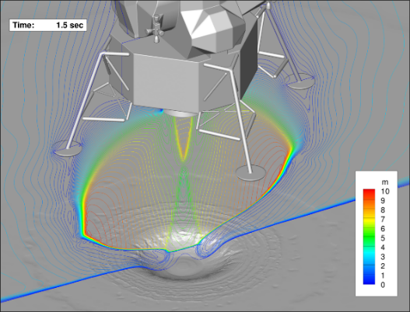
Figure 2. Example of a Loci/GGFS simulation of the Apollo Lunar Excursion Module. Note the crater formation at the location where the plume impinges on the soil surface.

The last part of the production readiness phase is the demonstration that Loci/GGFS was ready for the next development phase, the Validation Assessment. Attempts to perform simulations of the PFGT began in FY2021 and encountered significant difficulties. Most of the difficulties were associated with the specific configuration of the PFGT. The next section provides a short description of the PFGT.

Physics Focused Ground TesT
The purpose of the Physics Focused Ground Test (PFGT) was to provide validation data for the predictive tool that predict PSI environments. The test was designed [8] as a subscale, non-reacting supersonic plume impingement on a soil surface with parameters similar to that of the HLS Program reference vehicle. The test was conducted within a vacuum chamber capable of both Martian and Lunar-like ambient pressure. The PFGT explored a parametric space defined by variations in nozzle flow rate, altitude, ambient pressure and soil composition. The range of parametric space explored by the PFGT is shown in Figure 3. The plume effluent was gaseous N₂ at a temperature of 500 K.

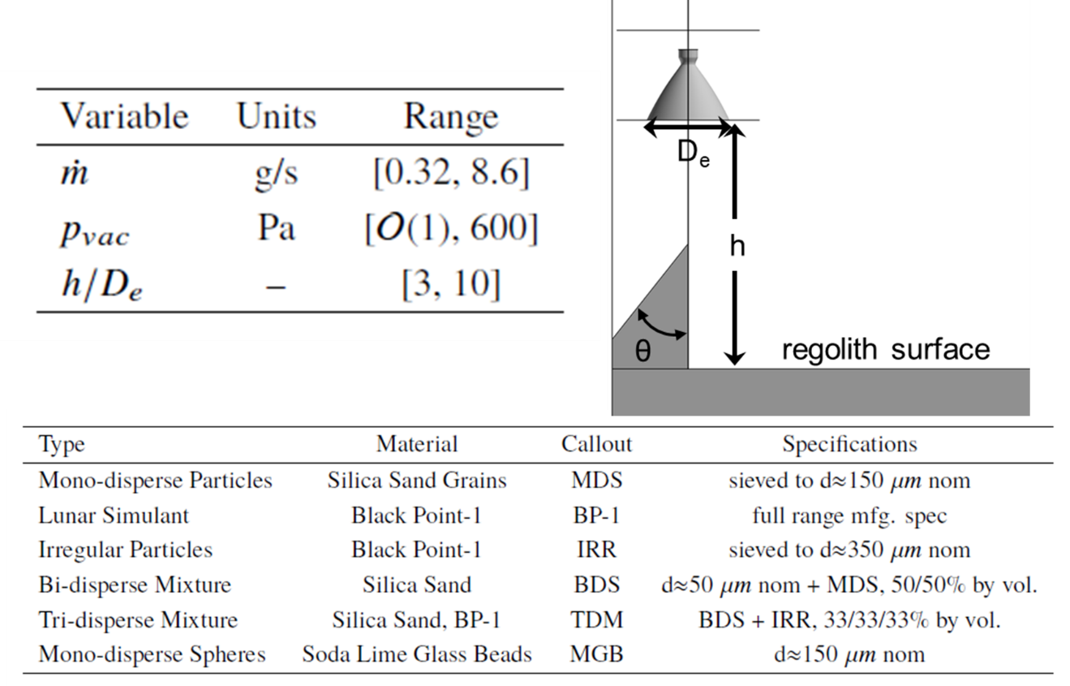
Figure 3. Parametric space explored by the PFGT campaign in terms of nozzle mass flow rate, ambient pressure (p_{vac}), dimensionless altitude and soil composition.

Illustrations of the test setup are shown in Figure 4. The soil bin is mounted in the structure on the left of the figure. The splitter plate, the vertical sharpened top edge transparent plate, is pointed out in the middle top of the figure. The purpose of the splitter plate is to split the plume in half such that a crater will form inside the soil bin along the splitter plate, allowing the growing crater to be seen and recorded with high-speed video cameras, while the other half of the plume flows downward on the outside of the soil bin. A depiction of the plume intersection with the splitter plate is shown in Figure 5.

The location of the cameras is shown in the bottom middle of Figure 4 and example fields of view of the camera are shown on the right of the figure. Camera imaged both the crater formation as well as soil ejected from the crater by the plume, only the crater camera results will be shown in this paper.

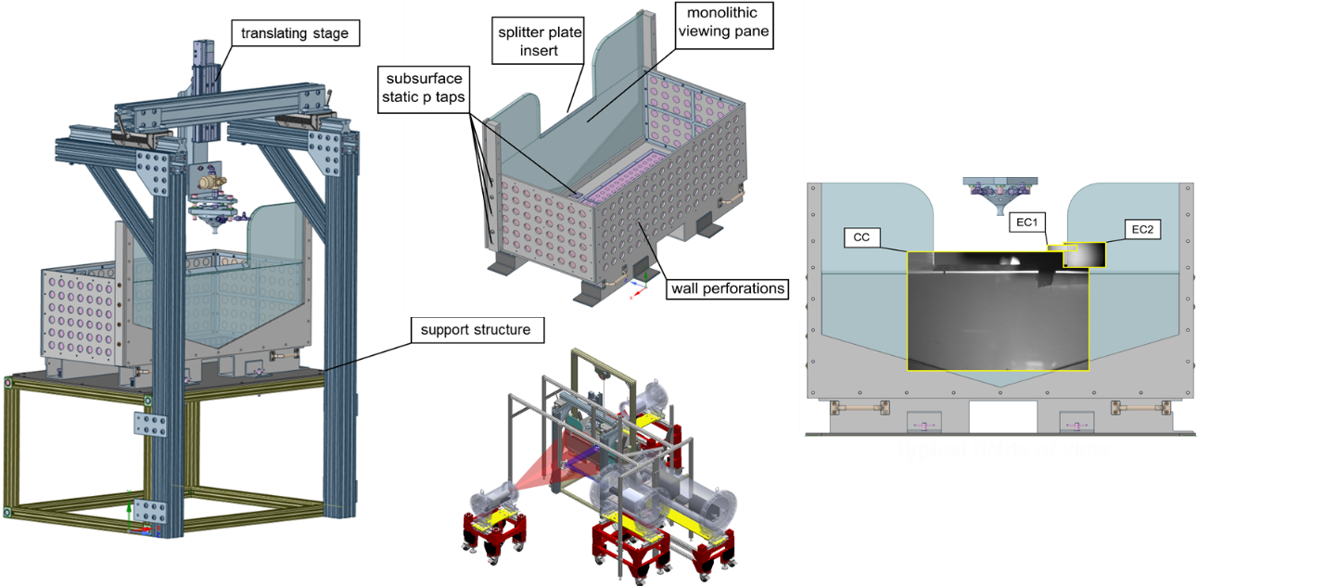
Figure 4 Illustration of the PFGT hardware. The test mount is shown on the left with the soil bin and splitter plate called out in the middle top. Camera locations are shown in the middle bottom and the camera fields of view are shown on the right.

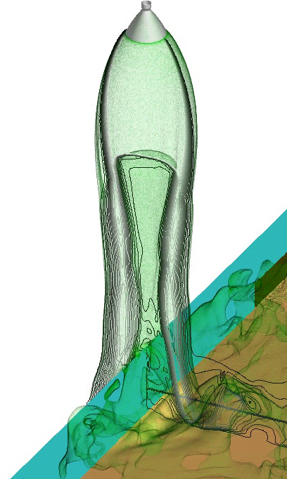

Figure 5. Picture from a simulation of a supersonic plume impinging on the splitter plate (light blue) with one half flow down the outside of the soil bin while the other half of the plume forms a crater along the splitter plate within the soil bin. Black contours are Mach number, the transparent green is the Mach=1 isosurface, and the brown is the soil volume fraction of 0.275, representing the soil surface.

Pathfinder Simulation
The PFGT conditions chosen for the Pathfinder simulation were selected to provide the most challenging conditions for Loci/GGFS. This was perceived to be the most intense plume impingement on the soil surface, which occurs for maximum nozzle flow rate and greatest ambient pressure. While the lowest altitude provides the most intense surface impingement, the highest altitude was chosen because it is more application-like and results in the largest need for computational resources. Spherical-shaped Mono-Disperse Glass Beads (MGB) was chosen as the soil type because it was the only PFGT soil model available for Loci/GGFS at the time of Pathfinder definition.

The PFGT dataset that most closely correspond to these settings is labeled Run 142. Shown in Figure 6 is crater camera views from PFGT Run 142 at 0.05, 0.1, 0.25, 0.5, 1.0 and 2.0 seconds elapsed time. Note soil disturbance at 0.1 seconds followed by visible crater at 0.25 seconds and increasing size of crater from 0.5 to 2.0 seconds.
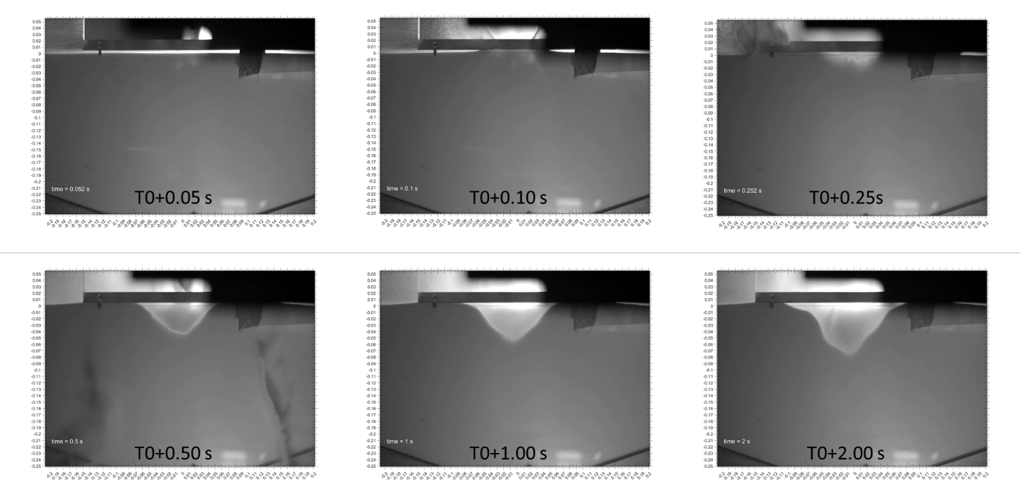
Figure 6. Crater camera view from PFGT Run 142 at 0.05, 0.1, 0.25, 0.5, 1.0 and 2.0 seconds elapsed time. Note soil disturbance at 0.1 seconds followed by visible crater at 0.25 seconds, and increasing size of crater from 0.5 to 2.0 seconds.

Geoemtry and MEsh
The computational domain is shown in Figure 7 with a size of 10 meters per edge. Note the soil bin is located at the bottom center of the computational domain. A zoomed view of the soil bin is shown in Figure 8 where the splitter plate is rendered cyan.

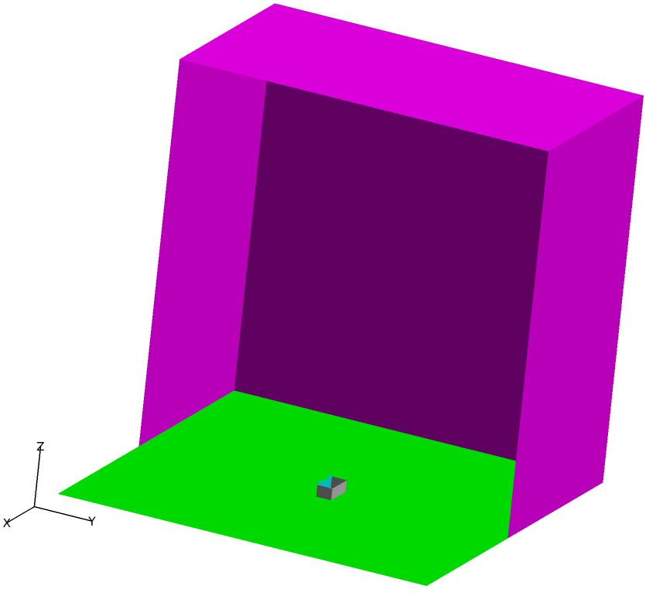
Figure 7. Pathfinder simulation computational domain. PFGT soil bin located at the center bottom.

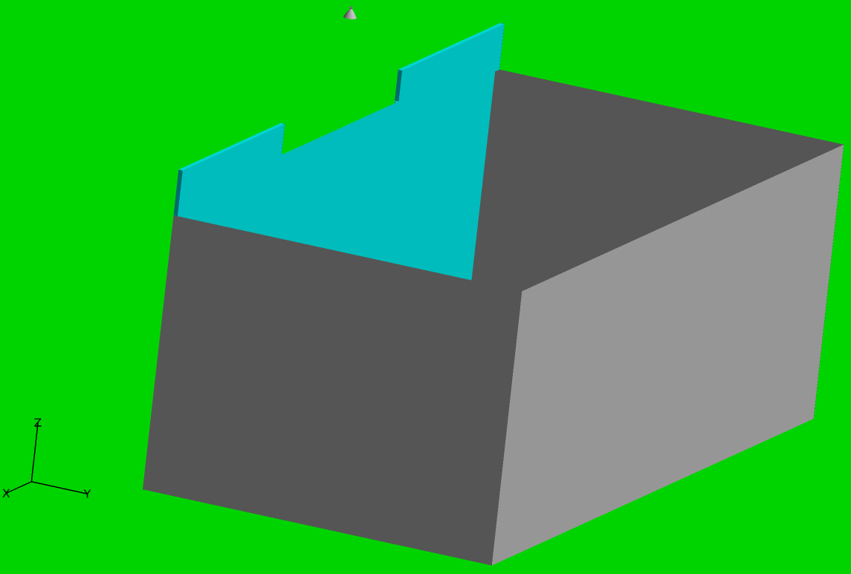
Figure 8. Zoomed in view of the Pathfinder soil bin. The splitter plate is rendered cyan. Note the supersonic nozzle inner profile at the top of the image.
The geometry, surface and volume meshes were created using the ANSA software package[9] with a regional mesh refinement supplied by the Loci/RefMesh tool[10]. The mesh within the supersonic nozzle is shown in Figure 9 where the unstructured mesh extends to the inner surface of the nozzle. The volume mesh along the path from the nozzle to the splitter plate is shown in Figure 10. Note the region where the tetrahedral cells are decomposed into hexahedral cells by the Loci/RefMesh tool. The volume mesh in the region of the plume impingement and cratering is shown in Figure 11. An important step to achieve success of the Pathfinder was the use of structured mesh in regions where soil-gas interfaces are expected. The total mesh size is 92.5 million cells.

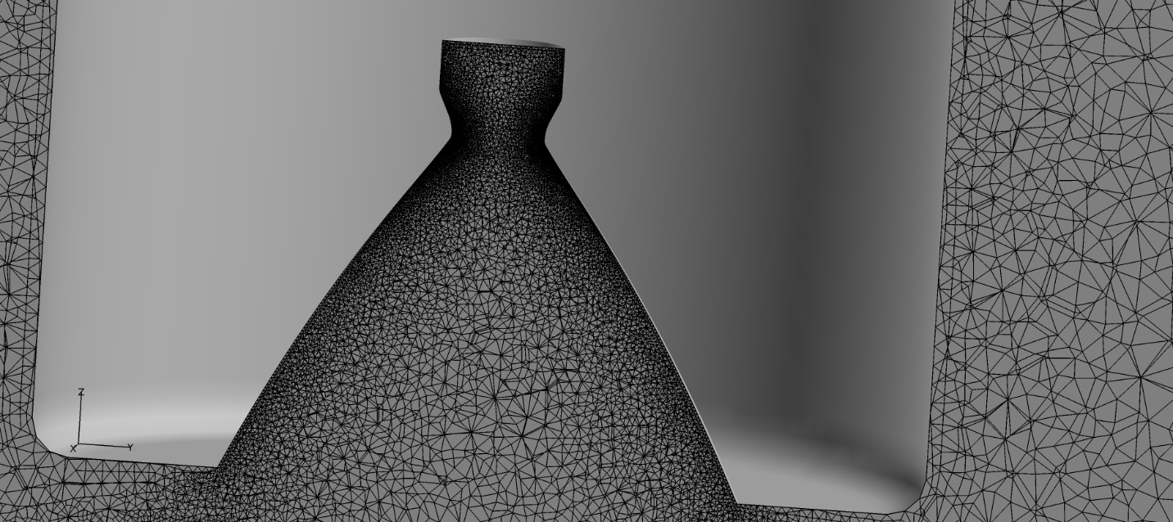
Figure 9. Volume mesh distribution within the supersonic nozzle.

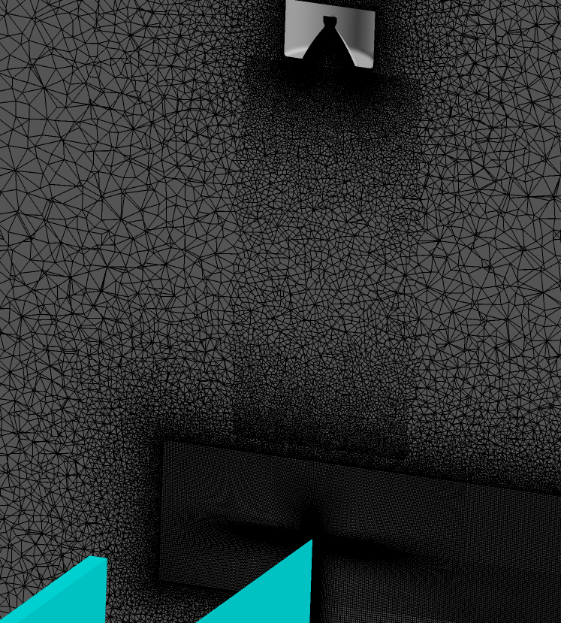

Figure 10. Volume mesh along the path from the nozzle to the splitter plate. Note this region is refined by splitting tetrahedral cells into hexahedral cells.

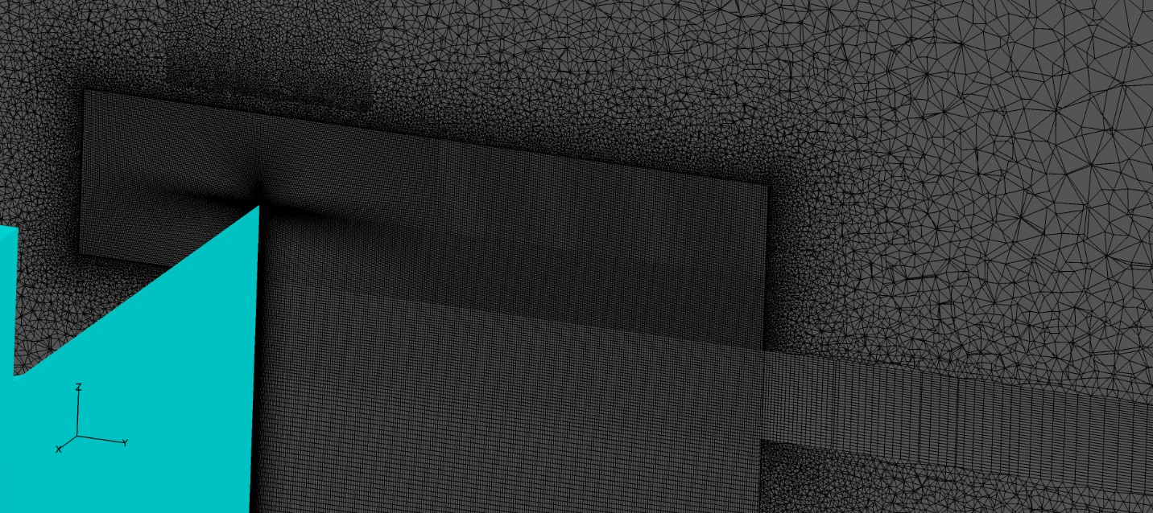
Figure 11. Volume mesh in the region of plume impingement and cratering. Note the structured mesh in the regions where soil to gas interfaces are likely.

Initial and boundary Conditions
The initial conditions for the Pathfinder simulation were quiescent conditions with an ambient pressure of 600 Pa of gaseous N₂ and ambient temperature of 300 K. The soil bin was initialized with MGB soil filled to the level corresponding to a dimensionless altitude of 10. The soil granular pressure was set consistent[5,6] with the gravity field and the local soil depth.

The nozzle inlet boundary condition was set to a transient mass flow rate boundary condition. The mass flow rate was ramped linearly from zero to 8.6 g/s at T+0.5 seconds with a constant temperature of 500 K. All solid surfaces were set to no-slip with temperature fixed at 500 K, except for the nozzle interior surface which was set to a slip wall. Without this nozzle boundary condition, the soil traveled upstream in the nozzle through the subsonic boundary layer and caused numerical difficulties leading to divergence. The outer boundaries, including the bottom of the computational domain were set to maintain an outlet pressure of 600 Pa.

Key Simulation Settings and Computational Resources
The simulation was executed in time-accurate mode with a timestep of 5x10⁻⁶ seconds with 8 newton iterations using second order time and space settings. The simulation was conducting using 9600 Ivy Bridge cpu cores over a time period of 6 weeks.

The Pathfinder simulation conditions were selected before the PFGT was conducted. Some differences between the Pathfinder and Run 142 are: i) the ambient pressure in Run 142 was 588 Ps instead of 600 Pa, ii) the transient nozzle boundary condition occurred over approximately 1 second instead of 0.5 seconds, and iii) the Pathfinder soil density was 2630 kg/m³ instead of the actual 2500 kg/m³. The last difference was due to an oversight when constructing the Pathfinder simulation.

Shown in Figure 12 is isometric views of Pathfinder simulation at 0.05, 0.1, 0.25, 0.5, 1.0 and 2.0 seconds elapsed time. Note the nozzle rendered in gray, splitter plate rendered in cyan and soil surface, represented by the soil volume fraction of 0.275, in sand color. Solid grayscale lines are contours of Mach number and colored lines are contours of the Log₁₀ of soil volume fraction. Shown in Figure 13 are crater camera views of Pathfinder simulation at 0.05, 0.1, 0.25, 0.5, 1.0 and 2.0 seconds elapsed time. Note transparent splitter plate rendered in cyan and soil surface, represented by the soil volume fraction of 0.275, in sand color. Solid grayscale lines are contours of Mach number. Shown in Figure 14 are crater camera views of Pathfinder simulation at 0.05, 0.1, 0.25, 0.5, 1.0 and 2.0 seconds elapsed time. Note transparent splitter plate rendered in cyan and solid grayscale lines are contours of Mach number. Four isosurfaces of soil volume fraction are rendered, limited to locations within one-half millimeter of the splitter plate. The isosurface values (color) are 0.275 (sand), 0.02 (green), 0.002 (blue) and 0.0002 (crimson).

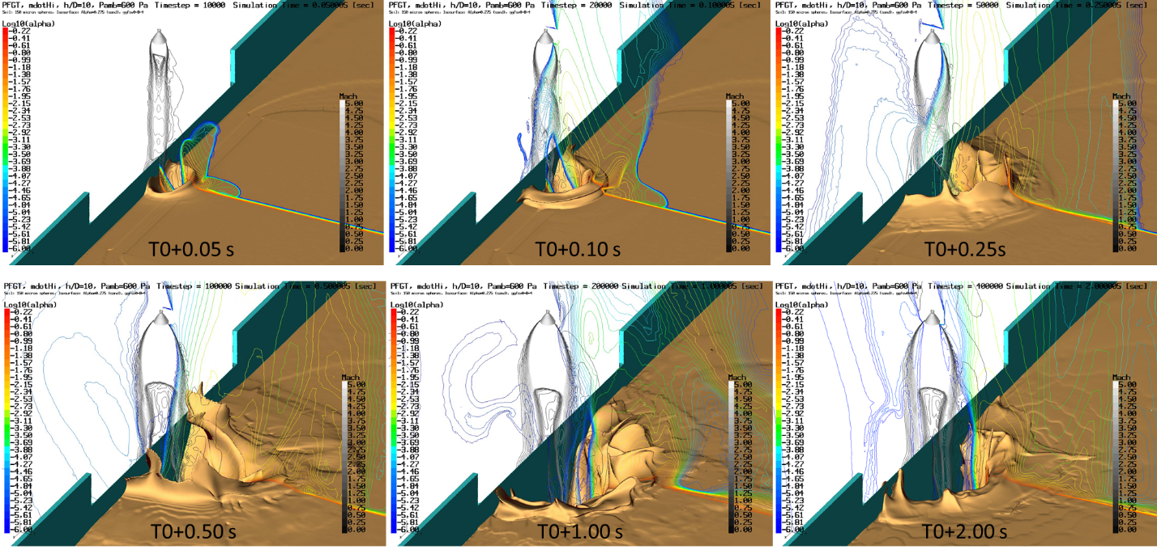
Figure 12. Isometric view of Pathfinder simulation at 0.05, 0.1, 0.25, 0.5, 1.0 and 2.0 seconds elapsed time. Note the nozzle rendered in gray, splitter plate rendered in cyan and soil surface, represented by the soil volume fraction of 0.275, in sand color. Solid grayscale lines are contours of Mach number and colored lines are contours of Log₁₀ of soil volume fraction.

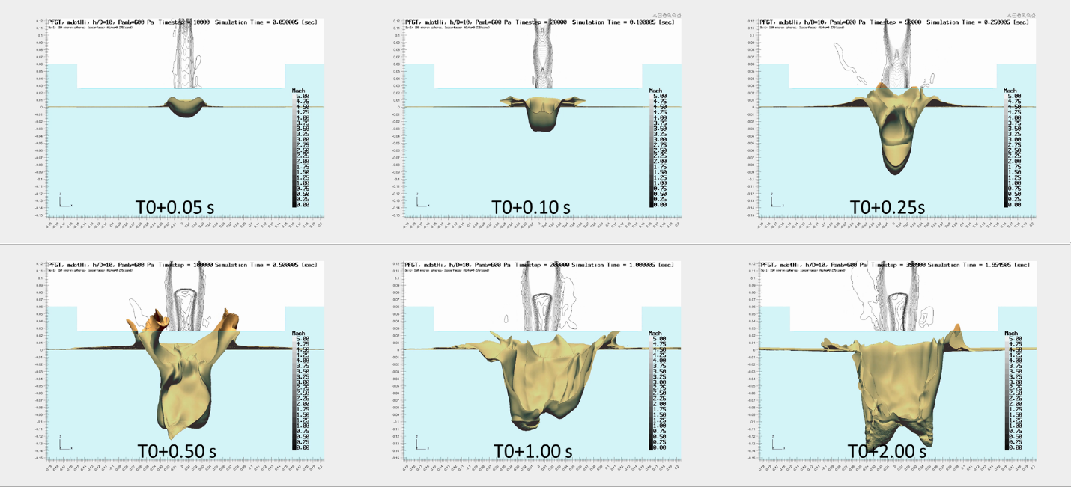
Figure 13. Crater camera view of Pathfinder simulation at 0.05, 0.1, 0.25, 0.5, 1.0 and 2.0 seconds elapsed time. Note transparent splitter plate rendered in cyan and soil surface, represented by the soil volume fraction of 0.275, in sand color. Solid grayscale lines are contours of Mach number.

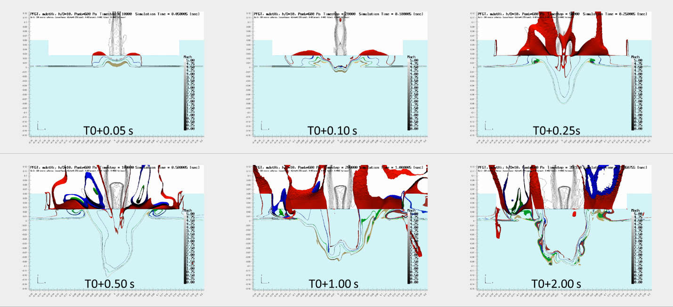
Figure 14. Crater camera view of Pathfinder simulation at 0.05, 0.1, 0.25, 0.5, 1.0 and 2.0 seconds elapsed time. Note transparent splitter plate rendered in cyan and solid grayscale lines are contours of Mach number. Four isosurfaces of soil volume fraction are rendered, limited to locations within one-half millimeter of the splitter plate. The isosurface values (color) are 0.275 (sand), 0.02 (green), 0.002 (blue) and 0.0002 (crimson).

With respect to the last three figures, a crater has formed by 0.05 seconds and soil particle are being ejected upwards with some soil above the top of the splitter plate. However, the soil level on the splitter plate is still higher than the original soil surface. By 0.10 seconds, the crater has grown in size such that the crater is visible on the splitter plate. The crater is deeper away from the splitter plate than at the splitter plate, this occurs frequently throughout the simulation. Soil ejecta is more than half the distance between the nozzle centerline and the edge of the splitter plate. By 0.25 seconds, the crater edges defined by the 0.275 isosurface are approaching the height of the splitter plate and significantly exceed that height by 0.5 seconds. Significant growth in crater width and depth occurs between 0.5 and 2.0 seconds.

ValIdation Observations and Discussion
The previous section described both the test results as viewed by the crater camera as well as the Pathfinder simulation results from multiple views. This section will highlight several features that both have in common as well as point out significant differences.

Crater camera views of both Run 142 and the Pathfinder are shown in Figure 15 at 0.076 seconds. The test and Pathfinder simulation views have been scaled similarly such that rough comparison of feature size and location is possible. The first disturbance of the soil surface in the test is evident as well as several soil grains are visible above the splitter plate to the left of the nozzle centerline. The Pathfinder also shows soil surface disturbance in terms of the 0.275 soil volume fraction isosurface on the splitter plate. The crimson isosurface, corresponding to the 2x10⁻⁴ soil volume fraction, indicates dispersed soil in a similar location.

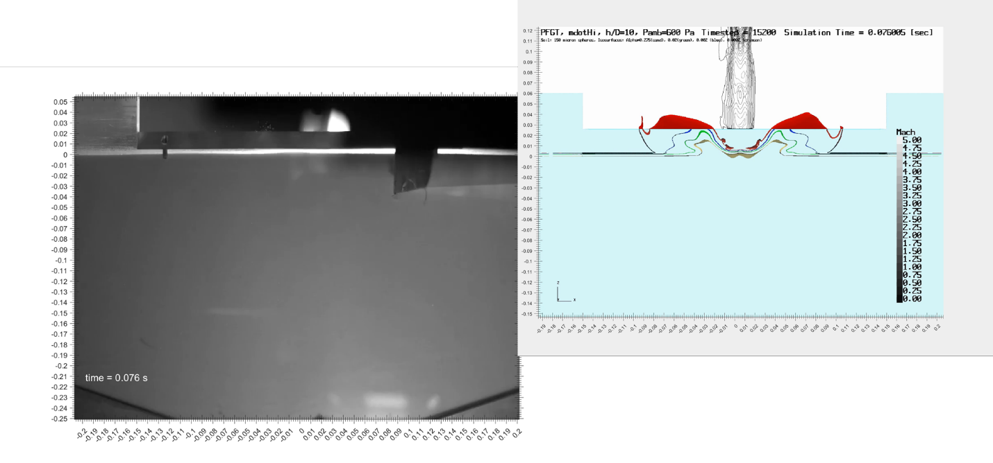
Figure 15. Crater camera views at T+0.076 seconds of PFGT Run 142 (left) and Pathfinder simulation (right), similarly scaled.

Crater camera views of both Run 142 and the Pathfinder are shown in Figure 16 at 0.18 seconds. A significant crater has formed in each and appear to be nearly equal in depth at about 2 cms. The Run 142 crater width is significantly larger than the Pathfinder crater width by at least a factor of two.

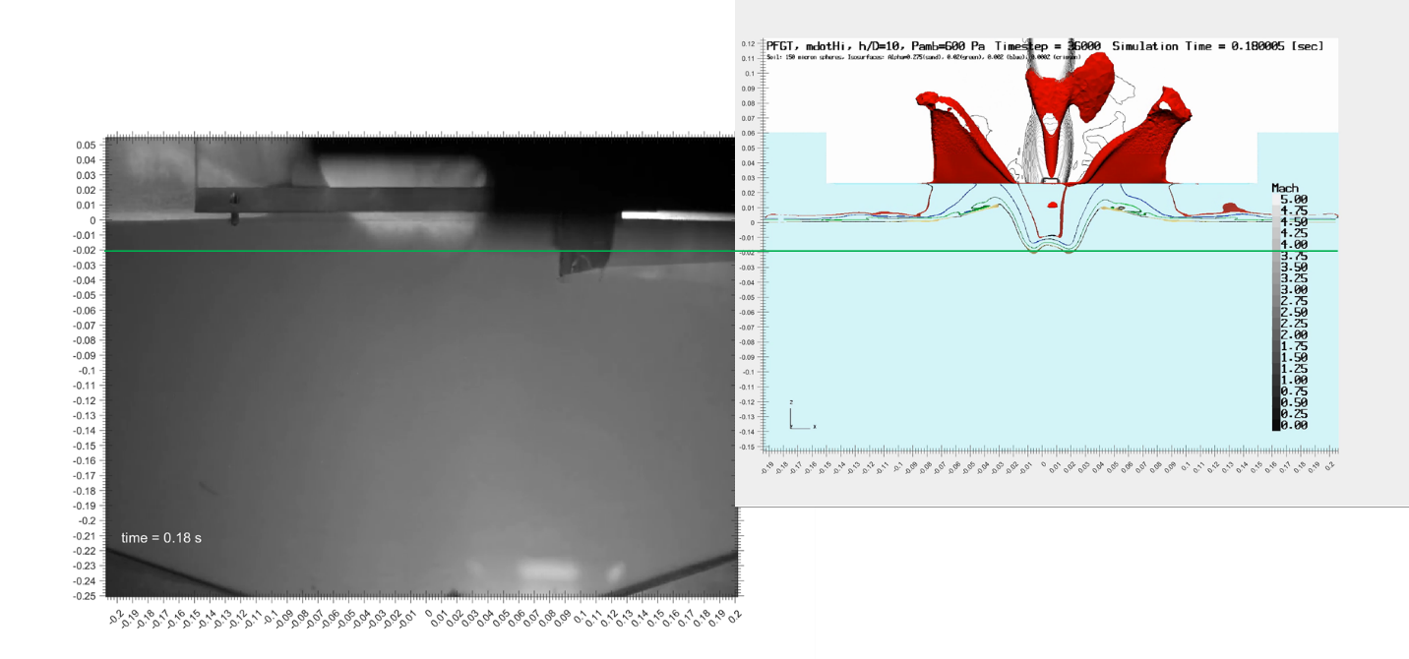
Figure 16. Crater camera views at T+0.18 seconds of PFGT Run 142 (left) and Pathfinder simulation (right), similarly scaled. Horizontal green line is located at 2 cms below initial soil level.

Crater camera views of both Run 142 and the Pathfinder are shown in Figure 17 at 0.328 seconds. The Pathfinder crater has grown to 6 cm in depth while the depth in Run 142 is about 3 cm. The crater widths are reversed with Run 142 being 6 cm and the Pathfinder at 4.5 cm. In this timeframe, both Run 142 and the Pathfinder exhibit pulsing crater sizes with the pulse times of 70 ms and 140 ms for Run 142 and the Pathfinder, respectively.

The Pathfinder crater surface, represented by the 0.275 soil volume fraction, shows repeated roll-ups and then convection up the slope of the crater until the roll-up is ejected from the crater. This behavior is evident from as early as 0.2 seconds in the Pathfinder. While similar behavior can be identified in Run 142 at similar times, a clear beginning and end of a roll-up and convection cycle appears at 0.664 and 0.74 seconds as shown in Figure 18. This type of behavior is consistent with the Diffusion Driven Flow (DDF) regime of erosion[11].

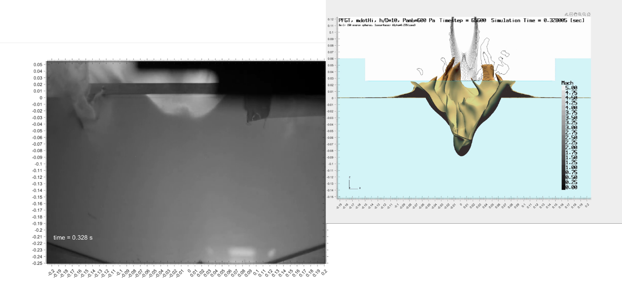
Figure 17. Crater camera views at T+0.328 seconds of PFGT Run 142 (left) and Pathfinder simulation (right), similarly scaled.

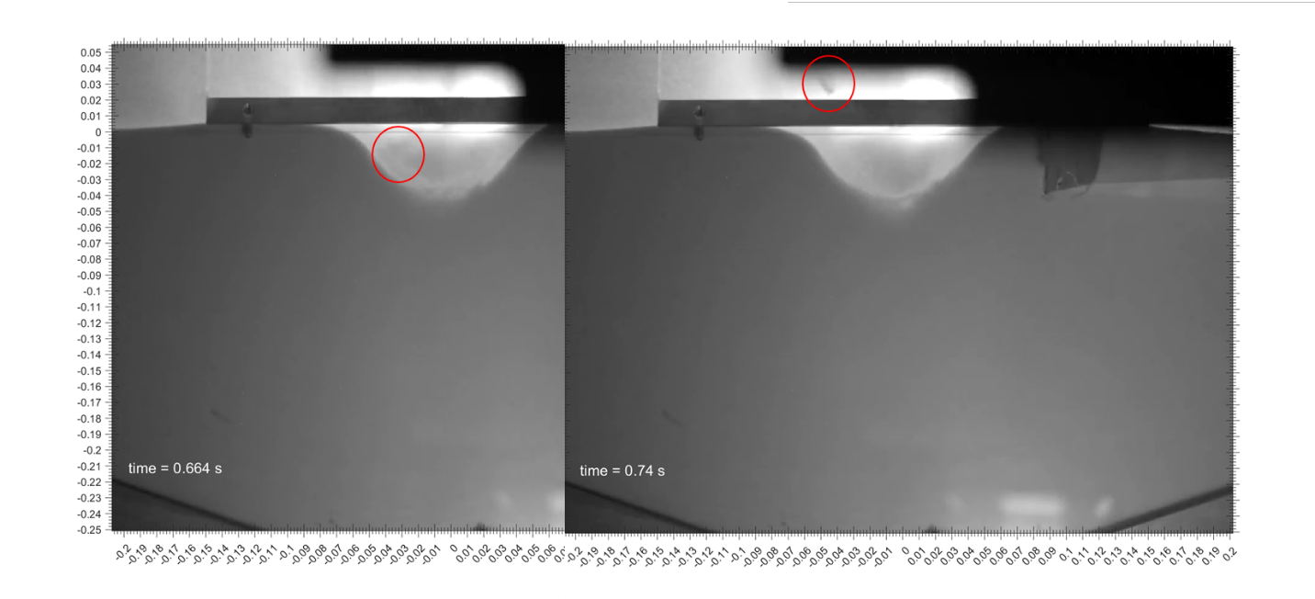
Figure 18. Crater camera views of PFGT Run 142 at T+0.0.664 (left) and T+0.74 (right) seconds. Note fluidized region indicated with the red circle in each.

Crater camera views of both Run 142 and the Pathfinder are shown in Figure 19 at 2.0 seconds. The Pathfinder crater has grown to 7.5 cm in depth while the depth in Run 142 is about 10.5 cm. The crater widths are reversed with Run 142 being 10.5 cm and the Pathfinder at 7 cm.

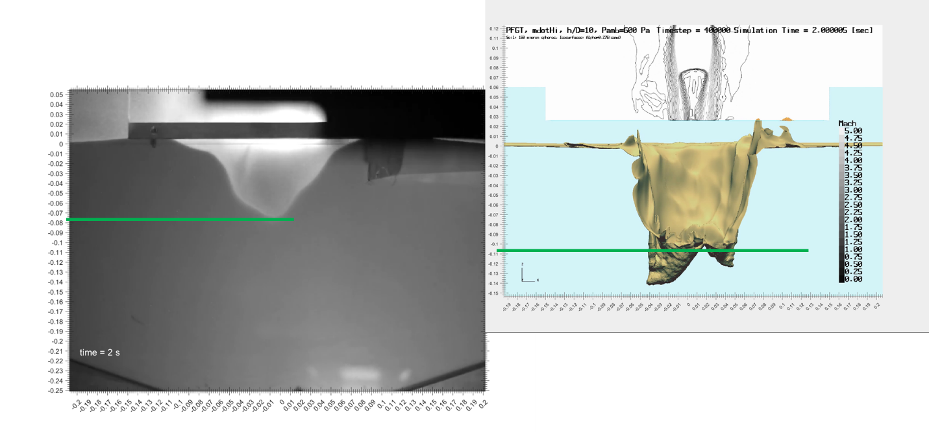
Figure 19. Crater camera views at T+2 seconds of PFGT Run 142 (left) and Pathfinder simulation (right), similarly scaled. Horizontal green lines are aligned with crater depths.

Summary and conclusions
The results of a Pathfinder Loci/GGFS simulation for the PSI Project Physics Focused Ground Test was presented. A successful Loci/GGFS simulation of a PFGT case is required before embarking on a focused Validation assessment. Important details of the Pathfinder simulation were presented along with select results.
Comparison of the Pathfinder results to the nearest PFGT case, Run 142 were presented. In general, similar features were identified in both test and simulation. Several detailed comparisons of crater and ejecta patterns were conducted with some significant similarities noted. While the crater shapes are not quantitatively the same, they are qualitatively similar. Both test and simulation show similar features of crater size pulsing and fluidized soil regions that roll up and are convected out of the crater. On the whole, there is significant similarity of test and simulation to warrant expending resources on a more rigorous quantitative Validation Assessment.

references
- Vizcaino, J., and Mehta, M., Quantification of plume-soil interaction and excavation due to the Mars Science Laboratory Sky Crane Descent Phase, AIAA Paper 2015–1649, 2015. https://doi.org/10.2514/6.2015-1649.
- Manginelli, M. S., Mehta, M., and Thomas, O. H., Flight Reconstruction of Plume-Induced Site Alteration from InSight, Journal of Spacecraft and Rockets, Vol. 58, No. 3, 2021, pp. 879–893. https://doi.org/10.2514/1.A34935.
- West, J., Griffin, L, Liever, P, Weaver, Shurtz, T., Gale, M. and Krolick, W., Overview of the Predictive Simulation Capability Element of the Plume Surface Interaction Project, AIAA Scitech, San Diego, CA, January 2022.
- Weaver, A., Krolick, W., Liever, P., West, J., Overview of Predictive Simulation Capability Development for Crater Evolution and Ejecta in Continuum/Rarefied Flows AIAA Scitech, San Diego, CA, January 2022.
- Gale, M., Buettner, K., Mehta, R., Liever, P. A., and Curtis, J., Gas-Granular Flow Solver for Plume Surface Interaction and Cratering Simulations, AIAA Paper 2017-4503, 23rd AIAA Computational Fluid Dynamics Conference, June 2017.
- Gale, M., Liever, P., Mehta, R., Yang J. and Curtis, J., Realistic Regolith Models for Plume-Surface Interaction in Spacecraft Propulsive Landings, AIAA Paper 2020-0797, AIAA SciTech Forum 2020.
- Craig, A. S., Anzalone, E. J., Hannan, M. R., Belanger, B. L., Burke, L. M., Condon, G. L., Joyce, R. T., Mahajan, B., Means,L. L., and Pei, J., Human Landing System Storable Propellant Architecture: Mission Design, Guidance, Navigation, and Control, AAS Paper 20–592, 2020.
- Korzun, A., Eberhart, C., West, J., Liever, P, Weaver, A., Mantovani, J., Langton A., Kemmener, B., and Atkins, A., Design of a Subscale, Inert Gas Test for Plume-Surface Interactions in a Reduced Pressure Environment, AIAA Scitech, San Diego, CA, January 2022.
- Beta ANSA Mesh Generation software, version 20, https://www.beta-cae.com/ansa.htm
- Chamberlain, R., and Luke, E., Loci RefMesh User Guide, Mesh Refinement Software for Use with Loci/CHEM, STTR Phase II report for NASA contract NNM06AA96C, April 2010.
- Metzger, P., Immer, C., Donahue, C., Vu, B., Latta, R., and Deyo-Svendsen, M., Jet-induced cratering of a granular surface with application to lunar spaceports , Journal of Aerospace Engineering, 22(1), June 2009.

