Enabling Architecture Trades and Design Exploration for Nuclear Electric Propulsion

M. A. Rodriguez*, R. J. Hetterich*, T. E. Brooks*, T. M Boswell*, G. Jones*, and L. L. Fabisinski⁺

*NASA Marshall Space Flight Center

Huntsville, AL

⁺Jacobs Engineering, ESSCA Group

Huntsville, AL

Abstract
Recent renewed interest in Nuclear Electric Propulsion (NEP) at NASA has driven the need for design space exploration and analysis of alternative architectures to evaluate performance and feasibility of NEP concepts. It has been over a decade since NASA last invested in Nuclear Electric Propulsion development efforts, and the landscape has shifted in both mission objectives and technology readiness levels. This also means that many of the engineering analyses and design frameworks tailored to NEP date back to the Jupiter Icy Moons Orbiter (JIMO) days of the early 2000s. Thus, a need was identified for updating and modernizing the modeling and simulation toolsets for NEP.
This paper will detail the development efforts in the Marshall Space Flight Center’s Advanced Concepts Office, with a particular focus on the development of the NEP stage of the NEP-Chem vehicle. The paper will cover the various models used, and their current development status, as well as provide an overview of the integrated vehicle model and plans for further development.

introduction
NEP systems have been considered by NASA for some time, due to their ability to support high-power, high-efficiency propulsive options, and without their power output being constrained by solar distance. Recent efforts can be traced back to the early 2000s with Project Prometheus, which was established to develop nuclear-powered systems for deep space missions^{[1]}. The nuclear systems and technologies that were evaluated as part of Project Prometheus, also were used to develop the Jupiter Icy Moons Orbiter (JIMO) NEP vehicle concept^{[2]}, as shown in Figure 1.

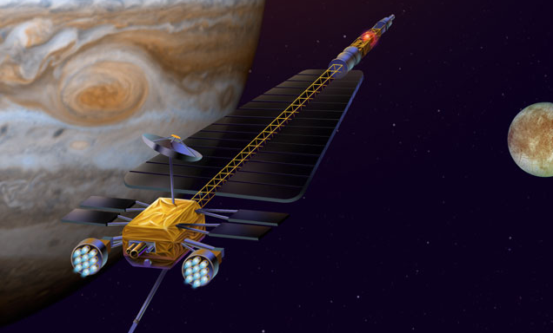.
Figure 1. The Jupiter and Icy Moons Orbiter NEP Vehicle concept.

In recent years, a number of studies have been conducted to continue evaluating the feasibility of NEP technologies for deep space missions; in particular, with the significant focus on human Mars missions, NEP technologies are being evaluated for crewed vehicle concepts for Mars transport. This work will leverage recent efforts by NASA Marshall Space Flight Center’s Advanced Concepts Office into developing hybrid NEP/Chemical propulsion concepts for human Mars crew/cargo transport systems^{[3]}, as well as the efforts by NASA Glenn Research Center’s COMPASS Team in 2021^{[3]}. The hybrid NEP/Chem concept featured a nuclear-electric propulsion system using Xenon Hall electric thrusters, combined with a LOX/Methane chemical propulsion system. The chemical propulsion system would aid in high thrust, short duration maneuvers – such as the insertion and injection maneuvers used to transition into and out of Earth/Mars orbits. The Hall thrusters would handle long-duration propulsion maneuvers, particularly those in deep space in transit to Earth or Mars. Figure 2 shows the COMPASS team’s depiction of the NEP/Chem crewed vehicle.
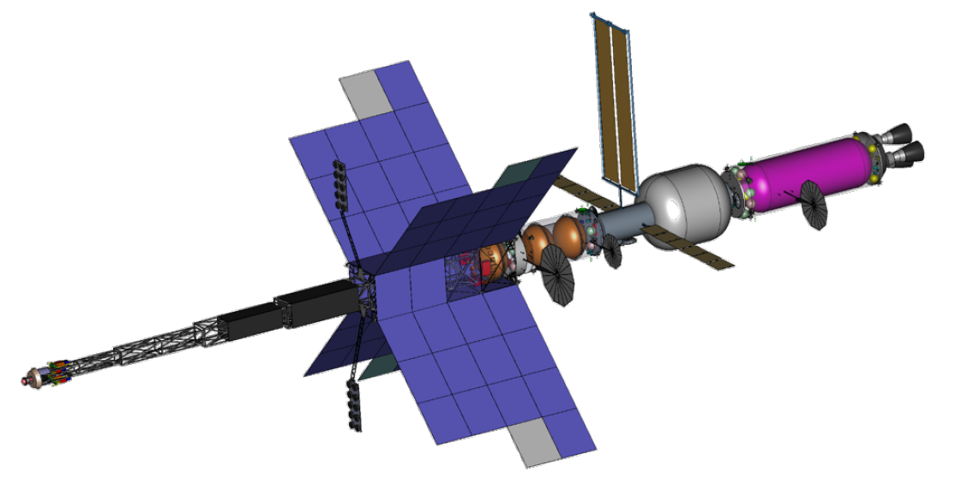
Figure 2. The NEP/Chem vehicle concept developed by the COMPASS team in 2021.

NEP systems typically have very tight coupling between major subsystems such as power, propulsion, and thermal. When sizing and evaluating NEP systems, it is important to consider the interactions between these subsystems and tradeoffs between them at the system level. Therefore, this work looked to develop models for major components in a NEP module and bring them together into an integrated system model. The system model can fly a mission and size the components of a nep module simultaneously while considering interactions between them.

Vehicle Modeling approach
For this work, the vehicle components were modeled and integrated using the Dynamic Rocket Equation Tool (DYREQT). DYREQT is a multi-disciplinary analysis and optimization (MDAO) tool in Python which allows for generalized synthesis and execution of space transportation architectures.^{[4]} It is built on top of OpenMDAO, which is a generalized framework for efficient solving, integration, and optimization of multidisciplinary problems.^{[5]} In DYREQT, each stage of the vehicle can be modeled as an object referred to as an “Element”. An Element is an object which contains and rolls up the properties of a collection of “SubElement” objects. Each SubElement can size a subsystem or component in the Element at varying levels of fidelity. When setting up a DYREQT model, one can define whatever SubElement objects one wants to make up an Element, as well as what simulation code one wants to use to size each SubElement. One SubElement in the Element could, for example, model a detailed, physics based engine model, while another SubElement could just be a basic regression equation to represent an entire avionics subsystem. Additionally, SubElements can also interact with other SubElements by exchanging “resources”. In DYREQT, a resource refers to any type of commodity (power, fuel, heat, data, food, etc.), that a SubElement may use and that it may exchange with other SubElements. An engine SubElement, for example, can exchange a propellant resource with a tank SubElement so that the tank can size itself to the propellant load needed by the engine. One of DYREQT’s biggest strengths is that it is very flexible in the vehicles and missions it can size and optimize. SubElement models can easily and modularly be placed in / removed from an Element, connected along a variety of paths with resources, and their inputs can easily be varied or added to an optimizer.
For this work, several SubElement models were built in DYREQT to represent some of the major components in a NEP Element and the interactions / coupling between those components. These components were then built into a representative NEP Element model and flown through a mission. The initial focus of this work was developing SubElements for the major components in the power, thermal, and propulsion subsystems. The integrated vehicle model was built up with an agile approach. Prioritized SubElement models were built up in development sprints and incorporated into the integrated vehicle model as they became available. As models were iterated on and new models were created, they were continuously worked into an expanding integrated model. Due to this, currently available SubElement models are at various levels of fidelity based on what was prioritized for this initial development. The SubElement models will continue to be iterated on and new models will be added.

Reactor modeling
Within the NEP element, the reactor component is evaluated as a DYREQT model composed of a single SubElement; this SubElement consists of the components pertaining to the reactor, up to and including the reactor-side interface with the power conversion system. The following components are assumed to be part of this model:
- Reactor fuel and moderator, and the containing pressure vessel
- Safety/control system, which includes control drums and/or other safety structures/mechanisms
- Shielding systems, which includes both the shadow shield and the conical safety shield, as well as internal reactor shielding
- Coolant systems, which includes the molten Lithium working fluid that transfers heat to the power conversion system
- Secondary structures, which includes all structural support components that are not covered within structural bookkeeping values in the other components.
- Miscellaneous components, which include brackets, wiring, tubing and other components that add mass to the reactor but are not directly quantified in the other components.
Reactor Model Source and Basic Assumptions
At present, the DYREQT model for the reactor is composed of a single SubElement, with plans to expand the model’s components into discrete DYREQT components with improved fidelity. The reactor model is derived from the RSMASS-RANKSYS code originally developed by Sandia National Laboratories in 1986^{[6]}. Currently, the model assumes that the reactor is a scaled derivative of the SP-100 systems, with a liquid/molten Lithium working fluid and a moderated core. The DYREQT reactor model also incorporates some of the functionality for specifying required electrical power output and enrichment levels, which allow for adjusting the DYREQT model for HALEU (High-assay, low-enriched Uranium)-type reactor configurations.
Basic Reactor Calculations
The initial reactor calculations obtain the thermal power demand, pressure conditions, and mass values pertaining to desired fuel performance, including burnup masses and specific power limits.
The initial reactor model calculations determine the thermal power requirements, based on working fluid mass flow rates, and the desired inlet/outlet temperatures for the reactor. These values can be linked with the power conversion model to ensure consistency between the thermal model of the reactor and the thermal inputs for the power conversion system. The working fluid can also be adjusted based on reactor design assumptions; for the purposes of this work, liquid/molten Lithium is assumed.
The reactor model calculates the enthalpy change across the reactor, using the mass flow rate and power conversion model inputs for desired inlet/outlet temperature ranges (which can be linked, but are currently hardcoded by the user). The thermal power demand is then calculated from this information.
Lastly, a series of calculations are performed that examine the desired fuel mass based on the enrichment and fuel type assumptions, and calculates expected burnup based on desired operational lifetime, as well as the specific power limit mass.
Secondary Reactor Calculations
The moderator and structures masses are derived using the preceding reactor/fuel mass data that was calculated, using a series of scaling mass equations. The reflector mass is also obtained this way, with a secondary calculation that obtains volume and radius information based on the provided reactor data. All of these calculation outputs are, in turn, used to evaluate the pressure vessel mass, which relies on calculating the dimensions of the inner and outer radii of the pressure vessel. The last item evaluated is the mass of miscellaneous systems, which is also calculated using a set of linear scaling equations based on the previous fuel/reactor mass calculations.

Power conversion modeling
As with the other subsystems of the NEP vehicle Element, the power conversion subsystem will be modelled in DYREQT as a collection of SubElements easily connected to the other SubElements comprising the integrated vehicle Element model. There is currently a working version of the power conversion model in DYREQT consisting of a single SubElement, but more fidelity and design customization is to be added before it is considered complete. The Brayton constituent components - Turbine, Compressor, Alternator, Recuperator and Gas Cooler - will be modelled individually as DYREQT SubElements and connected to each other to comprise various Brayton engine configurations. It is intended that this collection of SubElements be usable for developing other systems beyond this specific proposal. Therefore, the model will be designed so that the fluids, heat source, and gas cooler are easily interchangeable. At present, however, the Brayton model consists of a single SubElement that models the Brayton configuration shown in Figure 3.
In this configuration, molten Lithium from the reactor heats 40g/mole He-Xe, which drives the Turbine, Compressor, and Alternator on a common shaft. The gas comes out of the Turbine through a recuperator to the Gas Cooler – a heat exchanger for the main radiator. The much colder gas returning from the Gas Cooler is sent to the compressor with a portion bled through the alternator to cool it. The pressurized gas from the compressor is then heated in the recuperator on its way back to the Reactor’s heat exchanger inlet. The power conversion model computes the electric power, size and mass of the Brayton components, heat to be rejected, and the temperature and pressure at the boundary of each of the Brayton components from the desired turbine pressure ratio, compressor inlet temperature, compressor outlet pressure, and working fluid mass flow rate. DYREQT iteratively runs the model to converge on the required electric power at steady state. The resulting brayton size and thermal rejection requirements are forwarded to the other components of the vehicle Element.
For this vehicle design, the model will use 40 g/mol He Xe as the operating fluid but other fluids can be used instead for other designs given their properties. Basic ground rules & assumptions for this integrated model:
- Turbine inlet temperature must be 800K – 1500K
- Compressor is assumed to be centrifugal
- Alternator is assumed to be 2-Pole, ring-wound and toothless
- Mass flow rate must be < 25 kg / sec
- The Brayton engine electrical output is < 1MW
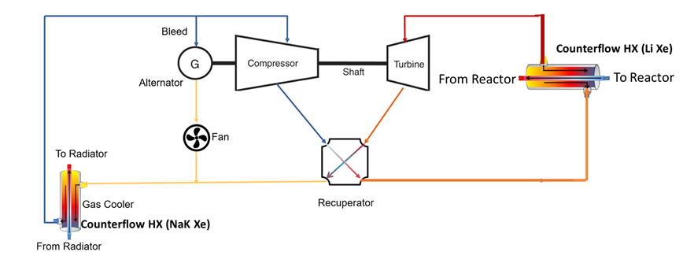
Figure 3. Brayton Diagram

power management and distribution modeling
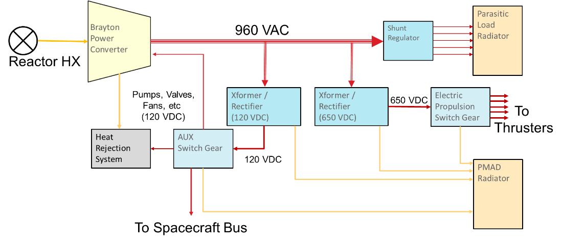
Figure 4. Typical NEP PMAD configuration

Figure 4 illustrates the most common configuration of a power management and distribution system for a NEP vehicle. In general, each Brayton engine has its own PMAD system managing all the power that it generates. Each of the constituents in Figure 4 (including the electrical cables) is modelled as an individual DYREQT PMAD SubElement. The PMAD component models are derived from actual components designed for use on the International Space Station (ISS) PMAD system. The modelling equations are taken from work outlined by Metcalf.^{[7]} The PMAD models are:
AC Transmission Line
The AC transmission lines are sized to a specified power loss (as a %), line length, voltage, current limit, and frequency by simple, physics-based formulae. The model provided can size cabling for either Aluminum or Copper.
DC Cable
The DC cables are sized to a specified power loss (as a %), line length, voltage, and current limit, by simple, physics-based formulae. The model provided can size cabling for either Aluminum or Copper.
Shunt Regulator
The Brayton engine is designed to run at a particular, pre-determined speed (e.g. 36000 RPM). Its major mechanical load is the Alternator rotor, which is rotated against the force of the magnetic field generated by current flowing to the Brayton’s electrical load. When that load changes quickly – say because one of the thrusters is turned off – the mechanical load on the alternator will drop quickly as well. This will cause the Turbine, Compressor and Alternator assembly to speed up dramatically. To avoid that (and precisely control the shaft speed), the Shunt Regulator senses the change in the electrical load, and switches in additional parasitic loads in parallel with the operational loads in order to keep the overall power load the same. These parasitic loads are part of the:
Parasitic Load Radiator
This unit consists of a number of equal resistive load circuits – usually made from NiChrome wire – embedded in a Carbon-Carbon radiator that is sized to convert power switched to the wire into heat and to then dissipate it to space. The individual load circuits are switched by the Shunt Regulator as described above. The radiator typically rejects heat at 1000K – 1200K.
Transformer / Rectifier
The Transformer / Rectifier converts AC current from one specified voltage to DC current at another voltage. This component is modelled with a DYREQT SubElement that computes size, mass, and power losses using physics-based methods.
Switch Gear
A Switch Gear is a mechanically actuated electrical switch capable of switching a number of electrical inputs to a common bus, and then to a number of outputs. The inputs must be of the same voltage, and the outputs must be of the same voltage as the inputs. This component is modelled with a DYREQT SubElement that computes size, mass, and power losses using physics-based methods.

Heat Rejection Modeling
The heat rejection subsystem includes heat exchangers, fluid loops, heat pipes, and radiators. Heat exchangers and dedicated radiators (for the nuclear reactor and power handling systems) are modelled in the nuclear and power conversion sections of this paper. This section covers the thermal subsystem that moves heat from the Brayton counterflow heat exchanger and radiates it to space. A fluid loop (pump, working fluid, pipes, and accumulators) and a large deployable radiator with embedded heat pipes are a part of this thermal subsystem. This system has significant performance interfaces with the heat engine, because the heat engine efficiency increases as radiator temperature decreases (thus also reducing amount of heat that must be removed), and the radiator area increases as its temperature decreases.

The NEP system’s waste heat must be removed by thermal radiation to space. Gray body radiation is used to calculate the net heat emitted per unit area of radiator using the equation below where Q is the heat radiated, A is the surface area of the radiator, ε is the emissivity of the radiator, T_{rad} is the effective radiator temperature, T_{space} is the temperature of space, A_{f} is the ratio of the radiator’s sunlit projected area to the radiators total area, α is the radiator’s solar absorptivity, and ϕ_{solar} is the solar heat flux.

 | $$\frac{Q}{A}=εσ\left(T_{rad}^{4}-T_{space}^{4}\right)-{A_{f}αϕ}_{solar}$$ | Equation 1

The radiator’s areal heat rejection is further knocked down by a view factor efficiency number that was calculated with numerical ray tracing to account for the difference between an x-wing radiator (radiator has a view factor to itself) and a flat radiator (no view factor to itself). The x-wing radiator only net emits ~79% as much heat as a flat radiator due to the x-wing radiating heat to itself. It is also noteworthy that sunlight at Venus reduced the net emission by only ~2.5% for a design study performed by ACO in the winter of 2021, so this consideration may not need to constrain the NEP vehicle’s orientation.

The radiator heat rejection calculation is further complicated by the unavoidable existence of a gradient in the radiator. A gradient exists in the radiator due to the limitations of the heat exchange between the radiator and the fluid loop as well as the fluid loop’s ability to transport heat. Therefore, an effective radiator temperature, T_{rad}, must be determined based upon this gradient by calculating the Newtonian average function value with the equation below where T_{h} is the hot-side (inlet from the Brayton) radiator temperature and T_{c} is the cold-side (outlet back to the Brayton). This equation was derived by assuming a linear temperature gradient across the radiator. After the required radiator area is determined, it is multiplied by a radiator areal density to determine the radiator mass.
 | $$T_{rad}={\left(\frac{\left(T_{h}^{5}-T_{c}^{5}\right)}{5\left(T_{h}-T_{c}\right)}\right)}^{1/4}$$ | Equation 2

The fluid loop’s sizing greatly affects the temperature gradient and the effective radiator temperature which then impacts the required radiator surface area. The fluid loop flow rate is set so that it can move the waste heat from the Brayton engine. Frictional losses at this required flow rate are calculated using the Darcy-Weisbach equation. The system of equations below is used to calculate the pump power as a function of flow rate and pipe geometry where f_{D} is the Darcy friction factor, μ is the dynamic viscosity, Re is the Reynolds number of the flow, Δp is the pressure drop (head) in the pipes, ρ is the fluid density, v is the fluid’s velocity, D is the inner diameter of the pipes, L is the length of the pipes, P_{pump} is the pump’s electrical power, η_{pump} is the pump’s efficiency, and $\dot{V}$ is the volumetric flow rate of the working fluid. The Reynold’s number is calculated assuming laminar flow

 | $$Re=\frac{ρvD}{μ}$$ | Equation 3
 | $$f_{D}=\frac{64}{Re}$$ | Equation 4
 | $$\frac{Δp}{L}=\frac{f_{D}ρv^{2}}{2D}$$ | Equation 5
 | $$P_{pump}=\frac{Δp\dot{V}}{η_{pump}}$$ | Equation 6

The required flow rate is determined by the specific heat and the amount of heat that must be transferred as shown in the equation below where c_{p} is the working fluid’s heat capacity, and the other variables have been defined for preceding equations.

 | $$\dot{V}=\frac{Q}{ρc_{p}\left(T_{h}-T_{c}\right)}$$ | Equation 7

After the fluid loop dimensions and characteristics are determined, the fluid loop’s pipe and working fluid mass are calculated based upon its geometry, and the pump mass is scaled based upon its required power. Our modelling varies the pipe cross section and radiator temperature gradient to minimize the thermal subsystem mass at a given waste heat power level and Brayton compressor inlet temperature. The thermal subsystem mass is very sensitive (often varying by >50%) to the interdependencies between the radiator effective temperature and the fluid loop performance.

Electric propulsion modeling
For this work, the focus in the propulsion system sizing was the thrusters and the tanks. Other parts of the propulsion system such as plumbing, valves, etc. will be addressed in the future. The currently available DYREQT SubElement models for modeling the electric propulsion system are:
Thrusters
The initial focus for this work was looking at hall effect thrusters. The thrusters are currently represented with a level 0 SubElement model using NASA internal scaling data. The data can be used to estimate the overall efficiency, specific impulse, thrust, etc. for a 100 kWe hall thruster at a variety of discharge voltages. The mass of the thrusters and associated PPUs can also be computed using provided specific masses.
There are also other, optional hall thruster scaling equations available in the model, which can be used to estimate the mass and efficiency of a hall effect thruster. These are curve fits to publicly available hall thruster data. The mass curve is fit to the data using a specific power relationship formulated by Gulczinski.^{[8]} The efficiency curve is fit to the data using an efficiency relationship formulated by Gilland.^{[9]}
In addition to Hall thrusters, MPD thrusters will also be incorporated. MPD data / curves are currently being incorporated into the model using data from ALFA² project along with other internal NASA data sources.
Xenon Tank Model
The tank model computes the propellant load through the “xenon” resource connected to the thruster SubElement model. The thruster tells the tank how much usable propellant is needed and then the tank can apply any residuals or reserves on top of that. The Xenon propellant volume can be estimated using the propellant mass and the density, which comes from a fluid model wrapping the Thermolib and CoolProp python modules for thermodynamic properties.^{[10],[11]} The tank model uses the gaseous density of xenon for a given temperature and pressure, which was verified to be very similar to the density at supercritical conditions. The tank material was selected to be Carbon Fiber T-1000 and CRES-301, and the code calculates a tank thickness by referencing the yield strength of the composite material.
The operating pressure and temperature were selected to be 150 bar and 296.2 K, which determines the density of the xenon propellant. From there, a spherical tank volume is calculated based on the volume of xenon propellant (including usable, residual, and reserve), the thickness of composite tank material, and a safety factor of 2.0. The composite mass takes into consideration the mass of the fiber and the epoxy components.
Because this is a level-0 calculation, assumptions were made to take an educated guess at detailed design considerations. These assumptions are based on historical data but will be improved at later stages of the design. An estimate is made for the peripheral tank hardware such as tank outlet size, the mass of the tank weld, and the mounting hardware (20% of the tank mass).
A similar approach will be taken to size a liquid lithium tank for the MPD configuration, but this work is currently in the early stages of work.

Integrated NEP MOdule element Overview
The available SubElement models can be placed into an Element in DYREQT to represent an integrated stage. For this work, the above described SubElement models were used to build up a representative NEP Module Element. Though the library of available SubElement models does not represent every single component required in a NEP Module, they still represent over 80% of the stage mass and scaling. Other parts of the stage, such as structures, avionics, plumbing, etc. not included in the currently available SubElement models are lumped into a fixed, unchanging mass which is stored in a “SpacecraftBus” SubElement model. The NEP-Chem technical memorandum by the NASA COMPASS team was used as a reference for the fixed NEP Module masses.^{[3]} In the future, some of these unavailable models will be built and added to the library as SubElement models.
As the SubElement models are placed into the DYREQT Element, the components can be connected to each other via “resources” to represent some of the component interactions. Resources allow DYREQT to do integrated sizing of the different models in the Element. The primary resources used in this Element model are electrical power, reactor thermal power, shunted electrical power, heat to be dissipated, and xenon propellant. Additional properties such as temperature, voltage, current, etc. are also passed along with the resources where appropriate. Figure 5 below shows a top level view of some of the resource connections defined for the DYREQT Element. The NEP Module Element built for this demonstration contains multiple “Brayton modules”. Each module contains a Brayton converter, PMAD, PMAD radiator, shunt regulator, and parasitic load radiator. All the modules are connected to the reactor, primary radiator, hall thrusters, and spacecraft bus. This top level view shows how some of the SubElement models interact with each Brayton module.
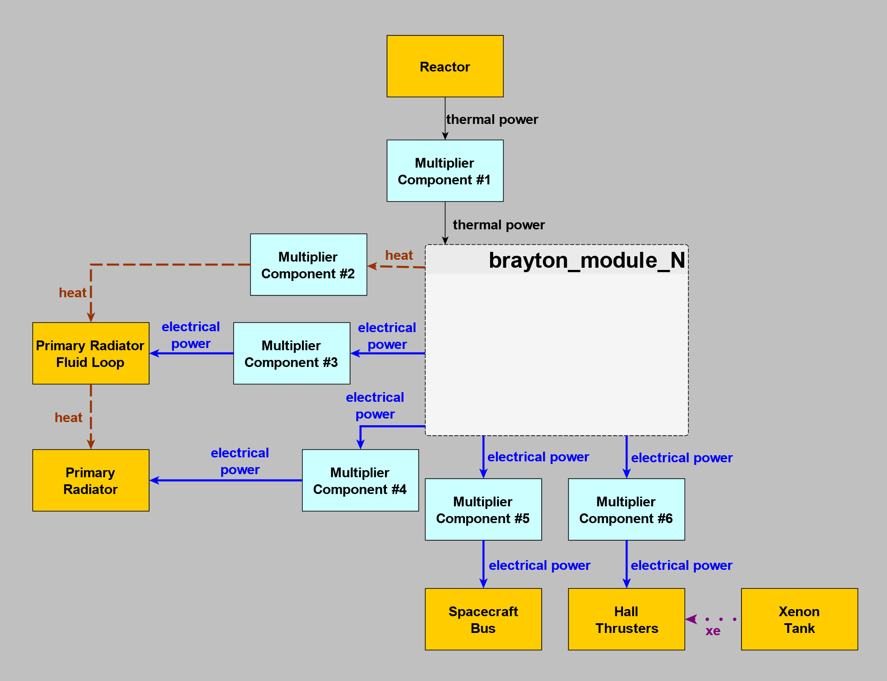
Figure 5. Top level view of resource diagram input to DYREQT for the NEP Module Element.
Each block in the diagram represents a SubElement in the Element with an associated model, labeled with the name the SubElement was given. Each edge represents a resource being exchanged between SubElements. The edges are labeled with the name of the resource being exchanged. The “Xenon Tank” SubElement, for example, provides a xenon resource called “xe” to the “Hall Thrusters” SubElement. Thus the xenon tank knows how much xenon the hall thrusters are consuming during burns and can size to the proper propellant load. For the other resources, just follow the arrows to see how they are exchanged across the available SubElement models.
Note that the “Multiplier Component” blocks are a special type of SubElement in DYREQT. There are multiple Brayton modules in the Element, but they are all identical. The Element model will be unnecessarily slowed down if each Brayton module is modeled individually. Instead, the Element can just model a single Brayton module, then use the multiplier components to account for the mass and resources of any number of additional, identical Brayton modules.
The Brayton module itself also contains multiple SubElements and resources interacting with each other and external SubElements. Figure 6 below shows a zoomed in look of the DYREQT resource diagram for a Brayton module. Inside each module is a Brayton SubElement, which takes in thermal power from the reactor SubElement. That thermal power is converted to electrical power, with some also lost as heat. The electrical power passes through the PMAD before going to the spacecraft bus and hall thrusters. The PMAD components generate heat, which is dissipated by a radiator in the module. Power can also be shunted off from the Brayton SubElement. Due to the flexibility of DYREQT, if a different PMAD architecture is desired, the components can be rearranged and the electrical power flow can be drawn along a different path.
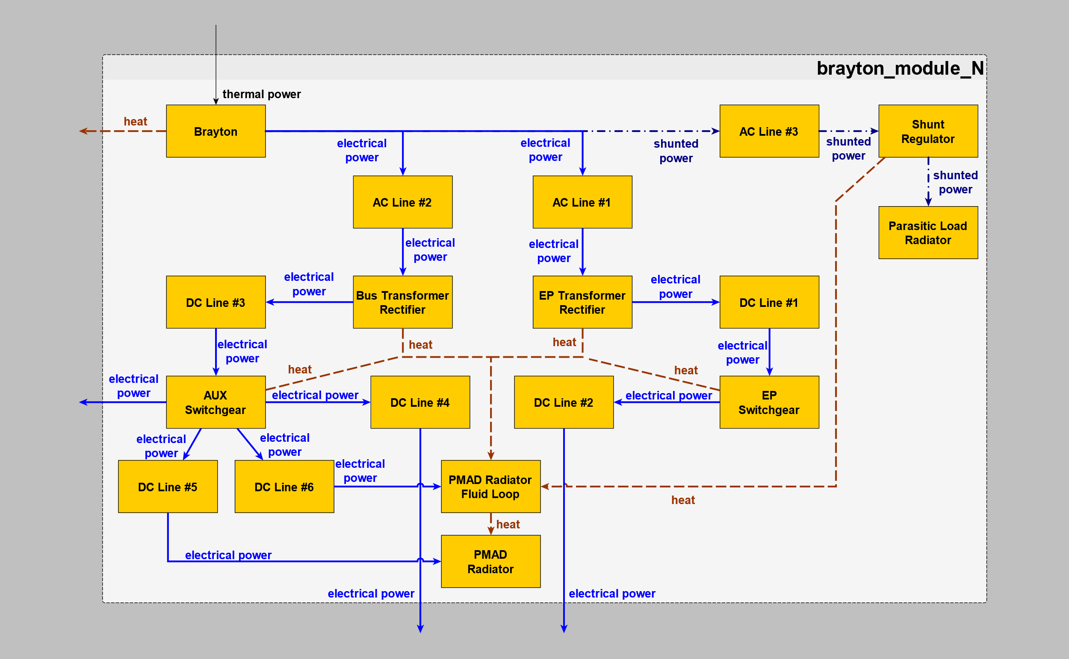Figure 6. Inside view of resource diagram input to DYREQT for each Brayton module in the NEP Module Element.
…to S/C bus
…from reactor
…to radiator
…to radiator
…to thrusters
With the SubElements interacting with each other and exchanging resources, multi-disciplinary trades can be analyzed at the system level. DYREQT will handle and converge any feedback loops in the model while doing the simultaneous sizing. You can, for example, look at the impact that adding additional thrusters might have. More thrusters will increase the thrust, but will also increase the power load for the Brayton and PMAD, increase the required radiator heat dissipation, and increase the thermal power from the reactor. As another example, the efficiency of the power cables can be analyzed. Increasing the efficiency of the AC cables will decrease the power losses, which means the Brayton must produce less power. Although the Braytons, radiator, reactor can get lighter, the cables will get heavier, which means there is a balance point where the AC cable efficiency is optimal for the system. With this integrated model, trades like these can be analyzed at the system level in how they impact the different components of the model. Additionally, these types of trades can be simultaneously optimized to try and get the best vehicle design for a given mission profile.

Mission modeling approach
Elements in DYREQT are simulated and sized simultaneously with a mission profile. Each Element in DYREQT is flown through a series of mission events and can interact with other Elements by docking, undocking, exchanging resources, etc. during the mission. For this work, the NEP Element was flown through a simplified roundtrip, crewed Mars mission. The NEP-Chem technical memorandum by the NASA COMPASS team was used as a reference for the mission sequence.^{[8]} This mission is a hybrid NEP-Chem mission, so the NEP Element was modeled along with a liquid oxygen / methane chem stage Element, habitat Element, and a xenon interstage Element. The chem stage was modeled with SubElements containing regression equations fit to previous chem stage designs as a function of loaded propellant. The xenon interstage was modeled using the xenon tank model described above along with some fixed mass SubElements. Finally, the habitat was modeled primarily as a fixed mass SubElement along with a logistics module, which sizes itself based on the total roundtrip mission time.
While DYREQT can run low thrust trajectories, for the purpose of simplicity, the first iteration of the mission profile for this work was simulated with fixed, input delta-V events. The delta-V for each burn was pulled from the COMPASS report.^{[8]} Since the focus for this work was on the sizing of the crew NEP Element, other parts of the Mars campaign such as the cargo missions, vehicle aggregation, etc. were ignored for now. Future work will involve adding a low thrust trajectory for simultaneous mission and vehicle optimization as well as a more detailed mission sequence including RCS burns.
Figure 7 below, shows the mission event graph that was built in DYREQT. Each box in the graph is an event in the DYREQT mission profile. The events are shown sequentially with time along the arrows connecting each box. This mission profile consists of a mix of several electric propulsion burns by the NEP module and high thrust burns by the chemical stage. The chemical stage is dropped after the trans Earth injection burn and the habitat is carried the rest of the way back to Earth by the NEP module and xenon interstage. Also note that there are several trash / consumables dumps throughout the mission.
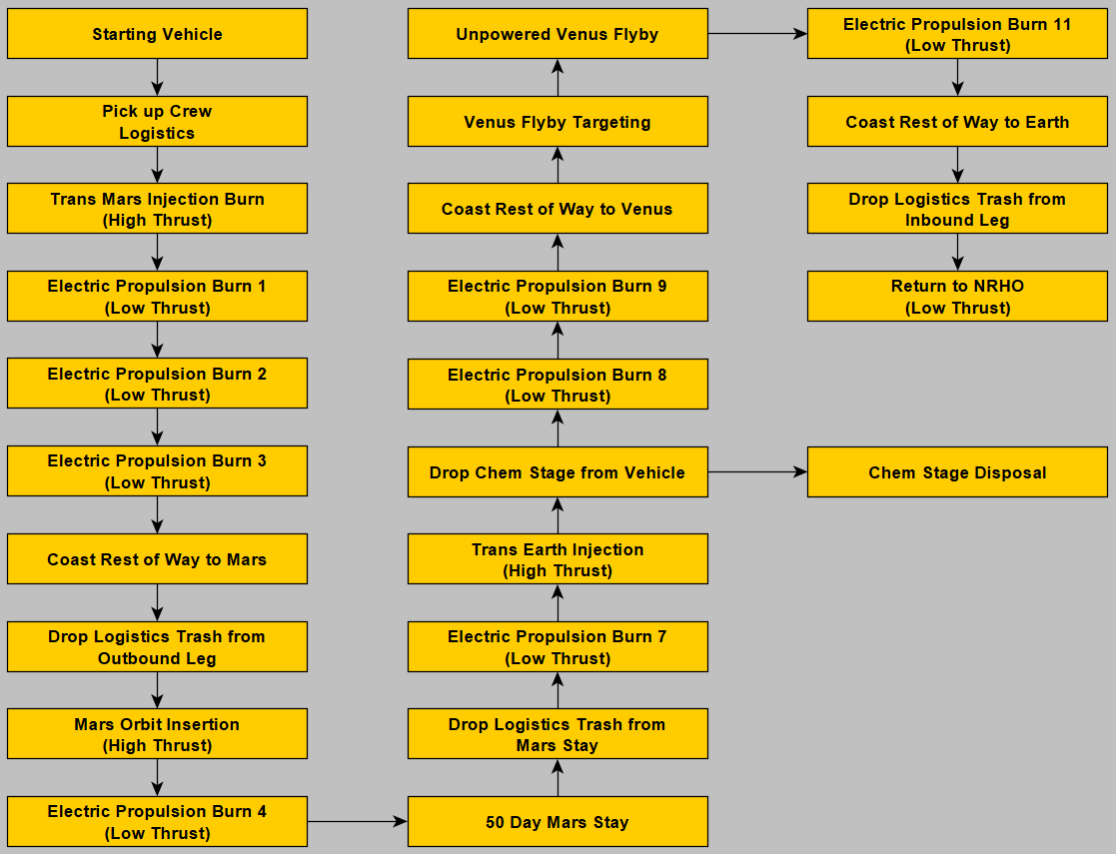
Figure 7. Sequence of mission events modeled in DYREQT.
Overall this is a 760 day roundtrip mission, which includes a Mars stay time of 50 days. The primary burn events can be seen in Table 1, which were mostly pulled from the COMPASS report.^{[8]} So the NEP Module, with the above described SubElement component models, is sized to perform this mission along with the other less detailed Elements. The sizing of the NEP Module for the provided mission is carried out simultaneously by DYREQT with the integrated component sizing.
Table 1. Information about the primary mission events flown by the NEP Module.
Event | Burning Element | DV [m/s]
Trans Mars Injection | Chem Stage | 1306
EP Burn 1 | NEP Module | 1187
EP Burn 2 | NEP Module | 2853
EP Burn 3 | NEP Module | 2098
Mars Orbit Insertion | Chem Stage | 823
EP Burn 4 | NEP Module | 11
Mars Stay | Chem Stage | -
EP Burn 7 | NEP Module | 8
Trans Earth Injection | Chem Stage | 57
EP Burn 8 | NEP Module | 800
EP Burn 9 | NEP Module | 2589
EP Burn 11 | NEP Module | 3337
Return to NRHO | NEP Module | 45

Results and discussion
Using the NEP-Chem vehicle and the mission model described in this report, a representative demonstration can be setup and run. For these results, the NEP Module was run with four Brayton modules, a planar primary radiator, and eighteen 100 kWe hall thrusters (plus two redundant). For these results, the focus is on the NEP Module since the NEP Module was the focus of the integrated component models developed in this work. The other Elements (the Chem Stage, Habitat, and Xenon Interstage) were modeled very basically and were only included to make sure that the propellant load sizing of the NEP Module was about correct. Table 2 shows some of the overall masses of the sized NEP Element. The goal for this first demonstration was to show the integrated sizing capability, not necessarily to do a fine tuned comparison to any other data point with matching assumptions.

Table 2. NEP Element Masses from Example Run
Basic Dry Mass [mT] | Xenon Propellant Mass [mT] | Gross Mass [mT]
41 | 33 | 95

Since this modeling takes a component based approach, these masses can be expanded and broken down further into the SubElement models that make up the NEP Module Element. Some of the major components making up the power system can be split up and looked at in more detail, for example, in Table 3. The PMAD was modeled with several individual SubElements as well, so the mass and properties can be viewed further broken down into components, if desired

Table 3. Breakdown of some major component masses from the NEP Module.
Component | Quantity | Unit Mass [kg] | Basic Mass [kg]
Reactor | 1 | 18410 | 18410
Brayton Power Converter | 4 | 550 | 2200
PMAD | 4 | 1994 | 7976
External Shield | 1 | 3000 | 3000
Primary Radiator and Fluid Loop | 1 | 4393 | 4393

One important thing to note is that the NEP Module in this DYREQT simulation run showed a significant excess in mass of the reactor. As mentioned earlier, this development is taking an agile approach, where SubElements are worked into the integrated model as they become available. The reactor SubElement has been incorporated into the Element model, but some refinements need to be made to the scaling equations for the core and fuel masses to bring the reactor model more in-line with existing power-mass estimates.
Additional refinements of the reactor model include an updated shielding component model, and further division of the reactor subcomponents into DYREQT model library components that can be individually adjusted with a greater degree of freedom than the current model allows. This also includes incorporating additional NEP reactor components to allow for the modeling of other NEP reactor configurations, including NEP reactors using heat pipe power conversion systems as opposed to liquid metal systems. Lastly, the integration of the fluid, electrical and thermal energy resource networks in the integrated vehicle, with the reactor model, will allow for a more accurate optimization of the reactor model design and a better assessment of reactor performance impacts on the overall vehicle.
To demonstrate some of the integrated sizing capabilities of the model, inputs to the model can be varied to see how they propagate through the system and impact the overall sizing. As an example, the efficiency of the AC transmission lines was varied to see how it impacted the NEP Module’s sizing. The baseline case that produced the data shown in Table 2 and Table 3 was run with an AC transmission line efficiency of 99%. If that efficiency was lowered the cables would have to be lighter, but the Brayton would have to produce more power due to the higher losses. If the efficiency was increased the cables would have to be heavier, but the Brayton would have to produce less power due to the lower losses. The impact of varying the efficiency on the Element and integrated SubElement sizing can be seen in Figure 8.
To better see the changes in mass across the SubElements, this figure plots the change in mass for each Element / SubElement, relative to its value at a baseline efficiency of 99%. So for the PMAD, for example, when the efficiency of the AC transmission lines is raised from 99% to 99.5%, the mass of the PMAD goes up by about 2800 kg. When the efficiency is lowered from 99% to 98%, the mass of the PMAD goes down by about 800 kg. The PMAD includes the mass of the cables, so this is primarily driven by the changing mass of the AC transmission lines. As the efficiency of the lines is lowered, the Brayton mass goes up a slight amount. Though lower efficiency means the braytons must produce more power, the increased power production is not a lot relative to the total and does not impact the brayton scaling much in the given model. It can also be seen that through the integrated model, the change in the cable efficiency also propagates an impact to the primary radiator. Since the braytons need to produce more power, they let off more heat and the radiator must grow to dissipate that additional heat.
From the perspective of the overall Element, the decreasing mass of the PMAD is eventually overtaken by the increasing mass of the other SubElements as the efficiency is lowered. This results in an optimal efficiency somewhere between 97% and 98% for this example.

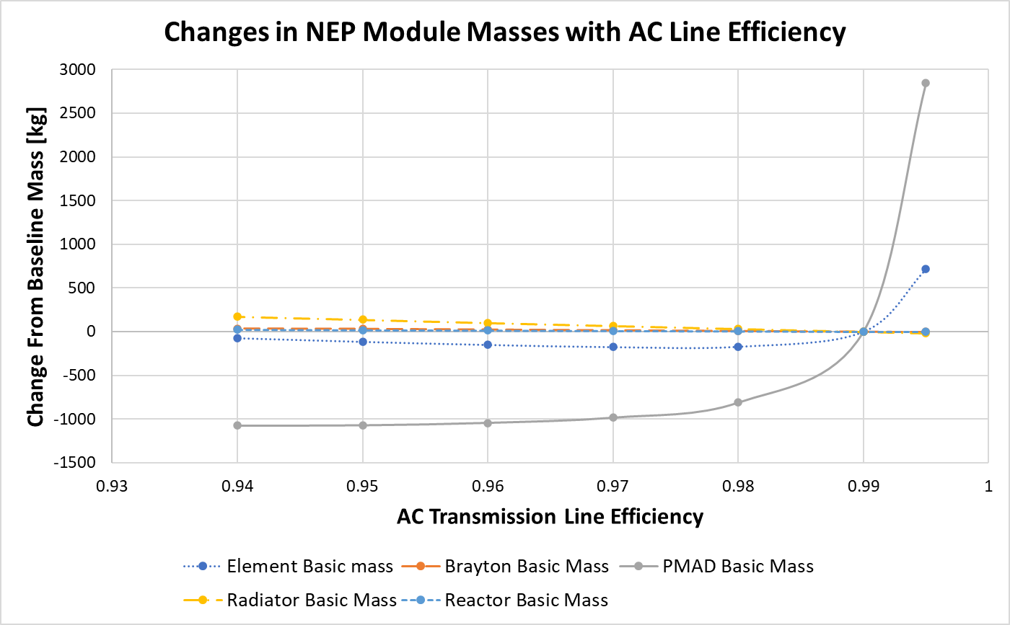
Figure 8. Change in mass for major NEP Elements as AC transmission line efficiency changes.

Though this example just shows one trade, the component based, integrated DYREQT model can be used run a variety of simultaneous trades as well as optimization. Future work will look to expand and improve the SubElement models, then run a variety of trades between SubElements and the mission by varying inputs, swapping out models, and seeing how it all propagates through the integrated model.

Summary and conclusions
This report showcases recent efforts at NASA MSFC’s Advanced Concepts Office to update the modeling and simulation toolkits used for evaluating and optimizing NEP-based designs for human Mars space transports. Currently, ACO is using an MDAO-based approach in modeling and optimizing both the vehicle and mission architectures, via the DYREQT modeling toolkit. Recent modeling efforts have focused on the NEP stage of the NEP-Chem vehicle, with special attention to the reactor, power conversion, heat rejection and EP thruster / propellant storage models. The integrated vehicle model has completed an initial iteration and has been successfully incorporated with the mission profile model. Additional refinements to the NEP stage models will be performed in the near future, including improved model fidelity, additional functionalities that allow for more technology/component trades and improved resource network management that helps optimize vehicle sizing based upon thermal energy, electrical power and fluid/propellant management systems that are being modeled.

references
- Prometheus project Final Report (Report). NASA/JPL. 2005
- Jupiter Icy Moons Orbiter Mission Design Overview. Jon A. Sims, JPL. 16th AAS/AIAA Space Flight Mechanics Conference, January 2006, Tampa, FL
- Oleson, S. R., Burke, L. M., Mason, L. S. et al., “Compass Final Report: Nuclear Electric Propulsion (NEP) Chemical Vehicle 1.2,” NASA/TM 2021-0017131
- Edwards, S. J., Diaz, M. J., Mavris, D. N., and Trent, D., “A Model-Based Framework for Synthesis of Space Transportation Architectures,” AIAA SPACE and Astronautics Forum and Exposition, AIAA, Orlando, FL, 2018.
doi: 10.2514/6.2018-5133
- Gray, J. S., Hwang, J. T., Martins, J. R. R. A, et al, “OpenMDAO: An open-source framework for multidisciplinary design, analysis, and optimization,” Structural and Multidisciplinary Optimization, Vol. 59, 2019, pp. 1075-1104
doi: 10.1007/s00158-019-02211-z
- Marshall, Albert C., “RSMASS: A Preliminary Reactor/Shield Mass Mod el for SDI Applications,” Sandia National Laboratory Report: SAND80-1020, August 1986.
- Metcalf, Kenneth J, “Power Management and Distribution (PMAD) Model Development,” NASA /CR-2011-217268
- Gulczinski, Frank S. III, "Examination of the Structure and Evolution of Ion Energy Properties of a 5 kW Class Laboratory Hall Effect Thruster at Various Operational Conditions", Ph.D. Dissertation, The University of Michigan, 1999.
- Gilland, James H., "Mission and System Optimization of Nuclear Electric Propulsion Vehicles for Lunar and Mars Missions", IEPC-91-038, December 1991.
- Caleb Bell and Contributors (2016-2021). Thermo: Chemical properties component of Chemical Engineering Design Library (ChEDL). https://github.com/CalebBell/thermo.
- Bell, I. H., Wronski, J., Quoilin, S., and Lemort, V., “Pure and Pseudo-pure Fluid Thermophysical Property Evaluation and the Open-Source Thermophysical Property Library CoolProp,” Industrial & Engineering Chemistry Research, Vol. 53, 2014, pp. 2498 – 2508
doi: 10.1021/ie4033999

