SpaceOps-2023, ID # 565

Science Off the Earth: An Integrated Approach to Science Operations in the Artemis Era and Beyond

Ian J Howleyª*, Josh Johnsonª

ª Payload and Mission Operations Division, Marshall Space Flight Center, Huntsville Alabama 35806, USA, ian.howley@nasa.gov, josh.johnson@nasa.gov
* Corresponding Author

Abstract

Humanity is standing on the cusp of its next giant leap – an international, sustainable, and commercial return to the moon. Unlike the Apollo missions, the expectation that a permanent human presence will be established is well founded. Initially, crewed missions to the lunar surface are expected to last between 6 and 30 days and occur approximately once per year, however the robust suite of landers and orbiting assets proposed by both commercial and government entities provide an opportunity to conduct science research on the moon and in cis-lunar space, 24x7 for many years.
In the 50 years since the conclusion of Apollo, NASA’s crewed space science missions have been evolving. This can be seen clearly from Skylab and the Space Shuttle’s Spacelab to the International Space Station (ISS). Presently aboard the ISS, international crews spend nearly half their time working on experiments while many payloads collect science non-stop with either very limited, or no crew interaction. Additionally, a fleet of orbiting experiments complement and validate those investigations performed on the ISS.
As the number, variety, and complexity of these investigation increase, it becomes ever more necessary to integrate across the many entities involved to prevent duplication of effort, ensure complementary results, reduce cost, and create a sustainable environment to conduct ground-breaking scientific research in space.
In this paper, we examine how the various elements of the Artemis program including NASA’s Lunar Gateway, Commercial Lunar Payload Services (CLPS) endeavor, the Human Landing Systems (HLS), surface habitats, rovers and many more will be operated to ensure interoperability, maximize science return, and enable success for government, commercial and private partners.

Keywords: Science Operations, Artemis, Payloads, Integration, MSFC

Acronyms/Abbreviations
International Space Station (ISS), low-Earth-orbit (LEO), Payload Mission Operations Division (PMOD), Marshall Space Flight Center (MSFC), Payload Operations Integration Center (POIC), Huntsville Operations Support Center (HOSC), Commercial Crew Program (CCP), Space Launch System (SLS), Human Landing System (HLS), Commercial Lunar Payload Services (CLPS), Artemis Base Camp (ABC), Power and Propulsion Element (PPE), Habitation and Logistics Outpost (HALO), Near-Rectilinear Halo Orbit (NRHO), Extra-Vehicular Activity (EVA), Flight Control Teams (FCT), Artificial Intelligence (AI), Machine Learning (ML), Augmented/Virtual Reality (AR/VR), Commercial LEO Destination (CLD)

- Introduction
Humanity has entered a new era of spaceflight. In the past decade, we have seen the rise of commercial space companies providing the safe and reliable delivery of crew and cargo to low-Earth-orbit (LEO). This has elevated the International Space Station (ISS) from technological marvel into a one-of-a-kind, international research facility. This paradigm-shift in capability brings exciting new possibilities and opportunities to those in the spaceflight community and indeed the entire world. They strengthen the underlying reason all countries undertake the immense challenge of human spaceflight: discovery.
From humanities very first forays into space each mission has discovered something new about not only how to conduct the mission, but something more fundamental, something novel, something strange, something unexpected. In this new era of regular shipments to and from LEO discoveries have exploded in all areas of scientific undertaking: Biology/Biotechnology, Earth & Space Science, Human Research, Physical Science, and Technology Demonstrations. From impacts of microgravity on the human body to understanding the nature of antimatter in the universe the new information uncovered each year on the ISS continues to expand, diversify and inform humanities understanding of ourselves and our universe.
Many of these discoveries are in part made possible by the Payload Mission Operations Division (PMOD) of Marshall Space Flight Center (MSFC). For over 20 years, the Payload Operations Integration Center (POIC) has performed the integration and operations of payloads onboard the ISS [1]. However, in the next 20 years as part of Artemis, many new agencies, partners, commercial providers, and individuals are anticipated to begin participating in conducting research off the planet. It is therefore necessary to leverage the wealth of experience of conducting science aboard the ISS when defining and creating new programs, operations concepts, and contract strategies.
In the sections to follow, we will discuss how ISS Science operations are conducted, what the Artemis Program proposes to achieve and how to organize the science operations community to create a sustained, productive research portfolio in space.

2. ISS Science Operations
Since the earliest days of research in space, operators and scientists have supported missions from the Huntsville Operations Support Center (HOSC) at MSFC. What started as a group to determine the position and location of NASAs earliest satellites, has grown into an international community of science operators supporting a variety of missions for over 50 years. Operators and engineers at the HOSC supported all the Saturn V launches (1967-1973), Skylab (1974-1979) and Space Shuttle launches including over 20 Spacelab missions from 1981-2011. Spacelab missions ranged in durations from a few days to two weeks and typically involved large teams of experts supporting from dedicated facilities inside the HOSC (see Figure 1).
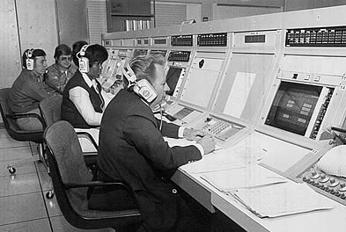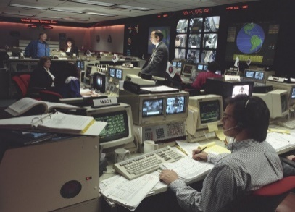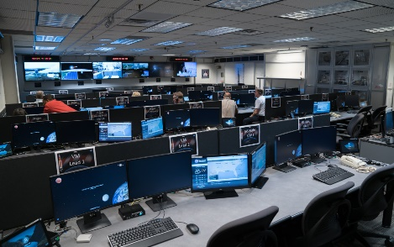
Figure 1: HOSC support of science operations through the years

Beginning in 2001, 24x7 ISS science operations support began and continues to the present day. During the ISS Assembly Phase (1998-2012) crew time availability for science was limited, ranging from 0-25 hours per week with 3 crew. During this period the HOSC advanced a Distributed Architecture support model, that allowed remote parties access to the voice loops, commanding, and telemetry services. This allowed for payload developers, principal investigators, and students to support science operations from anywhere in the world [1] (See Figure 2).

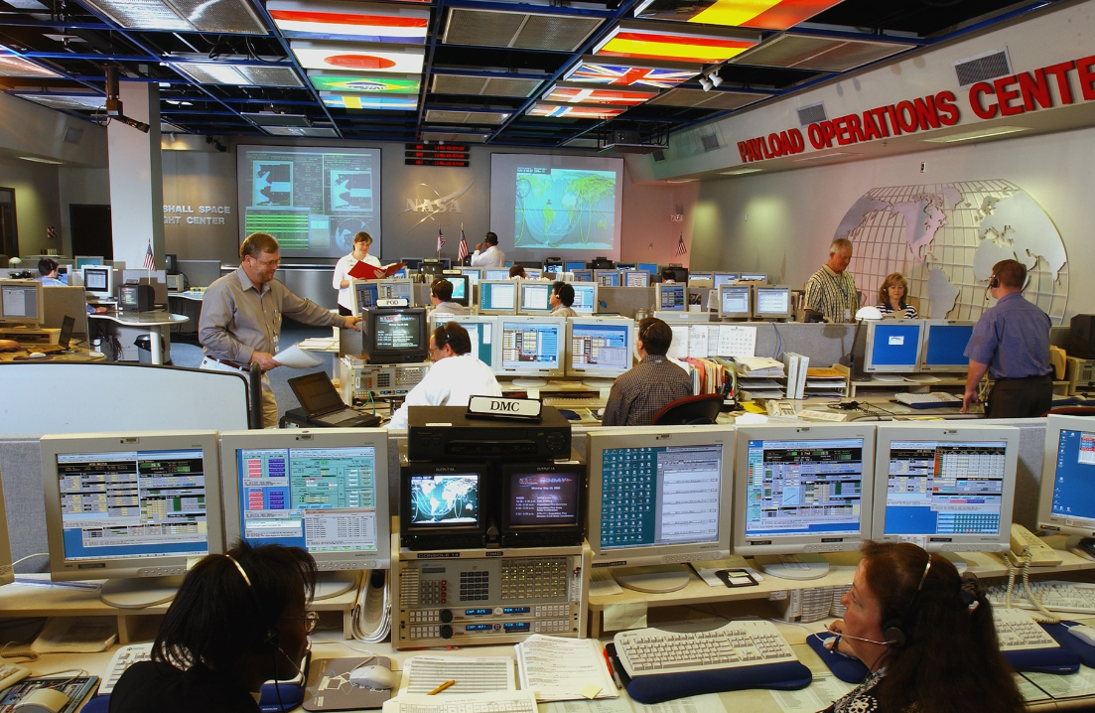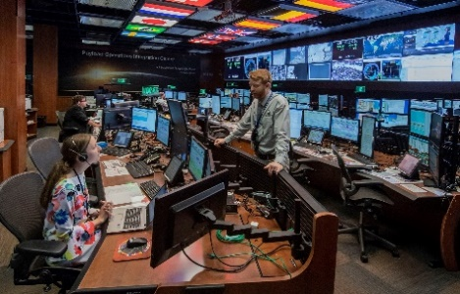
Figure 2: POIC support of ISS through the years

Since 2012 the ISS has been in the era of Commercialization, beginning with the Commercial Resupply contracts. SpaceX’s Dragon and Northrop Grumman’s (originally Orbital Science’s and Orbital ATK’s) Cygnus vehicles became the first commercially built vehicles to be launched into LEO and to date have supplied the ISS with over 40 missions containing thousands of pounds of experimental equipment and samples. The Dragon vehicle additionally has the capability to return samples in both powered and passive cargo. Utilizing ultra-cold, compact freezers each mission can return dozens of frozen biological samples. Samples collected from on board crew are regularly returned under ambient conditions and are in the ground lab for processing withing 48 hours of being collected.
The Commercial Crew Program (CCP) increased the ISS crew complement to 4 NASA/CSA/ESA/JAXA crew in 2017. During this era the average crew time per week has increased drastically averaging between 55-80 hours per week, with several record-breaking weeks over 110 hours. Today crew flown from the US, regularly spend 6 months aboard the ISS with approximately 1 week of handover after a new crew arrive
This dramatic increase in ISS science utilization drove significant changes to how PMOD operated. The distributed architecture continued to evolve to where it supports over 4000 remote users from 14 different countries. Increasingly, automation became a key capability that allows for the large number of entities to support, while reducing the amount of 24x7 positions required to operate the various experiments. [2]
Throughout the history of the HOSC we have utilized a Plan-Train-Fly philosophy. This threefold approach allows for novice participants to quickly integrate into the program and have their desired data or samples available in real-time or near-real-time reducing burden on the user and maximizing results. The ever-increasing complexity of future Artemis missions, considering the scale of international and commercial partnerships, is the natural extension of the detailed integration performed successfully at the HOSC for over 50 years.

3. Artemis Overview
Artemis is a campaign of programs, hardware, and capabilities that will enable a sustained lunar orbit staging capability and surface exploration. It consists of the Space Launch System (SLS) the most powerful rocket ever built, the Orion crew capsule, capable of launching and returning 4 crew on deep space missions; Gateway, a lunar orbiting outpost supporting long-term science and allowing for crew transfer between Orion and the lunar lander; the Human Landing System (HLS) a suite of vehicles capable of taking crews from Gateway to the lunar surface; Commercial Lunar Payload Services (CLPS) delivery of payloads and logistics to the lunar surface to support science and exploration; and Artemis Base Camp (ABC) a permanent human presence on the Moon including living quarters, and rovers [3] (see Figure 3).
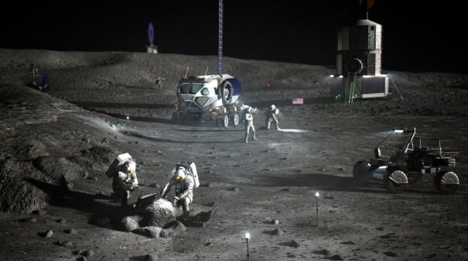
Figure 3: Artist’s concept of Artemis Base Camp
In November 2022 NASA launched Artemis I, an uncrewed demonstration flight of the SLS and Orion. During this mission Orion set the altitude record for a human-rated spacecraft at 249,666 miles from the Earth. Also during this mission, the SLS upper stage released various cubesat payloads with investigations into communications, lunar probes, and imaging among others. Gateway’s first launch of the Power and Propulsion Element (PPE) and Habitation and Logistics Outpost (HALO) will include NASA and ESA radiation instruments that will operate on its year long journey to the Near-Rectilinear Halo Orbit (NRHO). Artemis II will be the first mission in over 50 years to return humans to lunar orbit and provide an opportunity to use modern equipment and operations on human subjects outside of LEO. The Artemis III mission will be the first mission to return humans to the lunar surface and will utilize SpaceX’s Starship. NASA [4] has identified clear science goals for this mission including:
- Understanding planetary processes
- Understanding the character and origin of lunar polar volatiles
- Interpreting the impact history of the Earth-Moon system
- Revealing the record of the ancient sun and our astronomical environment
- Observing the universe and the local space environment from a unique location
- Conducting experimental science in the lunar environment
- Investigating and mitigating exploration risks, human/robotic interactions
Subsequent launches and missions will support the crewed durations on Gateway, lunar logistic missions and the establishment of Artemis Base Camp.

4. Artemis Integration Science Operations
Each element of Artemis will necessarily involve science depending on the specific capability and mission requirements. In many ways Gateway can be thought of as a pared down version of ISS with similar payload accommodations however, it will not be crewed throughout the year. Instead, crews will visit for up to 3 months. Therefore, science operations will need to be robust enough to operate without intervention for long periods of time. Designing automatic fault detection and corrective action into the architecture of the vehicle is paramount to payload success. The HLS strategic acquisition strategy of utilizing service contracts to execute the mission offers a wide range of scientific and utilization capabilities. Depending on the selected provider and mission requirements, science operations may include lunar sample collections or could accommodate payloads internally or externally mounted utilizing power, thermal, and data resources from the vehicle. The Artemis Base Camp architecture may include accommodations for payloads in the pressurized rovers, lunar terrain vehicles, and surface habitats CLPS prior to Artemis III will deliver standalone research equipment including rovers and stationary science platforms and pre-positioned equipment for utilization on upcoming missions. Orbiting and lunar surface support infrastructure can also provide an opportunity for science with technology demonstrations and secondary observations or data sharing.
The sheer number and variety of potential interfaces make for a difficult integration challenge for science operations. However, to successfully execute this vast portfolio of experiments a single integrating and operating authority will be necessary. Leveraging decades of experience, PMOD proposes to lead this effort.
For each program, we will be involved in requirements development and payload integration processes to influence science capabilities with respect to Artemis objectives. This is important not only as lessons learned from previous programs but to also understand the nature of executing science operations with reduced flexibility and numerous constraints (vehicle resources, crew time, etc.).
Furthermore, cross-program integration poses unique challenges to the Artemis team. Take for example a volatile surface sample return. It must first be collected with tools developed by the extra-vehicular activity (EVA) team, based on objectives laid out by a principal investigator, stored in a freezer developed and built by a commercial entity, installed and powered in a commercial return vehicle, temporarily installed with resource connections on Gateway, before finally transferring to Orion for descent and turned over to the scientists. Not only are the integration challenges clear, but the real-time operational challenges from such a complex sequence of events are daunting. For these reasons, it is critical to establish standards for not only inter-operability (mechanical interfaces, connector types, software, data types etc) but also for the Flight Control Teams (FCT) themselves.
FCT for human spaceflight have adapted over the past 30 years to a 24x7 support model to maximize the efficiency of the ISS. This is largely driven by our ability to rotate crews every few months and continually crew ISS for over 20 years. The Artemis architecture requires we fundamentally rethink this support structure. Crews will visit Gateway for 90 days in the year, and the lunar surface for only 30. These crewed time frames will seem familiar the operational concepts of ISS, but quiescent operations (times with no crew present) will be quite different. The crews will have left behind experiments to operate and monitor, but troubleshooting will be only available remotely or robotically.
For Science Operations during the Artemis Era one central Science Ops Center should be used as the integration and operational authority, led by the Science Operations Director. Supporting this director will be a small team dedicated to the monitoring of payload support systems of the core asset, initially Gateway but eventually to include Artemis Base Camp. We refer to this team as the Core FCT. This team will interface with Mission and Science Control centers all over the world. They support 8x7, 8x5 or even less frequently while assets are uncrewed, periodically monitoring systems and experiments as necessary. With the arrival of new assets or crew, the hours and number of team members supporting would necessarily increase. These elements will include the HLS, Lunar Terrain Vehicles, pressurized and unpressurized rovers, payloads delivered by CLPS providers. We refer to the combination of these teams with the Core FCT as the Core+ FCT (see Figure 4). These specialized positions will support, from anywhere in the world using the HOSC remote capabilities. This allows expertise to be distributed but information to be delivered rapidly and key decisions made centrally with inputs from all teams.
The Core+ FCT will train and operated based on standardized flight controller certifications. Held to the highest level of excellence as previous missions like Apollo and the ISS. However, in this new era of spaceflight the role of Artificial Intelligence (AI) and smart systems will place some responsibility for these actions on computer systems, allowing the FCT to address more difficult concerns. Additionally, this allows for less human presence in traditional control rooms.
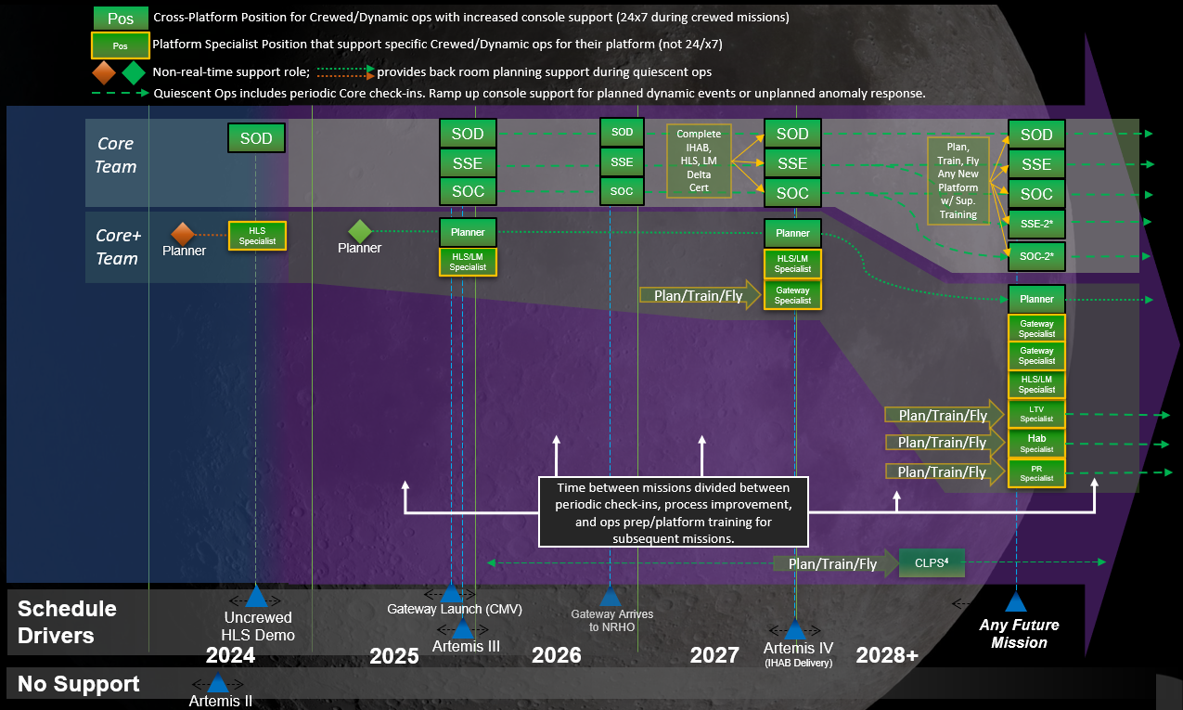
Figure 4: Core+ Model of Science Ops Flight Control Team

Reduced human presence in control rooms applies also to pre-mission time frames and mission planning. To support long-term sustained research operations in space significant improvements to planning are necessary. This will help reduce operational cost and allow resources (people and funding) to be redirected to more complex problems. Onboard the ISS the total bandwidth available for science users has increased several times, often long after the need is identified. Developing new assets for Artemis missions with sufficient resources is necessary, but strictly choreographed usage of the asset will greatly aide the wider community of users. Autonomous systems that can understand requirements and develop the most efficient and effective plan are already in used for ISS payload operations and continue to demonstrate and refine the technology and operational concepts for Artemis missions.
Artificial Intelligence (AI) can also be used to great effect in reducing the number of displays, (and hence monitors) for FCTs, which in turn reduces the footprint and cost of control rooms. Smart monitoring systems utilizing Machine Learning (ML) can not only identify and report issues, but also take action to resolve them and use each instance to learn and diagnose issue better in the future. This type of monitoring is crucial to the Core+ concept. Standardization of displays across programs and projects will streamline operations and increase mission success.
During missions to the lunar surface and particularly once ABC is established it will be necessary to perform in-situ science (science performed by the crew semi or completely independently from the ground FCT). Long durations crews will require a wide breadth of knowledge of hardware, tools and experimental techniques that are impractical to fully train pre-flight. Hence, robust on-board training, and procedures will be necessary. To solve this problem, we propose the use of AI and Augmented/Virtual Reality (AR/VR) embedded into crew procedures and systems to seamlessly assist crews. In the current paradigm scientist communicate directly with onboard crew during complex science operations. This communication path can still be utilized on the moon for some experiments given the ~2s delay, but for certain types of operations the crew will be required to know and make science decisions on their own. Having a database of videos and information on board and available to the crew will increase crew autonomy and maximize the scientific output of the Artemis missions.

5. Beyond Artemis
Being developed in parallel to the Artemis missions is the transition of LEO from a government sponsored environment, into one sustained by commercial endeavors. The Commercial LEO Destination (CLD) Program has begun to aide in this transition. It will include the orderly transition of the ISS to a commercial providers as well as standalone orbiting platforms for tourism and research. These platforms will be the first fully modern human-rated space assets and will include technologies like Smart Assistants (i.e. Alexa, Siri etc.) which will require new operational technique and paradigms to be developed. In order to ensure a successful transition PMOD supports another threefold model: Plan & Develop, Prepare & Connect, Execute & Deliver. A robust commercial LEO environment will require many different companies of different sizes, interests, and capabilities. It is the vision of PMOD to be able to deliver à la carte services to any and all providers.
Using the decades of experience in ISS science operations, PMOD will lead the effort to establish international standards for commercial FCT. In this way the Science Operations Mission Directorate will ensure the success of a robust LEO economy by making it safe, reliable, and accessible.

6. Conclusions
The Artemis era of space exploration is upon us. It will create opportunities for governments, commercial entities and individuals to rewrite history books. The era will be defined by the resolve all partners show in carrying out the missions for the benefit of all. In order to make it a success therefore, it is necessary to strategically define the science operations strategy to ensure interoperability of science activities across the multiple platforms by establishing operational standards and thereby ensuring a consistent implementation by multiple agencies and commercial providers. MSFC is the lead center for science operations and is best postured to lead the transition to a sustained, robust, multifaceted, scientific research endeavor in space. PMOD will serve as the bridge between the science community and the mission ops community, translating between science objectives and mission priorities. Being an ally for science, all while assuring crew safety, vehicle safety, and mission success.

Acknowledgements
The authors of this paper would like to thank the entire ISS Payload Operations and Integration community, the Payload Mission and Operation Division, and the ISS Program for their tireless efforts to make science off the Earth a reality. The collective effort of thousands of dedicated team members across more than two decades have produced a collection of data and information whose full impact may not be realized for many years to come. Ad Astra.

References
[1] C. Cruzen, R. Gibbs, S. Dyer, J. Cech, “Expanding Remote Science Operation Capabilities Onboard the International Space Station, IEEE Aerospace Conference, March 2005.
[2] H. Stetson, D. Deitsch, C. Cruzen, A. Haddock, “Autonomous Payload Operations Onboard the International Space Station,” IEEE Aerospace Conference, March 2007.

[3] J. Bridenstine, “Artemis Plan, NASA’s Lunar Exploration Program Overview”, September 2020

[4] R. Weber, B Cohen, S. Lawrence, “Artemis III Science Definition Team Report”, December 2020.

