Testing of TVS Augmented Injectors for Tank-to-Tank Transfers of Cryogens
Nicole M. Vaughn, Travis Belcher, Cameron Hines, Omar Mireles, Kevin Pedersen, James Smith, Jonathan Stephens and
NASA Marshall Space Flight Center, Huntsville, Alabama, 35812, USA
Noah Rhys
Yetispace, Huntsville, Alabama, 35802, USA
NASA is developing reusable cryogenic systems to enable manned missions to the Moon and Mars. These cryogenic systems will require replenishing cryogens on-orbit via a tanker or propellant depot with minimal loss to boil-off. Three additively manufactured injectors augmented with a Thermodynamic Venting System have been developed for use in tank-to-tank cryogenic fluid transfer. A Vented Chill/No-Vent Fill approach to tank-to-tank transfer has been the industry standard and is explored in this work with emphasis on injector spray patterns and compared to the Charge-Hold-Vent chill method.
- Nomenclature
AM = Additive Manufacture
CHV = Charge-Hold-Vent
CTB2 = Cryogenic Test Bed 2
GN₂ = Gaseous Nitrogen
JT = Joule-Thompson
LN₂ = Liquid Nitrogen
L-PBF = Laser Powder Bed Fusion
NVF = No Vent Fill
TVS = Thermodynamic Venting System
VC = Vented Chill
- Introduction
NASA is developing reusable cryogenic systems to enable manned missions to the Moon and eventually Mars. Such systems will require replenishing cryogens on-orbit via a cryogenic tanker or propellant depot, and potentially on the Lunar and Martian surfaces with the utilization of in-situ resources. Cryogenic tank-to-tank transfers on-orbit present challenges due to thermal environments and the absence of gravity. If the transfer process is initiated with the receiving tank empty and at ambient temperature, it must be chilled to cryogenic temperature to enable filling. Likewise, the transfer lines and associated hardware must be prechilled to assure liquid is transferred. Since prechilling results in propellant loss, it is preferred to minimize this process in interest of saving propellant mass. To simplify the operations associated with propellant transfer and explore potential mass savings, NASA has been experimenting with the Vented Chill/No-Vent Fill (VC/NVF) approach and enhances the process using a laser powder bed fusion (L-PBF) additively manufactured (AM) spray injector augmented with a Thermodynamic Venting System (TVS)[1].
The operations associated with the VC/NFV approach are straightforward [2]. With an empty receiving tank at ambient temperature and vented to the atmosphere, the process is started by flowing cryogen through the transfer line and into the receiving tank via a spray injector. During this initial phase, cryogens boil-off, absorbing energy from the transfer hardware, receiving tank walls, and the ullage space. Boil-off gas is vented from the receiving tank to avoid excessive pressure. This Vented Chill (VC) process continues until the tank temperature decreases to a predetermined “trigger point” value which is as an indication to command the receiving tank vent valve closed. If sufficient energy is removed from the receiving tank during the VC process, then the spray pattern of the injector can interact with the ullage space and tank walls to absorb thermal energy resulting in ullage collapse. This collapse decreases the pressure in the receiving tank without venting, and a successful transfer can ensue, filling the receiving tank to near 100% liquid level. If insufficient energy is removed from the receiving tank as a result of setting the “trigger point” temperature too high, then the flow will stall, resulting in a failed transfer. In the event of a stall, then the TVS on the spray injector can be activated to provide additional subcooling to condense the ullage and the stalled flow can recover and allow the transfer to continue successfully.
- Test Articles and Procedure
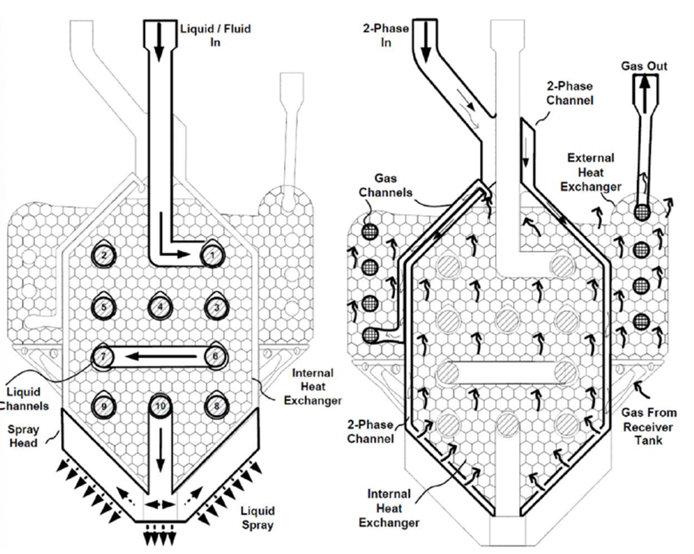
Three AM AlSi10Mg TVS augmented injectors have been design and tested at NASA Marshall Space Flight Center’s Exploration Systems Test Facility. Two of the injectors were designed to accept subcooled cryogen which passes through an internal coiled heat exchanger before spraying into the receiving tank. The third injector was designed with a parallel flow heat exchanger on the interior, simplifying the heat transfer predictions. For all three injectors, on a separate circuit upstream, an isenthalpic expansion of liquid cryogen occurs across a Joule-Thomson device resulting in a cold two-phase mixture which is introduced via a separate path into the injector. This cold mixture then enters a cavity where it acts as the cold side of a heat exchanger with the primary spray flow, further subcooling the liquid nitrogen (LN₂) inside. On the two versions of the coiled heat exchanger injector, the cold two-phase mixture then passes through a series of coils surrounded by lattice on the external surface of the injector which chills the ullage gas and causes some to condense, causing a reduction in receiving tank pressure.
Fig. 1 Diagram of the flow through the V5 TVS Augmented Injector. The 2-phase fluid exchanges heat with both the liquid channel and the lattice structures on the injector to further subcool the flow and condense ullage[1].

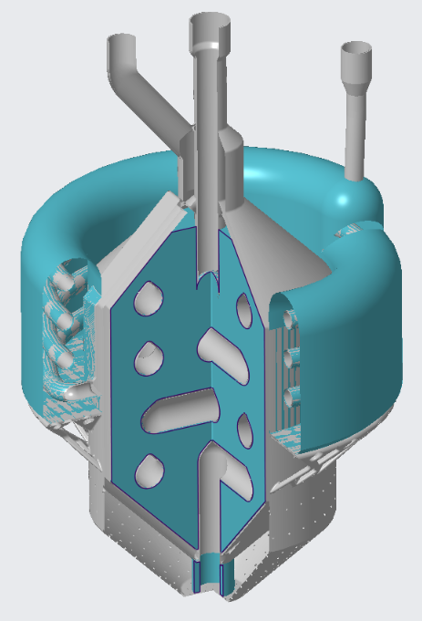
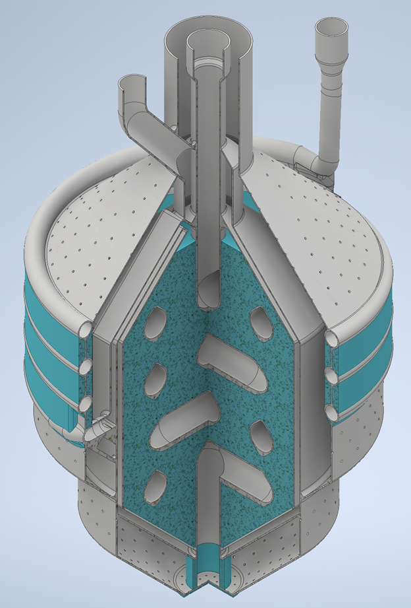
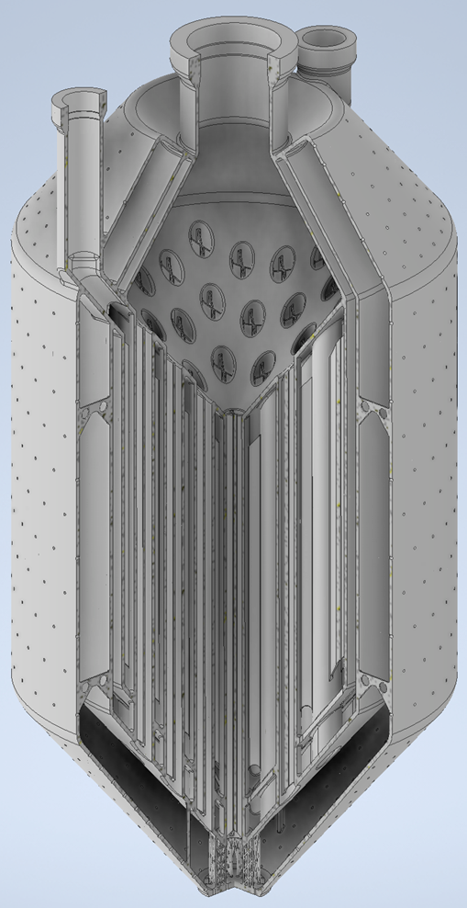
These injectors were tested in a 304L stainless steel tank with 9.52 mm (0.375 in) thick walls called Cryogenic Test Bed 2 (CTB2). CTB2 is an ASME rated, 3000lb tank with significant mass on the forward, making it significantly more energy intensive to chill and No-Vent-Fill than a flight-like tank would be. The tank itself is insulated with spray on foam insulation and then covered with a commercially available insulation. The tank was instrumented with silicon diodes for wall skin temperatures, and a thermocouple rake in the ullage and liquid levels. The injectors were instrumented with an assortment of thermocouples and RTD’s that provided fluid inlet conditions and skin temperatures. Each injector was tested with LN₂ sourced from a 3000L dewar. The LN₂ was directly plumbed to the spray flow path to the injector via a vacuum jacketed line, with a smaller line tapped off just upstream of the tank mounting flange to feed the TVS path. Tests were completed from November 2021 to June 2022. Vented Chill/No Vent Fills were attempted for each injector and compared to the current state of the art chilling method the Charge-Hold-Vent. Of particular note was the impact of spray pattern on the chilling efficacy of each injector. There were few conclusions that could be drawn regarding the functionality of the TVS system to recover from a stalled flow due to facility and injector design issues that were encountered during testing.
Fig. 2 Three TVS Augmented Injectors that were tested as part of this work. From right to left are the V5, the V6, and the Shell and Tube Injectors. Areas in blue indicate lattice regions.
- Results and Discussion
- V5 Injector

Charge-Hold-Vent testing was attempted unsuccessfully with the V5 injector and subsequent test attempts of just the TVS system identified several issues that became lessons learned for future injector designs. The failure of the Charge-Hold-Vent testing was due to an inability of the injector to remove enough heat from the large and relatively thick walled CTB2 tank. This was not an entirely unexpected result, as the V5 was design as part of an earlier test series to be used in a much smaller tank in a vacuum chamber. CTB2 chilled from the bottom up as it filled, but never reached ullaged temperatures cold enough in the upper parts of the tank to enable a No-Vent-Fill attempt. The V5 injector has spray only in the horizontal plane and below, so no LN₂ was being sprayed into the upper half of the tank to chill the walls or interact with the ullage. On all subsequent injectors, spray was directed towards the top of the tank to ensure that the entire thermal mass of the tank was subject to chilling. The V5 injector also had very thin 0.5mm walls to maximize heat transfer through the wall, and no post print heat treatments for additional strength. Checkout testing done before its installation into CTB2 indicated at least one small pinprick leak in the TVS tubes that was likely due to wall porosity or a minor print defect. When installed in CTB2, a crack developed on the TVS inlet during testing, rendering it unusable. On future injectors, the wall thickness was increased to 1mm and flexible bellows sections were added upstream of the injector inlet tubing to provide strain relief as the system thermally cycled.
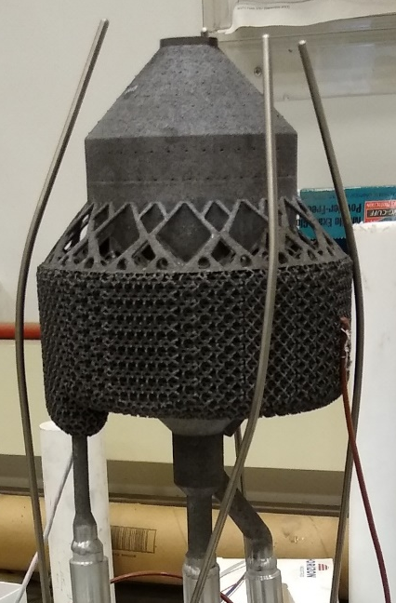
Fig. 3 Photograph of the V5 TVS Augmented Injector
- V6 Injector

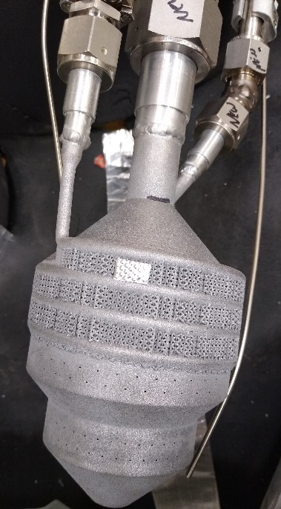
The Version 6 injector had the same internal geometry as the V5, but with less exterior lattice and additional spray holes directed upwards. This resulted in a volumetric flow rate three times greater than the V5, which limited testing time available with this injector as the available supply was limited to 3000L. Additionally, it was determined that chilling the CTB2 Tank from an ambient condition required too much LN₂ to have an adequate supply left for testing, so the day before each test, CTB2 would be “precharged” with approximately 136 kg (300 lb_{m}) of LN₂ which would result in a partially prechilled tank at the start of every test. After this preloading, the supply dewar could then be refilled. The previous testing had revealed that the supply LN₂ warmed with time and this was thought to be the result of using ambient pressurant. A heat exchanger was added to the pressurant line to keep its temperature as close to liquid temps as possible without condensing the ullage. Prior to this addition, the supply was warming at 0.57 K/min. With the heat exchanger, that warming was brought down to 0.008 K/min until the last 15% of the supply. However, the heat exchanger consisted of a coil submerged in LN₂ that the gaseous nitrogen (GN₂₎ pressurant passed through, so a dedicated operator was required to maintain the proper liquid level during operation.
Fig. 4 Photograph of the V6 TVS Augmented Injector

Both Charge-Hold-Vent and Vented Chill methods were tested to chill the tank to the predetermined trigger point temperature where a No Vent Fill had been shown to be possible. A comparison of those methods is shown in Fig. 5. Six total charges were necessary to reach the trigger point temperature over a time period of approximately 45 minutes. The chill was accomplished with the operationally simpler Vented Chill in half that time, despite the tank walls starting approximately 10K warmer on the VC test than the CHV test. However, the LN₂ accumulated in the tank much more rapidly in the VC test and was about 40% full at the trigger point compared to about 26% for the CHV test. Comparing the load cell and flow meter measurements indicated that the Vented Chill had resulted in a loss of 54.8 kg (121 lb_{m}) more of vented gas than the Charge-Hold-Vent.

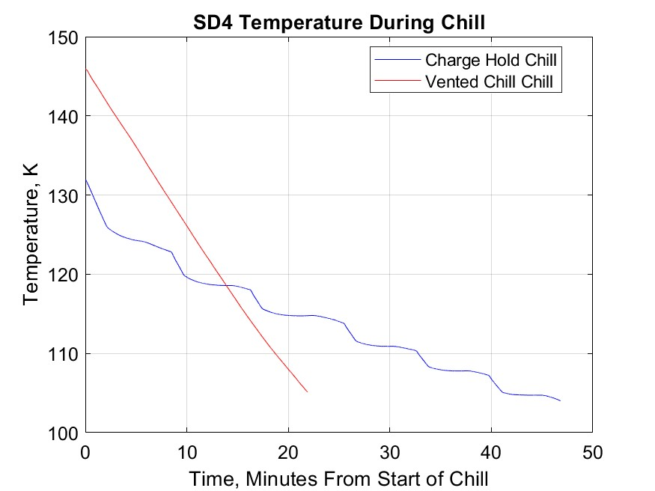
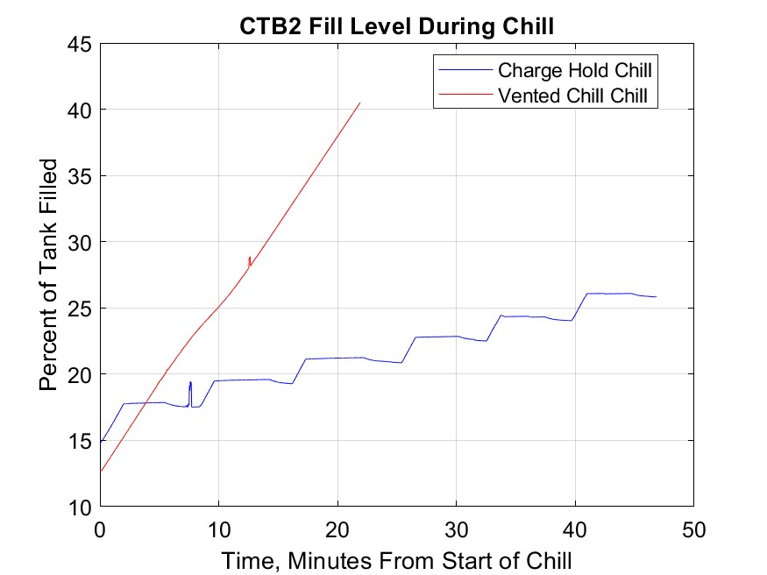
During the No-Vent-Fill portion of the tests for both chill down methods, the tank pressure profile and fill levels behaved similarly, as is expected since the vents were closed at the same trigger point temperature and comparable flowrates. As depicted in Fig. 6, the pressure curves for the locked-up tank both reached a maximum between 32 and 35 psia before the curve rolled over and ullage collapsed dropped the pressure by 2 psia. This rollover and evidence of ullage collapse indicates that the No Vent Fill of CTB2 is possible despite its large thermal mass. Temperature measurements from silicon diodes installed on the tank walls as various heights correlate strongly with the spray pattern of the injector. That the V6 could successfully induce ullage collapse and the V5 could not suggests that evenly chilling the entire tank via spray pattern is a significant contributor to a successful No-Vent-Fill. The large pressure rise at the end of each test corresponds with draining the supply tank down to less than 10% full as the final liters were significantly warmer that the rest of the supply due to stratification in the storage dewar. This behavior occurred at the end of each test with all the injectors and is considered a facility limitation.
Fig. 5 Comparison of tank fill level and tank wall temperature for the VC and CHV testing with the V6 injector in the partially prechilled CTB2 Tank.

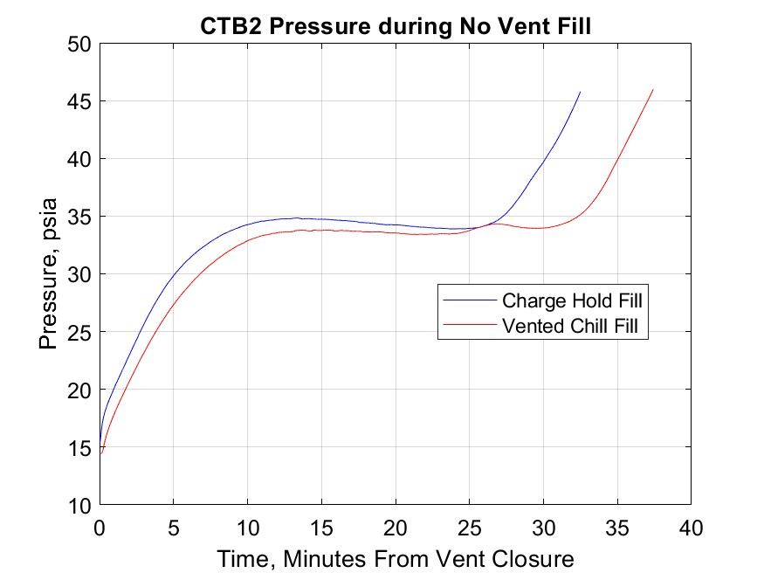
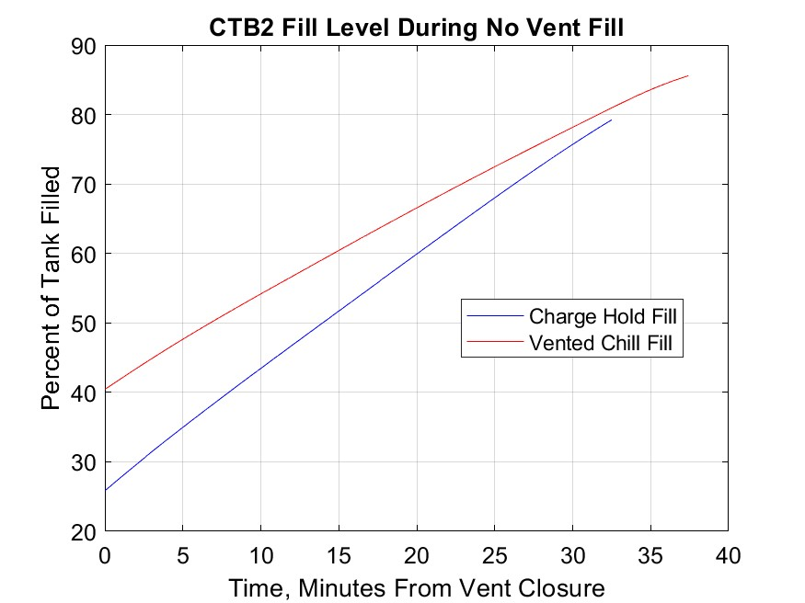
The TVS portion of the V6 was tested over several days both in the context of a stall recovery and as a standalone series of measurements. The results of this effort showed that the TVS heat exchanger on the V6 was largely ineffective and had a significant flow restriction in one of the internal flow passages. This resulted in a TVS flowrate below the design point and increased the difficulty of delivering two-phase flow to the injector out of the JT device.
Fig. 6 Comparison of tank fill level and tank pressure for the VC and CHV testing with the V6 injector after the chill had been completed. Tank vents were closed, and ullage collapse observed in both cases.
- Shell and Tube Injector

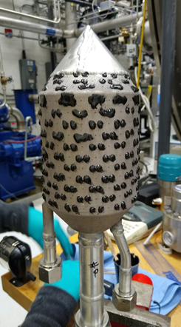
The Shell and Tube injector approached the TVS design differently than the earlier iterations of the injector had. The V5 and V6 had attempted to balance heat transfer from the two-phase flow out of the JT device to the spray and chilling the exterior lattice to encourage ullage condensation. The Shell and Tube injector instead focused on the heat exchange between the TVS and flow going to the spray. The interior parallel flow heat exchanger had wide open passages and significantly less lattice, eliminating the issues of flow restriction seen in the V6. Additionally, the entire injector was available for spray holes since there was no exterior lattice so the CTB2 tank would see spray over a broader range of angles. However, the high flowrates through the V6 had been a problem from a facility standpoint and the Shell and Tube injector required an even greater flowrate. To reduce the flowrate without compromising the overall spray pattern, approximately one third of the holes on the injector were sealed with cryogenically compatible epoxy.
Fig. 7 Photograph of the Shell and Tube TVS Augmented Injector

A series of Vented-Chill-No-Vent-Fill tests were completed with the Shell and Tube injector for increasing trigger point temperatures and the data is presented in Fig. 8. The trigger point 125K data is not entirely in family. The supply LN₂ was warmer during that test and is thought to be a result of operator error. The pressurant heat exchanger did not have a dedicated operator that day, and as a result the pressurant temperature was not monitored closely and stayed at a higher value than is typical. It is evident in the plot of the 125K data that the supply LN₂ temperature exhibited warming from the close of the vent through the remainder of the test. Excluding the 125K data, a clear trend of increasing maximum tank pressure before ullage collapse with increasing trigger point temperature emerges. This result makes intuitive sense, as there is a greater amount of energy that must be removed from warmer tank walls and the only mechanism available to do so is phase change. Once ullage collapse began, the tank pressure dropped, which increased the pressure differential from the supply tank so flowrate increased, which encouraged additional ullage collapse. Less LN₂ was required for the chill-down portion of the test at higher trigger points, which allowed an increased duration for the No-Vent-Fill. At the highest trigger point case, 135K, the pressure collapsed occurred continuously for approximately an hour before the end of the LN₂ supply was reached. Had a greater capacity supply dewar been available, it is believed a complete No-Vent-Fill could have been achieved.

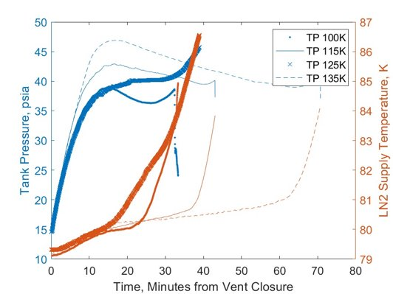
The TVS system on the Shell and Tube injector did not have a measurable impact on spray temperature. The temperature measured out of the JT device was significantly colder than anticipated for a two-phase fluid and suggests that the orifice was producing only gas. Despite the cold temperature, gas flow alone does not have the cooling capacity needed to significantly impact the spray temperature. This proved to be a facility heat load issue that would need to be addressed independently of testing.
Fig. 8 No-Vent-Fill measurements with the Shell and Tube injector for increasing trigger point temperatures. The supply temperature of the LN₂ correlated with the viability of the No-Vent-Fill.
- Conclusions and Future Work
The various iterations of injectors provided an abundance of insight into more effective design and operational choices. One important conclusion was that the upwardly directed spray was critical for this particular tank since the thermal mass on the foreward dome was so large. It is likely that on a thinner, flight-like tank the spray pattern would be less critical, but overall consideration for the mass and shape of the tank must be taken into account when designing any cryogenic spray injector. The lessons learned from testing culminated in one final injector designed as part of the Enhanced Cryogenic Transfer Project. This injector diverged from its predecessors in that it was decided to have the cold side (TVS flow) of the injector focus on condensing the ullage of the tank as opposed to directly transferring heat to the warm side (core flow) of the injector, acting as a large cold finger. Three key improvements were identified and implemented. First, the wall thickness of 0.5mm proved to be insufficient since a crack formed in the first injector tested. Second, the porosity of the printed material is suspected to have caused small leaks seen in each of the injectors, which could be minimized by heat treating (hot isostatic press, solution aging) the injector after it's printed. Lastly, there were several locations identified on the internal TVS flow paths where flow was restricted to the point that it rendered TVS flow ineffective. For the final injector design, a considerable amount of analysis was performed to optimize the amount of TVS flow, rectify the flow restriction issue, and maximize condensation while minimizing excess cooling. The current design has been printed in plastic so that the flow rate and pattern could be verified via waterflow. In parallel, the testing facility has been upgraded to include a 11,356 L (3000 gal) LN₂ supply tank that will enable fill levels in CTB2 up to 95% with supply liquid to spare. The TVS flow path up to the injector, to include the JT device, has been completely redesign and preliminary checkouts indicate that two phase flow will be successfully delivered to the injector. The work described herein was essential in providing the background data and feedback needed to bring the facility and injector design into readiness for stall recovery testing in the near future.

References
[1] Mireles, O. and Martin, J., “Development of an Additive Manufactured Cryogenic TVS Augmented Injector,” AIAA Propulsion and Energy 2020 Forum, AIAA-2020-3508, AIAA, Virtual Event, 2020
[2] Rhys, N., Foster, L., Martin, A. and Stephens, J., “Vented Chill / No-Vent Fill of Cryogenic Propellant Tanks,” JANNAF Joint Subcommittee Meeting, M16-5445, JANNAF, Phoenix, AZ, 2016

Engineer, Advanced Propulsion Research and Technology Branch
Engineer, Advanced Propulsion Research and Technology Branch
Engineer, Systems Modeling and Simulation Branch
Engineer, Spacecraft and Vehicle Propulsion Branch
Engineer, Advanced Propulsion Research and Technology Branch
Engineer, Advanced Propulsion Research and Technology Branch
Team Lead, Advanced Propulsion Research and Technology Branch
Yetispace Inc.

