Development and Validation of the NASA Modified System Usability Scale (NMSUS):
A Brief Summary

Usability (the ability of a user to complete a task with effectiveness, efficiency, and satisfaction) is often assessed during spacecraft verification testing, along with other human performance metrics (e.g., workload, errors). Over a recent one- to two-year period of spacecraft verification tests, human factors subject matter experts noted that on multiple occasions, astronauts had comments regarding the face validity of the System Usability Scale (SUS; Brook, 1996*) that was being used to measure usability. The SUS is a widely used and accepted measure of perceived usability within the human factors community, and is supported by a robust literature. Although the SUS scale is well validated and has been used to measure perceived usability for a wide variety of products and systems, crew comments indicated that the phrasing of some of the scale items did not align with the types of safety-critical tasks being completed as part of spacecraft verification.
A Human Research Program (HRP) project was undertaken to explore ways to address crew comments regarding the SUS, with the broader goal of improving verification testing for all future space programs. The output of this project was a tailored SUS, shorter, and better aligned with NASA tasks and terminology: the NASA Modified SUS (NMSUS; see Figure 1). Changes were minor and consisted of rephrasing three items and removing two items.
Validation of the NMSUS
A study was conducted to assess and validate the NMSUS in terms of internal reliability (how strongly a set of items within a measure relate to one another); convergent validity (the extent to which two measures of the same target construct agree); sensitivity (the ability of a measure to reliably detect differences between interfaces); and equivalence (high similarity between SUS and NMSUS results). In the validation study, 35 crew-like participants completed procedures-driven tasks related to configuring a hypothetical backup electrical power system on a spacecraft. They interacted with two different prototypes to complete the tasks (one “well-designed”, and one “less-well-designed”). In each case, they completed a post-test survey consisting of the SUS, NMSUS, and the Usability Metric for User Experience (UMUX).
Results demonstrated that the NMSUS was as reliable as the SUS. Likewise, results supported the validity of the NMSUS in terms of convergent validity with the UMUX. The NMSUS was also determined to be sensitive, as there was a statistically significant difference in perceived usability as measured by the NMSUS between the “well-designed and the less-well-designed prototypes. Finally, multiple significance tests showed the NMSUS and SUS scores to be “practically equivalent”.
Taken together, the tests indicate that the NMSUS can be used with confidence in lieu of the SUS for measuring perceived usability at NASA. The scale should be considered a suitable replacement for the SUS when used in the safety-critical spaceflight domain. The NMSUS is currently part of NASA requirements sets for multiple spaceflight programs and scheduled for inclusion in NASA-STD-3001.
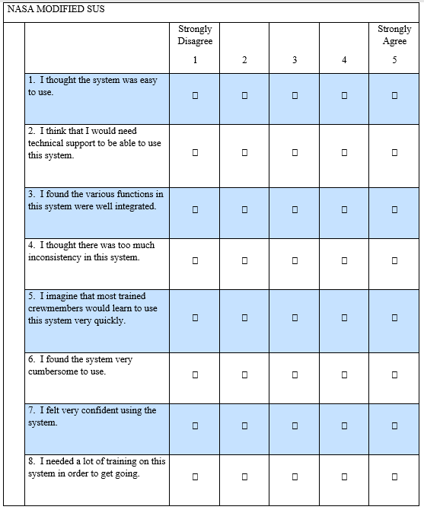
SCORING: The NMSUS is scored using the following equation: NMSUS = 3.125 * ((Q1-1)+(5-Q2)+(Q3-1)+(5-Q4)+(Q5-1)+(5-Q6)+(Q7-1)+(5-Q8))

Figure 1. NASA Modified System Usability Scale (NMSUS)

