Validation of Ullage Collapse Due to Violent Lateral Slosh
H. Q. Yang and Brandon Williams
¹CFD Research Corporation, Huntsville, Alabama, 35806, USA
² NASA Marshall Space Flight Center, Alabama, 35812, USA

Understanding the coupling between thermodynamics and propellant sloshing is important for cryogenic upper stages, especially during the lift-off phase and in missions including multiple engine restarts, as the fluid dynamic condition of the propellant is mainly influenced by various flight maneuvers. This paper describes the development and validation of a Volume of Fluid (VOF)-based CFD solver, Loci/STREAM-VOF, to the ullage collapse under violent later slosh conditions. Loci/STREAM-VOF is shown to be able to capture detailed slosh dynamics, including slosh frequency, non-linear slosh damping, and violent surface breakup due to forced acceleration. The comparison of surface shape and small drops formed during large amplitude slosh with experimental imagery shows excellent agreement throughout the sloshing period. Comparison of temperature histories in the ullage, at the gas-liquid interface, and inside liquid with the experiment conducted at JAXA also show very good agreement. The simulation points to a stratified temperature field inside the liquid near the interface, critical to the ullage pressure after the collapse. The predicted pressure collapse matches well with the experimental value due to sloshing. Parametric sensitivity studies suggest that high-fidelity Loci/STREM-VOF simulations can play an essential role in predicting the actual thermodynamics of ullage collapse when following the recommended simulation methodology.

Nomenclature
A area
c_{v} heat capacity at constant volume
c_{p} heat capacity at constant pressure
C_{m} mass transfer coefficient
e internal energy
F volume of fluid
g gravity vector
h enthalpy
k thermal conductivity
L latent heat
m interfacial mass flux
n surface normal
p pressure
R gas constant
Q surface heat flux
S surface
T temperature
t time
u velocity
V volume

Greek
β thermal expansion coefficient
κ compressibility
ρ density
τ shear stress
ω specific turbulence dissipation rate
Φ dissipation

Subscript
face surface
g gas phase
i component in x,y, and z direction
l liquid phase
ref reference
sat saturation

- Introduction

Propellant slosh is a potential source of disturbance critical to the stability of space vehicles. The driving sloshing forces of the propellant mass come from lateral disturbances, oscillatory thrust forces, or angular rotation of the vehicle during the powered phase of flight. As such, sloshing is expected to occur during vehicle taxi, takeoff, engine shutoff, and flight maneuvers. Since the liquid oscillatory frequency may nearly coincide with either the fundamental elastic body bending frequency or the dynamic control frequency of the vehicle at some time during the powered phase of the flight, the slosh forces can interact with the structure or control system. This can cause a failure of structural components within the vehicle or excessive deviation from its planned flight path [1].

From a thermodynamics perspective, the liquid contact on hot tank walls caused by sloshing can result in rapid vaporization and subsequent rapid pressure rise. The fluid motion produced during these operation maneuvers can circulate subcooled liquid propellant near the liquid-vapor interface, resulting in increased condensation and corresponding pressure collapse. It is known that the orbital maneuvers of upper-stage rockets may generate propellant slosh waves and propellant breakup into droplets within the oxidizer and fuel tanks. When many droplets are created, increased propellant evaporation may occur and lead to a significant reduction in ullage gas temperature and pressure, known as ullage collapse. The uncertainty regarding the magnitude of the ullage collapse causes a mass penalty associated with carrying extra pressurant gas to maintain tank pressure at levels that are used for nominal engine operation. For engine restart, it is important to predict the ullage and propellant conditions to ensure that pressure and temperature levels inside the tank remain within acceptable limits and that the propellant pressure leaving the tank satisfies the net positive suction pressure (NPSP) requirement of the pump feeding the engine.

As to be addressed in this paper, understanding the coupling between thermodynamics and propellant sloshing is important for cryogenic upper stages, especially during the lift-off phase and in missions including multiple engine restarts, as the fluid dynamic condition of the propellant is mainly influenced by various flight maneuvers. One of the significant technical challenges associated with cryogenic fluid management (CFM) is ullage collapse. As this collapse is mainly caused by heat and mass transfer between the ullage and liquid propellants, which are at a temperature well below the saturation temperature of ullage, high-fidelity computational fluid dynamics (CFD) simulations can play an essential role in predicting the actual thermodynamics of ullage collapse.

Unlike a typical CFD code, the computational tool for CFM applications requires multi-phase and multi-physics capability as ullage collapse and lateral slosh involve both liquid and gas phases and their mutual interaction. At the same time, numerical modeling tools need to have sufficient fidelity to answer critical design and operational issues and must be validated by comparing results with test data. Several well-established methods exist for dealing with interfaces in fluid flow. These methods include the front tracking [2], the level set method [3-4], and the volume of fluid (VOF) methods [5-6]. For CFM applications, ensuring mass conservation and energy conservation for both phases is essential. In these situations, VOF methods are found to be superior.

- PROCESS

The principal aim of the work documented in this paper is to validate the Loci/STREAM-VOF CFD code and physics models implemented for CFM and propellant tank dynamics applications for the purpose of predicting ullage collapse due to propellant sloshing. The experimental data of Himeno et al. [7] on phase change and pressure drop due to violent sloshing will be used for validation. The physics under consideration are the lateral slosh dynamics and ullage pressure collapse. In the following section, the experiment used for the validation will be described first; then, the Loci/STREAM-VOF CFD code and the essential features needed to deal with the heat and mass transfer will be described. In the results section, the comparisons of the simulation results and experimental data will be presented.

Test Description
Figure 1 (left) shows the experimental apparatus of Himeno et al. [7]. The cryostat was composed of a test vessel and vacuum insulation. The vessel consisted of a cylindrical part having a 0.105 m inner diameter (middle) and a lower portion with a dome shape. The test tank was contained inside the coolant jacket made of copper and a vacuum chamber. The time variation of pressure and temperature in the tank was measured respectively by a pressure transducer and five thermometers on a rod at 255 mm (hereafter, T1), 205 mm (T2), 155 mm (T3), 105 mm (T4), and 55 mm (T5) from the bottom (middle). The initial liquid level, h, was set to be about 160 mm from the bottom, and the initial pressure at the beginning of excitation was set to be about 0.40 MPa. The lateral acceleration ax(t) was varied impulsively. This acceleration was determined by the similarity rule in terms of the Froude number between the laboratory scale of the model tank and the actual scale of a reusable sounding rocket [7].

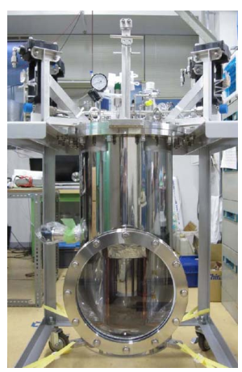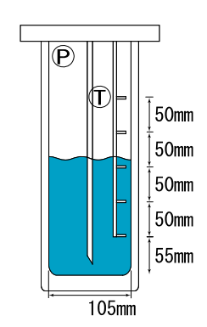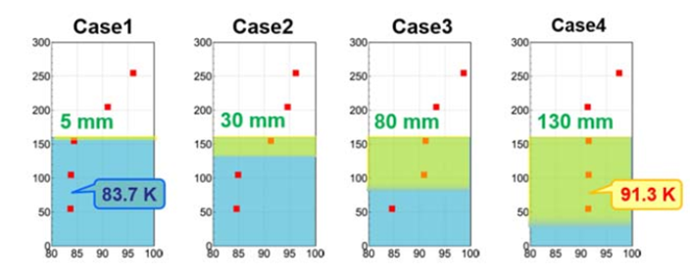
Figure 1. Ullaged collapse experimental setup [7]
A few different temperature distributions were initiated in the experiment in order to study the initial condition effect. The purpose was to create various thicknesses of the thermal stratification layer in the liquid. The changes in temperature distribution in the vessel are estimated and illustrated on the right in Figure 1. After pre-conditioning, high amplitude slosh motion was induced by a single lateral acceleration pulse with tank pressure and temperature measurements and video recorded during the transient.

Computational Tool
The VOF method is a powerful and robust technique for simulating free-surface and gas-liquid interfacial flows such as those encountered in CFM. The geometric algorithms tracking the interface are more accurate than other methods at simulating free-surface flows and allow for simulations with excellent conservation properties when adequately implemented. The Fluid Dynamics Branch (ER42) at Marshall Space Flight Center (MSFC) has been active in applying CFD methods to CFM analyses and tank dynamics applications, such as propellant slosh, to extract engineering metrics, like slosh frequency and damping, that can be used for system-level design and analysis.

During a MSFC study of slosh damping in 2009 [8], it was found that commercially available CFD programs simulating gas/liquid interfaces using the VOF approach were limited to approximately 16 to 32 central processing unit (CPU) cores in their parallel scalability. In contrast, non-interface CFD applications demonstrated functional parallel scalability of up to 4,096 processors or more. In response to this finding, NASA/MSFC established a path in 2010 [8] to fulfill its needs by developing a VOF module to augment the general-purpose CFD program Loci/STREAM. Loci [9] is a novel software framework that has been applied to the simulations of non-equilibrium flows. The Loci system uses a rule-based approach to automatically assemble the numerical simulation components into a working solver. This technique enhances the flexibility of simulation tools, reducing the complexity of CFD software induced by various boundary conditions, complex geometries, and different physical models. Loci plays a central role in building flexible goal-adaptive algorithms that can quickly match numerical techniques with various physical modeling requirements. Loci/STREAM [10-11] is a pressure-based, all-speed CFD code for generalized grids in the rule-based programming framework Loci. Loci/STREAM uses SIMPLE, SIMPLEC, and PISO algorithms for pressure-momentum coupling and provides various turbulence models which can be executed in Reynolds-Averaged Navier-Stokes (RANS) or Large Eddy Simulation (LES) mode. The coupled simulations between the flow solver and VOF transport are carried out using the Loci/STREAM flow solver and a VOF module developed by CFDRC [12]. The final product, Loci/STREAM-VOF, has been applied to practical rocket propulsion-related VOF applications and has shown significant parallel scalability, up to thousands of CPU cores [8,13].

Governing Equations and Solution Methodology
The governing equations for mass, momentum, and energy implemented in Loci/STREAM-VOF are accompanied by an additional transport equation for the volume of fluid (liquid phase). First, the governing equations for mass, momentum, and energy are:

$\frac{∂ρ}{∂t}+\frac{∂ρu_{j}}{∂x_{j}}=0$ (1)

$\frac{∂ρu_{i}}{∂t}+\frac{∂ρu_{j}u_{i}}{∂x_{j}}=-\frac{∂p}{∂x_{i}}+\frac{∂τ_{ij}}{∂x_{j}}+ρg_{i}$ (2)

$ρc_{p}\frac{DT}{Dt}-\frac{DP}{Dt}=\frac{∂}{x_{i}}\left(k_{eff}\frac{∂T}{∂x_{i}}\right)+$ (3)

where all the variables are defined in the nomenclature. The above equations are for single-phase fluids. Next, we will discuss the incorporation of two-phase fluids.

VOF Module
To consider the liquid phase, an additional equation for volume fraction, 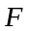, to track the location of the liquid phase is solved in the VOF module. The volume fraction represents the local fraction of the cell volume occupied by the liquid of interest. All cells where the volume fraction is between 0.0 and 1.0 are interface cells in which both fluids and the interface between them exist. The spatial and temporal evolution of the liquid volume fraction is given by the following equation:

$\frac{∂F}{∂t}+u_{i}\frac{∂F}{x_{i}}=0$ (4)

where $u_{i}$ is the velocity field.

The above equation is nothing but a scalar transport equation; however, the advection of the VOF field using conventional finite-volume discretization techniques is highly diffusive and leads to “smoothing” and destruction of the sharp interface between gas and liquid. To keep the interface sharp for a very long period of time, the initialization and transport of are carried out using purely geometric constructions.

The simulation of two-phase flows with VOF methods consists of three main aspects:
- VOF initialization, interface construction, and advection of liquid phase
- Evaluation of body forces due to gravity and surface tension
- Coupling of body forces and density changes to the solved pressure, momentum, and energy equations
A detailed description can be found in reference [13].

Coupling between VOF Module and Flow Solver
For two-phase flow with gas-liquid interfaces, the density is not constant in space, and therefore the total continuity equation has to be solved. It is given by

$\frac{∂ρ}{∂t}+∇∙\left(ρu\right)=\frac{∂ρ}{∂t}+\sum_{S}{\left(ρ_{f}u_{f}\right)}∙n_{f}=0$. (5)

In order to maintain consistency between the VOF module and Loci/STREAM flow solver, appropriate face density values are required. The face densities cannot be modeled as the current STREAM implementation, which uses inverse distance weighted values from the cell centers. Instead, a new implementation of the face densities was carried out as

$ρ_{f}=\frac{ρ_{g}V_{g}+ρ_{l}V_{l}}{V_{g}+V_{l}}$ (6)

where V_{g} and V_{l} denote the gas-volume and liquid-volume fluxes across the face at a given time step. This approach is expected to provide a consistent formulation between the explicit VOF advection and the implicit STREAM time-step advances.

STREAM utilizes the cell densities based on advected VOF and the new face densities. This provides it with the information to calculate mass fluxes into and out of each cell to solve the pressure correction and then the momentum equations.

Based on the previous work by Lowry and Yang [14], the formulation for the pressure correction equation was modified so that it uses ln(ρ) for the source term of the p’ equation as recommended by Pericleous et al. [15] using a total derivative form of ln(ρ) for free surface problems as shown below:

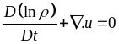. (7)

Energy Conservation Equation Modifications
Regardless of the liquid or gas phase, the original energy conservation equation is derived based on total energy conservation:

$ρ\frac{De}{Dt}-∇k∇T-+p∇.u=0$. (8)

The first term represents the internal energy increase, the second the heat conduction, the third term is dissipation, and the fourth term is the pressure work. The internal energy can be expanded as follows:

$e=h-\frac{p}{ρ}$ (9)
with the use of equations (8) and (5), we have:

$ρ\frac{Dh}{Dt}-\frac{Dp}{Dt}-∇k∇T-=0$. (10)

Using the thermodynamic relation, we have:

$dh={\left(\frac{∂h}{∂T}\right)}_{p}dT+{\left(\frac{∂h}{∂p}\right)}_{T}dp=c_{p}dT+\frac{1}{ρ}\left(1-βT\right)dp$. (11)

For an ideal gas, $βT=1$, and $dh=c_{p} dT$. Combining equations (10) and (11), one gets:

$ρc_{p}\frac{DT}{Dt}-βT\frac{Dp}{Dt}-∇k∇T-=0$. (12)

In comparison to the gas phase energy equation, the difference is the Dp/Dt coefficient. Combining the gas phase (g) and liquid phase (l) equations and weighting by the VOF volume fraction, one gets:

$\left(1-F\right){\left(ρc_{p}\frac{DT}{Dt}-\frac{DP}{Dt}-∇k∇T-\right)}_{g}+F{\left(ρc_{p}\frac{DT}{dt}-βT\frac{Dp}{Dt}-∇k∇T-\right)}_{l}=0$. (13)

After rearranging, the final equation becomes:

$\left[\left(1-F\right){\left(ρc_{p}\right)}_{g}+F{\left(ρc_{p}\right)}_{l}\right]\frac{DT}{Dt}-\left[1-F+F{\left(βT\right)}_{l}\right]\frac{Dp}{Dt}-∇k∇T-=0$. (14)

Mass Transfer Rate
The mass transfer rate between the gas and liquid phase, $\dot{m}$, is based on the kinetic theory of the Hertz-Knudsen equation,

$\dot{m}=C_{m}{\left(\frac{1}{2πR_{g}T_{in}}\right)}^{1/2}\left(p_{sat}-p_{g}\right)A_{in}$. (15)

where $\dot{m}$is mass evaporation rate in kg/s, C_{m} is the mass transfer coefficient that lies between 0 and 1, R_{g} is the gas constant, T_{in} is the interfacial temperature, p_{sat} is the saturation pressure based on the interfacial temperature, and p_{g} is the gas phase pressure. The Clausius-Clapeyron or Antoine equation can be used to compute the saturation pressure based on the local temperature. The Clausius-Clapeyron equation is given by:

$ln\frac{p_{1}}{p_{2}}=\frac{L}{R_{g}}\left(\frac{1}{T_{2}}-\frac{1}{T_{1}}\right)$. (16)

where L is the latent heat, and T₁ and p₁ are the temperature and saturation pressure at a reference point. The mass flux is subtracted from the liquid phase equation (VOF equation) and is added to the condensable gas species equation. The associated latent heat (m*L) is added to the gas phase energy and subtracted from liquid energy.

2.3 Simulation Model
The full 3D geometrical CAD model of the JAXA experimental tank [7] is shown in Figure 2 on the left. To take the tank wall heat transfer into account, models for the solid wall, as well as the fluid volume, are included in this analysis, as shown in Figure 2 on the right.
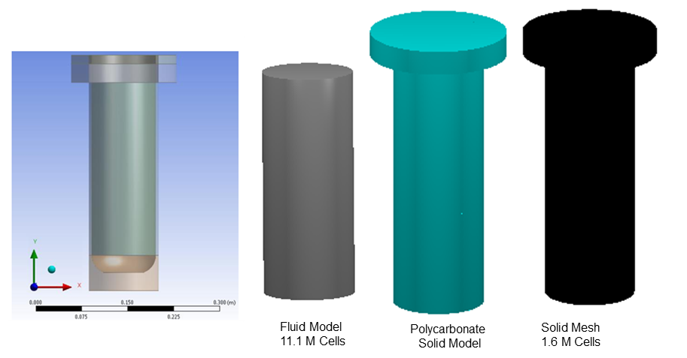
Figure 2. 3D LN2 tank geometrical model and simulation meshes for fluid and for solid with conjugate heat transfer

Mesh
From the experiment[7], one can see a violent interface breakup due to the imposed side force and slosh. The capability to resolve the interface breakup and the resulting small drops is critical in high-fidelity CFD validation. To this end, the baseline mesh has a total of 11.1 million cells. There are 200 cells across the diameter of the tank. The cell size in the ullage and near interface is about 0.5mm. In the vertical direction, there are 350 cells, which have a coarser distribution near the bottom of the tank and a finer resolution of 0.6mm near the interface. Figure 3 shows the two cross-sectional views of the mesh.
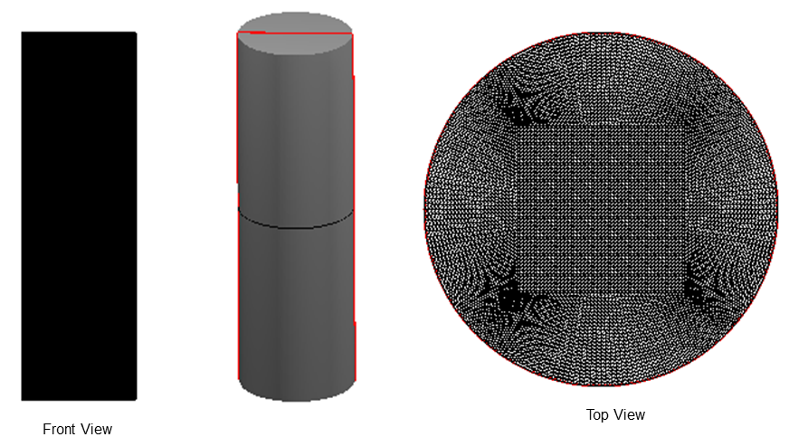
Figure 3. Cross-sectional and vertical views of the baseline mesh
A mesh sensitivity study in the fluid region has been conducted. The mesh resolution varied from 1.5 million, 4.6 million, and 11.1 million to 20 million cells, as shown in Figure 4.

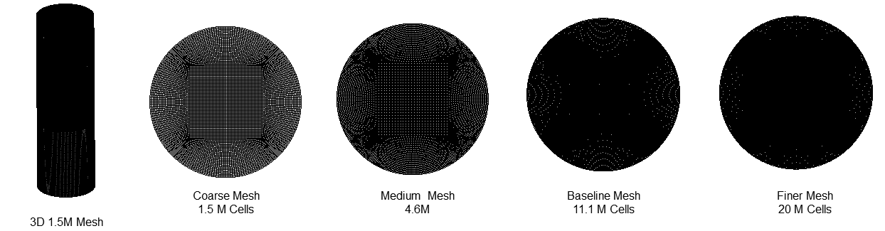
Figure 4. Simulation meshes of different resolutions used in this study
Boundary Conditions
For this closed tank system, all fluid boundaries are modeled as no-slip walls. For conjugate heat transfer, temperature and heat flux continuities are imposed at the fluid/solid wall boundary. As for the heat conduction in the solid, a zero heat flux condition is applied to the outside wall. When the heat transfer in the solid is not considered, a zero heat flux condition (adiabatic wall) is imposed at the fluid-solid boundaries.

Initial Conditions
The test parameters for different initial conditions were summarized in Table 1 and illustrated in Figure 1, where the initial temperatures in gaseous and liquid phases were read by thermometers T1 to T5, respectively. Case 1 and Case 4 are simulated in the present validation study as the detailed pressure and temperature variations and flow images are documented in the reference [7].

Table 1. Test Parameters
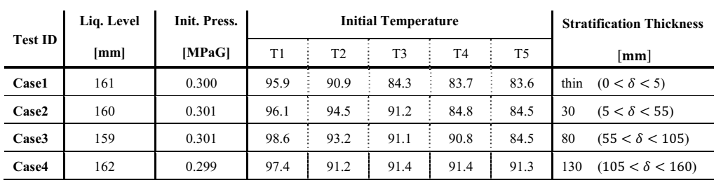

Fluid/Material Properties
Fluid and material properties were extracted from the National Institute of Standards and Technology (NIST) databases [16]. The liquid-related properties and solid conduction properties are listed in Table 2. The gas properties are taken from the existing thermodynamic table in Loci/STREAM.

Table 2. Thermodynamic Properties of LN2 Used in the Simulation
Parameters | Description | Value
$$ρ_{l}$$ | Liquid density | 776.20 kg/m³
$${\left(c_{p}\right)}_{l}$$ | Liquid-specific heat at constant pressure | 2080.7 J/Kg K
$$k_{l}$$ | Liquid thermal conductivity | 0.13214 W/m K
$$μ_{l}$$ | Liquid dynamic viscosity | 1.267x10⁻⁴ Kg/m s
β | Liquid volume expansion coefficient | 0.0062 /K
L | Latent heat | 1.675x10⁵ J/kg
σ | Surface tension | 0.007560 N/m
$$ρ_{s}$$ | Solid density | 1200 kg/m³
$${\left(c_{p}\right)}_{s}$$ | Solid-specific heat at constant pressure | 400.0 J/Kg K
$$k_{s}$$ | Solid thermal conductivity | 0.14 W/m K

Physics Models and Simulation Options
As the liquid density is assumed to be constant, the buoyancy force in the liquid phase is taken into account by the Boussinesq approximation. The liquid density is considered as a linear function of temperature in the gravity term:

$F_{g}=ρ_{l}g-ρ_{ref}g=\left[ρ_{ref}-β_{l}ρ_{ref}T-ρ_{ref}\right]g=-β_{l}ρ_{ref}T$. (17)

Both laminar flow and turbulence models will be evaluated. Two turbulence models will be applied: the k-ω shear stress transport model (k-ω-SST) and the k-ω-SST Delayed Detached Eddy Simulation (DDES).

The initial time step size for the simulation was set to dt=1e-2 sec. for all cases. For the calculation of a stable time step for the VOF module, a CFL number of 0.2 was chosen.

RESULTS
In the following, the simulation efforts for the validation of Loci/STREAM-VOF with the JAXA experiment will be discussed. A baseline model case for Case 1 (Figure 3) will be presented first, and then the model predictions for the fluid dynamics of interface breakup, pressure drop in the ullage, and temperature variations at three locations (inside the liquid, at the interface, and in the ullage) will be compared with experimental data so that one can have a better understanding of the ullage collapse process. Then parametrical studies will be conducted to investigate the solution sensitivity to the various parameters. Finally, the results for Case 4 will be presented.

  - Validation of Baseline Models/Parameters for Case 1
As there are many different simulation parameters that can affect the solution, the following baseline conditions were chosen as a starting point based on previous experience with the Loci/STREAM-VOF model and understanding of the physics of the problem. The variation and sensitivity of the results will be presented in the subsequent sections.

- Turbulence Model: None (laminar flow assumption). In section 3.2, two turbulence models of the k-ω shear stress transport model (k-ω-SST) and the k-ω-SST Delayed Detached Eddy Simulation (DDES) will be assessed.
- Mesh size: 11.1M cells. The mesh sensitivity study is reported in section 3.3.
- Numerical Treatment of Phase Change: Explicit. The comparison of explicit and implicit treatments will be reported in section 3.4
- Mass Transfer Coefficient: C_{m}=1.0e-3. This value has performed well for past simulations of tank self-pressurization. The sensitivity is reported in section 3.5.
- Conjugate Heat Transfer: Omitted. As the initial solid temperature distribution was not measured and the experimental time was short, the solid wall was taken as an insulating material. The sensitivity of conjugate heat transfer is reported in section 3.6.

3.1.1. Verification and Validation of Slosh Dynamics
As the goal of this study is to investigate the phase change and pressure drop enhanced by the violent sloshing of cryogenic fluid, it is essential to first verify and validate the fundamental slosh dynamics. The slosh dynamics can be expressed as a mass-spring-damper equation [1]:

$m\frac{d^{2}x}{dt^{2}}+c\frac{dx}{dt}+kx=F_{f}$ (18)

where m is the slosh mass (which is different from the total liquid mass in the tank), c is the friction coefficient related to the slosh damping, and k is the equivalent spring due to gravity. F_{f} is the forcing function applied to the tank. From the above equation, the sloshing frequency can be determined as follows:

$f=\frac{1}{2π}\sqrt{\frac{k}{m}}$ (19)

Figure 5 shows early results on the prediction of slosh mass and slosh frequency by the Yang and Peugeot [17] using the VOF method for a straight cylindrical tank as used in this study. The work [17] demonstrated the soundness of a CFD approach in modeling the detailed fluid dynamics of tank slosh and showed excellent accuracy in extracting the mechanical properties for different tank configurations as a function of the liquid fill level.

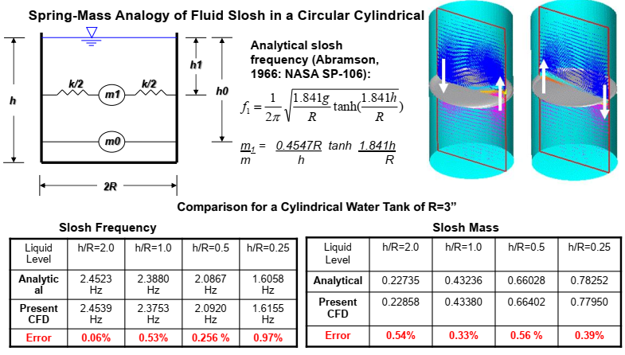
Figure 5. Verification study for slosh frequency and slosh mass using CFD-VOF modeling approach [17]
Verification of Slosh Frequency and Slosh Damping
Figure 6 shows the imposed forcing function in the JAXA experiment [7]. A Fourier analysis of the acceleration has been carried out and is shown on the right. As the present tank is essentially a straight cylinder, the analytical solution for the sloshing frequency can be determined using the equation in Figure 5. With h=0.16m, R=0.0505m, one can show that:

$f=\frac{1}{2π}\sqrt{\frac{1.84g}{R}tanh⁡(\frac{1.84h}{R})}$ =2.95 Hz (20)

As seen in Figure 6, the forcing function contains a rich spectrum of frequencies close to the natural frequency of 2.95Hz. It is expected that the slosh amplitude will increase during the driving phase and then will go through free decay after the forcing is stopped.

Figure 7 shows the CFD-predicted total mass center displacement of the fluid in the horizontal direction with respect to time and the corresponding forcing acceleration of Figure 6. As one can see, before the tank is subject to forced acceleration, the mass center is zero, which represents a horizontal interface as the mass center passes the cylinder center. The forcing starts around 3 seconds, and one can see the periodic response of the tank slosh. The frequency is the natural frequency and is about 2.85Hz, which is in good agreement with the theoretical prediction of 2.95Hz. The maximum displacement is reached at around 3.73 seconds, after which is the free decay of the sloshing. The decay rate is related to the friction coefficient, c, in Equation (18), which is directly related to slosh damping. As the slosh dynamics are in the mass-spring-damper form, one can expect that when the damping is zero, the slosh amplitude will be unbounded during resonance. A correct value of c is directly related to the maximum wave amplitude.

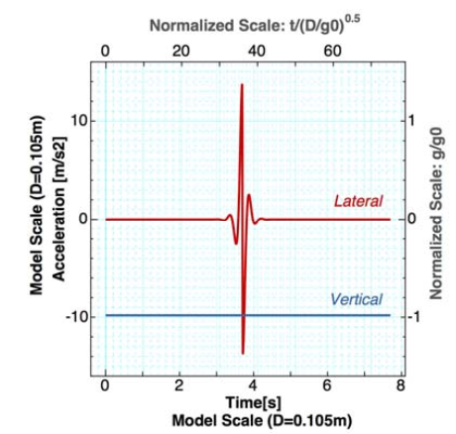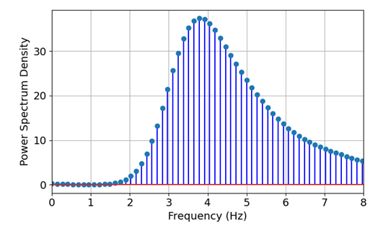
Figure 6. The waveform of acceleration is provided by the exciter (left) and Fourier analysis of the acceleration (right).

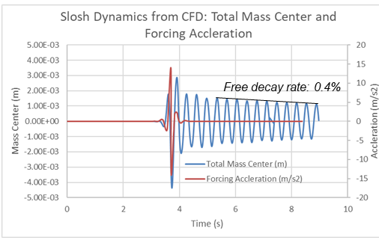
Figure 7. Total mass center response to the forcing acceleration of the tank from CFD
Figure 8 shows the previous validation study for the linear (small amplitude) damping prediction of the above equation by Yang et al. [18]. For reference purposes, the current JAXA tank has an sqrt(Re)=2.0E-3. Based on the study [18], the minimum requirement for a reasonable damping prediction is 1 million cells for this Reynolds number. When comparing the empirical correlation, the value is high: 0.4% vs. 0.2%. This is due to the large wave amplitude of the current slosh dynamics. A study by Yang and West [13] proves that slosh damping is a function of slosh amplitude. At small slosh amplitude, the damping ratio is essentially constant, which is consistent with the established empirical correlation. Once the amplitude reaches a critical value, the damping ratio becomes a linear function of slosh amplitude. The validation of this relationship is shown in Figure 9. The damping value of 0.4% predicted for this tank matches well with the previous experiment and validation results reported in reference [13].
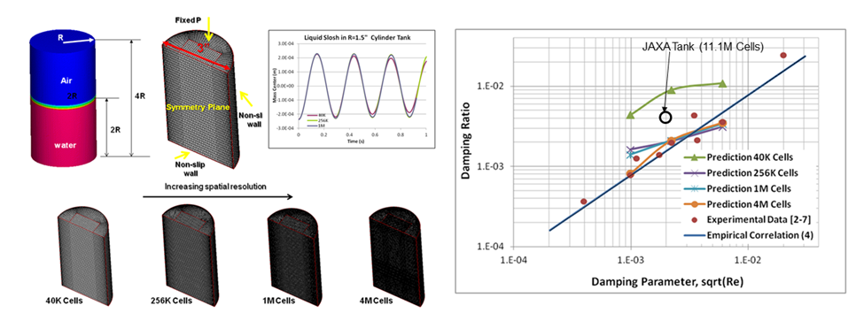
Figure 8. Grid sensitivity study for the prediction of slosh damping in a straight cylinder filled with liquid [18].

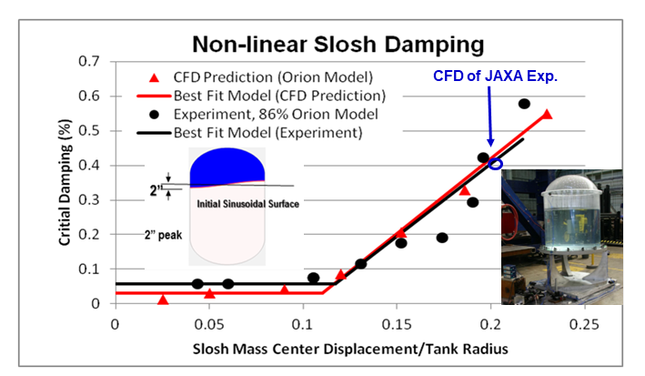
Figure 9. Comparison of the predicted JAXA experimental slosh damping with the previous experimental data and simulations

3.1.2. Validation of Slosh Interface Dynamics
For the experiment, the cylindrical test vessel shown in Figure 1 (left) was made of transparent polycarbonate and consisted of a cylindrical part having a 0.105 m inner diameter and a lower portion with a dome shape. The test tank was contained inside the coolant jacket made of copper and a vacuum chamber made of SUS304. As a result, the unsteady deformation of the liquid surface could be observed through the transparent wall of the vessel and recorded with a high-speed camera.

Figure 10 shows the time variation of liquid motion taken from the camera in Case 1 with a thin stratification layer. Since there was not a significant obstacle in the vessel except for small rods holding instrumentation, the wave of the excited liquid surface can be compared to the iso-surface of VOF in the CFD simulation. To understand the thermodynamics process, the temperature distribution in the central vertical plane is also shown. As the forcing acceleration starts around 3 seconds, one can see the development of surface waves around 3.4 seconds in the experiment and the CFD. By 3.8s (actually 3.73s based on mass center displacement in Figure 7), the wave height reaches the maximum and starts to break up. A large number of drops begin to form around 3.9 seconds. The drops detach from the original gas-liquid interface and stay in the ullage for a certain time. At the same time, a large amount of vapor was found to be entrained and brought into the liquid, as shown in Figure 10 after t=4.0s. From the temperature distribution, some low-temperature spots are visible in the ullage. The formation of drops increases the surface area and hence enhances the heat transfer between the cold liquid and hot ullage. It is apparent that slosh introduces significant mixing between the hot ullage gas and cold liquid. From the surface dynamics comparison, CFD matches the experiment very well. This comparison in Figure 10 demonstrates the capability of Loci/STREAM-VOF in resolving wave breakup and in capturing tiny drops due to violent lateral slosh.

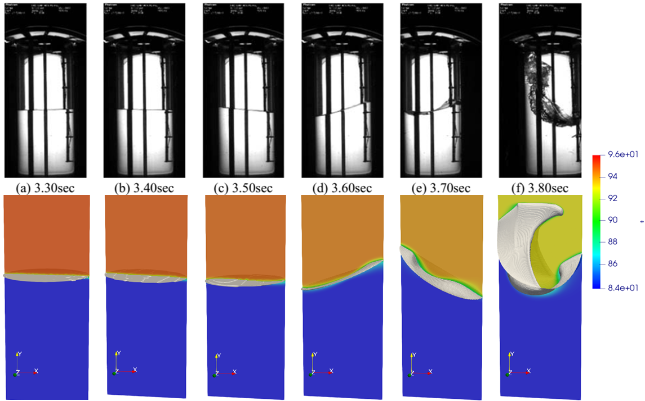

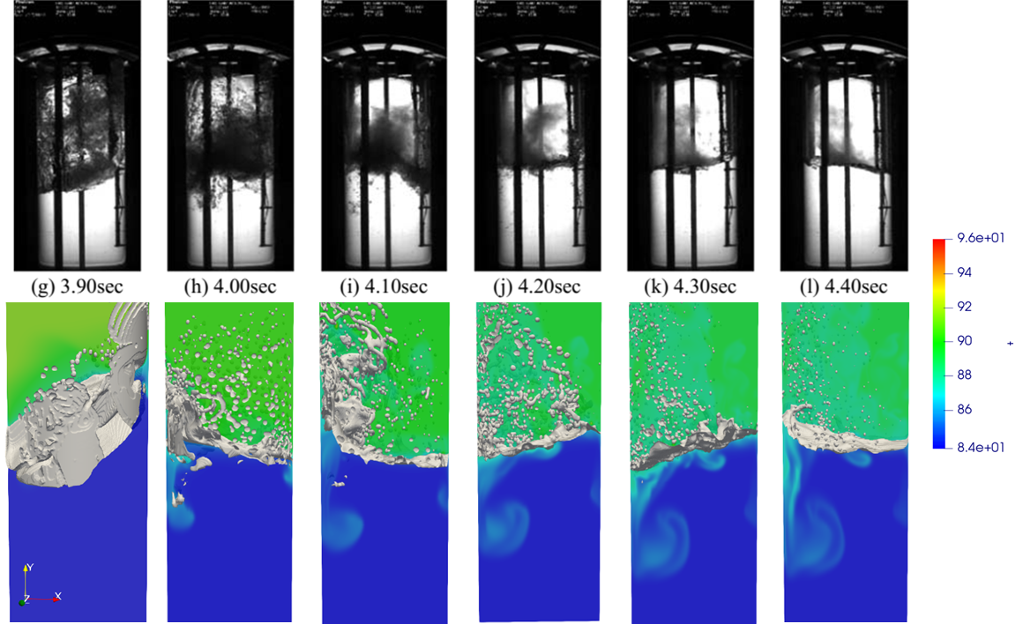
Figure 10. Comparison of interface dynamics between CFD and experiment for Case 1

3.1.3. Validation of Temperature Histories
Figure 11 shows the temperature histories obtained by thermometers T1, T3, and T5 at different locations in the tank from the experiment [7]. The CFD simulation results are also shown for comparison. At the beginning of excitation, the temperature in the gaseous phase was not homogeneous and higher than the saturation temperature of nitrogen (91.3 K at 0.40MPa), while most parts of the liquid nitrogen were sub-cooled. When the wave breaking took place in the following period, t > 3.90 sec, shear flow and vortices were induced. At the same time, the total area of the liquid surface was increased, as seen from flow visualization and from CFD in Figure 10, on which the gaseous phase and sub-cooled liquid nitrogen of larger heat mass contacted each other. Thus, the gaseous phase was cooled rapidly to the liquid temperature. In Case 1, with single species pressurization, some part of the GN2 was cooled enough to be condensed, and the displacement of vapor mass caused the pressure drop. One can see a minimal variation in the deep liquid temperature (T5), as only partial mass near the interface participates in the slosh. The interface temperature (T3) experiences large oscillations due to sloshing from CFD, and the higher temperature indicates that the thermometer location is exposed to the warmer ullage gas. There appears to be a delay in the thermometer response from the experimental measurement, which raises the possibility that the thermal sensor lacks a dynamic response. In general, the CFD agrees with the experiment measurement reasonably well at all three locations.

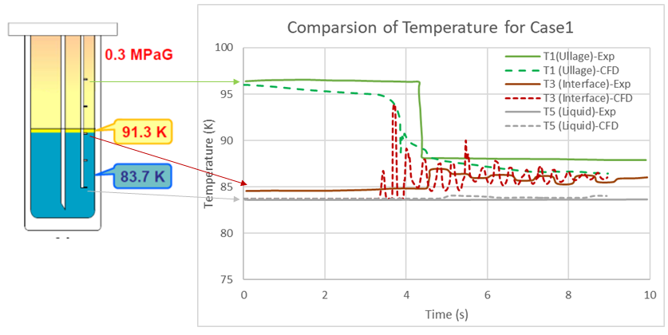
Figure 11. Comparison of temperature variations at different locations during the ullage collapse.

3.1.4. Validation of Pressure Drop
The comparison of ullage pressure with time from the present VOF formulation and experiment is given in Figure 12. One notices a rapid pressure drop (ullage collapse) around 3.9 seconds from the experiment measurement. In order to correlate the surface dynamics to the pressure drop, the temporal experimental images and CFD renderings are also displayed in the same plot. It is clearly seen that the pressure drop is associated with the quick increase in the cold liquid and hot ullage interface area when the surface breakup occurs. In addition to evaporation, leading to absorbing latent heat, the cold liquid also takes heat from the gas phase. This causes a rapid temperature drop in the gas phase resulting in an immediate decrease in ullage pressure. As seen in the figure, the Loci/Stream-VOF code does an excellent job of capturing the surface dynamics and predicting the pressure drop from the experiment. The absolute pressure also compares well with the experiment, though there is some discrepancy in the post-slosh pressure value where the CFD solution continues to drop, and the experimental data flattens.
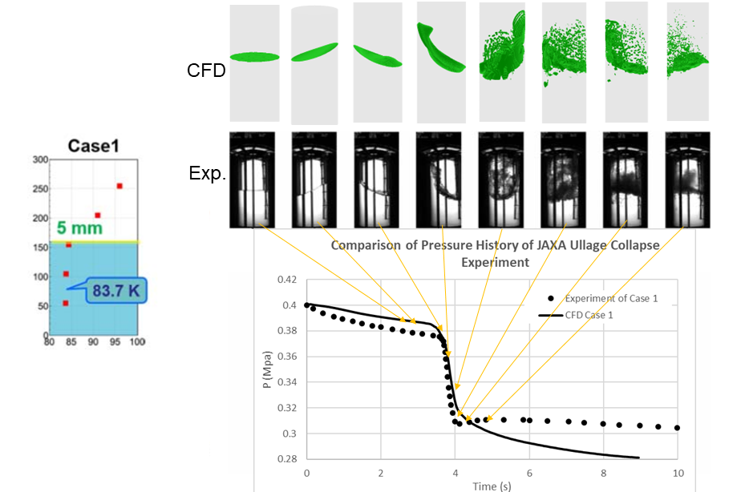
Figure 12. Pressure probe comparison in ullage between CFD and experiment

  - Turbulence Modeling Sensitivity
In the above section, the baseline case with 11.1 million cells and a laminar flow model were studied. In this section, the turbulence model sensitivity using the same mesh and setup will be investigated. Again, the same experimental conditions are considered, and other simulation models/parameters are:

- Mass transfer coefficient: C_{m}=1.0e-3
- Computational mesh: 11.1 million cells
- Adiabatic walls (no conjugate heat transfer)
- Explicit treatment of phase change in the energy equation
- Clausius-Clapeyron for saturation conditions
- Turbulence models considered: k-ω SST model and k-ω SST model DDES

Figure 13 left shows the slosh dynamics aspect of the comparison. One observation is that the slosh-damping ratio of 2.1% from the k-ω SST simulation is much higher than the previous laminar simulation value of 0.4%, which correlates well with experimental data. This is due to the high eddy viscosity computed from the turbulence model. Figure 13 right shows the gas-liquid interface dynamics during the violent slosh period of the experiment at t=4.0s and t=4.3s. At t=4.0s, both the laminar flow and k-ω STT model capture the interface breakup and drop formation, but the laminar simulation contains a greater number of smaller drops. The vapor bubbles inside the liquid in the simulations are visible, just as seen from experimental snapshots. Except for a slightly lower number of smaller drops with the k-ω SST model, the laminar flow simulation, k-ω SST model simulation, and experiment agree with each other.

For the thermal aspect of the comparison, the temperature histories in the ullage, at the interface, and inside the liquid from both the laminar flow model and from the k-ω SST model are shown in Figure 14. Before the interface breakup, both models trace each other very well. Due to the higher turbulent thermal conductivity from the turbulence model, there is a much higher heat exchange rate between the gas phase and liquid phase in the ullage, which leads to lower temperatures in the ullage from the turbulent simulation. This is also true for the thermometer at the interface (T3). The same periodic temperature spikes corresponding to the slosh motion uncovering the T3 probe location occur in both simulations, but the magnitude of the spikes in the turbulent simulation is diminished due to the more effective cooling of the ullage gas.

The comparison of ullage pressure drop due to the slosh is given in Figure 15. Both laminar and turbulence models predict the pressure drop during the slosh event reasonably well. The experimental pressure shows evidence of a stratified temperature distribution inside the tank, while the turbulent simulation tends to result in more mixing between the two phases, making ullage, interface, and liquid approach the same temperature. This leads to a lower predicted post-slosh pressure in the ullage.

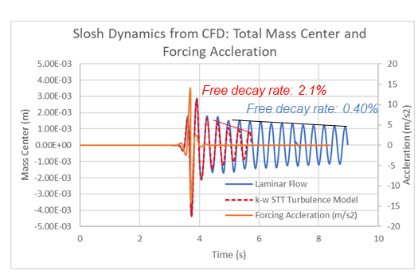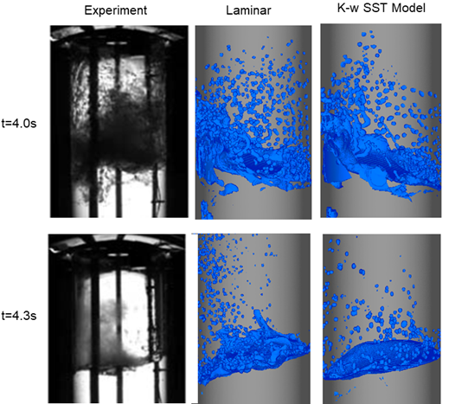
Figure 13. Total mass center response to the forcing acceleration of the tank from CFD using laminar flow model and using k-ω SST turbulence model (left). Comparison of interface dynamics between CFD using laminar flow model, k-ω SST turbulence model, and experiment for Case 1 at t=4.0s and at t=4.3s (right)

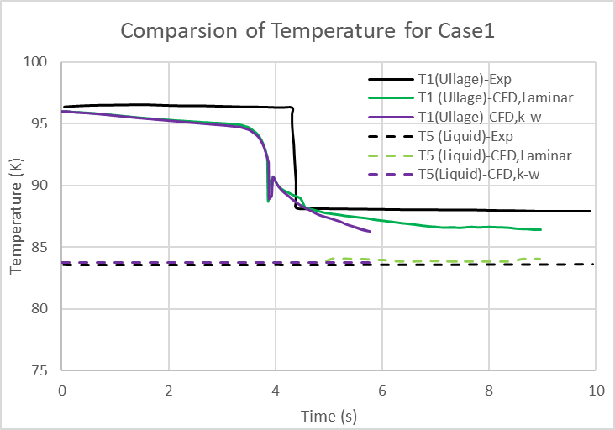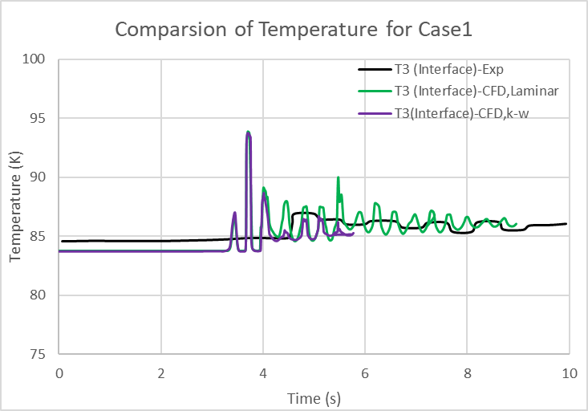
Figure 14. Comparison of temperature variations at different locations during the ullage collapse using laminar and turbulence models

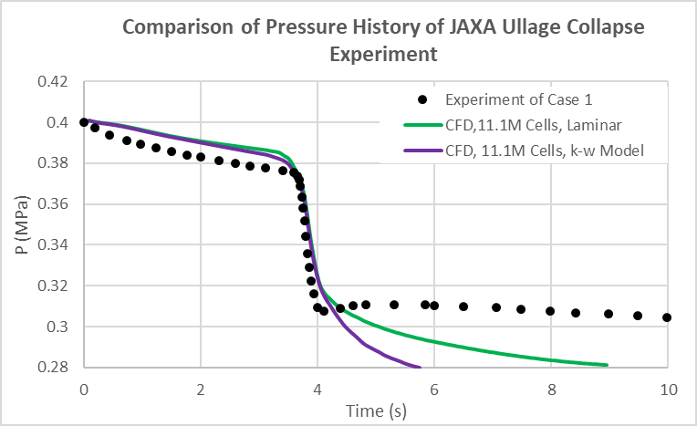
Figure 15. Pressure probe comparison in ullage between different CFD turbulence models and experiment

Hybrid RANS-LES model: k-ω SST DDES
Industrial CFD simulations increasingly rely on Scale-Resolving Simulation (SRS) models, which resolve at least a part of the turbulence spectrum in the flow domain. Due to the high costs of classical LES for high-Reynolds number industrial simulations, hybrid RANS-LES models are quickly becoming the models of choice for such applications.

One of the hybrid RANS-LES models, known as Detached Eddy Simulation (DES), switches explicitly between RANS and LES model formulations based on the local grid spacing and turbulent length scale. The original intent of DES was to be run in RANS mode for attached boundary layers and to switch to LES mode in large separated (detached) flow regions. The explicit switch to the LES model, however, is not accompanied by a corresponding transfer of modeled (RANS) turbulence to resolved (LES) turbulence. As such, DES relies on inherent flow instability for a quick generation of such resolved content. Due to the direct impact of the grid spacing on the RANS model, DES models require more carefully crafted grids to avoid inappropriate behavior. Menter [19] developed the delayed-DES (DDES) method to reduce the grid dependency of the DES limiter on the RANS part of the boundary layer. This DDES model, as implemented in the Loci/STREAM code, has the potential to address some of the issues using the k-ω SST model in the previous section and has been examined in this study.

Figure 16 shows the comparison of the turbulent to laminar viscosity ratio for the k-ω SST and k-ω SST DDES models on the coarsest mesh (1.5M cells) at 4.2s. The corresponding interface shapes are also shown so the distribution of turbulent viscosity can be related to the slosh dynamics. It is seen that the k-ω SST model produces very high turbulent viscosity near the gas-liquid interface (from 300 to 30,000 times the laminar viscosity). As a result, fewer drops are generated, and the initial thermal stratification has disappeared. On the other hand, the turbulent viscosity distribution from the k-ω SST DDES model is smaller and is only limited to the high-velocity regions. From the blending function, it is seen that the RANS model is only applied near the wall and some limited interior areas, and no turbulence model is applied near the gas-liquid interface. This blending helps to remove unnecessary turbulence dissipation at the interface.
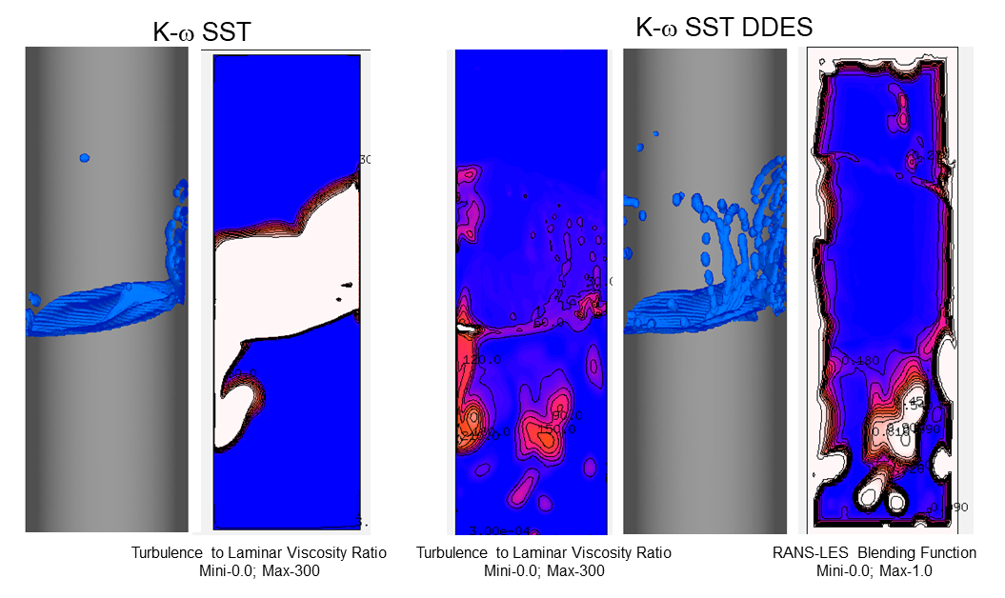
Figure 16. Free surface and turbulent to laminar viscosity ratio between k-ω SST and k-ω SST DDES models at t=4.2s with coarse mesh (1.5M cells)

Figure shows the comparison of temperature histories from the three models: laminar, k-ω SST, and k-ω SST DDES. One can see that the k-ω SST DDES model is not as dissipative as the k-ω SST model and follows the laminar model closely. The pressure history in Figure 18 also shows the same trend.

In general, the hybrid RANS-LES k-ω SST DDES model improves the predictive capability of the original k-ω SST model and does not significantly degrade the accuracy for cases such as this, where turbulence is not important, and laminar model results are quite good.

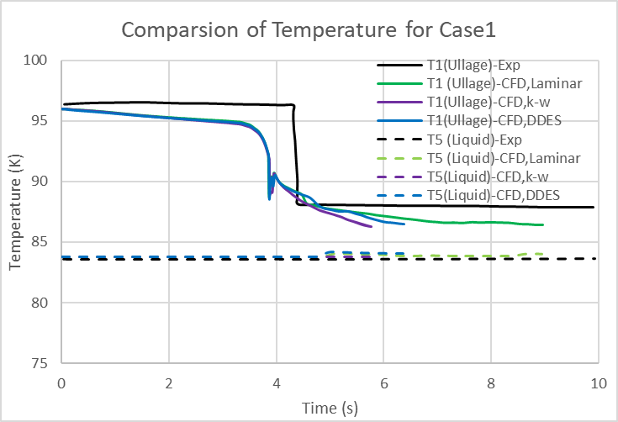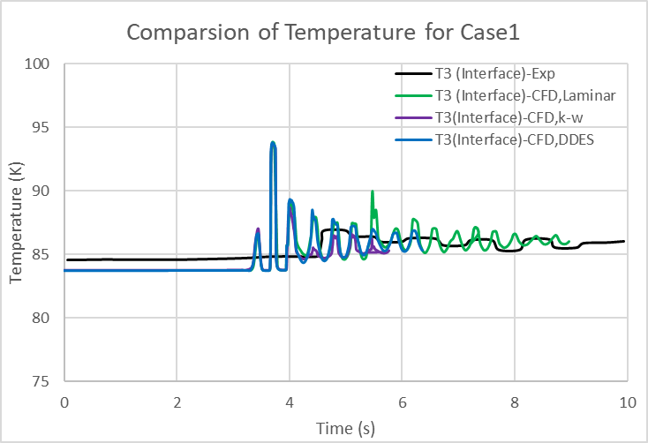
Figure 17. Comparison of temperature variations at different locations during the ullage collapse using laminar and turbulence models for baseline mesh (11.1M cells)
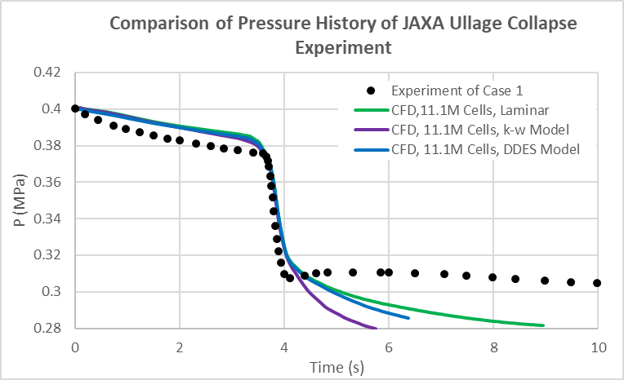
Figure 18. Pressure probe comparison in ullage between experiment and CFD with different turbulence models for baseline mesh (11.1M cells)

  - Mesh Resolution Sensitivity
The mesh sensitivity of the predicted pressure drop due to slosh is examined with four meshes: a baseline of 11.1M cells, a medium mesh with 4.6M cells, a coarse mesh of 1.5 M cells, and a refined mesh of 20 M cells, as shown in Figure 3.

Again, the experimental conditions and simulation models/parameters considered are:

- Mass transfer coefficient: C_{m}=1.0e-3
- Computational mesh: 1.5M, 4.6M, 11.1 M, and 20M cells
- Adiabatic walls (no conjugate heat transfer)
- Explicit treatment of phase change in the energy equation
- Clausius-Clapeyron for saturation conditions
- Turbulence model: None (laminar flow model)

The slosh dynamics comparison is given in Figure 19 (left). From the free decay signal, it is seen that as the coarse mesh introduces more numerical dissipation, it leads to higher slosh damping. For example, the coarse mesh of 1.5 M cells predicts a slosh damping of 0.61% vs. 0.40% with the baseline 11.1 M cell mesh. In addition to the high slosh damping, the coarse mesh cannot resolve the small drops observed in the experiment, as shown in Figure 19(right). On the other hand, as the mesh is refined, a more detailed flow structure can be seen, which compares more favorably with the experiment. With the finest 20 M cell mesh, the qualitative comparisons of drop sizes, distribution, and locations between the prediction and experiment are surprisingly remarkable.

For the temperature probe comparison, the 1.5M cell mesh results are shown in Figure 20. Again, the coarse mesh tends to introduce more numerical dissipation, and it predicts a lower interface temperature similar to the turbulent simulation results. The pressure signals in the ullage with different meshes are given in Figure 21. It appears that the pressure drop during the violent sloshing period of 3.5 to 4.4 seconds is less sensitive to the mesh resolution. All simulations predict the pressure drop rather well. But the pressure values during the free decay period are different, and the finer mesh tends to give a better comparison with the experiment.
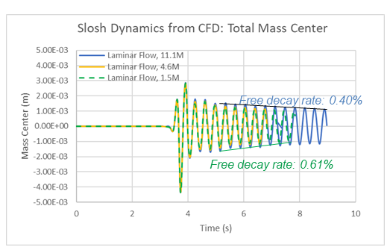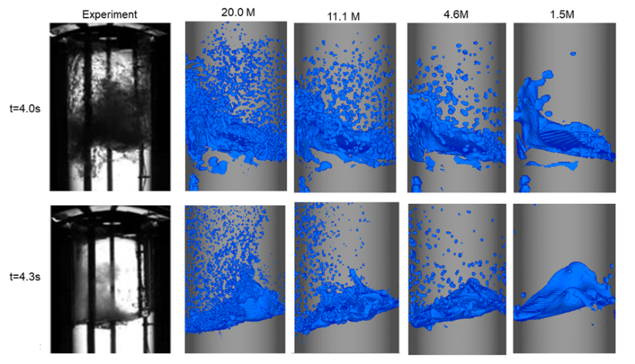
Figure 19. Total mass center response to the forcing acceleration of the tank from CFD using different mesh resolutions (left). Comparison of interface dynamics between CFD using different mesh resolutions, and experiment for Case 1 at t=4.0s and at t=4.3s(right)

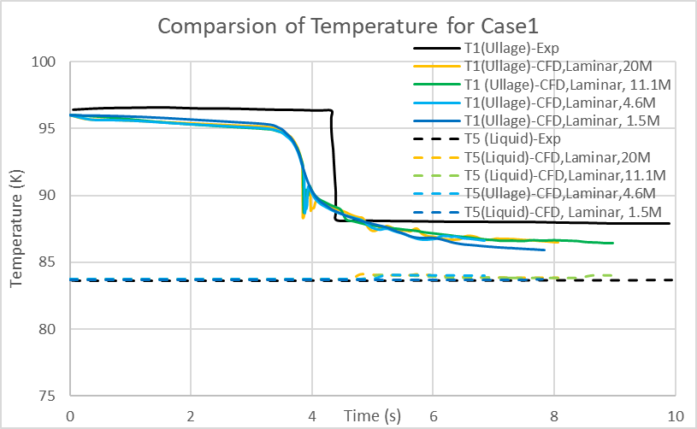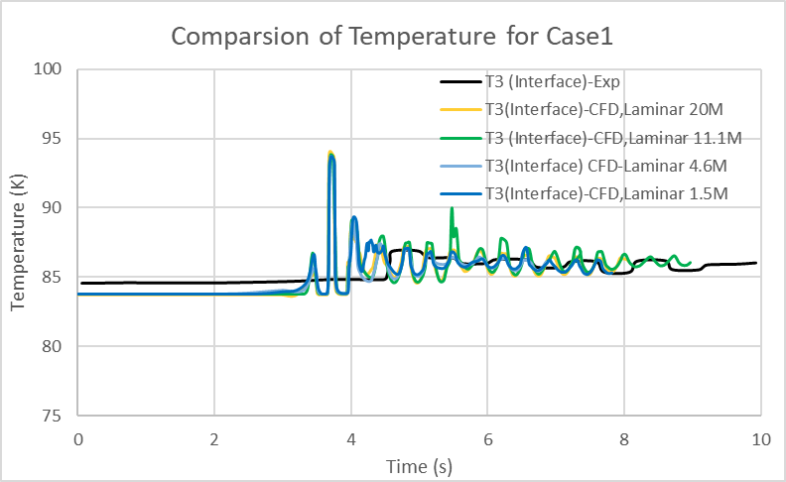
Figure 20. Comparison of temperature variations using different CFD meshes during the ullage collapse with experiment.

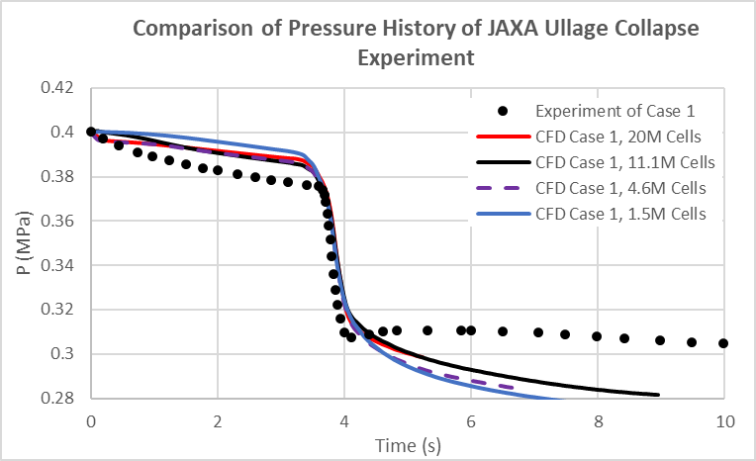
Figure 21. Pressure probe comparison in ullage between CFD with different meshes and experiment

  - Implicit and Explicit Treatment of Phase Change Source Term
The mass transfer rate between the gas and liquid phase ($\dot{m}$) is based on the kinetic theory of the Hertz-Knudsen equation in our current implementation, as given in Equation (15). It is repeated here:

$\dot{m}=C_{m}{\left(\frac{1}{2πR_{g}T_{in}}\right)}^{1/2}\left(p_{sat}-p_{g}\right)A_{in}$ (22)

where $\dot{m}$is mass evaporation rate in kg/s, C_{m} is the mass transfer coefficient that lies between 0 and 1, R_{g} is the gas constant, T_{in} is interfacial temperature, p_{sat} is the saturation pressure based on the interfacial temperature, and p_{g} is the gas phase pressure. For an interfacial cell, the value of VOF is between 0 and 1. An energy source is added or subtracted based on the difference (p_{sat}-p_{g}). It should be noted that the above source term is dependent on the local temperature T_{in}, and through T_{in} it is also reliant on p_{sat}, as the saturation pressure is a function of saturation temperature through the Clausius-Clapeyron equation, given by:

$ln\frac{p_{1}}{p_{2}}=\frac{L}{R_{g}}\left(\frac{1}{T_{2}}-\frac{1}{T_{1}}\right)$. (23)

For the original explicit treatment of the phase change source term, the T_{i} and p_{sat} are taken as the previous time step value, and as such, during the sub-iteration, the source term is unchanged. This treatment leads to a time delay in the energy equation. The error is small when the time step is small. On the other hand, the energy equation becomes stiff due to the source term, and it can lead to divergence if the source term is updated at the sub-iteration level but is not coupled to the implicit solution iteration for the energy equation. To this end, an implicit approach has been developed to linearize the phase change source term so that there is no delay in the mass transfer treatment. To make the source term implicit, the energy source term is linearized as:

${S_{h}}^{i+1}={S_{h}}^{i}+{\frac{∂S_{h}}{∂T}}^{i}\left(T^{i+1}-T^{i}\right)$ ; $S_{h}=\dot{m}L$ (24)

By linearization, some terms are moved to the left-hand side of the discretized equation to make the solution stable. One should note that due to the segregated solution procedure of the pressure-based CFD solver, the last sub-iteration value was used for gas pressure in equation (22). This can lead to convergence difficulties when there is a significant change in the mass flux. A relaxation in temperature can alleviate the problem. In any case, the implicit treatment of the source term was found to behave equivalently at small time steps, and the reduction in numerical error in interfacial cells allowed the use of a higher stable time, which allowed the simulation to run faster.

The comparison of the pressure drop from both implicit and explicit treatments is shown in Figure 22. Although there is a small difference in the initial pressure history before the slosh event (possibly due to the larger time step size with the implicit method), there is no significant variation between the two approaches in the predicted pressure drop.

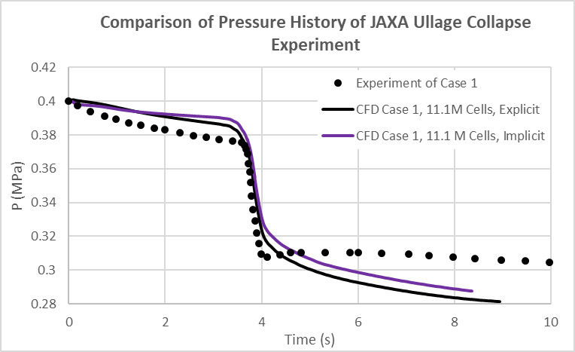

Figure 22. Pressure probe comparison in ullage between CFD with implicit and explicit treatment and experiment

  - Mass Transfer Coefficient Sensitivity
Another important parameter in the ullage collapse modeling is the mass transfer coefficient C_{m} in the phase change model. The mass transfer coefficient C_{m} is a parameter that must be calibrated rather than derived from empirical data. In fact, the mass transfer rate is controlled by the factor of C_{m}*(p_{sat}-p_{g}). During the initial self-pressurization study with Loci/STREAM-VOF [23], the sensitivity of C_{m} was systematically investigated, and it was found that for values between 1.0e-5 and 1.0e-3, the pressure history was not sensitive. This is consistent with previous studies [20] of self-pressurization; however, in a study of slosh-induced ullage collapse, it was found that the value of the mass transfer coefficient (accommodation coefficient) played a significant role [21]. It should be noted that these previous investigations of self-pressurization consider scenarios where the interface is at equilibrium with the ullage pressure. For the current case, the interface is not in equilibrium due to the violent sloshing, and the mass transfer coefficient is therefore expected to have a first-order effect. In this study, C_{m} values of 0, 1.0e-5, 1.0e-4, 1.0e-3, and 1.0e-2 are assessed.

Again, the experimental conditions and simulation models/parameters considered are:

- Mass transfer coefficient: C_{m}=0, 1.0e-5, 1.0e-4, 1.0e-3, and 1.0e-2.
- Computational mesh: 11.1 M cells
- Adiabatic walls (no conjugate heat transfer)
- Implicit treatment of phase change in the energy equation
- Clausius-Clapeyron for saturation conditions
- Turbulence model: None (laminar flow model)

Considered first is the case when there is no mass transfer but only heat transfer. As seen in Figure 23, the simulation shows no visible change in the interface dynamics. However, the temperature history at different locations inside the tank shows some interesting responses, as illustrated in Figure 23(right). Compared to the baseline case with C_{m}=1.0e-3, the interface temperature (T3) after the wave breakup has experienced a minimal increase for the case without mass transfer. The mass transfer and slosh apparently generate stratification near the liquid surface. This stratification is almost nonexistent when there is no mass transfer. Without the mass transfer, in order to conserve the total gas mass, one expects the pressure to exhibit a similar profile as the ullage temperature. This is precisely the case, as shown in Figure 24. Compared to the experiment and the simulation with C_{m}=1.0e-3, it can be concluded that mass transfer during the slosh plays a significant role in pressure collapse.

This point can also be seen in Figure 24 for the pressure drop with different values of C_{m}. One can see that the pressure drop for the case of C_{m}=1.0e-2 is very much similar to that of C_{m}=1.0e-3. This indicates that the pressure collage is independent of the mass transfer coefficient once the value of C_{m} is 1.0e-3 or above.

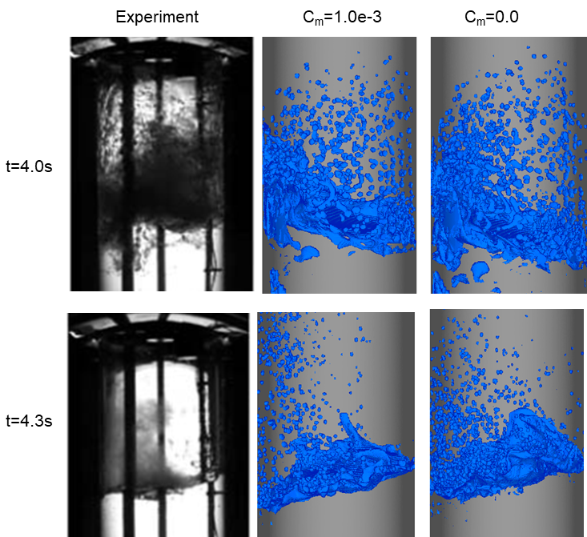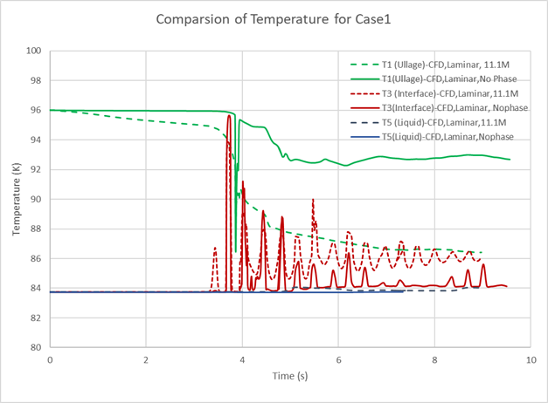
Figure 23. Comparison of interface dynamics (left) and temperature histories (right) between CFD using different mass transfer coefficients (Cm=1.0e-3 and Cm=0), and experiment for Case 1

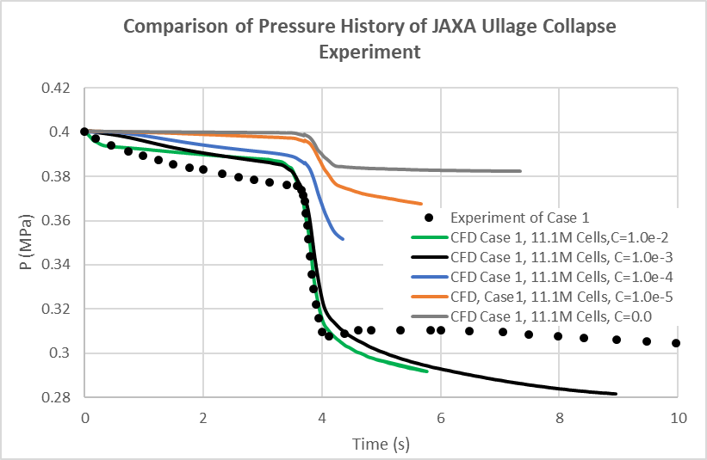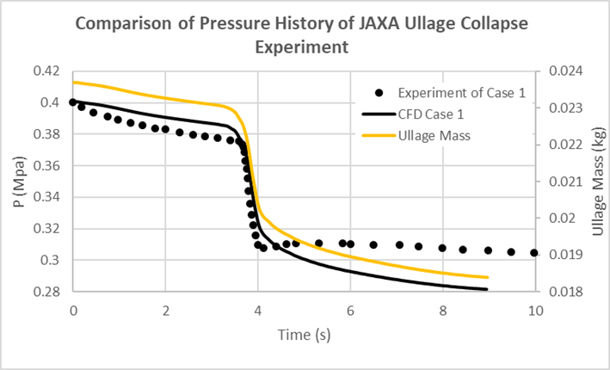
Figure 24. Pressure probe comparison in ullage between CFD with different mass transfer coefficients and experiment(left). Correlation between ullage mass and ullage pressure for C_{m}=1.0e-3 (right)

Figure 24 right also shows the pressure and mass in the ullage for the C_{m}=1.0e-3 case. There is a clear correlation between the mass transferred and ullage pressure. More than half of the mass transfer occurs during the violent sloshing when the sub-cooled liquid is in contact with the ullage.

  - Conjugate Heat Transfer
Another potentially critical parameter in the ullage collapse modeling is the heat exchange from convection in the fluid and conduction in the solid wall. However, one of the unknown simulation input parameters from the experiment is the wall's initial temperature profile. In order to study the sensitivity, the wall's initial temperature is specified uniformly at two limiting conditions: a) the same temperature as the initial ullage high temperature of 91.23K and b) the sub-cooled liquid temperature of 83.7K.

Again, the experimental conditions and simulation models/parameters considered are:
- Mass transfer coefficient: C_{m}=1.0e-3.
- Computational mesh: 11.1 M cells
- Conjugate heat transfer enabled
- Explicit treatment of phase change in the energy equation
- Clausius-Clapeyron for saturation conditions
- Turbulence model: None (laminar flow model)

The pressure probe comparisons are given in Figure 25. In general, there is little sensitivity in the solution to the initial wall temperature. This may be due to the fact the heat exchange time between the solid wall and fluid is rather short. A warmer solid wall tends to lead to a higher post-slosh pressure value, but the pressure drop during the slosh event is not significantly different. The fluid dynamics at t=4.4s are given in Figure 26. The temperature distribution inside the solid indicates the heat exchange between the solid and fluid.
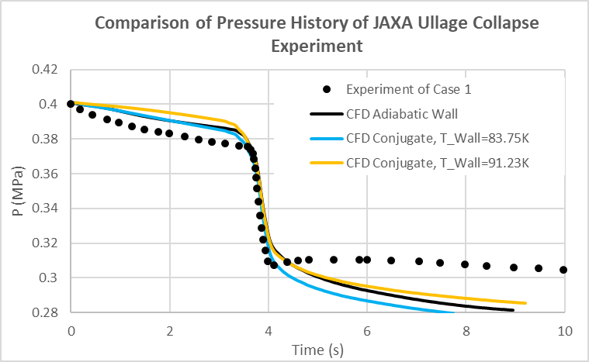
Figure 25. Pressure probe comparison in ullage between CFD with different initial wall temperatures and experiment

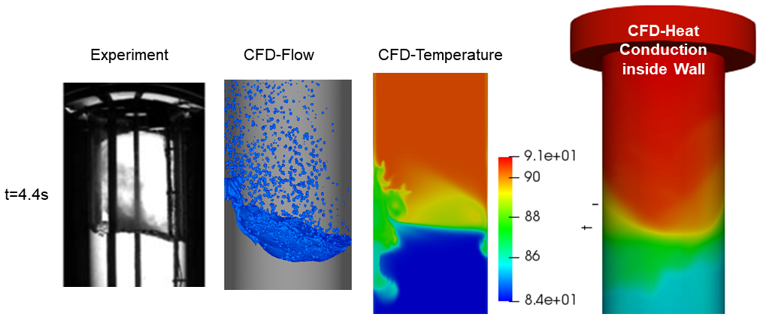
Figure 26. Comparison of interface dynamics between CFD and experiment, and temperature distribution inside the fluid and solid at t=4.4s.

  - Validation of Baseline Conditions for Case 4
Case 4 is different from Case 1 in that there is a thick layer of liquid at the equilibrium saturation temperature with the initial ullage pressure. The distribution of the temperature is given in Table 2 and shown in Figure 1. The simulation models/parameters for this simulation are:

- Mass transfer coefficient: C_{m}=1.0e-3
- Computational mesh: 11.1 M cells
- Adiabatic walls (no conjugate heat transfer)
- Clausius-Clapeyron for saturation conditions
- Explicit treatment of phase change in the energy equation
- Turbulence model considered: None (laminar flow model)

The comparison of fluid dynamics of the interface between the experiment and CFD simulation is shown in Figure 27. In the CFD, the cross-sectional temperature distribution is also plotted. One can see that the interface dynamics are very similar to Case 1, with the sloshing wave breaking around 3.9s and a large number of drops formed from 3.9s to 4.2s. One can also see the submerging of vapor in the liquid. From the temperature distribution, it is clear that the portion of the gas and liquid phases that participate in the slosh event is very much in the same saturated condition region, and there is not much heat and mass transfer exchanged. This is confirmed by the pressure probe comparison in Figure 28, which shows that the pressure changes very little over the simulation. Here, data for Case 1 are also offered to see the difference between the two. The reason for the small pressure increase in the experiment is not understood, but in general, excellent agreement is seen between the present prediction and the experiment.

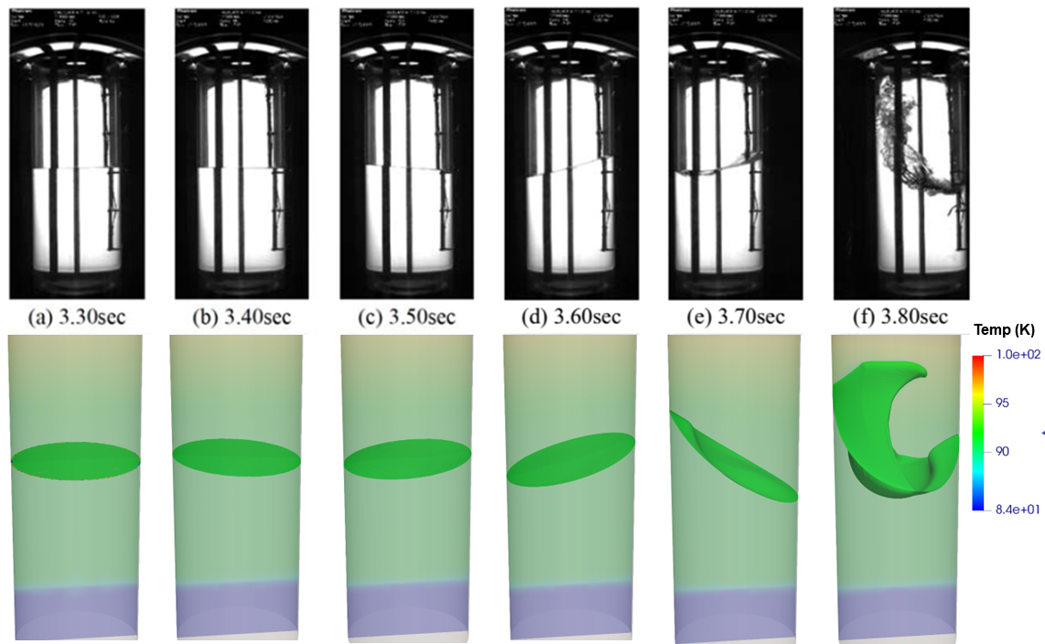

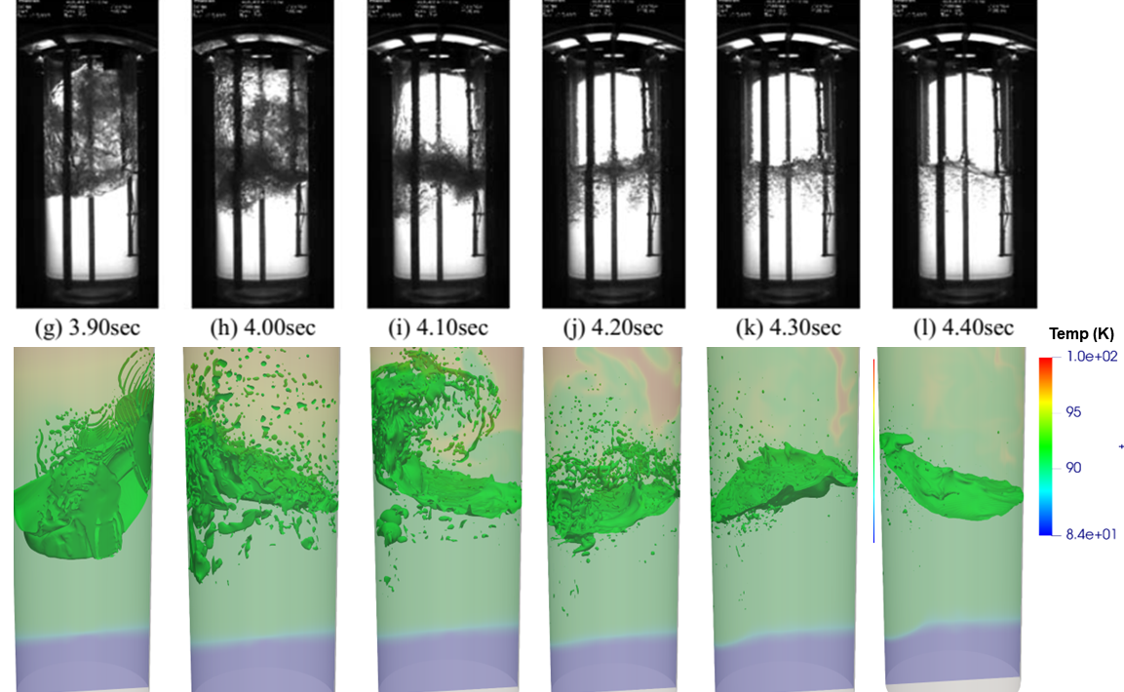
Figure 27. Comparison of interface dynamics between CFD and experiment for Case 4

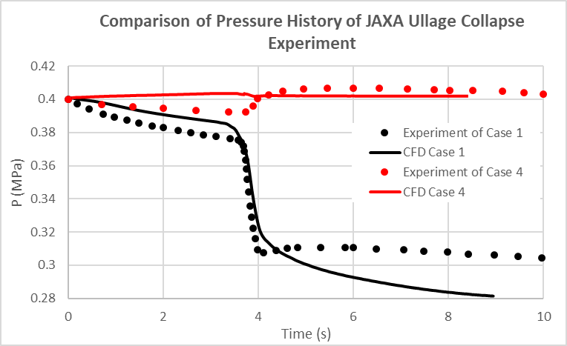
Figure 28. Pressure probe comparison in ullage between CFD with experiment

- Conclusion
This paper documents a model validation effort for the prediction of CFM tank ullage collapse due to violent slosh using the Loci/STREAM-VOF two-phase CFD code developed at NASA MSFC. In the past, the MSFC Propulsion Fluid Dynamics Branch has validated and used the Loci/STREAM-VOF code extensively for propellant slosh applications which are dominated by fluid motion. CFM applications require accurate modeling of heat transfer and thermodynamics. Therefore, detailed validation of those physics is essential to ensure simulation accuracy and success. For the present study, Loci/STREAM-VOF simulations were compared with data from the complex flow images, thermometers in the ullage, at the interface, and inside the liquid, and pressure probe in the ullage in experiments conducted at JAXA [7]. This study investigated several parametric sensitivities and made a number of important observations on the performance of the Loci/STREAM-VOF model for the prediction of ullage collapse:

- With the use of the baseline set of simulation parameters (11.1M cell mesh, laminar viscosity, and mass transfer coefficient C_{m} of 1.0e-3), it is found that:
  - Loci/STREAM-VOF can capture detailed slosh dynamics, including slosh frequency, non-linear slosh damping, and violent surface breakup due to forced acceleration. The comparison of surface shape and small drops formed during large amplitude slosh with experimental imagery shows excellent agreement throughout the sloshing period.
  - Comparison of temperature histories in the ullage, at the gas-liquid interface, and inside liquid also show very good agreement with the experiment. The simulation points to a stratified temperature field inside the liquid near the interface, which is critical to the ullage pressure after the collapse.
  - The predicted pressure drop compares well with the experimental value due to sloshing. The post-slosh pressure is slightly lower than the experimental value. There appears to be some dissipation that leads to the smearing of the stratified temperature field at the interface.
- The sensitivity of the laminar model, k-ω SST, and k-ω SST DDES turbulence models were evaluated. The standard k-ω SST model produces very high eddy viscosity, as high as +300x of laminar viscosity in the interface region. As a result, the slosh-damping value is higher, the same mesh can’t capture as many small droplets, and there is much less stratification of the temperature inside the liquid. The post-slosh pressure is lower than the experiment measurement. On the other hand, the hybrid RANS-LES k-ω SST DDES model improves the prediction capability of the original k-ω SST model, and the temperature and pressure predictions show good agreement with experimental values.
- A grid sensitivity study was conducted with four different mesh sizes from 1.5M to 20M. The capability of STREAM-VOF in resolving small-scale vapor-liquid interface dynamics is well demonstrated. One can clearly see that with the increase in cell number, the smaller drops are captured, and the comparison of interface shape with the flow images and the comparison of ullage pressure drop improves.
- The mass transfer coefficient sensitivity study reveals that mass transfer leads to a warmer gas-liquid interface due to the condensation of ullage vapor. The pressure drop due to the slosh event is sensitive to the mass transfer coefficient for Case 1, where the liquid is very much sub-cooled. The use of C_{m}=1.0e-3, a value previously used for self-pressurization simulations, yields a prediction for the ullage collapse problem consistent with the experimental data. Results with a higher value of C_{m}=1.0e-2 shows the convergence of pressure collapse.
- Conjugate heat transfer analyses were conducted. It is found that the pressure drop during the slosh event is not sensitive to the solid wall conduction. The post-slosh pressure value is dependent on the initial wall temperature, and a warmer wall tends to give a slightly higher post-slosh pressure.
- The baseline simulation parameters also yield good agreement with experimental data for conditions where a thick layer of the liquid is at saturation conditions (Case 4).

Based on these results, the Loci/STREM-VOF model is expected to provide accurate predictions of ullage collapse when following the recommended simulation methodology from the above observations.

Acknowledgments
This study was performed by a Task Order of Jacobs Engineering NASA MSFC ESSCA Contract 80MSFC18C0011. Dr. Ram Ramachandran was the Jacobs ESSCA Task Lead. Helpful discussions with Vinod Venugopalan and Ranjan Mehta of CFDRC, Chintan Patel of Jacobs ESSCA, and Jacob Brodnick of NASA MSFC are greatly appreciated.

References
- H. N. Abramson, “The Dynamic Behavior of Liquids in Moving Containers,” NASA SP-106, 1967.
- S. O. Unverdi, G. Tryggvason, A front-tracking method for viscous, incompressible, multi-fluid flows, Journal of computational physics; Vol. 100, No. 1 pp. 25-37. 1992.
- M. Sussman, E. Fatemi, P. Smereka, S. Osher, An improved level set method for incompressible two-phase flows, Computers & Fluids; Vol. 27, No. 5 pp. 663-80. 1998.
- S. Osher, R. P. Fedkiw, Level set methods: an overview and some recent results, Journal of Computational Physics; Vol. 169, No. 2 pp. 463-502. 2001.
- D. J. Benson, Volume of fluid interface reconstruction methods for multi-material problems, Applied Mechanics Reviews; Vol. 55, No. 2 pp. 151-65. 2002.
- W. J. Rider, D. B. Kothe, Reconstructing volume tracking, Journal of computational physics; Vol. 141, No. 2 pp. 112-52. 1998.
- T. Himeno et al., “Investigation on Phase Change and Pressure Drop Enhanced by Violent Sloshing of Cryogenic Fluid,” AIAA Propulsion and Energy Forum, July 2018, Cincinnati, OH, AIAA 2018-4755.
- J. West, H. Q. Yang, and P. A. Liever, “Development, Verification, and Validation of Parallel, Scalable Volume of Fluid CFD program for Propulsion Applications,” JANNAF Conference paper, 2014.
- E. Luke, and T. George, "Loci: “A Rule-Based Framework for Parallel Multidisciplinary Simulation Synthesis," Journal of Functional Programming, Special Issue on Functional Approaches to High-Performance Parallel Programming, Vol. 15, No.3, 2005, pp. 477-502.
- S. Thakur, J. Wright, J., and W. Shyy, “An Algorithm for Chemically Reacting Flows on Generalized Grids Using a Rule-Based Framework.” 43rd AIAA Conference 2005. p. 0875.
- R. Kamakoti, S. Thakur, J. Wright, W. Shyy, “Validation of a new parallel all-speed CFD code in a rule-based framework for multidisciplinary applications,” 36th AIAA Fluid Dynamics Conference and Exhibit, Paper No. AIAA 2006-3063, San Francisco, CA (June 2006).
- R. S. Mehta and V. Venugopalan and H. Q. Yang, J. Wright and S. Thakur, “Development of a Highly Scalable Volume of Fluid Solver for Arbitrary Polyhedral Grids,” JANNAF Conference paper, 2015.
- H. Q. Yang and J. West, “Nonlinear Slosh Damping Model Development and validation,” JANNAF 62nd JPM/ 10th MSS /8th LPS /7th SPS Joint Subcommittee Meeting, Nashville, TN, June 1-4, 2015.
- S. Lowry, H. Q. Yang, Numerical Model of the Fluid-Structure Interaction in the Space Shuttle External LOX Tank for Modified Baffle Configurations. CFD Research Corporation; 1996.
- K. Pericleous, M. Cross, G. Moran, P. Chow, K. Chan, Free surface Navier-Stokes flows with simultaneous heat transfer and solidification/melting, Advances in Computational Mathematics; Vol. 6, No. 1 pp. 295-308. 1996.
- P. Linstrom, W. Mallard, Editors. NIST Chemistry WebBook, NIST Std. Ref. Database Number 69, NIST, 2005, http://webbook.nist.gov
- H. Q. Yang and J. W. Peugeot, Propellant Sloshing Parameter Extraction from CFD Analysis, Journal of Spacecraft and Rockets, Vol. 51, No. 3 (2014), pp. 908-916.
- H. Q. Yang, R. Purandare, J. Peugeot, and J. West, “Prediction of Liquid Slosh Damping Using a High-Resolution CFD Tool,” 48th AIAA/ASME/SAE/ASEE Joint Propulsion Conference & Exhibit, 30 July-01 August, Atlanta, GA. AIAA-2012-4294, 2012.
- F. R. Menter and M. Kuntz, “A Zonal SST-DES Formulation, ”DES-WORKSHOP, July 2003 (http://cfd.me.umist.ac.uk/flomania/index2.html)
- M. Kassemi, O. Kartuzova . Effect of interfacial turbulence and accommodation coefficient on CFD predictions of pressurization and pressure control in the cryogenic storage tank. J Cryogenics 2016;74:138–53
- O. Kartuzova, M. Kassemi, Y. Umemura, K. Kinefuchi, and T. and Himeno, “CFD Modeling of Phase Change and Pressure Drop During Violent Sloshing of Cryogenic Fluid in a Small-Scale Tank,” AIAA Paper 2020-3794, 2020
- T. Arndt, M. Dreyer, P. Behruzi, M. Winter, A. van Foreest; Cryogenic Sloshing Tests in a Pressurized Cylindrical Reservoir; AIAA Joint Propulsion Conference and Exhibit, AIAA 2009-4860; Denver, Colorado; August 2009
- H. Q. Yang, “Loci/STREAM-VoF Model Validation of Cryogenic Propellant Tank Self-Pressurization” CFM-MODEL-RPT-008, NASA Glenn Research Center, October 2021

Chief Scientist, Aerospace and Defense Solutions, CFD Research Corporation, 6820 Moquin Dr. NW, Huntsville, AL, 35806, USA, AIAA Associate Fellow.
Team Lead, Fluid Dynamics Branch-ER42, George C. Marshall Space Flight Center, AL 35812, AIAA Member

