Haiti Agriculture II
Evaluating the Success of Reforestation Practices in Haiti

Technical Report
Final – August 12th, 2022

Kelli Roberts (Project Lead)
Monique Howlett
Justin Meyer
Rajneesh Sharma

Advisors:
Dr. Marguerite Madden, University of Georgia, Center for Geospatial Research (Science Advisor)
Dr. Kunwar Singh, William and Mary, AidData, Global Research Institute (Science Advisor)

Previous Contributors:
Ilan Bubb
Nohemi Huanca-Nunez
Taylor Simkins

1. Abstract
The Caribbean country of Haiti has an extensive history of deforestation and environmental degradation stemming from French colonization. Over the past 33 years, the Haiti Reforestation Partnership (HRP) and their partners, Comprehensive Development Program (CODEP), have planted approximately 15.52 million trees. However, these efforts lacked scientific guidance to ensure successful forest stand survival. The NASA DEVELOP team partnered with the HRP to create a habitat suitability model (HSM) by using PlanetScope and Sentinel-2 Multispectral Instrument (MSI) imagery. The team also incorporated Landsat 8 and 9 OLI surface temperature, Centre National de L’Information Geo-Spatiale (CNIGS) Airborne Lidar, and ancillary datasets to analyze areas suitable for future reforestation efforts. The habitat model suggested locations with higher forest stand survival based on topography, soil health, climate, and feasibility to access suggested locations. We confirmed the HSM through a cross-analyzation of high enhanced vegetation index (EVI) values. Areas with lower EVI values and higher suitability based on the HSM were suggested for future planting as they lack well-established forest stands but have optimal conditions for growth. Through the creation of the HSM, the team provided the HRP with static maps of high suitability, a 3D printed elevation model, and a guidebook for animators. Additionally, the team provided a structured video highlighting the HRP’s efforts. Effective reforestation and better forest stand survival would help to achieve the goal of securing community food security. This would also serve as a guide to expand planting efforts into other locations and communities.

Key Terms
remote sensing, Habitat Suitability Model (HSM), PlanetScope, Sentinel-2 MSI, forest stand survival, watershed analysis, topography, vegetation indices

2. Introduction
2.1 Background Information
Haiti is near the North American and Caribbean tectonic plate boundary in a seismically active area. Natural disasters such as hurricanes, earthquakes, and landslides can be tied to tectonic plate boundaries (Duarte, J.C. and Schellart, W.P., 2016). Other natural disasters such as floods, droughts, and cyclones are frequent threats according to the World Bank Group’s Climate Change Portal. Alongside natural disasters, the environmental issues experienced in Haiti today are directly bound to its history of colonization and debt repayment. The island, once filled with hardwood forests and vegetation, has been severely deforested. The French mass cleared forests to produce slave plantations for the exportation of sugar cane, coffee, and indigo to produce profit. Many years later, the Haitian Revolution occurred, resulting in the world’s first free black republic. Followed by their independence, a loan repayment of $560 million in today’s USD was paid back to France over several decades (New York Times, 2022). This adversity resulted in further land degradation due to the continued exportation of hardwood. By the 1950s, logging operations increased deforestation even further due to the increased demand for charcoal and firewood production. This intensified poor agricultural practices with a lack of environmental regulation (Williams, 2011). Today, deforestation is an ongoing issue for Haitian citizens. However, the ideas and benefits of reforestation has been generationally instilled into many Haitian agronomists and farmers.

There is a lack of extensive studies on efficiency of reforestation and information about current forest stands in Haiti. One of the main challenges facing an extensive reforestation study is inconsistency in criteria for land cover classification (Southworth and Nagendra, 2009). According to numerous global studies, Haiti is one of the most deforested areas in the world. Some studies have tried to quantify forest stands using remote sensing and refining the classification of tree cover. A highly cited study done by Churches et al. (2014) found a 32.4% tree cover in Haiti based on Landsat data. This estimate was higher than previous international datasets. Another study done by Pauleus and Aide (2020) estimated Haitian forest cover to be 26% in 2000 and 21% in 2015 using Landsat data. Although there are inconsistencies within the studies and estimates for forest cover over the years, they are still higher than international agency studies. Topographic factors are also a vital part in reforestation success. Factors such as higher water availability, cooler northeast exposures, and higher precipitation were found to increase sapling survival rate. Suitability studies on reforestation aid in the continuation of efforts to better gauge what areas are suited for reforestation of targeted tree species.

A study done by Lundi (2012) conducted a suitability and political ecological analysis of bamboo reforestation in Haiti. The research involved conducting a GIS suitability analysis to create reference maps highlighting various land layouts utilizing slope, soil analysis, and hydrology. The study resulted in a suitability analysis map that showcased the best and worst areas in Haiti to reforest specific bamboo species. This term’s project will provide maps to partner organizations on the most suitable areas of various tree species using similar methods. The second part of the study involved political-economic limitations, mirroring the community research done by the DEVELOP team. Lundi found that reforestation challenges in Haiti arise from land ownership historically being informal, pinpointing another limitation discussed by Southworth and Nagendra (2009). Political unrest has made management for such projects challenging as scientific data is often inconsistent.

2.1.3 Previous Term
The previous NASA DEVELOP team conducted a vegetation change analysis over the past 37 years to provide historical context to present-day reforestation efforts in Haiti. Their time series showed a positive EVI trend, pointing to substantial vegetation growth in both the demonstration forest and multiple planting zones, indicating that active reforestation is a factor in the expansion of landscape recovery. Additionally, the team created a habitat suitability model (HSM), finding aspect, temperature, and slope to be the most important environmental predictor variables. Their model demonstrated that there are 49,000 hectares of suitable land for future plantings.

2.2 Project Partners and Objectives
The Haiti Reforestation Partnership (HRP) is responsible for providing resources, information, and aid to communities throughout Haiti. The HRP primarily provides guidance to the Comprehensive Development Program (CODEP), as well as financial and technical support via forestry techniques, financial management, and leadership development. Additionally, they facilitate construction, solar energy, and computer training support. Together, the HRP and CODEP planted over 15.52 million trees, with 12 million successfully surviving throughout the last 33 years (Haiti Reforestation Partnership, 2022). The HRP continued their partnership with NASA DEVELOP to guide micro-level planting operations to address food insecurity using Earth observation data. The second term of the project focused on data from January 2015 to June 2022. The team rebuilt and refined a habitat suitability model to guide silvicultural decisions. Additionally, the team produced a video that highlighted the efforts of the HRP and their partnership with the NASA DEVELOP team to promote the importance of reforestation in local Haitian communities. Utilizing the results from the habitat suitability model, physical large-scale maps were created, printed, and shipped for CODEP ground workers to use directly in the field. The team also created a guidebook for animators to further the technical knowledge of local leaders. Additionally, a 3D printed elevation model was sent to partners to assess accessibility of suitable areas for local workers with limited transportation and resources.

2.3 Study Area
The study area of Fondwa, Haiti, lies southwest of the capital, Port-au-Prince, and north of Jacmel. Based on the planting data from the HRP and the partners’ input on viable areas for future plantings, the team refined the study area from the previous term. The first term’s study area included an estimated 75% of all planting efforts of the HRP, divided into planting areas based on animators, and two control groups. The team eliminated these divisions, as well as the controls, to pivot from gauging past efforts to pinpointing future areas for planting. Our finalized study area included the previous term’s general area with various expansions based on an evaluation of partner needs. This included a Southeastern expansion towards the University of Fondwa and the Jacmel River, introducing a body of water into our analysis (Figure 1). Additionally, the team included a Southwestern expansion to analyze areas of land accessible to our partners that have yet to be utilized. The climate in the area varies between two dry seasons and two rainy seasons. The rainy seasons extend from March to early June, and from August through November. The dry seasons extend from December to February, as well as mid-June to the end of July.

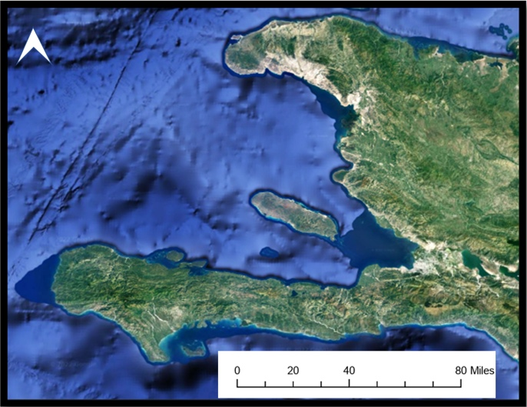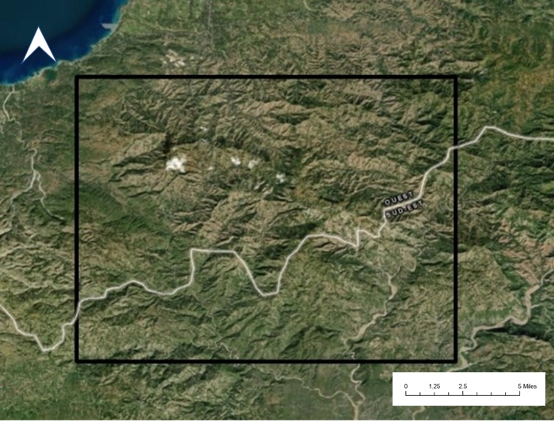
Figure 1. Map of Haiti (left), zoomed in to show the selected study area (right).

3. Methodology
3.1 Data Acquisition
In this project, the team utilized Sentinel-2 Multispectral Instrument (MSI), PlanetScope, and RapidEye imagery to create Normalized Difference Vegetation Index (NDVI), Enhanced Vegetation Index (EVI), and Normalized Difference Moisture Index (NDMI) median composite images in Google Earth Engine (GEE). The team utilized the Digital Chart of the World Server which identified Haiti Administrative Boundaries to provide geographical context to the project. Additionally, the team utilized Landsat 8 OLI and Landsat 9 OLI-2 for surface temperature data and a Centre National de L’Information Geo-Spatiale (CNIGS) digital elevation model (DEM) to complete a watershed analysis, as well as various topographic rasters for the HSM.

Table 1. List of sensors and data products
Platform and Sensor | Parameters | Resolution | Date Range Used | Acquisition Source
Landsat 9 OLI-2 | Surface temperature | 100 m (bands 10 and 11) | October 2021 –June 2022 | USGS Earth Explorer
Landsat 8 OLI | Surface temperature | 100 m (band 10) | July 2021 – June 2022 | USGS Earth Explorer
Sentinel-2 MSI | True color composites (RBG), NDVI, EVI | 10 m | December 2018 – May 2022 | GEE Collections
PlanetScope and RapidEye | RGB, NDVI, EVI | 3 m | January 2015 – June 2022 | Planet Labs
CNIGS Airborne Lidar | Elevation, slope, aspect, roughness, watershed analysis | 1.5 m | January 2014 – December 2016 | OpenTopography
Digital Chart of the World Server | Geographical context | N/A | January 2014 – January 2016 | OpenTopography

3.2 Connecting with the Haitian Community
The team found it imperative to obtain direct input from partners and CODEP animators throughout the second term for better expertise on deliverables. Throughout partner meetings, the team actively sought input from every member of our partner organization. However, the executive director and field specialist of HRP, Michael Anello, was a key correspondent regarding the study area. Michael Anello has been living in Haiti for 12 years, working alongside CODEP animators and locals daily. All the partners were critical to the team across various areas of expertise. The team grew to know if specific roads existed, if areas of the extended study area were accessible by car or only by hiking, stream accessibility, and the protocol for nurseries and reforestation plantings.

Michael stated that satellite data is very different from physical data in the study area. This motivated us to have continuous communication with partners when refining the study area, specifically the direction of expansion in the analyzation of future suitable planting areas. It was also vital for the team to make the physical maps accessible to Haitian animators. The team requested Creole translations for specific words that would be on the static maps, and a list of landmarks that animators were familiar with, such as the University of Fondwa and the CODEP Depot.

HRP supports locals, by providing them with leadership roles to reforest land and build their communities. A team member created a list of interview questions for Michael to ask all CODEP animators during a quarterly meeting. The questions prompted their opinions on Haiti’s history, as well as the concerns, how they envisioned CODEP and Haiti long term, as well as the impact of the NASA DEVELOP partnership. A virtual interview with Michael and an animator named Carlo Cènat was conducted to gather the community viewpoints desired by the team. Cènat spoke on behalf of the CODEP animators, while Michael answered on behalf of HRP. This interview aided in DEVELOP building a connection with Haitian animators. Additionally, it strengthened the production of a highlight video, by providing up-to-date perspectives and background testimonials. Connecting with the partners and the Haitian community inadvertently became the key component of the project's methodology.

3.3 Data Processing
3.3.1 Normalized Difference Vegetation Index (NDVI)
The team utilized NDVI to visualize vegetation health in the study area using Sentinel-2 and PlanetScope imagery. For Sentinel-2 data, clouds were filtered out using the pixel_qa band, clipped to the study area, and restricted to the years 2018 to 2022. An NDVI band was calculated using the following equation (Rouse et al., 1974) where NIR is near infrared (band 8) and Red is visible red light (band 4):

$NDVI = \frac{NIR - Red}{NIR + Red}$ (1)

This NDVI band was added to each image in the collection and the team created a median true color composite image for this time period. The team repeated the process for PlanetScope imagery from the years 2015 to 2022 without cloud filtering, as the images had little to no cloud cover due to Planet’s collection process.

3.3.2 Enhanced Vegetation Index (EVI)
The team calculated EVI to visualize vegetation presence while accounting for atmospheric disturbances. The EVI utilizes the blue light band, “C” coefficients for atmospheric resistance, and an “L” value for canopy adjustments. The same process was used to create a Sentinel-2-derived EVI band using the following equation where NIR is near infrared (band 8), Red is visible red light (band 4), and Blue is visible blue light (band 2) (Huete et al., 2002):

$EVI = \frac{NIR - Red}{\left(NIR + C1*Red -C2*Blue+L\right)}$ (2)

The standard coefficients used by the Moderate Resolution Imaging Spectroradiometer (MODIS) were applied where L = 1, C1 = 6, C2 = 7.5, and G = 2.5. This process was then repeated for PlanetScope imagery from the years 2015 to 2022.

3.3.3 Normalized Difference Moisture Index (NDMI)
The team calculated NDMI for Sentinel-2 imagery to visualize vegetation moisture content as a replacement for precipitation data. The last term’s team found the precipitation data lacking for recent years and too coarse for intended usage. An NDMI band was added to each image using near infrared (band 8) and short wave near infrared (band 11) through the equation below (Lastovicka et al., 2020):

$NDMI= \frac{NIR - SWIR}{NIR + SWIR}$ (3)

This NDMI band was added to each image in the collection and the team created a mean true color composite image for the same time period as both NDVI and EVI. This process was not repeated for PlanetScope imagery due to a lack of short wave infrared bands in their imagery. This process was repeated for mean images from 2018-2022.

3.3.4 Surface Temperature
Images from Landsat 8 and 9 containing the median value for each pixel were downloaded for each month dating from July 2021 to June 2022. Production of surface reflectance (SR) land surface temperature (LST) data required the input of Thermal Infrared 1 (TIRS1), band 10 of Landsat 8 and 9 and then processed from original digital number values. Landsat 8 images were processed through Google Earth Engine and converted into top-of-atmosphere (TOA) via Equation 4 (Kafer et al., 2019):

$TOA= M_{L}*Q_{CAL}+A_{L}$ (4)

Coefficients used for calculating TOA are $M_{L}$as the band specific radiance multiplier, $Q_{CAL}$ representing band 10 (TIRS1), and $A_{L}$ as the band specific additive rescaling factor. All coefficients are in the metadata associated with Landsat image downloads. This converts the Landsat 8 TIRS1 band to top of atmosphere (TOA). Next, the team converted from TOA into brightness temperature values (Kafer et al., 2019; Equation 5).

BT = $\left(\frac{K_{2}}{\left(\ln\left(\frac{K_{1}}{L}\right)+1\right)}\right)-273.15$(5)

For the above equation, K2 represents the K2 band-specific thermal conversion constant, K1 represents the K1 band specific thermal conversion constant, and L is the previously calculated temperature raster. Then, using equation 1, band 5, and band 4, the team calculated NDVI. The proportion of vegetation was then calculated${(P}_{V})$ using NDVI and minimum and maximum NDVI values (Kafer et al., 2019; Equation 6).

$P_{V}=Square\left(\frac{NDVI-NDVI_{MIN}}{NDVI_{MAX}-NDVI_{MIN}}\right)$(6)

The team then calculated emissivity ($ε)$ with equation 7 (Kafer et al., 2019):

$ε=0.004* P_{V}+0.986$ (7)

This $P_{V}$ equals the previously calculated proportion of vegetation. 0.986 is the equation correction value. Finally, Landsat 8 LST was calculated with equation 8 (Kafer et al., 2019):

$LST=(\frac{BT}{\left(1+\left(0.00115*\frac{BT}{1.4388}\right)*\ln\left(ε\right)\right)})$ (8)

To convert Landsat 9 imagery to LST the team simply downloaded the SR corrected TIRS1, thermal infrared, band 10 image collection and performed equation 9 with the ST_B10 band (Vermote et al., 2022).

$Landsat 9 LST=\left(1.8*\left(\left(0.00341802*ST_{B10}+149.0\right)-273.15\right)+32\right)$ (9)

Next, the team took the LST imagery and divided it into the wet seasons and dry seasons for our study area.

3.3.5 Elevation, Slope, Aspect
Supported by the results of the previous DEVELOP team’s work and other supporting literature, the team utilized topography as a top criterion for habitat suitability. Lower elevations tend to hold water for a longer period compared to relatively higher elevations (Duane et al., 2008). Aspect influences plant growth through the availability of moisture and sunlight. In the northern hemisphere, south facing slopes receive more sunlight, thus creating higher heat and drier conditions. The slope determines the ease of planting as it is difficult to access and plant in steep locations. Aspect influences the amount of sunlight, influencing heat and water stress for plant growth. The team used a DEM raster to create slope and aspect using the “Slope” and “Aspect” tools in ArcGIS Pro.

3.3.6 Roughness
Roughness shows the abrupt changes in elevation by giving higher value to steep, uneven locations and giving lower value to relatively flat locations. Roughness was also derived from the DEM raster. The team used a 3x3 cell size to calculate the mean, minimum, and maximum elevation of the center pixel. The mean, minimum, and maximum rasters were fed into the equation below to create a roughness raster (Mukherjee and Singh, 2020; Equation 10):
$R = \frac{\left(mean - \min{}\right)}{\left(\max{} - \min{}\right)}$ (10)

3.4 Data Analysis
3.4.1 Habitat Suitability Model
Our model utilizes variations in topography, weather, and soil properties to suggest habitat suitability. The effects of these factors have been well reviewed in the literature (Gogol-Prokurat, 2011). The previous term’s results solidify the effects of these factors on tree growth. They found surface temperature as one of the main predictors for suitable habitat. Utilizing information from our research and the previous term’s findings, our model delineates locations with optimal tree growth conditions. One of the main tree species used for reforestation in Haiti is eucalyptus. Other trees species such as mango and Haitian catalpa are used for reforestation efforts to focus on the local community’s need for increased food supply and lumber exportation. The team derived the optimal environmental and climatic conditions indicated through various literature sources to inform habitat suitability.
3.4.2 Temperature
Optimum temperature for eucalyptus growth was found to be between 64° to 72°F in South America. However, the minimum annual temperature required for growth was 43°F, while the maximum was 88°F (Queiroz et al., 2020). Assuming similar temperature constraints for Haiti, the team filtered out places with average monthly temperatures below 43°F or above 88°F, as they were limited suitability zones. Combining the temperature ranges for eucalyptus and mango resulted in an optimum range of 64°F - 84°F. Additionally, any outlier values above 100°F were removed to improve accuracy for the HSM.

3.4.3 Slope and Aspect
The team classified slope values into high and low slope. Low slope included slopes less than 20% and were classified as 1. High slope included locations with slopes higher than 35% and were classified as 0. The high slope raster was given a negative weight in the HSM. North facing slopes were given a weight of 1 due to their ability to retain moisture while remaining relatively cool (Måren et al., 2015). South facing slopes were given a weight of 0.

3.4.4 Watershed Analysis
The team conducted a watershed analysis using ArcGIS Pro to develop stream buffers for the habitat model. Using the “hydrology” toolbox, the DEM was the foundation for the analysis. From the DEM, the “fill” tool was used to create a depressionless DEM to account for any small imperfections in data. Next, the team used the “flow direction” and “flow accumulation” tools to visualize water movement along the elevation gradient using the “Deterministic 8” method, a standard method for this process (Al & Merkel, 2011). Based on flow accumulation, stream orders were developed to show areas with water movements from multiple directions. This was done using the “steam order tool” to get areas with relatively higher ground moisture levels based on topography. Then, these streams were buffered to 500 m to extract places with higher water availability compared to surrounding areas (Figure B1).

3.4.5 NDMI
The team used satellite imagery to derive NDMI to delineate areas with higher moisture (U.S. Geological Survey, 2022). Next, the wetness frequency of the past 5 years was used to delineate areas with higher water availability over the years in the HSM model. NDMI differs from topography-based water catchment analysis as it is based on reflected surface spectra rather than elevation. There was overlap between the two which re-confirmed that the water availability was based on elevation as well as spectral data.

NDMI ranges from –1 to 1; values less than 0 were classified as dry locations and above 0 as relatively wet locations. The team reclassified the rasters to get dry and wet maps classified as 0 and 1, respectively. Then, the 0 and 1 maps were added together to create a single raster showing the number of years a location was wet in the last five years. Its range was 0 to 5; 0 being dry in all 5 years and 5 being wet in all 5 years.

3.4.6 Roughness
When overlaying the CODEP planting zone data over our roughness raster, the areas with no roughness values lined up with the zoning boundaries of the animators, confirmed by the HRP. Watersheds align with less rugged areas, the roughness model, and the steepness of the topography based on feedback from their GIS specialist’s observations collected during ground visits.

3.4.7 Road Buffer
The HRP expressed a desire to specify areas of interest stemming from the Jacmel road, Route 4, to show suitability within reachable distances. Buffers at distances of 3, 5, and 7 miles were created encompassing areas of high and low suitability. Showcasing suitability within these buffers allowed the HRP to envision possible areas of expansion and coordinate planting efforts.

3.4.8 Weighing Our Model
All factors discussed earlier were used to create the habitat suitability model, except for the EVI, which will be used in our confirmation. Using a weighted model allowed easy-to-follow and intuitive understanding of controls of factors used for the HSM. The relative weights of these factors were decided based on the previous team’s findings, partner input, and extensive literature review. All variables were given equal weights based on their range of values. Original raster values were reclassified in order to avoid a bias of a heavier weight when assembling the HSM.

Table 2. List of variables, weights, and justifications
Parameter | Weight | Range | Justification
Aspect | 1 | North facing vs  South facing | HRP confirmed that north facing slopes contained higher moisture content and residual forests
NDMI | 0.2 | 0 years moisture to 5 years moisture | Used in place of precipitation due to the previous team’s findings, eucalyptus thrives in high soil moisture
Roughness | -1 | No Roughness to High Roughness | Strong correlation with CODEP animator planting zones, confirmed by our partners corresponding to watersheds
Slope | 1 | 0° to 20° and 35° to 90° | HRP indicated the flatter an area is, the easier it is to grow on and areas with steep slopes reduce viability of plant growth
Stream Buffer | 1 | 500 meters buffer for 1 and 0 for outside of buffer | Buffers correlate with higher vegetation; HRP confirms landowners compete to grow in these areas
Temperature | 1 | 64 to 84 Fahrenheit | Previous term’s model and literature indicate optimal temperature ranges for eucalyptus and mango tree growth; HRP supports the climatic patterns of the southern parts of the study area

3.4.9 Refining our Model Through Raster Reclassification
All variables were given equal weights and ranges between –1 to 1. Equation 11 was used in the ArcGIS Pro raster calculator to create the HSM Suitability Score. The rasters for NDMI, SOC and roughness had 5 classes, ranging from 0 to 5. These rasters were multiplied by 0.2, creating a new range of 0 to 1. Similarly, the other rasters were classified as 0 and 1. Then, all rasters were either added or subtracted based on their effect on habitat suitability as described in the previous term’s findings and this term’s research.

$HSM Suitability=North Eastness+\left(SOC*0.2\right)+\left(NDMI*0.2\right)+ LS9_{LST}+ LS8_{LST}+ Low Slope+Buffers-\left(Roughness*0.2\right)-High Slope$ (11)

3.4.10 Reclassification of Model
The HSM score for our study site ranged from -4.694 to 6.8. Figure 5 shows the spread, as well as the quantile distribution around the mean HSM score. The team used the top third quantile (~3.2 - 6.8), shown in yellow, as a very high suitability class. Next, the top second quantile, shown in orange (~2.2 - 3.2), is a high suitability class. The first quantile, shown in pink (~1.3 - 2.2), was designated as medium suitability. The purple (~0.35- 1.3) represented the lower second quantile, designated as low suitability. Finally, the black (-4.7 ~ 0.35) represents the areas with very low suitability.

3.4.11 Confirming Our Model
Both an NDVI and EVI analysis were done in Google Earth Engine on high resolution PlanetScope imagery as well as Sentinel-2. The team opted for the Planet imagery due to its high spatial resolution of 3 meters.
Individual EVI and NDVI values were plotted in a chart on Google Earth Engine. The team found average EVI values to be slightly higher than NDVI overall. This is due to EVI's ability to account for additional corrections for atmospheric disruption and adjust for canopy height, lowering the number of possible factors skewing vegetation presence values. Overall, the team opted to utilize EVI in confirming the model. This was not used as a variable in the HSM but was a point of comparison to speak to accuracy.

The team chose 100 randomized high EVI points from our median composite image to use as a baseline reference for vegetation presence levels. Our model was based on investigating the correlations of all other factors to these EVI points. The HSM labelled almost 46 points out of hundred as very high and high habitat suitability (Table 1), however as these classes are based on third and second top quantiles, they represent ~ 16% of study area. Another 27 points were labelled as medium suitability, and only 27 points were labelled as low and very low suitability according to the HSM. This could be because lots of random high EVI points are in northeast side of the study site (Figure 6), which have high EVI for the point location but surrounding areas have lower EVI.

Table 3. The HSM classes of the 100 random high EVI points on the median composite EVI image.
_{HSM Class} | _{Very High} | _{High} | _{Medium} | _{Low} | _{Very Low}
_{High EVI Points} | ₂₁ | ₂₅ | ₂₇ | ₁₈ | ₉

3.4.12 Creation of Maps
The team drafted maps to print and ship to the Haiti Reforestation Partnership. Utilizing the HSM raster and ArcGIS Pro, the team overlayed stream buffers and road feature layers, as well as landmark symbols provided by the HRP. The map layouts were created with a scale bar, legend, and north arrow. Additionally, Haitian creole translations were included to assist in accessibility and enhance the connectivity of the HRP and CODEP ground workers. After exporting high-resolution PDF maps, the files were delivered to a large-scale map printer to be printed on waterproof vinyl. At 24 by 36 inches each, the final products were exceptionally detailed and easy to read. Additional maps were created to address partner needs, focusing on specific areas of suitable land near the Grande Rivière de Jacmel and the southwest corner of the study area. The HRP also requested focus on the largest continuous section of highly suitable land. The team incorporated a color-blind friendly color scheme called “Inferno” in ArcGIS Pro, which showed the most variation and contrast in suitable and not suitable areas.

3.4.13 Creation of 3D Printed Model
To additionally support CODEP ground workers, 3D printed models were created; derived from the CNIGS DEM data. Using the DEM raster, the team exported a “.STL” file from QGIS with the help of a plugin called “DEMto3D”. To make changes and edit the 3D file, Fusion 360 CAD software was used in combination with Ultimaker Cura to create the “.gcode” file suitable for 3D printing. This “.gcode” file was then printed via a Creality Ender 3 S1 printer using a standard PLA filament.

3.4.14 Creation of Animator Guidebook
A guidebook was created for partners and CODEP animators explaining habitat model predictor variables. The guidebook discusses variables such as temperature, slope, aspect, roughness, soil organic carbon (SOC), stream buffer, road buffer, NDMI, and EVI. Each one includes a photo of what the variable looks like in ArcGIS Pro as a single layer, as well as the purpose behind its use. The book also provides background information including the definition of an HSM, its focus, the software used to create one, and how it can benefit partners and animators. The descriptions provided are short with limited scientific jargon to increase accessibility and give ease in translations for partners to Creole and French speaking animators.

4. Results and Discussion
4.1 Analysis of Results
4.1.1 Results of Habitat Model
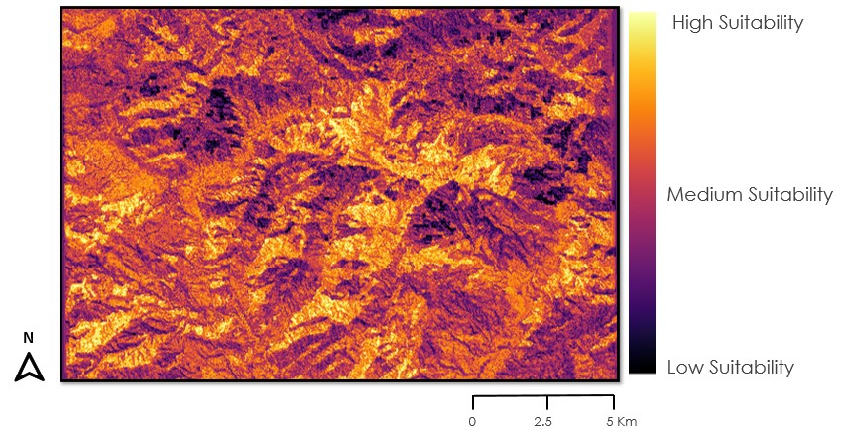
Figure 4. HSM model score distribution over our study site. Raster represented as a stretch.

Overall, the team found the top environmental variables for high suitability to be temperature and proximity to streams. Additionally, high SOC values paired with high NDMI were found to indicate mid to high suitability. When it comes to low suitability, high roughness values and elevation were the main culprits, impacting both accessibility and viability (Figure 4). When looking at specific suitable areas, our model showed the areas along the Jacmel River, as well as the entire Southwestern portion of the study areas as the highest suitability. There were also pockets of highly suitable land in the Northwestern corner, as well as scattered throughout other portions of the study area (Figure 5).

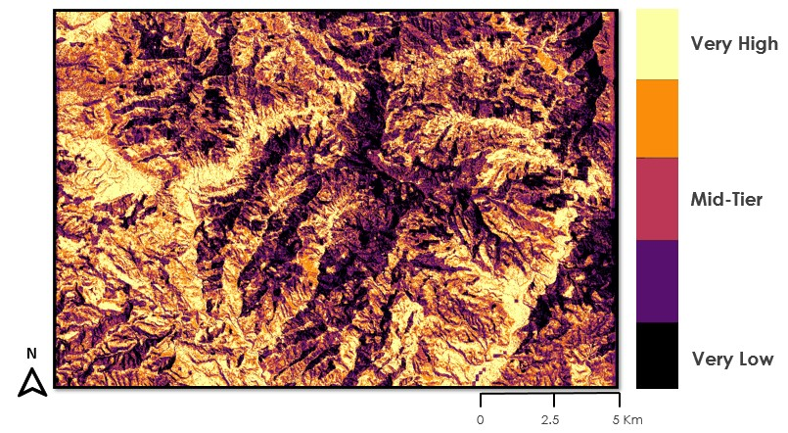
Figure 5. Map showing the reclassified HSM into 5 classes based on HSM scores.

The team found the best areas for mango trees to be those with low-mid EVI and higher suitability, based on their optimal growing conditions. The combination of lower EVI and high suitability points to usable land that is being under-utilized. This is the best option for the success of fruit tree growth. Areas of low-mid EVI and lower suitability are best to plant Haitian catalpa due to its ability to survive in rugged land. Eucalyptus would be best planted in areas with low-mid EVI and middle suitability. This is a combination of prioritizing higher suitability land for fruit trees, as well as eucalyptus's ability to survive in suitable, but not optimal, land.

4.1.2 Static Maps
Our final printed static maps included key locations noted by the HRP, as well as a 3-mile buffer stemming from the Jacmel road (Route 4). Areas of light yellow are very highly suitable areas indicated as “bon tèren”, or good terrain. Areas of low suitability are indicated as “move tèren”, or bad terrain (Figure 6).
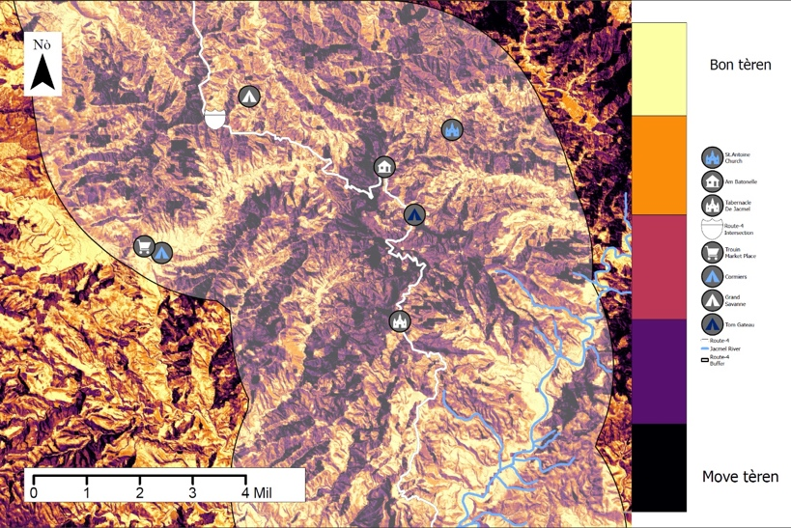
Figure 6. This is a map of the general study area showing the high and low suitability areas throughout Haiti.

4.2 Future Work
The DEVELOP team recommends the HRP continue with vegetation monitoring in regular increments of two to five years to monitor impacts of reforestation efforts and the effects of climate variation. The team also suggests that static maps used by ground workers be updated every five years and that static nursery maps be created and printed seasonally. In doing so, the ground workers will be exposed to more accurate data, and this will alleviate confusion as reforestation efforts expand. Additionally, the HRP and ground workers may choose to focus on areas outside of the current study area requiring the creation or rectification of static maps. Finally, the team suggests pinpointing a high-resolution precipitation dataset for any future habitat modeling.

4.2.1 Limitations
The team found four general limitations. First, eucalyptus comprises of around 80% of the planting efforts of our partners. On average, it exhibits lower NDVI and EVI values, skewing the results of most vegetation analyses. Therefore, values could be higher than what is shown. Second, there was a lack of data for Sentinel-2 dating back to 2018 for our study area. This was likely due to a catalog error in Google Earth Engine. Third, there is a lack of high-quality precipitation data in our study area, especially in recent years. The available precipitation data had a spatial resolution of 1 km, thus leading to the use of NDMI as a proxy. The study site did not have a substantial body of water, so we lacked a complete watershed. Due to this, the team relied on stream networks to highlight depressions and valleys where higher moisture levels can be retained by soils for longer periods of time.

4.2.2 HSM Limitations
While reclassifying our model made it highly intuitive, this method takes away details that may be relevant to understand the suitable habitat of tropical tree species. Another limitation of our model is the lack of ability to account for the combined effect of two variables. The model assumes variables are mutually exclusive, which may not be the case on the ground. However, this would have complicated the model, the interpretation by our partners, and the use of it as an educational tool. Additionally, the confirmation method of our model is very conservative and discredits the model’s performance. This is because there is limited high and very high suitability areas indicated by placing the EVI into quantiles, transforming the data from continuous to categorical quantiles loses detail. Out of 100 points, 46 high EVI points are in areas designated in very high and high suitability classes. These two classes combined represent only around 16% of the total study area. The quantile methods for the HSM classification were used due to time constraints and thus represents a conservative confirmation of our model.

5. Conclusions
The NASA DEVELOP team created a habitat suitability model that was able to pinpoint and highlight the most suitable areas for future plantings on a micro-level. The HSM resulted in hard copy maps for partners to distribute amongst ground workers in Haiti, bridging the gap between the local and scientific communities. Alongside hard copy maps, a guidebook was created for animators to clarify the HSM variables and methodology. A 3D printed DEM of the study area was also provided to assist ground workers with navigation and planning. Additionally, a video highlighting the project provided a resource for informing HRP’s audience on their ongoing reforestation efforts, as well as the importance behind their work and the partnership with NASA DEVELOP. This project aided the partners in giving agency to Haitian citizens to make long term impacts on their community. End products will be utilized to strengthen relations with Haitian communities, improve resources, and support education for future generations.

6. Acknowledgments
The NASA DEVELOP team would like to thank Dr. Marguerite Madden, Dr. Kunwar Singh, and Sarah Payne. As the science advisors and graduate fellow for the Georgia node, they provided mentoring and guidance throughout the extent of this project. The team also would like to thank our partners, the Haiti Reforestation Partnership (HRP). This project was supported by information and advice from Michael Anello, Hunter Brown, Bill Hathaway, and Jamie Rhoads, as well as all the Animators and workers who have put in countless years of labor into reforesting their local land. This material contains modified Copernicus Sentinel data (2018-2022), processed by ESA. Any opinions, findings, and conclusions or recommendations expressed in this material are those of the author(s) and do not necessarily reflect the views of the National Aeronautics and Space Administration. This material is based upon work supported by NASA through contract NNL16AA05C.

7. Glossary
Animators – local Haitian group leaders that oversee groups of planting efforts
Deterministic 8 method – The direction of flow is determined by the direction of steepest descent, or maximum drop, from each cell
Digital Elevation Model (DEM) – a representation of the terrain’s surface excluding trees, buildings, and any other surface objects
Earth observations – Satellites and sensors that collect information about the Earth’s physical, chemical, and biological systems over space and time
Google Earth Engine (GEE) – a cloud-based geospatial analysis platform
Habitat suitability map – used to predict the distribution of a species from environmental data and occurrence records
Landsat 8 – a satellite launched in 2013 that collects images of Earth on a 16-day repeat cycle
Landsat 9 – a satellite launched in 2021 that collects images of Earth on a 16-day repeat cycle
Multi-spectral Imaging Mission (MSI) – an instrument aboard Sentinel-2 that measures Earth’s reflected radiance in 13 spectral bands
Normalized Difference Vegetation Index (NVDI) – an index that differentiates between visible and near-infrared reflectance to serve as a proxy for vigor of vegetation in an area
Normalized Difference Moisture Index (NDMI) – an index that serves as a proxy for vegetation water content
Operational Land Imager (OLI) – an instrument aboard Landsat 8 that provides two new spectral bands of deep blue visible designed for water resources and an infrared for detection of cirrus clouds
Quantile – a threshold for the range of a probability distribution into continuous intervals with equal probabilities
Roughness – the degree of irregularity of the surface
Silviculture – the growing and cultivation of trees
Sentinel-2 – a pair of satellites launched in 2015
Stand survival analysis – statistical method for investigating tree population within an area
Strahler order – All links without any tributaries are assigned an order of 1 and are referred to as first order and the stream order increases when streams of the same order intersect Watershed analysis – analyzing the overall flow of water over a topographic area

8. References
Al-Muqdadi, S. W., and Merkel, B. J. (2011). Automated watershed evaluation of flat terrain. Journal of Water Resource and Protection, 3(12), 892–903. https://doi.org/10.4236/JWARP.2011.312099
Churches, C.E., Wampler, P.J., Sun, W., Smith, A.J. (2014). Evaluation of forest cover estimates for Haiti using supervised classification of Landsat data. International Journal of Applied Earth Observation and Geoinformation, 30, 203-216. https://doi.org/10.1016/j.jag.2014.01.020
Duarte, J.C., and Schellart, W.P. (2016). Introduction to plate boundaries and natural hazards, Geophysical monograph series. (1st ed. Vol. 219). John Wiley and Sons. https://doi.org/10.1002/9781119054146.ch1
Gogol-Prokurat, M. (2011). Predicting habitat suitability for rare plants at local spatial scales using a species distribution model. 21(1), 33–47. https://doi.org/10.1890/09-1190.1
HaitiData, The World Bank. (2021). Haiti Digital Terrain Model 2014 – 2016. Distributed by OpenTopography. https://doi.org/10.5069/G9GX48R8
Haiti Reforestation Partnership. (2022). “Fact sheet Haiti Reforestation Partnership”. https://haitireforest.org/wp-content/uploads/2020-Fact-Sheet-.pdf
Huete, A., Didan, K., Miura, T., Rodriguez, E.P., Gao, X., and Ferreira, L.G. (2002). Overview of the radiometric and biophysical performance of the MODIS vegetation indices. Remote Sensing of Environment, 83(1-2), 195–213. https://doi.org/10.1016/S0034-4257(02)00096-2
Hughes, R. M., Kaufmann, P. R., and Weber, M. H. (2011). National and regional comparisons between Strahler order and stream size. Journal of the North American Benthological Society, 30(1), 103–121. https://doi.org/10.1899/09-174.1
Duane, W. J., Pepin, N. C., Losleben, M. L., Hardy, D. R., and Pepin M L Losleben, N. C. (2008). General characteristics of temperature and humidity variability on Kilimanjaro, Tanzania. Arctic, Antarctic, and Alpine Research, 40(2), 323–334. https://doi.org/10.1657/1523-0430(06-127)[DUANE]2.0.CO;2
Käfer, P. S., Rolim, S. B. A., Iglesias, M. L., da Rocha, N. S., and Diaz, L. R. (2019). Land surface temperature retrieval by LANDSAT 8 thermal band: Applications of laboratory and field measurements. IEEE Journal of Selected Topics in Applied Earth Observations and Remote Sensing, 12(7), 2332–2341. https://doi.org/10.1109/jstars.2019.2913822
Landsat Missions. (n.d.). Normalized Difference Moisture Index. United States Geological Survey. https://www.usgs.gov/landsat-missions/normalized-difference-moisture-index
Lastovicka, J., Svec, P., Paluba, D., Kobliuk, N., Svoboda, J., Hladky, R., and Stych, P. (2020). Sentinel-2 data in an evaluation of the impact of the disturbances on forest vegetation. Remote Sensing, 12(12), Article 1914. https://doi.org/10.3390/rs12121914
Lundi, D. (2012). A tree grows in Haiti: A suitability and political ecological analysis of potential bamboo reforestation in Haiti [Unpublished master’s thesis]. The University of Texas.
Måren, I. E., Karki, S., Prajapati, C., Yadav, R. K., and Shrestha, B. B. (2015). Facing north or south: Does slope aspect impact forest stand characteristics and soil properties in a semiarid trans-Himalayan valley? Journal of Arid Environments, 121, 112–123. https://doi.org/10.1016/j.jaridenv.2015.06.004
Mukherjee, I., Singh, U. K. (2020). Delineation of groundwater potential zones in a drought-prone semi-arid region of east India using GIS and analytical hierarchical process techniques. CATENA, 194, Article 104681. https://doi.org/10.1016/J.CATENA.2020.104681
Murray, G. F. (1987). The Domestication of Wood in Haiti: A Case Study in Applied Evolution. In R. M. Wulff and S. J. Fiske (Eds.), Anthropological Praxis: Translating knowledge into action (pp.1-10). Avalon Publishing. https://doi.org/10.4324/9780429043628
Nagourney, E. (2022, May 20). 6 Takeaways About Haiti’s Reparations to France. The New York Times. https://www.nytimes.com/2022/05/20/world/americas/takeaways-haiti-reparations-france.html
Porter, C., Méheut, C., Apuzzo, M., Gebrekidan, S. (2022, May 20). The Root of Haiti’s Misery: Reparations to Enslavers. The New York Times. https://www.nytimes.com/2022/05/20/world/americas/haiti-history-colonized-france.html
Queiroz, T. B., Campoe, O. C., Montes, C. R., Alvares, C. A., Cuartas, M. Z., and Guerrini, I. A. (2020). Temperature thresholds for eucalyptus genotypes growth across tropical and subtropical ranges in South America. Forest Ecology and Management, 472, Article 118248. https://doi.org/10.1016/J.FORECO.2020.118248
Rouse, J. W., Haas, R. H., Schell, J. A., and Deering, D. W. (1974). Monitoring vegetation systems in the Great Plains with ERTS. NASA, 1(A). Retrieved March 23, 2022 from https://ntrs.nasa.gov/citations/19740022614
Skolmen, R.G., Ledig, F.T. (n.d.) Eucalyptus globulus Labill. USDA Forest Service Southern Research Station. Retrieved June 29, 2022, from https://www.srs.fs.usda.gov/pubs/misc/ag_654/volume_2/eucalyptus/globulus.htm
Sprenkle-Hyppolite, S.D., Latimer, A.M., Young, T.P., and Rice, K.J. (2016). Landscape factors and restoration practice associated with initial reforestation success in Haiti. Ecological Restoration 34(4), 306-316. https://doi.org/10.3368/er.34.4.306
Strahler, A. N. (1957). Quantitative analysis of watershed geomorphology. Eos, Transactions American Geophysical Union, 38(6), 913–920. https://doi.org/10.1029/TR038i006p00913
Southworth, J. and Nagendra, H. (2009). Reforestation: Challenges and themes in reforestation research. Reforesting landscapes. Landscape series, vol 10. Springer, Dordrecht. https://doi.org/10.1007/978-1-4020-9656-3_1
USGS EROS Archive – Landsat Archives (2020). Landsat 8-9 OLI/TIRS Collection 2 Level-2 Science Products [Data set]. US Geological Survey. https://doi.org/10.5066/P9OGBGM6
USGS EROS Archive – Landsat Archives (2018). Landsat 8 OLI/TIRS Level-2 Data Products – Surface Reflectance [Data set]. US Geological Survey. https://doi.org/10.5066/f78s4mzj
Vermote, E., Cook, M., Zhu, Z., and Woodcock, C. (2022, March 24). Landsat 8-9 Collection 2 (C2) Level 2 Science Product (L2SP) Guide. USGS.
Williams, V.D. (2011). A case study of desertification in Haiti. Journal of Sustainable Development 4(3), 20-31. https://doi.org/10.5539/jsd.v4n3p20
World Bank Group. (n.d.). Climate Projections Haiti [Data set]. https://climateknowledgeportal.worldbank.org/country/haiti/climate-data-projections

9. Appendices

Appendix A

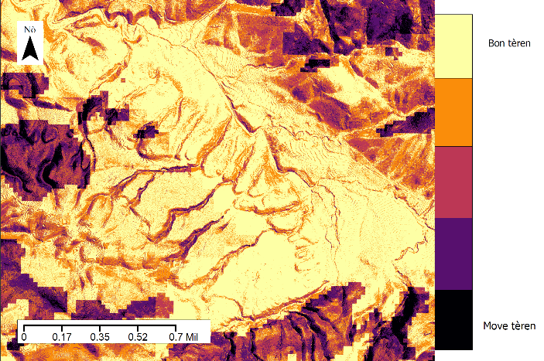
Figure A1. Additional maps provided to partners: map of bottom half of Grande Rivière de Jacmel (left), and map of largest continuous highly suitable area (right).
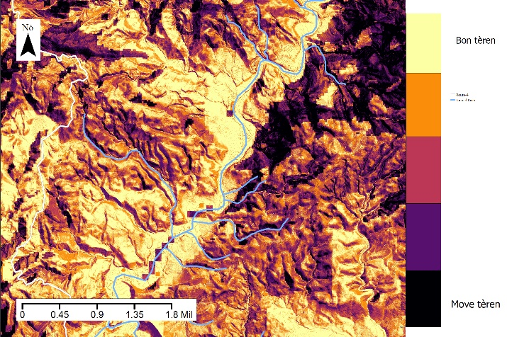
Appendix B

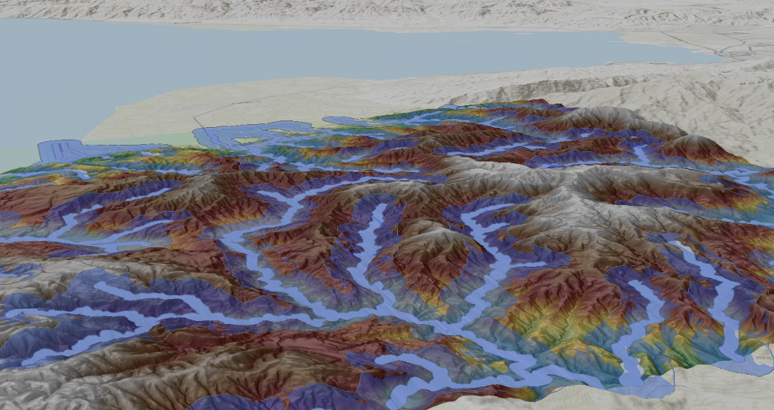
Figure B1. Hillshade of digital elevation model of the study site; stream network in bright blue and 500 m buffer in dark blue color.

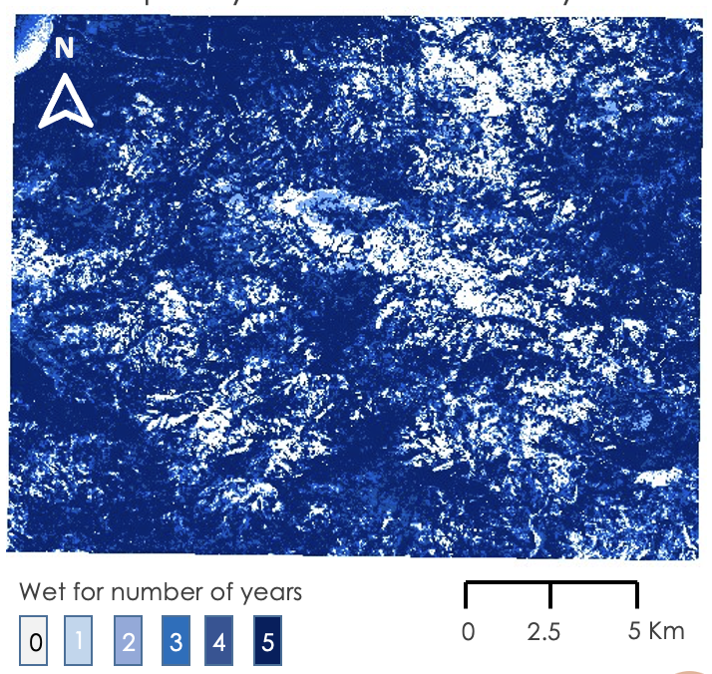
Figure B2. Frequency of wetness for 5 years (2018-2022) based on NDMI for each year.

