AIAA SciTech Forum
23-27 Jan. 2023, National Harbor, MD.
A Microphone Phased Array for Launch Acoustics Application

J. Panda
NASA Ames Research Center, Moffett Field, CA

M. P. Nguyen
USAF, Moffett Field, CA

D. R. Keil
Jacobs, Moffett Field, CA

K. R. Hamm, Jr.
NASA Ames Research Center, Moffett Field, CA

A new, portable, phased array of microphones is built at NASA Ames Research Center specifically for the harsh environment encountered in launch pads of rocket vehicles. It uses 70 piezoresistive, dynamic pressure sensors, optimally distributed on a 10.5ft diameter open frame dome structure. The open frame is light yet robust to sustain the high wind load of typical seaside launch pads, and the blast and acoustic loads from the launch. A 200-ft long cable bundle carries the microphone signals to a weather-protected cabinet containing the data systems, and allows for the placement of the array tall structures. The array is equipped with an infra-red camera and a visible wavelength camera for imaging the launch pad. The beamformed noise maps will be superimposed on the video footages collected by the cameras for correct identification of the noise sources. The array is tested with very loud speaker sources to determine the beamforming ability using different schemes, such as the conventional beamforming, orthogonal-functional beamforming, and spectral element methods. A comparative study was conducted to determine the minimum attainable spatial resolution. Data from a validation test in an outdoor setup, where the array was placed on a Telehandler at several different heights and distances from either a single or a pair of speakers, is presented in this paper. The final goal is to use the array during NASA’s Artemis-II launch to determine the distribution of noise sources on the Mobile Launcher.
- Nomenclature:
b: Beamformed output | c = speed of sound
w: Steering vector | k = wavenumber = 2πf / c
p: pressure | N, N_{s} = No of grid points in the viewing region
u: Eigenvector
σ: Eigenvalues | Superscripts:
Σ: Matrix of eigenvalues | † = Complex-conjugate and transpose
φ: Phase | * = Complex conjugate only
G: Cross-spectral matrix | T = Transpose only
Φ, θ : Angular separation from speaker sources. | mod = model
M = Total no of microphones
St = Strouhal frequency | Subscripts:
λ = Wavelength | c = center of the array
d = Aperture of the array | j = index for interrogation grid
f = Frequency | m = microphone index
t: time | R = Rayleigh resolution
TH: Train Horn | t: total
SEM: Spectral Element Method | s: desired sound source
CB: conventional beamform | b: background noise
FB: functional beamform | e: electronic noise
LRAD: Long-Range Acoustic Device | sb: combination of desired and background noise

II. INTRODUCTION
Every part of a launch vehicle, launch pad, and ground operation equipment is subjected to the high acoustic load generated during lift-off [1]. The acoustic load is a major contributor to the vibro-acoustics environment to which every payload, vehicle structure, propellant storage and handling devices, and electronics and navigational component must be designed, tested and certified. Even a couple of decibel reduction of the acoustic level translates into a sizable reduction of certification cost, operation cost and even vehicle weight. The same is true for every payload that the vehicle carries. Therefore, lowering of the acoustic level via various mitigation schemes is an important aspect of a launch pad design. The first step is the identification of the sources responsible for noise generation. Typically, single microphones are placed at different locations on a launch pad and on the vehicle to measure acoustic fluctuations. Such microphones, however, are unable to determine the noise sources. Single microphones provide a measure of the absolute level, leaving the cause of noise generation to speculation. In contrast, a phased array of microphones directly identifies the locations and relative strengths of the noise sources and is therefore capable of providing significant insights into the underlying cause. Effectively a phased array acts as a “tuned ear,” a “sound camera” capable of finding the sound generating regions.
Another advantage of a phased array is its ability to “see” through the smoke, water vapor and dust cloud generated during a rocket launch. While the view of the pad becomes obscure by this cloud the sound waves pass through. This allows for the identification of the noise sources at all phases of the launch from hold-down to elevation above the launch tower. A third advantage of a phased array is its ability to identify regions of the pad affected by the splashing of the rocket plumes as the vehicle ascends from the hold-down state. The zones affected by the plume impingement are typically locations of louder noise sources and are easily identifiable by a phased array [2, 3]. The plume impingement zones can create thermal damage to the launch platform. To mitigate such thermal damage and to reduce the acoustic environment many launch pads for heavy-lift rocket vehicles employ extensive water suppression systems. A knowledge of the distribution of the acoustic sources at every stage of the launch provides actionable information to optimize the water suppression system. An important goal of the present effort is to determine the plume splashing regions on the Launchpad via acoustic source identification.

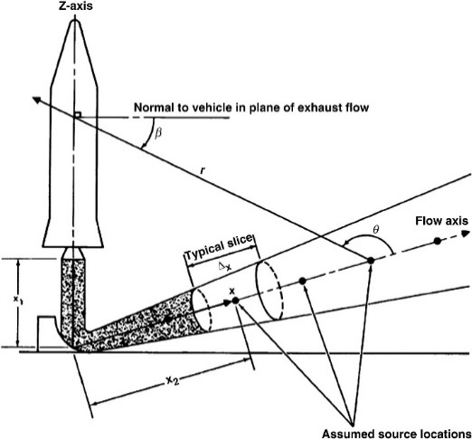 (a) | (b) | (c)
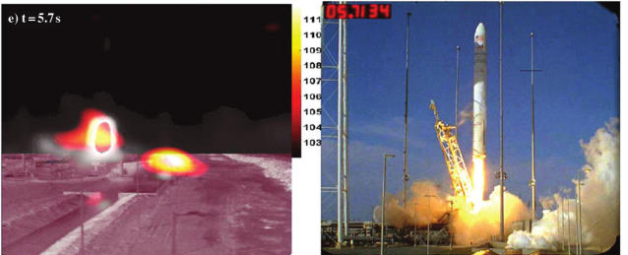(d)
Fig. 1. (a) Eldred (NASA SP8072, [1]) model of the noise sources; (b) 5% model scale test of Ares-I vehicle with water injection; (c) Noise sources at indicated frequency identified using a phased array [2]; (d) Noise sources identified (left photo) during liftoff of Antares vehicle (right photo), [3].
The benefits of a phased array were demonstrated earlier in the static-burn tests [2], and in the static engine test and the first launch of the Northrop Grumman’s Antares vehicle [3]. In the recent past phased array proved to be a valuable tool to redesign the launch pads of Ariane [4] and Vega [5] vehicles.
Unlike aeronautical or automotive applications, where sources of relatively higher frequency sound are of interest for community noise or human comfort issues, in space vehicle applications the lower frequency sounds are of more importance for the structural dynamic response mentioned above. It’s indeed difficult to directly resolve the sources of the very low frequency such as 50Hz using a reasonably sized array. However, an important observation from our past work is that the strongest sources, contributing to the peak 10dB range of noise at any frequency band, are “compact,” i.e., the same flow physics at the same location is responsible for generating sound over a wide frequency band. Therefore, if the major sources can be identified for say 1 kHz then the primary locations for the sources at all other frequencies can also be identified. These aspects are discussed in the following.
For conventional beamforming the minimum resolvable detail is due to the diffraction-limit of the array, i.e., when the first diffraction minimum of the image of one source point coincides with the maximum of another. For a circular aperture of diameter d, the Rayleigh resolution in radian θ_{R} is as following:
$sinθ_{R}=1.22 \frac{λ}{d}$ (1)
For the present d=10.5ft array the resolution is poor: ±18.5° at 200Hz and improves to ±1.85° at 2 kHz. For aeronautical application on full-scale airplanes very large sized phased arrays are laid out on the ground to improve resolution at low frequencies. Such a configuration is impractical for a vertically launched space vehicle, where the array needs to be mounted high up on a vertical structure. Additionally, the harsh environmental conditions of high wind, intense acoustic load, and the arrival of the blast waves, require a rigid structure. All of these requirements led to the present choice of the nominally 10.5 ft diameter array. It is known that various advanced beamforming schemes can attain resolution much lower than the Rayleigh criterion. The paper explores Functional-Orthogonal, and Spectral estimate methods to find the improvements over the conventional technique.
Figure 1 shows a comparison between the widely used Eldred’s model of launch acoustics [1] and the actual noise sources found from the application of the phased array. The Eldred’s model (fig 1a) follows the traditional description of noise of free-flowing jets: the noise sources are distributed along the long plume; the J-deflector under the engine mount plays the only role of deflecting the plume and has no role in sound generation! Figures 1(b) and (c) are from Panda & Mosher [2] where a phased array was used during a 5% scale model test that employed water injection. The strongest noise sources over a range of frequencies investigated were found to be compactly located at the locations where the motor plume splashed on the launch pad. From a series of such observations, it was concluded that the Eldred’s model completely overlooked the importance of plume impingement. Panda et al. [3] presented data from the static engine test on the top of a launch mount. The primary noise source was found to be compactly located at the trench opening, which provided the escape route of the sound of all frequencies generated inside the trench from the plume impinging on the J-deflector. Similar results were also found by Gély et al. [4] and Mortain and Clero [5]. Figure 1(d) is from the use of a phased array during Antares launch [3]. The left photo shows the noise sources detected during one of the instances in the lift-off sequence. As the vehicle lifted the plume came out of the flame trench and became a part of the distributed noise sources. Yet the trench opening and the plume splashing zones on the launch pad, remained as major noise sources. The sound-escape ports and the plume splashing locations are compact noise sources radiating sound of all frequencies and can be easily identified by looking into beamformed maps created say at 1 kHz, or higher frequencies, where the spatial resolution attainable by the 10.5ft diameter array is sufficiently high. Once identified one can use measures such as redirecting water, closing openings, or extending opening away from the vehicle to attenuate the acoustic levels. That’s how most of the past deployments of the array benefitted launch vehicles. The present effort is to identify such sources for future launch vehicles with an improved array design.
The data presented in this paper is from a planned series of validation and verification tests that makes the path towards the final deployment during Artemis-II launch. Individual speakers are used as sound sources in this test. For the next tests the plan is to attend static engine fire test and the launch of a smaller rocket.

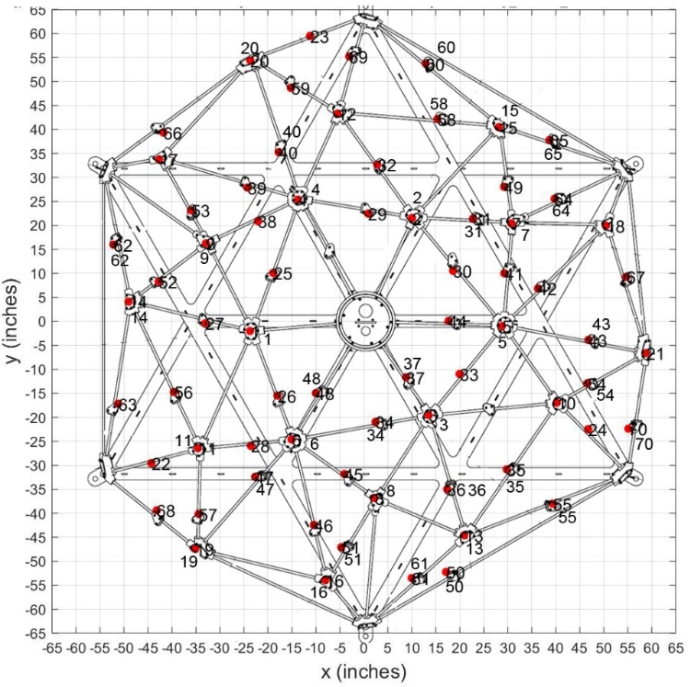
Fig 2: Location and numbering of Microphones.
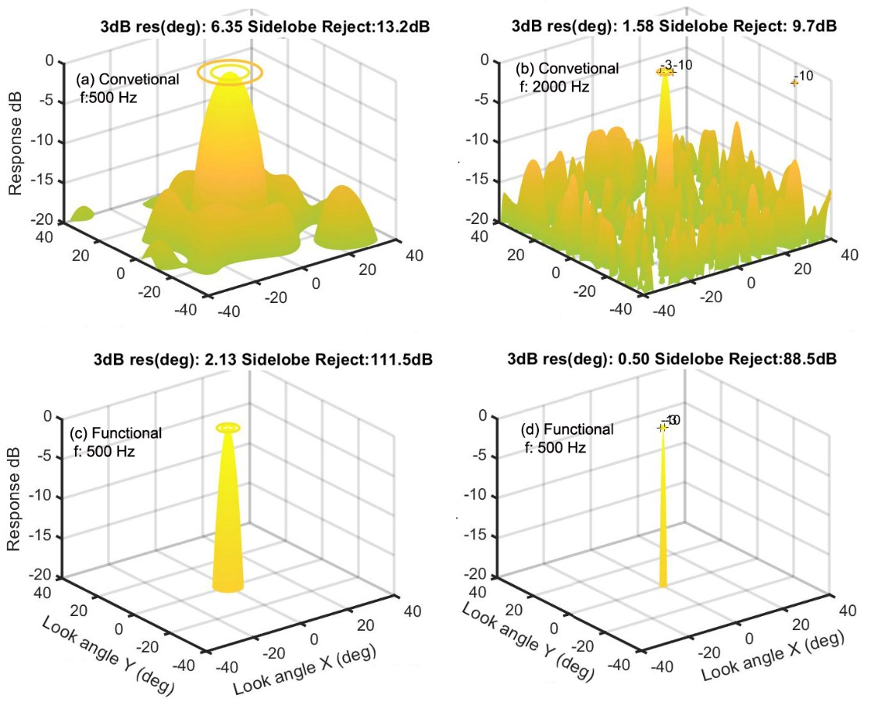
Fig 3. Ideal sound map (point spread function) created by the array at the indicated frequencies and using conventional and functional beamforming methods from a sound source located along the line of sight and 500-ft away from the array.

III. Array Hardware
The custom-built, one-of-a-kind, phased array uses 70 dynamic pressure (Kullite) sensors laid out in a predetermined arrangement (fig 2). The goal of the layout is to maximize the array resolution at 500Hz ≤ f ≤ 2 kHz range, and to reduce the side lobes (fake noise sources) in the resulting sound maps. To design the layout at first the locations were determined on a two-dimensional base circle of 62.7” radius; subsequently they were raised on a hemispherical surface with 88.67” radius. Inside the base circle 24 of the microphones were positioned on logarithmic spirals and the rest were randomly scattered. The resulting pattern produces a fairly narrow point-spread function (psf)., Fig 3 shows the ideal array response at two different frequencies using two different methods of analysis. The conventional beamform created large 3dB spot sizes of 6.38° and 1.58° at respectively 500Hz and 2kHz. The spot sizes are close to the predicted value from the Rayleigh criteria of equation 1. The functional beamform created spot sizes smaller by a factor of ~3: 2.13° and 0.5° for the two frequencies. The sidelobe rejection also improved significantly. These beamform models will be described in the next section. A goal of the present work was to determine if such reductions were attainable in actual tests.

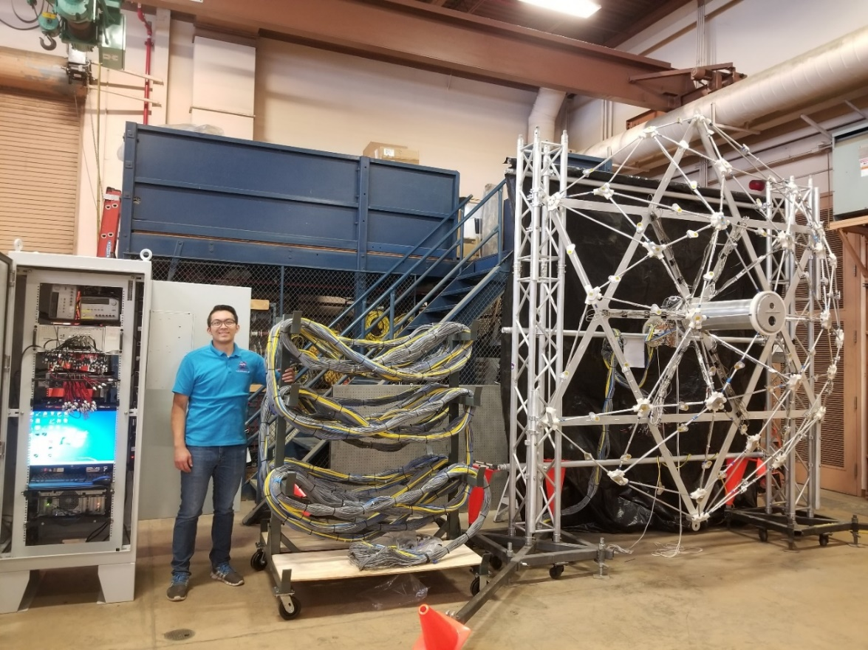
Figure 4. Overall view of the phased array, cable bundle, and data acquisition cabinet.

Figure 4 shows a photograph of the newly built phased array with its three primary components: (a) the hemispherical dome shaped lattice structure that holds 70 dynamic pressure sensors, (b) a 200-ft long cable bundle, and (c) an air-conditioned cabinet to hold all electronic components and personal computers. The cylinder (also known as the canister) at the center of the dome structure holds one visible wavelength video camera, and a long infra-red wavelength (2micron- 10micron meter) video camera (fig 5b). A glass and a Germanium window, placed on the front cap, provide clear view of the launch pad and the vehicle in the visible and infra-red wavelengths, respectively. Additionally, amplifiers for all 70 microphones are also housed inside the canister (fig 5a). To monitor the temperature of the amplifier-rack a resistance temperature detector (RTD) is attached to the amplifier housing. Additionally, a three-axis accelerometer is placed on the mounting rod for the amplifier rack to monitor the vibration levels expected during the launch. Finally, a ½-inch diameter tube is placed close to the amplifier housing to bring in dry air to cool the amplifiers, and to maintain a low humidity environment at the interior of the canister. The array is expected to be mounted close to a launch pad weeks before the actual launch with little access. The cooling air will limit the temperature and humidity rise inside the canister.

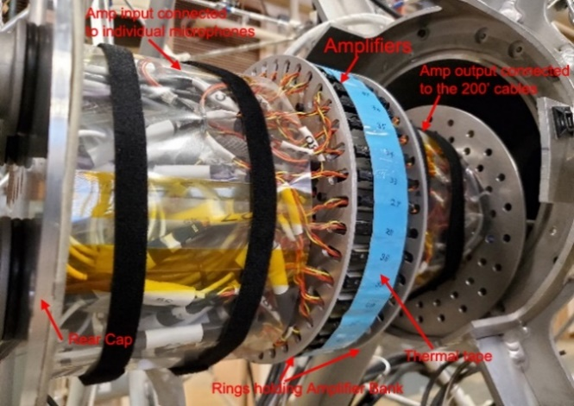(a) | 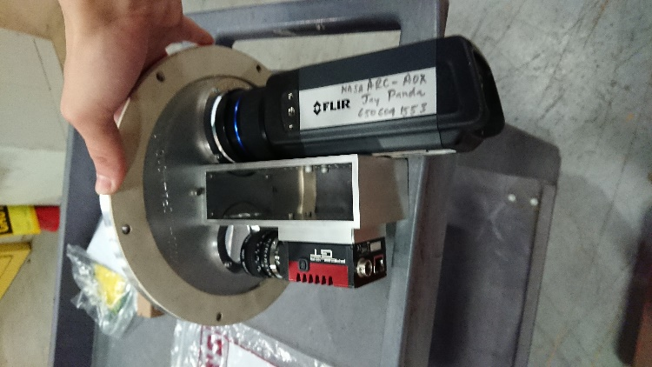(b)
Fig 5. (a) Amplifier rack with amplifiers installed; (b) cameras mounted on the front cap.

The cable bundle passes DC power and signals to and from the Kulite amplifiers, RTD sensor, accelerometer, and the two cameras. The cable bundle is wrapped with conductive Aluminum tape to minimize radio-frequency interference to the low voltage signals transmitted through the cables. Finally, a semi-rigid braided sleeving provided protection and structural strength to the bundle. The 200-ft long cable bundle is suitable for raising and mounting the array on nearby tall structures (such as lightening towers, water tanks or any other suitable structure) so that a clear view of the top surface of the launch platform becomes visible to the array cameras.
The electronic cabinet holds a primary and a backup data acquisition system to digitize the microphone and the accelerometer signals. Both systems have 80 channels of differential inputs. The 24-bit primary ADC system can sample at a higher 1024k Samples/s and the 16-bit backup ADC system at a lower 10240 /s. The DC power supplies for all amplifiers and cameras, two personal computers, a monitor and keyboard, RTD and accelerometer processing units, network switches, distribution boxes and other peripheral equipment were packed in this cabinet. The cabinet is made of steel for protection from the launch environment. It also has an air-conditioning unit to cool all electronics during the expected multiple weeks of continuous operation in the hot sun.
The hemispherical shape of the array dome and the triangular lattice frames are known to produce structural stiffness while minimizing the overall weight. The lattice structure was inspired by a similar dome shaped array built by Burnside and Horne [6] for use in a wind tunnel. Prior acoustic phased arrays [2, 3] used for the rocket launch studies had solid cross-section areas, which made them to catch the overpressure and the acoustic waves from rocket launches creating large vibrational responses. The present design allows for the minimization of the wind and acoustic loadings and is expected to cause less vibration. This was confirmed from multiple load analysis and calculations of the modal response of the frame. Physically, the hemispherical shape is constructed from ½” diameter hollow aluminum tubes connected at FDM Nylon nodes. The hemisphere is attached to a six-point star shaped aluminum frame that provides the fundamental integrity to the configuration. Braces from the center of the frame to some of the FDM parts provide additional stiffness. A structural analysis of the load path on the array dome revealed the need for a strong-back to provide additional stiffness in the event of high wind. A hexagonal shaped strong back that attaches to the hexagonal base frame was designed and fabricated to satisfy this need. The back frame of the array dome and the strong back is joined via ten mounting clamps and mounting adapters. The strong-back also provides additional support during road transportation to different test facilities.
The acoustic sensors on the phased array are piezo-resistive dynamic pressure sensors manufactured by Kulite Corporation. There are three different types of sensors on the phased array: larger 0.15” diameter XTEH-10L-190S-25A, and XTL-190-25A, and miniature 0.072” diameter XCL-072-25A. All are of absolute pressure gauges with 25psia range and produce full-scale output of 0-5V. The sensors were tested in a jet flow facility to ensure phase matching. The microphones were approximately mounted based on the designed location. The exact locations were established after the completion of the dome assembly and mounting. A photogrammetry-based technique using a V-STARS instrument (of Geodetic Systems) was used for this purpose . A single camera was used to take many photographs of the array, reference points, and guide poles and markers mounted on and around the array. Later on, a proprietary software was used to extract the microphone coordinates to an accuracy less than ±0.01”.
The survivability of the sensors over long duration of exposure to the windy, salty, and rainy environment with large temperature swings is a concern. The piezo-restive sensors were selected to cover the expected temperature change. From several artificial rain tests (spraying water on the array at different rate) it was realized that moisture on the sensor creates large voltage spikes in the output signal. To prevent such spikes the exposed end of each sensor was covered by a thin Mylar film glued on a Kapton tape. The tape created <0.5dB attenuation of sound transmission. Since the interest is in the relatively low frequency (≤3kHz) part of the acoustic spectrum the film is not expected to cause local resonances. A dab of RTV sealant was applied on the backside of each sensor to prevent moisture leakage. Additionally small holes were drilled next to each Kulite recessed within a FDM node to prevent rain accumulation.

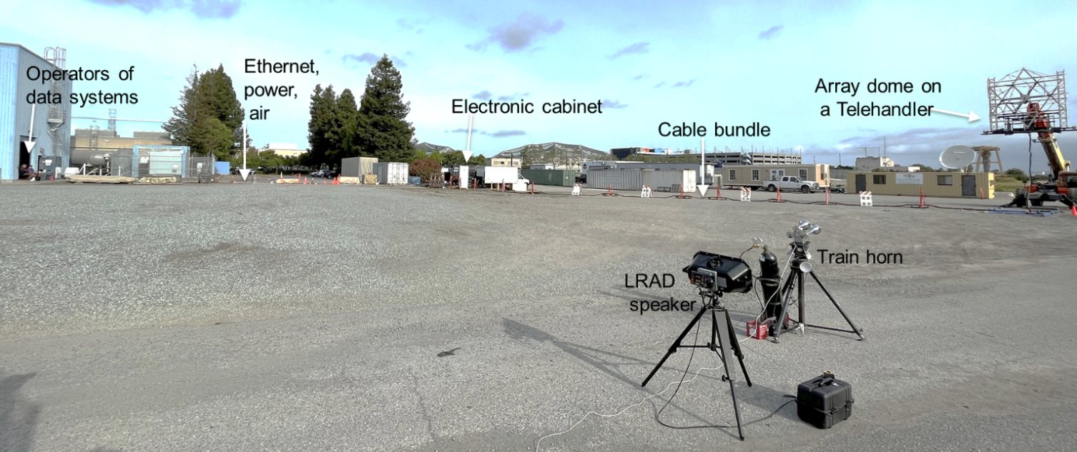
Fig 6. Setup for the outdoor test using a train horn and an LRAD speaker, and the array raised by a Telehandler.

IIIa. Outdoor test setup
The first series of tests conducted on the array simulated the expected setup around a Launchpad – the array elevated on a platform, the data system kept 120 ft away from the platform and the data acquisition was performed remotely over a local area network (Fig 6). In addition to the network line, compressed air and power were supplied to the cabinet, which in turn powered-up the amplifiers inside the canister and sent air cooling the amplifiers. The array dome was elevated at different heights, 10’, 15’, 20’ and 40’ above ground using a Tele-handler crane (fig 6). A special pallet was built to mount the array frame. The Tele-handler boom was able to swing and pitch the array for pointing it to the noise sources. A three-horn train horn and a Long-Range Acoustic Device (LRAD) were used to create sufficiently loud noise for the piezo-resistive microphones to sense. The train horn was of a relatively weaker source, producing omnidirectional tonal noise of amplitude ~135dB at 1m. The LRAD was much louder, 145dB at 1m, and produced a focused beam along the line of sight. The separation between the two noise sources were varied to determine the spatial resolvability of sound sources by the array.

IV. PHASED ARRAY DATA PROCESSING
Fundamentally a phased array detects the curvature of the acoustic waves to determine the angular location of the noise sources. The information is extracted via calculating cross-spectrum of pressure fluctuations between every possible pair of microphones on the array. In addition to the desired sound signals p_{s}(t) the time-signal generated by the microphones p_{t}(t) carry two different sources of noise. For the piezo-resistive sensors used in the present array the electronic noise is high. Even for the 24-bit data system the equivalent acoustic pressure p_{e}(t) was around 105dB. Additionally, for launch acoustics application there are host of weaker spurious sources that create background fluctuations p_{b}(t). For example, the pressure fluctuations from the strong wind blowing on the array can be 100dB or higher. There are weaker sound sources such as valve and gas flow generated noise, and reflections of various kinds that contaminate the measured pressure fluctuations p_{m}(t). Let m = 1, 2, …M be indices for microphones, then the following holds for the total fluctuations measured by the m^{th} microphone:
$p_{m,t}\left(t\right)= p_{m,s}\left(t\right)+p_{m,b}\left(t\right)+p_{m,e}\left(t\right)$ (2)
Assuming that $p_{m,s}\left(t\right), p_{m,b}\left(t\right), and p_{m,e}\left(t\right)$ are mutually uncorrelated and stationary, the following relationship holds for the cross spectrum between a microphone pair m and m/ [11]:
$G_{mm^{/},t}=〈{P_{m,t}}^{*} P_{m^{/},t}〉= G_{mm^{/},s}+G_{mm^{/},b}+G_{mm^{/},e}$ (3)
The contribution from the electronic noise can be subtracted by taking a set of data p_{m,e}(t) at an indoor condition with the sound sources turned off, and then by calculating noise-induced cross spectrum $G_{mm^{/},e}$ for every pair of microphones.
$G_{mm^{/},e}=〈{P_{m,e}}^{*} P_{m^{/},e}〉$ (4)
Direct subtraction of the noise cross-spectra from the total measured was found to be problematic for the beamformed map since the cross-spectral phase contaminated by the random noise of the former spectra. Therefore, only the magnitude of the noise-induced cross-spectrum was subtracted from that of the total measured leaving the phase part intact:
$G_{mm^{/},t}(f)=\left|G_{mm^{/},t}\right|e^{-i {f Φ}_{mm^{/}}}$
$G_{mm^{/},sb}(f)=\left(\left|G_{mm^{/},t}\right|-\left|G_{mm^{/},e}\right|\right) e^{-i {f Φ}_{mm^{/}}}$ (5)
The resulting $G_{mm^{/},sb}(f)$ is the cross-spectrum from the combination of the desired sound sources and the background noise.
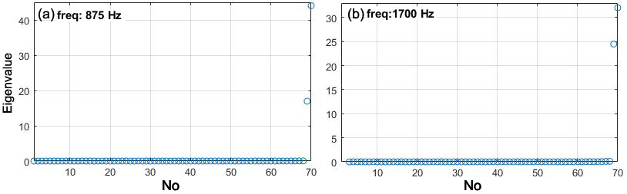
Fig 7. Eigenvalues of the cross-spectral matrix $G_{mm^{/},sb}(f)$ at indicated two frequencies from two speaker sources.

To farther reduce the influence of the background noise the eigenvalues of the $G_{mm^{/},sb}$ matrix was inspected via an eigenvalue decomposition:
$G_{sb}=UΣU^{*}=\sum_{m=1}^{M}{σ_{m}u_{m}u_{m}^{*} ,}$ (6)
where, U is a unitary matrix whose columns are the eigenvectors (u₁, u₂,…. u_{M}) of G_{sb} and Σ is a diagonal matrix whose diagonal elements are real valued eigenvalues (σ₁, σ₂,… σ_{M}) of G_{sb}. Fig 7 shows the distribution of the eigenvalues obtained from the present test where two speakers were used as sound sources. Following the idea of the orthogonal beamforming [12, 7] the individual eigenvalues σ_{m} can be associated with a particular point source of noise. For speaker sources it was indeed possible to find that most eigenvalues are of very small magnitude compared to the two large ones. Because the intention was to investigate the peak noise sources within a given dB range, a threshold level can be used based on the highest eigenvalue σ_{max}. For the present application the intention was to find the sources responsible for creating at most the top 15dB range of pressure fluctuations. Therefore, all eigenvalues below the following criteria were considered due to the background noise sources and were equated to zero.
$σ_{m }<\frac{σ_{max }}{40} →0.$ (7)
The cross-spectral matrix G_{s} free of the background noise, and due to the desired sound sources can be reconstructed based on the remaining eigenvalues, σ_{s,} s=1,2…S:
$G_{s}=UΣ_{S}U^{*}$, (8)
where, Σ_{s} is a diagonal matrix composed of the non-zero eigenvalues, rest equated to zero.

IVa. Conventional beamforming (CB):
To create maps of the noise sources at first the region where such sources are expected to be present is divided into a set of grid points (fig 8). Typically, a planar phased array is insensitive in the depth direction (i.e., along the normal to the array plane). The current hemispherical shape is expected to provide improvements, yet the large separation distance between the pad and the array location is expected to make such improvements insignificant. Therefore, a two-dimensional set of grid points (also called interrogation points) is set up. Let j =1, 2, 3…N be the interrogation points. The radial distance r_{jm}, from an interrogation point to an individual microphone, determines the phase shift and the relative amplitude measured by the microphone. The steering vector is a column matrix defined to incorporate these properties:
$w_{j, m}=\frac{r_{jm}}{r_{jc}} e^{-ik r_{jm}}$ (9)
Here r_{jc} is the distance of each interrogation point to the center of the array. Note that: $w_{j }^{†}w_{j}=1$.
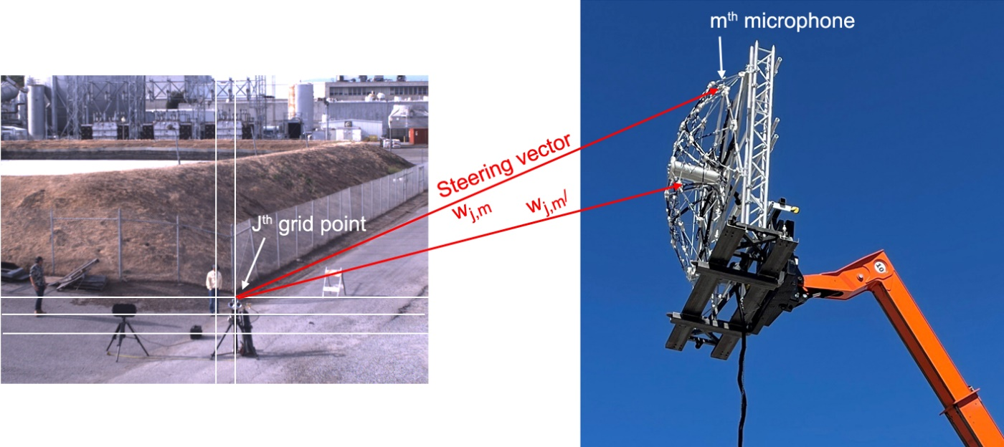
Fig. 8. Schematic of beamforming process.

The elements of the cross-spectral matrix of equation 8 above are summed up, preceded by a phase adjustment by the steering vectors, to interrogate the individual grid points. These two steps are combined in a matrix manipulation which leads to the conventional beamform map. In the following$G_{m, m^{/}}$is the tensor representation of the matrix G_{s} of equation 8.
$b_{j, cb}\left(f\right)= {w_{j, m}}^{†}G_{m, m^{/}} w_{j, m^{/}}$ (10)
Zeroing out the diagonal elements of $G_{m, m^{/}}$improves the beamformed map.

IVb. Functional beamforming (FB):
This method proposed by Dougherty [8, 9] uses the eigenvalue and eigenvector decomposition of the cross-spectral matrix described above. For the present case the electronic noise subtracted, and background noise removed cross-spectrum and its’ eigenvalue decomposition of equation (8) is used. The central idea of the functional beamforming is to reduce the spot size (point-spread function) and the alias points (sidelobes – fake noise sources) by reducing the magnitude of the cross-spectral matrix via an exponent 1/ν, ν>1, before adjusting the phase and summing up the levels. This is followed by raising the beamformed levels back to the original. The reductions in the magnitude of the cross-spectral matrix can be accomplished by operating on the non-zero eigenvalues: ${σ_{s}}^{\frac{1}{ν}}$. The expression for the functional beamform is the following.
$b_{j, fb}\left(f\right)= {\left[{w_{j, m}}^{†}\left\{\sum_{m=1}^{M}{{σ_{s}}^{\frac{1}{ν}}u_{m}u_{m}^{*}}\right\} w_{j, m^{/}}\right]}^{ν}$ (11)
The exponent ν is to be selected by the user. For a completely noise free data the dynamic range (reduction of the side lobes) and the reduction in the spot size (i.e., improvement in the resolution of the beamformed map) is directly related to ν: the higher the ν the smaller is the spot size, and wider is the dynamic range. In practice the residual noise level, and the lack of convergence due to the limited time extent of the microphone data, plateau the spot size to a fixed level. Typically, ν in the range of 10 to 100 is used in the literature. Marino-Martinez et. al. [10] found an improvement of the array resolution by a factor of 6 compared to the conventional beamformed value by applying ν=100 to clean data from an airframe noise test. Note that diagonal removal, and thereby eliminating the microphone self-noise cannot be performed in the functional beamforming method.

IVc. Direct Spectral Estimate – Spectral Element Method (SEM, [13]):
The resolving capability and the dynamic range available by a phased array of a given size and given number of microphones are limited by the 3dB width of the psf. As discussed earlier the point-spread function and the sidelobe makes a point source of sound to appear over a wide spatial extent and at pseudo locations. The functional beamform do makes significant improvements of the resolvability, but the best results can be obtained if the point-spread function can be deconvolved out of the beamform maps. There are a host of different schemes available [7] towards that end. An important limitation of many such schemes is that they break down a distributed source into small points which makes them to appear unphysical. The spectral element method also suffers from this limitation but to a lesser extent [7]. Like others SEM also assumes that the sound sources are made of uncorrelated monopoles. However, instead of making phase adjustment via the steering vectors the method attempts to find the strength of the monopoles directly from the measured cross-spectral matrix G_{s}. Like before the source region is divided into N_{s} interrogation points (also called grid points) and the steering vectors are used to calculate a model of cross-spectrum between two microphones m and m/. The unknown in the model is the strength of the monopole sources α_{j}² at each of the interrogation point j = 1, 2 … N_{s}. The model cross-spectrum between microphones m and m/ is the following.
$G_{mm^{/}}^{mod}=\sum_{j=1}^{N}{w_{j, m}α_{j}^{2}w_{j, m^{/}}^{*}}=\sum_{j=1}^{N}{\left(\frac{r_{jm}}{r_{jc}} e^{-ik r_{jm}}\right)α_{j}^{2}{\left(\frac{r_{jm^{/}}}{r_{jc}} e^{-ik r_{jm^{/}}}\right)}^{*}}$ (12)
The positive values of α_{j}² assure elimination of the unphysical negative source strength. In the method proposed by Blacondon & Élias [13] the source distribution is determined via minimization of the error between the measured and the modeled cross-spectra using an iterative least-square minimization scheme.
$E\left(α_{j}, f\right)=\sum_{m, m^{/}=1}^{J}{{\left|G_{mm^{/}}-\sum_{j=1}^{N}{w_{j, m}α_{j}^{2}w_{j, m^{/}}^{*}}\right|}^{2}}$ (13)
An advantage of the SEM is that the diagonal terms of the measured cross-spectrum can be avoided in the minimization scheme. Without the diagonal terms the measured cross-spectral matrix G_{s} contains (M²-M)/2 number of independent, complex values. Counting the imaginary and the real numbers separately, the total number of independent variables to be minimized becomes J.
J = M²-M (14)
Similar to a procedure followed by Casalino et al [14], the calculations were carried out in Matlab® using routine lsqnonneg that uses a non-negative least square process.

IVd. Matlab® implementation:
The above beamforming schemes were implemented in the commercially available Matlab® platform. Once the cross-spectral matrix (Eq 8) was calculated the rest of the beamforming operation for conventional, functional and SEM methods happened quickly. To facilitate direct identification of the noise sources, the interrogation grid was created over a photograph of the region of interest captured via either the visible band or the infra-red band video camera. The photographed region was divided into a uniformly spaced grid. To select the number of grid points, Rayleigh criterion was applied to the highest frequency of interest. Typically, the grid spacing obtained using Eq 1 was refined by a factor between 6 and 10. The beamformed colored maps were superimposed on a video frame from either the visible band or the IR-band camera.
Correct registration of the beamformed map and the video frames required a calibration process. The look-angle of the video camera changed slightly every time the array was rebuilt. To correct for such a small but important change, a speaker was placed at various locations in the camera field of view, and the video image was rotated in pitch, yaw and/or roll directions for correct superposition of the beamformed maps. This calibration step was applied to both the visible and thermal imaging cameras.
Implementation of SEM typically required fewer grid points.To limit the computing time to a reasonable duration, the maximum number of iterations in lsqnonneg routine was limited to 500.
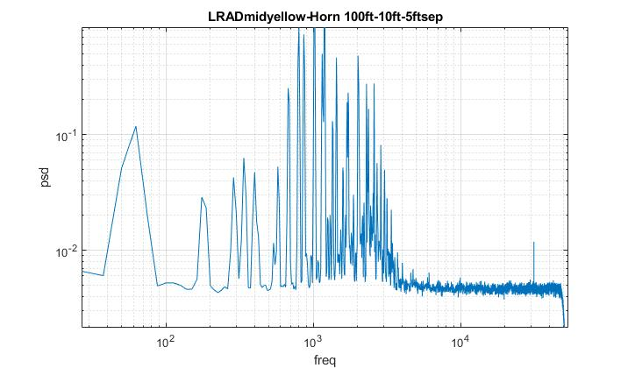
Fig 9. Spectral content from the combined operation of the LRAD and the train horn.
- results
Only a small set of data collected from the outdoor validation test is presented in the following section. The results are typical of all other found in the study.

Va. Speaker characteristics
A challenge of testing of the array made of the piezo-resistive sensors connected to a fixed gain amplifier is that the signal level attainable from most of the commercially available speakers, which mostly produces <120dB at 1m distance, is close to or below the electronic noise floor. Additionally, the speakers needed to be far away from the array to simulate the separation distance of hundreds of feet between the array and the launch vehicle. Two solutions were found. First one is a diesel train horn that produced a combination of sharp low frequency tones of OASPL of ~135dB at 1m distance. Second, is a Long-Range Acoustic Device (LRAD) that was capable of creating noise in the frequency range of >1 kHz with an OASPL of 145dB at 1m distance. The speakers differed significantly in the sound directivity- the former was mostly omnidirectional while the latter had a very strong forward directivity in the forward direction. The sound field from the train horn dissipated following the expected 1/r relationship, which limited the maximum separation distance between the array and the Train horn to ~100ft. But the LRAD did not follow this relationship and produced loud sound field over hundreds of feet away, yet only along the forward direction. Another difference between the two sources of sound was the frequency range of operation. The train horn created sharp tones at discrete frequencies between 288Hz and 2 kHz. The LRAD could produce broadband noise mostly above 1 kHz. A goal of the present study was to determine the resolvability of the array when two speakers were operated simultaneously and with variable spatial separations. To achieve this objective the train horn spectrum was copied and fed into the LRAD. Figure 9 shows the spectrum of the combined field 100ft away from the speakers. The 60Hz and 120Hz tones were electronic noise and needed to be neglected. The rest of the tones of f≤863Hz were mostly produced by the train horn. The two speakers were found to be create comparable amplitudes of sound at a few selective frequencies of 1013Hz, 1188Hz, 1338Hz, 1725Hz, 2013 Hz and 2300Hz. Narrowband beamforming was performed at these narrowband frequencies only.

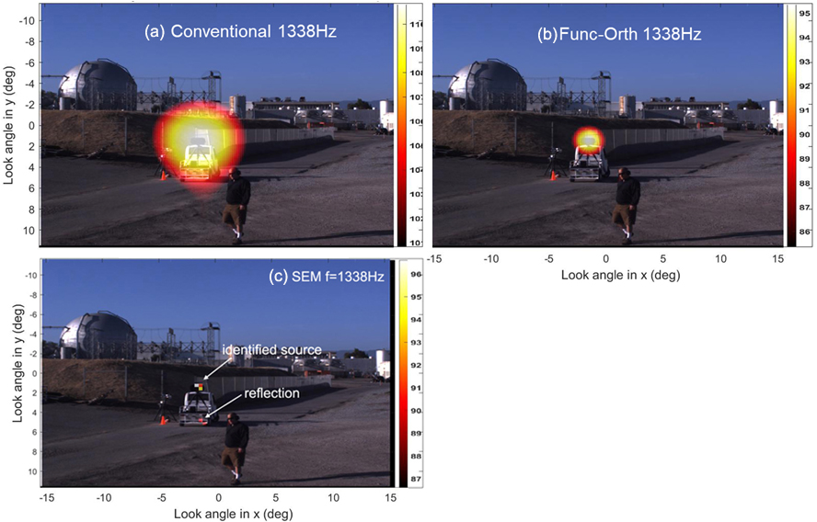
Fig 10. Comparison between different beamform schemes at a fixed f=1338Hz. The array center was 100ft away and 10ft above the LRAD speaker.

Vb. Comparison between beamform schemes:
After setting up the array in the outdoor parking lot a set of data was taken with a single source of sound (either the train horn or the LRAD) at variable distances of 50ft, 100ft and 200ft from the array, and the array lifted at different heights. Fig 10 shows the beamformed map from one data point where a comparative study was performed among the three different beamforming schemes. The data was acquired for ~30s duration, which provided reasonably clean estimate of the noise subtracted cross-spectra. The beamformed map was superimposed on a photo of the LRAD speaker acquired by the visible camera. The large spot size of the CB map of fig 10(a) followed the expected Rayleigh criteria. The FB map of fig 10(b) used nu=10, and as predicted by the point spread function analysis of fig 3, the spot size was reduced by a factor of ~3. The SEM map of fig 10(c) farther reduced the spot size to a very small size (smaller than the size of the speaker) of a couple of grid points, and also captured the reflection from the extended trunk of the golf cart on which the speaker was mounted. Such results were obtained from many other test points and at the other frequencies investigated in the study.

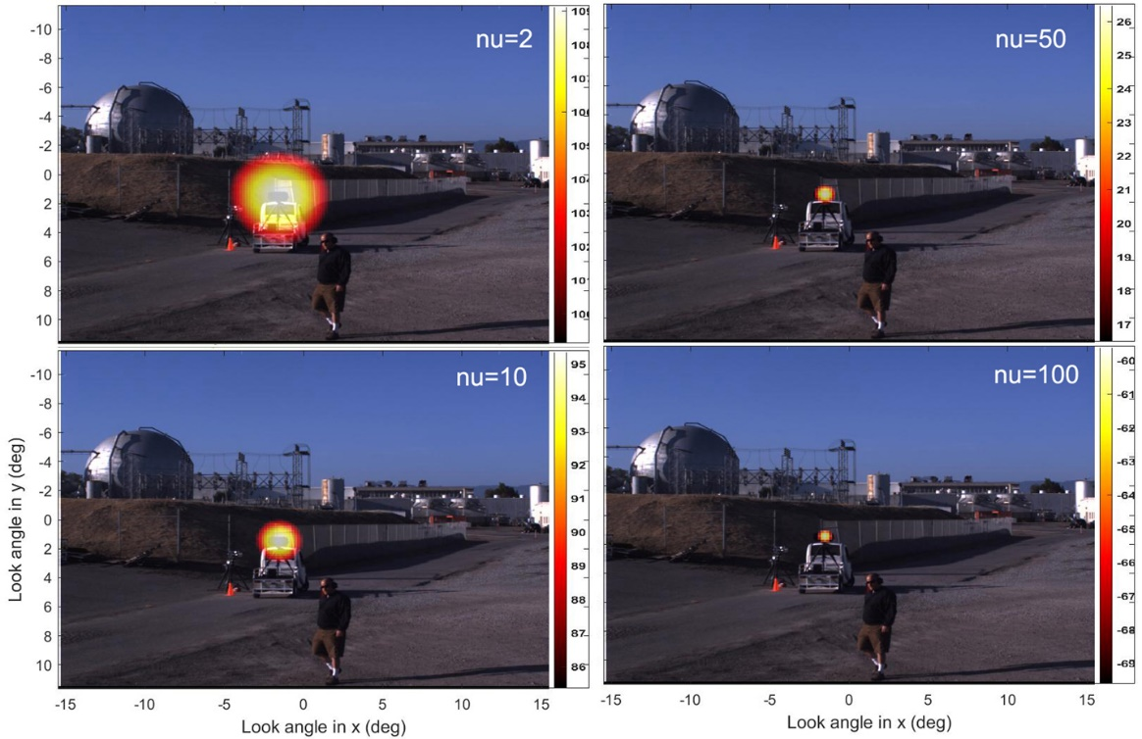
Fig 11. Impact of indicated values of ν (nu) on Functional-Orthogonal beamform at f=1338Hz. The array center was 100ft away and 10ft above the LRAD speaker.

Vc. Impact of functional beamform exponent ν on array resolution.
Fig 11 shows a typical result for the subject study: as the value of the FB exponent was increased the spot size became progressively smaller. The reduction was significant between ν=2 and 10; the impact fell as ν was increased to 50. The difference between ν=50 and 100 is insignificant. Note that a small spot size implies improved resolution of the beamformed map. It is to be determined how ν would affect the results from data collected in the future rocket engine burn, where the source can be more distributed and definitely of broadband in nature. The present paper uses ν=10 for the FB results in the rest of the figures.
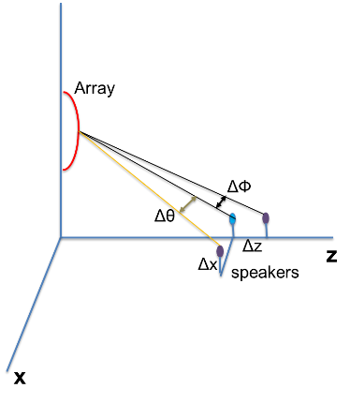
Fig 12. Schematic of angular separation between two speakers
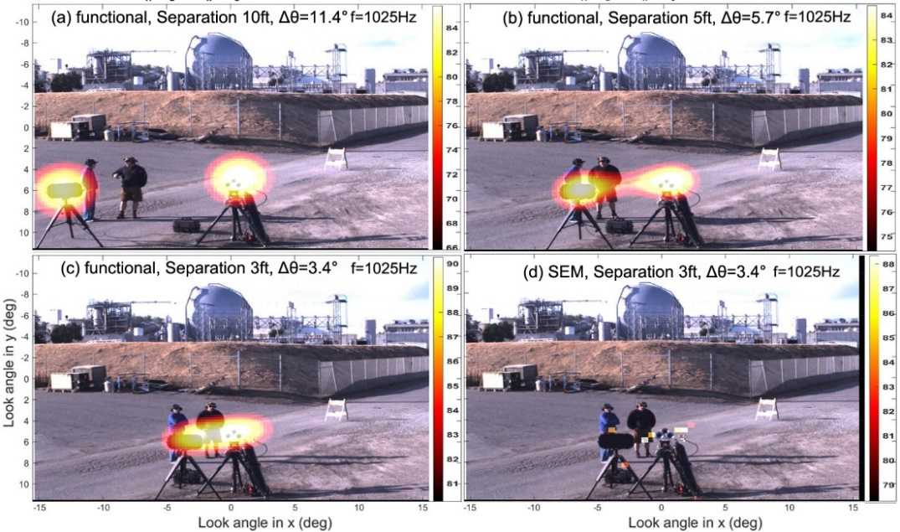
Fig 13. Source resolvability study using two speakers with indicated side-by-side separation distances and beamform schemes. Array located 50ft away and 10ft above the train horn.

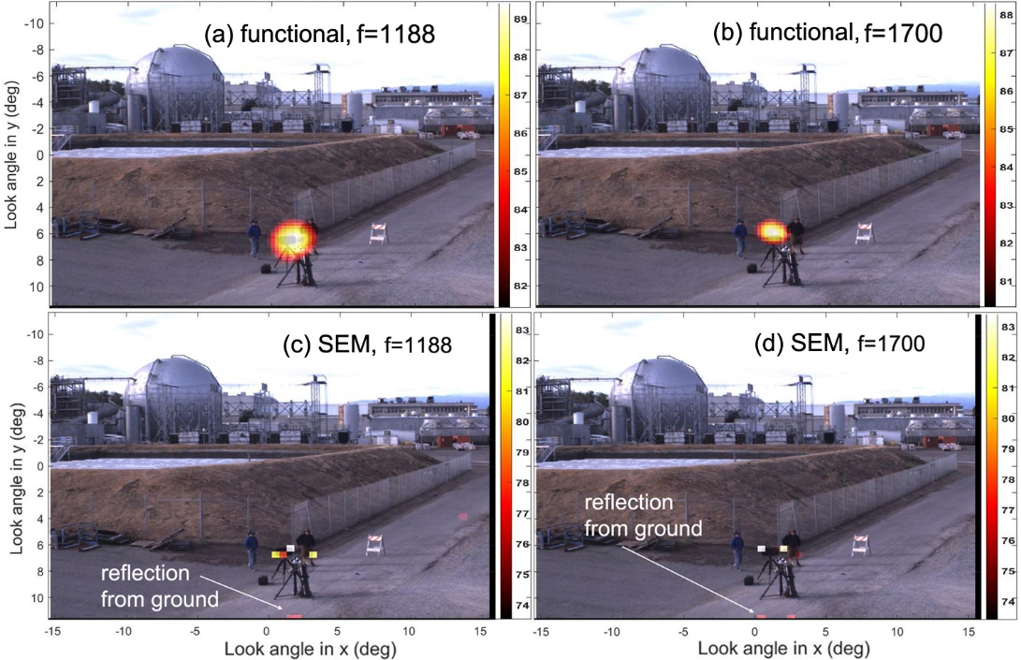
Fig 14. Comparison of sound source resolvability in the front-back direction between the indicated schemes at the indicated frequencies. Array located 100ft away and 20ft above the train horn. The LRAD is 10ft behind train horn, ΔՓ=0.81°.

Vd. Two speakers with variable separations:
A more rigorous study of the resolvability of the array was performed using two available sources (LRAD and train horn) spatially separated by different distances in both the front-back (Δz) direction and the side-by-side (Δx) direction as shown in fig 12. Since the array resolution is measured in the angular separation between two point sources, the Δz and Δx values were used to calculate Δθ and ΔΦ – the angular separation seen by the array. A pitfall of this study is the relatively weak level of sound created by the TH: ~102dB at the phased array from 50-ft away, and ~96dB when 100-ft away. The LRAD had to be operated at a significantly lower power to match the weaker acoustic level of the train horn. The signal to noise ratio was poor in all such test data; in other words, the differences between the electrical outputs of the piezo-resistive microphones between the speak-on and speaker-off conditions were very small. Even after the noise reduction measures, the residual noise especially in the phase spectra was high, which increased the spot size and deteriorated the array resolvability. In an actual rocket launch acoustic levels are expected to be 40dB to 60dB higher than those produced in the present study. Nonetheless, fig 13 shows results from different separations of the sound sources in the plane of the array. The FB scheme was able to identify the two speakers until Δθ=3.4°. The SEM methodology, as expected made the individual sources to appear as multiple dots with no improvement of the resolvability.
Separating the two speakers in a direction perpendicular to the plane of the array (front-back direction, Fig 14) made them more difficult to separate using either CB or FB methods. However, SEM proved to be more effective. Another possible reason was for the data in fig 14 the phased array was elevated to an higher height of 20-ft. In general, increasing the array height was found to improve the resolvability of the array in the front-back direction.
- Summary and Conclusion
The newly built phased array was tested in an outdoor setup using speaker sources and in an arrangement that bear similarities with the arrangement expected in a launch pad. The test is the first of a three part series to validate the instrument before the intended use during Artemis-II launch. In this test the array was elevated on a Telehandler crane and one or two speaker sources were placed at variable distances, between 50-ft and 200-ft, from the array. A LRAD and a diesel train horn were the speakers. In spite of the loud levels of 135dB at 1m and 145dB at 1m created by respectively, the LRAD and the train horn, the sound levels were much weaker than expected in a real launch. The data processing was conducted using three different beamforming schemes: conventional, functional-orthogonal and SEM with a goal of improving the resolution of the beamformed map. In order to reduce the impact of the electronic noise at first a background subtraction process was employed on the calculated cross-spectrum. Additionally, the weaker eigenvalues of the cross-spectrum were zeroed out to farther reduce the impact of noise. The speaker data processed through the conventional beamform showed 3dB spot sizes similar to that expected from the Rayleigh criteria. The functional beamform, on the other hand reduced the spot size by a factor of three. Also a significant suppression of the side lobes was attained using functional beamform. This should extend the resolvable range to lower frequencies than expected from the conventional beamform. Another series of test was conducted when the two speakers were separated in directions along and perpendicular to the plane of the array. These series of data suffered from increased noise from the weaker train horn speaker. Nonetheless, it was observed that all beamform schemes perform better when the sources are separated along the plane of the array than along the line of sight. Resolution in the latter direction was found to improve with the height of the array, and from using the SEM scheme, which in spite of excessive localization of the sound sources, outperformed the rest two in this direction of separation.
The remaining two validation tests of the array, to be conducted with a static engine burn, and a rocket launch are expected to provide farther insights into the performance of the array, validate a central hypothesis that the launch acoustic sources are mostly compact, and determine the best parameters for the beamform schemes.

Acknowledgements:

The authors are thankful to NASA Engineering and Safety Center (NESC) for supporting the building of the hardware and to run the verification and validation tests. Help from Mr. Don Morr of Millennium Engineering to design the array frame, Mr. David Stathatos (also of Millennium Engineering) for help with procurement and transportation of the array, Mr. Nick Garbe (Metis Technology Solutions) for IT support, Mr. Earl Daley of NASA Ames for the design of the pallet and test support, and Mr. Winston Czakon of NASA Ames for test support are also acknowledged. Ms. Michelle Dominguez of NASA ARC-AV and Edward T. Schairer of NASA ARC-AOX performed the photogrammetry work. We are thankful for their help.

References:
[1] Eldred, K. M. & Jones, G. W., Jr., “Acoustic load generated by the propulsion system,” NASA SP-8072, 1971.
[2] Panda, J. & Mosher, R., “Microphone Phased Array to Identify Liftoff Noise Sources in Model-Scale Tests,” Journal of Spacecraft and Rockets, Vol. 50, No. 5, Sept-Oct 2013. DOI: 10.2514/1.A32433
[3] Panda, J., Mosher, R. N. & Porter, B. J., “Noise Source Identification during Rocket Engine Test Firings and a Rocket Launch,” Journal of Spacecraft and Rockets, Vol. 51, No. 4, July-Aug 2014. DOI: 10.2514/1.A32863.
[4] Gély, D., Elias, G., Bresson, C., Foulon, H., Radulovic, S, 2000 “Reduction of supersonic jet noise. Application to the Ariane 5 launch vehicle,” 6th AIAA/CEAS Aeracoustics Conference, AIAA paper 2000-2026, 2000.
[5] Mortain, F. & Clero, F., “Full-scale acoustic source identification on Vega Launch pad at lift-off”, 26th Intl. Congress on Sound & Vib., July 2019.
[6] Burnside, N. J. & Horne, W. C., “Development of Instrumentation and Methods for Time-Domain Measurement of Rotor-Type noise Sources in a Hard Wall Wind Tunnel,” presented at the VFS Aeromechanics for Advanced Vertical Flight Testing Meeting, San Jose, CA, Jan. 21-23, 2020.
[7] R. Merino-Martinez, P. Sijtsma, M. Snellen, T. Ahlefeldt, J. Antoni, C.J. Bahr, D. Blacondon, D. Ernst, A. Finez, S. Funke, T.F. Geyer, S. Haxter, G. Herold, X. Huang, W. M. Humphreys, Q. Leclere, A. Malgoezar, U. Michel, T. Padois, A. Pereia, C. Picard, e. Sarradj, H. Siller, D.G. Simons, C. Spehr, “A review of acoustic imaging methods using phased microphone arrays,” CEAS Aeronautical Journal, 10:197-230, 16 March 2019.
[8] Dougherty, R.P., “Functional Beamforming”, Berlin Beamforming Conference, BeBeC 2014-1, 2014.
[9] Dougherty, R.P., "Functional Beamforming for aeroacoustic source distributions", AIAA Paper 2014-3066, 2014.
[10] Merino-Martínez, R. Snellen, M.,† and Simons, D. G. “Functional Beamforming Applied to Imaging of Flyover Noise on Landing Aircraft,” AIAA J. Aircraft, Vol. 53, No. 6, 2016.
[11] Bahr, C.J., Horne, W. C.: Subspace-based background noise subtraction applied to aeroacoustic wind tunnel testing. Int. J. Aeroacoust. 16(4–5), 299–325, 2017.
[12] Sarradj, E., Schulze, C., Zeibig, A. “Identification of noise source mechanisms using orthogonal beamforming,” Noise Vib Emerg Methods (2005)
[13] Blacondon, D., & Élias, G., “Level Estimation of Extended Acoustic Sources Using a Parametric Method,” J. Aircraft, vol. 41, no. 6, pp. 1360-136, Nov.-Dec. 2004.
[14] Casalino, D., Santini, S., Genito, M., and Ferrara, V., “Rocket Noise Sources Localization through a Tailored Beam-Forming Technique,” AIAA J., Vol. 50, No. 10, Oct. 2012, pp. 2146–2158. doi:10.2514/1.J051479

Engineer, Experimental Aero-Physics branch, AIAA associate fellow
Associate Engineer, NFAC
Engineering Technician, Experimental Aero-Physics branch
Chief Engineer, NESC (ARC)

