Implementation of the Lifetime Method in Unsteady Pressure Sensitive Paint Measurements

David D. Murakami, Marc A. Shaw-Lecerf, E. Lara Lash, Kenneth R. Lyons, Nettie H. Roozeboom
NASA Ames Research Center, Moffett Field, CA 94035
At NASA Ames Research Center, unsteady pressure-sensitive paint (uPSP) measurements are obtained using the ‘intensity method’ which measures paint luminescence in response to a continuous, constant excitation. These measurements are obtained using high-speed cameras and are processed into fluctuating components of pressure. However, the nature of the intensity method also requires a separate steady state (time mean) pressure measurement to be obtained. This steady state measurement has typically been obtained using a separate set of PSP equipment that uses the ‘lifetime method’, which uses pulsed excitation to measure paint decay lifetime. If the lifetime method were implemented in the high-speed uPSP system, both the fluctuating and mean components of pressure could be obtained with a single system. This would greatly streamline setup, operations, and processing. In this paper, we describe work performed at the Fluid Mechanics Laboratory at NASA Ames to implement the lifetime method in our uPSP system. The uPSP acquisition system uses Phantom v2512 high-speed cameras, and it was initially uncertain if results of adequate quality could be obtained - their high framerate comes at the cost of several undesirable characteristics, which are explored in this paper. It was also uncertain if illumination using LED lamps, rather than a stronger source such as lasers, would be adequate. The data acquisition and data processing are discussed and the results analyzed. It was found that satisfactory lifetime method results can indeed be obtained using these high-speed cameras and LED lamps. This will allow the uPSP system to be greatly simplified and will have a large operational impact on how uPSP data is acquired in future wind tunnel tests.
- Introduction
In the intensity method, the excitation source (in our case, 400 nm LED lamps) is switched on and stays on during the entire measurement. In response to this continuous excitation, the pressure sensitive paint luminesces continuously with intensity that changes in response to the local pressure. The paint is imaged with a high-speed camera (typically at 10,000 frames per second). Each frame is normalized to the time average of the whole measurement. This data is converted to fluctuating component of pressures using a ‘paint gain’ obtained from a laboratory calibration. This paint gain is a function of steady state pressure, which must be obtained separately. The gain is applied to each normalized frame to obtain the fluctuating component of pressure.
In the lifetime method, the excitation source is modulated, and the transient response of the paint is measured. The rise or decay time of the paint luminescence changes with pressure. Two images are taken in quick succession: ‘gate 1’ measures the rise of the paint luminescence in response to excitation, and ‘gate 2’ measures the decay. Using a laboratory paint calibration, this information can be used to obtain the pressure directly without separation into a fluctuating component and a steady state component. In our application, the steady state pressure (averaged over several seconds) is the quantity of interest, as that is required for the intensity method. The lifetime of the paint is on the order of 10 μS, and as such the exposure duration of each image must be on a similar timescale. Also, the luminescence is rising or falling during an exposure, in comparison to the intensity method where the luminescence is at its maximum value during the entire exposure. In general, the lifetime method will produce dimmer images than those obtained with intensity method, with correspondingly worse signal to noise ratios. The signal can be improved by using a strong excitation source such as a UV laser, or by using a camera optimized for low noise rather than high speed. Previous work on the lifetime method has been conducted by Sellers [1]. However, it was found in this work that adequate quality data can indeed be obtained with the LED lamps and high-speed cameras of the current uPSP system. Similar work has recently been conducted by Sugioka et al. [2].
- Experimental Setup
Experiments were conducted in Test Cell 3 in the Fluid Mechanics Laboratory at NASA Ames. This is a small-scale facility with a 14 inch × 14 inch test section, and an operating Mach number range up to approximately 0.6. Optical access in the test section is excellent – the side walls are acrylic, and a large BK-7 glass window is installed in the ceiling. Pressure-sensitive paint was applied to the floor, and a 2 inch × 2 inch × 1 inch cube was mounted to generate the flow phenomena observed. The high-speed cameras are mounted in the ceiling panel and look down at the floor below. The configuration of the test section is shown in Figure 1 below.

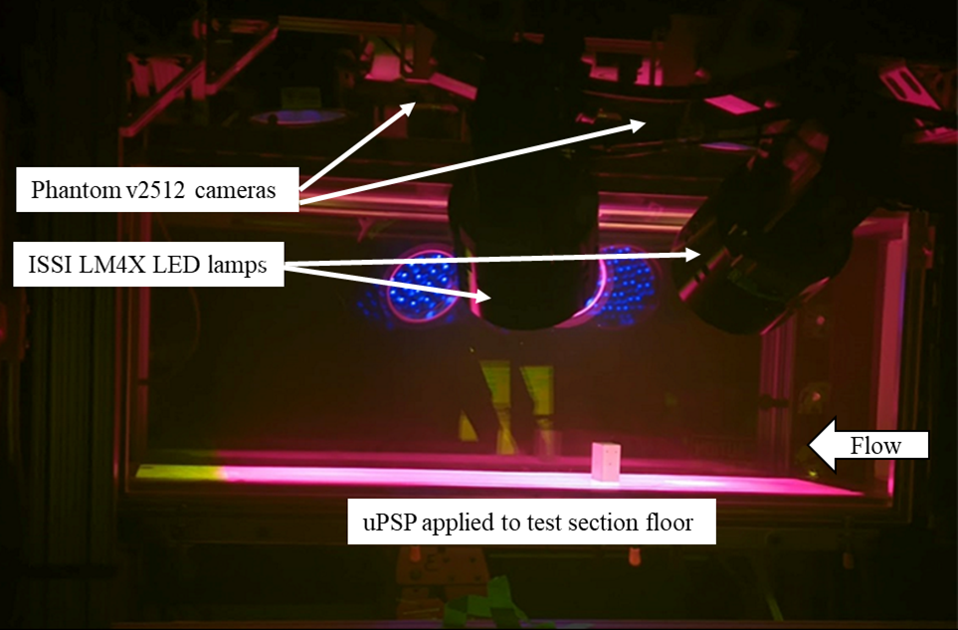
Figure 1. Test section setup with LED lamps and fluorescent paint shown. Cameras look down onto the plate from above. Flow is from right to left.

The Porous Fast-Response PSP paint formulation from ISSI was used. This is a three component, single luminophore paint with fast response time, allowing measurements at greater than 10kHz. Two Phantom v2512 high-speed cameras were used for data acquisition. Six ISSI LM4X LED lamps were used for illumination. A BNC 575 Digital Delay / Pulse Generator was used to coordinate timing. The plate was instrumented with fifteen type T thermocouples, which were read by a National Instruments NI-9213 thermocouple module. Thirteen Kulite pressure transducers were installed to record reference pressure fluctuation data. Fifteen static pressure taps were also installed.
Paint calibration data was obtained in a separate apparatus using an ISSI CAL-04 system in Figure 2, shown below.
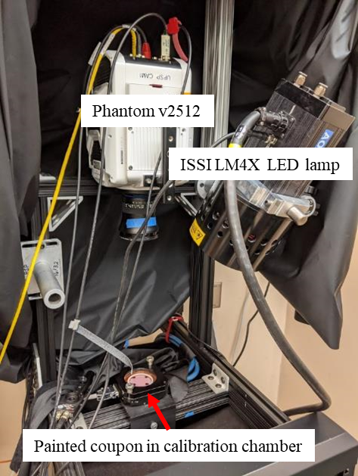
Figure 2. Paint calibration setup with installed coupon in test chamber, high-speed camera, and LED lamp.

The burst feature of the Phantom v2512 cameras allows multiple images to be taken in quick succession following a frame sync pulse. The frame sync pulse and the trigger signal to the LED lamps are coordinated through the digital delay generator. A two-frame burst is taken, which are called the ‘gate 1’ and ‘gate 2’ images. Figure 3 below depicts the timing in a typical acquisition, along with a representative paint response with a 10 μS time constant.

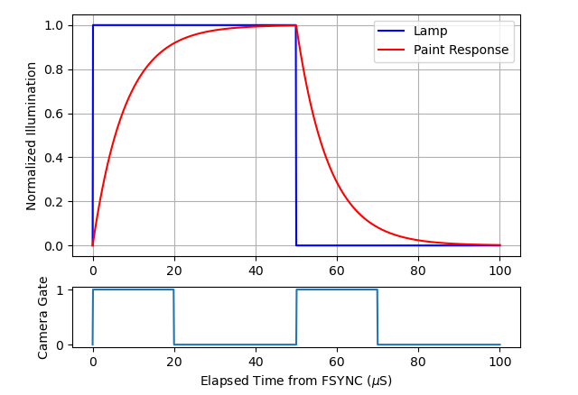
Figure 3. Typical lifetime method acquisition timing.
The lamp is turned on and the gate 1 exposure begins at time zero. The gate 1 exposure lasts for 20 microseconds, which captures the rise of the paint’s transient response. The lamp stays on after gate 1 has finished exposure to allow the paint to rise to its maximum luminescence, in order to make the gate 2 exposure as bright as possible. The lamp is turned off at 50 microseconds, and the 20 microsecond gate 2 exposure is started. The ratio of the gate 2 to gate 1 exposures is the quantity used to obtain pressure and is referred to as the lifetime ratio. This particular timing was called ‘LifetimeD’. Data for other gate timings were collected, but in this paper only the LifetimeD timing is discussed. Because this choice of timing integrates over the fastest changing parts of the paint response, it should have high sensitivity to paint time constant changes (and therefore pressure changes). However, if the exposure duration were extended, the overall brightness of the images would increase and the signal to noise ratio of the data would improve, but at the cost of pressure sensitivity. This tradeoff between pressure sensitivity and noise is a common theme when considering different lifetime timings.
- Lifetime Data Processing
The process for converting image data into pressures is quite similar to the process implemented in the PSP processing software used at the Arnold Engineering Development Complex (AEDC) [1]. Some additional corrections (items A and B in the list below) were introduced in order to account for non-ideal behavior of the high-speed cameras. The correction steps are as follows:

- Correction for camera photo response non-linearity
- Correction for ‘image lag’
- Non-Uniform Paint Response correction (NUPR)
- NUPR to wind-on image registration

These steps are listed in the order they are performed. After these corrections are applied, the paint calibration is used to convert lifetime ratios to pressures.

Camera Photo Response Non-Linearity
The Phantom v2512 cameras tend to exhibit noticeable fixed pattern noise when operated in burst mode with short exposure times. The patterns also change with varying acquisition settings, such as number of frames in a burst, frame rate, and exposure time. In particular, the gain is non-uniform spatially across the sensor, and also varies with incident intensity. The intensity dependent gain, or ‘photo response non-uniformity’, is of particular importance in this work. The lifetime technique inherently involves large intensity changes between the lamp-on gate 1 image and the lamp-off gate 2 image, and as such is much more sensitive to fixed pattern noise in comparison to the intensity method. Correcting for fixed pattern noise improves the quality of lifetime results significantly, while this correction is generally not significant in the intensity method.
In order to characterize fixed pattern noise, flatfield images with varying illumination level were obtained using a Gamma Scientific RS-7-1 calibration light source. The light source is computer-controlled and incorporates an integrating sphere and provides a uniform scene whose brightness can be precisely adjusted. Two samples of flatfield images are provided below. These images are averages over 9957 frames, and as such the effect of shot noise can be assumed to be negligible.

Figure 4: Mid-range flatfield image.

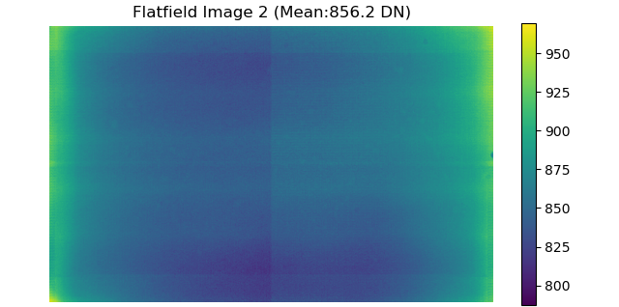
Figure 5: Low-range flatfield image.

Fixed pattern noise features can be discerned in the images - a vertical line down the center, horizontal bars spanning the width, and increased brightness on the sides and corners. At a finer scale, a grid pattern is also apparent in the top right quadrant. These are clearly camera artifacts, but the flat-field scene is also imperfect. Dust on the sensor can be discerned, the illumination of the flat field is not perfectly uniform, and lens vignetting is probably also present (although not obviously discernable).
However, in the PSP application, we generally use ratios of images rather than the images themselves. The figure below shows the ratio between Image 2 and Image 1.
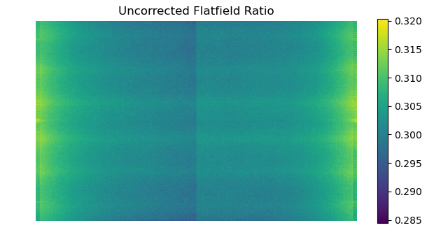
Figure 6: Ratio of flatfield images.
The ratio of light source illumination level between the two images was 0.30, but the ratio image above shows appreciable deviations from that value. It can also be observed that the dust on the sensor is no longer discernable. Any effect that is strictly linear with illumination (such as dust, lens vignetting, or nonuniform illumination of the scene) is cancelled out when the ratio is performed. In this way, the image above can be interpreted as a measurement of the non-linearity of the camera gain with illumination. The ratio image also shows the same pattern seen in the original images – horizontal bars, brightened edges, and a vertical line in the middle.
In a simple nonlinear model, the signal S (in digital counts [DN]) measured by a pixel is proportional to the incident light intensity I multiplied by a gain G, with a constant of proportionality k.
$S=k G I$ (1)
The gain is not a constant – it is a function of the incident light intensity and varies from pixel to pixel. The constant of proportionality k represents all parameters affecting the conversion from incident light intensity to signal that are proportional to incident intensity, such as quantum efficiency, lens vignetting, dust on the sensor, etc. In the flatfield calibration data, the illumination of the scene was set simply as a fraction of maximum power output, with 31 levels between black and near-saturation. Physically, the light intensity I should have units of irradiance such as photons per pixel. However, we assume that the commanded light intensity and incident light intensity on the pixel have a linear relation. As such, I can be expressed in fraction of maximum power output rather than in true radiometric units, with the appropriate scaling factors being included in k.
It is useful to normalize the signal to a reference value, as expressed below.
$S_{ref}=k G_{ref} I_{ref}$ (2)
A reference signal value S_{ref} of 2000 counts was used, which is approximately in the middle of the Phantom v2512 camera’s 12-bit range. A 6th order polynomial was fit to the calibration data, and this was used to find the corresponding value of I_{ref} for the reference signal value. A normalized gain can be obtained by dividing S by S_{ref} and rearranging terms.
$\frac{G}{G_{ref}}=\frac{S}{S_{ref}}\frac{I_{ref}}{I}$ (3)

Because the signal level is a function of intensity, this normalized gain is a function of I only. However, because there is a 1 to 1 relationship between signal level and intensity, the independent variable can be changed - the normalized gain can be expressed as a function of signal level instead. Figure 7 below shows the normalized gain curves for several pixels.
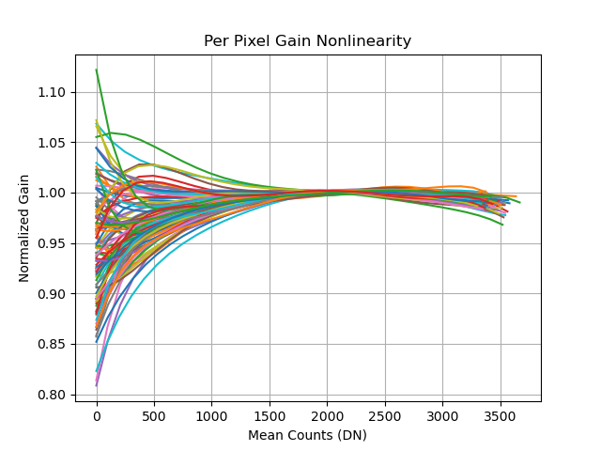
Figure 7: Variation of several photo response non-linearity curves with illumination level.

By design, the normalized gain curves converge to one at the reference signal level of 2000 counts. They do not pass exactly through one due to small errors introduced by the polynomial fit. The different behavior between pixels is readily apparent, especially at lower signal levels – these differences between pixels is responsible for the features observed in the uncorrected flatfield ratio image, Figure 6. It is also noteworthy that the slope of the normalized gain curve is quite flat at mid-range – this indicates that nonlinearity is not a major concern if measurements are taken only in that vicinity. However, this is not the case for lifetime PSP measurements, where signal levels between gate 1 and gate 2 images can vary widely.
Due to gain nonlinearity, the ratio of two measured signals will not be the same value as the true ratio of incident intensities. However, these per-pixel normalized gains can be used to perform a correction. Considering an ideal pixel with a constant gain equal to G_{ref} :

$S_{ideal}=k G_{ref} I$ (4)

The ratio of two measurements taken by this ideal pixel will also be the true ratio of incident intensities.

$\frac{S_{ideal,2}}{S_{ideal,1}}=\frac{{k G_{ref} I}_{2}}{k G_{ref} I_{1}}=\frac{I_{2}}{I_{1}}$ (5)

The measured non-ideal signal and the expression for normalized gain can be inserted in the above equation. This will yield the true incident intensity ratio in terms of the non-ideal pixel signals.

with $I=\frac{S}{k G}$

$\frac{I_{2}}{I_{1}} = \frac{G_{ref} \frac{S_{2}}{k G_{2}}}{G_{ref} \frac{S_{1}}{k G_{1}}} = \frac{\frac{G_{1}}{G_{ref}}}{\frac{G_{2}}{G_{ref}}} \frac{S_{2}}{S_{1}}$ (6)

Therefore, for two measured signals from a non-ideal pixel, the true incident intensity ratio is the ratio of their normalized gains, divided by the ratio of their signals.
As implemented in this work, each pixel has an associated 6th order polynomial fit to its normalized gain. The above correction is performed whenever a lifetime ratio is calculated. Some results of this correction are shown in the figure below.

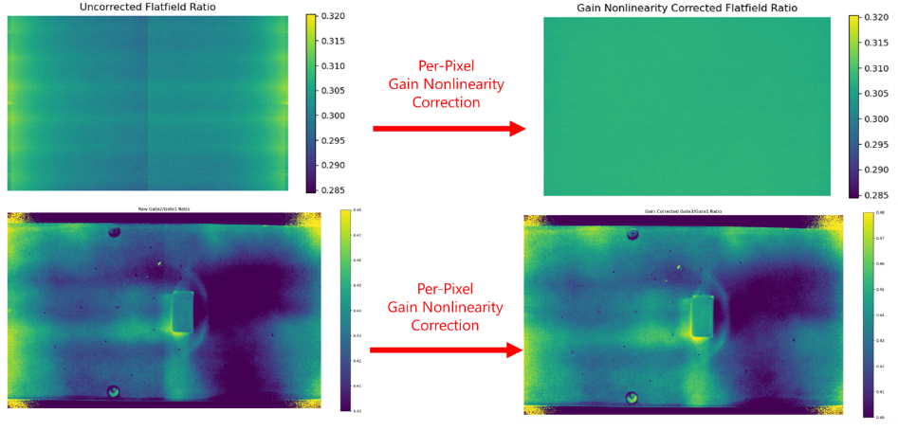
Figure 8: Gain nonlinearity correction applied to flatfield data (top row) and experimental lifetime method data (bottom row).
The per-pixel gain nonlinearity correction appears to work very well on the flatfield data. It also works well on actual test data - the most obvious improvement is removal of the vertical stripe down the plate. However, it is not perfect – there are still grid-like features at the left and right edges that are obviously fixed pattern noise. This may be attributed to slight differences in the noise pattern when the camera is run in the test cell, as opposed being calibrated in the laboratory – temperature differences, warmup time, and other factors likely play a role.
Through this process, the actual values of k and G_{ref} were never explicitly calculated – these variables always cancelled themselves out. Obtaining these values would require a true radiometric calibration, which is significantly more involved than our method of gathering flatfield images. As such, the process described here cannot be used for correcting images for fixed pattern noise – only ratios of images. We have exploited the fact that we are always interested in ratios of images rather than the images themselves to perform a fixed pattern noise correction in a simple yet effective way.

Image Lag
When run in the two-frame burst, short exposure settings required for lifetime data acquisition, the Phantom v2512 cameras also exhibit an ‘image lag’ effect, where a frame will be affected by brightness changes from preceding frames. This is illustrated in the figure below. The images shown are again averages (in this case over 1000 frames) in order to reduce the influence of shot noise.

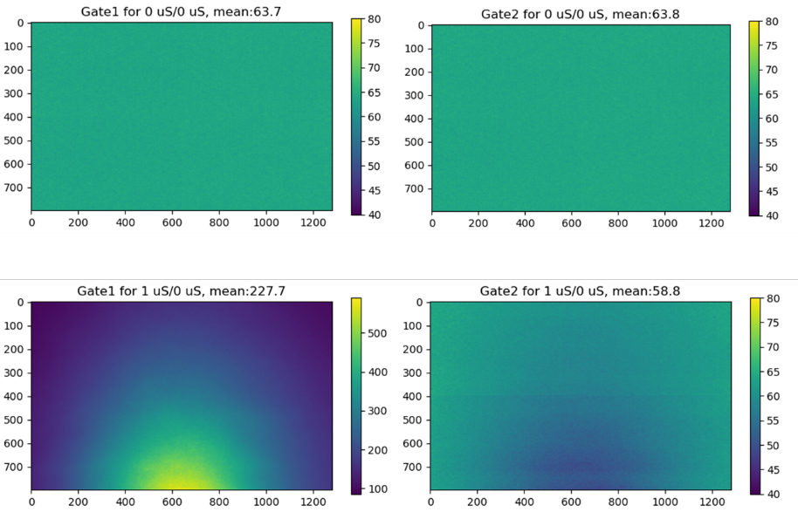
Figure 9: Demonstration of image lag effects. Top row: no light source. Bottom row: with light source.

The top two frames in the figure are images taken in the dark, with no lighting in the scene. They show the correct black level of ~64 counts. The bottom left image was taken with a short 1 μS LED flash partially illuminating a plate. The bottom right is the subsequent gate 2 image taken with no LED illumination. The scene is dark and should show a uniform dark level, but the areas that were bright in the preceding frame have been reduced below the black level. This is the ‘image lag’ effect.
The top two frames were taken with the same lighting condition, with no change in brightness. This is taken to be the true image without image lag for that lighting condition. The image lag can be quantified as the difference between the true image and the bottom right, lagged image. Similarly, a true image for the bottom left can be obtained by having the LED lamp flash for 1 μS in both gate 1 and gate 2. In this case, it was observed that image lag was actually increasing the signal in the bottom left image, compared to the true image.
Seven LED flash durations, chosen to cover the range from dark (0 μS flash duration) to near saturation (14.5 μS) were chosen, and data was taken for every combination of flash duration for gate 1 and gate 2. Each recording consisted of 2000 frames – 1000 repetitions of gate 1, and 1000 repetitions of gate 2. The combinations where gate 1 and gate 2 flash durations were identical were taken to be true images, and image lag is quantified relative to them. The following two figures show the results of this image lag calibration.

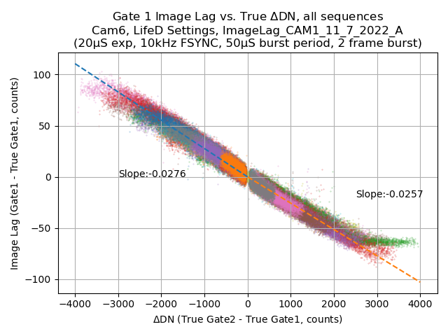
Figure 10: Gate 1 image lag calibration.
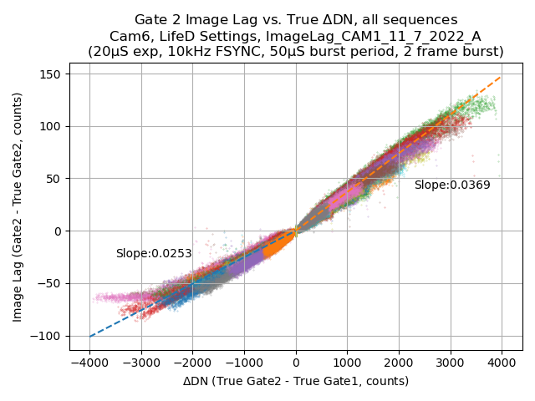
Figure 11: Gate 2 image lag calibration.
The figures show image lag with change in brightness in the true image, with each point representing the values for a particular pixel. Each color corresponds to a particular single gate 1 / gate 2 LED lamp flash duration, and the dashed line shows the least squares linear fit.
In Figure 10, the gate 1 image lag calibration, can be interpreted to mean ‘for every 1000 counts gate 2 is brighter than gate 1, image lag will artificially reduce the gate 1 measurement by approximately 25 counts’. Conversely, if gate 2 is dimmer than gate 1, gate 1 will be artificially brightened instead. Figure 11, the gate 2 image lag calibration, can be interpreted in a simlar way, although the negative and positive ΔDN regions have different slopes.

The image lag effect appears to be more complicated than described here, in this relatively simple quasi-steady, 2 frame case. When this analysis was performed for a 5 frame burst with one illuminated frame, it was observed that the image lag effect was noticeable for more than two frames. It was also observed that the image lag effects were different depending on exactly which one of the five frames in the burst was illuminated.

Non-Uniform Paint Response (NUPR) Correction
Spatial nonuniformity of the paint response is a familiar problem to PSP practitioners. In a wind-off condition, the pressure over the model is uniform and equal to atmospheric pressure. In addition, the entire model can be at a uniform temperature before wind-on runs commence. Ideally, a wind-off lifetime measurement should show a single value of lifetime ratio over the entire model, and that lifetime ratio should match the value for atmospheric pressure from the paint calibration. In practice this is not the case, particularly with the fast response paint used in this work. It appears that the non-uniformity of the paint response may be related to paint photo-degradation, paint thickness, base coat roughness, and many other factors, but its sources are beyond the scope of this work. Here we describe our process to correct for it.
The figure below shows lifetime ratios for a wind-off condition. The image lag and camera photo response non-linearity corrections described in the previous sections have already been applied.

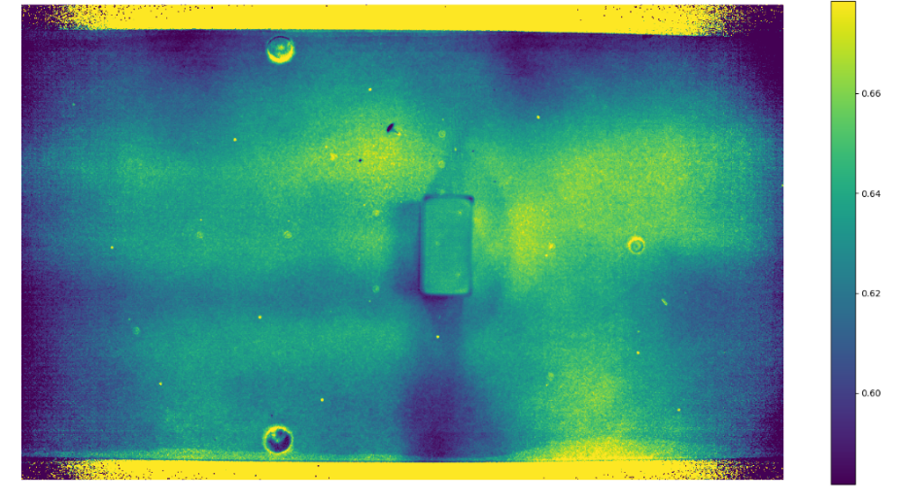
Figure 12: Representative wind-off lifetime ratios showing spatial non-uniformity.

According to the paint calibration, the model should be showing a uniform lifetime ratio of 0.51, corresponding to a pressure of 2080 psf. However, the lifetime ratio varies from 0.59 to 0.67 – nowhere does it actually match the predicted value from the laboratory paint calibration. A correction that can be tried is applying a per-pixel linear scaling of the measured wind-off ratio to match the predicted ratio from the paint calibration. A Non-Uniform Paint Response (NUPR) correction image can be formed by simply dividing the measured wind-off value by the predicted lifetime ratio from the paint calibration – that is, simply taking the image above and dividing it by 0.51. This is the factor by which wind-on images will be scaled before applying the paint calibration. The figure below shows processed wind-on, time-averaged pressure results with and without this NUPR correction.

Figure 13: Time-averaged, wind-on pressures without NUPR correction (left) and with NUPR correction (right).
This NUPR correction is by far the most important correction to the data that has been performed, and this form of NUPR correction (a per pixel linear scaling of lifetime ratio) appears to produce satisfactory results. The correction is intended to address nonuniformity of the paint response, but it was also observed to help with camera fixed pattern noise as well.

Image Registration
Even in this simple experimental setup, slight model motion (up to about 3 pixels) is observed between wind-on and wind-off conditions. The NUPR correction is generated at wind-off conditions, and some artifacts will appear if it is applied without being registered to the wind-on image. This image registration is performed using feature detection routines in the OpenCV library. The ORB detector is used to find features in both wind-off and wind-on images and these features are matched using the brute force matcher. Using these matches, a 3x3 homography matrix is generated using the findHomography function. The wind-off NUPR is then registered to the wind-on image with the perspectiveTransform function. The figures below compare registered and unregistered results with all the corrections of the previous sections applied. Artificial surface texture can be seen in the unregistered image, and features like fiducial marks and scratches in the paint are prominent. The registered results remove most of these artifacts. However, removing the artificial texture seems to reveal more of the residual fixed pattern noise.

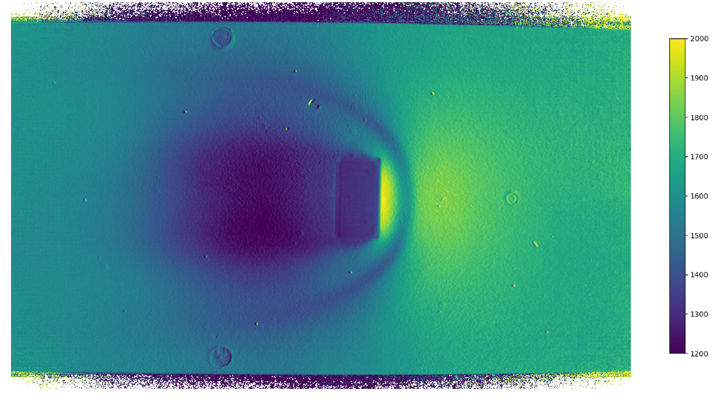
Figure 14: Time averaged pressures without image registration.

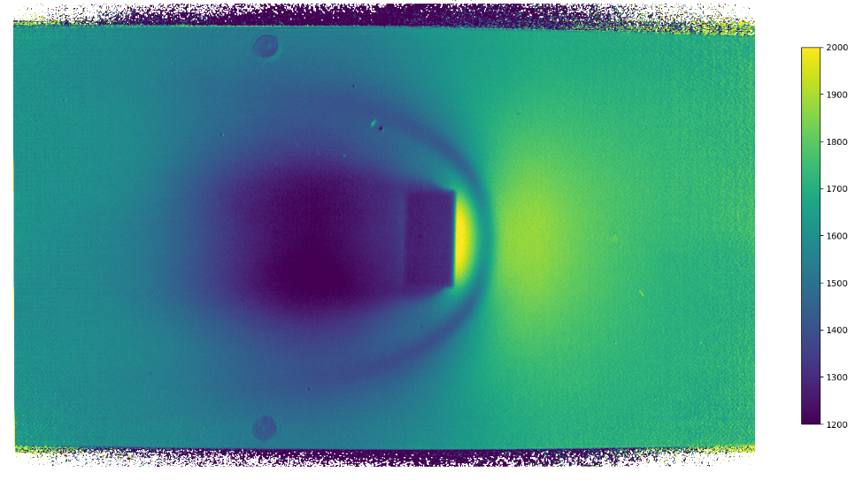
Figure 15: Time averaged pressures with image registration.

The preceding processed results showed time averaged pressures. The data processing steps can also be applied to individual pairs of frames as well, to produce high-speed lifetime PSP data. Shot noise will be much more apparent due to the lack of averaging. The figure below shows the pressure field derived from a single lifetime ratio and is a snapshot of the flow taken over a 70 μS duration. Although unsteady lifetime PSP (typically at 10,000 frames per second) can be performed, the intensity method still tends to produce better results.

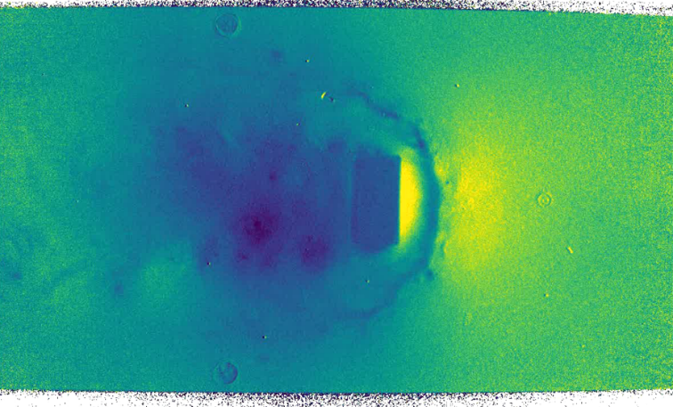
Figure 16: Processed lifetime PSP pressures for a single gate 2 / gate 1 pair.
- Pressure Tap Comparisons
As described in Section II, the model was well instrumented with thermocouples, static pressure taps, and Kulite pressure transducers. The arrangement of these sensors is shown in the figure below.

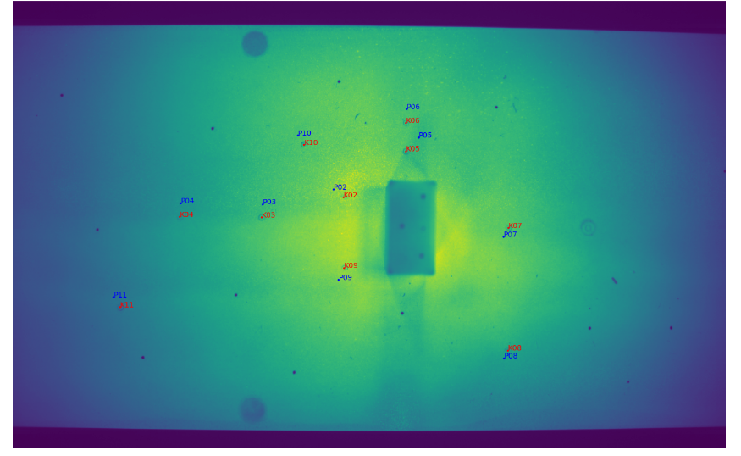
Figure 17: Arrangement of static pressure taps (P) and Kulite pressure transducers (K) on the model.
Thermocouple locations are not explicitly shown, but a thermocouple was installed near each static pressure tap / Kulite pair. The particular paint used in this test is highly sensitive to temperature, and thermocouple readings were used to establish the temperature used in the paint calibration. ‘Virtual taps’ for comparison to static pressure taps were created from PSP data. These virtual taps covered a 3x3 pixel area five pixels downstream (to the left in Figure 17) of each static pressure tap. The figure below shows comparisons between these virtual taps and the static pressure taps for five freestream Mach conditions.

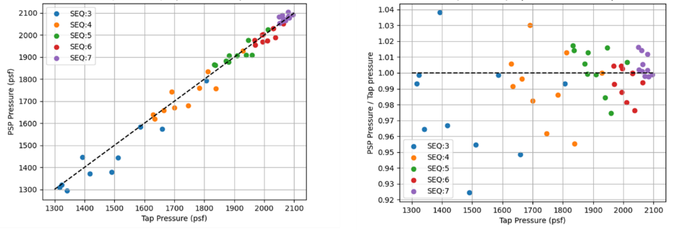
Figure 18: Comparison of PSP virtual taps and static pressure taps.

The data were collected at Mach 0.61, 0.46, 0.34, 0.24, and 0.17, corresponding to the labels “SEQ:3” through “SEQ:7”. The static pressure taps and virtual taps agree within about 100 psf, and usually much closer. The steady state pressures obtained by this method will only be used to calculate the gain for intensity method processing, and this level of accuracy appears to be adequate for that purpose.
- Conclusions
The lifetime PSP method was implemented using the NASA Ames uPSP system’s Phantom v2512 high-speed cameras and operated in small-scale wind tunnel tests. These cameras are optimized for high speed and exhibit some undesirable characteristics. However, it appears that the photo-response non-linearity can be corrected and that the image lag effect can be calibrated out. A novel method for performing the photo-response non-linearity correction was introduced. It was found that the level of illumination provided by LED lamps and the inherent noise characteristics of the Phantom v2512 high-speed cameras do not preclude the use of the lifetime method. Comparison between high-speed camera lifetime PSP results and static pressure taps show adequate agreement. Future work will focus on integrating this technique into the production uPSP system and processing pipeline. This will have the major benefit of eliminating the added overhead of running a separate lifetime PSP system in parallel, and will streamline setup, operations, and processing.

Acknowledgements
The authors would like to thank the NASA Aerosciences and Test Capabilities (AETC) Portfolio office for their support, as well our colleagues at the Arnold Engineering Development Complex for fruitful discussions.

References
- Sellers, Marvin E., “Advances in AEDC’s Lifetime Pressure-Sensitive Paint Program” U.S. Air Force T&E days, December 2005, Nashville, TN. https://doi.org/10.2514/6.2005-7638.
- Sugioka, Y., Nakakita, K., Saitoh, K., Nonomura, T., and Asai, K., “First Results of Lifetime-Based Unsteady PSP Measurement on a Pitching Airfoil in Transonic Flow,” AIAA SciTech Forum, January 2018, Kissimmee, FL. https://doi.org/10.2514/6.2018-1030.

Research Engineer, Experimental Aero-Physics Branch, MS 260-1
Aerospace Engineer, Experimental Aero-Physics Branch, MS 260-1, AIAA Member
Aerospace Engineer, Experimental Aero-Physics Branch, MS 260-1, AIAA Member
Aerospace Engineer, Systems Analysis Office, MS 258-1
Aerospace Engineer, Experimental Aero-Physics Branch, MS 260-1, AIAA Member

