Navigation Doppler Lidar Signal Processing Architecture and Algorithms
Glenn Hines, Farzin Amzajerdian, Mitchell Jordan Davis, Aram Gragossian, and Greg Crowther
NASA Langley Research Center, Hampton, Virginia 23681, USA
A coherent Doppler lidar has been developed to address the need for a high-performance, compact, and cost-effective velocity and altitude sensor onboard landing vehicles. One of the core subsystems within NDL is its signal processing architecture. The primary function of this subsystem is to digitize the analog output of the homodyned signal received from the photo-diode associated with each telescope, process this signal in the frequency domain, and then turn this information into velocity and range measurements. A secondary function of this subsystem is to setup and control the internal components within NDL and to enable the instrument to interface with external systems by receiving commands, sending telemetry, and synchronizing its measurements with external clocks and pulses. This paper will give an overview of the signal processing architecture within NDL. This will include a discussion on its fundamental processing components and the core signal processing algorithms. Command, telemetry and internal component controls will also be discussed as will how the signal processing architecture has also evolved over the years of development. We will discuss provisions for robust operation including Triple-Mode Redundancy (TMR) within NDL’s Field Programmable Gate Array (FPGA) and storage elements, a fault-tolerant boot process, and Error Detection and Correction (EDAC) on the Static Random-Access Memories (SRAMs). Finally, we conclude this paper with how this architecture could continue to evolve.
- Introduction
Global Positioning System (GPS) is commonly used in terrestrial navigation for vehicle position and velocity knowledge. In the absence of a GPS signal, past landing missions to planetary bodies relied on radar to provide the necessary data to execute descent and landing maneuvers.^{1,2} Radar limitations however, place unnecessary constraints on future landing vehicles adding risk to ambitious mission objectives. For this reason, we have developed and demonstrated the Navigation Doppler Lidar (NDL) as an alternative to radar sensors.³⁻⁵ NDL offers several critical advantages compared to radar, including significantly higher precision with reduced size, weight, and power. In addition, the laser-based NDL sensor does not suffer from measurement perturbation from terrain features or signal ambiguity from transmitted side lobes, and is far less susceptible to signal clutter, such as those caused by returns from the lander structure or jettisoned vehicle components like heatshields. The higher quality data provided by NDL will enable both a more precise navigation towards the designated landing site and a well-controlled touchdown (with greater stability and lower impact loads). This translates into lower fuel reserve and smaller leg span for a landing vehicle and thus further reduces vehicle mass. Therefore, NDL can potentially reduce the overall cost and risk of landing missions and enable new capabilities for planetary exploration missions including missions to the Moon, Mars, asteroids, and planetary moons.
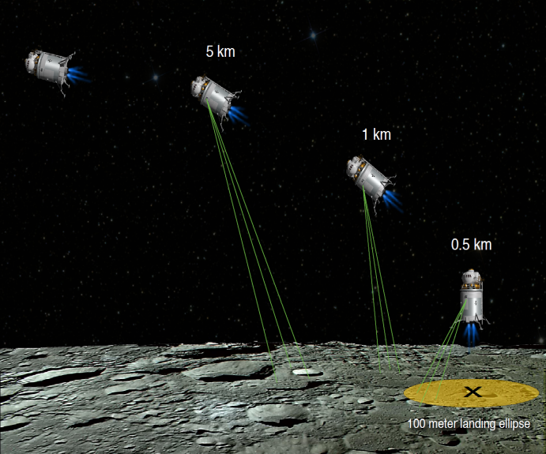
NDL transmits three laser beams at fixed but different pointing angles toward the ground to measure range and velocity along each beam (Figure 1) using a frequency modulated continuous wave (FMCW) technique. The three Line-Of-Sight (LOS) measurements are then combined in order to determine the three components of the vehicle velocity vector and its altitude relative to the ground. NDL can measure velocities up to +/-218 m/sec along the LOS of its beams from over 5 km down to a few meters above the ground.
Fig. 1 Illustration of NDL operation during descent and landing showing three transmitted beams.
Multiple units of the instrument have been built for upcoming robotic lunar missions in order to demonstrate its viability for more critical human landing missions. NDL can also benefit terrestrial aerial vehicles that cannot rely on the GPS for position and velocity data. NDL offers a viable option for enabling aircraft operation in areas where the GPS signal can be blocked or jammed by intentional or unintentional interference. This paper focuses on the performance of NDL operating on space vehicles landing on the Moon and other planetary bodies. The results of the analytical and experimental work quantifying the impact of vehicle motions on the measurement’s precision and operational range will be described.
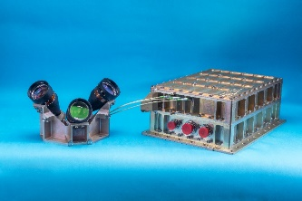
Figure 2 shows one of the four NDL Engineering Test Units (ETUs) built for terrestrial testing and lunar landing demonstration. The terrestrial tests include flat-sat testing with various avionics, and aircraft and suborbital flight tests. Two of the ETUs will be flown on lunar landing vehicles developed by Intuitive Machines and Astrobotic in 2022. The lunar landing missions will demonstrate the capabilities of the NDL and validate its readiness for future robotic and human landing missions to the Moon and other planetary bodies. The NDL ETU consists of an electro-optic chassis and an optical head. All the lidar components including the transmitter laser, receivers, and signal processor are housed in the electro-optic chassis. The optical head, housing three transmit/receive lenses, is mounted rigidly on the vehicle with a clear field-of-view to the ground, and connected to the electro-optic chassis through a long fiber optic cable carrying the transmitted beams to the lenses and directing the returned signals collected by the same lenses to the receivers. The full transmit to received signal processing chain for each beam is called a channel.
Fig. 2 NDL Engineering Test Unit developed for two lunar landing missions.
- NDL System Description
NDL uses a frequency modulated continuous wave (FMCW) technique⁶ to simultaneously measure velocity and range to the ground. The principle of NDL operation is illustrated in Figure 3 which shows the modulation waveform for one channel consisting of three segments: up-ramp chirp, constant frequency, and down-ramp chirp. The resultant returned waveform from the target is delayed by t_{d}, the light round trip time. When the target or the lidar platform is not stationary during the beam round trip time, the signal frequency will be also shifted up or down, depending on the velocity direction, due to the Doppler effect. When mixing the two waveforms at the detector, an interference signal is generated whose frequency is equal to the difference between the transmitted and received frequencies. In the absence of velocity along the laser beam, the signal frequency during the “up-ramp” and “down-ramp” periods are equal and their magnitude is directly proportional to the distance to the target. When the vehicle is moving, the up-ramp and down-ramp frequencies will not be equal and their difference is related to the Doppler velocity. The target range and magnitude of the velocity component along the laser beam are determined through the following simple equations:
$$R=\left(\frac{ TC}{2B}\right)\left(\frac{f_{IF}^{+}- f_{IF}^{-}}{2}\right) (1)$$
$$V_{r}=\left(\frac{λ}{2}\right)\left(\frac{f_{IF}^{+}+ f_{IF}^{-}}{2}\right) (2)$$
where $f_{IF}^{+}$ and $f_{IF}^{-}$ are the intermediate up-ramp and down-ramp frequencies, B is the modulation bandwidth, T is the waveform period, C is the speed of light, and λ is the laser wavelength. The constant frequency segment of the waveform provides a second independent measurement of the radial velocity which is extracted directly from the Doppler frequency shift due to the relative motion of the sensor and target:
$V_{r}=\left(\frac{λ}{2}\right)f_{D}$ $\left(3\right)$
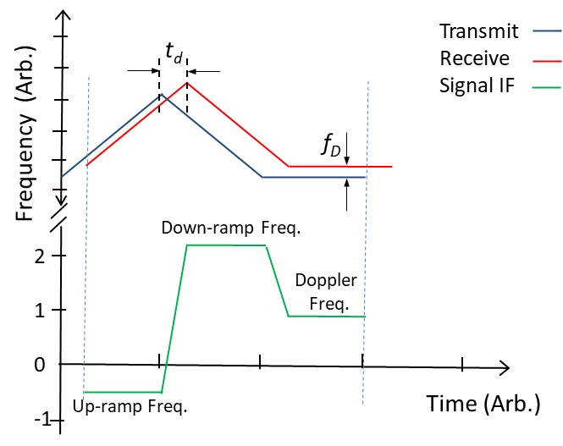
Fig. 3 Linearly frequency modulated transmitted beam and returned signal,
and the resulting intermediate frequency (IF) of the homodyne signal.
The constant frequency segment also produces the Doppler velocity and its existence may seem unnecessary at first glance. However, the signal from the constant frequency segment serves three important purposes: 1) it resolves
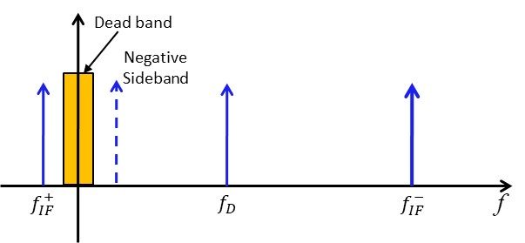
possible ambiguity in determination of velocity direction, 2) it minimizes false alarms in determination of the range in the presence of Doppler frequency, and 3) it eliminates data dropout when either the up-ramp or down-ramp signals fall within the receiver dead band around DC. Figure 4 illustrates the intermediate signals corresponding with each segment of the modulation waveform in the frequency domain. The signs and magnitudes of the up-ramp and down-ramp signal frequencies are functions of both velocity magnitude and direction for a given time delay or range. However, it is not possible to discriminate positive and negative frequencies in a homodyne system. The velocity magnitude obtained directly from the constant frequency part of the waveform resolves this ambiguity. In other words, it allows for determining the signs of the up and down ramp intermediate frequencies in Eq. (2). Also, when either up or down ramp frequency falls within the receiver dead band, the remaining two signals can be used to determine both range and velocity in most possible scenarios.
Fig. 4 Intermediate Frequencies (IF) corresponding to the three segments of the laser modulation waveform.
- Signal Processing Architecture Background
A core subsystem within NDL is its signal processing architecture. The primary function of this subsystem is to digitize the analog output of the homodyned signal received from the photo-diode associated with each channel, process this signal in the frequency domain, and then turn this information into the resultant velocity and range measurements in engineering units. It is also used to initialize multiple internal components within NDL, and to handle communication with external systems by receiving commands, sending telemetry, and synchronizing its measurements with external clocks and pulses.
Initial versions of NDL digitized the analog input data and only recorded it during early flight test campaigns, so no real-time onboard processing was implemented. The recorded data was then post processed to retrieve and determine system performance during the prior flight. Even with the architecture being a non-real-time system, the onboard data acquisition system was large in size and mass, and required significant power. Pictures of two of the early prototype flight systems are shown in Figure 5.
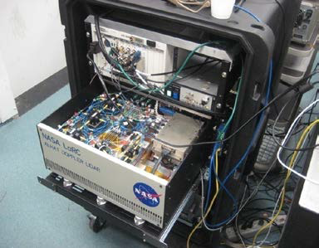
Fig. 5 Prototype NDL data acquisition systems. Mass was ~200 Kg (on the helicopter) and ~60 Kg. (rack).
The second generation NDL (Gen 2), which flew on the Morpheus flight test vehicle, contained an embedded signal processing architecture, called the Command and Data Handling unit (C&DH), that digitized, real-time processed, and stored flight data. It also processed commands, generated instrument output telemetry packets, synchronized system operation with external systems, and controlled multiple internal components. This C&DH was based on a PC-104 stack which sat adjacent to other primary components within the chassis as shown in Figure 6.

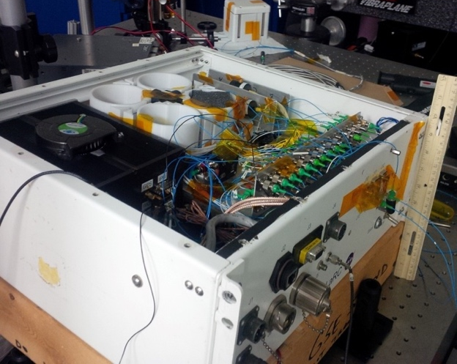
Fig. 6 NDL Generation 2 chassis showing the C&DH as the black box in the upper left corner.
The PC-104 stack contained a power converter board, a single board computer (SBC), a digital input-output (DIO) board, and a Virtex 5 SXT95 field programmable gate array (FPGA) board with an attached 3-channel Analog to Digital Converter (ADC) daughter-board. A block diagram of the stack with pictures of the FPGA board and ADC is shown in Figure 7. The stack was mounted in a container with internal vibration isolators and was convectively cooled via fans. Other microprocessors that controlled various components were also embedded within the NDL chassis.
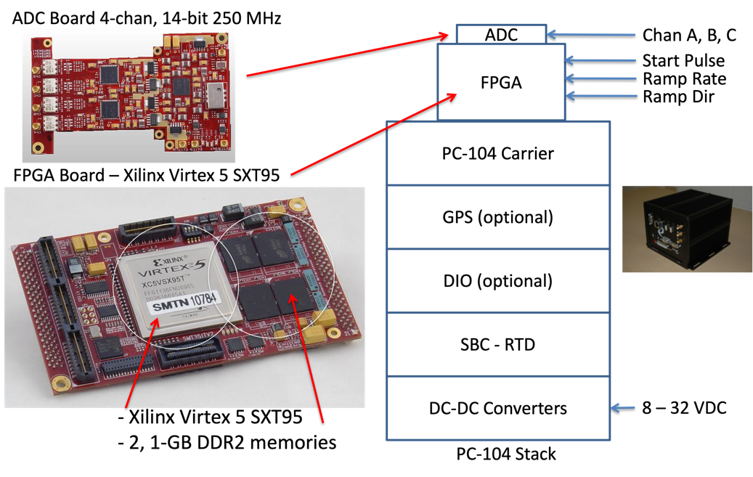
Fig. 7 Images of the NDL Gen 2 FPGA and ADC board and a block diagram of the PC-104 stack.
Although this architecture was robust and operated successfully throughout the Morpheus closed-loop flight test campaign, several inefficiencies were noted. As the next generation system was being considered, multiple trades and studies were performed on these inefficiencies and on the overall system design. From these trades several potential significant improvements were analyzed and the decision was made to design and develop a custom C&DH based on the Xilinx Virtex 5 FPGA. Many of the core instrument functions were consolidated onto this board as will be discussed later. Below are a sample of some the trades and comments on the solution implemented.
In observing the early NDL architecture, from a system level perspective, the instrument consisted of a heterogeneous, distributed set of processing systems which required independent qualification and verification of their performance, as well as additional power and mass. One of the first trade spaces studied was to determine if this architecture could be simplified by combining or absorbing some of this distributed functionality into a single primary signal processor. Since the core signal processing was performed using an FPGA, and this FPGA could instantiate a microprocessor, all microprocessor related functions could be combined into the fabric of the FPGA thus eliminating the need for the SBC board of the PC-104 stack. The functionality of the DIO board could also be implemented inside the FPGA fabric using its numerous I/O pins. Reductions such as these produced a significant savings in size, mass and power.
For spaceflight, volume, which strongly correlates with mass, is a prime parameter to minimize. With the prior PC-104 stack architecture in the Gen 2 system, the stack either had to sit adjacent (as configured) to other large subsystems and components or it could be placed above or below them. Having the stack adjacent widens the overall footprint of the chassis, and placing it above or below the other large components would significant expand the required volume as well as make the mechanical and structural design unnecessarily complicated. Being able to fully design the custom C&DH enabled targeting as small a footprint as possible. This board could lay flat and adjacent to the other large components creating a sandwich-like configuration that minimizes the overall chassis volume. The initial target design dimensions focused on matching the size of the fiber amplifier. The final design exceeded the footprint of the fiber amplifier mostly due to the complexity of the layout and the large number of passive devices required, however this enabled the placement of other electro-optical components next to the fiber amplifier so the overall chassis dimensions were still somewhat optimized.
Thermal management was another area that required change from the Gen 2 system. The convective cooling methodology used for thermal management in the Gen 2 PC-104 stack had to be redesigned to be conductively cooled to operate in the vacuum of space. The primary producers of heat were concentrated in a few components, particularly the FPGA and the ADCs. Several cooling solutions were considered such as heat pipes and flexible heat straps. In the final design of the custom C&DH the primary high power components were placed on a single side of the board. This allowed for these components to be physically located adjacent to the instrument’s metal baseplate which was augmented with pedestals that matched the high power component layout. The baseplate with pedestals, supplemented with thin gap pads for margin control, thus served as a heatsink providing conductive cooling of the high power components. This same concept was also applied to other subsystems within the chassis such as the high power components on the power distribution unit.
One other prime consideration during development of the custom C&DH was the selection of components. In preparing for the instrument to eventually be used in spaceflight, the NDL team philosophy has always been to use the highest qualified part that could be obtained within the current cost and schedule constraints. The early architectures contained a mixture of commercial off the shelf (COTS), military, and space-grade components. Budget and schedule constraints prevented the complete migration to using all space-grade components, but component improvements were made where and whenever possible. We will discuss a few of these updates below as we go into more detail on the signal processing hardware, but overall, NDL has effectively evolved into an engineering test unit with components capable of being used for spaceflight with the only qualification of depending on the risk posture of the mission.
- C&DH Signal Processing Hardware and Software
A block diagram of the C&DH is shown in Figure 8. The core components are: a Xilinx Virtex 5 compute Field Programmable Gate Array; a ProASIC3 utility FPGA (used during development) and a RTAX FPGA (for flight); Cypress QDRII+ SRAM; 3D Plus NAND flash memory; three Texas Instruments (TI) high speed ADCs; several RS422 interfaces; and multiple busses for communicating with internal components such as the frequency synthesizer, optical filter, seed laser and fiber amplifier.
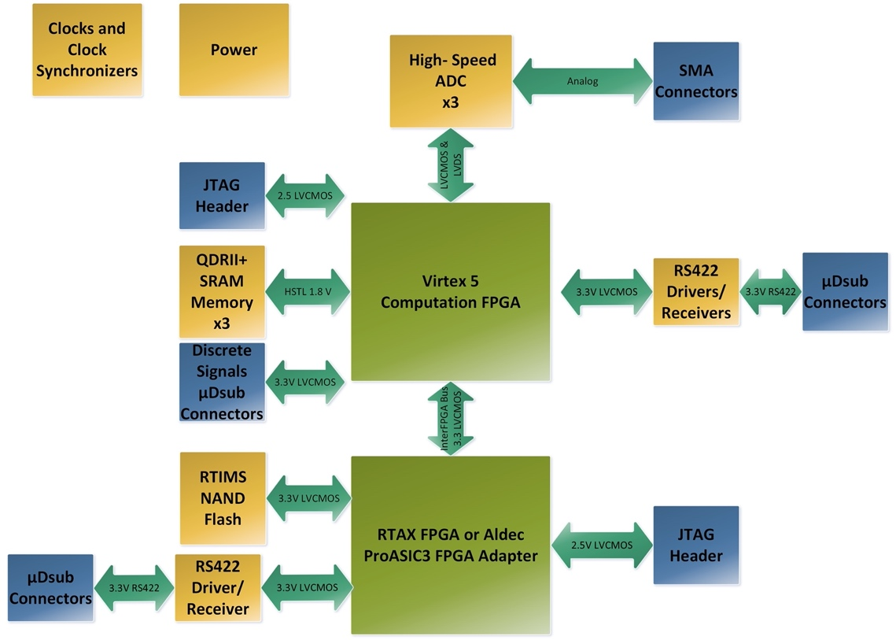
Fig. 8 Block diagram of the C&DH primary components and interfaces.
The Virtex 5 is the QML B version (Xilinx “B” hi-reliability flight prototype). This version was used instead of a full space-grade QML V component. The QML B was less expensive, more readily available and has effectively the same performance and footprint as the spaceflight version, but was not screened to the same levels. This was one of the compromises made during component selection to stay within cost and schedule constraints. An FPGA was chosen as the core processor of the system because of its excellent performance in executing Fast Fourier Transforms (FFTs), its capability to instantiate a microprocessor internal to its logic thus providing the ability to absorb system functions, and its flexibility in design enabling it to implement various interfaces and functions and to be able to modify or change them if necessary.
The reprogrammable ProASIC3 utility FPGA was contained in an adapter which allowed it to be changed to a one time programmable RTAX for flight. Being able to reprogram the device was important during early development since the design was still in flux. This core component retrieves the configuration file for the Virtex 5 from the NAND flash, performs with some housekeeping functions, and enables a fault-tolerant boot process which is discussed later, thus moving to the space-grade RTAX was required for this device.
The Cypress QDRII+ SRAM provides 216 Mb of memory for the FPGA. Multiple banks of memory are implemented and its primary use is to temporarily hold and transform data during FFT and peak detection processing. Data is also held there to enable writing certain values and measurement results into long-term flash memory. The flash memory is implemented using a 3D Plus 24 Gb flight part which has 8 Gb of available storage when configured for TMR. Any required and selectable data recorded for post flight retrieval is stored in this memory. Some examples of selectable data products are a copy of output telemetry packets, pre or post filtered FFT data and direct outputs (time domain data) of the ADCs.
Three high-speed TI ADCs, one for each channel, are placed on the board. These are 12-bit ADCs, providing the necessary resolution for NDL signal processing, and they are clocked at 560.4 MHz, thus covering the 280 MHz bandwidth of the NDL receivers. One drawback of this ADC is that it uses a parallel bus instead of a serial one for data output thus requiring additional pins on the Virtex 5 FPGA as well as more space for layout, but it was still chosen during design because it was the only available spaceflight qualified ADC that fit within our budget and met the high performance specifications. For future designs finding a qualified ADC that uses a serial interface such as the JESD204 for data transfer would simplify board layout, thus enabling a smaller form factor and enhancing FPGA utility by reducing the required amount of inputs and outputs (I/O).
Several external instrument data interfaces, such as SpaceWire and Ethernet, were considered for the custom C&DH but a RS-422 interface was selected for implementation due to its simplicity, robustness, and ubiquitous use throughout the industry. Using RS-422 also maintained consistency with our prior systems and allowed the continued use of some of the previously developed ground support equipment (GSE). Four external RS-422 ports are provided. One is used to receive commands, with embedded time stamp information, and to transmit telemetry packets containing NDL measurement data and status information. Another is configured as an input for a differential pulse per second (PPS) timing signal. The third port is used to communicate with the ProASIC3/RTAX utility FPGA. The fourth port is used for general purpose GSE.
The industry standard Joint Test Action Group (JTAG) interface serves as another GSE interface to both FPGAs. It can be used to read back various internal data values from within the FPGAs such as housekeeping data and device identifiers. The ProASIC3 is initially programmed via the JTAG interface and can subsequently be configured via the RS422 firmware port. The RTAX devices are received pre-programmed from the manufacturer prior to board assembly. The ProASIC3/RTAX can be used to transfer a configuration file using the RS-422 port to the NAND flash, and a SelectMap interface going to the Virtex 5 can be used to program the configuration file of the Virtex 5.
Several internal interfaces between the Virtex 5 FPGA and various instrument components are also implemented on the custom C&DH. Serial peripheral interface (SPI) and RS-422 interfaces are used to communicate with and program the seed laser and fiber amp. Communication with the frequency synthesizer is performed using an RS-422 interface. The Virtex 5 FPGA sends data over an inter-integrated circuit (I2C) interface to initialize and program the optical filter. Configuration of the ADCs is performed over an SPI interface. Clock signals to the ADCs are provided by a TI clock synchronizer. Several additional components are also on the board including DC/DC converters, low dropout regulators (LDOs), housekeeping ADCs, and multiple passive devices. A composite of the board layout, levels and top and bottom views of the board are shown in Figure 9. The diagram showing the 20 layers of the board is an indicator of the complexity of the design. It has over 100 unique components and has a total component count of more than 800 parts.
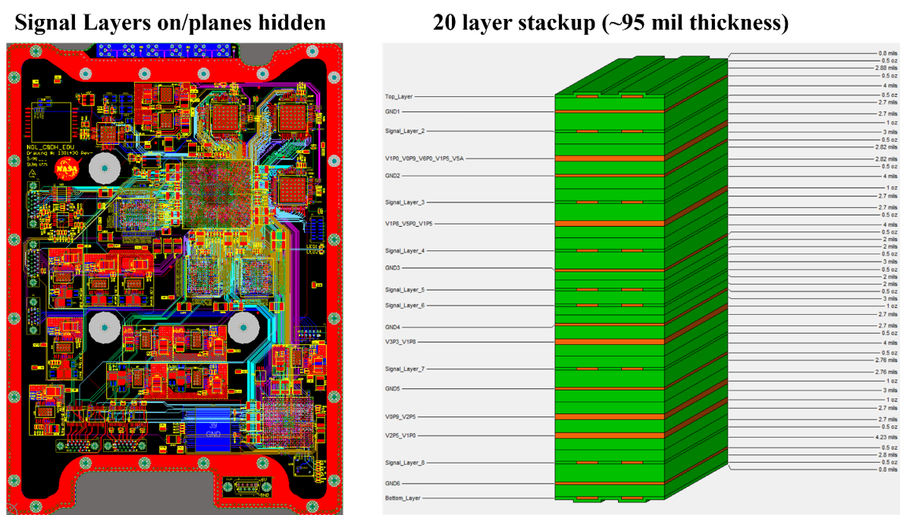
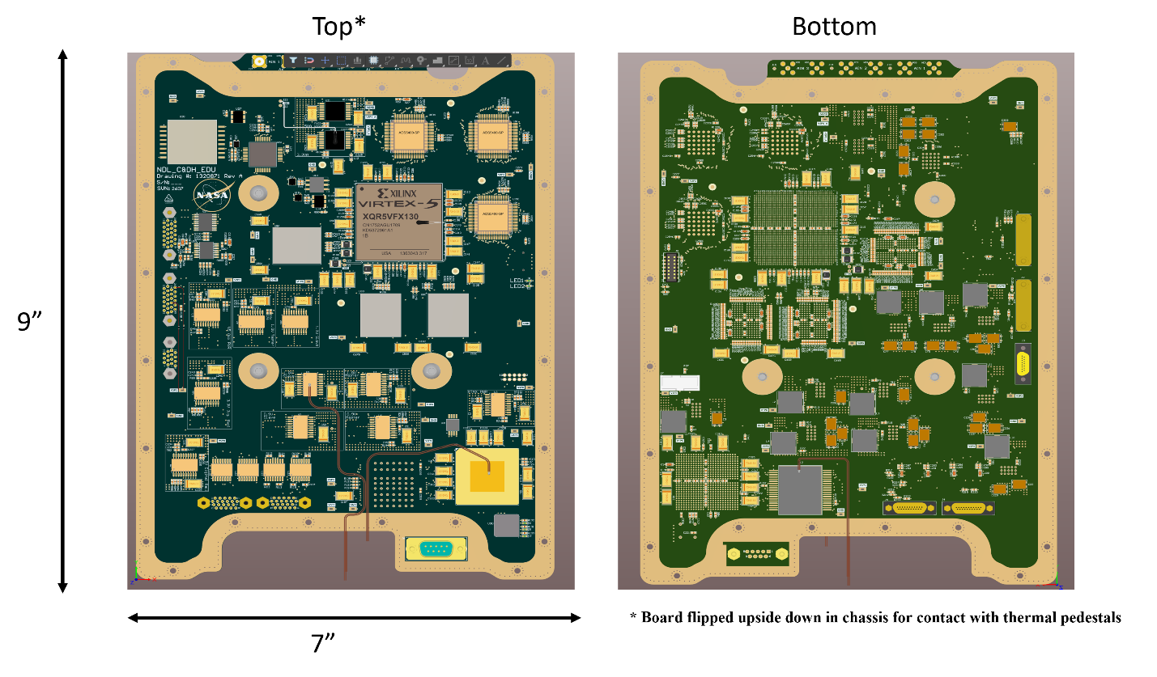
Fig. 9 The layout, layers and component placement of the NDL C&DH.
The firmware for NDL is focused on capturing the sampled data from the ADCs, processing this data in real-time, and providing the results to the internal software algorithms which generate the output velocity and range measurements. The firmware is written in VHDL with some portions of the FFT code written using Verilog. A block diagram of the firmware core functions is shown in Figure 10. As discussed above in the system description, each of the three segments for each channel must be processed. NDL thus requires nine 256-K point FFTs to be executed in real-time (at 20 Hz). A 256-K point FFT is used to produce the required ~2 KHz resolution for each measurement. The UltraLong 256K point FFT Intellectual Property (IP) core from Dillon Engineering is used to perform the FFTs. Dillon Engineering also provided support functions that tie in the IP core with the other FPGA logic.
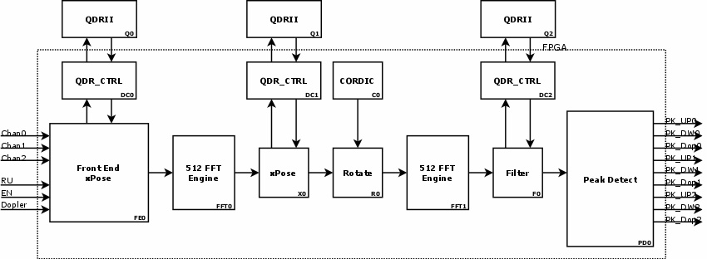
Fig. 20 Core signal processing engine.
Data is shuffled between multiple banks of QDR memory during FFT processing. Once the signal is in the frequency domain, the next phase of processing is to apply a filter (designated as a background filter) to remove backscatter and any additional recurrent noise sources that occur above the baseline noise floor. This filter is generated prior to flight and is stored in flash memory. It is acquired with the system fully operational but with no return signal applied thus capturing the noise characteristics of the instrument and environment. The final phase of processing is to perform a linear, O(n), search for the peak value (designated as peak detection). The magnitude and frequency for which this peak occurs for each segment is passed to the instrument software for further processing. The instrument runs at 20 Hz producing 20 measurements per second, so there is a 50 ms window for processing. Data capture occurs over a ~1.5 ms window. Data processing of all nine segments takes ~23.8 ms. Adding in laser settle time and copying of captured data leaves ~16 ms for software processing. Final Virtex 5 utilization is ~50%.
- C&DH Software
The instrument software, written in C, is executed on a MicroBlaze soft core processor instantiated in the Virtex 5 FPGA. A block diagram to place in context where this is allocated in the architecture is shown in Figure 11. The program size is constrained to 256 KB of executable and working memory and it does not utilize interrupts, a real-time operating system or task scheduler. The MicroBlaze is clocked at 60 MHz. The primary task of the instrument software is to process the magnitude and frequency information passed to it through a buffer from the Virtex 5 FPGA firmware at 20 Hz into velocity and range measurements for each beam. Derivative measurements, such as vector velocity and altitude are also generated.
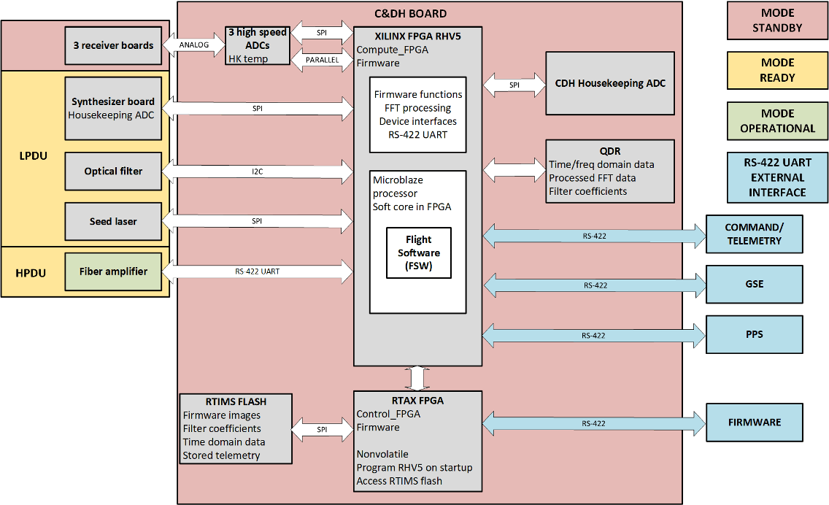
Fig. 11 Block diagram showing where the software resides in the architecture.
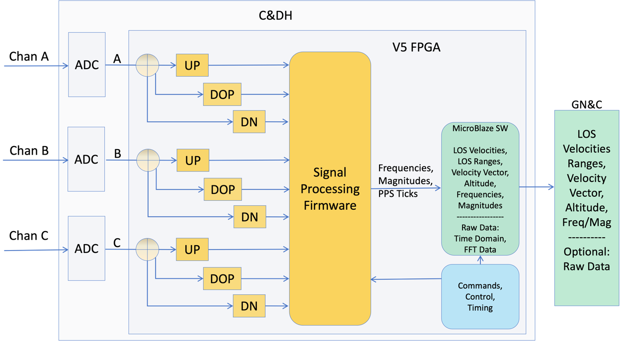
Fig. 13 Firmware and software interfaces and products.
All three frequencies (up, down and doppler) of the modulation waveform for a channel are used, per Equations (1) – (3), to determine the line of sight (LOS) velocity magnitude and sign (positive moving toward the ground and negative moving away from the ground), and LOS range to the ground. Using all three frequencies eliminates any possible ambiguity. However, there are occasions when all three frequencies are not available. The algorithm can still provide valid range and velocity data with two, or valid velocity data with even one valid (doppler) frequency.
The first phase of software processing determines which if any of the three segments for a channel is valid. This is performed by comparing the magnitude for each against a heuristically determined threshold value. The second phase of processing goes through a sequence of steps based on which segments are valid for a channel to either provide a measurement with extremely high confidence for both magnitude and sign (designated as case 1), a measurement with moderate confidence (or high if a previous case 1 measurement has been made) for both magnitude and sign, or a measurement with null (0) values assigned if none or only one of the modulation ramp segments are valid indicating effectively no measurement was made.
The sequence of steps mentioned above includes a series of additional checks to determine if the signals acquired are within the range of being valid. If so, the appropriate velocity and range equations based on which segments are valid are applied to generate a properly signed velocity measurement, and a range measurement for each beam. This information is then sent to additional code functions so it can be embedded in the output telemetry stream.
A secondary, but just as important, function of the software is to initialize and control the internal components within NDL and to enable the instrument to communicate with external systems. Initialization of components, such as the optical filter, seed laser and fiber amplifier, is performed at system startup. Commands are received via the RS-422 port and are processed to determine what action should be taken. Time stamp information is also embedded in the commands so this information is parsed and applied to subsequent measurements. The input PPS is used by the firmware to provide higher (microsecond level) resolution on these measurement times.
Output data from the instrument is provided in telemetry packets. These are categorized primarily into navigation packets, which contain the generated measurement data, and housekeeping packets, which contain additional information on the status and health of the instrument. Examples of status and health information include values such as multiple internal temperatures, current and voltage measurements, and statistics on measurements. Navigation and Housekeeping packets are generated at 20 Hz and 1 Hz respectively. A block diagram of this configuration is given in Figure 12. Having multiple packet sizes helps to minimize the required output data bandwidth which is a limited resource on most missions.
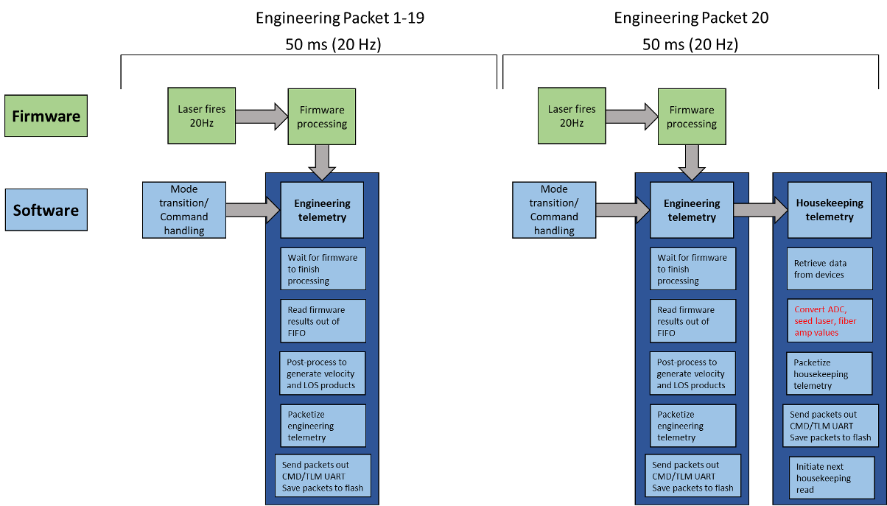
Fig. 14 Telemetry packet timing showing engineering packets at 20 Hz and housekeeping packets at 1 Hz.
The software controls the overall instrument operation by organizing this operation into different modes. This allows various components to be turned on at different times providing flexibility in mission operation by, for example, saving power while being ready to enter full operation (firing the laser) on command or supporting faster warm-up times by keeping a subset of components on. The modes of the instrument are standby where the C&DH and receivers are on; ready which turns on the seed, optical filter and synthesizer, and operational which enable the fiber amp to fire. A block diagram of mode transitions is shown in Figure 13.
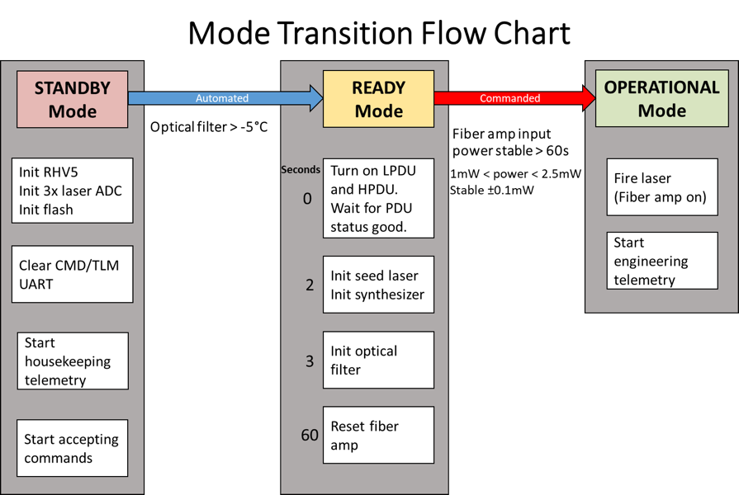
Fig. 15 Software mode transitions between standby, ready and operational.
Overall the instrument software provides a robust and flexible environment for both instrument operation and interfacing with various avionic architectures. Automation is built into the code enabling transitions between modes based on timing and internal events. The software also supports recording of all generated data to the flash and transferring recorded data stored on the flash through the RS-422 data telemetry port. Retrieval of onboard recorded data enables additional verification of the instrument performance post flight. Another large component of software development not covered in this paper is dedicated to ground software which supports both terrestrial instrument testing and data retrieval and visualization during flight missions.
- C&DH Fault Tolerance
Robust operation, without any disruptions or interruption, is of utmost importance during a flight mission, therefore, the signal processing architecture incorporates several fault recovery provisions. C&DH design robustness against radiation effects is ensured by both appropriate parts selection and implementation of fault-tolerance methods such as triple mode redundancy (TMR) and error detection and correction (EDAC) which are implemented throughout the design. The Virtex 5 is protected against single event upsets (SEU) and single event transients (SET) through implementation of TMR in the device fabric. TMR also protects the integrity of data stored in the NAND flash, and boot configuration file integrity is further ensured through storage of redundant configuration files. Upon a failed programming event, the RTAX FPGA will retrieve the backup configuration file automatically for use in programming the Virtex 5. Hardware based EDAC is utilized on the SRAM modules to protect against single event effects (SEE) and allows detection and correction of single-bit errors. Firmware based EDAC provides partial protection of the ADC. The RTAX FPGA which controls the Virtex 5 configuration is rad-hard by design inherently due to being an anti-fuse based device. All C&DH integrated circuits have demonstrated performance in a radiation environment which is documented by manufacturer provided radiation test reports.
- Future Work
It should be noted that NDL was not designed with a specific mission in place that would drive the requirements on size/volume/footprint, mass and power (SMAP). It was built to fulfill the sensing requirements for precise and safe landing of as large a segment of expected future missions as possible. A large effort was put into minimizing SMAP within its budget and schedule constraints. Even with this effort, several future developmental opportunities and potential refinements may be possible to implement on a future version of the Command and Data Handling (C&DH) board. For example, when paired with a beam steering device instead of three independent telescopes, a reduction in the number of ADC and QDR memory channels could occur which would enable significant board size, mass, cost, and power reductions. It may also be possible to implement an alternative power on FPGA configuration process for the Virtex 5 FPGA which would eliminate the need for the RTAX FPGA. Higher resolution and sampling rate ADCs could be utilized alongside higher performance FPGAs (such as the Xilinx. Kintex), a higher frequency synthesizer, and a higher bandwidth receiver to improve velocity and range measurement accuracy and precision. Modest layout adjustments to the existing board may also enable improved measurement signal-to-noise ratio further enhancing measurement quality. Finally, as mentioned earlier, using an ADC that meets the performance requirement with a serial data output would reduce board size and simplify layout, and reduce pin use on the FPGA.
- Conclusion
NDL, developed at NASA Langley Research Center, is a viable alternative to radar sensors for providing onboard velocity and altitude data during descent and landing on planetary bodies. Two of the four NDL ETUs have been delivered to Intuitive Machines and Astrobotic Technology for projected lunar landing missions in 2023. These missions will demonstrate the NDL capabilities for future human and large robotic landing missions to the Moon, Mars, and other planetary destinations. A core enabling technology within NDL is its LaRC developed, custom signal processing architecture which digitizes and calculates the instrument’s measurement data, and handles the command, data and timing interfaces to both internal components and external avionics systems. This paper provided a brief history on the evolution and development of the NDL signal processing architecture and discussed some of the trades that were performed to optimize its development and use in the instrument. The hardware, firmware and software components of the custom C&DH were described as well as some of its fault tolerant capabilities. Finally, we concluded this paper by discussing a few potential areas in which the architecture could continue to evolve.

Acknowledgements
The authors would like to acknowledge the continued support from multiple NASA program offices including the Space Technology Mission Directorate (STMD)-Game Changing Development (GCD), and Planetary Exploration Science Technology Office. We would also like to thank the excellent work of recently retired LaRC engineer Tak-kwong Ng for his steadfast commitment and dedication to the design and development of the NDL C&DH. His vision and knowledge of electronic circuit design and FPGA programming made the build of this board possible; and his genius in testing, finding and diagnosing issues made it work exceptionally well.

References
- Braun, R. D. and Manning, R. M., “Mars Exploration Entry, Descent and Landing Challenges,” IEEE Aerospace Conference, paper no.0076, (2005)
- Pollard, B. D., and Chen, C. W., “A Radar Terminal Descent Sensor for the Mars Science Laboratory Mission,” IEEE Aerospace Conference, paper no.1597 (2008)
- Farzin Amzajerdian, Glenn D. Hines, Diego F. Pierrottet, Bruce W. Barnes, Larry B. Petway, John M. Carson, “Demonstration of coherent Doppler lidar for navigation in GPS-denied environments,” Proc. SPIE 10191, Laser Radar Technology and Applications XXII, 1019102 (2017)
- F. Amzajerdian, D. F. Pierrottet, G. D. Hines, L. B. Petway, B. W. Barnes, J. M. Carson III, “Development and Demonstration of Navigation Doppler Lidar for Future Landing Mission,“ AIAA Space Forum, 10.2514/6.2016-5590 (2016)
- F. Amzajerdian, G. D. Hines, D. F. Pierrottet, B. W. Barnes, L. B. Petway, and J. M. Carson, "Navigation Doppler Lidar for autonomous ground, aerial, and space vehicles," in Conference on Lasers and Electro-Optics, OSA Technical Digest, paper AW3R.3 (2018)
- D.F. Pierrottet, F. Amzajerdian, L.B. Petway, B.W. Barnes, G.E. Lockhart, and M. Rubio, “Linear FMCW Laser Radar for Precision Range and Vector Velocity Measurements,” Materials and Devices for Laser Remote Sensing and Optical Communication Symposium, Materials Research Society Proc. Vol. 1076 (2008)

NDL Chief Engineer, LaRC Engineering Integration Branch, Engineering Directorate
NDL Principle Investigator, LaRC Remote Sensing Branch, Engineering Directorate
NDL Electronics Lead, LaRC Electronic Systems Branch, Engineering Directorate
NDL Electro-Optics Lead, LaRC Remote Sensing Branch, Engineering Directorate
NDL Electronics, LaRC Electronic Systems Branch, Engineering Directorate

