Wichita Climate II
Quantifying and Mapping Urban Heat to Inform Equitable and Sustainable Urban Planning Initiatives in Wichita, Kansas

Technical Report
Final Report – November 17th, 2022

Ritisha Ghosh (Project Lead)
Richard Kirschner
Raina Monaghan
Ria Mukherjee

Advisors:
Dr. Kent Ross (NASA Langley)
Lauren Childs-Gleason (NASA Langley)

Previous Contributors:
Brooke Laird
Melissa Ashbaugh
Muskaan Khemani
Sadie Murray

Fellow:
Julianne Liu (Virtual Environmental Justice Node)

1. Abstract
Wichita, Kansas is experiencing a host of climate threats, particularly extreme heat manifested through Urban Heat Islands (UHI). Heat is unevenly distributed within cities due to factors such as income inequality, historical discriminatory practices like redlining, and divestment in neighborhoods of color. This leads to less vegetation and more heat-absorbing infrastructure in specific communities. Moreover, adverse effects of heat, including heat-related morbidity and mortality, disproportionately impact populations that experience vulnerability through social inequities and structural discrimination. Heat vulnerability is a combination of the factors of heat exposure, sensitivity, and adaptive capacity, and can be harnessed to guide urban heat interventions. This DEVELOP project partnered with the City of Wichita to understand the spatial distribution and drivers of UHIs and heat vulnerability indicators. The team modeled outcomes of tree cover interventions using Landsat 8’s Thermal Infrared Sensor (TIRS) and Operational Land Imager (OLI), Landsat 9 TIRS-2 and OLI-2, and the International Space Station’s Ecosystem Spaceborne Thermal Radiometer Experiment on the International Space Station (ECOSTRESS) sensor, along with the Integrated Valuation of Ecosystem Services and Tradeoffs (InVEST) Urban Cooling model. The team also leveraged statistical analysis by implementing principal component analysis to develop a heat vulnerability index (HVI) specific to Wichita. Ultimately, the project’s outputs will inform the City of Wichita’s Climate Adaptation and Mitigation Plan, identify priority areas for heat mitigation initiatives, and be used in public-facing communications to educate communities on the impacts of urban heat.

Key Terms
Environmental Justice, urban heat island, Landsat, ECOSTRESS, InVEST, tree canopy, climate mitigation, heat vulnerability

2. Introduction
2.1 Background Information
2.1.1 Study Area
Wichita, Kansas was founded in 1864 by white settlers on the land of the native Wichita people, initially as a trading post and then rapidly growing with agricultural settlements (Wichita | Kansas, United States | Britannica, n.d., Wichita Tree Canopy Assessment, 2018). Today, Wichita is the largest city in Kansas with a population of approximately 395,699 people (U.S. Census Bureau QuickFacts: Wichita City, Kansas, 2021). The city has a predominately white population, with large Black/African American, Asian, and Latino/Hispanic populations as well (U.S. Census Bureau QuickFacts: Wichita City, Kansas, 2021). Wichita has a median household income of $53,466 with 15.5% of the total population in poverty (U.S. Census Bureau QuickFacts: Wichita City, Kansas, 2021).

Wichita is located in south-central Kansas on the Arkansas River and is a gently rolling plain with an elevation of 1,300 feet and about 101,534 land acres (Wichita | Kansas, United States | Britannica, n.d.). In 2017, Wichita had 23% existing urban tree canopy and 45% possible planting area (Wichita Tree Canopy Assessment, 2018).

Daily weather in Wichita varies, but summers are hot, humid, and mostly clear, while winters are cold, snowy, and usually partly cloudy (Wichita Climate - Weather Spark, n.d.). However, the average summer temperature in Wichita has increased 1.3 degrees (F) since 1970. The number of days over 100 degrees (F) has historically increased, from 40 days in 1934 to 53 days in 2011 (US Department of Commerce, n.d., Wichita Eagle). It is projected that by 2100, the average temperatures could rise 2 degrees (F) above the historical average under a low-emissions scenario and 11 degrees (F) under a high-emissions scenario (Frankson et al., 2022).

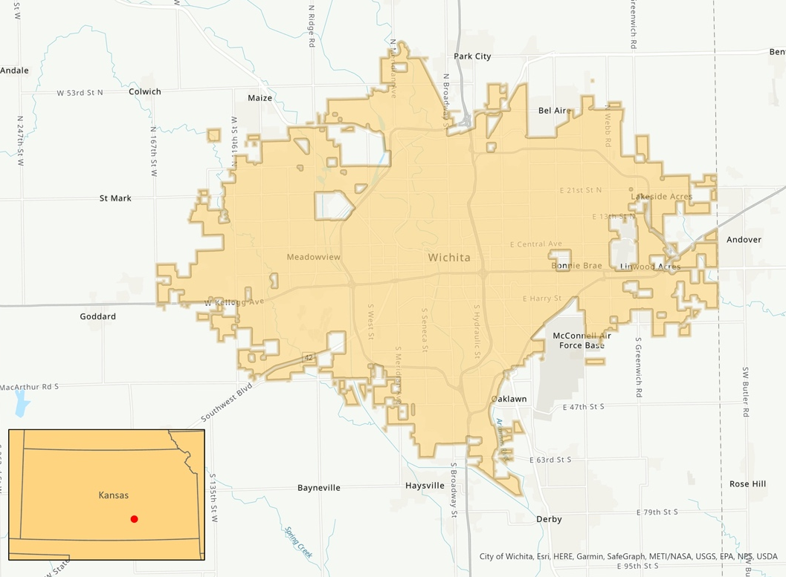
Figure 1. Study area map with Wichita City boundary; red dot indicates location on inset map

2.1.2 Heat Inequity
Extreme heat is the deadliest weather-related event in the United States, as well as one of the least discussed, and climate change has raised the frequency, intensity, and duration of severe heat events (Marx & Morales-Burnett, 2022). The built, urban environment is often hotter than neighboring rural areas due to a denser concentration of pavement, building, and other materials absorbing and retaining heat and a low amount of vegetation, creating the urban heat island (UHI) effect (Hsu et al., 2021; Marx & Morales-Burnett, 2022). This effect contributes to a wide range of public health issues, associated with heat strokes, dehydration, loss of work productivity, decreased learning, respiratory difficulties, and heat-related mortality (Hsu et al., 2021; Hondula et al., 2015). Extreme heat can also have severe impacts on mental health and increase city-wide rates of violence (Marx & Morales-Burnett, 2022).

Heat risk (high exposure + high vulnerability) varies widely from city to city and is not experienced equally within communities (Marx & Morales-Burnett, 2022). Structural racism, income inequality, and historical discriminatory practices such as segregation and redlining can lead to underinvestment in neighborhoods of color and low income, leading to fewer green spaces and a higher concentration of heat-absorbing infrastructure in these areas (Marx & Morales-Burnett, 2022). Such practices lead to higher temperatures and less access to cooling for these marginalized populations (Marx & Morales-Burnett, 2022). Populations of low-income are also more likely to live in lower-quality housing with less access to affordable air conditioning (Chen, Ban-Weiss, and Sanders 2020; Farbotko and Waitt 2011). Certain populations are more vulnerable to the health impact of heat as well, such as children, the elderly, unsheltered individuals, outdoor workers, and people with pre-existing medical conditions, illuminating the need to focus on equity when addressing extreme heat in cities, such as Wichita (Marx & Morales-Burnett, 2022).

In 2021, a survey of 69 large U.S. cities found that most reported not specifically addressing heat in sustainability, resilience, or climate action plans (Meerow and Keith 2021). However, changes are recently occurring with local governments dedicating efforts to address extreme heat (Marx & Morales-Burnett, 2022). Building climate resiliency is complex, and there is a need to be mindful of the cascading, unintended consequences of intervention on vulnerable populations as well as incorporate community voices in planning and implementation (Marx & Morales-Burnett, 2022).

2.1.3 Remote Sensing Approach
Earth observations are a powerful tool in investigating the potential of increased canopy to reduce land surface temperatures (LST), which can be used as a proxy for air temperature to understand how extreme heat affects humans (Mutiibwa et al., 2015). LST has significant impact on human thermal comfort in both outdoor and indoor spaces during heatwaves and the summer months, and it can be used to understand how extreme heat disproportionately affects certain communities (Mashhoodi, 2021). Urban greening, through increased tree planting efforts, is a common response to mitigating heat risk as the potential of canopy cover to regulate temperatures is widely acknowledged (Ziter et al., 2019) Additionally, the spatial continuity and temporal repeatability of remotely sensed data acts as an advantage when investigating extreme heat and its impacts in urban areas over long duration of time (Stathopoulou and Cartalis, 2007).

2.1.4 Findings from Term I
The summer 2022 DEVELOP Wichita Climate Team collected LST, along with social vulnerability index (SVI) data, to visualize heat exposure through daytime and nighttime LST maps and analyze the heat risk on both a census block group and census tract level. The team used age, race, and income as proxies for heat vulnerability and identified three high-risk census blocks and 17 high-risk census tracts. The high-risk tracts were concentrated near the city center, while the city’s southwest area was found to have high-exposure yet medium vulnerability. The team also acquired tree canopy cover data to produce a tree canopy cover map, highlighting high coverage on the eastern side of Wichita and sparse coverage in and around the city center, which coincided with areas of high LST.

2.2 Project Partners & Objectives
The Fall 2022 DEVELOP Wichita Climate II Team continued the partnership with City of Wichita, who are interested in identifying the distribution of UHIs, areas of heat vulnerability and priority locations for heat mitigation initiatives. The City of Wichita is in the early stages of drafting their Climate Adaptation and Mitigation Plan, along with formulating tree canopy policies to mitigate the effects of extreme heat. To assist their decision-making process, the partners requested maps displaying the urban heat and tree canopy cover correlation, heat vulnerability, and priority areas for heat mitigation, which will ultimately help them better allocate resources to build climate resiliency across communities. Furthermore, the heat vulnerability maps and flyer, produced will be used to facilitate information to the residents of Wichita about the impacts of heat as well as to apply for future grants that benefit communities at risk from extreme heat and other environmental issues.

3. Methodology
3.1 Data Acquisition (Appendix Tables B1 & B2)
Both remotely-sensed and geospatial data were collected for each of our analysis. They are listed in Table B1 and B2. Table B1 lists the NASA Earth observations and data sets used, while Table B2 lists the ancillary datasets.

Landsat 8 OLI/TIRS analysis-ready daytime LST product data were collected through Google Earth Engine (GEE) while nighttime LST data were collected through the Application for Extracting and Exploring Analysis Ready Samples (AppEEARS) API. These data were used to understand the spatial distribution of urban heat and as inputs into heat vulnerability analysis. For the creation of evapotranspiration maps, we obtained daily Evapotranspiration data from the ECOsystem Spaceborne Thermal Radiometer Experiment on Space Station (ECOSTRESS). Data were obtained from AppEEARS for the study period and filtered by peak evapotranspiration times, which are generally between 10:00 am and 3:00 pm, using Python. Census tract level sociodemographic data for Wichita was retrieved from five-year datasets in the 2020 American Community Survey (ACS) using the Census API in Python.

The team acquired remotely sensed NASA Earth observation data within the study period (2017-2021, months of May through September); their acquisition methods and use are listed in Appendix B.

3.2 Data Processing
As our project is a continuation of Summer 2022 Wichita Climate, we received data that were previously acquired and analyzed from the Centers for Disease Control (CDC), Climate and Economic Justice Screening Tool (CJEST), and the United States American Community Survey (ACS). Our team processed and compared our data to the previous terms to ensure continuity.

3.2.1 Land Surface Temperature (LST)
Data queried within the GEE platform were further filtered by year alongside months to provide images falling within the summer season for the summer period. Then, scenes were filtered by a cloud cover threshold for the entirety of the scene. The Quality Assessment (QA) band was applied and only images with less than 20 percent cloud cover were selected to ensure a higher quality output. To remediate the different Landsat missions, 8 and 9, that we drew from, the image collections were merged and sorted by time.

In Python, we filtered ECOSTRESS nighttime land surface temperature images as those falling between 01:00:00 and 05:00:00 Central Time. These images were cloud masked in order to ensure routine quality control. We reviewed each of the 74 images acquired by plotting histogram values, removing if they contained erroneous values. Null values were replaced by linear interpolation. Lastly, a composite, mean raster was created and imported into ArcGIS Pro, in order to calculate the mean zonal statistic per census block group and census tract.
3.2.2 Tree Canopy Cover
Tree canopy data were collected by Summer 2022 Wichita Climate Team during the previous term. For their process to assess tree canopy cover, the Term I team used a Random Forest (RF) supervised classifier and a Classification and Regression Trees (CART) on Planet imagery, which was acquired from NASA’s Commercial Smallsat Data Acquisition (CSDA) program. This supervised classification processes resulted in a binary raster, where values reflected the absolute presence or absence of tree canopy.

3.2.3 Landcover (Appendix Figure A1)
The InVEST model uses a landcover raster to format the spatial resolution of all output files. In ArcGIS Pro, we acquired and clipped the NLCD 2019 layer to our study area. The model requires all raster files to be in meters and in the same projection, so we chose the NAD 1983 HARN StatePlane Kansas South FIPS 1502 (Meters) projection. InVEST calculates the cooling capacity and heat mitigation indices based off biophysical characteristics of each landcover type across the study area. To increase the spatial resolution of our outputs, we combined the landcover layer with Wichita’s census block groups. By splitting the land cover by census block groups, the team was able to modify the biophysical attributes of specific geographies within the study area, allowing us to simulate targeted canopy interventions for our project partners.

In ArcGIS Pro, we rasterized our census block group layer to create a composite rater with the land cover, with pixel values reflecting both land cover and block group identifier. To allow us to merge the unique identifiers we multiplied the land cover raster by 1,000,000 to create space to add unique field ID values from our census block group layer. To create a new field of unique values we concatenated the string values of each pixel landcover typing and census block group field ID. This calculation results in values like 2200278, with22 as the land cover code for developed low-intensity land and 00278 as the census block group field ID created in ArcGIS Pro. This methodology output approximately 1,800 unique fusions of land cover and census block groups as most census block groups contain multiple land cover types. The result is a raster and table in which each area that is defined by a two-character land cover class, and a 5-code census block group identifier. This ensured that our InVEST model could output results at a finer resolution, and simulations could be carried out in focus areas.

3.2.4 Shade (Appendix Figure A2)
Shade is an important input into the InVEST model’s biophysical attribute table. For our project we are using canopy cover percentage as an analog for shade. To calculate shade, we snapped the Term I binary tree cover raster to our concatenated landcover and census block group layer. Then, we used the Zonal Statistics tool to yield a mean value for canopy cover percentage for each landcover type per census block group. This allowed the team to change shade metrics in the biophysical attribute table for each landcover type in each census block group instead and enabled the team to increase or decrease shade percentage manner that is aligned with out project partners urban forestry capacity.

3.2.5 Evapotranspiration (ET- Appendix Figure A3)
The InVEST model uses ET as an input as the process involves absorption of heat to convert water to vapor, thereby creating a cooling effect. After filtering acquired daily ET data by time, the images were further filtered by manually inspecting each file for maximum coverage, reasonable values, and accuracy in alignment of linear features. A mean composite from the remaining images was created using the Cell Statistics tool in ArcGIS and clipped to the Wichita city limits. This provided value as latent heat flux in W/m^{2,} which was converted to mm/day per the requirements of InVEST Urban Cooling model, using a modified format of the Penman-Monteith equation stated below.

ET [mm day⁻¹] = ET [W m⁻²] * 0.0864 J⁻¹m²s * 0.408 mm day⁻¹
(1)

3.2.6 Albedo (Appendix Figure A4)
To calculate albedo, the Landsat 8 OLI-2 TOA product was processed with Liang’s (2001) for narrowband to broadband conversions of land surface albedo, below.

$αLiang$= $0.356b_{2}$+ 0.130b₄ + 0.373b₅ + 0.085b₆ + 0.072b₇ - 0.0018
(2)

The mean aggregate of these images was calculated in Google Earth Engine, and then imported into ArcGIS Pro, where it was projected and clipped to the Wichita city limits. To calculate albedo for our concatenated landcover and census block group layer, we utilized the Zonal Statistics tool to quantify a mean value for each landcover type per census block group. This method allows for a more nuanced analysis of the spatial distribution of albedo across landcover types and census block groups instead of for each landcover type across the entire city.

3.2.7 Heat Risk and Vulnerability (Appendix Figure A5 & Table B3)
The sociodemographic variables used for calculating an HVI were collected using the Census API in Python. These variables are formed as a percent of, or estimates of, the population based on the total number of respondents for each Census question per tract. Air quality variables were acquired through EJ Screen. Health variables of asthma, coronary heart disease, and stroke prevalence were collected from the CDC PLACES dataset by Wichita Census tract. Remaining variables were extracted from the American Community Survey (ACS) from the year 2020. These variables are detailed in Table 3. Chosen variables fell within three broad categories: adaptive capacity, exposure, and sensitivity. Adaptive capacity refers to a person’s ability to adjust to environmental change, exposure is a measure of direct or indirect environmental characteristics a person is subject to, and sensitivity implies the susceptibility of people to the impacts of heat. To create an HVI that encompassed different factors of vulnerability, we incorporated sociodemographic data with physical characteristics of Wichita at the tract level. These physical characteristics were captured through the calculation of spectral indices, visualized in Figure A5:
- NDBI to measure the built-environment, which typically exacerbates heat
- NDWI to measure the presence of water, which provides temperature cooling effects
- NDVI to measure vegetation, which counteracts heat

Table B3, found in Appendix B, lists all variables used for quantifying heat risk, representing each of the three categories defined above.

3.3 Data Analysis
3.3.1 Heat Exposure (Appendix Figures A6 & A7)
Image composites obtained post-processing of the daytime LST data from GEE were analyzed on the ArcGIS platform. A mean daytime LST per census block group and tract was obtained by using the Zonal Statistics by Table tool in ArcGIS Pro. Nighttime LST images obtained from ECOSTRESS ECO2LSTE.001 and processed in Python also underwent similar analysis. The resulting images were aggregated by their mean, and exported in the TIFF file format. Zonal statistics were implemented to retrieve mean land surface temperature per census block group and tract in Wichita. Visualizations for daytime LST and nighttime LST can be found in Appendix Figures A6 and A7.

3.3.2 InVEST Urban Cooling Model
To understand the spatial distribution of heat burden in Wichita our team utilized the Natural Capital Project from Stanford University’s InVEST 3.11 urban cooling model. The model uses inputs of evapotranspiration, landcover, shade, albedo, and distance from cooling islands (green areas larger than two hectares) to create a relative cooling capacity and heat mitigation index. To run the model, our team acquired raster files of land cover and evapotranspiration and created a biophysical attribute table to link environmental attributes to land cover classes within Wichita.

Our team ran multiple canopy adaptation scenarios within InVEST to demonstrate how canopy cover is directly associated with heat burden. For our first model, we ran a business-as-usual scenario where all biophysical attributes reflected the current canopy conditions in Wichita. These baseline values were used as comparison to other adaptation scenarios that the team ran. The three additional scenarios we ran are a canopy decrease of 10%, an increase of 10%, and an increase of 30%. Because the City of Wichita has jurisdiction over certain land cover types, our team only increased shade in developed land cover types 21, 22, 23, 24.

The model calculates the cooling capacity index based on evapotranspiration, albedo, and shade. This is demonstrated in the equation below. Here, ETI is the evapotranspiration index of each pixel, calculated by multiplying the crop coefficient (always a value of 1 for actual evapotranspiration data) and the reference evapotranspiration values.

$$CC-day=\left(0.6⋅shade\right)+\left(0.2⋅albedo\right)+\left(0.2⋅ETI\right)$$

Further, if the pixel is located within 500m of a cooling island, the model calculates the effect on cooling capacity to output a heat mitigation index (HMI). All pixel values that are not within 500m of a cooling island receive a value equal to the pixels associated cooling capacity index value. Utilizing the Zonal Statistics tool enabled the team to extract mean HMI values for every canopy adaptation scenario at both the city-wide and focus area resolution. This allowed the team to quantify the impacts of urban canopy on the urban thermal landscape.

3.3.3 Heat Risk and Vulnerability Analysis (Appendix Tables B4 & B5)
To assess heat risk and vulnerability holistically, we implemented statistical analyses guided by qualitative understanding. We integrated our chosen variables and created a composite score of overall sociodemographic vulnerability per census tract through principal component analysis (PCA). PCA is a quantitative method through which we can input a set of highly correlated variables and output principal components, or groupings of variables which explain the maximal variation found within the dataset overall. The variables in the first principal component can best describe the variation found within the dataset, and this ability declines with each succeeding principal component. The team performed PCA on the input variables listed using the R programming language.

After conducting PCA, we interpreted each principal component by scores given to each variable within. Variables which had the highest scores above a threshold, 0.35, within each principal component were used as defining the overall category represented by the principal component. Using this tactic, our principal components explained variance and contributed towards heat vulnerability through the groupings illustrated in Appendix Table B5. They are labeled as: sensitivity by population makeup and pre-existing health conditions, sensitivity and adaptive capacity by population makeup, compromised exposure to heat, sensitivity to air quality and adaptive capacity, adaptive capacity, and finally, urban development. These principal components allowed us to understand vulnerability through the vantage point of variable interactions.

Additionally, to measure the association of the calculated HVI with historic influences of discrimination, the composite HVI score was aggregated by historic redlining grade boundaries, where neighborhood grades as defined by the HOLC are as described in Appendix Table B4. This allowed us to leverage the systematized influence of vulnerability into our analyses.

4. Results & Discussion
4.1 Analysis of Results
4.1.1 InVEST
The spatial distribution of heat burden in Wichita varies greatly. Due to the large concentration of impervious surfaces in areas like central and southwestern Wichita, these areas have a lower capacity to mitigate urban heat and a higher prevalence of UHIs. Although the Arkansas river bisects the southwestern region, it does not alleviate the effect of impervious surfaces absorbing and emitting thermal radiation as well as it does in other parts of the city. In the area north of US-400, the Wichita Art Museum is flanked to the East and West by the Little Arkansas River and Arkansas River respectively. Here, the presence of two water bodies and relatively high tree canopy contributes to high cooling capacity and heat mitigation values, demonstrating the effect of water and shade on the urban thermal landscape.

Overall, the InVEST model’s outputs displayed that north-east Wichita had a greater capacity for cooling as indicated by the blue and green pixel values. Localized areas with less capacity to cool included central and south-west Wichita as well as the historically redlined zip code, 67214. Utilizing the EPA’s EJ Screen Tool, we found that the sociodemographic snapshot of this zip code has lower-income, less educational attainment, and a greater population of people of color when compared to other areas that were not historically redlined. The implications of the results informed the assumption that sociodemographic indicators can be used to estimate the location of heat burden within Wichita.

To create different outputs of the model with regards to tree canopy, an initiative of priority to the City of Wichita, shade values were modified to reflect best-case, business-as-usual, and decreasing trend scenarios in tree canopy. Our business-as-usual canopy adaptation scenario demonstrates that currently, Wichita’s mean heat mitigation index (HMI) value is .360. Index values closer to zero indicate that pixel cannot mitigate urban heat well. Conversely, scores closer to 1 mean that pixel is doing a better job of mitigating urban heat. Our focus area, zip code 67214 has a mean HMI score of 0.331, below the City’s average HMI score. The decreasing canopy scenario reflects Wichita’s declining canopy demonstrates how with less urban canopy, Wichita’s mean HMI score drops to 0.351, with the focus zip code yielding a value of 0.319. Our final adaptation, best-case scenario, is an ambitious target of increasing canopy by 30%. Here, Wichita’s mean HMI increases to 0.389 with our focus zip code leaping to 0.365, a value higher than Wichita’s current HMI mean.

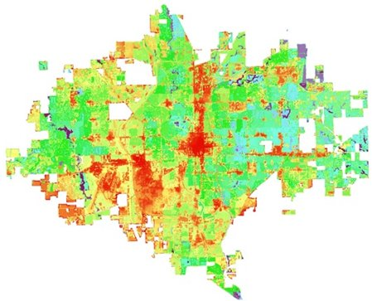
Figure 2. Output for Cooling Capacity. Cooler blues and purples indicate higher cooling capacity; warmer yellows and reds indicate low cooling capacity

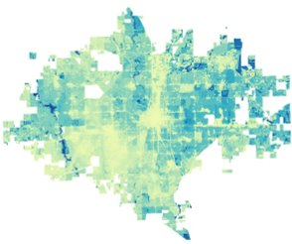

Figure. 3 Output for Heat Mitigation Index from the InVEST Urban Cooling Model for the City of Wichita. Blues indicate higher capacity to mitigate heat; warmer yellows indicate low capacity to mitigate heat.

4.1.2 Heat Vulnerability and Environmental Justice
Our composite HVI score largely reflects trends in daytime urban heat, with observable clustering in South-Central Wichita and extending to some western tracts. Notably, a large portion of Southwest Wichita and a comparatively smaller portion of north-east Wichita show low HVI clustering. While portions of these areas do have a population makeup we defined as “vulnerable” - such as low income and low educational attainment—these areas more notably have a lack of racial and ethnic diversity. This sociodemographic characteristic is a major indicator of heat burden and susceptibility, and can be found in tandem with comparatively higher counts of unemployed populations, those over 65 with a disability, and who may not speak English proficiently.
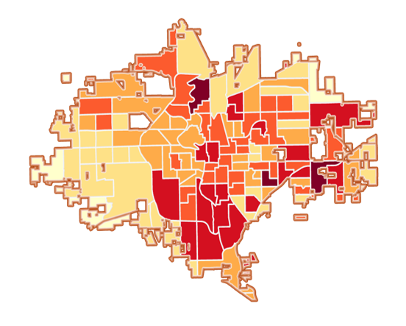
Figure. 4 Heat Vulnerability Index by census tract map created using HVI values obtained from PCA. Darker reds indicate higher vulnerability to heat; lighter yellows indicate low vulnerability to heat.

In order to quantitively measure the relationship between the HVI, non-white, over 65 with a disability, non-English proficient populations, built-up area, and daytime LST, we implemented Geographic Weighted Regression (GWR). GWR is a form of spatial linear regression which inputs a dependent variable and measures the linear relationship between it and one or more explanatory variables. It furthermore calculates the statistical significance of the explanatory variables’ ability to predict the dependent variable, and quantifies how much of the variation found within the explanatory variable can be explained by the dependent variables. Using HVI as the dependent variable and non-white population counts, non-English proficient population counts, over 65 with a disability population counts, built-up area, and daytime LST as explanatory variables, our analysis indicated these three variables, combined, explained approximately 78% of the variance found within the HVI score. Without daytime LST, non-proficient English, over 65 with a disability, and racial minority populations were attributed as explaining approximately 55% of the variation found within the HVI. These results indicate that, above all, a census tract with a large non-white population has a high probability of having high urban heat, and older populations impaired and especially sensitive to subsequent heat impacts are especially susceptible.

To further explore this relationship, we turned towards historic influences of discrimination on present-day urban heat by aggregating our composite HVI scores by historic redlining grade boundaries. While we expected to see a growth in HVI with successive HOLC grades, results indicated that that grade A areas encompass the second-highest mean of HVI, grade B has the lowest mean HVI, and grade C has the third highest. From these results, it can be inferred that the population makeup of these areas has changed over time. We can assume that marginalized populations that were concentrated largely in downtown and Central Wichita in the time of redlining has dispersed throughout the city. By visualizing the spatial distribution of sociodemographic indicators of vulnerability, we can confirm that many of these populations are no longer confined to Central Wichita, and often their spatial distributions do not have a clear trend.

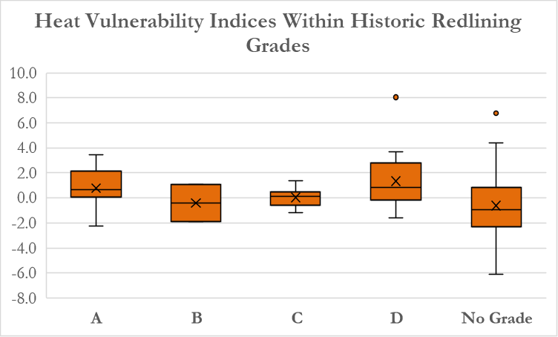
Figure. 5 Distribution of HVI Within Historic Redlining Grades

Historic influence of discrimination on present-day vulnerability, however, can be seen in the mean HVI for grade D areas, where the index is the highest and approximately double the second-highest HVI mean by HOLC grade. This indicates that while geographic mobility and population growth may have affected areas less vulnerable through the perspective of redlining, the crucial and most vulnerable populations in present day still fall within the influence and reach of the most severe historic discriminatory practices.

5. Conclusions
Through our analyses, our team identified areas of Wichita that face a disproportionate heat burden. Areas that were historically redlined, like the 67214 zip code, exhibit how redlining and discriminatory practices align with present day communities that experience heat vulnerability. We found that areas in downtown Wichita near this zip-code, on an average, were exposed to higher land surface temperatures (~101 degrees F) during the summer days. Higher average daytime temperatures were also observed in southwest Wichita near the airport and residential areas around southeast Wichita. The high daytime temperature can exacerbate the heat burden for the vulnerable population in these areas. Average nighttime temperatures were relatively much lower throughout the city. Utilizing the InVEST model, we demonstrate how cooling capacity can be increased through canopy adaptation efforts leading to a reduction of heat burden on populations that experience vulnerability. Our analysis determined that through focused urban forestry initiatives, Wichita can act to mitigate heat on developed land cover types. The heat mitigation outputs visualize the how biophysical variables determine the spatial distribution of heat and can be used as a tool for identifying priority areas for mitigation efforts. This output is also useful in illustrating how canopy directly impacts heat burden and can be leveraged in the hands of policy makers into informed decision making.
In order to further quantify the relationship between vulnerability and urban heat, we conducted heat risk and heat vulnerability analysis. This analysis delineated areas within the city particularly vulnerable and susceptible to unjustly distributed high heat burden. We were furthermore able to classify groupings of our variables through PCA to explore determinants of social vulnerability categorically. Results indicated that, while high heat vulnerability indices were dispersed throughout Wichita, observable clustering could be seen in South-Central and Southwest Wichita. Additionally, many of these areas fell within discriminatory redlining areas that received the lowest grade. Through qualitative assessment, areas with high racial minority, with those over 65 with a disability, and those with low English proficiency were isolated as those absent from areas of low HVI. Quantitatively assessing the relationship of these variables with areas of high heat revealed a strong statistical correlation with their ability to influence HVI scores. These results can be used for Wichita to identify priority areas for focused heat intervention initiatives, to understand the sociodemographic inner-functioning of heat distribution, and finally how these variables can act as determinants or drivers of environmental characteristics which make them especially at risk.
We created a flyer, poster and presentation to relay our findings to a public facing audience, understanding that for Environmental Justice to be effective and interactive, community engagement is necessary. Furthermore, we recognize that the creation of a robust Climate Action and Mitigation Plan can benefit from community mapping campaigns, surveying, focus groups and interviews to grasp the needs of the residents it serves, and ensuring accessible science communication is a crucial step forward.
Urban heat places a disproportionate burden on communities that experience vulnerability. However, through exploring the relationship between sociodemographic indicators of vulnerability and the spatial distribution of heat, the City of Wichita is taking the first steps to remediate these environmental injustices. By providing the City of Wichita with different forms of nuanced urban heat analysis, we hope they are empowered to tackle the complex and institutionalized issues associated with Environmental Justice and urban heat, incorporate data-driven solutions into Wichita’s community needs, and take concrete steps towards heat equity and climate resiliency.

6. Acknowledgments
6.1 Land Acknowledgement
Our team acknowledges that the geographic boundaries utilized for our maps were constructed as part of colonial policies, which disregarded the existence of indigenous communities to whom the land belonged. Furthermore, as participants in the NASA DEVELOP National Program, we acknowledge that many of the inequities that exist within a city are a result of discriminatory government policies that disenfranchise minority and low-income communities. While the results reported by this paper are limited to the study period, the disproportionate effects of heat observed during this study period is a manifestation of governmental choices and federally affiliated programs stemming from the colonial divisions of land.
Honing into Environmental Justice in Wichita, we acknowledge the significance of the history of the unceded indigenous land that Wichita is on prior to be stolen by colonists. The word ‘Wichita’ originates from the Choctaw word ‘Wia chitch’ means “big arbor” or “big platform”, to signify the long grass that grows in this region. This Osage, Kiowa, Wichita and Sioux people congenially lived on this indigenous land before it was stolen by colonists. We acknowledge the complex and violent history of the stealing of indigenous land and resources, and the consequent discriminatory treatment against the Native American people who lived on it. Additionally, we would like to acknowledge the four federally recognized tribes in Kansas: The Prairie Band Potawatomie, the Kickapoo Tribe in Kansas, the Iowa Tribe of Kansas and Nebraska, and Sac and Fox Nation of Missouri in Kansas and Nebraska. Native American philosophies of unity, holistic living and interconnectedness has helped them persevere despite having dealt with contradictory colonial practices of demarcation and isolation.

We would also like to acknowledge the unceded indigenous land where our team members worked. The land of Mahomet, Illinois is situated on the land of the Sioux, Cherokee and Iroquois people. Washington, D.C. is the traditional territory of the Nacotchtank, Anacostan and Piscataway people. Lawrence, Kansas occupies the ancestral territories of the Kaw/Kansa, Shawnee, and Osage people and had been the place of migration and forced relocation of many Native American people. Ithaca, New York is located on traditional homelands of the Gayogo̱hó:nǫ (the Cayuga Nation), part of the Haudenosaunee Confederacy.

6.2 Limitations of Our Study
As researchers that are geographically removed from the study area of Wichita, Kansas, we acknowledge that this study has limitations. Our partners played a significant role in remediating this issue by sharing their lived experience residing in Wichita. However, our team was not able to delve into much detail about community-level impacts due to heat, lived experiences of residents or gain significant amount of input from the affected community.

Beyond our restricted ability to engage with the community, limitations can be grouped by spatial and remote sensing analysis, heat risk and vulnerability analysis, and modeling heat mitigation and cooling capacity indices. While we remained vigilant throughout the implementation of our analysis, we concede that there may have been undetected and unmitigated processing errors in acquired data for all categories. In our spatial and remote sensing analysis, we suggest that there was likely a loss of natural trends in aggregating input data such as land surface temperature and spectral indices, by administrative boundaries.

In our calculation of a heat vulnerability index, other forms of analysis—such as a Geographic Weighted PCA—may have output comparatively more robust results by harnessing spatial distribution. We would also like to emphasize that our exhaustive list of variables may have been insufficient, and that the exclusion of these unidentified variables may have influenced output. Inferring a variable by proxy through the relationship of others may have also incurred error into our statistical analyses. Lastly, we would like to emphasize the inherent discrimination and underrepresentation of underserved communities in data collection, whether authoritative or otherwise. In modeling heat mitigation and cooling capacity indices, while we dedicated time and effort to ensure accuracy, reference areas used may not have been an ideal representation of Wichita's natural lands.

Lastly, we acknowledge that our analyses may be reductive to human experience and therefore limits the analysis of extreme heat as an Environmental Justice issue.

6.3 Thank You
Our sincere gratitude and heartfelt thanks to Dr. Kenton Ross (NASA Langley Research Center), Lauren Childs-Gleason (NASA Langley Research Center), Julianne Liu (DEVELOP VEJ Node Fellow), Lance Watkins (Arizona State University Urban Climate Research Center), Akshay Agarwal (UCSB Data Science), and Christina Dennis (Former DEVELOPer) for their guidance, scientific advice and recommendations, feedback and support throughout the duration of our project. A special thank you to our partner Nina Rasmussen from the City of Wichita for her valuable time, irreplaceable insights, and dedication to weave Environmental Justice and climate resilience into the City of Wichita.

Any opinions, findings, and conclusions or recommendations expressed in this material are those of the author(s) and do not necessarily reflect the views of the National Aeronautics and Space Administration.

This work utilized data made available through the NASA Commercial Smallsat Data Acquisition (CSDA) program.

This material is based upon work supported by NASA through contract NNL16AA05C.

7. Glossary
Albedo – The fraction of light that is reflected by a surface. A measure of a surface's capacity to absorb or reflect sunlight
Earth Observations – Satellites and sensors that collect information about the Earth’s physical, chemical, and biological systems over space and time
Environmental Justice – The right for all people—regardless of race, color, age, disability, income, national origin or other demographic identifiers—to experience the impact of environmental phenomena, development, policy and laws in a fair and just manner.
Evapotranspiration – The sum of evaporation of water from land, other surfaces, and through transpiration by plants.
Heat Exposure – A measure of how much heat an area or individual is exposed to during heat events.
Heat Mitigation Index – The index output by the InVEST Urban Cooling model which reflects the cooling effect of green spaces (>2 hectares) on surrounding areas
Heat Risk – The likelihood of experiencing adverse effects from heat events based on individual heat exposure and vulnerability
Heat Vulnerability – The likelihood of an individual/ population to experience negative impacts from heat events due to their exposure, sensitivity, and adaptive capacity to heat
Heat Vulnerability Index – Indices created to reflect the disproportionate impact of urban heat on vulnerable and at-risk populations
InVEST – The Integrated Valuation of Ecosystem Services and Tradeoffs (InVEST) designed by Stanford University is a suite of models used to map and value the goods and suerfces from nature that benefit human life
ISS ECOSTRESS – The ECOsystem Spaceborne Thermal Radiometer Experiment on Space Station, an on-going experiment through a radiometer aboard the International Space Station, that provides products such as water availability, water stress, and land surface temperature
Urban Greening – The addition of more green spaces by installing trees, parks, and other landscaped green areas to urban environments
Urban Heat – The phenomenon of high heat in metropolitan areas due to low vegetation, urban development and other environmental factors

8. References
Chen, Mo, George A. Ban-Weiss, and Kelly T. Sanders. 2020. “Utilizing Smart-Meter Data to Project Impacts of Urban Warming on Residential Electricity Use for Vulnerable Populations in Southern California.” Environmental Research Letters15 (6). https://doi.org/10.1088/1748-9326/ab6fbe
Earth Resources Observation And Science (EROS) Center. (2013). Collection-2 Landsat 8-9 OLI (Operational Land Imager) and TIRS (Thermal Infrared Sensor) Level-2 Science Products [Data set]. U.S. Geological Survey. https://doi.org/10.5066/P9OGBGM6
Frankson, R., K.E. Kunkel, L.E. Stevens, D.R. Easterling, X. Lin, M. Shulski, N.A. Umphlett, and C.J. Stiles, 2022: Kansas State Climate Summary 2022. NOAA Technical Report NESDIS 150-KS. NOAA/NESDIS, Silver Spring, MD, 5 pp. https://statesummaries.ncics.org/chapter/ks/
Hoffman, J. S., Shandas, V., & Pendleton, N. (2020). The effects of historical housing policies on resident exposure to intra-urban heat: A study of 108 US urban areas. Climate, 8(1), Article 12. https://doi.org/10.3390/cli8010012
Hondula, David M., Robert E. Davis, Michael V. Saha, Carleigh R. Wegner, and Lindsay M. Veazey. 2015. “Geographic Dimensions of Heat-Related Mortality in Seven U.S. Cities.” Environmental Research138: 439–52. https://doi.org/10.1016/j.envres.2015.02.033
Hook, S., Hulley, G. (2019). ECOSTRESS Land Surface Temperature and Emissivity Daily L2 Global 70 m V001. NASA EOSDIS Land Processes DAAC. Accessed 2022-10-11 from https://doi.org/10.5067/ECOSTRESS/ECO2LSTE.001
Hook, S., & Fisher, J. (2019). ECOSTRESS Evapotranspiration PT-JPL Daily L3 Global 70 m V001 [Data set]. NASA EOSDIS Land Processes DAAC. https://doi.org/10.5067/ECOSTRESS/ECO3ETPTJPL.001
Hsu, A., Sheriff, G., Chakraborty, T. et al. Disproportionate exposure to urban heat island intensity across major US cities. Nat Commun 12, 2721 (2021). https://doi.org/10.1038/s41467-021-22799-5
Liang, Shunlin. (2001). Narrowband to Broadband Conversions of Land Surface Albedo I. Remote Sensing of Environment, vol. 76, no. 2, 2001, pp. 213–238. https://doi.org/10.1016/s0034-4257(00)00205-4.
Marx, R., & Morales-Burnett, J. (2022). Centering Equity to Address Extreme Heat. https://www.urban.org/sites/default/files/2022-02/centering-equity-to-address-extreme-heat_1.pdf
Mashhoodi, B. (2021). Environmental justice and surface temperature: Income, ethnic, gender, and age inequalities. Sustainable Cities and Society, 68, 102810. https://doi.org/10.1016/J.SCS.2021.102810
Meerow, Sara,and Ladd Keith. 2021. “Planning for Extreme Heat: A National Survey of U.S.Planners.” Journal of the American Planning Association. https://doi.org/10.1080/01944363.2021.1977682
Mutiibwa, D., Strachan, S., & Albright, T. (2015). Land Surface Temperature and Surface Air Temperature in Complex Terrain. IEEE Journal of Selected Topics in Applied Earth Observations and Remote Sensing, 8(10), 4762–4774. https://doi.org/10.1109/JSTARS.2015.2468594
Sharp, R., Douglass, J., Wolny, S., Arkema, K., Bernhardt, J., Bierbower, W., Chaumont, N., Denu, D., Fisher, D., Glowinski, K., Griffin, R., Guannel, G., Guerry, A., Johnson, J., Hamel, P., Kennedy, C., Kim, C.K., Lacayo, M., Lonsdorf, E., Mandle, L., Rogers, L., Silver, J., Toft, J., Verutes, G., Vogl, A. L., Wood, S, and Wyatt, K. (2020). InVEST 3.11.0.post55+ug.geeeb7c3 User’s Guide. The Natural Capital Project, Stanford University, University of Minnesota, The Nature Conservancy, and World Wildlife Fund. https://invest-userguide.readthedocs.io/en/latest/index.html
Stathopoulou, Marina and Cartalis, Canstantinos, Daytime urban heat islands from Landsat ETM+ and Corine land cover data: An application to major cities in Greece, Solar Energy, Volume 81, Issue 3, (2007), Pages 358-368, ISSN 0038-092X, https://doi.org/10.1016/j.solener.2006.06.014.
The Wichita/Sedgwick County Metropolitan Area Planning Department. (2021). 2020 Census—Initial Report (p. 26). https://www.wichita.gov/Planning/PlanningDocument/2020%20Census%20Initial%20Profile.pdf
U.S. Census Bureau QuickFacts: Wichita City, Kansas. US Census Bureau. (n.d.). Retrieved June 16, 2022, from https://www.census.gov/quickfacts/wichitacitykansas
US Department of Commerce, N. N. W. S. (n.d.). Record number of 100 degree days for Wichita.
Wichita | Kansas, United States | Britannica. (n.d.). Retrieved October 10, 2022, from https://www.britannica.com/place/Wichita-Kansas
Wichita Climate - Weather Spark. (n.d.). Retrieved October 10, 2022, from https://weatherspark.com/y/8281/Average-Weather-in-Wichita-Kansas-United-States-Year-Round
Wichita KS - Tree Canopy Assessment Report - 2018. (n.d.).
Ziter, C. D., Pedersen, E. J., Kucharik, C. J., & Turner, M. G. (2019). Scale-dependent interactions between tree canopy cover and impervious surfaces reduce daytime urban heat during summer. Proceedings of the National Academy of Sciences of the United States of America, 116(15), 7575–7580. https://doi.org/10.1073/PNAS.1817561116/SUPPL_FILE/PNAS.1817561116.SAPP.PDF

9. Appendices

Appendix A - Maps
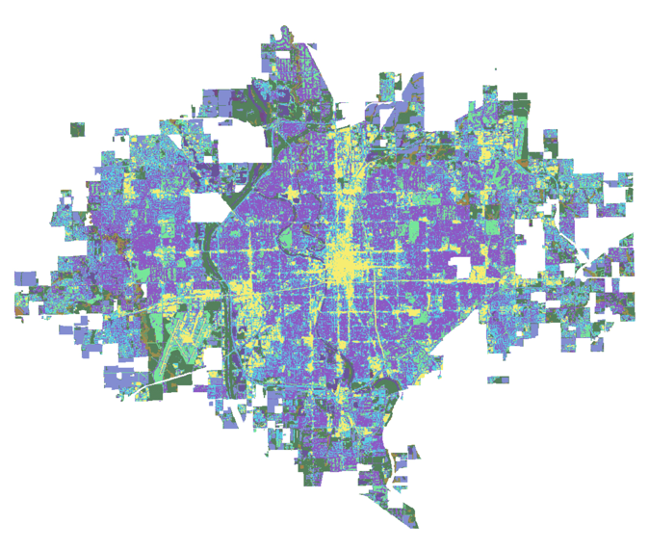
Figure A1. Different Land cover types indicated by different colors. Major land cover types in Wichita include low, medium, and high intensity urban and forested cover.

Figure A2. Shade as a proxy for tree canopy. Lighter areas indicate low shade values, while the darker/greener areas indicate higher shade values.
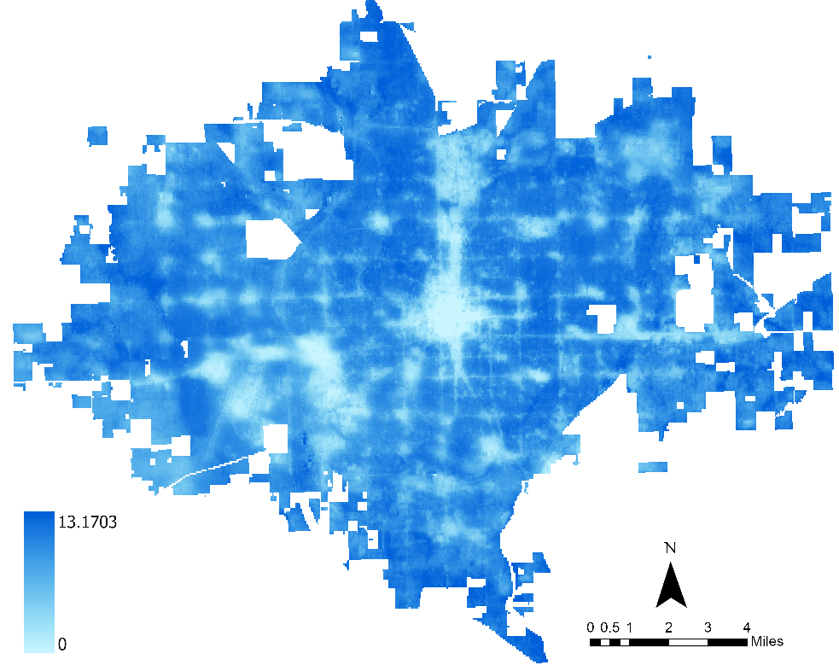
Figure A3. Mean ET during the summer months across the city; higher values indicated by darker blues; lower values by lighter blues. InVEST resampled this 70 m resolution composite image to the 30 m resolution landcover raster.
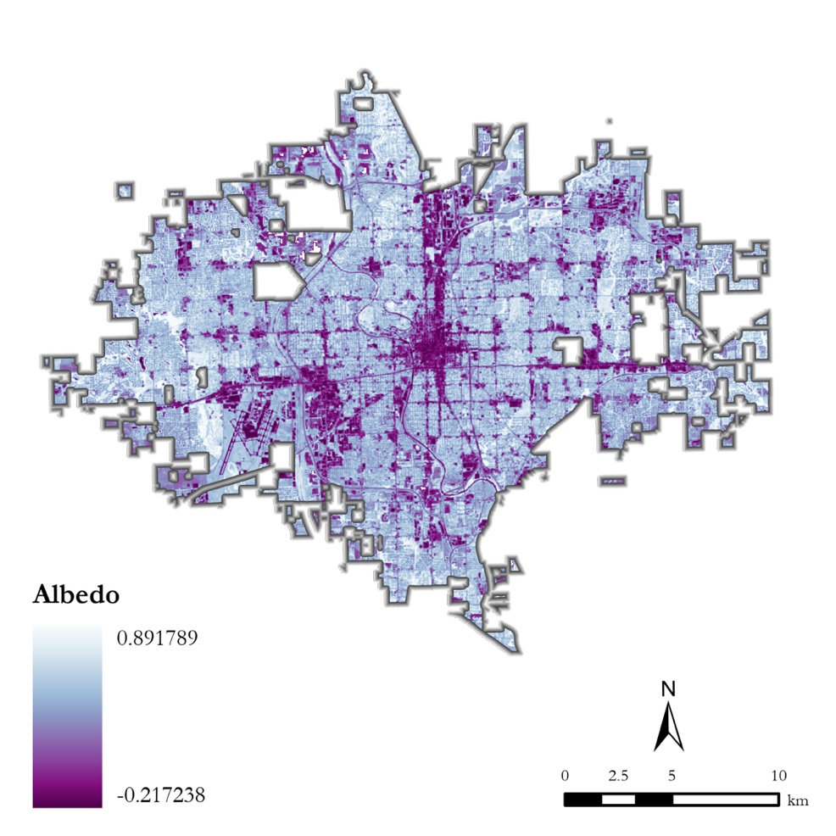
Figure A4. Albedo

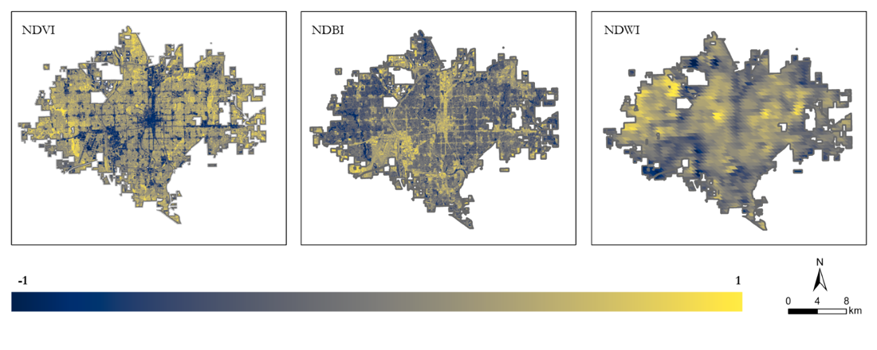 Figure A5. (Left) NDVI, (Center) NDBI, (Right) NDWI

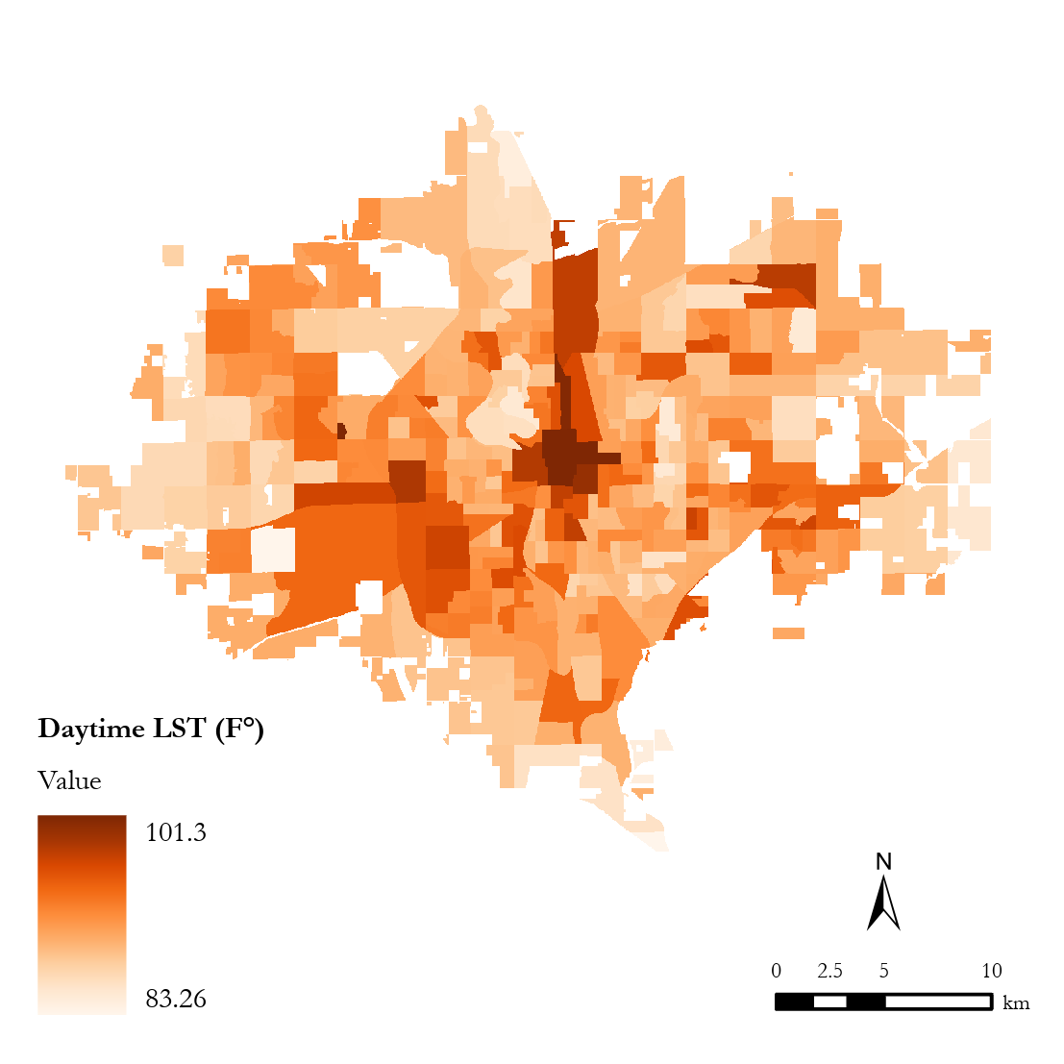
Figure A6. Mean Daytime Land Surface Temperature by Census Block Group 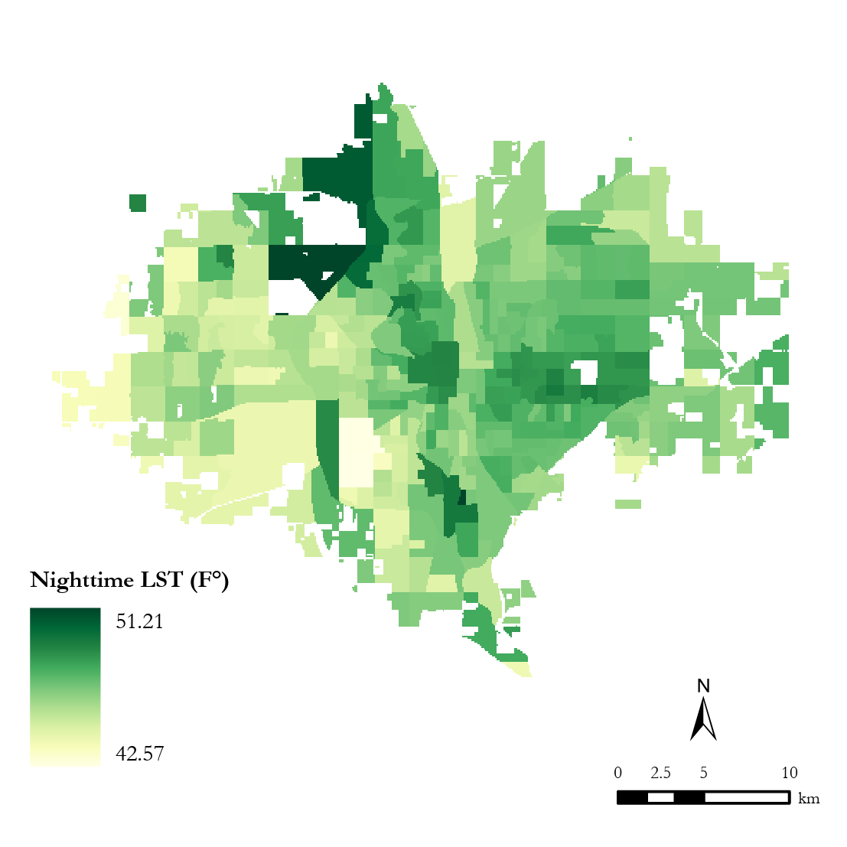
Figure A7. Mean Nighttime Land Surface Temperature by Census Block Group

Appendix B – Tables
Table B1
NASA Earth Observation used, acquisition methods, and purpose
Platform/ Program | Sensor | Product ID | Purpose | Dates | Acquisition Method | Spatial Resolution
Landsat 8 | OLI/TIRS | LANDSAT/TIRS/L T08/C02/Level-2 | Retrieve mean daytime LST and calculate albedo for input into InVEST. Calculate Normalized Difference Vegetation Index (NDVI), Normalized Difference Built-up Index (NDBI), Normalized Difference Water Index (NDWI) for heat vulnerability analysis. | May 1st – September 30th of 2017-2022 (LST calculation limited to year range 2017-2021) | Google Earth Engine | 100-meter
Landsat 9 | OLI-2/TIRS-2 | LANDSAT/LC09/C02/T2_L2 | Calculate daytime LST for input into InVEST | May 1st – September 30th of 2021-2022 | Google Earth Engine | 100-meter
ISS | ECOSTRESS | ECO2LSTE.001 | Calculate nighttime LST for heat vulnerability analysis. Retrieve mean evapotranspiration for input into InVEST. | May 1st – September 30th of 2018-2022 | AppEEARS API for Python | 70-meter

Table B2
Ancillary data acquired, acquisition methods and use
Parameter | Provider | Purpose | Date | Acquisition Method/Source | Spatial Resolution
Land Cover | United States Geological Survey | Used as input for InVEST model | 2019 | United States Geological Survey National Land Cover Database | 30-meter
PlanetLab Imagery | Planet | Used to create fine-scale tree canopy raster, created by Wichita Term I | 2011-2021 | PlanetLab | 50-centimeter
2020 United States American Community Survey | United States Census Bureau | Calculate social vulnerability to generate heat vulnerability index | 2020 | United Status Census Bureau American Community Survey through Python Census API | Census Tract
Environmental Justice Screening and Mapping Tool (EJ Screen) | United States Environmental Protection Agency (US EPA) | Used for determining social vulnerability, and acquiring air quality data to be used for heat vulnerability index | 2021 | US EPA Website | Census Tract
Centers for Disease Control (CDC) Population-Level Analysis and Community Estimates (PLACES) | Centers for Disease Control | Integrate health indicators into heat vulnerability index | 2021 | PLACES Data Portal | Census Tract

Table B3
Variables and their categories in constructing an HVI
Adaptive Capacity | Sensitivity | Exposure
- Daytime LST  - Nighttime LST  - NDVI  - NDWI  - NDBI | - Asthma prevalence  - Coronary heart disease prevalence  - Stroke prevalence  - Children Under 5  - Ozone  - Adults over 65  - Below poverty level  - PM 2.5 | - Less than a high school education  - Unemployment  - Bilingual with compromised English proficiency  - Disability prevalence  - Adults over 65 without health insurance  - Racial minority

Table B4
Historic redlining grades and their descriptions
Grade | Label | Description
A | Best | Characterized as upper- or upper-middle class white neighborhoods, with a perceived low risk to mortgage lenders
B | Still Desirable | Dominant white, U.S.-born populations perceived as sound investments by mortgage lenders
C | Declining | Neighborhoods with working-class, immigrant residents often lacking utilities, residing in older homes, and generally advised by the HOLC to refrain from lending mortgages to
D | Hazardous | Neighborhoods that were non-ethnically homogeneous with diverse populations, including Jewish, Asian, Mexican and Black residents, comprised primarily of older structures and often located near industrial areas

Table B5
Heat vulnerability analysis principal components and interpretations
Principal Component Interpretation | Key Observations | Spatial Distribution
Sensitivity by population makeup and pre-existing health conditions:  - Adults 65+ without health insurance  - Stroke prevalence  - Asthma prevalence  - Coronary heart disease  - Racial minority  - Less than a high school education | High vulnerability through this principal component is concentrated in Central Wichita, stretching into South Wichita. Far eastern and western portions of the city generally have a low vulnerability. In this principal components, all 3 health indicators are present. | 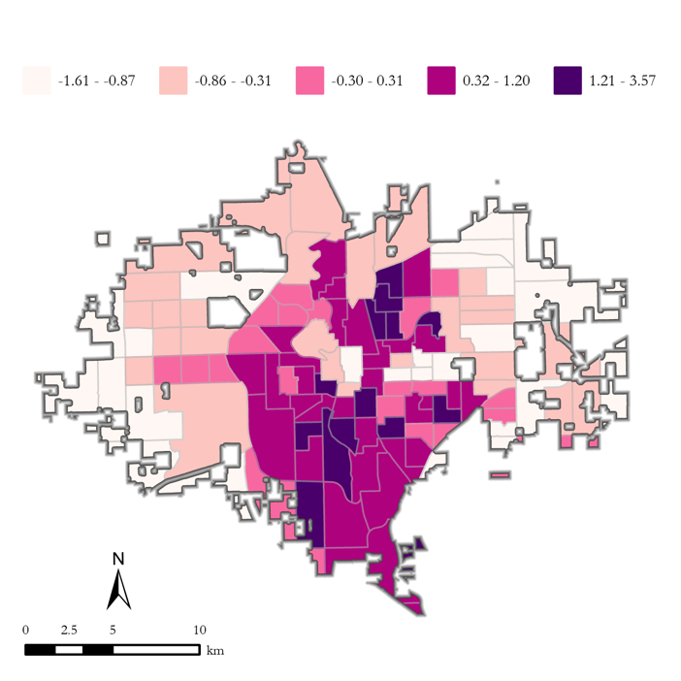
Sensitivity and adaptive capacity by population makeup (age, employment, disability and education status):  - Children under 5  - Adults over 65  - Adults over 65 without health insurance  - Unemployed  - Less than a high school education | This principal component shows a high vulnerability dispersion along the western half of Wichita. Areas of low vulnerability are seen stretching from directly east of the downtown area to the northeast. | 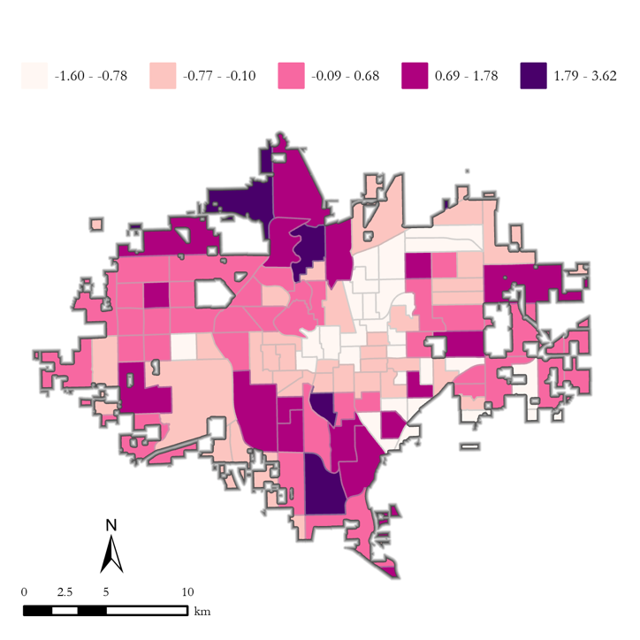
Compromised exposure to heat:  - Urban development  - Daytime land surface temperature | Results shown for this principal component very clearly follow daytime land surface temperature trends, with a hot spot located in Downtown Wichita. | 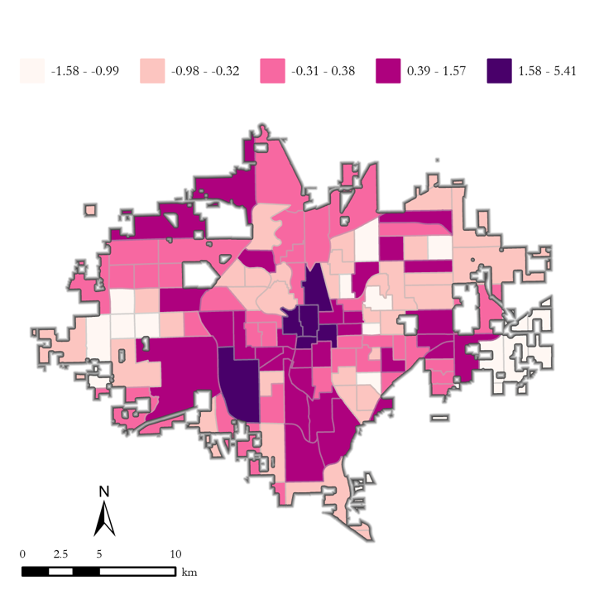
Sensitivity to air quality and adaptive capacity:  - PM 2.5  - Bilingual with compromised English proficiency  - Racial minority | Air quality in this principal component directly influences its western-lean. This portion of Wichita is also comprised of residents with low English proficiency at the western-most tips, and non-white populations dispersed throughout. | 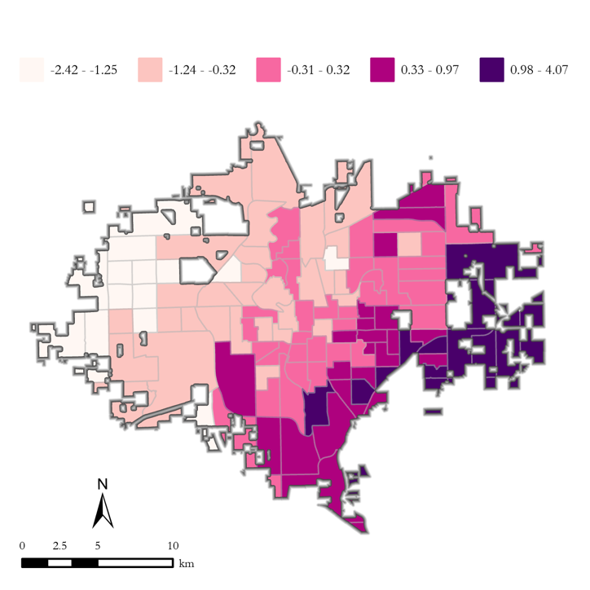
Adaptive capacity:  - Racial minority  - 65+ without health insurance  - Bilingual with compromised English proficiency | This principal component is composed primarily of variables used within the “adaptive capacity” category. The spatial distribution of vulnerability does not show a clear trend, in accordance with dispersed concentrations of racial minority and residents who do not speak English proficiently. | 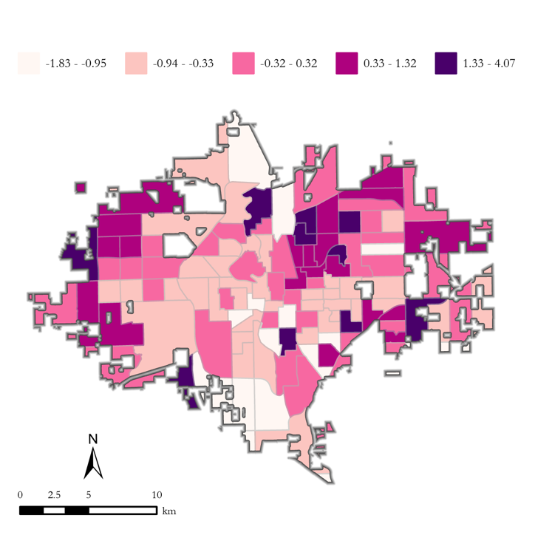
Urban development:  - Built area  - Lack of nearby waterbodies and streams | With tracts more sporadically located near sources of water in the Western half of Wichita, and built-up/developed area concentrated in the center of Wichita, this principal component shows a spatial distribution that begins in South-Central Wichita, and diverges to the northeast and northwest. | 