Hypersonic Simulation with US3D using Unstructured Grids from Fidelity Pointwise

Abstract: For hypersonic simulations, unstructured flow solvers typically have problems predicting surface heat fluxes when strong shocks are present. This article outlines a workflow that applies best practices for structured and unstructured grids. In addition, unstructured grid generation can significantly reduce the time required to create quality grids for complex geometries. Several examples are computed using DPLR, a structured grid flow solver, and US3D flow, an unstructured flow solver. Results from the two codes are compared and they show excellent agreement. The unstructured grid workflow offers a viable and attractive alternative for hypersonic simulations.

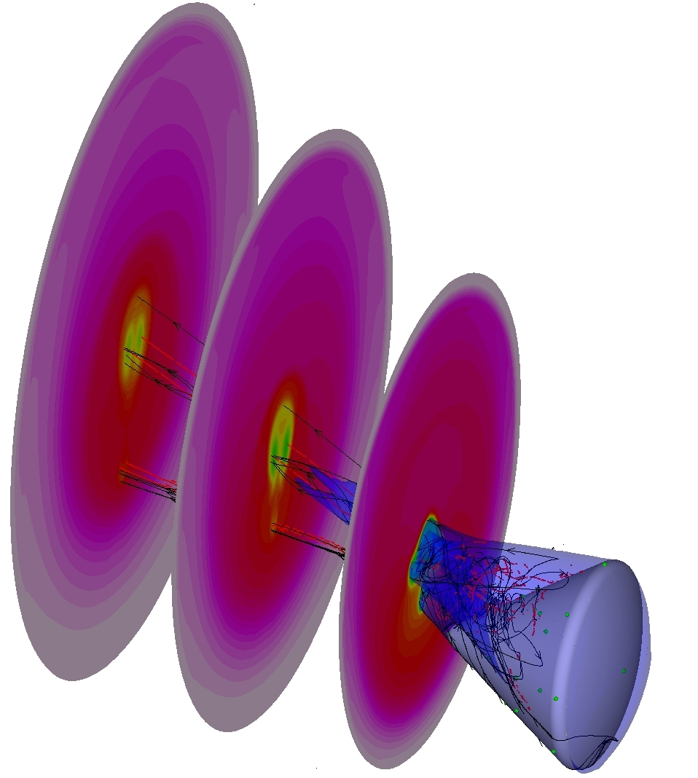

Introduction
It is desirable to run computational fluid dynamic (CFD) simulations to predict the aerothermal environment of a spacecraft during atmospheric entry. However, for complex geometries, the grid generation process for structured grids is often tedious and typically a bottleneck in the simulation workflow. During these times, unstructured grid generation offers a potential alternative by simplifying the grid generation process.

There are several instances when unstructured grid solvers have problems predicting surface heating, especially when strong shocks are present. These numerical issues can be mitigated by applying best practices developed for structured grids to unstructured grids. Proper shock alignment of unstructured grids can minimize numerical noise emanating from shocks, thereby reducing the spurious oscillations in computed surface quantities (such as pressure, temperature, and heat flux).

Workflow for Structured Grids

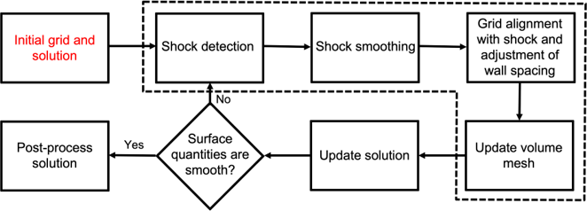
Figure 1. Workflow for structured grids.
As shown in Figure 1, the CFD workflow for structured grids starts with generating a surface grid around the spacecraft. For a simple shape, like an idealized smooth Orion capsule, a structured surface grid can be easily constructed on the capsule’s surface. Next, the volume grid is generated by extruding the surface grid outward using a hyperbolic PDE extrusion algorithm available in Fidelity Pointwise. The surface grid, volume grid, and initial flow solution computed using DPLR (a structured grid, Navier-Stokes flow solver for reacting flows) are illustrated in Figure 2.
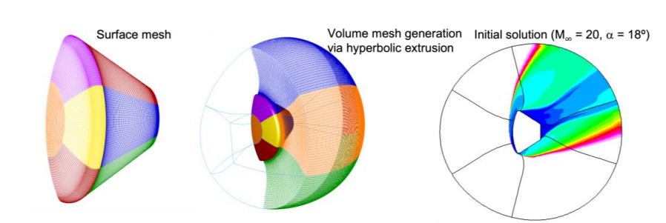
Figure 2. Surface grid, volume grid, and centerline Mach contours on the initial grid.
The next step in the workflow is to align the grid with the bow shock and adjust the wall spacing, so there is sufficient grid resolution to resolve the boundary layer in a viscous simulation properly. The tedious tasks of shock detection, shock smoothing, grid alignment, and updating the volume grid can all be handled automatically using the built-in grid adaption tool within DPLR. It usually takes approximately 3-5 CPU minutes to generate a new grid using the grid adaption subroutine.

Workflow for Unstructured Grids
As an alternative to structured grids, a workflow using unstructured grids (see Figure 3) can simplify the grid generation process and produce faster turnaround times for hypersonic simulations.

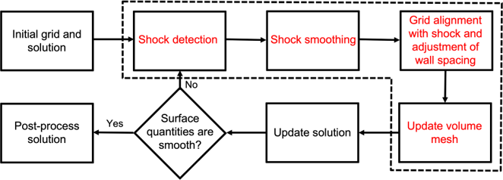
Figure 3. Workflow for unstructured grids.
- Initial grid
To start the simulation, an initial grid needs to be generated. One option in Fidelity Pointwise is to utilize the T-Rex algorithm, an advanced layer technique method. This technique is conceptually similar to the PDE-based hyperbolic method in that both involve extrusion of the volume grid from a surface grid. One key difference is that T-Rex tests each extrusion step for grid quality and potential collisions with other parts of the extrusion. If either test fails, the extrusion process is stopped locally for that point. The marching front continues for the remaining points until all tests fail, a specified maximum number of layers is reached, or the volume grid achieves isotropy.
When the marching front stops, the remaining volume is filled by a Delaunay-based isotropic grid algorithm. Once these parameters are set, the algorithm can be initialized to run without any user interactions.
- Initial solution
After the unstructured grid is generated, US3D (an unstructured grid, Navier-Stokes flow solver for reacting flows) simulates the flow on the initial grid. The computational domain is initialized using freestream conditions and an artificial boundary layer at the surface. A second-order implicit Euler-time integration and line relaxation method is selected to solve the governing equations. Line relaxation is active in the prismatic layers at the wall surface for a hybrid grid. Outside of this region, the solver switches to a point implicit method.
- Shock detection and extraction
The shock detection/extraction process starts by post-processing the US3D solution to output the Mach number at each point in the volume grid. The bow shock location is selected using a percentage of the freestream Mach number. A Mach iso-surface is extracted from the flow solution using the Tecplot visualization package.
- Shock smoothing and edits
The iso-surface in use case diagram (UCD) format can be imported as a database file (a geometry model) in Fidelity Pointwise and exported as an STL file. In Figure 4, the image on the right is the Mach iso-surface smoothed using a combination of Humphrey’s Classes (HC) Laplacian smoothing and Laplacian smoothing. For the initial iso-surface, many smoothing steps are needed (around 30-50 steps) to obtain a relatively smooth surface. For subsequent adaptions, the extracted iso-surface is reasonably smooth, so only a few smoothing steps (around 3-5 steps) are needed.
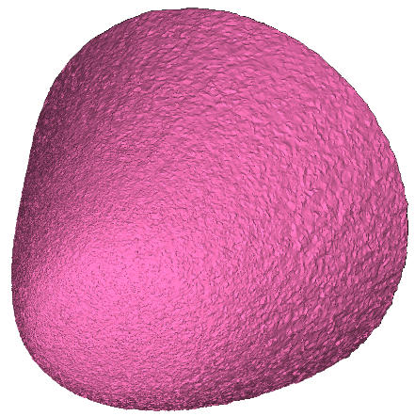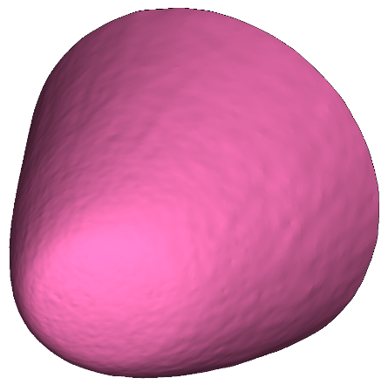
Figure 4. Mach iso-surface from Tecplot (left) and smoothed iso-surface using MeshLab (right)
- Generate new surface and volume grids
Although the new iso-surface is smooth, it may contain triangles with very small areas, which could result in the generation of poor-quality volume cells. This problem can be resolved by creating a new unstructured surface via Fidelity Pointwise's “On Database Entities” command. By selecting the “isotropic” option for unstructured domains, the new surface should be quite uniform in cell size. If desired, the user can change the cell size distribution by adding source terms. The plot of a new grid representing the bow shock surface is shown in Figure 5.
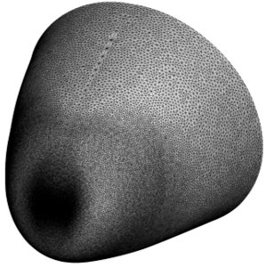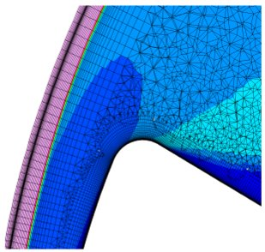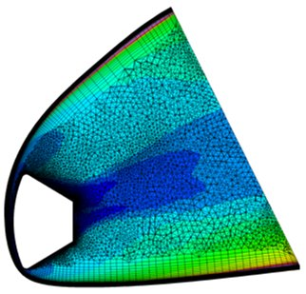
1st adaption
wall
$$(∆n=10 μm)$$
Figure 5. New surface grid (left), volume grid (right), and close-up view of volume grid (middle)
- Update the solution
For faster convergence, a user should use the US3D-interp utility to interpolate the previous solution onto the new volume grid and use the interpolated solution to restart a US3D simulation. After the simulation has converged, the computation can be restarted using second-order fluxes and a lower dissipation value.

Sample Cases
To illustrate the differences in workflow between structured and unstructured grids, two examples are presented:
- A simple geometry using an idealized, smooth Orion capsule and
- A complex geometry using the Space Shuttle.
DPLR v4.02.2 is used on structured grids, while US3D v1.1.7 is selected for unstructured grids.
Orion Capsule
To compare DPLR and US3D results on a simple geometry, laminar Navier-Stokes simulations are computed on a smooth Orion capsule. A single-layer grid was generated using a hyperbolic extrusion algorithm in Pointwise for the structured grid. For the unstructured grid, the initial grid was constructed using the surface grid from the structured grid and a rotated hemisphere to define the outer boundary.
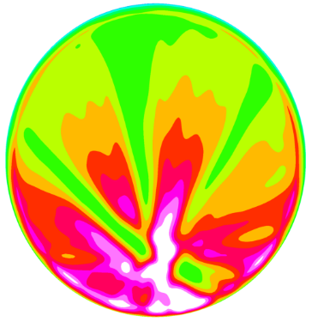  Initial solution (US3D) | 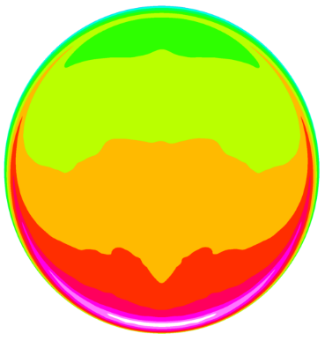  z  Windside  Leeside  1st adaption (US3D)
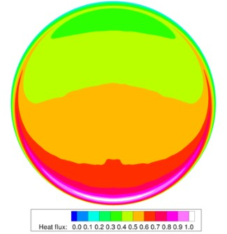  2nd adaption (US3D) | 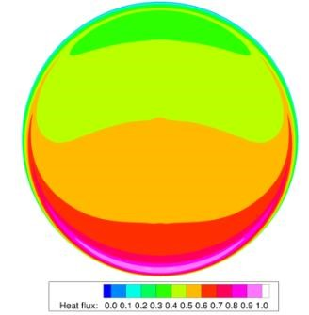  Adapted DPLR Solution
Figure 6. Comparison of normalized heat flux between US3D and DPLR.
A comparison of the surface heat flux is shown in Figure 6. It is evident that the initial unstructured grid produced significant oscillations in the surface heating. After two adaption cycles, the US3D solution agrees reasonably well with the final DPLR solution. For simple geometries, the unstructured workflow does not offer a speed advantage over a structured workflow since the built-in grid adaption routine in DPLR is very fast and well-automated. Overall, the results from both codes are in excellent agreement when the workflows and best practices (as detailed in the previous section) are followed.
Space Shuttle
While generating a single-layer, structured grid for a smooth capsule is straightforward; grid generation is often quite challenging for a more complex configuration. For the Space Shuttle, certain geometric features were simplified or ignored to make the grid generation possible. Even when simplifying the geometry model by removing the main engine exhaust nozzles, structured grid generation took two work-weeks of elapsed time.
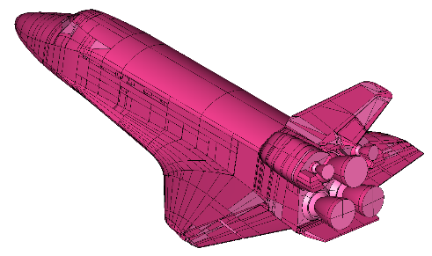 | 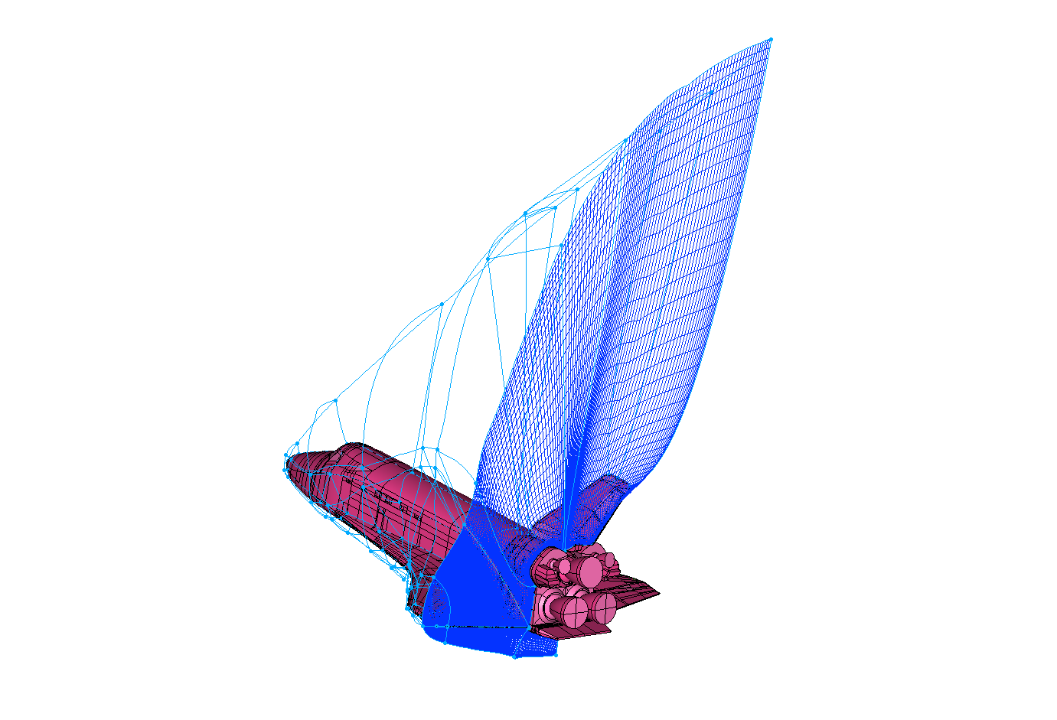
Figure 7. Space Shuttle CAD geometry (left) and adapted structured grid (right).
To test the unstructured workflow, the structured surface grids of the shuttle were used to create a hybrid volume grid. However, unlike the structured grid, the unstructured grid includes the exhaust nozzle details. Mesh generation for this case required one 8-hour workday, quite a reduction versus the structured grid. Further, comparing the heat flux shows excellent agreement between the two codes. Figure 8 illustrates the normalized heat flux contours on the windside (left) and leeside (middle), and a plot of the centerline heat flux down the length of the vehicle (right). The peak centerline heat flux predicted by US3D is about 2% lower than the DPLR estimate. These results indicate that an unstructured flow solver can produce heating estimates comparable to a structured flow solver if best practices are applied.
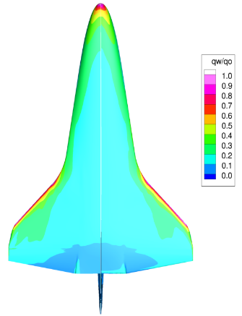  US3D  x  DPLR  Wingside | 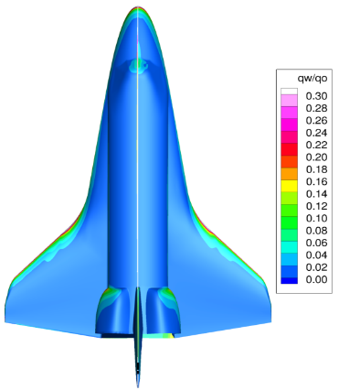  DPLR  US3D  Leeside | 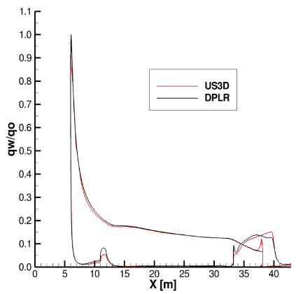  Centerline Heat Flux
Figure 8. Normalized heat flux contours on windside (left), leeside (right), and centerline (right).

Conclusion
A workflow using an unstructured grid has been developed and tested. As demonstrated by the Space Shuttle example, the new process can quickly produce accurate heating estimates for a complex geometry. It is a viable and promising alternative to the traditional structured grid methods. In particular, the T-Rex meshing algorithm is shown to be fast, robust, and easy to implement. While an unstructured workflow does not offer a speed advantage over a structured workflow for simple geometries, the difference is significant for complex geometries.
Unstructured grid generation also offers great flexibility in modifying existing surface and volume grids because grid points can be easily added or deleted without the need to adhere to a particular grid topology. Overall, the current unstructured workflow offers a fast and straightforward process to model hypersonic flows for complex geometries.

Request a free trial today if you’d like to use unstructured grids in Cadence Fidelity Pointwise for your hypersonic simulations.


Reference
- Tang, C. “Rapid Hypersonic Simulations using US3D and Pointwise,” Eleventh International Conference on Computational Fluid Dynamics (ICCFD11), ICCFD11-3205, July 2022.
- DPLR, https://software.nasa.gov/software/ARC-16021-1A
- US3D, https://license.umn.edu/product/us3d-aerodynamic-and-aerothermodynamic-simulations-software

