Modeling and Simulation of Tank Pressure Control using Zero-Boiloff Active Thermal Control for LOXSAT Technology Demonstration Mission

Jonathan A. Bentley, Leonid G. Bolshinskiy, and Anson R. Koch
NASA Marshall Space Flight Center, Huntsville, AL
William Notardonato and Daniel Hollibaugh
Eta Space LLC, Rockledge, FL
This paper considers multiple modeling approaches to evaluate the performance of the Active Thermal Control System of the LOXSAT demonstration mission. Independent approaches have been developed to converge upon the predicted system performance given the fact that zero-g droplet heat transfer is not well characterized with test data. The independent models agree qualitatively with some differences. TankSIM shows more subcooling of the liquid, while Easy5 shows a more well-mixed system near saturation. Easy5 also depressurizes and repressurizes more rapidly than TankSIM’s prediction, but the overall pump duty cycles are the same order of magnitude in both models.
- Nomenclature
A = Surface area of ullage-liquid interface
h_{fg} = Heat of vaporization
k_{g} = Thermal conductivity of ullage
k_{l} = Thermal conductivity of liquid propellant
${\dot{m}}_{evap}$ = Evaporation mass flowrate from liquid to ullage
Nu_{droplet-gas} = Nusselt number for droplet-gas heat transfer
Pr = Prandtl Number
Q_{ui} = Heat flow from ullage to liquid interface
Q_{il} = Heat flow from interface to liquid
R = Radius of ullage-liquid interface
R_{o} = Tank radius
Re_{g} = Droplet Reynolds number for gas-side heat transfer
T_{g} = Temperature of ullage vapor
T_{i} = Temperature of liquid-ullage interface
T_{l} = Temperature of liquid propellant
T_{sat} = Saturation temperature
μ_{g} = Viscosity of ullage
μ_{l} = Viscosity of liquid propellant
ρ_{g} = Density of ullage
ρ_{l} = Density of liquid propellant
D_{dr} = Droplet diameter
D_{orif} = Orifice diameter

- Introduction
As of the writing of this paper, cryogenic fluid management technologies (CFM) for spaceflight have not had any large-scale demonstration on a flight-like system on-orbit. Data exists for ground-based testing and small-scale on-orbit, or short duration drop tower experiments. Technology development must take place in order to facilitate NASA missions to carry humans further in space than we have been before. To provide data to aid that effort, NASA has awarded a tipping point technology demonstration award to Eta Space, Lockheed Martin, Space Exploration Technologies (SpaceX), and United Launch Alliance (ULA) to demonstrate on-orbit storage and transfer of cryogenic propellant.

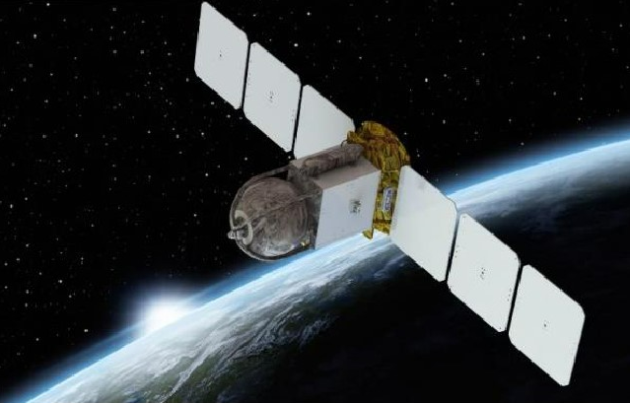
Figure 1. LOXSAT-1 Rendering

For its award, Eta Space is developing LOXSAT-1 which will be launched on a Rocket Lab Electron rocket. The spacecraft consists of a Rocket Lab Photon spacecraft bus with a spherical liquid oxygen (LOX) tank with an active thermodynamic control system (ATCS). One of the primary objectives of the mission is to demonstrate zero-boiloff storage of LOX. To accomplish this, the spacecraft is equipped with an ATCS which pulls liquid out of the tank through a propellant management device (PMD), flows through a pump and a cryocooler prior to injecting the subcooled liquid into the ullage through a spray bar, which cools the ullage and controls tank pressure.

- Modeling Approach
Due to a lack of credible data on zero-g droplet heat transfer of a spray bar, NASA has provided Eta Space with two independent modeling approaches of the tank thermodynamics and heat/mass transfer. The goal is that by having multiple independent approaches, this will allow the team to cross check results and hopefully converge upon a general idea of how the ATCS will perform under flight conditions. Having multiple approaches allows the team to see the effect of applying different correlations to give a broader base to draw from once flight data is obtained to anchor the models. The two models presented here have been constructed in TankSIM and in Easy5. Further analysis has been conducted in Generalized Fluid System Simulation Program (GFSSP) and Thermal Desktop/FloCAD, but those are outside of the scope of this paper.
While each model is independent of one another, both models have the same tank thermodynamics that need to be captured. The first area of emphasis is the heat transfer between the ullage and the droplet spray. Secondary to that is heat transfer between the ullage and the liquid interface. Each model’s approach and guiding assumptions will be discussed in detail in the subsequent sections. Both models assume that in zero-g the ullage forms a sphere in the center of the tank, with the liquid propellant forming a shell between the ullage and the tank wall.
Using a spray bar to inject subcooled liquid into the ullage has a twofold effect on ullage pressure. Liquid, that is sprayed into the ullage will form droplets which facilitates heat transfer with the vapor. The heat transfer will cool ullage vapor by convection and condensation of vapor on the droplet. Decreasing of ullage temperature lowers ullage pressure. In addition to that, liquid that is not sprayed into the ullage will rejoin the liquid mass in the tank at a lower temperature, which lowers the bulk temperature of the liquid propellant. These two effects provide the mechanism for zero-boiloff pressure control.
A variety of cases have been considered to bound the performance of the ATCS. Parameters that are studied include the pump’s flowrate, the pressure band setting, and the cryocooler capacity. The cases are laid out in Table 1. The cases with a constant cryocooler capacity have a net cooling on the order of five times the external heat loads. The cases where the cryocooler capacity varies is +/-1W from the sum of the external heat loads (external heat leak and pump heat input). The capacity is +1 W from the external heat loads while depressurizing and -1 W from the external heat loads while repressurizing.
For all cases analyzed in this cycle, the pump is assumed to be running constantly, while the cryocooler turns on or off when the ullage pressure exceeds boundaries of required pressure band in either direction (with exception to the varied cryocooler capacity cases).

Table 1. Analysis Cases
Case | Pump Flowrate Setting | Cryocooler Capacity Status | Pressure Band [kPa]
1 | Low | Constant | 100-200
2 | Medium | Constant | 100-200
3 | High | Constant | 100-200
4 | Low | Constant | 70-170
5 | Medium | Constant | 70-170
6 | High | Constant | 70-170
7 | Low | Varied | 100-150
8 | Medium | Varied | 100-150
9 | High | Varied | 100-150

  - TankSIM Model
TankSIM is a FORTRAN program designed to predict the behavior of cryogenic propellants under different conditions such as self-pressurization, boiloff, and can implement a thermodynamic vent system (TVS) [1] and [2]. For modeling the droplet heat transfer to the ullage, droplets are treated as spheres with varying radius. Heat is transferred to the droplet and warms the droplet until it reaches saturation, which then begins to evaporate and therefore reduces the radius and mass of the droplet. The droplet can also have ullage vapor condense on the surface which would increase the radius of the droplet. The Ranz-Marshall correlation [3] as shown in Equation 1 is used to calculate the heat transfer coefficient between the droplet and the ullage. The total number of droplets in the ullage at any one time is based on a resident mass approach.

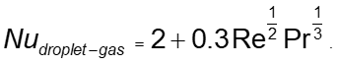 (1)

At the ullage-liquid interface, TankSIM models the heat transfer from the ullage to the liquid using the energy-jump boundary condition to assess the heat and mass transfer across the boundary. Here, the interface temperature is calculated by Alabovskii’s equation [4] which provides a correction factor for interface temperature.

(2)
For example, in Oxygen at a temperature of 100 K and a pressure of 200 kPa, K = 52, which means that the interface temperature will be much closer to the liquid temperature than to the ullage temperature.
In TankSIM, droplet diameter is calculated using Lyshevskiy [5] correlation for atomization of a liquid jet moving through gas as seen in Equation 3.
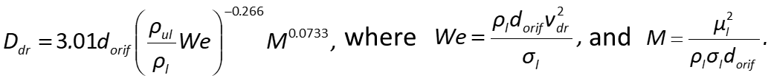 (3)
  - Easy5 Model
Easy5 is a commercial code developed by Hexagon that can be used to model hydraulic and gas propulsion systems [6]. For this model, the thermal hydraulics library has been implemented along with the gas dynamics library to model the ullage volume. A user-defined fluid property file had to be generated for LOX. The model links the 2 phases together by tracking the mass transfer at the droplet-ullage interface, as well as the liquid-ullage interface to conserve mass and energy in the system.

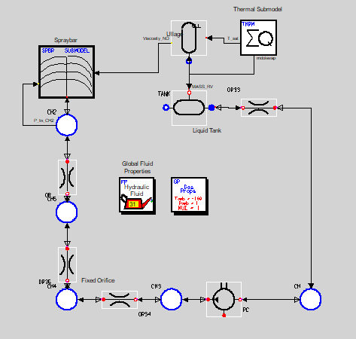
Figure 2. Schematic of Easy5 Model

The heat transfer from the gas to the droplet interface is performed by conducting an energy balance at the interface. For the gas side, the Ranz-Marshall correlation [3] is used, seen in Equation 1 above. For the liquid side of the droplet, a Nusselt number correlation of 2.0 is applied. Other correlations have been attempted, but with higher Nusselt numbers the heat transfer on the liquid-side of the droplet is simply unrealistically high. These values/correlations will be anchored with ground testing and are subject to change. The total number of droplets in the ullage is also calculated on a resident mass approach where the characteristic length is the radius of the ullage volume.
The heat transfer at the ullage-liquid interface is calculated by the energy jump method and is assumed to be linear conduction on both the gas and liquid sides. The interface is assumed to be at saturation temperature based on the ullage pressure. These are shown in Equations 4 and 5. Equation 6 shows the calculation for the evaporation mass flowrate at the ullage-liquid interface. With this approach, once the liquid becomes saturated, all heat input results in evaporation.

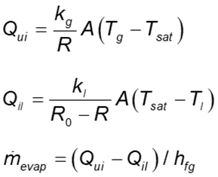
(4)

(5)

(6)

- Results
  - TankSIM Results
TankSIM has been run across the analysis cases and the results are summarized in Table 2. Example plots of ullage pressure for cases 1-3 can also be seen in Figure 3. In this figure and table, notice that the increased system flowrate results in a longer depressurization time along with a quicker repressurization time which is due to the increased pump head causing a higher pump heat input. In the TankSIM results, there is a slope change during repressurization. The low slope portion is due to the liquid being subcooled and heating back to saturation, while the high slope portion is due to evaporation once the liquid has reached saturation as seen in Figure 5. As can be seen in Figure 4 (cases 7 – 9), at the repressurization time, the behavior of the ullage pressure is close to that in cases 1 - 3, but the cycle time is 5 - 7 times longer. Pressurization time decreases when flow rate increases, but duty cycles are the same in all three cases.

Table 2. TankSIM Modeling Results
Case | Depressurization Time [hr] | Pressurization Time [hr] | Duty Cycle
1 | 26.2 | 81.5 | 24.3%
2 | 28.3 | 65.3 | 30.2%
3 | 33.8 | 47.7 | 41.5%
4 | 31.3 | 95.8 | 24.6%
5 | 34.1 | 75.1 | 31.2%
6 | 41.4 | 53.8 | 43.5%
7 | 319.4 | 316.7 | 50.2%
8 | 294.4 | 291.7 | 50.2%
9 | 283.3 | 280.6 | 50.2%

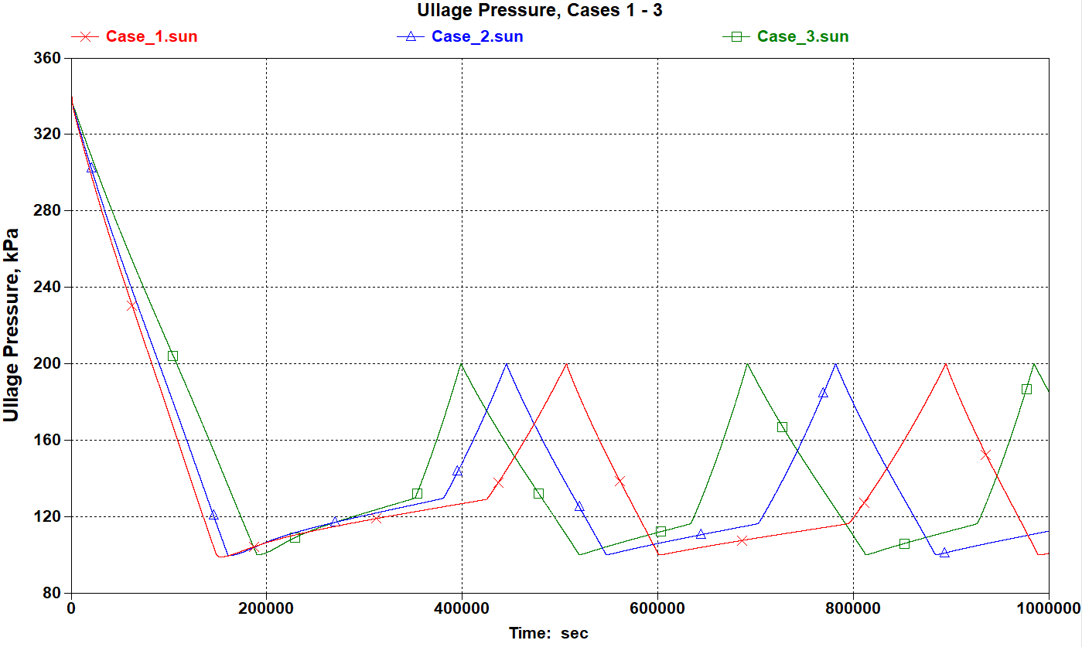
Figure 3. Ullage Pressure, Cases 1 - 3.

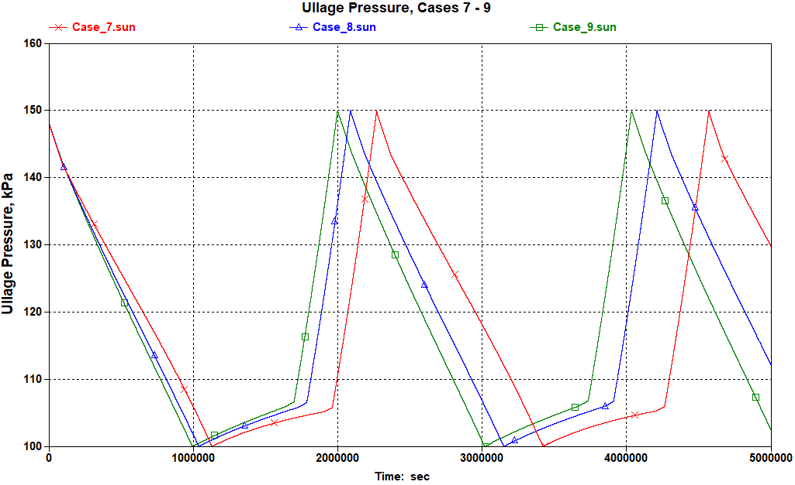
Figure 4. Ullage Pressure, Cases 7 - 9.

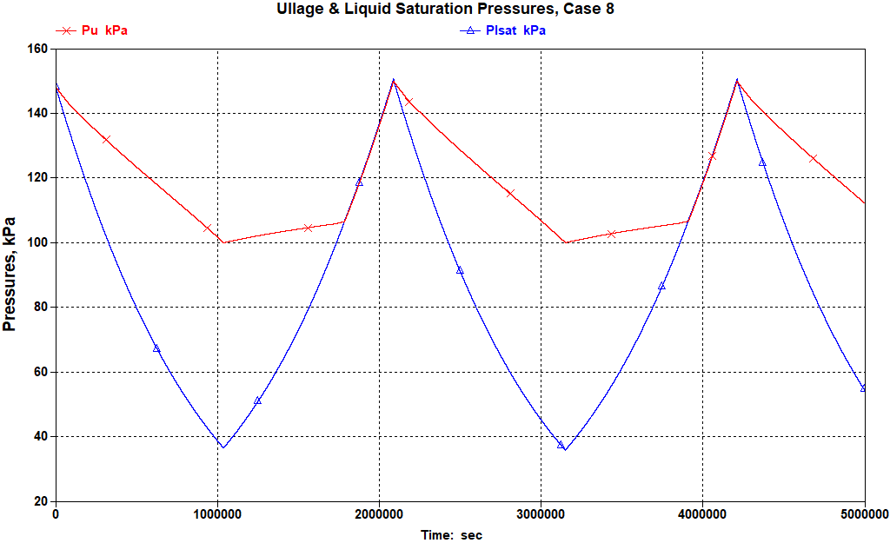
Figure 5. Ullage and Liquid Saturation Pressures, Case 8.

  - Easy5 Results
The Easy5 model has been run across the analysis cases and the results are summarized in Table 3. This model showed all cases completing at least 1 cycle, so the duty cycle is calculated on all cases. An example ullage pressure plot is shown in Figure 6. In this plot, notice that the tank reaches saturation quickly and maintains that condition. With the repressurization portions being quasi-linear, there is no subcooling generated and all heat input results in evaporation. For all cases, as pump flowrate increases, the depressurization time increases, and the pressurization time decreases. This combined effect increases the duty cycle at higher flowrates.

Table 3. Easy5 Modeling Results
Case | Depressurization Time [hr] | Pressurization Time [hr] | Duty Cycle
1 | 12.6 | 30.6 | 29%
2 | 16.1 | 19.7 | 45%
3 | 38.6 | 11.7 | 77%
4 | 15.8 | 36.7 | 30%
5 | 19.9 | 23.7 | 46%
6 | 48.2 | 14.4 | 77%
7 | 105 | 103 | 50%
8 | 118 | 93.7 | 56%
9 | 169 | 75.2 | 69%

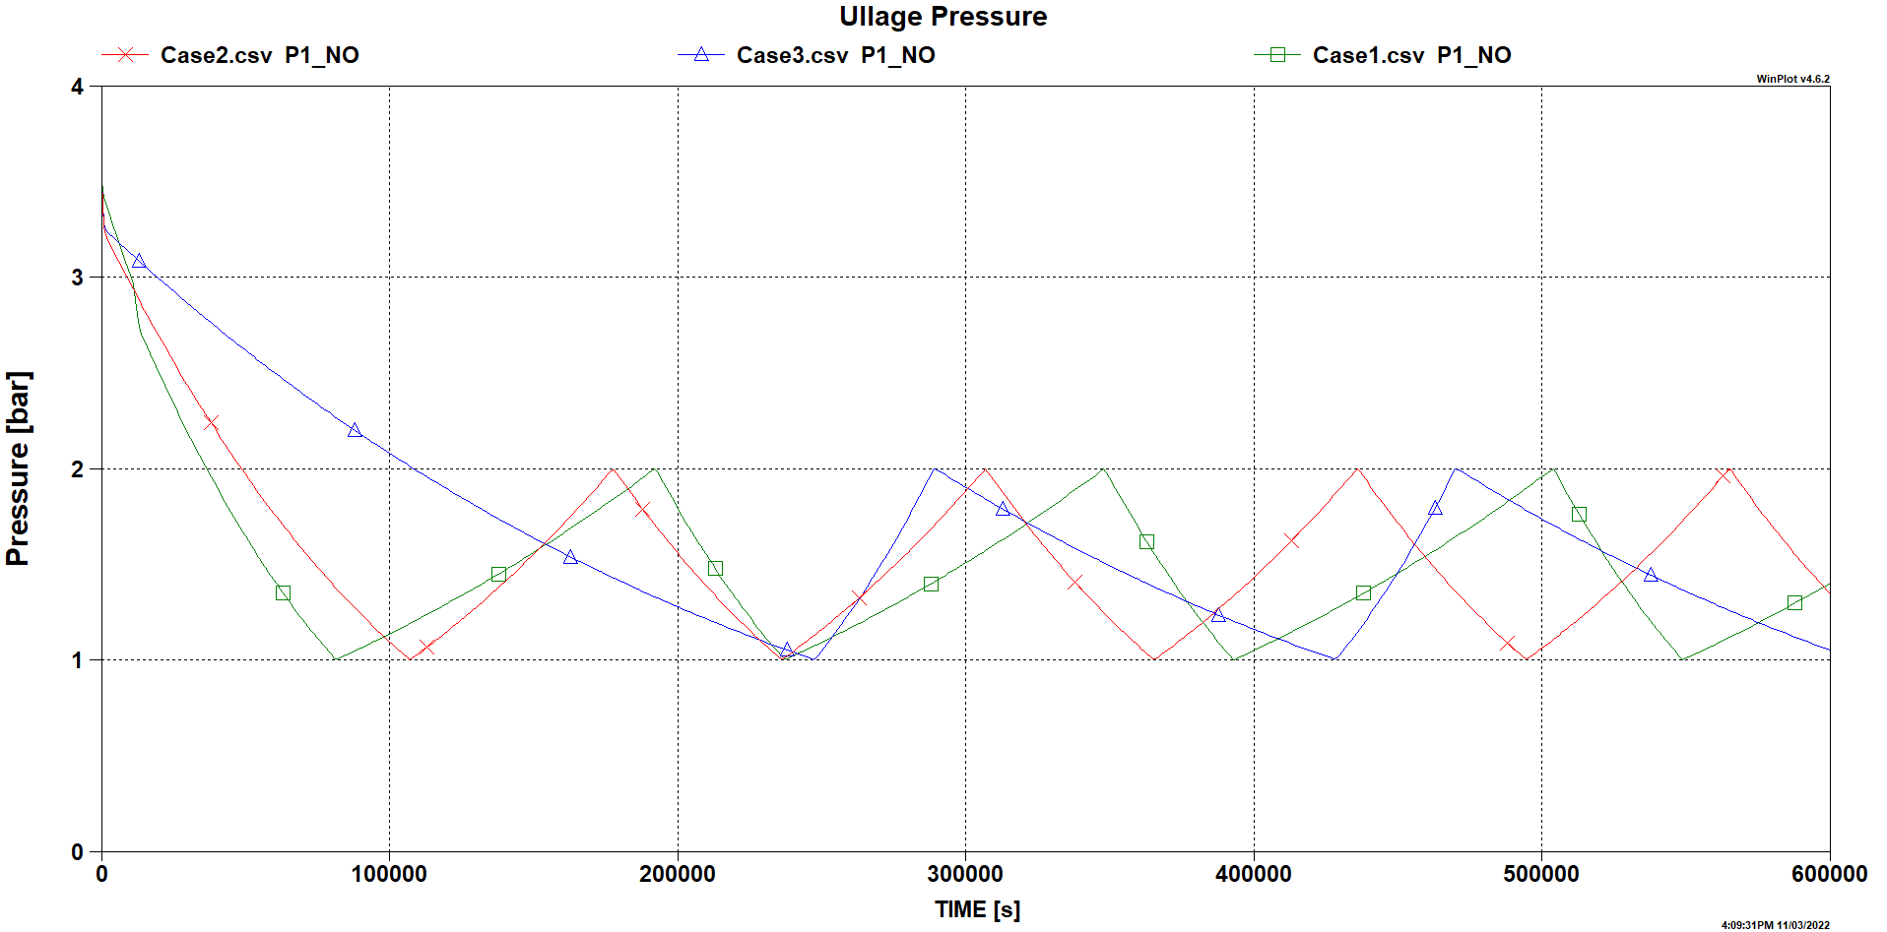
Figure 6. Ullage pressure, Cases 1 - 3.

- Model Comparison
Both TankSIM and Easy5 qualitatively agree on the general behavior that will be seen in zero-boiloff of the system.
Both models agree on the duty cycle for the lower system flowrate but depart as the flowrate increases. This is likely due to the difference in droplet heat transfer assumptions used in each model. One significant difference in the droplet modeling is how the diameters of the droplets are handled.
TankSIM shows the liquid propellant reaching a subcooled state whereas Easy5 shows saturation for nearly the whole cycle (except for right at the very beginning of the first depressurization). This is due to a difference in how the interface temperature is handled (saturated vs. Alabovskii’s equation). In most cases Easy5 shows a faster depressurization and repressurization time than TankSIM. The heat transfer coefficient generated on the liquid side of the droplet in Easy5 is higher than what TankSIM shows, which explains the higher rate of condensation of saturated ullage gas and therefore faster depressurization.

- Conclusion
The ATCS has been well characterized in this modeling effort by multiple tools. Further fidelity will be added soon when ground testing is completed, and the GFSSP and Thermal Desktop models are completed. The ground testing will supply much needed data that can be used to anchor droplet heat transfer correlations that will better inform how the system will perform on-orbit. The ground testing will also verify system pressure drop, which is what drives the pump head requirement and therefore pump heat into the fluid, which is a large factor of the overall heat input to the system.

Acknowledgments
The authors would like to thank the MSFC CFM project office for funding this endeavor. Also, special thanks to Ali Hedayat at MSFC for lending his CFM expertise and coordinating the overall analytical effort. Also special thanks to Cameron Hines who performed a bulk of the Easy5 analysis prior to his departure from NASA.

References
[1] L.G. Bolshinskiy, A. Hedayat, et al., “Tank System Integrated Model: A Cryogenic Tank Performance Prediction Program”, NASA/TM—2017–218239, April 2017
[2] Bolshinskiy, L., “TankSIM 8 User’s Manual”, Huntsville, AL, April 2021.
[3] Incropera, F. P., DeWitt, D. P., Bergman, T. L., &; Lavine, A. S., “Fundamentals of Heat and Mass Transfer”,
5th Edition, pp. 433–434, 2007.
[4] N. Alabovskii, “Thermal Interaction at the Gas-Liquid Interface in an Apparatus with an Immersed Burner”, Kiev Polytechnical Institute. Translated from Inzhenerno-Fizicheskii Zhurnal, Vol.22, No. 1, pp. 117-122, January 1972.
[5] А. С. Лышевский, «Процессы распыливания топлива дизельными форсунками», Машгиз, Москва, 1963 (In Russian). (S. Lyshevskiy, “Fuel atomization by diesel injectors”, Mashgiz, Moscow, 1963, in Russian)
[6] Hexagon, “Easy5 2022.3 User Manual”, Irving, CA, July 2022.

AST Aerospace Flight Systems, Propulsion Systems Modeling and Analysis Branch
Senior Research Scientist, Jacobs ESSCA, Propulsion Systems Modeling and Analysis Branch
AST Liquid Propulsion Systems, Propulsion Systems Modeling and Analysis Branch
Founder/CEO, Eta Space LLC
Fluid and Thermal Analyst, Eta Space LLC

