Gatlinburg & Beatty Wildfires

Evaluating the Role of Soil Moisture in Determining Vegetation Health, Fuel Loads, and Wildfires in the Gatlinburg and Beatty Fires

 **Technical Report**

Final – November 14th, 2022

Kelli Roberts (Project Lead)

William Hadley (Technical Lead)

Daniel Littleton (N/A)

***Advisors:***

Molly Woloszyn, NOAA National Integrated Drought Information System (Science Advisor)

Ronald Leeper, NOAA National Centers for Environmental Information, North Carolina Institute for Climate Studies (Science Advisor)

***Fellow:***  
Kathryn Caruso (North Carolina – National Centers for Environmental Information)

# 1. Abstract

Wildfire potential monitoring, which is increasingly vital under climate change-induced droughts, could be improved by incorporating remotely-sensed soil moisture data. To better understand the connections between soil moisture and vegetation health, stakeholders are interested in using soil moisture data in the development of fire-related indices. NASA DEVELOP partnered with the Desert Research Institute’s Western Regional Climate Center (WRCC), NOAA’s National Integrated Drought Information System (NIDIS), the North Carolina State Climate Office, and Oklahoma State University to evaluate how measures of remotely-sensed standardized soil moisture compare to vegetation health and fire fuel indices in a case study of two fire events: the 2016 Chimney Tops 2 Fire near Gatlinburg, Tennessee and the 2021 Bootleg Fire near Beatty, Oregon. The team visualized vegetation change six months prior to each event using spectral vegetation indices observed by the Moderate Resolution Imaging Spectroradiometer (MODIS) aboard NASA’s Terra satellite and the Keetch-Byram Drought Index (KBDI). These visualizations were compared to soil moisture data from European Space Agency's (ESA) Climate Change Initiative Soil Moisture (CCI SM) project, collected in part by the Soil Moisture Active Passive (SMAP) satellite. Overall, period of record percentiles and fraction of available water standardizations correlated more strongly with fuel load and vegetation indices, indicating their utility for fire potential monitoring. Soil moisture conditions remained exceptionally dry for several months before the Chimney Tops 2 Fire whereas drought conditions only intensified immediately prior to the Bootleg Fire. This indicates greater sensitivity to drought conditions under Western fire regimes. These findings will inform partners’ monitoring of wildfire potential in both regions and development of early warning systems.

**Key Terms**

soil moisture, drought, wildfire management, remote sensing, KDBI, MODIS, NDVI, EVI

# 2. Introduction

***2.1 Background Information***

As changes in climate and land use increase the frequency and intensity of wildfires (Sullivan et al., 2022), improved wildfire monitoring can support communities to prepare for and respond to fire events. Since 1990, 178 million hectares of forest have been lost globally (Global Forest Resources Assessment of 2020). Wildfires are a major threat to forests and damage water quality, cause vegetation mortality, and release pollutants that lead to public health crises. Not only has fire potential generally increased across the United States, but the very large fire (VLF) potential has also increased in both frequency of favorable conditions and longevity of fire season due to changing weather patterns and increased fuel (Barbero, 2015). In many regions of the United States, wildfires are three times more frequent and up to four times the size in the 2000s as compared to previous decades (Iglesias, 2022). These increases point to greater burn extent and larger burn areas in the Western United States and an increased number of fires in the eastern portion of the country (Iglesias, 2022).

When approaching the understanding of indicators of fire risk and spread, a variety of factors fall into the scope with varying levels of interrelation. Typical fire risk assessments investigate interactions among topography, fuel, weather, and ignitions. Spatial variability in terrain conditions and fuel also impact overall fire risk and spread, showing the importance of including measurements of vegetation health when calculating flammability of specific areas. Littell et al. (2016) found that increased fuel flammability was driven by overall climate warming facilitating drier conditions as well an increase in fuel availability being driven by antecedent moisture. In the Southern Great Plains, low soil moisture was found across large growing season wildfires, highlighting the need for the inclusion of soil moisture in indicative wildfire analyses (Krueger, 2015).

As climate change causes increasingly extreme weather patterns and events, the combination of drought and fuel build up creates high fire risk in both urban and rural areas. Many fire monitoring and management systems utilizing early hazard warning systems currently lack the inclusion of soil moisture conditions. To address these gaps, the DEVELOP team examined soil moisture conditions, along with other environmental variables, in the lead-up to two wildfire events to improve understanding of and communication about fire risk and vulnerability based on comparisons of these metrics.

***2.2 Project Partners & Objectives***

NASA DEVELOP partnered with the North Carolina State Climate Office, NOAA’s NIDIS, the DRI’s WRCC, and Oklahoma State University. The North Carolina State Climate Office developed the online Fire Weather Intelligence Portal for land managers to assess fire risk in the southeastern U.S. using geospatial data; they are interested in incorporating environmental variables that are found to correlate with fire indices into the Portal. NIDIS forecasts, monitors, and communicates drought conditions to communities and would like to apply the results of the project to enhance early drought hazard warning systems. WRCC addresses climate concerns across the 11 westernmost United States by engaging in research, tool development, and analyzing and interpreting data to inform environmental decision-making. Oklahoma State University’s Plant and Soil Sciences Department, a collaborator on this project, analyzes remotely-sensed vegetation indices in their research and monitoring on wildfire danger ratings.

The project partners are interested in investigating patterns in soil moisture to understand how changes in soil moisture compare with variability in vegetation and fuel content before wildfires. The objectives of this project were to 1) produce fuel load maps and a spatially averaged time-series using vegetation indices and the KBDI, 2) analyze soil moisture conditions preceding two fire events through three standardized approaches, and 3) compare changes among these variables before both fire events. By evaluating how measures of soil moisture compare to measures of vegetation health and fire fuel indices, the results of this project can inform partners’ efforts to monitor for and communicate wildfire risk to communities across the United States.

***2.3 Study Area & Study Period***

The project contained two separate study areas for each wildfire event, with study areas of the same time frame in different years. The Chimney Tops 2 Fire began on November 23rd, 2016 on Chimney Tops Mountain in the central Great Smoky Mountains National Park. After burning 11,000 acres, it was extinguished on December 13th, 2016. The Bootleg Fire occurred between July 6th and August 15th, 2021 near Beatty, Oregon and burned over 400,000 acres, making it the second largest fire in the United States in 2021. The project examined conditions in the six months preceding each fire from May 2016 – November 2016 and January 2021 – July 2021. The direction of a fire’s spread is primarily determined by meteorological conditions at the time of a fire (Bradshaw et al., 1983). This means that trends in fuel conditions preceding fire events often extend beyond the specific footprints of individual fires. As such, the study area for each of the fires was expanded to a circle with a 250 km radius extending from the center of each fire footprint to include non-burned areas surrounding each event (Figure 1).

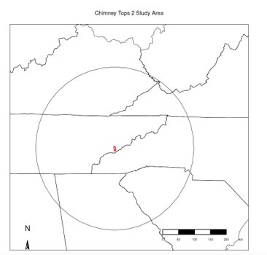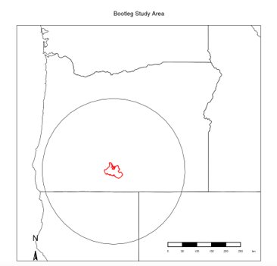

*Figure 1.* A map of each study area, including a 250km buffer surrounding the fire footprint.

# 3. Methodology

***3.1 Data Acquisition***

The team acquired data across the study period (May 2016 – November 2016 and January 2021 – July 2021) from multiple sources, including preprocessed datasets as well as unprocessed Earth observation imagery (Table 1). The European Space Agency (ESA)’s Climate Change Initiative (CCI) Soil Moisture (SM) dataset, which was used to assess soil moisture conditions prior to each fire event (Dorigo et al., 2017), was accessed through the ESA’s FTP server. This dataset incorporates measurements from NASA’s SMAP satellite, in addition to other sensor platforms, to compile a daily record of volumetric soil moisture conditions at a 25 km spatial resolution. To examine correlations between soil moisture and vegetation health—a significant component in wildfire potential—these soil moisture data were compared to vegetation indices derived from NASA’s Terra MODIS, which provided spectral data at a scale of 250 m every 16 days. A combination of Google Earth Engine (GEE) and RStudio was used to access and manipulate the Terra MODIS imagery for the six months prior to each wildfire event. The Terra MODIS vegetation indices were acquired as a Level 3 product from Application for Extracting and Exploring Analysis Ready Samples (AppEEARS), a database of geospatial data from a variety of federal archives (Vermote and Wolfe, 2021). Finally, a gridded dataset of the KBDI, an index specifically designed to quantify wildfire risk using a moisture balance, was used to assess antecedent soil moisture trends (Keetch & Byram, 1968). This dataset, accessed through the United States Forest Service’s (USFS) Wildland Fire Assessment System (WFAS), was calculated by the North Carolina State Climate Office using normal precipitation from daily precipitation totals from the Parameter-elevation Regressions on Independent Slopes Model (PRISM) high resolution climate dataset, daily precipitation totals from National Weather Service Advanced Hydrologic Prediction Service, and daily maximum temperatures from the Real-Time Mesoscale Analysis product.

Table 1. *List of datasets and sources*

|  |  |  |  |  |  |
| --- | --- | --- | --- | --- | --- |
| **Variable Type** | **Standardization Method/ Index** | **Source** | **Spatial Resolution** | **Temporal Resolution** | **Processing** |
| Soil Moisture | Period of record percentiles | ESA CCI SM | 25 km | Daily | R |
| Soil Moisture | Interannual standardized anomaly | ESA CCI SM | 25 km | Daily | R |
| Soil Moisture | Fraction of available water | ESA CCI SM/ SSURGO/ STATSGO | 25 km | Daily | R |
| Vegetation Health | Normalized Difference Vegetation Index (NDVI) | Terra MODIS | 250 m | 16 Days | GEE/R |
| Vegetation Health | Enhanced Vegetation Index (EVI) | Terra MODIS | 250 m | 16 Days | GEE/R |
| Fire Potential | KBDI | USFS WFAS/ NC State Climate Office | 4 km | Daily | R |

***3.2 Data Processing***

*3.2.1 Soil Moisture Standardization*

In order to thoroughly examine the role of soil moisture in determining wildfire potential, three standardization methods were used to analyze volumetric soil moisture conditions: 1) period of record percentiles, 2) interannual standardized anomaly, and 3) fraction available water.

1. To determine the period of record percentiles, the team calculated the percentile of every observation from the empirical distribution function of the entire period of record (1990–2021). Under this method, the data range from 0 to 1, where any measurement above 0.5 is wetter than the average of the period of record and any measurement below 0.5 is dryer than the average of the period of record.
2. The team adjusted soil moisture observations for seasonal variations to generate the interannual standardized anomaly. Specifically, a 15-day rolling mean was calculated for every day of the year and averaged across every year in the period of record, resulting in a smoothed, seasonally adjusted average soil moisture measurement for every date. Finally, the team calculated the anomaly of each observation from this moving average.
3. Finally, the team calculated fraction available water (FAW), which represents the amount of water available to plants, based on the wilting point (WP) and field capacity (FC) of the soil from Soil Survey Geographic Database (SSURGO) and the State Soil Geographic Database (STATSGO) data (Sharma et al., 2022; Equation 1). The resulting output was generated in fractional values ranging from 0 to 1, with numbers closer to 0 representing the driest areas and numbers closer to 1 representing the wettest areas:

$FAW=\frac{SM-WP}{FC-WP}$ (Equation 1)

*3.2.2 Calculation of Vegetation Indices*

The team used MODIS data to calculate the Normalized Difference Vegetation Index (NDVI) after clipping the data to each study area and study period. NDVI estimates the density of green vegetation in one area using a ratio between visible red (R) and near infrared (NIR) reflectance (Robinson et al., 2017; Equation 2). After calculating seasonal trends, the team plotted them across a time-series chart to show NDVI values over time. This process was completed for each fire event.

$NDVI=\frac{NIR-R}{NIR+R}=\frac{Band 5 - Band 4}{Band 5 + Band 4}$ (Equation 2)

Enhanced Vegetation Index (EVI), which corrects beyond NDVI for some atmospheric conditions and canopy background noise, is more sensitive in areas of high vegetation (Huete et al., 2002; Equation 3). The team calculated EVI using the following ratio between NIR, R, blue reflectance (B), an “L” value to adjust for canopy background, and “C” values as coefficients of atmospheric resistance.

$EVI=\frac{NIR-R}{NIR+\left(C_{1}⋅R\right)-\left(C_{2}⋅B\right)+L}=\frac{Band 5 - Band 4}{Band 5 + \left(6⋅Band 4\right)-\left(7.5⋅Band 2\right)+1}$ (Equation 3)

The standard coefficients used by MODIS were applied where L = 1, C1 = 6, C2 = 7.5, and G = 2.5. The team also calculated EVI values as seasonal trends and plotted them in a time-series chart for each fire event. Finally, the results of both the NDVI and EVI time-series were combined in a single graph.

***3.3 Data Analysis***

*3.3.1 Spatially Averaged Time Series*

For each soil moisture, vegetation health, and fire potential variable, the team averaged all observations within the defined study area for every available timestep in order to generate a spatially averaged time series of conditions in the short term (six months prior to fire event) and long term (a decade prior to fire event). These time series visualized the relationships among variable behaviors and depicted trends in these variables compare to typical conditions in the lead-up to a fire event.

*3.3.2 Fire Potential, Vegetation Health, and Soil Moisture Maps*

In order to visualize the spatial changes among all variables in the lead up to fire events and how those trends compare to typical conditions in the study area, the team generated maps for each variable during the month prior to each fire event. Additionally, a long-term, seasonally-adjusted average of corresponding conditions during the 7–10 years prior to fire events were generated in order to compare those maps to average conditions.

*3.3.3 Correlation Analysis*

In order to determine which soil moisture standardization methods were most aligned with the vegetation health and fire potential indices, the team calculated a Pearson correlation coefficient to assess the relationships between each of the soil moisture time series and each of the vegetation health and fire potential indices. The relationships with the strongest correlation were noted, as these provide the most promising opportunity for the use of remotely sensed soil moisture in future fire potential monitoring. Each analysis was conducted over varying time frames, but this correlation analysis was performed for the six months preceding each fire event for more confident results.

# 4. Results & Discussion

***4.1 Analysis of Results***

*4.1.1 Fuel Load Analysis*

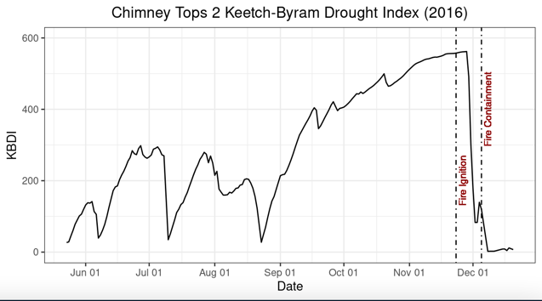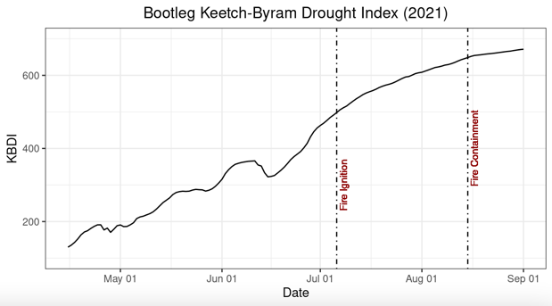

*Figure 2:* Charts displaying the KBDI preceding the Chimney Tops 2 and Bootleg Fires.

Figure 2 shows the spatially averaged time series of KBDI values for each study area, indicating the condition of fuel loads preceding each fire, and therefore the potential for wildfire occurrence. Both show increasing drought intensity in the months before fire ignition. The Chimney Tops 2 study area saw KBDI values rapidly increase during late August and early September, with a continuous steady increase ahead of the fire event. This indicates that long-term drought conditions contributed to the Chimney Tops 2 fire. This time series also demonstrates how KBDI responds to precipitation events, as the rainstorm that facilitated the containment of the Chimney Tops 2 fire also resulted in a rapid decrease in KBDI values. While the Bootleg study area also saw increasingly dry conditions prior to the fire, drought intensification only peaked shortly before ignition, providing evidence that shorter-term drought effects contributed to the fire.

*4.1.1.1 Fuel Load Maps*

As shown in Appendix A, the KBDI maps for both study areas show drought conditions in the six months leading up to each fire. The Chimney Tops 2 drought map shows more extreme conditions than usual for this region of the country during that time frame. The immediate fire area and the region to the West of the fire footprint all fall between values of 600 and 800, falling within KBDI’s “extreme drought” classification. There was a rapid increase of this index from September to the fire event. The Bootleg drought map shows an influence of drought immediately before the fire, up until its ignition.

*4.1.2 Results of Vegetation Analysis*

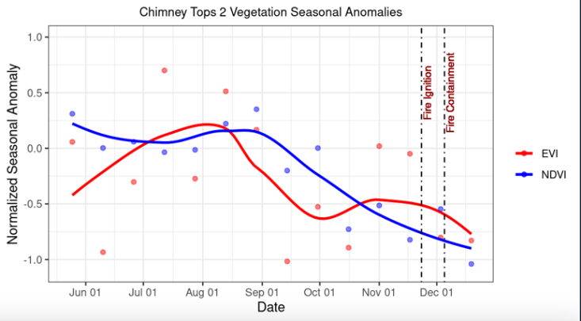

*Figure 3:* Chart displaying the vegetation seasonal anomalies for the Chimney Tops 2 fire.

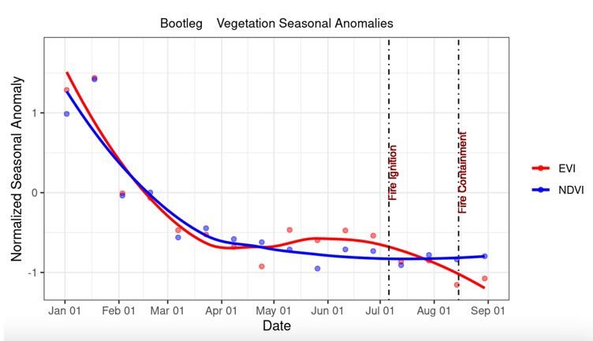

*Figure 4:* Chart displaying the vegetation seasonal anomalies for the Bootleg fire.

Figures 3 and 4 show the spatially averaged time series of NDVI and EVI seasonal anomalies over each study area, visualizing how vegetation greenness deviated from average seasonal conditions prior to each fire event. Generally, vegetation around the Chimney Tops 2 fire remained similar to seasonal averages before both anomaly values dropped within the several months leading up to the fire. This differs from vegetation conditions surrounding the Bootleg fire, where EVI and NDVI dip below average starting about four months before the fire and remaining significantly low until ignition. Since this differs from the steady intensification of drought conditions in the Bootleg study area indicated by the KBDI time series, it is likely that this indicates a vegetation response to longer-term climate conditions.

*4.1.2.1 Vegetation Health Animations*

A spatial visualization of the NDVI time series was created over each study area using GEE’s animation toolbox. The NDVI imagery were 16-day median composite images, resulting in animations with seasonal differentiation that included both fire events. As expected, the region over the Great Smoky Mountains showed high vegetation presence and the region to the west showed more areas with scarcer vegetation. A static visualization of vegetation conditions immediately prior to fire ignition can be viewed in Appendix B and mirrors the findings of the animated maps in that the eastern study area contains significantly greater levels of vegetation than the western study area.

*4.1.3 Results of Antecedent Moisture Conditions Analyses*

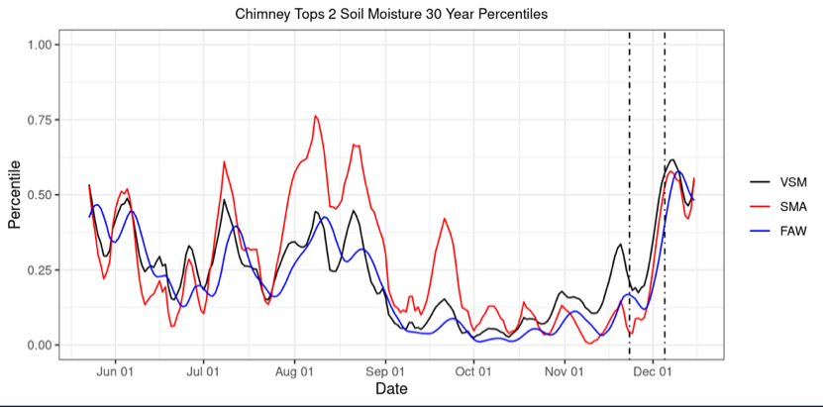

*Figure 5.* Chart displaying the soil moisture percentiles for Chimney Tops 2 across three standardization methods.

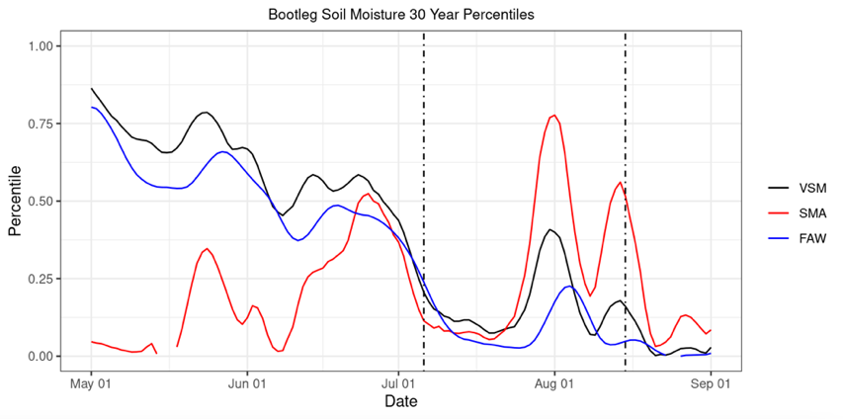

*Figure 6.* Chart displaying the soil moisture percentiles for Bootleg across three standardization methods.

Spatially averaged time series of soil moisture conditions in each study area are displayed in Figures 5 and 6. In order to display all trends on a single chart, the 30-year percentile values were calculated for each soil moisture variable. As such, a 0.00 would represent the driest observation in the complete dataset and a 1.00 would represent the wettest observation in the complete dataset for the VSM, SMA, and FAW.

Prior to the Chimney Tops 2 fire, soil moisture conditions generally mirrored the KBDI values for the study area, as they fell sharply around late August and early September, remaining low until post-fire conditions. The rain event that brought an end to the Chimney Tops 2 fire is also visible, as the three variables jump suddenly in late November and early December. The soil moisture trends for Chimney Tops 2 also demonstrate how the standardization approaches can differ, as VSM began to rise in November while SMA and FAW remained low. Since soil moisture recharge typically occurs over the late fall and winter in the Chimney Tops 2 study area, VSM will usually rise over this time of year. However, this analysis indicates that though VSM rose in again in late fall in 2016, it did not rise as much as typical, resulting in a consistently and intensely dry drought signal from SMA and FAW.

The Bootleg Fire also saw soil moisture trends similar to that of KBDI. VSM and FAW values declined continually from May through June before dropping suddenly immediately prior to the fire event. SMA followed a similarly sharp decline in the weeks before the fire, though SMA values remined substantially lower than VSM and FAW in the previous months. However, this could be a result of the limited data available during the winter and early spring as soil water freezes. Nevertheless, these soil moisture trends reinforce the short-term nature of the drought conditions preceding the Bootleg fire, especially in comparison to the longer-term drought seen around the Chimney Tops 2 study area.

*4.1.4 Results of Fuel Load and Antecedent Moisture Comparison*

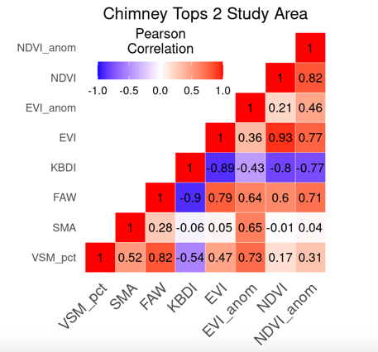 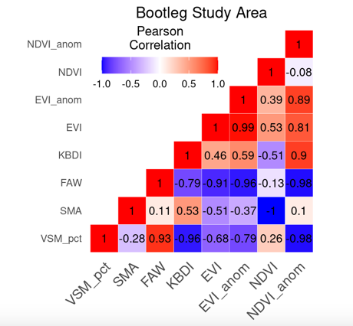

*Figure 7.* Graphs displaying the correlation coefficients across all variables for six months preceding each fire.

Figure 7 displays the strength of relationships between each of the soil moisture standardization methods, the vegetation indices and their anomalies, and KBDI in the six months prior to each fire using the Pearson Correlation Coefficient. Overall, these correlations indicate that soil moisture anomalies are less correlated with KBDI and vegetation health than the other soil standardization methods. This is expected since wildfires are seasonal phenomena, occurring more often during the driest and hottest times of year. Additionally, KBDI is generally negatively correlated with the soil moisture variables across both fires. This is expected since higher values of KBDI indicate more intense drought while lower soil moisture values indicate these conditions.

However, many of the other correlations differ between the two fires. For example, prior to the Chimney Tops 2 fire, FAW and VSM had mostly strong, positive correlations with KBDI and all of the vegetation indices. Before the Bootleg fire, however, these variables had mostly strong, negative correlations. Likewise, KBDI is mostly negatively correlated with the vegetation indices prior to the Chimney Tops 2 fire, but positively correlated with the vegetation indices prior to the Bootleg fire. These differences are possibly the result of greater data gaps in the Bootleg soil moisture time series during the winter and early spring when much of the study area is frozen. This could result in fewer data points to correlate between soil moisture and the other variables, and consequently could lead to less meaningful correlations. This is especially true for the correlations with the MODIS-derived vegetation indices since they are only observed every 16 days. These differences, however, could also indicate longer-term vegetation trends present in the Bootleg study area that are less affected by soil moisture conditions or short-term drought.

***4.2 Future Work***

Project partners are interested in conducting a national assessment of major wildfire occurrences across all states and Puerto Rico to provide additional context on metrics such wildfire frequency, median acreage burned, and annual and seasonal variations at a state-by-state level. This assessment would look at acreage burned and seasonal variations to provide additional context of fire event behavior. Additionally, other vegetation & drought indices could be pursued in future research. The Evaporative Stress Index (ESI) demonstrates capacity for capturing early signals of drought by visualizing temporal anomalies in evapotranspiration, showing rates of land surface water use. The Vegetation Drought Response Index (VegDRI) shows the weekly drought effects of vegetation stress across the United States. The Vegetation Health Index (VHI), created by NOAA, characterizes vegetation health as a combination of moisture and thermal conditions to estimate crop yield. Other future work would include expanding this analysis to grassland fires, soil fires, or timber fires to look at different kinds of fuel loads.

*4.2.1 Limitations*

The team encountered limitations in both the data acquisition and analysis of the project. The Chimney Tops 2 fire footprint lacked adequate satellite imagery data due to the 9x9 km pixel size of the study area being too small for analysis with the 25x25 km pixel datasets. Second, there was high cloud cover in the Great Smoky Mountains, also impacting the number of usable images to analyze this fire event. Third, the drought index used is not commonly used in the West due to its inability to cover the seasonal dynamics there. The KBDI was developed for the United States Southeastern Forest and its seasonal rainfall trends, therefore making it a better indicator for the Eastern United States. Fourth, The Chimney Tops 2 Fire occurred in late November after the leafing season concluded, so vegetation indices were unable to consistently measure trends in vegetation greenness in the weeks prior to the fire event. Fifth, the results of our FAW values were outside of the expected range. Typically, values fall within a range of zero to one, with values closest to one indicating the wettest areas. Values in our analysis had variability with high values falling between 1 and 1.5. This scaling discrepancy may be attributed to the way in which FAW was calculated during the analyses, and future work could recalculate these measurements. Lastly, the correlation between SMA and NDVI has a result of negative 1. This could be due to a lack of NDVI data points for this time frame and region, leaving not enough points for a correlation to be found.

**5. Conclusions**

The NASA DEVELOP team provided the WRCC, NIDIS, and the NC State Climate Office with insight on the relationships among vegetation health, soil moisture, and fuel load to help inform future fire and drought monitoring decisions. The team created time series analyses for both the Chimney Tops 2 and Bootleg Wildfires across two different vegetation indices and KBDI to quantify vegetation health in the six months leading up to the fire events. This showed a longer-term drought influence in the lead up to the Chimney Tops 2 fire. Additional time series were created to visualize antecedent soil moisture, which indicated strong evidence that low soil moisture conditions immediately before the Bootleg Fire contributed to its ignition and spread. Using the Pearson correlation coefficient, the team pinpointed correlations between vegetation health, fuel load, and soil moisture. This identified NDVI, EVI, and KBDI as appropriate fire risk indicators for the Eastern region of the United States. These results will assist the WRCC in the future development of wildfire management products and procedures. This work will support NIDIS’s efforts to establish a National Coordinated Soil Moisture Monitoring Network, which will reduce risks from drought and fire using satellite data. It will also be incorporated in the NC State Climate Office’s Fire Weather Intelligence Portal, providing visual fire analysis tools to the public. In addition, improvements of fire and drought monitoring methods will protect incomparable ecosystems and communities vulnerable to the impacts of fire damage. Overall, the DEVELOP team’s work provides partners with results in a non-traditional fire risk analysis, jumpstarting future endeavors in investigations of antecedent soil moisture impacts on wildfires.

# 6. Acknowledgments

The authors with to thank everyone who assisted in this study, especially our project partners: Dr. Timothy Brown, Marina Skumanich, Britt Parker, Dr. Sheila Saia, Corey Davis, and Dr. Tyson Ochsner. We also thank Ronald Leeper and Molly Woloszyn for advising this study.

Any opinions, findings, and conclusions or recommendations expressed in this material are those of the author(s) and do not necessarily reflect the views of the National Aeronautics and Space Administration.

# This material is based upon work supported by NASA through contract NNL16AA05C.

# 7. Glossary

**Earth observations** – Satellites and sensors that collect information about the Earth’s physical, chemical, and biological systems over space and time

**Enhanced Vegetation Index (EVI)** – A measurement that—like NDVI—quantifies vegetation greenness and also corrects for atmospheric conditions and background noise

**Evapotranspiration** – A cumulative process in which water is transferred from the land surface to the atmosphere through the processes of evaporation and transpiration

**Field capacity** – The amount of water remaining in soil after it has been saturated and drained

**Fraction of Available Water (FAW)** – The ratio of the difference between moisture content and wilting point to field capacity and wilting point difference

**Fuel load** – The amount of fuel present in terms of weight per fuel unit area

**Google Earth Engine (GEE)** – A cloud-based geospatial platform used for analysis and visualization of satellite imagery

**Interannual Standardized Anomaly –** A calculation that is produced by the division of anomalies according to the standard deviation of multiple precipitation rates

**Keetch-Byram Drought Index (KBDI)** – A measurement of the risks of fire by way of the net effect of evapotranspiration and precipitation which results in the cumulative moisture deficiency in the various layers of soil

**Moderate Resolution Imaging Spectroradiometer (MODIS)** – A sensor aboard the Terra and Aqua satellites with a high temporal resolution of 1-2 days

**Normalized Difference Vegetation Index (NDVI)** – A measurement of the difference between infrared light to quantify the presence of live, green vegetation

**Pearson Correlation Coefficient** – A mathematical value which measures how strong and linear a relationship is between two variables

**Period of Record Percentiles** – A series of values used to measure the period of time of the length of droughts

**Soil Moisture** – A measure of the amount of water—or water content—held in surface soils, which can be measured through remote-sensing instruments by active microwave radar

**Terra** –A satellite launched in 1999 that houses five remote sensors to monitor Earth’s environment and climate

## 8. References

AppEEARS Team. (2022). *Application for Extracting and Exploring Analysis Ready Samples (AppEEARS)* (3.14.). [Tool]. NASA EOSDIS Land Processes Distributed Active Archive Center (LP DAAC), USGS/Earth Resources Observation and Science (EROS) Center, Sioux Falls, South Dakota, USA. [https://appeears.earthdatacloud.nasa.gov](https://appeears.earthdatacloud.nasa.gov/)

Barbero, R., Abatzoglou, J. T., Larkin, N. K., Kolden, C. A., & Stocks, B. (2015). Climate change presents increased potential for very large fires in the contiguous United States. *International Journal of Wildland Fire*, *24*(7), 892–899. <https://doi.org/10.1071/wf15083>

Bradshaw, L.S., Deeming, J.E., Burgan, R.E., and J.D. Cohen. (1983). 1978 National Fire-Danger Rating System: Technical Documentation General Technical Report INT-169 United States Department of Agriculture (USDA), Forest Service, Intermountain Forest and Range Expansion Station. <https://doi.org/10.2737/INT-GTR-169>

Dorigo, W., Wagner, W., Albergel, C., Albrecht, F., Balsamo, G., Brocca, L., Chung, D., Ertl, M., Forkel, M., Gruber, A., Haas, E., Hamer, P. D., Hirschi, M., Ikonen, J., de Jeu, R., Kidd, R., Lahoz, W., Liu, Y. Y., Miralles, D., Mistelbauer, T., Nicolai-Shaw, N., Parinussa, R., Pratola, C., Reimer, C., van der Schalie, R., Seneviratne, S. I., Smolander, T., & Lecomte, P. (2017). ESA CCI soil moisture for improved earth system understanding: State-of-the art and Future Directions. *Remote Sensing of Environment*, *203*, 185–215. <https://doi.org/10.1016/j.rse.2017.07.001>

Food and Agriculture Organization of the United Nations. (2020). *Global Forest Assessment 2020.* <https://www.fao.org/forest-resources-assessment/2020/en/>

Huete, A., Didan, K., Miura, T., Rodriguez, E.P., Gao, X., Ferreira, L.G. (2002). Overview of the radiometric and biophysical performance of the MODIS vegetation indices. *Remote Sensing of Environment*, *83*(1-2), 195-213. <https://doi.org/10.1016/S0034-4257(02)00096-2>

Keetch, J. J., & Byram, G. M. (1968). A Drought index for forest fire control: Forest Service Research Paper SE-38. United States Department of Agriculture (USDA), Forest Service, Southeastern Forest Experiment Station.

Krueger, E. S., Ochsner, T. E., Engle, D. M., Carlson, J. D., Twidwell, D., & Fuhlendorf, S. D. (2015). Soil moisture affects growing-season wildfire size in the Southern Great Plains. *Soil Science Society of America Journal*, *79*(6), 1567–1576. <https://doi.org/10.2136/sssaj2015.01.0041>

Landsat Missions. (n.d.). *Normalized Difference Vegetation Index*. United States Geological Survey. <https://www.usgs.gov/landsat-missions/landsat-normalized-difference-vegetation-index>

Landsat Missions. (n.d.). *Enhanced* *Difference Vegetation Index*. United States Geological Survey. <https://www.usgs.gov/landsat-missions/landsat-enhanced-vegetation-index>

Robinson, N.P., Allred, B.W., Jones, M.O., Moreno, A., Kimball, J.S., Naugle, D.E., Erickson, T.A., & Richardson, A.D. (2017). A dynamic Landsat derived Normalized Difference Vegetation Index (NDVI) product for the conterminous United States. *Remote Sensing, 9*(8), 863. <https://doi.org/10.3390/rs9080863>

Sharma, S., Carlson, J., Krueger, E., Engle, D., Fuhlendorf, S., Patrignani, A., Feng, L., Ochsner, T. (2007). Soil moisture as an indicator of growing-season herbaceous fuel moisture and curing rate in grasslands. *International Journal of Wildland Fire*,*30*(1). https://doi.org/30. 10.1071/WF19193

Sullivan, A., Baker, E. & Kurvits, T. (2022). Spreading Like Wildfire: The Rising Threat of Extraordinary Landscape Fires. United Nations Environment Programme (UNEP)and GRID-Arendal. https://wedocs.unep.org/bitstream/handle/20.500.11822/38372/wildfire_RRA.pdf

Vermote, E., Wolfe, R. (2021). *MODIS/Terra Surface Reflectance Daily L2G Global 1km and 500m SIN Grid* (V061) [Data set]. NASA EOSDIS Land Processes DAAC. <https://doi.org/10.5067/MODIS/MOD09GA.061>

# 9. Appendices

**Appendix A**

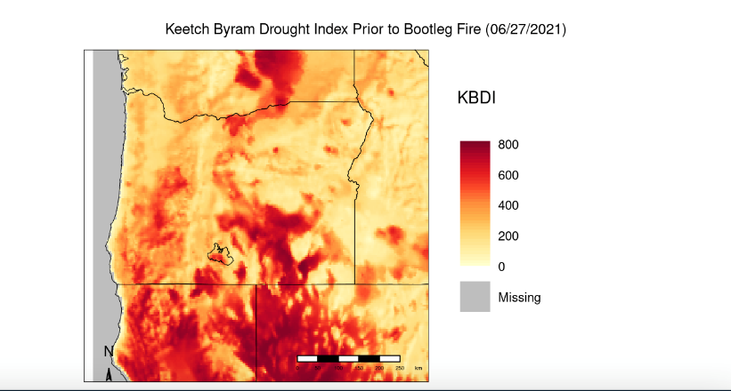 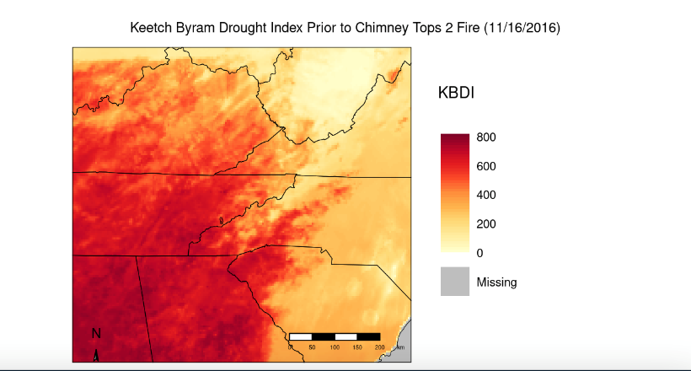

*Appendix 1.* Visualizations of the KBDI over the Western and Eastern regions of the United States, including the direct fire areas.

**Appendix B**

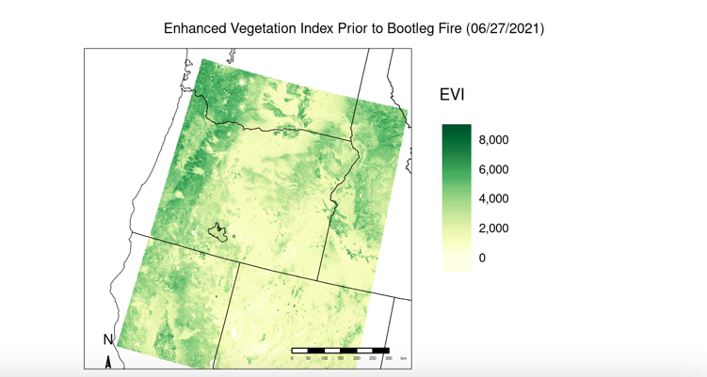 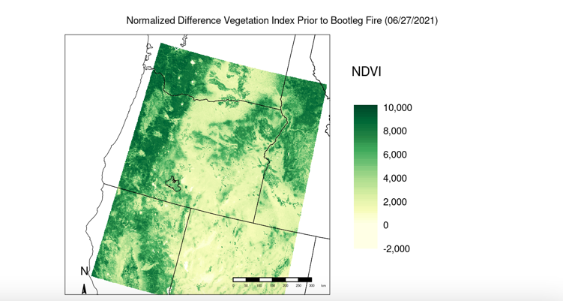

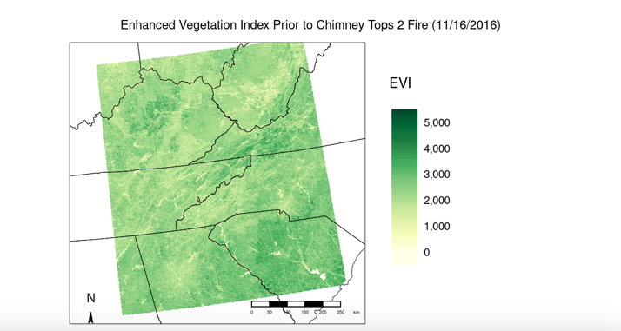 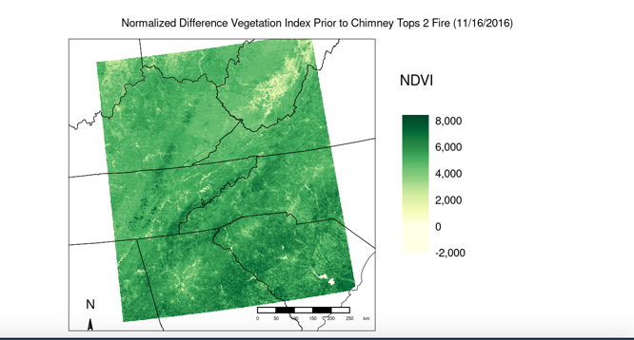

*Appendix 2.* Image showing the NDVI and EVI maps for both fire events.