Variable Pressure - Scanning Electron Microscopy (VP-SEM)
Dr. Jessica Gaskin, NASA MSFC
Variable Pressure (or Environmental) Scanning Electron Microscopy (VP-SEM) combined with Energy Dispersive X-ray Spectroscopy (EDS) is one of the most powerful methods for characterizing the sub-micron topography and chemical composition of uncoated samples. Terrestrially, VP-SEM is extensively used to non-destructively study geologic and manufactured materials with high spatial resolution (tens of nanometers) and large depth-of-field. An SEM offers a geologist a first survey of microscopic mineral phases via secondary electron imaging (SEI), which provides a topographic look at a sample, as well as backscattered electron (BEI) imaging, which contrasts the phases present based on their geochemistry (atomic number). A VP-SEM utilizes a gas in the sample chamber as a charge dissipation and signal amplification method, allowing analysis of a sample without preparation in the form of a conductive coating. A miniaturized VP-SEM operating in-situ on a lander or rover would be able to use the CO₂-rich Martian atmosphere (e.g., Nier et al., 1976; Williams 2016) as an imaging medium for this purpose.
Adaptation of a VP-SEM for in-situ Mars surface studies will provide a new imaging capability (via SEI) that is at least an order of magnitude higher resolution than the Mars Hand Lens Imager (MAHLI) on the Mars Science Laboratory (Williams et al., 2015), and equal to or better than the achieved resolution of the Atomic Force Microscope on the Phoenix Mars lander (Pike et al., 2011). In addition, the MVP-SEM is capable of BSI and simultaneous chemical analysis of the imaged region. In this sense, the MVP-SEM can be regarded as an instrument suite that will provide a new set of information not achievable by any other instrument.
The Miniaturized Variable Pressure Scanning Electron Microscope (MVP-SEM) was designed, built, and benchtop tested by a team at NASA’s Marshall Space Flight Center and Jet Propulsion Laboratory (JPL), Jacobs Space Exploration Group, Applied Physics Technologies, Inc. (AP-Tech), and Creare LLC, working with a team of technical and science collaborators. Benchtop testing was successful, proving concept feasibility. To date, the MVP-SEM has achieved an imaging resolution of <100 nm in the lab, and with continued optimization, even better performance (~50 nm resolution) is possible. Use in-situ on the lunar or other planetary surfaces would require some redesign to optimize instrument performance, but such an instrument would be equally useful.

Nier A.O., Hanson W.B., Seiff A., McElroy M.B., Spencer N.W., Duckett R.J., Knight T.C.D.,
and Cook W.S., “Composition and structure of the Martian atmosphere: Preliminary results
from Viking 1,” Science 193, 786-788 (1976).
Pike W.T., Staufer U., Hecht M.H., Goetz W., Parrat D., Sykulska-Lawrence H., Vijendran S.,
and Madsen M.B., “Quantification of the dry history of the Martian soil inferred from in-situ
microscopy,” Geophysical Research Letters 38 (L24201), doi: 10.1029/2011GL049896
(2011).
Williams, A.J., Sumner, D.Y., Alpers, C.N., Karunatillake, S., Hofmann, B.A., “Preserved
filamentous microbial biosignatures in the Brick Flat Gossan, Iron Mountain, CA,”
Astrobiology 15 (8), 637-668 (2015).
Williams, D.R., “Mars Fact Sheet,” https://nssdc.gsfc.nasa.gov/planetary/factsheet/
marsfact.html, updated 23 December 2016 and accessed 20 May 2018 (2016).
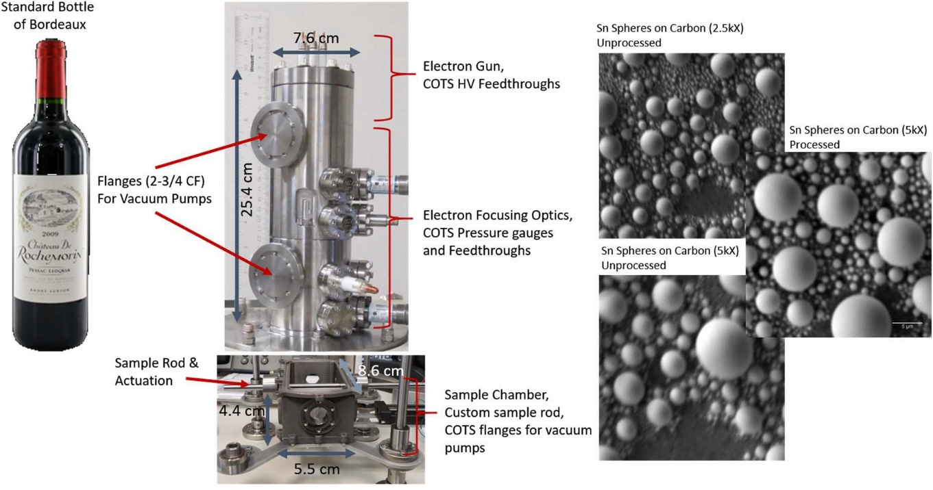
Wine Bottle
Figure 1. (Center) MVP-SEM showing dimensions of the main instrument. The full length of the electron gun and column (not including the sample chamber) is slightly shorter than a standard bottle of wine, showed at comparative scale (Left). The instrument is attached to a commercial SEM sample chamber for benchtop testing. Supporting electronics and vacuum pumps are not shown. (Right) Representative images taken with the MVP-SEM at various magnifications. Resolution is estimated to be ~100 nm. Images are of Sn Spheres on Carbon tape taken at 2.5kX and 5kX (unprocessed), and 5kX (processed using ImageJ software).

