Active and Passive Storage Solutions for Low Temperature Lunar Sample Return
Greg Schunk and Carlos Gomez
Thermal Analysis and Control Branch
NASA/Marshall Space Flight Center

Active and passive thermal storage solutions to return lunar biological, physical science and/or geology samples to the Earth are under development. Temperature requirements for biological/physical science sample conditioning range from -100˚C to -153˚C and possibly down to -253˚C for geological samples. The lower limit for geological samples is derived from the temperature of permanently shadowed regions on the lunar surface and the sublimation temperature of specific volatiles of interest (i.e., H₂O, NH₃ and CH₄). Individual samples for the lunar application are expected to be less than 50 kg with a 700 kg allowance for the container and refrigeration. Requiring no electrical power or heat rejection, passive approaches, comprised of high performance insulation and consumable Joule-Thompson cooling, may be preferred for shorter duration missions (< 30 days) to provide significant mass savings. Active storage approaches with cryogenic cooling may be necessary to preserve samples for longer periods of time.
A notional passive storage concept with an internal vapor cooled shield is shown below. The vapor cooled shield contains the sample and is isolated from the outer container with concentric reflective rigid shields and conventional multi-layer and/or aerogel insulation on the outer layer. A special removable, insulating end cap to stow or retrieve the sample is included.
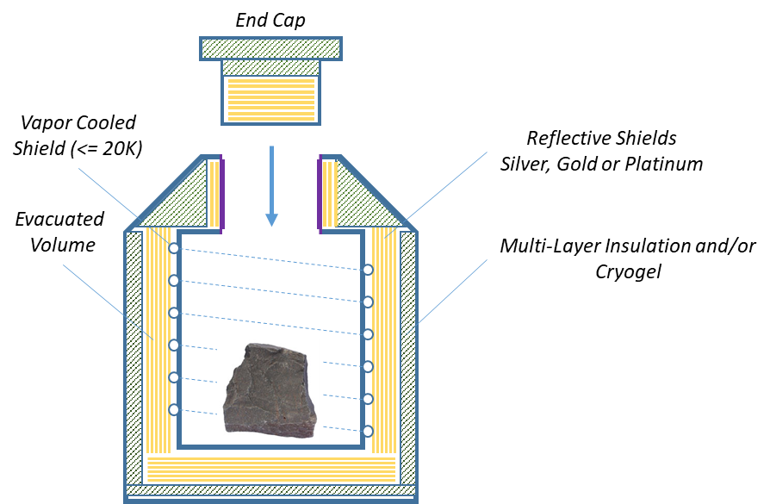
Projected heat leak versus sample stowage volume is shown below for an ambient temperature of 20˚C. An effective emittance of 0.005 through the rigid and multi-layer insulation is assumed. A penalty of 0.8 W heat leak through the end cap is assumed. It is anticipated that this developed technology could be extended or scaled for interplanetary missions as well as lunar applications.
