**AN IMPROVED HF VAPOR ETCHING APPARATUS FOR STARDUST PARTICLE EXTRACTION.** K. A. McCain,1 T. M. Hahn1, R. M. Armytage1, W. P. Buckley1, C. J. Snead2, and L. -A. Nguyen3 1Jacobs JETSII contract, NASA JSC, Mail Code XI3, Houston, TX 77058 ([kaitlyn.mccain@nasa.gov](mailto:kaitlyn.mccain@nasa.gov)), 2ARES, NASA JSC, Mail Code XI2, Houston, TX 77058, 3ARES, NASA JSC, Mail Code XI3, Houston, TX 77058.

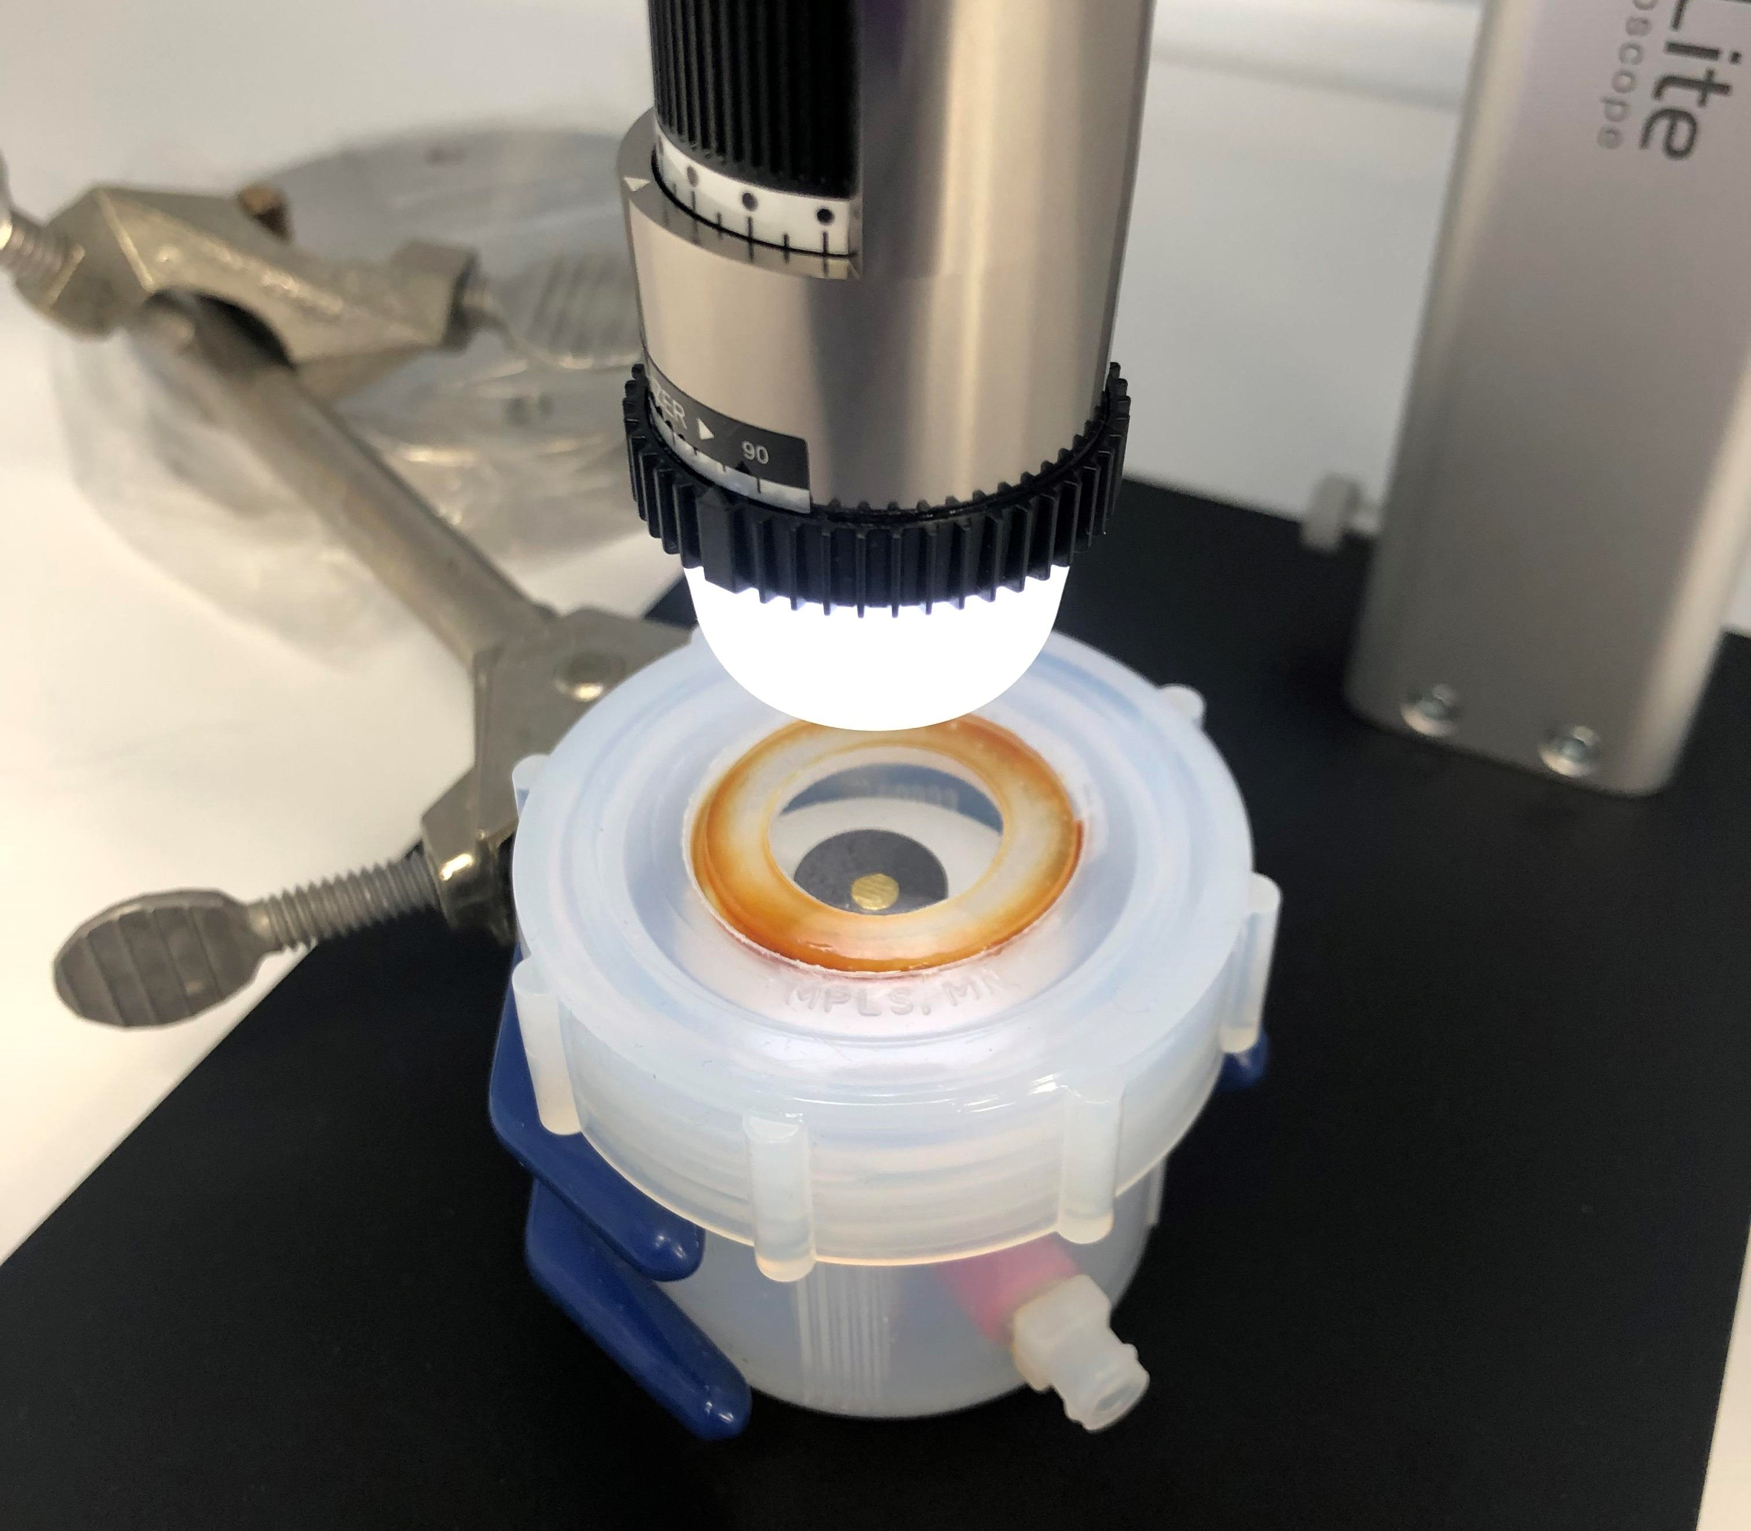

**Introduction:** The NASA Stardust mission captured thousands of particles from the Jupiter-family comet 81P/Wild 2 in a collector composed of aluminum foil and blocks of silica aerogel [1]. To date, most Wild 2 particles available for study are relatively large and coherent particles extracted individually from the ends of hollow, carrot-shaped impact tracks produced during impact into aerogel. However, >65% of the impacting mass can be found in the ‘bulb’ of the track, including nearly all of the <1 μm size fraction [2]. This fraction contains organic-rich material and is likely to include presolar grains, representing a critical opportunity to constrain the organic and presolar inventory of primitive outer solar system materials. However, the small size and susceptibility of this fraction to melting or alteration during capture poses significant analytical challenges.

Figure 1. Chamber used for HF etching of Stardust aerogel keystones. Gold foil suitable for SEM and NanoSIMS analysis is visible through chamber lid.

Previous attempts to extract and concentrate fine-grained material from the bulb of Stardust tracks have attempted to develop techniques that efficiently destroy aerogel and leave impactor particles relatively unharmed. The low density and high porosity of silica aerogel makes it more susceptible to attack by etching with hydrofluoric acid (HF) [3] or CF4 plasma ashing [4] than collected cometary silicates. Previous studies of HF vapor etching used HF solutions varying between 5 to 49% and noted that at high concentrations and etch rates, a liquid droplet was produced according to the etching reaction 4HF + SiO2 → SiF4 (g) + 2H2O [3]. SiF4 readily decomposes into HF and silicic acid in water, which has the potential to alter the freed cometary silicates. The plasma ashing technique avoids production of a liquid droplet and minimizes damage to embedded silicates but requires specialized equipment [4].

In this abstract, we present recent improvements to the HF etching procedure with the aim of constructing an etching chamber capable of slowly etching silica aerogel using small quantities of dilute HF. The etching chamber can be assembled using readily available materials.

**Methods:** The HF etching chamber consists of a modified Savillex sample jar and lid (Figure 1). A portion of the lid has been milled out and fitted with a HF-compatible clear plastic window using HF-resistant epoxy. An HF-compatible inlet port to allow injection of small quantities of acid is installed several mm above the bottom of the jar and affixed using HF-resistant epoxy. A high-density polyethylene sample stand with a removable secondary electron microscope (SEM) stub sample holder is attached to the bottom of the sample chamber using HF-compatible epoxy to raise the sample safely above the acid and allow easy sample loading and unloading.

HF solution is injected into the sealed jar below the sample stand through the port using an HF-compatible syringe. The reaction progress is monitored in real-time and with time-lapse photography through the viewport in the lid using a Dino-Lite Edge digital microscope, which has plastic optics resistant to HF attack. The etching procedure is carried out in a fully exhausting fume hood used for HF digestion, which allows us to open the chamber once the aerogel has been consumed to stop the etching process quickly and safely, thereby minimizing alteration of embedded particles. After removing the sample holder, all components can be easily cleaned by soaking in ultrapure water (UPW) and readied for another etch process. The sample stub and holder can be left to evaporate in the hood before transferring the Au foil to an Al stub for further SEM and Nano-SIMS characterization.

We determined the minimum concentration of HF solution capable of vapor etching aerogel by injecting HF solutions of 0.01 N, 1.5 N, and 3.0 N into an etching chamber containing a ~2 mm aerogel fragment resting on an HF-compatible graphite SEM stub. Time-lapse photography was used to monitor the etch rate for each concentration.

We investigated the effect of the vapor etching procedure on target particles by pressing a variety of minerals into an annealed, HF-cleaned Au foil overlaid with an HF-cleaned Au grid for reference. The pressed minerals include San Carlos olivine, Eagle Station olivine, Admire olivine, SLP-400 orthopyroxene, calcite, dolomite, Burma spinel, and magnetite. Before exposure to HF vapor, the appearance of these particles was documented using optical microscopy and SEM imaging.

After imaging the mineral analogues, a 1 mm fragment from the bulb of a track produced by firing Allende particles into aerogel using a light gas gun was placed on top of the foil away from the mineral grains to serve as an analogue for embedded Stardust particles. This foil was placed into the etching chamber, which was injected with ~1 mL 3N HF and monitored using time-lapse photography. After the aerogel fragment had etched, the reaction was stopped by removing the lid from the chamber. The Allende residue and mineral grains were imaged using SEM and optical microscopy to assess the results of the etching procedure and the collapse behavior of the aerogel.

**Results:** *Minimum HF concentration tests.* The 0.01 N and 1.5 N solutions did not produce any vapor etching visible to our time-lapse photography setup within 20 minutes after injection of acid into the chamber. Approximately 20 minutes after injection of 1 mL 3.0 N HF, the aerogel increased in opacity indicating that etching had begun. The 2 mm aerogel fragment slowly decreased in size and was fully consumed after approximately 2 hours and 40 minutes. Therefore, subsequent etching tests were performed with 3N HF solution.

*Effect of the etching procedure on Stardust particle analogues.* Discuss any morphological changes. Discuss spatial preservation of embedded Allende particles and homologous collapse effects if any.

**Discussion: We extended the range of HF concentrations used for vapor etching and found that 3N appears to be the most dilute HF capable of destroying aerogel in our setup within a few hours. No liquid droplet was observed during the digestion process, nor was condensation noted inside the chamber or on the chamber window at any of the tested concentrations, suggesting that this apparatus and procedure reduces the risk of producing a HF-rich water droplet capable of etching the cometary particles.**

Benefits of this technique over plasma ashing include the relative ease of setup and cleanup of the apparatus and the ease of which etched samples can be prepared for SEM and NanoSIMS analyses. Discuss any problems found in the next etching test and how we will attempt to resolve them.

Upcoming tests of the etching procedure will etch tracks produced by firing Allende particles into silica aerogel to determine the degree to which homologous collapse and aerogel etching affect the spatial distribution of freed cometary particles. Based upon the results of these tests, further refinements to the procedure will be made before we etch full Stardust keystones or bulb fragments.

**Acknowledgments:** This work was supported by the NASA LARS Program grant NNH20ZDA001N to L. -A. Nguyen. We also thank Justin Hayles for the use of the magnetite reference material.

**References:** [1] Brownlee D. et al. (2006) *Science*, *314*, 1711-1716. [2] Flynn et al. (2006) *Science, 314*, 1731-1735. [3] Westphal A.J. et al. (2004) *LPSC XXXV,* Abstract #1860. [4] Haas B.A. et al. (2018) *LPSC XLIX,* Abstract #2245.