Youngstown and Warren Disasters
Mapping Flood Susceptibility, Vulnerability, and Risk and Tree Canopy Coverage in Northern Ohio to Inform Stormwater Management and Flood Mitigation Efforts

Technical Report
Final – November 18th, 2022

Lauren Mahoney (Project Lead)
David Henriques
Nada Haddad
Thomas Ferrell

Advisors:
Lauren Childs-Gleason, NASA Langley Research Center (Science Advisor)
Dr. Kenton Ross, NASA Langley Research Center (Science Advisor)

Fellow:
Olivia Landry (Virginia – Langley)

1. Abstract
Both pluvial and fluvial flooding events pose direct challenges on urban infrastructure and communities across the United States. Heavy rainfall events oversaturate the ground, overflow waterbodies, and overwhelm stormwater infrastructure. Vulnerable areas receive heavy damage from flooding events due to physical factors like increased impervious surfaces, poor stormwater systems, and limited greenspaces. These vulnerable neighborhoods are comprised of aging populations, minority communities, and lower income levels. Lack of data in these communities have made it difficult to implement policymaking and flood mitigation strategies. Using the Urban Flood Risk Mitigation model (InVEST) and the PlanetScope satellite constellation, the team visualized historical flooding and tree canopy coverage as a measure of flood susceptibility. The team also used the Arc-Malstrom model to provide further insight into where flooding accumulates via surface elevation depressions in the study area. To validate these models, the team explored the spatial variation of rainfall events using NASA’s Integrated Multi-satellite Retrievals for Global Precipitation Measurement (GPM IMERG). The resulting maps highlight areas surrounding the cities of Youngstown and Warren as being the most flood susceptible and socially vulnerable, while the city centers contain the lowest tree canopy coverage. The DEVELOP team collaborated with the Environmental Collaborative of Ohio (ECO) to create products for end users within the City of Warren’s Water Pollution Control Department, the Eastgate Regional Council of Governments and the Healthy Community Partnership of Mahoning Valley. These products help identify target areas for preventative flood mitigation measures as well as areas ideal for green infrastructure intervention.

Key Terms
InVEST Urban Flood Risk Mitigation Model, urban flooding, tree canopy cover, flood vulnerability

2. Introduction
2.1 Background Information
The cities of Youngstown and Warren, Ohio, and their surrounding areas are vulnerable to flash flood events due to changes in weather patterns and the lack of adequate infrastructure to manage flooding that has been increasing in both severity and frequency. The primary concern for this area is pluvial flooding, which occurs when surface water accumulates and “saturates the urban drainage system” past its capacity (Seleem et al., 2021). As climate change increases the frequency and severity of precipitation events, this will likely put further strain on the infrastructure for handling pluvial flooding (Hosseinzadehtalaei et al., 2021).

Youngstown and Warren are the county seats of Mahoning and Trumbull counties, respectively. The cities are located only sixteen miles from each other with the Mahoning River flowing through them. During the late 19th and early 20th centuries, both cities were major industrial towns and steel manufacturing was the primary source of employment for the area's growing population (Traficant, 1970). Since the collapse of the steel industry in the 1970s, however, both cities experienced an economic downturn and a significant decrease in population. Insufficient means of drainage, combined with old and deteriorating infrastructure in many areas of Trumbull and Mahoning counties, compounds the problem of pluvial flooding events (Ricciutti, 2022). As water accumulates or pools with no means of proper drainage, property damage and threats to human life increase.

Green infrastructure, such as rain gardens, permeable pavements, or even increased urban tree canopy, is more cost-effective and environmentally beneficial than gray infrastructure, such as dams, seawalls, or pipes for stormwater management (Zimmerman et al., 2016). In one study, the planting of trees in a parking lot was found to reduce runoff by 17%, as well as reducing stormwater management costs (Zabret and Sraj, 2015). The Mahoning River Valley is already moving away from gray infrastructure and starting to embrace green infrastructure. One of our partners, Eastgate Regional Council of Governments, has been working to bring the Mahoning River back to its free-flowing state by removing all nine low-head dams, once used for steel mills, on the river. So far, they’ve removed two dams, and are working to acquire the $20 million in funding to demolish the rest (Eastgate).

Modeling urban flooding has come a long way within the past few decades, with a variety of options existing varying in both spatial extent, dimensionality (2D vs. 3D), and mathematical complexity (Nkwunonwo et al., 2020). However, the use of Earth observations within these modeling scenarios is often rare, as the complexity of urban environments’ surfaces make it challenging to map floods using spectral data (Zhang et al., 2021). Previous studies have used the Natural Capital Project’s Integrated Valuation Services and Tradeoffs (InVEST) Urban Flood Risk Mitigation Model to successfully model pluvial flooding in urban environments similar to our study area in Cincinnati, OH. The InVEST Model is a software package that calculates flood runoff and retention using primarily landcover and gridded soil datasets. The model is especially well suited for helping users understand pluvial flooding, which is often more difficult to capture via radar, as these types of flood events tend be very localized and to happen during a very short duration (Ochoa-Rodriguez et al., 2013). Another flood methodology, the BlueSpot Model, also known as the Arc-Malstrøm model, is a series of tools that allow the user to identify depressions in elevation in which water may pool during a precipitation event. The BlueSpot Model is particularly useful for identifying developed areas and specific buildings that may be susceptible to damage during a flooding event, as large blue spots can indicate where there is likely to be large amounts of water accumulation.

2.3 Study Area and Period
The study area is Trumbull County and Mahoning County, Ohio, which encompass the cities of Warren and Youngstown, respectively (Figure 1). These two counties are in northeastern Ohio, along the Pennsylvania border. The study period extends from January 2017 to December 2022. For use in the InVEST model and BlueSpot model, the team created a watershed boundary that encompassed all of Trumbull and Mahoning counties, using the HUC-12 basin level classification (Figure 2).
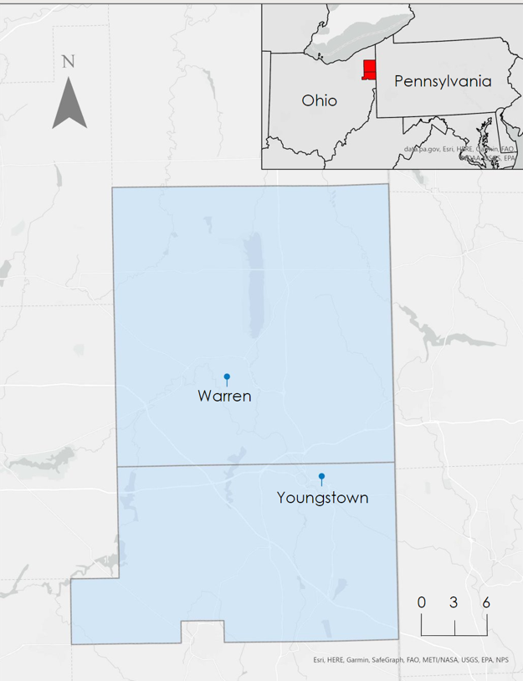Figure 1. The study area of Trumbull and Mahoning counties. The inset map highlights the counties' location in Ohio alongside the border of Pennsylvania. | 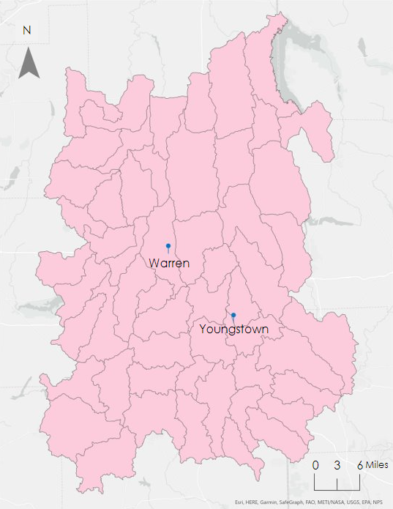 Figure 2. The selected sub watersheds are at the HUC 12 level and encompass the Trumbull and Mahoning counties study area.

2.2 Project Partners & Objectives
The NASA DEVELOP Langley team partnered with the Environmental Collaborative of Ohio (ECO), Eastgate Regional Council of Governments, Healthy Community Partnership Mahoning Valley, and City of Warren, Water Pollution Control Department, to analyze social vulnerability of flooding in the cities of Youngstown and Warren, Ohio. The primary project collaborator, ECO, is a multidisciplinary environmental collaborative that works to solve complex environmental problems by partnering with communities across Ohio. One of the ways they address this is by implementing preventative flood mitigation measures such as removing existing aging dams and adding green infrastructure solutions, including rain gardens, permeable pavement, and natural play spaces, and gathering areas. Eastgate Regional Council of Governments is an association of local governments working on restoring the Mahoning River to its pre-industrial state through removing dams along the river, and is also interested in increasing green spaces and green infrastructure. Healthy Community Partnership Mahoning Valley is a collaboration of organizations that work with community partners to improve the health and social determinants of health for its residents and a key tenet of this mission is through making sure residents have access to healthy greenspaces and safe transportation.

We created runoff and runoff retention maps as well as a tree canopy cover map within the study area of Mahonning and Trumbull Counties. For their ongoing flood mitigation initiative, ECO and the City of Warren will be able to use the flood susceptibility map product to identify neighborhoods of high priority. These analyses will help support the ongoing water resource management initiative and provide important results from Earth observations that our partners currently do not have.

3. Methodology

3.1 Data Acquisition
3.1.1 InVEST Inputs
The InVEST Urban Flood Mitigation model requires several inputs including a watershed vector, a rainfall depth value for each run of the model (mm/24hr), a soil hydrological group classification raster, a land cover raster, and a biophysical table showing curve values that correspond to the soil types and land cover classes. The watershed vector was acquired from the Unites States Geological Survey (USGS) Watershed Boundary Dataset (WBD). We created a raster dataset of hydrologic soil groups, which are a measure of water infiltration and runoff potential, using a 10m resolution raster and tabular soil data from the United States Department of Agriculture (USDA) Gridded Soil Survey Geographic (gSSURGO). We collected this data from the USDA Natural Resources Conservation Service (NRCS) Geospatial Data Gateway. We created a biophysical table containing runoff curve numbers based on each hydrologic soil group for each United States Geological Survey (USGS) National Land Cover Dataset (NLCD) land use class. This methodology was based off the Soil Conservation Service (SCS) curve number method, which is used to model surface runoff from precipitation based on the relationship between rainfall and ground conditions (Appendix 4, USDA, 2009). We selected three values for rainfall depth in 24 hours for three runs of the model from the Hydrometeorological Design Studies Center. These values are the point precipitation frequency estimates in a 24-hour duration for a 1-year, 10-year, and 1000-year rainfall event. The selected point precipitation frequency estimates are 2.47 in, 3.36 in, and 6.91 in, respectively. We collected this data from The National Oceanic and Atmospheric Administration's (NOAA) Hydrometeorological Design Studies Center, from the Precipitation Frequency Data Server. We obtained the land use land cover (LULC) raster from the 2019 NLCD.

3.1.2 Tree Canopy Coverage
We used PlanetScope imagery as the input for a supervised land cover classification for the land class of interest which was canopy cover. The spatial resolution of the imagery was three meters and consisted of eight bands. The imagery was captured from the month of June 2022, covering the Mahoning and Trumbull counties (Table 1). National Agriculture Imagery Program (NAIP) data was acquired for the accuracy assessment of the supervised classification. NLCD landcover data from 2019 was also acquired to compare with the classification output.

3.1.3 Pluvial Flood Pooling
For the Blue Spot Model, we used a ten-meter resolution digital elevation model (DEM) from the USGS of Warren and Mahoning counties. This model allows us to locate impervious surfaces based on elevation within the area of study and understand how and where water would accumulate during a pluvial flooding event. For the flood vulnerability map, we retrieved a census block group polygon shapefile and social vulnerability index data from the Centers for Disease Control's Geospatial Research, Analysis, and Services Program 2018 data.

3.1.4 Other Data
The data for the flood vulnerability map were acquired from Center for Disease Control’s Social Vulnerability Index, which included US census block group shapefiles and social vulnerability data. We extracted daily precipitation data from the Global Precipitation Measurement (GPM) Integrated Multi-satellite Retrieval GPM IMERG using both Google Earth Engine (GEE) and the Earthdata portal (Table 1). This precipitation data was retrieved as a companion to the InVEST Urban Flood Mitigation Model to show the spatial variability of precipitation in the study area.

Table 1
Description of Earth observations used in data processing
Platform | Parameter | Dates | Purpose | Source | Resolution
GPM IMERG | Daily calibrated precipitation | January 2017 – November 2019 | Precipitation reference data for the InVEST input | NASA GES DISC at NASA Goddard Space Flight Center | 10 km x 10 km
Planet Scope | Surface reflectance | June 2022 | Used to create high resolution tree canopy coverage maps | PlanetLabs PBC | 3 m per pixel

3.2 Data Processing
3.2.1 InVEST Inputs
For the InVEST model, we created a watershed vector from the National Hydrography Dataset (USGS) by selecting the Hydrologic Unit Code (HUC) level 12 sub-watersheds that encompass the entire study area of Mahoning and Trumbull counties. We clipped the LULC raster and soil hydrologic group raster to the watershed vector. We then reclassified the soil hydrologic groups into A, B, C, and D categories based on different infiltrations rates (USDA, 2009). We assigned intermediate soil types of A/D, B/D, and C/D as type D, in accordance with the USDA National Engineering Handbook Chapter 7 (USDA, 2009). We created a biophysical table that associated the soil hydrological groups and the LULC types with a runoff curve number, based on the Natural Resources Conservation Service (NRCS) Soil Survey Geographic Database (SSURGO, USDA, 2022).

3.2.2 Tree Canopy
We clipped the 3-meter resolution PlanetScope imagery to the extent of the Warren and Trumbull County boundaries. We filtered the imagery to remove cloud cover when possible. We then mosaiced the raster imagery and projected it to the State Plane Ohio North coordinate system. Lastly, we classified the mosaiced image through a supervised classification method, where training points were made to delineate each land class. A pixel-based classification was used along with the Support Vector Machine classification approach.

3.2.3 Blue Spot
The Blue Spot model, also known as the Arc-Malstrøm model was created from a digital elevation model from the USGS as well as vector layers depicting building footprints and streams within the study area. These layers were then used as inputs to run a series of geoprocessing tools which created watershed basins, building digital terrain models, and flowline outputs. Using these outputs, we were then able to identify areas within Trumbull and Mahoning counties that are susceptible pluvial flooding, and the possible depth of water accumulation based on the outputs of the ‘identify bluespot features’ tool. These processes allowed us to conduct analysis to help inform risk mitigation policy.

3.2.4 Other Data
Utilizing GEE, GPM IMERG data were spatially averaged over the study area to generate a chart of monthly aggregated precipitation values across Trumbull and Mahoning Counties during 2017 to 2019. We identified a major precipitation event with large variation in precipitation amounts across the study area from September 8th – 10th, 2018. We then mapped these three days of precipitation in ArcGIS Pro to visualize the spatial distribution of precipitation totals across the study area (Figure A).

3.3 Data Analysis
3.3.1 InVEST
To validate the rainfall values used as inputs for the InVEST model, we used aggregated precipitation values from GPM IMERG to assess the variability of rainfall across the study area. Figure 3 below shows pixel values of rainfall amount over the study area from 2018.

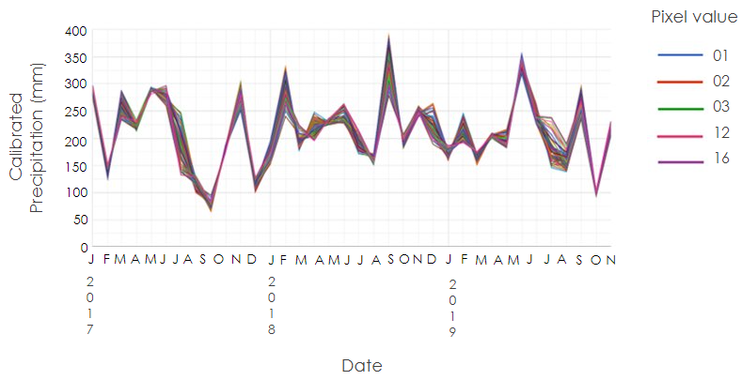
Figure 3. Spatially averaged, monthly aggregated precipitation in Trumbull and Mahoning counties

3.3.2 Tree Canopy Coverage
To look at how canopy cover compares across different regions of the study area, we produced an aggregated tree canopy map for each census block group. The Summarize Within tool was used to calculate the area of canopy cover in each block group. We then divided the area of canopy cover by the area of its block group, producing the final percentage value for each boundary. Additionally, to validate the original canopy cover classification, an accuracy assessment was conducted by placing 50 random points for each of the two classes, tree cover or no tree cover. The reference imagery used was NAIP, which has a higher resolution than the PlanetScope imagery used for the classification. The outcome of the assessment was 94% accuracy for the tree canopy map.

3.3.3 Blue Spot
In order to assess which locations within the study area are most susceptible to flooding damage, the team used the outputs of the Arc-Malstrøm model to find areas with large amounts of overlap between where water accumulates and areas that have high levels of social vulnerability. These areas include portions of Youngstown and Warren that are adjacent to the Mahoning River.

3.3.4 Environmental Justice Impacts
3.3.4.1 Flood Vulnerability Bivariate Analysis
For comparing the intersection between flood susceptibility and social vulnerability, we produced a bivariate map comparing surface runoff amount with the Social Vulnerability Index (Centers for Disease Control and Prevention). This analysis was conducted using the Zonal Statistics tool in ArcGIS Pro to calculate the mean surface runoff value for each census block group. This was then added to the attribute table of the Social Vulnerability Index using a table join with the census block groups FIPS attribute. Lastly, bivariate symbology was used to depict the intersection of surface runoff amount and social vulnerability.

3.3.4.2 Tree Canopy Equity Bivariate Analysis
We generated a tree canopy equity map to compare the Social Vulnerability Index to percent tree canopy cover by block group. This analysis was conducted using the Zonal Statistics tool in ArcGIS Pro to calculate the percent tree canopy cover by census block group. This was then added to the attribute table of the Social Vulnerability Index using a table join with the census block groups FIPS attribute. Lastly, bivariate symbology was used to depict the intersection of tree canopy cover and social vulnerability.

4. Results & Discussion

4.1. InVEST Results
To understand flood susceptibility at different levels of intensity, we used storm precipitation data for a 1-year, 10-year, and 1000-year storm. For the 1-year storm, the areas directly surrounding the cities of Youngstown and Warren were modeled to have the highest surface runoff levels, reaching 2.44 inches (Figure 4). The eastern and western boundaries of watershed have the highest runoff retention, up to 2825 ft³, likely due to the decrease in urban development in areas further away from the two cities (Figure 4).

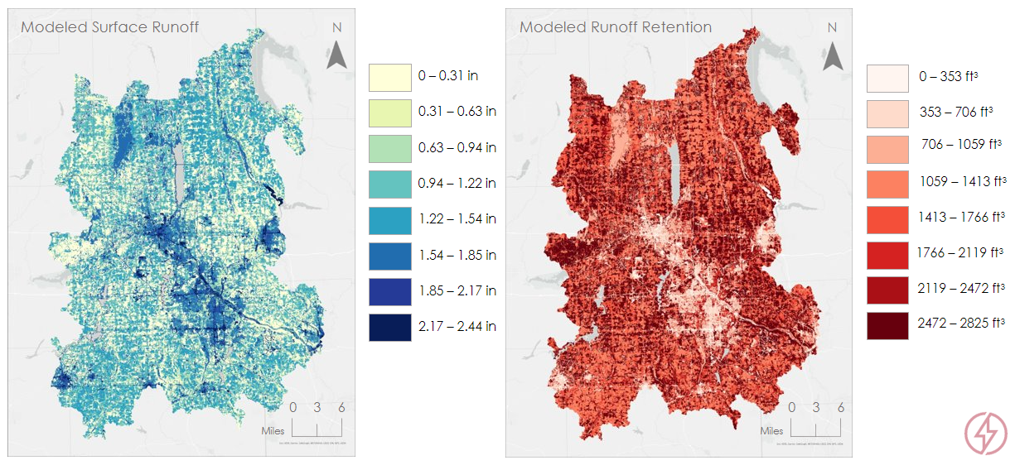Figure 4. Modeled surface runoff and runoff retention for a 1-year storm of 2.47 inches in 24 hours.

For the 10-year storm, surface runoff gets significantly worse across the county, illustrated in the abundance of darker blue tones across the entire watershed (Figure 5). Runoff retention increases in amount, but decreases in concentration along the scale, indicating that the land and soil cannot keep up with the increasing surface runoff (Figure 5).

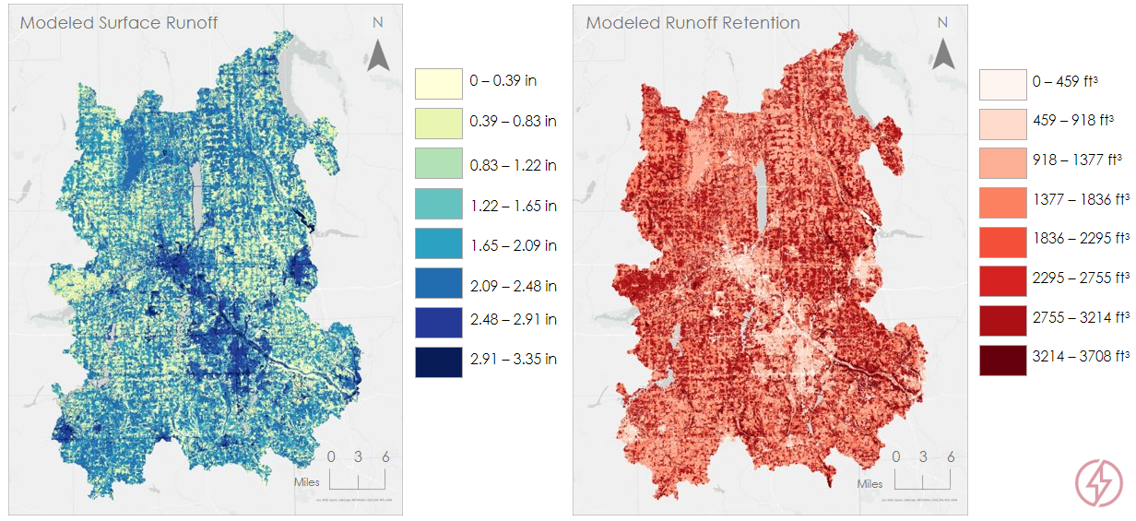Figure 5. Modeled surface runoff and runoff retention for a 10-year storm of 3.36 inches in 24 hours.

For the 1000-year storm, the trend continues, with high levels of surface runoff across the entire watershed, reaching a high of 6.98 inches (Figure 6). The majority of land is represented in values on the second half of the scale, from 3.43 inches to 6.89 inches (Figure 6). Although the runoff amount increases for the 1000-year storm, the land types are primarily represented in the lower part of the scale from 0 – 3673 ft³ (Figure 6). The runoff retention map is lighter because land and soil type are unable to infiltrate water at higher storm levels. All three outputs show similar spatial patterns of runoff and retention due to the InVEST model inputs of land use and land cover type and soil hydrological group remaining the same. The only input that changes is the rainfall amount, expressed in the increasing intensity of output runoff and retention values. The outputs of the InVEST model illustrated that the areas around Youngstown and Warren will experience high surface runoff and low runoff retention during storm events. The highly developed and impervious land cover in these areas contribute to pluvial flooding and should be where flood risk mitigation efforts are focused.

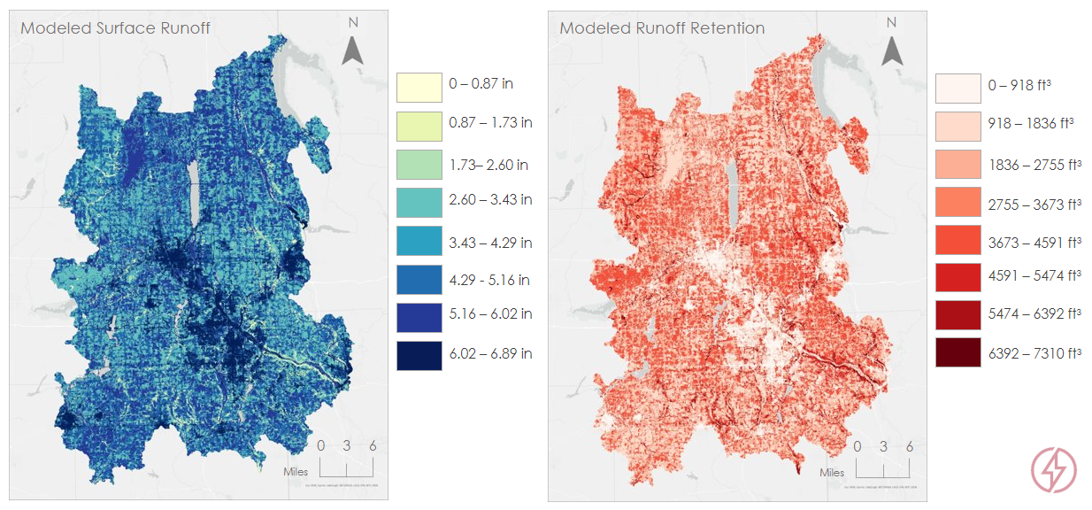
Figure 6. Modeled surface runoff and runoff retention for a 1000-year storm of 6.91 inches in 24 hours.

4.2 Tree Canopy Cover Results
Figure 7 shows tree canopy cover as of June 2022, where areas in green represent canopy cover. Canopy cover is low within the cities of Youngstown and Warren and starts to increase away from the cities. Outside of the cities, cropland is responsible for fragmenting large sections of tree cover, which prevents large continuous areas of forests from establishing. At the census block group level (Figure 8), the lightest green colors indicate block groups that are of highest priority to increase tree canopy cover. These areas are primarily located in and around the cities of Youngstown and Warren. The 40% tree canopy percentage goal can be applied to many of these block groups with low tree canopy percentages (USDA, 2019).

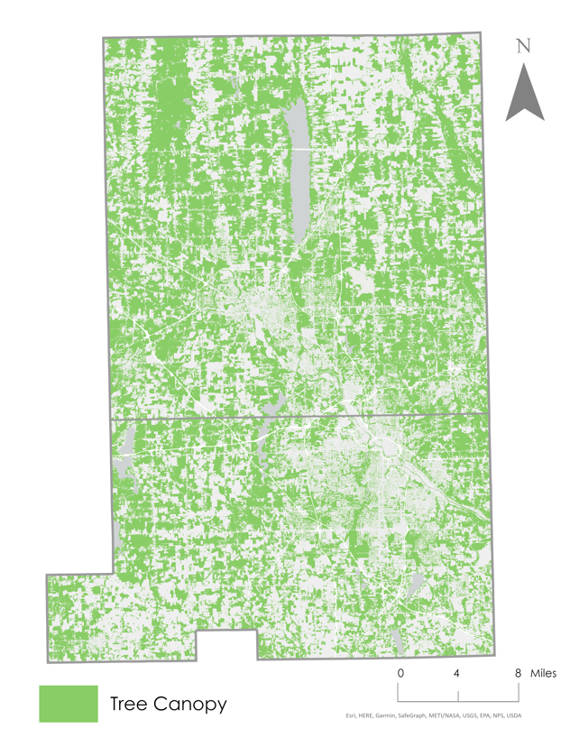 | 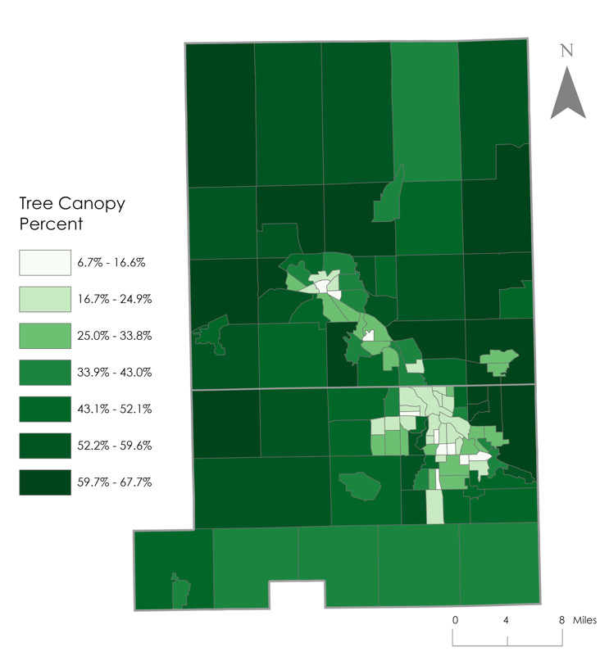
Figure 7. Tree canopy cover of Trumble and Mahoning Counties from June 2022 | Figure 8. Percent tree canopy cover for each census block group.
4.3 Blue Spot Results
The Bluespot Model outputs illustrate where water will accumulate based on elevation within the study area. Based on the model, low-lying areas, as well as areas near streams, rivers, major and highways and railroads are particularly susceptible to pluvial flooding. Additionally, larger blue spots can be found within developed areas in and around Youngstown and Warren. Building footprints are outlined in red, and “blue spots,” or areas where rainfall is likely to pool during a storm event according to elevation depressions (Figure 9). Based on the model, water is most likely to pool in urban areas within Youngstown and Warren and their surrounding suburbs and less likely in rural surrounding areas and cropland.

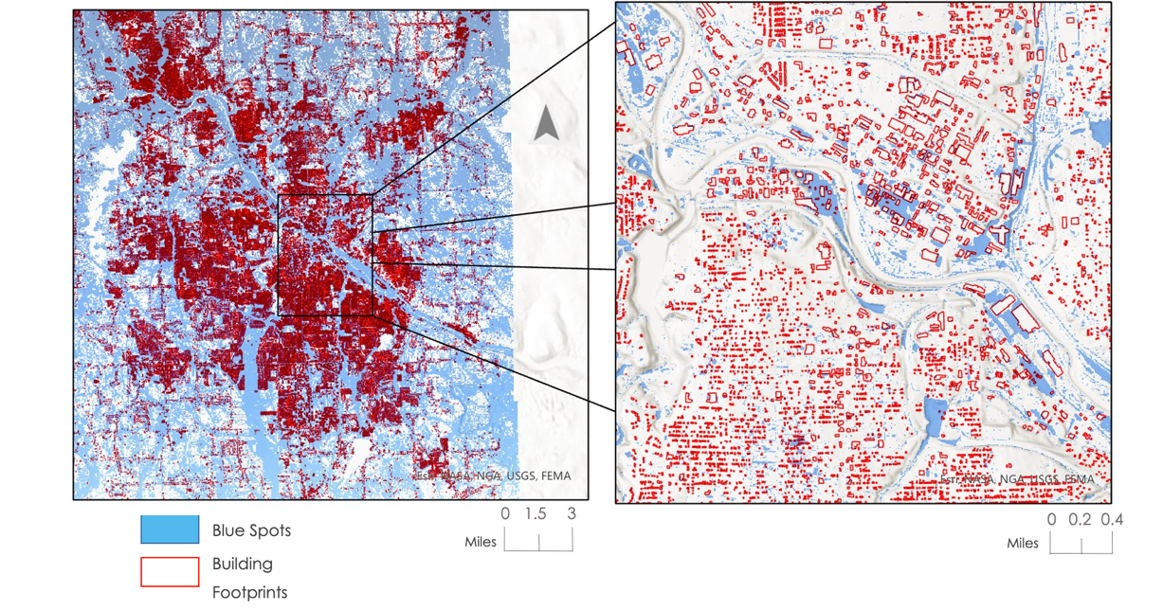
Figure 9. Results of the Blue Spot model shown at the city- and neighborhood-scale.

4.4 Environmental Justice Results
4.4.1 Social Vulnerability Bivariate Map
To understand who is most vulnerable during flood disasters, we examined the spatial relationship between flood susceptibility and social vulnerability. The bivariate analysis results showed 20 census block groups surrounding the cities of Youngstown and Warren that have the highest aggregate value of social vulnerability and surface runoff amount, putting these areas at the greatest vulnerability and risk during flood disasters (Figure 10). It is also apparent in the pink colored census block groups that there is a high amount of social vulnerability in the less urbanized districts on the outskirts of the two counties (Figure 10). These are still important areas for intervention as the rain regime changes and flood disasters become worse in all parts of the county.

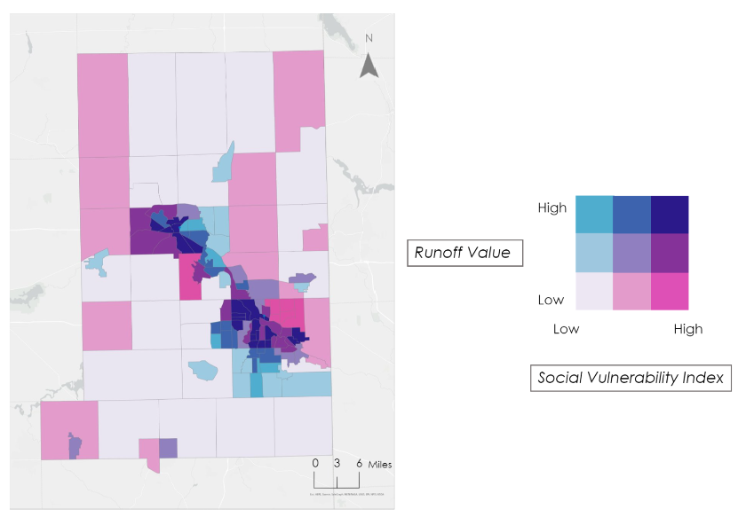
Figure 10. Bivariate analysis of social vulnerability and surface runoff

4.4.2 Tree Canopy Equity
The census block groups in blue represent areas with high social vulnerability and low tree canopy cover (Figure 11). There are 10 census block groups that have high social vulnerability and low tree canopy cover, in the areas surrounding the cities of Youngstown and Warren. This region overlaps with the areas where there is high flood vulnerability in Figure 10. Efforts to expand tree canopy coverage should begin in these 10 most vulnerable census block groups.

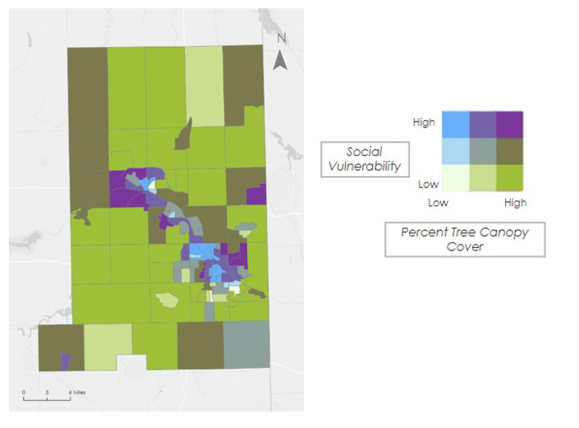
Figure 11. Bivariate Analysis of social vulnerability and tree canopy cover

4. 2 Limitations, Errors, and Uncertainties
Our errors and uncertainties included the InVEST Model not considering elevation in its model calculation as well as applying uniform rainfall across the study area, whereas in real life, rainfall is not always uniform. For the Blue Spot analysis, the spatial accuracy of the model is dependent on the quality of the input DEM. The Blue Spot model is also unable to account for sewer systems. For tree canopy there were misclassifications for some pixel values due to the spatial and spectral resolution of the imagery. Additionally, the classification model was being used on both urban and agricultural areas resulting in a diverse pixel value for the training classes, contributing to some error. Lastly, the bivariate social vulnerability map uses the scale of the census block level, not the neighborhood level.

4.3 Future Work
Future research in this area should include running the second component of the InVEST Urban Flood Mitigation model to include the building damage economic costs. Other InVEST models can be used in research, such as the InVEST Urban Stormwater Retention model, which outputs annual stormwater retention volume. This would be useful for creating water management masterplans, to understand the capacity of the stormwater system and plan for alternative methods of water management. In addition, future work should map past historical tree canopy cover to calculate canopy change over time, helping cities with planning decisions. Lastly, mapping riverine flooding using Sentinel imagery could be used to compare the effectiveness of FEMA maps and citizen reports.

5. Conclusions
This study examined flood susceptibility, flood vulnerability, tree canopy coverage, and tree canopy equity in Mahoning and Trumbull counties in northeastern Ohio. Flood susceptibility based on infiltration was modeled using the InVEST Urban Flood Mitigation model outputs of surface runoff and runoff retention. The BlueSpot model was used to illustrate where flooding will pool, based on elevation. We observed that surface runoff was worst in areas around Youngstown and Warren because of urban development and impervious landcover. Runoff retention was highest along the eastern and western boundaries of the watershed. In addition, rainfall pools mainly in rural and suburban areas surrounding Youngstown and Warren towards rivers and streams. When comparing these results to social vulnerability, we found that the 20 census block groups surrounding Youngstown and Warren have both high values for social vulnerability and surface runoff, making these high-risk areas during flood disasters. The tree canopy coverage results showed that tree canopy is low within the center regions of Youngstown and Warren, where there are high levels of urban development. We compared tree canopy coverage to social vulnerability and found that there are 10 census block groups with the highest category of social vulnerability and lowest amount of tree canopy coverage. These results are important for our partners to use when planning flood mitigation measures by targeting highly vulnerable and susceptible areas where increasing adaptation capacity is most important.

6. Acknowledgments

We would like to thank our partners: Environmental Collaborative of Ohio, Eastgate Regional Council of Governments, Healthy Community Partnership Mahoning Valley, and the City of Warren, Water Pollution Control Department. We would also like to thank Dr. Kenton Ross and Lauren Childs-Gleason who were our science advisors. From DEVELOP, we would like to thank our Fellow Olivia Landry, our PC Senior Fellow Cecil Byles and PC Fellow Laramie Plott, and Eric Sjöstedt from the Summer Kansas City Disasters team.

Any opinions, findings, and conclusions or recommendations expressed in this material are those of the author(s) and do not necessarily reflect the views of the National Aeronautics and Space Administration.

This material is based upon work supported by NASA through contract NNL16AA05C.

7. Glossary
Earth observations – Satellites and sensors that collect information about the Earth’s physical, chemical, and biological systems over space and time.
Fluvial flooding – flooding caused by a river breaking its banks due to extreme rainfall; commonly known as riverine flooding.
InVEST – Integrated Valuation Services and Tradeoffs: a suite of models used to visualize and assess the changes in ecosystems influencing natural goods and services that sustain human life.
LULC – Land Use Land Cover: the classification of human-related activities and land elements on the Earth’s surface.
Pluvial flooding – flooding that occurs when water accumulates due to extreme rainfall, independent of a water body; commonly referred to as flash floods.

8. References
Balstrøm, T., & Crawford, D. (2018). Arc-Malstrøm: A 1D hydrologic screening method for stormwater assessments based on geometric networks. Computers & Geosciences, 116, 64–73. https://doi.org/10.1016/j.cageo.2018.04.010

Centers for Disease Control and Prevention/ Agency for Toxic Substances and Disease Registry/ Geospatial Research, Analysis, and Services Program. CDC/ATSDR Social Vulnerability Index 2018, database Ohio.

Eastgate Regional Council of Governments(n.d.). Mahoning River Restoration. Eastgate Regional Council of Governments. Retrieved November 15, 2022, from https://eastgatecog.org/projects/environmental/mahoning-river-restoration

Hosseinzadehtalaei, P., Ishadi, N. K., Tabari, H., & Willems, P. (2021). Climate change impact assessment on pluvial flooding using a distribution-based bias correction of regional climate model simulations. Journal of Hydrology, 598, 126239. https://doi.org/10.1016/j.jhydrol.2021.126239

Huffman, G.J., E.F. Stocker, D.T. Bolvin, E.J. Nelkin, Jackson Tan (2019), GPM IMERG Final Precipitation L3 1 day 0.1 degree x 0.1 degree V06, Greenbelt, MD, Goddard Earth Sciences Data and Information Services Center (GES DISC), Accessed: 2022-11-16, 10.5067/GPM/IMERGDF/DAY/06

MRLC (2019). NLCD 2019 Land Cover (CONUS). https://www.mrlc.gov/data/nlcd-2019-land-cover-conus

Nkwunonwo, U. C., Whitworth, M., & Baily, B. (2020, January 23). A review of the current status of flood modelling for urban flood risk management in the developing countries. Scientific African. Retrieved November 17, 2022, from https://www.sciencedirect.com/science/article/pii/S2468227620300077

Ochoa-Rodriguez, S., Wang, L., Grist, A., Allitt, R., Onof, C., & Maksimovic, C. (2013, December 31). Improving the applicability of radar rainfall estimates for urban pluvial flood modelling and forecasting. Spiral Imperial College London. Retrieved November 17, 2022, from https://spiral.imperial.ac.uk/handle/10044/1/14678

Planet Team (2022, June). PlanetScope Product Specifications. San Francisco, CA. https://www.planet.com/products/

Ricciutti, G. (2022, April 19). Youngstown looking to update old lead pipes. WKBN.com. Retrieved November 17, 2022, from https://www.wkbn.com/news/local-news/youngstown-looking-to-update-old-lead-pipes/

Seleem, O., Heistermann, M., & Bronstert, A. (2021, September 9). Efficient hazard assessment for pluvial floods in urban environments: A benchmarking case study for the city of Berlin, Germany. MDPI. Retrieved November 17, 2022, from https://www.mdpi.com/2073-4441/13/18/2476

Stanford Natural Capital Project. (2022). InVEST. Natural Capital Project. https://naturalcapitalproject.stanford.edu/software/invest

Stanford Natural Capital Project. (2022). InVEST Documentation: Urban Flood Risk Mitigation model. Natural Capital Project. https://invest-userguide.readthedocs.io/en/latest/urban_flood_mitigation.html

Traficant, J. A. (1970, January 1). Rise and fall of the steel industry in the Mahoning Valley. Ohio: Rise and Fall of the Steel Industry in the Mahoning Valley (Local Legacies: Celebrating Community Roots - Library of Congress). Retrieved November 17, 2022, from https://memory.loc.gov/diglib/legacies/loc.afc.afc-legacies.200003429/

United States Department of Agriculture (USDA) (2009). Chapter 7: Hydrologic soil groups in National Engineering Handbook: Part 630 - Hydrology.

United States Department of Agriculture Soil Survey Staff. (2022). Gridded Soil Survey Geographic (gSSURGO) database for the Conterminous United States [Data set]. https://catalog.data.gov/dataset/gridded-soil-survey-geographic-gssurgo-30-database-for-the-conterminous-united-states-30-m

United States Department of Agriculture, Forest Service. (2019). Urban tree canopy assessment: a community’s path to understanding and managing the urban forest. FS–1121. Washington, DC. 16 p.

Zabret, K., & Šraj, M. (2015). Can Urban Trees Reduce the Impact of Climate Change on Storm Runoff? Urbani Izziv, 26, S165–S178. http://www.jstor.org/stable/24920954

Zhang, Y., Jin, Z., Sikand, M. (2021). The top-of-atmosphere, surface, and atmospheric cloud radiative kernels based on ISCCP-H datasets: Method and evaluation. Journal of Geophysical Research: Atmospheres, 126(24), e2021JD035053. https://doi.org/10.1029/2021JD035053

Zimmerman, E., Bracalenti, L., Piacentini, R., Inostroza, L. (2016). Urban flood risk reduction by
increasing green areas for adaptation to climate change, Procedia Engineering, 161, 2241-2246, https://doi.org/10.1016/j.proeng.2016.08.822

9. Appendices
Appendix A

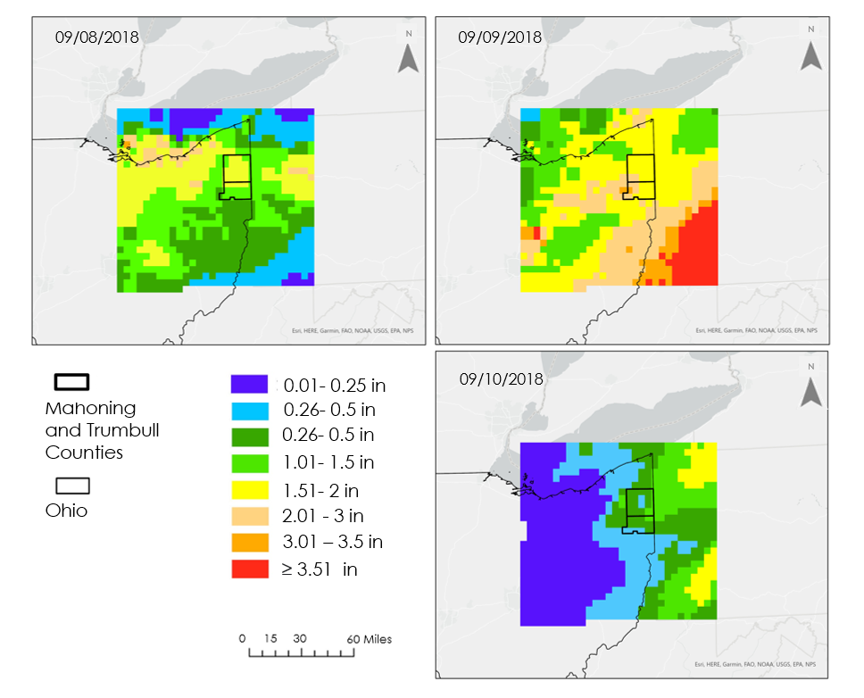
Figure A. This plot shows rainfall variability over the study area from GPM IMERG data during a high precipitation event from September 8th through the 9th 2018. The study area of Trumbull and Mahoning counties area outlined in bolded black, and the state border of Ohio is outlined in a thinner black line.

