Conformal PICA TPS – Enabling Future NASA Planetary Science Missions

Mairead Stackpoole,
Thermal Protection Materials Branch ,
NASA Ames Research Center, Moffett Field, CA

Initial development of conformal PICA (C-PICA) ablative TPS occurred under NASA’s Hypersonics Project in the 2000’s and demonstrated very low through the thickness conductivity compared to state-of-the-art PICA. PICA, which was first demonstrated on Stardust, has some inherent limitations that C-PICA improves on, primarily strain to failure. More recently C-PICA has been further matured and a family of C-PICA materials are now ready for consideration as an enabling technology for New Frontiers and other NASA missions. C-PICA has several improvements compared to PICA including:
- Higher strain to failure and lower thermal conductivity (up to 55% less than PICA depending on C-PICA variant)
- CTE comparable to typical composite carrier structures
- Temperature independent mechanical properties
- Suited for single piece (up to ~ 1.5m) or tiled configurations
- Larger tiles leading to reduced integration complexity compared to tiled PICA
- Reduced mass compared to PICA due to reduced thermal conductivity

C-PICA has been tested at heating fluxes ranging from 250-1850 W/cm² with excellent performance.

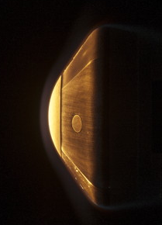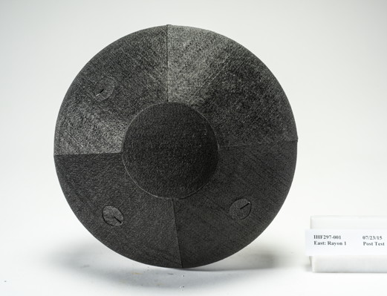
C-PICA model during/post arc jet testing

Based on our evaluation, multiple missions listed on the SMD Technology Showcase will potentially need a thermal protection system capable of withstanding entry environments where C-PICA is suited either as a forebody or backshell TPS. We will be highlighting mature conformal PICA variants to support the following missions at the showcase in January 2023.

Outer Planets
 | Mission Abstract | Comment/Application
1 | New Frontiers Titan Orbiter | Aerocapture requires a mass efficient TPS suite - Conformal PICA is very suitable
2 | Small Next-Generation Atmospheric Probe (SNAP) For Ice Giant Missions | Conformal PICA for backshell TPS
3 | Uranus Orbiter and Probe (UOP) | Conformal PICA for backshell TPS
4 | Saturn Probe | Conformal PICA for backshell TPS
Venus
 | Mission Abstract | Comment/Application
5 | SAEVe: Seismic and Atmospheric Exploration of Venus | Conformal PICA for backshell TPS
6 | V-BOSS: Venus Bridge Orbiter and Surface System | Conformal PICA for backshell TPS
7 | Venus In Situ Explorer (VISE) | Conformal PICA for backshell TPS
8 | Cupid’s Boomerang | Conformal PICA for backshell TPS
Small Body Sample Return
 | Mission Abstract | Comment/Application
9 | Ceres Sample Return | Conformal PICA is an alternate to PICA forebody TPS with improved mass efficiency
10 | Comet surface sample return (CSSR) | Conformal PICA is an alternate to PICA forebody TPS with improved mass efficiency

