NASA GRC Solar Cell Characterization Facilities

Jeremiah D. Sims   
Photovoltaic and Electrochemical Systems Branch  
NASA Glenn Research Center Cleveland, Ohio, USA

*Abstract*— NASA GRC maintains various equipment to calibrate and characterize photovoltaic devices to Air Mass Zero standards and different space-simulated environments. These characterization capabilities are critical to developing and advancing photovoltaic devices, allowing advancements in various NASA-related projects (Artemis, Lunar Gateway, Human Landing System, etc.). Our facilities include an X-25 Triple source Solar Simulator, G2V Sunbrick, Angstrom Designs pLEDss (Programmable LED Solar Simulator), Thermal Balance facility, ER-2 High Altitude aircraft calibration.

Keywords— Air Mass, AM0, ER-2, LED, Photovoltaic, Solar Cell, Solar Simulator, X-25

# Solar Simulators

Solar simulators are ground-based systems that design light sources to replicate the irradiance of the sun. NASA GRC houses two X-25 solar simulators for various testing at Air Mass Zero (AM0) conditions and different space simulated conditions. The X-25 is a Xenon-arc lamp based solar simulator designed by Spectrolab. NASA GRC has modified one of the solar simulators by adding 2 addition IR (Infra-Red) sources to closely replicate the AM0 spectra. Figure 1 showcases NASA GRC’s triple source X-25 solar simulator.

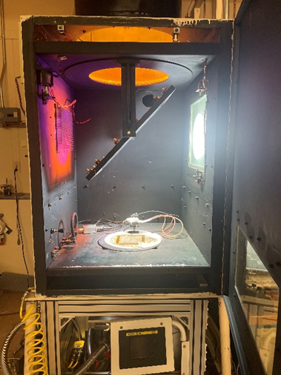

**Fig. 1.** X-25 Triple Source Solar Simulator

## X-25 Temperature coefficient and LILT system

In addition to simulating AM0 conditions, our X-25 solar simulator is equipped with a small-sized temperature controlled vacuum chamber. This allows for temperature coefficient testing of photovoltaic devices and testing within LILT (Low Intensity and Low Temperature) conditions. The temperature controlled vacuum chamber with a temperature-controlled plate reaches temperatures between -150 oC and 100 oC [1]. Figure 2 showcases NASA GRC’s temperature controlled vacuum chamber housed underneath the triple source X-25 solar simulator.

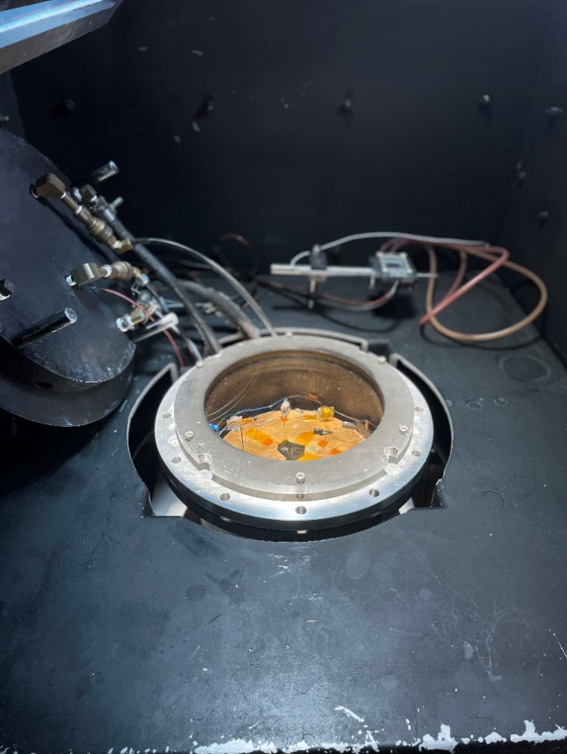

**Fig. 2.** X-25 LILT/ Temp Coefficient chamber

## X-25 Thermal Balance System

NASA GRC’s 2nd X-25 Solar simulator is used in combination with a medium sized vacuum chamber for thermal balance testing. Equipped with a liquid nitrogen cold wall, the medium sized vacuum chamber easily reaches temperature between as -180 oC and 100 oC. The described x-25 thermal balance setup is shown in figure 3.

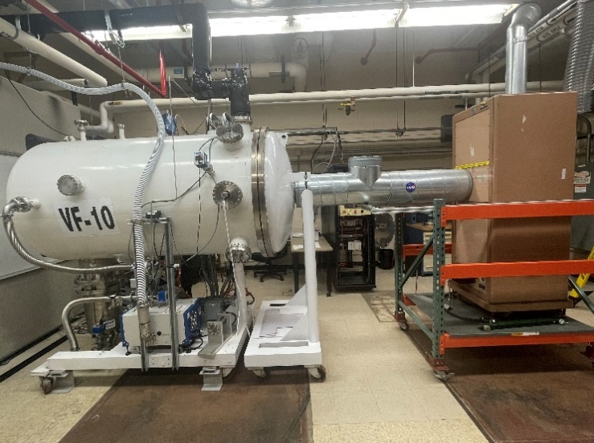**Fig. 3.** X-25 Thermal Balance System

# LED-based Solar Simulators

In addition to the Xenon Arc-based solar simulators, NASA GRC houses two LED based solar simulators. Advancements in high intensity LEDs have enabled the design of LED based solar simulators. As opposed to Xenon solar simulators, LED solar simulators offer various tuneability of desired spectra, provide a longer light source lifetime, lower cost in maintenance.

## G2V Sunbrick

Sunbrick is a LED-based solar simulator designed by G2V optics. The Sunbrick is a AAA class solar simulator with a programmable Spectra between AM0 - AM40 with options to create spectra seen on different planets. The Sunbrick is used in conjunction with our X-25 triple source solar simulator to allow for accurate and comparable characterizations.

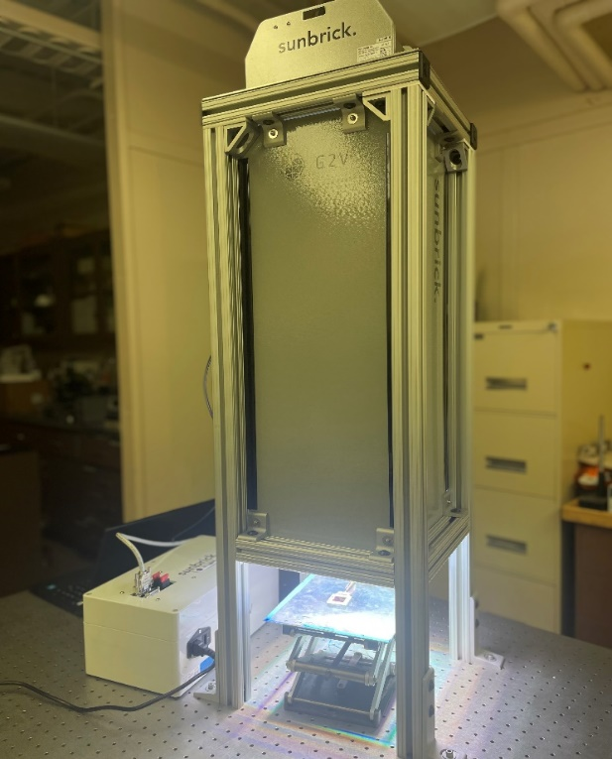

**Fig. 4.** G2V Sunbrick

## Angstrom Designs pLEDss LAPSS

In conjunction with the Sunbrick, GRC houses a second LED-based solar simulator, programmable LED solar simulator (pLEDss). pLEDss is a LED-based Large Array Pulse Solar Simulator (LAPSS) is designed for testing larger arrays and wings of photovoltaics. GRC houses 8 active modules allowing for a reconfigurable illumination area of 84cm x 30cm. These modules allow for testing up to 5 junction photovoltaic devices.

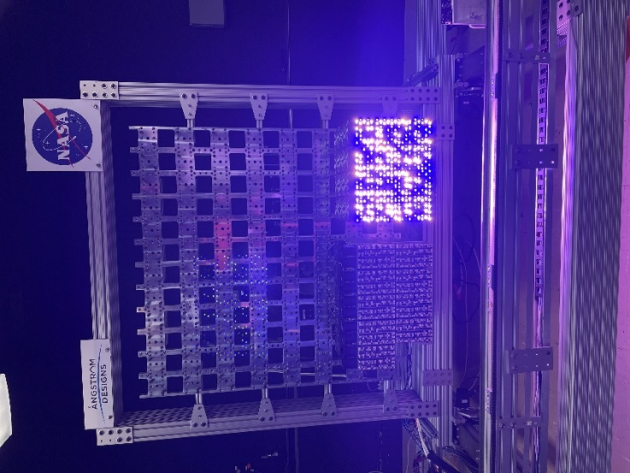

**Fig. 5.** Angstrom Designs pLEDss

# High Altitude Solar Calibration Flights

In order to characterize solar cells and create primary standards for ground-based solar simulators, photovoltaics are characterized in a space or near-space environment. NASA GRC utilizes a collaboration with NASA Armstrong Flight Research Center to fly an ER-2 airframe to near-space conditions. A temperature-controlled test staged has been designed to hold twelve 2cm x 2cm cells, or different combinations, per flight. This stage sits at the bottom of a collimation tube that is pointed directly at the sun. During a campaign, the airframe is flown to around 70,000 feet [2]. Upon descent the collimation tube is aimed towards the sun and solar cell Isc (short circuit) measurements are obtain along with the changes in atmospheric pressure. After completion of flight campaigns AM0 estimation of Isc is extrapolated.

ER-2 high altitude calibration flights have avaibility is based on NASA AFRC, the soonest possible window of opportunity is October 2023

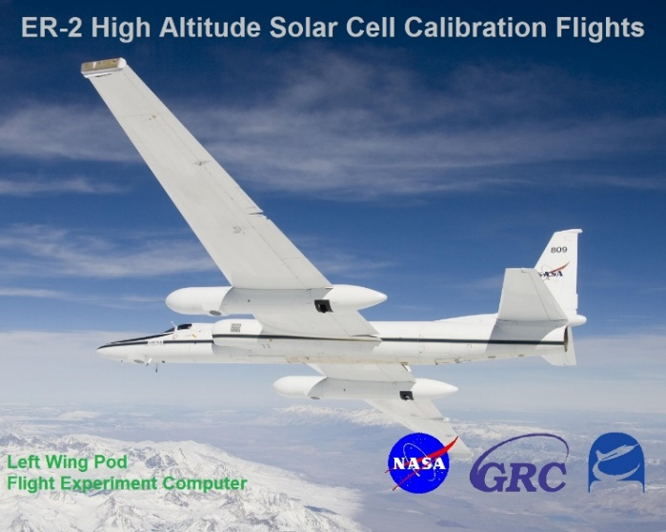

**Fig. 6.** ER-2 Airframe

# Summary

Testing photovoltaics in space or near space conditions is crucial for the development and advancement of photovoltaic devices. NASA GRC houses various facilities to provide characterization and calibration for photovoltaics in various types of space environments.

.

##### References

1. D. A. Scheiman and D. B. Snyder, “Low intensity low temperature (LILT) measurements of state-of-the-art triple junction solar cells for space missions,” *2008 33rd IEEE Photovolatic Specialists Conference*, 2008.
2. M. G. Myers, D. S. Wolford, and M. F. Piszczor, “ER-2 High Altitude Solar Cell Calibration Flights,” in 42nd *IEEE Photovoltaic Specialists Conference*, 2015.
3. M. Myers and D. Snyder, “Calculation method for predicting AM0 ISC from high altitude aircraft flight data,” 2018 IEEE 7th World Conference on Photovoltaic Energy Conversion (WCPEC) (A Joint Conference of 45th IEEE PVSC, 28th PVSEC & 34th EU PVSEC), 2018.