Effects of Defects Analysis and Sizing Framework for Efficient Design of Composite Structures

August Noevere   
Collier Aerospace  
Newport News, VA 23606

ABSTRACT

Design of large composite structures requires striking a balance between permitted flaw size, strength margins, weight, and production rate. Stringent requirements manufacturing flaws can result in a lightweight structure because the strength properties are assumed to be closer to pristine. However, these stringent requirements can lead to production delays due to increased inspection and rework needed during the layup and rejection of parts after cure. Conversely, permitting larger flaws can reduce production delays, but will likely result in a heavier structure due to increased conservatism needed to maintain acceptable structural margins. The tradeoff between these criteria can vary between different structures and material systems, so the balance between manufacturing and design requirements is always a moving target. Assessment of this tradeoff requires having the ability to quickly evaluate the impact of flaw size on strength margin across an entire structure for a large number of load cases. The approach taken in this work is to implement an effects of defects analysis and sizing framework within HyperX. HyperX performs optimization of composite structures; this capability has been enhanced to include structural flaw data in the margin of safety calculations performed during optimization. Both the flaw import process and analysis of flaws have been generalized such that any flaw type from any source can be considered. The resulting tool enables rapid assessment of the impact of defects both at a vehicle and part level.

Keywords: Effects of Defects, Design for Manufacturing, Stress Analysis

Corresponding author: August Noevere (August.Noevere@CollierAerospace.com)

# INTRODUCTION

Accounting for manufacturing defects and damage in composites remains a significant hurdle in realizing the full advantage in strength-to-weight ratio of composites compared to metallics [1]. Conservative properties are often used for material strength based on manufacturing capabilities and damage that is expected while the structure is in service [2]. This can result in mass penalties if the defects or damage occur in parts of the structure that are not as highly loaded. Conversely, it is possible that parts of the structure where defects occur more frequently may not always be strength-driven, and it would be possible to relax manufacturing defect requirements in those areas.

Mapping and analysis of Automated Fiber Placement (AFP) defects has been studied by the authors previously in references [3], [4], and [5]. A process was developed to extract fiber directions, overlaps and gaps, and tow wrinkling from VCP and COMPRO simulations. However, the mapping process and analysis methods were restricted to defect types and data formats used only by those tools.

The approach taken in this work is to create a defect analysis framework that makes it possible to assess the impact of defects and damage from *any* source on a case-by-case basis to avoid over-conservatism from both a mass and manufacturing perspective. Achieving this capability requires an analysis framework with defect data, the structural design, and loads co-located on the same model. Traditionally, this information is often spread across multiple software and files; the first challenge is to import and map all of this data onto the same model. The second challenge is to provide generalized analysis tools to allow any type of defect or damage to be accounted for in analysis. This framework is outlined in Figure 1.

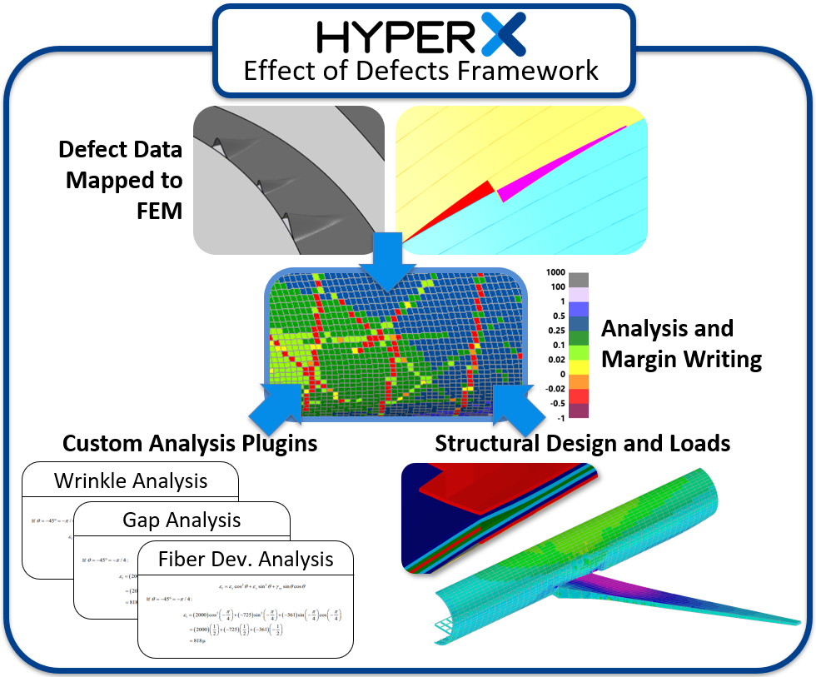

Figure 1. Effects of defects analysis framework.

The framework is comprised of three main areas:

1. **Structural design and loads**. Performing stress analysis requires having a representation of the structural design stored on the Finite Element Model (FEM), as well as Finite Element Analysis (FEA) loads that are used to derive internal stresses and strains in the structure.
2. **Analysis plugins**. Analysis of defects and their effect on composite strength remains a highly studied area and the approach varies widely between material system, structure, and manufacturer. Therefore, it is important to have a modular analysis tool, where the analysis method can easily be swapped or modified.
3. **Defect data**. This data can come from multiple sources and formats, and can potentially have thousands of data entries per structure. Automated tools are needed to efficiently manage the data and map it to the analysis model.

The stress analysis and structural sizing tool HyperX was used as the basis of the defect analysis framework. HyperX uses a FEM and FEA results to analyze structures with typical aerospace stress analysis methods, and can then size the thickness and dimensions of the structures to minimize weight while meeting strength and stability requirements. Being a FEM-based tool, significant work was needed to import, map, and manage defect data, as described in the next section.

# Defect Mapping

While the current work is primarily focused on defects, the same framework will be equally applicable to composite damage that can be quantified and located on the structure in 3D space. Defect and damage data can come from a variety of sources, including scans from Non-Destructive Evaluation (NDE) of completed parts, in-situ inspections during manufacturing (automated or manual), or even manufacturing process simulations. This data is often stored as a point cloud with data associated with each point [5]. Some scanning systems are also able to record the footprint of a defect as a surface patch [6]. Defects from a manufacturing process simulation can be represented by points, surfaces, or even solid geometry [7][8][9][10].

## Data Import

A generic data import process was developed for the framework to account for all of the possible scenarios and formats described above. The defect import consists of two parts: a geometry file and a defect data file. The geometry file is a CAD format and contains points, surfaces, or solid geometry. The defect data file contains a list of defects that reference the entities in the geometry file. Each entry in this file can contain any number of attributes associated with the defect, such as height or aspect ratio of AFP tow wrinkles, porosity content of a cured laminate, etc. Additionally, defects can be grouped into user-defined categories. The import process is indicated in Figure 2.

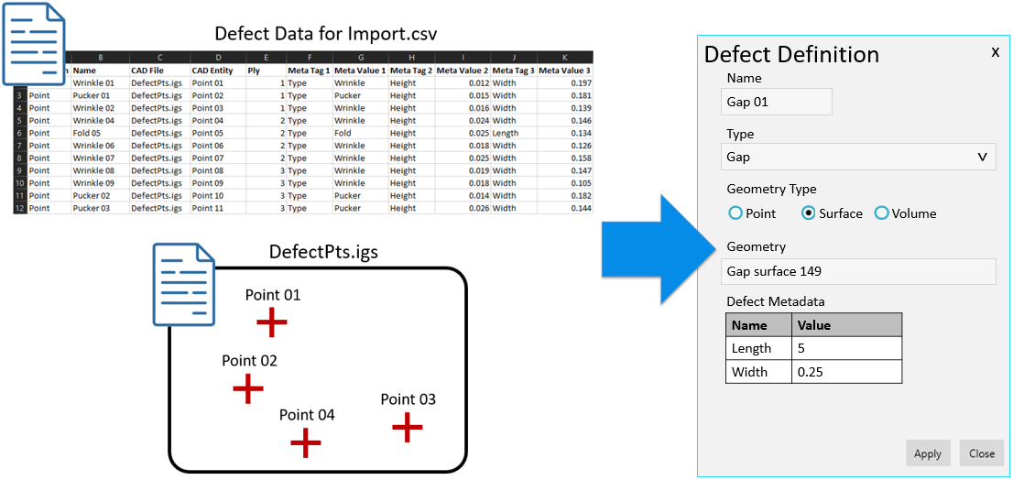

Figure 2. Defect import process.

The end result is a series of defect definitions in HyperX corresponding to each of the entries in the defect data file. Each of these definitions contains the defect information and is linked to the CAD geometry associated with the defect.

## Mapping

Regardless of the source, the defect or damage data usually does not originate from the same FEM that is used for stress analysis. The defects must be associated to individual elements in the FEM for analysis, since loads and analysis results are tracked on a per-element basis. This requires a mapping process to project points, surfaces, and solid geometry onto the FEM.

Mapping of points is straightforward since the FEM is essentially comprised of many individual planes. The mapping process simply iterates through the elements, projecting the point onto each, and checking to see if the projection falls within the boundary of the element.

Mapping of surfaces and solid geometry is more complex due to the possibility of the features covering multiple elements. The approach taken is to tesselate these features and map the centroid of each triangle using the process described above for points. This process has been demonstrated previously for AFP overlaps and gaps [3], and has now been generalized to work for any CAD surface. The density of the tessellation is determined by the density of the FEM mesh; a balance must be achieved to avoid excessive computation time while preserving the fidelity of the mapping. If the tessellation is too dense, the mapping will take a long time to run. If too coarse, the defect will not be mapped to all of the elements that it actually covers. Figure 3 shows an example of an AFP gap that has been tessellated for mapping to the FEM.

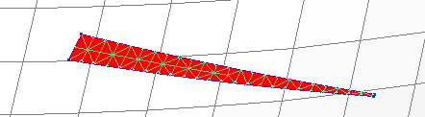

Figure 3. AFP gap tessellated for mapping to FEM mesh.

With any type of mapping to a mesh, there is a possibility that multiple defects can be mapped to a single element. HyperX provides mapping options for this scenario: the min, max, or average of the defect data entries can be associated with the element. The end result of the mapping is a tabular data set with per-element defect data (per ply, where applicable).

# Defect Analysis

The analysis plugin environment is not complete; future and existing capabilities will be described in this section. Effects of defects analysis varies widely depending on materials, structure, and type of defect. The most simplistic approach is to use empirical data to “knock down” the material strength and stiffness in the presence of a defect [5]. This approach is commonly used for large-scale structural analysis and sizing due to the relatively low cost of testing.

At the other extreme, physics-based simulations can be used to determine localized effects of defects [11], but are typically computationally expensive. The HyperX plugin framework will be capable of handling analysis approaches ranging across this spectrum. The framework manages the internal loads, structural design, material properties, and defect information, allowing an analysis of many different types or complexities to be implemented.

The two types of analyses currently supported by the framework are described in the following sections.

## Ply Thickness Adjustments

This approach was originally developed for AFP overlaps and gaps, which essentially cause off-nominal material thicknesses in the laminate. The analysis approach adjusts the thickness of a ply in an element based on the size of the overlap or gap covering the element, as shown in Figure 4. The thickness adjustment is accounted for in the Classical Lamination Theory (CLT) analysis, which determines how the stress and strain are redistributed in the laminate due to the thickness change [3].

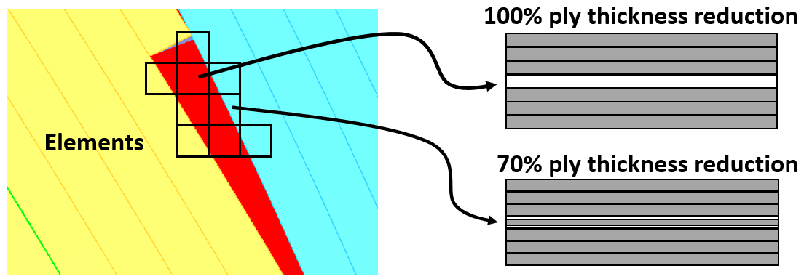

Figure 4. Ply thickness adjustment approach [3].

The approach can also be extended to any type of defect that results in off-nominal defects, such as AFP folds, darts in a draped fabric part, or thickening/thinning in a uniaxial ply in a hand-layup.

## Direct Strength Knockdowns

This approach is commonly used when the analysis approach is based on empirical data where the impact on laminate strength has been determined as a function of defect severity, such as the curve for gaps shown in Figure 5. In this scenario the defects mapped to the FEM in HyperX are simply cross-referenced to the knockdown curve and the strength margins of safety are updated accordingly.

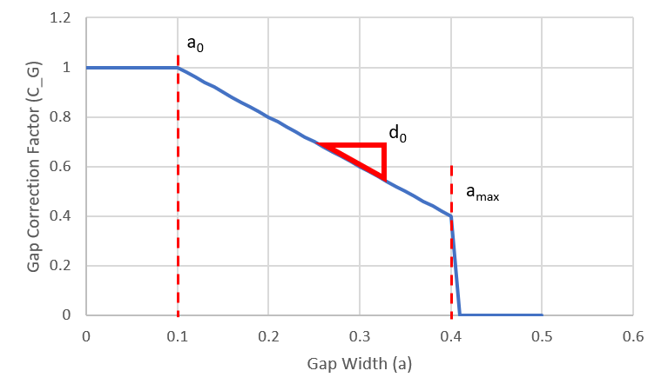

Figure 5. Correction factor (knockdown) curve based on gap width [12].

# Example Application

The funnel-shaped duct structure shown in Figure 6 was used to demonstrate the mapping and analysis of AFP wrinkle defects. These wrinkles were captured by University of South Carolina’s automated defect detection system [6] during a demonstration build at the McNAIR facility. The system automatically recognizes the defect and records its footprint as a surface patch located on the model in 3D space.

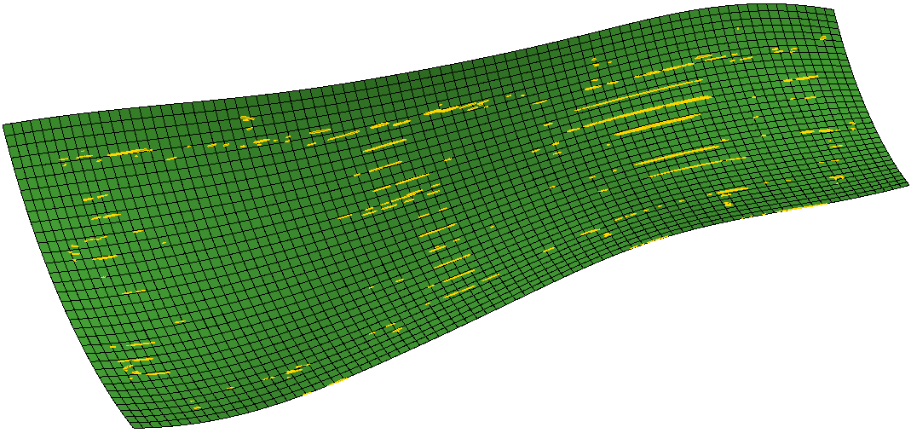

Figure 6. "Funnel" structure FEM with overlaid wrinkle patches.

## Mapping of Wrinkles

The surface patches were imported to HyperX and mapped to the FEM using the process described in previous sections. This resulted in a mapped wrinkle area per element, as shown in Figure 7.

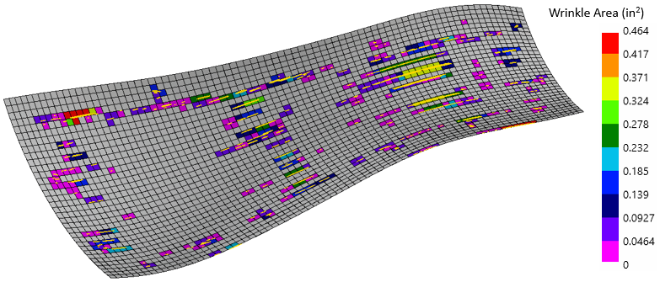

Figure 7. Wrinkle data mapped to the FEM.

## Updated Analysis

Once mapped to the model, the impact on strength margins was assessed using the knockdown curve in Figure 8. This knockdown curve is representative for the example and not based on test data. The severity of the knockdown on each element was determined by the wrinkle area mapped to the element.

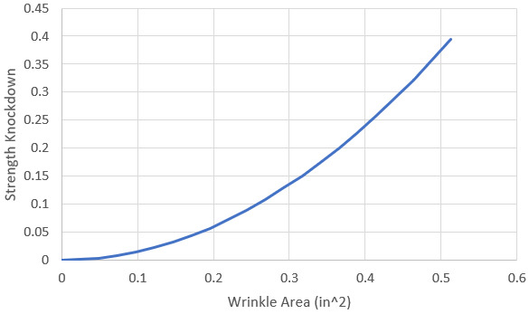

Figure 8. Strength knockdown as a function of wrinkle area.

The margins of safety resulting from the updated analysis are shown in Figure 9. The margins were originally all positive after the structure was optimized to the internal running loads. However, the inclusion of the wrinkling knockdowns causes several small areas on the structure to have negative margin (indicating failure).

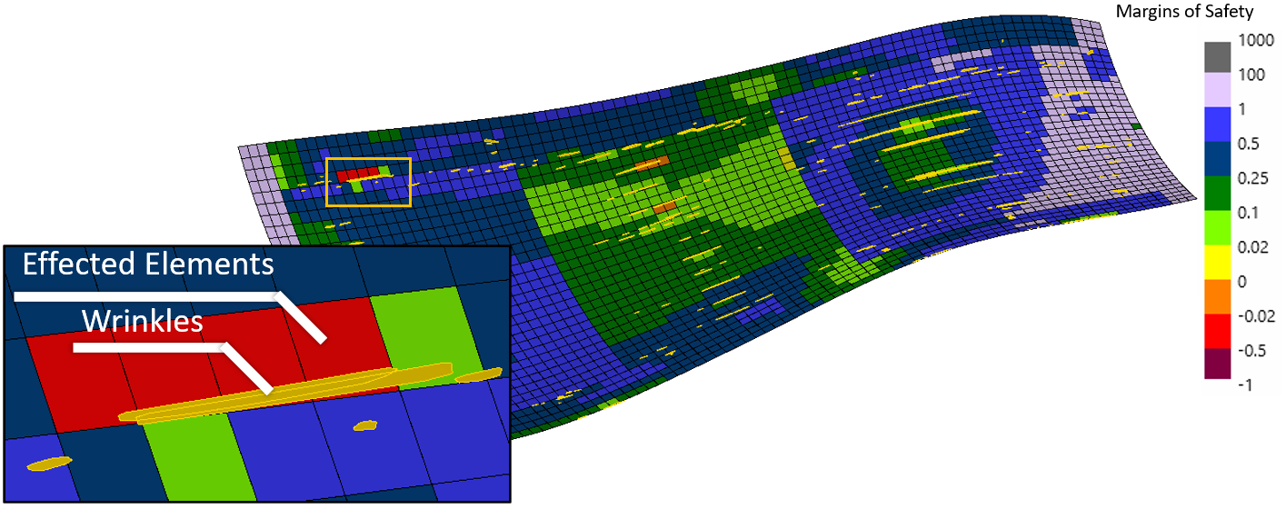

Figure 9. Impact of wrinkles on strength margins.

## Resizing Laminates

The challenge with accounting for manufacturing defects during the design process is that their occurrence is not fully understood until a part is built. In the scenario described in this work, it is expected that a subset of the plies for the structure would be laid down, defects captured, and the information fed back to the design tools. The defects recorded from the preliminary build would be used to estimate the defects expected on all plies, and this would be accounted for in the design.

This approach was taken to resize the funnel structure. Strength knockdowns from the existing plies were used to determine where additional plies could be added to resolve the negative margins. HyperX laminate optimization tools were used to determine the optimum placement, size, and orientation of the additional plies. The resulting margins of safety after resizing are shown in Figure 10.

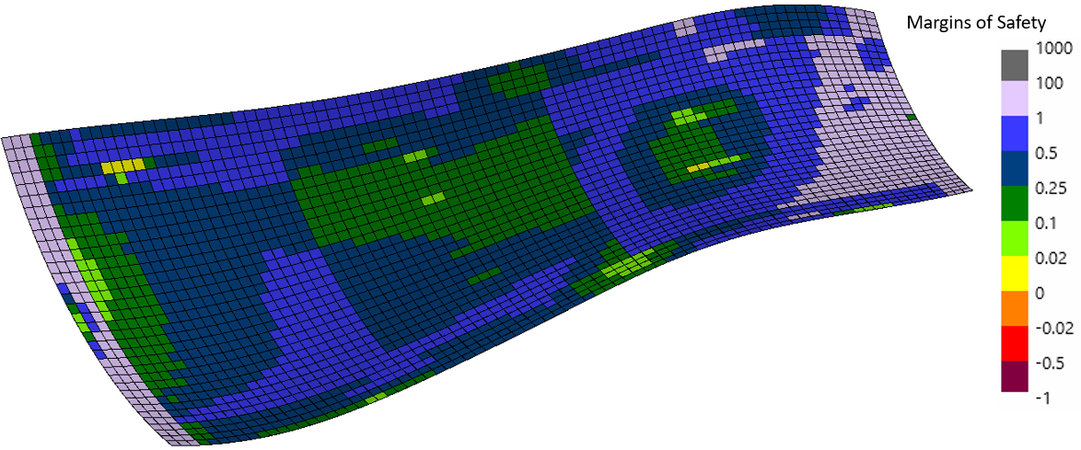

Figure 10. Margins of safety after resizing laminates.

An alternate and equally valid approach to resolving the negative margins would have been to adjust the manufacturing process to move the wrinkles out of critical areas [13].

# Conclusions

An initial defect analysis framework has been implemented and tested in the HyperX stress analysis and sizing tool. The framework uses a generalized import and mapping process to manage defects from any source, physical or simulation, and associate them with elements on the stress analysis FEM. This allows the defects to be evaluated against the structural design and internal loads (also stored in HyperX) to determine their impact on the structural margins of safety. The end goal is to enable weight savings by reducing conservatism via localized defect analysis, as well as enable manufacturing rate improvements by relaxing criteria in non-critical regions.

# References

[1] V. Giurgiutiu, *Comprehensive Composite Materials II: Smart Materials and Health Monitoring of Composites*. Vol 7, pg 364-381, Elsevier, 2018.

[2] Z. del Rosario and R. Fenrich, *AIAA Journal: When Are Allowables Conservative.* Vol 59, Num 5, AIAA, 2021.

[3] A. Noevere and C. Collier, Mapping Manufacturing Data for Stress Analysis of Automated Fiber Placement Structures, *2018 AIAA/ASCE/AHS/ASC Structures, Structural Dynamics, and Materials Conference*, Kissimmee, FL, 2018

[4] A. Noevere and C. Collier, Development of a Design for Manufacturing Tool for Automated Fiber Placement Structures, *2019 AIAA/ASCE/AHS/ASC Structures, Structural Dynamics, and Materials Conference*, San Diego, CA, 2019

[5] A. Noevere and C. Collier, Design for Manufacturing Tool for Automated Fiber Placement Structures – Verification and Validation, *2020 AIAA/ASCE/AHS/ASC Structures, Structural Dynamics, and Materials Conference*, Orlando, FL, 2020

[6] C. Sacco, A. Radwan, A. Anderson, R. Harik, and E. Gregory, *Composite Structures: Machine learning in composites manufacturing: A case study of Automated Fiber Placement inspection.* Vol 250, 15. Elsevier, 2020.

[7] Hutten, V., Forghani, A., Silva, P., Hickmott, C., Sreekantamurthy, T., Wohl, C., Grimsley, B., Coxon, B., Poursartip, A., A Validation Study of a Physics-based Tack Model for an Automated Fiber Placement Process Simulation, SAMPE 2019 Technical Conference and Exhibition, Charlotte, NC, 2019

[8] Bedayat, H., Roy, M., Forghani, A., Hickmott, C., Palmieri, F., Grimsley, B., Coxon, B., Fernlund, G., Poursartip, A., An Efficient Modelling Approach for Prediction of Porosity Severity in Composite Structures, SAMPE 2017 Technical Conference and Exhibition, Seattle, WA, 2017

[9] Bedayat, H., Forghani, A., Hickmott, C., Palmieri, F., Grimsley, B., Coxon, B., Fernlund, G., Poursartip, A., Numerical and Experimental Study of Local Resin Pressure for the Manufacturing of Composite Structures and their Effect on Porosity, SAMPE 2018 Technical Conference and Exhibition, Long Beach, CA, 2018

[10] Hickmott, C., Forghani, A., Hutten, V., Lorbiecki, E., Palmieri, F., Grimsley, B., Coxon, B., Fernlund, G., Poursartip, A., A Numerical and Experimental Approach for Modeling Porosity Due to Entrapped Air and Volatiles Off-gassing During Manufacturing of Composite Structures, SAMPE 2019 Technical Conference and Exhibition, Charlotte, NC, 2019

[11] S. Joglekar, M. Pankow, and V. Ranatunga, Simulation of BVID and CAI Strength of Carbon Fiber Reinforced Composite Laminates, *Proceedings of the American Society for Composites*, 2016.

[12] A. Noevere and C. Collier, Verification and Validation of Integrated Design and Manufacturing Analysis Tool for AFP Structures, *SAMPE Conference Proceedings*, 2020

[13] A. Brasington, C. Smith, J. Halbritter, R. Wehbe, and R. Harik, Surrogate Based Methods for Rapid Starting Point Optimization in Automated Fiber Placement, *SAMPE Conference Proceedings*, Charlotte, NC, 2022

# Acknowledgements

The material contained in this paper is based upon work supported by NASA under award No. 80NSSC22M0157.

Any opinions, findings, and conclusions or recommendations expressed in this material are those of the author(s) and do not necessarily reflect the views of the National Aeronautics and Space Administration.

Thanks to the McNAIR Center at University of South Carolina for providing the CAD model and wrinkle scan data.