Autonomous Maneuver Planning and Execution  
for GeoXO Station Keeping and  
Momentum Management

(Preprint) AAS 23-082

Douglas Freesland,[1] Seth Napora,[2] Edwin Harvie,[3]  
Christopher Wheeler,[4] and Alexander Krimchansky[5]

GOES-16 was launched in 2016 using GPS at GEO, a first for civil space. With the subsequent launch of GOES-17 in 2018, followed by GOES-18 in 2022, we have accumulated over a decade of error free GPS navigation experience at GEO. Confident in GPS performance at GEO, the next generation NOAA/NASA geosynchronous weather satellite program GeoXO will require the spacecraft flight software to automate station keeping and momentum management maneuver planning and execution. Coupled with low thrust propulsion, it gives us assurance that on-board maneuver planning and execution can be implemented at a very low risk, allowing instruments to operate through maneuvers while maintaining a more accurate orbital slot and reducing operational costs. In this paper, we discuss how GOES-R maneuver planning is currently performed on the ground and contrast this with our vision of how it might be automated on-board.

Introduction

In 2004, the then next generation NOAA/NASA geosynchronous weather satellite GOES-R series Phase A studies were initiated with tight orbit knowledge requirements intended to drive the spacecraft design to an on-board GPS based navigation solution. Twelve years later, the initial spacecraft in the series, GOES-16, was launched using GPS at GEO, a first for civil space.[6] GPS navigation is used on-board to define an orbital reference frame for precision attitude control. In addition, it is distributed to the instruments for pointing and image navigation. It has the advantage of eliminating the need for ranging, ground based orbit determination, and periodic ephemeris uploads. Telemetered to the ground, mission operators use the data to plan station keeping and daily momentum management maneuvers.

Fast forward 20 years from those initial studies and today NOAA/NASA have embarked on the next generation geosynchronous weather satellite. GeoXO will require the spacecraft flight software to perform station keeping and momentum management planning and execution on-board. The current Phase A requirements are defined in the Spacecraft Functional and Performance Specification, summarized in Table 1. As with the GOES-R series, GeoXO will require that instruments continue to operate through these maneuvers. This drives the spacecraft to maintain instrument pointing and stability during these thruster based events.[7]

Table . GeoXO Autonomous On-Board Maneuver Requirements[8]

|  |  |
| --- | --- |
| **ID** | **Requirement** |
| SCFPS43 | The Spacecraft shall provide station keeping to maintain a north/south position of ± 0.05° about the equator and an east/west position of ±0.05° of the on-station longitude during normal operational phases of the mission. |
| SCFPS798 | During normal operations, the Spacecraft shall perform autonomous on-board maneuver planning for station keeping and momentum unloading. |
| SCFPS799 | Upon ground command, the Spacecraft shall downlink maneuver plans. |
| SCFPS800 | The Spacecraft shall autonomously execute planned station keeping and momentum unloading maneuvers unless inhibited by ground command. |

The concept of automating GEO station keeping maneuvers on-board is not new; it has been around since the late 60’s,[9],[10],[11] and was first demonstrated on the Lincoln Experimental Satellite LES-6 maintaining an orbital slot accuracy to within a few degrees.[12] Two roadblocks to autonomous precision orbit box maintenance have been: 1) lack of an accurate on-board navigation solution, and 2) spacecraft processing power. On GOES-R, GPS provides orbit knowledge accurate to 15 m, an order of magnitude improvement over ranging.[13] Modern spacecraft processors such as the RAD750 operating at 200 MHz can execute instructions at a 2.1 MIPS rate, sufficient to support the increased load.[14]

In this paper, we discuss how maneuver planning is currently performed on the ground for the GOES-R series and then contrast that with how it might be implemented on-board for the GeoXO series. The GOES-R spacecraft is illustrated in Figure 1, with its thruster layout shown in Figure 2. North/South station keeping (NSSK) is typically performed using a diagonal pair of 0.22 N arcjets (AJT) located on the north panel. East/West station keeping (EWSK) is performed using 0.09 N Low Thrust REAs (LTR) located on the east and west panels. As a result of the asymmetric single wing design, secular solar torques are significant. Accumulated momentum is eliminated through periodic Momentum Adjust (MA) maneuvers using LTRs on the north, east and/or west panels. The AJT and LTR thrust levels are low to satisfy operate through requirements, but results in more frequent maneuvers. Typical four and seven day maneuver cadences are shown in Table 2.

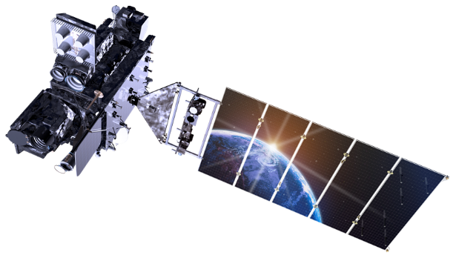

**Earth Pointed Platform**

Advanced Baseline Imager

Geostationary Lightning Mapper

Star Trackers

IMUs

**Sun Pointed Platform**

Solar Ultraviolet Imager

EUVS XRS Irradiance Sensors

Figure . GOES-R spacecraft on-orbit deployed operational configuration.[15]

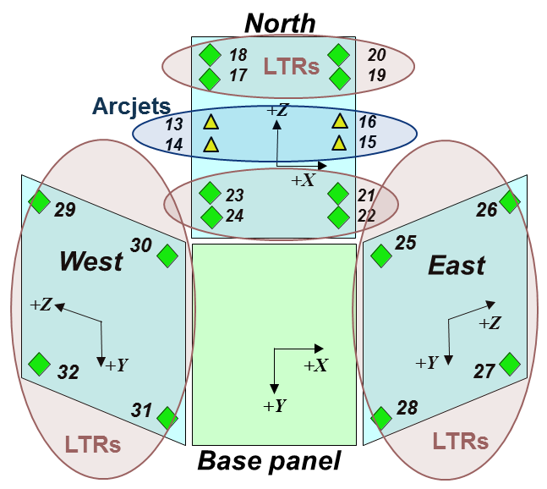

Figure . GOES-R AJT and LTR locations.1

Table 2. Typical GOES-R Maneuver Cadences

|  |  |  |  |  |  |  |
| --- | --- | --- | --- | --- | --- | --- |
| **Four Day Cadence** | | |  | **Seven Day Cadence** | | |
| **Day** | **Maneuver** | **Thrusters** |  | **Day** | **Maneuver** | **Thrusters** |
| 1 | Pre NSSK MA  NSSK  Post NSSK MA | LTR  AJT  LTR |  | 1 | MA | LTR |
| 2 | MA | LTR |  | 2 | EWSK  Post EWSK MA | LTR  LTR |
| 3 | EWSK  Post EWSK MA | LTR  LTR |  | 3 | Pre NSSK MA  NSSK  Post NSSK MA | LTR  AJT  LTR |
| 4 | MA | LTR |  | 4 | MA | LTR |
|  |  |  |  | 5 | EWSK  Post EWSK MA | LTR  LTR |
|  |  |  |  | 6 | Pre NSSK MA  NSSK  Post NSSK MA | LTR  AJT  LTR |
|  |  |  |  | 7 | MA | LTR |

goes-R series Ground based maneuver planning

The GOES-R series of spacecraft use a hybrid ground based maneuver planning process where repeatable tasks are automated and the remainder require user interaction. This approach allows the navigator to focus on targeting future maneuvers rather than executing repetitive routines that are prone to human error. In addition, the time saved by automated processes allows the user to be more efficient and handle multiple satellites. Figure 3 describes GOES-R maneuver planning workflow. Prior to the navigator reporting to site, a flight dynamics script is executed by the ground system at a scheduled epoch. This script updates spacecraft parameters before planning maneuvers as described in the following steps.

Figure . Maneuver planning workflow.

Reconstruction

All executed maneuvers from the last planning session to the current day are modeled using archived telemetry. ΔV and fuel usage are computed for each maneuver and used to update the spacecraft’s orbit knowledge and fuel levels respectively. In addition, a sanity check is performed to ensure thruster durations are consistent with each planned maneuver.

Orbit Determination

The use of an on-board GPS receiver for the GOES-R series has significantly reduced the complexity of orbit determination. Position and velocity measurements are continually available in telemetry at 1 Hz, which eliminates the need to schedule ranging passes for routine operations. The spacecraft’s orbit state is updated to the current time using archived GPS receiver measurements. The ΔV for each maneuver in the orbital determination interval is estimated from the observed orbit change.

Maneuver Planning

A desired number of station keeping and momentum management maneuvers are planned using a sequence of tasks defined by the navigator. The length of the sequence is configured by the user and repeats when the end is reached. Table 2 defines some of the maneuver cadences used by the GOES-R series of spacecraft at a high level. For example, the Nominal Operations (7-day) sequence creates specific maneuvers on the same day of the week to simplify the scheduling of instrument activities. Note that each task in the cadence requires extensive setup where the user provides details such as the orbit control strategy, thruster selection, and vehicle momentum targets. One common use of this functionality is to alternate thruster sets by changing a repeated task’s thruster selection. For instance, NSSK maneuvers require the selection of a diagonal pair of AJTs. Selecting AJTs 13/15 for the first NSSK in the cadence and AJTs 14/16 for other NSSK results in alternating pairs.

The majority of maneuver sequences used for routine operations require few, if any, updates between sessions. Special event planning is the exception, but is accomplished using the same framework. For example, a station relocation from one GEO orbit slot to another is typically planned using an n-day maneuver cadence. The length of the maneuver cadence is chosen to exceed the stop burns ensuring the sequence does not repeat during planning sessions. After the stop burns occur, the n-day cadence is replaced by a nominal repeating version.

Product Generation

Various products such as predicted ephemeris and orbital events are created using the latest spacecraft information and planned maneuvers. Generated files reside in a navigation directory where they can be reviewed before distribution on the ground system. This concludes the automated portion of the maneuver planning cycle. The remainder of the process is manually run by the navigator. This allows the user to review the results and decide on the proper course of action. In most situations, the process continues as defined, but this can vary based on the situation. For example, if a maneuver were aborted between planning sessions, the navigator would remove any thruster selection in the maneuver cadence that includes an aborted thruster. Automated maneuver planning would be rerun and used by the vehicle while the aborted maneuver is analyzed.

Navigation Review

This step mirrors the automated planning process starting with reconstruction. Automatic reports are generated for each maneuver and reviewed for accuracy. Any observed inconsistences are rectified before continuing with orbit determination.

A successful orbit determination creates residual plots and a report file. Plots are examined for rejected measurements and out-of-family behavior. The report file contains the new orbit state and estimated ΔVs for each maneuver. Any irregularities are investigated before moving onto the maneuver plan review.

Figure 4 displays some of the outputs used to verify the maneuver plan. The navigator confirms the maneuver details found in the printout as well as day-to-day trends. For example, standalone momentum adjust maneuvers should occur approximately four minutes earlier each day during standard operations to optimize fuel use for inclination control. Various satellite plots are also analyzed for orbit performance. The longitude plot in the bottom left shows that GOES-18 is currently maintaining a longitude slightly east of its defined orbit slot while co-locating with GOES-17. The longitude box is violated near the end of the fourteen-day prediction. This behavior is expected because ten days of maneuvers were planned. The next planning session will produce an EWSK burn that maintains the desired longitude. Lastly, the bottom right plot depicts the inclination vector in polar coordinates. GOES-18 is maintaining an inclination around zero that is well below the 0.1° limit shown by the red circle. Any issues with the maneuver plan can be addressed during this step before proceeding to deployment.

Product Deployment

After a satisfactory navigation review, products are deployed to the ground system for all users. In addition, a file notification occurs in the Mission Planning and Scheduling software. This informs the mission planner that updated maneuvers, orbital events, and backup ephemeris are available. After retrieving the navigation information, the mission planner schedules other activities

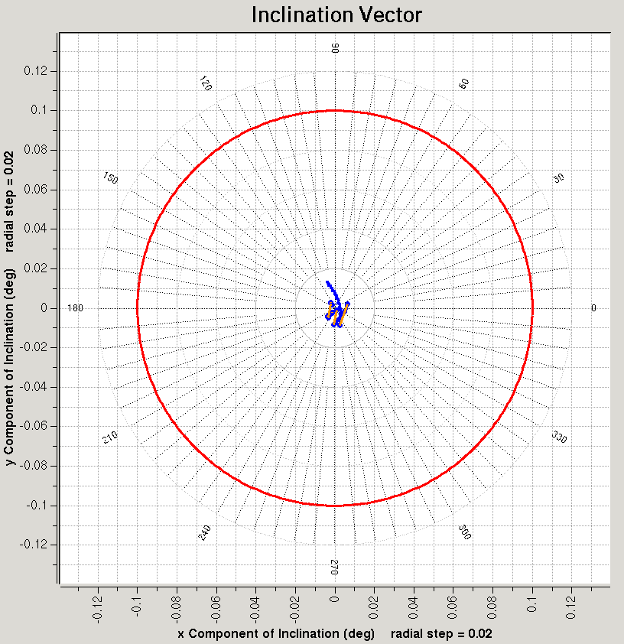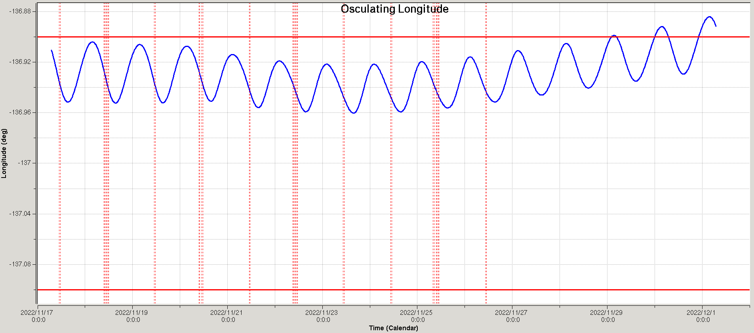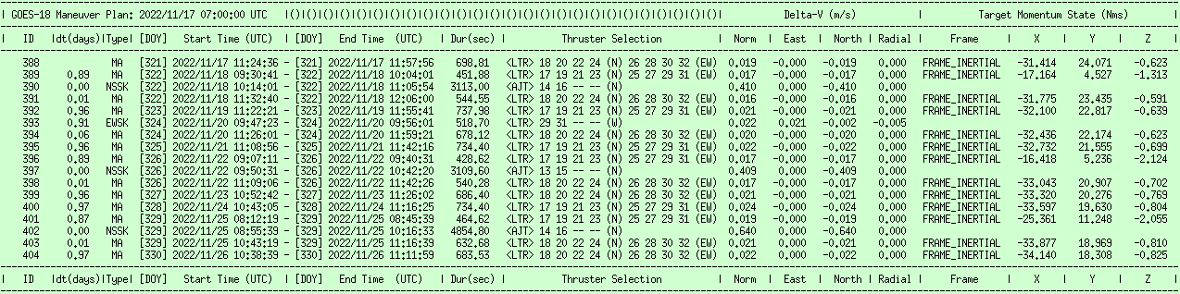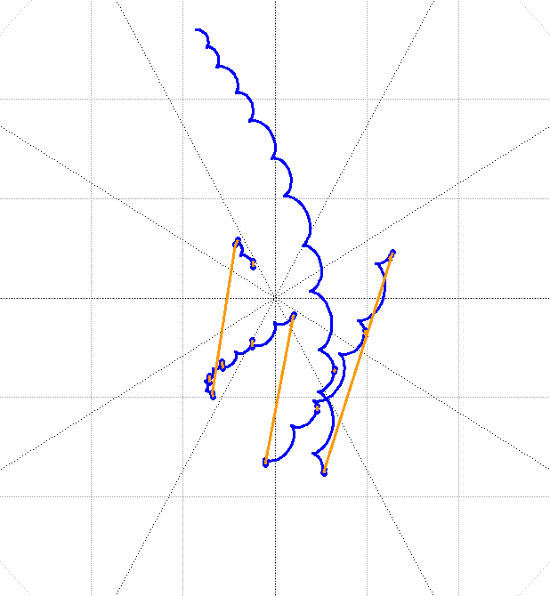

Figure . Typical maneuver planning outputs.

and confirms there are no conflicts with maneuvers. This process results in an Absolute Time Sequence (ATS) command schedule uploaded to the satellite for execution. The ATS includes a minimum of 7 days of activities that allows the vehicle to remain operational without ground contact for extended periods of time (normal practice is to refresh station keeping maneuvers in the 7-day ATS at least twice per week with refined solutions).

Configure & Schedule Next Planning Session

The final step in the maneuver planning process is to configure and schedule the next execution. Modifications to the automated configuration are uncommon, but can be done at any time. For example, the orbit determination solve epoch would be changed if it conflicts with a station keeping burn. Once configured, the automated routine is scheduled to run on the next planning day.

Momentum Adjust Optimization to Benefit Inclination Control

GOES-R is required to maintain its orbital box to within ±0.1°. The majority of its propellant budget is consumed by the AJTs used to counteract natural inclination growth caused by the Sun and the Moon. Its single wing solar array requires daily MA maneuvers using LTRs, the primary of which are aligned with the NSSK thrusters. Optimizing the timing of MA maneuvers benefits inclination control. For example, Figure 5 demonstrates this concept by applying an average MA ΔV timed to execute using various strategies: 1) timed to execute at the same UTC time each day, or 2) timed to execute each day at the ascending node.[16] Executing a MA at the ascending node is beneficial resulting in a 0.1° reduction in inclination growth over a year, saving ~2.6 kg of fuel.

|  |  |
| --- | --- |
|  |  |
| a) Inclination growth over a year. | b) ΔV and fuel estimate for required inclination change. |

Figure . Comparison of daily MA strategies.

Figure 6 shows a year-long simulation of GOES-R NSSK, targeted every four days with two different timing strategies for the daily MAs occurring in between: 1) timed to execute at 12:00 UTC each day, or 2) targeted to move the inclination and right ascension of the ascending node toward 0.1° and 270° respectively. Results show that both strategies maintain a low inclination throughout the year ~0.01°. The targeted strategy used 3.2 m/s less ΔV, an approximate fuel savings of 2.2 kg as estimated from propellant logs. This equates to a 7 month life extension over a 10 year mission. ΔV and fuel savings are summarized in Table 3.



Figure . Simulated NSSK/MA inclination performance.

Table . Summary of MA Strategies

|  |  |  |  |  |  |  |  |  |  |
| --- | --- | --- | --- | --- | --- | --- | --- | --- | --- |
|  | **Timed Strategy** | | | **Targeted Strategy** | | | **Δ (Targeted – Timed)** | | |
|  | **Burns**  **(#)** | **ΔV**  **(m/s)** | **Fuel**  **(kg)** | **Burns**  **(#)** | **ΔV**  **(m/s)** | **Fuel**  **(kg)** | **Burns**  **(#)** | **ΔV**  **(m/s)** | **Fuel**  **(kg)** |
| **NSSK** | 85 | 45.7 | 34.3 | 78 | 42.4 | 31.8 | -7 | -3.3 | -2.5 |
| **MA** | 281 | 3.5 | 10.5 | 289 | 3.6 | 10.8 | +8 | +0.1 | +0.3 |
| **Total** | 366 | 49.2 | 44.8 | 367 | 46.0 | 42.6 | +1 | -3.2 | -2.2 |

GeoXO Autonomous on-board Maneuver planning and execution

Although some aspects of routine maneuver planning have been automated on the ground for the GOES-R series, the design space exists for even more navigation autonomy with GeoXO. The goals of increased automation are:

* Reduce the manual workload of the navigation task with the added benefit of reducing the possibility of human error
* Support the goal of reduced operations staffing for GeoXO
* Further increase mission autonomy and continuity of operations via decreased requirements for ground intervention
* Decrease ground system cost and complexity

While the first two could be achieved through ground automation, the second two are only possible with on-board automation.

There is a broad range of possibilities for automating maneuver planning and execution at GEO with examples shown in Figure 7. One end of the spectrum is to automate the maneuver planning on the ground and upload an ATS with the commands necessary to execute the burn. At the other end of the spectrum is a more sophisticated on-board classical closed loop system.[17],[18],[19] Our concept lies somewhere in the middle, an evolutionary step forward in on-board automation, developed based on a hypothetical spacecraft using the same thruster complement as GOES-R.

Figure . Autonomous maneuver planning and execution spectrum.

The approach is illustrated in Figure 8, based on a seven day maneuver cadence. This cadence simplifies mission operations since the operators know that certain events fall on the same day every week. In addition, on the weekends when staffing is minimized, only the more routine, lower complexity/risk, momentum adjust maneuvers are performed.

The concept implements algorithms similar to those currently used on the ground into the on-board flight software. The software computes the required station keeping and momentum adjust parameters based on a set of rules and constraints defined by the ground, and executes and monitors the maneuvers (with the option for ground intervention). In this quasi-closed loop method, orbit position and velocity feedback is provided by the GPS receiver. Spacecraft momentum feedback is provided by the gyros coupled with the reaction wheel tachometers. On-board planning starts the day before, after completion of that day’s maneuver. This allows the resulting maneuver plan to be downlinked well in advanced of the next burn, important because:

* Allows for review on the ground during early operations to check out the algorithms and adjust any parameters relevant to maneuver planning. As confidence builds, the need for review diminishes.
* Used by navigators to maintain mass properties: fuel usage and Center of Mass (CM).
* Used by operators in a shadow schedule on the ground, integrated with other instrument and bus activities.

Key assumptions are listed in Table 4. In our concept, if the ground has any issues with the plan, it commands an inhibit, otherwise the maneuver executes as scheduled. We envision the software as being table driven to eliminate use of thrusters marked by the ground as non-operational.

******Figure 8. Quasi-Closed loop autonomous on-board maneuver planning and execution.**

As shown in Figure 8, North/South station keeping consist of three separate events: 1) pre-burn MA to bias the momentum to compensate for torques produced during the NSSK firing, 2) NSSK maneuver, and 3) post-burn MA to return the momentum level to a given target.

Table . Key Assumptions

|  |  |
| --- | --- |
| Ground Performs Non-Routine Ops | * Initial acquisition * Thruster calibrations and corresponding scale factor table uploads * Station relocations * Conjunction Assessment Risk Analysis (CARA) * Collision Avoidance Maneuvers |
| Ground Performs Mass Analyses | * Fuel usage * CM location |
| Maneuver Plan Download | * Plan downloaded daily in telemetry for review on the ground |
| Inhibit Command | * Ground command inhibits autonomous maneuver execution (as opposed to an enable command for each maneuver) |
| Fault Management | * Sanity checks provided on-board to suspend automation process * Ground responsible for resolving issue * Nothing time critical about station keeping or MA maneuvers |
| Table Driven Hardware Selection | * Software or ground marks hardware as non-operational or preferred thruster sets |
| Momentum Adjust Optimization | * MA targeted to ascending node to benefit inclination control |
| Manual Mode | * Nothing precludes the ground from executing its own maneuvers |

The on-board MA software selects the appropriate LTRs and start time to achieve the desired pre/post burn momentum state. The on-board NSSK software selects the appropriate AJT pair, burn duration and start time relative to one of the nodes. East/West station keeping consists of a single event. The on-board EWSK software selects the appropriate LTRs, burn duration and start time. For standalone momentum adjusts, the on-board MA software selects the appropriate LTRs, momentum state and start time. On GOES-R, momentum adjusts are optimized to benefit inclination control. Although propellant savings are modest, ~2.2 kg/year, we retained this optimization in our GeoXO concept as *low hanging fruit,* straight forward for the on-board software to determine node location.

The Viceroy IV GPS receiver flown on GOES-R was a first-generation GEO receiver built by General Dynamics. Its ability to rapidly acquire and track low-level signals above the GPS constellation was pioneered at NASA GSFC. The receiver satisfied all its requirements including the ability to operate through station keeping and momentum adjust maneuvers. A maneuver flag was provided to open the receiver’s Kalman filter covariance during thruster events. We envision this being enhanced with next generation GEO receivers by replacing a simple flag with an estimate of the expected acceleration.[20]

ConclusionS

In this paper, we laid out assumptions and presented a reference concept for automating on-board maneuver planning and execution for GeoXO using the existing GOES-R series as an example. The GeoXO spacecraft Phase A studies are currently ongoing with multiple vendors participating. The solution space is dependent on the hardware technologies offered and other on-board automation concepts may be more compatible with a particular design. At the end of the day, as long as requirements are met, we operate through maneuvers, and have sufficient propellant to meet mission life; the Flight Project is open to other automation strategies.

That said, with over a decade of error free GPS navigation experience at GEO, we are confident in its performance and view it as an enabling technology. Coupled with low thrust propulsion, it gives us assurance that on-board maneuver planning and execution can be implemented at a very low risk, allowing instruments to operate through maneuvers while maintaining a more accurate orbital slot and reducing operational costs on GeoXO.

Acknowledgments

The authors wish to thank Michael Mesarch from the NASA GSFC Code 595 Navigation and Mission Design Branch for his expert technical review, insight and contributions. This work was supported under contract to the NASA Goddard Space Flight Center:

* Systems Engineering Advanced Services (SEAS) NNG15CR66C
* Software Engineering Services (SES) III 80GSFC22CA056
* Omnibus Multidiscipline Engineering Services (OMES) III NNG17HP02C

1. GOES-R/GeoXO GNC, The ACS Engineering Corporation, Goddard Space Flight Center.
2. GOES-R MOST Navigation Lead, MCSG Technologies Inc, NOAA Satellite Operations Facility.
3. GOES-R MOST Team Lead, KBR, NOAA Satellite Operations Facility.
4. GeoXO Deputy Flight Project Manager, NOAA, Goddard Space Flight Center.
5. GOES-R/GeoXO Program Systems Engineering Manager, NASA, Goddard Space Flight Center.
6. J. Chapel, D. Stancliffe, T. Bevacqua, S. Winkler, B. Clapp, T. Rood, D. Freesland, A. Reth, D. Early, T. Walsh, A. Krimchansky, “In Flight Guidance, Navigation, and Control Performance for the GOES-16 Spacecraft,” Proceedings of the 10th International ESA Conference on Guidance, Navigation & Control Systems, Salzburg, Austria, Jun 2017.
7. D. Freesland, D. Chu, A. Reth, A. Krimchansky, M. Donnelly, G. Comeyne, “Advancing the Next Generation GOES-R Operational Availability,” Proceedings of the 28th AAS Guidance, Navigation and Control Conference, AAS 05-006, Breckenridge, CO, Feb 2005.
8. “GeoXO Flight Project Spacecraft Functional and Performance Spec,” 418-XO-PSPEC-0051 Version 0.1, Nov 2021.
9. A. Braga-Illa, “Automatic Satellite Station-Keeping,” Journal of Spacecraft and Rockets, Vol 6 No 4, Apr 1969.
10. A. Braga-Illa, “The Future of Self-Contained Control of Synchronous Orbits,” Proceedings of the 3rd AIAA Communications Satellite Systems Conference, AIAA 70-479, Apr 1970.
11. B. Vendy, D. Plummer, “Autonomous Stationkeeping of Geostationary Satellites,” Proceedings of the 8th IFAC Symposium on Automatic Control in Space, Oxford, England, Vol 12 No 4, Sep 1979.
12. A. Braga-Illa, “Automatic Orbit Control of the Lincoln Experimental Satellite LES-6,” MIT Lincoln Laboratory Technical Report 469, Jul 1969.
13. S. Winkler, G. Ramsey, C. Frey, J. Chapel, D. Chu, D. Freesland, A. Krimchansky, M. Concha, “GPS Receiver On-Orbit Performance for the GOES-R Spacecraft,” Proceedings of the 10th International ESA Conference on Guidance, Navigation & Control Systems, Salzburg, Austria, Jun 2017.
14. BAE System, “RAD750 Radiation-Hardened PowerPC Microprocessor,” Data Sheet CS-16-F78, 2018.
15. J. Chapel, D. Stancliffe, T. Bevacqua, S. Winkler, B. Clapp, T. Rood, D. Gaylor, D. Freesland, A. Krimchansky, “Guidance, Navigation, and Control Performance for the GOES-R Spacecraft,” CEAS Space Journal, DOI 10.1007/s12567-015-0077-1, Mar 2015.
16. The ascending node on GOES-R processes west at a rate of ~1°/day equivalent to ~4 minutes earlier each day.
17. C. Chao, “Semiautonomous Stationkeeping of Geosynchronous Satellites,” Journal of Guidance, Control, and Dynamics, Vol 7 No 1 Jan-Fen 1984.
18. C. Chao, H. Bernstein, “Onboard Stationkeeping of Geosynchronous Satellites using a Global Positioning System Receiver,” Journal of Guidance, Control and Dynamics, Vol 17 No 4, Jul-Aug 1994.
19. B. Park, M. Tahk, H. Bang, C. Park, J. Jin, “A New Approach to On-Board Stationkeeping of GEO-Satellites,” Aerospace Science and Technology, Vol 9 No 8, Nov 2005.
20. G. Ramsey, L. Barker, J. Chapel, S. Winkler, C. Frey, D. Freesland , P. Baltimore, A. Krimchansky, “GOES-R Series GEO Side-Lobe Capable GPSR Post-Launch Refinements and Operational Capabilities,” Proceedings of the 42nd AAS Guidance, Navigation and Control Conference, AAS 19-074, Breckenridge, CO, Feb 2019.