MARS SCIENCE LABORTORY MASTCAM MULTISPECTRAL INVESTIGATION OF DRILL TARGETS FROM THE BEGINNING OF THE CLAY SULFATE TRANSITION TO MARKER BAND VALLEY. S.R. Jacob^{1*}, J.F. Bell III¹, A. Eng², E.B. Rampe³, and M. Rice², ¹Arizona State University (*samantha.jacob@asu.edu), ²Western Washington University, ³Astromaterials Research and Exploration Science Division, NASA JSC

Introduction: In March, 2021 the Mars Science Laboratory Curiosity rover officially started exploring the Clay Sulfate Transition (CST). This area of Mt. Sharp has been interpreted to have hydrated Mg-sulfate spectral signatures in CRISM orbital data, and it no longer has the strong phyllosilicate spectral signature as the previous Glen Torridon region [1,2]. Recently, the Curiosity rover has also encountered the marker band that was also identified in orbital data [1,3]. This shift from phyllosilicates to hydrated Mg-sulfates suggests a major change in the environmental conditions during which these rocks were deposited. This abstract focuses on changes seen in the Mastcam multispectral data between the CST drill targets.
Clay Sulfate Transition Drill Targets: Including the recent drill attempt at the Amapari marker band target, there are 8 drill targets in the CST (Fig. 1). These drill targets cover the most recent ~210 m of elevation up the slopes of Mt. Sharp. The biggest mineralogical difference between these drill targets is the CheMin measured abundance of phyllosilicates. Targets Nontron and Bardou have high abundances of phyllosilicates, ~12 & 18 wt.%, respectively [4]. The other more recent targets have minor to no measurable phyllosilicates. Other mineralogical differences include the abundance of hematite and the presence of goethite [4]. Mastcam spectra also suggest significant differences in mineralogy from drill targets at the beginning of the CST through the most current drill attempt that sampled the marker band (Fig. 2). The Mastcam instrument acquires images at 12 unique filters in the visible to near-infrared wavelength range (~400-1013 nm) [5]. The specific band centers for the 12 Mastcam filters were primarily picked to help understand the presence or absence of ferric iron minerals. The largest spectral change seen in the CST drill targets is in the longer Mastcam filters (751-1013 nm). Targets Nontron and Bardou have a strong positive NIR slope (867-1013 nm), consistent with the significant hematite abundance (7+ wt.%) measured by CheMin. Targets Pontours through Canaima have a fairly flat NIR slope that is correlated with the abundance of phyllosilicates (Fig. 3) but is not correlated with the abundance of other ferric minerals [6]. The drill tailings produced by the Amapari drill attempt has a significantly different average Mastcam spectrum compared to previous CST targets (Fig. 2). Elemental data from the APXS and ChemCam rover instruments show that marker band targets like Amapari have a significant increase in FeO_{t} and MnO compared to previous CST targets [7,8].
Hydrated Minerals in Mastcam Spectra: While Mastcam spectra are generally best suited for characterizing the ferric iron mineralogy of rocks in Gale crater, the slope between the longest two filters can also potentially be used to identify the presence of hydrated minerals [9,10]. Despite the CST having orbital spectral signatures of hydrated Mg-sulfates, those phases have been difficult to identify using rover instruments. Canaima is the only drill target thus far with crystalline Mg-sulfate above the CheMin detection limit [4]. Additionally, there have been no signs of hydrated minerals in the Mastcam spectra of CST targets. If hydrated Mg-sulfates were more prevalent in the CST targets, Mastcam spectra might show a negative slope between the last two filters [6,9,10]. However, recent lab work [6] suggests that this spectral feature can be easily overwhelmed by other common minerals, including plagioclase and pyroxene, even when the abundance of crystalline Mg-sulfate is up to 50 wt.%.
Mastcam Spectra from the Marker Band Valley: Over the last few months, the Curiosity rover has been investigating rocks in the marker band valley (MBV). Mastcam spectra and data from other rover instruments show that there are significant compositional differences between the marker band rocks and targets directly above and below the marker band (Fig. 4) [4,7,8,11]. Slope differences in the Mastcam 400-650 nm wavelength range are likely correlated to differences in ferric vs. ferrous iron in the targets.
Conclusions: Over the last year, targets analyzed by the Curiosity rover have had dramatic compositional differences over a relatively short distance, especially compared to previous areas explored by Curiosity, like Vera Rubin ridge and the Glen Torridon trough. This is a very exciting time in the MSL mission as data suggest a marked change in the aqueous and potentially environmental conditions in which the rocks have been deposited.
References: [1] Milliken R. E. et al., (2010) GRL, 37. [2] Sheppard, R. Y. et al., (2021) J. Geophys. Res., 126. [3] Weitz, C. M., et al. (2022). JGR:P, 127(4). [4] Rampe E. B. et al. (this meeting), [5] Bell J. F. et al. (2017) Earth and Space Science, 4(7). [6] Jacob (2022) [Doctoral Dissertation, Arizona State University]. [7] Gasda et al. (2023) LPSC. [8] Berger J. A. et al. (this meeting). [9] Rice et al., 2010. [10] Jacob et al., (2022) LPSC. [11] Farrand et al., (2023) LPSC.

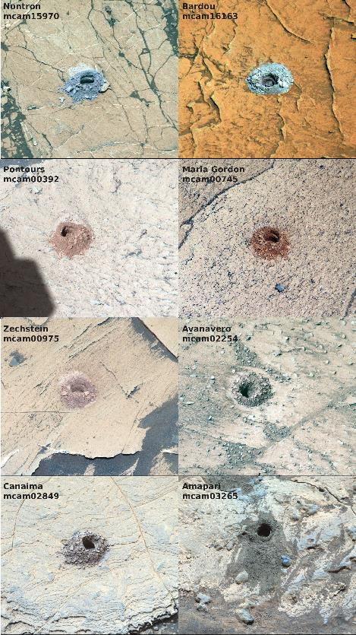
Figure 1: Mastcam RGB composite images of the CST drill targets. Drill holes are ~1.5 cm across.

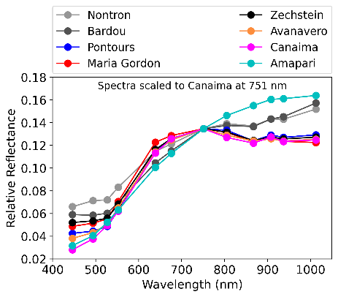Figure 2: Scaled Mastcam spectra of CST drill targets.

Figure 3: Mastcam multispectral NIR slope of CST drill targets vs. CheMin phyllosilicate abundances [4].

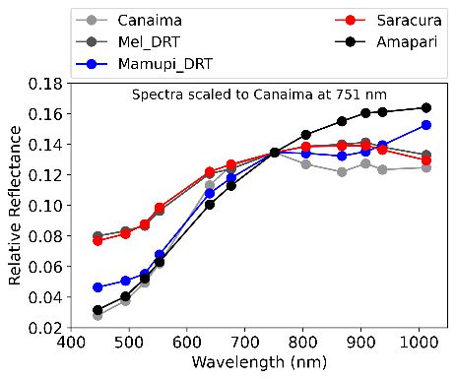
Figure 4: Scaled Mastcam spectra of CST and marker band targets.

