Video That’s Out of This World

A Snapshot of Video Distribution from Across the Solar System

Jennifer L. Christopher
National Aeronautics and Space Administration, Huntsville, Alabama, 35812, USA
And

Dr. Melissa Garber
Leidos, Huntsville, Alabama, 35806, USA

While extraterrestrial scientific research advances to the Moon and Mars, so does the need for secure high-quality video links to capture data and share the experience. This paper describes the space to ground architecture needed to satisfy the cultural mantra challenging “Pictures or it didn’t happen!” as NASA travels beyond Low Earth Orbit.

The Marshall Space Flight Center’s Delay Tolerant Network Marshall Enterprise (DTNME) protocol is the framework for video distribution beyond the terrestrial Internet, appropriate for communications across the solar system. Utilizing the International Space Station (ISS) as a test facility, NASA engineers and contractors will demonstrate new technologies and capabilities to transmit high-quality video imagery for NASA’s return to the Moon, Mars exploration, and next generation of explorers.

Nomenclature

- CCSDS Consultative Committee for Space Data Systems
- DSN Deep Space Network
- DTN Delay Tolerant Network
- DTNME Delay Tolerant Network – Marshall Enterprise
- HIRISE High-Resolution Imaging Science Experiment
- ILLUMA-T Integrated LCRD Low Earth Orbit User Modem and Amplifier Terminal
- IP Internet Protocol
- ISS International Space Station
- JPL Jet Propulsion Laboratory
- LCRD Laser Communication Relay Demonstration
- LEO Low Earth Orbit
- NEN Near Earth Network
- MARCI Mars Color Imager
- MITLL MIT Lincoln Lab
- MRO Mars Reconnaissance Orbiter
- O2O Orion Artemis II Optical Communications System
- RF Radio Frequency
- SCaN Space Communications and Navigation
- SN Space Network
- TBIRD TeraByte InfraRed Delivery
- TDRS Tracking and Data Relay Satellite
- TDRSS Tracking and Data Relay Satellite System

Introduction

From exploring outside their cave, to new lands, across seas, and ultimately to the Moon, man has consistently endeavored to discover. In 1969, an estimated 650 million people watched Neil Armstrong take man’s first steps on the Moon¹. Over a span of 5 years, images of the Earth taken from the International Space Station (ISS) averaged over 81,000 unique viewers per day from 226 countries. Peak live viewership of the November 16, 2022 Artemis-1 launch was 884k, even though it was the third attempt and a night launch². The public is clearly interested in viewing video that’s out of this world.

To support imagery requirements of NASA manned and unmanned exploration missions, communications networks with ground and space-based components were developed. The Near Earth Network (NEN) includes more than twenty tracking sites around the globe. The Space Network (SN) is made up of a fleet of tracking and data relay satellites. The Deep Space Network (DSN) includes three primary sites located 120 degrees apart in longitude for use by spacecraft beyond Earth orbit. All these networks are continuously developed to address growing communications requirements as NASA missions continue to explore the solar system.

This paper describes the simultaneous evolution of US space-based imagery and the enabling space to ground architecture, including SN, DSN, and NEN, as illustrated in Figure II-1. The time span begins with the first space photos captured from a V2 rocket in 1946 and continues with the Apollo Lunar landings in the 1970s, planetary probes during multiple decades, Artemis Campaign in the 2020s, and Mission to Mars planned for the 2030s.

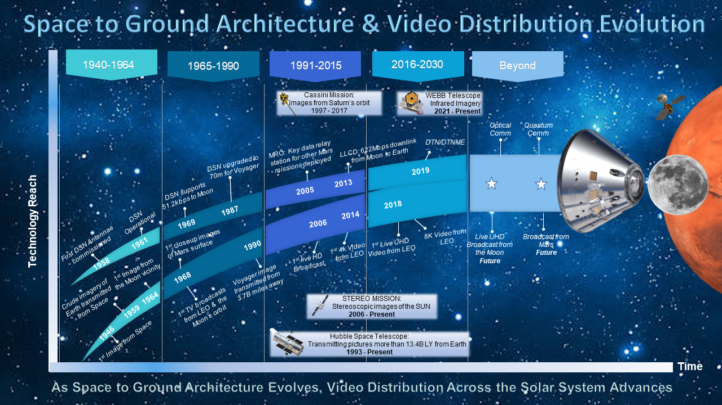
Figure II-1: Space to Ground Architecture & Video Distribution Evolution

1940-1964

Scientific and space exploration in the United States began shortly after World War II, driven by advances in rocketry during the War. Rocket science for the sake of exploration took off, and soon enough American researchers realized attaching a camera to the rockets would create an opportunity to view the world in a way we never have before. The Space Race was about to begin and thanks to technological advances in capturing and distributing still and motion imagery, the world was going to have a front row seat.

The first images from space were taken from a captured V2 rocket launched by the U.S. in 1946. See Figure III-1 for sample photos. A standard 35mm DeVry movie camera modified to withstand the shock of a rocket launch and the impact of landing was attached to the rocket. The camera had a one-inch-thick steel magazine to protect the film, and the entire camera was protected by a three-eighths inch thick aluminum box, with only the lens protruding. Utilizing Eastman Super XX film exposed at four frames per second and set with an aperture of 5.6 and shutter speed of 1/50 of a second, the first images from space were recovered after the V2 crashed back to Earth.³

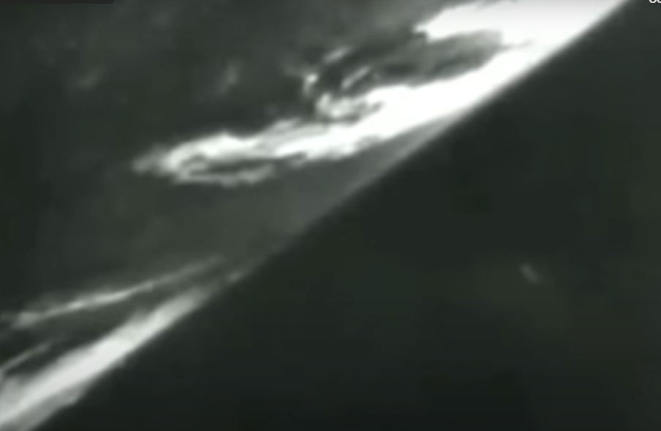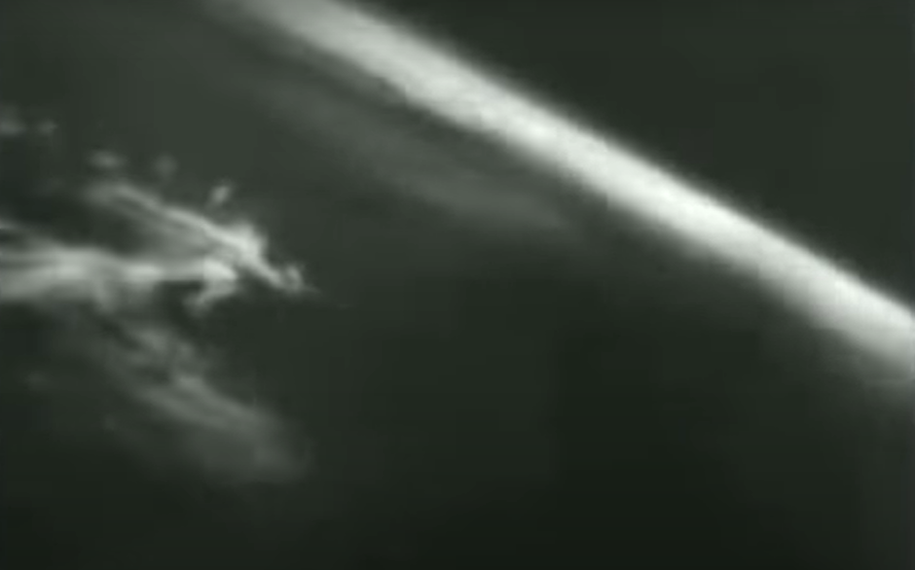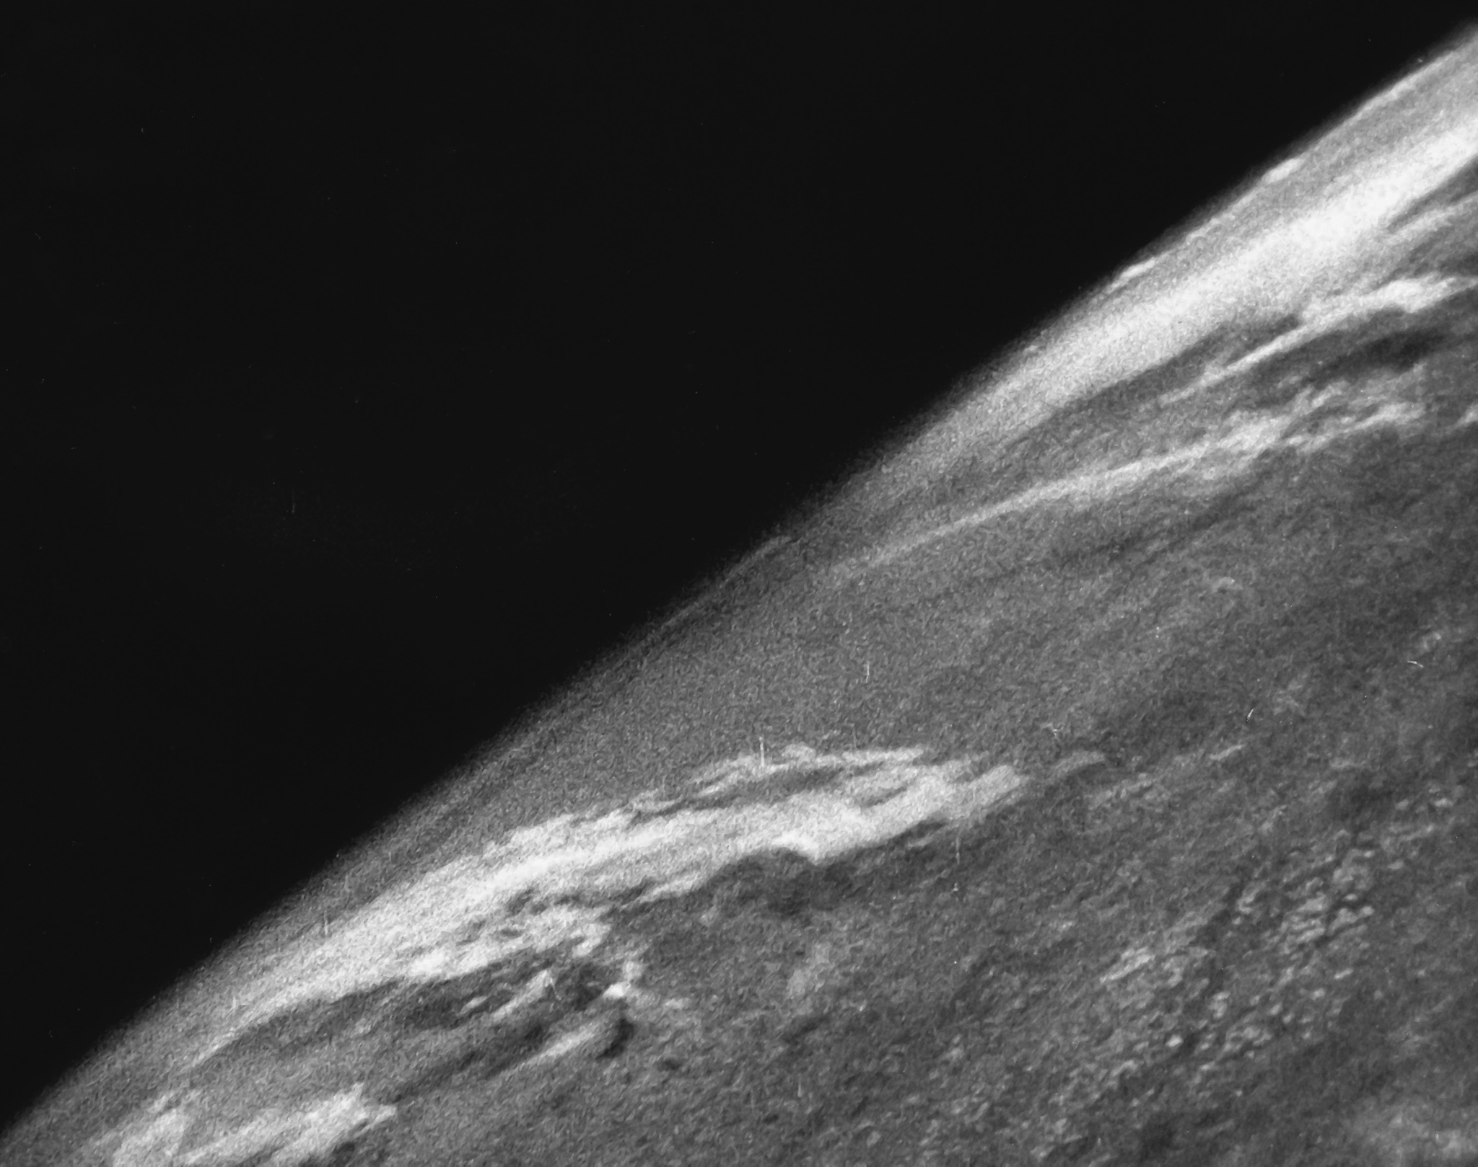
Figure III-1: Imagery Taken by US Army in 1946 from Captured V2 Rocket

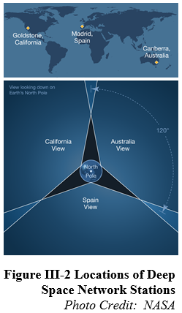In 1946 there was no functional space network to transmit imagery to the Earth, but even before NASA was commissioned in 1958, JPL had begun work on one for the Army. The first 26m antenna in what would become the DSN was built in 1958 at the Goldstone Complex in California. Called DSS 11 through most of its life, this antenna supported the first US spacecraft to escape Earth’s gravity, Pioneer 4. The Space Science Panel of the President’s Scientific Advisory Committee declared in 1958 that visual reconnaissance was the most significant Lunar vehicle experiment. Unfortunately, although Pioneer 4 was outfitted with photographic capability and was planned to take pictures of the Moon surface, it failed to meet that mission objective. However, JPL envisioned a series of deep space probes as early as the 1950s, and understood that to receive data from them, a minimum of three 26m antennas would be required, ideally located 120 degrees apart in longitude. “The strategic placement of these sites permits constant communication with spacecraft as our planet rotates – before a distant spacecraft sinks below the horizon at one DSN site, another site can pick up the signal and carry on communicating.”⁴. These antennas used an S-Band operating frequency and could communicate with all vehicles from 330 miles above the Earth to as far as Mars. In 1959 NASA signed an agreement with the DoD that included installation of antennas in Australia and South Africa. All three DSN antennas supported the Ranger 1 launch in 1961.⁵

By 1964, NASA launched the Ranger 7 Lunar spacecraft with a mission to transmit high-quality pictures from the Moon before crashing into its surface. The TV subsystem onboard Ranger 7 included a tower superstructure and thermal shield, a central box containing principal electronic components, and six slow-scan television cameras. 25-millimeter wide-angle lenses were on two of the cameras and 75-millimeter telephoto lenses were on the other four. Resolution was 0.1 to 0.5 meter (4 to 20 inches). Each camera was able to convert video data and the system used two transmitters, primary and backup, to transmit the data back to Earth. On the ground, the video data was then recorded onto 35-millimeter film and magnetic tape.⁶ According to NASA sources, “Ranger 7 transmitted 4,308 high-quality images over the last 17 minutes of flight, the final image having a resolution of 0.5 meter/pixel.”⁷ It was considered a resounding success.

1966-1990
Due to the network advances achieved thus far, in 1968 during the Apollo 7 mission, television audiences saw the first live television broadcast from space, featuring astronauts Walter Schirra, Donn Eisele, and Walter Cunningham. The spacecraft was equipped with a black-and-white RCA television camera that transmitted live images of the astronauts to Earth, allowing people around the world to watch six real-time broadcasts during the mission. The camera, shown in Figure IV-1, was a slow-scan television (SSTV) camera with a monochrome signal limited to 10 frames per second (fps) due to network constraints. It was 85 cubic inches, weighed 4.5 pounds and 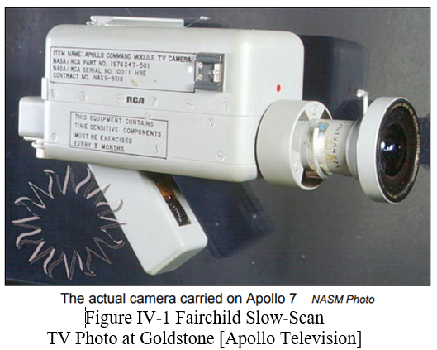required 6.75 watts at 28 volts dc. The camera had a 1-inch vidicon tube and required signal processing back on Earth to make the frame rate and color encoding compatible with analog broadcast television standards of the time.⁸ These cameras had a 160-degree field of view. Due to power and network constraints, analog transmission at 500 kHz rate was chosen.⁹

Because Apollo 7 remained in Earth orbit, it used small antennas, rather than the three large DSN antennas. RCA Slow-Scan Converters were only installed at the Texas and Florida ground stations, restricting video broadcast to just seven short passes. By Apollo 8, which orbited the Moon, NASA had continuous coverage due to the installation of RCA Slow-Scan Converters at Australia, California, and Spain. These stations were able to receive and process six different broadcasts for a total of ninety minutes of television. However, only Goldstone in California was provisioned to provide real-time video to Houston, and from there to commercial TV networks.¹⁰ These same conditions were in place on July 20, 1969, when Neil Armstrong famously took man’s first steps on the moon. To document the event, NASA worked with camera manufacturing company, Hasselblad, to modify a silver Hasselblad Data Camera (HDC) with Réseau plate, fitted with a Zeiss Biogon 60mm ƒ/5.6 lens. This camera was mounted to astronaut Armstrong's chest and a second black Hasselblad Electric Camera (HEC) with a Zeiss Planar 80mm ƒ/2,8 lens was used to shoot from inside the Eagle lunar module. The camera worked perfectly despite the extreme conditions of the lunar surface. The network worked perfectly as well. Pictures were transmitted back to Earth through Earth-orbiting satellites to NASA’s Manned Spaceflight Center in Houston. The Intelsat ‘Early Bird’ communications satellite was used to broadcast the Apollo 11 mission to the world creating arguably the biggest television event of the 20th Century. Figure IV-2 shows an illustration of how a live TV signal was sent from the Moon to Earth.

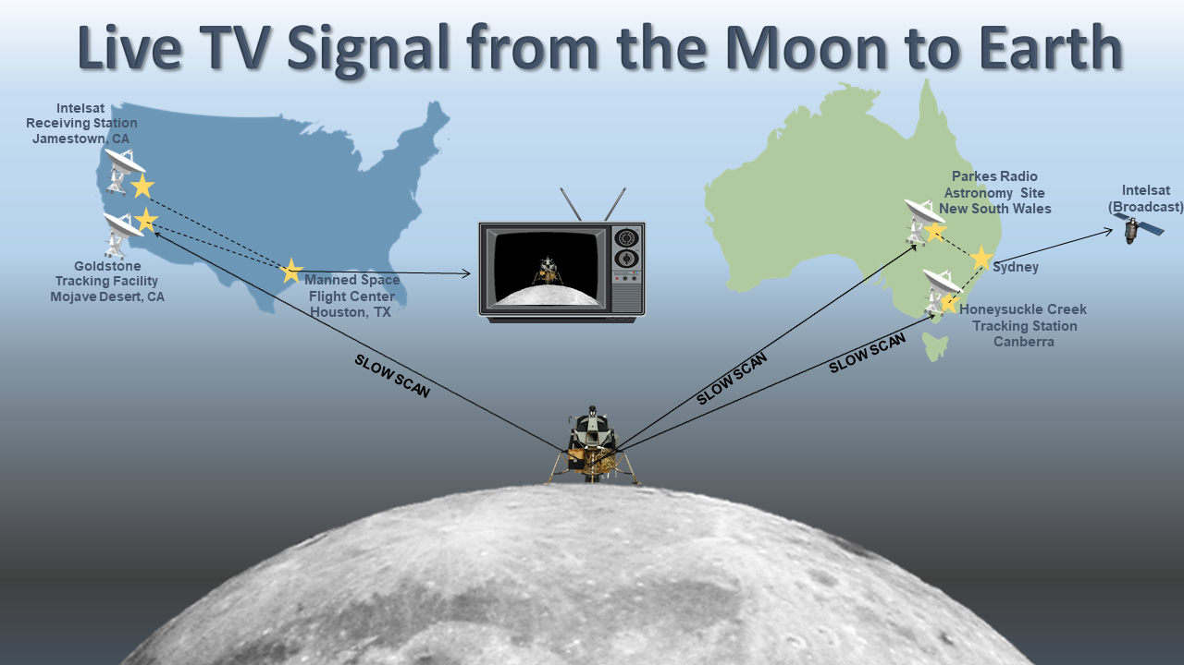
Figure IV-2: Live TV Signal from Moon to Earth (Apollo 11)

To address communication requirements of spacecraft beyond Mars, three new 26m S-Band antennas at Goldstone, Australia, and Spain became operational in 1965. 64m antennas were added at all three sites to support higher data rates of future spacecraft. NASA’s Voyager spacecraft was one of the first to take advantage of the upgrade capabilities. These spacecrafts flew by Mars and returned the world’s first closeup imagery of the red planet. 76m antennas became operational at all three sites by 1973 to address increased spacecraft data rates. The 26m antennas added capability for X-Band by 1980 to support Jupiter and Saturn flybys of the two Voyager spacecraft. Two new 34m high efficiency antennas were added at all three sites by 1987, to be used along with the 64m antennas as a three-element array to support 19kbps data rate from the two Voyager spacecraft. To support Voyager’s Neptune flyby, by 1988 the 64m antennas were enlarged to 70m and their surfaces were reshaped, resulting in 50% increase in signal capture.¹¹ The famous “Pale Blue Dot” photo of Earth was taken in February 1990 by Voyager 1 from approximately 3.7 billion miles away. The image was taken as the spacecraft was leaving the Solar System. The phrase "Pale Blue Dot" was coined by Sagan in his reflections on the photograph's significance, documented in his 1994 book of the same name.¹² He had pleaded with NASA to turn the spacecraft around to get the shot and made history doing so.

To complement the DSN, the Space Network and the Near-Earth Network were implemented. SN is a constellation of Tracking and Data Relay Satellites (TDRSs), which thus far includes three generations of satellite technology. Three first generation TDRS became operational between 1983 and 1989.¹³

1991-2015

The TDRS satellite system collects data and sends it to ground systems on Earth. They provide a near continuous relay service for data from Earth’s orbit. Three additional first generation TDRSs became operational between 1991 and 1995, for a total of six. Then shortly after three second generation TDRSs were added to the constellation, and two third generation TDRSs were added by 2014. This expansion of the network made it possible for NASA to explore more options for gathering imagery throughout the Solar System and the Hubble Space Telescope was created. This giant telescope (about the size of a large school bus) was launched into LEO in the early 90s and remains in service today. Its mission is to relay important data about our universe back to Earth. Seeking answers to questions like ‘How big is the Universe’ and ‘What is beyond our Solar System’, Hubble transmits approximately 140 Gb of data per week, including raw visible, infrared, and ultraviolet data.¹⁴ Some of the world’s most stunning and fascinating images were taken by Hubble. Most impressive are images from more than 13.4 billion light years away that have been captured, providing the world with data from light that existed in the Universe 13.4 billion years ago.

Success from network and imagery technology in the early 1990s let way for NASA to build more, explore more, and capture more. NASA, ESA, and ASI partnered to send the Cassini space probe to study Saturn, its rings, and its moons in 1997. The mission ended in 2017, but for twenty years the spacecraft orbited Saturn, far surpassing the planned mission of four years. The craft included a scientific instrument called the Imaging Science Subsystem that took hundreds of thousands of visible, infrared, and ultraviolet images. While in Saturn’s orbit, telemetry, and commanding signals experienced greater than one hour latency.¹⁵

Then in 2005, a two-ton Mars Reconnaissance Orbiter (MRO) was launched from LC 41 at CCAFS atop an Atlas V rocket, on an interplanetary rendezvous mission with Mars, 72 million miles from Earth. MRO carried six scientific instruments for studying the Martian surface, subsurface, and atmosphere from low orbit, in never-before-seen detail. MRO entered Mars orbit in 2006.¹⁶ Three of the six onboard instruments of particular interest are cameras. The High-Resolution Imaging Science Experiment (HIRISE) camera is the most powerful reflecting telescopic camera ever built for interplanetary use aboard a spacecraft and has a resolution of 1 microradian (0.3m from an altitude of 300km) / (1-ft @ 190-miles). The Context Camera (CTX) captures monochromatic images down to 6m (20ft) per pixel, and the Mars Color Imager (MARCI), with seven filters, five being centered in visible-light wavelengths and two UV wavelengths, with a selectable spatial resolution from 1km/pixel (0.6mi/pixel) to 10km/pixel (6mi/pixel). MRO also carried a UHF telecommunications and navigation package (ELECTRA) that functions as a relay for Mars rovers and subsequent Martian spacecraft. Additionally, MRO demonstrated a Ka-band telecommunications experiment package that reduced standard X-band power requirements significantly and showed that the Ka-band data transmission rate was 4x higher at 32GHz compared to 8GHz for X-band.¹⁷

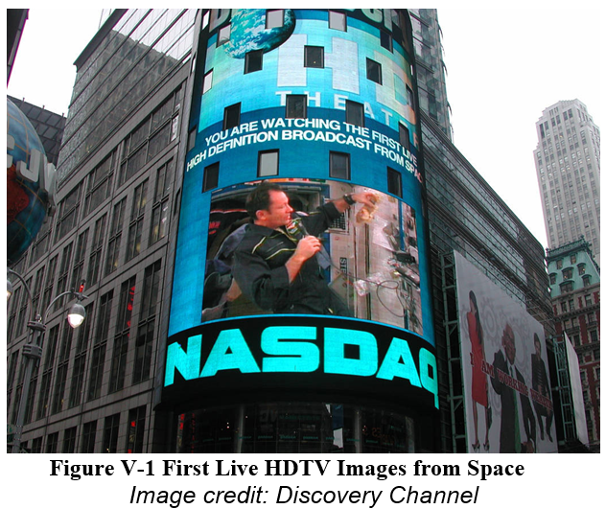On November 15, 2006, NASA, in cooperation with JAXA, Japanese broadcast network NHK, and Discovery Channel HD Theater, used the TDRS constellation as a “Space Video Gateway”, and made history broadcasting the first live high-definition television (HDTV) images from the ISS 220 miles from Earth, as shown in Figure V-1. (Reference 1) The images from space were flashed across the screen in New York’s Times Square. "HDTV provides up to six times the resolution of regular analog video," said Rodney Grubbs, NASA principal investigator. "On previous missions, we've flown HDTV cameras but had to wait until after the mission to retrieve the tapes, watch the video and share it with the science and engineering community, the media and the public. For the first time ever, this test lets us stream live HDTV from space so the public can experience what it’s like to be there."¹⁸

2016-2030

By 2017 the last of the third generation TDRSs became operational giving missions in LOE the ability to relay signals with nearly 100% coverage. Figure VI-1 illustrates the current SN constellation configuration.¹⁹
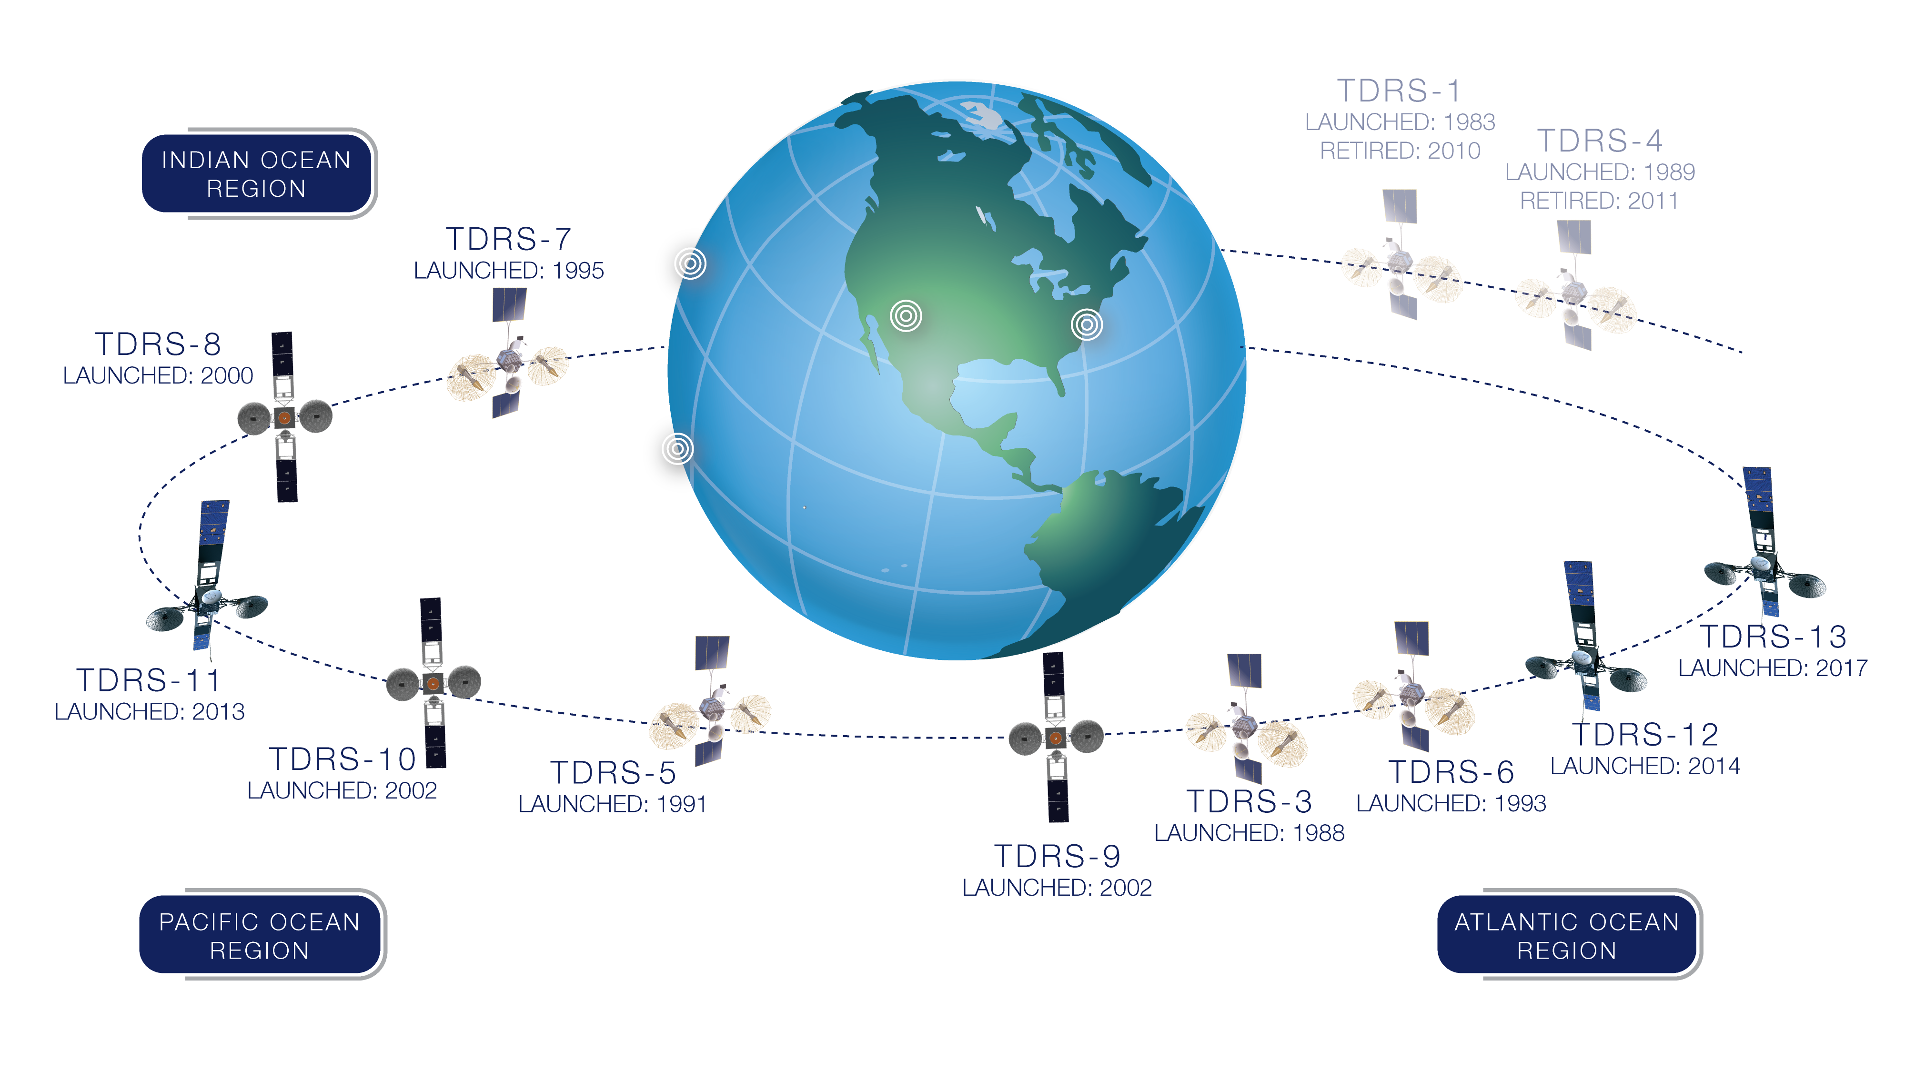
Figure VI-1 Tracking and Data Relay Satellite System Configuration

One such mission is that of the International Space Station (ISS). Built in the late 1990s, the ISS became operational in the year 2000 serving as a microgravity space research lab and human outpost in space. Hundreds of scientific experiments have been performed on the ISS. On average, approximately 1.4 terabytes of high-definition, real-time space data is transferred to Earth from the ISS every day. In 2017, NASA teamed with AWS Web Services, the National Association of Broadcasters, AWS Elemental, and RED to add to NASA’s exceptional history in imagery and show the world the first live digital cinema quality discussion with astronauts in space. “What goes up must come down, except when what goes up goes into outer space,” said Sam Matheny, executive vice president and chief technology officer of the National Association of Broadcasters (NAB), in April of 2017 at the organization's annual show in Las Vegas. "And that is what makes the first RED camera to go to the International Space Station so special.”²⁰ The RED Epic Dragon, capable of filming at 300fps in 2k all the way up to 83fps in full 6k resolution, was carried to the ISS in 2015 aboard the SpaceX Dragon spacecraft.²¹ This historical event was executed flawlessly showing off not only the impressive camera technology used but also the network’s ability to support such an event.

In addition to adding and upgrading the TDRSS satellites. NASA is improving the network protocols in use. Although still in the conceptual stage, numerous DSN upgrades will be implemented to support the Artemis Campaign. Many of the enabling technologies will be tested first in LEO. Delay / Disruption Tolerant Networking (DTN) is a protocol for data transmission in cases where Internet Protocol (IP) is inadequate to allow spacecraft to communicate as if directly linked to the operations center. DTN accounts for data rate mismatches and disconnections. Also, DTN does not require intermediate nodes to a priori know data destination.²² The Consultative Committee for Space Data Systems (CCSDS) DTN Working Group writes and maintains standards for DTN development.²³ The International Deep Space Interoperability Standards resulted from ISS member collaboration. This group’s communications standard addresses imagery transmission in cislunar and deep space, including the use of DTN.²⁴ JPL introduced the Interplanetary Overlay Network (ION) DTN implementation in 2007.²⁵ As of January 2023, MSFC had introduced DTN Marshall Enterprise (DTNME), a CCSDS-compliant implementation of DTN to increase ISS DTN bandwidth from 100 to 400Mbps. This implementation includes partial ISS DTN redundancy, setting the stage for a fully redundant ISS DTN architecture, as well as a path for expansion through Enabling Network Communications with Optical and DTN for Exploration (ENCODE) in collaboration with the Glenn Research Center (GRC). Testing of MSFC’s DTNME with GRC’s High-Rate DTN (HDTN) has demonstrated 1 Gbps with 4 seconds latency is achievable.²⁶ DTN will empower missions with unparalleled connectivity by storing and forwarding data at points along the network to ensure critical information reaches its destination.

Beyond 2030

As NASA makes plans to safely travel beyond the bounds of the Earth, back to the moon, and ultimately to Mars, engineers and scientists are working to develop the next generation of network and communications technology. Today’s network communicates via radio frequencies which have bandwidth limitations. Optical communications can help solve this problem. Current and future space missions are expected to transmit increasing volumes of data including high-definition images and video. NASA has made the first steps into space optical communications. GSFC, JPL, and the MIT Lincoln Lab (MITLL) partnered to build the Laser Communication Relay Demonstration (LCRD), which was launched on 12/7/2021. LCRD’s goal was to prove the utility of bidirectional optical communications between geosynchronous orbit and Earth, with 10x to 100x data rate compared to radio frequency systems. The Integrated LCRD Low-Earth Orbit User Modem and Amplifier Terminal (ILLUMA-T), scheduled to be delivered as an ISS payload in February 2023, will use LCRD as its relay in communications from ISS to Earth.²⁷ MITLL also partnered with NASA on the TeraByte InfraRed Delivery (TBIRD) project, which set a record for LEO communications in 2022. 1.4 TB of data was downlinked via laser communications link in a single five-minute pass.²⁸ NASA’s Artemis II mission will introduce an Orion Artemis II Optical Communications System (O2O) with data rates estimated at 10x current systems. O2O will support live, 4k UHD video from the Moon’s orbit.²⁹

NASA is also exploring space-based quantum communication demonstrations with the eventual goal of creating distributed quantum network entanglement-enabled applications. These applications may include distributed quantum sensing, improved timing/synchronization, multi-processor quantum computing over short-range interconnects, and distributed computing or secure communication over long-haul links.³⁰ Once these enhancements on the network are completed, bandwidth will be less of an issue, enabling 4k, 8k, and higher video streams from Moon and eventually Mars.

Conclusion

NASA continuously pushes the limits of man’s exploration of the universe. The simultaneous evolution of US space-based imagery and the enabling space to ground architecture have empowered NASA to venture further into space, outside of Earth’s orbit, to the Moon, and beyond. 76 years ago, NASA captured the first images of Earth from space retrieving them only after the camera made it back to Earth. Today we can stream live ultra-high-definition video from the International Space Station in Low Earth Orbit. In 1969, the nation watched, in black and white, with great anticipation as man took his first steps on the Moon. When NASA returns the next man and first woman to the Moon, we will have high quality still images and streaming video to share with the world. It's exciting to see how far we've advanced through the years and even more exciting to think about where we'll be in the future.

REFERENCES:

- NASA, 2022, Apollo 11 Mission Overview website, US Government, accessed 1/10/2023, <https://www.nasa.gov/mission_pages/apollo/missions/apollo11.html>.
- F. Carrico, 2022, Artemis 1 Mission to the Moon website, Streams Charts, accessed 1/10/2023, <https://streamscharts.com/news/artemis-1-launch-sets-scenario-return-moon>.
- T. Reichhardt, 2006, Smithsonian Air & Space Magazine website, Smithsonian, accessed 1/10/2023, <https://www.smithsonianmag.com/air-space-magazine/the-first-photo-from-space-13721411/>.
- NASA, 2020, What is the Deep Space Network website, US Government, accessed 1/1//2023, <https://www.nasa.gov/directorates/heo/scan/services/networks/deep_space_network/about>.
- Waff, C., 1993, "The Origin and Evolution of the Deep Space Network", accessed 1/10/2023, <https://hdl.handle.net/2014/34915>.
- Hall, R.C., 1977, Lunar impact: A history of Project Ranger (Vol. 4210). Scientific and Technical Information Office, National Aeronautics and Space Administration.
- NASA, 2014, First Image of the Moon Taken by a US Spacecraft website, US Government, accessed 1/10/2023, < https://www.nasa.gov/content/first-image-of-the-moon-taken-by-a-us-spacecraft >.
- Coan, P. M., 1973, "Apollo Experience Report – Television System" (PDF), in Jones, Eric M.; Glover, Ken (eds.), Apollo Lunar Surface Journal, Washington, DC: NASA (published 1996–2013), archived (PDF) from the original on 17 November 2004, accessed 1/10/2023, Originally published by NASA HQ as NASA Technical Note TN-A7476.
- Lebar, S.; Hoffman, C. P., 3/6/1967, "TV show of the century: A travelogue not atmosphere" (PDF), in Jones, Eric M.; Glover, Ken (eds.), Apollo Lunar Surface Journal, Washington, DC: NASA (published 1996–2013), archived (PDF) from the original on 8 August 2006, accessed 1/10/2023, Originally published in ELECTRONICS, published by McGraw Hill (1967).
- Wood, B., 2005, “Apollo Television” (PDF), accessed 1/10/2023, <https://www.hq.nasa.gov/alsj/ApolloTV-Acrobat7.pdf>.
- NASA, “The Origin and Evolution of the Deep Space Network” (PDF), <https://ntrs.nasa.gov/citations/20060038690>
- Sagan, C. and Druyan, A., 2011, Pale blue dot: A vision of the human future in space. Ballantine books.
- NASA, Advanced Communications Capabilities for Exploration and Science Systems (ACCESS) website, accessed 1/10/2023, <https://esc.gsfc.nasa.gov/projects/ACCESS>.
- NASA, HubbleSite | Quick Facts website, accessed 1/10/2023, <http://hubblesite.org/the_telescope/hubble_essentials/quick_facts.php>.
- NASA, 2023, Solar System Exploration | Cassini website, accessed 1/10/2023, <https://solarsystem.nasa.gov/missions/cassini/overview/>.
- The Planetary Society, The Mars Reconnaissance Orbiter, studying the Red Planet’s climate and geology website, accessed 1/10/2023, <https://www.planetary.org/space-missions/mars-reconnaissance-orbiter>.
- NASA, Mars Reconnaissance Orbiter website, accessed 1/10/2023, <https://mars.nasa.gov/mro/mission/overview/>.
- NASA, 2008, First HDTV Broadcast From Space website, accessed 1/10/2023, <https://www.nasa.gov/multimedia/imagegallery/image_feature_698.html>.
- NASA, 2019, Tracking and Data Relay Satellite (TDRS) Fleet website, accessed 1/10/2023, <https://www.nasa.gov/directorates/heo/scan/services/networks/tdrs_fleet>.
- Amazon Web Services, A History First - Streaming 4K Live from the International Space Station Using AWS Technology website, accessed 1/10/2023, <https://www.youtube.com/watch?v=AExVC9RqIyc>.
- RED, 2018, “EPIC DRAGON Specs” (PDF), accessed 1/10/2023, <https://support.red.com/hc/en-us/articles/360011398413-EPIC-DRAGON-Specs>.
- Israel, D.J., Edwards, B., Hayes, J., Knopf, W., Robles, A. and Braatz, L., 2019, October. The Benefits of Delay/Disruption Tolerant Networking (DTN) for Future NASA Science Missions. In International Astronautical Congress (IAC) 2019 (No. GSFC-E-DAA-TN74214).
- CCSDS, Delay Tolerant Networking Working Group, accessed 1/10/2023, <https://cwe.ccsds.org/fm/Lists/Charters/DispForm.aspx?ID=43>.
- NASA, 2020, “International Communication System Interoperability Standards (ICSIS)” (PDF), accessed 1/10/2023, <https://nasasitebuilder.nasawestprime.com/idss2/wp-content/uploads/sites/45/2020/10/communication_reva_final_9-2020.pdf>.
- Burleigh, S., 2007. Interplanetary overlay network: An implementation of the dtn bundle protocol.
- NASA, 2022, HOSC DTN Overview (PPTX).
- NASA, 2018, ILLUMA-T: 2023 website, <https://www.nasa.gov/directorates/heo/scan/opticalcommunications/illuma-t/>.
- Via Satellite, 2022, NASA’s TBIRD Mission Demonstrates 1.4TB Optical Downlink website, accessed 1/10/2023, <https://www.satellitetoday.com/technology/2022/12/06/nasas-tbird-mission-demonstrates-1-4tb-optical-downlink/>.
- NASA, LASER ENHANCED MISSION COMMUNICATIONS NAVIGATION AND OPERATIONAL SERVICES PIPELINE (LEMNOS) website, accessed 1/10/2023, <https://esc.gsfc.nasa.gov/projects/LEMNOS?tab=overview>.
- Hamilton, S.A., Boroson, D.M., Dixon, P.B., Grein, M.E., Hardy, N.D., Howe, T.R., Lee, C., Murphy, R.P., Rao, H.G., Spellmeyer, N.W. and Cornwell, D.M., 2019, October. Overview of NASA’s national space quantum laboratory program. In Proc. IAC (pp. 1-12).

Deputy Artemis Imagery Integration Lead, Advanced Exploration Systems, NASA, jennifer.christopher@nasa.gov
Artemis Imagery Ground Systems Engineer, Leidos Corporation, melissa.j.garber@nasa.gov

