Applicability of micro x-ray fluorescence spectroSCOPY to Astromaterials Curation and research E. W. O’Neal¹, S. A. Eckley¹, and R. A. Zeigler² ¹Jacobs Technology, JSC, Houston, TX 77058, USA, ²Astromaterials Acquisition and Curation Office, NASA JSC, Houston, TX 77058, USA.

Introduction: The Astromaterials Acquisition and Curation Office at NASA’s Johnson Space Center (JSC) curates NASA’s astromaterial sample collections which includes: Apollo samples, Luna samples, Antarctic meteorites, cosmic dust particles, microparticle impacts into space-flown materials, Genesis solar wind atoms, Stardust comet Wild-2 particles, Stardust interstellar particles, Hayabusa asteroid Itokawa particles, Hayabusa 2 asteroid Ryugu particles, and future OSIRIS-Rex asteroid Bennu particles (landing in September, 2023) [1–3]. To enhance JSC’s advanced curation capabilities, we have recently installed a high-performance micro-X-ray fluorescence (µXRF) spectrometer to assist in sample characterization through rapid, non-destructive, in-situ elemental analyses that do not require the sample preparation protocols (i.e., polishing and carbon-coating) commonly needed for electron beam analyses. With this new instrument, we are capable of detecting all elements down to carbon in a variable-pressure or He-purged chamber for analysis of a wide range of sample types. Here we describe the instrumental set-up, capabilities, and applicability of µXRF analysis to astromaterials curation and research.

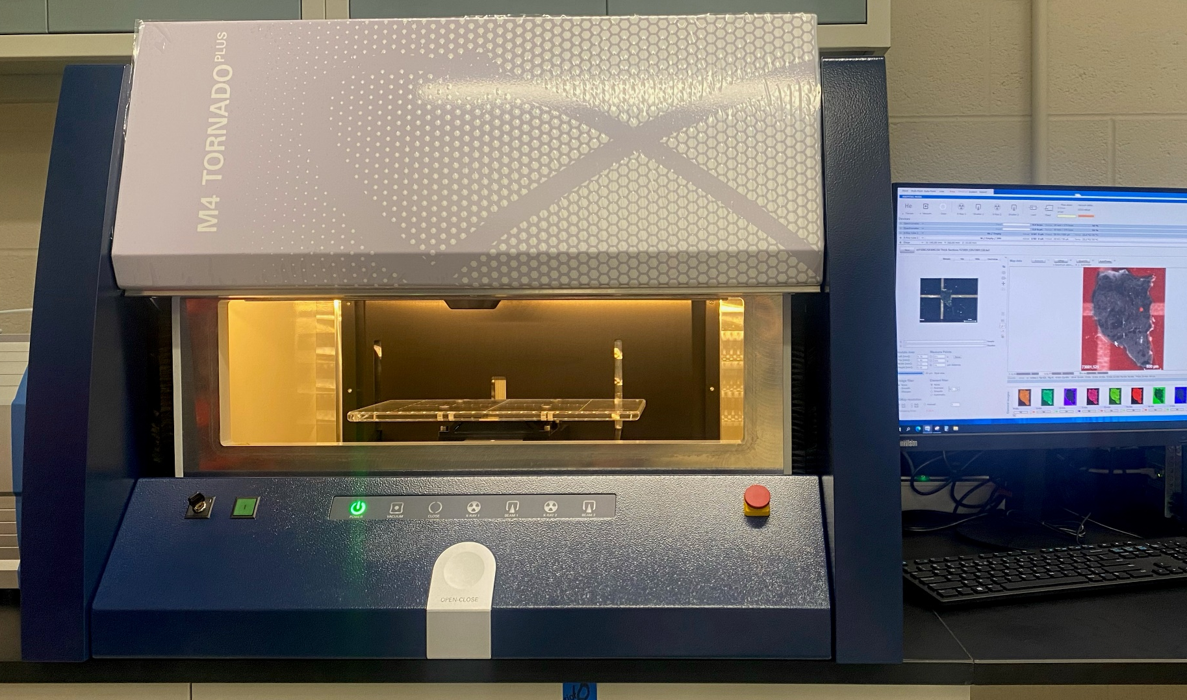

Figure 1: Bruker M4 Tornado plus micro X-ray fluorescence spectrometer and accompanying software computer

Instrumentation and Methodology: The X-ray fluorescence and computed tomography lab (X-FaCT) lab at JSC is now equipped with a Bruker M4 Tornado Plus µXRF (Fig. 1). This system is an energy-dispersive x-ray spectrometer equipped with two 60 mm² silicon drift detectors (SDD) that are able to be used simultaneously for output count rates ~500,000 cps. New light element windows allow detecting and analyzing the entire elemental range from carbon to americium. Two x-ray tubes (micro-focus Rh with polycapillary lenses and W with collimators of 0.5, 1.0, 2.0, and 4.5 mm) with max excitation parameters of 50 kV, 30 W and 50 kV, 40 W, respectively, allow for more flexibility of the analysis of high energy lines. The motorized X-Y-Z stage has a mapping range of 190 x 160 mm and can support samples up to 7 kg (~15.5 lbs) and a height of 120 mm [4].
Analytical modes include elemental analysis (down to ~20 µm spot size) via point, line, or area of bulk materials (rock surfaces, thin sections, thick sections, etc.) as well as coating analysis (determination of thickness and composition) of samples. This system has a variable vacuum chamber (1 mbar to 1 atm) that is also equipped with a He-purge system which accommodates vacuum sensitive samples while still allowing detection of light elements at atmospheric pressure.
Utility and Applicability of µXRF in Astromaterials research and exploration science (ARES): Elemental analysis using µXRF is commonly employed for both terrestrial and planetary geological science disciplines [5]. It is especially useful for analysis of astromaterials given the limited sample preparation required, which is not feasible for certain materials. Here we show select applications of µXRF analyses of astromaterials that can, have, and will be done at JSC’s X-FaCT lab.
Point analysis: In-situ spot analyses (~20 µm spot size) on a cut slab of Martian meteorite NWA 10922 allowed for the discovery, qualitative elemental analysis and determination of different feldspar minerals [6]. These point analyses served as an effective preliminary step for subsequent quantitative analyses. Analytical standards can be employed for more accurate quantification of µXRF spot analyses.
Area analysis: This analytical mode measures all detectable elements (from C to Am) at each pixel (>5 µm pixel size) in a user-defined area. The results are shown as elemental maps which can be extracted as 16-bit TIFF’s for further data processing. In Fig. 2. we show elemental distribution maps of the high-Ti basalt 73001,531 that have been processed using ImageJ software. From these maps you can accurately and quickly (this map took ~50 mins.) identify mineral components, such as pyroxene, plagioclase, oxides, and phosphates, compositional zoning, and mineral textures.
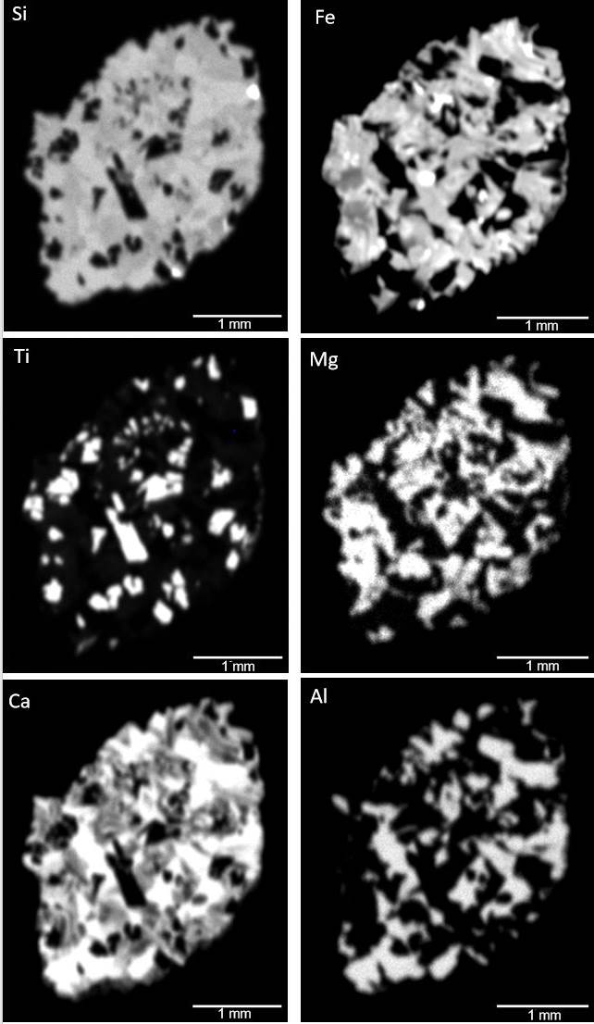

Figure 2: Element distribution maps for 73001,531 including silicon (Si), iron (Fe), titanium (Ti), magnesium (Mg), calcium (Ca), and aluminum (Al). Pixel Size: 16 um, Pixel Time: 50 ms/pixel

Detection of high-Z phases: µXRF techniques are especially effective at analyzing trace minerals with high-atomic-number (high-Z) elements because the high-energy characteristic X-rays used (relative to SEM EDS) allow for mapping of Kα lines in elements up to La (typically SEM maps use L X-ray lines for elements >Zn, and these can often have interferences). Thus, µXRF is especially suited for identifying minerals like zircon, baddeleyite, REE-rich phosphates, Fe-rich metals, oxides, sulfides, and phosphides [4]. In Fig. 3 we show elemental distribution maps for 73001,530 where we are able to correlate the original video image with, Zr, Si, Y and Hf elemental maps together identifying the location of a zircon. In this location you would expect lower Si compared to surrounding material, as well as higher Zr, Y, and Hf content compared to surrounding material, all of which is confirmed by our XRF elemental distribution maps (Figure 2.)

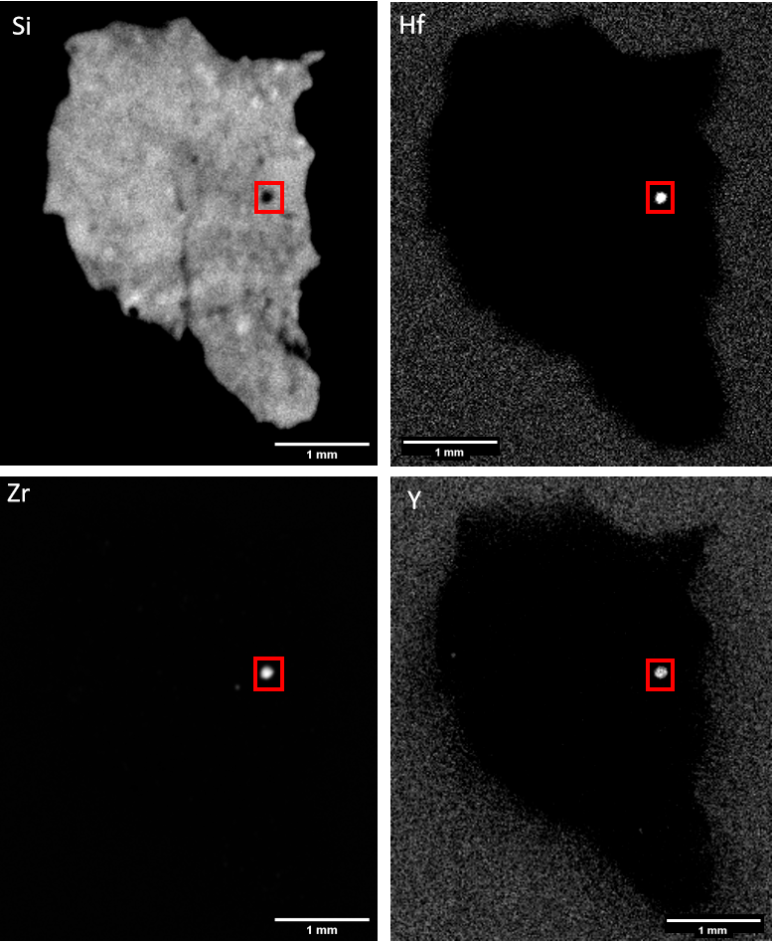

Figure 3: Element distribution maps for 73001, 530 including silicon (Si), hafnium (Hf), zirconium (Zr), and yttrium (Y). Red square highlights location of zircon

Conclusions: The new M4 Tornado Plus µXRF within the Astromaterials Acquisition and Curation office at NASA JSC allows for rapid and non-destructive elemental analysis of astromaterials with limited or no sample preparation. µXRF analyses provide crucial compositional knowledge for the preliminary examination and curation of astromaterials. This instrument enhances the advanced curation capabilities in the X-FaCT laboratory at JSC by allowing productive, cohesive, and non-destructive multi-modal x-ray analyses on astromaterial samples, which is necessary for the comprehensive curation and study of our current and future astromaterial collections. Additionally, µXRF can provide complimentary information to researchers for studies on astromaterials.
References: [1] Allen, C. et al., (2011). Chemie De Erde Geochemistry, 71, 1-20. [2] McCubbin, F. M. et al., (2016) 47th LPSC, abstract #2668 [3] Zeigler, R. A. et al., (2017) 48th LPSC, abstract #2772 [4] Bruker User Manual [5] Young et al., (2016) Appl. Geochemistry, 72, 77-87 [6] Morris, R. V. et al., (2023) 54th LPSC.

