The Challenges with Material Interfaces in a Nuclear Thermal Propulsion Engine Heat Exchanger

Sarah L. Langston¹, Carl C. Poteet¹, and Julia E. Cline¹

¹ NASA Langley Research Center, 1 NASA Drive, Hampton, VA, 23666

Primary Author Contact Information: sarah.langston@nasa.gov ; 757.864.2923

[Placeholder for Digital Object Identifier (DOI) to be added by ANS]

Nuclear Thermal Propulsion (NTP) technology is an enabling technology to send humans to Mars and for agile cislunar mobility. NTP systems operate by flowing a propellent through a nuclear reactor. The resulting heated propellent is expulsed through a nozzle to create thrust. A key component in an NTP engine is the heat exchange tubes located within the nuclear reactor. The heat exchange tubes must be able to operate structurally at temperatures up to 2900 K. Carbon-Carbon is a potential material choice for the heat exchange tubes as the material maintains structural integrity at high temperatures. To achieve desired propulsion performance, NTP engines operate at extreme temperatures. In the extreme environment, differences in material coefficients of thermal expansion must be taken into account to avoid potential reduction of engine performance or system failure. Identified potential problems and proposed solutions to material interface challenges in the material interfaces of the heat exchange tubes are discussed, along with lessons learned for future work on NTP engine designs.

I. INTRODUCTION
NASA is committed to sending humans to Mars in the late 2030s and, thus, to developing critical enabling technologies to successfully complete human-rated Mars missions. One such technology being rapidly developed is a Nuclear Thermal Propulsion (NTP) system, which would greatly decrease crew transit time to and from both cis-lunar space and Mars.¹ An NTP system would also allow for additional abort options during Mars transit that are not viable using current chemical propulsion technologies. NASA has studied nuclear propulsion in the past, such as the Rover and Nuclear Engine for Rocket Vehicle Applications (NERVA) programs.² NTP is currently being studied by the NASA Space Nuclear Propulsion project as well as the DARPA Demonstration Rocket for Agile Cislunar Operations (DRACO) program.¹
An NTP system operates by flowing a propellent (typically hydrogen) through a nuclear reactor where the heat generated by the fission reaction increases the temperature of the hydrogen propellent before the propellent is exhausted through a nozzle to generate thrust. An integral component of the NTP reactor is the heat exchange tubes. The primary purpose of the heat exchange tubes is to transfer the heat generated from the nuclear fission reaction from the fuel to the propellent while protecting the fuel from the hydrogen gas (i.e., the propellent). NASA is currently researching different materials and designs for the heat exchange tubes and how the tubes might be integrated into the larger engine design.³ The lessons learned for the design and integration of Carbon-Carbon (C/C) heat exchange tubes will be the focus of this paper.
II. BASELINE NTP ENGINE DESIGN AND REQUIREMENTS
II.A NTP Engine Design and Operating Conditions
A notional schematic of an NTP engine is shown in Figure 1. In this schematic, the flow of the propellent, labeled as hydrogen (H₂) in the figure, is from left to right. The propellent is pumped from a storage tank into the nuclear reactor, which is encased in a moderator material. The propellent is heated via a nuclear fission reaction in the nuclear reactor section of the engine and is then expulsed through a nozzle to create thrust. The engine is designed such that the nuclear reaction can be pulsed (or turned on and off) by rotating the control drums, allowing the engine to be used multiple times for short durations during the course of a potential Mars mission.

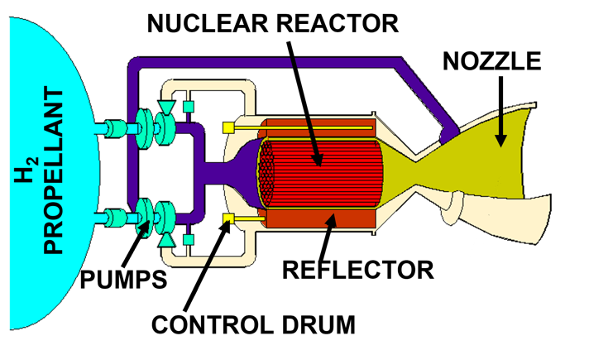
Fig. 1. Notional schematic of an NTP engine.

The heat exchange tubes reside within the moderator reactor core. The core contains multiple fuel elements, which contain more than fifty heat exchange tubes. A flow chart denoting the relationship between the moderator reactor core, fuel elements, and heat exchange tubes is shown in Figure 2.
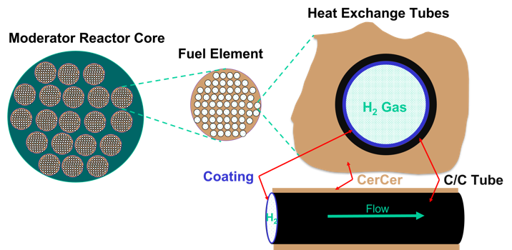
Fig. 2. Relationship between the moderator reactor core, fuel elements, and heat exchange tubes.

The fuel elements are comprised of a ceramic-ceramic (CerCer) nuclear fuel. The CerCer is a ceramic material with nuclear fuel particles imbedded throughout, which create the fission reaction. Channels run through the length of the fuel element for the propellent to pass through. The channels contain the C/C tubes. The C/C tubes must be coated to prevent erosion from the hydrogen propellent. The coating will also aid in hermiticity, ensuring that the CerCer is not exposed to the hydrogen propellent.
The primary system level function of the reactor core and subsequent subsystems is to heat the hydrogen gas being used as the propellent. The C/C tube is necessary to react the structural loads and protect the CerCer from the hydrogen pressure.
II.B Heat Exchanger Tube Requirements
The performance goals of the NTP system require that the exit temperature of the propellent remain as high as possible because the temperature of the propellent is directly proportional to the specific impulse, which is a metric of engine performance. To be successful, the heat exchange tubes must meet a number of requirements including: be made from a material that is compatible with nuclear fission (a low-neutron absorption cross-section); be able to structurally operate at high temperature (2900 K) while maintaining a pressurized environment for the propellent; and, have a very low thermal gradient between the nuclear fuel and the propellent (as any loss in temperature directly leads to a loss in engine performance). The tubes and subsequent integration plan would need to be able to withstand multiple temperature cycling as the engine will be pulsed and not continuously “on.” The NTP project determined that the tubes would be made with a filament wound carbon-carbon at a size of 1/8th inch outer diameter and that the propellent is hydrogen gas.³ The choice of C/C as the tube material led to additional requirements including: coatings required to hermetically seal the (likely) porous C/C tube to prevent hydrogen gas from entering the nuclear fuel; and coatings to prevent recession of the C/C from the flowing hydrogen gas (as hydrogen will corrode unprotected C/C).
III. C/C TUBE DESIGN AND MATERIAL INTERFACES
As discussed in the preceding section, the C/C tube must integrate with different materials, including the CerCer and a coating. The three different materials have different coefficients of thermal expansion (CTE). The differences in CTE will lead to different material behaviors as the engine is temperature cycled. The potential reaction for the first temperature cycle is show in Figure 3.
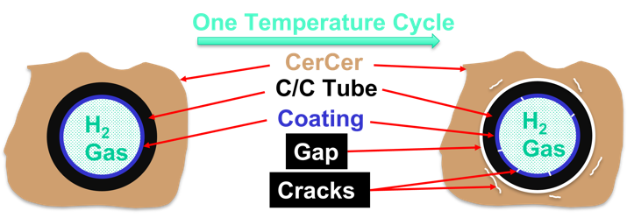
Fig. 3. Potential material behavior as C/C tube undergoes first temperature cycle.

The left side of the image in Figure 3 is a rendering of the pristine C/C tube, coating, and CerCer interfaces. The right side of the figure denotes the gaps and cracks that may form under temperature due to the CTE mismatch. At the CerCer to C/C tube interface, a gap will open between the CerCer and the C/C tube due to the much larger radial CTE of the CerCer material. The gap will reduce or eliminate conduction heat transfer, which requires intimate contact between the fuel and the tube. This loss of heat transfer will directly correlate with a loss of engine efficiency and thrust due to the subsequent lower propellent temperature. At the C/C tube to coating interface, cracks will form in the coating. The cracks may be through cracks, or cracks that go through the entire coating, allowing the hydrogen gas to reach the C/C surface and, thus, begin corroding the carbon. Cracking and/or crushing within the CerCer material is also possible, and the likely extent and consequences of cracks within the CerCer are currently unknown. If the C/C tube were to be eliminated and the flow channels for the hydrogen gas were coated directly, the issue of coating cracking due to CTE mismatch would likely remain, but without the structural protection of the C/C tube. The CerCer does not have the structural strength necessary to resist the hydrogen gas pressure at operating conditions without the C/C tube.
IV. POTENTIAL DESIGN SOLUTIONS
Over twenty different design solutions were proposed to address the issues derived from material CTE mismatch at material mating interfaces. The design solutions were investigated using finite element modeling (FEM). The FEM allowed the determination of stress states for the solutions that could then be compared against both material failure properties and other solutions. The C/C tube was modeled with appropriately modified Advanced C/C-6 (ACC-6) properties to match the filament wound patterns. The coating was approximated as Zirconium Carbide (ZrC). Due to lack of material properties for the CerCer, the CerCer was modeled as a large (minimum three times the size of the C/C tube diameter) section of ZrC. The materials and properties were chosen in accordance with the rest of the larger NASA effort³ and remained constant between solution comparisons. In future work, a better understanding of the CerCer material and mechanical properties will allow for more accurate models and better comparison and selections of potential design solutions.
Four of the more promising design solutions will be discussed along with their advantages and disadvantages. Of important note, none of the four proposed solutions presented will completely solve all the interface problems and may create new problems. The presentation of the four potential design solutions is meant to promote discussion and facilitate new and improved ideas for heat exchange tube integration into an NTP engine. Tailoring the C/C tube layup during the filament winding manufacture process to modify the C/C tube CTE would be an ideal solution. However, a direct match of the different CTEs over the temperature range is not feasible.
IV.A Flowing Helium
A proposed design solution utilizing flowing helium (He) between the CerCer and the C/C tube is depicted in Figure 4. The helium gas would flow in a gap between the CerCer and the C/C tube. The flowing helium would allow the gap width to increase and decrease between the CerCer and C/C tube during temperature cycling while maintaining adequate heat transfer. The helium must be hot and flowing to obtain the necessary heat transfer to the hydrogen propellent. Passive heat pipe designs analyzed did not give promising results. Therefore, pumps and other machinery needed to operate at 2900 K are required, but may be difficult to obtain and integrate. If the helium cannot be recirculated and must be expulsed, an extra tank to carry helium would be required resulting in additional weight and complexity. The problem of the C/C to coating interface remains an issue in the flowing helium design.

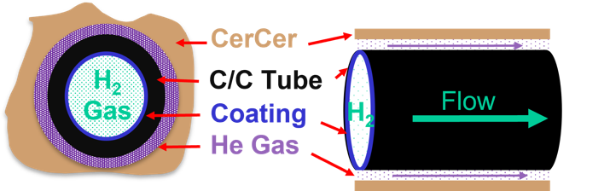
Fig. 4. Flowing Helium proposed design solution.

IV.B Restrained System
A proposed solution utilizing a restrained system is depicted in Figure 5. In the restrained system design solution an additional, larger, C/C tube is added to the outside of the system. The outer C/C tube would restrain the CerCer radial expansion. Manufacturing of a larger diameter C/C tube can be easily accomplished and no major challenges integrating the additional tube in the system have been seen. The restraining of the CerCer would reduce the issues between the CerCer and C/C tube, however, a gap would still form and the potential reduction in heat transfer due to a gap is not completely solved. Additionally, due to the stresses generated, the outer C/C restraining tube would need to be much thicker than the heat exchange tube, which would reduce the number of fuel elements that could be integrated into a moderator core. Due to the project’s current fuel selection, a reduction in the amount of radioactive fuel in the engine should be avoided.³ Crushing of the CerCer is probable and may not be deemed acceptable. The issue of the C/C to coating interface is not addressed in the restrained system design.

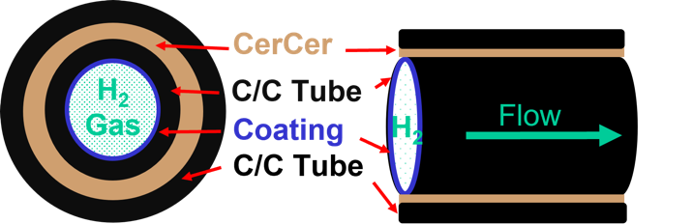
Fig. 5 Restrained system proposed design solution.

IV.C Melt Layer
A proposed design solution utilizing a melt layer between the CerCer and the C/C tube is depicted in Figure 6. The intent of the melt layer design solution is similar to the flowing helium design solution previously discussed, in that an additional layer of material between the CerCer and C/C would be integrated into the system. The melt layer material would be chosen such that the material would melt prior to approximately 1000K and expand under heating such that the gap between the CerCer and C/C tube would be filled with the melt layer material. Preventing the formation of the gap would eliminate the CerCer to C/C interface issue and the design is relatively simple to integrate. However, an appropriate melt layer material has yet to be identified. The candidate material must match the neutronics of the system, have high thermal conductivity, and an appropriate expansion during the phase change from solid to liquid. A failure to comply with the material requirements may lead to a reduction in NTP engine performance. The issue of C/C to coating interface is not addressed in the melt layer design.
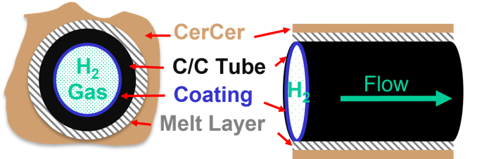
Fig. 6. Melt layer proposed design solution.

IV.D Inverted System
A proposed solution utilizing an inverted design is depicted in Figure 7. The inverted system design solution inverts the design at the fuel element level. In the nominal design the fuel element is comprised of CerCer with channels machined through the length. C/C tubes line the channels and the hydrogen propellent flows through the interior of the C/C tubes. In the inverted design, the fuel element is comprised of multiple CerCer rods. The CerCer rods are then encapsulated in the C/C tubes and the hydrogen gas flows around the exterior of the C/C tubes. The C/C tubes must be coated on the exterior rather than the interior to protect the C/C from being exposed and thus corroded from the hydrogen gas.
The inverted design may improve both the CerCer to C/C tube interface as well as the C/C tube to coating interface. The inverted design is the only proposed design that addresses the C/C to coating interface. However, the inverted design is complicated and requires changes that affect the rest of engine integration, likely necessitating a complete engine redesign. Additionally, the larger radial CTE of the CerCer would likely crush at least the outer edge of the CerCer. Furthermore, coating cracks may open during cooling.

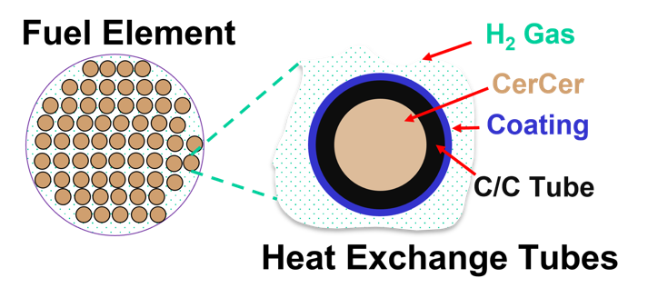
Fig. 7 Inverted system proposed design solution.

IV.E Discussion of Design Solutions
None of the preceding four proposed design solutions completely address all material interface problems and all solutions create new challenges. The most promising designs at present are the flowing helium, melt layer and inverted designs. The advantage of the flowing helium and melt layer designs is that both designs structurally decouple the C/C tube from the CerCer while maintaining efficient heat transfer. The inverted design potentially allows for the introduction of compliance by allowing a limited amount of crushing of the CerCer. All three designs follow a similar methodology of introducing compliance into the material system to prevent or control cracking in the system in permissible ways. The flowing helium, melt layer, and inverted designs all require additional refinement and understanding, but all merit future study. The restrained design is unlikely to be selected as a final solution in part due to the high stresses involved as well as the large reduction in nuclear fuel as compared to the baseline and other three proposed designs.
A better understanding of the mechanical behavior of the nuclear fuel material is needed to improve design approach and analytical models. In particular, most or all solutions will allow coating cracking at least during a portion of the heating cycle. These cracks can be designed to close up at operating temperature but may permit hydrogen gas leakage at lower temperatures. An understanding of the systems tolerance to contaminants would be helpful to understand if using a flowing helium or melt layer is a viable approach. Finally, using the inverted system would work by allowing compression and some degree of local damage to the outside layer of the CerCer. Understanding if this is permissible to the NTP system is needed.
V. CONCLUDING REMARKS
Differences in material CTE between the heat exchange tubes and nuclear fuel may lead to reduced performance of an NTP engine or potential failure if not properly addressed. Two distinct interfaces, between the C/C tube and the CerCer and between the C/C tube and the coating, are the most cause for concern. Four different design solutions were proposed and the advantages and disadvantages of each were discussed. While none of the four solutions completely address all the material interface challenges, the flowing helium, melt layer, and inverted designs are considered the most promising for future development. A better understanding of the mechanical behavior and system requirements of the CerCer nuclear fuel under thermal loading is necessary to refine analytical models and more accurately investigate and improve design solutions that would address the material interface challenges. Due to the nature of NTP engines, a high number of dissimilar materials will always be present in the designs. The issue of CTE mismatch is not unique to the C/C tube heat exchange design. As investments in NTP increase documentation and dissemination of lessons learned in design and testing will be important to create a successful and enduring mission in a timely manner.

ACKNOWLEDGMENTS
The authors would like to thank Dr. Anthony Calomino and the NASA Space Technology Mission Directorate, which funded this work through the Space Nuclear Propulsion project.
REFERENCES
- National Academics of Sciences, Engineering, and Medicine 2021. Space Nuclear Propulsion for Human Mars Exploration. Washington, DC: The National Academies Press. https://doi.org/10.17226/25977.
- W. ROBBINS, “A Historical Perspective of the NERVA Nuclear Rocket Engine Technology Program,” Conference on Advanced SEI Technologies, Cleveland, OH, 4 -6 September 1991
- J. CLINE, S. LANGSTON, C. POTEET, B. KOWALSKI, N. JACOBSON, M. KUCZAMARSKI, J. JOHNSTON, J. HASKINS, W. TUCKER, C. BAUSHLICHER, J. CHO, C. HILL, I. MORALES, R. GONZALEZ, J. HAWBAKER, B. PATEL, A. CALOMINO, “Carbide Coated Carbon-Carbon Heat Exchange Tubes for Nuclear Thermal Propulsion Fuel Assembly,” Nuclear Emerging Technologies for Space 2023, Idaho Falls, ID, 7-11 May 2023.

