Application and Use of Lunar Node-Derived Beacons for Lunar Surface Navigation
(Preprint) AAS 23-XXX
Evan J. Anzalone, Tamara Statham, and Michael Fritzinger
To maximize the scientific return and safety of operations on the lunar surface, multiple civil organizations are investing in Position, Navigation, and Timing infrastructure. This approach mimics the deployment of Global Navigation Satellite Systems around the Earth and aims to enable a similar robust capability around the moon. With these satellites, it will be possible to maintain high- fidelity knowledge of positioning and timing both on the surface and in orbit. For initial deployments, this capability is focused on high need areas, such as the Lunar South Pole, the target of the currently in-planning Artemis surface missions to high accuracy. Similar to GNSS systems, this capability will be implemented over time to build up to a level of global access for real-time navigation. For early missions, this means a limited capability in terms of coverage. To provide increased performance, ground augmentation can be leveraged. This not only provides an additional reference signal but helps to supply timing to enable a high accuracy real-time position solutions. This paper discusses the path towards evolving the Lunar Node 1 platform to augment these early constellation deployments. Analysis of notional performance with and without surface aids is provided, as well as discussion and paths towards deployment and operation. Given the analysis results, the benefit of surface navigation aids to both provide additional surface-based signals to fill in coverage gaps helps to provide additional robustness and an early-on capability.
Introduction
Operations on the moon lunar surface present a bevy of challenges and an endless number of opportunities. One of these is the need to understand where any asset (such as a person, lander, or rover) is at a given time, as well as understanding the onboard time of the asset itself. These are needed from a science perspective in order to correlate any observations, samples, or data collected to a global frame enabling comparison with results from other missions. There is also an operational aspect to this data, enabling the placement and movement of assets into the desired location to collect the required data. An example is the Volatiles Investigating Polar Exploration Rover (VIPER) rover mission, which based on the landing accuracy and initial, it will need to be driven in order to reach the primary areas of scientific interest, a Permanently Shadowed Region. After observations are complete, the rover would then need to be able to travel to the next site of interest and navigation around potential hazards.
Human-centric operations will face very similar challenges to any robotic explorers. A well-discussed example can be taken from Apollo 14. During this mission, the combination of the gently sloping environment and reliance on visual navigation, let to the crew coming within 15 m of the primary target, Cone Crater. Without an external reference to provide a navigation solution, it is incumbent upon the crew or flight operations to track the current position on the surface using large surface features, heading to the sun, and number of steps (or time walking) to track their location. This can be especially difficult in an environment without many large surface features and limited visibility of surface depressions. In these environments, it is difficult to tell where a craters ends since your line of sight is over the rim and it is difficult to tell the difference between a shallow hill and a deep crevasse until you are on its edge.
This scenario is a good example of the challenges faced when operating on the lunar surface. As aspects like a Lunar Terrain Vehicle) or Pressurized Rover are included into the architecture, the crew will be able to travel much greater distances than on foot. This provides an incredible opportunity for exploration and discovery, but bring with it a large number of contingency scenarios that need to be addressed. Many of these are reliant on the ability and accuracy of onboard navigation knowledge to enable robust and quick path-finding for quick recovery. In order to address this, the architecture, requirements, and approaches are continuously assessed to ensure the right capability is fielded at the right time to ensure safety and mission success.
Navigation Architecture Developments
There has been much documentation and architecture work over the decades since Apollo to formulate how to achieve the high accuracy navigation needed on the lunar surface. During the Constellation era, the implementation focused on the usage of a mixture of satellites and ground assets to provide a localized navigation capability. Other studies have looked at large constellations of satellites, similar to GNSS, to provide a local capability. In addition to local assets, there has been a large growth in the capability to utilize terrestrial GNSS signals at and near the moon to perform onboard navigation. This will be demonstrated by payloads such as LUGRE, that will capture data on cruise to and from the surface of the moon to validate this capability.
With the current international and commercial push to the moon, these concepts are moving from ideation to formulation and implementation. Currently multiple agencies are investing in infrastructure to enable navigation and communication by means of lunar satellites. Guiding architectural efforts such as LunaNet and ICSIS have laid the groundwork for interoperabilty and high level approach to these services at an international level. For NASA, the focus is on the the Lunar Communications Relay and Navigation Services = procurement, which focuses on high level requirements such as coverage and navigation accuracy. This leaves specifics about satellite hardware, orbits, and daily operations to a potential provider to define. The intention with teh procurement approach is to make NASA one customer of many, and supporting development and deployment of an infrastructure that will be used by both commercial and government missions (includes the developers of other services that NASA is procuring).
The European Space Agency (ESA) is taking a slightly different approach. Their primary focus is the deployment of the Pathfinder mission as the first node in a larger constellation as part of their Project Moonlight. Commercial launch providers are also deploying similar communication capabilities for far-side missions, such as the Intuitive Machines’ IM-3 Mission. In addition to this, JAXA is also investigating navigation techniques for surface operation.
Analysis Framework and Background
This analysis aims to provide insight to the potential orbits and performance impacts to a surface user over the course of initial deployments. In order to provide insight, individual satellites orbits and a surface user were simulated within a MATLAB analysis framework to perform such functions as calculating the line of sight between satellite and surface user, generating measurements, processing measurements within a low fidelity Extended Kalman Filter, and performing Monte Carlo analysis. The orbits themselves were developed using the GMAT to aid in visualization and initial coverage analysis. The back end for this navigation analysis (including filter derivation) consists of a straight-forward 3 error state formulation. This assumes a fixed surface user. This scenario was selected to emulate an operational scenario where a user on the surface of the moon (particularly an astronaut out on an EVA) is performing science or engineering tasks within a small footprint. This allows approximation of the use’s location and sets bound for the highest accuracy being assessed. This simulation tool was also used for previous analysis focused on orbital users . The key difference with a static user is not solving for a velocity state in the inertial frame. Whilst the user will have a small velocity due to the angular velocity terms, this is considered negligible for this analysis. Between each update of the filter, the state is reported out in a body-fixed frame. This would be necessary for navigating using references such as maps. One caveat to this analysis is that the user’s clock drift is not modeled as an error term. This error will need to be considered in more detailed analysis. For the static user scenario being presented, it is assumed that the user has the ability to perform a time synchronization prior to the analysis here for surface location and a sufficiently accurate clock to maintain short term stability. With a full constellation in view with adequate geometry, this term can be easily solved for and estimated on the user side, enabling a high precision time synchronization to the satellite -based timing system.
Table 1 Simulation Ground Rules and Assumptions
Variable | Value | Rationale
User Location | 89.5S x 90W | Provides a relative user in the Lunar South Pole Region
Initial Position Error | 2 km per axis normally distributed | Provide an upper edge for a potential area of operation for an early traverse
Time between Updates | 1 Hz | Based on terrestrial capabilities, assuming a moderate rate of measurement updates once initialized
Number of Runs in Monte Carlo | 100 | Provides an initial insight into average performance given randomly distributed errors on measurements
Navigation Measurement and Ephemeris Errors | … | Aligned with LCRNS SRD to capture a notional set of errors in-flight

The orbits were developed in GMAT using reference literature to capture two extremes of potential navigation constellation design. The first, consisting of Elliptical Frozen Orbits (ELFO) is an orbital design that can allow for maintaining coverage of the South Polar region with a minimal number of satellites. A large amount of work has been done to assess these orbits and show their benefits. Using this orbit, two satellites can be phased appropriately to always have one in view over the South Pole to enable communication to Earth at all times. While very beneficial for communication, this orbit has limitations for navigation. Due to the high elliptical and hovering over the South Pole, there is only a slowly observing change of observation geometry that can be used to support navigation. This is better than the results for a NRHO orbit, though, where the spacecraft would essentially be a fixed point in the sky over a notional 8-hour duration traverse.
In order to achieve a real-time navigation accuracy, additional satellites are needed. One approach would be to simply phase additional assets (both into the same orbit) into multiple orbits. By doing this, sets of satellites can be phased appropriately enabling long periods of time with 4 references in view. The limitation is that by being phased in this manner, all 4 would also be out of view of the Pole at the same time, therefore additional satellites would be needed, in sets of 4, to increase coverage. This analysis assumes 6 satellites to capture an initial deployment that both meets requirements for always available communication coverage to 2 assets (one backup) and maximizes time with 4 assets in view. The orbital parameters and satellite numbering (used throughout this paper) is given in the table below with a pictorial of the configuration given in Figure 1.
Table 2. ELFO Orbits Being Analyzed
Sat: | SMA (km) | ECC | RAAN (deg) | INC (deg) | AOP (deg) | TA (deg)
1 | 6142.4 | .6 | 0 | 57.7 | 90 | 0
2 | ‘ | ‘ | 90 | ‘ | ‘ | 0
3 | ‘ | ‘ | 180 | ‘ | ‘ | 0
4 | ‘ | ‘ | 270 | ‘ | ‘ | 0
5 | ‘ | ‘ | 180 | ‘ | ‘ | 190
6 | ‘ | ‘ | 180 | ‘ | ‘ | 150

An alternate extreme approach is to put the satellites in the constellation in very low orbits. These would also need to be polar in order to support regular coverage of the South Pole region. This paper includes a series of deployments of Low Lunar Orbit satellites in a 100 km circular orbit to capture a scenario in which there would be a rapidly observable change in observation geometry over a navigation pass. The downside to this approach is the larger number of satellites required for coverage with multiple satellites in view for a large amount of time. For example, the pass duration is much reduced from the earlier scenarios; and to maintain full-time communication would require a minimum of 8 satellites (with minimal overlap). These constellations were included in the analysis here to provide an alternate method for deploying comm and navigation services. The phasing of the individual satellites can be seen in Table 3 below. The numbering of the satellites is set to show a buildup from 1 satellite to 4 that are 90 degrees apart to 8 that are 45 degrees apart. This is intended to simulate a phased deployment approach. The numbering picks up after the elliptical orbits to allow for scenarios where both are considered. Figure 1 below provides insight into the integrated geometry of the two constellations.
Table 3 LLO Orbital Parameters
Sat: | SMA (km) | ECC (deg) | RAAN (deg) | INC (deg) | AOP (deg) | TA (deg)
7 | 1837 | 0 | 0 | 90 | 0 | 0
8 | ‘ | ‘ | ‘ | ‘ | ‘ | 90
9 | ‘ | ‘ | ‘ | ‘ | ‘ | 180
10 | ‘ | ‘ | ‘ | ‘ | ‘ | 270
11 | ‘ | ‘ | ‘ | ‘ | ‘ | 45
12 | ‘ | ‘ | ‘ | ‘ | ‘ | 135
13 | ‘ | ‘ | ‘ | ‘ | ‘ | 225
14 | ‘ | ‘ | ‘ | ‘ | ‘ | 315

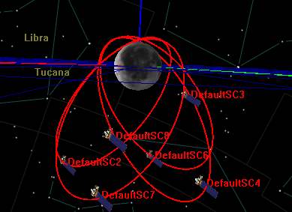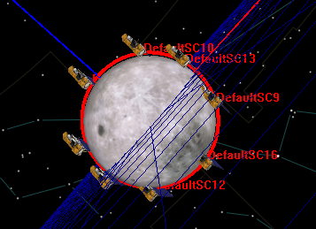
Figure 1. Visual Imagery of (L) ELFO and (R) LLO Constellations
This analysis focused on the performance of these two orbits with and without surface aiding radiometric beacons. Additional orbits are certainly feasible and could be assessed, including higher altitude polar orbits or other families of elliptical orbits. Satellites placed in NRHO such as CAPSTONE or Gateway could also provide navigation services if adequate assets were phased across the orbit. Additionally, these orbits have unique orbital characteristics that can help to inform user navigation, impacting number of asset in view needed and/or time to a desired solution. The main drawbacks from this approach would be the larger satellite size required to receiver communication signals from the planet. There are a plethora of options that can be considered for both deployment schedules, approaches, and orbit design that are outside of the scope of this paper. This starting point was selected to provide insight into promising designs of literate that help to bound the problem from a navigation perspective in terms of the variable observation geometry of the solution.
To provide insight into coverage capability, the line of sight between the satellites for each configuration and a user on the South Pole region was calculated. The plot below provides an overview of the repeating patterns for each constellation type over the course of one day. For the LLO orbits, the rapid passes are seen in the transitions from one to another, with minimal overlap. Figure 2 below shows the difference in coverage between 4 and 8 satellites. The main takeaway is that for continuous coverage for comm, greater than eight satellites would be required.
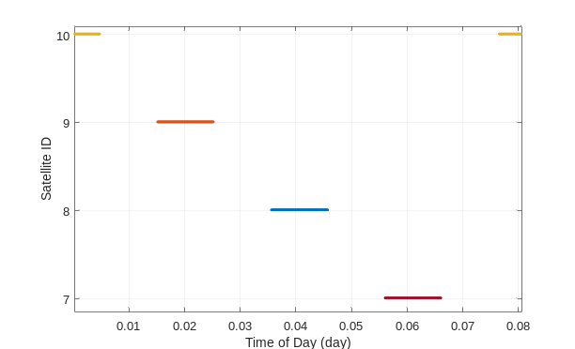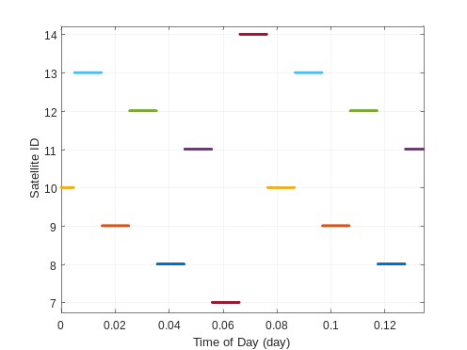
Figure 2. Coverage of LLO Assets for (L) 4 and (r) 8 Equally Space Assets
Figure 3 shows a similar result but for the Elliptical Frozen Orbit (ELFO) scenarios. Here it can be seen how the phasing of the 4 satellites 1-4 come over the ground site at the same time, enabling a high degree of observability into the surface state. The additional two sats, 5 and 6, were added in to a matching orbit to 2, to demonstrate a potential mixed constellation of ELF-based assets, providing both comm and nav. As can be seen, the 4 satellites have limited time out of line of sight, with the two other satellites phased to ensure 1-2 comm assets always in view. This constellation can achieve 100% com with 2-3 satellites with additional phased satellites to achieve geometry disparity for navigation needs.
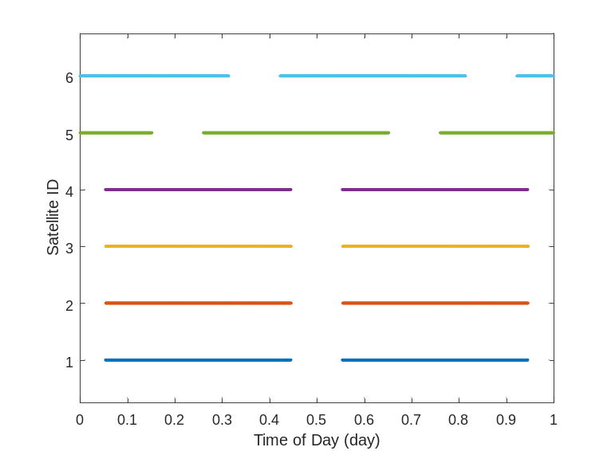
Figure 3. Coverage of ELFO Assets
Analysis Approach and Transient Capability
In order to assess the capability of the orbital nodes as a function of their deployment, a static user on the surface was used (as stated above). This user was placed at a fixed location on the lunar surface (90X89.5) at an altitude of 0m (assuming a spherical moon). The first part of the analysis is to assess the ability of the various configurations to reach desired accuracy levels of 10, 50, and 100 m normalized errors. These levels were chosen to align with the potential capabilities laid out in the SRD for surface user requirements, and provide insight to real-time capabilities greater than that achieved in the Apollo missions. For each of these scenarios, a Monte Carlo was performed with a start synced with an overhead satellite passing overhead. 100 cases were run for each simulation scenario and were used to capture the average error across runs at each point in time. This allows for an assessment of the capability of the filter to localize the user as a function of random errors (as opposed to a purely covariance-based analysis).
The navigation errors of the various cases are given below in Figure 4. As seen in the figure, the added benefit of having additional satellites within the ELFO configuration is very clear. With 3-4 satellites, the surface user is quickly able to determine their location to high precision. The case of two satellites in view is also able to achieve similar precision, but at a much longer duration. The results for one ELFO asset show the sensitivity to the observation geometry, due to the slow-moving dynamics a much longer pass is required in order to achieve similar results. Similar behavior is identified with the LLO cases. The surface user may be able to quickly attain errors less than 100 m, but the achievement of great accuracy is a function of gathering more observations. The more satellites overhead, the quicker a 10 m accuracy can be attained. For both the 4 and 6 satellite scenarios, the ability to quickly reduce error is due to the limited time between passes. As such, the time to reach a high level of performance is directly correlated with how long you have satellites in view, and the results here show that two passes with some overlap help to provide the most rapid path to reduction in errors, though this will become difficult to scale up for always-on coverage.
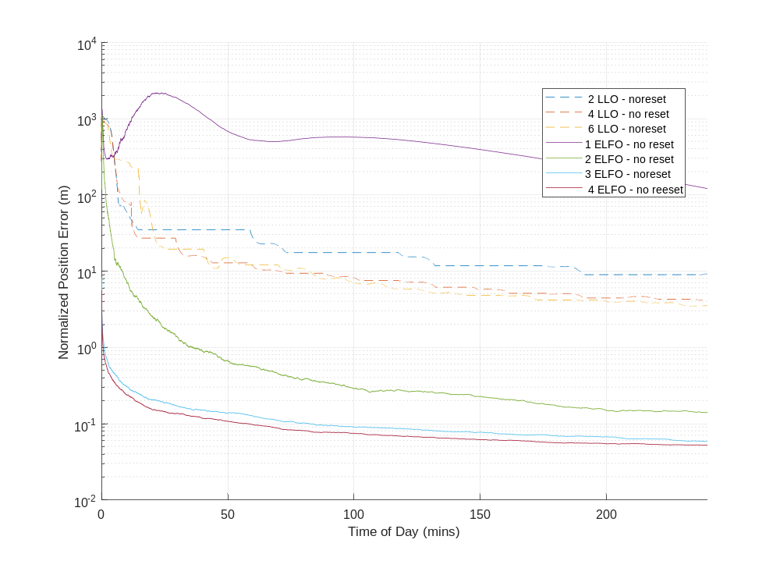
Figure 4. Long Duration Navigation Capability
While the above provides insight into the performance of a specific constellation once it is in view, it is also useful to assess the longer-term stability. This is especially important for scenarios operating under limited initial deployments. For example, even in the case of 4 EFLO satellites while can provide real-time high accuracy coverage over a portion of each day, this may not align with the additional mission constraints and timeline planning. The ability to understand the impact of navigation capability as a function of deployment over the course of a day can provide insight into the level of impact into surface operations. For example, this may limit surface traverse to certain times of each day. For crewed EVAs, this may interfere with larger mission planning aspects or for telerobotic platforms, provide an upper bound or constraint on primary operations. The impact of this may be as simple as deriving mission operations around constellation availability.
In order to assess the long-term and transient performance of each potential deployment, a series of Monte Carlos were performed capturing navigation capability over the course of a day. In order to provide a measure of robustness of surface navigation to the constellation, the simulations include a hard reset on navigation errors every 10 minutes. This number was chosen in order to provide a notional duration for surface activities when a crew member (or vehicle) would stay within a small are doing surface science or engineer activities. In order to capture this metric, the static surface’s position was re-initialized to a random error based on the input parameters. The navigation filter is then allowed to run for 10 minutes in order to provide insight into answering the question: “at any point during the day, what is the probability to achieve a given navigation accuracy within 10 minutes”. The above results show the capability and duration required for initialization or anchoring or locations to the lunar surface, but these transient results help to inform mission planning over the course of a traverse (which may be as long as 8 hours).
ELFO Constellation Capability
For each set of scenarios, results are shown below both capturing both statistics on time of number of satellites in view as well as integrated performance. Table 4 shows the growth of coverage statistics as a function of the increased constellation size. As seen in the diagram, each satellite’s orbit provides coverage of the South Pole for 78% of the day, and as more satellites are aligned, this number stays constant. The addition of assets in differently oriented orbits primarily impacts the time when no satellites are visible, directly correlating with the additional satellites included. For this analysis, the 2 additional satellites in the 6 asset constellation, are in the same orbit as the first asset but phased. This was designed to maintain two satellites in view over the user, enabling a redundant capability. As such, these are out of alignment with the other 4 and while they do have some overlaps, all 6 are never visible at cone.
Table 4. Coverage Statistics for ELFO (% of Day)
Case | 0 | 1 | 2 | 3 | <4 (sum of previous) | >=4
1 EFLO (1) | 21.7 | 78.3 | 0 | 0 | 100 | 0
2 ELFO (1+2) | 21.6 | 0.3 | 78.1 | 0 | 100 | 0
3 ELFO  (1+2+3) | 21.5 | 0.2 | 0.2 | 78.1 | 100 | 0
4 ELFO  (1+2+3+4) | 21.5 | 0.1 | 0.3 | 0.1 | 21.9 | 78.1
6 ELFO  (1+2+3+4+5+6) | 0.0 | 0 | 21.5 | 0.1 | 21.6 | 78.4

The navigation errors provide a similar insight. For the initial deployment of only 1 or 2 satellites, there is only a limited capability for achieving <100 m accuracy. Similar to the transient results previously presented, the accuracy is dependent on having two assets in view at once, and as such, there is a high correlation between accuracy and constellation density. Table 5 shows the integrated results below.
Table 5. Performance for ELFO Constellations (% of Day)
Case | t < 10 m | t < 50 m | t < 100 m
1 EFLO (1) | 0.2 | 3.1 | 7.9
2 ELFO (1+2) | 20.7 | 52.8 | 63.0
3 ELFO (1+2+3) | 78.6 | 79.3 | 79.4
4 ELFO (1+2+3+4) | 78.9 | 79.4 | 79.4
6 ELFO (1+2+3+4+5+6) | 80.3 | 83.3 | 86.7

The reduction noted here, from 78% time with 2 in view to 63% time with errors < 100 m is due to the transient and time required to capture enough data to be filtered to reduce the estimation errors. With the inclusion of more satellites, the constellation is robustly capable of providing <10 m accuracy within 10 minutes over 78% of a day, closely mimicking the time in view of 3 satellites (78%). The slight increase here is primarily due to a 10 minute scenario where the satellites are out of view, but the solution has already been achieved. This can be cleanly seen in the Figure 5below that provides the average error over the 4 ELFO Constellation compared to the satellite coverage. The left y-axis is presented a logarithmic scale showing rapid drop in error when the third satellite comes into view. This also provides insight to show that though in phased orbits, the coverage is not completely synchronized,. The coverage edges aligning with the 10 minute cycles modeled cause the slight shift in statistics.
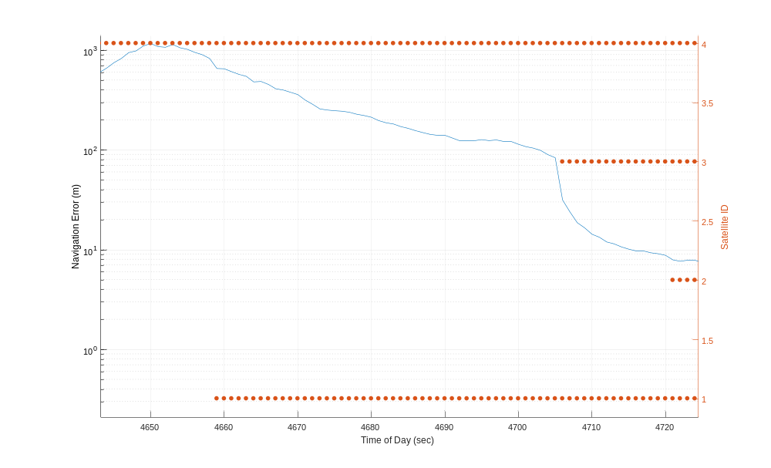
Figure 5. Error and Coverage for 4 ELFO Constellation

This aligns with the ability to converge to a high accuracy solution quickly with 3 or more satellites in view. With 6 satellites, the capability only slightly increases, primarily due to the fact that these provide 2 additional satellites in view simultaneously with the other 4 as seen in Figure 1,. Conversely, they may be the only satellites in view and such take longer to achieve high precision. This is seen in the overlap for the 3 satellites phased within the same orbit. As such, the duration does not increase to 100%. To achieve this, three or more satellites would need to be in view with adequately dispersed geometry.
It is important to note the correlation between high performance and the scenario being assessed in this simulation. For example, the time error of the user is not modeled here. While timing synchronization could be achieved over a longer term initial fix with other ground hardware such as over a network and a sufficiently capable oscillator, this was assumed primarily to allow the analysis to focus on larger architecture trades. As seen here, the difference between 3 and 4 satellites in view in minimal. This is primarily due to not modeling user-side clock biases. For example, in a terrestrial GNSS-scenario, 4 satellites in view are needed to determine 3D position and a user time bias. This same constraint would hold for an instantaneous solution on the lunar surface. Either solving only for a time synchronization, fewer satellites area needed.
LLO Constellation Capability
With the results of ELFO orbits given, the LLO should also be characterized. As shown above, the time to reach a given accuracy level is wholly dependent on being able to get at least 2 passes of LLO. As such, the time to solution is dependent on the time of day and phasing of the satellites. In contrast to the ELFO results, the LLO constellation (As defined) typically only has 1 asset in view. Seeing two in view is only possible on the transitions, when there are coverage overlaps between satellites. But this does provide a path of 8 satellites to maintain near-full-time coverage of the lunar south pole. A summary of this coverage is given in Table 6.
Table 6. LLO Constellation Coverage (% of Day)
Case | 0 | 1 | 2 | 3 | <4 | >=4
1 LLO | 87.9 | 12.1 | 0 | 0 | 100 | 0
2 LLO | 75.5 | 24.5 | 0 | 0 | 100 | 0
4 LLO | 50.8 | 49.2 | 0 | 0 | 100 | 0
6 LLO | 26.1 | 73.5 | 0.4 | 0 | 100 | 0
8 LLO | 1.9 | 97.7 | 0.4 | 0 | 100 | 0

The performance over the day for short periods of time is a clear handicap of this solution. While it is possible to achieve moderate performance, this is limited by having adequate time to get multiple satellites in view over a 10 minute pass. For example, due to the short passes for lower altitude satellites, while the geometry does provide good insight, limited constellations have larger gaps, impacting overall capability over an entire day. These results are given in Table 7 below.
Table 7. LLO Constellation Performance (% of Day)
Case | < 10 m | < 50 m | < 100 m
1 LLO | 0.5 | 2.7 | 4.7
2 LLO | 1.1 | 5.4 | 9.3
4 LLO | 2.2 | 10.7 | 18.1
6 LLO | 8.1 | 27.5 | 37.3
8 LLO | 13.1 | 42.6 | 54.9

Paths to Augmentation
As shown, these constellations can be deployed to provide a high-quality solution. Their robustness is primarily a function of the number of assets. Similar to the phased build-out of GNSS systems, these constellations will take time to be put into place. As such, it is important to understand what methods are available in order to provide additional observations or methods that can be used to take advantage of the signals that are there. This helps to provide improved capability early on, and can provide an approach to augmenting potential dead zones in any constellation This can also be used to help support scenarios where orbital signals may not be able to reach the surface due to either line of sight constraints (For example, being deep in a crater or near a large terrain features that blocks a portion of the sky, or within a geological structure such as a lava tube) or providing backing services in a contingency scenario. There are two main approaches to this: software and hardware. Each will be discussed separately.
A software solution of value is to take advantage of the operational constraints of a surface user. Primarily, that they are fixed to the lunar surface. This can be interpreted as a reduction of degrees of freedom, as the two degrees of latitude and longitude defines a given altitude based on a digital elevation map. As such, this can be interpreted as applying constraints to the position estimate, such as being fixed on a surface of known radius (in terms of the Moon, knowing latitude and longitude defines the attitude based on a digital elevation map). To model this, a radial position constraint was also applied to this scenario, i.e. the user is fixed on the surface of a sphere of the lunar radius. This was applied within the navigation filter as range measurement from the user to the center of the frame. The results of the same cases in Table 8 are shown below. This is similar to alternate methods that take advantage of high fidelity DEMs and gravity models to perform localization. As shown, this constraint provided minimal benefit when adequate satellites are in view to determine a 3-D fix. But for the scenarios for one or two satellites, this provided both a sizeable jump in coverage at medium performance (case 1) and increases in accuracy (case 2). As shown, this surface constraint can help to aid navigation, but primarily focused on when there are limited assets in view. While this analysis did assume a spherical moon (which is not nearly the case at the poles), it does provide support for further refinement of this approach through the inclusion of DEMS within an local navigation model.
Table 8. Impact of Applying Surface Constraint to ELFO Scenarios (% of Day)
Case | < 10 m | < 50 m | < 100 m
1 EFLO (1) | 15.3 | 48.9 | 60.7
2 ELFO (1+2) | 71.0 | 79.4 | 79.8
3 ELFO (1+2+3) | 79.0 | 79.5 | 79.8
4 ELFO (1+2+3+4) | 79.2 | 79.6 | 79.9

An alternate approach is to provide additional signals of opportunity. These can provide stopgaps and improve diversity for a local area. These can take many forms and hosts. For example, one approach is to deploy surface navigation beacons that transmit similarly coded signals to those being transmitted by orbital assets. These surface nodes need to be able to account for interference and ephemeris integration (for example, identifying a node is a fixed asset vs in orbit and the appropriate way to share that information in a format consistent with an orbital satellites). This can be accomplished by frequency diversity and/or custom messaging within the signal standards. Alternately, terrestrial approaches to ranging such as used in radio networks (REF RF Positioning) can be used to provide a ranging measurement to a fixed ground asset. The main limitation of these will be line of sight. While for early missions, the largest traverses may be only 2 to 10 km , local terrain and deployment approach will need to be considered. There are similar constraints on surface users staying within line of sight for communication to a central asset. As such, these surface communication hosts can also be used to host navigation beacon hardware. One implementation of a hosted navigation beacon is Lunar Node -1, which is discussed in more detail in the following section.
Aiding Orbital Relays via Lunar Node-derived Ground Nodes
As mentioned above, surface beacons provide an opportunity to augment orbital signals to improve navigation capability for early missions. Lunar Node 1 (LN-1) is an S-band Navigation beacon for lunar applications that was recently designed and built at MSFC. LN-1’s goal will be to demonstrate navigation technologies that can support local surface and orbital operations around the moon, enabling autonomy which would decrease dependency on heavily utilized Earth based assets like the Deep Space Network (DSN). To do this, LN-1’s design leverages Cubesat components as well as the Multi-spacecraft Autonomous Positioning System (MAPS) algorithms, which enable the autonomous spacecraft positioning through communication-integrated navigation measurements. In addition to demonstrating the MAPS payload, the radio will also be used in PN-based one-way non-coherent ranging and Doppler tracking to provide alternate approaches and comparisons for navigation performance. LN-1 will represent a single node in a potential greater MAPS network of assets.
LN-1, shown below in Figure 6, is being developed as a payload part of NASA's Commercial Lunar Payload Services initiative. It will be delivered to the Moon's south pole by Intuitive Machine's NOVA-C lunar lander in 2023. The lander provides a host interface, including power and commanding and transports the payload to the lunar surface. The payload takes advantage of modern cubesat technology to create a small footprint, lower power platform to allow for demonstration of the MAPS technology.
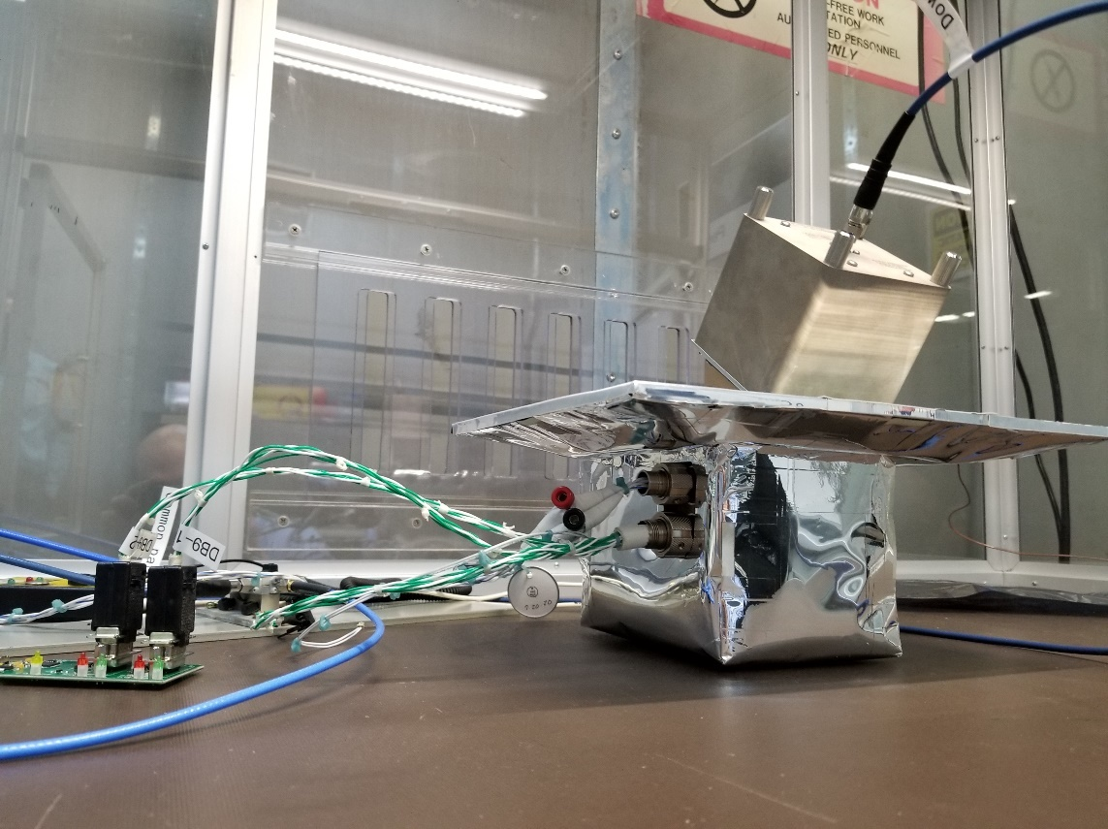
Figure 6. Lunar Node - 1 During RF Compatibility Testing at DSN/DTF-21
Concept of Operations
A diagram of the LN-1 concept of operations is shown below in Figure 7. LN-1 will sync its internal time and state to that of the lander from its best estimate. All commanding and health and status will be relayed through primary payload telemetry. The payload includes an independent high stability oscillator and S-band radio to support communications back to Earth. Over the course of the trans-lunar cruise and lunar surface operations, LN-1 will broadcast out its state and timing information back to Earth for several observation passes to the DSN. Upon reception of this data, high accuracy packet reception timestamps will be used (along with atmospheric data for induced delays) to assess a ranging observation. This data will be captured across multiple passes to compute a navigation state of the payload over the mission. In addition to broadcasting telemetry, the payload will operate switch to a one-way PN ranging tone consistent with the JPL definition to capture long-term stability and performance. Similarly, there are plans to include potential VLBA observations to provide a completely independent navigation solution. As such, post-flight Lunar Node-1 will be able to compare performance across multiple methods: radiometric tracking based on the host vehicle and its landed state, LN-1 derived PN and Doppler observations, LN-1 time of flight measurements, and VLBI angular observations.
Overview of Payload
The primary structure of LN-1 is approximately 175x220x300 cm in volume and ~2.8kg in mass. Cutaway views of the payload can be seen below in Figure 8. The dominating factor of the design is the large top surface which is the spacecraft’s radiator. To provide a clean interface with the host vehicle, LN-1 has designed a radiator to allow for heat dumping during operation. This is needed due to the hot environment on the lunar surface, combined with the heat generated by the power draw of the radio while transmitting. While this payload is not being designed to survive the lunar night, it provides a modular design that could be integrated into a variety of host vehicles and with adequate power generation/storage be able to offer long-term operation at any landing site.
Payload Status
After LN-1 was assembled, the payload successfully completed a slew of environmental checkouts including vibration, thermal vacuum, and electromagnetic interference testing. LN-1 also performed DSN-LN1 RF Compatibility testing that was unique to the payload. Performed at DSN's DTF-21 facility in early 2021, these tests successfully verified RF compatibility between DSN and the LN-1. Specifically, it was tested that DSN can receive S-band telecommunication signals in all the planned operational modes required to process telemetry and one-way ranging data from LN-1¹⁷. Downlink tests comprised of Telemetry threshold data and Ranging delay measurements.

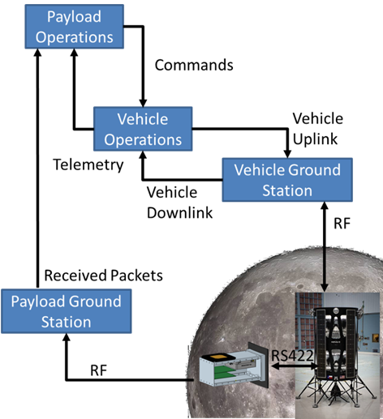
Figure 7. Lunar Node Con-Ops
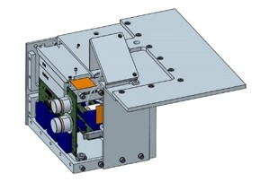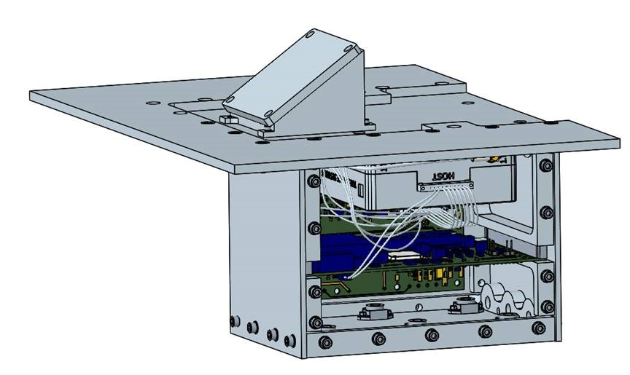
Figure 8. Cutaway View of LN-1

As seen in Figure 9, the LN-1 payload is now installed on its NOVA-C lander panel and is currently awaiting launch on a SpaceX Falcon 9 in 2023. The team is regularly conducting data flow tests between the DSN and the MSFC’s Huntsville Operations Support Center where the LN-1 operations will be led. These tests verify this end-to-end data flow connectivity between the two sites by testing firewalls and authentication methods. The MSFC team is also working alongside DSN and Intuitive Machines for operational sims and pass planning as launch nears.
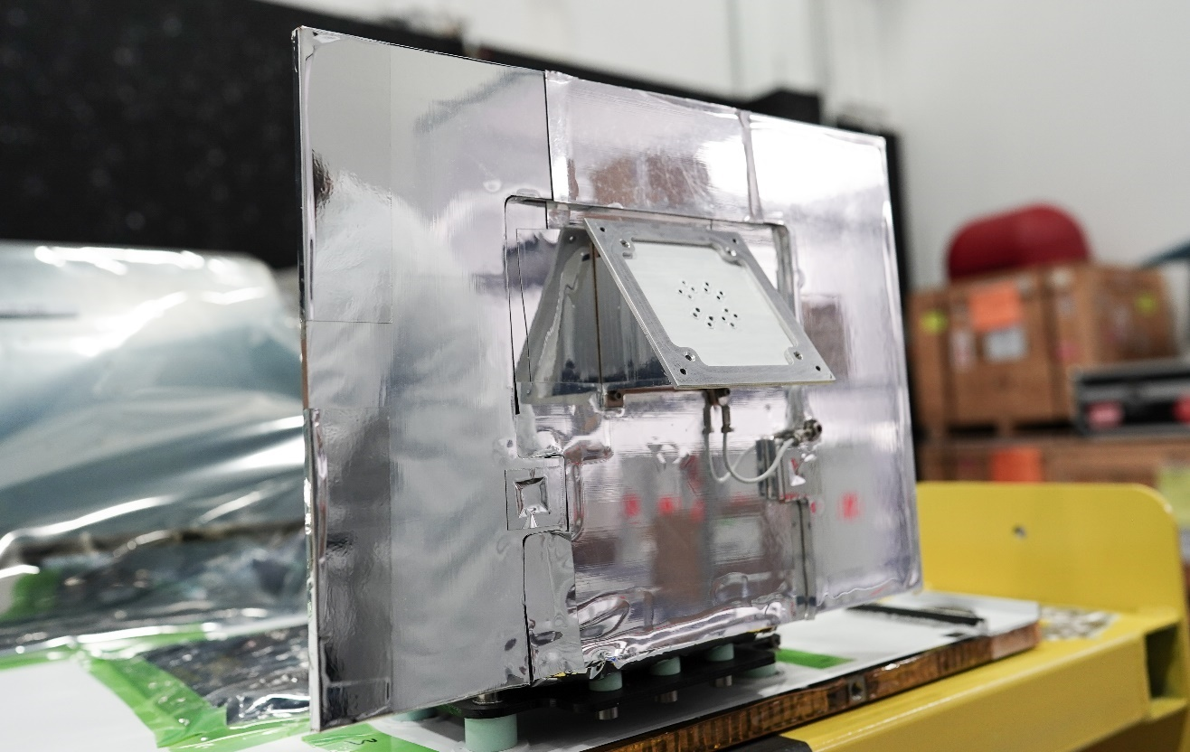
Image Credit: Intuitive Machines/ Nicholas Rios
Figure 9. Lunar Node – 1 Installed onto NOVA-C Flight Panel (12/2023)
Performance Analysis of AIDED Infrastructure
Given the analysis results above, one can observe the growth in capability and coverage as more satellites are deployed as part of a navigation constellation. For early missions, there is expected to be reduced navigation requirements and a focus on building field experience ahead of more complex surface operations. As such, any capability gained can help to provide insight into potential ground operations and provide additional performance to augment for science and safety objectives. To assess the performance gained by including surface navigation beacons into the architecture, a range of additional scenarios was assessed that include the capability for one or two surface nodes. These were assumed to maintain adequate hardware to transmit a ranging signal with ephemeris and time uncertainty on the same order as those of the orbital assets. Architecturally, these nodes would be surveyed to their surface position with high precision and be users of the initial deployment in order to perform timing synchronization. The operations implications of this are described more in the following section on constraints.
Performance of Augmenting ELFO Constellations
To focus the analysis on the early constellation deployments, a limited set of scenarios were assessed. For the ELFO scenarios, these covered potential early coverages that provide high coverage for communications as the primary goal, and as such provide a relevant example of an early constellation. The four cases represent a build-up of one-satellite in view up to a full constellation of 4 view that can enable a real-time solution. The data is shown below in Table 9. For each constellation four scenarios were assessed via Monte Carlo analysis intending to show the impacts right to left of improvements and augmentations building from a scenario with just satellites and not applying surface constraints to including a beacon and a surface constraint. Similar to the above results, performance is captured in terms of average percentage of the day that the navigation solution is within a given bound. The bounds of 10 and 100 m are given to provide a fine and coarse navigation accuracy.
Table 9. Impact of Node on ELFO Constellations (% of Day)
Case | With Beacon  and Constraint |  | With Beacon  Without Constraint |  | With Constraint |  | Baseline
Case | <10 m | <100 m | <10 m | <100 m | <10 m | <100 m | < 10 m | <100 m
1 ELFO + 1 Node | 55.7 | 78.8 | 7.9 | 38.4 | 15.3 | 60.7 | 0.2 | 7.9
2 ELFO + 1 Node | 78.6 | 82.4 | 75.2 | 78.9 | 71.0 | 79.8 | 20.7 | 63.0
3 ELFO + 1 Node | 79.2 | 82.5 | 78.5 | 79.7 | 78.9 | 79.8 | 78.6 | 79.4
4 ELFO + 1 Node | 79.4 | 82.4 | 78.9 | 79.7 | 79.2 | 79.9 | 78.9 | 79.4

As seen in the results, with 3 or 4 satellites in view, the navigation solution has high accuracy very reliably that is essentially driven by the coverage statistics (78% of a day due to the orbital shape). At this level of coverage, the performance is fairly consistent, and adding a ground beacon or surface constraints provides minimal benefit. For scenarios with less than 3 satellites, the ground node and surface constraints can essentially be treated as additional satellite and coverage to similar levels of performance for 1 satellite + constraint + beacon and 2 satellites + beacon. One important caveat to mention is the assumption about the user clock. In cases where the user clock error in non-negligible, it is assumed that that would derive an additional degree of freedom, and for two satellites in view, both the beacon and constraints would be needed to achieve the high level of accuracy. Regardless, these results demonstrate how the inclusion of a surface beacon and enhanced navigation constraints within the estimation filter can help to greatly improve capability for surfaces users.
Results of Augmenting LLO Constellations
Similar capability enhancements can be identified for the LLO scenarios. The primarily distinction between this and the ELFO cases, is the limitation that all satellites are placed into the same orbit. As such, the user will typically only see one satellite at a time. This is balanced by the greater rate of changing observation dynamics over each pass. Similarly, the results here are bounded on an upper end by how much time a satellite is in view, and the scenarios with 2 or 4 satellites are sensitive to the relative phasing between the two, where during times of overlap the user has increased performance. In order to provide addition insight into these cases, an additional scenario includes a second surface beacon located at a heading of 180 degrees from the user (i.e. one beacon 2 km North and a second 2 km South). Similar to the above, these scenarios were limited to 4 satellites to represent a limited initial deployment focused on communication. The results are provided in Table 10 below.
Table 10. Impact of Beacon on LLO Constellations (% of Day)
Case | With Beacon  and Constraint |  | With Beacon  Without Constraint |  | With Constraint |  | Baseline
Case | <10 m | <100 m | <10 m | <100 m | <10 m | <100 m | <10 m | <100 m
1 LLO +  Node | 15.5 | 28.8 | 10.3 | 15.9 | 1.7 | 11.3 | 0.5 | 4.7
2 LLO +  Node | 29.6 | 43.2 | 20.7 | 30.2 | 3.3 | 21.2 | 1.1 | 9.3
4 LLO + Node | 58.2 | 71.9 | 41.6 | 59.2 | 6.8 | 41.2 | 2.2 | 18.1
4 LLO +  2 Nodes | 62.8 | 81.6 | 49.6 | 76.9 | 6.8 | 41.2 | 2.2 | 18.1

As seen in the table above, the additional nodes do provide benefit to the surface user. When looking right to left, both the constraint and beacon are important to enabling increases in accuracy. It should be noted that each satellite is in view for only 12% of a day individually. As such, the ability to get to the fine level of accuracy near the end of a pass is greatly aided by the augmentation. For example, where the node and constraint alone are inadequate to get to high precision, these results that show increases over 12% likely represent a 10 minute period that starts near the end of the pass and the user is able to quickly solve for their position. Scenarios where limited observations from the LLO satellite simultaneously with the beacon enabled a quick reduction to coarse accuracy. This behavior is seen across the scenarios. As the constellations density increases, the overall level of capability increases. But it should be noted that this is primarily improvements on the coarse accuracy level. Improvements to get to fine accuracy rely on additional concurrent satellite observations and more time in general to process the solution.
Operational Constraints
As previously mentioned, the use of such aids on the lunar surface will be impacted by multiple elements of overall architecture. This includes not just potential interference between ground beacons and orbital nodes but also impacts from the landing site, traverse area, and proposed deployment locations. A fundamental limitation of their usage will be to ensuring line of sight between the user and the ground node. For early Artemis missions targeting the South Pole, the terrain will have an impact on traverse planning, for rationale such as staying in communication with the lander. As such, it is assumed that early mission with on-foot traverse alone will be limited by this constraint. As additional elements are deployed, such as LTV (footnote to architecture/requirements), the range of potential crewed traverses will greatly increase as it did for the Apollo missions (ref Apollo 17). For these missions, the location of the ground node will be important, and further studies would need to be conducted to further understand.
One potential use case is the deployment of a navigation beacon midway through a traverse. In this scenario, the crew would drop off a navigation beacon on an outward leg early in a traverse. This site would be chosen to maximize line of sight over the entire planned mission. Once powered on, this deployed reference would determine its location and time to the LTV’s current solution coupled with observations of any orbital relays as well. As shown above, the payload should be able to quickly anchor its possible and timing for multiple constellation configurations. At this point, the beacon would begin transmission and serve as an aid to LTV, helping to provide an additional reference to augment the orbital signals.
This transmission mode is another constraint that needs to be addressed, in terms of interference as well as interoperability. While standards are in work to define the navigation signals, coordination will be needed to ensure the beacon is assigned a non-conflicting identified to produce a unique signal from the satellites. Additionally, concerns with interference will need to be addressed by either a low power transmission mode such that orbital signals are not overwhelmed, but the signal can still reach out to cover the operational area. An alternate approach is to consider usage of a secondary frequency, thus separating ground and orbital beacons signals. The usage of dual frequencies would require updates to any PNT receiver but would be in line with current GNSS implementations that are multi-frequency. Another impact will be to develop and incorporate a unique message format to differentiate surface vs orbital ephemeris data. This could be implemented either as part of the constellation standard or provided to the user offline via telemetry or central database.
PAths to ImplemeNTation
As shown in the previous sections, the deployment of surface beacons helps to provide enhanced capability, enabling high precision PNT in early stages of a constellation deployment. Additionally, these beacons can help provide additional robustness in surface operations by increasing navigation signal density. But as mentioned, these will need to be deployed to the operational area. Two primary approaches are considered implemented within a hosted payload and as in independent platform. These represent a trade between deployment flexibility and complexity. The approaches are described in detail below.
Implementation as a Standalone Asset
An alternate approach is to incorporate the navigation beacon into a standalone self-sufficient platform. One potential path to implementation is the Lunar Harpoon. This platform has been in development at MSFC. Lunar harpoon is a highly portable, short range, GPS-denied relative navigation solution and communications relay. The system relies on extremely low power, high bandwidth, ultra-wideband radios in the in the 3.1 to 10.6 GHz frequency range for its primary navigational capability, and sports lower frequency UHF radios for health and status communications. This is focused on enabling high precision local navigation. Additionally, it is being designed to be self-sufficient in terms of power generation and storage, while maintain a small size. This allows the platform to take minimal mass and be easily deployed to the lunar surface.
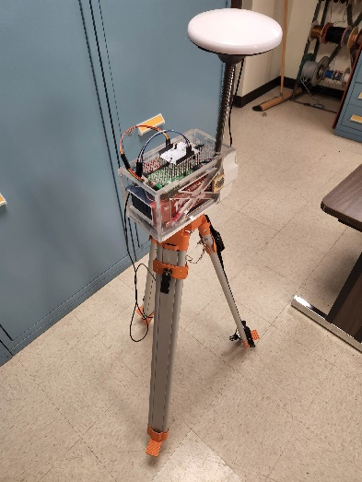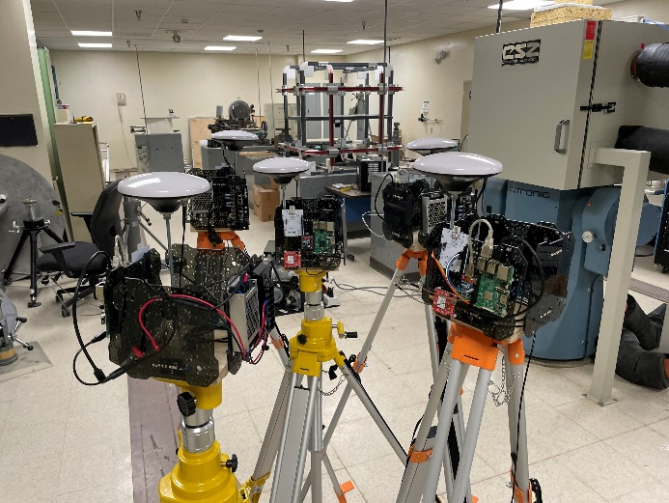
Figure 10. Lunar Harpoon by Itself (L) and in a Mesh Configuration (R)

Lunar Harpoons can be mounted to surface exploration vehicles such as rovers, carried or attached to an EVA suit, or deployed as temporary infrastructure to critical areas of science, exploration, or development to provide centimeter - level state information along with critical data on all other nodes in the mesh. The network is self-calibrating, and is designed to accommodate a high number of Harpoon nodes, while also being compatible with the larger navigation infrastructure. Lunar Harpoon meshes can provide localized, higher accuracy navigation information when disciplined to the global network. Additionally, these can host Lunar Node -derived beacons to act as a relay to overcome extreme line of sight challenges in the case of obstructions like caves and craters. Lunar Harpoon meshes equipped with Lunar Node receivers can use observations from the navigation constellation to act as a Satellite-Based Augmentation System (SBAS) for local users and can also anchor the network to an inertial frame allowing for absolute navigational information within the mesh.
This concept was demonstrated successfully in Summer of 2022 at MSFC, with a standalone 40-square-meter mesh-produced navigation solution yielding accuracies on the order of centimeters indoors using laser tracker observations for truth, and sub one meter outdoors using GPS with Real-Time-Kinematic (RTK) corrections as a truth reference. Figure 11 below shows results of a harpoon mesh tracking a single node outdoors. The outdoor test of the lunar harpoon was capable of located a node to within 1 meter accuracy when compared to an RTK truth reference.

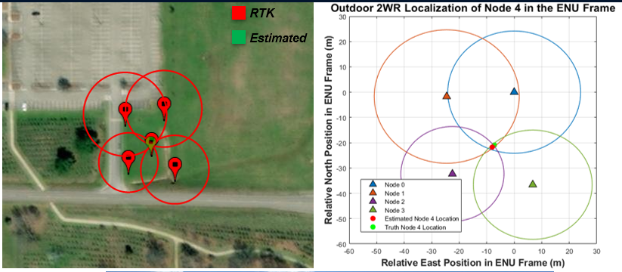
Figure 11. Lunar Harpoon Testing

The FY2023 plan will include development of prototype circuit board assemblies to facilitate a lower volume design, and integration of harpoon technology with a rover for a demonstration at MSFC’s Lunar Regolith Field. Once complete, the team will begin to add capabilities to the lunar harpoon to make it compatible with Lunar Node-derived beacons Upcoming tests will demonstrate the integration of Lunar Node-derived transmitters and receivers compatible with the planned PNT signal standard into the platform. In this manner, it will be possible demonstrate localization within the network as well as anchoring to a global frame. To simulate PNT satellites around the moon, individual GNSS satellite will be used in place of LCRNS transmitter. While this is not a one-for-one swap in terms of orbital parameters, messages, or frequency (i.e. LCRNS PNT is over S-Band vs. GPS L-Band signals), it sufficiently bounds the problem and will allow for simulating limited orbital constellations in a real hardware platform.
Implementation as a Hosted Payload
An alternate approach is to embed the navigation beacon directly within a host platform, similar to the flight approach taken by Lunar Node -1. This allows for reduction of complexity and mass of the hardware encompassing the beacon, limiting its elements to those strictly needed for the navigation capability. In this scenario, all power, commanding, and thermal control is provided by an outside element. The trade in complexity of hardware is traded for complexity of interface, electrical, mechanical, and software. Potential host vehicles for this platform include landers such as those used in the Human Landing Systems. For deployments farther afield from the primary landing site it is possible to deploy beacons ahead of time. The caveat is that as aa a hosted payload, it would not likely be the only user and be only one element impacting mission operations. Similarly, if pre-deployed any payloads would need to be capable of surviving a limited lunar night. Similarly, as a hosted payload on the landing vehicle, the payload may be operationally simpler, but would have no say over the landing location. Similarly, integration with the host vehicle may impact local coverage (i.e. where the vehicle itself may cause blockages of the navigation signal. A tight integration to take advantage of other elements of the host vehicle’s communication system for surface operations would provide beneficial to maximizing coverage but would be difficult in terms of contract boundaries and hardware integration.
To enable a more flexible deployment, the beacon could be implemented as a hosted payload on a mobile vehicle such as LTV. In this mode of operation, the payload would be deployable to a range of locations and be able to traverse the surface to minimize the impact from shadow conditions by continuing to traverse in sunlit areas. This could also aid a scenario where the crew leaves on foot from the host vehicle and is able to use this signal as a beacon both to improve their localization and to have a known signal to aid in returning to the rover. This may be especially in the harsh lighting conditions at the South Pole where it may be difficult to discern surface assets when looking up-sun.
Forward work
While LN-1 is being integrated into the host vehicle for operation during cruise to and from the surface of the moon in 2023, the base platform is being matured in a second iteration. The primary hardware elements are the same, but upgrades are being implemented and tested in the areas of signal generation and reception as well as timing stability. As identified in prior work, LN-1 is utilizing the JPL PN Ranging code during part of its operation. The results from compatibility testing identified a unique drift one-way ranging that has been corrected in a radio firmware upgrade. Due to maintaining certification from DSN RF Compatibility Testing, this update was not included on the flight hardware, and will be calibrated and assess during flight as a known drift rate. However, a new radio with the update is currently in-hand and being integrated with the flight spare. This will allow the team to conduct an additional round of compatibility testing this year in order to validate the improved performance and stability.
Similarly, the team is also performing work on improving the timing stability of the payload. Multiple timing references, including space-grader Ultra-Stable Oscillators have been procured. The team is developing in-house capabilities for measuring and tracking the PN phase as a function of the reference oscillator (which provides the radio a 10 MHz reference signal). Additionally, studies are in preparation to capture the long-term timing of the payload as a function of clock stability to characterize the timing accuracy of the onboard clock used when broadcastings time-stamped MAPS packets of onboard state and time.
Lastly, the team is also planning to upgrade the signal definitions to improve compliance with recent standards. This includes both implementation of the CCSDS PN code as defined in ICSIS standards as well as implementation of the proposed Augmented Forward Signal within the LuneNet Specification. This will enable any future deployments to be compatible with and operate as part of the growing navigation network around the moon. Similarly, this will enable ground testing of these signals for characterization and demonstration purposes.
Conclusion
With the return to the moon in the current decade, NASA and its partners have an opportunity to take advantage of advances in PNT algorithms, hardware, and software that have been developed since the design of the Apollo missions. These approaches can enable great advances in being to perform surface operations that require precise real-time navigation data such as in-situ resource utilization, in-space assembly and manufacturing, and high value science return. The current approach of deploying a network of navigation and communication assets to lunar space will enable navigation across a broad swath of the lunar systems and could be expanded to enable high accuracy always-on global coverage.
This deployment of assets will take time, both in terms of building the representative spacecraft, launching them into their respective orbits, and gaining experience operating a remote autonomous PNT network. While not at full constellation density, early deployments can still provide a powerful capability to surface users, when in view. This can help to anchor high value regions of interest and provide additional situational awareness to surface users. This paper has provided an overview of the capability of various constellation phasing options and their performance in terms of navigating a surface user. The two options presented represent two edge cases of potential deployments, intended to provide insight to guide future studies.
Similarly, this paper has shown how surface beacons and algorithmic constraints can be taken advantage of to improve the performance for partial constellations. The augmentation of surface beacons can be readily accomplished with hardware built on the lessons learned from Lunar Node –1. This can be used to provide a responsive capability in specific regions of interest. And through platforms like the Lunar Harpoon, these capabilities can be deployed and operated near a desired area to enable high accuracy localization in a local frame. This enables operations such as high precision geological surveys or multi-vehicle autonomous coordinated operations. With platforms such as these, high value capabilities can be deployed much earlier, helping to further increase the value of early Artemis exploration missions.
Acknowledgments
The authors would like to express our appreciation to the NASA Science Mission Directorate’s NASA-Provided Lunar Payloads Program for the funding and support of our missions. Similarly, we would like to acknowledge the work of all of our team members and partners at NASA/MSFC, NASA/JSC, NASA/HQ, NASA/JPL, Peraton, and Intuitive Machines for helping to develop, test, integrate, and host the Lunar Node-1 payload.

Navigation SME, EV42 Guidance, Navigation and Mission Analysis Branch, NASA/Marshall Space Flight Center, MSFC/EV42, Huntsville, AL 35812.
Mission Design Team Lead, EV42 Guidance, Navigation and Mission Analysis Branch, NASA/ Marshall Space Flight Center, MSFC/EV42, Huntsville, AL 35812.
Aerospace Engineer, EV42 Guidance, Navigation and Mission Analysis Branch, NASA/Marshall Space Flight Center, MSFC/EV42, Huntsville, AL 35812.
https://www.nasa.gov/mission_pages/LRO/news/lro-apollo14.html
https://www.nasa.gov/jsc/procurement/ltv
https://www.internationaldeepspacestandards.com/
https://esc.gsfc.nasa.gov/projects/LCRNS
https://www.intuitivemachines.com/lunar-data-services
https://opensource.gsfc.nasa.gov/projects/GMAT/
https://esc.gsfc.nasa.gov/static-files/ESC-LCRNS-REQ-0090%20RevB%2012-05-2022.pdf
https://esc.gsfc.nasa.gov/static-files/Draft%20LunaNet%20Interoperability%20Specification%20Final.pdf
Colaprete, Anthony, et al. "An overview of the volatiles investigating polar exploration rover (viper) mission." AGU Fall Meeting Abstracts. Vol. 2019. 2019.
S. Creech, J. Guidi and D. Elburn, "Artemis: An Overview of NASA's Activities to Return Humans to the Moon," 2022 IEEE Aerospace Conference (AERO), Big Sky, MT, USA, 2022, pp. 1-7, doi: 10.1109/AERO53065.2022.9843277.
Moreau, Michael C., "Navigation Concepts for NASA's Constellation Program and Human Missions to the Moon," Proceedings of the 2008 National Technical Meeting of The Institute of Navigation, San Diego, CA, January 2008, pp. 27-54.
Bhamidipati, Sriramya, Mina, Tara, Gao, Grace, "Design Considerations of a Lunar Navigation Satellite System with Time-Transfer from Earth-GPS," Proceedings of the 34th International Technical Meeting of the Satellite Division of The Institute of Navigation (ION GNSS+ 2021), St. Louis, Missouri, September 2021, pp. 950-965. https://doi.org/10.33012/2021.18021
Parker, Joel JK, et al. "The Lunar GNSS Receiver Experiment (LuGRE)." Proceedings of the 2022 International Technical Meeting of The Institute of Navigation. 2022.
Israel, David J., et al. "Lunanet: a flexible and extensible lunar exploration communications and navigation infrastructure." 2020 IEEE Aerospace Conference. IEEE, 2020.
Giordano, Pietro, et al. "The Lunar Pathfinder PNT Experiment and Moonlight Navigation Service: The Future of Lunar Position, Navigation and Timing." Proceedings of the 2022 International Technical Meeting of The Institute of Navigation. 2022.
Murata, Masaya, Isao Kawano, and Satoshi Kogure. "Lunar Navigation Satellite System and Positioning Accuracy Evaluation." Proceedings of the 2022 International Technical Meeting of The Institute of Navigation. 2022.
Anzalone, Evan. Woffinden, Dave. “Architecture Options for Navigation in Cislunar Space for Human Landing System Vehicles.” Proceedings of the 2022 American Astronautical Society Guidance, Navigation and Control Conference, 2022.
Interagency Operations Advisory Group Lunar Communications Architecture Working Group. “The Future Lunar Communications Architecture”. V1.3, January 31, 2022. https://www.ioag.org/Public%20Documents/Lunar%20communications%20architecture%20study%20report%20FINAL%20v1.3.pdf
Delépaut, Anaïs, et al. "A system study for cislunar radio navigation leveraging the use of realistic Galileo and GPS signals." Proceedings of the 32nd International Technical Meeting of the Satellite Division of The Institute of Navigation (ION GNSS+ 2019). 2019.
Gardner, Thomas, et al. "Capstone: A cubesat pathfinder for the lunar gateway ecosystem." AIAA/USU Small Satellite Conference, 2021.
Fuller, Sean, et al. "Gateway Program Status and Overview." 72nd International Astronautical Congress. No. IAC-21, A3, 2B, 13, x6624. 2021.
Smith, Earnest C., and William C. Mastin. Lunar roving vehicle navigation system performance review. No. NASA-TN-D-7469. 1973.
Gardner, Anthony, et al. "Star Tracker Based Inertial State Estimation on Planetary Bodies: An Update on the Stellar Positioning System." AAS/AIAA Space Flight Mechanics Meeting. 2020.
Geroga, Tamra. “Lunar Surface Data Book”. National Aeronautics and Space Administration, ACD-50044, 2022, https://ntrs.nasa.gov/api/citations/20220015275/downloads/ACD-50044%20Lunar%20Surface%20Data%20Book_100622.pdf.
Anzalone, Evan J., et al. "Ground-testing of One-way Ranging from a Lunar Beacon Demonstrator Payload (Lunar Node-1)." Proceedings of the 2022 International Technical Meeting of The Institute of Navigation. 2022.
Anzalone, Evan, and Jason Chuang. "Conceptual Design of a Communication-based Deep Space Navigation Network." AIAA SPACE 2012 Conference & Exposition. 2012.
Anzalone, Evan J., Chris Becker, and Herb Sims. "Initial Results of the Software-driven Navigation for Station Experiment." 2018 AIAA SPACE and Astronautics Forum and Exposition. 2018.
O’Dea Andrew, et al. 214 Pseudo-Noise and Regenerative Ranging. Jet Propulsion Laboratory, California Institute of Technology, 810-005 214 Rev A, 2015.
Craig, A. S., et al. "Human Landing System Storable Propellant Architecture: Mission Design, Guidance, Navigation, and Control." 2020 AAS/AIAA Astrodynamics Specialist Conference (Video Presentation). 2020.

