Automated Reconfigurable Mission Adaptive Digital Assembly Systems (ARMADAS): Robotically Assembled Sustainable Lunar Infrastructure. C. E. Gregg¹ and K. C. Cheung¹, ¹NASA Ames Research Center, Moffett Field, CA, (Contact: christine.e.gregg@nasa.gov)

Introduction: The Automated Reconfigurable Mission Adaptive Digital Assembly Systems (ARMADAS) project at NASA Ames Research Center is developing autonomous infrastructure, instrumentation, and spacecraft assembly and manufacturing capabilities for next generation exploration and science missions, with a goal to change the cost scaling of these missions relative to mission size and duration. Using a building-block approach with a 'kit of parts' composed of ultra-light, high-performance mechanical metamaterials, simplified robots leverage the period environment to achieve high levels of autonomy and reliability for in-space and surface assembly of large-scale apertures, solar-arrays, towers, habitats, and other infrastructure. Robots and structure break down into a compact form factor for launch. By leveraging economies of scale and achieving high-packing ratios, ARMADAS technology can revolutionize possible space missions by breaking the tyranny of the launch shroud, decreasing development times, decreasing mission costs for transformative science capability, and providing a scalable and versatile space infrastructure strategy.
Capabilities: To date, the ARMADAS project has demonstrated autonomous assembly of large numbers of structural modules into a meters-scale structure in an earth gravity environment. The mechanical performance is on par with conventional space structures, at a fraction of the cost. By using highly repeatable manufacturing processes (injection molding carbon fiber reinforced space-rated polymers), the structures are both cost effective and highly precise. The ARAMADAS system carefully designs parts for high-precision assembly–the simple and cost-effective robots build structures much larger and more precise than themselves. While maintaining structural efficiency, the ARMADAS system encompasses many functional module types, including for solar power, comm/power routing, etc., that will enable entire infrastructure systems to be engineered and autonomously assembled with modular parts. With well-defined interfaces, custom instrumentation modules can easily be added to fit many mission objectives.
Lunar Infrastructure Vision: At the LSIC spring meeting, ARMADAS will present a vision for a general-purpose lunar construction kit capable of meeting a wide variety of lunar surface infrastructure needs (Figure 1). Investing in an ecosystem of reconfigurable, discretely repairable parts and robots enables systems than can expand their capability, reconfigure to meet emergency or unforeseen needs, self-repair and reduce spare-part needs.
With a small set of parts (module types), a wide variety of infrastructure needs can be met. Footing modules will allow infrastructure construction at locations with no surface preparation. Footer, primary structure, and rail modules can create reconfigurable rail systems. These rail systems can be used to reduce cost-of-transport between frequently accessed sites, provide dust mitigation, and convey power and communications. High-performance structure modules combined with power-routing and solar modules can create tall towers for power and communication. Concepts for habitats and garages encompass a structure to support regolith cover for a pre-integrated module to an entirely ARMADAS system-based structure. This system can be leveraged by many in-situ resource utilization (ISRU) technologies to simplify processes and augment capabilities.
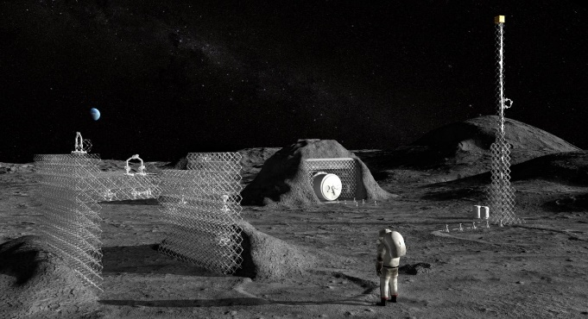
Figure 1. Concept art depicting how a small set of general ARMADAS structural module types and construction robots can meet a wide range of infrastructure needs, including towers, ISRU integration, and habitats/garages.

