Development of New Lunar Highland Regolith Simulant, NUW-LHT-5M., M. J. Creedon¹ ,T. Linneman², D. L. Rickman³, Michael Effinger⁴, ¹,²Washington Mills Electro Minerals (Washington Mills Electro Minerals, 1801 Buffalo Ave., Niagara Falls, NY, 14303, mcreedon@washingtonmills.com, tlinneman@washingtonmills.com) ³Jacobs (Jacobs Space Exploration Group/NASA Marshall Space Flight Center, Huntsville, AL, 35812, douglas.l.rickman@nasa.gov) ⁴NASA (NASA Marshall Space Flight Center, Huntsville, AL 35812, michael.r.effinger@nasa.gov)

Introduction: NASA has a need for large quantities of lunar simulants that closely match future manned lunar missions at landing sites near the Lunar South Pole. The current simulant was designed to approximate NU-LHT-2M, and -4M, except using natural minerals and a fully synthetic, non-basaltic, high calcium glass.
Washington Mills in Niagara Falls, NY was contracted to produce this new simulant due to their electric arc furnace (EAF) fusion technology and capabilities for crushing and sizing ceramics.
The primary objectives of this work were: (1) to create a commercially produced simulant that contains a high fidelity, high calcium (An90+), low Mg/Fe glass without basaltic constituents; (2) to create a simulant that uses existing, terrestrially mined, and readily available minerals blended with a synthetic glass, and (3) accomplish objectives (1) and (2) using conventional processing methods capable of production levels that can meet substantial current and future demands of NASA projects. Another consideration was that highland simulants closest to meeting these requirements, NU-LHT-2M and -4M types, are out of production and largely out of stock.
Design: The design chosen for development and production for this work is NU-LHT-2M, designed by Doug Stoeser and Douglas Rickman, which uses Stillwater anorthosite and norite rocks and synthetic glass. The composition targeted the average composition, glass content and particle size distribution of Apollo 16 samples [1]. The design utilizes two Stillwater minerals, anorthosite (37.7 wt.%), norite (17.6 wt.%), a commercially sourced olivine (4.7 wt.%), and a synthetic glass (40 wt.%).
Processing: Stillwater rocks were hand collected and initially crushed by the USGS. Further crushing and milling was performed at Washington Mills.
For the glass, oxides were blended in the appropriate ratios, blended in a v-blender, and placed in a graphite lined, water cooled pot. The mixture was fused in Washington Mills’ pilot scale, 500 kW EAF. The molten glass was then poured into water and quenched to inhibit crystallization. Several pour/quench cycles were required to produce the total quantity of glass needed.
Anorthosite, norite and olivine were milled together to the target particle size in a ball mill. The glass was ball milled separately. The complete simulant was produced by blending the milled materials. Particle size distribution, phase and chemical analyses of the materials was were performed at Washington Mills.
Results: The glass composition was found to match the Apollo 16 oxide content average [1] quite well, with the exception of SiO₂ and Fe₂O₃. The deviation of SiO₂ and Fe₂O₃ from batched content was believed to be due to limitations inherent in the use of the arc furnace technique for these types of materials. A particle size distribution of the full simulant formulation closely matching the average for the Apollo 16 samples was also achieved. Fig. 1 shows the morphology of the final simulant particles. The size distribution is compared to the target in Fig. 2.

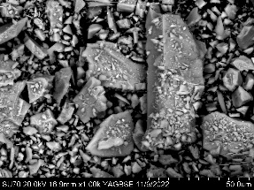
Figure 1. Particle morphology of milled simulant

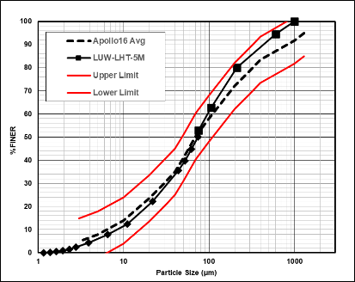
Figure 2. Size distribution of simulant.

Conclusions: A new lunar highlands type simulant containing a high-quality synthetic glass, closely matching an average composition of the Apollo 16 regolith was produced. Processing utilized easily scalable mineral and glass making methods.
References: [1] Stoeser et al. (2010) “Design and Specifications for the Highland Regolith Prototype Simulants NU-LHT-1M and -2M.” NASA TM 2010–216438.

