Noninvasive Electronic Nose for Rapid COVID-19 Detection using a Nanosensor Array
Jing Li,^{1,*} Ami M. Hannon,¹ George Yu,² Luke A. Idziak,¹ Adwait Sahasrabhojanee,¹ Prasanthi Govindarajan,³ Yvonne A. Maldonado,³ Khoa M. Ngo,¹ John P. Abdou,¹ Nghia N. Mai,¹ and Antonio J. Ricco^{1,*}
¹NASA Ames Research Center, Moffett Field, CA 94035 USA; ²Variable, Inc., Chattanooga, TN 37406 USA; ³School of Medicine, Stanford University, Stanford, CA 94305 USA
KEYWORDS: COVID-19; electronic nose; sensor array; nanomaterial; infection detection.
ABSTRACT: We adapted an existing, spaceflight-proven, robust “electronic nose” (E-Nose) that uses an array of electrical resistivity-based nanosensors mimicking aspects of mammalian olfaction to conduct on-site, rapid screening for COVID-19 infection by measuring the pattern of sensor responses to volatile organic compounds (VOCs) in exhaled human breath. We built and tested multiple copies of a hand-held prototype E-Nose sensor system, comprised of 64 chemically sensitive nanomaterial sensing elements tailored to COVID-19 VOC detection; data acquisition electronics; a smart tablet with software (App) for sensor control, data acquisition and display; and a sampling fixture to capture exhaled breath samples and deliver them to the sensor array inside the E-Nose. The sensing elements detect the combination of VOCs typical in breath at parts-per-billion (ppb) levels, with repeatability of 0.02% and reproducibility of 1.2%; the measurement electronics in the E-Nose provide measurement accuracy and signal-to-noise ratios comparable to benchtop instrumentation. Preliminary clinical testing at Stanford Medicine with 63 participants, their COVID-19-positive or -negative status determined by concomitant RT-PCR, discriminated between these two categories of human breath with a 76%-correct identification rate using “leave-one-out” algorithm training-and-analysis methods. Analyzing the E-Nose response in conjunction with body temperature and other non-invasive symptom screening using advanced machine learning methods, with a much larger database of responses from a wider swath of the population, is expected to provide more accurate on-the-spot answers. Additional clinical testing, design refinement, and a mass manufacturing approach are the main steps toward deploying this technology to rapidly screen for active infection in clinics and hospitals, public and commercial venues, or at home.
The current COVID-19 pandemic is unprecedented, a single pathogen having exhibited exceptional lethality in one strain, followed by remarkable communicability in another.¹ Thankfully, these two characteristics have not co-manifested thus far, but the pandemic underlines the need for an easy-to-use, non-invasive tool to detect infection in large numbers of people rapidly, at reasonable cost.
The potential to diagnose disease based on volatile organic chemical (VOC) signatures in exhaled breath has been understood for at least half a century, since the pioneering work of Pauling;² work in the intervening years described suitable disease targets including diabetes, several cancers, and various pathogenic infections.³⁻⁷ Mammalian tissues and organs produce unique patterns of VOCs, dubbed the volatilome,⁸ that change during pathologic states including infection,^{9,10,3} neoplasia, or metabolic disease. The volatilome can be pathogen-specific; it is sometimes associated with a perceptible odor that signals the presence of disease.^{11,8} Studies of influenza breath signatures¹² include a recent characterization of the volatile “scents” emitted by cells co-infected with influenza A and Streptococcus pyogenes, suggesting how VOC analysis could monitor this dangerous viral-and-bacterial affliction.¹³ In the urgent context of the COVID-19 pandemic, two groups have reported on COVID-19 screening using breath-borne VOCs.^{14,15}
Volatile at ambient temperatures by definition and often associated with odors detectable by humans and other animals, exhaled-breath VOCs provide a readily accessible signal for (near-) real-time detection¹⁶ using arrays of gas/vapor/chemical sensors.¹⁷⁻²⁰ The strategy to mimic mammalian olfaction by analyzing response patterns from sensor arrays is inspired by the amazing selectivity and sensitivity of the dog’s nose to classify odors,^{21,22} exemplified by a recent report of real-time canine viral infection detection.²³
An effective technical approach to sense and quantify mixtures of volatile chemical compounds using compact solid-state devices, including application-appropriate chemical selectivity (clinically, specificity), limits of detection (clinically, sensitivity), and reversibility (reusability), is to combine an array of microfabricated transducers with a set of chemically sensitive materials, each with a unique set of partial selectivity to the target VOCs, mixtures, potential interferents, and backgrounds. The overall response pattern is analyzed with mathematical methods to identify the analyte or mixture; response amplitudes provide concentration information. Limits of detection (LODs) can be improved without jeopardizing sensor selectivity and reversibility if the sensing material has a high density of target-analyte binding sites, leading to more adsorption per unit area for a given interaction energy.
Nanomaterials, including carbon nanotubes (CNTs) and inorganic nanowires^{24,25} have large surface-to-volume ratios: single-walled carbon nanotubes (SWCNTs) have been reported with surface areas of 1600 m²/g.²⁶ Adsorption, even for weakly interacting adsorbates, can alter nanomaterials’ electrical properties, leading to numerous reversible conductivity-based SWCNT gas and vapor sensors.^{24, 27-38}
We previously developed array-based gas and VOC detection systems with sufficient orthogonality³⁹ to identify many distinct yet chemically similar compounds or mixtures.^{30,34} The array combined nanotubes of differing physicochemical constitution: the selection of pristine SWCNTs, doped-SWCNTs, metal oxide nanowires, and nanotubes with polymer coatings provides (enhanced) signals from selected sensors for target analytes or mixtures. The conductivity of these sensing materials was tracked by pairs of interdigitated electrodes (IDEs) realized through silicon-wafer-based microfabrication or screen printing on printed-circuit-board (PCB) substrates. The fundamentals of (partial) charge-transfer to/from adsorbed analytes and its impact on SWCNT conductivity have been studied in detail.^{3-5, 21,22,9,10,12,13} Sensor response characteristics and array performance can be tuned by varying IDE finger gap and the density of nanotubes across the electrodes.
Prior to developing a system for COVID-19 breath analysis, this sensor technology was field tested twice: aboard a Midstar Satellite, then on the International Space Station (ISS).⁴⁰ The sensor system was also miniaturized to fit into a cell phone for homeland security applications.⁴¹
In this article, we describe the adaptation of our spaceflight-proven E-Nose, which uses a swappable sensor-head-contained 64-channel array of nanomaterial-based sensors to mimic key aspects of olfaction, for rapid screening for COVID-19 infection by measuring (“smelling”) the pattern of VOCs in human exhaled breath: levels of some breath constituents are affected by virus infection in the upper respiratory tract and lung.^{23, 8-16} The cylindrical E-Nose device (Figure 1a) includes sensor head (Figure 1b), electronics, Bluetooth and USB interfaces, and rechargeable batteries; an iPad App controls the hand-held device and displays data. A separate sampling fixture (Figure 1c), which includes gas-handling pump and valves, particle filters, and connecting plumbing, delivers human breath samples from single-use air-tight bags to the E-Nose.
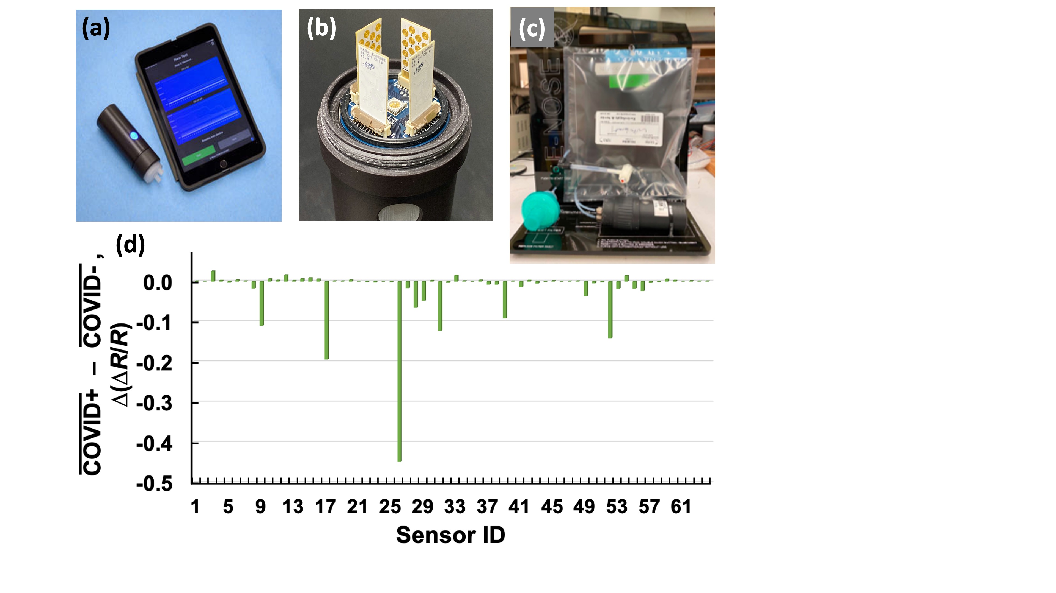
Figure 1. (a) Integrated E-Nose system (4 cm diameter x 12 cm long) with controlling iPad mini; (b) four 16-sensor PCB arrays installed in the sensor head; (c) sampling fixture with Tedlar® breath-collection bag; (d) response of CNT-based sensors to human breath, relative to a background of filtered ambient air: each bar represents the difference, for a single sensor response, between the mean of 32 COVID-19-PCR-positive breath samples and the mean of 31 COVD-19-PCR-negative breath samples.

To guide development of the sensor array, nitric oxide/nitrogen dioxide plus 12 VOCs, Table 1, were selected for initial laboratory testing: some of their concentrations are reported to differ significantly in the breath of humans infected with COVID-19 relative to uninfected people.^{1, 3-5} Ultimately, field tests at Stanford Health Care screened 63 participants, approximately half of whom were determined to be COVID-19 positive by a RT-PCR (reverse-transcription polymerase chain reaction) test administered the same time as breath sample collection. The breath samples were measured by the E-Nose at Stanford (Figure 1d); data were transmitted by the Stanford team to NASA Ames Research Center (ARC) on the same day for analysis.

Table 1. VOCs and a pair of inorganic gases reported to differ in concentrations in the breath of humans infected with COVID-19 ^{1,3,4} relative to uninfected humans.⁵
Molecule | Healthy breath concentration range (ppb by vol) | Direction of change for COVID-19-infected breath
ethanol | 13 – 1,000 | Decrease
1,1-dipropoxypropane | 5 – 14 | Increase
ethyl butanoate | 1.3 – 2000 | Increase
butyraldehyde | 50 – 260 | Decrease
i-propanol | 1.2 – 1.9 | Unknown
NO/NO₂ª | 6 – 26 | Unknown
Acetone | 12 – 580 | Decrease
acetaldehyde | 3 – 7 | Unknown
n-propyl acetate | 9 – 13 | Unknown
methyl methacrylate | 0.51 – 1.0 | Unknown
styrene | 3.7 – 20 | Unknown
isoprene | 0.29 – 13 | Unknown
n - propanol | 0.7 – 15 | Increase
ªWhen mixed with air, NO gradually oxidizes to form NO₂.⁴²
METHODS AND MATERIALS
Sensors, Nanomaterials, VOCs, and Lab Measurements. Details of sensor fabrication and array construction have been reported elsewhere.^{4,} ⁹⁻¹³ In brief, a 16-sensor array chip, Figure 2, right), was designed with standard PCB manufacturing process (1 oz/ft² of copper, ~ 35 µm thick); gold was applied via immersion plating.⁴³ Concentric circular IDEs, each electrode about 7.5 mm in total length, measure sensing layer conductivity, Figure 2, left. Four such chips are housed in the sensor head (Figure 1b) to form a 64-sensor array, enabling a 16-sensor subset to be swapped in case of a faulty sensor or new choice of sensor material(s).
Figure 2. Left: Single sensor IDEs, 2.1 mm diameter with ~100 µm-wide traces and spaces. Right: One PCB substrate with 16 IDE-based sensors, all connected via an internal PCB layer to the edge connector that plugs into the E-Nose’s ZIF socket.

Nanomaterial sensing layers were drop-cast, in 0.3 – 0.7 µL volumes at concentrations from 0.03 – 1% (w/w) in various solvents, onto the circular IDE of each sensor, bridging the gaps between the electrodes. Sensing layer thickness, typically 1 – 10 µm, was adjusted to provide baseline resistance in the 1 kΩ – 10 MΩ range based on the nanomaterials. The conductivities of the sensor nanomaterials were measured before, during, and after VOC exposure by recording voltage at constant current (1.4 – 900 µA, dependent on baseline resistance) using a benchtop digital multimeter with integral current source (Model 2700, Keithley, Cleveland, OH, USA).
The dozen array-development VOCs (Table 1) were obtained as calibrated diluted vapors; six were in compressed clean, dry air cylinders (Airgas, Radnor, PA, USA), the other six were neat liquids in permeation tubes (KIN-TEK Analytical, La Marque, TX, USA); nitric oxide was obtained as a 2.5 ppm mixture in N2 (Airgas). These gas and vapor sources were connected to a gas-dilution-and-delivery system (Model S-2040, Environics, Toronto, ON, Canada) using clean, dry air for purge, mixing, and carrier streams, and including the capability to humidify the gas mixtures with a deionized-water-filled gas-washing bottle. A total of 64 different conductive nanomaterials were tested individually with breath-appropriate concentrations of the 12 target VOCs and NO by toggling the flow from dry air to relevant concentrations (see Table 1) of these individual biomarkers and/or a mixture of them in dry air, then toggling back to dry air. Tests with both laboratory and field E-Nose systems utilized dynamic flow conditions: sensor purging used flowing clean air in lab tests, flowing ambient air for breath testing; VOC exposure tests used air plus added VOCs in the lab, human breath for field COVID-19 studies.
Breath-Sampling Fixture Development and Operation. Because consistent sensor responses from human breath samples require a constant, controlled sample flow rate across the sensor array for well-defined time intervals, as well as a clean-air purge for baseline measurement before and after sample exposure, a sampling fixture was designed and fabricated. It delivers human breath samples in single-use Tedlar bags (Figure 1c) to the E-Nose; a functional block diagram, Figure 3, shows the critical components, together with the E-Nose (described below). The pump was placed at the end of flow path to draw the breath sample from the Tedlar bag and through the E-Nose flow cell, thereby avoiding possible contamination/carryover by the pump or valves. This fixture consists of an air pump (KNF, model NMP05-KPDC), a three-way solenoid-actuated valve (The Lee Co., model LHLA0531211H), connecting tubing (1/8 in OD PFA (perfluoroalkoxy alkane), McMaster-Carr Supply), and an N99 spirometry filter (Medtronic, model DAR Electrostatic Smallby) placed at the pump exhaust port to trap any bacteria or virus particles. The fixture also houses microcontroller (Arduino, model Uno), pump motor driver (Pololu Corp, model 2183-2814-ND) and power-supply circuit boards, indicator LEDs, and control buttons for test procedure timing; it can be AC line or battery powered (battery life ~ 50 hr); the pump flow rate is software controllable over the range 250 – 400 cc/min at room temperature.
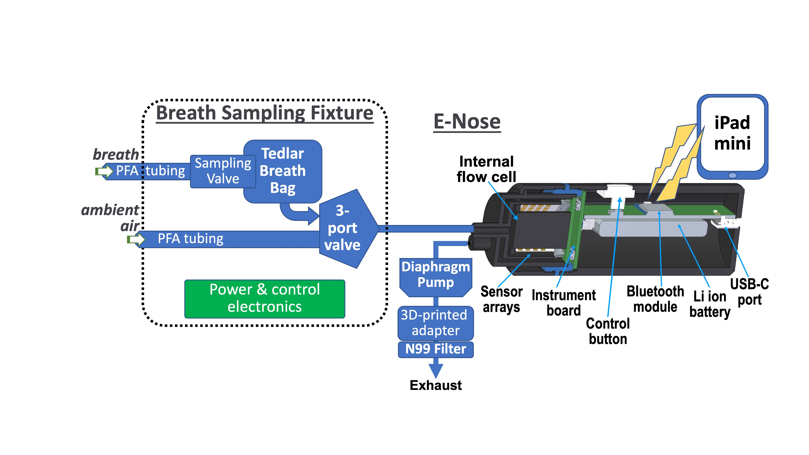
Figure 3. Sampling fixture functional block diagram (left) with interface to E-Nose (right), showing main components of the integrated E-Nose system.
The individual components of the sampling fixture are commercially available, except for a customized 3D-printed adaptor, to connect the tubing to the filter, that we fabricated from commercial “biosafe” resins approved for use in human implants (FormLabs brand, model BioMed Clear Resin, USP Class VI Certified). After 3D printing, the adaptors were UV cured, then vacuum baked at 50 °C for 24 hr to significantly diminish the likelihood of off-gassing during use. Components in direct contact with sampled gasses or breath, such as tubing and valves, were selected for their non-off-gassing properties (predominantly fluoropolymers) and heritage in laboratory and spaceflight biology experiments. The frame of the fixture was built from laser-cut acrylic panels.
For testing at Stanford Health Care, the details of recruitment, consenting, study setting, population, and procedures for testing COVID-19-positive and -negative volunteers, their status determined by concurrent PCR testing, are reported separately;⁴⁴ Institutional Review Board and Biosafety panel approvals were obtained before the pilot study was initiated.
Integrated E-Nose Prototype Development and Details. The integrated E-Nose prototype system (Figure 1a) was adapted and updated from a previous design of an iPhone-operated sensor.⁴¹ That system and the improved COVID-19 breath-detection version are products of a collaborative effort between NASA ARC and Variable, Inc., with detailed electromechanical engineering, App development, and build of prototypes carried out by Variable under NASA contract. Key features of the E-nose are shown in Figure 1b (the sensor head) and Figure 3 (main internal components). The 4 sensor chips, supporting 64 sensors in total, face inward and are contained in an internal flow cell. A gas inlet at the center of the flow cell evenly distributes the purge and sample gas streams to the 4 sensor chips; the gas outlet is a side port. Each sensor chip plugs into a ZIF (zero-insertion force) socket, making them ready swappable for replacement or update. The handheld E-Nose device is controlled by a custom Apple iPad-mini App via Bluetooth communication. 64-Nanosensor array data are transmitted in Bluetooth Low-Energy mode to the iPad, from which it can be forwarded via email to the end user for analysis.
The conductivity of each E-Nose nanosensor is measured via the voltage drop under constant current in the range 50 nA – 3.3 mA, auto-selected according to sensor baseline resistance; conductivities were verified by comparison to the benchtop multimeter measurement (values were typically within one order of magnitude). Integrated E-Nose sensing performance was assessed via sensitivity to the target VOCs, as well as noise level and drift, as reported in the Results section below.
To test breath samples collected in Tedlar bags using the integrated E-Nose system, a single button press starts a 14-min automated measurement sequence, including: a) 5-minute baseline measurement from all sensors, using ambient air; b) 1-minute breath sample exposure and measurement, using the filled breath bag; c) 2-minute sensor “recovery” using ambient air; d) repeat steps b) and c) two more times (i.e., three cycles in total of expose-and-recover measurement). In preparation for the next sample, another button press initiates flushing of the E-Nose with ambient air for 14 min, through both the sampling and purge paths. E-Nose results were then saved on the iPad and later transmitted from Stanford to NASA ARC.
Data Processing and Algorithm Development. A graphical user interface (GUI) manages data collected by the E-Nose device by preprocessing and extracting key decision-making information from each experiment. The GUI detrends and normalizes the data, plots it, and returns sensor response peak values from experiments according to user-selectable filters. Detrending 1) removes the rolling median; 2) standardizes mean and variance; 3) determines if peak(s) are negative- or positive-going; 4) removes the rolling extremum from the series of data points. Detrended sensor response peaks are then extracted via an algorithm built on SciPy’s find_peaks( ) function,⁴⁵ customized and extended to handle either positive- or negative-going responses, to detect a specified number of peaks (equal to the number of vapor/breath exposures), and to use all 64-sensor responses to refine the time-axis location of the response peaks via a voting system. Median-based filtering rejects false-peak spike artifacts sometimes observed near peaks; anomalous peaks are identified and flagged. Ultimately, peak extraction was refined to eliminate the need for timestamping so that variation in peak location relative to that associated with the initially defined experimental time protocol was well tolerated. For all valid extracted peaks, baseline was extracted, signal level measured, and signal-to-noise ratio calculated; peak values were then normalized relative to a zeroed baseline.
Classifying sensor array responses as COVID-19-positive or -negative is a binary classification problem with structured numeric data as inputs. Initially, the viability of discrimination using principal-component analysis (PCA) and clustering was examined, but factors other than positive/negative identity of the analytical sample were found to be discriminated. Two model-based approaches, logistic regression and support-vector machine (SVM) analysis, were found to be better suited to classifying E-Nose responses. The decision boundaries of both models are linear (non-linear SVMs were found to perform poorly).
Logistic regression is a generalized linear model to estimate the probability of a data point belonging to a class, given the values of its input variables. Logistic regression fits a logistic S-curve to the data, Figure 4a, which brings outputs to the probabilistically valid range of 0 ≤ p ≤ 1, while also being well suited to fitting linearly separable data, given availability of ground-truth labels, i.e., data points known to belong to a certain class with 100% certainty. The result is a logistics-conducive graph (Figure 4a), in which the x-axis is the input variable and the y-axis the probability of each point belonging to a certain class. The green points in Figure 4a are those with ground-truth labels, used to configure the model; the three blue points are predicted by the model.
A support vector machine is a supervised learning model with associated learning algorithms that analyze data for classification and regression analysis; it is a geometrically motivated model that fits a decision boundary with the goal of maximizing the margin separating two classes, as diagrammed in Figure 4b. An SVM uses a user-defined “kernel” function, which dictates the type of decision boundary the SVM will form; a linear kernel was found to work best for E-Nose responses.
Figure 4. Depiction of (a) logistic regression model and (b) SVM model. H1 does not separate classes; H2 does, but only with a small margin. H3 separates them with maximal margin.

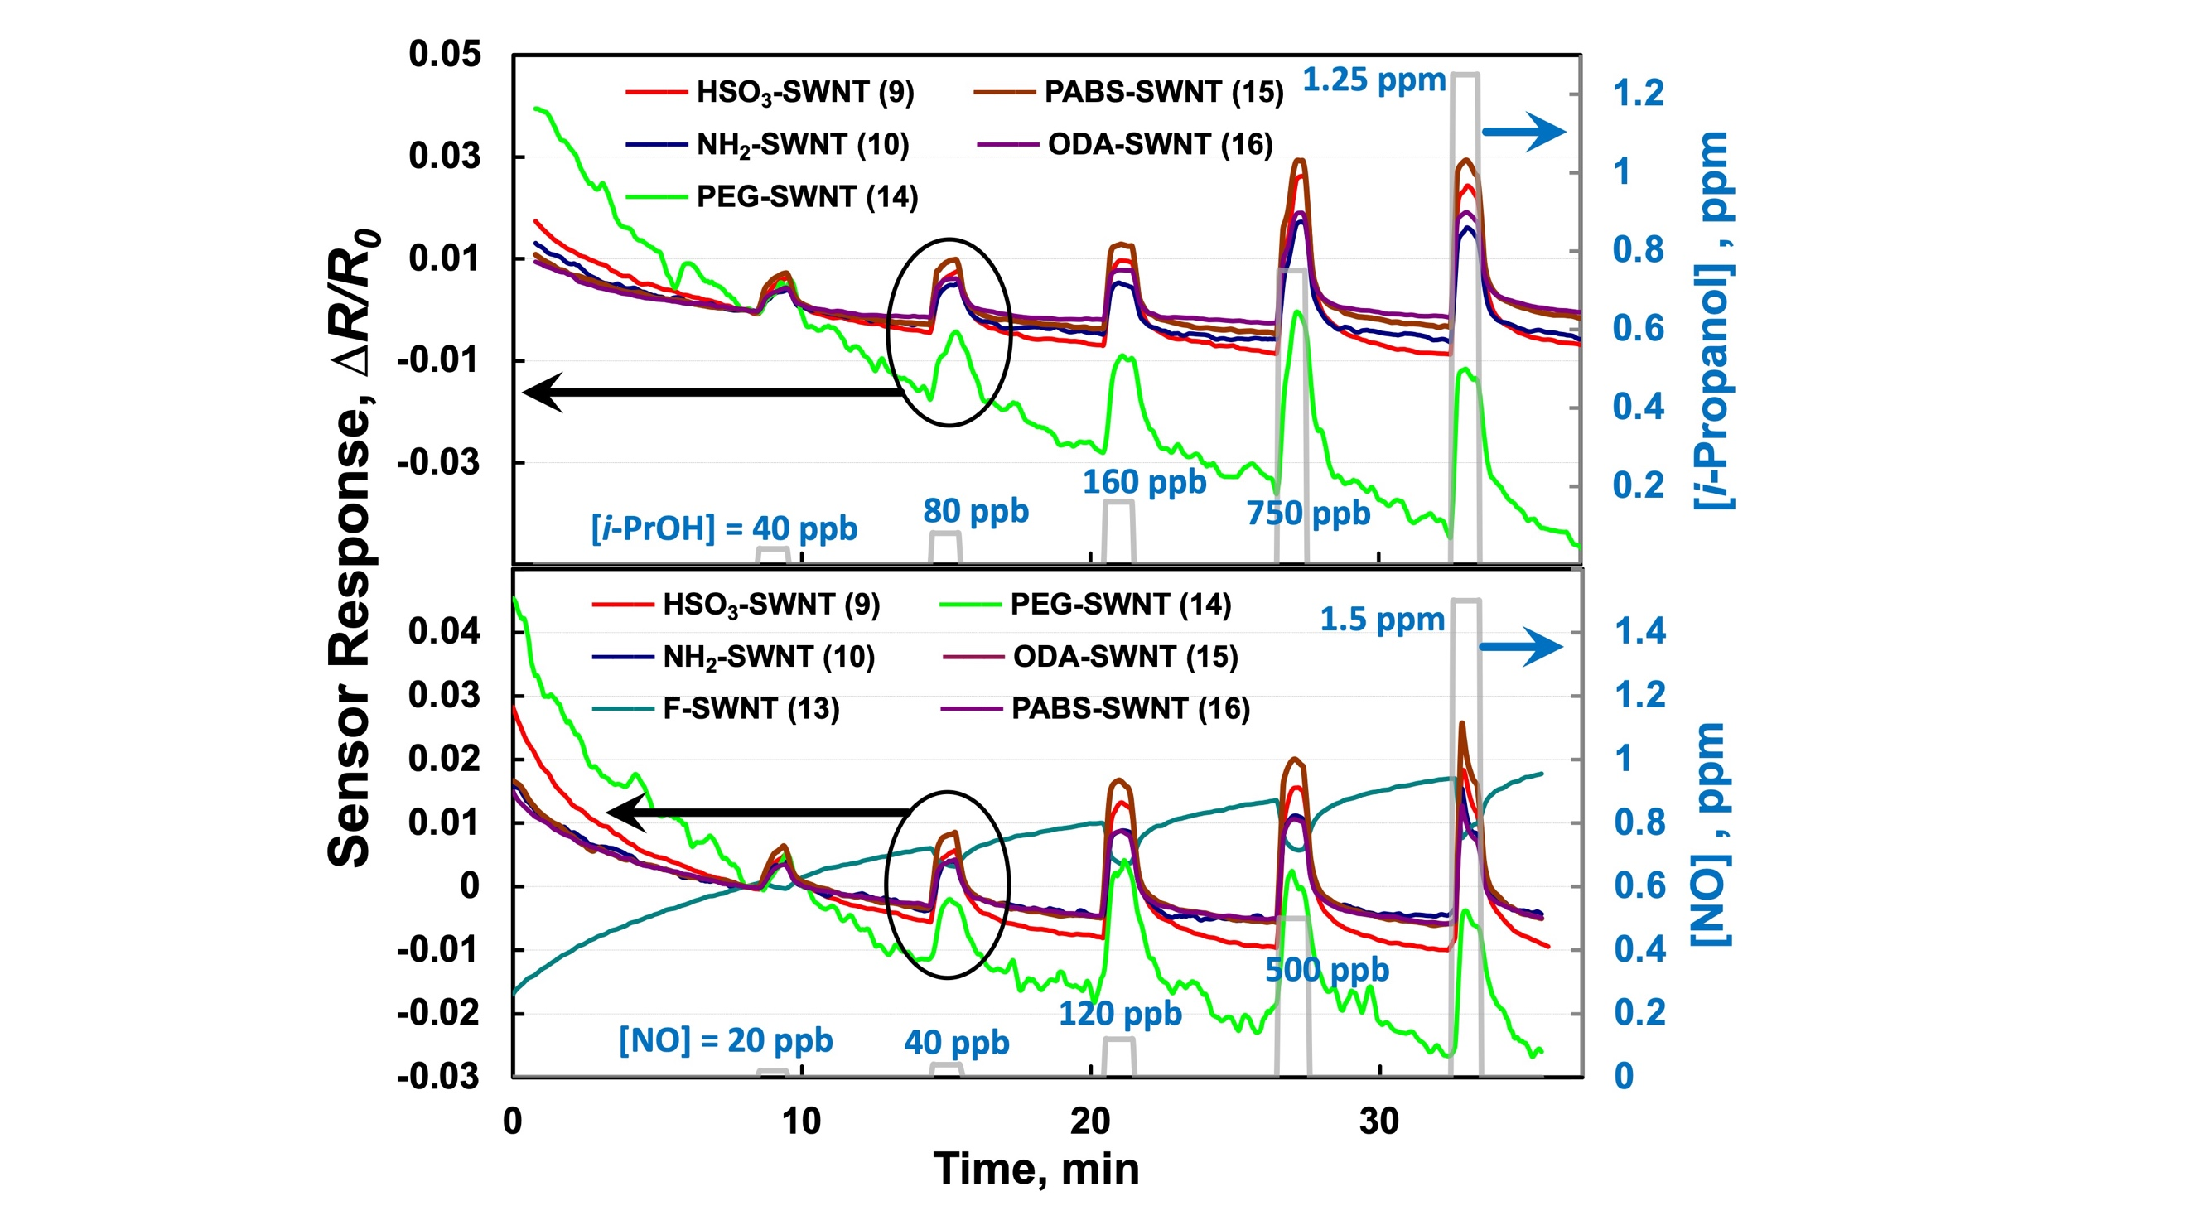
Figure 5. Time-varying responses, as fractional change in measured resistance at constant current, for five (top) or six (bottom) SWNT sensors to the introduction and displacement of i-propanol (top) and nitric oxide (bottom) in flowing clean air. Sensor materials (with ID numbers as in Table 2) and analyte concentrations are given on the figures.
RESULTS AND DISCUSSION
Sensor Response to Individual VOCs and Mixtures. A set of 64 unique sensing nanomaterials, grouped into four categories (nanotubes, composites, nanoparticles, and polymers), Table 2, was selected based on our previous work with E-nose sensors^{24, 30-34, 41} in combination with their responses, particularly limits of detection and repeatability, to the 12 VOCs, as well as NO/N₂O, reported to differ between the breath of COVID-19-infected and uninfected individuals (Table 1). Ultimately, the 64 materials, deposited onto four 16-sensor chips (Figure 2) were characterized in the integrated E-Nose system; results were compared to those from the laboratory benchtop system.
Results are shown in Figure 5 for the sequential exposure of multiple sensors to five concentrations (by volume, at 1 atm, in air) of i-propanol (40 ppb to 1.25 ppm) and NO (20 ppb to 1.5 ppm). The unprocessed responses are shown; sloping baselines, noise, and other artifacts were removed, as outlined in Materials and Methods, prior to calculating peak values to define the response of the full array to a given single VOC, mixture, or breath sample.
Sensitivity and Selectivity. Many sensing materials showed excellent sensitivity to these VOCs with LODs at parts per billion (ppb) levels. Of 64 sensing materials, 20 materials (ID numbers highlighted in light green or lavender in Table 2) showed sensitivity to the VOCs over a broad range of ppb-level concentrations; among them, a dozen showed exceptional sensitivity to very low concentrations (ID’s highlighted in light green only) and, from their responses, detection as low as 2 – 5 ppb was feasible. In addition, nine of the materials, highlighted in light orange, provided unusually large responses to a few specific VOCs, thus bolstering array selectivity. Overall, 21 of the sensing materials were “exceptional performers” in one or more ways, suggesting that a smaller array size might be effective (discussed further below).
After recording individual VOC responses from single sensors, multi-sensor sets were exposed to mixtures of VOCs mimicking key components of both healthy and COVID-19-infected breath, Figure 6. A so-called “Base Mixture” of VOCs was used
Figure 6. Response of 16 sensors (Table 2, ID 1 – 16) to six COVID-19-breath-relevant VOC mixtures. The “Base Mixture” was 10 ppm ethanol, 200 ppb styrene, 150 ppb n-propanol, 140 ppb 1,1-diproproxypropane, 130 ppb isoprene, 130 ppb propyl acetate, and 10 ppb methyl methacrylate; it remained constant for all tests, while the concentrations of butyraldehyde, ethyl butanoate, and acetone were varied as shown in the plot. Bars represent normalized peak heights; all VOCs were carried in flowing clean air at room temperature and 1 atm.
for these tests, a combination of 10 ppm ethanol, 200 ppb styrene, 150 ppb n-propanol, 140 ppb 1,1-diproproxy-propane, 130 ppb isoprene, 130 ppb propyl acetate, and 10 ppb methyl methacrylate. Concentrations of these seven VOCs were held constant as added concentrations of ethyl butanoate, butyraldehyde, and acetone were varied, leading to the 6 distinct color-coded response patterns of Figure 6. Only eight of the 16 sensors tested in this experiment responded above background.

Similar results were observed with three other sensor sets on which such tests were performed. In total, 15 – 18 sensing materials (of 64) showed promising response patterns.
Table 2. 64 sensing materials used for the E-Nose sensor arrays.
ID | Nanotubes | ID | Composites | ID | Nanoparticles | ID | Polymers
1 | pristine-SWNT | 17 | PANI-CNT | 33 | Fun Au 1-SWNT | 49 | EVA
2 | pristine-MWNT | 18 | Nano Ag crystal-SWNT | 34 | poly(2-vinylpyridine) | 50 | SBR
3 | Iso-nanotubes | 19 | Nano Au-SWNT | 35 | Rh-SWNT | 51 | PI/Cl
4 | graphene | 20 | F-SWNT (ARC) | 36 | Pd-SWNT | 52 | PDAN
5 | short SWNT | 21 | poly(bis(phenoxy) phosphazene) | 37 | Pt-SWNT | 53 | PEI
6 | OH-SWNT | 22 | hexadecafluoro-1,10-decanediol | 38 | Ag-SWNT | 54 | Ppy/TiO₂
7 | COOH-SWNT (COTS) | 23 | ferrocene, 0.5% | 39 | Au-SWNT (ARC) | 55 | PEC
8 | COOH-SWNT (ARC) | 24 | ferrocene, 2% | 40 | NiFe-SWNT | 56 | PEUT
9 | HSO₃-SWNT | 25 | PB-SWNT | 41 | SnO₂-SWNT | 57 | OV-210
10 | NH₂-SWNT | 26 | Au-PB-SWNT | 42 | ZnO-SWNT | 58 | PIB
11 | NH₂CO-SWNT | 27 | [BMIM][BF₄] | 43 | TiO₂-SWNT | 59 | PDMS
12 | HS-SWNT | 28 | [THA][Tf2N] | 44 | Fe₂O₃-SWNT | 60 | OV-275
13 | F-SWNT | 29 | [HEA] [fm] | 45 | SiO₂-SWNT | 61 | SC-F303
14 | PEG-SWNT | 30 | [BMIM][Tf2N] | 46 | WO₃-SWNT | 62 | SC-F105
15 | PABS-SWNT | 31 | PANI-ferrocene | 47 | ZnO-SWNT (diff.) | 63 | SC-F108
16 | ODA-SWNT | 32 | Pt-Pd-Ru-CNT | 48 | Ag nanobox-SWNT | 64 | SC-F201
Color coding: | sensitivity to most VOCs over a range of ppb-level concentrations
 | sensitivity to most VOCs over a range of ppb-level concentrations, plus exceptional sensitivity to very low (ppb) concentrations
 | unusually large responses to specific VOCs
Abbreviations: ARC: synthesized at NASA-ARC; BMIM: 1-butyl-3-methylimidazolium; BF4: tetrafluoroborate; CNT: carbon nanotube; COTS: commercial, off-the-shelf; EVA: ethylene-vinyl acetate copolymer; HEA: 2-hydroxyethylammonium; MWNT: multi-walled (carbon) nanotube; ODA: octadecylamine; OV-210: trifluoropropylmethyl polysiloxane (50% trifluoropropyl, 50% methyl); OV-275: 65% dimethyl, 35% divinyl polysiloxane; PABS: polyaminobenzene sulfonic acid; PANI; poly(aniline); PI/Cl: 65%-chlorinated poly(isoprene); PDAN: poly(1,8-diaminonaphthalene); PDMS: poly(dimethylsiloxane); PEC: poly(epichlorohydrin); PEG: poly(ethylene glycol); PEI: poly(ethyleneimine, branched); PEUT: poly(ether urethane); PIB: poly(isobutylene); Ppy/TiO₂ = poly(pyrrole) + TiO₂; SBR: styrene-butadiene copolymer; SC-F30: fluoroalcohol polycarbosilanes (linear); SC-F105: fluoroalcohol polycarbosilanes (hyperbranched); SC-F103: fluoroalcohol polycarbosilanes (hyperbranched); SC-F201: fluoroalcohol polycarbosilanes (hyperbranched); SWNT: single-walled (carbon) nanotube; Tf2N: bis(trifluoromethanesulfonyl)imide.
Repeatability and Reproducibility. All 64 sensors in the array were characterized for repeatability using the benchtop lab setup. Figure 7 shows results from two SWNT-based sensors (both in the “light green” category, see Table 2) to three consecutive exposures of the VOC Base Mixture described above, diluted to 2% of its initial concentration in air. Standard deviations (SDs) were computed after extraction of each peak as described in Methods and Materials, including detrending, baseline subtraction, artifact removal and finding the median. SD was 0.01% of the extracted peak height for the Fe₂O₃-SWNT sensor (ID = 44) and 0.02% of peak height for the COOH-SWNT sensor (ID = 8).
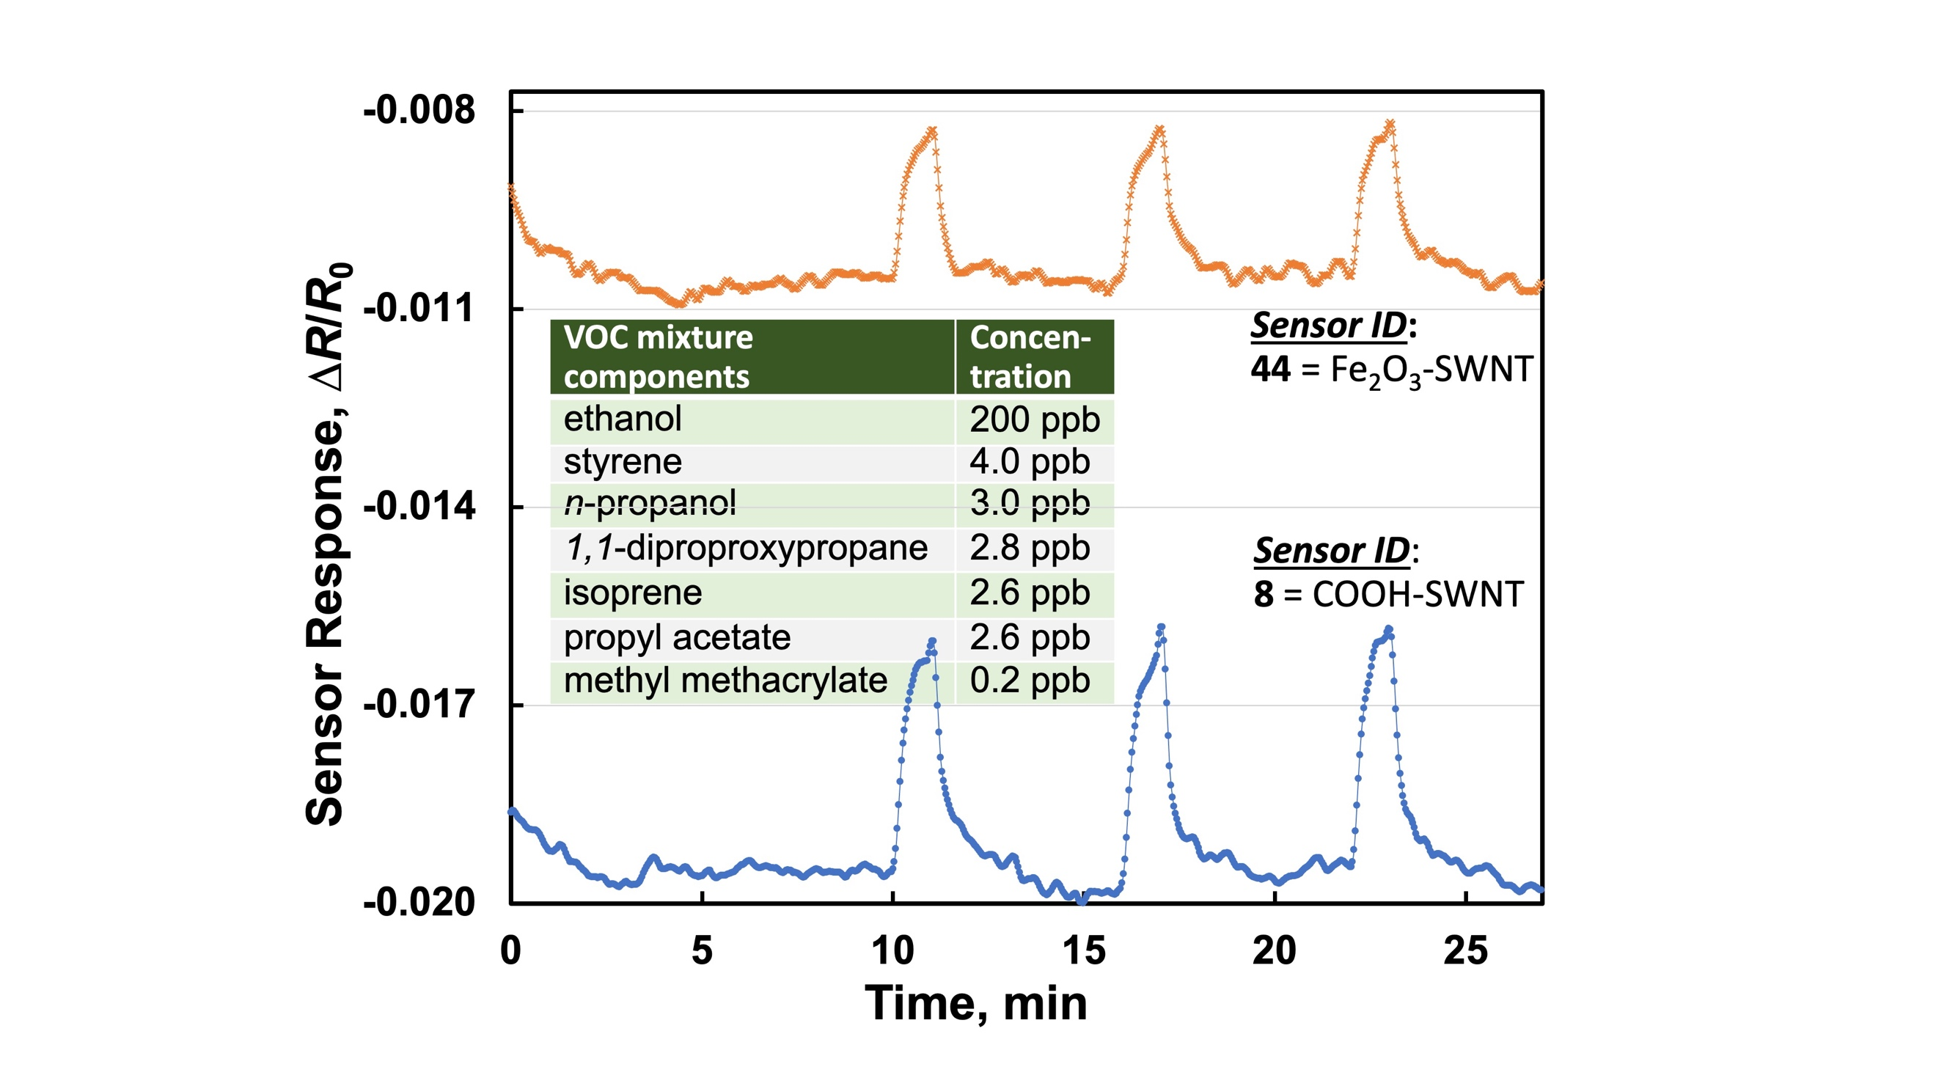
Figure 7. Repeatable responses of two SWNT-based sensors to three identical, sequential challenges of the Base Mixture, diluted to 2% of initial strength. Peaks were extracted (see Methods and Materials) before computing standard deviations of 0.01% and 0.02% of the averages of the three extracted peak heights for Sensor ID 44 and 8, respectively.

By comparing results from a dozen individual E-Nose prototypes (Figure 1a), each with an identical 64-sensor array, reproducibilities at both the sensor and system levels were characterized using the Base Mixture of VOCs, diluted to 2%, 10%, and 50% of the initial concentrations in air. Figure 8 shows the overall reproducibility for two SWNT-based sensors: the SDs for channel 8 (COOH-SWNT) from the dozen prototypes were 0.09%, 0.31%, and 1.23% of the extracted peak heights for the three concentrations of Base Mixture; for channel 44 (Fe₂O₃-SWNT), the analogous SDs were 0.04%, 0.11%, and 0.4% of the extracted peak heights. Not surprisingly, in every case, the larger the signal, the smaller the standard deviations when expressed as a percentage of average peak height.
Performance Comparison of Prototype and Benchtop Instrumentation. The E-Nose device showed comparable performance to the “gold-standard” laboratory benchtop digital multimeter in its measurement performance: Figure 9 shows results from the same sensor of the 64-sensor array tested within the E-Nose device and with the benchtop multimeter. The measured E-Nose sensor relative resistance changes (∆R/R₀) were 40 ± 3% smaller than the benchtop DMM measurements for acetaldehyde over the 30 ppb – 1.5 ppm concentration range, Figure 9; average noise levels (SDs of 21 measurements) of 0.027%, relative to the sensor resistance baseline, were identical for the two measurement methods. In addition to validating the capability of the E-Nose system to measure sensor responses with the required stability and accuracy, these test results demonstrate that the internal gas flow cell in the E-Nose system is as effective as the lab setup. While the thermal environments in which tests were conducted were moderate (a science laboratory for benchtop tests; mild weather conditions at Stanford’s facility), the integrated E-Nose system includes internal temperature-control capability for the sensors. In field environments with larger temperature fluctuations or extremes, temperature control will maintain sensor baseline stability and repeatability: sorptive equilibration processes, which are the basis of E-Nose responses, are notoriously temperature sensitive.
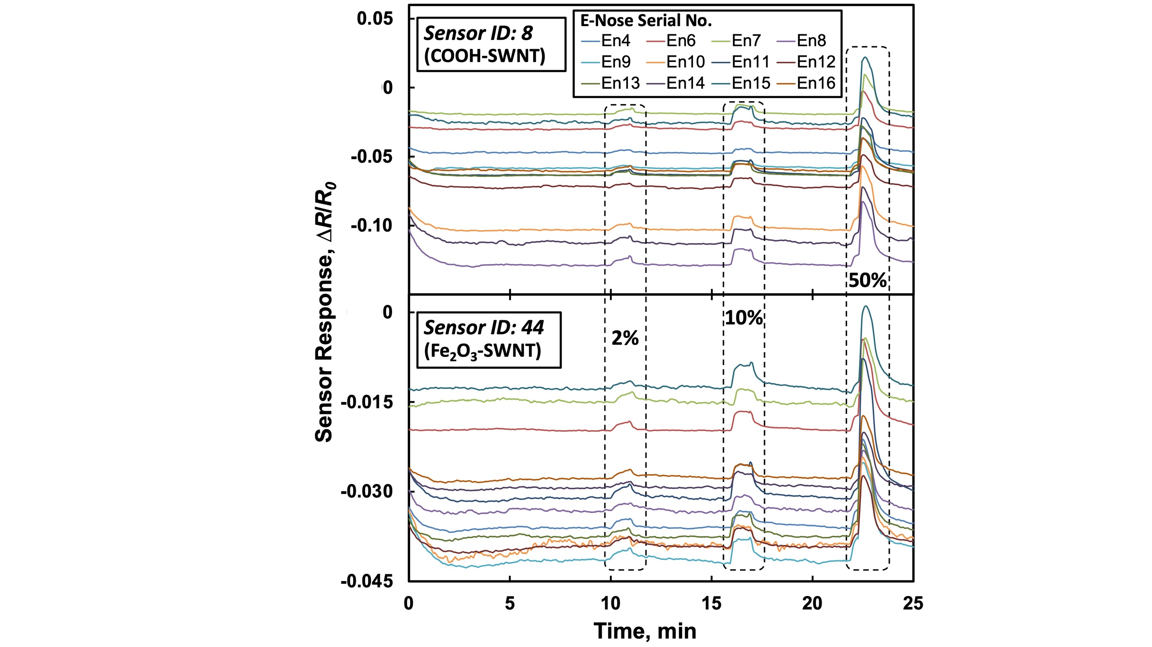
Figure 8. Outstanding device-to-device reproducibility revealed in this comparison of responses from a dozen E-Nose prototype systems as two channels (8 and 44) to the Base Mixture at 2%, 10%, and 50% of initial concentrations. The (extracted) dozen peaks had SDs of 0.09%, 0.31%, and 1.2% for the COOH-SWNT sensor and 0.04%, 0.11%, and 0.40% for the Fe₂O₃-SWNT sensor for the 2%, 10%, and 50% dilutions, respectively.

Management of Relative Humidity and Its Effects. During initial laboratory testing of sensors and candidate materials, the relative humidity (RH) of the gas/vapor carrier stream was found to have significant, sensor-material-dependent effects on the magnitude of the responses, particularly for large humidity differences between purge gas and carrier stream. This posed a concern due to the high humidity (nearly 100%) of exhaled breath, leading to attempts to match the RH of the air used for sensor baselines to the RH of breath samples. Adding the appropriate moisture content proved challenging.
Fortunately, characterization of many breath samples captured and stored in Tedlar bags for between 20 min and 24 hr revealed consistent RH varying from the high 50%’s to the low 70%’s, i.e., over a range of ~15 percentage points on the RH scale at ambient temperature: the sampling process and equilibration with the Tedlar bag brought the RH of breath samples close to ambient RH levels (no condensation was observed inside the bags). Therefore, the decision was made not to control RH of either the breath sample or ambient-air baseline purge gas. Initial results from Stanford School of Medicine (SOM), presented in the next subsection, show that the absence of RH control does not prevent discrimination of COVID-19-positive and -negative breath samples, yet further study of this issue will be necessary if the E-Nose system is to be applied outdoors in conditions of (more) extreme temperature and/or humidity.
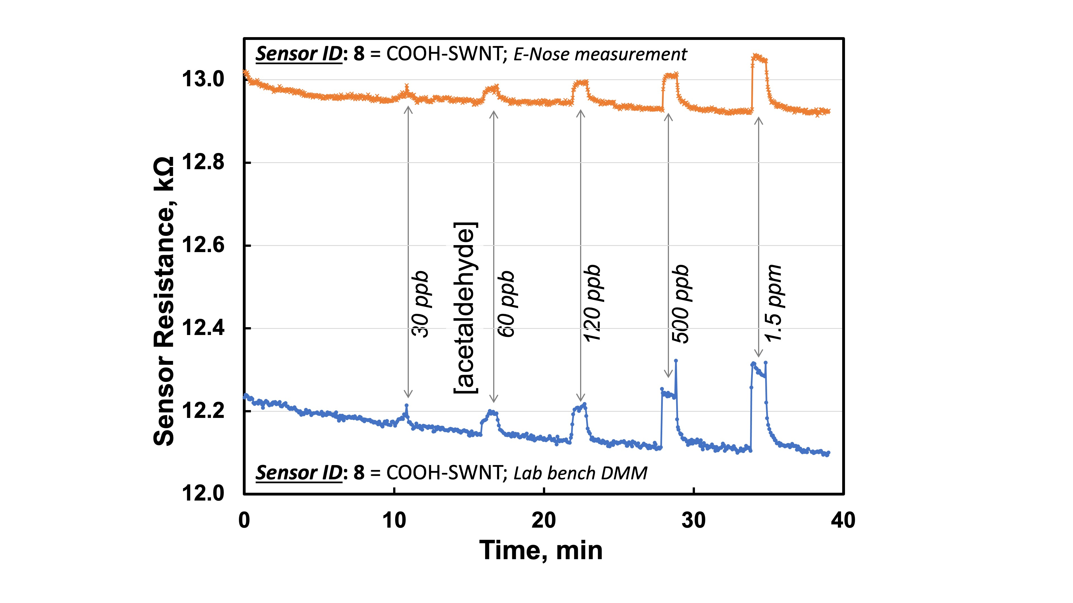
Figure 9. Response comparison of field-ready integrated E-Nose sensors (top curve) with laboratory measurement instrumentation (bottom curve) for exposure of the same sensor to a range of acetaldehyde concentrations, as indicated, in air.

Initial Classification of COVID-Positive (COV+) and COVID-Negative (COV–) Results. The integrated E-Nose breath-test data collected at Stanford Health Care⁴⁴ were transmitted to ARC and initially processed using a commercial chemometrics software package that includes multiple options for classification of multivariate data sets (Pirouette, Infometrix, Seattle, USA). Soft independent modelling by class analogy (SIMCA), a statistical method for supervised classification of data, was chosen to visually separate COVID-19-PCR-positive and COVID-19-PCR-negative E-Nose tests, Figure 10. Because all data points are treated as “ground truth” (i.e., their true status is known due to the accompanying PCR results), the 98%-accurate classification obtained with this analysis is no surprise. However, the ability to separate the multivariate E-Nose data into two almost entirely non-overlapping classes is significant nonetheless: it shows that COV+ and COV– breath samples do produce distinguishable results. The critical question, then, is whether a set of “training data” can be used to create two such classes, and if separate, non-overlapping sets of “test data” can be subsequently correctly classified. We found the total of 63 breath sample responses inadequate for sub-division into sufficiently broad and inclusive training and test data using the SIMCA approach, but explored this key step using our in-house methods (next section).
As Figure 1d shows, the extracted-peak E-Nose data from the 64-channel array shows promise at the individual- and array-of-sensors levels—at least for certain sensors—to differentiate COV+ and COV– samples. Figure 11 provides more detail: in the top panel, stacked bars show average responses for the 32 COV+ breath samples (orange) compared with those for the 31 COV– samples (blue). The bottom panel of Figure 11 shows the same differential response (green bar = orange bar – blue bar) as in Figure 1d between averages of COV± samples, with the addition of four-pointed stars on the 21 peaks for which the standard deviation of the differential response is smallest relative to the difference of averages. While many of these are the same materials highlighted in Table 2 for their “most useful” responses to individual VOCs, a significant number are different, suggesting that sensors with the largest responses to low levels of individual VOCs are not invariably the most useful in differentiating responses for human COV ± breath status.
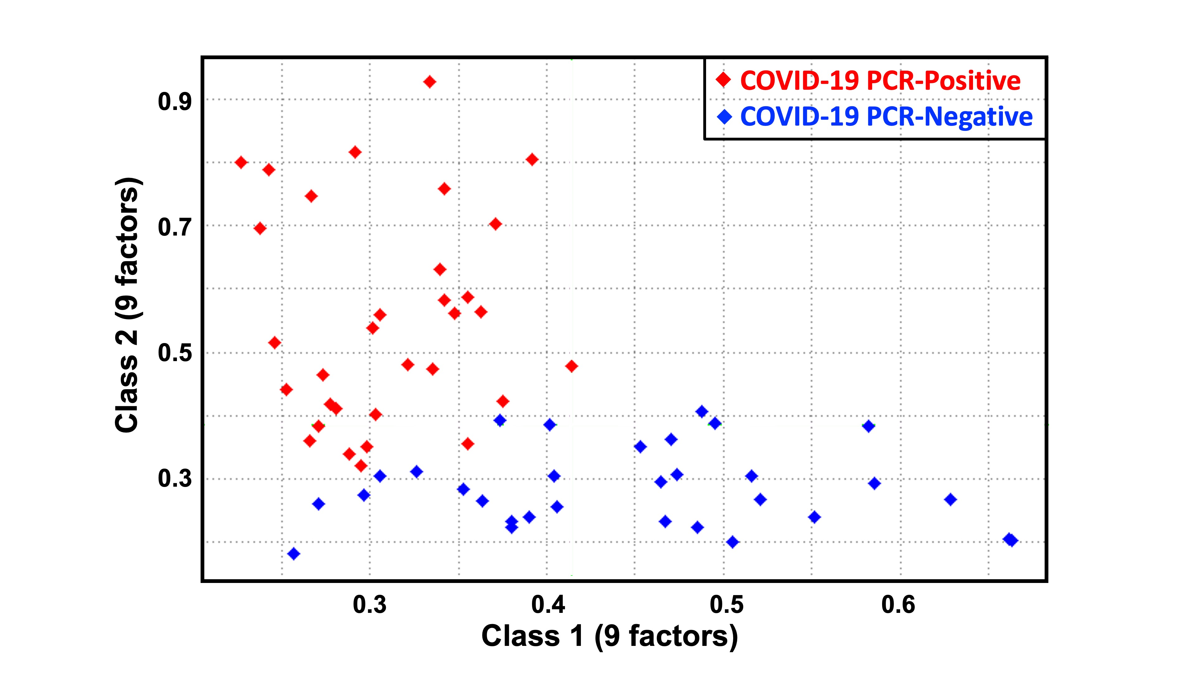
Figure 10. 9-Factor SIMCA plot showing 2D classification of E-Nose-analyzed human breath samples as COVID-19 positive or -negative, according to the concomitant RT-PCR test results.
Identification of COV+ and COV– with linear SVM via the “Leave-One-Out” Approach. We analyzed E-Nose test data using linear support-vector machine analysis (see Methods and Materials) with the leave-one-out approach, in which all but one of the responses (here, 62 of the 63 breath-sample measurements) are used to construct the two-class model, then the omitted sample point is identified. This process is repeated for each single sample point (62 more times), always building the two classes with all but one result, then identifying it. While this is not a useful approach for a large-scale, real-world diagnostic system, it does offer insight into two key questions: 1) given a sufficiently large and populationally diverse training set, could this (E-Nose) method accurately emulate PCR test results? Or, setting the bar lower, 2) could this method compare in clinical accuracy to rapid-antigen tests for COVID-19 infection?
Clinical Testing at Stanford Health Care. Study details and results are published elsewhere⁴⁴ but, briefly, the objective was to compare E-Nose device performance with SARS-CoV-2 RT-PCR results obtained by trained staff in a clinical setting, including examination of how the choice of Ct (threshold for PCR positivity) value might impact the comparative accuracy of the device. The results showed high sensitivity when compared to a quantitative threshold (Ct value of 29) and high sensitivity and specificity when compared to the qualitative test results for SARS-CoV-2. The E-Nose results also compared favorably to a recently published assessment of the diagnostic accuracy of a SARS-CoV-2 rapid antigen test conducted in clinical settings,⁴⁶ which reported a poorer sensitivity, 65%, than the E-Nose results, but superior specificity (> 99%).
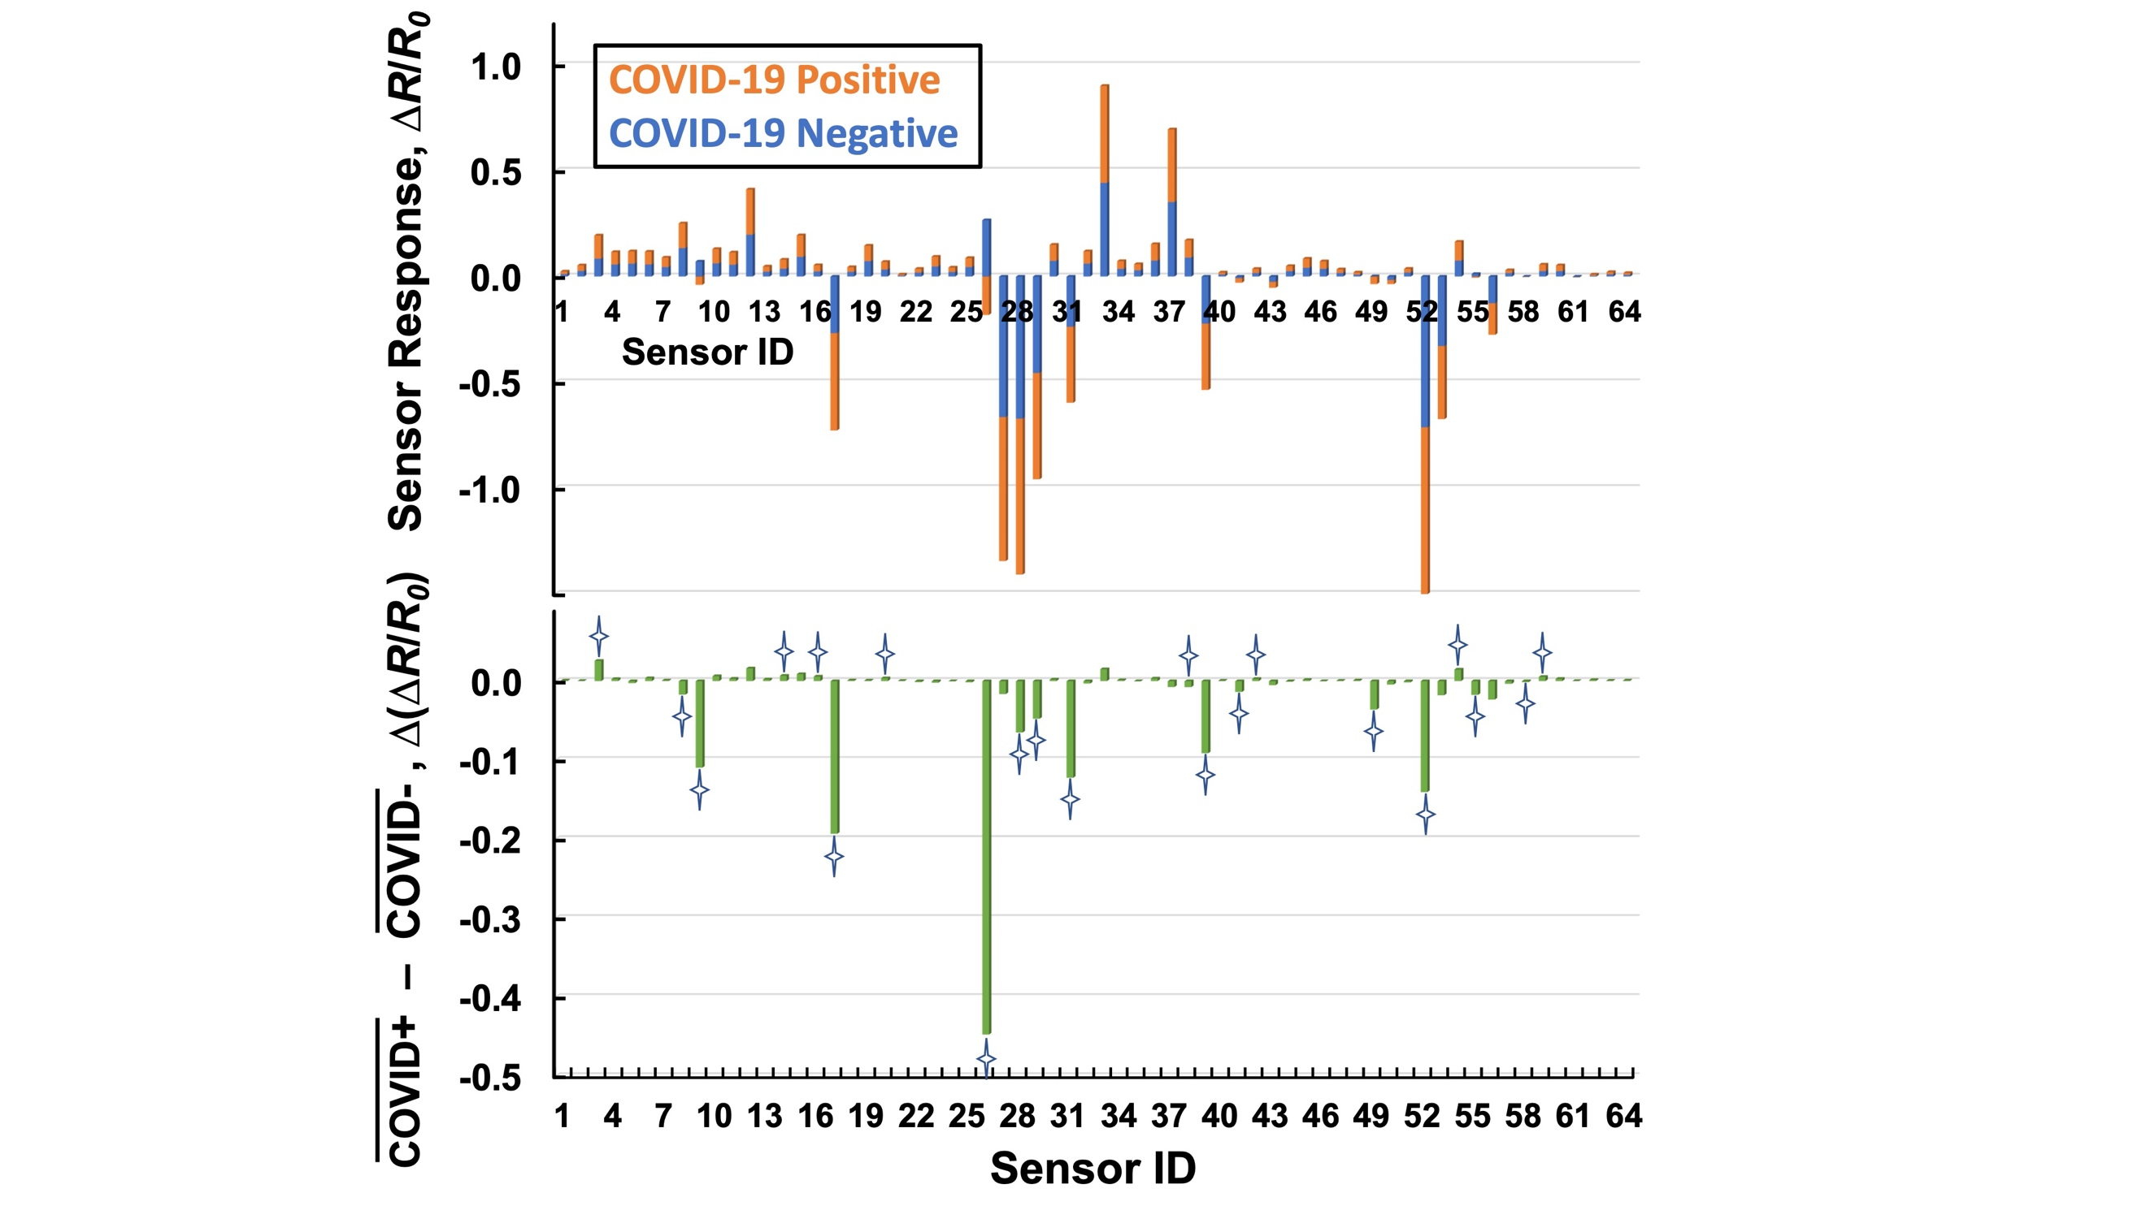
Figure 11. Top panel: Average responses for the 32 COV+ breath samples (orange) compared with the 31 COV– samples (blue). Bottom panel: differential response (each green bar = corresponding orange – blue bars) between average responses of all COV+ and all COV– samples. Four-pointed stars designate 21 peaks for which the standard deviation of the differential response is smallest relative to the absolute height of the green bar. Sensors IDs as in Table 2.
CONCLUSIONS AND FUTURE WORK
Our preliminary results from a flashlight-size, spaceflight-heritage electronic nose (E-Nose) that can detect COVID-19 in human breath include promising levels of diagnostic accuracy using the indicative, though not ultimately definitive, leave-one-out approach to analyze breath samples from 63 volunteers. The sensors respond to relevant VOCs in the breath at low ppb levels with repeatability of 0.02% and reproducibility of 1.2%; the measurement electronics in the handheld E-Nose device provide comparable data quality to benchtop instrumentation.
Volunteers were not eliminated from eligibility, nor were their breath analyses treated differently if they had other conditions or habits that might impact breath signature. A larger clinical study could account for a range of comorbidities and personal behaviors that might impact exhaled breath composition; we expect this to improve the diagnostic accuracy and provide an understanding of which breath-relevant factors are confounding to test results and which can be ignored.
The promising preliminary performance of the E-Nose approach was obtained using responses from 64 different conductive nanomaterial-based sensors that our team has developed and optimized over two decades of sensor research and development. Nevertheless, the fact that our results and observations show that about 20 of these sensors provide significantly larger responses to the individual VOCs important for determining COVID-19 infection, and also that a different, partially overlapping set of ~ 20 sensors exhibits the largest average difference, relative to standard deviations, between COV+ and COV– breath responses, suggests that a smaller array might provide similar, perhaps superior, performance: depending on the classification approach, omitting sensors that effectively generate only “noise” (signals uncorrelated with the classification objective) can improve identification accuracy. With the compact 64-channel E-Nose system we have developed, this would enable the use of 2 – 4 identical copies of each sensing material to provide a more robust, accurate response, per material, by averaging and eliminating single outliers (e.g., single defective sensors). Using fewer materials would diminish the cost of mass production: each distinct material requires its own material synthesis, sensor fabrication, and quality control. To choose the best 16 – 32 sensing materials requires both a significantly larger clinical study, again numbering in the hundreds of human subjects, along with an “array optimization” process that compares a wide range of combinations of the sensing materials to find the best performance.
To prepare for larger clinical tests, we are integrating the sampling fixture (Figure 3) and the E-Nose device into one hand-held box (3rd generation E-Nose) and all functions are controlled by the App on the iPad, leaving just the single-use connecting tubing, Tedlar bag that captures human breath, and N99 filter as external components. Classification algorithms will be included in the iPad App to obtain the identification and display it. We estimate that such an integrated system can provide a total screening time, including breath collection, E-Nose peak extraction and classification, and results display on the iPad, of ~2 minutes, a timescale compatible with wide-scale deployment in clinics and hospitals, in public venues from airports to sporting events, and in businesses of all sorts. We are investigating the analysis of E-Nose responses in conjunction with body temperature and other non-invasive symptom screening using advanced machine learning methods to improve the accuracy of on-the-spot answers.
ACKNOWLEDGMENTS
At Stanford SOM, we thank Rosita Thiessen, BA, CCRP, and Jonathan Altamirano, MS, for regulatory oversight and supervising the clinical research coordinator, and for lab collaboration to obtain data, respectively; we also express our gratitude to the clinical research coordinators for their contributions to data collection, device maintenance, and completing patient-related activities: Emma Stainton, BS (lead study coordinator), Marcela Lopez, BA, Grace K-Y Tam, BS, Leanne Chun, BBiomed we thank the lab staff, Sherry Carrington, BA, BBA, and Frank Zhou, BS, for providing lab space for the study activities. We thank the following collaborators for their significant contributions to the E-Nose technology testing at Stanford SOM: Drs. Youyou Duanmu, MD, MPH, and Milana Trounce, MD, MBA, for the PCR data interpretation. The Biosafety & Biosecurity Specialists (Stanford University Environmental, Health & Safety), Simone Schubert and Dolores B. Cunanan, were responsible for biosafety evaluation and recommendations, for which we extend our sincere thanks.
This work was supported by the US Dept. of Health and Human Services under HHS-NASA interagency agreement No. SAA5-2020-4-I32973.
REFERENCES
- Cascella,M,; Rajnik, M.; Aleem, A.; Dulebohn, S. C.; Raffaela Di Napoli, R. D. Features, Evaluation, and Treatment of Coronavirus (COVID-19) In: StatPearls [Internet]. Treasure Island (FL): StatPearls Publishing; 2022 Jan. 2022 Oct 13. PMID: 32150360 Bookshelf ID: NBK554776
- Pauling, L.; Robinson, A.B.; Teranishit, R.O.Y.; Cary, P. Quantitative Analysis of Urine Vapor and Breath by Gas-Liquid Partition Chromatography. Proc. Nat. Acad. Sci. USA 1971, 68, 2374–2376.
- Nakhleh, M. K.; Amal, H.; Jeries, R.; Broza, Y. Y.; Aboud, M.; Gharra, A. et al Diagnosis and Classification of 17 Diseases from 1404 Subjects via Pattern Analysis of Exhaled Molecules. ACS Nano 2017, 11, 112-125
- Costello, B. L.; Amann, A.; Al-Kateb, H.; Flynn, C.; Filipiak, W.; Khalid, T.; Osborne, D. and Ratcliffe, N. M. A review of the volatiles from the healthy human body. J. Breath Res. 2014, 8, 014001 (29pp)
- Fenske, J. D.; Paulson, S. E. Human Breath Emissions of VOCs. J. Air and Waste Management Association 1999, 49 (5), 594-598
- Minh, T. D. C., Blake, D. R., & Galassetti, P. R. The clinical potential of exhaled breath analysis for diabetes mellitus. Diabetes research and clinical practice 2012, 97(2), 195-205.
- Kumar, S., Huang, J., Abbassi-Ghadi, N., Španěl, P., Smith, D. and Hanna, G.B., 2013. Selected ion flow tube mass spectrometry analysis of exhaled breath for volatile organic compound profiling of esophago-gastric cancer. Analytical chemistry, 85(12), pp.6121-6128.
- Amann, A.; Costello, B.; Miekisch, W.; Schubert, J.; Buszewski, B.; Pleil, J.; et al. The human volatilome: volatile organic compounds (VOCs) in exhaled breath, skin emanations, urine, feces and saliva. J Breath Res 2014, 8, 034001. doi:10.1088/1752-7155/8/3/034001
- Buljubasic, F.; Buchbauer, G. The scent of human diseases: a review on specific volatile organic compounds as diagnostic biomarkers. Flavour Frag J 2015, 30, 5–25. doi:10.1002/ffj.3219
- Wilson, A.D. Advances in electronic-nose technologies for the detection of volatile biomarker metabolites in the human breath. Metabolites 2015, 5, 140–63. doi:10.3390/metabo5010140
- Elmassry, M. M.; Piechulla, B. Volatilomes of Bacterial Infections in Humans. Front Neurosci. 2020; 14, 257.
- Yan, J.; Grantham, M.; Pantelic, J.; Mesquita, J. B.; et al. Infectious virus in exhaled breath of symptomatic seasonal influenza cases from a college community. PNAS 2018, 115 (5), 1081-1086
- Traxler, S.; Barkowsky, G.; SaB, R,; Klemenz, A.; Patenge, N.; Kreidemeyer, B.; Schubert, J. K.; Miekisch, W. Volatile scents of influenza A and S. pyogenes (co-)infected cells. Nature/Scientific Report, 2019, 9, 18894
- Chen, H.; Qi, X.; Zhang, L.; Li, X.; Ma, J.; Zhang, C.; Feng, H.; Yao, M. COVID-19 screening using breath-borne volatile organic compounds. J. of Breath Res, 2021, 15, 047104. doi.org/10.1088/1752-7163/ac2e57
- Shan, B.; Broza, Y. Y.; Li, W.; Wang, Y.; Wu, S.; Liu, Z.; Wang, J.; Gui, S.; Wang, L.; Zhang, Z.; Liu W.; Zhou, S.; Jin, W.; Zhang, Q.; Hu, D.; Lin, L.; Zhang, Q.; Li, W.; Wang, J.; Liu, H.; Pan, Y.; Haick, H. Multiplexed Nanomaterial-Based Sensor Array for Detection of COVID-19 in Exhaled Breath. ACS Nano, pre-print, 2020,dx.doi.org/10.1021/acsnano.0c05657
- Sethis, N. R.; Chakraborty, T. Clinical application of volatile organic compound analysis for detecting infectious diseases. Clin Microbiol Rev 2013, 26, 46275. doi:10.1128/CMR.00020-13
- Konvalina, G. and Haick, H., 2014. Sensors for breath testing: from nanomaterials to comprehensive disease detection. Accounts of chemical research, 47(1), pp.66-76.
- Guntner, A.T., Abegg, S., Konigstein, K., Gerber, P.A., Schmidt-Trucksass, A. and Pratsinis, S.E., 2019. Breath sensors for health monitoring. ACS sensors, 4(2), pp.268-280.
- Broza, Y.Y., Zhou, X., Yuan, M., Qu, D., Zheng, Y., Vishinkin, R., Khatib, M., Wu, W. and Haick, H., 2019. Disease detection with molecular biomarkers: from chemistry of body fluids to nature-inspired chemical sensors. Chemical reviews, 119(22), pp.11761-11817.
- Sola Martinez, R.A., Pastor Hernandez, J.M., Yanes Torrado, O., Canovas Diaz, M., de Diego Puente, T. and Vinaixa Crevillent, M., 2021. Exhaled volatile organic compounds analysis in clinical pediatrics: a systematic review. Pediatric Research, 89(6), pp.1352-1363.
- Gardner, J. W.; Bartlett, P. N. Electronic Noses: Principles and Applications. Oxford University Press, 1st edition (1999), ISBN-13: ‎978-019855955
- Lonergan, M. C.; Severin, E. J.; Doleman, B. J.; Beaber, S. A.; Grubb, R. H.; Lewis, N. S. Array-based vapor sensing using chemically sensitive, carbon black-polymer resistors Chemistry of Materials, 1996, 8, 2298-2312
- Craig Angle, C.; Waggoner, L. P.; Ferrando, A.; Haney, P.; Passler, T. Canine Detection of the Volatilome: A Review of Implications for Pathogen and Disease Detection Front Vet Sci, 2016, 3, 47 PMID: 27446935
- Li, J. Carbon Nanotube Applications: Chemical and Physical Sensors, in Carbon Nanotubes: Science and Applications, Editor: M. Meyyappan, CRC Press, Boca Raton, FL, 2004
- Meyyappan, M. and Sunkara, M. Inorganic Nanowires: Applications, Properties and Characterization, CRC Press, Boca Raton, FL, 2010
- Cinke, M.; Li, J.; Chen, B.; Cassell, A.; Delzeit, L.; Han, J.; Meyyappan, M. Pore Structure of Raw and Purified HiPco Single-Walled Carbon Nanotubes. Chem. Phys. Lett., 2002, 365, 69
- Kong, J.; Franklin, N.R.; Zhou, C.; Chapline, M.G.; Peng, S.; Cho, K.; Dai, H. Nanotube Molecular Wires as Chemical Sensors. Science, 2000, 287, 662
- Qi, P.; Vermesh, O.; Grecu, M.; Javey, A.; Wang, Q.; Dai, H.; Peng, S.; Cho, K.J. Toward Large Arrays of Multiplex Functionalized Carbon Nanotube Sensors for Highly Sensitive and Selective Molecular Detection. NanoLett., 2003, 3, 347
- Ng, H.T.; Fang, A.; Li, J.; Li, S.F.Y. Flexible Carbon Nanotube Membrane Sensory System: A Generic Platform. J. Nanosci. Nanotech. 2001, 1, 375
- Li, J.; Lu, Y.; Ye, Q.; Cinke, M.; Han, J.; Meyyappan, M. Carbon Nanotube Sensors for Gas and Organic Vapor Detection. NanoLett., 2003, 3, 929
- Lu, Y.; Li, J.; Han, J.; Ng, H.-T.; Binder, C.; Partridge, C.; Meyyappan, M. Room Temperature Methane Detection Using Palladium Loaded Single-Walled Carbon Nanotube Sensors. Chem. Phys. Lett., 2004, 391, 344
- Li, J. ; Lu, Y.; Ye, Q.; Delzeit, L.; Meyyappan, M. A Gas Sensor Array Using Carbon Nanotubes and Microfabrication Technology. Electrochem. Solid State Lett., 2005, 8, H100
- Lu, Y.; Partridge, C.; Meyyappan, M.; Li, J. A carbon nanotube sensor array for sensitive gas discrimination using principal component analysis. J. Electroanal. Chem., 2006, 593, 105
- Li, J.; Lu, Y.; Meyyappan, M. Nano Chemical Sensors With Polymer-Coated Carbon Nanotubes. IEEE Sens. J., 2006, 6, 1047
- Bekyarova, E.; Davis, M.; Burch, T.; Itkis, M.E.; Zhao, B.; Sunshine, S.; Haddon, R.C. Chemically Functionalized Single-Walled Carbon Nanotubes as Ammonia Sensors. J. Phys. Chem. B, 2004, 108, 19717
- Star, A.; Joshi, V.; Skarupo, S.; Thomas, D.; Gabriel, J.P. Gas Sensor Array Based on Metal-Decorated Carbon Nanotubes. J. Phys. Chem. B, 2006, 110, 21014
- Chang, Y.W.; Oh, J.S.; Yoo, S.H.; Choi, H.H.; Yoo, K.H. Electrically Refreshable Carbon-Nanotube-Based Gas Sensors. Nanotechnol., 2007, 18, 435504
- Cho, T.S.; Lee, K.J.; Kong, J.; Chandrakasan, A.P. A 32-μW 1.83-kS/s Carbon Nanotube Chemical Sensor System. IEEE J. Solid State Circ., 2009, 44, 659
- Ricco, A.J.; Crooks, R.M.; Osbourn, G.C. Surface Acoustic Wave Chemical Sensor Arrays: New Chemically Sensitive Interfaces Combined with Novel Cluster Analysis to Detect Volatile Organic Compounds and Mixtures. Accounts of Chemical Research. 1998, 31 (5), 289-296.
- http://www.nasa.gov/home/hqnews/2007/jun/HQ_07140_Nanotech_Sensor_Test.html
- Li, J.; Yu, G.; Lu, Y.; Jsoimg. C.; Hannon, A.; Kim, D.; Dennis, Nanotechnology Based Cell-All Phone-Sensors for Extended Network Chemical Sensing. IEEE Sensor 2012 Proceeding, IEEE Xplore, 2012.
- Tsukahara, H.; Ishida, T.; Mayumi, M. Gas-Phase Oxidation of Nitric Oxide: Chemical Kinetics and Rate Constant. Nitric Oxide: Biology and Chemistry 1999 3,191-198.
- Lowenheim, F.A. Electroplating--Fundamentals of Surface Finishing. McGraw-Hill Book Co., 1978, Ch. 18.
- Govindarajan, P.; Duanmu, Y.; Boukhman, M.; Li, J.; Hannon, A.; Ricco, A. J. Performance Assessment of Electronic Nose Device for Detection of COVID-19 in Breath Samples. Journal of The American Medical Association 2023, submitted for publication.
- https://docs.scipy.org/doc/scipy/reference/generated/scipy.signal.find_peaks.html
- Jegerlehner, S.; Suter-Riniker, F.; Jent, P.; Bittel, P.; Nagler, M. Diagnostic accuracy of a SARS-CoV-2 rapid antigen test in real-life clinical settings, International Journal of Infectious Diseases 2021, 109, 118-122.

ASSOCIATED CONTENT
Supporting Information
(Word Style “TE_Supporting_Information”). (Word Style “TE_Supporting_Information”). A listing of the contents of each file supplied as Supporting Information should be included. For instructions on what should be included in the Supporting

Information as well as how to prepare this material for publication, refer to the journal’s Instructions for Authors.

The Supporting Information is available free of charge on the ACS Publications website.

brief description (file type, i.e., PDF)

brief description (file type, i.e., PDF)

AUTHOR INFORMATION
Corresponding Author
* (Word Style “FA_Corresponding_Author_Footnote”). Give contact information for the author(s) to whom correspondence should be addressed.
Present Addresses
†If an author’s address is different than the one given in the affiliation line, this information may be included here.
Author Contributions
The manuscript was written through contributions of all authors. / All authors have given approval to the final version of the manuscript. / ‡These authors contributed equally. (match statement to author names with a symbol)
Funding Sources
Any funds used to support the research of the manuscript should be placed here (per journal style).
Notes
Any additional relevant notes should be placed here.
ABBREVIATIONS
CCR2, CC chemokine receptor 2; CCL2, CC chemokine ligand 2; CCR5, CC chemokine receptor 5; TLC, thin layer chromatography.
SYNOPSIS TOC (Word Style “SN_Synopsis_TOC”). If you are submitting your paper to a journal that requires a synopsis graphic and/or synopsis paragraph, see the Instructions for Authors on the journal’s homepage for a description of what needs to be provided and for the size requirements of the artwork.

To format double-column figures, schemes, charts, and tables, use the following instructions:

Place the insertion point where you want to change the number of columns
From the Insert menu, choose Break
Under Sections, choose Continuous
Make sure the insertion point is in the new section. From the Format menu, choose Columns
In the Number of Columns box, type 1
Choose the OK button

Now your page is set up so that figures, schemes, charts, and tables can span two columns. These must appear at the top of the page. Be sure to add another section break after the table and change it back to two columns with a spacing of 0.33 in.
Table 1. Example of a Double-Column Table
Column 1 | Column 2 | Column 3 | Column 4 | Column 5 | Column 6 | Column 7 | Column 8
Authors are required to submit a graphic entry for the Table of Contents (TOC) that, in conjunction with the manuscript title, should give the reader a representative idea of one of the following: A key structure, reaction, equation, concept, or theorem, etc., that is discussed in the manuscript. Consult the journal’s Instructions for Authors for TOC graphic specifications.
Insert Table of Contents artwork here

