Supplementary Materials for “Climate change-induced peatland drying in Southeast Asia”

Authors
Nathan C. Dadap¹, Alexander R. Cobb², Alison M. Hoyt¹, Charles F. Harvey³, Andrew F. Feldman⁴, Eun-Soon Im⁵, Alexandra G. Konings¹

Affiliations
¹ Department of Earth System Science, Stanford University, Stanford, CA
² Center for Environmental Sensing and Modeling, Singapore-MIT Alliance for Research and Technology, Singapore, Singapore
³ Department of Civil and Environmental Engineering, Massachusetts Institute of Technology, Cambridge, MA
⁴ NASA Goddard Space Flight Center
⁵ Department of Civil and Environmental Engineering, Hong Kong University of Science and Technology

Corresponding author: Nathan C. Dadap (ndadap@stanford.edu)

Supplementary Text I: Neural network model information

Input feature information
Predictor features for the neural networks include data on climate, degradation, and location. Descriptions of the climate features are included in Section 2.3.2 of the main text. As noted in that section, degradation features used in the neural network model included percent of different land use types, tree cover fraction, drainage canal density, fire area, and fire count. Land use categories used included pristine forest, degraded forests, open/undeveloped areas, and smallholder and industrial plantations, following categorization by (Miettinen et al 2017). Land use data was derived from 2015 maps by (Miettinen et al 2016), who visually interpreted Landsat images at 30 m. Analysis was limited to 9x9 km pixels with at least 50% land use of one type. Tree cover fraction data was from the Global Forest Cover Change 2015 dataset (Townshend 2016). Tree cover fraction captures the extent of deforestation, and can affect soil moisture by altering a number of variables such as transpiration, shading, interception, etc. Drainage canal density, a measure of drainage canals length per unit area, was obtained from 2017 maps (Dadap et al 2021). Fire area and fire count were from 2012-2015 and calculated from the Visible Infrared Imaging Radiometer Suite (VIIRS) active fire product (Schroeder et al 2014). Fire count includes the same spatial areas as the fire area variable, but also accounts for repeated fires. Fires are both a cause and effect of peatland degradation, since they can burn layers of peat and also clear aboveground vegetation. Together, these data constituted the degradation features (Supplementary Table 1).

Location information including latitude, longitude, region, and distance from the edge of the peat boundary were also included as predictors. Use of latitude and longitude in deep learning models is a common practice (e.g., Wang et al 2015, Yang et al 2018, Shatnawi and Abu Qdais 2019, etc) that enables accounting for possible spatial autocorrelation in unaccounted-for factors affecting soil moisture, such as land use history, peat physical properties, and land management practices (e.g., maintenance of water level, mechanical compaction, etc). The use of region as an input feature serves a similar purpose and refers to four geographic areas: Northwest (Peninsular Malaysia and Sumatra north of the equator), Northeast (northern Borneo), Southwest (southern Sumatra), and Southeast (southern Borneo). Distance from peat edge refers to the distance from the center of a given pixel to the edge of the peatlands defined in Miettinen et al (2016). It is a proxy for distance from the nearest river/stream and depth of peat (Hoyt et al 2020).

Dry season definition
There are two dominant climate regimes in the study area (Aldrian and Dwi Susanto 2003). Southern Sumatra, Central Kalimantan, and Northwest Borneo experience one dry season from June-October. North Sumatra, Peninsular Malaysia, West Kalimantan, and Northeast Borneo experience two dry seasons in February and June-August. To account for such geographic differences, the dry season was defined independently for each pixel based on the monthly precipitation climatology obtained from 1979-2020 ERA5 reference reanalysis data. Here, the dry season was defined to include any months with monthly average precipitation within the lower third of the annual range, following (Myneni et al 2007). Dry season months were not required to be contiguous.

Neural network structure
To train and validate the neural network, a random hyperparameter search was performed to optimize the learning rate, number of layers, number of neurons per layer, and dropout rate of each network. For the sm_{dry season} neural network, the learning rate = 0.001, number of layers = 8, and number of neurons per layer = 55. For the pct_{low sm} neural network, the learning rate = 0.001, number of layers = 19, number of neurons per layer = 45. The dropout was 0 for both neural networks. The models were then trained for 300 epochs which was sufficient to approach convergence for model accuracy.

To test the ability of the trained neural network to predict sm_{dry season} and pct_{low sm} on future years without soil moisture observations, cross-validation was performed by holding out one year of data at a time for the test set, and training on the other years. For example, the data would be trained on 2015-2019 data and evaluated on unseen 2020 data. This was then repeated for all six years of data. To train the models such that data from all years were incorporated into training, we separately performed random five-fold cross validation across all pixel-times. For both variables of interest, the best performing model from the five-fold cross validation was selected.

Climate Data
The downscaled global circulation models used were the Norwegian Earth System Model (NorESM1-M, Bentsen et al 2013), the Max Planck Institute for Meteorology Earth System Model-Mixed Resolution (MPI-ESM-ER, Stevens et al 2013), and the Met Office Hadley Centre Earth System model (HadGEM2-ES, Jones et al 2011), which are representative of low, medium, and high climate sensitivity to greenhouse gas forcing, respectively, and have been shown to perform well in the study domain (Giorgi et al 2021). PET was calculated from temperature and net radiation using the Priestley-Taylor method.

Feature importance
Feature importance was calculated by randomly shuffling one feature at a time and calculating the change in root-mean-squared-error (RMSE) of the neural network’s predictions. Larger increases in root mean squared error when shuffling a given feature implies higher importance of that feature.

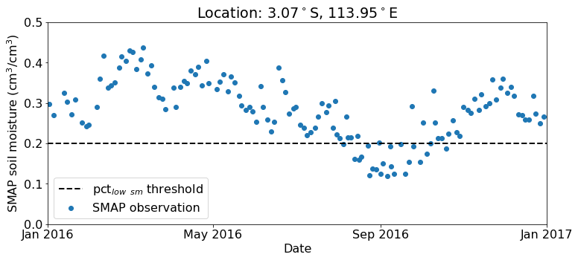

Supplementary Figure 1. Example SMAP soil moisture time series from Central Kalimantan. Low soil moisture threshold of 0.2 cm³/ cm³ is shown as dashed line.

Variable | Category | Source | Native resolution
Annual precipitation | Climate | ERA5, RCM | 25 km, 30 km
Dry season precipitation | Climate | ERA5, RCM | 25 km, 30 km
Dry season PET | Climate | ERA5, RCM | 25 km, 30 km
Precipitation entropy | Climate | ERA5, RCM | 25 km, 30 km
Tree cover fraction | Degradation | Global Forest Cover Change 2015 (GFCC30TCv003) | 30 m
Drainage canal density | Degradation | Dadap et al 2021 | 5 m
Fire area | Degradation | VIIRS Active Fire | 375 m
Fire count | Degradation | VIIRS Active Fire | 375 m
Land use type | Degradation | Miettinen et al 2016 | 30 m
Distance from peat edge | Location | Calculated from peatland map, Miettinen et al 2016 | N/A
Latitude | Location | EASE Grid 2.0 | N/A
Longitude | Location | EASE Grid 2.0 | N/A
Region | Location | Determined from Lat/Lon | N/A
Supplementary Table 1. Predictor features

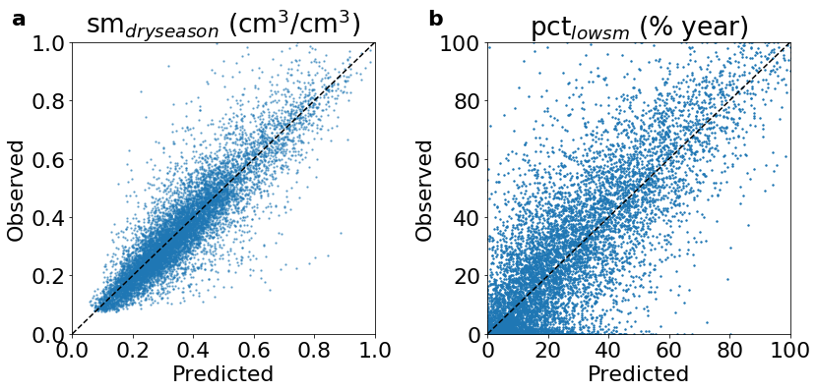Supplementary Figure 2. Scatterplot showing model performance for a) sm_{dry season} and b) pct_{lowsm}. These were computed using hold-one-year-out cross-validation.

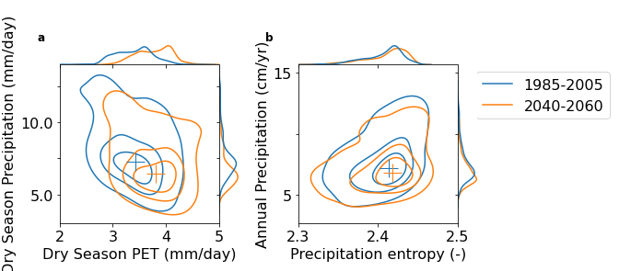

Supplementary Figure 3. Change in distributions of input climate features. Contours depict probability density and cross denotes median. a) Dry season precipitation and PET. b) Annual precipitation and precipitation entropy. Higher precipitation entropy implies lower seasonality.

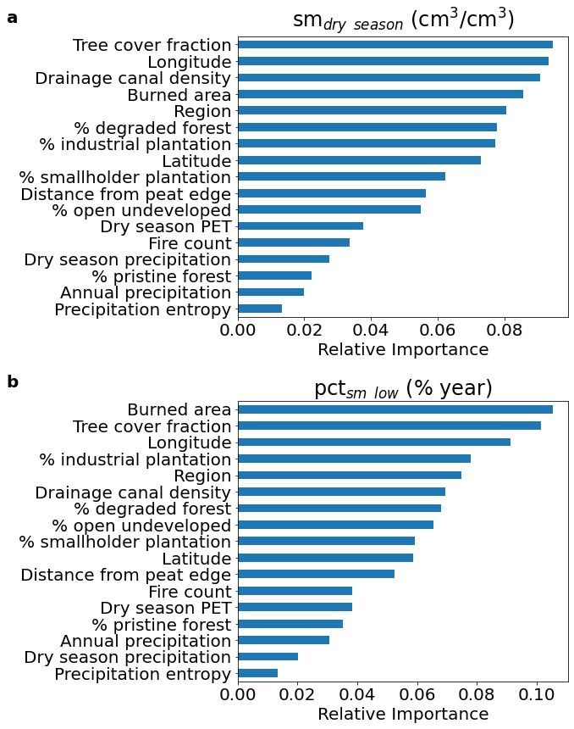
Supplementary Figure 4. Feature importance for a) sm_{dry season} and b) pct_{low sm}. These were calculated by comparing the relative increases in cross-validation error when randomly shuffling a given predictor feature. Higher resulting error corresponds to higher importance. Values are normalized to sum to one.
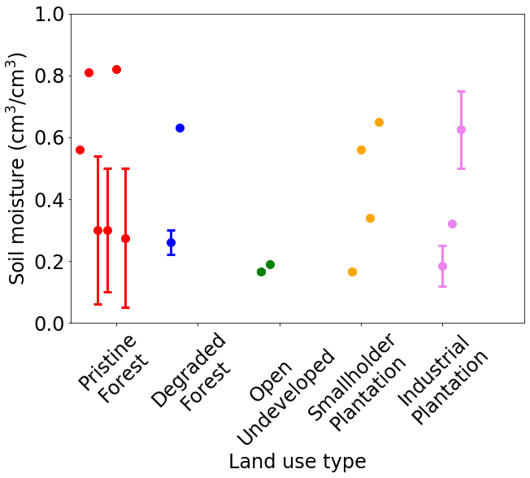
Supplementary Figure 5: In situ surface soil measurements from literature (Supplementary Table 2). Where applicable, range of values is denoted by whiskers.

Supplementary Table 2. In situ soil moisture (SM) measurements from literature, during the dry season.

Paper | Land Use | Low  SM | High  SM | Mean  SM | Where | Time Avg | Depth (cm) | Setting
Hirano et al 2007 | Degraded  Forest | 0.22 | 0.3 | 0.25 | Block C, ex-Mega Rice Project area | Monthly | 0-20 | Tree vegetation, lots of leaf litter, drainage canal present
Jauhiainen et al 2014 | Open  Undeveloped | 0.16 | 0.17 | 0.165 | ex-Mega Rice Project area | Yes | 0-10 | Clear felled, large drainage canals, surface compacted
Jauhiainen et al 2014 | Smallholder  Plantation | 0.16 | 0.17 | 0.165 | ex-Mega Rice Project area | Yes | 0-10 | Usually drained to 30-50 cm, raised, fallow, surface compacted
Hergoualc’h et al 2017 | Smallholder  Plantation |  |  | 0.56 | Central Kalimantan | Yes | 0-10 | Oil palm
Hergoualc’h et al 2017 | Pristine Forest |  |  | 0.56 | Tanjung Puting, Central Kalimantan | Yes | 0-10 | National park
Matysek et al 2018 | Industrial  Plantation | 0.12 | 0.25 | 0.2 | South Selangor | Monthly | 5-8
Könönen et al 2018 | Pristine Forest |  |  | 0.81 | Sabangau, Central Kalimantan | Yes | 0-5 | Selective logging and small ditches prior to 1997
Könönen et al 2018 | Degraded  Forest |  |  | 0.63 | Sabangau, Central Kalimantan | Yes | 0-5 | Reforested drained site 3-4 m deep canal
Könönen et al 2018 | Open  Undeveloped |  |  | 0.19 | Sabangau, Central Kalimantan | Yes | 0-5 | Drained site 3-4 m deep canal
Könönen et al 2018 | Smallholder  Plantation |  |  | 0.34 | Sabangau, Central Kalimantan | Yes | 0-5
Sakabe et al 2018 | Pristine Forest | 0.06 | 0.54 | 0.31 | Palangkaraya, Central Kalimantan | Yes | 0-20 | Hummock is low number, hollow is high number. Hollow covers 65-80 % of area
Wong et al 2018 | Pristine Forest | 0.1 | 0.5 | 0.4 | Maludam National Park, Sarawak | Monthly | 0-30
Manning et al 2019 | Industrial  Plantation |  |  | 0.32 | Sarawak | Yes | 0-10 | Highly variable values depending on location (0.14-0.64 cm³/cm³)
Marwanto et al 2019 | Industrial  Plantation | 0.5 | 0.75 | 0.61 | Riau | No | 0-10
Swails et al 2019 | Smallholder  Plantation |  |  | 0.65 | Tanjung Puting, Central Kalimantan |  | 0-5
Swails et al 2019 | Pristine Forest |  |  | 0.82 | Tanjung Puting, Central Kalimantan |  | 0-5
Tang et al 2020 | Pristine Forest | 0.05 | 0.5 | 0.33 | Maludam National Park, Sarawak | Yes | 0-30 | SM probes averaged over flat and hummock terrain

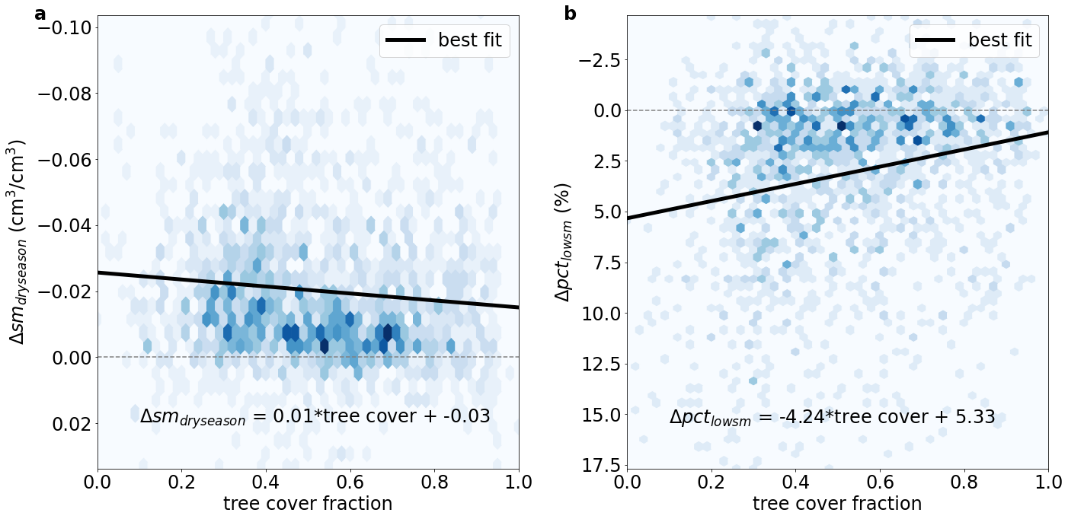

Supplementary Figure 6: Relationship between change in a) dry season soil moisture (sm_{dry season}) and b) percent low soil moisture (pct_{low sm}) with tree cover fraction. Equations show best fit linear regression line with p<<0.01 for the regression slope for both variables. Background shows binned density of the two variables. Data is clipped on the y-axis to show the 2nd-98th percentile range of the soil moisture variables.

References

Aldrian E and Dwi Susanto R 2003 Identification of three dominant rainfall regions within Indonesia and their relationship to sea surface temperature Int. J. Climatol. 23 1435–52 Online: http://doi.wiley.com/10.1002/joc.950
Bentsen M, Bethke I, Debernard J B, Iversen T, Kirkevåg A, Seland Ø, Drange H, Roelandt C, Seierstad I A, Hoose C and Kristjánsson J E 2013 The Norwegian Earth System Model, NorESM1-M – Part 1: Description and basic evaluation of the physical climate Geosci. Model Dev. 6 687–720
Dadap N C, Hoyt A M, Cobb A R, Oner D, Kozinski M, Fua P V, Rao K, Harvey C F and Konings A G 2021 Drainage Canals in Southeast Asian Peatlands Increase Carbon Emissions AGU Adv. 2 1–14
Giorgi F, Coppola E, Jacob D, Teichmann C, Abba Omar S, Ashfaq M, Ban N, Bülow K, Bukovsky M, Buntemeyer L, Cavazos T, Ciarlo’ J, Da Rocha R P, Das S, di Sante F, Evans J P, Gao X, Giuliani G, Glazer R H, Hoffmann P, Im E-S, Langendijk G, Lierhammer L, Llopart M, Mueller S, Luna-Nino R, Nogherotto R, Pichelli E, Raffaele F, Reboita M, Rechid D, Remedio A, Remke T, Sawadogo W, Sieck K, Torres-Alavez J A and Weber T 2021 The CORDEX-CORE EXP-I initiative: Description and highlight results from the initial analysis Bull. Am. Meteorol. Soc. 1–52 Online: https://journals.ametsoc.org/view/journals/bams/aop/BAMS-D-21-0119.1/BAMS-D-21-0119.1.xml
Hergoualc’h K, Hendry D T, Murdiyarso D and Verchot L V 2017 Total and heterotrophic soil respiration in a swamp forest and oil palm plantations on peat in Central Kalimantan, Indonesia Biogeochemistry 135 203–20
Hirano T, Segah H, Harada T, Limin S, June T, Hirata R and Osaki M 2007 Carbon dioxide balance of a tropical peat swamp forest in Kalimantan, Indonesia Glob. Chang. Biol. 13 412–25
Hoyt A M, Chaussard E, Seppalainen S and Harvey C 2020 Widespread Subsidence and Carbon Emissions across Southeast Asia Peatlands Nat. Geosci. 13 435–40 Online: http://dx.doi.org/10.1038/s41561-020-0575-4
Jauhiainen J, Kerojoki O, Silvennoinen H, Limin S and Vasander H 2014 Heterotrophic respiration in drained tropical peat is greatly affected by temperature - A passive ecosystem cooling experiment Environ. Res. Lett. 9
Jones C D, Hughes J K, Bellouin N, Hardiman S C, Jones G S, Knight J, Liddicoat S, O’Connor F M, Andres R J, Bell C, Boo K O, Bozzo A, Butchart N, Cadule P, Corbin K D, Doutriaux-Boucher M, Friedlingstein P, Gornall J, Gray L, Halloran P R, Hurtt G, Ingram W J, Lamarque J F, Law R M, Meinshausen M, Osprey S, Palin E J, Parsons Chini L, Raddatz T, Sanderson M G, Sellar A A, Schurer A, Valdes P, Wood N, Woodward S, Yoshioka M and Zerroukat M 2011 The HadGEM2-ES implementation of CMIP5 centennial simulations Geosci. Model Dev. 4 543–70
Könönen M, Jauhiainen J, Straková P, Heinonsalo J, Laiho R, Kusin K, Limin S and Vasander H 2018 Deforested and drained tropical peatland sites show poorer peat substrate quality and lower microbial biomass and activity than unmanaged swamp forest Soil Biol. Biochem. 123 229–41
Manning F C, Kho L K, Hill T C, Cornulier T and Teh Y A 2019 Carbon Emissions From Oil Palm Plantations on Peat Soil Front. For. Glob. Chang. 2
Marwanto S, Sabiham S and Funakawa S 2019 Importance of CO2 production in subsoil layers of drained tropical peatland under mature oil palm plantation Soil Tillage Res. 186 206–13 Online: https://doi.org/10.1016/j.still.2018.10.021
Matysek M, Evers S, Samuel M K and Sjogersten S 2018 High heterotrophic CO2 emissions from a Malaysian oil palm plantations during dry-season Wetl. Ecol. Manag. 26 415–24 Online: https://doi.org/10.1007/s11273-017-9583-6
Miettinen J, Hooijer A, Vernimmen R, Liew S C and Page S E 2017 From carbon sink to carbon source: Extensive peat oxidation in insular Southeast Asia since 1990 Environ. Res. Lett. 12 024014
Miettinen J, Shi C and Liew S C 2016 Land cover distribution in the peatlands of Peninsular Malaysia, Sumatra and Borneo in 2015 with changes since 1990 Glob. Ecol. Conserv. 6 67–78
Myneni R B, Yang W, Nemani R R, Huete A R, Dickinson R E, Knyazikhin Y, Didan K, Fu R, Negrón Juárez R I, Saatchi S S, Hashimoto H, Ichii K, Shabanov N V., Tan B, Ratana P, Privette J L, Morisette J T, Vermote E F, Roy D P, Wolfe R E, Friedl M A, Running S W, Votava P, El-Saleous N, Devadiga S, Su Y and Salomonson V V. 2007 Large seasonal swings in leaf area of Amazon rainforests Proc. Natl. Acad. Sci. U. S. A. 104 4820–3
Sakabe A, Itoh M, Hirano T and Kusin K 2018 Ecosystem-scale methane flux in tropical peat swamp forest in Indonesia Glob. Chang. Biol. 24 5123–36 Online: http://doi.wiley.com/10.1111/gcb.14410
Schroeder W, Oliva P, Giglio L and Csiszar I A 2014 The New VIIRS 375 m active fire detection data product: Algorithm description and initial assessment Remote Sens. Environ. 143 85–96 Online: https://www.sciencedirect.com/science/article/pii/S0034425713004483
Shatnawi N and Abu Qdais H 2019 Mapping urban land surface temperature using remote sensing techniques and artificial neural network modelling Int. J. Remote Sens. 40 3968–83 Online: https://doi.org/10.1080/01431161.2018.1557792
Stevens B, Giorgetta M, Esch M, Mauritsen T, Crueger T, Rast S, Salzmann M, Schmidt H, Bader J, Block K, Brokopf R, Fast I, Kinne S, Kornblueh L, Lohmann U, Pincus R, Reichler T and Roeckner E 2013 Atmospheric component of the MPI-M earth system model: ECHAM6 J. Adv. Model. Earth Syst. 5 146–72
Swails E, Hertanti D, Hergoualc’h K, Verchot L and Lawrence D 2019 The response of soil respiration to climatic drivers in undrained forest and drained oil palm plantations in an Indonesian peatland Biogeochemistry 142 37–51 Online: https://doi.org/10.1007/s10533-018-0519-x
Tang A C I, Melling L, Stoy P C, Musin K K, Aeries E B, Waili J W, Shimizu M, Poulter B and Hirata R 2020 A Bornean peat swamp forest is a net source of carbon dioxide to the atmosphere Glob. Chang. Biol. 26 6931–44
Townshend J 2016 Global Forest Cover Change (GFCC) Tree Cover Multi-Year Global 30 m V003 [Data set]
Wang J, Yu W, Chen X, Lei L and Chen Y 2015 Detection of potential fishing zones for neon flying squid based on remote-sensing data in the Northwest Pacific Ocean using an artificial neural network Int. J. Remote Sens. 36 3317–30
Wong G X, Hirata R, Hirano T, Kiew F, Aeries E B, Musin K K, Waili J W, Lo K S and Melling L 2018 Micrometeorological measurement of methane flux above a tropical peat swamp forest Agric. For. Meteorol. 256–257 353–61
Yang S, Feng Q, Liang T, Liu B, Zhang W and Xie H 2018 Modeling grassland above-ground biomass based on artificial neural network and remote sensing in the Three-River Headwaters Region Remote Sens. Environ. 204 448–55 Online: https://doi.org/10.1016/j.rse.2017.10.011

