Ariane 5 Fairing Preparations for the James Webb Space Telescope (JWST)
E M Stewart¹, E M Wooldridge¹, O Schmeitzky², J Bonhomme³, M Madsen³
1 NASA Goddard Space Flight Center, Greenbelt, MD 20771 USA
2 ESTEC Keplerlaan 1, 2201 AZ Noordwijk, Netherlands
3 Beyond Gravity Schweiz AG Schaffhauserstrasse 580, 8052 Zürich, Switzerland

Elaine.m.stewart@nasa.gov, eve.m.wooldridge@nasa.gov, olivier.schmeitzky@esa.int, jerome.bonhomme@beyondgravity.com, mats.madsen@beyondgravity.com

Abstract. The James Webb Space Telescope (JWST) is a large, infrared space telescope operating at Lagrange point 2. JWST is a joint effort between NASA, ESA, and CSA and was launched from the Centre Spatial Guyanais (CSG) on an Ariane 5 rocket in December 2021. The Ariane 5 payload faring (PLF), as shown in Figure 1, interior and Vehicle Equipment Bay membranes received multiple cleanings, detailed inspections, and verification sampling to achieve necessary cleanliness levels.
Investigation of PLF cleanliness began early in the JWST program to test the Fairing Acoustic Protection (FAP) panels. Initial PLF cleaning was performed at RUAG in Switzerland prior to shipment to the launch site in collaboration with NASA and ESA. The cleaning procedure used at RUAG premises was based on heritage of the PLF cleaning procedure for ESA/Herschel-Planck and NASA/Mars2020 missions on an Atlas V launcher. The Ariane 5 fairing was packaged in a clean manner and inspected and cleaned upon arrival to CSG. Silicon wafers and particle fall out (PFO) plates were used to monitor the internal fairing cleanliness prior to encapsulation. Just after encapsulation, PFO plates and calcium fluoride (CaF2) crystals were placed inside the fairing on a specific tool door for monitoring the cleanliness inside the fairing during the ventilation phase. The fairing itself was specially sealed to protect the inner environment with just a small, doored porthole accessible via diving board for final closeout of the purge interface. Fairing cleanliness was achieved and mitigated contamination distribution upon launch.

- Introduction
The James Webb Space Telescope (JWST) has four main science objectives to investigate the first light, galaxy change over time, star cycles, and formation of planets as shown in Figure 1.
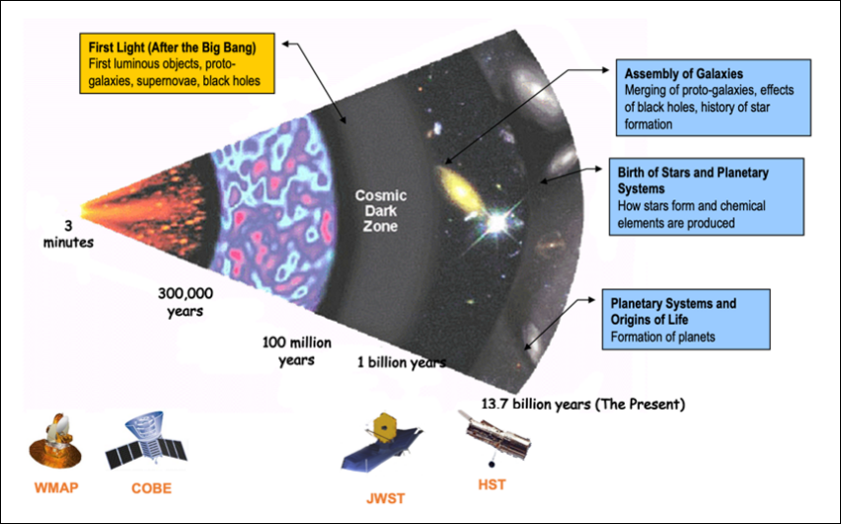
Figure 1. JWST science themes. Credit: NASA

To detect first light, a primary mirror of 6.5 meters observing in the infrared (IR) wavelength range of 0.6 µm to .29 µm was required. To operate at cryogenic temperatures for IR observations, JWST optics needed to be very clean, stringent particulate contamination requirements were set based on optical stray light and throughput analyses. With 30-50 K optics temperatures, there is also sensitivity to molecular and water/ice redistribution during thermal vacuum chamber (TVac) and on-orbit cool-down. To mitigate stray light, the strict particulate requirements were necessary. Because JWST has an open architecture, as shown in Figure 2, the sensitive optical surfaces were exposed for long periods of time throughout assembly, integration, and test (AI&T), during the launch campaign, and finally for launch.

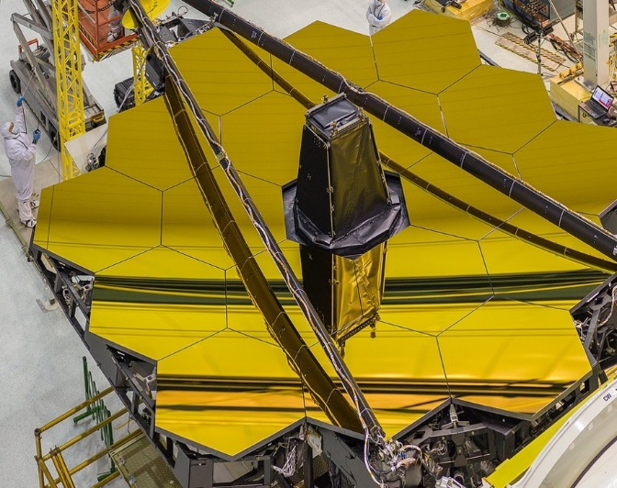
Figure 2. Exposed primary mirror optics during I&T.
Credit: NASA/Chris Gunn

Small particles and Non-Volatile Residue (NVR) are critical to stray light & transmission. In addition, the (NIRSpec) instrument’s microshutter array was discovered sensitive to fibers during environmental testing, so it was imperative to implement fiber-free requirements to the extent possible. The other JWST instruments are Mid-Infrared Instrument (MIRI), Near-Infrared Camera (NIRCam), and Near-Infrared Imager and Slitless Spectrograph/Fine Guidance Sensor (NIRISS/FGS).

The contamination requirements for launch campaign through contamination and collision avoidance mauver (CCAM) were 0.45 Percent Area Coverage (PAC), 4500 ppm and 0.50 mg/.1m² NVR (50 angstroms). To meet these requirements, flight hardware was cleaned throughout I&T, the primary mirror was cleaned twice, I&T was conducted in ISO Class 7 or better clean areas with enforced ISO Class 6 cleanroom protocols, extensive in-situ contamination monitoring was performed from mirror segment delivery through fairing encapsulation, and water deposition was controlled through environmental controls monitoring T & RH. Additionally, the Ariane 5 fairing requirements included cleaning with white/ultra violet (UV) light inspections.
- Pathfinders: Fairing Acoustic Protection (FAP) testing and Herschel-Planck (HP) cleaning and Automatic Transfer Vehicle (ATV)
  - ATV-1 Launch Campaign 2008
During the ATV-1 launch campaign, the FAP panels met standard visibly clean (VC) at 1 m but not sensitive VC at 30 cm. The requirements were met for ATV-1, but further cleanliness requirements and implementation was required for JWST.

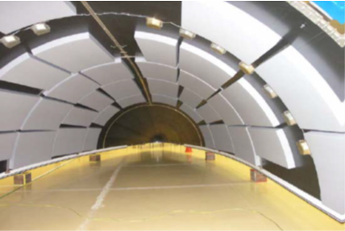
Figure 3. ATV-1 FAP. Credit: ESA
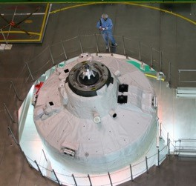 |  | 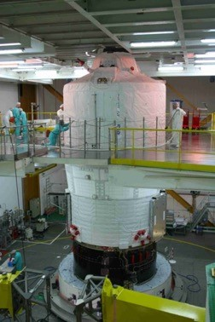
Figure 4. Mating surface for ATV-1 integration on top of launcher. Credit: ESA |  | Figure 5. ATV-1 launcher accessed from platforms. Credit: ESA

  - Heritage from HP telescopes launch 2009 ESTEC FAP Testing
In preparation of the HP launch, A FAP panel was exposed to vibration and depressurization test for assessing of the PAC release. During the test, about 120 ppm of PAC was released by the FAP panel with a view factor 1/1.
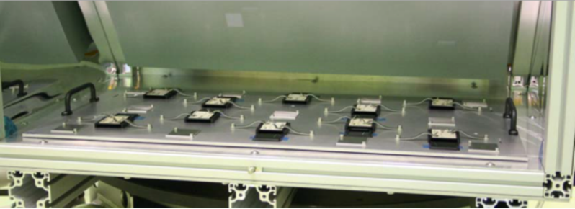
Figure 6. Configuration for vibrational testing of FAP panel. Credit: ESA

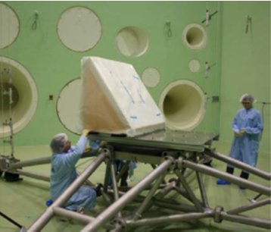 |  | 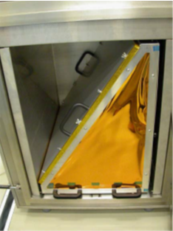
Figure 7. Acoustic testing of FAP panel. Credit: ESA |  | Figure 8. Configuration for depressurization testing. Credit: ESA
  - Heritage from HP telescopes launch 2009 GSFC FAP Testing
In conjunction with the testing performed at ESTEC, further testing occurred at GSFC. A FAP panel exposed to vibration& depressurization tests, averaged over samples, released:
- 324 ppm (0.0324 PAC) on horizontal samples
- 148 ppm (0.0148 PAC) on vertical samples

The silicon wafer witness samples were configured as shown in Figures 9, 10 and 11 in order to measure particulate fallout during acoustic testing of the panel, and then during rapid depressurization of the same panel. These tests were designed to simulate the launch conditions for JWST on the Ariane 5.

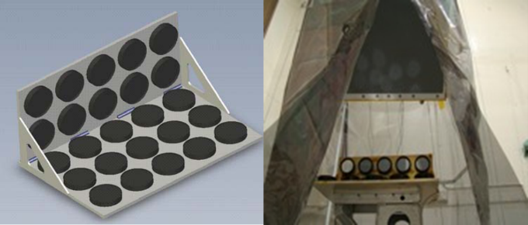
Figure 9. Silicon wafers used to monitor FAP panel fallout during acoustic testing. Credit: NASA
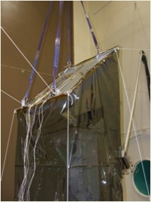 |  | 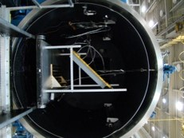
Figure 10. Configuration for acoustic testing of the FAP panel. Credit: NASA |  | Figure 11. Configuration for rapid depressurization of the FAP panel. Credit: NASA

  - Heritage from HP telescope launch in 2009
Before shipment of the fairing to Kourou, a cleanliness inspection with white light for VC highly sensitive criteria was performed. Further cleaning of the strongbacks, a dedicated clean blanket (double bagging) and specific HEPA filter implemented on the protective layer.

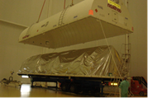
Figure 12. Bagging over HP fairing for shipment. Credit: ESA-O. Schmeitzky
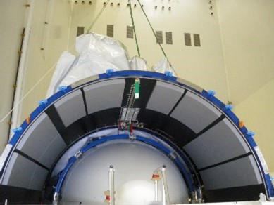 |  | 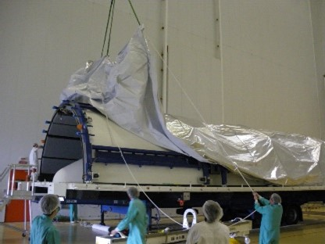
Figure 13. FAP with bagging integration for protection during shipment. Credit: ESA-O. Schmeitzky |  | Figure 14. Integration of bagging over HP fairing for shipment. ESA- O. Schmeitzky

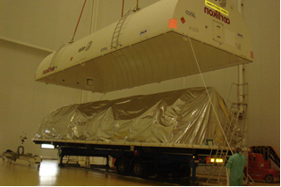

HP requirements were met after fine cleaning was performed on the upper part of the fairing with the VC sensitive level but not VCHS+UV required by JWST.

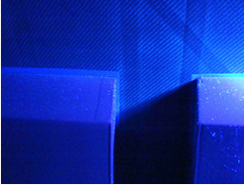 |  | 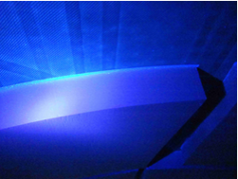
Figure 15. Particulate identified on HP fairing under UV. Credit: ESA

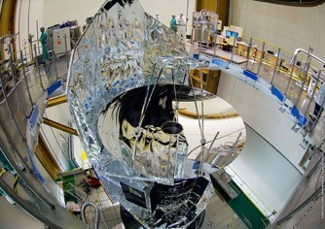 |  | 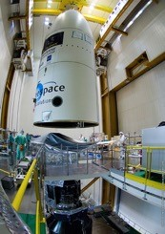
Figure 16. HP integration to Ariane 5 launcher. Credit: ESA |  | Figure 17. Fairing integration for HP. Credit: ESA

- Ariane 5 modifications and cleaning at beyond gravity
  - Handling point covers
To avoid generating particles and foreign object debris (FOD) during payload fairing (PLF) handling in Kourou, special covers were installed. These covers are installed on the “PLF Handling points” which are used for transportation and encapsulation with different tooling. The covers prevented FOD from entering the PLF when the handling tools are installed.
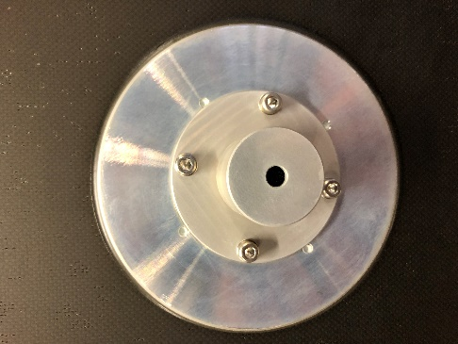
Figure 18. Filters placed over handling points to block metal particles from coming into the fairing. Credit: Beyondgravity
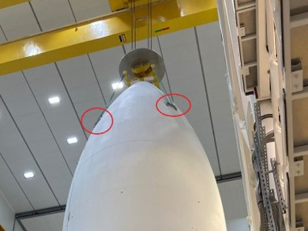 |  | 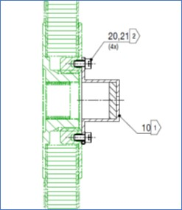
Figure 19. Locations of handling points on fairing for Webb. Credit: Beyondgravity |  | Figure 20. Design of handling points. Credit: Beyondgravity

  - Handling point covers
To avoid generating particles and foreign object debris (FOD) during payload fairing (PLF) handling in Kourou, special covers were installed. These covers are installed on the “PLF Handling points” which are used for transportation and encapsulation with different tooling. The covers prevented FOD from entering the PLF when the handling tools are installed.
Figure 18. Filters placed over handling points to block metal particles from coming into the fairing. Credit: Beyondgravity
Figure 19. Locations of handling points on fairing for Webb. Credit: Beyondgravity |  | Figure 20. Design of handling points. Credit: Beyondgravity

3.3 Sealing of sandwich panels
The PLF sandwich panels were sealed with adhesive to reduce the residual pressure at PLF separation. Adhesive sealing also helped to maintain the cleanliness of the payload volume by avoiding ingress of air coming from honeycomb venting.

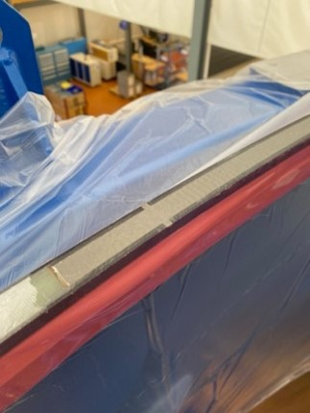 |  | 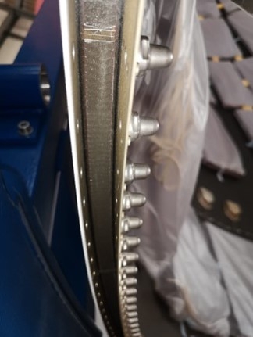
Figure 21. Process of sealing sandwich panels with adhesive. Credit: Beyondgravity

3.3 Sealing of sandwich panels
The PLF sandwich panels were sealed with adhesive to reduce the residual pressure at PLF separation. Adhesive sealing also helped to maintain the cleanliness of the payload volume by avoiding ingress of air coming from honeycomb venting.
Figure 21. Process of sealing sandwich panels with adhesive. Credit: Beyondgravity

  - Improved cleaning of payload fairing (PLF)

Mars 2020 Perseverance mission required cleaning protocols that served as a basis for JWST PLF. Any personnel working on PLF wore cleanroom garments to mitigate contamination. Any facility the PLF was exposed in was cleaned and verified. In addition to the standard “visual clean” inspection, a full inspection with UV lights was performed.

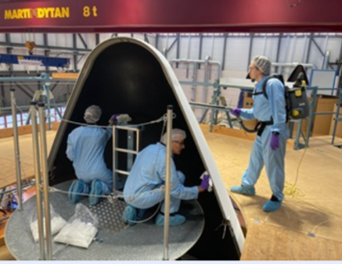
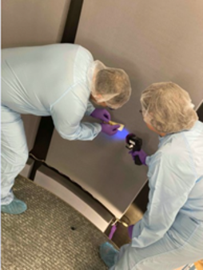 |  | 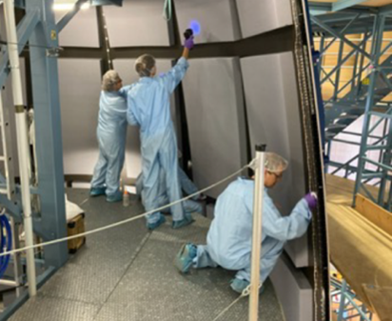
Figure 22. Cleaning of the fairing for Mars 2020 Perseverance rover. Credit: ESA

  - Bagging of payload fairing (PLF) for transport

With the heritage bagging designed for ESA Herschel-Planck Mission, each PLF half was bagged with a special foil in its container to reduce any possible risk of contamination during transport. High performance particle air (HEPA) filters were added to ensure the cleanliness and temperature/humidity control of the environment for the transporter container.

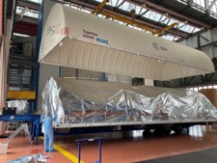
Figure 23. Protected fairing with inner bag. Credit: Beyondgravity
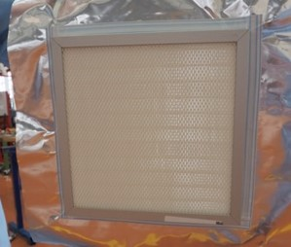 |  | 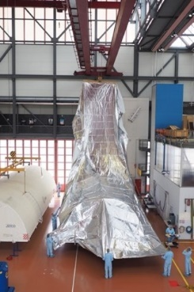
Figure 24. HEPA filters to ensure particulate cleanliness during transport. Credit: Beyondgravity |  | Figure 25. Inner bag protecting fairing for shipping. Credit: Beyondgravity

- Ariane 5 payload fairing (PLF) cleaning and Centre Spatial Guyanais (CSG)
  - Cleanliness preparations in Bâtiment Assemblage Final encapsulation
hall (BAF-HE)
The Bâtiment Assemblage Final encapsulation hall (BAF-HE) was vacuumed and wiped using sealed edge wipers, any prohibited surfaces were covered, and white/UV inspections occurred over multiple days prior to the arrival of the A5 fairing. HEPA filters, shown in Figure 31, were turned on after cleaning was completed to ensure the environment JWST would be placed in was to ISO 7 standards. The scaffolding used to access the PLF was cleaned and inspected.

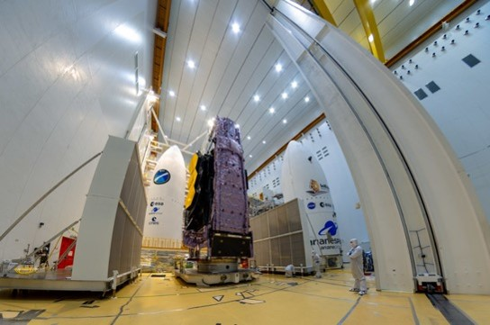
Figure 26. BAF-HE operations with HEPA walls. Credit: ESA-M.Pedoussaut
  - Final cleaning at Centre Spatial Guyanais (CSG)
The final cleaning of the PLF during the launch campaign was performed with all stakeholders including beyond gravity, ESA, NASA, and CNES. The PLF was placed over the scaffolding showing in Figure 32 to access the interior. All areas of the PLF able to be accessed were inspected and cleaned. White light and UV, shown in Figure 33, were used during inspections. Metallic surfaces were cleaned using sealed edge wipers with IPA. Particulate identified on the FAP was carefully removed with approved tape. After cleaning, the fairing was sealed out until D-6 lift to launcher. The fallout measured within the fairing environment while sealed was measured as 0.0002 PAC/day (2 ppm).

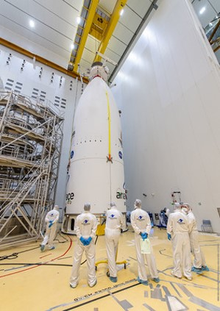 | Figure 27. Ariane 5 fairing for Webb near access scaffolding. Credit: ESA-M.Pedoussaut

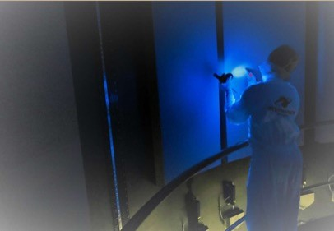
Figure 28. Elaine Stewart using UV light to clean the interior FAP of Ariane 5 for Webb. Credit: ESA- O. Schmeitzky
  - Particle area coverage (PAC) and molecular organic contamination (MOC) results inside fairing during ventilation phase up to D-2

The final cleaning of the PLF during the launch campaign was performed with all stakeholders including beyond gravity, ESA, NASA, and CNES. The PLF was placed over the scaffolding showing in Figure 32 to access the interior. All areas of the PLF able to be accessed were inspected and cleaned. White light and UV, shown in Figure 33, were used during inspections. Metallic surfaces were cleaned using sealed edge wipers with IPA. Particulate identified on the FAP was carefully removed with approved tape. After cleaning, the fairing was sealed out until D-6 lift to launcher. The fallout measured within the fairing environment while sealed was measured as 0.0002 PAC/day (2 ppm).

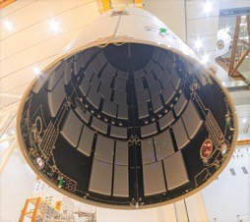 |  | 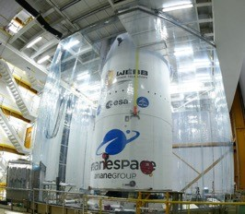
Figure 29. FAP inside Ariane 5 fairing during lift operations for encapsulation. |  | Figure 30. Ariane 5 fairing encapsulating Webb observatory.

- Discussion
On March 11 2022, the Webb team completed the stage of alignment known as "fine phasing." At this key stage, every optical parameter that had been checked and tested was performing at, or above, expectations. The team also found no critical issues and no measurable contamination or blockages to JWST's optical path. The observatory can successfully gather light from distant objects and deliver it to its instruments without issue. The first images were released in July 2022 showing the star and universe cycles with spectrometer measurements of atmospheres. There are frequent releases of new images and data from the Webb space telescope institute (STsci) in Baltimore, MD. Table 1 shows the cleanliness achieved was better than required for End of Life (EOL) for both particulate and molecular.

Table 1. Contamination Levels Achieved
 | Particulate, PAC  Percent Area Coverage (PAC) |  | Molecular Angstroms (Å)
 | End of Life (EOL) reqt | Measured | EOL | Measured
PM | 1.5 | 0.754 | 300 | 45
SM | 0.5 | 0.149 | 300 | 59

 | Particulate  Percent Area Coverage (PAC) |  | Molecular  Angstroms (Å)
 | EOL Reqt | Measured | EOL Reqt | Measured
Primary Mirror | 1.5 | 0.754 | 300 | 45
Secondary Mirror | 0.5 | 0.149 | 300 | 59
References
[1] Elaine M. Stewart, Eve M. Wooldridge, Joseph O. Ward, "Predicting contamination accumulation in facilities with limited data," Proc. SPIE 12224, Space Systems Contamination: Prediction, Control, and Performance 2022, 122240E (3 October 2022)

[2] Abeel, A. C., Wooldridge, E. M., Ward, J. O., Calcabrini, M., Schmeitzky, O., “Overview of contamination control for the James Webb Space Telescope launch campaign”, Proc. SPIE 12224, Space Systems Contamination: Prediction, Control, and Performance 2022, 12224–13P (24 August 2022); https://spie.org/optics-photonics/presentation/Overview-of-contamination-control-for-the-James-Webb-Space-Telescope/12224-13 Google Scholar

[3] Wooldridge, E. M., Arenberg, J., “Contamination effects and requirements derivation for the James Webb Space Telescope,” Proc. SPIE 7069, Optical System Contamination: Effects, Measurements, and Control 2008, 70690J (2 September 2008); https://doi.org/10.1117/12.801664 Google Scholar

[4] Wooldridge, E. M, Abeel, A. C.,. Jones, C. B., Goldman, E. M., Lepage, C. D.,“ Transforming any facility for meeting strict cleanliness requirements,” Proc. SPIE 12224, Space Systems Contamination: Prediction, Control, and Performance 2022, 12224–12 (23 August 2022); https://spie.org/optics-photonics/presentation/Transforming-any-facility-for-meeting-strict-cleanliness-requirements/12224-12 Google Scholar
[5] Abeel, A. C., Jones, C. B, Wooldridge, E. M., Goldman, E. M., and Lepage, C. D., “Evaluating the performance of portable air filter walls for James JWST Space Telescope launch campaign.”, Proc. SPIE 12224, Space Systems Contamination: Prediction, Control, and Performance 2022, 12224–11P (23 August 2022); https://spie.org/optics-photonics/presentation/Evaluating-the-performance-of-portable-air-filter-walls-for-the/12224-11?SSO=1 Google Scholar
[6] Rumler, P. ESA JWST Launcher Liaison. “Contamination Control Feedback from ATV Launch Campaign”. 28 March 2008. Google Scholar
[7] Rumler, P., Schmeitzky, O. “Ariane 5 Cleanliness, Herschel-Planck Launch Campaign Experience”. ESA-ESTEC, 20 May 2009. Google Scholar
[8] Van Eesbeck, M., Schmeitzky, O. “ Herschel-Planck Launch campaign”. ESA-ESTEC, 02 July 2009. Google Scholar

[9] Calcabrini, M. and Erin, B., “JWST-Launch Vehicle Provider-Contamination Control Implementation Plan,” Issue 9-Revision 0, Arianespace, (October 2021). Google Scholar

[10] Lepage, C. D., Abeel, A. C., Stewart, E. M., Rodriguez, I., Horton, C. T., Morales, K. Z., Transforming any facility for meeting strict cleanliness requirements,” Proc. SPIE 12224, Space Systems Contamination: Prediction, Control, and Performance 2022, 12224–16 (24 August 2022); https://spie.org/optics-photonics/presentation/Establishing-cleaning-methods-for-cleanroom-and-safety-suits-at-remote/12224-16?SSO=1 Google Scholar

[11] Pinol, N., Fisher, A., and Betz, L.,, “NASA’s Webb Reaches Alignment Milestone, Optics Working Successfully”, NASA HQ press release, March 16, 2022. (http://spaceref.com/news/viewpr.html?pid=59635) (https://www.nasa.gov/press-release/nasa-s-webb-reaches-alignment-milestone-optics-working-successfully) Google Scholar

