Utilizing Gaps and Performance Measures to Inform NASA Environmental Control and Life Support Systems and Human Health and Performance Capability Technology Decisions
James L. Broyan, Jr.
NASA Headquarters, Washington, D.C. 20546
Andrew Abercromby
NASA, Johnson Space Center, Houston, TX, 77058
and
Alexander Burg
Bryce Space and Technology, Alexandria, VA, 22314
Human spaceflight is a complex endeavor requiring multiple capabilities for transportation, crew health, scientific goals, and safe return to Earth. The difference between spaceflight proven capabilities and those needed for future exploration architectures is defined as a capability gap. Capability gaps are not technology specific. Each capability gap may be closed with a wide array of technologies that have unique benefits and challenges. Determining what a capability’s relevant and distinguishing key performance parameters (KPPs) are for a mission is critical. Mass, power, and volume are always constrained and important, but defining these in a way normalized by performance is very important. KPP definition for reliability, dormancy, and integration needs are hard to define but critical. Outside of technical considerations, the programmatic factors of the estimated time to develop the technology and how the technology validation objectives are matured are strong considerations in which technologies should be pursued and how they should leverage earlier mission elements. The Environmental Control and Life Support (ECLSS) and Crew Health and Performance (CHP) capability areas are decomposed to high level gaps. While KPPs should be technology agnostic, they can be used to both compare technologies and measure progress of technology development over time. KPPs help define when the gap is closed, and the core mission objectives can be accomplished. Proposed technology improvements to enhance a capability should balance improved KPPs and against investments in other capabilities that are not yet closed. A selection of gaps, KPPs, and validation objectives and their formulation, current state, and how they inform capability roadmap planning are discussed.

Nomenclature
CHP = Crew Health and Performance
CIT = Capabilities Integration Team
CLPS = Commercial Lander Payload Services
ECLSS = Environmental Control and Life Support System
ESDMD = Exploration Systems Development Mission Directorate
HILT = Human in the loop testing
HRP = Human Research Program
HSRB = Human Systems Risk Board
ISS = International Space Station
KKP = Key Performance Parameter
MTBF = Mean Time between Failure
NASA = National Aeronautics and Space Administration
NESC = NASA Engineering and Safety Center
OCHMO = Office of the Chief Health and Medical Officer
OSMA = Office of Safety and Mission Assurance
POS = Probability of Sufficiency
PPBE = Planning, Programming, Budgeting, and Execution
PT = Principal Technologist
SCLT = System Capability Leadership Team
SOA = State of the Art
STMD = Space Technology Mission Directorate
TRL = Technology Readiness Level
VMO = Validation Maturation Objective

Introduction
E
NVIRONMENTAL Control and Life Support System (ECLSS) technologies are combined with Crew Health and Performance (CHP) technologies under the ECLSS-CHP System Capability Leadership Team (SCLT). The SCLT provides strategic advisement across NASA between evolving exploration missions and technology development programs. The intent is to ensure safe, reliable, and habitable environments and provide technologies to allow the crew to maintain their health and productivity so they can accomplish future mission objectives. The SCLT capability areas are broadly grouped into ECLSS and CHP, see Figure 1. Each ‘Capability Area’ (e.g., ‘Life Support’) is composed of ‘Capabilities’ (e.g., ‘Atmosphere Management’). The SCLT is in the process of formulating the Human Systems Integration capability area so the gaps and measures will not be detailed here. Overviews of technology development progress in the past year for ECLSS¹ and CHP² are covered in separate papers. This paper will address how various NASA objectives, processes, and measures are used to inform technology strategy. Specifically the paper will show how exploration objectives, mission architectures, capabilities, gaps, Human System Risks, technology validation maturation, and SCLT technology roadmaps are being aligned.
NASA released the Moon to Mars Objectives³ to define big picture “what” and “why” objectives of what NASA should be doing for deep space exploration. Of the 63 high-level objectives, approximately 27 are related to ECLSS-CHP capability areas and allow NASA to “architect from the right” and work development logic backwards so that technology can be “executed from the left” in a manner that supports the big picture objective. For example, Transportation & Habitation objective 4 is “Develop in-space and surface habitation system(s) for crew to live in deep space for extended durations, enabling future missions to Mars.”
While objective 4 seems straight forward to achieve, NASA mission architects need to consider how best to achieve all the objectives with a range of architecture elements. Mission architects are in the process of reviewing the moon and Mars architecture to better address the objectives. An updated plan is expected later in 2023, but previously identified ECLSS-CHP capability needs are likely to largely remain. The lunar surface missions and elements may change, but the initial duration of ~30 days and high EVA rates are likely to remain. The travel duration to Mars may change modestly but remain in the 800–1200-day range. Hence, the high level ECLSS-CHP capability assumptions for moon and Mars are still relevant for supporting technology development. The current architecture is used to identify the capability gaps through a structured NASA process.
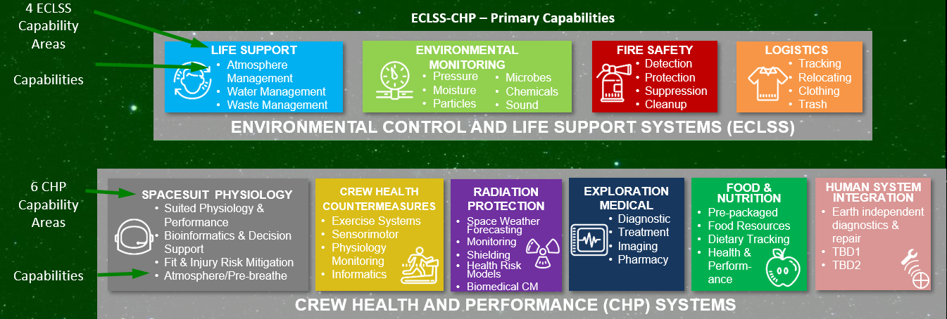
Figure 1. ECLSS-CHP Capability Areas.

NASA Capability Gap Process

Data Collection
NASA’s Exploration Systems Development Mission Directorate (ESDMD), Capabilities Integration Team (CIT) conducts an annual data call to NASA-designated subject matter experts in all technical disciplines associated with human exploration plans to update capability gap data based on the current set of architecture assumptions. Those subject matter experts consist of Systems Capability Leadership Teams (SCLTs), Space Technology Mission Directorate (STMD) Principal Technologists (PTs), ESDMD program managers and executives, center experts, Office of Safety and Mission Assurance (OSMA) planetary protection experts, and NASA Engineering and Safety Center (NESC) Technical Fellows⁴.
Capability gaps are defined simply as the difference between the current state of the art capabilities and the anticipated needs of future human spaceflight architectures. High-level missions are derived by the human spaceflight architecture which considers national space policy, stakeholder considerations, and NASA strategic guidance. Teams of discipline experts from across NASA review these missions and identify capability needs within their capability area. They then articulate the gaps between the current state of the art and the capability needs of the proposed exploration missions.
Once the capability gaps have been determined, the discipline experts further characterize by type, indicating possible closure via new technology development, engineering development, acquisition of new knowledge/science, operations processes, or policy definition. These gap types are further defined, below:
- Technology Gap: new and/or novel performance or function that has not been demonstrated (solutions to this gap type are generally Technology RL 1-4); this gap type aligns with the Technology Readiness Levels (TRL) 1-4 definition within the NASA Technology Readiness Assessment Report (2016)⁵.
- Development Gap: at least one potential solution has been identified, but additional work is required to ensure feasibility of the new and/or novel performance or function in a specific operational application (solutions to this gap type are generally TRL 5-9); this gap type aligns with TRLs 5-9 definition within the NASA Technology Readiness Assessment Report (2016).
- Engineering Gap: performance or function is well accepted (not new or novel), but requires engineering development for a specific mission (solutions to this gap type are generally TRL 5-9).
- Knowledge Gap: unknown data (e.g., chemical, and physical properties) that will ultimately drive hardware requirements; these gaps typically require additional scientific research in order to close.
- Operations Gap: crewed and uncrewed mission operations considerations, including training and flight operations, that differ from current standards of practice and need to be defined and/or tested in order to enable the mission.
- Policy Gap: policy or management issues that are needed to define closure of other gap types (e.g., risk postures, planetary protection policies, strategic mission objectives, etc.).

Data Integration
Gaps are distributed to the respective human spaceflight architecture element leads to validate those gaps are mapped appropriately to selected campaign elements and are characterized as enabling or enhancing, which are further defined, below:
- Enabling: System/architecture cannot function or achieve mission success without closing this gap; there may be alternatives such as different operational approaches or accepting more risk, but usually at additional cost/resources.
- Enhancing: Not strictly required to function or achieve mission success, but closing this gap (potentially in combination with other gaps) improves the architecture by adding functionality or resiliency.
The resultant integrated gap list represents a set of accepted enabling or enhancing gaps that have been validated and agreed upon by stakeholders across multiple technical communities.

Data Categorization
The data call culminates with the categorization of the integrated gap list based upon the following factors: 1. Whether the gap is enabling or enhancing, and 2. Investment need date based upon current campaign manifest and projected design development test and evaluation schedules. The investment need date thresholds are intended to inform the current Planning, Programming, Budgeting, and Execution (PPBE) cycle and provided, as follows:
- Near-Term: present – 2 years; investment in this category is required presently through the execution phase of the current PPBE cycle.
- Mid-Term: 3 – 6 years; investment in this category is required during the formulation and advocacy phases of the current PPBE cycle.
- Long-Term: greater than 6 years; investment in this category is beyond the current PPBE budget horizon.
These categorizations influence senior management decision making regarding funding strategy. The gap process allows for better integration across all relevant stakeholders by enabling creation of gap closure roadmaps with element development timelines. In total, there are nearly 500 gaps, of which around 100 pertain to Human Health, Life Support, and Habitation Systems and approximately 76 directly relate to the ECLSS-CHP SCLT capability areas.

NASA Human Risk Alignment
While the gap process directly aligns with mission architectures and vehicle elements, the astronauts are considered additional as part of the human “system” and additional gap alignments need to be considered. The Human System Risk Board (HSRB) is chartered by NASA’s Office of the Chief Health and Medical Officer (OCHMO) and maintains a set of twenty-nine Human System Risks to aid in identifying and prioritizing human research needs⁶. Discipline experts provide periodic updates to the estimated likelihood and consequence associated with each risk based on a set of generic design reference missions. While the HSRB does not direct agency investments, the Human System Risks are valuable tools in identifying and prioritizing human-centered research investments. For example, the Human Research Program (HRP) maintains a Human Research Roadmap7 which is a strategic plan that identifies research activities aimed at improving NASA’s ability to characterize and/or mitigate the respective human system risks.
In many cases, research must be accompanied by technology development to mature required countermeasures or other capabilities. While the HRP conducts technology development in some instances, it is primarily a research program, and thus the “Path to Risk Reduction” roadmaps used by HRP have typically focused on HRP-funded research and development activities aligned with HSRB Risks. The HRP research supports closure of some of the CIT knowledge and operation gaps in addition to other gap types.
Where the need for a new capability is identified for a future mission, these are referred to as capability gaps, and a primary function of the ECLSS-CHP SCLT is to continually monitor and update the capability gaps relevant to ECLSS-CHP, and to establish and oversee multiyear strategic roadmaps aimed at guiding NASA’s technology development priorities in these areas. Close coordination between the SCLT and HRP is therefore essential to ensure appropriate alignment and prioritization of CHP-related research and technology development to enable NASA’s future exploration missions.
To this end, the SCLT and HRP collaborated to establish a set of Human System Capability Gaps⁸, which established a formal linkage between the capability gaps used to prioritize investments across much of NASA, and the Human System Risks that are primarily used to inform and prioritize human research. This set of twenty-eight gaps was developed by subject matter experts, and each gap was mapped to the primary associated Human System Risks. The gaps and risk mapping were then formally reviewed and approved via the HSRB in 2021 and submitted via the agency-level capability gap update process. This process is now repeated annually with the most recent updates described in a companion paper².
The over-arching purpose of this integration effort is to enable development of fully integrated research and technology development roadmaps with activities that are formally linked to agency-recognized capability gaps and Human System Risks. These roadmaps, like the SCLT itself, are intended to be agency-wide and independent of any program, directorate, or other organization within NASA. Figure 2 is a simplified visualization of the relationship between the program-independent SCLT and different research and technology development organizations within NASA.
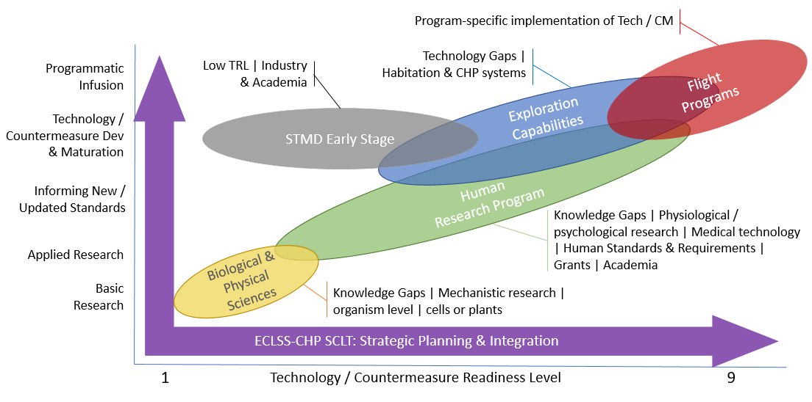
Figure 2. ECLSS-CHP SCLT serves a program-independent strategic planning integration across NASA for ECLSS and CHP related research and development.

ECLSS-CHP Technology Gaps and Key Performance Parameters
As described in the previous section, the ECLSS-CHP SCLT reviews the current exploration mission concepts and compares the state of the art to capabilities required to reduce mass, power, volume, crew time, and other mission drivers⁹. Gaps in capability are identified at a high to medium level to allow flexibility how the gap is closed. It is important that gaps are not at too low of a level where they inadvertently centered around a single technology solution. The ECLSS-CHP gaps are fairly well developed but still evolving more detailed key performance parameters (KPPs). NASA plans to release a public version of gaps later this year. Until that occurs specific gaps may be found in specific ECLSS-CHP technology papers referenced in previous overview papers^{1,2,8,9}. Additionally the Space Technology Mission Directorate has published a strategic framework that captures a summary of many of the ECLSS-CHP gaps in a short-hand format under the ‘Live’ thrust’s ‘Advanced Habitation’ area¹⁰. There are 76 direct ECLSS-CHP gaps distributed across the 10 domain areas as indicated in Figure 3. This graphic shows where gaps have matured and where they are still evolving. Examples of two ECLSS and two CHP gaps are included in Appendix Table 1 to illustrate the range of gaps and KPPs.

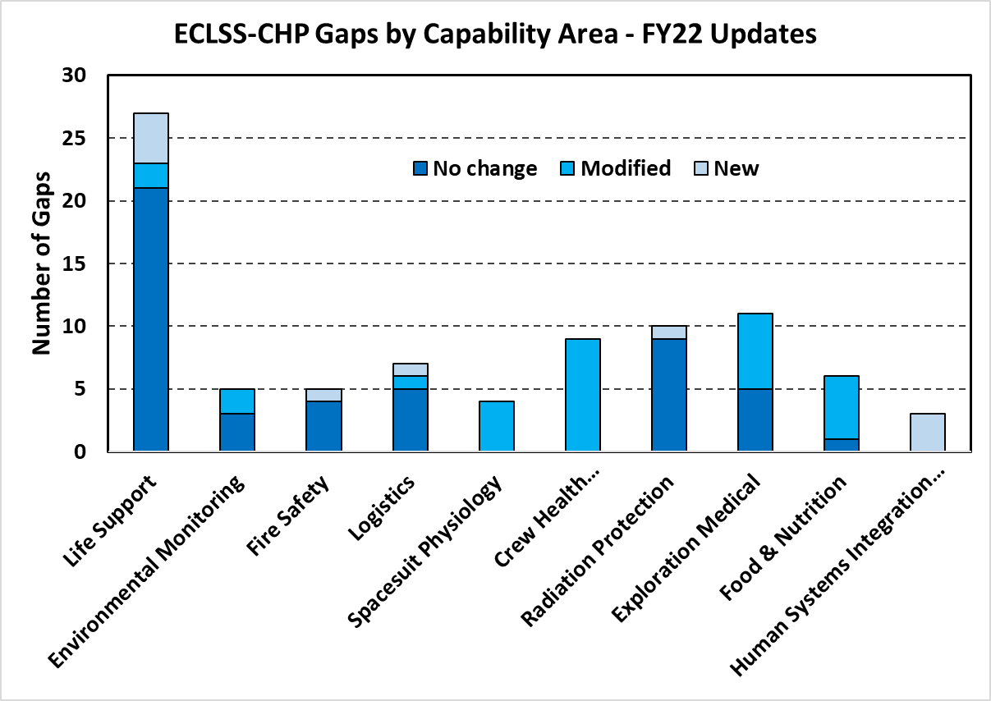
Figure 3. Gap distribution across the ECLSS-CHP Capability Areas in 2022 update.

Technology Validation Maturation Objectives
As described in the CIT gap process, the NASA Technology Readiness Level (TRL)⁵ is used to broadly characterize a technology or system across a wide range from basic principals observed (TRL 1) to system is ‘flight proven’ (TRL 9). TLR does not describe what functions a system should perform or measure how it compares to other technological solutions that may provide a similar capability. Key Performance Parameters (KPPs) are measurable engineering parameters that are used to compare the benefits between technologies and measure technical progress during development, operation, and in planning technology upgrades¹¹. Gaps use KPPs to characterize the state of the art (SOA) and establish targets for exploration missions, Table 1 illustrates an example of gaps and KPPs. Examples of SOA KPPs can also be found in the NASA Life Support Baseline Values and Assumptions Document (BVAD)¹². KPPs (along with test verified reliability data) are a major input top mission planners for predicting the total earth departure mass. TRLs or KPPs generally do not characterize how much validation is required of a particular function or KPP. Technology validation maturation objectives (VMOs) are being formulated to help establish and communicate progress on a technology or system maturation is to reduce risk and improve crew survivability for long endurance missions¹³. Gaps, TRLs, KPPs, and VMOs all have a place in helping inform technology development.
There are a wide range of performance objectives for exploration that are beneficial to establish validation objectives. The SCLT identified six validation objectives that apply to a large number of technologies that should be matured to ensure technologies are sufficiently robust and reliable before departing on long duration missions to improve crew safety and survivability. Typically the most demanding mission is Mars transit missions with an endurance of 800-1200 days. VMOs for Mars Transit were established for each. Long duration surface mission VMOs were established similarly. For each VMO, the suggested ‘requirement’ is defined along with the rationale behind it for both Mars transit and long-term lunar surface. In practice the SCLT has established a five-color scale of gradation (red, orange, yellow, green, blue) to help describe the technology maturation. Green is the suggested ‘requirement’ and blue is the goal. A table of all of the VMOs gradated across the colors appears in the appendix. While it is desired to use the six identified VMOs, there is an option of a unique VMO that can be defined for a particular system. This is an initial description of the VMOs and they are expected to evolve over the coming year as their greater input from the technical community.

Integrated System Operation Objective
Validating basic technology functionality in microgravity, or other relevant environments, is a key initial step to technology validation. Validation is the establishment that the system will meet the customer’s (astronauts, ground support) expectations. Systems are often tested and verified independently so that performance can be evaluated as input parameters can be varied across their expected ranges. Verification is establishment specific requirements were met. This is necessary to gain confidence the system is functioning as intended on ground or initial in-flight demonstrations. However, even weeks of operation are insufficient to understand and validate the long-term cumulative complexities of repeated transitions into and out of operational cycles with variable loading in a closed loop space habitat with crew generated waste products. Systems may deteriorate from cumulative exposure and decrease the capacity, selectivity, or sensitivity of catalysts, adsorbers, coatings, and detection sensitivities. The following VMOs are recommended for the Integrated System Operation Objective.
- Mars transit objective: >5 years of μg operation or >9 years of full-scale integrated ground testing. Rationale: Round trip Mars duration is likely between 2 and 3.3 years depending on propulsion capability, vehicle mass, and year of departure. Five years cumulation of integrated system testing in μg provides approximately a factor of 2 in determining if low level of trace contaminants or system interactions will result in unexpected failures over the course of the mission. It is important that human in the loop testing (HILT) be included if human loads are a substantial aspect of the performance (e.g. exercise countermeasures, or chemical catalysts). If only ground testing is utilized, it is recommended that twice the duration be used to be conservative since its unlikely to fully replicate the μg environment. If there are clearly no μg sensitivities or features sensitive to contamination then only 1.2x the μg duration is recommended. The 2x and 1.2x factors are engineering assumptions and not yet supported with data.
- Long duration lunar surface objective: >12 months of μg or ground full-scale integrated ground testing depending on the system. In addition to integrated system testing, with HILT where appropriate, testing must include reduced pressure (~8.2 psia) and elevated oxygen (~34%) and if applicable representative dust exposure tolerance/filterating. Ground testing may be sufficient for most systems unless fine particle or capillary liquid separation is required. Rationale: The first several lunar missions will be of the order of 30 days and assume a goal that systems should support at least six repeat missions for a total of 180 days. Appling the same factor of 2x to account for low levels of trace contaminants or system interactions results in 12 months.

Reliability Objective
Reliability testing is related to integrated system operations but the focus is on longer term operation with a focus on reducing the life time or capacity uncertainty in components, assemblies, and the system. . Reducing the uncertainty is used to reduce the overall spares mass required for a given mission duration and probability of sufficiency^{14,15}. Spares mass is calculated to be the second largest Mars transit habitat mass after propellant¹⁶. Since spares mass allocation for future missions will be limited, it is important the best spares distribution be taken to improve crew survivability. Testing time in integrated systems operation (above objective) can be used as part of total reliability test time. However, longer cumulative test time beyond understanding system interactions, is generally required, and focus is primarily on operational wear and tear and manufacturing variability impacts. Additional units on the ground may be required to augment integrated testing and loading with representative major constituents. This is considered a reasonable trade over a more complicated and expensive attempts to replicate all the possible trace contaminants. The VMO for reliability run time depends on the system mass. Larger system masses have potentially greater savings benefit from a reduction in uncertainty and warrant longer testing. Of course, actual savings will depend on the test results, but in all cases reduces uncertainty and allows better spares quantity distribution for a given mass target. If the system’s duty cycle is intermittent, it is reasonable to reduce the combined testing proportionally. Replacing combined testing time with a multiple of Mean Time between Failure (MTBF) is being considered and may appear in a future evolution of VMOs. The following VMOs are recommended for the Reliability Objective.
- Mars transit objective: System mass >300kg, >12 years combined testing. System mass 50-300 kg, >9 yrs combined testing. System mass<50 kg, >4 years combined testing. Rationale: Cumulative spares mass reliability testing analysis indicates that about 15 years (~5x the Mars transit duration) has provided ~80% of the likely benefit¹⁷. If the system’s duty cycle is intermittent is reasonable to reduce the combined testing by a proportional amount.
- Long duration lunar surface objective: System mass >300kg, >30 months combined testing. System mass 50-300 kg, >9 20 months combined testing. System mass <50 kg, >10 months combined testing. Rationale: Similar to integrated system testing, systems should support at least six repeats 30-day missions for a total of 180 days. Appling the same factor for Mars transit of 5x results in 30 months.

Dormancy Objective
Human systems for Mars transit and lunar surface are expected to be built up over several missions. During a mission, systems are operated and contaminated with microorganisms and chemicals from humans, the vehicle off gassing environment, and materials that enter the habitat. During uncrewed periods (referred to as dormancy even if some vehicle systems are still active), these contaminants can microbially proliferate, precipitate, cause corrosion, or increase seal friction. Systems that are wetted with water or high humidity are particularly susceptible to microbial upset. While ISS regenerative life-support has operated since 2008, the system has not been placed in a dormant mode as ISS has been continually crewed. Procedures and operations to enter dormancy, tolerate dormancy, and recover and operate after dormancy need to be validated over representative timescales. Systems must be representatively operated in a relevant environment sufficiently long to establish contamination before testing dormancy countermeasures. The following objectives are recommended for the Dormancy Objective.
- Mars transit objective: Operate a system for >60 days in μg to sufficiently contaminate it, perform dormancy procedures, remain dormant for >270 days, perform dormancy recovery/exit procedures, and operate nominally for >30 days in μg. Rationale: While the actual transit to Mars will not have a dormant period (if 2 crew remain in orbit and 2 descend to the surface), the outfitting of the transit vehicle over several years will have typical dormancy periods of 9-11months. 60 days of operation is a reasonable timeframe for microbial biofilms to establish themselves. Fluid distributes itself differently in μg during operational transitions so dormancy is best demonstrated in μg unless it can be reasonable replicated on the ground (where humidity is the predominant wetting mechanism). 270 days of dormancy is a reasonable period for fungi or biofilms to have replicated after adapting to challenging conditions of limited nutrients imposed by dormancy preparation procedures. Post dormancy, it may take time (30 days is reasonable) for the biomass or chemical precipitation to detach and accumulate and fail a component.
- Long duration lunar surface objective: The same requirement as Mars transit with 1-g testing likely sufficient except for systems with fine fluid mists or light-weight and small diameter particles. Rationale: Lunar surface missions notionally have a one-year cadence but may have to tolerate a skip cycle due to lost launch opportunity so the dormancy period may be 11-23 months. 270 days of demonstrated dormancy tolerance is considered reasonable to determine dormancy countermeasures adequacy.

Understanding Crew Time for Operations and Maintenance
It is important that systems are operated long enough for components to reach their life, wear out, or fail and then be maintained by the crew to reestablish normal functionality. The act of maintenance of the entire system is important for understanding the crew time required, unexpected difficulty, and the complexity of the task to reduce the risk of overscheduling the crew in the future. Equally important is to understand if hardware was damaged, unexpected releases of fluids or particles occurred, or if additional contingency supplies are required during maintenance. It is imperative that these operations be demonstrated in a relevant environment where fluids, particles, and small parts may float away or be contaminated with lunar/Mars dust. For simple non-fluid, non-particle containing, or portable equipment ground validation may be sufficient, but, in general, μg operations are recommended. The following VMOs are recommended for the Crew Time for Operations and Maintenance Objective.
- Mars transit objective: Demonstration of lower-level maintenance (component level) operations in a relevant environment. The relevant environment is generally μg unless the hardware is simple. Rationale: To keep the spares mass manageable or to allow a greater number of faults to be addressed for a given spares mass, it is strongly recommended that most systems be maintainable at the component level or small assembly level. ISS generally maintains systems at the on-orbit replaceable unit which are often relatively large assemblies with many components of which only one has failed. This is not viable when resupply is infeasible.
- Long duration lunar surface objective: The same requirement as Mars transit with 1-g testing likely sufficient except for systems with fine fluid mists or light-weight and small diameter particles or where pressure differentials are an important consideration in maintenance. Rationale: Partial gravity will likely make releases of material, hardware restraints, and equipment cool downs more similar to ground operations than μg.

Consumables and Spares Shelf-life
Spares are only needed when the installed equipment performance decreases or fails so by intent they generally are stored for substantial periods of time before use. It is essential that spare works as intended. Spares may be stored on the ground or on the space vehicle for substantial periods before the mission starts and still need to be viable at the end of the mission. Even when stored in controlled and uncontaminated conditions (unlike the dormancy objective), corrosion between dissimilar materials, coatings can break down, seals and bearings may develop increased friction, and gas permeability may change the chemical makeup of calibration fluids, and chemical compounds/adsorbers. These can all contribute to an item not working when needed. The inoperable spare has occurred multiple times on ISS. The following VMOs are recommended for the Consumables and Spares Life Objective.
- Mars transit objective: >5-year storage of the spare and then operate nominally. Rationale: The five-year assumption assumes 0.5 years prelaunch storage, 2 years of Mars transit vehicle spares build-up at Gateway, and 2.5 years Mars transit round trip mission duration.
- Long duration lunar surface objective: >3-year storage of spare and then operate nominally. Rationale: The three-year assumption assumes 0.5 years prelaunch storage, 1 year of skip mission incase a launch opportunity is lost, and >1.5 years storage on the surface to allow the spare to support at least two crewed surface missions.

Human Systems Integration
Human Systems Integration (HSI) applied to ECLSS-CHP is a recently added capability area and the gaps objectives are still being formulating in coordinating with the larger HSI community. There are general vehicle autotomy aspects that our outside of ECLSS-CHP HSI. The ECLSS-CHP HSI focus is to reduce the risk that systems do not have sufficient features/sensors to provide information directly to the crew (and time delayed to ground) and the crew has sufficient proficiency for key operations independent or with limited time delay ground assistance. The following initial VMOs are recommended for the Human Systems Integration Objective.
- Mars transit objective: Independent in-mission HSI troubleshooting, with limited time delay ground assistance demonstrated in a relevant environment. Rationale: Time delay for Mars transit may be up to 20-min one way and may include solar conjunction that prohibit communication for 10-20 days. The crew needs to be able to independently respond to critical time to effect events that can occur in those timeframes.
- Long duration lunar surface objective: The same requirement as Mars transit but the relevant operations to target will be different because time delay is less.

Closing Comments on Supporting Technology Decisions
A single technology measure for the full range of decisions necessary from technology ideation to full spaceflight supportability is not practical. M2M objectives define broadly what NASA seeks to achieve at a very high level. Mission architects and planners parametrically formulate a range of possible mission elements and campaigns to achieve the M2M objectives. These architecture trade studies highlight driving mass, power, volume, crew time, propulsion, thermal, and many other constraints and driving factors. From these, capability gaps are defined. Critically the gaps should define KPPs for the SOA and what is minimally required to be sufficiently enhancing or enable the mission. These KPPs should be used identify possible technology canidates and where their performance should be improved. Development testing and prototypes should target improving these basic KPP technology characteristics of key components first rather than jumping to developing the balance of system components. Significant financial resources are consumed developing non-critical system components before it is understood how much the critical KPP can be improved so it can be compared to competing technologies. Often a single TRL is used for the entire system and there is a push to elevate the entire TRL level. It would be more useful if the key components contributing to the KPPs were measured with TRL separate from the entire system TRL. This would better focus both the developer and be more informative to NASA decision makers.
Technology development proposals should clearly communicate they understand the SOA and relevant KPPs. How their proposal specifically addresses and seeks to improve on the SOA KPPs is critical to helping NASA understand the potential benefits over general statements of benefits. The later often comes across as it is just different than the SOA.
TRLs are very useful in combination with a systematic process¹¹ in determining when a technology is ready for a μg flight experiment. Again, TRLs can be applied to the critical KPP or the whole system. The International Space Station (ISS) and its follow-on commercial replacement are increasingly being fully utilized. So using KPPs to explain the ‘why’ it is important and ‘what’ potential quantitative benefit for exploration exists is very useful in NASA decision makers in prioritizing what payloads and systems can best use the limited μg test platforms.
Validation Maturation Objectives (VMOs) are useful after a successful μg technology demonstration to measure how mature a technology is compared to where it needs to be for a long endurance mission. Using the six VMOs can help identify and communicate ‘why’ additional investment in ground testing or extended ug testing is required. It also allows CIT, the SCLT, and NASA Project Managers to identify which vehicle and ground platforms might be used to achieve the VMOs over time. For example, maybe only the procedures for dormancy can be demonstrated on ISS, but the systems effluent needed for nominal operations cannot be allowed be dormant, so the dormancy VMO remains orange. But that communicates the following: Should the commercial replacement for ISS be targeted as a payload rather than a system, or can part of it be achieved on the ground with higher fidelity representative testing? Or, should the system launch early in the multiple year outfitting of the Mars transit vehicle so that it can have dormancy durations validated between outfitting missions and allow time for modifications if needed? The value of all measures is in quantitatively communicating what remains to reduce risk and improve crew survivability to NASA decision makers so informed decisions can be made.

Acknowledgments
This paper provides a summary of discussions with numerous NASA and contractor analysts, subject mater experts, and technology roadmap leads. These discussions help shape this initial development of initial technology validation objectives that will continued to be refined. In particular specific contributions from Marlon Cox, Andrew Owens, Alesha Ridley, and Walt Schneider.

References
¹ Schneider, W. F., …” NASA Environmental Control and Life Support Technology Development for Exploration: 2022 to 2023 Overview,”52nd International Conference on Environmental Systems, Calgary, Canada, ICES-2023-xxx, July 16-20, 2023.
² Abercromby A., F.,J., Douglas, G., Kalogera, K.L., Marshall-Goebel, K., Somers, Stephenson, J., J.T., Suresh, R., Thompson, M. S., Wood, S., J., Broyan, J.L., “NASA Crew Health and Performance Capability Development or Exploration: 2022 to 2023 Overview,” 52nd International Conference on Environmental Systems, Calgary, Canada, ICES-2023-299, July 16-20, 2023.
³ https://www.nasa.gov/sites/default/files/atoms/files/m2m-objectives-exec-summary.pdf
⁴ 2022 or 2023 IEEE Paper, Architecture Robustness in NASA’s Moon to Mars Capability Development,….
⁵ https://ntrs.nasa.gov/citations/20170005794
⁶ https://humanresearchroadmap.nasa.gov/Risks/
⁷ https://humanresearchroadmap.nasa.gov
⁸ Abercromby A., F.,J., Douglas, G., Kalogera, K.L., Somers, J.T., Suresh, R., Thompson, M. S., Wood, S., J., “NASA Crew Health and Performance Capability Development or Exploration: 2021 to 2022 Overview,” 51st International Conference on Environmental Systems, St. Paul, Minnesota, ICES-2022-299, July 10-14, 2022.
⁹ Broyan, J. L., McKinley, M., Stambaugh, I., Ruff, G.A., Owens, A. C., “NASA Environmental Control and Life Support Technology Development and Maturation for Exploration: 2021 to 2022 Overview,” 51st International Conference on Environmental Systems, St. Paul, Minnesota, ICES-2022-281, July 10-14, 2022.
¹⁰ https://techport.nasa.gov/framework
¹¹ Cowan, D.T., Broyan, J. L., Williams, D.E., Abney, M.B., Perry, J.L., Melendez, O., Delzeit, L.D., Meyer, M.E., “A Guide for Evaluating Spacecraft Environmental Control & Life Support Systems (ECLSS) Technology Developments,” 51st International Conference on Environmental Systems, St. Paul, Minnesota, ICES-2022-71, July 10-14, 2022.
¹² NASA Baseline Values and Assumptions Document NASA/TP-2015–218570/REV2, https://ntrs.nasa.gov/api/citations/20210024855/downloads/BVAD_2.15.22-final.pdf
¹³ Owens, A., Cirillo, W. M., Piontek, N., Stromgren, C., and Cho, J. “Analysis and Optimization of Test Plans for Advanced Exploration Systems Reliability& Supportability,” (virtual) 50th International Conference on Environmental Systems, ICES-2021-199, July 12-15, 2021.
¹⁴ Owens, A., and de Weck, O. “International Space Station Operational Experience and Its Impacts on Future Mission Supportability,” 48th International Conference on Environmental Systems, Albuquerque, NM, 2018. ICES-2018-198.
¹⁵ Owens, A. C., Cirillo, W. M., Piontek, N., Stromgren, C., and Cho, J. “More Data Needed for Failure Rate Estimation, Validation, and Uncertainty Reduction,” 50th International Conference on Environmental Systems, Virtual Event, 2021. ICES-2021-370.
¹⁶ Owens, A., and de Weck, O. “How Much Testing Is Needed to Manage Supportability Risks for Beyond-LEO Missions?” 49th International Conference on Environmental Systems, Boston, MA, 2019. ICES-2019-66.
¹⁷ Owens, or Stromgren <need to re-read papers to find the correct figure to reference.>

Appendix

Table 1. Examples of ECLSS and CHP gaps and KPPs.

Table 2. ECLSS-CHP System Validation Maturation Objectives Rubric.

ECLSS-CHP Systems Capability Lead, Crew & Thermal Systems Division, 2101 NASA Parkway, Mail Stop EC7, Houston, TX, 77058.
Deputy Lead, ECLSS-CHP System Capability Leadership Team, Biomedical Research & Environmental Sciences Division, Mail Stop SK3.
Capabilities Integration Analyst, Bryce Space and Technology, 1199 N. Fairfax St., Suite 800, Alexandria, VA, 22314.

