Mangroves cover change trajectories 1984-2020: The gradual decrease of mangroves in Colombia
- Paulo J. Murillo-Sandoval^{1,2,*} , Lola Fatoyinbo^{1*}, Marc Simard³
¹NASA Goddard Space Flight Center, 8800 Greenbelt Rd, Greenbelt, MD, 20771, United States
²Departamento de Topografía, Facultad de Tecnología, Universidad del Tolima, Ibagué, Colombia
³Jet Propulsion Laboratory, California Institute of Technology, 4800 Oak Grove Dr., Pasadena, CA 91109, United States
*Correspondence:
Paulo J. Murillo-Sandoval
pjmurillos@ut.edu.co

Data methods

Sentinel 1 and 2 basemap

The base map in 2020 using Sentinel 1 and 2 incorporate these following spectral metrics.

Sentinel 2 Spectral bands | Composites
[B1,B2,B3,B4,B5,B6,B7,B8,B8A,B9,B11,B12] | [mean, p20, p80, std]
Indices
[NBR, NDMI, NDVI, MNDWI, MVI, CMRI] | [mean]
Gray-Level Co-occurrence Matrix
[asm, contrast, corr, ent, var, idm, savg] | [mean]
Sentinel 1
[VV,VH] | [mean]

- LandTrendr setup
LT requires many parameters to establish an adequate temporal segmentation. The parameters employed have shown a good agreement for the Colombian forest.

Maximum number of segments | 6
Spike Threshold | 0.9
Vertec Count Overshoot | 3
Prevent one-year recovery | True
Recovery threshold | 0.75
P-value threshold | 0.05
Best Model Proportion | 0.75
Minimum observations needed | 3

Our predictors involve all spectral bands except the blue band, given the high variability and common noise during composites creation. Vegetation indices focus on tracking mangroves, but we also incorporate a general index such as NDVI and unmixing indices such as NDFI.

Figure 1 shows how LandTrendr fits linear segments and interpolate gaps (A,B,C). Using MVI as the main index for temporal segmentation, we imposed the timing of the vertices detected on MVI onto a set of spectral predictors and indices (index(i) in the Fig 1 of the main manuscript). Figure 1 D and E show an example of imposing vertices on TCB.
Landsat spectral bands | Composites
[B2,B3,B4,B5 ,B7] | [mean, p20, p80, std]
Indices
[NDMI, NDFI,TCW, TCG, TCA, SHADE_NDFI, GV_NDFI, SOIL_NDFI, NPV_NDFI, NDVI, MNDWI, MVI, CMRI, NBR, MI,MMRI] | [mean]
Other indicators
[ELEVATION, DEM_SLOPE, ASPECT]

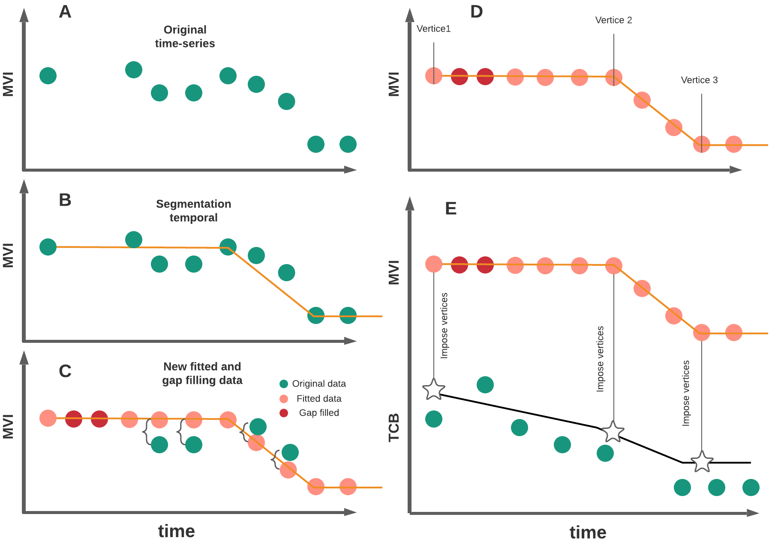

Fig 1. Example of LandTrendr fitting algorithm and imposing vertices from one index to another. The stars show the location on new vertices onto TCB.

- Accuracy assessment and area estimation
We develop two independent accuracy assessments. First, we create an assessment involving the land cover map using Sentinel 1 & 2 for two classes: mangroves and non-mangroves. The second assessment is the Landsat time-series change analysis. Both analyses employ unbiased estimators. Here, we present the confusion matrices, accuracy, and area estimation.

- Sentinel1&2 assessment

1=mangroves, 2= non-mangroves.

Table 1SP. Matrix Pixel-counts
Class | 1 | 2
1 | 45 | 5
2 | 4 | 192

Table 2SP. Matrix Proportions
Class | 1 | 2
1 | 0.177 | 0.02
2 | 0.016 | 0.786

Table 3SP. Errors and area estimates
Property/Strata |  | 1 | 2
1 | Area proportion | 0.194 | 0.806
2 | Standard Error (area prop) | 0.012 | 0.012
3 | Area (ha) | 287,678.54 | 1,196,409.65
4 | 95% CI (ha) | 34,107.19 | 34,107.19
5 | Producer's | 0.915 | 0.976
6 | User's | 0.9 | 0.98

Landsat assessment
We use the change map 1984-2020 to develop the accuracy assessment.

Table 4SP. Matrix Pixel-counts
Class | Mangroves | Man to water | Man to other veg | Gain | Agriculture | Urban
Mangroves | 798 | 1 | 0 | 0 | 0 | 1
Man to water | 1 | 45 | 1 | 0 | 0 | 3
Man to other veg | 17 | 3 | 129 | 0 | 1 | 0
Gain | 2 | 0 | 0 | 147 | 1 | 0
Agriculture | 3 | 0 | 8 | 0 | 38 | 1
Urban | 0 | 0 | 0 | 0 | 1 | 29

Table 5SP. Matrix Proportions
Class | Mangroves | Man to water | Man to other veg | Gain | Agriculture | Urban
Mangroves | 0.654 | 0.001 | 0 | 0 | 0 | 0.001
Man to water | 0.001 | 0.047 | 0.001 | 0 | 0 | 0.003
Man to other veg | 0.013 | 0.002 | 0.1 | 0 | 0.001 | 0
Gain | 0.002 | 0 | 0 | 0.13 | 0.001 | 0
Agriculture | 0.002 | 0 | 0.006 | 0 | 0.03 | 0.001
Urban | 0 | 0 | 0 | 0 | 0 | 0.003

Table 6SP. Area adjusted with 95% confidence intervals for all strata. The margin of errors (MoE. ratio of the confidence interval to area estimate expressed as percentages). The mapped areas are the raw values obtained directly from pixel counts using the 1984-2020 map change. Map bias IS the difference between mapped and adjusted areas. All areas are presented in hectares.

Class | Area Estimated | CI (95%) | MoE | Area Mapped | Map Bias | Producer's | User's
Mangroves | 239,977 | 2,708 | 1 | 234,079 | 5,898 | 0.973 | 0.998
Man to water | 17,970 | 1,918 | 11 | 18,701 | -731 | 0.937 | 0.9
Man to other veg. | 38,469 | 2,829 | 7 | 41,698 | -3,228 | 0.932 | 0.86
Gain | 46,541 | 1,068 | 2 | 47,536 | -995 | 1 | 0.98
Agriculture | 11,285 | 1,870 | 17 | 13,997 | -2,712 | 0.944 | 0.76
Urban | 2,824 | 1,478 | 52 | 1,170 | 1,654 | 0.399 | 0.967

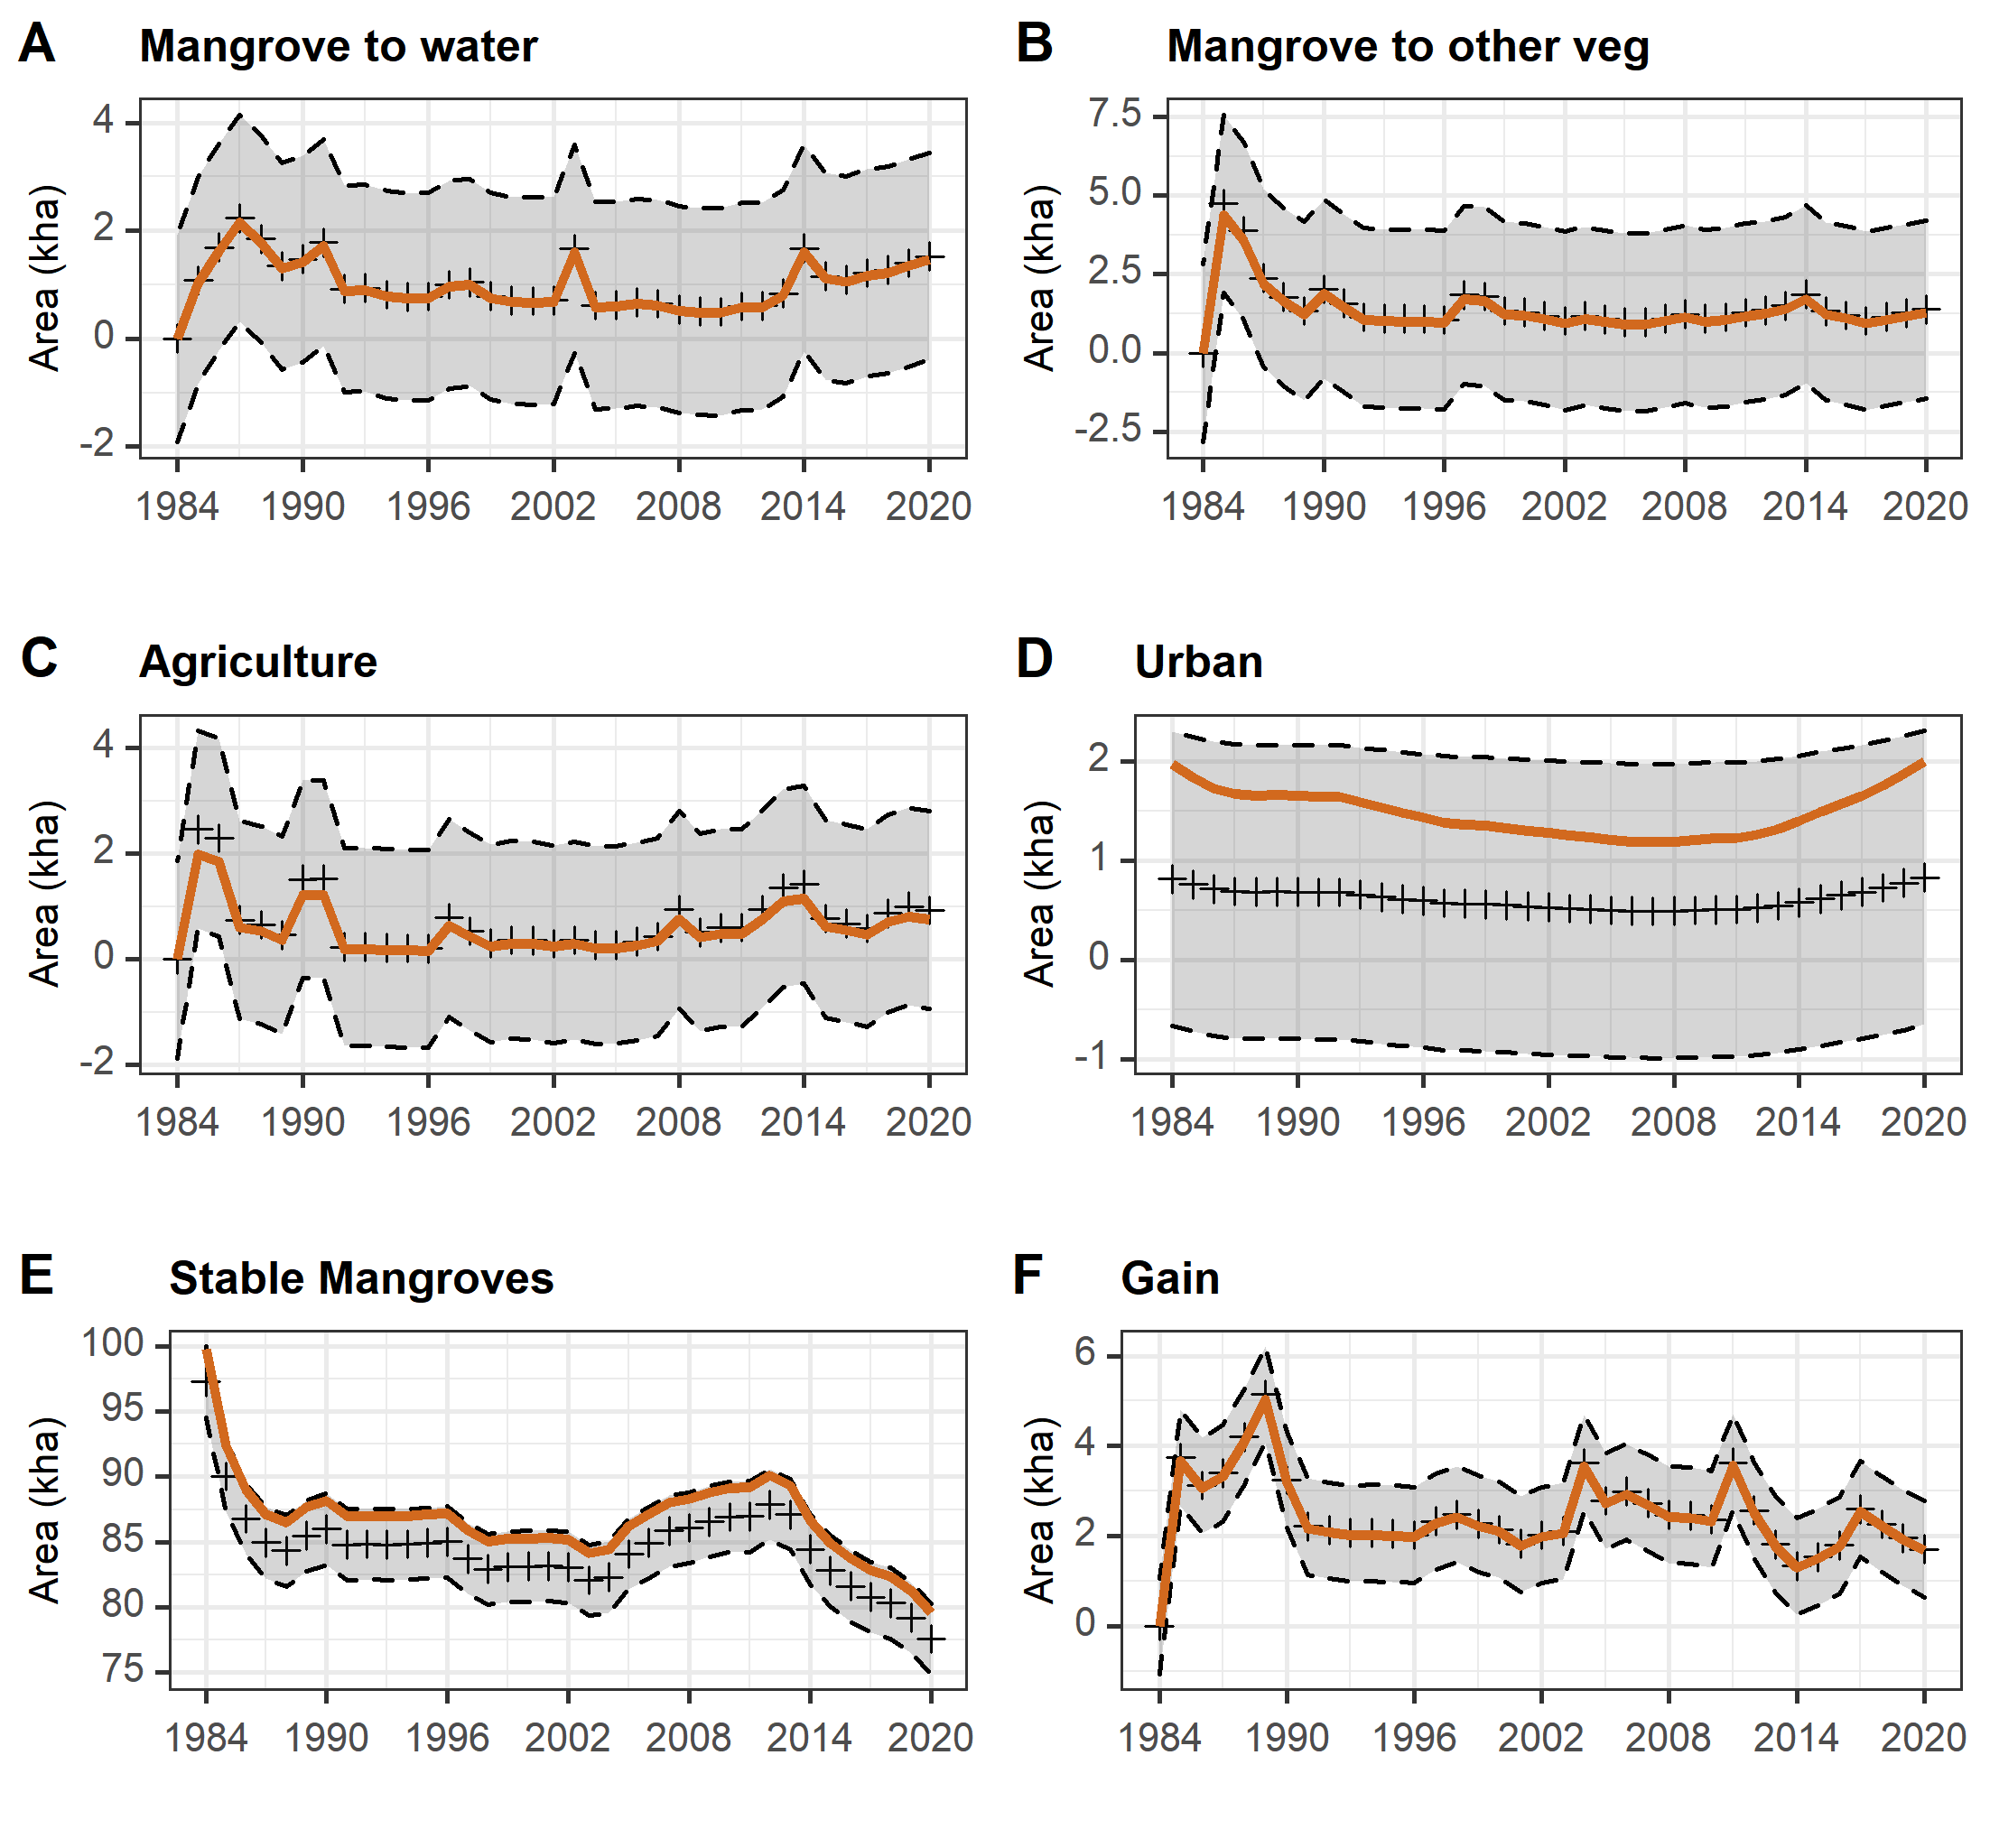
Fig 2. Mangroves area for the Caribbean coast. Area estimates with 95% confidence intervals (dashed lines). The brown line represents the area mapped (pixel counts), and cross symbols represent the area estimated.

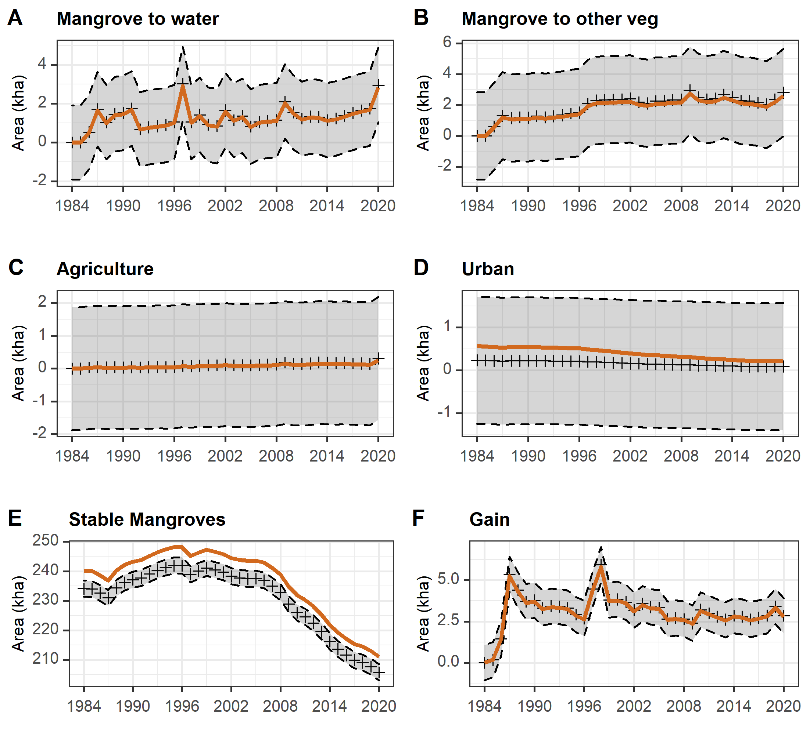
Fig 3. Mangroves area for the Pacific coast. Area estimates with 95% confidence intervals (dashed lines). The brown line represents the area mapped (pixel counts), and cross symbols represent the area estimated.

Table 7SP. Pixel counts tables for each transition in CGSM

year | Man-to-OtherVeg | Man-to-Water | Gain | Stable Mangroves | Water | Man-to-Ag | Man-to-Urban
1984 | 0.00 | 0.00 | 0.00 | 48286.89 | 119516.97 | 0.00 | 745.21
1985 | 2181.78 | 626.92 | 2696.69 | 44059.37 | 117052.84 | 1408.44 | 696.32
1986 | 1485.55 | 1145.75 | 1607.51 | 42686.01 | 116675.96 | 1483.83 | 685.42
1987 | 708.42 | 1576.49 | 1451.72 | 41618.98 | 116921.88 | 388.85 | 684.25
1988 | 490.11 | 875.30 | 2325.10 | 41528.20 | 117263.03 | 171.73 | 652.36
1989 | 361.83 | 768.20 | 2503.06 | 42510.28 | 117200.54 | 204.13 | 637.90
1990 | 703.34 | 853.15 | 1456.18 | 42716.26 | 116956.79 | 735.84 | 642.60
1991 | 490.36 | 1187.24 | 1069.10 | 41922.99 | 117006.37 | 567.72 | 663.70
1992 | 268.25 | 641.42 | 1041.67 | 41982.91 | 117461.45 | 96.62 | 679.29
1993 | 245.76 | 625.23 | 1018.47 | 42055.30 | 117380.71 | 95.04 | 670.98
1994 | 244.61 | 552.96 | 1010.70 | 42181.68 | 117326.70 | 92.58 | 661.44
1995 | 236.61 | 526.41 | 1013.35 | 42339.15 | 117245.82 | 88.19 | 648.34
1996 | 240.20 | 503.87 | 982.53 | 42514.81 | 117172.93 | 90.12 | 644.27
1997 | 565.06 | 584.61 | 1300.53 | 42031.63 | 116627.45 | 309.72 | 633.98
1998 | 677.34 | 644.66 | 1470.05 | 41749.62 | 116043.34 | 259.48 | 641.06
1999 | 357.19 | 458.96 | 1252.44 | 42257.54 | 115820.89 | 146.16 | 650.04
2000 | 392.41 | 396.58 | 1100.53 | 42546.79 | 115445.07 | 173.22 | 650.36
2001 | 302.26 | 391.03 | 940.47 | 42791.38 | 115196.35 | 160.02 | 650.51
2002 | 265.25 | 387.87 | 1030.12 | 42932.06 | 114880.82 | 142.98 | 649.30
2003 | 317.75 | 1150.97 | 1032.95 | 42318.87 | 114577.36 | 171.52 | 645.62
2004 | 294.58 | 266.65 | 2233.98 | 42659.56 | 113968.81 | 131.65 | 650.17
2005 | 269.62 | 239.95 | 1585.94 | 44256.62 | 113106.92 | 121.28 | 635.95
2006 | 289.91 | 274.72 | 1887.38 | 45117.49 | 111986.38 | 153.16 | 628.74
2007 | 381.54 | 254.26 | 1713.17 | 46138.88 | 111029.26 | 223.42 | 628.94
2008 | 442.66 | 204.20 | 1563.31 | 46664.30 | 110045.22 | 535.88 | 637.28
2009 | 357.87 | 184.81 | 1477.31 | 47395.56 | 109171.22 | 282.43 | 644.31
2010 | 358.59 | 189.74 | 1386.48 | 47976.75 | 108392.86 | 334.08 | 638.84
2011 | 443.82 | 234.70 | 2497.78 | 48331.99 | 106791.82 | 340.42 | 633.05
2012 | 545.37 | 289.07 | 1434.67 | 49440.87 | 106108.25 | 545.86 | 641.60
2013 | 614.78 | 484.95 | 938.22 | 48950.48 | 105886.52 | 816.29 | 659.53
2014 | 899.94 | 1343.67 | 643.34 | 46735.54 | 106070.95 | 902.95 | 683.43
2015 | 580.16 | 875.11 | 820.13 | 45447.69 | 107148.28 | 473.99 | 716.83
2016 | 505.66 | 801.36 | 1025.49 | 44552.86 | 107641.98 | 401.45 | 741.37
2017 | 472.36 | 850.59 | 1366.83 | 43887.68 | 108040.96 | 357.26 | 759.35
2018 | 492.65 | 874.34 | 1214.93 | 43360.84 | 108497.66 | 516.05 | 784.42
2019 | 544.74 | 1064.80 | 1073.89 | 42336.92 | 109017.40 | 615.34 | 814.35
2020 | 662.74 | 1142.95 | 853.01 | 41004.24 | 109982.38 | 577.60 | 845.26

Table 8SP. Pixel counts tables for each transition in the Gulf of Uraba

year | Man-to-OtherVeg | Man-to-Water | Gain | Stable Mangroves | Water | Man-to-Ag | Man-to-Urban
1984 | 0.00 | 0.00 | 0.00 | 7859.84 | 81089.53 | 0.00 | 100.75
1985 | 0.00 | 0.00 | 0.00 | 7859.84 | 81089.53 | 0.00 | 100.75
1986 | 0.00 | 0.00 | 0.00 | 7859.84 | 81089.53 | 0.00 | 100.75
1987 | 92.25 | 68.94 | 315.48 | 7703.88 | 80786.56 | 4.25 | 83.57
1988 | 65.64 | 68.25 | 200.26 | 7884.80 | 80729.55 | 1.06 | 92.34
1989 | 58.34 | 62.15 | 200.16 | 7967.67 | 80649.60 | 1.86 | 95.52
1990 | 69.32 | 46.04 | 153.95 | 8053.26 | 80603.85 | 1.50 | 102.43
1991 | 71.01 | 58.61 | 131.38 | 8069.81 | 80538.97 | 5.58 | 101.72
1992 | 81.25 | 41.16 | 129.16 | 8072.58 | 80492.02 | 2.21 | 99.42
1993 | 88.62 | 43.65 | 117.39 | 8066.02 | 80408.55 | 1.15 | 96.41
1994 | 101.19 | 41.97 | 129.51 | 8037.85 | 80317.44 | 1.51 | 91.10
1995 | 110.04 | 35.68 | 113.57 | 8017.52 | 80245.27 | 1.68 | 84.72
1996 | 117.83 | 40.37 | 110.84 | 7967.93 | 80183.93 | 1.59 | 79.94
1997 | 148.05 | 66.93 | 140.05 | 7859.01 | 80094.90 | 2.66 | 73.30
1998 | 153.08 | 60.38 | 140.50 | 7785.44 | 80027.32 | 3.54 | 63.03
1999 | 241.23 | 78.70 | 147.58 | 7599.64 | 79956.93 | 7.35 | 58.52
2000 | 174.62 | 61.26 | 176.61 | 7503.54 | 79858.64 | 4.87 | 53.56
2001 | 158.12 | 42.14 | 133.06 | 7467.93 | 79825.55 | 5.49 | 47.81
2002 | 158.65 | 47.54 | 133.79 | 7387.90 | 79778.26 | 4.25 | 44.53
2003 | 151.12 | 69.05 | 161.04 | 7289.88 | 79735.06 | 3.45 | 37.45
2004 | 157.68 | 64.27 | 114.56 | 7212.42 | 79715.62 | 4.96 | 34.08
2005 | 145.02 | 51.25 | 107.29 | 7120.79 | 79703.83 | 5.75 | 32.23
2006 | 128.56 | 49.31 | 104.81 | 7041.81 | 79683.41 | 5.75 | 28.95
2007 | 121.47 | 48.77 | 98.18 | 6967.79 | 79668.34 | 5.49 | 26.47
2008 | 112.53 | 50.99 | 104.90 | 6894.22 | 79650.29 | 5.40 | 24.61
2009 | 113.94 | 54.00 | 125.88 | 6821.70 | 79610.74 | 5.75 | 22.58
2010 | 106.15 | 45.24 | 153.86 | 6781.59 | 79558.07 | 5.58 | 21.25
2011 | 108.54 | 47.80 | 158.19 | 6770.16 | 79484.87 | 6.73 | 20.01
2012 | 103.49 | 50.46 | 153.23 | 6768.47 | 79425.95 | 6.90 | 18.59
2013 | 102.17 | 56.57 | 153.65 | 6754.37 | 79377.63 | 8.85 | 17.18
2014 | 116.77 | 47.81 | 126.06 | 6735.64 | 79361.77 | 8.25 | 15.23
2015 | 98.80 | 46.48 | 110.57 | 6708.23 | 79336.35 | 10.13 | 13.90
2016 | 88.26 | 48.78 | 112.60 | 6671.75 | 79316.01 | 8.94 | 12.31
2017 | 80.65 | 50.99 | 116.77 | 6642.26 | 79299.11 | 8.23 | 11.69
2018 | 95.70 | 49.84 | 118.80 | 6601.36 | 79277.70 | 9.91 | 11.33
2019 | 100.57 | 48.51 | 126.50 | 6557.45 | 79264.97 | 9.29 | 11.95
2020 | 97.91 | 62.85 | 109.25 | 6502.48 | 79269.20 | 10.36 | 11.60

Table 9SP. Pixel counts tables for each transition in Sanquiaga Protected Area

year | Man-to-OtherVeg | Man-to-Water | Gain | Stable Mangroves | Water | Man-to-Ag | Man-to-Urban
1984 | 0.00 | 0.00 | 0.00 | 40188.45 | 39942.42 | 0.00 | 30.43
1985 | 0.00 | 0.00 | 0.00 | 40188.45 | 39942.42 | 0.00 | 30.43
1986 | 0.63 | 2.77 | 21.25 | 40185.14 | 39924.59 | 0.09 | 29.25
1987 | 141.50 | 329.37 | 1293.20 | 39690.38 | 38699.52 | 1.96 | 26.79
1988 | 127.96 | 254.28 | 1018.01 | 40602.46 | 38102.62 | 2.50 | 28.20
1989 | 145.68 | 362.12 | 799.28 | 41108.05 | 37639.65 | 1.96 | 28.65
1990 | 140.49 | 336.47 | 830.18 | 41417.96 | 37268.90 | 2.23 | 29.81
1991 | 152.30 | 379.70 | 710.24 | 41705.38 | 36971.64 | 2.05 | 30.55
1992 | 141.03 | 120.26 | 694.40 | 42142.68 | 36725.08 | 1.96 | 30.32
1993 | 150.01 | 140.38 | 680.09 | 42529.68 | 36227.32 | 3.03 | 29.93
1994 | 160.17 | 143.55 | 710.96 | 42884.51 | 35708.67 | 3.39 | 29.93
1995 | 174.79 | 163.55 | 563.23 | 43237.84 | 35339.33 | 2.59 | 29.37
1996 | 186.06 | 213.57 | 491.20 | 43362.28 | 35057.86 | 2.05 | 29.55
1997 | 252.45 | 1084.09 | 950.45 | 42464.66 | 34432.86 | 6.74 | 27.06
1998 | 254.55 | 266.37 | 1346.80 | 42916.36 | 34262.85 | 4.11 | 25.78
1999 | 260.39 | 278.89 | 844.47 | 43711.43 | 33725.57 | 7.41 | 24.63
2000 | 231.99 | 127.82 | 773.22 | 44156.83 | 33284.23 | 4.30 | 23.83
2001 | 230.41 | 93.32 | 584.76 | 44570.36 | 32890.44 | 5.65 | 23.02
2002 | 245.47 | 205.33 | 414.95 | 44652.08 | 32637.68 | 12.86 | 23.26
2003 | 182.23 | 209.40 | 485.76 | 44647.13 | 32494.89 | 4.33 | 22.84
2004 | 184.41 | 314.33 | 437.80 | 44616.82 | 32370.83 | 4.48 | 21.68
2005 | 172.37 | 165.70 | 437.30 | 44721.98 | 32336.24 | 5.06 | 22.04
2006 | 170.70 | 221.74 | 411.54 | 44741.65 | 32151.81 | 3.89 | 22.31
2007 | 196.82 | 214.17 | 483.56 | 44703.84 | 31959.32 | 4.01 | 21.24
2008 | 191.90 | 254.11 | 429.08 | 44714.13 | 31834.90 | 5.20 | 21.05
2009 | 285.50 | 519.16 | 437.98 | 44243.66 | 31747.52 | 12.99 | 20.61
2010 | 238.41 | 366.65 | 578.44 | 44071.21 | 31844.27 | 4.25 | 18.91
2011 | 226.21 | 223.19 | 590.86 | 44212.03 | 31731.55 | 4.65 | 18.47
2012 | 245.51 | 237.00 | 495.36 | 44270.68 | 31546.62 | 4.62 | 18.02
2013 | 296.21 | 236.20 | 434.96 | 44141.52 | 31428.75 | 6.23 | 17.22
2014 | 276.32 | 222.64 | 427.88 | 44011.48 | 31359.74 | 4.77 | 17.04
2015 | 261.54 | 179.05 | 497.71 | 43921.38 | 31223.82 | 5.48 | 15.88
2016 | 310.16 | 256.16 | 341.62 | 43765.56 | 31195.79 | 8.87 | 15.70
2017 | 327.09 | 207.99 | 445.22 | 43488.22 | 31186.61 | 8.11 | 14.99
2018 | 333.82 | 323.49 | 476.98 | 43191.49 | 31181.17 | 11.51 | 14.54
2019 | 404.95 | 320.73 | 597.58 | 42887.60 | 31181.08 | 11.23 | 14.72
2020 | 494.97 | 694.21 | 521.05 | 42174.81 | 31231.73 | 27.12 | 14.52

