JGR: Biogeosciences
Supporting Information for
A process-model perspective on recent changes in the carbon cycle of North America
Guillermo Murray-Tortarolo^{1*}, Benjamin Poulter², Rodrigo Vargas³, Daniel Hayes⁴, Anna Michalak⁵, Christopher Williams⁶, Lisamarie Windham-Myers⁷, Jonathan A. Wang⁸, Kimberly P. Wickland⁹, Abhishek Chaterjee², David Butman¹⁰, Hanqin Tian¹¹, Stephen Sitch¹², Pierre Friedlingstein¹³, Mike O’Sullivan¹³, Peter Briggs¹⁴, Vivek Arora¹⁵, Danica Lombardozzi¹⁶, Atul Jain¹⁷, Wenping Yuan¹⁸, Roland Séférian¹⁹, Julia Nabel²⁰, Andy Wiltshire²¹, Almut Arneth²², Sebastian Lienert²³, Sönke Zaehle²⁰, Vladislav Bastrikov²⁴, Daniel Goll²⁵, Nicolas Vuichard²⁴, Anthony Walker²⁶, Etsushi Kato²⁷, Xu Yue²⁸, Zhen Zhang²⁹, Werner Kurz³⁰
Affiliations:
1 Instituto de Investigaciones en Ecosistemas y Sustentabilidad. Universidad Nacional Autónoma de México, Morelia, México
2 NASA Goddard Space Flight Center, Biospheric Sciences Lab., Greenbelt, USA
3 Department of Plant and Soil Science, University of Delaware, Newark, DE, USA
4School of Forest Resources, University of Maine, Orono, ME, USA
5 Department of Global Ecology, Carnegie Institution for Science, Stanford, CA, USA
6 Graduate School of Geography, Clark University, Worcester, MA, USA
7 U.S. Geological Survey, Water Resources Mission Area, Menlo Park, California, USA
8 Department of Earth System Science, University of California, Irvine, CA, USA
9United States Geological Survey, Water Resources Mission Area, Boulder, CO, USA
10 School of Environmental and Forest Sciences and with Civil and Environmental Engineering at the University of Washington, Seattle, WA, USA
11 International Center for Climate and Global Change Research, School of Forestry and Wildlife Sciences, Auburn University, Auburn, USA
12 Department of Geography, College of Life and Environmental Sciences, University of Exeter, Exeter, UK
13 College of Engineering, Mathematics and Physical Sciences, University of Exeter, Exeter, UK
14 Commonwealth Scientific and Industrial Research Organization (CSIRO) Oceans and Atmosphere, Aspendale, Australia
15 Canadian Centre for Climate Modelling and Analysis, Environment and Climate Change Canada, University of Victoria, Victoria, British Columbia, Canada
16 Climate and Global Dynamics Laboratory, National Center for Atmospheric Research, Boulder, CO, USA
17 Department of Atmospheric Sciences, University of Illinois, Urbana, IL, USA
18 School of Atmospheric Sciences, Southern Marine Science and Engineering Guangdong Laboratory (Zhuhai), Sun Yat-sen University, Zhuhai, China
19 CNRM, Université de Toulouse, Meteo-France, CNRS, Toulouse, France
20 Max Planck Institute for Meteorology, Hamburg, Germany
21 Met Office Hadley Centre, Exeter, UK
22 Institute of Meteorology and Climate Research/Atmospheric Environmental Research, Karlsruhe Institute of Technology, Garmisch–Partenkirchen, Germany
23 Climate and Environmental Physics, Physics Institute and Oeschger Centre for Climate Change Research, University of Bern, Bern, Switzerland
24 Laboratoire des Sciences du Climat et de l'Environnement, Institut Pierre-Simon Laplace, CEA-CNRS-UVSQ, CE Orme des Merisiers, Gif-sur-Yvette CEDEX, France
25 Université Paris Saclay, CEA-CNRS-UVSQ, LSCE/IPSL, Gif sur Yvette, France
26 Environmental Sciences Division and Climate Change Science Institute, Oak Ridge National Laboratory, Oak Ridge, TN, USA
27 Institute of Applied Energy, Tokyo, Japan
28 School of Environmental Science and Engineering, Nanjing University of Information Science & Technology (NUIST), Nanjing 210044, China
29 Earth System Science Interdisciplinary Center, University of Maryland, College Park, MD 20740, USA

*Corresponding author: gmurray@iies.unam.mx ORCID: https://orcid.org/0000-0002-5620-6070

Contents of this file

Table S1
Table S2
Figure S1
Figure S2
Table S3
Figure S3

Table S1. DGVMs characteristics and key processes included in this study. Additional information can be found in Friedlingstein et al. (2020) table A1.
 | Cable-pop | Classic | CLM5 | DLME | IBIS | ISAM | ISBA | JSBACH | JULES.ES.10 | LPJ.Guess | LPX.Bern | LPJ | OCN | ORCHIDEE | ORCHIDEE.CNP | ORCHIDEEv3 | SDGVM | VISIT | YIBs
Original Resolution | 1x1 | 2.185x2.185 | 1.25x0.9375 | 0.5x0.5 | 1x1 | 0.5x0.5 | 1x1 | 1.875x1.875 | 1.875x1.25 | 0.5x0.5 | 0.5x0.5 | 0.5x0.5 | 1x1 | 0.5x0.5 | 2x2 | 0.5x0.5 | 1x1 | 0.5x0.5 | 1x1
Fire | No | Yes | Yes | No | No | No | Yes | Yes | No | Yes | Yes | Yes | No | No | No | No | Yes | Yes | No
Harvest  (wood + crops) | No | No | Yes | No | No | No | Yes | Yes | Yes | Yes | No | No | No | Yes: | Yes | No | No | No | No
Grazing | No | No | No | No | No | No | No | Yes | No | Yes | No | No | No | No | No | No | No | No | No
FLUC | No | Yes | Yes | No | No | Yes | Yes | Yes | Yes | Yes | No | No | Yes | Yes | Yes | Yes | Yes | Yes | Yes

References
Friedlingstein, P., Jones, M. W., O'sullivan, M., Andrew, R. M., Hauck, J., Peters, G. P., ... & Zaehle, S. (2019). Global carbon budget 2019. Earth System Science Data, 11(4), 1783-1838.
Table S2. Model Ensemble Mean C fluxes by subregion and decade.

Region | Decade | NBP | NBP error | GPP | GPP error | RH | RH error | Ra | Ra Error | D | D error
USA | 2000-2009 | 0.14 | 0.16 | 8.50 | 1.09 | 3.71 | 0.67 | 4.23 | 1.06 | 0.41 | 0.49
 | 2010-2019 | 0.17 | 0.17 | 9.12 | 1.17 | 3.95 | 0.69 | 4.55 | 1.14 | 0.43 | 0.40
CAN | 2000-2009 | 0.15 | 0.11 | 5.76 | 1.26 | 2.74 | 0.68 | 2.59 | 0.86 | 0.10 | 0.08
 | 2010-2019 | 0.20 | 0.12 | 6.10 | 1.31 | 2.86 | 0.70 | 2.75 | 0.91 | 0.11 | 0.07
MEX | 2000-2009 | 0.02 | 0.05 | 2.08 | 0.41 | 0.86 | 0.28 | 1.12 | 0.22 | 0.08 | 0.21
 | 2010-2019 | 0.02 | 0.05 | 2.19 | 0.42 | 0.89 | 0.29 | 1.18 | 0.23 | 0.07 | 0.13
CA+C | 2000-2009 | 0.01 | 0.02 | 1.87 | 0.83 | 0.71 | 0.22 | 1.09 | 0.64 | 0.02 | -0.08
 | 2010-2019 | 0.01 | 0.02 | 1.91 | 0.83 | 0.72 | 0.22 | 1.12 | 0.65 | 0.02 | 0.05

Figure S1: temporal NBP evolution in North America by individual Models from 2000-2019.

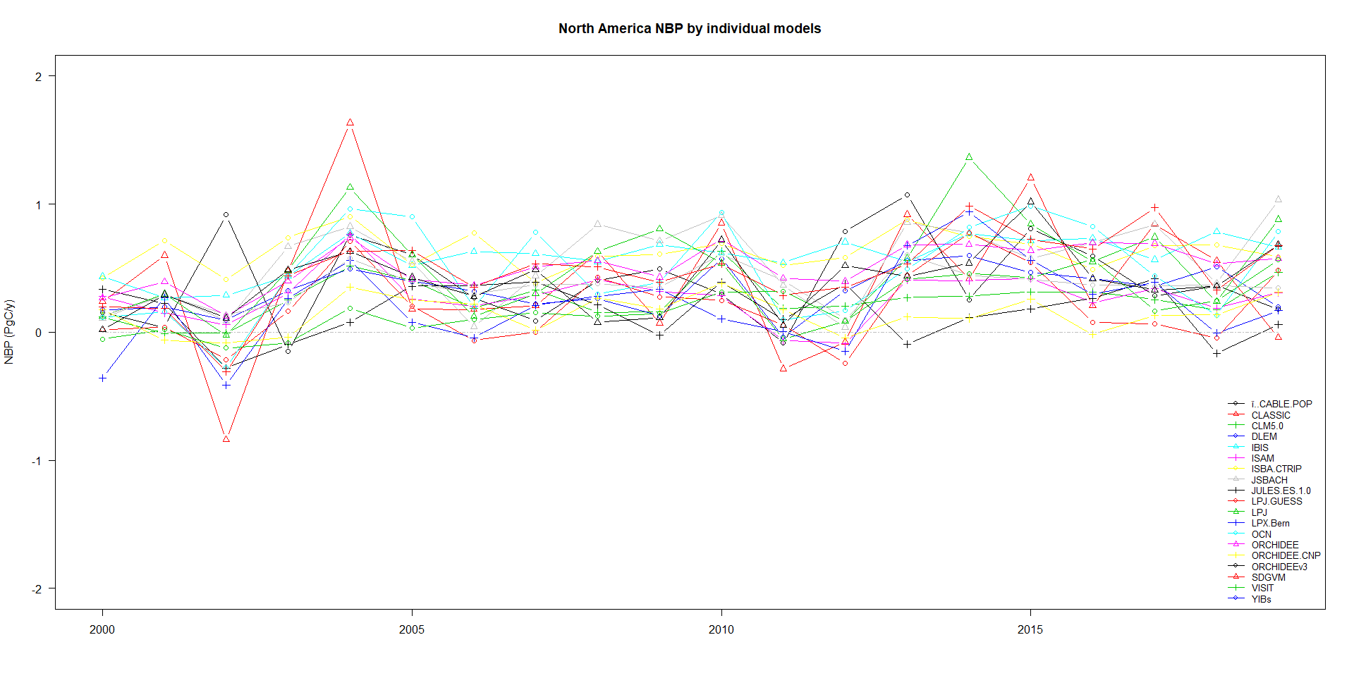

Figure S2. Individual NBP model evaluation based on the mean and trend for the period 2000-2019. Grey rectangle indicates ranges of observed values from previous works as reported in Table 1 of the main text. Models that include a fire module are indicated in red.

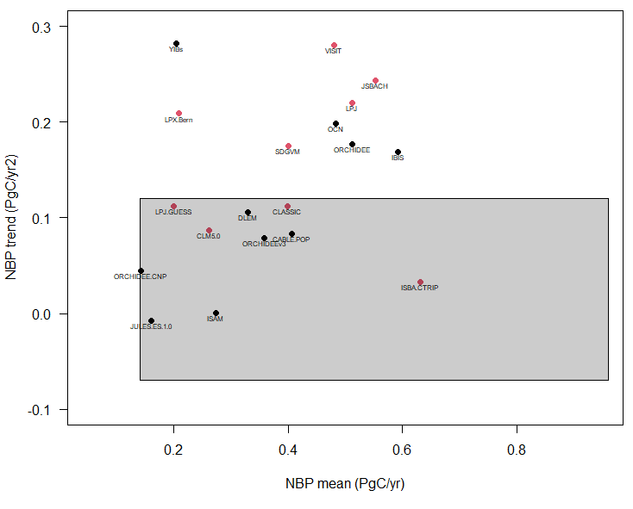

Figure S3: gridded NBP during years with the lowest (left) and highest (right) NBP values in each decade. 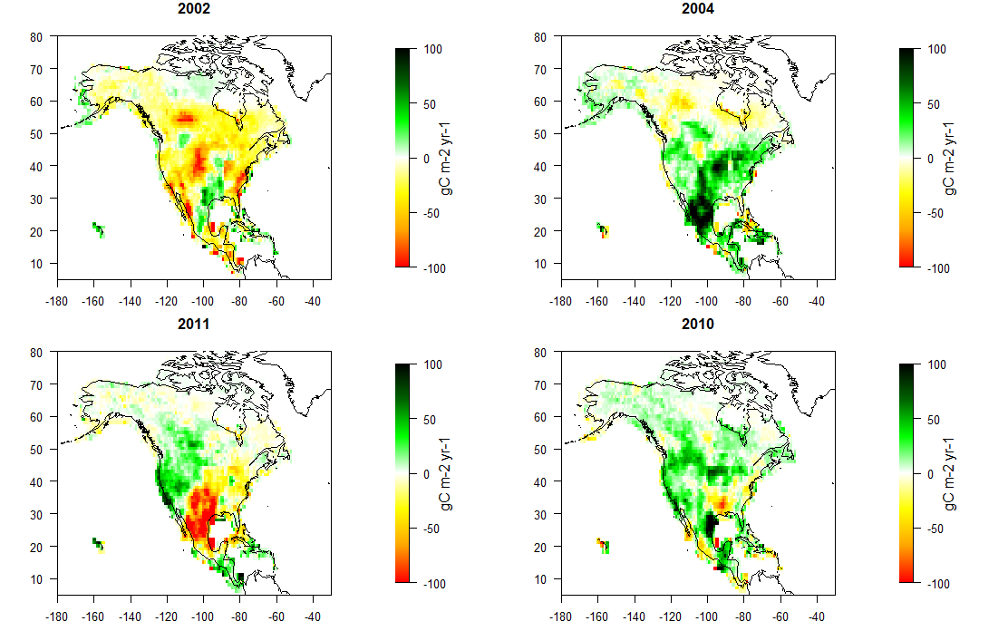
Table S3 NBP separated for the conterminous USA and Alaska for 2000-2019.

Region | Period | NBP (PgC yr⁻¹)
Conterminous USA | 2000-2019 | 0.12 ± 0.13
Alaska | 2000-2019 | 0.04 ± 0.05
Whole USA | 2000-2019 | 0.16 ± 0.17

Figure S4. Land mask employed for this work.

