

Quiet Spacecraft Cabin Ventilation Fan Development: Motivation and Context

Christopher S. Allen
NASA Johnson Space Center
2101 NASA Road 1, Mail Code SF3
Houston, TX, 77058

ABSTRACT
It is important to control acoustical noise aboard crewed space vehicles and space habitats to provide a satisfactory environment for voice communications, alarm audibility, and restful sleep, and to minimize the risk for hearing loss and annoyance. As with most noise control efforts, it is best to control the noise at the source, and for spaceflight vehicles these are typically the fans associated with the Environmental Control and Life Support system. These include cabin ventilation fans and intermodule ventilation fans, among others. Throughout the history of crewed spaceflight, there have been issues with noise from ventilation fans, going back to Apollo. And, with the spaceflight vehicles and habitats currently being developed, there are again concerns with noise from ventilation fans. To address this problem, NASA is working to leverage the technology developed in its Aeronautics Research Mission Directorate, specifically at the Glenn Research Center, to design highly efficient and quiet fans for reducing community noise levels from civilian aircraft. This paper will discuss the need for transfer of this technology to spaceflight use, and will discuss the potential benefits, which are significant and will be crucial for the successful development and operations of future spaceflight vehicles, space suits, and habitats.

1. INTRODUCTION
It is important to control acoustical noise aboard crewed space vehicles and space habitats to provide a satisfactory environment for voice communications, alarm audibility, and restful sleep, and to minimize the risk for hearing loss and annoyance. As with most noise control efforts, it is best to control the noise at the source, and for spaceflight vehicles these are typically the fans associated with the Environmental Control and Life Support (ECLS) system. These include air ventilation fans, such as the main air conditioning fan (the ‘cabin fan’), intermodule ventilation (IMV) fans, air revitalization fans (for removal of carbon dioxide and trace contaminates), and thermal cooling fans. Thermal cooling pumps that circulate cooling fluid are another significant noise source in spaceflight vehicles, but these are outside of the scope of this paper.

Throughout the history of crewed spaceflight, there have been issues with noise from ECLS ventilation fans. In the Apollo Command Module (CM) the crew would turn off the CM cabin fan once in orbit and use the backup suit-loop fan for ventilation because noise from the cabin fan interfered with communications and was an annoyance.¹ On the Space Shuttle the ventilation system underwent significant redesign, including the addition of ventilation system mufflers, with resulting noise levels that were still too-high for long-duration missions.¹ In the early years of International Space Station (ISS) operations, acoustical noise in the Russian Segment was one of the top two habitability issues, resulting in significant noise controls being implemented on-orbit (along with significant cost and crew-time impacts) on many fans.² Significant noise reductions were only realized after replacing noisy fans with fans of a quieter design, funded by the ISS Program.³ Noise levels in the ISS U.S. Segment were well-controlled, mostly meeting requirements, though significant mass and volume were allocated for noise controls, including mufflers/silencers and acoustically treated duct-lining.

With the spaceflight vehicles and habitats currently being developed, there are again concerns with noise levels from ventilation fans. In the Orion vehicle, additional duct mufflers needed to be added to address the cabin fan noise.⁴ The Gateway’s Habitation and Logistics Outpost (HALO) module and low-Earth orbit (LEO) Freeflyer habitats are currently working to solve this problem. This will also be an issue for lunar and Mars spaceflight vehicles, space suits, and surface habitats.

In an effort to address this problem, NASA is working to leverage the technology developed in its Aeronautics Research Mission Directorate (ARMD), specifically at the Glenn Research Center (GRC), to design highly efficient and quiet fans for reducing community noise levels from civilian aircraft. This technology was created over decades of research and development, and was proven to be effective at reducing aircraft noise levels. The current collaboration across NASA Centers, including HQ, GRC, and the Johnson Space Center (JSC), in this area is the first effort at re-purposing these tools, i.e. design codes and techniques, developed for high Reynolds number fans, to spaceflight vehicle and habitat, small, lightweight, low Reynolds number, fans.

This paper will discuss the need for transfer of aeronautics fan design technology to spaceflight use. This paper will also discuss the potential benefits from this, which are significant, including 1) volume and mass savings from noise controls that are no longer as large or needed at all, 2) reduced system pressure loss from mufflers and silencers (that don’t need to be as restrictive) for better ventilation, 3) reduced power draw because of the reduced system pressure loss and the highly efficient fan design, and 4) satisfying spaceflight vehicle acoustic requirements to provide a safe and habitable acoustic environment for astronaut crewmembers. These benefits will be crucial for the successful development and operations of future spaceflight vehicles, space suits, and habitats.

2. ventilation system overview and opportunity
A representative layout for an ISS module’s ventilation system, part of the overall ECLS system is shown in Figure 1.¹ This layout is specific to the U.S. Laboratory Module, but the other U.S. Segment modules use a similar concept. The ventilation system is separated into two main functions, 1) the main cabin air circulation and 2) inter-module (between modules) air circulation. The fans used for these applications are generically called ‘cabin fans’ and ‘inter-module ventilation (IMV) fans,’ respectively.

For the main cabin air circulation, air is drawn-in along the bottom of the module into the return ducts, pulled by the Common Cabin Air Assembly (CCAA), i.e. the cabin fan. For redundancy, there are two CCAAs in each module; nominally, one CCAA operates at a time. The CCAA then pushes the air through the upper duct-work and out of the supply diffusers into the crew cabin. Downstream of the CCAA are heat exchangers for cooling the air and controlling its humidity.
To control the noise from the CCAA cabin fan, there are many noise control features. These include a substantial acoustic enclosure around the fan and acoustically absorbent baffles, surface treatments, and Helmholtz resonators along the ventilation system ductwork.¹ There is also additional absorptive treatments and sound blocking included in the rack that houses the CCAA.¹ This noise control hardware have worked well for ISS, but their high mass and volume would be problematic for small crewed vehicles or habitats outside of low Earth orbit.

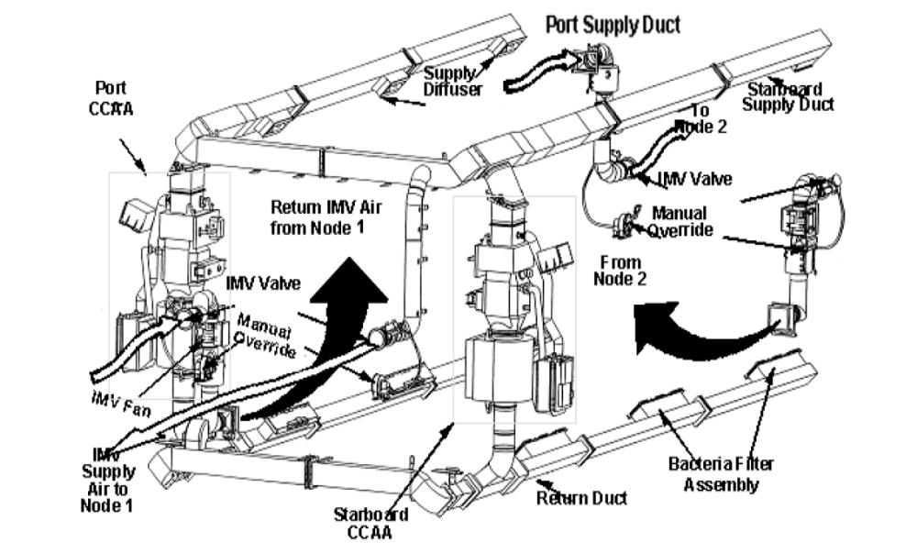

Figure 1. Ventilation system of ISS U.S. Laboratory Module.

The inter-module ventilation (IMV) system ensures that airflow is well-mixed along the stack of ISS modules. Air cooling, carbon dioxide (CO2) removal and trace contaminant removal only occurs in specific modules. So, it is important to mix the air throughout the stack to make sure there are no regions with high CO2 concentrations and to make sure all of the air is processed for contaminant removal and cooling.

To facilitate this mixing, IMV ventilation ducting connects the modules that are adjacent to each other, and IMV fans move the air between the modules through this ductwork. There are generally two IMV ducts per module interface with air moving one direction in one duct system and in the opposite direction in the other. Note that in Figure 1, the duct supplying IMV airflow to Node 1 is connected directly to the main U.S. Lab cabin ventilation system. The other three IMV systems shown in Figure 1 are independent of the main ventilation system and have individual IMV fans that provide the airflow for each separate duct string.

Case-radiated noise from the IMV fans is mitigated with sound blocking material that is integrated into the fan’s package.¹ Additional external treatments have also been added for some installations to further mitigate the case-radiated noise.¹

Ductborne noise from the IMV fans is substantial and requires significant attenuation both upstream and downstream of the fan. Figure 2 shows an example IMV fan installation with silencers included. Note the additional acoustic lagging included between the fan and silencers.

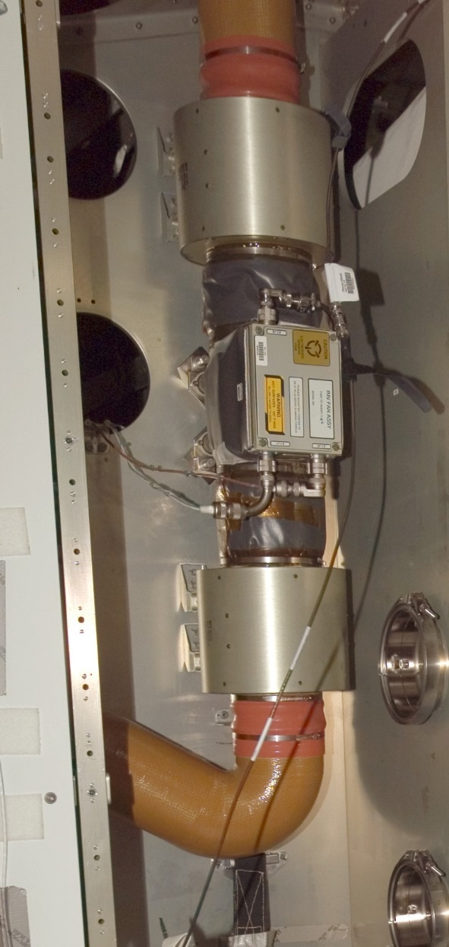

Figure 2. Example ISS IMV fan installation with silencers upstream and downstream of the fan

The needed acoustic attenuation, i.e. Insertion Loss, both upstream and downstream of the fan is shown in Figure 3. This Insertion Loss exceeds 10 dB at 500 Hz (and above and exceeds 25 dB at 2000 Hz (and above).
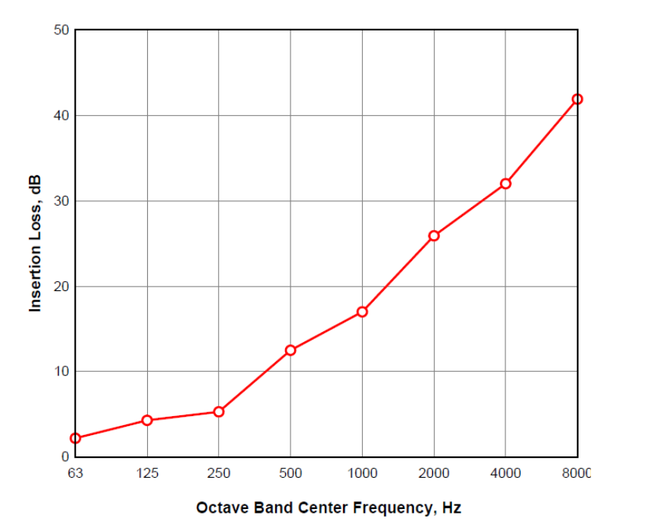

Figure 3. Acoustic attenuation provided by ISS IMV Silencers .¹

In order to obtain the necessary attenuation, the IMV Silencer needs a tortuous flow path to block ‘line-of-sight’ within the duct, provide a large surface area for acoustic absorption, and reduce passage heights to attenuate the high frequency (small wave-length) noise. See Figure 4. This lossy airflow path causes a pressure loss of 0.37 “H20 at 150 cfm.⁵

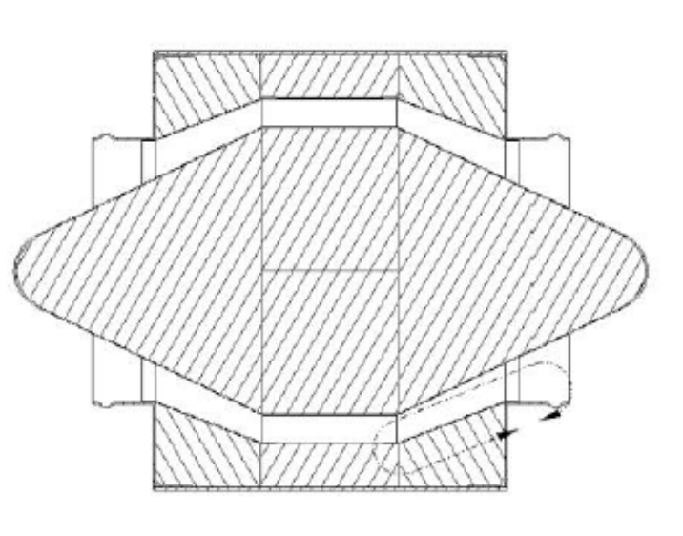
Figure 4. Tortuous IMV Silencer air flow passage. Airflow can be in either direction (symmetric).¹

While the IMV fan noise has been successfully controlled on ISS,^{2,3} it is clear that a significant amount of mass, volume, and flow loss is attributable to the IMV Silencers. With potentially four silencers at each module interface, there are 20 or more of these silencers on ISS.

However, if the fan’s ductborne source-noise were significantly less, then a less restrictive, less massive silencer could be designed to meet the IMV noise requirement⁷ without sacrificing airflow. It is possible that a silencer would not be needed at all, and that duct-lining may suffice. And without such a tortuous path, the system’s pressure losses would be less, allowing for more airflow and requiring less electrical power to drive the fan. And, if the fan were designed to be significantly more efficient, that would reduce the electrical power required even further. And this is the goal of current research at NASA. To use the tools, techniques and testing validation methods developed over decades of research and investment, made to reduce the environmental noise from aircraft engine fans, to bring substantial improvements to human spacecraft ventilation and other ECLS systems.

3. Quiet Spacecraft Cabin Ventilation Fan Noise Research at NASA

For the reasons outlined above, a project to design a quiet and efficient spaceflight vehicle ventilation fan, utilizing the design techniques developed at Glenn Research Center (GRC) for airplane engine noise reduction, was initiated in 2009.⁶ The design point chosen was to be the same as for the Orion cabin fan, with a flow rate of 150 cfm at a pressure rise of 3.84 inches H2O. The plan was to compare the resulting fan’s aerodynamic performance and acoustic emissions to that of the Orion cabin fan. And, once the design was completed and proven to be beneficial, it would be released to the public to be used as a baseline for further noise reduction development, or so that spaceflight hardware developers could use the design in their own vehicles.

The GRC quiet and efficient ‘Spacefan’ was designed, and its performance was computationally analyzed by Dan Tweedt.^{7, 8} In 2011, a 3-D printed plastic prototype was developed and tested at GRC by Danielle Koch, et. al..⁹ At the conclusion of this testing, it was decided that a metal fan prototype was needed to properly document aerodynamic and acoustic performance.

The project experienced some funding delays, but in 2020 was granted funding to proceed with fabrication and testing of a metal Spacefan prototype. Operating conditions and design of the Orion cabin fan had evolved by that time to higher pressure-rise needs, as the Orion ECLS system matured. But it was decided to proceed with Spacefan at its original design point, knowing that comparisons to other spaceflight ventilation fans could be made. Figure 5 shows design or operating points, at that time, for various spaceflight ventilation fans, with the GRC Spacefan also included. The Avionics Air Assembly (AAA) fan is a cooling fan used in the ISS’s Expedite the Processing to Space Station (ExPRESS) experiment racks. The Rocket Space Corporation -Energia (RSC-E) quiet fan is the fan designed to reduce noise levels in the ISS Russian Segment.³

Figure 5. Design/operating points for various spaceflight ventilation fans at the time of Spacefan development

Even though fabrication and testing of the Spacefan was done during the height of the COVID pandemic, two working units were developed. One of the Spacefan units was used for aerodynamic performance and acoustic validation testing at GRC and the other unit was used for sound power level evaluations at Johnson Space Center (JSC). Measured and predicted aerodynamic and acoustic performance were in good agreement with predictions.¹⁰ A novel 3-D printed structure was developed for light-weighting with a resulting fan weight of 3.6 lbs. GRC has published the resulting measured aerodynamic and acoustic performance, in comparison to predictions, with very promising results.¹⁰

Spacefan sound power level measurements have been made at JSC and comparisons to other spaceflight ventilation fan sound power levels are currently in-work. Figure 6 shows one of the Spacefan sound power measurement set-ups in the JSC Acoustics and Noise Control Laboratory’s anechoic chamber.

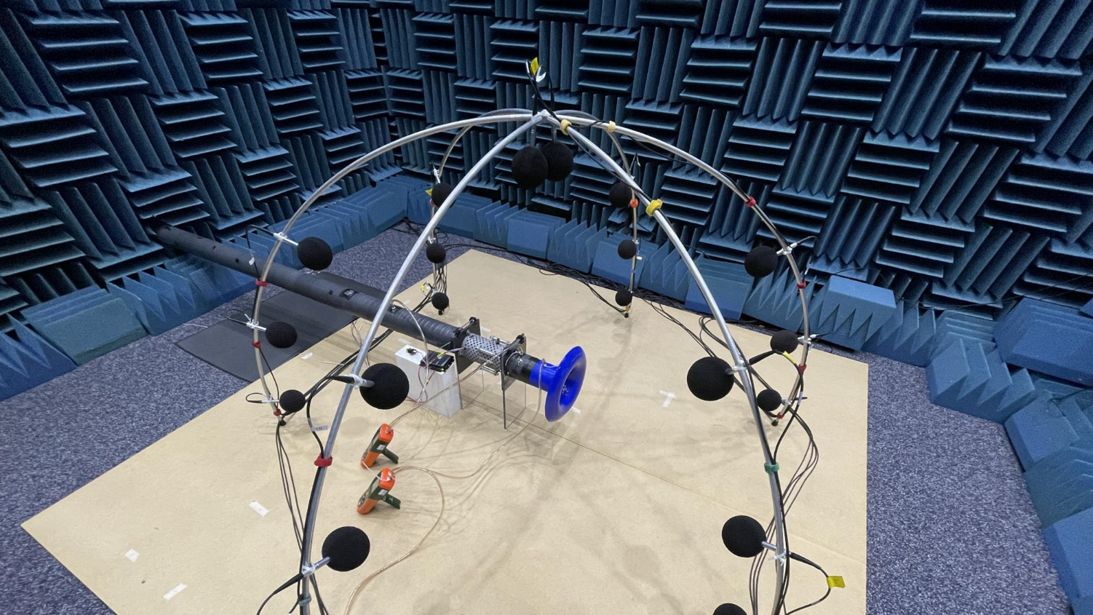

Figure 6. Example sound power level measurement set up in the JSC Acoustics and Noise Control Laboratory’s anechoic chamber

The Spacefan fan geometry, CAD, and flowlines have been released to the public through the NASA Technical Report Server (NTRS). This information is available at the following link: https://ntrs.nasa.gov/citations/20220012622.

Future work for expanded use of this technology has been proposed. With the existing Spacefan, work would include investigating installation effects and benefits of acoustic liners to support realistic spacefligt vehicle use scenarios. This could also include flight certification and an ISS on-orbit demonstration of the existing Spacefan to provide evidence/confidence of spaceflight performance. It is also proposed to continue advancing additive manufacturing, lightweighting, and polishing improvements.

To further the capability of the current design, it is envisioned that non-dimensional analysis could be used to build and test a scaled version of this fan to higher flow/pressure rise for wider ventilation applications, for the commercial low Earth orbit freeflyers as well as for the Gateway outpost. Preliminary investigations on scaling are favorable to produce a Spacefan with twice the flow rate and twice the pressure-rise capability, putting the design point very close to that of the original Gateway cabin fan. See Figure 5. Another approach would be to use a GRC workflow, similar to that used to design the Spacefan, to design new quiet and efficient fans for unique design points.

In addition to the current ventilation fan design, GRC could also leverage its quiet aircraft technology in the turbomachinery area to design quiet, efficient high pressure-rise centrifugal or mixed flow blowers for use in toilets/waste collection systems, CO2 and trace contaminant removal systems, or for use in suit loops to provide life support air to spacesuits through an umbilical. These all currently have significant acoustic challenges and require a significantly high pressure rise, i.e. up to approximately three times the largest pressure-rise shown in Figure 5.

Finally, it would also be advantageous to perform aerodynamic testing of the Spacefan, or derivatives, at reduced atmospheric pressure, e.g. 8-10 psi. This information would be used to inform developers of fan performance differences and acoustic changes in the exploration atmospheres of Gateway, as well as lunar and Martian habitats.

4. CONCLUSIONS
In order to address the need to meet acoustic requirements in spaceflight vehicles and habitats, NASA is performing ventilation fan research, utilizing technology developed for aircraft engines, to design much smaller spaceflight ventilation fans that are efficient and quiet, and to confirm the applicability of GRC aircraft fan computational design codes to fans appropriate for spacecraft cabin ventilation systems. Benefits from this research will include reductions in mass, volume, and system pressure-loss because the quieter fans will need fewer and less restrictive mufflers and noise controls. In addition, these fans will require less electrical power because the fans will be more efficient, producing more flow for the same power input, and as mentioned above, the system pressure losses will be less.

NASA GRC has designed, built, and tested the quiet Spacefan and has reported promising results, meeting aerodynamic and acoustic design goals. Sound power level testing at JSC has been performed and will be compared to sound power levels of other spaceflight ventilation fans. Future work is also hoped to include research on installation effects, integrated duct-liners, and improvements to additive manufacturing methods for the Spacefan’s design and construction. Future work also hopes to include expanding the operating regime of the Spacefan using scaling, or designing new quiet, efficient fans for unique design points, including high pressure-rise blowers. Finally, testing of one or more of these fans as a technical demonstration on-orbit in the ISS, or at reduced air pressures and densities, are aimed to enhance ventilation design of future space exploration vehicles and habitats.

ACKNOWLEDGEMENTS
We gratefully acknowledge the support from the Environmental Control and Life Support/Crew Health and Performance System Capabilities Leadership Team and the ISS Program for sponsoring and supporting this work.

REFERENCES
- Goodman, J. R., and Grosveld, F. W., “Acoustics and Noise Control in Space Crew Compartments,” NASA/SP—2015–624. 2015.
- Allen, C. S. and Denham, S. A, “International Space Station Acoustics – A Status Report,” Proceedings of International Conference on Environmental Systems. American Institute of Aeronautics and Astronautics, AIAA 2011-5128, 2011.
- Allen, C. S., “International Space Station Acoustics – A Status Report,” Proceedings of the 45th International Conference on Environmental Systems, ICES-2015-286, 2015.
- Dandaroy, I., Chu, S. R., Dornak, J., and Allen, C. S., “Development of Acoustic Mufflers for Cabin Noise Reduction in Orion,” Proceedings of Inter-Noise 2021, Washington, D.C., USA, 1-5 August 2021.
- Link, D. W., and Balistreri, S., “Inter-Module Ventilation Changes to the International Space Station Vehicle to support integration of the International Docking Adapter and Commercial Crew Vehicles,” Proceedings of 45th International Conference on Environmental Systems, Bellevue, Washington,12-16 July 2015.
- Koch, L. D, “Quiet, Efficient Fans for Spaceflight: An Overview of NASA’s Technology Development Plan, “NASA/TM-2010-216238, 2010.
- Tweedt, D. L., "Aerodynamic Design and Computational Analysis of a Spaceflight Vehicle Cabin Ventilation Fan," NASA TM-2010-216329, 2010.
- Tweedt, D. L., "Computational Aerodynamic Simulations of a Spacecraft Cabin Ventilation Fan Design," NASA TM-2010-216330, 2010.
- Koch, L. D. et. al., “Acoustic measurements of an uninstalled spacecraft cabin ventilation fan prototype, “ Proceedings of InterNOISE 2012, 2012.
- Stephens, D. S., Goodman, J. M., Buehrle, R. A., Mirhashemi, A., Koch, L. D., Shook, T. D., Sutliff, D. L., Allen C. S., and Matty, C. M., “Highlights of Aeroacoustic Tests of a Metal Spacecraft Cabin Ventilation Fan Prototype,” NASA/TM-20220012622, 2022.

Senior Member, AIAA; Manager, JSC Acoustics Office, ISS and Orion Acoustics System Manager; christopher.s.allen@nasa.gov

