Guidelines on Deploying Small Satellites from Gateway

Abstract
The issue of small payloads released from Gateway may become a concern for the space users' community. Man-made objects can stay in the same or crossing orbit for a long time, creating significant hazard for Gateway, other users and sites on the surface of the Moon.
It is important to coordinate efforts between organizations and agencies to ensure that Gateway operates safely.
The purpose of this paper is to outline the Gateway Program approach for evaluating the deployment of candidate research payloads from Gateway Modules and/or Visiting Vehicles (VV) docked to the Gateway or vehicles/modules on the route to/from the Gateway.
Acronyms and abbreviations
Change Request (CR); Deep Space Logistics (DSL); Delta-Velocity (dV); Extravehicular Activity (EVA); Extravehicular Robotics (EVR); Gateway Integrated Safety Review Panel (GISP); Gateway Logistics Services (GLS); Gateway Program Control Board (GPCB); Gateway SE&I/VSI Control Board (GSVCB); Gateway Utilization Coordination Panel (GUCP); Multi-mission Automated Deep Space Conjunction Assessment Process (MADCAP); Near Rectilinear Halo Orbit (NRHO); Payload Integration Agreement (PIA); Robotics Control Panel (ROBOCP); Systems Engineering and Integration (SE&I); Service Preparation Subsystem (SPS); Vehicle Systems Integration (VSI)
Introduction
While there is no official standard or definition for a Small Satellite, the term typically refers to a spacecraft with a mass of less than 500 kg. CubeSats are better defined than any other Small Satellites using Unit sizes to describe configuration and mass. However, this definition may limit use of other Small Satellite designs on Gateway. Thus, for the purpose of this paper we consider Small Satellites to be under 25 kg and not define their configuration.
This paper outlines the required analyses and demonstrates the approval process for candidate payload deployments from the Gateway Modules/Robotic Arm, Gateway-docked Visiting Vehicles, or Gateway Logistics Services (GLS) vehicles in flight to/from Gateway. The deploy candidate is defined as any satellite payload active or passive released from the Gateway Modules or Visiting Vehicles while the vehicle is docked to the Gateway, on the way to the Gateway, or post departure from Gateway and in Near-Rectilinear Halo Orbit (NRHO) or crossing NRHO. In this paper we also define data required to initiate a candidate satellite deployment evaluation & approval by the Gateway Program team.
Candidate satellites fall under one of two categories that are currently identified:
- Passive satellites, for which the only delta-Velocity (dV) and directional capability are achieved through the deployment mechanisms. With no active propulsive attitude control or translational capability.
- Active satellites which can perform dV and/or directional maneuvers post deployment. Have a capability to provide active (propulsive and non propulsive) attitude control and/or translational capability.
This paper covers the Gateway analysis coordination process and guidelines for performing necessary analyses through the payload approval process. Payload integration as well as verification processes is covered under current Gateway Payload Interface Definition Document and Payload Integration Agreement (PIA) document. Some of the documents are currently in development.
The development of Hazard Reports is performed using a standard GISRP process as documented in Gateway Program Hazard Analysis Requirements.
Overview
While there are risks associated with satellite deployments during approach, while docked, and post mission completion, the Gateway Program recognizes that there are also significant benefits associated with conducting scientific research, technology demonstration and education.
Payloads may be deployed from a deploy mechanism installed on a Gateway-docked visiting vehicle or Gateway module or by the Robotics Arm. It is important to ensure that any planned release does not pose threat to the Gateway or other NASA assets and safely leaves the Gateway orbit.
It is the intent of the Gateway Program to ensure that all satellites intended for deployment from the Gateway and Logistics Vehicles at any time of the mission comply with constraints set forth by the NASA Interim Directive NID 8715.128: Planetary Protection Categorization for Robotic and Crewed Missions to the Earth’s Moon, NPR 8715.6B: NASA Procedural Requirements for Limiting Orbital Debris and Evaluating the Meteoroid and Orbital Debris Environments, and NID 7120.132 Collision Avoidance for Space Environment Protection, and NPR 2570.1 NASA Radio Frequency (RF) Spectrum Management Manual.
Given a limited ability to track objects in cis-Lunar space, payloads not related to NASA may not be covered by the proposed process. However NASA expects external payload owners to provide information on their satellite ephemerides data to the Deep Space Network Service (DSN) Service Preparation subsystem (SPS) for inclusion in the Multi-mission Automated Deep Space Conjunction Assessment Process (MADCAP) screening process and comply with NID 8715.128 NASA Interim Directive: Planetary Protection Categorization for Robotic and Crewed Missions to the Earth’s Moon, NPR 8715.6B NASA Procedural Requirements for Limiting Orbital Debris and Evaluating the Meteoroid and Orbital Debris Environments and NID 7120.132 Collision Avoidance for Space Environment Protection. The process of data exchange and agreements with external payload owners are currently in work
Guidelines
The deploy candidate provider with consultation support from NASA teams, will be responsible for performing a series of analyses that demonstrate the safe execution of the proposed mission. Analysis results will be reviewed prior to making a decision as to whether or not a deploy candidate satellite will be approved. NASA Gateway Systems Engineering and Integration (SE&I) Office will be responsible for managing these analyses and presenting an integrated recommendation to the Gateway Program. NASA Gateway Integrated Safety Review Panel (GISRP) will be responsible for determining credible failure scenarios, identifying additional analyses required and reviewing Hazard Reports submitted by the provider in accordance with the NASA safety process. The Gateway Utilization Coordination Panel (GUCP) will be responsible for coordinating the science objectives with International Partners, external users and science communities. The Mission Integration and Utilization Control Board, with the sub-panel Gateway Utilization Integration Panel, will be responsible for tracking integration and manifest.
Deploy Candidate Analysis Guidelines
Potential deploy candidates need to be identified at least 18 to 24 months before mission to ensure that all analyses results are reviewed by appropriate Gateway boards and forums. Once the candidate is identified, NASA Gateway SE&I Office will define types of analyses that are required for a specific candidate based on proposed mission objectives and candidate satellite design. The list of data required from a provider includes, but is not limited to:
- Detailed description of a candidate satellite mission profile including final desired location/orbit
- Candidate satellite properties such as mass, size, volume, shape, materials, etc.
- Candidate satellite propulsive properties including propellant systems, translational delta-V capability, and attitude control
- Candidate satellite communications and tracking properties, e.g., comm system
- Proposed deploy method
  - Robotically deployed candidates require ROBOCP board approval prior to proceeding
- Trajectory analysis and ephemerides
  - Deployed payloads owners are expected to provide real-time trajectory updates to the Deep Space Network Service (DSN) Service Preparation subsystem (SPS) for inclusion in the Multi-mission Automated Deep Space Conjunction Assessment Process (MADCAP) screening process that NASA relies on for collision avoidance in cis-lunar space in accordance with NPR 87156B section 3.3.
- Deploy attitude, direction, and location in orbit
- Detailed description of deploy mechanism
- Details of any sub-deploys
  - Any constituent portion of a primary payload, which can separate into its own free-flying object either intentionally or under credible failure scenarios. Examples include secondary satellite payloads, drag parachutes, solar sales, tethers, harpoons, nets, probes, chip sats, etc.
- Spectrum management analysis
- Electromagnetic effects analysis
Once a deploy candidate has been identified, the NASA Gateway SE&I Office provides a summary of deploy candidate characteristics and proposed mission plan to Gateway SE&I/VSI Control Board (GSVCB). In coordination with GISRP, the GSVCB decides on the type of additional analyses required from the provider, if any, so that the Gateway Program can recommend if the deploy candidate be accepted for the mission.
Additional analysis maybe required based on individual spacecraft and mission design.
Trajectory Analysis
The owner of the deploy candidate will be responsible for conducting trajectory analysis of the deployed satellite and providing mission details and objectives to the Gateway Program.
For payloads deployed using Robotic Arm trajectory analysis includes Extra Vehicular Robotics (EVR) deployment analysis due to the impact to trajectory from Robotic Arm reaction to deploy forces.
Relative Motion Analysis
The owner of the deploy candidate will have to demonstrate that deployed satellite is capable of continuing positive separation from the Gateway and eventual departure from the NRHO without activating its propulsion system. The owner will also be responsible for demonstrating that dV imparted into the satellite by the deploy mechanism, the deploy attitude and location in the orbit meet the criteria for safe departure.
The satellites that may intersect Artemis mission orbits (e.g. Low Lunar Orbit, Lunar Surface missions, NRHO missions, etc.) will have to demonstrate that they meet fault tolerance requirements similar to Gateway Visiting Vehicles to ensure that the satellite can complete mission objectives and its proposed end of mission plan.
Expedited Approval
The analysis/approval process can be expedited if the proposed deployment conforms to a set of conditions that have been pre-approved by the Gateway Program by generic analysis. Guidelines may include, but are not limited to, direction of release, orbital parameters at time of release, and deployment dV. Deploy candidates that elect to deploy within these conditions may follow a more streamlined approval process. Only passive payloads may be considered for an expedited process.
Expedited approval of EVR-based deployments rely on generic analysis performed by CSA based on a range of allowable payload masses and forcing function parameters.
NOTE: Expedited approval from Spectrum Management may not be possible for RF systems.
A specific range of deployment delta-V magnitudes, directions, and locations have been identified before and after apolune. Analysis shows that recontact can be avoided even for small delta-V magnitudes about 1 m/s as shown in fig. 1 Directions ensure maximum separation from Gateway.
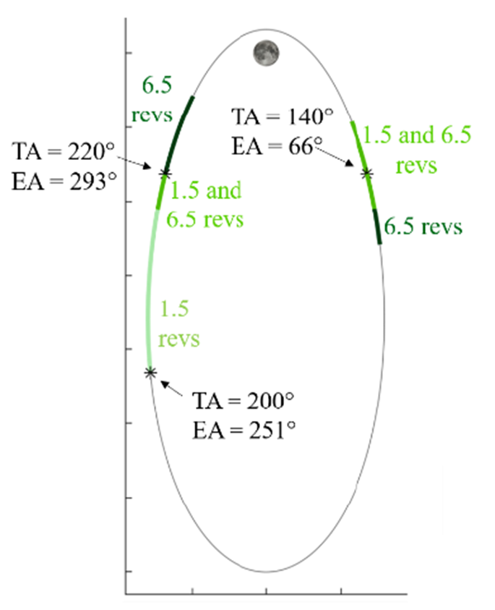
FIGURE 1 PRE-APPROVED SMALL SATELLITE RELEASE ZONES

It is important to remember that destination of the payload post departure cannot be guaranteed. Analysis only ensures that payload departs NRHO. Potential risk of payload return post NRHO departure still exists.
Further analysis is still required to better characterize the limitations of green zone releases including delta-V errors in magnitude and direction.
Long term trajectory analysis is desired to better understand payload behavior post NRHO departure.
Visiting Vehicle Traffic
The deploy satellite candidate owner is responsible for coordinating with the Gateway Program to ensure that the time of deployment does not interfere with primary Gateway objectives including upcoming approach and departure of crewed vehicles, lunar landers and other visiting vehicles/modules.
Gateway Structural Clearance
The owner of the deploy candidate in collaboration with the NASA Gateway SE&I Office and deploy mechanism provider is responsible for performing clearance analysis to ensure that orientation of the deploy mechanism, deploy velocity and trajectory, while factoring in an appropriate cone of uncertainty, allow the satellite to clear the Gateway and all attached visiting vehicle structure within 2 meters (6.56 feet)
Hazard Analysis
The owner of the deploy candidate is responsible for performing safety assessments of deploy candidate systems, hardware elements and potential contingency scenarios. Such contingency scenarios include candidate satellite system failures, deploy mechanism failures, etc. The owner of the deploy candidate is responsible for demonstrating that all systems have required levels of safety and are sufficiently fault tolerant to ensure safe execution of the mission. The provider must consider all hazards (lasers, radio frequency interference, etc.) to the Gateway and/or visiting vehicles.
Spectrum Management Analysis
The payload provider will also be responsible for ensuring compliance with Gateway Spectrum Management Pan and Gateway Electromagnetic Effects Requirements with the Gateway Program.
Spectrum Management Plan
Each Small Satellite Provider that plans to utilize RF transmissions performs assessment to ensure their compliance with the process defined in the Gateway Spectrum Management Plan
Spectrum Management
In coordination with the Gateway Spectrum Management team, Providers evaluate potential interferences before procuring any RF equipment to prevent delays and/or rejection of spectrum applications.
RF Clearance
Upon a successful evaluation of the small satellite RF licenses, Radio Frequency Compatibility Analysis, Electromagnetic Effect Analysis, Gateway Spectrum Manager will issue an approved RF Clearance for Small Satellite Deployment from Gateway. Post deployment RF constraints may be placed on the small satellite to protect core Gateway RF links. Deployment of a satellite from Gateway requires an approved RF Clearance for Small Satellite Deployment from Gateway.
Electromagnetic Effects Analysis
Small Satellite Provider ensures compliance with the processes defined in the Gateway Electromagnetic Effects requirements. Failure to meet the requirements may impose significant operational constraints on the Payload to protect Gateway systems.
Deploy Candidate Approval Process
Deploy analysis will be performed by the candidate owner and NASA teams and provided to the Gateway Program for review and evaluation. The Gateway Program will be responsible for identifying types of required analyses, analysis review and deploy candidate approval. It will be the responsibility of the owner of the deploy candidate/payload to deliver analysis results and required information in a timely manner.
RoboCP (CSA) approves the deploy assessment for any robotic deployments due to the hazards posed to EVR hardware.
The GUCP will be responsible for initial assessment of proposed payloads and coordination with GPCB for initiation of payload integration coordination.
Payload integration coordination and analysis review will be performed by Gateway SE&I and vetted through the GSVCB and GISRP.
All assessments will be provided to the GISRP in the form of hazard reports in accordance with the safety review process. Controls and verifications must be identified for each hazard, and the controls must ensure compliance with the requirements of this policy. Review and approval of hazard reports will be performed by the GISRP at least six months prior to candidate launch.
Once the GISRP approves a deploy candidate the integrated assessment is presented to the GPCB for final approval. For payloads deployed during Orion flight, final approval will be obtained through Gateway/Orion JPCB.
PAYLOAD INTEGRATION PROCESS
For Small Satellite process description, see Figure 2, Small Satellite Integration Process Flow Diagram and Figure 3, Small Satellite Integration Process Description.
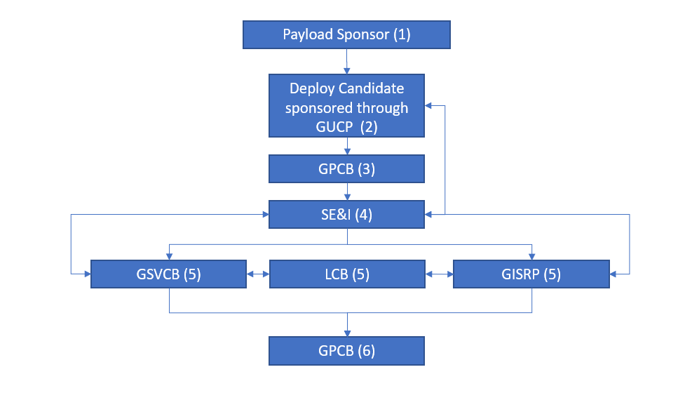FIGURE 2 SMALL SATELLITE INTEGRATION PROCESS FLOW DIAGRAM
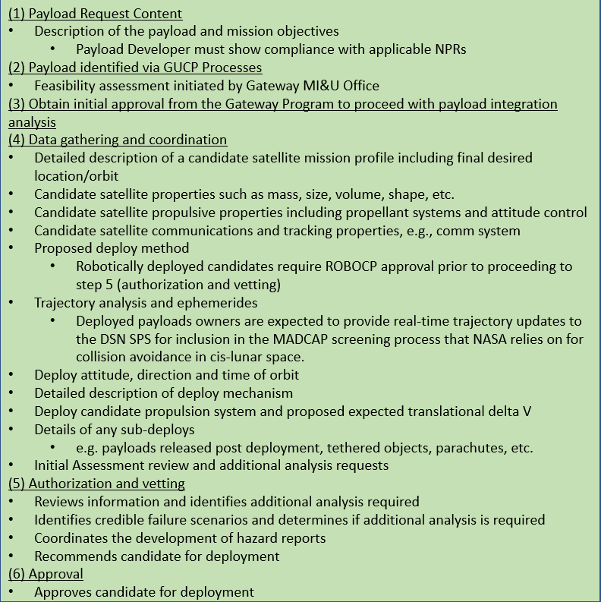
FIGURE 3 SMALL SATELLITE INTEGRATION PROCESS DESCRIPTION
Conclusions
It is important to for potential payload providers outside of NASA community to have a good understanding of NASA payload integration processes and payload deployment approval guidelines to simplify and streamline the process of payload inclusion into Gateway missions.
Gateway Program will support and guide all deployable payload providers through the approval process to ensure that all science objectives are met and safety of the Gateway.

