Three-Wavelength Approach for Aerosol-Cloud Discrimination in the SAGE III/ISS Aerosol Extinction dataset

Surendra Bhatta,1,2,3\* Amit k Pandit,4 Robert P Loughman3 and Jean-Paul Vernier4,5

1NASA Goddard Space Flight Centre, Greenbelt, MD, USA,

2Goddard Earth Sciences Technology and Research II, Morgan State University, Baltimore, MD

3Hampton University, Hampton, VA, USA

4National Institue of Aerospace, Hampton, VA, USA

5NASA Langley Research Center, Hampton, VA, USA

\*Corresponding author : surendra.bhatta@nasa.gov

**Abstract:** The tropical upper troposphere and lower stratosphere (UTLS) region is dominated by aerosols and clouds affecting Earth's radiation budget and climate. Thus, satellites' continuous monitoring and identification of these layers is crucial for quantifying their radiative impact. But distinguishing between aerosols and clouds is challenging, especially under the perturbed UTLS conditions during post-volcanic eruptions and wildfire events. Aerosol-cloud discrimination is primarily based on their disparate wavelength-dependent scattering and absorption properties. In this study, we use aerosol extinction observations in the tropical (15°N-15°S) UTLS from June 2017 to February 2021, available from the latest generation of the Stratospheric Aerosol and Gas Experiment (SAGE) instrument-SAGE III onboard the International Space Station (ISS) to study aerosols and clouds. During this period, the SAGE III/ISS provided better coverage over the tropics at additional wavelength channels (relative to previous SAGE missions) and witnessed several volcanic and wildfire events that perturbed the tropical UTLS. We explore the advantage of having an extinction coefficient at an additional wavelength channel (1550 nm) from the SAGE III/ISS in aerosol-cloud discrimination using a method based on thresholds of two extinction coefficient ratios, R1 (520nm/1020nm) and R2 (1020nm/1550nm). This method was proposed earlier by Kent et al. (1997) for the SAGE III-Meteor-3M but was never tested for the tropical region under volcanically perturbed conditions. We call this method the Extinction Color Ratio (ECR) method. The ECR method is applied to the SAGE III/ISS aerosol extinction data to obtain cloud-filtered aerosol extinction coefficients, cloud-top altitude, and seasonal cloud occurrence frequency during the entire study period. Cloud-filtered aerosol extinction coefficient obtained using the ECR method revealed the presence of enhanced aerosols in the UTLS following volcanic eruptions and wildfire events consistent with the Ozone Mapping and Profiler Suite (OMPS) and space-borne lidar-Cloud-Aerosol Lidar with Orthogonal Polarization (CALIOP). The cloud-top altitude obtained from the SAGE III/ISS is within 1km of the nearly co-located observations from OMPS and CALIOP. In general, the seasonal mean cloud-top altitude from the SAGE III/ISS events peaks during the December-January-February months, with sunset events showing higher cloud-tops than the sunrise events, indicating the seasonal and diurnal variation of the tropical convection. The seasonal altitude distribution of cloud occurrence frequency obtained from the SAGE III/ISS also agrees well with CALIOP observations within 10%. We show that the ECR method is a simple approach that relies on thresholds independent of the sampling period, providing cloud-filtered aerosol extinction coefficients uniformly for climate studies irrespective of the UTLS conditions. However, since the predecessor of SAGE III did not include a 1550nm channel, the usefulness of this approach is limited to short-term climate studies after 2017.

1. Introduction

Processes in the tropical upper-troposphere and lower-stratosphere (UTLS) region (14-18.5 km) are affected by the complex interplay between trace gases (water vapor, ozone, etc.), aerosols, clouds, low temperatures, and radiation  [1]. Some examples are gas-to-particle formation, ice nucleation, dehydration, heterogeneous chemistry, associated radiative heating/cooling, and transport processes  [2–6]. Moreover, the tropical region is dominated by deep convection  [7]. The increased occurrence of optically thin cirrus clouds in the UTLS  [8] affects these processes. Understanding these complex processes in the UTLS is critical for the Earth’s climate study. These processes, particularly aerosol-cloud interaction, are currently not well represented in the global climate models, due to which climate predictions are associated with significant uncertainties  [9]. Aerosols and clouds interact differently with radiation; thus, their accurate distinction is crucial for their radiative forcing estimates, which depend on their optical and microphysical properties. Volcanic eruptions and wildfire events perturb the UTLS composition and add further complexities to aerosol-cloud detection in satellite measurements. So, clear distinction/identification of clouds and aerosols in satellite measurements is a major step toward accurately characterizing their roles in Earth’s climate.

Satellite instruments such as the SAGE (https://sage.nasa.gov/), space-borne lidar CALIOP onboard the Cloud-Aerosol Lidar and Infrared Pathfinder Satellite Observation (CALIPSO), OMPS onboard Soumi-National Polar-orbiting Partnership **(**NPP), etc., are extensively used to study the spatial distribution of aerosols and clouds in the UTLS region. These instruments have different viewing geometry, and they use different measurement techniques, such as solar occultation (SAGE), lidar-backscattering (CALIOP), and limb scattering (OMPS). As a result, they use different retrieval algorithms to detect aerosols and clouds, as described later in Section 2. SAGE series of instruments have provided the earliest and longest measurements of the UTLS aerosols and clouds  [10]; more specifically, the SAGE-II instrument provided 21 years (1984-2005) of continuous observations  [11,12]. SAGE-III on International Space Station (ISS) is the latest instrument that continues the legacy of the SAGE since 2017, with additional wavelength channels than SAGE II and better coverage over the tropics than its predecessor SAGE III Meteor-3M  [13]. The SAGE III/ISS has provided observations overlapping with OMPS and space-borne lidar CALIOP/CALIPSO. This was not the case for its predecessors, allowing the construction of a long-term climatology of stratospheric aerosols  [10,14]. These overlapping observations will enable us to validate the recent SAGE III/ISS measurements of aerosols and clouds, which is one of the crucial aspects of this study. The present study exploits all these SAGE III/ISS advantages to explore aerosol and clouds in the tropical (15°N-15°S) UTLS.

SAGE instruments measure the extinction coefficient at each altitude bin during a solar occultation event (sunrise or sunset). In such measurement, the enhanced extinction coefficient (above the level expected from molecular scattering and gaseous absorption) indicates the presence of aerosol and/or clouds in the instrument’s line of sight (LOS). The extinction coefficient profiles are acquired under random positions of aerosol and/or cloud layers along the optical path, which is challenging for aerosol-cloud discrimination. This challenge becomes greater during volcanic eruptions and other situations that inject material into the UTLS, as described in Thomason & Vernier (2013) [12]. The aerosol-cloud discrimination in SAGE-I data was first studied by  [15], whose simplified approach was based on the extinction coefficient threshold at 1.0 $μm$ wavelength. They declared extinction coefficient values ranging from 1x10-4 km-1 to 1x10-3 km-1 for stratospheric background aerosols. The extinction coefficient values larger than 8x10-2 km-1 were referred to as ‘thick’ cirrus, while the extinction coefficient values between 8x10-3 km-1 and 8x10-2 km-1 as ‘thin’ cirrus clouds.

In SAGE II, the stratospheric background aerosols are assumed to be homogeneously distributed along the latitudes with a mean extinction coefficient (at 1 $μm)$ of ~ 2x10-4 km-1 [12]. The extinction greater than this threshold value (2x10-4 km-1) is caused by the mixture of clouds or enhanced aerosols with an upper measurement limit of 2x10-2 km-1. Using a single extinction coefficient value to separate aerosols from clouds is questionable, particularly following volcanic eruptions  [11,12]. Kent et al. (1993) [16] used the extinction coefficient ratio at 520 nm and 1020 nm wavelengths from SAGE II data to separate aerosol from clouds based on the particle size information contained in the extinction ratio (referred to as the Kent method hereafter). Later, (called TV-13 hereafter)  [11] modified Kent’s method to include more cloud-like observations by fusing it with a cloud discrimination method developed by Pits et al. (2009)  [17] for the polar stratospheric clouds. They used a threshold value of 2 for the 525nm/1020nm extinction ratio and the centroid curve to distinguish aerosols from clouds/aerosol-cloud mixture. A threshold value based on the median absolute deviation of the 1020 nm extinction coefficient was used to indicate further primary aerosols from enhanced aerosols and cloud-aerosol mixture (Figure 6, TV-13). TV-13 method was applied only for those SAGE II data obtained during non-volcanic UTLS conditions to detect the Asian Tropopause Aerosol Layer  [18].

Schoeberl et al. (2021) [19] recently proposed an approach to detect the presence of visible, sub-visible, and cloud-aerosol mixture using a 1020 nm extinction coefficient and 521nm/1020 nm ratio from SAGE III/ISS by following Kent and TV-13 methods. They used a range of values for the 521nm/1020 nm extinction ratio between 0.8 and 1.2 for clouds that satisfied the Mie theory for large particles (ice crystals) with extinction efficiency 2. All these methods for SAGE II data were based on a two-wavelength (521nm and 1020 nm) approach with thresholds of 1020 extinction coefficient and/or extinction ratio. The performance of the 2-wavelength method might be less reliable for aerosol-cloud discrimination, particularly during volcanically perturbed UTLS conditions, as mentioned by  [20,21]. However, the 2-wavelength approach can be applied to all the SAGE family of instruments back to SAGE I allowing them to rely on a very long time series of observations. Since SAGE III/ISS provides an additional channel at 1550 nm, it increases the discrimination of larger aerosols that can penetrate better than the shorter wavelength. We explore the usefulness of another extinction ratio (1020nm/1550nm) for cloud-aerosol discrimination. This additional ratio helps discriminate larger aerosol (especially during the volcanically perturbed period) from cloud particles, as Kent et al. (1997)  [20] proposed for the SAGE III- Meteor-3M before its launch. This 3-wavelength approach was found to work better under volcanically perturbed conditions in the UTLS, with an error rate of less than half that obtained using the 2-wavelength approach (Kent et al., 1997)  [20]. However, this outcome was based on aerosol extinctions (Mie theory) simulations using over 100 in situ measured aerosol size distributions from published literature under different volcanic situations. It could not be thoroughly tested because SAGE III Meteor-3M observations did not provide solar occultation data over the tropics (due to its orbit) and did not observe any significant volcanic eruption (Kent et al., 2007) [20]. Since the launch of SAGE III/ISS, several volcanic eruptions (2018 Ambae, 2019 Ulawun, 2019 Raikoke) and wildfire smoke (2017 Canadian fire, 2019/2020 Australian wildfire) have affected the tropical UTLS region  [19,22]. The current study tests the Extinction Color Ratio (ECR) approach on SAGE III/ISS data in discriminating aerosols and clouds over the tropics under volcanically perturbed situations. We also use overlapping observations from OMPS and CALIOP to verify SAGE III/ISS observations of UTLS aerosols and clouds.

This paper is organized as follows: Section 2 describes the instruments and data used, the methodology in Section 3, the results in Section 4, and finally, the summary and conclusions in Section 5.

1. Instruments
   1. *SAGE III/ISS*

The Stratospheric Aerosol and Gas Experiment (SAGE III) on the International Space Station (ISS) is the most recent SAGE series version. It is the continuation of the ongoing SAGE mission of the National Aeronautics and Space Administration (NASA). It first started as Stratospheric Aerosol Measurement (SAM I/II) in 1975/1978  [23], followed by SAGE I in 1979 (operated through 1979-1981)  [24]. It continued as SAGE II in 1984  [25], which provided continuous observations until 2005, followed by SAGE III Meteor-3M in 2001  [26] until 2006. Finally, after a decade gap, SAGE III/ISS was installed on the ISS in February 2017 and has been operational since then  [10]. It has additional wavelength channels for solar occultation measurements and provides better coverage over the tropics than its predecessors. It also includes limb-scatter and lunar occultation measurement modes. Adding such wavelength channels with a vertical resolution of 0.5 km helps us study atmospheric species such as ozone, water vapor, aerosols, etc. The SAGE III/ISS retrieval algorithm is similar to SAGE III  [27]. The algorithm consists of the slant-path-transmission-profile algorithm and various steps such as data screening, position, altitude and wavelength registration, data grouping, and statistics.

The species characterization such as aerosols, ozone (O3), water vapor (H2O), Nitrogen dioxide (NO2), etc., inversion algorithm is explained by Wang et al. (2020)  [28]. Level 2, version 5.1 aerosol extinction coefficient profile data [29] are used for this study.

* 1. *CALIOP*

The Cloud-Aerosol Lidar with Orthogonal Polarization (CALIOP) onboard the Cloud-Aerosol Lidar and Infrared Pathfinder Satellite Observation (CALIPSO) satellite is a space-borne nadir viewing elastic backscatter lidar. It has been operating since April 2006 in a sun-synchronous orbit (altitude~705 km, inclination 98.2 degrees), providing vertical distribution of aerosols and clouds at high resolution globally  [30]. It provides backscatter measurements at two wavelengths (532 nm and 1020 nm) with a vertical resolution of 30 m for altitudes from -0.5 to 8.2 km and 60 m for altitudes from 8.2 to 20.2 km. Its ability to measure the polarization caused by aerosols and clouds is used to discriminate them in the tropical UTLS [31]. Backscatter attenuated radiance-based measurement uses the Selective Iterative Boundary Locator (SIBYL) algorithm to identify the clouds’ layers and aerosols  [30]. Extinction coefficient profiles for aerosols and clouds are retrieved using Hybrid Extinction Retrieval Algorithms  [32]. This study used level 2 version 4.2 nighttime cloud layer and cloud profiles data products. Cloud layer (Clay) data product provides cloud boundaries and optical properties of clouds, while extinction profiles are provided in the cloud profile product. The aerosol-cloud detection is based on their optical properties, such as backscattering ratio, particulate depolarization ratio, and layer-integrated total color ratio (532nm/1020nm backscattering coefficient ratio). These products also contain a Cloud-Aerosol Discrimination (CAD) score, which quantifies the algorithm’s confidence level for layer classification. CAD score varies between -100 and 100, where positive (negative) values indicate cloud (aerosol) layers with high absolute values representing the higher confidence of layer classification.

* 1. *OMPS*

Ozone Mapping and Profile Suite (OMPS) was launched onboard on Suomi National Polar-Orbiting Partnership (Suomi-NPP) Spacecraft in 2011 [33]. The data obtained from the OMPS is to build up the Environmental Data Records (EDR) that will primarily describe the global vertical, horizontal, and temporal variation of certain atmospheric species such as ozone. It consists of three parts viewing mechanism and performance. They are Nadir mapper, Nadir profiler, and Limb profile (data used in this study). The limb scattered profile uses the UV, visible, and near-IR spectral regions to retrieve ozone density and aerosol extinction coefficient. The limb-scatter technique primarily measures ozone density at high vertical resolution in the UTLS. Aerosols in the UTLS are the secondary products of OMPS retrieved from the scattered radiance by the atmosphere towards its edge in the limb view. It is available from 10.5 km to 40.5 km with a resolution of 1 km in the absence of clouds for aerosol measurement from the Earth’s surface using the Chahine nonlinear relaxation technique  [34]. The possible cloud top altitude is detected using an algorithm described by Chen et al. (2016) [35]. The algorithm is based on the idea that the cloud produces greater radiances than aerosols. It only provides the top altitude of any thick aerosol/cloud layer. The recent version-2 of OMPS has an added feature enabling the tentative distinction between clouds and thick-aerosols layers  [36]. Still, it does not account for the possibility of multiple cloud layers. Version-2 cloud-filtered aerosols extinction coefficients at 997 nm are compared with the cloud filtered/unfiltered SAGE aerosols data products at 1020 nm in Section 4.2.

1. Methodology

We use aerosol extinction coefficients (β) at three wavelengths (520 nm, 1020 nm, and 1550 nm) from the SAGE III/ISS instrument to compute two extinction coefficient ratios, R1 and R2, following the approach suggested by Kent et al. (1997) [37] as shown below:

$$R_{1}=\frac{β_{520}}{β_{1020}} \& R_{2}=\frac{β_{1020}}{β_{1550}}$$

Ratios R1 and R2 were estimated from June 2017 to February 2021 at 17.5 km over the tropical region (15°N-15 °S), and their distribution is shown in Fig. 1 with a corresponding 1020 nm extinction coefficient. At this altitude (17.5km), sub-visible cirrus clouds are usually high in the tropics  [38]. So, we expect extinction coefficients to be frequently affected by the presence of clouds. The extinction ratios of clouds are close to unity as their extinctions do not exhibit wavelength dependence [16,20]. In addition to this, they demonstrate high values of 1020 nm extinction. So, on a crude approximation, all the data points with ratios R1 and R2 lying between 0.9 and 2 are considered cloud contaminated and labeled as “possible cloud-like events (PCLE).” However, this group may contain mixtures of aerosol and clouds (in short, cloud-aerosol mixtures), as discussed by Thomason and Vernier (2013) [11] and Schoeberl et al. (2021) [19].

Fig. . Scatterplot for the SAGE III/ISS extinction color ratios R1 and R2 with the color of each data point showing the 1020 nm extinction coefficient value at 17.5 km from June 2017 and February 2021 over the tropics (15 °S – 15 °N). All the data points bounded by the green-colored continuous lines (defined by 0.9< R1 and R2 <2) are considered as possible cloud-like events, while those inside the red-colored box (defined by 0.9<R1 and R2<1.2) represent high confidence (definite) clouds. The data points with extinction color ratios (R1 or R2) between 2 and 5 outside the green-colored box are considered aerosols.

The remaining data points with ratios between 2 and 5 are considered “aerosols” based on the study and the arguments presented by Kent et al.(1997)  [20,39–41] that aerosols’ extinction at 525 nm is typically a factor of 2–5 greater than that at 1020 nm. We use the aerosol subtype to study the temporal variation of aerosol extinction in the UTLS affected by volcanic eruptions and extreme wildfires (Section 4.2. The PCLE group may further be classified into optically thin (sub-visible) and thick cirrus clouds based on β1020.  [39] and  [42] used criteria based on R1 and β1020 for SAGE II data to identify cirrus clouds. According to their standards, all data points with $β_{1020}$ > 0.0008 km-1 and R1 between 0.9 and 1.1 are considered cirrus clouds. We apply the same criteria on both R1 and R2 to identify cirrus clouds in our data set. Also, we consider this group to be more definite cirrus clouds (labeled as cirrus in Table 1 and shown in the red box in Fig. 1), while the remaining data as possible sub-visible cirrus clouds. The PCLE group obtains the seasonal cloud occurrence frequency distribution and cloud-top heights in section 4.3.

There is another group containing events with ratios (R1 or R2) smaller than 0.9, and they are referred to as anomalous extinction ratio (AER) events. The AER group represents the events with $β_{1020}$ > $β_{520}$ or $β_{1550}$ > $β_{1020}$. Such extinction values are physically impossible for aerosols [40]. Usually, AER events are observed in cloud-contaminated profiles below the cloud top. Clouds’ presence at higher altitudes in the same profile influences the retrieval at lower altitudes, thus generating the AER events. Such AER events do not always appear below the clouds because very thin clouds might not often produce the AER. These events are excluded from our analysis.

The process mentioned above hereafter of grouping SAGE III/ISS aerosols or PCLE using R1 and R2 is referred to as the ECR method. Our main objective is to obtain cloud-free aerosols and explore probable clouds from discriminated events using the ECR method. The results and performance of the ECR method in aerosol-cloud discrimination are discussed in the following section.

1. Results
   1. Performance of the ECR method in Aerosol-Cloud Discrimination

We used the ECR method to classify each event in the data set as “possible cloud-like events” and “cloud-filtered aerosols,” as in Table 1. In order to test the performance of our method, we investigate the wavelength dependence of the average extinction for these two groups. It is carried out for various altitudes and plotted against nine wavelengths, as shown in Fig. 2 (a). The two groups exhibit contrasting behavior in terms of the extinction magnitude, with wavelength dependence indicating differences in particle sizes. It can be seen that the slope of the extinction for the PCLE observed between 15-17 km is almost flat, indicating little wavelength dependence (as required by the criteria for the ECR method).

**Table 1. Some possible clouds detection methods using various channels and thresholds.**

|  |  |  |  |
| --- | --- | --- | --- |
| SN | Methods | Criteria | Remarks |
| 1 | A | 0.9 < R1 & R2 < 1.1 &> 0.0008 km-1 | Cirrus (ECR) |
| 2 | B | 0.9 < R1 & R2 < 2.0 &> 0.001 km-1 | Cirrus |
| 3 | C | 0.9 < R1 < 1.1 &> 0.0008 km-1 | Cirrus |
| 4 | D | 0.9 < R1 & R2< 2 | High-altitude clouds (ECR) |
| 5 | E | D-A | Possible SVCs (ECR) |
| 6 | AER | R1 or R2 < 0.9 | Anomalous extinction ratios |

Also, these events show higher extinction values indicating large particles, most likely ice crystals. However, we see a slight wavelength dependence for 18 km altitude, which could be due to the presence of an aerosol-cloud mixture probably contaminated with sub-visible cirrus clouds.

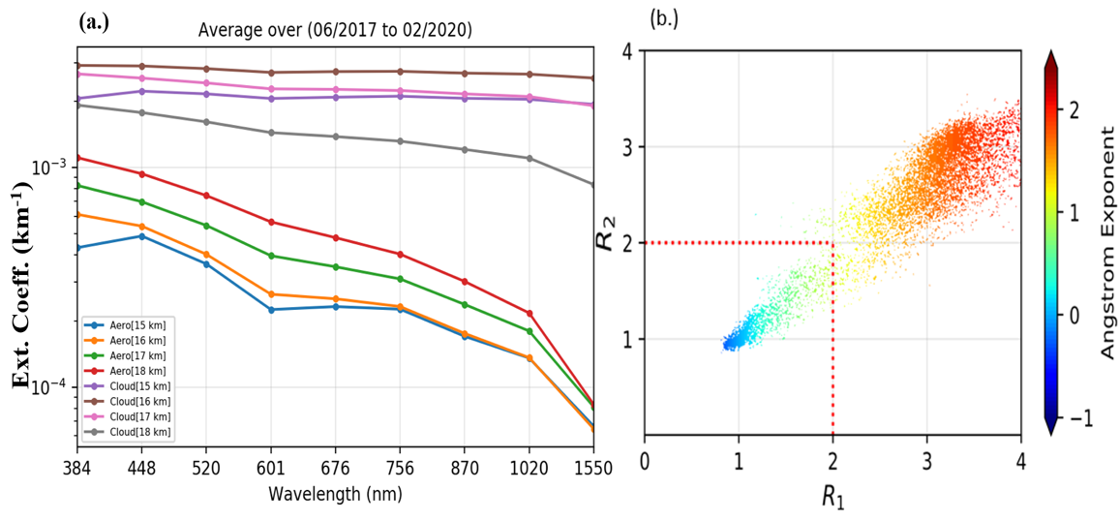

Fig. 2. (a) Variation of mean extinction coefficient as a function of different wavelength channels for discriminated possible cloud-like events (PCLE) and aerosols found from June 2017 to February 2020 based on the proposed ECR method D for altitude levels from 15 km to 18 km with an interval of 1 km. (b) Relation between both ECR (R1 and R2) with aerosol Angstrom exponent. The red dotted lines represent the separation between the possible cloud-like events (PCLE) and aerosols.

On the other hand, the slope of the wavelength dependence for the aerosol group is steeper than the other group, with lower extinction values for all the altitudes. It is a clear signature of aerosol dominance. We also estimated Angstrom’s exponent (α) using extinctions at 520 nm and 1020 nm wavelengths for these two groups, as shown in Fig. 2(b). One group satisfies PCLE criteria centering at ratios 1 with ratios less than 2 and Angstrom exponent less than 1, referring to higher extinction and larger particle sizes. The other group separated distinctly from the previous group, not meeting the PCLE criteria. So, the ECR method effectively classifies into two groups with two ranges of Angstrom exponent. The aerosol category has ratios R1 and R2 centered near 3, with α mainly falling between 1 and 2. The aerosol group shows larger α values and possible high-altitude cloud events leading to smaller α values.

All these findings suggest that the performance of the ECR method in discriminating aerosols and PCLE is promising for the selected sampling region, space and wavelengths with some influences of aerosols at 18 km. We further use the ECR method to study the temporal variation of these groups at different altitudes in the subsequent sections.

* 1. Time Series of Aerosols- Impact of Volcanic Eruptions and Wildfire events

The aerosols are obtained after removing the PCLE from various altitudes using the ECR Method. The time series of cloud-filtered 1020 nm aerosol extinction for altitudes from 15 to 24 km is shown in Fig. 3(a), and our focused region (15 to 18 km) is in Fig. 3(b).

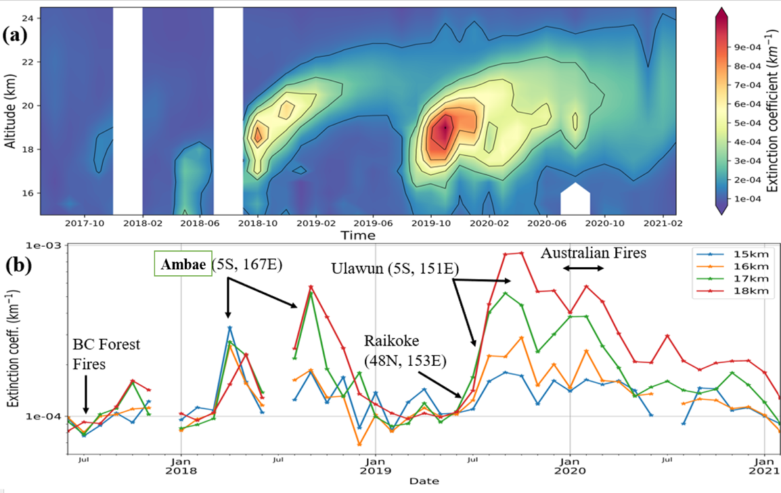

Fig. 3. (a) Time-series of monthly mean 1020 nm extinction coefficient as a function of altitude ( from 15 to 24.5 km) for the cloud-filtered data (i. e. aerosols) obtained using ECR method D with enhanced values representing the footprints of volcanic activities and wildfire events. (b) Time series of monthly mean extinction coefficient for the cloud-filtered data at selected altitudes with enhanced values corresponding to different volcanic activities and wildfire events [37].

Enhancements in aerosol extinction can be observed during different months of 2017, 2018, 2019, and 2020. These enhanced extinctions are attributed to a series of tropical and extratropical moderate volcanic eruptions and wildfires that perturbed the tropical UTLS region during this period (2017-2021). The British Columbia Forest fire in August 2017 injected smoke into the lower stratosphere (18-20 km) [43] that was transported to the tropics through the Asian Summer Monsoon Anticyclone (ASMA)  [44] during late August and early September 2017. The Ambae volcanic eruptions in April and July of 2018 injected substantial amounts of SO2 into the tropical UTLS, especially during July, significantly impacting the UTLS aerosol load  [44]. During the year 2019, two volcanic eruptions in the tropics (Ulawun: (5oS, 151oE)) and the other in the extra-tropics (Raikoke: (48oN,153oE)) took place that had a significant impact on the stratosphere. The Raikoke volcanic eruption in June of 2019 injected massive amounts of ash and SO2 into the lower stratosphere that the ASMA transported to the tropics  [22]. Ulawun eruption on June 26, 2019, followed by another eruption on August 3, 2019, also contributed to the stratospheric aerosol enhancement up to 24 km  [22]. The massive Australian forest fire in the last week of December 2019 and the first week of January 2020 injected unprecedented amounts of smoke into the Southern Hemisphere stratosphere that circumnavigated the globe  [43,45,46]. This event might have also contributed to the enhanced stratospheric aerosol extinction in the tropics after January 2020. These events might be the contributing factors behind the observed peaks at different altitudes, as shown in Fig. 3(b).

* + 1. *Comparison of SAGE III/ISS with OMPS*

SAGE III/ISSobservation period (2017-2020) has witnessed many volcanic eruptions (Ambae, Ulaun, Raikoke) and wildfire events (British Columbia fire and 2019/20 Australian fires) as described above. These events affected the composition of the tropical UTLS and presented a challenging situation for aerosol-cloud discrimination in the SAGE III/ISS observations. The availability of overlapping measurements from the SAGE III/ISS, CALIOP, and OMPS helps us to assess these situations. We compare unfiltered (without PCLE removed) and cloud-filtered SAGE III/ISS monthly mean aerosol extinction at 1020 nm with those from the OMPS cloud-filtered aerosol extinction at 997 nm wavelength for different altitudes, as shown in Fig. 4 (a-d).

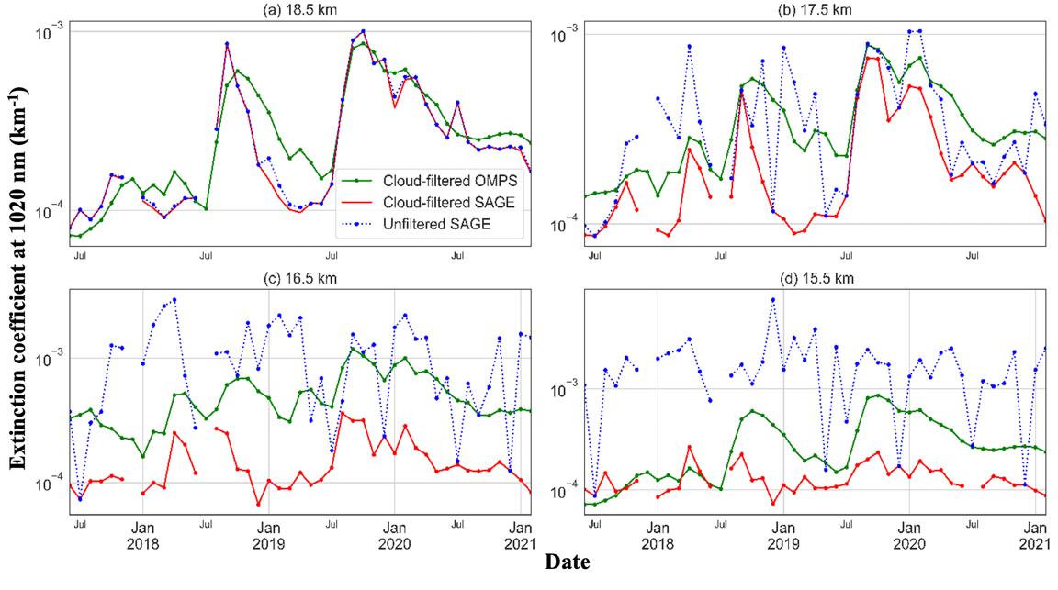

Fig. 4. **(a)** Time-series of aerosol extinction coefficient for unfiltered (dotted line with filled blue circles) and cloud-filtered (solid line with filled red circles) SAGE III/ISS (1020 nm) data at 18.5 km compared with OMPS (997 nm) cloud-filtered aerosol extinction coefficient at 997nm (dotted line with filled green circles) within the tropics (15oN-15oS). **(b), (c)** and **(d)** are the same as (a) but for 17.5 km, 16.5 km and 15.5 km, respectively.

The monthly averaged aerosol extinction at 1020 nm from unfiltered SAGE is usually higher than the cloud-filtered OMPS aerosols in the tropics. Also, SAGE extinction has abrupt highs rather than smooth variations in the monthly averages, whereas OMPS shows a slow rise for the volcanic periods. Cloud filtration in SAGE data by the ECR makes the aerosols profile smooth and shows similar trends as the OMPS. Removing clouds at higher altitudes (at 18.5 km) does not significantly alter its time-series pattern in SAGE, as shown in Fig. 4(a). Because at those altitudes, there are very few PCLE. However, cloudy events are detected up to 18.5 km in some seasons but are not so frequent to significantly impact that altitude. Still, these effects are noticed in some of the seasons. But cloud filtration has greater implications at the lower altitudes that substantially improve the SAGE data matching with the OMPS. Cloud filtration using the ECR method removes unusual peaks and smoothens down the SAGE data, as shown in Fig. 4(b), (c), and (d). Also, both data sets encompass the enhanced aerosols in various months following volcanic eruptions. So, ECR cloud filtration of SAGE helps obtain the aerosol data resembling OMPS time-series trends, especially during the volcanic periods at 17.5 and 18.5 km altitudes. However, cloud-filtered SAGE data generally underestimate the extinction coefficients at lower altitudes where the occurrence of cloud is higher, as shown in Fig. 4(c) and (d). This could be due to the differences in the cloud detection algorithms of the two instruments.

We further discuss the variation of aerosol in the UTLS region by ECR cloud-filtering and compare the same with cloud-filtering using two-wavelength methods in the following sub-section below.

* + 1. *Comparison of 2-wavelength vs. 3-wavelength (ECR) methods*

Since the SAGE III/ISS launch has provided observations of several volcanic eruptions and wildfire smoke in the UTLS region, as discussed in the previous section. Before the SAGE III-Meteor-3M launch, Kent et al. (1997) proposed a new method for separating the effects of aerosols and clouds by using aerosol extinction coefficients at its three wavelengths, viz., 525, 1020, and 1550 nm. This method was thought to work well under volcanically perturbed conditions in the UTLS. However, it was simulation-based and has not been thoroughly tested due to the lack of suitable observations over the tropics under perturbed UTLS conditions. The SAGE III- Meteor-3M observation period did not provide occultation data over the tropics due to its orbit and did not witness any volcanic perturbation in the UTLS [21].

Table 2. Position of Centroid and k0 based on TV-13 method for various situations and seasons considering volcanic and calm periods.

|  |  |  |  |
| --- | --- | --- | --- |
| Altitude | Period | Centroid (R) | Corresponding Extinction (k0) |
| 18 km | 2017/06/07-2021/02/28 | 3.11 | -3.72 |
| 2018/07/01-2018/12/31 | 4.37 | -3.88 |
| 2019/01/01-2019/05/31 | **3.38** | -4.05 |
| 2019/07/01-2019/12/31 | 2.99 | -3.22 |
| 17 km | 2017/06/07-2021/02/28 | 2.88 | -3.96 |
| 2018/07/01-2018/12/31 | 3.98 | -3.90 |
| 2019/01/01-2019/05/31 | 2.87 | -4.03 |
| 2019/07/01-2019/12/31 | 3.89 | -3.66 |

We used a similar approach for discriminating aerosols from clouds in this study to investigate the performance of the ECR method in separating clouds from SAGE III/ISS extinction at 17 and 18-km altitudes from June 2017- February 2021. We compare this cloud-filtered aerosol extinction with those obtained using the method proposed by Thomason and Vernier (2013) (referred to as the TV-13 method hereafter), as shown in Fig. 5(a) and (b). The technique was initially developed to improve the separation between clouds and aerosols during the Asian Summer Monsoon to detect the Asian Tropopause Aerosol Layer  [14] and thus tested in the absence of volcanic eruptions and wildfires.

Clouds-filtering by the TV-13 method involves computation of aerosol centroid and its corresponding extinction coefficient at 1020 nm (ka and k0) using a threshold value for R1 as 2, as discussed in Section 1. However, the centroid’s location is influenced by volcanic activities, as shown in Table 2 for various SAGE III/ISS observation periods. During Jan-May of 2019 (volcanically calm period), the value of extinction at 1020 nm is lowest at both 17 and 18 km compared to two volcanic periods (July-December 2018 and 2019). Since the TV-13 method depends on the centroid and its corresponding extinction coefficient at 1020 nm, cloud filtering using the TV-13 approach would need to be adapted to various conditions, especially during In the absence of volcanic eruption, TV-13 showed that the centroid of R1 lies at 4.5 for 18 km altitude using SAGE II data from 1998 to 2005.

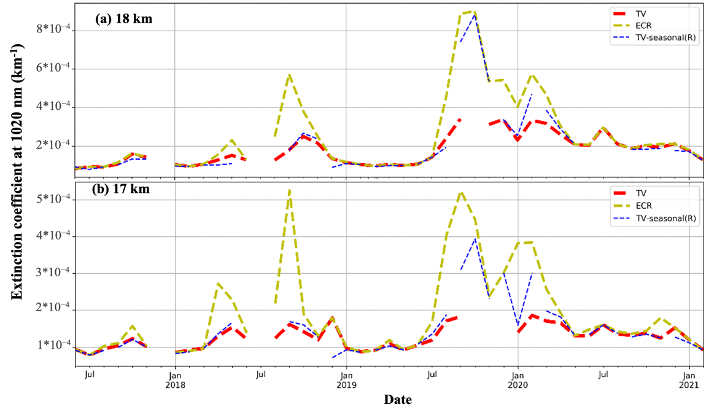

Fig. 5. **(a)**. Time series of the SAGE III/ISS cloud-filtered 1020 nm aerosol extinction coefficient at 18 km altitude obtained from the ECR method D (dashed yellow line). Solid red and dashed blue lines represent the time series obtained from the TV method using the aerosol-centroid and k0 value obtained from the entire data set and seasonal dataset, respectively. **(b)** Same as **(a)** but for 17 km altitude.

the volcanic period. This is shown in Fig. 5(a) and (b), where we find that during the absence of volcanic eruption (Jan-May 2019 and May 2020-February 2021), both cloud filtering techniques produce similar cloud-filtered aerosol extinction at 1020 nm. However, during volcanically perturbed situations (July-December 2018 and 2019), the TV-13 method filters out some enhanced aerosols, unlike the ECR method. Narrowing the sample space focusing only on the perturbed period, and using the corresponding centroid and k0 for cloud filtering produces results similar to the ECR method, as shown in Fig. 5(a) and (b). So, the seasonal breakdown based on the volcanic or non-volcanic periods followed by the estimation of centroid and k0 corresponding to those periods is advised when the TV 13 method is used to study long-term time series additional 1550 nm presents an undisputable advantage to improve cloud-aerosol discrimination in the SAGE III data that we make use in this study.

4.3 Cloud Top Height and Cloud Occurrence Frequency

4.3.1 Co-located Cloud-top altitude comparison from SAGE III/ISS, OMPS, and CALIPSO

SAGE III/ISS profiles with cloudy events obtained from the ECR method can be used to study the cloud properties, such as cloud-top altitude and cloud occurrence frequency over the tropics. For a given profile, we look for the highest altitude bin for which both R1 and R2 satisfy the thresholds set for the ECR method. This altitude bin is considered as the cloud top height for that given profile. The detection of cloud top height is illustrated for two SAGE III/ISS events observed on August 23, 2018, at 23:35:52 UTC and April 21, 2018, at 04:48:33 UTC in Figures 6(b) and 6(d), respectively. The cloud top altitudes detected for these two cases are 16 km and 16.5 km, respectively.

Fig. 6. **(a)**. The vertical profile of the 1020 nm extinction coefficient for the SAGE III/ISS event observed over 6.29 °N, 95.414 °E, on 23rd August 2018 at 23:35:52 UTC, is represented by a black line with black-filled circles. Unfiltered (red line with red filled circles) and cloud-filtered (blue line with blue filled circles) profiles from co-located observation from OMPS over 6.27 °N, 95.413 °E at 06:59:53 UTC on the same day. A green dotted line shows cloud-top detected by OMPS **(b)** Corresponding vertical profiles of SAGE III/ISS extinction color ratio, R1(blue filled circle line) and R2 (orange filled circle line) with the location of cloud top height detected using ECR method D represented by the dotted horizontal line. **(c)** same as (a) but for the co-located events observed on 21st April 2018 by OMPS at 09:00:59 UTC over 12.85S, 165.15W, and by SAGE III/ISS over 12.83S, 165.18W at 04:48:33 UTC and **(d)** same as (b) but for the SAGE III/ISS event observed on 21st April 2018.

These events are selected because we have near-collocated OMPS observations separated by 1.46 km and 4.2 km from SAGE III/ISS events on the same days with ~7.5 and ~4.2 hrs., respectively, as shown in Fig. 6 (a) and (c). The cloud top altitudes provided by OMPS for these events are 16.5 km and 17.5 km, which exceed the corresponding SAGE cloud top altitudes by 0.5 and 1 km, respectively. Considering the different viewing geometry, vertical resolution, detection algorithm, and the quickly evolving nature of clouds, these differences in cloud top altitudes from SAGE III/ISS and OMPS are acceptable for the selected collocated events.

The SAGE-CALIPSO co-located events were also detected by finding the shortest distance between the two instrument positions regarding latitude and longitude using the Haversine method for the same calendar day. One of those events was on April 26, 2018. These two observations are separated by 10.5 km on that day, and their locations are provided in Table 3*.* We used the CALIOP cloud layer product for this event to get information about the cloud layer, such as cloud boundaries, cloud optical thickness, CAD score, etc., listed in Table 3. In this case, the cloud has a CAD score of 98, a cloud-detected case with high confidence.

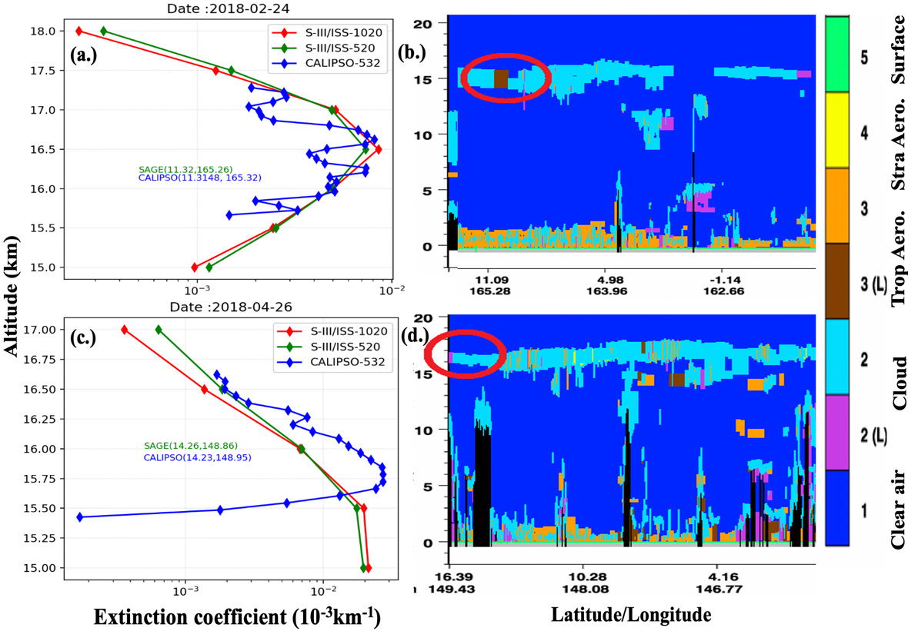

Fig. 7. **(a)**. Extinction coefficient profiles at 520 nm and 1020 nm avelengths for the SAGE III/ISS event on 26th April 2018 observed at 19:19:37 UTC are represented respectively by green and red diamond symbols at each 0.5 km altitude bin. The near co-located 532 nm extinction coefficient profile at every 60 m resolution obtained from the CALIOP at 14:42:01 UTC on the same day is shown by blue diamond symbols. (b) Vertical distribution of the vertical feature mask along the CALIPSO orbit track for the same event with a red circle indicating the location of sampled cirrus cloud. (c) Same as (a) but for the SAGE III/ISS event on 24th February 2018 at 19:48:08 UTC with a near co-located observation from CALIOP at 15:57:08 UTC. (d) Same as (b) but for the co-located event observed by CALIOP on 24th February 2018 at 15:57:08 UTC.

**Table 3. SAGE-CALIOP co-located on 2018-04-26 and 2018-02-24 pieces of information, including cloud information from CALIOP, two cases at a 10.46 and 7.5 km distance.**

|  |  |  |  |  |  |
| --- | --- | --- | --- | --- | --- |
| **2018-04-26** | **CALIPSO** | **SAGE III/ISS** | **2018-02-24** | **CALIPSO** | **SAGE III/ISS** |
| Time (local) | 14:42:01 | 19:19:37 | Time (local) | 15:57:08 | 19:48:08 |
| Latitude | 14.232 | 14.259 | Latitude | 11.315 | 11.316 |
| Longitude | 148.95 | 148.85 | Longitude | 165.2567 | 165.325 |
| Cloud top (km) | 16.62 | 17 | Cloud top (km) | 17.28 | 18 |
| COD | 0.01 | n/a | COD | 0.007 | n/a |
| CAD | 98 | n/a | CAD | 96 | n/a |
| Dist. (km) | 10.46 | 10.46 | Dist. (km) | 7.5 | 7.5 |

CALIOP indicates a cloud optical depth of 0.0139, indicating a sub-visible cirrus cloud type. The cloud-top height from the CALIOP is about 16.6 km, while from the SAGE, it is about 17 km, as shown in Fig. 7(a). The cloud layer along the CALIPSO orbit track, for this case, is shown in Fig. 7 (b). The extinction coefficient profile at 532 nm from CALIOP retrieved using the HERA algorithm  [32] is compared with the SAGE III/ISS extinction at 520 nm, as shown in Fig. 7(a). The second co-located event was on February 24, 2018. The latitude, longitude, and other information for these events are shown in Table 3. CALIPSO cloud has a CAD score of 96 with an optical depth of 0.007 and is 7.5 km from the SAGE event. The cloud top height is 18 km from SAGE and 17.28 km from CALIPSO Fig. 7(d). The cloud layer along the CALIPSO orbit track, for this case, is shown in Fig. 7(d). Despite the differences in viewing geometry, sampling airmass, vertical resolutions of these two instruments, and the dynamic nature of clouds, the difference within 1 km in cloud-top height is acceptable.

Fig. 8. Map showing the locations of SAGE III/ISS cloud events observed during 2017-2021 with cloud-top altitude detected at 18 km or above. The boxes highlight the regions exhibiting a high density of such cloud events.

We estimated the cloud-top altitudes from many other SAGE III/ISS profiles using the ECR method during the study period (June 2017- February 2021). Since our study is focused on the tropics, we expect a high occurrence of cumulonimbus clouds with their cloud-top above the tropopause (~18 km). Fig. 8 shows a map of cloudy events observed by SAGE III/ISS with high occurrence of cloud top altitudes equal to 18 km and above over the equatorial part of Africa, South America, Southeast Asia, western/eastern Pacific oceans, and the highest occurrence over the Western Pacific regions. These regions are dominated by frequently occurring deep convective clouds that often reach 18 km and above. These findings are consistent with the previous studies with observations from the SAGE II  [12], CALIOP/Cloud Sat [7], and MIPAS  [47] instruments.

Fig. 9. *Seasonal mean cloud top altitude observed by SAGE III/ISS sunrise (green dashed line with green filled circle) and sunset (orange dashed line with orange filled circle) events during June 2017- February 2021.*

Since SAGE III/ISS solar occultations provide extinction profiles at sunsets and sunrises, we can explore the variation in the cloud-top altitudes over the tropics during different seasons for those local times. We divide the year into four seasons (December to February (DJF), March to May (MAM), June to August (JJA), and September to November (SON)). For most seasons, the cloud-top altitudes are higher during sunset events than those during sunrise, as shown in Fig. 9 , with the highest cloud-tops observed during DJF. This finding is consistent with the cloud-top altitude diurnal variation over the tropics. Cloud-top altitude peaks during the late afternoon and early evening hours  [7,48]; thus, we expect cloud-top altitudes to be higher during sunset.

*4.3.2 Cloud Occurrence Frequency from SAGE III/ISS and CALIPSO*

Using the ECR method, the SAGE data are grouped seasonally to compare to the cloud occurrence obtained from the CALIOP. The cloud occurrence frequency for each season is computed by taking the ratio of the total number of cloudy events to the total number of profiles at each altitude bin of 0.5 km following Pandit et al. (2015). CALIOP cloud layer data are binned to 0.5 km to match the SAGE’s vertical resolution. The seasonal altitude distribution of cloud occurrence frequency obtained from SAGE and CALIOP is shown in Fig. 10(a)-(d). In the case of SAGE, the cloud occurrence frequency is estimated for the cloudy profiles obtained from both the ECR method for PCLE and cirrus cloud groups. The cloud occurrence frequency for PCLE is higher at each altitude bin than that obtained for cirrus clouds due to the strict cloud selection criterion imposed on it, which reduces the number of cloudy profiles.

Fig. 10. Altitude distribution of cloud occurrence frequency obtained from SAGE III/ISS and CALIOP for (a) DJF, (b) MAM, (c) JJA and (d) SON season. In each panel, SAGE III/ISS, cloud occurrence frequency, obtained using ECR methods D and A, are shown by blue dotted lines with blue-filled circles and solid blue lines with blue-filled circles, respectively. For each season, cloud occurrence frequency from CALIOP observations are obtained for three different categories viz., (i) all cloud layers without imposing any criterion (red line with red filled circles), (ii) only cloud layers satisfying 90<CAD<100 (green line with green inverted triangles), and (iii) only cloud layers satisfying 90<CAD<100 with layer integrated attenuated total color ratio (CR) greater than 0.7 (yellow line with yellow crosses).

To compare the occurrence frequency distributions from SAGE III/ISS with those obtained from CALIOP, we classified CALIOP cloudy data into three categories. These categories are: (a) all cloud layers as they are in CALIOP Clay product without imposing any criterion, (b) only cloud layers with a high confidence level of their detection (satisfying 90<CAD score<100), and (c) only cloud layers with a high confidence level (satisfying 90<CAD score<100) and layer integrated attenuated total color ratio (CR) greater than 0.7 (a threshold value used to distinguish between aerosol and cloud layers (Vernier et al., 2015; Brunamonti et al., 2018). These criteria have been chosen to reduce the probability of misclassifying the layers by the CALIOP layer detection algorithm, especially during perturbed UTLS situations. The cloud occurrence frequency for the SAGE III/ISS for cirrus clouds is within a 10% difference from that obtained from CALIOP for category (c). The cloud top difference is smallest at higher altitudes (above 16 km) and largest below 16 km altitude. The possible contributing factors for such differences in occurrence could be due to differences in satellite viewing geometries, sampling volumes, sampling time, and cloud variability. SAGE sampling frequency is sparser than CALIOP. Since SAGE is very sensitive to extremely thin clouds, clouds detected at higher altitudes might produce abrupt peaks occasionally, leading to higher cloud occurrence.

1. Summary and Conclusions

This study uses aerosol extinction data obtained between June 2017 and February 2021 from the SAGE III/ISS instrument to study the aerosols and clouds in the tropical UTLS region. Since the launch of SAGE III/ISS, it has provided observations of several volcanic eruptions and wildfire smoke in the UTLS region. We explore the advantage of having extinction coefficient data at an additional wavelength channel (1550 nm) from the SAGE III/ISS in aerosol-cloud discrimination. A method based on thresholds of two extinction coefficient ratios, R1 (520nm/1020nm) and R2­ (1020nm/1550nm), was proposed earlier for the SAGE III-Meteor 3M but never tested for the tropical region under volcanically perturbed conditions [1,20]. This method (called the Extinction Color Ratio, or ECR, a method in this study) was thought to work well under volcanically perturbed conditions in the UTLS based on simulations using in-situ data under different aerosol loading conditions. It could not be thoroughly tested during the SAGE III- Meteor-3M observation period due to the lack of observations over the tropics and the absence of significant volcanic-perturbed conditions.

We test the usefulness of the 3-wavelength approach/ECR in separating clouds from aerosols. The conclusions reached based on SAGE III/ISS data are evaluated by comparison with overlapping observations from OMPS and CALIOP instruments, which were impossible for SAGE predecessors. The following are the outcomes of this study:

1. Aerosol extinction data with R1 and R2­ values ranging between 0.9 and 2.0 are considered possible cloud-like events, while those with R1 and R2­ greater than 2.0 are cloud-free aerosols. After applying this method, the cloud-filtered aerosol data exhibit clear wavelength dependence with Angstrom’s exponent aerosol characteristic.
2. Despite the different observation techniques and the limitations of OMPS to clearly separate clouds and aerosols due to vertical resolution and a priori on the stratospheric layer, the time series of cloud-filtered aerosols obtained from the SAGE III/ISS using the ECR show enhanced aerosols in the UTLS following several volcanic eruptions (Ambae, Ulawun, and Raikoke) and wildfire events (Canadian and Australian wildfires).
3. The cloud separation using the ECR method is simple, and the thresholds are independent of the sample size and sampling period. However, studying long-time series of aerosol and cloud properties may pose a problem since SAGE III’s predecessors did not include a third channel. The benefit of an additional third wavelength compared to the two-wavelength approach from TV-13 is shown here. Indeed TV-13 relies on thresholds depending on the sample size and sampling period, with different thresholds for non-volcanic and volcanic periods. At the same time, the ECR method is independent of those parameters. The cloud-free aerosol extinction derived from the TV-13 method agrees well with the cloud-filtered ECR dataset during unperturbed situations. Still, it deviates from the ECR results during the perturbed condition when the data sample’s thresholds are derived from the entire observation period. The agreement becomes better when TV-13 thresholds are derived from the subset of data focusing on the perturbed observation period.
4. Cloud-top height can be estimated from cloudy data filtered by the ECR method. The cloud-top altitudes agreed well (within 1 km or better) with near-co-located cloud-top observations from CALIOP and OMPS. We observed high clouds with a cloud-top height exceeding 18 km in SAGE III/ISS data over the equatorial parts of Africa, South America, Southeast Asia, and Western Pacific oceanic regions influenced by deep convection. This result is consistent with previous satellite observations. The seasonal mean cloud top altitudes derived for SAGE III/ISS sunset events are higher than sunrise events, indicating clouds’ diurnal cycle over the tropics.
5. Cloud-occurrence frequencies during different seasons (DJF, MAM, JJA, and SON) are obtained from the SAGE III/ISS cloudy data and compared with those obtained from the CALIOP. Despite differences in viewing geometry, sampling time, and measurement technique, we found good qualitative agreement between the two observations.

This study demonstrates that the ECR method is a simple approach with thresholds independent of the sampling period that can efficiently and consistently separate clouds during perturbed UTLS conditions. ECR method can be used for long-term SAGE III/ISS data for aerosol-cloud discrimination and to study the variation of UTLS aerosols and clouds.

* 1. *Funding*

This study is supported by NASA’s various grants

1. MUREP (<https://www.nasa.gov/stem/murep/home/index.html>) Institutional Research Opportunity (MIRO) and HU CARE Program (Grant: NNX15AQ03A )
2. Nexus for Exoplanet Systems Science ([NExSS](https://www.nasa.gov/feature/nasa-s-nexss-coalition-to-lead-search-for-life-on-distant-worlds" \t "_blank" \o "NExSS Announcement)) program refered as Living Breathing Planet (LBP) (Grant: NNX15A05G)

6.2 Acknowledgments

William Moore and James Russel III, two Hampton University professors who evaluated the larger version of this study, made informative comments and useful ideas that are greatly appreciated. For data products, the author thanks NASA Langley Research Center and Goddard Space Flight Center. The author also thanks Yuekui Yang from NASA Goddard's Climate and Radiation Lab, GESTAR II, Morgan State University, Hampton University's Department of Atmospheric and Planetary Science. Also acknowledged are the two anonymous reviewers for this article with superb remarks as well as the Optica publication crew.

*6.3 Disclosures*

“The authors declare no conflicts of interest.”

6.4 Data availability statement

Data used in this study can be obtained from <https://asdc.larc.nasa.gov/project/SAGE%20III-ISS/g3bssp_51> for SAGE III/ISS data. CALIPSO data is available at <https://subset.larc.nasa.gov/calipso/> and OMPS at <https://doi.org/10.5067/CX2B9NW6FI27>. Graphics are generated by open Python source and library.

References

1. S. Fueglistaler, A. Dessler, T. Dunkerton, I. Folkins, Q. Fu, and P. W. Mote, "Tropical tropopause layer," Rev. Geophys. **47**, (2009).

2. B. Bregman, P.-H. Wang, and J. Lelieveld, "Chemical ozone loss in the tropopause region on subvisible ice clouds, calculated with a chemistry-transport model," J. Geophys. Res. Atmospheres **107**, ACH-5 (2002).

3. A. Gettelman, "A climatology of the tropical tropopause layer," J. Meteorol. Soc. Jpn. Ser II **80**, 911–924 (2002).

4. J. R. Holton, P. H. Haynes, M. E. McIntyre, A. R. Douglass, R. B. Rood, and L. Pfister, "Stratosphere-troposphere exchange," Rev. Geophys. **33**, 403–439 (1995).

5. E. J. Jensen, O. B. Toon, L. Pfister, and H. B. Selkirk, "Dehydration of the upper troposphere and lower stratosphere by subvisible cirrus clouds near the tropical tropopause," Geophys. Res. Lett. **23**, 825–828 (1996).

6. W. J. Randel and E. J. Jensen, "Physical processes in the tropical tropopause layer and their roles in a changing climate," Nat. Geosci. **6**, 169–176 (2013).

7. K. Sassen, Z. Wang, and D. Liu, "Cirrus clouds and deep convection in the tropics: Insights from CALIPSO and CloudSat," J. Geophys. Res. Atmospheres **114**, (2009).

8. E. Martins, V. Noel, and H. Chepfer, "Properties of cirrus and subvisible cirrus from nighttime Cloud-Aerosol Lidar with Orthogonal Polarization (CALIOP), related to atmospheric dynamics and water vapor," J. Geophys. Res. Atmospheres **116**, (2011).

9. "AR5 Climate Change 2013: The Physical Science Basis — IPCC," (n.d.).

10. M. Kovilakam, L. W. Thomason, N. Ernest, L. Rieger, A. Bourassa, and L. Millán, "The Global Space-based Stratospheric Aerosol Climatology (version 2.0): 1979–2018," Earth Syst. Sci. Data **12**, 2607–2634 (2020).

11. L. Thomason and J.-P. Vernier, "Improved SAGE II cloud/aerosol categorization and observations of the Asian tropopause aerosol layer: 1989-2005," Atmospheric Chem. Phys. **13**, 4605 (2013).

12. P. Wang, P. Minnis, M. P. McCormick, G. S. Kent, and K. M. Skeens, "A 6‐year climatology of cloud occurrence frequency from Stratospheric Aerosol and Gas Experiment II observations (1985–1990)," J. Geophys. Res. Atmospheres **101**, 29407–29429 (1996).

13. Atmospheric Sciences Data Center, "Stratospheric Aerosol and Gas Experiment on the International Space Station (SAGE III/ISS).," (2018).

14. J.-P. Vernier, L. W. Thomason, J.-P. Pommereau, A. Bourassa, J. Pelon, A. Garnier, A. Hauchecorne, L. Blanot, C. Trepte, D. Degenstein, and F. Vargas, "Major influence of tropical volcanic eruptions on the stratospheric aerosol layer during the last decade," Geophys. Res. Lett. **38**, (2011).

15. G. E. Woodbury and M. McCormick, "Global distributions of cirrus clouds determined from SAGE data," Geophys. Res. Lett. **10**, 1180–1183 (1983).

16. G. Kent, D. Winker, M. Osborn, and K. Skeens, "A model for the separation of cloud and aerosol in SAGE II occultation data," J. Geophys. Res. Atmospheres **98**, 20725–20735 (1993).

17. M. C. Pitts, L. R. Poole, and L. W. Thomason, "CALIPSO polar stratospheric cloud observations: second-generation detection algorithm and composition discrimination," Atmos Chem Phys 13 (2009).

18. J.-P. Vernier, L. W. Thomason, and J. Kar, "CALIPSO detection of an Asian tropopause aerosol layer," Geophys. Res. Lett. **38**, (2011).

19. M. Schoeberl, E. Jensen, T. Wang, G. Taha, R. Ueyama, Y. Wang, M. DeLand, and A. Dessler, "Cloud and Aerosol Distributions From SAGE III/ISS Observations," J. Geophys. Res. Atmospheres **126**, e2021JD035550 (2021).

20. G. S. Kent, P.-H. Wang, and K. M. Skeens, "Discrimination of cloud and aerosol in the Stratospheric Aerosol and Gas Experiment III occultation data," Appl. Opt. **36**, 8639–8649 (1997).

21. G. Kent, K. Sage, C. Trepte, and P.-H. Wang, "Stratospheric Aerosol and Gas Experiment III cloud data product," Appl. Opt. **46**, 1261–1278 (2007).

22. C. Kloss, G. Berthet, P. Sellitto, F. Ploeger, G. Taha, M. Tidiga, M. Eremenko, A. Bossolasco, F. Jegou, and J.-B. Renard, "Stratospheric aerosol layer perturbation caused by the 2019 Raikoke and Ulawun eruptions and their radiative forcing," Atmospheric Chem. Phys. **21**, 535–560 (2021).

23. M. P. McCormick, H. M. Steele, P. Hamill, W. P. Chu, and T. J. Swissler, "Polar stratospheric cloud sightings by SAM II," J. Atmospheric Sci. **39**, 1387–1397 (1982).

24. G. Kent and M. McCormick, "Separation of cloud and aerosol in two-wavelength satellite occultation data," Geophys. Res. Lett. **18**, 428–431 (1991).

25. W. Chu, E. Chiou, J. Larsen, L. Thomason, D. Rind, J. Buglia, S. Oltmans, M. McCormick, and L. McMaster, "Algorithms and sensitivity analyses for Stratospheric Aerosol and Gas Experiment II water vapor retrieval," J. Geophys. Res. Atmospheres **98**, 4857–4866 (1993).

26. L. W. Thomason and G. Taha, "SAGE III aerosol extinction measurements: Initial results," Geophys. Res. Lett. **30**, (2003).

27. T. SAGE III ATBD, "SAGE III Algorithm Theoretical Basis Document (ATBD) Solar and Lunar Algorithm version 2.1," LaRC Rep 4750-00 **109**, (2002).

28. H. R. Wang, R. Damadeo, D. Flittner, N. Kramarova, G. Taha, S. Davis, A. M. Thompson, S. Strahan, Y. Wang, L. Froidevaux, and others, "Validation of SAGE III/ISS Solar Occultation Ozone Products with Correlative Satellite and Ground Based Measurements," J. Geophys. Res. Atmospheres e2020JD032430 (2020).

29. NASA Langley Atmospheric Science Data Center DAAC, "NASA/LARC/SD/ASDC. (2017).," https://doi.org/10.5067/ISS/SAGEIII/SOLAR\_BINARY\_L2-V5.1.

30. D. M. Winker, M. A. Vaughan, A. Omar, Y. Hu, K. A. Powell, Z. Liu, W. H. Hunt, and S. A. Young, "Overview of the CALIPSO mission and CALIOP data processing algorithms," J. Atmospheric Ocean. Technol. **26**, 2310–2323 (2009).

31. J. P. Vernier, J. P. Pommereau, A. Garnier, J. Pelon, N. Larsen, J. Nielsen, T. Christensen, F. Cairo, L. W. Thomason, T. Leblanc, and I. S. McDermid, "Tropical stratospheric aerosol layer from CALIPSO lidar observations," J. Geophys. Res. Atmospheres **114**, (2009).

32. S. A. Young and M. A. Vaughan, "The retrieval of profiles of particulate extinction from Cloud-Aerosol Lidar Infrared Pathfinder Satellite Observations (CALIPSO) data: Algorithm description," J. Atmospheric Ocean. Technol. **26**, 1105–1119 (2009).

33. L. E. Flynn, C. J. Seftor, J. C. Larsen, and P. Xu, "The ozone mapping and profiler suite," in *Earth Science Satellite Remote Sensing* (Springer, 2006), pp. 279–296.

34. R. Loughman, P. K. Bhartia, Z. Chen, P. Xu, E. Nyaku, and G. Taha, "The ozone mapping and profiler suite (OMPS) limb profiler (LP) version 1 aerosol extinction retrieval algorithm: theoretical basis," Atmospheric Meas. Tech. **11**, 2633–2651 (2018).

35. Z. Chen, M. DeLand, and P. K. Bhartia, "A new algorithm for detecting cloud height using OMPS/LP measurements," Atmospheric Meas. Tech. **9**, 1239–1246 (2016).

36. G. Taha, R. Loughman, T. Zhu, L. Thomason, J. Kar, L. Rieger, and A. Bourassa, "OMPS LP Version 2.0 multi-wavelength aerosol extinction coefficient retrieval algorithm," Atmospheric Meas. Tech. **14**, 1015–1036 (2021).

37. S. Bhatta, *High-Altitude Cloud/Aerosol Detection from SAGE III-ISS and Comparison with OMPS/CALIPSO* (Hampton University, 2021).

38. W. Sun, G. Videen, S. Kato, B. Lin, C. Lukashin, and Y. Hu, "A study of subvisual clouds and their radiation effect with a synergy of CERES, MODIS, CALIPSO, and AIRS data," J. Geophys. Res. Atmospheres **116**, (2011).

39. J. Jia, "Cirrus cloud observations from tangent path measurements of solar extinction.," The University of Wyoming. (1991).

40. G. S. Kent and P.-H. Wang, *SAGE II Satellite Data Set Validation.* (NASA, Langley Research Centre., 1986).

41. G. K. Yue, "Wavelength dependence of aerosol extinction coefficient for stratospheric aerosols," J. Clim. Appl. Meteorol. **25**, 1775–1779 (1986).

42. F. Dongbin, "Tropospheric Aerosol Profiles from SAGE II Solar Extinction Observations.," Master’s Thesis, The University of Wyoming (1993).

43. S. Khaykin, B. Legras, S. Bucci, P. Sellitto, L. Isaksen, F. Tence, S. Bekki, A. Bourassa, L. Rieger, and D. Zawada, "The 2019/20 Australian wildfires generated a persistent smoke-charged vortex rising up to 35 km altitude," Commun. Earth Environ. **1**, 1–12 (2020).

44. C. Kloss, P. Sellitto, B. Legras, J.-P. Vernier, F. Jégou, M. Venkat Ratnam, B. S. Kumar, B. L. Madhavan, and G. Berthet, "Impact of the 2018 Ambae eruption on the global stratospheric aerosol layer and climate," J. Geophys. Res. Atmospheres e2020JD032410 (2020).

45. E. Hirsch and I. Koren, "Record-breaking aerosol levels explained by smoke injection into the stratosphere," Science **371**, 1269–1274 (2021).

46. G. Kablick III, D. R. Allen, M. D. Fromm, and G. E. Nedoluha, "Australian pyroCb smoke generates synoptic‐scale stratospheric anticyclones," Geophys. Res. Lett. **47**, e2020GL088101 (2020).

47. L. Zou, S. Griessbach, L. Hoffmann, B. Gong, and L. Wang, "Revisiting global satellite observations of stratospheric cirrus clouds," Atmospheric Chem. Phys. **20**, 9939–9959 (2020).

48. C. Liu and E. J. Zipser, "Diurnal cycles of precipitation, clouds, and lightning in the tropics from 9 years of TRMM observations," Geophys. Res. Lett. **35**, (2008).