NASA’S HABITATION DEVELOPMENT STATUS: CURRENT CONCEPTS AND ISRU OPPORTUNITIES. J. E. Johnson¹, J. Clawson², P. Kessler¹, A. Choate³, and T. Nickens¹. ¹National Aeronautics and Space Administration (NASA), Marshall Space Flight Center (MSFC), Martin Rd, Huntsville, AL; james.e.johnson@nasa.gov, paul.kessler@nasa.gov, tiffany.nickens@nasa.gov ²Stellar Solutions, NASA Headquarters; james.clawson@nasa.gov ³Jacobs Engineering, NASA/MSFC; andrew.choate@nasa.gov

Introduction: The National Aeronautics and Space Administration (NASA) is embarking on a bold journey to return humankind to the Moon and onward to Mars with innovative commercial, international, and academic partnerships [1]. Under the Artemis series of missions, NASA seeks to establish sustained human exploration of deep space through an objectives-based approach [2]. This approach drives the identification of needed system functionality and the current and future capabilities which will eventually allow humanity to sustainably live beyond Earth. Providing evolvable and scalable habitation is a cornerstone function that calls for the collection and integration of current, developmental, and future technologies that can meet near-term exploration needs while growing into long-term sustained presence. NASA is advancing in-space habitation through its Next Space Technologies for Exploration Partnerships (NextSTEP) model while designing lunar, Mars transit, and Mars surface habitat government reference concepts for Artemis missions. These efforts have unveiled possible near-term opportunities for the in-space resource utilization community if human habitation is considered a future customer of space resources.
NextSTEP Habitation Development: NASA is closely working with commercial partners under its NextSTEP Appendix A model to advance habitation systems in the arena of inflatable and composite habitation structures. Such efforts promise efficiencies in volumetric packaging and overall spacecraft mass respectively. Recent testing by commercial partners have helped to quantify possible failure mechanisms for inflatable structures while advancing their technology towards eventual flight certification. The advancement of such Class II habitation structures, in which the habitat is only fully deployed once in-space or on a planetary surface [3], is critical to providing increased habitable volume for long-duration missions with no additional mass penalties. The progression of such technology is infused into NASA’s government reference concepts for notional deep space habitation concepts.
Current Government Reference Concepts: To best inform the formulation of future collaborative solicitations, NASA employs the practice of internally developing reference concepts for future exploration elements. These concepts aid in identifying the functions and capabilities needed to complete NASA missions as well as feasible solutions within the timeframe needed. Government reference concepts for a lunar Surface Habitat, Mars Transit Habitat, and Mars Surface Habitat are continuously being developed and updated to better guide the Agency’s overall exploration architecture.
Lunar Surface Habitat. As NASA returns to the Moon, it is evaluating possible lunar surface habitation concepts. The Surface Habitat (SH) reference concept entails a hybrid metallic-inflatable structure capable of initially housing two crew for surface stays of up to 30 days in duration [4]. While initial missions may span ~7 days in duration, consideration is being given to expanding SH’s capability to support a crew of four for up to 60 days over its 15-year design life [5]. Functionally, the SH serves as a ‘hub’ for all Artemis crewed surface operations, providing internal volume for maintenance, medical, logistics, science utilization, and extravehicular activity (EVA) support in addition to core habitation functionality such as environmental control and life support (ECLS) and power generation and distribution among many others.
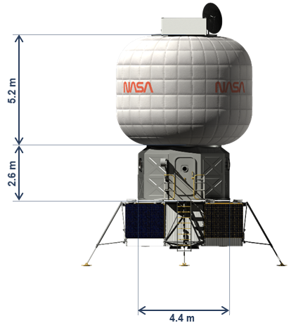
Figure 1 SH government reference concept.
Additionally, NASA has entered a study agreement with the Italian Space Agency (Agenzia Spaziale Italiana – ASI) to investigation a possible Multi-Purpose Habitat (MPH) as an additional or augmenting habitable element for the lunar surface [6].
Mars Transit Habitat. NASA’s current architectural concept for initial human missions to Mars entails the utilization of a transit habitat (TH) to transport a four-person crew to and from Mars orbit, departing from and returning to a lunar near-rectilinear halo orbit (NRHO), over the course of a ~1,200-day mission [5]. While holding a similar 15-year design lifetime, TH will also support a series of analog mission activities in NRHO to gradually test the systems and interaction with lunar surface elements, some of which may be adapted for Mars surface exploration. Holding similar functional capabilities as SH, TH is sized to support much longer durations in space and greater logistical independence.
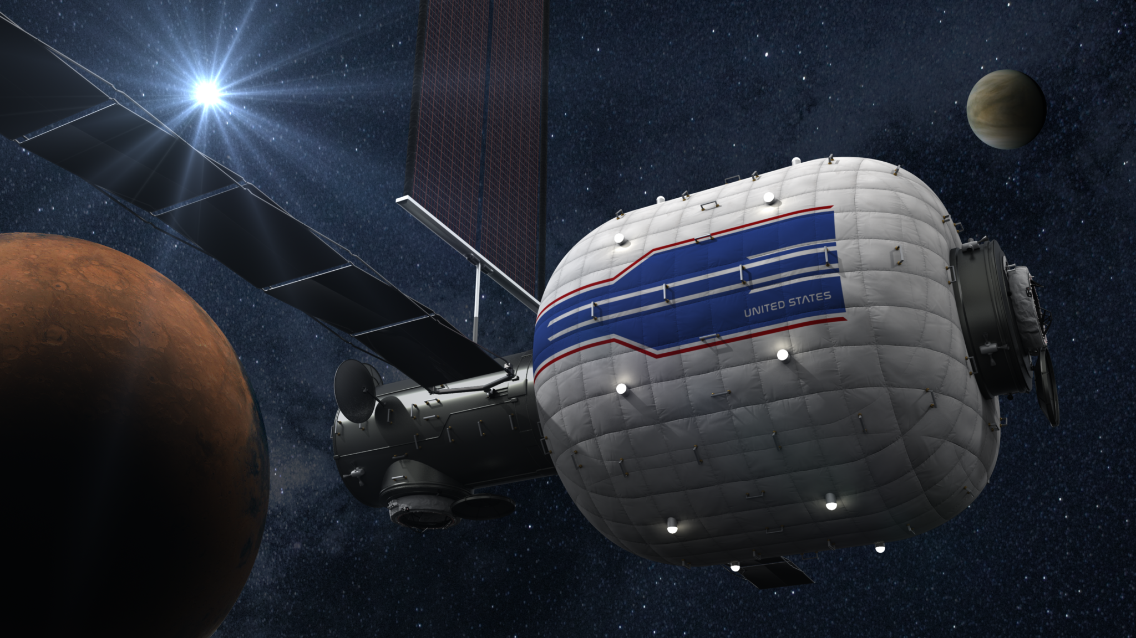
Figure 2 Rendering of TH government reference concept.
Mars Surface Habitat. NASA is still exploring the concept of operations for initial crewed missions to Mars. As such, the Mars Surface Habitat (MSH) concept is still in its infancy as options for mobile, pressurized habitation and stationary habitats are being explored. It is expected MSH will leverage heavily from the lunar SH and possible lunar pressurized rover, however the very different Martian environment will likely necessitate modifications.
ISRU Opportunities: Despite the advancements under NASA’s NextSTEP habitation work and continually optimized reference concepts, NASA is facing near-term mass and power challenges that may create opportunities to the ISRU community by providing yet another possible customer for space resources.
While NASA desires to use regenerative ECLS systems (ECLSS) for all habitation concepts, their operation comes with initial mass penalties and maintenance overheads when compared to simpler open-loop architectures. Because of this, NASA is currently proposing an open-loop, consumables-based architecture for its surface habitats to achieve initial launch and delivery lander mass targets while scarring for the incorporation of regenerative ECLSS to meet longer mission durations and sustained presence. With such an architecture, oxygen and potable water are needed consumables, which initial ISRU systems may be able to provide in a pilot capacity. Although the TH is expecting to utilize regenerative ECLSS, advancements in lunar surface-based ISRU and possible re-supply of spacecraft in lunar or Mars orbit could significantly reduce the logistical need for ECLSS related spares on TH and possibly allow a similar open-loop and consumables-based architecture.

Table 1 Notional ECLSS consumables per mission use for SH and TH [5].
Consumable | SH (28-day)  Open-Loop | TH (1110-day)  Closed-Loop
Water (kg) | 288 | 182
Oxygen (kg) | 30 | 123
In addition to ECLSS mass concerns, the SH is facing challenges with energy storage to support operations over periods of darkness exceeding 100 hours. Both battery and fuel cell-based power architectures are being traded, opening options for external power generation and energy storage. One possibility is ISRU-produced H₂ and O₂ feeding external primary fuel cell systems which could supplement habitation power generation while reducing initial mass and volume until much more powerful fission power systems might be deployed.
Conclusion: Significant advancements are being made in evolvable habitation concepts that span from near-term technologies, such as inflatable structures under NextSTEP, to potentially revolutionary capabilities like the lunar surface construction as funded through the Moon-to-Mars Planetary Autonomous Construction Technologies (MMPACT) project [7]. As NASA investigates both heritage capabilities and rapidly advancing, disruptive technologies, there are likely many near-term opportunities for initial ISRU capabilities to significantly aid human habitation and increase self-sufficiency beyond Earth.

References:
[1] National Aeronautics and Space Administration (NASA), September 2020, “The Artemis Plan.” URL:
https://www.nasa.gov/sites/default/files/atoms/files/artemis_plan-20200921.pdf
[2] NASA, September 2022, “Moon to Mars Objectives.” URL: https://www.nasa.gov/sites/default/
files/atoms/files/m2m-objectives-exec-summary.pdf
[3] Cohen, Marc, and Kriss J. Kennedy. "Habitats and surface construction: technology and development roadmap." NASA conference publication. NASA, 1997.
[4] Kessler, Paul, et al. "Artemis Deep Space Habitation: Enabling a Sustained Human Presence on the Moon and Beyond." 2022 IEEE Aerospace Conference (AERO). IEEE, 2022.
[5] Harris, Danny W., et al. Moon to Mars (M2M) Habitation Considerations: A Snap Shot As of January 2022. No. M-1538. 2022.
[6] Agenzia Spaziale Italiana. “Artemis Mission: Signed Agreement Between ASI and NASA.” URL: https://www.asi.it/en/2022/06/artemis-mission-signed-agreement-between-asi-and-nasa/
[7] Clinton, Raymond G., et al. "NASA’s Moon-to-Mars Planetary Autonomous Construction Technology Project: Overview and Status." 73rd International Astronautical Congress (IAC 2022).

