Yampa Water Resources
Monitoring Water Quality and Evaluating Potential Drivers of Algae Blooms in the Upper Yampa River Watershed


Technical Report
Final – August 11th, 2022

Samrin Sauda (Project Lead)
Erin Weitzel
Ethan Gates
Morgan Guttman

Advisors:
Dr. Anthony Vorster (Colorado State University, Natural Resource Ecology Laboratory)
Christopher Tsz Hin Choi (Colorado State University, Natural Resource Ecology Laboratory)
Dr. Paul Evangelista (Colorado State University, Natural Resource Ecology Laboratory)
Dr. Catherine Jarnevich (USGS, Fort Collins Science Center)
Peder Engelstad (Colorado State University, Natural Resource Ecology Laboratory)
Nicholas Young (Colorado State University, Natural Resource Ecology Laboratory)

1. Abstract
The Upper Yampa River Watershed (UYRW), located in northwestern Colorado, plays a key role in providing water to the Colorado River. However, the UYRW has been impacted by increasingly frequent and widespread harmful algal blooms (HABs) that emit cyanotoxins and deteriorate the water quality. Due to these cyanotoxins, recreational closures have been enacted and drinking water has been impaired, leading to adverse health, economic, and ecological effects. Partnering with the Upper Yampa Water Conservancy District (UYWCD) and the Colorado State University (CSU) Agricultural Water Quality Program, the DEVELOP team utilized Earth observations from Landsat 5 Thematic Mapper (TM), Landsat 7 Enhanced Thematic Mapper Plus (ETM+), and Landsat 8 Operational Land Imager (OLI) to analyze trends in water quality from 1984 to 2021 for nine waterbodies of interest: Lake Catamount, Lake Dumont, Elkhead Reservoir, Fish Creek Reservoir, Sheriff Reservoir, Stagecoach Reservoir, Steamboat Lake, Stillwater Reservoir, and Yamcolo Reservoir. The team generated time series plots and maps exhibiting parameters such as greenness, temperature, Apparent Visible Wavelength (AVW), and Broad Wavelength Algae Index (BWAI). Finally, evaluation plots were created to analyze the correlation between spectral indices and in-situ measurements. Surface temperature has risen on Lake Catamount, Stagecoach Reservoir, and Steamboat Lake. All other water quality parameters varied in trend and significance across all nine waterbodies. The limited amount of in-situ validation data made it difficult to determine the viability of satellite remote sensing as a tool for monitoring water quality in the UYRW.

Key Terms
algae, harmful algal bloom, remote sensing, water quality, lake color, temperature, time-series, Upper Yampa River Watershed

2. Introduction
2.1 Background Information
The Upper Yampa River Watershed (UYRW), located in northwestern Colorado, plays a key role in providing water to the western United States. The watershed contains the Yampa River, which is an important tributary of the Colorado River and the largest mostly free flowing river in the Colorado River system (Day, 2021; Hay et al., 2012). The watershed also contains a number of lakes and reservoirs that are crucial for local recreation and water storage (Figure 1). The UYRW has been impacted by increasingly frequent and widespread harmful algal blooms (HABs) that deteriorate water quality and impair recreational and municipal use. This has upset local economies by reducing tourism and has threatened water resources for the community and downstream users.

The HABs in this region are caused by cyanobacteria (i.e., blue-green algae). When the algae decompose, oxygen is consumed and carbon dioxide is produced. This decreases the water's dissolved oxygen (DO) and pH levels, creating hypoxic conditions and dead zones where life is unsustainable for local organisms (Day, 2021). Additionally, certain kinds of algae can produce bioactive toxins, which can be harmful to humans and other aquatic and terrestrial species (Lopez et al., 2008). Consumption of cyanotoxins can cause symptoms such as stomach pain, vomiting, liver damage, neurological issues, and more (Centers for Disease Control and Prevention [CDC], 2022). While HABs are naturally occurring, they have increased in frequency and distribution in recent decades (Lopez et al., 2008). The causes of HABs are complex, but they are related to changes in land use, land management, climate, precipitation, and temperature (Day, 2021).

The sustainable management of waterbodies requires the continuous monitoring of water quality, which has conventionally been carried out through the collection of field samples. Recently, water quality monitoring has begun to use geospatial technologies such as remote sensing and Geographic Information Systems (GIS) for analysis (Markogianni et al., 2020). These technologies present advantages over traditional in-situ sampling, as they are non-intrusive and allow monitoring over various spatial areas and temporal scales. Even so, they are never a replacement for field sampling, but rather act as an effective supplementary source of information.

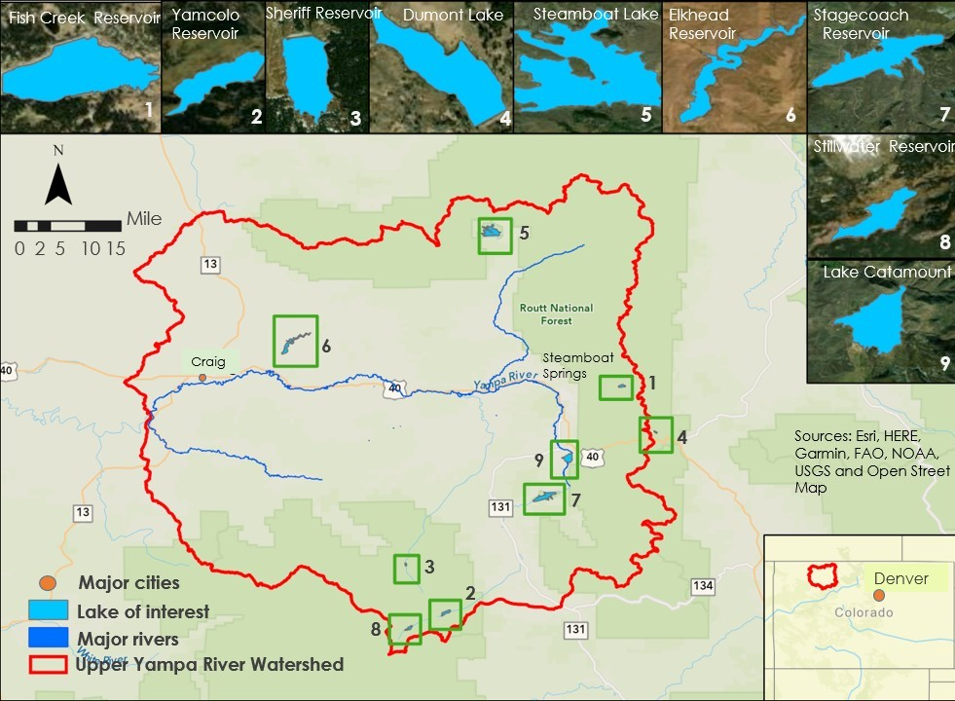
Figure 1. Upper Yampa River Watershed boundary and waterbodies of interest: Fish Creek Reservoir, Yamcolo Reservoir, Sheriff Reservoir, Dumont Lake, Steamboat Lake, Elkhead Reservoir, Stagecoach Reservoir, Stillwater Reservoir, and Lake Catamount. Watershed boundary and waterbody shapefiles were obtained from the USGS National Hydrography Dataset (NHD) High-Resolution Datasets.

2.2 Project Partners & Objectives
The Upper Yampa Water Conservancy District (UYWCD) is responsible for water conservation within the UYRW. As such, they are dedicated to providing water to users, preserving water rights, mitigating threats to water quality, and promoting sustainable water use. HABs have adversely affected water quality within the watershed and have impacted local recreation and the UYWCD’s ability to provide water to its users. In recent years, nutrient and chlorophyll-a levels have become strictly regulated by the Environmental Protection Agency (EPA). As a result, several waterbodies in the UYRW are set for mandated water quality reviews and reformations in 2025 by the 303d EPA regulations. Due to the prevalence of HABs, the UYWCD does not believe many of its waterbodies will pass these reviews. The Yampa DEVELOP team partnered with UYWCD, as well as collaborators from the Agricultural Water Quality Program (AWQP) at Colorado State University (CSU), to assess the feasibility of using remote sensing to analyze changes in water quality in the UYRW over time. Partners were interested in obtaining a thorough historical record of HABs and water temperature in key reservoirs and lakes in the UYRW (Figure 1). They were interested in using these data to inform decision making and mitigation strategies regarding the newly imposed state and federal water regulations.

The objective of this project was to use NASA Earth observations (EOs) to conduct a time-series analysis of lake color and temperature from 1984 to 2021, focusing on nine lakes and reservoirs of interest (Figure 1). An additional objective was to compare the timeseries data to in-situ water quality measurements taken during the time span of the project for validation of the remote sensing tools. NASA EOs had not previously been explored as a means of tracking water quality and HABs in the UYRW, and this project was meant to evaluate their effectiveness and assess the feasibility of using this methodology to study water quality in this region.

3. Methodology
3.1 Study Area
The primary study area for our project is the UYRW, which is defined as the area of land drained by the Yampa River from its headwaters near the Flat Tops, a mountain range in Garfield County, to near Craig, Colorado (Bauch et al., 2012). The UYRW drains approximately 2,100 square miles of the Yampa River Basin, and the elevation here ranges from 6,100 feet to more than 12,000 feet. The streamflow is dominated by snowmelt runoff and typically peaks in May and June. The geology of the UYRW consists of sedimentary rocks (Cretaceous in age), including sandstones, shales, and major coal beds. The UYRW landcover is predominantly forest, shrubs, and pasture/hay (Day, 2021). Characteristics such as the various waterbodies' elevations, areas, and construction dates are shown in Table B1.

3.2 Spectral Bands and Indices
To track changes in water quality over time, we selected two spectral bands and two spectral indices for analysis. For the spectral bands, we measured green band reflectance (GBR) and surface temperature. Reflectance in the green band provides a measure of lake color. It has been used to infer changes in lake ecology and has been linked to primary productivity (Kuhn & Butman, 2021). Lake color is easily derived from satellite imagery and serves as a good indicator of water quality (Giardino et al., 2014). The green band is also known to be effective at detecting HABs without floating scum because they tend to have higher reflectance in this wavelength range (Zhao et al., 2020). We used Level 2, Collection 2, Tier 1 Landsat products, where the surface temperature in Kelvin was measured using the ST_B6 band. Temperature is an important water quality parameter, and periodically high-water temperatures can be conducive to cyanobacterial HABs (Day, 2021).

For the spectral indices, we calculated measures of Apparent Visible Wavelength (AVW) and the Broad Wavelength Algae Index (BWAI). AVW is an optical water classification index that measures the dominant color of the water. It is calculated as the weighted harmonic mean of the reflectance values (R_{rs}) at all available visible wavelengths ($\text{λ}$) constrained by the intensity of reflectance at those wavelengths (Vandermeulen et al., 2020; Equation 1).
$AVW = \frac{\sum_{i=λ_{i} }^{ λ_{n}}{R_{rs}\left(λ_{i}\right)} }{\frac{\sum_{i=λ_{i} }^{λ_{n} }{R_{rs}\left(λ_{i}\right)}}{λ_{i}}}$ (1)

BWAI is derived from the visible, near-infrared (NIR), and shortwave infrared (SWIR) bands. The index is calculated through several equations that combine band reflectance values and their respective central wavelength values (Equations 2–5). It was created to detect and monitor cyanobacteria-rich HABs (CyanoHABs) in Landsat and MODIS imagery and has been used to detect HABs in Lake Erie (Zhao et al., 2020). The BWAI equation is meant to detect green or NIR reflectance peaks, accounting for HABs with or without floating scums, while also depressing this reflectance peak in highly turbid waters (Zhao et al., 2020).

$\text{RP}{\text{H}}_{\left(\text{Green,} \text{NIR}\right)} \text{=} {\text{ρ}}_{\text{max}} \text{-} {\text{ρ}}_{\text{blue}} \text{-} \left({\text{ρ}}_{\text{SWIR}} \text{-} {\text{ρ}}_{\text{blue}}\right)\text{×}\frac{{\text{λ}}_{\text{max}}\text{-} {\text{λ}}_{\text{blue}}}{{\text{λ}}_{\text{SWIR}}\text{-} {\text{λ}}_{\text{blue}}}$ (2)

Green or NIR reflectance peak height (RPH) is calculated where ${\text{ρ}}_{\text{max}}$ is the maximal water surface reflectance of the green and NIR bands, ${\text{λ}}_{\text{max}}$ is the corresponding central wavelength; ${\text{ρ}}_{\text{blue}}$ and ${\text{ρ}}_{\text{SWIR}}$ are the water surface reflectance of the blue and SWIR bands, and ${\text{λ}}_{\text{blue}}$ and ${\text{λ}}_{\text{SWIR}}$ are the corresponding central wavelengths.

${\text{F}}_{\text{S}} \text{=} \text{exp}\left({\text{ρ}}_{\text{red}} \text{-} {\text{ρ}}_{\text{green}} \text{-} \left({\text{ρ}}_{\text{NIR}} \text{-} {\text{ρ}}_{\text{green}}\right)\text{×}\frac{{\text{λ}}_{\text{red}} \text{-} {\text{λ}}_{\text{green}}}{{\text{λ}}_{\text{NIR}} \text{-} {\text{λ}}_{\text{green}}}\right)$ (3)

F_{s} is depressing factor based on red RPH to extract high turbidity pixels. This is calculated where ${\text{ρ}}_{\text{green}}$, ${\text{ρ}}_{\text{red}}$, and ${\text{ρ}}_{\text{NIR}}$ represent the water surface reflectance and ${\text{λ}}_{\text{green}}$, ${\text{λ}}_{\text{red}}$, and ${\text{λ}}_{\text{NIR}}$ represent the central wavelengths of the green, red, and NIR bands.
${\text{F}}_{\text{C}} \text{=} \text{exp}{\frac{\left({\text{ρ}}_{\text{green}} \text{-} {\text{ρ}}_{\text{blue}} \right)}{\left({\text{ρ}}_{\text{green}} \text{+} {\text{ρ}}_{\text{blue}}\right)}}$ (4)

To mondulate green or NIR surface reflectance peaks, a signal modulation factor (F_{C}) is calculated where ${\text{ρ}}_{\text{green}}$and ${\text{ρ}}_{\text{blue}}$ represent the water surface reflectance at the green and blue bands.

$\text{BWAI} \text{=} \text{RP}{\text{H}}_{\left(\text{Green,} \text{NIR}\right)}\text{×}\left\{ _{{\text{F}}_{\text{S}}^{\text{-1}}\text{,} \text{ln}\left({\text{F}}_{\text{S}}\right) \text{>} \text{T}}^{{\text{F}}_{\text{C} }\text{,} \text{ln}\left({\text{F}}_{\text{S}}\right) \text{≤} \text{T}}\right\}$ (5)

The BWAI is calculated based on equations 2-4 where T is a threshold to extract high turbidity waters.

3.3 Data Acquisition
3.3.1 Time-Series Plots
To track and visualize lake color and temperature over time, we accessed imagery from Landsat 5 Thematic Mapper (TM) and Landsat 7 Enhanced Thematic Mapper Plus (ETM+). For this project, our team utilized the visible, NIR, SWIR, and thermal bands across the different sensors. The visible and infrared bands have a spatial resolution of 30 meters on both sensors, while the thermal band has a resolution of 120 meters on TM and 60 meters on ETM+. Both sensors have a revisit time of 16 days. We chose to use these two sensors for time-series creation because their bands span the same wavelength ranges. This meant that we could use imagery from both sensors spanning our entire study period without the need for band harmonization.

We retrieved satellite imagery from the Google Earth Engine (GEE) public data archive. Since we were covering such a long period, we decided to use pre-processed imagery that had already been atmospherically corrected into surface reflectance and surface temperature. This led us to use two image collections in GEE: the United States Geological Survey (USGS) Landsat 5 Level 2, Collection 2, Tier 1 dataset and the USGS Landsat 7 Level 2, Collection 2, Tier 1 dataset. We filtered the image collections by year and month–from Landsat 5 we retrieved all available imagery from 1984 to 2011, and from Landsat 7 we retrieved all available imagery from 2012 to 2021. Within each year, we retrieved available images from June 1 until October 31; this is the approximate HAB season for algae. We also downloaded the USGS National Hydrography Dataset (NHD) for Colorado (U.S. Geological Survey, 2022a), which provided us with a shapefile of all waterbodies in Colorado. This shapefile included the boundaries of all nine lakes and reservoirs in our study area, which was used in data processing and map creation.

Table 1
NASA Earth observation platforms and sensors used for data acquisition

Platform and Sensor | Parameters | Use | Imagery Dates
Landsat 8 Operational Land Imager (OLI) | GBR, temperature, AVW, BWAI | Imagery from this sensor was used to create change maps of water quality parameters | June 1st – October 31st for years 2013 – 2021
Landsat 7 Enhanced Thematic Mapper Plus (ETM+) | GBR, temperature, AVW, BWAI | Imagery from this sensor was used to create time-series plots of water quality parameters | June 1st – October 31st for years 2012 – 2021
Landsat 5 Thematic Mapper (TM) | GBR, temperature, AVW, BWAI | Imagery from this sensor was used to create time-series plots and change maps of water quality parameters | June 1st – October 31st for years 1984 – 2011
.
3.3.2 Change Maps
Maps were constructed to visualize the spectral bands and indices in the waterbodies of interest to display both HAB presence and HAB absence. For HAB date selection, the EPA website known as the Cyanobacteria Assessment Network, or CyAN, was utilized in addition to USGS water quality data (National Water Quality Monitoring Council, 2020; U.S. Geological Survey, 2016) and Stagecoach Reservoir water quality data (EPA, 2022a). These ancillary datasets were reviewed for time periods of high chlorophyll-a concentration or cyanobacteria activity, and these time periods were recorded for visualization in the maps (Table B2). For selecting non-bloom dates, we looked at our time-series plots for time periods when greenness and BWAI were at their lowest. This selection process and map creation were completed for three lakes: Stagecoach Reservoir (Figure A15), Steamboat Lake (Figure A16), and Lake Catamount (Figure A17). Once the bloom and non-bloom dates were selected and finalized, GEE was used to acquire satellite imagery via Level 2, Collection 2, Tier 1 products from Landsat 5 and Landsat 8. We utilized Landsat 8 for visualization since the EPA CyAN data are only available from 2020, and it was important to use a satellite whose imagery could line up with this time period. Landsat 8 was also chosen over Landsat 7 because imagery from the latter is affected by a scan line corrector error that occurred May 31st, 2003, and impacts the image quality. As such, all recent imagery from Landsat 7 ETM+ has data gaps which made it unsuitable for map visualization.

3.3.3 Evaluation Plots
For validation, we acquired in-situ chlorophyll-a and temperature measurements through the Water Quality Portal (WQP), USGS, and the UYWCD to compare with our remotely sensed data. In previous studies and alternate sources, it has been determined that chlorophyll-a is an indicator of algal presence (EPA, 2022b). The data downloaded from the WQP on July 11th, 2022 were the sample results for aggregate surface-water-use for Routt County, Colorado from the National Water Information System (NWIS) and Water Quality Exchange (WQX) databases. The parameters used from this dataset were chlorophyll-a, corrected for pheophytin, and water temperature (National Water Quality Monitoring Council, 2020). These data were used to validate GBR, AVW, and BWAI at Stagecoach Reservoir, Steamboat Lake, and Lake Catamount as well as validate remotely sensed water surface temperature at Steamboat Lake and Lake Catamount. Additional chlorophyll-a data for Stagecoach Reservoir from USGS site 401707106495800 were downloaded on August 2nd, 2022 from the NWIS website (U.S. Geological Survey, 2016). These data were merged with the chlorophyll-a data acquired through the WQP in order to validate GBR, AVW, and BWAI at Stagecoach Reservoir. Temperature data for the Stagecoach Reservoir was acquired from the UYWCD; their temperature string (i.e., temperature profiling sensor), located at the outflow of Stagecoach Reservoir, provided measurements at 2-minute intervals and 5-foot increments throughout the water column from February 26th, 2016 to July 19th, 2022 and was used to validate the remotely sensed surface temperature at Stagecoach Reservoir. There were no in-situ measurements available to validate Lake Dumont, Elkhead Reservoir, Fish Creek Reservoir, Sheriff Reservoir, Stillwater Reservoir, or Yamcolo Reservoir. Therefore, Stagecoach Reservoir, Steamboat Lake, and Lake Catamount became the primary lakes of remote sensing interest due to their ability to be validated with in-situ measurements.

3.4 Data Processing
3.4.1 Time-Series Plots
After being filtered by year and month, the image collections for Landsat 5 TM and Landsat 7 ETM+ were processed in GEE for each waterbody of interest. First, we imported a shapefile delineating the boundaries of our nine waterbodies into GEE. This shapefile was derived from the original NHD Colorado waterbodies shapefile that we downloaded (see 3.2.1). In GEE, we applied an inner buffer of 30 meters to the waterbodies’ perimeters to avoid the inclusion of land pixels within waterbody extent. We then clipped every image to the boundary of each respective lake or reservoir using the buffered shapefile. We also masked every image for clouds, cloud shadows, and snow using the Quality Assessment band (QA_PIXEL). The Landsat 5 TM and Landsat 7 ETM+ image collections were then merged together into a single collection spanning 1984 to 2021. The exception was Stagecoach Reservoir; that merged image collection spanned from 1990 to 2021 because the reservoir was constructed in 1989. The first three images from 1990 were also removed because, in this first year, the extent of Stagecoach was smaller than it is today and didn’t line up well with our lake shapefile. This led to the inclusion of land pixels in our imagery. Each image in the merged collection now ideally contained only water pixels for the respective lake or reservoir. Additionally, because of variable cloudiness, some images contained fewer pixels than others. Since images with low pixel amounts couldn’t be used for analysis, we implemented a pixel count threshold, removing images with pixel counts falling below a certain value. Threshold values differed by the waterbody (Table B3). For every remaining image in the merged image collection, we then extracted the necessary bands to calculate our measures of interest and averaged the pixel values for GBR, surface temperature, AVW, and BWAI within the extent of each waterbody. A scale factor was also applied to the raw GEE values based on USGS recommendations for Landsat Level 2 products (U.S. Geological Survey, 2022b).

Surface Reflectance Scale Factor: 0.0000275, offset - 0.2 per pixel
Surface Temperature Scale Factor: 0.00341802, offset + 149.0 per pixel

For AVW and BWAI, the scale factor was applied to the raw band values prior to the index calculations. We then exported the scaled GBR, temperature, AVW, and BWAI values out of GEE as comma-separated-values (CSV) files, as well as the pixel counts for each image.

Before creating time-series plots, we noticed that certain images had very high values for GBR that seemed erroneous. These images also tended to have erroneous values for the other three measures of interest. We investigated this and found that most of the erroneous values were caused by issues with cloud masking or sun glint (Figure 2). To address this, each waterbody had a GBR threshold applied, where images with GBR above a certain value were removed. Since each waterbody had a different range of greenness values, individual thresholds were determined based on manual visualization of images with erroneous values (Table B3). Figure A1 shows the total number of images for each year that remained in the merged image collections for Stagecoach Reservoir, Lake Catamount, and Steamboat Lake after the GBR thresholds had been applied. Next, we imported the time-series CSVs for each waterbody into RStudio (RStudio PBC, 2022) for further analysis and creation of plots.

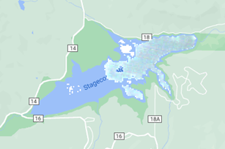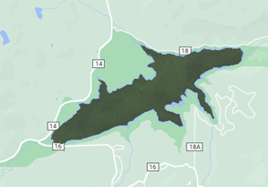
Figure 2. Example of imperfect cloud masking and sun glint in Stagecoach Reservoir imagery leading to erroneously high greenness values (left). Example of imagery without erroneous pixels (right).

3.4.2 Change Maps
For the Landsat 5 and 8 images of the selected dates, we used the visible, NIR, SWIR, and thermal bands to visualize true color, GBR, surface temperature, AVW, and BWAI for the three main lakes of interest. As a result, there were five maps for each date selected for the three lakes of interest; 25 images total for Stagecoach Reservoir, 20 images total for Lake Catamount, and 15 images total for Steamboat Lake. Calculations were performed to scale the green band reflectance and surface temperature imagery using the methodology described for the time-series plots (see 3.4.1). Additionally, AVW and BWAI were computed using the same equations explained in the spectral bands and indices methodology (see 3.2). This imagery was then imported into ArcGIS Pro 2.9.32739 (Esri, 2021) to visualize the various spectral bands and indices for the dates listed in Table B2.

3.4.3 Evaluation Plots
There were often multiple in-situ measurements taken on the same day for both chlorophyll-a and temperature at a given lake, so the average value was taken to represent that day. Of the temperature data provided by the UYWCD string sensor, only surface temperature was compared with the remotely sensed surface temperature. Since there was a limited number of in-situ measurements available to compare to the remotely sensed data, Excel was used to condense and match all of the in-situ and remotely sensed data into 5-day averages. This was a balance between maximizing observations without compromising accuracy. A CSV file for validation was created in Excel containing columns for date, chlorophyll-a concentration, temperature, GBR, AVW, BWAI, and remotely sensed surface temperature for Stagecoach Reservoir, Steamboat Lake, and Lake Catamount. This CSV file was then imported into RStudio for further analysis.

3.5 Data Analysis
3.5.1 Time-Series Plots
RStudio was used to create time-series plots for the different lakes and measures of interest. We first created GBR time-series plots for Stagecoach Reservoir, Steamboat Lake, and Lake Catamount. These three lakes were the primary focus for analysis because they were the only ones that had available in-situ field data for validation. These initial plots displayed GBR values for every image. Regression lines were fitted through the points and the R-squared, P-value, and regression equations were recorded. Next, we created time-series plots for the three primary lakes showing June to October yearly averages of GBR. We then generated yearly average plots for the other six waterbodies of interest, and all plots were fit with regression lines. Additionally, we created yearly average plots for the three primary lakes of interest using July to September yearly averages of GBR instead of June to October. This was meant to assess GBR using data collected during the summer months to see if there were any notable differences.

Next, we repeated this process for surface temperature, AVW, and BWAI. We created time-series plots of June to October yearly averages for Stagecoach, Steamboat, and Catamount in addition to showing individual images. We then created yearly average time-series plots for the other six waterbodies. For temperature, we also created July to September yearly average plots for the three primary lakes of interest. Regression lines were fitted to all these plots and regression statistics were recorded to evaluate the linear models. Additionally, we created time-series plots of pixel count for the three primary waterbodies.

3.5.2 Change Maps
After importing the imagery for the three lakes in ArcGIS Pro, we then clipped them to the shapefile for the waterbody of interest. We then edited the color schemes to assist in clear visualization and easy interpretation of the parameter of interest. The minimum and maximum for the legends were adjusted using the percent clip option, where a percent clip of 0.25 was used for temperature, true color imagery (TCI), and greenness and a percent clip of 0.5 was used for BWAI and AVW. The maximum and minimums selected for the different indices among the different lakes can be seen in Table B4. From here, three maps were made, one for Stagecoach Reservoir, one for Lake Catamount, and one for Steamboat Lake. The maps showed the different indices for each date side by side for easy comparison and visualization of the trends between the various water quality parameters.

3.5.3 Evaluation Plots
The CSV file containing the 5-day averages for in-situ chlorophyll and temperature and the remotely sensed GBR, AVW, BWAI, and surface temperature were imported into RStudio. Then, we made the validation plots for Stagecoach Reservoir, Steamboat Lake, and Lake Catamount showing the correlations between in-situ chlorophyll and GBR, AVW, and BWAI, and the correlations between in-situ surface temperature and remotely sensed surface temperature. These scatterplots only included dates where an in-situ measurement and a remotely sensed image fell in the same 5-day period. This allowed us to evaluate the accuracy of the remotely sensed data. However, due to the limited availability of in-situ measurements, there were a limited number of measurements that lined up with the remotely sensed images. For each plot, the R-squared value, P-value, RMSE, and equation of the line of best fit were calculated to quantify correlations between the variables.

4. Results & Discussion
4.1 Evaluation Plots
Figure 3 compares the remotely sensed GBR, AVW, and BWAI with chlorophyll-a field measurements at Stagecoach Reservoir. Each point represents a 5-day period where there was both a remotely sensed image and an in-situ chlorophyll measurement available. The high P-values that can be observed indicate that these relationships are statistically insignificant. However, this plot is deemed inconclusive since there could be a correlation that cannot be seen due to the low number of observations. The same plots were also made for Steamboat Lake (Figure A13). These relationships are also statistically insignificant according to P-values, but due to the low statistical power, they are inconclusive since there could be a relationship that might be revealed with additional observations. Additional valuation plots were made for Lake Catamount, but there were no in-situ measurements that lined up within 5 days of the remotely sensed data and it was therefore excluded from evaluation.

Due to the extremely limited amount of chlorophyll-a data available for validating GBR, AVW, and BWAI, there were no statistically significant trends observed in any lake of interest. All of the plots had low statistical power due to the low number of observations and were therefore deemed inconclusive rather than insignificant. This is because there might be a significant trend if there were more observations. Additionally, it is important to note that the chlorophyll-a measurements were taken at a single point in the lake, whereas the satellite data represent averages of the entire lake. Often, when there were chlorophyll-a measurements available, there were several taken on the same day at various points in the lake and averaged. However, due to the extremely heterogeneous nature of algae in these lakes, it is unreasonable to believe that these samples are representative of the entire lake. Lake Catamount had a very limited amount of chlorophyll data, and none of the measurements were taken in the same 5-day period as the remotely sensed images. Therefore, the waterbody was unable to be evaluated whatsoever.

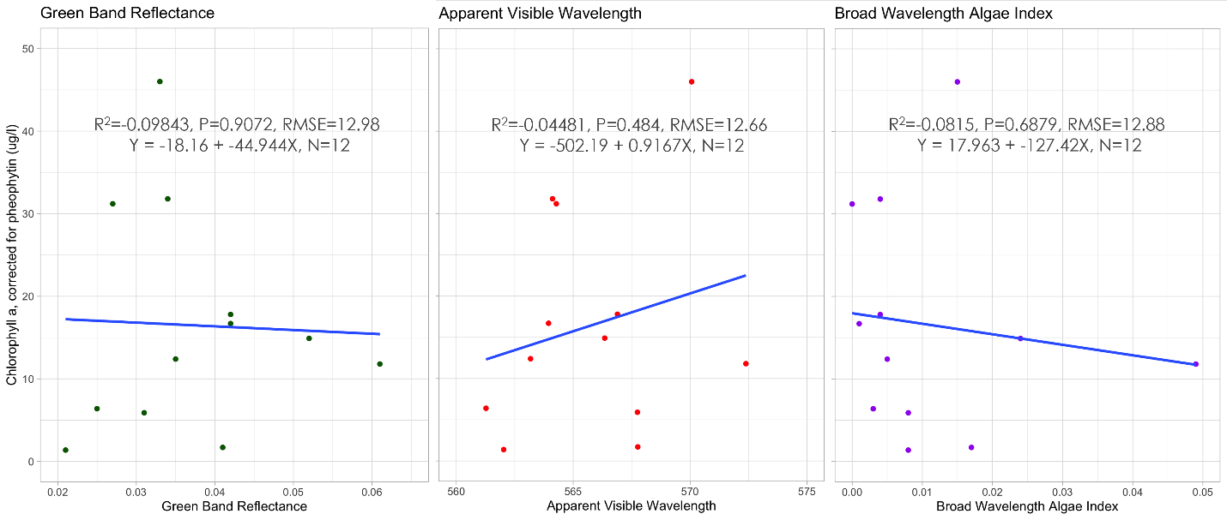Figure 3. Relationship between GBR, AVW, and BWAI and chlorophyll-a field measurements at Stagecoach Reservoir.

Figure 4 evaluates the remotely sensed lake surface temperature with in-situ temperature measurements at Stagecoach Reservoir. The temperature string provided by the UYWCD yielded a high number of observations. As can be seen from the data and looking at the P-value, this correlation is statistically significant. Additionally, the high R-squared value highlights the accuracy of the model. Given the strength of this correlation, it seems that using remote sensing is a viable way to monitor water surface temperature at Stagecoach Reservoir and could likely be used at other lakes as well. The same evaluation plot was produced for Steamboat Lake (Figure A14). However, the in-situ temperature at Steamboat Lake relied on limited and inconsistent measurements, which may have contributed to statistical insignificance. However, as with the chlorophyll-a validation, there could be an unseen correlation that might be revealed with more observations. Lake Catamount could not be evaluated because there was only one date of corresponding in-situ and remotely sensed temperature records.

As with the chlorophyll-a evaluations, temperature measurements represent one point in the waterbody whereas the remotely sensed surface temperature represents the average temperature for the waterbody. Oftentimes, these samples are taken at the edges of the waterbody where temperature likely does not represent the average surface temperature for the entire waterbody. The temperature string that provided in-situ temperature measurements for Stagecoach Reservoir is located beside the dam. This could potentially skew measurements due to the dam outflow causing turnover in the water column. However, the impressive fit of the model is highlighted by the R-squared value and the P-value. This indicates that remote sensing is a viable way to monitor the surface temperature of waterbodies in this region. Although it is not perfect, it has the potential to accurately monitor trends for this informative water quality parameter over vast spatial and temporal scales.

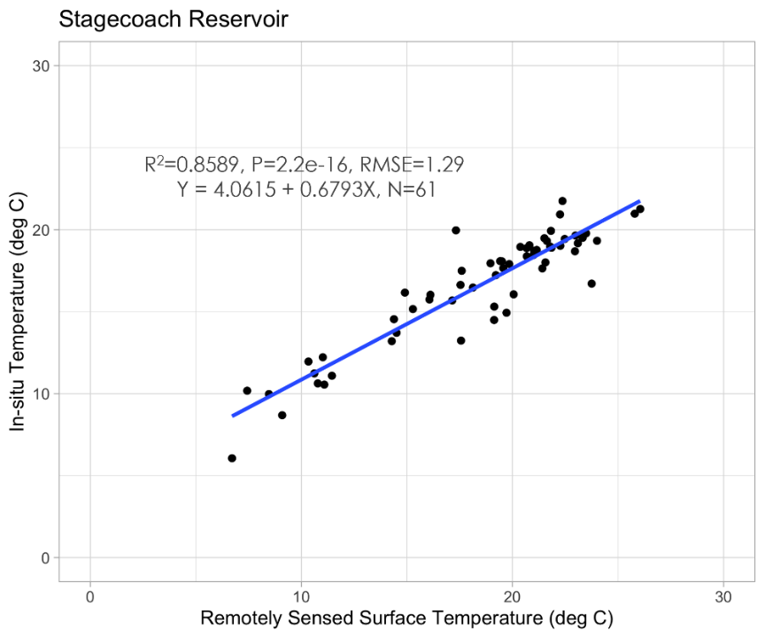

Figure 4. Evaluation plot displaying remotely sensed surface temperature in degrees Celsius versus in-situ surface temperature in degrees Celsius to evaluate the validity of remotely sensed water temperature.

4.2 Time-Series Plots
Figure 5 shows June through October yearly average time-series plots of GBR for Lake Catamount, Stagecoach Reservoir, and Steamboat Lake. There are mixed trends among the three waterbodies. The slope coefficients and P-values of the linear regression lines show that Lake Catamount has a significant downward trend, while Stagecoach Reservoir has an insignificant upward trend, and Steamboat Lake has an insignificant upward trend. Figure A2 shows the underlying data where each point represents a single image on a specific date. Figure A3 shows yearly average time-series plots for the other lakes of interest. Elkhead Reservoir was excluded from these plots and all others due to issues with masking and sun glint in the imagery. There are insignificant upward trends in greenness for Dumont Lake, Sheriff Reservoir, Stillwater Reservoir, and Yamcolo Reservoir, and an insignificant downward trend for Fish Creek Reservoir. Figure A4 shows July to September yearly averages (as opposed to June to October yearly averages in the other plots) of GBR for Lake Catamount, Stagecoach Reservoir, and Steamboat Lake. Averaging over these summer months retained the same long-term trends while actually reducing the R-squared values and increasing the P-values for the three regression lines. In general, the average summer GBR values tended to be higher than the bloom season GBR averages. This suggests that GBR is higher in the summer months.

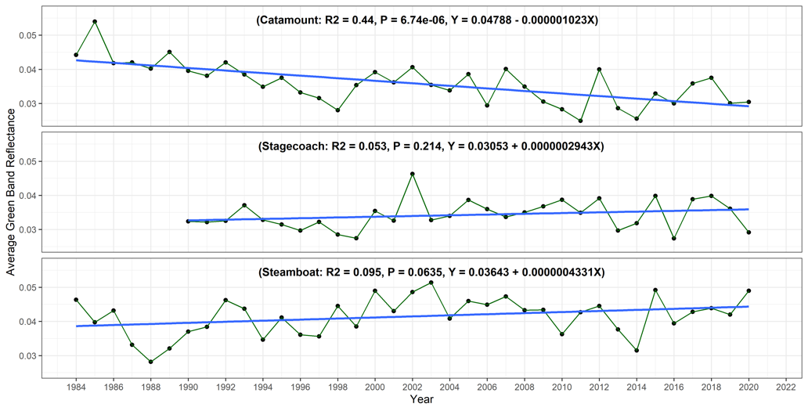
Figure 5. June through October yearly averages of GBR for Lake Catamount (top), Stagecoach Reservoir (middle), and Steamboat Lake (bottom), exhibiting mixed trends.

Figure 6 shows time-series plots of surface temperature for Lake Catamount, Stagecoach Reservoir, and Steamboat Lake. All three lakes have upward trends in temperature over time, with Catamount and Steamboat being significant. Figure A5 shows the underlying data for the individual images, and Figure A6 shows yearly average time-series plots for the other lakes of interest (excluding Elkhead Reservoir). All other lakes have upward trends in temperature over time, although none are significant. Since remotely sensed temperature had a strong correlation with in-situ temperature (Figure 4), we are confident that lake surface temperature has increased over time. This has implications for water quality, as high temperatures are known to be conducive to HABs. Figure A7 shows July to September yearly averages of surface temperature for Catamount, Stagecoach, and Steamboat. The trends are all still upward but the P-values are much higher, which implies they are significant and that summer water temperatures are increasing significantly over time.

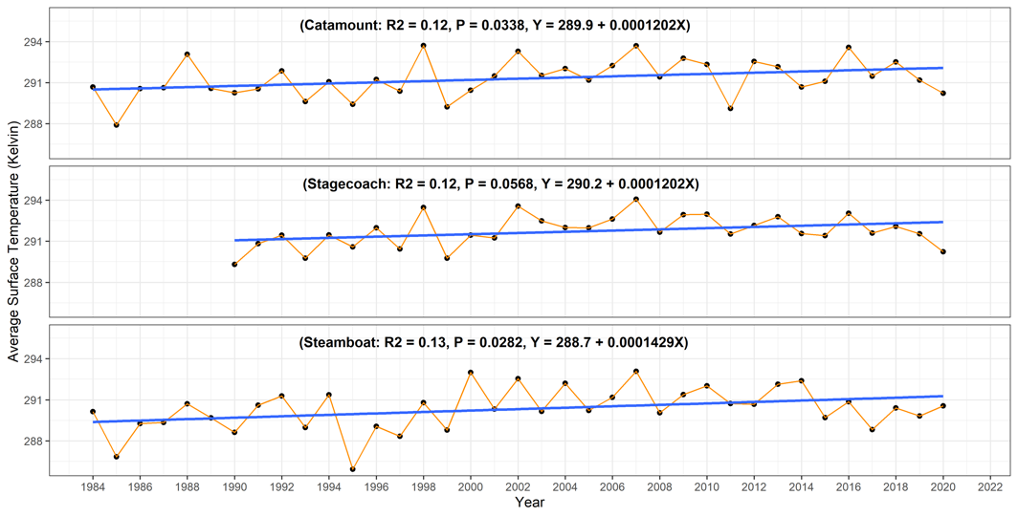
Figure 6. June through October yearly averages of surface temperature for Lake Catamount (top), Stagecoach Reservoir (middle), and Steamboat Lake (bottom) exhibit an increase over time.

Figures A8 and A9 show yearly average time-series plots of AVW for all waterbodies, excluding Elkhead Reservoir. All the lakes have downward trends over time, with Catamount, Stagecoach, Steamboat, Fish Creek, and Sheriff being significant. Generally, higher values of AVW represent red shifted waters, while lower values represent blue shifted waters (Vandermeulen et al., 2020). The plots indicate that average lake color is shifting to lower wavelengths. Figures A10 and A11 show yearly average time-series plots of BWAI for all waterbodies (excluding Elkhead). There are mixed trends among the waterbodies where Lake Catamount, Dumont, Sheriff, and Yamcolo have insignificant upward trends, Stagecoach, Steamboat, and Fish Creek have significant downward trends, and Stillwater has an insignificant downward trend. Table B5 (Appendix B) shows that, overall, the trends are mixed and do not have any clear patterns or associations.

There were a number of errors and uncertainties associated with the time-series plots. Overall, the limited amount of in-situ validation data made it difficult to interpret or draw firm conclusions from them. The measures of interest changed over time, but without the ability to correlate them with known water quality parameters such as chlorophyll-a, it is unclear if these trends were related to HABs. However, with remotely sensed surface temperature, we can confidently say that it has increased in all lakes over time due to its strong correlation with in-situ temperature. Potential errors and issues associated with the time-series data were caused by imperfect masking, static GBR thresholds, static shapefiles, averaging pixel values across each lake, and the use of Landsat 7 ETM+ imagery for the years 2012 to 2021. While masking clouds, it was inevitable that some cloudy pixels failed to be masked out in a few images, which led to erroneously high values for GBR, temperature, and our other measures of interest. We addressed this by applying GBR thresholds to our time-series data, which removed images with unnaturally high GBR values (see 3.4.1). This removed many images with erroneous values, but not all of them, mainly because the thresholds were static. Additional errors were introduced by clipping our satellite images to a static shapefile. Since we covered such a long time period, the extent of some of the lakes changed historically. This could not be accommodated by our static shapefile, which led to the inclusion of land pixels and exclusion of usable water pixels in some images. The inclusion of land pixels could lead to erroneous values for GBR, temperature, and other measures. We also calculated our measures of interest by averaging all the pixel values within the extent of each waterbody. This process may have missed some of the algae signal across the lake in each image. Algae are generally concentrated in specific areas of the lake (Figure 7), and this might not be detected well by averaging all pixel values. It’s also important to note that the Landsat 7 ETM+ imagery was affected by the scan line corrector error and resulted in all images from 2012 to 2021 containing fewer pixels for use in analysis (Figure A12).

4.3 Change Maps
In change maps, the stark contrast between HAB presence and absence can be observed, especially when examining the greenness columns (Figure 7). This aligns with greenness being a known indicator of HABs (Zhao et al., 2020). Additionally, a trend can be observed between the extent of algae seen in the BWAI columns when compared to the warmer zones exhibited in the temperature columns. The true color imagery was also consistent with the algae visualized by the BWAI; however, true color imagery can also display vegetation that does not identify as algae, hence the significance of including the BWAI column to differentiate between vegetation and algae. Greenness also seemed to correlate with temperature, with more green shown in areas that appeared brighter, or warmer, in the temperature index images. This is expected since we know that algae are more likely to bloom in higher temperature waters and greenness has been connected with algae.

In Figure A15, the trends of Stagecoach Reservoir can further be analyzed. In this map, it was observed that September 23rd, 2015 had the most notable algae bloom when compared to the other dates selected and displayed. This observation is corroborated by the BWAI time-series plot for Stagecoach in which we saw 2015 to be a peak year for algal blooms compared to other years. Additionally, for Lake Catamount, September 23rd, 2015 is again the most notable bloom among the dates selected (Figure A17). The BWAI time-series plot for Lake Catamount again exhibits a peak in 2015, suggesting more algal blooms that year than others. This similarity between the two waterbodies would suggest that they have closely related algal bloom patterns, since they are less than 15 miles apart and therefore would experience similar weather and temperatures. Lastly, Steamboat Lake exhibits a notable bloom on August 26th, 2020 (Figure A16). This remotely sensed bloom was validated by ground truthing since we know that Steamboat Lake was closed for recreation in August 2020 due to HABs (Martin, 2020).

The change maps not only display potential trends in HABs, but also some limitations in our methodologies. For example, the static shapefiles resulted in the potential inclusion of land pixels, which would impact the trends seen in the change maps, as the land pixels often contribute to the greenness. Additionally, the dates selected for the HABs in these maps may not be the largest or highest peak in algae during that year, since the in-situ data used to select those dates were limited. The legends within the maps are also unscaled values since the maps were created prior to realizing the Collection 2, Level 2 products required a scale factor. Lastly, the color ramps used to visualize the various indices may skew the results, since they were adjusted in order to more clearly show the water quality parameter or index of interest.
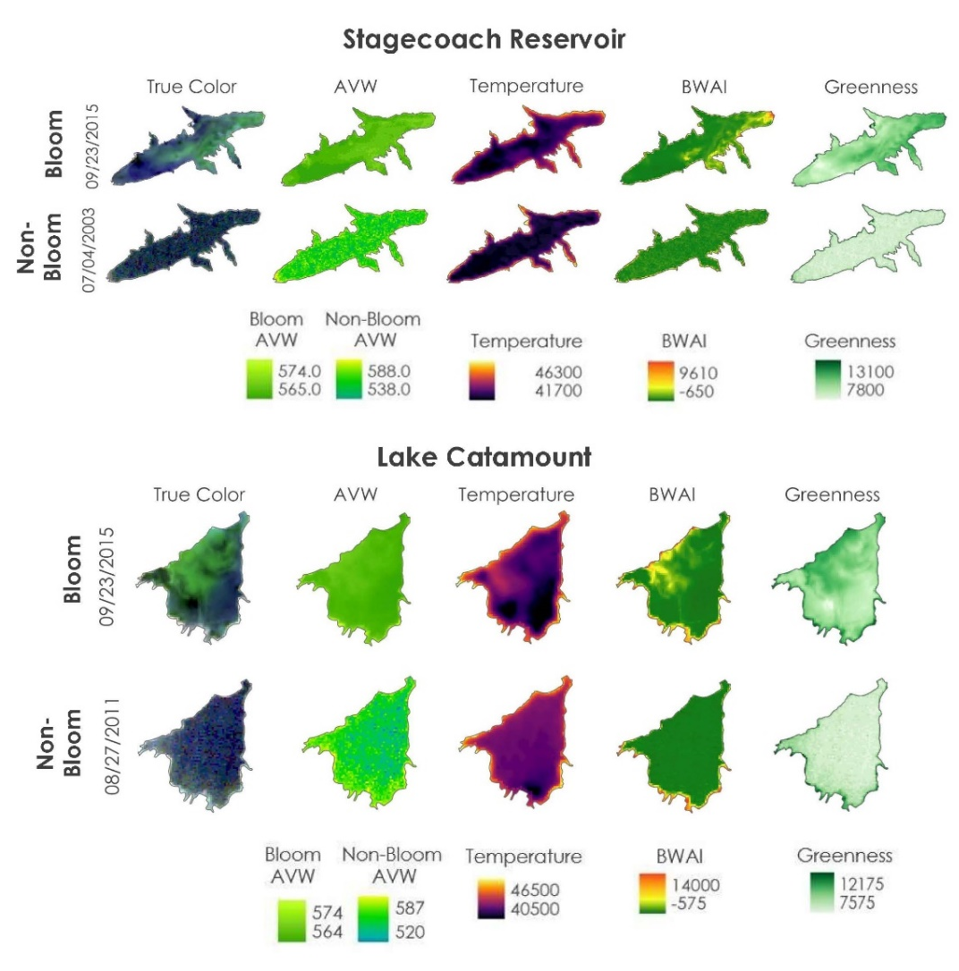
Figure 7. Change maps for Stagecoach Reservoir and Lake Catamount displaying a bloom date versus a non-bloom date to exhibit the difference between the spectral bands and indices when algae are present or absent.

4.4 Future Work
Looking forward, additional analyses could be performed to investigate whether factors such as land use change, climate change, lake depth, lake elevation, and nutrient concentration contribute to HAB outbreaks. Associations between these factors and HAB outbreaks could be investigated through models such as Random Forest. Another area of improvement would be exploring the use of alternative satellites and sensors for monitoring HABs and similar water quality parameters to observe how they may impact the trends and results seen. For example, utilization of sensors such as Sentinel-3 Ocean and Land Color Instrument (OLCI), with bands specific to cyanobacteria absorption features would most likely be beneficial in examining HABs and potentially allow for more accurate HAB assessments.

Due to the time constraints within this project, our team was unable to extensively interpret AVW results. Therefore, we recommend looking further into AVW as a tool for lake color interpretation, including how decreasing AVW may provide insights into water quality. Additionally, we recommend collecting in-situ data at set, regular intervals that coincide with satellite fly-overs in order to create a consistent water quality dataset to further validate the remote sensing data. Moving forward, we also recommend adapting the scripts and products to account for a dynamic waterbody extent, possibly using multiple lake shapefiles. Lastly, it would be beneficial to select a point within the waterbody of interest for analysis (Kislik et al., 2022) or average pixels in specific regions of the lake over time rather than create products that average the entire lake over time, as we did.

5. Conclusions
The HABs that have threatened public and environmental health in addition to the local economy have reached an unprecedented high in the UYRW. In order to see how water quality parameters have changed over time, our team generated both time-series plots and change maps of AVW, BWAI, GBR, and temperature from 1984 to 2021. The time-series plots reveal mixed trends of these indices for each of the waterbodies. They also revealed that the GBR is generally higher in the summer months (July to September) than the bloom season GBR averages (June to October). The temperature was observed to increase for all nine waterbodies of interest. A significant contrast was observed in the change maps exhibiting the difference between the indices when algae are present or absent. Assessing the viability of remote sensing tools for monitoring the algal blooms and water quality, the limited field data led to mainly inconclusive results. However, we found a strong correlation between the in-situ and remotely sensed temperature data, indicating that more validation data could exhibit the viability of remote sensing as a tool. All these findings will act as a preliminary step to identifying the scope of the problems for both the stakeholders and the general public. These results will benefit the partners as they plan to analyze the trends in water quality over time for future decision-making and mitigation strategies to prevent HABs and improve water quality in the UYRW.

6. Acknowledgments
The team would like to thank the Colorado DEVELOP Fellow Sarah Hettema, science advisors Dr. Anthony Vorster and Christopher Tsz Hin Choi from Colorado State University (CSU) National Research Ecology Laboratory, and our partners Andy Rossi from the Upper Yampa Water Conservancy District, Christina Welch from the CSU Agricultural Water Quality Program, Bob Woodmansee, and Lyn Halliday from the Upper Yampa River Watershed Group. In addition, the team would like to thank the Arizona DEVELOP Summer 2021 Highland Lakes Water Resources Team (Kaitlynn Hietpas, Shuyu Chang, Addison Pletcher, Mark Radwin, Emma Waugh) and Arizona DEVELOP Fellow Ryan Hammock for their help in providing literature and data that assisted in our production of BWAI results.

This material contains modified Copernicus Sentinel data (2012), processed by ESA.

All rights reserved. Any opinions, findings, and conclusions or recommendations expressed in this material are those of the author(s) and do not necessarily reflect the views of the National Aeronautics and Space Administration. This material is based upon work supported by NASA through contract NNL16AA05C.

7. Glossary

Apparent Visible Wavelength (AVW) – An optical water classification index that measures the dominant color of the water by taking the weighted harmonic mean of the visible bands (red, green, and blue bands)
Atmospheric correction – Removal of atmospheric effects (e.g., cloudiness) on the reflectance values of satellite images
Band harmonization – Combining the satellite observations from multiple sensors in a single data set
Broad Wavelength Algae Index (BWAI) – A spectral index derived from the visible, near infrared (NIR), and shortwave infrared (SWIR) bands to clearly visualize algae
Chlorophyll-a – A measure of algae growing in a waterbody
Earth observations – Satellites and sensors that collect information about the Earth’s physical, chemical, and biological systems over space and time
Greenness – A measure of water color determined by green band reflectance (GBR)
HAB – Harmful algal bloom; rapid growth of blue-green algae that may produce toxins and results in lower dissolved oxygen levels
In-situ – Field measurement data
P-value – A statistical measurement to validate a hypothesis against observed data
Primary production – The process by which organisms make their own food from inorganic sources
Random Forest – A machine-learning algorithm that assesses the relationships between variables
Root Mean Square Error (RMSE) – A measure of the differences between sample values and values observed.
Scan line corrector error – The error which causes the satellites to image Earth in a zig-zag manner
Scatter Plot – A plot consisting of points that shows the relationship between two sets of data

8. References

Bauch, N. J., Moore, J. L., Schaffrath, K. R., & Dupree, J. A. (2012). Water-quality assessment and macroinvertebrate data for the Upper Yampa River watershed, Colorado, 1975 through 2009. U.S. Geological Survey Scientific Investigations Report 2012-5214. https://doi.org/10.3133/sir20125214

Centers for Disease Control and Prevention. (2022, May 2). Illness and symptoms: Cyanobacteria in fresh water. Centers for Disease Control and Prevention. https://www.cdc.gov/habs/illness-symptoms-freshwater.html

Day, N. K. (2021). Assessment of streamflow and water quality in the Upper Yampa River Basin, Colorado, 1992–2018. U.S. Geological Survey Scientific Investigations Report 2021-5016. https://doi.org/10.3133/sir20215016

Dumont Lake – Steamboat Springs. Free Colorado Travel Guide Vacations Travel and Tourism. (n.d.). Retrieved August 11, 2022, from https://www.uncovercolorado.com/activities/dumont-lake/#:~:text=History,water%20available%20to%20the%20public.

Elhag, M., Gitas, I., Othman, A., Bahrawi, J., & Gikas, P. (2019). Assessment of water quality parameters using temporal remote sensing spectral reflectance in arid environments, Saudi Arabia. Water, 11(3), Article 556. https://doi.org/10.3390/w11030556

Elkhead Reservoir. Colorado River District 2022. (2022, July 1). Retrieved August 11, 2022, from https://www.coloradoriverdistrict.org/elkhead-reservoir/

Elkhead Reservoir - Craig, Colorado. Visit Moffat County. (2022, March 22). Retrieved August 11, 2022, from https://www.visitmoffatcounty.com/our-treasures/elkhead-reservoir/#:~:text=The%20900%2Dacre%20Elkhead%20Reservoir,%2C%20hikers%2C%20campers%20and%20hunters

EPA. (2022a). Cyanobacteria Assessment Network (CyAN). https://www.epa.gov/water-research/cyanobacteria-assessment-network-cyan

EPA. (2022b). Indicators: Chlorophyll a. https://www.epa.gov/national-aquatic-resource-surveys/indicators-chlorophyll

Esri. (2021). Technical Support. Esri Support ArcGIS Pro 2.9. https://support.esri.com/en/products/desktop/arcgis-desktop/arcgis-pro/2-9

European Space Agency. (n.d.). Sentinel-3 Mission Summary. Sentinel Online. https://sentinels.copernicus.eu/web/sentinel/missions/sentinel-3/overview/mission-summary

Giardino, C., Bresciani, M., Stroppiana, D., Oggioni, A., and Morabito, G. (2014). Optical remote sensing of lakes: An overview on Lake Maggiore. Journal of Limnology 73(s1), 201–214. https://doi.org/10.4081/jlimnol.2014.817

Hay, L. E., Battaglin, W. A., & Markstrom, S. L. (2012). Watershed scale response to climate change--Yampa River Basin, Colorado. Fact Sheet. https://doi.org/10.3133/fs20113117

Kislik, C., Dronova, I., Grantham, T. E., & Kelly, M. (2022). Mapping algal bloom dynamics in small reservoirs using Sentinel-2 imagery in Google Earth engine. Ecological Indicators, 140, Article 109041. https://doi.org/10.1016/j.ecolind.2022.109041

Kuhn, K., & Butman, D. (2021). Declining Greenness in Arctic-Boreal Lakes. Proceedings of the National Academy of Sciences, 118(15), 1–8. https://doi.org/10.1073/pnas.2021219118

Lake Catamount – Steamboat Springs. Free Colorado Travel Guide Vacations Travel and Tourism. (n.d.). Retrieved August 11, 2022, from https://www.uncovercolorado.com/activities/lake-catamount/#:~:text=The%20lake%20was%20formed%20with,acre%2Dfeet%20of%20water%20storage.

Lopez, C. B., Jewett, E. B., Dortch, Q., Walton, B. T., & Hudnell, H. K. (2008). Scientific Assessment of Freshwater Harmful Algal Blooms. Interagency Working Group on Harmful Algal Blooms, Hypoxia, and Human Health of the Joint Subcommittee on Ocean Science and Technology. Washington, DC. http://hdl.handle.net/1834/30787

Markogianni, V., Kalivas, D., Petropoulos, G. P., & Dimitriou, E. (2020). Estimating chlorophyll-a of inland water bodies in Greece based on Landsat data. Remote Sensing, 12(13), Article 2087. https://doi.org/10.3390/rs12132087

Martin, B. (2020, August 18). ‘Stay out of the water’: Steamboat Lake closed to all activities resulting in full-body water contact. Steamboat Pilot & Today. https://www.steamboatpilot.com/news/stay-out-of-the-water-steamboat-lake-closed-to-all-activities-resulting-in-full-body-water-contact/

National Water Quality Monitoring Council. (2020). Water Quality Portal, accessed July 11, 2022, at https://www.waterqualitydata.us

Plan your visit: Steamboat Lake Marina: Steamboat Springs Colorado. SLM 2022. (n.d.). Retrieved August 11, 2022, from https://www.steamboatlakemarina.com/plan-your-visit#:~:text=This%20beautiful%20man%20made%20lake,Peak%20named%20after%20Joseph%20Hahn.

RStudio, PBC. (2022). RStudio: Integrated Development Environment for R. RStudio. http://www.rstudio.com/.

Subramaniam, S., & Saxena, M. (2012). Automated algorithm for extraction of wetlands from IRS Resourcesat Liss III data. The International Archives of the Photogrammetry, Remote Sensing and Spatial Information Sciences, XXXVIII-8/W20, 193–198. https://doi.org/10.5194/isprsarchives-xxxviii-8-w20-193-2011

U.S. Geological Survey Earth Resources Observation and Science Center. (2014). Landsat 8 OLI Level-2 Surface Reflectance (SR) Science Product [Data set]. U.S. Geological Survey. https://doi.org/10.5066/f78s4mzj

U.S. Geological Survey. (2022a). USGS National Hydrography Dataset Best Resolution (NHD) - Colorado [Data set]. U.S. Geological Survey. https://www.sciencebase.gov/catalog/item/61f8b88fd34e622189c32894

U.S. Geological Survey. (2022b). How do I use a scale factor with Landsat Level-2 science products? U. S. Geological Survey. https://www.usgs.gov/faqs/how-do-i-use-scale-factor-landsat-level-2-science-products

U.S. Geological Survey. (2020a). USGS EROS Archive-Landsat Archives-Landsat 8-9 OLI/TIRS Collection 2 Level-2 Science Products [Data set]. USGS. https://www.usgs.gov/centers/eros/science/usgs-eros-archive-landsat-archives-landsat-8-9-olitirs-collection-2-level-2

U.S. Geological Survey. (2020b). USGS EROS Archive-Landsat Archives-Landsat 7 ETM Plus Collection 2 Level-2 Science Products [Data set]. USGS. https://www.usgs.gov/centers/eros/science/usgs-eros-archive-landsat-archives-landsat-7-etm-plus-collection-2-level-2

U.S. Geological Survey. (2020c). USGS EROS Archive-Landsat Archives-Landsat 4-5 TM Collection 2 Level-2 Science Products [Data set]. USGS. https://www.usgs.gov/centers/eros/science/usgs-eros-archive-landsat-archives-landsat-4-5-tm-collection-2-level-2-science

U.S. Geological Survey. (2016). National Water Information System data available on the World Wide Web (USGS Water Data for the Nation), accessed August 2, 2022, http://waterdata.usgs.gov/nwis/

Vandermeulen, R. A., Mannino, A., Craig, S. E., & Werdell, P. J. (2020). 150 shades of green: Using the full spectrum of remote sensing reflectance to elucidate color shifts in the ocean. Remote Sensing of Environment, 247, Article 111900. https://doi.org/10.1016/j.rse.2020.111900

Zhao, Y., Liu, D., & Wei, X. (2020). Monitoring cyanobacterial harmful algal blooms at high spatiotemporal resolution by fusing Landsat and MODIS imagery. Environmental Advances, 2, Article 100008. https://doi.org/10.1016/j.envadv.2020.100008

Appendix A: Figures

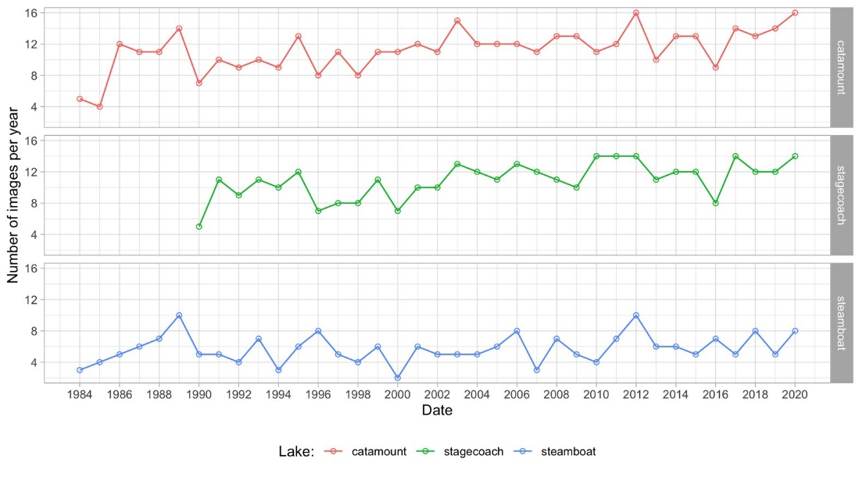
Figure A1. Number of images used per year in the time-series plots of Lake Catamount (top), Stagecoach Reservoir (middle), and Steamboat Lake (bottom).
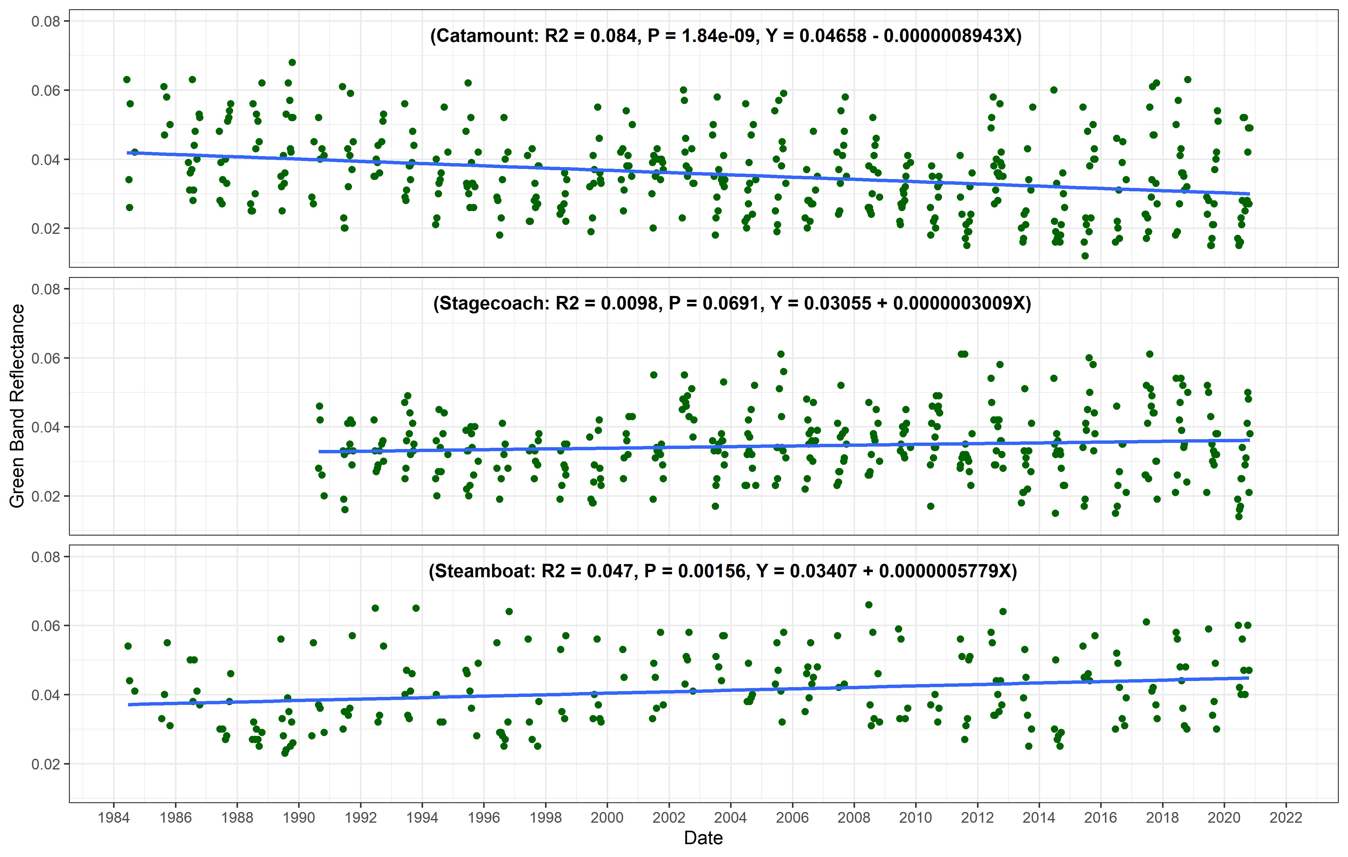
Figure A2. Time-series plots of GBR for Lake Catamount (top), Stagecoach Reservoir (middle), and Steamboat Lake (bottom) exhibiting mixed trends between the waterbodies.
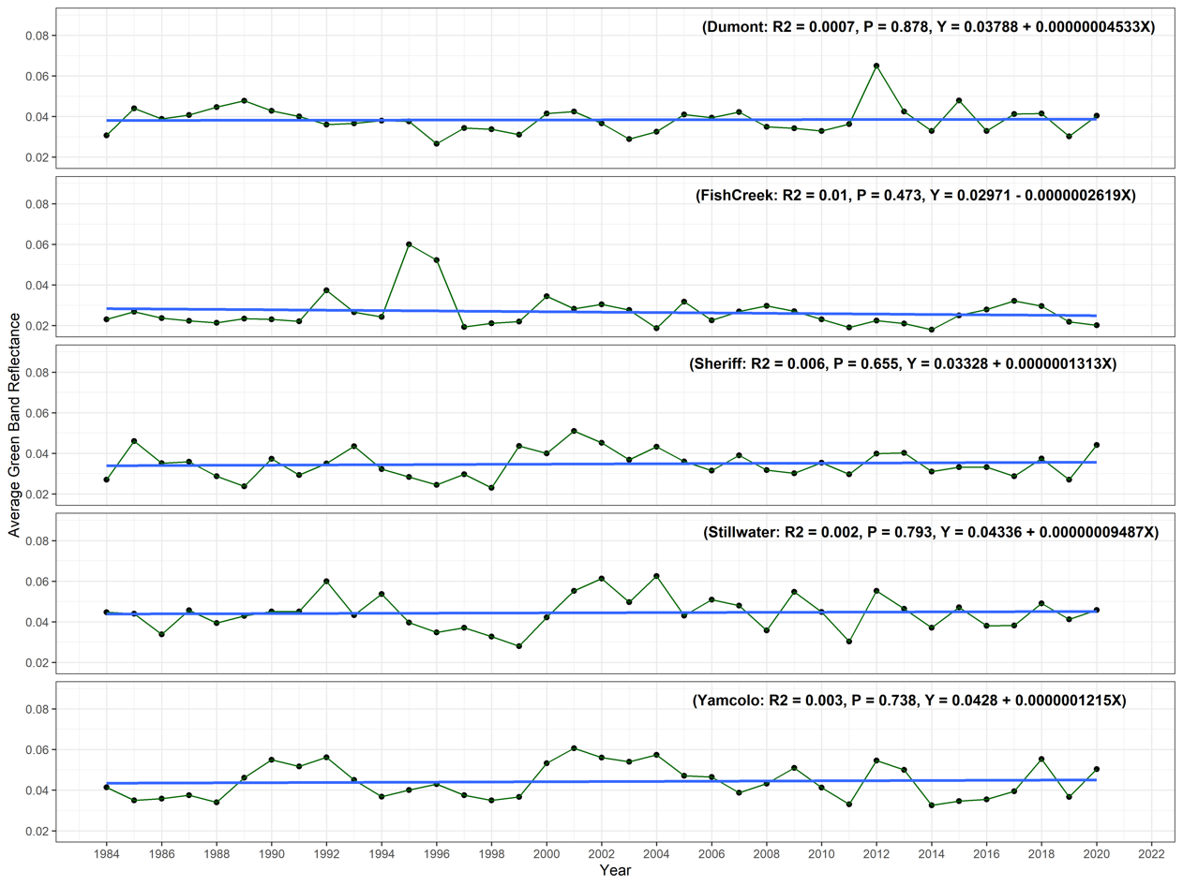
Figure A3. June-October yearly averages of GBR for 6 lakes of interest.

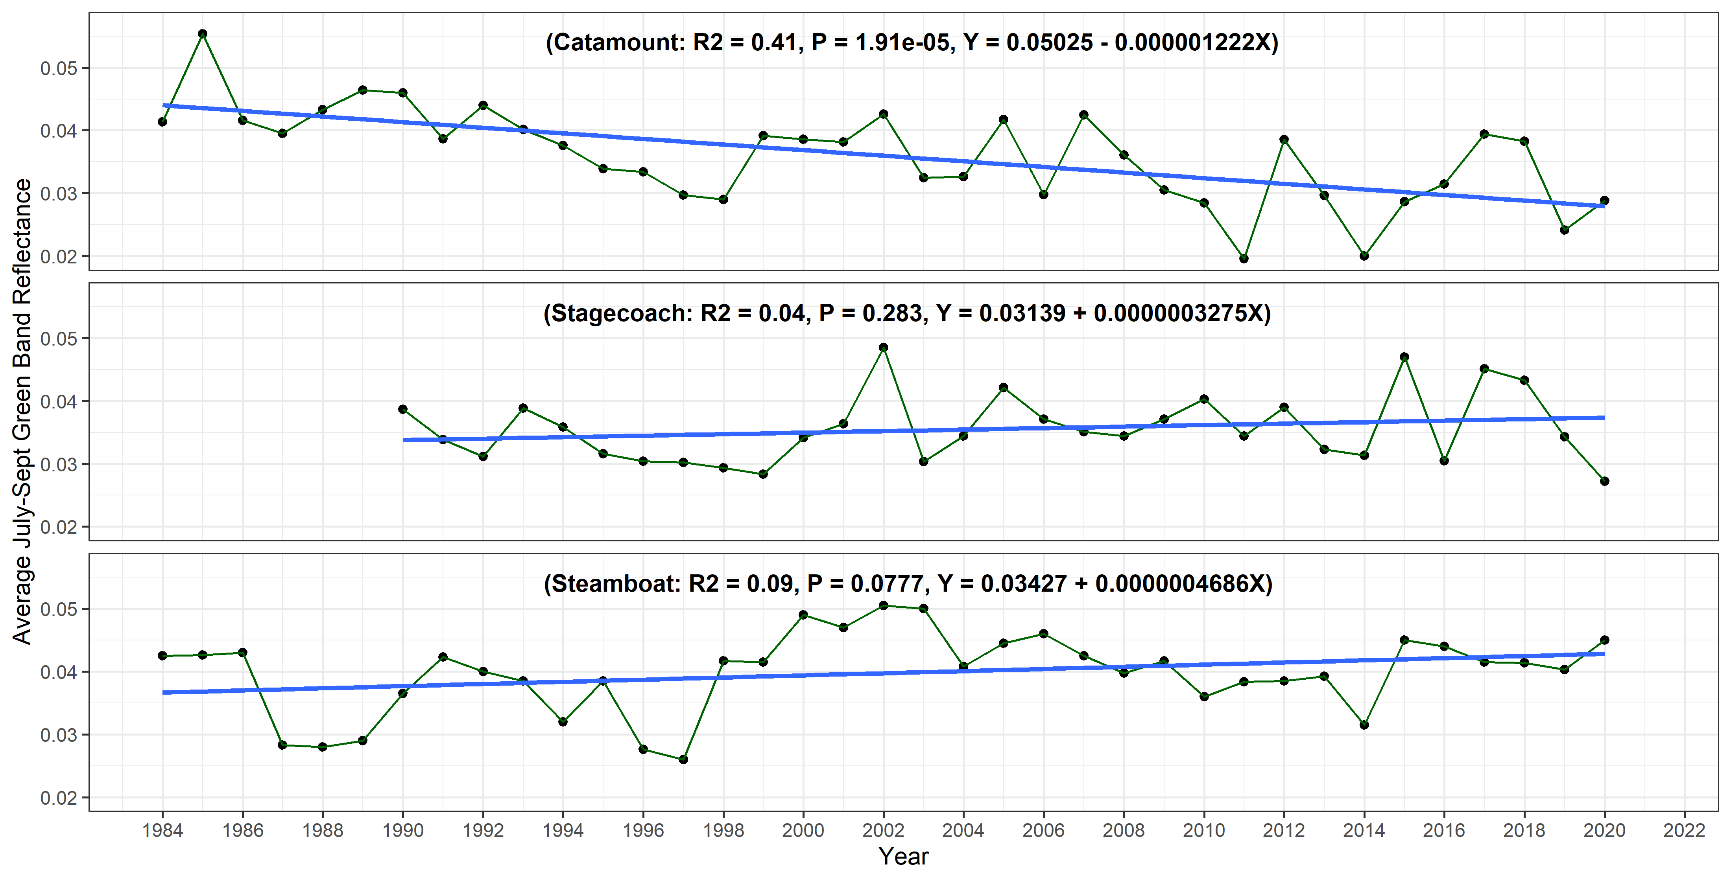
Figure A4. July-September yearly averages of GBR for Lake Catamount (top), Stagecoach Reservoir (middle), and Steamboat Lake (bottom).

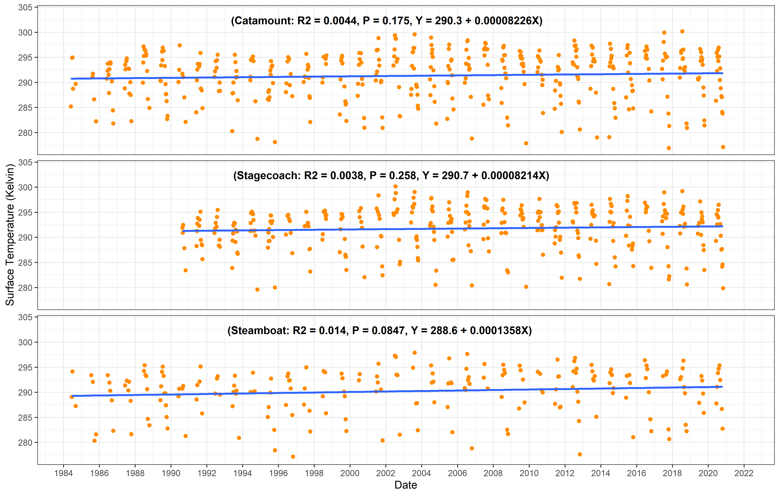
Figure A5. Time-series plots of remotely sensed surface temperature for Lake Catamount (top), Stagecoach Reservoir (middle), and Steamboat Lake (bottom).

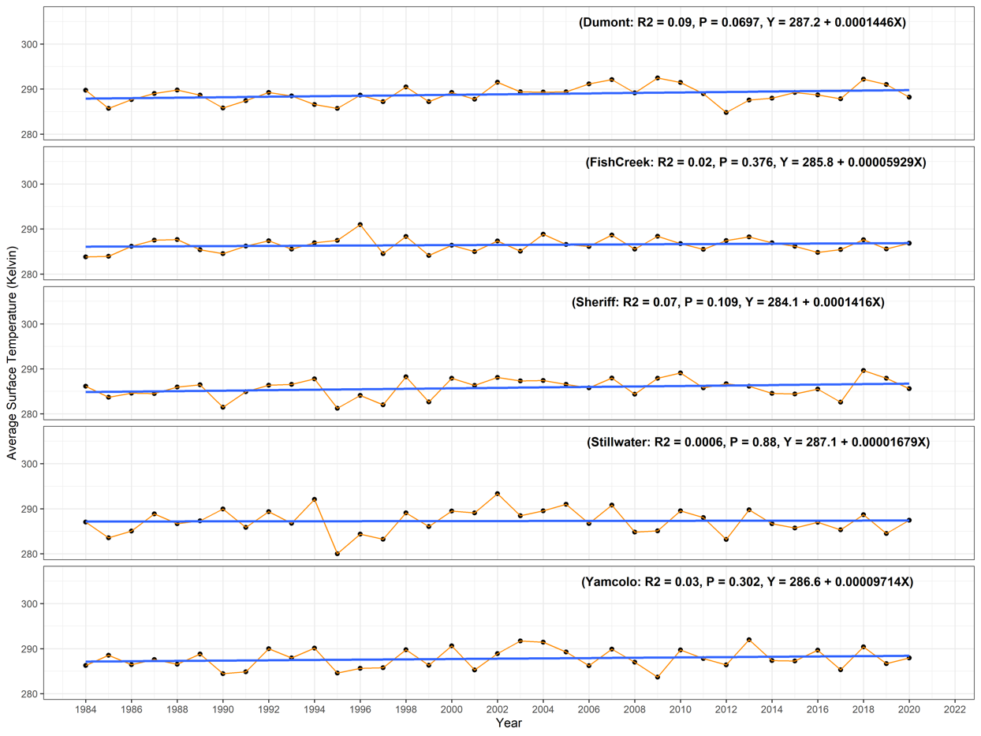
Figure A6. June-October yearly averages of remotely sensed surface temperature for 6 lakes of interest.

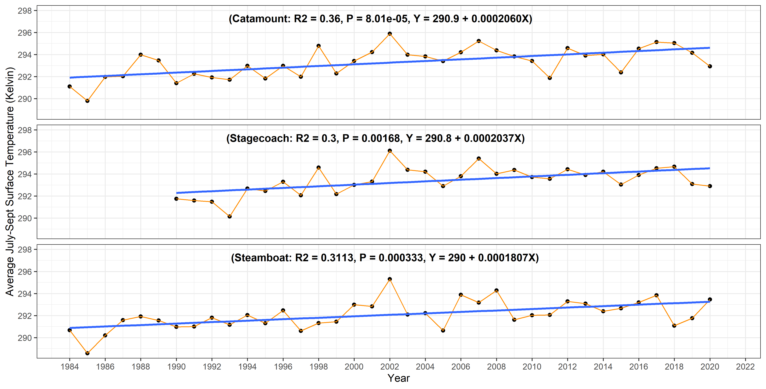
Figure A7. July-September yearly averages of remotely sensed surface temperature for Lake Catamount (top), Stagecoach Reservoir (middle), and Steamboat Lake (bottom).

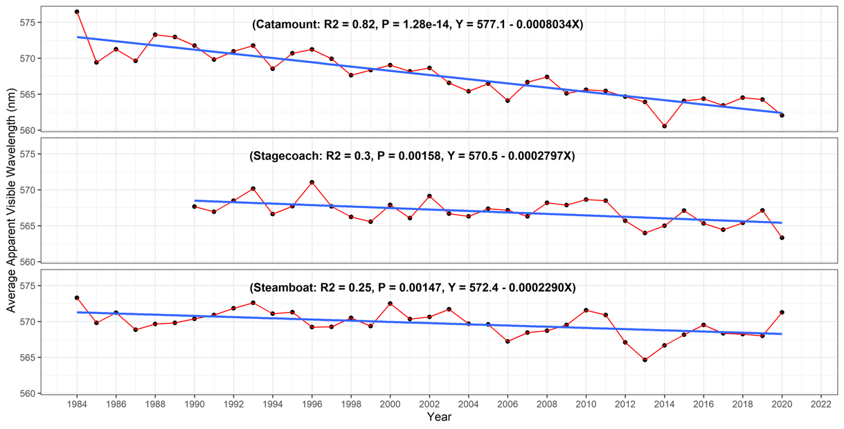
Figure A8. June-October yearly averages of AVW for Lake Catamount (top), Stagecoach Reservoir (middle), and Steamboat Lake (bottom).

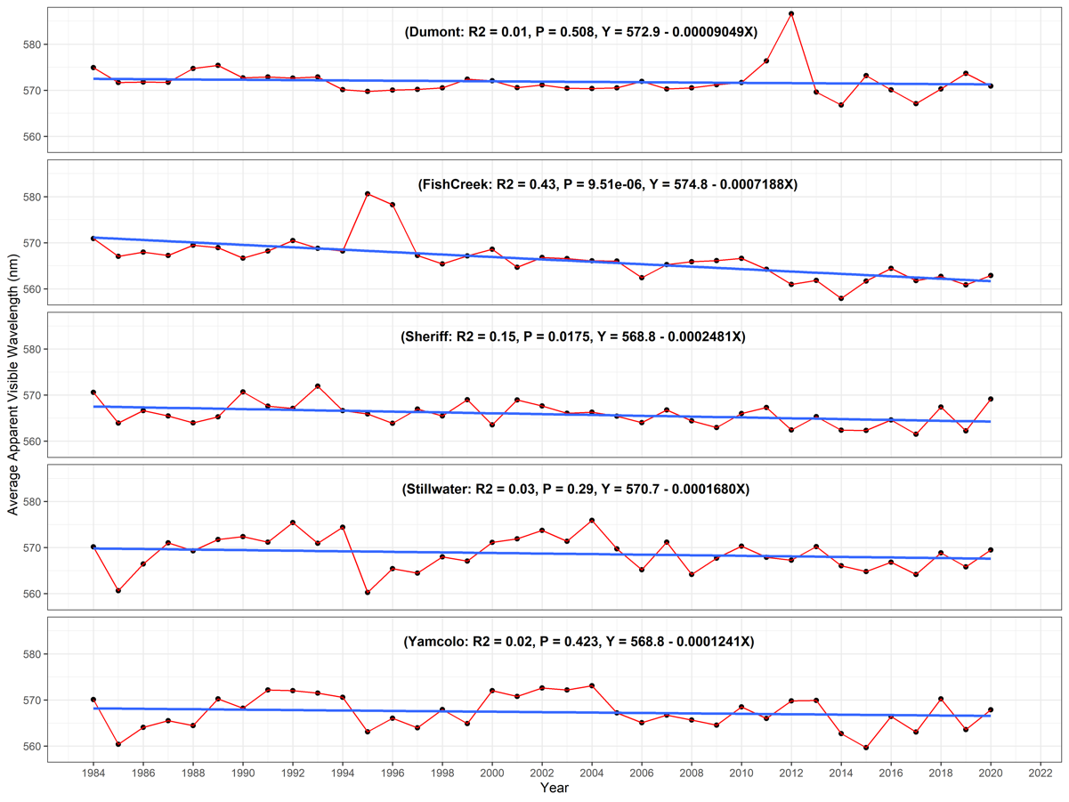
Figure A9. June-October yearly averages of AVW for 6 lakes of interest.

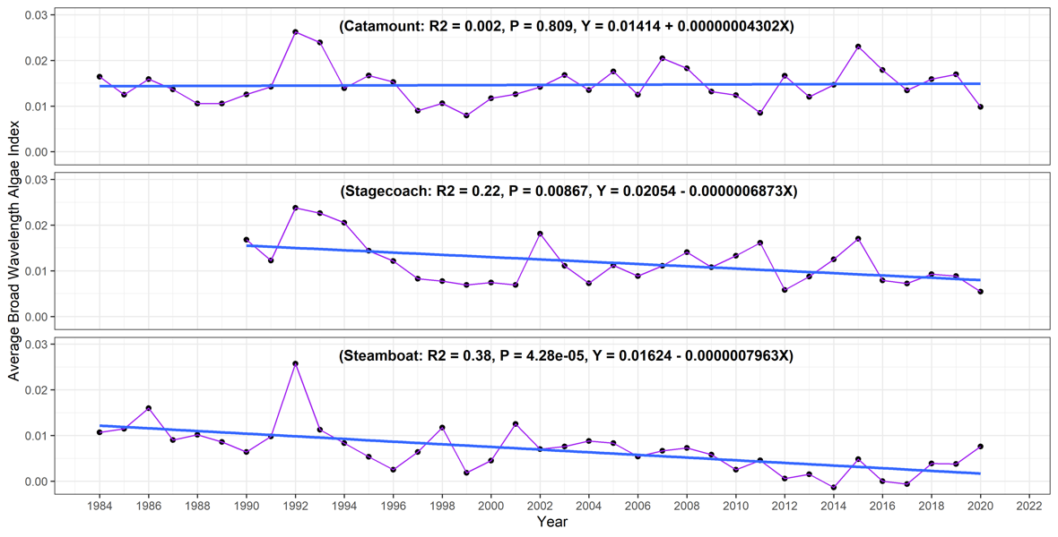
Figure A10. June-October yearly averages of BWAI for Lake Catamount (top), Stagecoach Reservoir (middle), and Steamboat Lake (bottom).

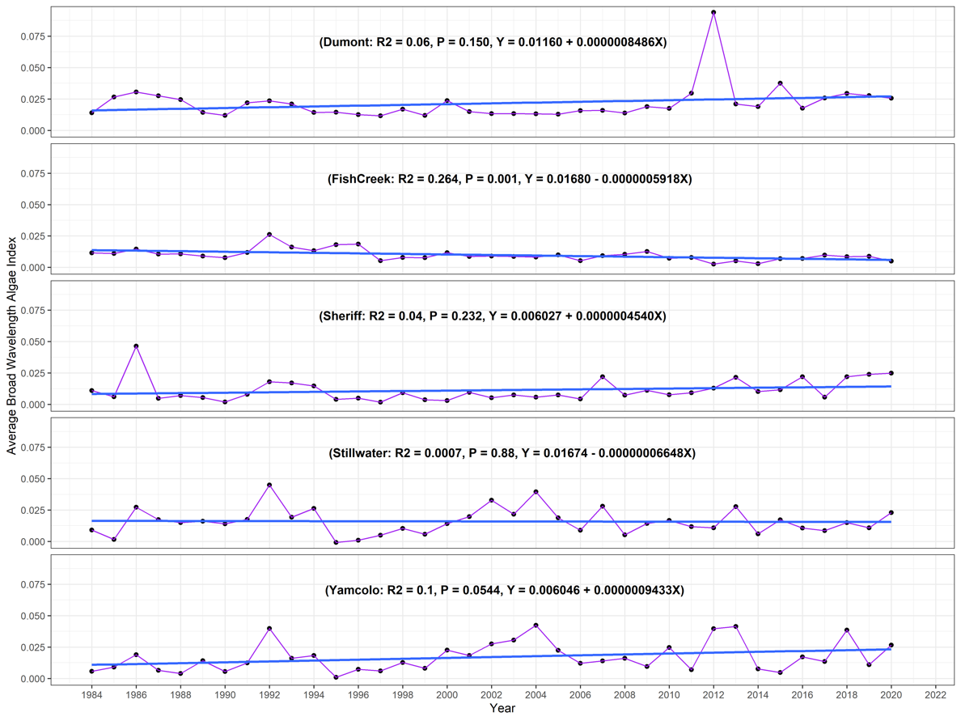
Figure A11. June-October yearly averages of BWAI for 6 lakes of interest.

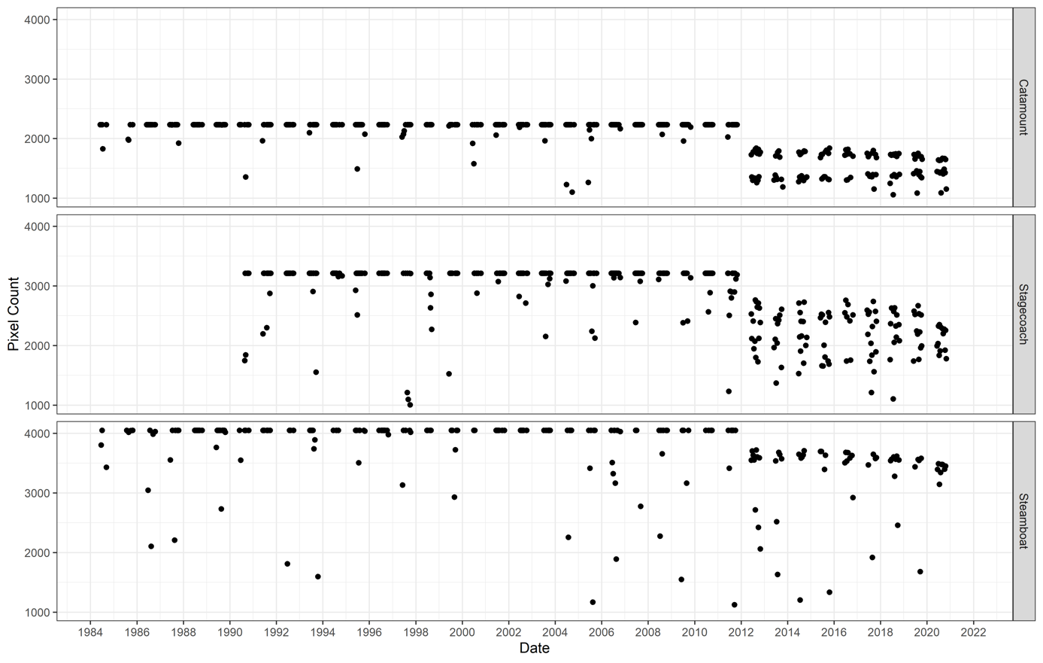
Figure A12. Time-series plot of image pixel count for Lake Catamount (top), Stagecoach Reservoir (middle), and Steamboat Lake (bottom).

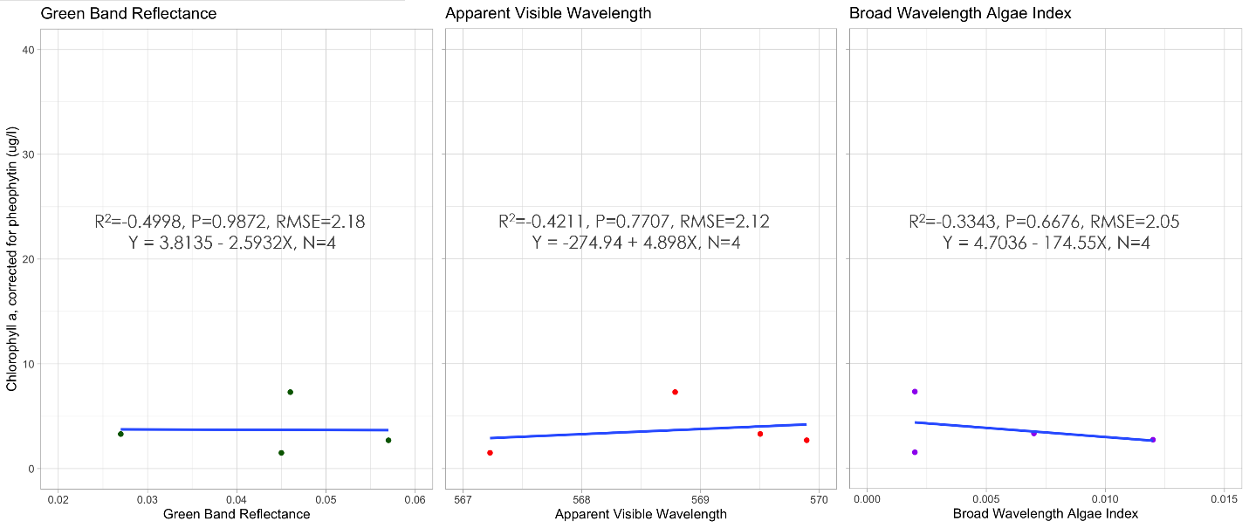
Figure A13. Evaluation plots comparing remotely sensed green band reflectance, apparent visible wavelength, and broad wavelength algae index to field-measured chlorophyll-a concentration for Steamboat Lake.

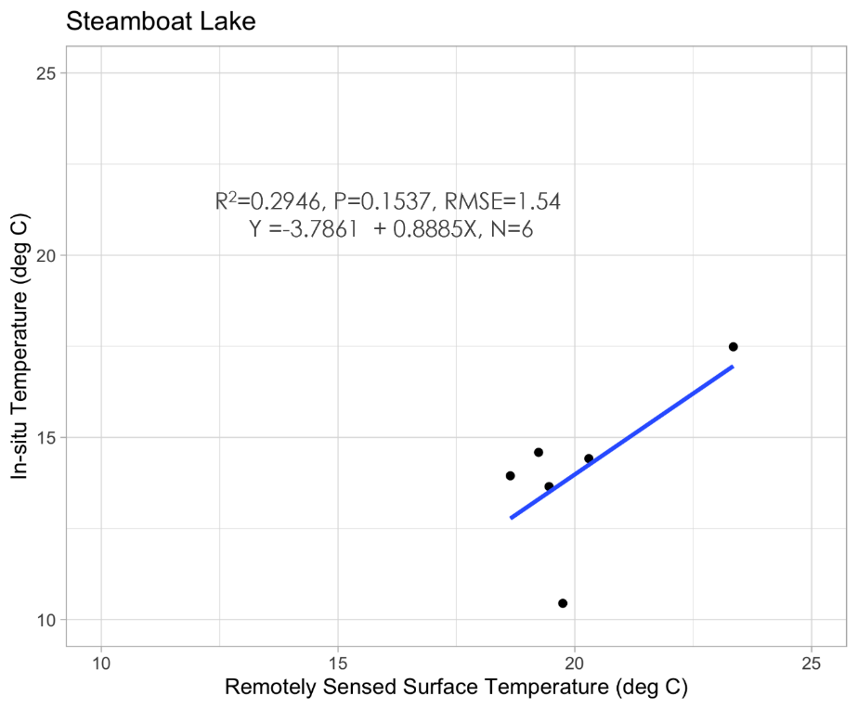
Figure A14. Evaluation plot comparing remotely sensed temperature for Steamboat Lake to field-measured temperature at Steamboat Lake.

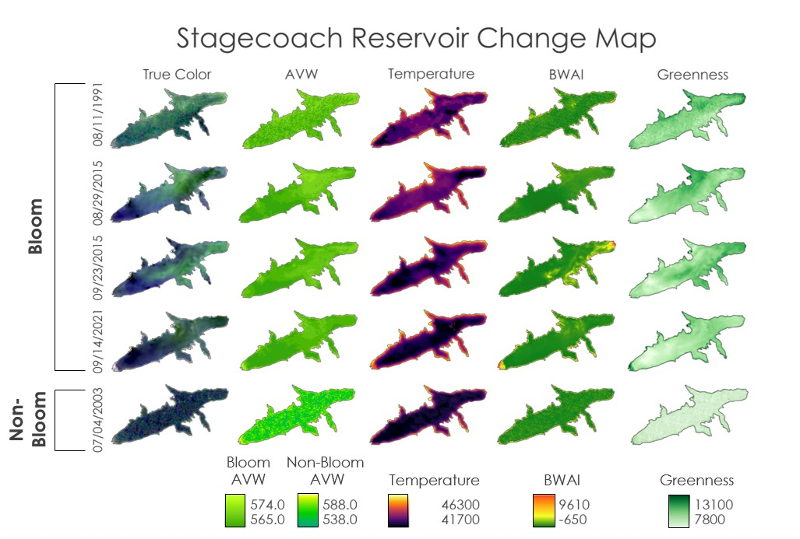

Figure A15. Change map for Stagecoach Reservoir.

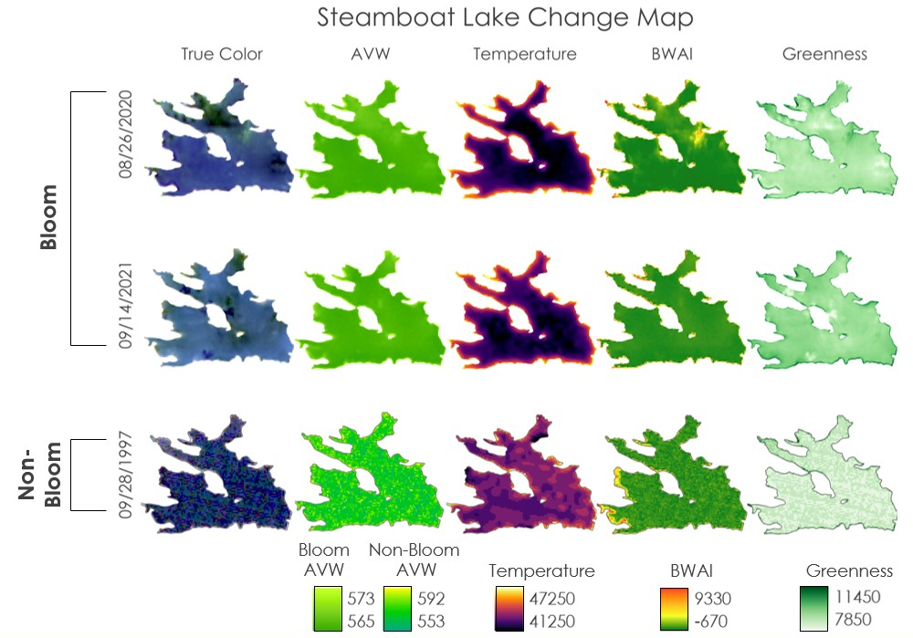

Figure A16. Change map for Steamboat Lake.

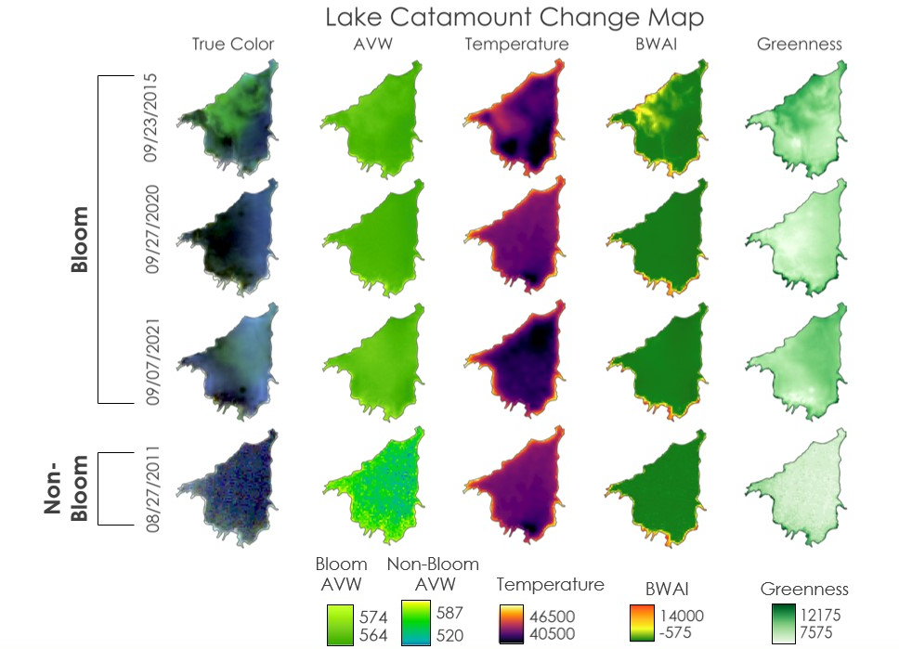

Figure A17. Change map for Lake Catamount.

Appendix B: Tables

Table B1
The characteristics of the nine waterbodies of interest in the UYRW
Waterbody | Elevation (feet) | Area (square miles) | Construction Year
Stillwater | 10,259 | 0.20 | N/a
Fish Creek | 9,902 | 0.184 | N/a
Sheriff | 9,760 | 0.056 | N/a
Dumont | 9,629 | 0.05 | 1954
Yamcolo | 9,501 | 0.29 | 1980
Steamboat | 8,097 | 1.51 | 1967
Stagecoach | 7,201 | 1.20 | 1988
Catamount | 6,896 | 0.82 | 1970
Elkhead | 6,355 | 1.11 | 1974

Table B2
Dates used to create change maps
Waterbody of Interest | Dates Selected for Bloom Analysis | Dates Selected for Non-Bloom Analysis
Stagecoach Reservoir | 08/11/1991, 08/29/2015, 09/23/2015, 09/14/2021 | 07/04/2003
Lake Catamount | 09/23/2015, 09/27/2020, 09/07/2021 | 08/27/2011
Steamboat Lake | 08/26/2020, 09/14/2021 | 09/28/1997

Table B3
Pixel count and GBR threshold values applied to the 9 waterbodies
Waterbody | Pixel Count Threshold | GBR Threshold  (scaled values)
Stagecoach Reservoir | 1000 | 0.0613
Steamboat Lake | 1000 | 0.0668
Lake Catamount | 1000 | 0.0676
Dumont Lake | 50 | 0.075
Elkhead Reservoir | 1000 | 0.0819
Fish Creek Reservoir | 75 | 0.0613
Sheriff Reservoir | 50 | 0.0613
Stillwater Reservoir | 100 | 0.075
Yamcolo Reservoir | 200 | 0.0668

Table B4
Minimum and maximum values selected for color scheme and legend visualization in the change maps
Waterbody | Water Quality Parameter/Index | Minimum Value | Maximum Value
Stagecoach Reservoir | AVW | 565 nanometers | 574 nanometers
Stagecoach Reservoir | Temperature | 41,700 Digital Number | 46,300 Digital Number
Stagecoach Reservoir | BWAI | -650 | 9,610
Stagecoach Reservoir | GBR | 7,800 | 13,100
Stagecoach Reservoir | TCI | N/a | N/a
Steamboat Lake | AVW | 565 nanometers | 573 nanometers
Steamboat Lake | Temperature | 41,520 Digital Number | 47,250 Digital Number
Steamboat Lake | BWAI | -670 | 9,330
Steamboat Lake | GBR | 7,850 | 11,050
Steamboat Lake | TCI | N/a | N/a
Lake Catamount | AVW | 564 nanometers | 574 nanometers
Lake Catamount | Temperature | 40,500 Digital Number | 46,500 Digital Number
Lake Catamount | BWAI | -575 | 14,000
Lake Catamount | GBR | 7,575 | 12,175
Lake Catamount | TCI | N/a | N/a

Table B5
Summary of time-series trends and elevation for 8 lakes of interest. Trends marked with a star “*” are statistically significant at an alpha of 0.05
Waterbody | Elevation (meters above sea level) | GBR | Temperature | AVW | BWAI
Stillwater | 3127 | Up | Up | Down | Down
Fish Creek | 3018 | Down | Up | Down* | Down*
Sheriff | 2975 | Up | Up | Down* | Up
Dumont | 2935 | Up | Up | Down | Up
Yamcolo | 2896 | Up | Up | Down | Up
Steamboat | 2468 | Up | Up* | Down* | Down*
Stagecoach | 2195 | Up | Up | Down* | Down*
Catamount | 2102 | Down* | Up* | Down* | Up

