Puget Sound Water Resources
Using Earth Observations to Map Bull Kelp in the Puget Sound, Washington, to Support Conservation and Restoration


Technical Report
Final – August 11th, 2022

Mike Hitchner (Project Lead)
Sofia Fall
Lily Oliver
Lyndsay Zemanek

Advisors:
Peder Engelstad, Colorado State University, Natural Resources Ecology Laboratory (Science Advisor)
Nicholas Young, Colorado State University, Natural Resource Ecology Laboratory (Science Advisor)
Dr. Tony Vorster, Colorado State University, Natural Resource Ecology Laboratory (Science Advisor)
Brian Woodward, Colorado State University, Natural Resource Ecology Laboratory (Science Advisor)
Dr. Paul Evangelista, Colorado State University, Natural Resource Ecology Laboratory (Science Advisor)
Dr. Catherine Jarnevich, Colorado State University, Natural Resource Ecology Laboratory (Science Advisor)

1. Abstract
Bull kelp (Nereocystis luetkeana) is a critical component of nearshore ecosystems in the Puget Sound region of the Salish Sea. The Port of Seattle and Washington State Department of Natural Resources (DNR) have identified possible declines in bull kelp extent and changes in its distribution throughout the Central Puget Sound near Seattle, Washington. Bull kelp losses threaten critical ecological services and marine habitat, as well as important cultural resources. However, these changes are not well tracked or understood due to the expensive and time-intensive nature of traditional kelp canopy monitoring methods. The Port of Seattle and Washington DNR partnered with the NASA DEVELOP team to explore the feasibility of using Earth observations between 2016 and 2021 obtained from Landsat 8 Operational Land Imager (OLI) and Sentinel-2 MultiSpectral Instrument (MSI) as a potential tool to monitor and map bull kelp. Our team identified a variety of challenges that need to be addressed before this approach can be utilized as an effective means for identifying or mapping nearshore urban kelp beds. We found that neither Sentinel-2 nor Landsat 8 significantly differentiates between kelp and no-known kelp using the Normalized Difference Vegetation Index (NDVI) or Normalized Difference Red-Edge Blue (NDREB). While the tidal and current filtering methods discussed here may be beneficial for identifying promising single image dates for kelp classification, the filters we used reduced the number of images each year to the point that modeling or mapping yearly kelp extent or creating time series of kelp did not appear to be feasible.

Key Terms
Bull kelp, remote sensing, conservation, Sentinel-2 MSI, Landsat 8 OLI, macroalgae

2. Introduction
2.1 Background Information
Bull kelp (Nereocystis luetkeana) is a common canopy-forming macroalgae species in the Puget Sound, an inlet of the Salish Sea in the U.S. Pacific Northwest. Kelp forests fulfill several critical ecological functions, including providing habitat for a variety of species such as salmon and endangered rockfish, and acting as ecosystem engineers by modifying their surrounding environment and associated food webs (Berry et al., 2021; Calloway et al., 2020). The bull kelp life cycle is biphasic and progresses from small gametophytes that are found on marine substrate to the sporophyte stage in spring where the more recognizable macroalgae appears. During the sporophyte stage, kelp plants are anchored by a holdfast that attaches to rocky substrate. From there, a long, hollow stipe reaches toward the surface, similar to a stem. At the end of the stipe, an air-filled bulb called a pneumatocyst is attached to multiple blades that often float on or near the surface of the water (Dayton, 1985; Schroeder et al., 2019). These blades form patchy canopies interspersed with water that are often visible from the surface. However, the blades can also be sucked under the surface of the water by high tide levels or strong currents, and canopy appearance is variable depending on time of year or environmental conditions (Schroeder et al., 2019). Bull kelp can reach lengths of up to 20 meters, with fullest canopy extent occurring at the surface from mid-July to late-September (Calloway et al., 2020).

Bull kelp is sensitive to changes in water temperature, nutrient load, and water motion, making it vulnerable to environmental and anthropogenic impacts. Bull kelp forests have declined globally in recent decades, including those in the Puget Sound (Berry et al., 2021). The reasons for these declines are intersecting, diverse, and not always well-understood. Lack of consistent or historical records of kelp canopy extent, and the limitations of current monitoring techniques, further complicate efforts to understand how these important aquatic communities change over time. In response to observed kelp declines in recent years, stakeholders in the Puget Sound have identified the need for new and better kelp forest monitoring techniques to better understand changes in kelp abundance and spatial distribution over time and in response to stressors like climate change (Hamilton et al., 2022).

Recent studies have turned to remote sensing as one possible solution to the difficulties of kelp canopy monitoring. Landsat data have been effective in mapping large bull kelp beds off the coast of Oregon, where the relatively straight coastline reduces the difficulty in differentiation between near-shore terrestrial vegetation and offshore kelp beds (Hamilton et al., 2020). Other Landsat mapping efforts off the coast of California have found that the satellites’ 30m spatial resolution limits its potential for detecting small bull kelp beds or those that are within 30m of shore (McPherson, 2021). The success of remote sensing as a kelp canopy monitoring tool often depends on environmental factors and other ocean dynamics such as tides, currents, and turbidity, all of which can impact the detectability of kelp in remotely sensed images. In other remote sensing-based studies of kelp, tidal activity has been shown to reduce remotely-sensed kelp detection by up to 40 percent for every two meters in additional tidal height (Nijland et al., 2019).

The feasibility of remote sensing as a kelp canopy monitoring tool has not yet been extensively explored in the Puget Sound. Due to spatial variation in drivers of kelp decline and the Puget Sound’s geomorphological complexity, the need for localized monitoring methods is crucial to understanding kelp forest dynamics in this region. Using imagery from mid-July to late-September, when bull kelp is at its peak extent and therefore most visible at the surface, we explored the use of Earth observation platforms to detect and map bull kelp extent in the Puget Sound in 2021 (Figure 1).

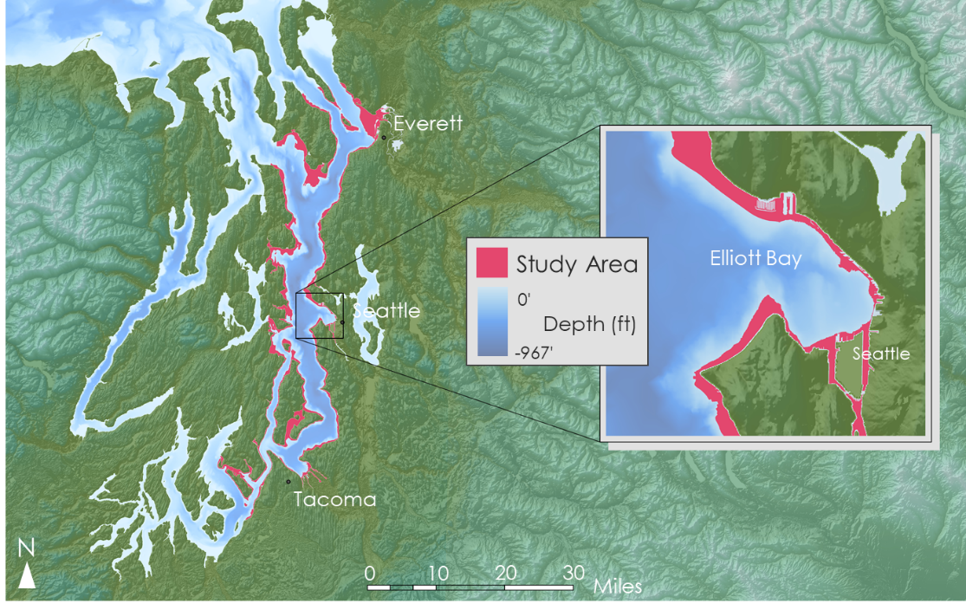

Figure 1. The study area lies along the nearshore coastal regions of Puget Sound from Everett in the north to Tacoma in the south.

2.2 Project Partners & Objectives
The Washington Department of Natural Resources (DNR) and the Port of Seattle have several kelp monitoring and restoration projects underway, including designating bull kelp as a Vital Sign metric (Berry et al., 2022). Vital Sign indicators, identified by a partnership of federal, state, and local agencies, are important ecosystem indicators of the overall health of Puget Sound (Berry et al., 2022). Floating kelp canopy area would join other designated Vital Signs such as the number of Southern Resident orcas, eelgrass health and extent, marine noise levels, and watershed forest cover, among others. The Port of Seattle has also introduced the Smith Cove Blue Carbon Pilot Project to assess the effectiveness of kelp and other marine vegetation as a nature-based carbon capture resource (Innovative idea: Smith Cove Blue Carbon Pilot Project, n.d.). To further their efforts, our partners are interested in better understanding trends in bull kelp extent and spatial distribution, particularly in the urban marine areas of the Puget Sound, including Elliot Bay. More precise kelp monitoring tools and spatial assessments would allow our project partners to more effectively shape policies concerning kelp conservation, restoration, and carbon sequestration. Specifically, our partners need more flexible canopy monitoring and assessment tools that will allow them to understand how urban kelp bed extent in Elliot Bay is changing over time, without having to survey and identify each individual kelp bed manually, which can be time and resource intensive.

Our primary project objective involved assessing the feasibility of remote sensing for kelp canopy monitoring in the Puget Sound using Landsat 8 Operational Land Imager (OLI) and Sentinel-2 MultiSpectral Instrument (MSI). This included investigating the use of two spectral indices for kelp sensing and exploring how bed size impacted kelp detection. Depending on this analysis, we also aimed to create a map of 2021 kelp extent and a time series of kelp extent from 2015 to 2021. These products contribute to our partner’s growing body of knowledge regarding kelp monitoring in the Puget Sound and provide them with an initial exploration into remote sensing as a kelp canopy monitoring tool.

3. Methodology
3.1 Data Acquisition
We acquired both Landsat 8 OLI and Sentinel-2 MSI imagery (Table 1) for 2016–2021 using Google Earth Engine (GEE) and chose to use top of atmosphere reflectance to reduce noisy signals from the aquatic environment. The two sensor platforms have different band coverage as well as differing resolutions (Figure 2). In addition to the known kelp extent polygons, we used full-year imagery from 2016–2021 to explore a time series. We did not use 2015 imagery, as that was Sentinel-2's first operating year, and it did not capture images throughout the entire year. Next, we removed scenes with >30% cloud cover from the Sentinel-2 imagery. Applying a >30% cloud cover threshold to the Landsat 8 image collection reduced the number of annual scenes to four or fewer, so we did not initially remove cloudy scenes from the Landsat 8 collection.

Table 1
Description of the satellite imagery used in mapping kelp extent.
Sensor | Date Range | Resolution(s)
Landsat 8 OLI | 1/1/2016 – 12/31/2021 | 30m
Sentinel-2 MSI | 1/1/2016 – 12/31/2021 | 10m – RGB & NIR  20m – Red Edge

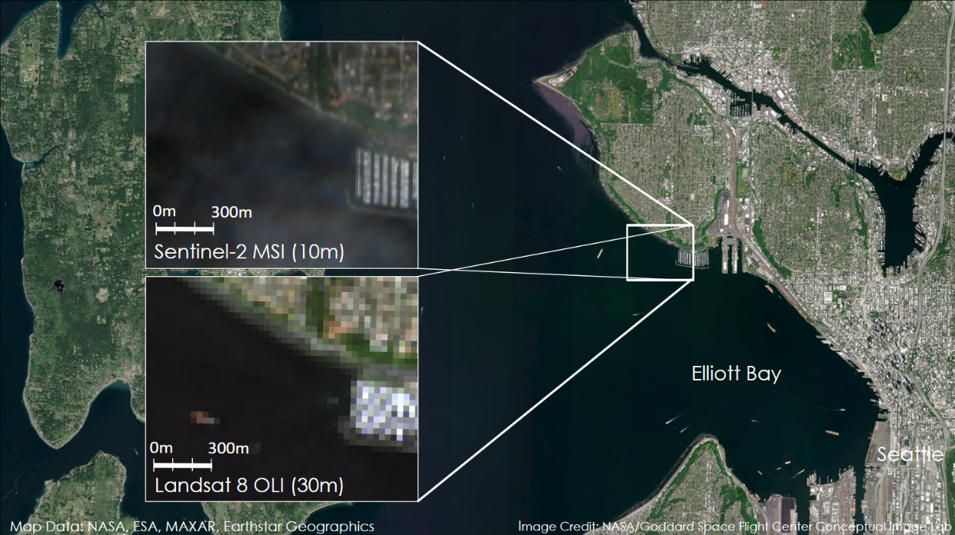
Figure 2. The study area of Elliot Bay with insets comparing the spatial resolution provided by Sentinel-2 MSI and Landsat 8 OLI sensors.

In addition to satellite imagery, we identified ancillary datasets that would assist our analysis (Table 2). The 2016–2021 annual kelp extent polygons collected via kayak surveys were acquired directly from the Northwest Straits Commission. These included 20–29 kelp beds surveyed each year, spanning from Edmonds to north of Bellingham. We also acquired kelp bulb counts collected along transects in Elliott Bay by the Puget Sound Restoration Fund in 2021. These two kelp datasets provided us with information on the current and past locations of known kelp beds. Historic daily tidal records for Seattle, Washington were provided by the National Oceanic and Atmospheric Administration. Finally, we downloaded bathymetry for Puget Sound to look specifically at depths where bull kelp grows (Finlayson, 2005).

Table 2
Description of ancillary datasets used for data processing and analysis.
Data | Source | Date(s) | Description
Puget Sound Bathymetry | David Finlayson | 2005 | Raster showing depth of Puget Sound (30ft resolution)
Tides and Currents | National Oceanic and Atmospheric Administration | 2016 – 2021 | Daily record of tide height and time for Seattle, WA (Station ID: 9447130)
Kelp Bulb Count Survey | Puget Sound Restoration Fund | 2021 | Kelp bulb counts collected in transects within Elliott Bay
Annual Kelp Surveys | Northwest Straits Commission | 2016 – 2021 | Yearly polygon extents of kelp beds collected by kayak survey

3.2 Data Processing
We identified a study area for the objective of potential kelp extent modeling, should our exploration indicate it is feasible. To delineate the boundaries of our study area, we used Puget Sound bathymetry data (Finlayson, 2005) to identify depths of 40m or shallower, limiting our study areas to where bull kelp can grow. We also masked out land and removed many above-water structures such as docks and bridges using an overwater structures dataset compiled by the Washington DNR (Department of Natural Resources, 2007). Finally, we removed areas up to 20m from the shoreline to exclude tidal areas and reduce the inclusion of terrestrial vegetation into the analysis. However, in Elliott Bay, this buffer removed much of the known kelp area, so we did not apply this buffer in the Elliott Bay portion of the study area.

The kelp extent polygons provided by the Northwest Straits Commission were clipped to exclude surveys collected in the Strait of Juan de Fuca to the northwest of Puget Sound. The resulting polygons spanned 2 adjacent scenes for both Landsat 8 and Sentinel-2, but a scene could be excluded if it exceeded the cloud threshold. Image scenes captured consecutively were mosaicked together to make one complete scene. Though the capture times differed between the two scenes, we considered this slight time difference negligible to the analysis. Therefore, when we compiled two images into a mosaic, we assigned the first scene’s time stamp to the mosaic image for time series plots. Finally, we applied a cloud mask for both the Landsat 8 and Sentinel-2 imagery.

With the Sentinel-2 imagery, we used GEE to calculate two indices known to be useful in mapping kelp canopy; the Normalized Difference Vegetation Index (NDVI; Equation 1) and Normalized Difference Red-edge Blue (NDREB; Equation 2; Cavanaugh et al., 2021). For each image date, we calculated the mean NDVI and NDREB of the area within all of the kelp extent polygons, resulting in one average NDVI and NDREB value for each date. Sentinel-2 has multiple red edge bands; we used red edge 6 because it most closely matched the red edge wave lengths used by Cavanaugh et al. (2021). Landsat 8 does not have a band equivalent to Sentinel-2’s red edge, so we only calculated mean NDVI for the Landsat 8 imagery. In using the mean value across all the kelp polygons for a given image date, we attempted to minimize inaccuracies coming from the natural “noise” of a dynamic nearshore environment, such as ephemeral spikes in vegetation indices due to water motion, an influx of nutrients and turbidity, or other factors.
$NDVI = \frac{\left(NIR - Red\right)}{\left(NIR + Red\right)}$ (1)

$NDREB = \frac{\left(Red edge - Blue\right)}{\left(Red edge + Blue\right)}$ (2)

3.3 Data Analysis
After obtaining mean NDVI and NDREB values for the known kelp beds (Appendix A1), we conducted a series of analyses to determine whether there was a difference in the spectral indices between polygons of known kelp and areas of no-known kelp. To obtain a no-known kelp area for comparison, we placed 131 points within our study area outside of the polygons containing surveyed kelp beds (Appendix A2). We then calculated the mean NDVI and NDREB, of the latter only from Sentinel-2 imagery, for these no known kelp points.

Next, we investigated whether there was a difference in the spectral indices dependent on kelp bed size. We found the average area of each kelp bed between 2016–2021 and divided the dataset into terciles corresponding to small, medium, and large beds. Then, for each survey year, we classified each bed polygon as Small (0.27 – 0.63 acres), Medium (0.64 – 2.4 acres), or Large (2.5 – 66.1 acres) based on the thresholds of each tercile category from the combined 2016–2021 dataset.

After assigning size categories to each of the polygons, we obtained mean NDVI for each bed size group for 2016–2021 for both the Sentinel-2 and Landsat 8 image collections. We repeated this with NDREB for the Sentinel-2 imagery. Then, we plotted the mean NDVI by bed size with the mean NDVI for non-known kelp from 2016–2021 to create a time series of interannual variability in NDVI for Landsat 8 and Sentinel-2 imagery. We repeated this interannual variability plot with NDREB from 2016–2021 for the Sentinel-2 imagery.

To evaluate the overall differences in kelp detection by bed size, we used R to create boxplots of the mean NDVI by kelp bed size and areas of no-known kelp during the peak growing seasons of 2016–2021 for both the Landsat 8 and Sentinel-2 imagery. We defined the peak kelp growing season as June 15 through September 15 of each year. We repeated this procedure for mean NDREB with the Sentinel-2 imagery. Additionally, to assess whether there was a difference in kelp detection for each of the spectral indices in any given year, we created boxplots of mean NDVI and NDREB by kelp bed size and for areas of no known kelp for the 2016–2021 Sentinel-2 images in R. We repeated this for mean NDVI for the 2016–2021 Landsat-8 imagery.

Given the established importance of tidal phase in remote sensing of kelp forests (Nijland et al., 2019; Schroeder et al., 2019), NOAA tidal data were used to find scenes captured under ideal tide conditions for kelp monitoring. We filtered the pre-mosaic image collections to scenes acquired within 1 hour before or after a tide recorded between –6ft and 1ft. Including imagery within 1 hour of the tide also acted to reduce the impacts of current pulling kelp below the water’s surface. We considered the resulting filtered image collections ‘tide-filtered’.

4. Results & Discussion
4.1 Analysis of Results
We hypothesized that the mean NDVI and NDREB for the kelp polygons would be higher than for the no known kelp points, regardless of the image resolution. We also expected to see spikes in both spectral indices during the peak growing season period of mid-June through mid-September for both our Landsat 8 and Sentinel-2 imagery. However, we found that it was more difficult than we had anticipated to isolate the spectral signal of kelp from water and other noise in a dynamic nearshore environment. For both mean NDVI and mean NDREB of the Sentinel-2 imagery, it was difficult to differentiate between areas of known kelp and no known kelp (Figures 3 and 4). Although both indices seemed to spike during the growing season in known kelp polygons, so did the signals in areas of no known kelp, and there were also spikes throughout the winter months when kelp does not grow in the Pacific Northwest. Although we expected the mean NDVI for Landsat to show a weaker signal for kelp than our Sentinel-2 imagery, we found that the signal was similarly muddled for kelp and no known kelp in our Landsat 8 imagery (Figure 5). In our 2021 plot for mean NDVI for areas of kelp and no known kelp for Landsat 8, the highest spike in NDVI for the year occurs in winter rather than during the kelp growing season, suggesting that non-kelp factors such as water turbidity or other marine vegetation are also present in areas of known kelp (Figure 5).

One possible reason that we don’t see as much differentiation between our kelp polygon and no known kelp point averages is that the points are not necessarily kelp absence points, they are simply areas where kelp presence was not confirmed. As they fall within our bathymetry-delineated study area, it’s plausible that some kelp does in fact grow in these points, or there is other marine vegetation with an NDVI or NDREB signal. Other environmental factors, such as wave action or nutrient fluxes in the active intertidal zone, could also be contributing to a higher spectral signal of the no known kelp points. Additionally, due to the patchy nature of kelp beds, it’s possible that water interspersed between kelp lowers the signal of the kelp polygons, or that high tides and strong currents reduced the amount of kelp visible from the surface.

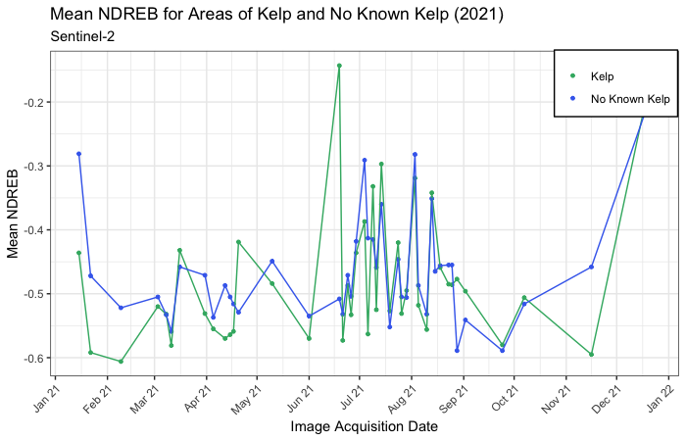

Figure 3. Plot of mean NDREB for kelp polygons and areas of no known kelp in the Central Puget Sound in 2021 for Sentinel-2 imagery.

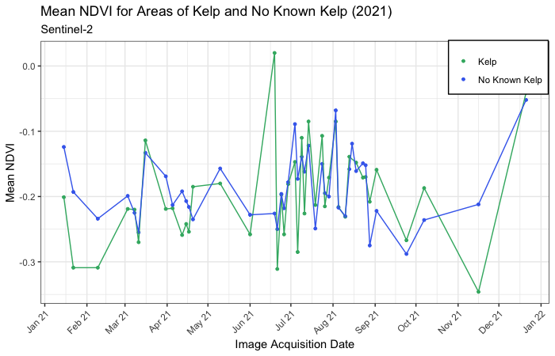
Figure 4. Plot of mean NDVI for kelp polygons and areas of no known kelp in the Central Puget Sound in 2021 for Sentinel-2 imagery.

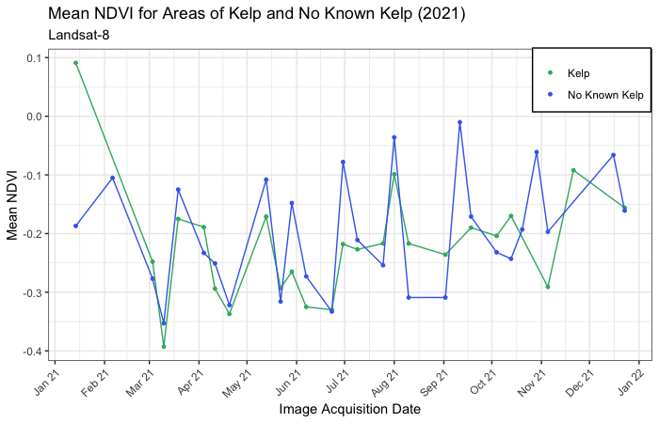
Figure 5. Plot of mean NDVI for kelp polygons and areas of no known kelp in the Central Puget Sound in 2021 for Landsat 8 imagery.

We theorized that another reason for the lack of differentiation between our known kelp polygons and areas of no known kelp with our spectral indices for Landsat 8 and Sentinel-2 might be that very small kelp beds had a lower signal that was skewing a clearer signal from larger beds. To determine whether this was the case, we classified the polygons by bed size as described in Section 3.3 and compared spectral indices for small, medium, and large kelp beds with areas of no known kelp.

Figure 6 shows the interannual variability in mean NDVI for different kelp bed sizes and areas of no known kelp from 2016–2021. Aside from an apparently anomalous spike in mean NDVI for Medium kelp beds in 2021, there is little difference in the NDVI signal for the four groups. The same is true for the growing season-only boxplots for NDVI for Sentinel-2 (Figure 9). We also did not find a stronger differentiation between kelp bed sizes and areas of no known kelp for the Sentinel-2 imagery when comparing interannual variability in mean NDREB (Figure 7).

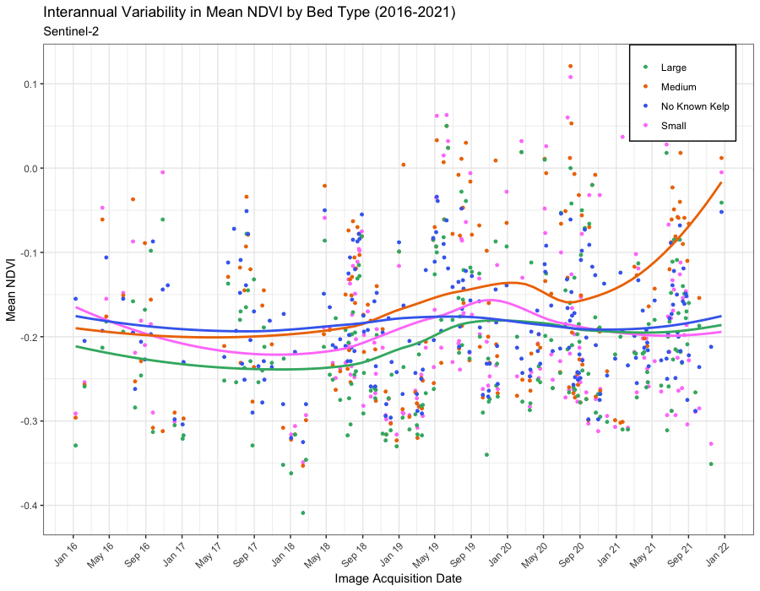
Figure 6. Differences in spectral response in NDVI for different kelp bed sizes and areas of no known kelp from 2016–2021 for Sentinel-2.

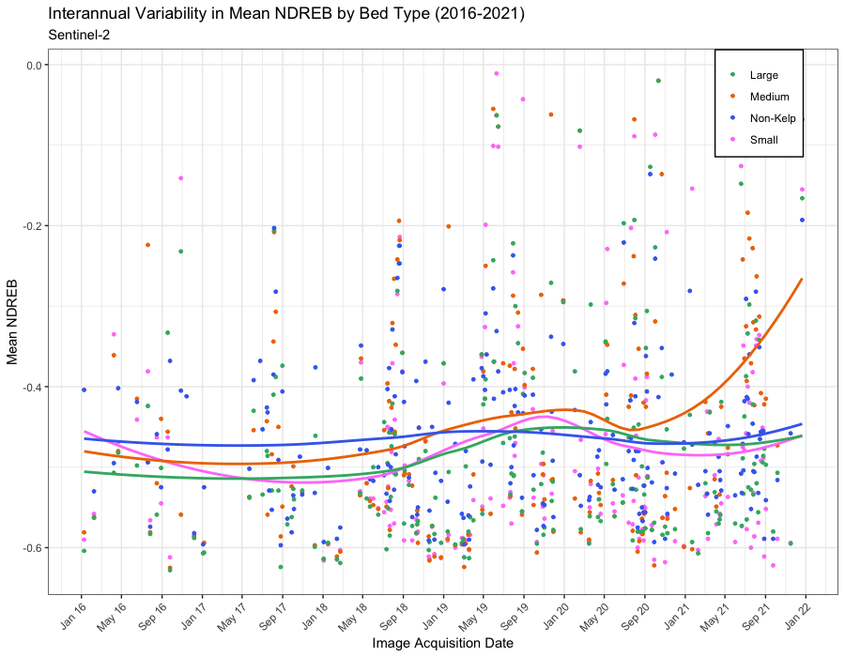

Figure 7. Differences in spectral response in NDREB for different kelp bed sizes and areas of no known kelp. There is little differentiation between the different sizes of kelp bed and areas of no known kelp across the period of 2016–2021.

We hypothesized that due to its higher resolution, differences in the spectral indices for kelp bed sizes would be more apparent with the Sentinel-2 imagery than the Landsat 8 imagery. As we did not detect differences between different kelp bed sizes and areas of no known kelp for either spectral index for our Sentinel-2 imagery, we did not expect to see a difference with the Landsat 8 imagery, and we generally did not. Both the interannual variability and growing season-only boxplots for mean NDVI by bed size for the Landsat 8 image collection show no qualitative differences in the different categories for kelp bed size and areas with no known kelp (Figures 8 and 9). Interestingly, for Landsat 8, the Medium bed size appears a little higher than the other bed sizes, and no known kelp for the 2016–2021 period, though the range of the Medium NDVI values still overlaps the other bed sizes and no known kelp points. It’s possible that specific characteristics of the Medium beds or the Landsat 8 imagery contributed to their higher NDVI. However, further investigation into this difference would be necessary to offer a definitive explanation.

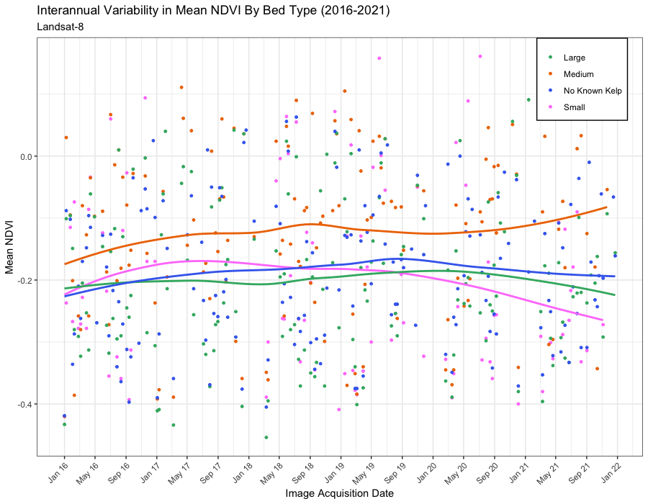

Figure 8. Differences in spectral response in NDVI for different kelp bed sizes and areas of no known kelp from 2016–2021 for Landsat 8.

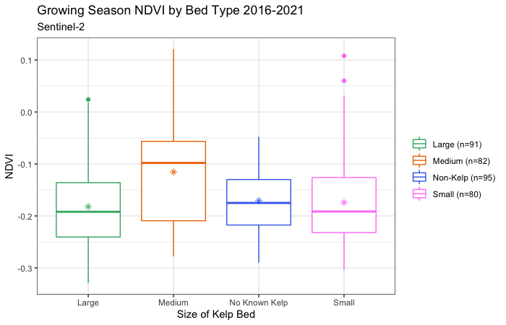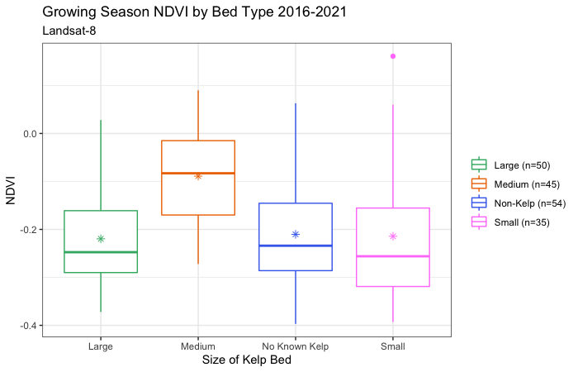
Figure 9. Boxplots of NDVI for the 2016–2021 growing seasons by bed size compared to the areas of no known kelp for Sentinel-2 and Landsat 8.

Because kelp detection is so influenced by tidal height, we hypothesized that our low tide-filtered images might have a distinctly higher NDVI or NDREB when compared with the image collections that included images taken at any tide level. However, we found that narrowing our image collections to optimal tides created other limitations, as it reduced the image collections so significantly. We were left with 15 total images for Sentinel-2 for the entire 2016–2021 period, and even fewer for Landsat 8 (Table 3). After combining the images into mosaic scenes, there were only 0–5 mean NDVI or NDREB values for any given year in both image collections. As a result, plotting a time series of the mean NDVI or NDREB of the low tide-only images was impractical, as comparing limited tide-filtered spectral index values in a year of many values for non-tide-filtered kelp and no-known kelp does not clearly illustrate whether the spectral index for low tide-only images was higher across an entire growing season.

Tides continue to present a significant challenge to the successful mapping of bull kelp with remotely sensed images. We hypothesize that one significant factor limiting our ability to differentiate kelp from areas of no known kelp with our two spectral indices is that kelp is most visible at very low tide levels. The rigid imagery acquisition time of Landsat 8 and Sentinel-2 restricted our ability to filter out images taken at non-optimal tides without so reducing our image collection that analysis was no longer feasible. As imagery acquisition time is a fixed aspect of remote sensing, it presents a significant limitation to accurate detection of kelp in nearshore marine environments using Landsat 8 or Sentinel-2.

Table 3
Filters used to reduce collections to scenes captured under ideal conditions for kelp detection.
 | Average Number of Scenes per Year (2016 – 2021)
Filter Description | Sentinel-2 | Landsat 8
Study Area Bounds | 524 | 109
Cloud Pixel Threshold (Sentinel-2 only) | 158 (30% of initial imagery) | —
Growing Season | 63 (12% of initial imagery) | 32 (30% of initial imagery)
Within 1 hour of tide | 18 (3% of initial imagery) | 11 (10% of initial imagery)
Tidal height between –6ft and 1ft | 10 (2% of initial imagery) | 6 (5% of initial imagery)

As part of our initial objectives, we had hoped to use machine learning to classify areas of kelp and water to produce extent maps for 2021 and a time series of changes in kelp extent from 2011–2021. However, given the results of our investigation into the spectral indices for kelp and areas of no known kelp, we determined that a classification model was not appropriate. Because the mean NDVI—and NDREB for Sentinel-2—was so similar between areas of kelp and no known kelp regardless of kelp bed size, we determined that any classification we ran with our existing inputs would not have accurately predicted kelp extent within our study area. When we attempted to isolate the kelp signal from water by filtering for optimal tides and currents, we were left with such reduced image collections we were unable to assess whether the kelp signal was improved.

There were various limitations to our approach. Tide filtering methods that targeted satellite scenes that coincided with favorable tidal conditions dramatically reduced the number of images available for analysis. Having fewer images per year does make it harder to discern variability over many years; however, having a small subset of images captured under ideal detection conditions could prove beneficial for classification on a yearly basis. Due to the nature of the mosaic process, our mean values for NDVI and NDREB were biased towards the first scene that made up a mosaic. This could have resulted in generally lower values for mean NDVI and NDREB if a second or third scene of a mosaic contained higher values than the first scene. Additionally, the many environmental conditions of the dynamic nearshore marine environment, including wave action, turbidity, and intertidal currents, likely introduced noise into both our kelp polygons and no known kelp points that impacted our mean values for both spectral indices.

4.2 Future Work
This project was an effective initial feasibility analysis of satellite-based remote sensing for the detection of bull kelp in Puget Sound, highlighting several limitations and challenges that the team contended with. One issue was the utilization of a “no known kelp” region as the basis for comparison to the surveyed areas of known kelp extent. This presented the uncertainty whether kelp and aquatic vegetation were included in comparison to the known kelp points, reducing differentiation. Building a more comprehensive dataset of known kelp extent, and of nearshore kelp and aquatic vegetation absence, would allow more effective analysis of the spectral response of bull kelp beds. Building this initial and extensive dataset would be resource intensive, but it may provide the necessary data to support efficient satellite-based remote sensing of bull kelp in the future.

The tide-filtering approach was effective at identifying specific scenes that coincided with favorable tidal and current conditions within Puget Sound, but the resulting scenes were limited and had sparse temporal coverage, particularly during peak growing season. Future research might find it advantageous to explore a wider range of acceptable tidal height as well as include a greater temporal window on either side of low tide. While this would increase the potential impact of higher water on kelp detection, it may also greatly increase the number of images available for analysis, which may be less useful for an annual or interannual variability time series. However, a limited number of scenes may be acceptable for yearly extent classification, so future work could explore the feasibility of kelp classification from these single, ideal scenes.

Combining the scenes of multiple sensors into the same analysis may be another method that increases the temporal resolution of acceptable tidal conditions. While the team looked at both Landsat 8 OLI and Sentinel-2 MSI individually, it may prove useful to combine the acceptable tidal acquisitions for both sensors in order to create higher temporal resolution. While there are differences in spectral resolution, spatial resolution, and spectral response between the two sensors, the increased temporal resolution may outweigh additional uncertainty brought on by utilizing two sensors in the same analysis.

Future research might also explore the differences between the spectral responses for areas of known bull kelp extent and areas of known giant kelp or seagrass presence. Only comparing known extents of these species where the species presence is consistent and dominant would help determine if there are spectral differences between each species of marine algae or vegetation. Identifying these spectral differences, if substantial, would help with future delineation between marine vegetation and macroalgal species.

Developing a more effective mask for the intertidal zone would be beneficial to the analysis as well since there is likely interference in spectral response for both known kelp and no known kelp regions caused by other intertidal marine vegetation. The proximity of kelp to coastlines, particularly at low tide, requires selective delineation of kelp or no known kelp regions in order to avoid interference from intertidal vegetation spectral response.

Future explorations of satellite-based detection of kelp in Puget Sound might explore the feasibility of multiple endmember spectral mixture analysis (MESMA) which has proved effective in other regions for kelp detection (McPherson et al., 2021). This spectral mixture analysis method models a fractional cover of several “endmembers” within a given pixel. This enables a more nuanced depiction of partial pixel cover for species such as kelp where any given pixel may only contain limited kelp coverage. Endmembers can be selected and identified based on local conditions and species, with one representing kelp and others assigned based on other relevant coverage types.

5. Conclusions
Based on our analysis, neither Sentinel-2 nor Landsat 8 sufficiently differentiated between kelp and no known kelp using NDVI or NDREB. This appeared to be consistent regardless of kelp bed size – Small, Medium, and Large kelp beds had similar NDVI and NDREB averages that were not differentiated from no-known kelp point averages. The similarity in spectral response between kelp and no-known kelp did not provide support for moving forward with our initial objectives of developing a model to classify 2021 kelp extent and create time series maps from 2011–2021. Tide and current filtering may provide an opportunity to map kelp extent on single image dates, though these filters considerably reduced the number of images available for each year. Even given near-ideal tide and current imagery conditions, we did not see consistent, reasonable differences between kelp and no known kelp.

Our exploration of the feasibility of using Sentinel-2 MSI and Landsat 8 OLI to map kelp in Puget Sound integrated ecological characteristics of bull kelp and its environment with image acquisition and analysis in order to maximize detection potential. The similarity in spectral response between known and no known kelp prevented the team from being able to develop a model to classify kelp and produce kelp extent maps for 2021, as well as for previous years.

Inclusion of additional data and different methodological approaches using these sensor platforms may address the limitations and data gaps that we encountered during this analysis. Given the additional avenues available, including the normalization of mosaic datasets, use of MESMA, and tide and current filtering, further research is required to determine whether use of Sentinel-2 MSI and Landsat 8 OLI is effective for mapping bull kelp canopy extent within Puget Sound. The ability to map and monitor kelp extent within Puget Sound remains an important goal; it is a critical addition to understanding overall nearshore ecosystem health in the region. Continuation of local efforts utilizing field, fixed wing, and small unmanned aircraft systems (sUAS) surveys to gather spatial kelp extent and absence data would avoid some of the limitations of satellite remote sensing in Puget Sound and aid in further development of satellite-based monitoring methods for the region.

6. Acknowledgments
We would like to extend our thanks to the following parties for their contributions and assistance throughout this project:

- Kathleen Hurley, Port of Seattle
- Jon Sloan, Port of Seattle
- Cinde Donoghue, Washington State Department of Natural Resources
- Danielle Claar, Washington State Department of Natural Resources
- Tyler Cowdrey, Washington State Department of Natural Resources
- Dana Oster, Northwest Straits Commission
- Suzanne Shull, Northwest Straits Commission
- Gray McKenna, Puget Sound Restoration Fund
- Hilary Hayford, Puget Sound Restoration Fund
- Luba Reshitnyk, Hakai Institute
- Wiebe Nijland, Hakai Institute

This material contains modified Copernicus Sentinel data 2016 - 2021, processed by ESA.

Any opinions, findings, and conclusions or recommendations expressed in this material are those of the author(s) and do not necessarily reflect the views of the National Aeronautics and Space Administration.

This material is based upon work supported by NASA through contract NNL16AA05C.

7. Glossary
Earth observations – Satellites and sensors that collect information about the Earth’s physical, chemical, and biological systems over space and time.
Landsat 8 – One of a series of NASA Earth observation satellites.
MESMA – Multiple endmember spectral mixture analysis. A spectral mixture analysis (SMA) approach that combines a variety of mixture models to find the best fit.
NDREB – Normalized difference red-edge blue. Another spectral index which can measure vegetation presence using the difference between red-edge bands and blue bands.
NDVI – Normalized difference vegetation index. A spectral index aimed at measuring vegetation presence and health with the difference between near-infrared (NIR), typically reflected by vegetation, and red light, which is typically absorbed by green or leafy vegetation.
Sentinel-2 – One of a series of European Space Agency Earth observation satellites.
SMA – Spectral Mixture Analysis. An analysis method that is based upon the idea that reflectance spectra from either air or satellite sensors are able to be deconvolved and split into a linear mixture of the spectra of ground components, often referred to as spectral endmembers.

8. References

Berry, H., Naar, N., Woodard, T., Shull, S., Mumford, T., Raymond, W., Dowty, P., Christiaen, B., Ferrier, L., Ledbetter, J., Dethier, M., & Spaulding, E. (2022). Floating kelp canopies: A new Vital Sign indicator in Puget Sound, Initial Scoping. https://repository.library.noaa.gov/view/noaa/45850
Berry, H. D., Mumford, T. F., Christiaen, B., Dowty, P., Calloway, M., Ferrier, L., Grossman, E. E., & VanArendonk, N. R. (2021). Long-term changes in kelp forests in an inner basin of the Salish Sea. PLOS ONE, 16(2), Article e0229703. https://doi.org/10.1371/journal.pone.0229703
Calloway, M., Oster, D., Mumford, T. & Berry, H. (2020). Puget Sound kelp conservation and recovery plan. Northwest Straits Commission. https://www.nwstraits.org/our-work/kelp/
Cavanaugh, K. C., Cavanaugh, K. C., Bell, T. W., & Hockridge E. V. (2021). An automated method for mapping giant kelp canopy dynamics from UAV. Frontiers in Environmental Science, 8, Article 587354. https://doi.org/10.3389/fenvs.2020.587354
Dayton, P. K. (1985). Ecology of kelp communities. Annual Review of Ecology and Systematics, 16(1), 215–245. https://doi.org/10.1146/annurev.es.16.110185.001243
Department of Natural Resources (2007). Over Water Structures in Marine Waters of Washington State. https://fortress.wa.gov/dnr/adminsa/gisdata/metadata/OWS_Marine_metadata.htm
European Space Agency (2021). Sentinel-2 Multispectral Instrument Level-1C. [Dataset]. Google Earth Engine. https://developers.google.com/earthengine/datasets/catalog/COPERNICUS_S2
Finlayson, D. P. (2005). Combined bathymetry and topography of the Puget Lowland, Washington State. [Data set]. University of Washington. http://www.ocean.washington.edu/data/pugetsound/
Gleason, M. G., Caselle, J. E., Heady, W. N., Saccomanno, V. R., Zimmerman, J., McHugh, T. A., & Eddy, N. (2021). A structured approach for kelp restoration and management decisions in California. The Nature Conservancy. https://www.researchgate.net/publication/352895521_A_Structured_Approach_for_Kelp_Restoration_and_Management_Decisions_IN_C_ALIFORNIA
Hamilton, S. L., Gleason, M. G., Godoy, N., Eddy, N., & Grorud-Colvert, K. (2022). Ecosystem-based management for kelp forest ecosystems. Marine Policy, 136, Article 104919. https://doi.org/10.1016/j.marpol.2021.104919
Hamilton, S. L., Bell, T. W., Watson, J. R., Grorud‐Colvert, K. A., & Menge, B. A. (2020). Remote sensing: Generation of long‐term kelp bed data sets for evaluation of impacts of climatic variation. Ecology, 101(7), Article e03031. https://doi.org/10.1002/ecy.3031
Innovative idea: Smith Cove Blue Carbon Pilot Project. (n.d.). Port of Seattle. Retrieved July 5, 2022, from https://www.portseattle.org/page/innovative-idea-smith-cove-blue-carbon-pilot-project
McPherson, M. L. (2021). Mapping kelp forests using existing and emerging remote sensing techniques. UC Santa Cruz. Retrieved June 7, 2022, from https://escholarship.org/uc/item/3z3681hn#author
McPherson, M. L., Finger, D. J., Houskeeper, H. F., Bell, T. W., Carr, M. H., Rogers-Bennett, L., & Kudela, R. M. (2021). Large-scale shift in the structure of a kelp forest ecosystem co-occurs with an epizootic and Marine Heatwave. Communications Biology, 4(1), Article 298. https://doi.org/10.1038/s42003-021-01827-6
Nijland, W., Reshitnyk, L., & Rubidge, E. (2019). Satellite remote sensing of canopy-forming kelp on a complex coastline: A novel procedure using the Landsat image archive. Remote Sensing of Environment, 220, 41–50. https://doi.org/10.1016/j.rse.2018.10.032
Schroeder, S. B., Dupont, C., Boyer, L., Juanes, F., & Costa, M. (2019). Passive remote sensing technology for mapping bull kelp (Nereocystis luetkeana): A review of techniques and regional case study. Global Ecology and Conservation, 19, Article e00683. https://doi.org/10.1016/j.gecco.2019.e00683
USGS (2021) USGS EROS Archive – Landsat Archives – Landsat 8 OLI and TIRS Level-1 Data Products. [Dataset]. https://developers.google.com/earth-engine/datasets/catalog/LANDSAT_LC08_C01_T1_TOA

9. Appendices

Appendix A

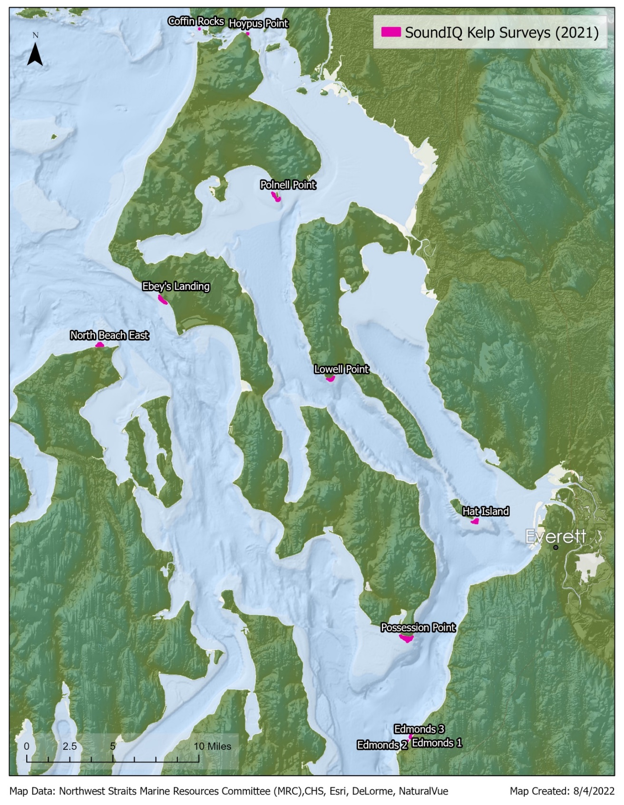
Figure A1. NDVI and NDREB values were extracted from within the bounds of known kelp extent survey polygons (some of which are shown above for 2021), surveyed and provided by the Northwest Straits Commission. NWSC conducted kayak surveys from 2016 to 2021.
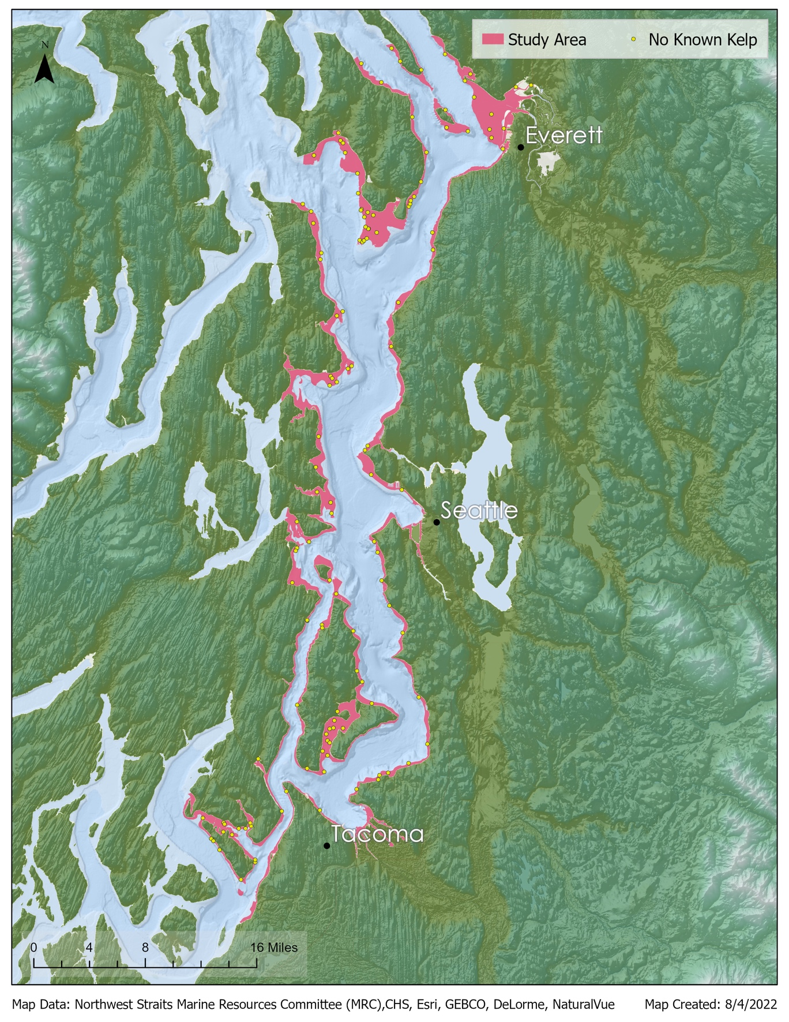
Figure A2. Location of randomly distributed “no known kelp” sample points for analysis against known kelp polygons shown in Figure A1.

