Ground Testing of an Oxygen Concentrator in a Simulated International Space Station (ISS) Cabin Environment
Laura Soto, Katerina Lewis²
NASA Johnson Space Center, Houston, TX, 77058
Jeffrey Sweterlitsch³
NASA Johnson Space Center, Houston, TX, 77058
The method for supplying medical oxygen to respiratorily-compromised astronauts on the International Space Station (ISS) and in future Orion missions consists of drawing oxygen from high pressure oxygen tanks. An Oxygen Concentrator Module (OCM) is a device that pulls in ambient air and separates out the nitrogen, resulting in a high concentration oxygen source. This technology has the potential to eliminate resupply and oxygen-enrichment issues associated with using high pressure oxygen tanks and become an alternative technology to support medical oxygen operations for future exploration missions. In this study, we test the long-term performance of a Commercial Off-the-Shelf (COTS) OCM in a simulated ISS cabin environment. Humidified air, carbon dioxide, and fifteen representative trace contaminants are continuously injected through an enclosed test chamber where the OCM is challenged. This study included the first successful demonstration of the Trace Gas Injection System (TGIS), which reliably and continuously produced ISS levels of trace contaminants, carbon dioxide, and humidity in an enclosed environment. The TGIS is a new and unique ground capability with significant implications for Test Readiness Level (TRL) advancement of COTS items and Government Furnished Equipment (GFE). This study demonstrated that the tested OCM reliably delivers enriched oxygen mostly at desired performance specifications. This study also demonstrated that the OCM does not inadvertently concentrate trace gases in its oxygen product stream, as detectable concentrations of trace contaminants in the oxygen product stream were at all times below the simulated ISS levels.

Nomenclature
AE = accuracy error
cm = centimeters
CO₂ = carbon dioxide
COTS = commercial off-the-shelf
D3 = hexamethylcyclotrisiloxane
D4 = octamethylcyclotetrasiloxane
D5 = decamethylcyclopentasiloxane
GC-FID = gas chromatography with flame-ionization detection
GC-MS = gas chromatography mass spectroscopy
GFCI = ground fault circuit interrupter
GFE = government furnished equipment
ISS = International Space Station
JSC = Johnson Space Center
kg = kilograms
LPM = liters per minute
m³ = cubic meter
mg/m³ = milligram per cubic meter
NASA = National Aeronautics and Space Administration
OCM = oxygen concentrator module
PE = precision error
R134a = 1,1,1,2-tetrafluoroethane
RH = relative humidity
TE = total error
TGIS = Trace Gas Injection System
TRL = test readiness level

Introduction
T
ESTING of an Oxygen Concentrator Module (OCM) was performed at the Johnson Space Center (JSC) to provide information on the long-term performance of the device in a simulated International Space Station (ISS) cabin environment. The OCM was tested in an enclosed, ambient-pressure environment where ISS-levels of relative humidity, carbon dioxide, and fifteen trace chemicals were replicated. The OCM was continuously exposed to the challenge environment for 12 weeks in a non-operating state, with 600 hours of intermittent operation within the 12-week period. Oxygen concentration, flow rate, and levels of trace contaminants in the oxygen product stream of the OCM were monitored and assessed for indications of device performance degradation and adverse effects to the product stream. Levels of humidity, carbon dioxide, and trace contaminants in the test environment were also assessed throughout testing to ensure target conditions were being met. This document provides a summary of the long-term performance of the OCM in the challenge environment and the performance of the Trace Gas Injection System (TGIS) in generating the challenge environment.

Background
In preparation for human emergencies during space flight, NASA missions rely on medical oxygen for maintaining the health and safety of crew members. The ISS and Orion programs use medical oxygen to treat medical emergencies, improve a crewmember’s medical condition, and reduce the likelihood of early flight termination¹. Sourcing medical oxygen from oxygen tanks, as is the case for ISS and Orion programs, increases flammability hazards in the habitable volume by risking introduction of excess oxygen². Utilizing an oxygen concentrator to respond to medical oxygen emergencies removes this risk, as a concentrator does not introduce new oxygen into the cabin environment and instead concentrates oxygen using air from the ambient environment.
The OCM tested at JSC was first assessed during Medical Oxygen Phase I Testing, where the concentrator was cycled through its three continuous flow rate settings (1, 2, and 3 LPM) and demonstrated reliable generation of 90% oxygen or greater in all three modes³. This testing also included integrated testing of the OCM with a mechanical ventilator to determine the oxygen concentration and ventilation pressures achieved through various combinations of OCM and ventilator settings. Other completed tests include assessments of the concentrator’s operating touch temperature⁴, battery life⁵, acoustics signature^{6,7}, and performance when subjected to thermal cycling⁸, high humidity⁹, and a reduced pressure/elevated oxygen environment^{10,11}. A human factors integration assessment was also performed for the device^{12,13}.
Preliminary medical oxygen requirements for exploration necessitate a production of at least 90% oxygen from a medical oxygen device at minute ventilations from 3.0 to 8.5 LPM to account for a wide range of lung capacities^{1,3}. Ninety percent oxygen is required to sufficiently oxygenate a patient in critical condition, though only 50% oxygen is needed for non-critical cases¹. At a maximum flow rate of 3 LPM and 90% or greater oxygen production, the tested OCM meets only the minimum minute ventilation requirements, yet an option to employ multiple OCM units in a medical oxygen scenario would allow for flexibility in meeting the minimum needs of each individual patient while minimizing power usage.

Experimental
For this test, the OCM is placed inside an acrylic glove box that receives a continuous flow-through of humidified air, carbon dioxide, and fifteen trace contaminants from the TGIS to generate the simulated ISS environment. The TGIS enables controlled injection of the required gas species, which are directed through the test chamber and out to a facility exhaust. A LabVIEW program is used to control injection of major air constituents and continuously records carbon dioxide concentration, relative humidity, and total flow rate data from the gas stream exiting the TGIS. The test configuration is depicted in Figure 1.
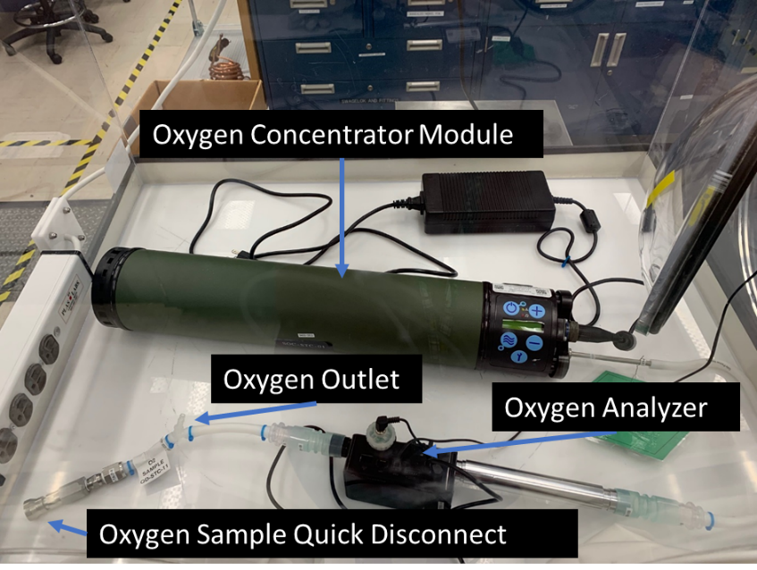
Figure 1: OCM Test Configuration.
When powered on, the concentrator pulls in surrounding air from the test environment and expels a concentrated oxygen product stream through a small outlet port. The outlet port is connected via medical tubing to an oxygen analyzer, which measures oxygen concentration, flow rate, and temperature of the oxygen product stream. The data from this analyzer provides information on the quality of the OCM oxygen product stream throughout testing and was recorded with LabVIEW software. Gas samples were taken from the test environment to ensure the test environment was reaching target conditions and from the OCM oxygen stream to provide information on how the trace contaminants were interacting with the device. The gas samples were sent to the Toxicology & Environmental Chemistry Lab at JSC for analysis of trace contaminant levels via gas chromatography-mass spectrometry (GC-MS) and gas chromatography with flame-ionization detection (GC-FID).

Oxygen Concentrator Module
For this test, the OCM was operating in Continuous Flow Mode at a flow rate of 3 LPM. The OCM operates by pulling in ambient air and applying pressure-swing adsorption to the process stream to separate out oxygen molecules¹⁴. The resulting concentrated oxygen is directed out to a port at the end of the device. The OCM has internal instrumentation, including an internal oxygen sensor and flow rate sensor, that continuously monitor the output of the device, though these readings are not displayed visibly for operators. If the internal instrumentation detects an issue with operation, the device will an generate audible and visual alarm and display a specific alarm code on the OCM display. In severe cases, the device may also automatically shut off. These alarm codes provide additional information on OCM performance¹⁴. In this test, the OCM is powered by an AC power supply connection to a GFCI outlet inside the chamber, though the device can also be powered via a detachable battery that increases its size and weight. In the tested configuration, without the detachable battery, the OCM weighs 4.54 kg, is 59.1 cm long, and has a 11.1 cm diameter. With the detachable battery installed, the OCM weighs 5.56 kg and is 68.1 cm long¹⁴.

Trace Gas Injection System
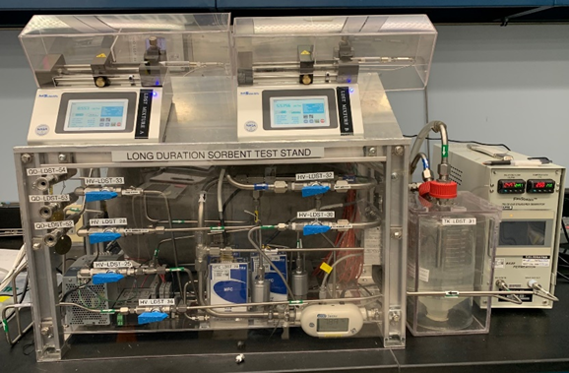
Figure 2: Trace Gas Injection System.

The TGIS, depicted in Figure 2, is a system that enables controlled injection of various gas species and combines them to reach user-defined species concentrations in the resultant stream. Pressurized carbon dioxide and dry air are introduced into the system, with the dry air splitting into three streams; one stream remains dry, another is directed through a bubbler to generate wet air, and another is directed into a permeation oven, which is used to introduce R134a (1,1,1,2-tetrafluoroethane) into the gas stream. These gases are directed into a large mixing tank, where two syringe pumps, each employing a single syringe, slowly inject trace quantities of liquid chemicals to evaporate and mix with the major gas constituents inside the tank.

Environmental Test Chamber
The test chamber is a clear, acrylic compact glove box of an approximate 0.5 m³ volume that allows the operator to access or manipulate items inside the chamber via Hypalon gloves. The glove box features a transfer chamber connected to the main body that allows users to transfer gas sample containers in and out of the test environment without exposing users to the full environment in the main chamber. The TGIS connects to the main chamber through stainless steel tubing, through which the resultant TGIS gas stream flows. The gas stream exits the main chamber through stainless steel tubing connected to facility exhaust.

Test Conditions
The target conditions for the test environment were 50% relative humidity, carbon dioxide at a partial pressure of 4 mm Hg, which is equivalent to 5,300 ppm, and trace contaminants at levels outlined in Table 1. Two liquid chemical mixtures, designated as mixtures A and B, were formulated to introduce fifteen of the fourteen trace contaminants into the test environment via syringe injection. The remaining trace contaminant, R134a was introduced via permeation oven, with facility air used as a carrier gas. Target environmental conditions and formulations of the liquid trace contaminants were determined based on recommendations from, and conversations with, Jay Perry^{15,16} and Matthew Kayatin^{17,18}. Replication of trace contaminants at target conditions would produce species levels that fall safely within defined 180-day Spacecraft Maximum Allowable Concentration (SMAC) values, as shown in Table 1^{19,20}.
Table 1: Target trace contaminant concentrations and 180-day SMAC values.
Component | Mixture | Target Concentration (mg/m³) | 180-day SMAC  (mg/m³)
Trimethylsilanol | A | 0.2 | 4
2-Butanone | A | 0.1 | 30
Acetone | A | 0.5 | 52
Dichloromethane | A | 0.1 | 10
Decamethylcyclopentasiloxane (D5) | B | 1.0 | 15
Octamethylcyclotetrasiloxane (D4) | B | 0.2 | 12
n-Butanol | B | 0.1 | 40
Hexamethylcyclotrisiloxane (D3) | B | 1.5 | 9
o-Xylene | B | 0.2 | 37
Toluene | B | 0.06 | 15
Isopropanol | B | 0.4 | 150
Ethanol | B | 4.8 | 2,000
Acetaldehyde | B | 0.5 | 4
Methanol | B | 0.7 | 26
1,1,1,2-tetrafluoroethane (R134a) | C | 0.5 | 9,441

The test team had proposed a goal of obtaining gas species in the environment within 25% of target levels, though this was not used as a pass/fail criteria to be addressed prior to the start of OCM testing. Initial checkouts of the TGIS in 2021 had indicated that individual data points for most gas species could be produced within 25% of target values, but were more reliably produced within 65%²¹. Important design improvements had been made since this testing, though fully ensuring reproducibility of gas species within 25% of targets would require extensive testing of the latest system, which would provide information to potentially necessitate iterative redesign of the TGIS system, modification of injection rates, revision of standard operating procedures, and/or modifications in the gas sample analysis method. Given the limited schedule for the development of the TGIS and the testing of the OCM in the ISS challenge environment, the test served doubly as the first demonstration of the latest TGIS design, which the test team understood would at least produce gas species data points within 65% of targets, and testing of the OCM in the challenge environment.

Formulation and Assessment of Liquid Chemical Mixtures
Table 2: Liquid species recovery from chemical dilution
Component | Mixture | Recovery (%)
Trimethylsilanol | A | 72.8
2-Butanone | A | 76.1
Acetone | A | 90.4
Dichloromethane | A | 83.3
Decamethylcyclopentasiloxane (D5) | B | 0.0
Octamethylcyclotetrasiloxane (D4) | B | 0.0
n-Butanol | B | 77.0
Hexamethylcyclotrisiloxane (D3) | B | 1.5 (*)
o-Xylene | B | 72.1
Toluene | B | 70.3
Isopropanol | B | 75.1
Ethanol | B | 96.4
Acetaldehyde | B | 72.8
Methanol | B | 85.9

On March 5, 2022, prior to the start of testing, bulk volumes of liquid chemical mixtures A and B were produced. Samples were provided to the Toxicology & Environmental Chemistry Lab at JSC and were assessed by diluting the samples, recovering the species, and assessing the quantity recovered with expected quantities. A recovery of 70 to 96% was seen for most chemicals, as shown in Table 2. Given that dilution ratios ranged from 1:10,000 to 1:3,000,000, these results strongly indicate that the liquid mixtures exhibit levels of species at the desired quantities, even with limited recovery of the siloxanes.
In future testing, the test team may consider a liquid analysis comparing actual measured mass fractions with targeted mass fractions to obtain further confidence in chemical mixing procedures and chemical stability. An analysis of all possible chemicals in the mixtures can also be performed to help the team identify if chemicals are breaking down within the mixture. For this test, analysis was limited to the species listed in Table 1. With knowledge that the chemical mixtures were producing chemical species at expected levels, the test team continued on with the next test preparation activity, which involved baseline testing of the TGIS.

Baseline TGIS Testing
Baseline testing of the TGIS was performed to ensure target levels of species were being reached in the test chamber prior to introduction of the OCM into the environment. Results of the testing indicated that the test stand consistently produced carbon dioxide levels between 5,200 and 5,300 ppm and relative humidity levels between 45% and 47%. With regard to trace contaminant levels, gas samples initially produced zero or near-zero levels of trace contaminants. Following troubleshooting and redesign of the liquid chemical injection system, which simplified and fortified the components connecting the syringe barrel to the TGIS mixing tank, gas samples analysis results indicated that most of the trace contaminants were reaching intended values within the test chamber, with the exclusion of 1,1,1,2-tetrafluoroethane (R134a), which trended low, and hexamethylcyclotrisiloxane (D3), which trended high.
The R134a permeation tubes used for this testing were procured to support a previous test configuration with a higher flow rate, though the manufacturer ensured that proper emissivity could be produced from these tubes by adjusting permeation oven temperature. Operators assessed that target R134a values could be reached by continuing to increase permeation oven temperature. Unlike the other species in this test, D3 is solid at room temperature and sparingly soluble in alcohols. Solid D3 crystals were dissolved into the mixture B liquid solution at room temperature on a stir plate for several days. The team determined that precipitation of D3 or incomplete dissolution of D3 was possible and could cause lower than expected levels seen in the test environment. . From an analytical point of view, developing quantitative standards to measure the vapor concentration of D3 is also problematic because of different published values of its vapor pressure^{22,23,24}.
With the knowledge that most of the trace contaminants were reaching intended values within the glove box, with R134a concentrations requiring a simple adjustment of permeation temperature settings to increase concentrations, and with consideration of known issues with consistent injection and analysis of D3, the test team proceeded to initiate testing of the OCM test article.

Results and Discussion
The test begins with the concentrator powered off and exposed to the test environment for multiple days. Following this initial exposure, the team alternates between 8-hour and 10-day periods of continuous concentrator operation. In between test periods, the OCM is powered off, but remains in the test environment. This test sequence was developed in collaboration with JSC Flight Surgeons and was based on a preliminary concept of operations for administering medical oxygen during exploration missions. Continuous exposure of the OCM to the challenge environment during testing simulates long-duration usage of the OCM in the ISS cabin.

Major Air Constituent Levels in the Environmental Test Chamber
While testing the OCM, data for the major air stream constituents in the test chamber was continuously collected to ensure target conditions were being met. The target conditions were 5,300 ppm of carbon dioxide, 50% humidity. Results from testing are presented in Table 3.
Table 3. Average levels of major air constituents in the test chamber.
Test | Description | Time Period | CO₂ Concentration (ppm) | Humidity (%)
1 | 8-hour run | 4/12/2022 | 5300 | 46
2 | 3-day run | 5/16/2022 – 5/19/2022 | 5400 | 47
3 | 10-day run | 5/26/2022 – 6/5/2022 | 5400 | 47
4 | 8-hour run | 6/13/2022 | 5300 | 47
5 | 10-day run | 6/21/2022 – 6/30/2022 | 6000 | 56
6 | 8-hour run | 7/6/2022 | 300 | 56

For Tests 1 through 6, results indicate that the TGIS produced a gas mixture with carbon dioxide levels ranging from 5,300 ppm to 6,000 ppm and humidity levels from 46% to 56%, values which are within 25% of targets. In Test 6, which occurred on July 6, 2022, low levels of carbon dioxide are due to the intentional halting of the carbon dioxide gas for an unrelated laboratory activity. Priorities were assessed and a decision was made to complete the final test point without elevated carbon dioxide. The carbon dioxide gas stream constituted 0.8% of the total flow rate, and loss of this gas stream was expected to consequentially result in the increase of trace contaminant levels by 0.6%, which was deemed as acceptable by the test team.

Trace Contaminant Levels in the Environmental Test Chamber
Gas samples were collected from the test chamber at various times during the test and analyzed for the specific gas species listed in Table 1. Analysis results were processed by calculation of the mean value of the species concentrations, accuracy error of the mean with respect to the species target, precision error, and total error. Accuracy Error (AE) was calculated using the following equation,

$AE=\frac{y-\overline{x}}{y}∙100\%$ (1)
where $y$ is the target value and $\overline{x}$ is the mean of the concentrations. AE demonstrates the proximity of the mean to the target value. Precision Error (PE) is calculated using the following equation,

$PE=\frac{\frac{t_{stat}∙σ}{\sqrt{n}}}{\overline{x}}∙100\%$ (2)
where n is the sample number, $t_{stat}$ is the t-statistic for a 95% confidence interval and n – 1 degrees of freedom, σ is the standard deviation, and $\overline{x}$ is the sample mean. PE provides information on the distribution, or spread, of the data. Total error (TE) is calculated using the following equation,
$TE=\sqrt{PE^{2}+AE^{2}}$ (3)
where total error equals the root mean square of PE and AE. TE represents the overall error in the test result attributed to data precision and accuracy.
There were a total of 10 gas samples taken of the environment during testing. Test data used to calculate the sample mean did not include any data from samples taken on July 6, 2022, when the carbon dioxide source was turned off. Data for Mixture B from a sample taken on May 16, 2022 was also not used, as concentrations were at or near zero values due to a Mixture B syringe leak that was immediately resolved. These data points were not used due to the injection rates of gas species being outside the intended rates during the time the sample was taken. A summary of results is outlined in Table 4.
Table 4: Mean values of trace contaminant concentrations compared to target levels with calculated accuracy error, precision error, and total error.
Mixture | Compound | Target (mg/m³) | Mean (mg/m³) | Accuracy Error | Precision Error | Total Error
A | Trimethylsilanol | 0.2 | 0.20 | 0% | 31% | 31%
A | 2-butanone | 0.1 | 0.11 | 10% | 21% | 23%
A | Acetone | 0.5 | 0.50 | 0% | 20% | 20%
A | Dichloromethane | 0.1 | 0.11 | 10% | 21% | 23%
B | Decamethylcyclopentasiloxane (D5) | 1.0 | 0.60 | 40% | 53% | 66%
B | Octamethylcyclotetrasiloxane (D4) | 0.2 | 0.21 | 5% | 20% | 21%
B | n-butanol | 0.1 | 0.07 | 30% | 12% | 32%
B | Hexamethylcyclotrisiloxane (D3) | 1.5 | 0.87 | 42% | 45% | 62%
B | o-xylene | 0.2 | 0.18 | 10% | 14% | 17%
B | Toluene | 0.07 | 0.07 | 17% | 12% | 21%
B | Isopropanol | 0.4 | 0.44 | 10% | 11% | 15%
B | Ethanol | 4.8 | 5.06 | 5% | 12% | 13%
B | Acetaldehyde | 0.5 | 0.48 | 4% | 14% | 14%
B | Methanol | 0.7 | 0.79 | 13% | 15% | 20%
C | 1,1,1,2-tetrafluoroethane (R134a) | 0.5 | 0.18 | 64% | 65% | 91%

Four gas species, D5, D3, R134a, and n-butanol, show an accuracy error ≥ 30%. All other species achieve an accuracy error of ≤ 20%. The accuracy error of R134a was likely due to the permeation tube being used outside of its intended configuration and not responding as expected when operators increased permeation oven temperatures. The accuracy error for D3 can be attributed to precipitation of the chemical from the liquid solution and/or failure of the solution to fully dissolve during chemical mixing. In the middle of testing, operators observed small granular particles in the solution of the Mixture B syringe, which strongly indicates that D3 may have been precipitating and/or was not properly dissolved. This was not addressed at the time because most chemicals were being successfully replicated, and there was no way to address the issue without an significant interruption or delay in testing. The error in D5 and n-butanol levels may be attributed to chemical breakdown or operator error during performance of chemical mixing procedures. Gas samples were only analyzed for the specified trace contaminants, so there is no data to confirm if breakdown of any chemicals occurred. After post-test processing of the data, the test team also considered that D5 was potentially being scrubbed from the environment via the OCM, which is further discussed later in this document.
The team concluded that accuracy error for D3 and R134a can be reasonably explained and addressed to obtain values closer to targets in the future. D3 could be more effectively dissolved if chemical mixing procedures were updated to mix D3 into the solution on a heated stir plate, and to prevent precipitation, an updated TGIS design could incorporate heating of the Mixture B syringe. Issues with injection of R134a could be addressed by procuring a certified R134a permeation tube for the specific conditions of the test. In future testing, the test team may also consider analysis of gas samples for all possible species to obtain more information on how the trace contaminants are reacting within the test environment and more confidently attribute low levels of n-butanol and D5 to a specified cause.

OCM Oxygen Product Stream Results
A summary of oxygen concentration and flow rate data from the OCM product stream, obtained from the oxygen analyzer located downstream of the OCM oxygen port, is shown in Table 5. The table shows an average flow rate of 2.0 to 2.1 LPM with limited variation in the recorded values. Operators observed, during post-test processing of the data, that this was inconsistent with expected the 3 LPM flow rate to which the OCM was set. Throughout testing, the test team completed daily check-ins of the test stand to ensure the challenge environment was consistently maintained, consumables were replenished, and the behavior of the OCM was assessed and recorded in the test log. Mostly, the OCM was being evaluated by whether the device was sounding any alarms and by observation of oxygen concentration values. The low flow rate issue was not noticed. The test team had no reason to suspect that the OCM would exhibit low flow rates at the start of the test, as previous checkouts of the unit had demonstrated the expected 3 LPM flow rate. Based on test data from the oxygen analyzer, the OCM produced 2.0 to 2.1 LPM throughout the entirety of the test. Further investigation and testing was performed on the OCM post-test to identify the cause of the lower than expected flow rate, which is discussed later in this document.
Table 5: Summary of flow rate and oxygen concentration data from the oxygen analyzer.
Test | Type | Time Period  (M/DD/YYYY) | Avg. Flow Rate (LPM) | Avg. Oxygen (%)
1 | 8-hour | 4/12/2022 | 2.1 ± 0.0 | 88 ± 1
2 (*) | 3-day | 5/16/2022 – 5/19/2022 | 2.0 ± 0.0 | 85 ± 7
3 | 10-day | 5/26/2022 – 6/5/2022 | 2.1 ± 0.0 | 92 ± 0
4 | 8-hour | 6/13/2022 | 2.0 ± 0.0 | 91 ± 1
5 | 10-day | 6/21/2022 – 6/30/2022 | 2.0 ± 0.0 | 90 ± 0
6 | 8-hour | 7/6/2022 | 2.0 ± 0.0 | 90 ± 1
(*) Following the conclusion of Test 2, the oxygen analyzer was newly calibrated with a new electrochemical sensor.
Table 5 also shows that oxygen readings were lower and varied more in Test 1 and 2 than in Tests 3 to 6. Oxygen readings taken by the oxygen analyzer are shown in Figure 3. Operators noticed the low, highly variable oxygen values during Test 2 and, because there were no observed issues with the OCM during testing, operators suspected an issue with the oxygen analyzer. After a few days of continuing to observe the oxygen data from Test 2, the test team made the decision to calibrate the oxygen analyzer with a new electrochemical cell when Test 2 was prematurely halted due to a syringe leak, even though calibration for the device was not due for another four more months. Subsequent tests demonstrated slightly higher oxygen concentration results that reached expected levels with significantly less data variation, which indicates that the oxygen analyzer may not have been performing reliably in Tests 1 and 2 due to a faulty sensor.
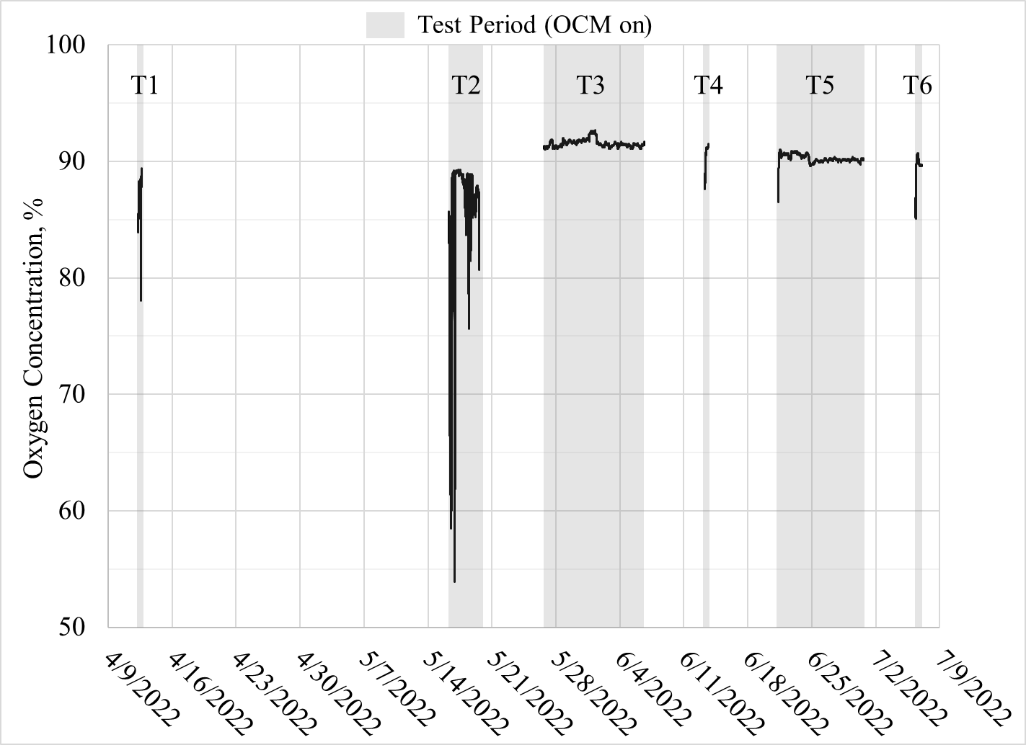
Figure 3: Oxygen concentration data from the oxygen analyzer.
During testing, the team inquired about the observed behavior to the OCM manufacturer as well as expected effects, if any, the manufacturer expected of the device in these conditions. The manufacturer only stated that they could not guarantee performance of the OCM in the challenge environment, but strongly reassured the team that, if the OCM was in fact producing oxygen levels below specifications, the internal oxygen sensor inside the OCM would detect this and the device would sound an audible alarm and flash a yellow or red LED light on the front display of the device. The manufacturer stated that oxygen concentration monitoring is one of the most critical features of the OCM device and is designed to be reliable in medical emergencies. Failure of the OCM to alert users of low oxygen would have catastrophic implications for those utilizing the device for emergency medical use. Upon review of the OCM technical manual, the team identified that alarm code 800, which indicates that the oxygen concentration has been below 85% for more than 60 seconds, would have sounded continuously until levels reached above 85%¹⁴. This alarm sounds every 119 seconds and flashes a yellow LED light on the OCM display. The operators observed the oxygen analyzer indicating oxygen levels below 85% real-time for multiple hours during Test 2 and did not observe this alarm at any point. This indicates that the internal oxygen sensor was reading oxygen values above 85% while the oxygen analyzer was reading values below 85% and further verifies that the oxygen analyzer may not have been functioning properly during Tests 1 and 2 due to a faulty electrochemical cell.
Following Test 2, calibration of the oxygen analyzer produced oxygen values within manufacturer specifications and eliminated the erratic variation observed in Tests 1 and 2. Upon further inspection of data from Test 3 through 6, a slow downward trend of oxygen concentration at a rate of 0.05% per day was calculated. The team considered that this data may indicate a slight degradation in performance of the OCM throughout testing, but also considered the possibility of degradation in the electrochemical cell of the oxygen analyzer. In an electrochemical cell, the current output utilized to make an accurate determination of oxygen concentration requires oxidation of a lead anode. This reaction changes the electrical and chemical properties of the cell over time, which is why most oxygen analyzers require periodic calibration to ensure data integrity. The calibration period for the oxygen analyzer used for this test 1 year, but – based on the limited information in the oxygen analyzer manual – this calibration period does not take into account the levels of oxygen to which the device is exposed. Exposure to higher concentrations of oxygen, like those produced by the OCM, or to trace contaminants in the test environment, may cause the oxygen analyzer to drift at a faster rate.
Following a full assessment of the data, the team concluded that the oxygen levels in the OCM did not fall below 85% during Test 1 and 2, and, when the oxygen analyzer was operating reliably, the OCM was generating oxygen within manufacturer specifications of greater than 90%. The downward trend of the oxygen concentration may be attributed to the OCM or oxygen analyzer, and life-cycle testing of the OCM with a more reliable oxygen analyzing device would produce clearer results.

Trace Contaminant Levels in the OCM Oxygen Product Stream
Compared to levels seen in the test environment, the OCM oxygen product stream contained significantly lower levels of the trace contaminant species. Zero values were seen for ten of the fifteen species, and non-zero values were seen for only five of the fifteen species: acetone, D5, o-xylene, ethanol, and acetaldehyde, as shown in Figure 4. Significant breakthrough only occurred for D5 at levels 0.10 to 0.18 mg/m³. Breakthrough for all other chemicals occurred at concentrations equal to or less than 0.01 mg/m³.
The minimal levels of trace contaminants in the oxygen stream may be due to the chemicals collecting on the zeolite sieve beds in the OCM, where nitrogen molecules are adsorbed. The adsorbed molecules on the beds would then be purged back out into the external environment with the nitrogen molecules via the OCM exhaust¹⁴. This operation is consistent with the test data, which shows no clear relationship between OCM operating periods and levels of trace contaminants in the test chamber. On July 21, 2022, D5 was not detected in the environment but was detected in the product stream, per Figure 4, which indicates that some D5 molecules may have accumulated on the sieve beds early in testing and were released later in the test. There is no additional information from the manufacturer as to why breakthrough of only some chemicals was seen. Some D5 molecules could have permanently accumulated on the zeolite bed, which would help explain the generally low levels of D5 in the environment, though an analysis of the levels of D5 on the OCM sieve beds would need to be performed to verify this.
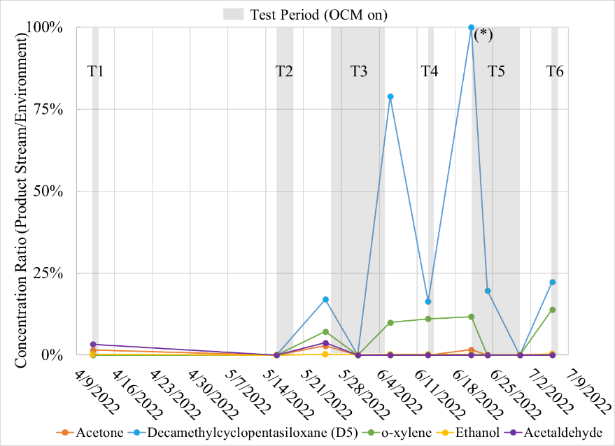
Figure 4: The ratio of trace contaminant concentrations in the product stream to concentrations in the environment. (*) On June 21, 2022, D5 was not detected in the environment, but was detected in the product stream.

Post-Test Assessment of Flow
Following the conclusion of testing, the test team investigated the lower-than-expected 2.1 LPM flow rate readings obtained from the oxygen analyzer. The team first ruled out the possibility of the oxygen analyzer producing erroneous data when it performed nearly identically to an air flow calibration device. Due to these results, all subsequent testing of the OCM flow rate utilized the oxygen analyzer as the flow measurement device.
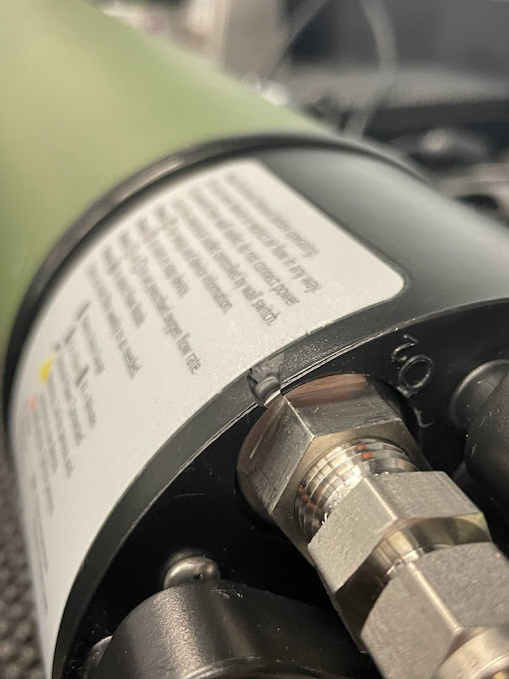
Figure 5: O-ring protruding out of a crack along the OCM.
The team initially completed filter maintenance on the OCM device with no improvement in flow. During the investigation, one of the operators observed a crack in the structure of OCM near where the oxygen port screws into the device. Upon closer inspection of this crack, an O-ring could be seen to protrude out of the structure, per Figure 5.
After observing this, operators proceeded to adjust the torque on the oxygen port fitting and observed that a tighter torque caused the O-ring to protrude out of the crack even further, creating a significant space between the O-ring and the fitting where a gross leak of the oxygen product stream could occur. Operators adjusted the torque on the port fitting to a modest tightness so the O-ring was seated well and as flat against the port fitting as possible. This resulted in a significant increase in flow rate from 2.2 to 2.7 LPM, which indicates that this crack and the resulting O-ring protrusion were the primary cause of the lower than expected flow rates seen during testing.
Operators allowed the OCM to continue to operate after demonstrating this finding and attempted to further seal the observed crack using a variety of other methods, but did not see a significant improvement in flow. According to the OCM manual, in nominal operation of the OCM, oxygen exits the oxygen port at 4 psig¹⁴. Even if the O-ring was properly set and the crack sufficiently sealed, it would be difficult to seal the crack enough to enable the flow at the oxygen port to reach elevated pressures. The cause of the crack was likely a pre-test activity in which polycarbonate structures mounted onto the OCM, which were used to support a previous test configuration, were removed from the OCM to support the test configuration described in this document. This activity required the oxygen port fitting to be unscrewed and removed from the device, which is likely the point at which the break occurred.
Operators reviewed the manual and learned that, if the output flow rate of the OCM reached below 10% of the set flow rate, or 2.7 LPM, an internal flow rate sensor inside the OCM would detect this and the device would activate alarm code 2000, which would sound 2 beeps every 119 seconds and flash a yellow light on the OCM display¹⁴. The operators did not observe this alarm at any point during testing. This indicates that the oxygen analyzer was reading flow rates of 2.0 to 2.1 LPM because part of the flow was leaking through the crack shown in Figure 5. Due to the absence of any alarms during testing, the OCM’s internal flow rate sensor was reading flow rates of at least 2.7 LPM. This was verified by the demonstration of a 2.7 LPM flow rate from the device following adjustment of the torque on the oxygen port fitting.
Although only a partial flow from the OCM was assessed throughout testing, this does not affect trace contaminant and oxygen concentration data obtained from the OCM product stream. The same concentration of gases is expected throughout the flowing volume, as there is no reason to expect selective leaking of any particular species, and test results are still valid.

Conclusions
The OCM was tested for 600 hours out of its 1,000-hour warranty life and continuously produced levels of 85% oxygen or higher at flow rates of 2.7 LPM or higher throughout testing, which indicates reliable operation within acceptable limits, as values below these would activate device alarms. During Tests 3 to 6, when the oxygen analyzer was operating reliably, the OCM generated 90% or higher oxygen concentration and a flow rate of 2.7 LPM or higher, which are within manufacturer specifications of 93 ± 3% oxygen and 3 LPM ± 10%. There were no indications of performance degradation other than a gradual downward trend in oxygen concentration, which may or may not have been due to drift in the electrochemical cell of the oxygen analyzer. Longer duration testing and a more reliable oxygen analyzing method is needed to determine the cause of this trend. The OCM oxygen product stream contained significantly lower levels of trace contaminant species compared to the test environment. Non-zero values were only seen for acetone, D5, o-xylene, ethanol, and acetaldehyde and were still lower than levels measured in the environment. These results show that trace contaminants generally do not concentrate in the oxygen product stream, and, in fact, appear at reduced levels. The OCM appears to remove most trace contaminants from the oxygen product stream while mostly returning the chemicals back to the test environment.
The TGIS demonstrated reliable production levels ISS cabin trace contaminants for most chemicals, and with improvements to the test design and further investigation into the cause of low D5 levels, can further close the gap to replicate all trace contaminants at a less than 20% error.
In future testing of oxygen devices, an oxygen analyzer utilizing laser diode spectroscopy would allow more accurate oxygen measurements to be made without consideration of electrochemical cell drift,. Future tests of oxygen devices should also provide a baseline performance test of the unit to obtain pre-test operational data and better assess post-test behavior. Additionally, more frequent sampling of the test environment is needed to better characterize trace contaminant behavior inside the glove box and provide more information on whether the test article affects the levels of trace contaminants in the environment at any given time.
Future work includes development of medical oxygen requirements to better assess available technologies against the medical oxygen needs for exploration. A trade study will also be performed to assess available oxygen concentrators on the market against these requirements. Testing of the OCM in an alternate mode, called pulse mode, is also being considered, though testing of the OCM in this mode would require a test system that can simulate inspiratory effort and oxygenation through a human body, which may prove difficult. With regard to the TGIS and the supporting test chamber, the test team is considering options for redesigning the test to support lower cabin pressures. The test team is also currently discussing potential use of the TGIS to simulate emergency scenarios and test equipment for other government agencies.

Acknowledgments
The authors would like to thank Edgar Hudson for coordinating the gas sampling analysis, Dr. Moriah Thompson for her recommendations for conducting the testing, Jay Perry and Matthew Kayatin for their contributions to the definition of the challenge environment, and Walt Schneider of the Exploration Capabilities (formally Advanced Exploration Systems) Life Support Project for funding the work effort.

References
¹ O’Dell, S. C. , “Exploration Medical Oxygen Requirements Interim Report,” NASA, MED-TM20-28-003, 2020.
² “Orion Multi-Purpose Crew Vehicle (MPCV) System Requirements Document,” NASA, MPCV 7200.
³ Soto, L. F., “Medical Oxygen Phase I Test Results,” NASA, CTSD-ADV-1687, 2020.
⁴ Gorrebeeck, D. A., “Touch Temperature Re-Test for the SAROS Oxygen System,” NASA 20-TPS-00070512, 2021.
⁵ Gorrebeeck, D. A., “Battery Life Evaluation for the SAROS Oxygen System in KBR SDL,” NASA 20-TPS-00066312, 2021.
⁶ Gorrebeeck, D. A., “Acoustics Engineering Evaluation Test and Return for the SAROS Oxygen System in JSC B241,” NASA 20-TPS-00066230, 2021.
⁷ Hoyt, T. N., and Boone, A. J., “SAROS Portable Oxygen Concentrator Acoustic Engineering Evaluation,” NASA ANCL-20-0288, 2020.
⁸ Gorrebeeck, D. A., “Thermal Cycle Engineering Evaluation for the SAROS Oxygen System in the KBR SDL,” NASA 20-TPS-00069987, 2021.
⁹ Gorrebeeck, D. A., “Humidity Functional Engineering Evaluation on the SAROS Oxygen System,” NASA 20-TPS-00070194, 2021.
¹⁰ Gorrebeeck, D. A., “Low Pressure High Oxygen Engineering Evaluation on the SAROS Oxygen System,” NASA 20-TPS-00075345, 2021.
¹¹ Gorrebeeck, D. A., “Engineering Evaluation Report: SAROS Low Pressure Elevated Oxygen Test”, accompaniment to NASA 20-TPS-00075345, 2021.
¹² Gorrebeeck, D. A., “SAROS Oxygen System Engineering Evaluation HFIT,” NASA 20-TPS-00066285, 2021.
¹³ Widjokongko, A. M., and Russi-Vigoya, N., “SAROS Preliminary Human Factor Implementation Team (HFIT) Evaluation Memorandum,” NASA HFIT-20-032, 2020.
¹⁴Saros Oxygen System Operator & Service Manual 9735-SEQ H, Caire, Inc., 2019.
¹⁵ Perry, J. L., “Confirmation of Trace Contaminants with for [sp] LDST EDU,” electronic communication, June 27, 2018.
¹⁶ Perry, J. L., and Kayatin, M. J., “Trace Contaminant Control Design Considerations for Enabling Exploration Missions,” 45th International Conference on Environmental Systems, ICES 2015-108, Bellevue, Washington.
¹⁷ Kayatin, M. J., “Trace Chemical Cocktail,” electronic communication, February 3, 2016.
¹⁸ Kayatin, M. J., “Is D3 + alcohol + water a bad combination,” electronic communication, May 11, 2016.
¹⁹ Ryder, V. E., “Spacecraft Maximum Allowable Concentrations for Airborne Contaminants,” NASA, JSC 20584 Revision B, 2022.
²⁰ Romoser, A., “Interim 7-d and 180-d SMAC for 1,1,1,2-Tetrafluoroethane,” NASA, 811-97-2, 2018.
²¹ Soto, L. F., “Test Readiness Review Board (TRRB) for Trace Contaminant Testing,” PowerPoint, 2021.
²² Safety Data Sheet for “Hexamethylcyclotrisiloxane, 90% - SIH6105.0”, Gelest, Inc., 2008.
²³ Safety Data Sheet for “Hexamethylcyclotrisiloxane – P/N 235687,” Sigma-Aldrich, Version 6.2, 2021.
²⁴ Osthoff, R. C.; Grubb, W.T.; and Burkhard, C. A., “Physical Properties of Organosilicon Compounds. I. Hexamethylcyclotrisiloxane and Octamethylcyclotetrasiloxane,” J. Am. Chem. Soc., 1953, 75, 9, 2227-2229.

Air Revitalization Engineer, Life Support Systems Branch, 2101 NASA Pkwy Mail Stop EC3, Houston TX 77058. ² Air Revitalization Engineer, Life Support Systems Branch, 2101 NASA Pkwy Mail Stop EC3, Houston TX 77058. ³ Air Revitalization Lead, Life Support Systems Branch, 2101 NASA Pkwy Mail Stop EC3, Houston TX 77058.

