Crew Earth Observations: New Tools to Support Your Research
Kenton R. Fisher¹, Sara Schmidt², Alex Stoken², and the Earth Science and Remote Sensing team¹, ¹NASA Johnson Space Center, Houston, Texas, ²Jacobs Technology, NASA Johnson Space Center, Houston, TX, USA.

The collection of astronaut photography hosted on the Gateway to Astronaut Photography of Earth (GAPE, eol.jsc.nasa.gov) forms one of the most extensive historical compilations of Earth remote sensing data sets available to researchers and the public. The GAPE database contains astronaut photography spanning all manned NASA spaceflight missions over the past 60 years and continuing to this day with operations on the International Space Station (ISS). The continuous crew presence in low Earth orbit (LEO) on the ISS for the last 22+ years and the advent of digital handheld cameras has resulted in an exponential increase in astronaut photography, growing the GAPE collection to over 4.5M photographs (Figs. 1 and 2). This increase in astronaut photography of Earth has corresponded to a significant increase in interest in the collection by the research community and the public. The Earth Science and Remote Sensing (ESRS) group at Johnson Space Center, which manages Crew Earth Observations (CEO) from the ISS, has been developing multiple new tools to improve the GAPE database so that users can more quickly find the imagery they need. The three major enhancements to GAPE are: a new API to interface with the database, a method for automatically georeferencing ISS photos (Fig. 3), and a new tool for automatically generating timelapse movies.
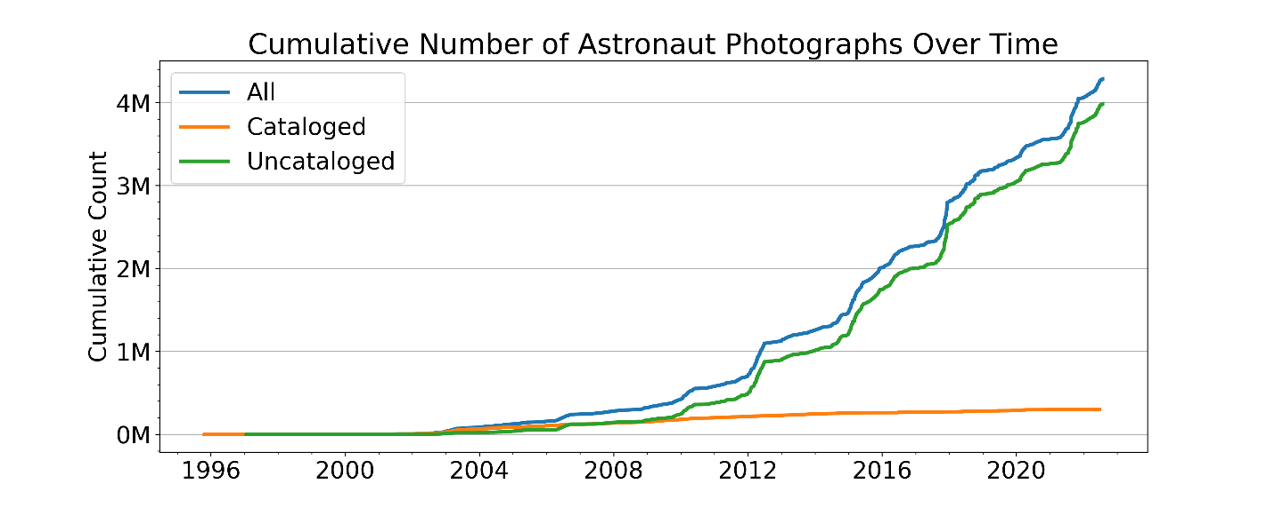
Figure 1: Growth of the astronaut photography collection over the last three decades. Cataloged photos are those that have associated center point and georeferencing data associated with the photo. The automated georeferencing algorithms developed by ESRS is working to close the gap between cataloged and uncatalogued images.
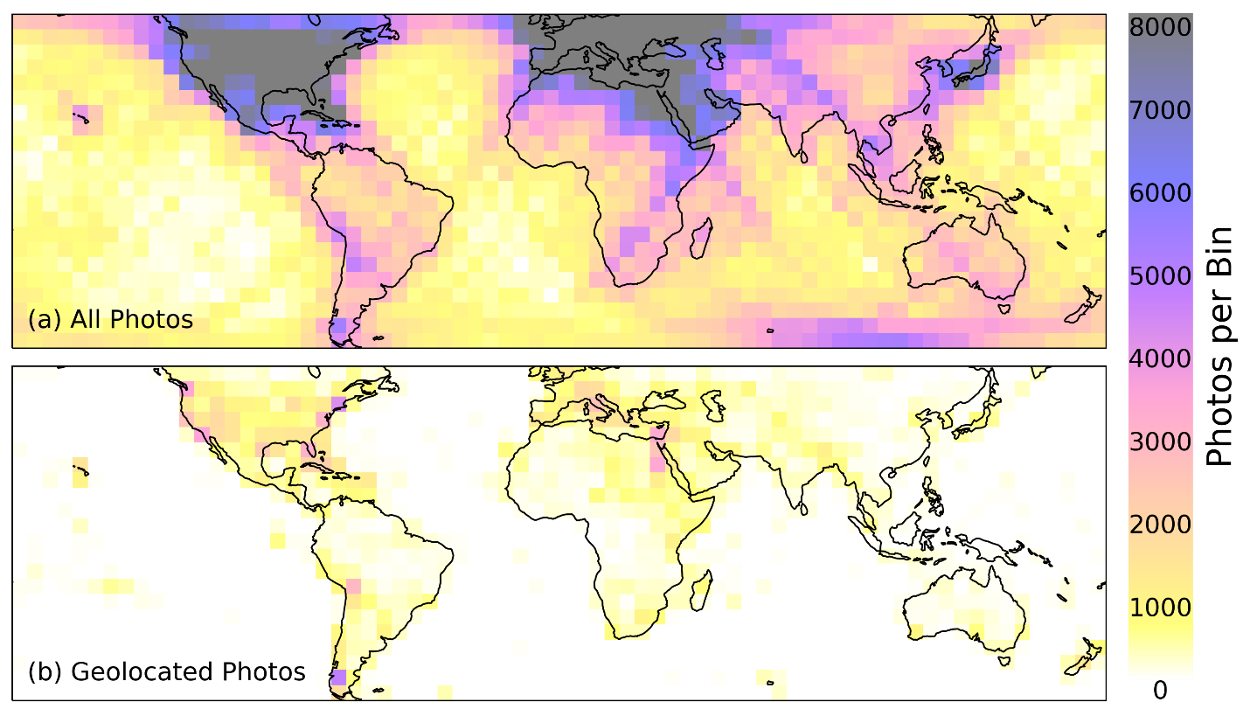
Figure 2: (a) Geographic distribution of astronaut photographs from the ISS. (b) Distribution of georeferenced (cataloged) photos. The number of cataloged images is significantly smaller due to the manually intensive process of georeferencing. The development of our auto georectification algorithms has significantly improved the process and has allowed us to catalog over 30k photos without any manual work. This tool will rapidly increase the number of cataloged photos on GAPE.
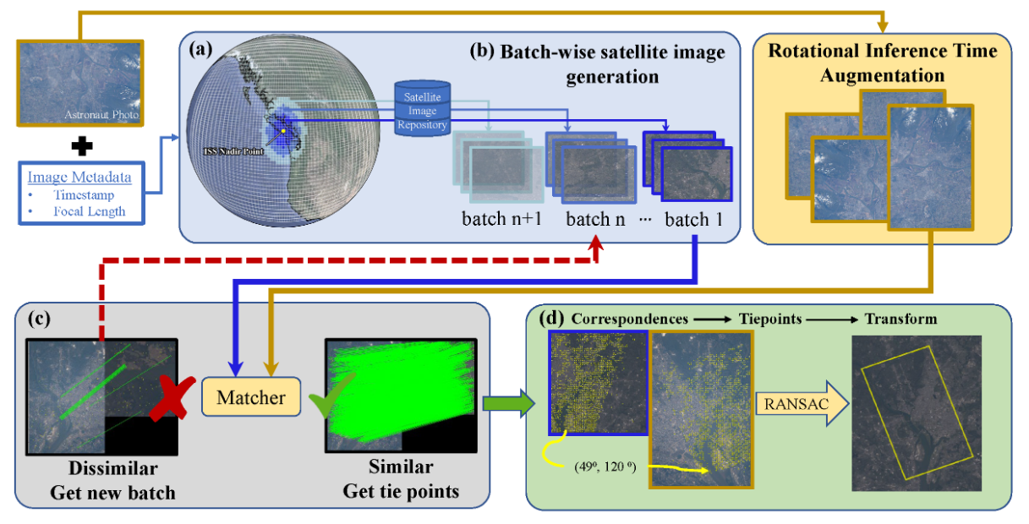
Figure 3: The Find My Astronaut Photo automated georeferencing pipeline. (a) From image metadata, we determine the ISS nadir point and discretize the Earth area visible from the ISS into a grid. (b) We produce satellite images covering the corresponding area of each grid patch from a satellite repository. (c) The astronaut photo and satellite image are put through a matcher. If the pair meets the match criteria, we move to (d), else return to (b) to generate more images. In (d), high confidence geometrically verified keypoint matches are used as tie points to georectify the astronaut photo.

