Shoshone River Water Resources II
Quantifying Sediment Input in the Shoshone River in Wyoming using the Soil and Water Assessment Tool for Enhanced Water Quality Monitoring


Technical Report
March 30th, 2023

Robyn Holmes (Project Lead)
Christian Bitzas
Jillian Greene
Isabella St John

Advisors:
Dr. Austin Madson, University of Wyoming

Previous Contributors:
Cassie Ferrante
Nelson Lemnyuy
Will Campbell

Fellow:
Caroline Williams (Pop-Up Project)

1. Abstract
The Willwood Dam, an irrigation diversion dam located on the Shoshone River (Wyoming, USA), has faced ongoing issues with sediment accumulation and needs frequent sediment flushing to remain operable. However, high suspended sediment levels during flushing events have negatively impacted downstream aquatic ecology and recreational opportunities. To address these problems, DEVELOP partnered with the Wyoming Department of Environmental Quality, Shoshone River Partners, and United States Geologic Survey. During term one, the team developed a workflow to map turbidity using PlanetScope imagery, analyze time series precipitation data, and create landcover maps. For this term, we focused on three methods to gain a better understanding of sediment sources: 1) improving remote sensing of turbidity, 2) modeling sediment transport within the watershed using the Soil and Water Assessment Tool (SWAT), and 3) conducting a snow cover time series analysis using Suomi NPP VIIRS imagery. Through remote sensing, we found Dry Creek/Homesteader Creek and Penney Gulch/Rough Gulch had the highest concentration sediment plumes. The SWAT+ model created a high-resolution grid model of the watershed, identifying high sedimentation in the western and southern subbasins but displayed low-correlated calibration and validation results due to limited observed data. We analyzed the snow cover extent alongside other hydrologic variables and found that snow melt events correlated with increases in suspended sediment concentration and turbidity values. Coupling remote sensing with hydrological modeling will give watershed managers a new perspective on high-priority regions for implementation of remediation to reduce the sediment build-up at the Willwood Dam.

Key Terms
Suspended Sediment, Turbidity, SWAT+, PlanetScope, Snow Cover, Suomi NPP VIIRS, Shoshone River, Tributary

2. Introduction
2.1 Background Information
The Shoshone River headwaters are located in northwestern Wyoming, flowing northeast through Cody, WY before joining the Big Horn River west of the Big Horn Mountain range. The Shoshone River encompasses several dams, including the Willwood Dam located southwest of Powell, Wyoming. The Willwood Dam is an irrigation diversion dam that influences the regional agricultural economy and culture. Since the dam’s construction, sediment has been collecting in the reservoir behind the dam. To prevent issues with the dam’s operation, the sediment is routinely released downstream where it negatively impacts water quality due to increasing the downstream sediment levels and turbidity. This increase in water turbidity damages the watershed’s ecology and negatively affects aquatic biota.

To help alleviate these negative effects to the aquatic ecology, this project strives to better understand the specific basins of sediment input and subsequent build up. Identifying high priority subbasins can help develop concentrated solutions to help reduce the amount of sediment building up behind the Willwood Dam. The study area for investigating these subbasins begins at the Buffalo Bill Dam, located west of Cody, Wyoming and extends downstream to the Willwood Dam, located southwest of Powell, Wyoming (Figure 1). Our project looks at data from January of 2019 to October of 2021. This study period was chosen to align with turbidity and streamflow data availability from a temporary water monitoring station within the study area.

During the first term of this DEVELOP project, the team performed a preliminary turbidity analysis for the study area. A land cover analysis was implemented to determine land cover percentages in each subbasin. A precipitation time series analysis revealed a one-day lag time produced the best correlation between daily rainfall and turbidity. Furthermore, the previous term utilized PlanetScope imagery to calibrate a sediment index that mapped relative turbidity along the river. This allowed sediment plumes to be identified visually, which laid the groundwork for future sediment index refinement and spatial turbidity analysis. Additionally, it can reduce the need to collect in-situ data though it is important to note that the temporal resolution is limited by both the revisit period of the satellite and by cloud cover.
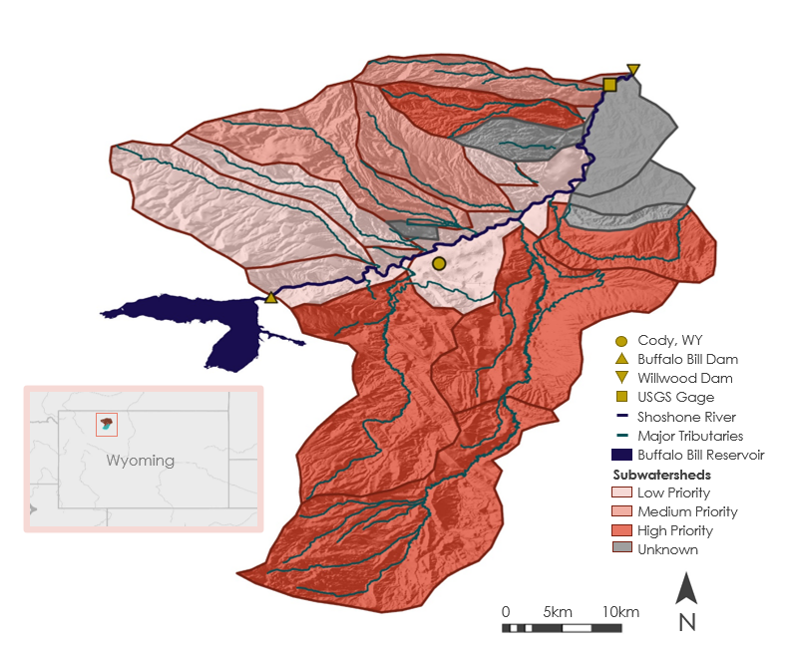

Image Credit: Inlay basemap courtesy of Esri, HERE, Garmin, FAO, NOAA, USGS, & EPA.
Figure 1. Map of the study area. The color of the watersheds indicates the priority level as determined by Willwood Working Group 3/Shoshone River Partners.

This term, we expanded on past work by refining the sediment index to be more quantitatively accurate and further spatially analyzed turbidity plumes. We also analyzed snow cover and snowmelt as a time series, comparing snowmelt events to concurrent weather and trends in turbidity. Finally, we used SWAT+, a newer release of SWAT, to spatially model streamflow and sediment discharge with a high spatial resolution.

2.2 Project Partners & Objectives
For this project we partnered with the Wyoming Department of Environmental Quality (WYDEQ), Shoshone River Partners, and the USGS Wyoming-Montana Water Science Center. These partners have been involved with various sediment monitoring, data analysis, policy improvement, and watershed management since the 2016 sediment release. Their current understanding of sediment dynamics relies on discrete in-situ turbidity measurements taken in the Shoshone River & select tributaries, along with timelapse photography and personal observations.

The overarching goal of their partnership with DEVELOP is to gain an improved understanding of sediment dynamics within the study area. The results of this feasibility study will help our partners (and other regional stakeholders) select areas to continue implementing best management practices (BMPs), inform improved dam operation decisions, and increase community understanding of sources and factors influencing excess sedimentation. Additionally, the partners are interested in improving their understanding of turbidity remote sensing methodologies that could be applied to issues in other areas of the state or region.

We identified three main objectives that will further the current knowledge of sediment dynamics within the study area. First, we sought to build upon the turbidity remote sensing that started during the first term of the project by improving the reliable turbidity mapping and plume detection methods. This will help decision makers identify tributaries contributing sediment to the Shoshone River. Second, we applied the SWAT+ model to model sediment input on a subbasin level which will allow the partners to determine high-priority areas of remediation. Our final objective was to investigate snowmelt-influenced turbidity spikes by analyzing the relationship between remotely sensed snow cover, weather, and turbidity.

3. Methodology
Suspended sediment alters the reflection profile of a water body, generally causing the greatest increase in reflectance percentage of red and near-IR bands (Lacaux et al. 2007). This change in reflectance can be mapped to an approximate turbidity value, however, the relationship varies based on sediment in region and imagery source. Therefore, study area-specific calibration greatly improves the ability to accurately model turbidity (Pierra et al., 2019). Turbidity calibration can be achieved by optimizing the regression fit of single- or multi-band equations (Pierra et al., 2019; Hughes et al., 2021; Hossain et al., 2021). Recently, machine learning methods such as a random forest have been used to accurately map turbidity (Umar et al., 2017; Duan et al., 2022; Ma et al., 2021). This process incorporates the supervised learning of multiple decision trees to create a “forest”. This method of supervised machine learning has seen success in remote sensing when compared to other machine learning methods (Ma et al, 2021).

In order to accurately sense turbidity, the Earth observation (EO) pixel size must be smaller than the width of the body of water. Historically, most EO applied to turbidity sensing had a resolution of 20-30m, however, recent advancements in high spatial and temporal resolution datasets through the rise of the commercial smallsat has expanded potential application areas to smaller bodies of water (Mansaray et al. 2021). While high spatial and temporal resolution data can come at the cost of lower spectral resolution, 4-band smallsat data has proven sufficient for turbidity monitoring at a quality as good or better than Landsat 8 Operational Land Imager (OLI) or Sentinel-2 MultiSpectral Instrument (MSI) (Mansaray et al., 2021). Higher resolution imagery has allowed for sediment plume monitoring for river tributaries, as demonstrated in Hughes et al. (2021), where landslide-generated sediment plume extent and suspended sediment concentration was analyzed temporally in the Peace River (British Columbia, Canada) using PlanetScope (3m) and RapidEye (5m) imagery. Previously, satellite imagery has not been used to detect turbidity on a river as small as the Shoshone (approximately 30m wide). Furthermore, we were unable to find any studies that used satellite imagery to identify tributaries contributing a high sediment load to a river.

Additionally, the SWAT+ model analyzes a myriad of hydrological variables on a subbasin and Hydrologic Response Unit (HRU) level (Beiger et al., 2016). This allows users to determine specific regions within a watershed that have higher or lower levels of streamflow or pollutant transport (Beiger et al., 2016). The utilization of SWAT+ requires limited data inputs and can process varying levels of spatial resolution permitting users to assess previously difficult-to-access watersheds (Abbaspour et al., 2007; Beiger et al., 2016; Grusson et al., 2015). The application of SWAT+ in this study determines subbasins with an elevated sediment input causing the build up at the Willwood Dam. At base level, SWAT+ requires only a Digital Elevation Model (DEM) and soil, land cover, & climate data to run (Beiger at al., 2016). The data inputs and processing set up can be further manipulated and cross-examined with pre-existing datasets for calibration and validation of the model. For this study, there will be an emphasis on simulating snow cover and snowmelt in the Shoshone River Watershed and its impacts on sediment transport. Numerous prior studies have analyzed the success of modeling snowmelt in SWAT+ and will be used to develop the methods of this paper (Grusson et al., 2015; Peker and Sorman, 2021; Pradhanang et al., 2011; Troin and Caya, 2013; Tuo et al., 2018).

Finally, time series analyses have been used as a tool in water resource management as a way to visualize quantitative data over a successive time period, which allows for the observation of correlated hydrologic factors such as precipitation events, fluctuations in turbidity, discharge, etc. (Xie et al., 2021; Rosenquist et al., 2010). To gain a better understanding of the temporal aspect of sediment contributions into the Shoshone River, this study will utilize six datasets in time series over the study period (January 2019 - October 2021), consisting of: discharge, suspended sediment, turbidity, precipitation, surface temperature, and snow cover. Snow cover is the principal variable being analyzed in this study, as snowmelt is a critical factor that influences hydrologic conditions and is considered to contribute significantly to sediment input into river systems due to surface runoff (Wu et al., 2018).

3.1 Data Acquisition
Sediment remote sensing relied on pairing in-situ turbidity measurements with high resolution imagery (Table C1). For remotely sensed turbidity analysis, we downloaded PlanetScope imagery taken within our study period from the Planet Explorer web portal. The specific product was Analytic Ortho Tile, which has undergone sensor and radiometric calibration, georectification, normalization, & resampling; has been merged into 25km tiles; but has not undergone atmospheric corrections. We also downloaded the corresponding usable data masks (UDM2 files) which are multiband rasters created by Planet using supervised machine learning to identify pixels as clear, cloud, snow, or haze.

With the small scale of the river and watershed, observed hydrological data was only available at one USGS station located above the Willwood Dam near Ralston, Wyoming. This USGS station recorded stream discharge data between October of 2018 and October of 2021. The suspended sediment concentration flowing through the river was also recorded starting March of 2019 and ending in October of 2021. This In-situ turbidity was provided by our project partner at the United States Geological Survey (USGS).

The SWAT+ model operates on elevation, soil, land cover, and climate data which are listed in detail with source, spatial resolution, and dates in Table A1. We used GPM IMERG precipitation data as a cross comparison dataset with the GridMET data. Due to the higher spatial resolution, full coverage of the time period, and processing method (PRISM), we decided to proceed with GridMET for this study region (Duan et al., 2022). For SWAT+ sensitivity and uncertainty analysis, observed streamflow and sediment data was acquired from USGS’s National Water Information System.

For the snow cover analysis, our team downloaded raster images from Suomi NPP VIIRS product VNP10A1F for the entire study period – January 1, 2019, to October 31, 2021. VNP10A1F is a snow cover product which uses the Normalized Difference Snow Index (NDSI) to detect snow cover, as well as a cloud-gap-filled algorithm to estimate snow cover that may exist under cloud cover.

3.2 Data Processing
3.2.1 Sediment Remote Sensing Data
We used the software ACOLITE to apply Dark Spectrum Fitting (DSF) atmospheric corrections to top of atmosphere images (Vanhelenmont & Ruddick, 2018). DSF is an atmospheric correction algorithm developed to be used meter- and decameter- scale imagery of turbid waters. It bases corrections off the minimum reflectance, assuming something in the image has very high absorption (usually near-infrared (NIR) band over water, but not always). This allowed us to estimate PlanetScope bands in terms of marine reflectance. We utilized PlanetScope to mask clouds, shadows, snow, and haze. Band 7 of the usable data mask (UDM2) gives a percent confidence in the pixel classification of which we only used pixels with >95% confidence. We removed land pixels by using Otsu’s method (Otsu, 1979; skimage.filters.threshold_otsu), an algorithm designed to find the value that will minimize intraclass variance between two-pixel classes, to find a threshold value for each image based on the Normalized Difference Water Index (NDWI). We used an alternate NDWI defined by McFeeters (1996) as:

$$NDWI = \frac{\left(Green-NIR\right)}{\left(Green+NIR\right)} (1)$$

In addition to NIR reflectance, this equation utilizes the Green reflectance band. To separate the land pixels, we set all pixels below the NDWI threshold to be land and masked them. Each image was finally clipped to the study area.

We further extracted average red, green, blue, and NIR values from each image at the location of the USGS monitoring station, using the ‘rasterstats.zonal_stats’ function in Python. We merged this data with 15-minute in-situ turbidity measurements then used this dataset to calibrate multiple equation options and train a random forest machine learning algorithm. We found the relationship between reflectance and turbidity weakened during the winter months (Figures C2 and C3), so only May 1st – October 31st was used for calibration. Machine learning was able to classify winter turbidity, so all dates were used. We calibrated four single-band and four double-band equations, iterating through all possible band combinations for a total of 64 equations calibrated. Data was split 50-50 into calibration and validation sets, sorting by descending magnitude of in-situ turbidity and then sending even indices (zero-based) to calibration and odds to validation. We used a global optimization algorithm (scipy.optimize.basin_hopping with 3000 iterations and a step size of 1000) to adjust equation parameters that minimized the root mean square error of the modeled vs measured turbidity. The best performing equation we found to be:

$$\begin{aligned}\text{Turbidity=}{\text{e}}^{\text{a*Red+b}} \#\left(2\right)\end{aligned}$$

Where a and b are calibrated coefficients with values of 277811.5 and 1.410944, respectively, Red is red band reflectance, and Turbidity is in units of Formazin Nephelometric Unit (FNU). This equation resulted in an R2 of 0.977 for calibration, 0.737 for validation, and 0.850 for all data. The Nash-Sutcliffe Efficiency (NSE, a measure of fit for time series datasets) for all data was 0.803 and the Kling-Gupta Efficiency (KGE) was 0.801. The DSF atmospherically corrected images with this equation provided a far better fit than the previous term, especially at turbidity values below 30 FNU. The equation was a significant improvement over last term, especially in reducing an overestimation bias for low turbidity values (Figure C4).

We used Python’s Scikit library (sklearn.ensemble.RandomForestClassifier) to create a random forest machine learning model to process turbidity data. Using the random forest, we trained the model with 135 data points. Parameters for training the model include 1000 trees, a validation ratio of 20% (34 data points), and a random state-run seed of 15. The trained model provided an R2 value of .929 for validation data, and .917 for the entire training dataset. To achieve these R2 values, the model determined the importance of each band used in its training. The bands ranked by their percentage of importance for training are: Red (42.9%), NIR (27.2%), Green (17.7%), and then Blue (12.1%). A comparison of the observed and predicted turbidity values with a 1:1 line can be seen in Figure D1.

For predicting turbidity using the model, we compiled four-band rasters into a dataset where they are rolled into a 1D array for simple and linear processing. The output of the model consists of a 1D array of turbidity values which can be combined to create a single band raster with its pixel values being the values of the predicted turbidity.

3.2.2 SWAT+ Model Data Processing
The GridMET climate variables required processing and formatting to be input into SWAT+. We converted temperature files from Kelvin to Celsius, solar radiation from W/m2 to MJ/m2, and we averaged the maximum and minimum relative humidity variables to obtain one mean value in order to match SWAT+’s specification. We converted the climate data from the native NetCDF format to separate txt files for the respective station locations.

We downloaded the SWAT+ soil data from the Wyoming gSSURGO geodatabase and converted the data from shapefiles to rasters using QGIS 3.26.3 following instructions from George (2020). Some of the gSSURGO soil data in Wyoming is unknown; therefore, we reclassified areas with unknown soils to the most frequently occurring soil type in the study region. Subsequently, we created a land cover look-up table based on NLCD values and their respective SWAT+ code. As the Shoshone River Watershed study region consists of primarily rangeland with very little agriculture; therefore, the land cover type was not split by crop grown. Finally, we exported all raster datasets in the WGS 1984 UTM Zone 12N coordinate system.

For the SWAT+ model, in utilizing SWAT+ over SWAT, we used a grid model to analyze high spatial resolution basins (Figure A1). Each grid cell was 500m which produced 4636 subbasins and 7467 HRUs. We used four elevation bands to more accurately analyze climate above 1500m (Grusson et al., 2015, Abbaspour et al., 2007; Tuo et al., 2018).

3.2.3 Snow Cover Time Series Data Processing
In order to estimate snow cover only within the study area, we clipped the raster images to the watershed boundary. We further divided the watershed into two regions, where the ‘NW watershed’ represents the area northwest of the Shoshone River and the ‘SE watershed’ represents the area southeast of the Shoshone River (Figure B1). The VNP10A1F (VNP) images were also clipped to these two regions. The division of the watershed at the Shoshone River was done to analyze the snow cover spatially as well as temporally, in order to discern differences in snow cover percentage on either side of the watershed.

We calculated the percentage of snow-covered pixels in the study area by first reclassifying pixel values as: 0 = ‘No Snow’, 10-100 = ‘Snow’, and >201 = ‘No Decision’ and then finding the percentage of ‘Snow’ from the total number of pixels in the watershed or side-of-watershed. This is a similar reclassification method used by Riggs and Hall (2020), which is based on the pixel NDSI parameter values in the VNP user guide. We then exported the resulting percentage values as a table with the assigned date, representing the percentage of snow-covered pixels. Similarly, we exported the climate and stream data to a data table with the corresponding date.

3.3 Data Analysis
3.3.1 Sediment Remote Sensing Analysis
To spatially analyze remotely sensed turbidity, we drew a river centerline and created points at 10m intervals along the line (Figure 2a). This point shapefile was then used to extract turbidity values along the river reach for each image, again using rasterstats.zonal_statistics. This data was plotted as turbidity over distance and spikes in turbidity. This helped in identifying potential sediment plumes though both manual interpretation and an automated algorithm (Figure 2b). For manual interpretation, plots were reviewed and images with a spike in turbidity that was sustained above 25 FNU were marked for review (Figure C1). These turbidity images and the corresponding RGB images were then inspected, especially near the location of the plume, to confirm plume presence and record which tributary was responsible.

Since manual plume detection is time consuming, we also developed an automatic possible plume detection algorithm to supplement the sediment plume analysis. This method of automatic plume detection utilized the machine learning turbidity predictions that have had the zero values filled via interpolation and filtered using a 3rd order Savitsky-Golay filter. This provided clean and smooth data that could be plotted based on downstream distance (Figure D3). To automatically detect possible plume events, a threshold of 50 units of turbidity over the course of 1km after each tributary was set. If the threshold was met, the tributary was labeled as a possible sediment plume event (Figure D4).

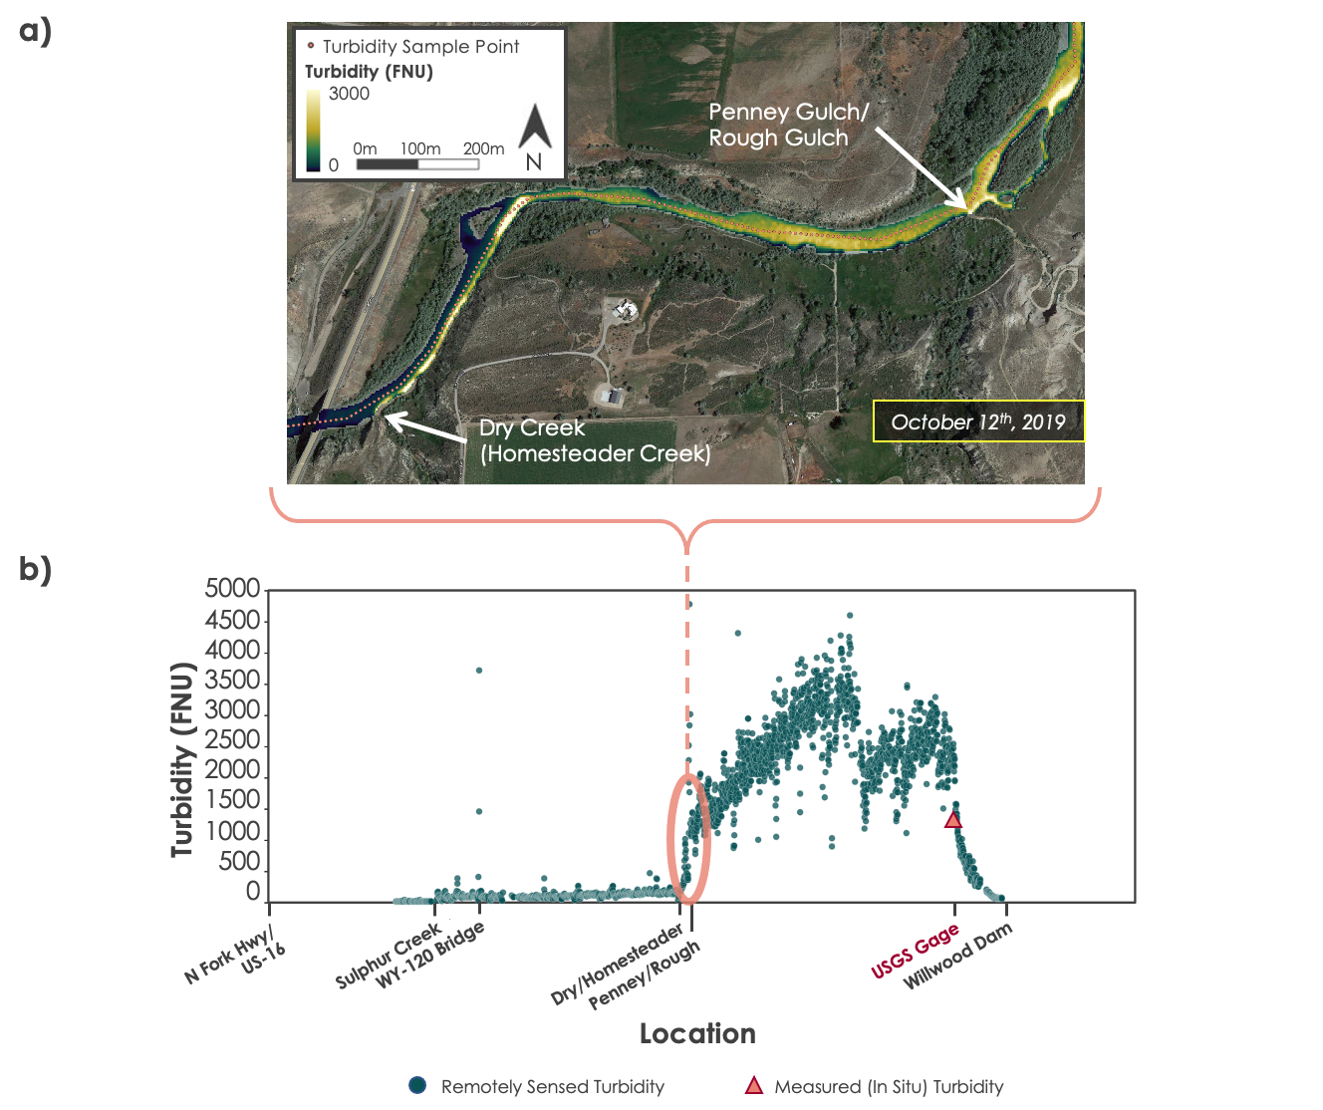

Figure 2. a) Displays remotely sensed turbidity plumes spatially near Dry Creek
(Homesteader Creek) and Penney Gulch/Rough Gulch. Low turbidity is dark blue and high turbidity is pale green. The dots along the river centerline indicate locations of pixels extracted to plot turbidity longitudinally across the study area. The pale, yellow-colored hotspots (high turbidity) indicate plumes with a concentration well over 1000 FNU coming from both Dry Creek (Homesteader Creek) and Penney Gulch/Rough Gulch. Image Credit: Google Hybrid basemap, turbidity layer derived from PlanetScope imagery. Includes copyrighted material of Planet Labs PBC. All rights reserved. b) Shows remotely sensed turbidity along the length of the study area for October 12th, 2019. The pink oval points out the beginning of a sustained spike in turbidity and approximately corresponds with the map shown in (a). The turbidity value measured at the USGS gage is plotted as a pink triangle and is reasonably close to the remotely sensed values in that area of the river.

3.3.2 SWAT+ Model Calibration
To calibrate the SWAT+ model and conduct an uncertainty analysis, we used R-SWAT, an open-source sensitivity analysis and auto-calibration tool compatible with the SWAT+ model. Calibration parameters included streamflow and measured sediment flowing through the river which were calculated using the USGS station data. These variables were compared to the SWAT+ model’s estimates and other parameters were altered to improve accuracy.

Ten SWAT+ parameters were chosen for calibration based on their relevance to the observed data and desired sediment input location results (K_USLE, CN2, SPCON, SURLAG, CHK, ALPHA, SPEXP, SNOFALL_TMP, SNOMELT_TMP, and SLOPE). We conducted a sensitivity analysis of these ten parameters to determine which parameters were most influential on the observation data (streamflow and sediment). Using the Uniform Latin Hypercube Sampling method, sensitivity analysis is done with a global approach to parameter sensitivity. P-values of the ten parameters are listed and ranked in Table A2 displaying which results were the most influential on the model output.

3.3.3 Snow Cover Time Series Data Analysis
Data for the six relevant variables (discharge, suspended sediment, turbidity, precipitation, surface temperature, and snow cover of the NW and SE portions of the watershed) were compared to snow cover of the whole study area and analyzed using time series analysis graphs (Appendix B). The time series graph is a tool that enables watershed partners to understand how different hydrologic inputs impact the river system as a whole and influence watershed dynamics, which can be used to manage the watershed and alleviate negative impact to the Willwood Dam and downstream conditions. The time series graphs visually correlate the six variables across time, where each line represents the value of a different variable throughout the study period (such as FNU) while columns represent the percentage value of snow-covered area for the duration of the study period. Several figures were produced for this time series analysis and inspected in order to compare these variables against the percentage of snow-covered pixels and identify any trends that may occur.

4. Results & Discussion
4.1 Analysis of Results
4.1.1 Sediment Remote Sensing
We were able to accomplish reliable turbidity estimation with remotely sensed data though both equation calibration and machine learning training. Machine learning produced a better turbidity relationship, especially during winter months. An example comparison between both methods can be seen in Figure D2. While machine learning script development and model training were time efficient, processing each image took around 10 minutes which caused time limitations during this short-term feasibility study. In this case, there was a straightforward relationship between red band reflectance and turbidity which made it easy for us to achieve relatively accurate results using an exponential equation (Equation 1). The ability to look at turbidity at this spatiotemporal resolution is a new method for both the study area and rivers this narrow. This is significant because it enables pinpointing of high turbidity locations in areas that may be costly or difficult to monitor otherwise.

Our spatial analysis of turbidity, using the calibrated red band equation, allowed us to map turbidity along the Shoshone River (Figure 2). Manual interpretation of longitudinal turbidity plots and images revealed Dry Creek/Homesteader Creek, Penney Gulch/Rough Gulch, and Sulphur Creek to be tributaries that most frequently caused high turbidity loading to the Shoshone River. Dry Creek/Homesteader Creek and Penney Gulch/Rough Gulch in particular caused a particularly turbid plume with turbidity over 1000 FNU on October 12th, 2019. While Dry Creek (Homesteader Creek) was indicated as a high priority on the Shoshone River Partners’ StoryMap “Sediment Watershed Plan for the Shoshone River from Buffalo Bill Reservoir to Willwood Dam”, Penney Gulch/Rough Gulch was listed as unknown. This information can inform future partner decisions for further monitoring or exploration of causes and BMPs to implement in the future.

In addition to our manual spatial analysis, the automatic sediment plume event detection found 31 possible plume events, with plumes occurring on 20 of 387 days analyzed. More images were available to analyze, however due to time constraints with pre-processing, we were not able to analyze all the days during our study period. Sulphur Creek and Cottonwood Creek had the highest frequency of auto-detected plumes (Table C2). We were unable to validate this automatic plume detection method due to time constraints, but the input data was from the more accurate machine learning prediction model and was also filtered to reduce noise which helps in identifying an increase in turbidity.

While remote sensing proved to be an extremely useful additional knowledge pathway during summer months, one thing we learned during this project is that the calibrated reflectance-turbidity relationship is unreliable during the winter (Figure C2, Figure C3). This may be due to snow or ice reflectance, low water levels, or phytoplankton/algae. This limits this method’s ability to accurately analyze sediment plumes due to snowmelt. However, machine learning seems to be far more capable of handling winter months. (Figure D1) Additionally, we found that for many rain events, PlanetScope was unable to capture the runoff response due to clouds blocking imagery. This should be kept in mind as it may bias the results. Since turbidity events are relatively infrequent, a small sample size from limited years of available data may also bias results. Additionally, it is difficult to distinguish plumes downstream of other plumes (turbid tributary entering an already turbid river), so there may be a bias against detecting plumes further along the Shoshone River using remote sensing. It is also difficult to identify small plumes in general because of reflectance variance from rapids, unmasked land or sand bars (due to NDWI masking errors), and aquatic vegetation/algae may cause interference and need to be excluded going forward.

4.1.2 SWAT+ Model Results
We used the SWAT+ model to analyze sediment input on a channel-by-channel level in order to determine the tributaries contributing the most sediment into the Shoshone River. The SWAT+ model attributes a significantly higher than average input of sediment in the northern portion of the Shoshone River, moving towards the Willwood Dam (Figure 3a). The lateral soil flow into channels output of the SWAT+ model corroborates the sediment flow results, attributing high soil flow into channels in the regions of high sediment input through channels (Figure 3b). Both outputs identify western and southern subbasins as areas of high sedimentation into tributaries as well as one area of concern in the northern portion of the Shoshone River moving towards the Willwood Dam. This data will point watershed managers to the high priority areas for environmental remediation to reduce the harmful impacts of sediment build-up at the Willwood Dam.

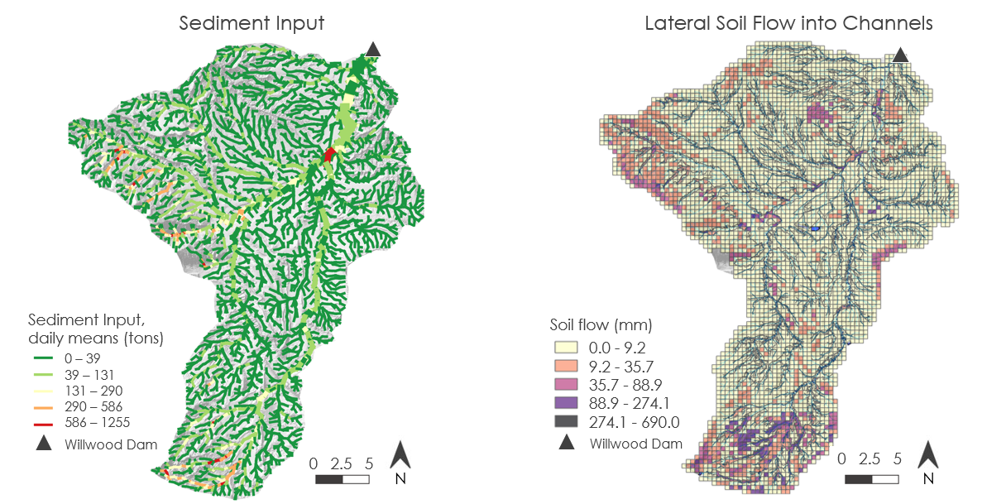
Figure 3. a) Left: SWAT+ model output; daily mean sediment input results by channel, b) Right: daily mean lateral soil flow into channels.

We also utilized the SWAT+ model to examine snow parameters and their potential influence on sedimentation into channels. SWAT+ analyzes snow fall temperature, snowmelt temperature, and snow water equivalents to calculate outputs such as mean annual snow or ice melt (Figure 4a) as well as mean annual water equivalent in snowpack (Figure 4b). Both of these results show patterns between the areas of high sediment input (or soil flow) with areas of high snowpack and subsequent snowmelt. As with the sedimentation results (Figure 3), areas of concern are primarily in western and southern subbasins. High snowmelt events could be contributing to the high soil erosion events being witnessed in the Shoshone River.

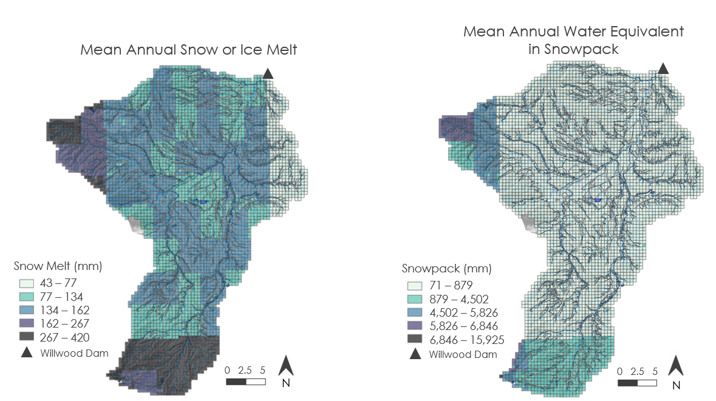
Figure 4. a) Left: SWAT+ model output; mean annual snow or ice melt, b) Right: mean annual snowpack.

The SWAT+ model is operating on a few uncertainties including an inadequate calibration period, unnatural streamflow resulting from controlled dams and irrigation, and incomplete soil data. With calibration, it is common for the warm-up, calibration, & validation period to be based on 7-10 years of observed hydrological data (Abbaspour et al., 2007; Bieger et al., 2016). However, the Shoshone River and Willwood Dam sediment build-up issues are newly studied, and only stream gauge data from late 2018-2021 is available within the Shoshone Watershed being modeled by SWAT+. Because of the limited observed data, calibration and validation objective function values (R²) are 0.022 and 0.002 respectively showing a very low correlation to the SWAT+ model. Although the correlations are low, we find the SWAT+ model to nevertheless hold value because the stream gauge data is largely limited in this study (roughly three years at one location).

Continuing, the correlations between the SWAT+ model and the observed data could be lacking due to the nature of the Shoshone River between the Buffalo Bill Dam and the Willwood Dam. The flow through the Buffalo Bill Dam is controlled, and surrounding irrigation streams are similarly controlled based on crop seasons. These factors are not incorporated into the SWAT+ model, as SWAT+ predicts natural flowing hydrological systems. Therefore, between these factors and the limited observed data, the model comparison to the observed data could be showing limited correlations due to insufficient amounts of observed controlled-flow data.

Finally, a possible uncertainty of the SWAT+ model surrounds the 266 soil types in the gSSURGO database that are undefined soil types. For the SWAT+ analysis we coerced the undefined soil types to the most frequently occurring soil type in the study region. This could have an impact on the sediment input results based on the unknown soil types’ erodibility factor having a large influence on results shown previously in Table A1.

4.1.3 Snow Cover Time Series
Results from the snow cover analysis show the northwest portion of the Shoshone River Watershed consistently having a greater percentage of snow-covered pixels than the southeast portion, with an average of 26.8% more snow covered area. Due to a greater snow cover extent, the northwest watershed could potentially contribute more snowmelt and sediment from runoff during late season melt events. Alternatively, the southeast watershed may have less snow cover due to a higher frequency of snowmelt throughout the season (Figure B2). The snow cover percentage values strongly align with recorded precipitation and temperature values (Figures B3 & B4), where an increase in snow cover percentage is associated with a snowfall event, and a decrease in snow cover percentage is associated with a snowmelt event. We produced several figures for the time series analysis to compare the selected variables and snow cover extent for the entire watershed shown in Appendix B.
Figure B5 shows the relationship between the percentage of snow cover in the entire watershed and discharge in the Shoshone River above Willwood Dam. Throughout the study period there is correlation between snow cover and discharge values in the Shoshone, where discharge values are relatively low during snow cover months and then there is a sudden increase in discharge beginning approximately in April for each year. This increase in discharge could be attributed to controlled dam operations, which have scheduled releases between March 28th and April 12th for sediment mobilization. The discharge increases may also be influenced by Spring snowmelt which may be contributing to runoff and increased flows.
The relationship between the percentage of snow cover in the entire watershed and suspended sediment concentration (SSC) in the Shoshone River above Willwood Dam is shown in Figure B6. Across the study period there is a trend between significant decreases in snow cover followed by significant increases in SSC values, which may be attributed to snowmelt related runoff transporting sediment from the watershed into the Shoshone River. Figure B7 shows the relationship between the percentage of snow cover in the entire watershed and measured turbidity in the Shoshone River above Willwood Dam. Similar to SSC values, the time series shows correlation between increases in turbidity values and decreases in snow cover, but the relationship is less strong than that of snow cover decrease and rise in SSC.
Overall, the time series figures, as seen in Appendix B, visually show the temporal correlative relationships between hydrologic variables in the study area and how these factors may affect sediment input to the Shoshone River. The results of the time series may be impacted by uncertainty from reflectance interference due to snow and/or cloud cover for the snow cover remote sensing, a short collection period for streamflow data, and/or the choice to calculate percent of snow-covered pixels at a 375m spatial resolution.

4.2 Future Work
The sediment plume analysis using remote sensing could be improved using machine learning instead of the calibration equation. We used the calibration equation method of turbidity estimation for most analysis since the images finished processing sooner. Future work could pursue further development and validation of auto-detecting sediment plumes. It could also be beneficial to expand the study period to include all years of currently available PlanetScope imagery. Additionally, estimation of sediment transport based on turbidity, plume size, and streamflow could be explored.

The SWAT+ model could continue to be refined with additional observed data from other points along the Shoshone River to better incorporate the controlled irrigation system used in the region. Additionally, the soil dataset could be improved with further research into the unknown soil types and their respective soil hydrologic grouping to ameliorate the related erosion factors. With the alteration of the soil input and greater calibration datasets, the SWAT+ model would be more accurate, increasing the correlation (R²) between the model and observed data.

Potential continuation of the snow cover time series analysis could include further analysis of snow cover extent and hydrologic variables both spatially and temporally. The snow cover analysis is scalable and could be executed at different spatial extents, such as looking at sub-basin snow cover extent. Finally, the time series analysis can be continued beyond the study period to reflect future changes in watershed dynamics resulting from management decisions.

5. Conclusions
The results of this study reflect the feasibility of using remote sensing coupled with environmental modeling (SWAT+) to direct watershed management practices. Using PlanetScope imagery to detect the turbidity of tributary sediment plumes (which we have not seen published in any other work on a river this small [~30m wide]) showed Dry Creek/Homesteader Creek and Penney Gulch/Rough Gulch produced the largest plumes. The status of Penney Gulch/Rough Gulch was previously unknown to Shoshone River Partners, so this is a major finding that can inform future investigations and management decisions. We also found Sulphur Creek and Cottonwood Creek to be frequent sediment contributors. Our results present the possibility that other watersheds previously listed as high concern for sediment inputs are of relatively small concern in comparison to Dry/Homesteader and Penney Gulch. It is important to note, however, that our findings may be biased by cloud cover and a relatively short study period.

Methodologically, we made improvements over the first term of this project (such as applying Dark Spectrum Fitting atmospheric corrections with ACOLITE) which improved our analysis. Machine learning and equation calibration both performed sufficiently well for plume analysis. Machine learning performed significantly better during training, especially during winter months, but the higher image processing time prevented us from performing a full analysis. Either method could be used for future projects and the choice should depend on team skills, access to computing power, and the complexity of the relationship between band reflectance and the predicted variable. Analyzing and interpreting spatial turbidity is challenging due to the sheer amount of data produced. The automatic plume detection algorithm we developed was shown to be promising and would likely be quite accurate with more time for development and validation.

With modeling the Shoshone River Watershed, we found that the high-resolution SWAT+ model offers a comprehensive view of a watershed to determine high-priority areas of remediation along the Shoshone River. With the limited observed data for calibration, this SWAT+ model provides a better view of where high sedimentation is occurring over quantitative accuracy of sedimentation amounts. These results will direct the Shoshone River Partners in identifying where to implement the most BMPs and further remediation to slow the sediment build up transpiring at the Willwood Dam, thereby preserving aquatic habitat and enabling the surrounding community to flourish.

Finally, the snow cover time series allows partners to better understand the temporal relationship between hydrologic variables, specifically snow cover extent, in order to guide best management practices and timelines. Results from the snow cover time series provide visual representation of relationships between hydrologic variables, including the influence of snow cover/snowmelt. The results also show the extent of correlation between trends in snow cover and other factors that influence sediment transport. Additionally, applied methods demonstrate the use of remote sensing to quantify snow cover extent. In combining these results with the remotely sensed turbidity and the SWAT+ model, the Shoshone River watershed managers have a comprehensive view of high-priority regions and what is causing the high rates of sediment build up. Going forward, managers can merge these results to address specific community concerns and ecosystem impairments.

6. Acknowledgments
We would like to thank our Pop-Up Project node fellow, Caroline Williams, science advisor, Austin Madson, as well as our project partners Jason Alexander (USGS), Carmen McIntyre (Shoshone River Partners), and David Waterstreet (WYDEQ), for their guidance and input. We also greatly appreciate the deliverable feedback provided by our Project Coordination Fellow, Laramie Plott and by Project Coordination Senior Fellow, Cecil Byles.

This work utilized data made available through the NASA Commercial Smallsat Data Acquisition (CSDA) program.

Includes copyrighted material of Planet Labs PBC. All rights reserved.

Some of the maps in this work were created using ArcGIS® software by Esri. ArcGIS® and ArcMap™ are the intellectual property of Esri and are used herein under license. All rights reserved.

Any opinions, findings, and conclusions or recommendations expressed in this material are those of the author(s) and do not necessarily reflect the views of the National Aeronautics and Space Administration.

This material is based upon work supported by NASA through contract NNL16AA05C.

7. Glossary
Basin – Area of land that collects water and sediment
BMP – Best Management Practice
Discharge – Rate of water flow
DSF – Dark Spectrum Fitting, an atmospheric correction algorithm
DEM – Digital Elevation Model
Earth observations – Satellites and sensors that collect information about the Earth’s physical, chemical, and biological systems over space and time
Formazin Nephelometric Unit (FNU) – A turbidity unit, measure of infrared light scattered at 90 degrees
Georectification – Assignment of an image to a known coordinate system
HRU – Hydrologic Response Unit
In-situ – Data measurement taken with on-site instruments
KGE – Kling-Gupta Efficiency
Machine Learning – Method of automated learning to find patterns in data
MODIS – Moderate Resolution Imaging Spectroradiometer
NDSI – Normalized Difference Snow Index
NDWI – Normalized Difference Water Index
NIR – Near-Infrared
NLCD – National Land Cover Database
Normalization – Transformation of pixel values to a different range
NSE – Nash-Sutcliffe Efficiency
PlanetScope – Commercially available smallsat imagery with a 3m spatial resolution
PRISM – Source of precipitation and climate data
Radiometric calibration – Conversion of values recorded by a sensor to radiance
Random Forest Algorithm – Machine learning model that uses a collection of decision trees to make predictions
Reflectance – Amount of light reflected off the surface
Resampling – Used when changing raster resolution
Runoff – Flow of water over land surface
Temporal Resolution – Image revisit time interval
Top of Atmosphere Radiance – The amount of energy recorded at the sensor
Tributary – A stream or river that flows into a larger stream or river
Turbidity – A measure of light scatter (used as a proxy for suspended sediment concentration)
Sediment – Organic Material that is broken down and deposited into a new location
Sedimentation – Process of erosion of sediment
Spatial Resolution – Size pixel represents at ground level
Suspended Sediment – The sediment suspended in volume of liquid
SSC – Suspended Sediment Concentration
Suomi NPP VIIRS – Suomi National Polar-Orbiting Partnership satellite Visual Infrared Imaging Radiometer Suite

SWAT – Soil and Water Assessment Tool

SWAT+ – Soil and Water Assessment Tool+, newer version of SWAT with enhanced features and interface
UDM2 – Usable Data Mask, image files distributed by Planet that use supervised machine learning to identify usable pixels in PlanetScope images as well as other mask layers such as cloud or snow pixels
USGS – United States Geological Survey
Watershed – An area of land that drains to a specific location
WYDEQ – Wyoming Department of Environmental Quality

8. References
Abatzoglou, J. T. (2013). Development of gridded surface meteorological data for ecological applications and modelling. International Journal of Climatology 33: 121–131. https://doi.org/10.1002/joc.3413

Abbaspour, K., Yang, J., Maximov, I., Siber, R., Bogner, K., Mieleitner, J., Zobrist, J., & Srinivasan, R. (2007, February). Modelling hydrology and water quality in the pre-alpine/alpine Thur watershed using SWAT. Journal of Hydrology, 333(2-4), 413-439. https://doi.org/10.1016/j.jhydrol.2006.09.014.

Bieger, K., Arnold, J., Rathjens, H., White, M., Bosch, D., Allen, P., Volk, M., & Srinivasan, R. (2017). Introduction to SWAT+, a Completely Restructured Version of the Soil and Water Assessment Tool. Journal of the American Water Resources Association (JAWRA) 53(1): 115– 130. https://doi.org/10.1111/1752-1688.12482.

Dewitz, J., & U.S. Geological Survey. (2021). National Land Cover Database (NLCD) 2019 Products (ver. 2.0, June 2021). U.S. Geological Survey data release. https://doi.org/10.5066/P9KZCM54.
Duan, P., Zhang, F., Liu, C., Tan, M.L., Shi, j., Wang, W., Cai, Y., Kung, H., & Yang, S. (2023). High-Resolution Planetscope Imagery and Machine Learning for Estimating Suspended Particulate Matter in the Ebinur Lake, Xinjiang, China. IEEE Journal of Selected Topics in Applied Earth Observations and Remote Sensing, 16(1019-1032). https://doi.org/10.1109/JSTARS.2022.3233113.

George, C. (2020). Using SSURGO soil data with QSWAT and QSWAT+. https://swat.tamu.edu/data/

Grusson, Y., Sun, X., Gascoin, S., Sauvage, S., Raghavan, S., Anctil, F., & Sáchez-Pérez, J. M. (2015). Assessing the capability of the SWAT model to simulate snow, snow melt and streamflow dynamics over an alpine watershed. Journal of Hydrology, 531, 574–588. https://doi.org/10.1016/j.jhydrol.2015.10.070

Hossain, A.K.M.A., Mathais, C., & Blanton, R. (2021) Remote Sensing of Turbidity in the Tennessee River Using Landsat 8 Satellite. Remote Sensing, 14, 3785. https://doi.org/10.3390/rs13183785

Huffman, G.J., E.F. Stocker, D.T. Bolvin, E.J. Nelkin, Jackson Tan (2019), GPM IMERG Final Precipitation L3 1 day 0.1 degree x 0.1 degree V06, Edited by Andrey Savtchenko, Greenbelt, MD, Goddard Earth Sciences Data and Information Services Center (GES DISC), Accessed: February 10, 2023, https://doi.org/10.5067/GPM/IMERGDF/DAY/06

Hughes, K. E., Wild, A., Kwoll, E., Geertsema, M., Perry, A., & Harrison, K. D. (2021). Remote Sensing of Landslide-Generated Sediment Plumes, Peace River, British Columbia. Remote Sensing, 13(23), 4901. https://doi.org/10.3390/rs13234901

Lacaux, J. P., Tourre, Y. M., Vignolles, C., Ndione, J. A., & Lafaye, M. (2007). Classification of ponds from high-spatial resolution remote sensing: Application to Rift Valley Fever epidemics in Senegal. Remote Sensing of Environment, 106(1), 66-74. https://doi.org/10.1016/j.rse.2006.07.012

Ma, Y., Song, K., Wen, Z., Liu, G., Shang, Y., Lyu, L., Du, J., Yang, Q., Li, S., Tao, H., & Hou, J. (2021). Remote Sensing of Turbidity for Lakes in Northeast China Using Sentinel-2 Images with Machine Learning Algorithms. IEEE, 14, 9132-9146, https://doi.org/10.1109/JSTARS.2021.3109292

Mansaray, A. S., Dzialowski, A. R., Martin, M. E., Wagner, K. L., Gholizadeh, H., & Stoodley, S. H. (2021). Comparing PlanetScope to Landsat-8 and Sentinel-2 for Sensing Water Quality in Reservoirs in Agricultural Watersheds. Remote Sensing, 13(9), 1847. https://doi.org/10.3390/rs13091847

McFeeters, S.K. (1996). The use of the Normalized Difference Water Index (NDWI) in the delineation of open water features. International Journal of Remote Sensing, 17(7), 1425-1432. https://doi.org/10.1080/01431169608948714.

National Oceanic and Atmospheric Administration. (2021). Global Historical Climatology Network daily. https://www.ncei.noaa.gov/cdo-web/datasets#GHCND

Otsu, N. (1979). A Threshold Selection Method from Gray-Level Histograms. IEEE Transactions on Systems, Man, and Cybernetics, 9(1) 62-66, Jan. 1979. https://doi.org/10.1109/TSMC.1979.4310076.

Peker, I. B., & Sorman, A. A. (2021). Application of SWAT Using Snow Data and Detecting Climate Change Impacts in the Mountainous Eastern Regions of Turkey. Water 13(14), 1982. https://doi.org/10.3390/w13141982

Planet Team. (2022). Planet Application Program Interface: In Space for Life on Earth. San Francisco, CA. https://api.planet.com

Pradhanang, S.M., Anandhi, A., Mukundan, R., Zion, M.S., Pierson, D.C., Schneiderman, E.M., Matonse, A., & Frei, A. (2011). Application of SWAT model to assess snowpack development and streamflow in the Cannonsville watershed, New York, USA. Hydrol. Process., 25: 3268-3277. https://doi.org/10.1002/hyp.8171

Riggs, G.A., Hall, D.K., & Román, M O. (2019). VIIRS/NPP CGF Snow Cover Daily L3 Global 375m SIN Grid, Version 1 (VNP10A1F). Boulder, Colorado USA. NASA National Snow and Ice Data Center Distributed Active Archive Center. https://doi.org/10.5067/VIIRS/VNP10A1F.001

Riggs, G., & Hall, D. (2020). Continuity of MODIS and VIIRS Snow Cover Extent Data Products for Development of an Earth Science Data Record. Remote Sensing, 12(22), 3781. https://doi.org/10.3390/rs12223781

Rosenquist, S., Moak, J., Green, a., & Flite, O. (2010). UNDERSTANDING HYDROLOGIC VARIATION THROUGH TIME-SERIES ANALYSIS. South Carolina Water Resources Conference. http://network.bepress.com/physical-sciences-and-mathematics/environmental-sciences

Soil Survey Staff. Gridded Soil Survey Geographic (gSSURGO) Database for Wyoming. United States Department of Agriculture, Natural Resources Conservation Service. Available online at https://gdg.sc.egov.usda.gov/. February, 2023 (202210 official release).

Troin, M. and Caya, D. (2013). Evaluating the SWAT's snow hydrology over a Northern Quebec watershed. Hydrol. Process., 28: 1858-1873. https://doi.org/10.1002/hyp.9730

Tuo, Y., Marcolini, G., Disse, M., & Chiogna, G. (2018) Calibration of snow parameters in SWAT: comparison of three approaches in the Upper Adige River basin (Italy), Hydrological Sciences Journal, 63:4, 657-678. https://doi.org/10.1080/02626667.2018.1439172

Umar, M., Rhoads, B., & Greenberg, J. (2018). Use of multispectral satellite remote sensing to assess mixing of suspended sediment downstream of large river confluences. Journal of Hydrology 556 325-338. https://doi.org/10.1016/j.jhydrol.2017.11.026

U.S. Geological Survey (2016). National Water Information System (USGS Water Data for the Nation). http://dx.doi.org/10.5066/F7P55KJN

Wu, Y., Ouyang, W., Hao, Z., Yang, B., & Wang, L. (2018). Snowmelt water drives higher soil erosion than rainfall water in a mid-high latitude upland watershed. Journal of Hydrology, 556, 438–448. https://doi.org/10.1016/j.jhydrol.2017.11.037

Xie, P., Wu, L., Sang, Y., Chan, F. K. S., Chen, J., Wu, Z., & Li, Y. (2021). Correlation-aided method for identification and gradation of periodicities in hydrologic time series. Geoscience Letters, 8(1). https://doi.org/10.1186/s40562-021-00183-x

9. Appendices
Appendix A: SWAT
Table A1
Source, resolution, and time period of SWAT+ input datasets.
Parameter | Source | Resolution | Time Period
Digital Elevation Model (DEM) | USGS | 10 meters | 2021 & 2023*
Soil classification | USDA gridded soil survey geographic (gSSURGO) database | 10 meters | October 2022
Land cover | National Land Cover Database (NLCD) | 30 meters | 2019
Precipitation, maximum and minimum temperature, solar radiation, wind speed, and maximum and minimum relative humidity | University of Idaho Gridded Surface Meteorological (gridMET) dataset | 4 kilometers | January 1, 2011 – December 31, 2021
Precipitation | Integrated Multi-satellitE Retrievals for Global Precipitation Measurement (GPM IMERG) | 10 kilometers | January 1, 2011 – September 30, 2021
*Note: the DEM includes rasters from two dates merged for the study area

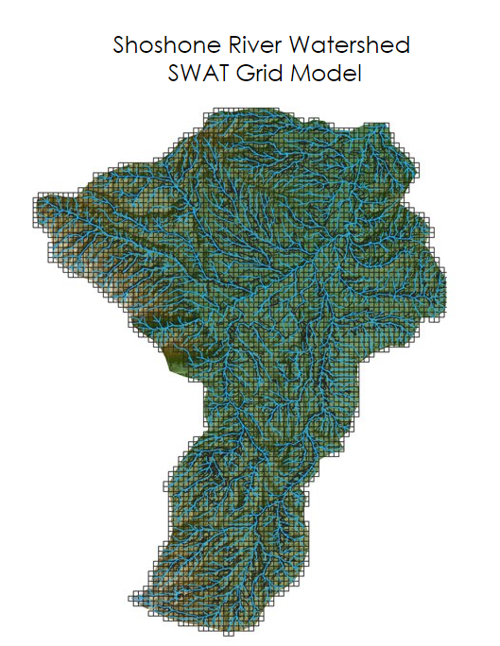
Figure A1. SWAT+ 500m Grid Model displaying high resolution analysis of parameters.

Table A2
Sensitivity ranking of selected parameters for SWAT+ calibration using R-SWAT.
SWAT+ Parameter | Definition | Range | P-Value
Surlag | Surface runoff hysteresis coefficient | -0.15 - 0.15 | 0.977
ChK | Effective hydraulic conductivity in main channel alluvium | -0.15 - 0.15 | 0.895
Snofall_tmp | Temperature for snowfall to occur | -0.15 - 0.15 | 0.772
Snowmelt_tmp | Temperature for snowmelt to occur | -0.15 - 0.15 | 0.293
Spcon | Sediment transport linear coefficient | -0.15 - 0.15 | 0.144
Slope | Slope of the terrain | -0.15 - 0.15 | 0.128
Cn2 | Soil conservation service runoff curve, curve number | -0.25 - 0.25 | 0.118
Usle_K | USLE soil erodibility factor | -0.15 - 0.15 | 0.117
Alpha | Baseflow alpha factor | -0.15 - 0.15 | 0.096
Spexp | Exponent parameter for calculating sediment reentrained in channel sediment routing | -0.15 - 0.15 | 0.031

Appendix B: Snow Cover Analysis
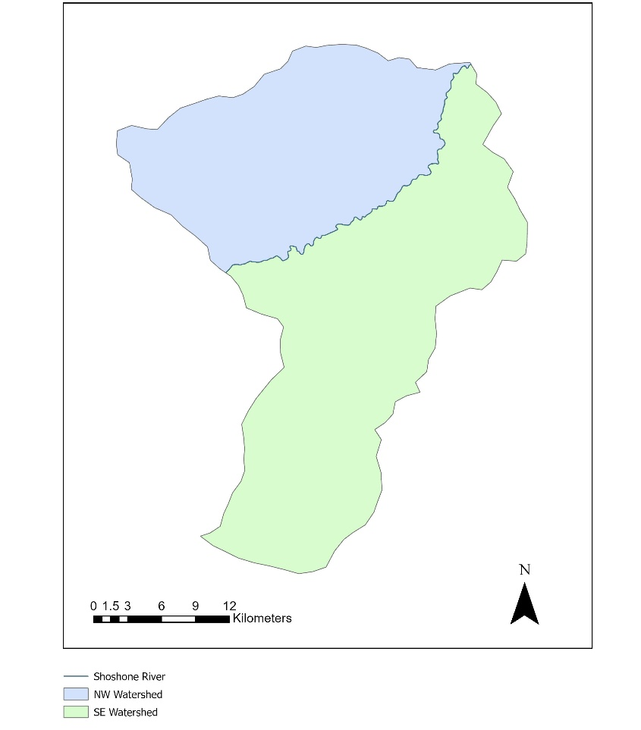
Figure B1. Watershed divided at the Shoshone River into the northwest (NW) and southeast (SE) watersheds.

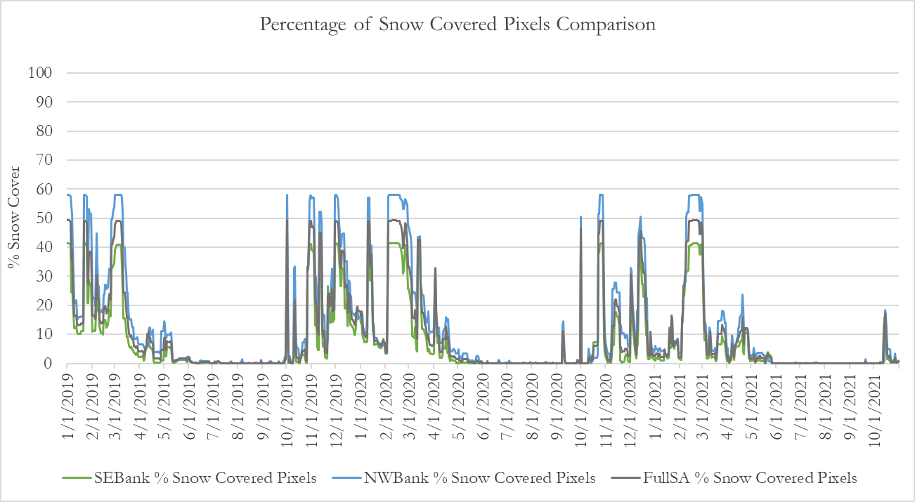
Figure B2. Percentage of snow cover extent for the entire watershed, NW watershed, and SE watershed.
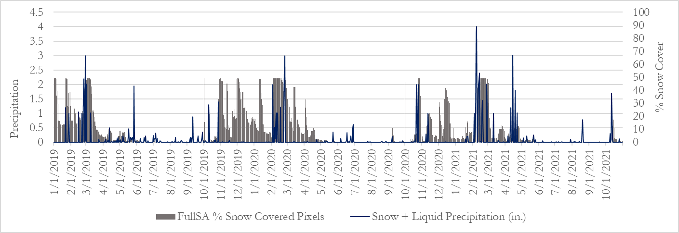
Figure B3. Precipitation values for station CODY USC00481840 compared to snow cover extent of the entire watershed.

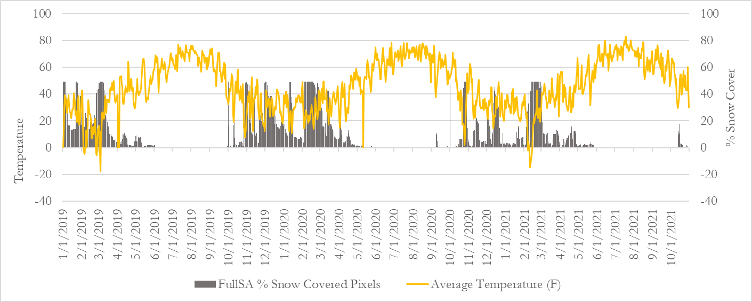
Figure B4. Average temperature values for station CODY USC00481840 compared to snow cover extent of the entire watershed.
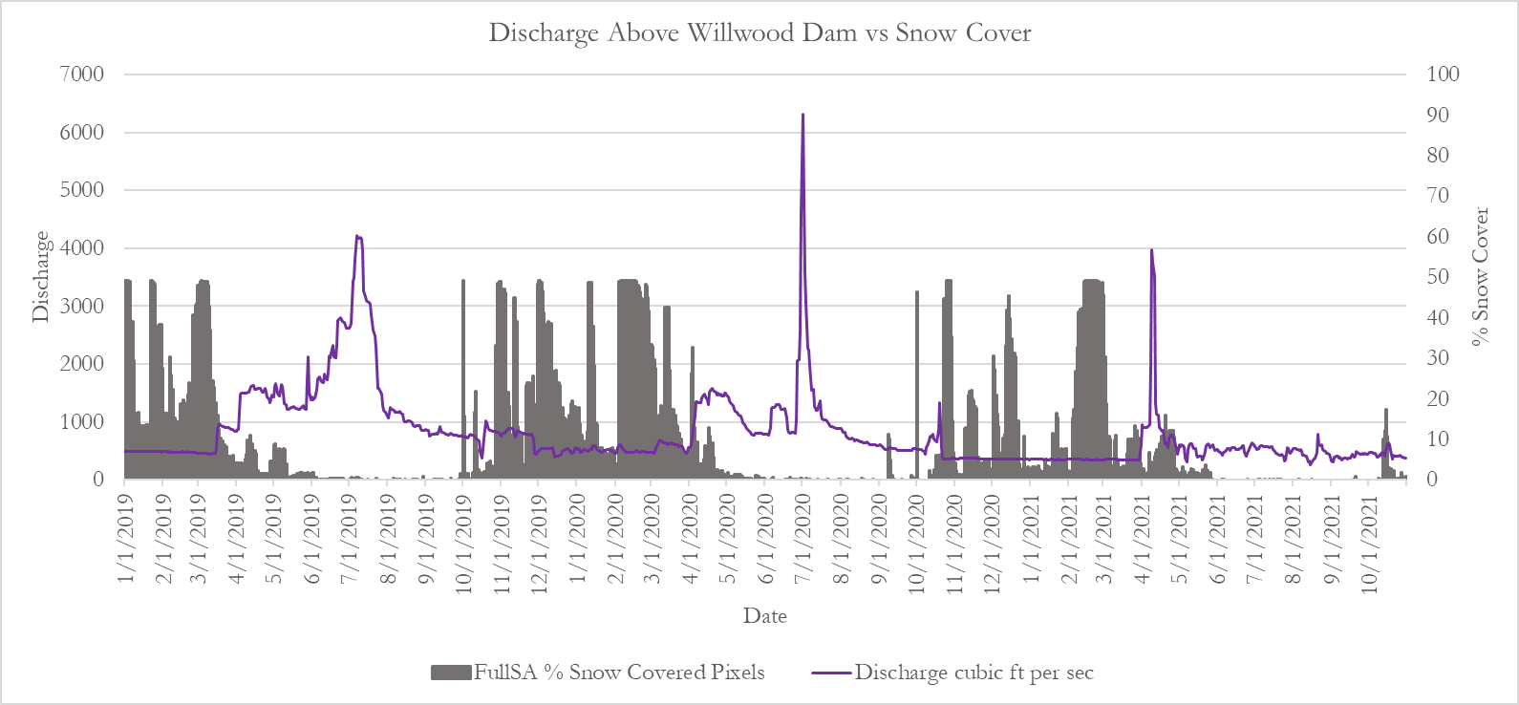
Figure B5. Average discharge values for gauge 06283995, above Willwood Dam, compared to snow cover extent of the entire watershed.

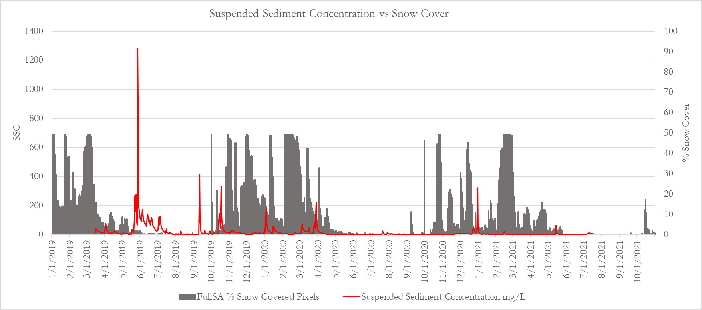
Figure B6. Average suspended sediment concentration values for gauge 06283995, above Willwood Dam, compared to snow cover extent of the entire watershed.

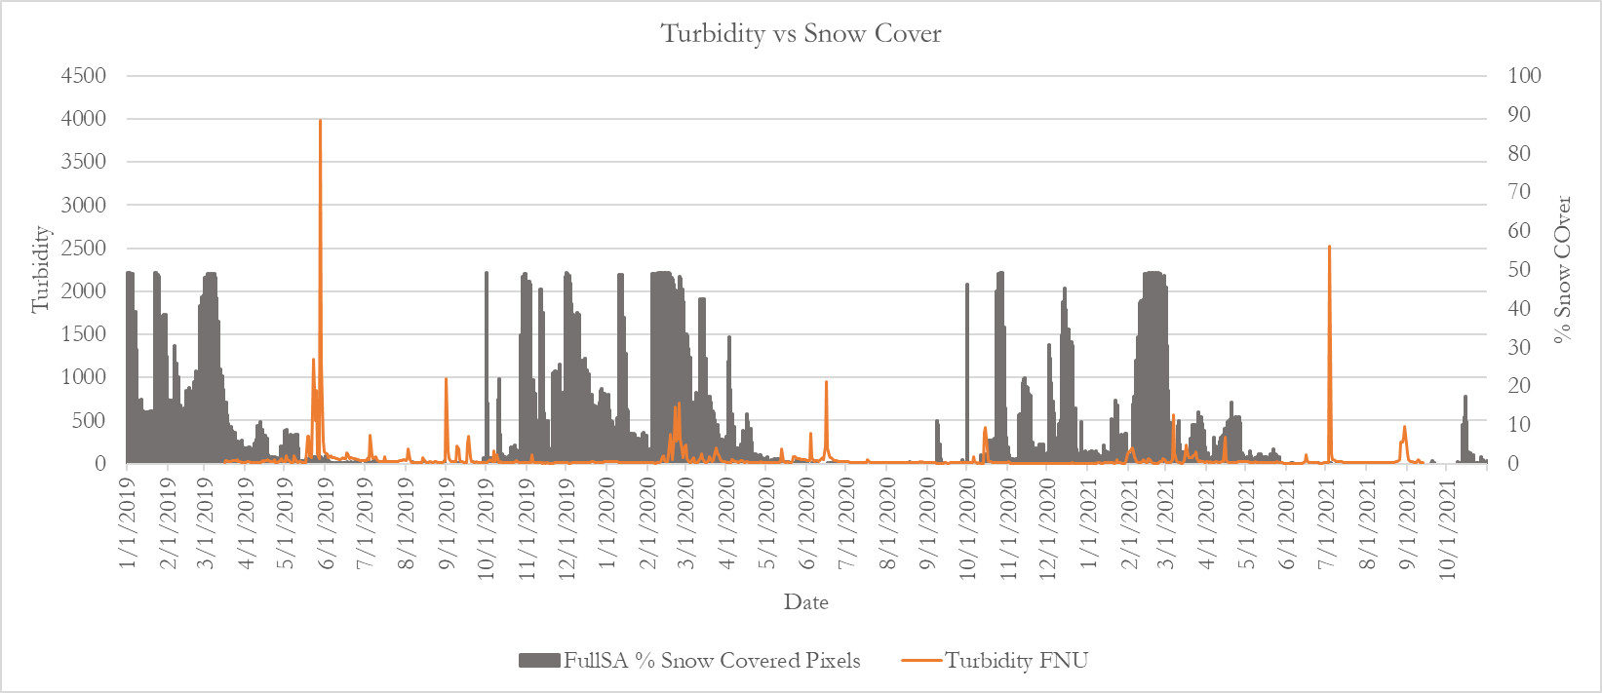
Figure B7. Average turbidity values for gauge 06283995, above Willwood Dam, compared to snow cover extent of the entire watershed.

Appendix C: Calibration and Manual Plume Detection
Table C1
Earth observations and turbidity data sources for sediment turbidity analysis.
Parameter | Source | Resolution | Time Period
PlanetScope Analytic Ortho Tile | Planet Explorer | 3 meters, daily | March 2019 – October 2021
Usable Data Mask (UDM2 files) | Planet Explorer | 3 meters, daily | March 2019 – October 2021
In-situ Turbidity | USGS | 15-minute, daily | March 2019 – October 2021

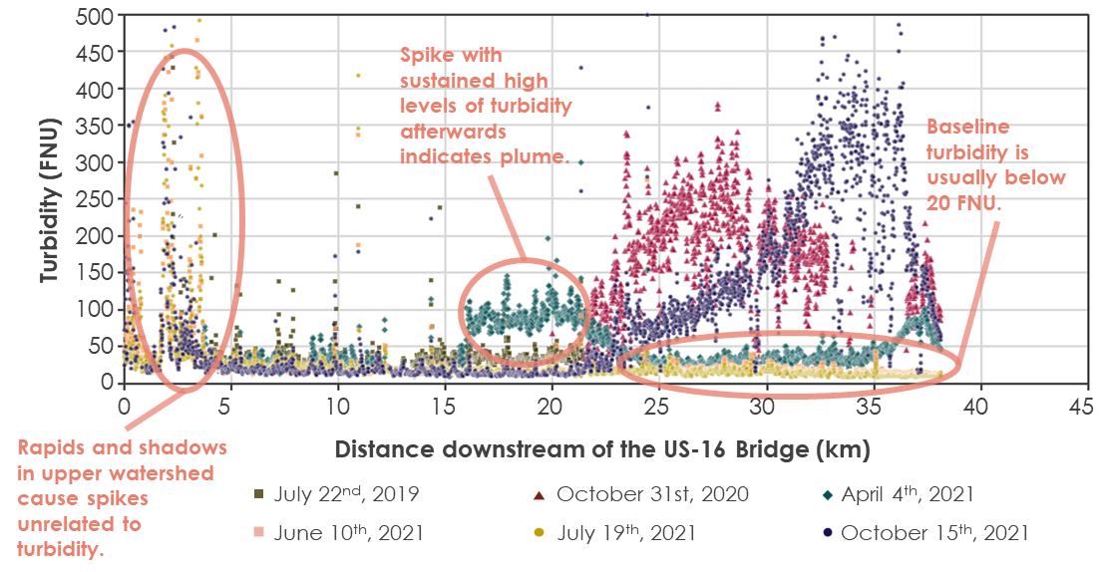
Figure C1. Turbidity values plotted over distance downstream of the US-16 bridge for six images. These images were selected to illustrate low turbidity days and the signature of some clear sediment plumes. You can also see interference from rapids, rocks, and/or land in the first 5km. While these are straightforward, some series are more challenging to interpret and, in any case, it is time consuming to go through 400+ series which pushed us to explore automated plume detection.
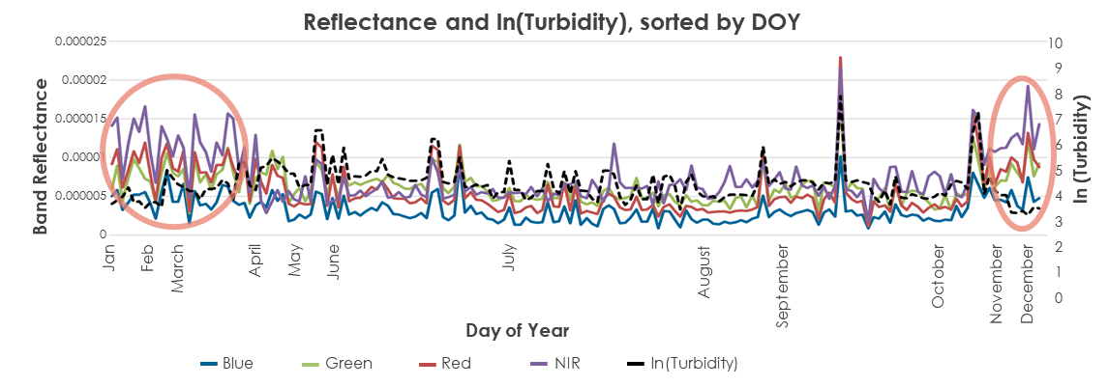
Figure C2. Band reflectance at the USGS gage and log-transformed turbidity, sorted by DOY.
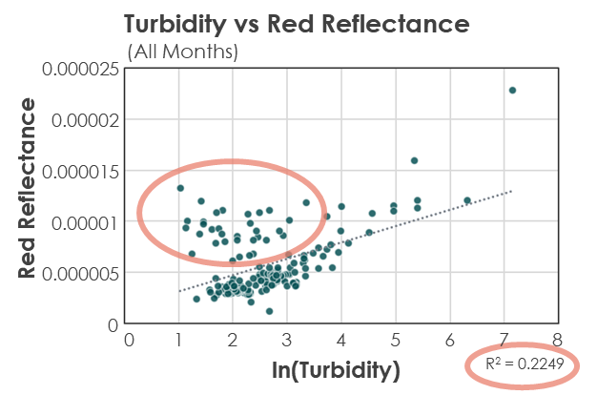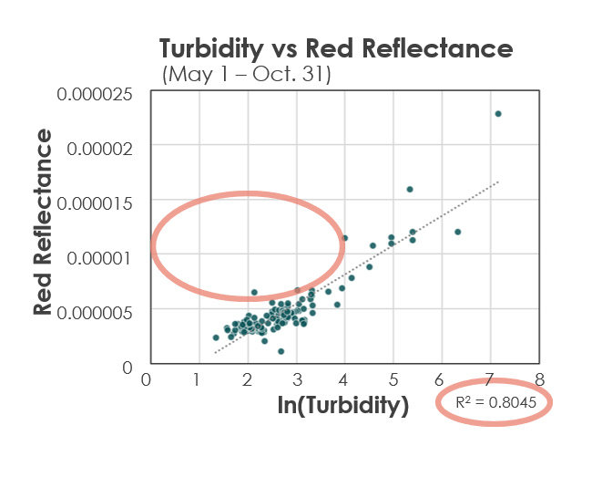
Figure C3. Red reflection vs. log-transformed turbidity for all months (top) and May 1st – Oct. 31st (bottom). The ovals point out a group of points from winter months and the increase in R² when those winter months are removed.

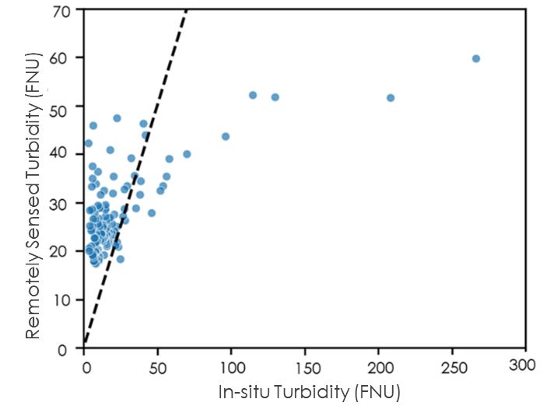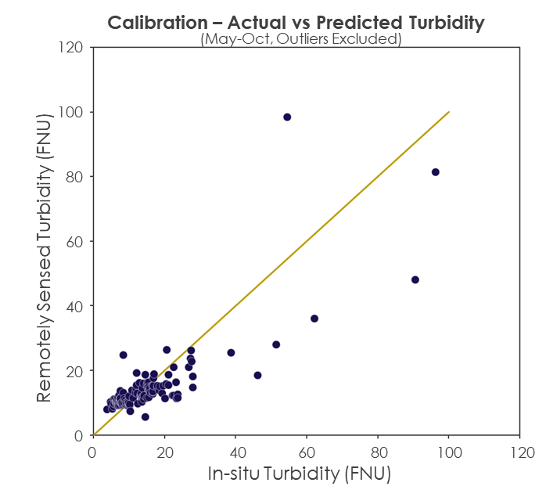
Figure C4. Remotely Sensed vs In-situ (measured) Turbidity for Term 1 (left) and Term 2 (right). In both plots, the line represents a 1:1 (perfectly modeled) relationship. High values have been cropped from the plot in order to see the accuracy of lower values. Term 2 is much more evenly distributed either side of the line and in general points are closer to the line, indicating significant improvements in accuracy and bias.

Table C2
Tributaries with the number of possible sediment plume events taking place during the study period.
Stream / Tributary Name | Manually Interpreted Plumes | # of Auto-detected RS Events | Concern Level Determined by Shoshone River Partners
Cottonwood Creek | Low | High | Medium
Dry Creek / Homesteader Creek | High | Medium | High
Dry Gulch | Low | Medium | Low
Idaho Creek | Low | Medium | Medium
Penney Gulch / Rough Gulch | High | Low | Unknown
Sage Creek | Low | Low | High
Sulphur Creek | Medium | High | High
Trail Creek | Low | Low | High

Appendix D: Machine Learning & Automatic Plume Detection

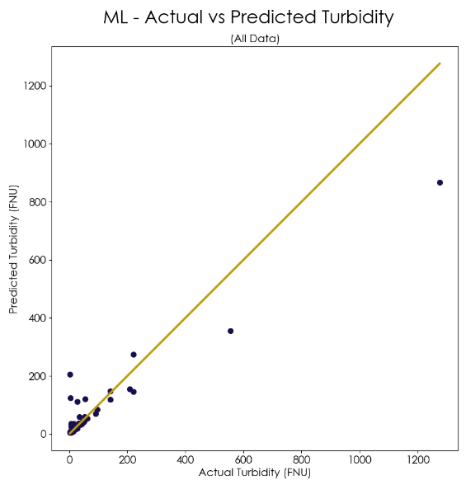
Figure D1. Predicted data using machine learning versus observed data with a 1:1 trendline. This data includes winter months.

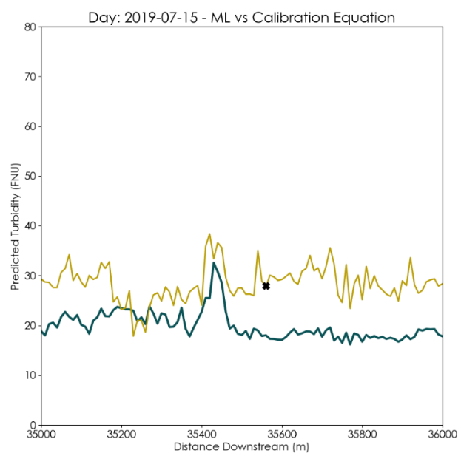
Figure D2. Predicted turbidity versus downstream distance of the machine learning model (yellow) and the calibration equation model (blue) with observed USGS turbidity value at station distance (black cross).

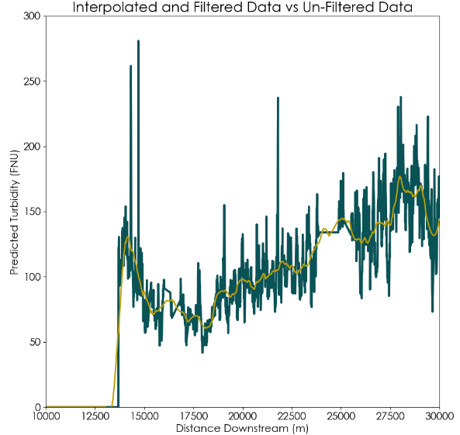
Figure D3. Noisy and interpolated machine learning predicted turbidity plotted by river distance (green) compared to the same data but filtered with the Savitsky-Golay filter (yellow).

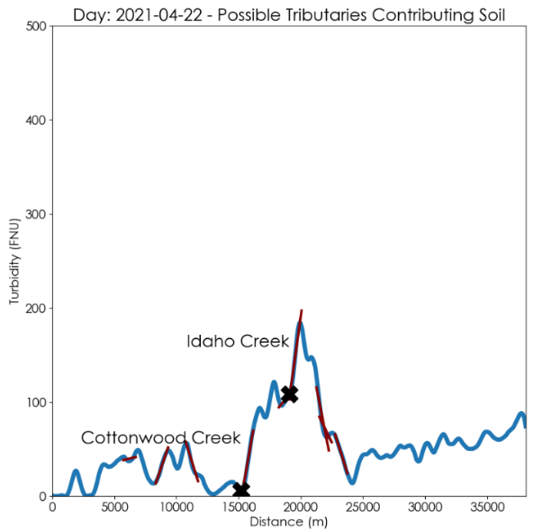
Figure D4. Machine learning predicted turbidity plotted by river distance with labels for possible sediment plumes at Cottonwood Creek and Idaho Creek on April 22, 2021.

