Empowering Open Science with the Science Discovery Engine Emily Foshee¹, Kaylin Bugbee², Ashish Acharya¹, Carson Davis¹, Xiang Li¹, Muthukumaran Ramasubramanian¹, and Stephanie Wingo¹. ¹University of Alabama in Huntsville (elf0005@uah.edu), ²NASA Marshall Space Flight Center (kaylin.m.bugbee@nasa.gov)

Introduction: As the amount of available scientific data and information continues to expand rapidly, it is crucial that the science community enhances the accessibility and inclusivity of both new and existing data and information to further science knowledge and exploration. Through the creation of the Open-Source Science Initiative (OSSI), NASA has committed to establishing and fostering an open science community over the next ten years. To enhance the visibility and impact of the OSSI, NASA has designated 2023 as the Year of Open Science.
To support the goal of open science and accelerate the time to actionable science, NASA has championed the development of the Science Discovery Engine (SDE). The SDE serves as a unified search platform, providing easy access to science data, documentation, software, and code for users with diverse levels of science knowledge and backgrounds.
The SDE draws information from NASA's five Science Mission Directorates (SMDs), spanning a broad range of scientific disciplines. These disciplines include Astrophysics, Biological and Physical Sciences, Earth Science, Heliophysics, and Planetary Science. The SDE enhances the accessibility of scientific information by incorporating data from all five SMD divisions. Moreover, it promotes interdisciplinary science among multiple divisions.
Science Discovery Engine: The SDE project began in late 2020. Initial work was focused on technical assessment of potential search architectures and a comprehensive analysis of the SMD information landscape. After thorough evaluations, the SDE team opted to develop a search prototype utilizing Insight Engine capabilities through the Sinequa Intelligent Search platform with content comprised of scientifically relevant sources curated by subject matter experts. The beta version of the SDE was released in December of 2022.
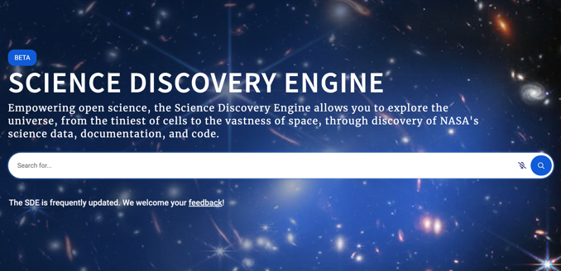
Figure 1: Interface for the Science Discovery Engine
To date, over 700,000 datasets, documents, images, tools, code, and software from more than 100 sources are searchable within the SDE, and new information from additional sources is being incorporated continuously. Users have options to perform free-text searches for data and information and apply text-based facets to further refine searches based on SMD division, data repository, source name, and document type. Furthermore, the SDE team and collaborators are prototyping ways to enhance user and search experiences within the SDE by exploring issues such as relevancy, emerging search techniques, and information curation.
Summary: This presentation will describe the work to date in building the SDE as well as what the team has learned about the SMD ecosystem, information curation, and data governance. A short demonstration of the SDE will be presented, and an overview of near- and long-term goals for future development will be shared. Community feedback will be welcomed about the interface, content, and other features to help inform actions to maximize the SDE’s performance and usability.
Whether users aim to discover Earth-like atmospheres on planets outside of our solar system or better understand the impacts of solar energy on our own planet, the Science Discovery Engine provides a means for scientists and all curious individuals to find content to further their understanding of science across all time and space scales.
Acknowledgments: We would like to acknowledge the work of all past and current members of the SDE team, collaborators, and contributors to the Science Mission Directorate Working Group.

