A Multi-Probe Mission at Jupiter is Within our Reach!!
E. Venkatapathy¹, M. Stackpoole², M. Macdonald², and G. Hartman³
¹MS 229-3, NASA Ames Research Center, Moffett Field, CA, ethiraj.venaktapathy-1@nasa.gov
² NASA Ames Research Center, ³Sierra Lobo Inc., NASA Ames Research Center.

Brief Presenter Biography: Ethiraj Venkatapathy, Raj, is one of the founding members of the IPPW and was recognized for his contributions by IPPW with the 2022 Al Seiff Award.
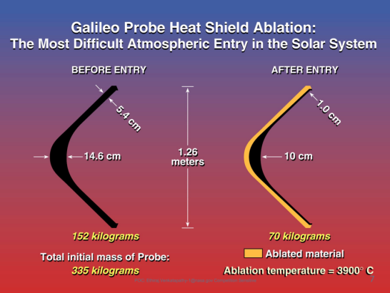
Background: The Galileo Probe plunged into Jupiter at a relative entry speed of 48.5 km/s, and successfully delivered science instruments and performed in-situ investigations of the Jovian atmosphere. The fastest ever entry system was protected by a Carbon-Phenolic heatshield during entry. The heatshield mass was 50% of the entire entry system mass and 50% of the heatshield ablated away in ~ 10 sec during entry.
The heatshield was designed using the best tools and testing capabilities at the time and margined to account for uncertainties. Carbon-phenolic was used in ballistic missiles and prior to Galileo Probe, it was used by NASA on the Pioneer-Venus probes successfully. The Galileo entry heating was extreme due to combination of convective as well as shock layer radiation. The entry conditions were compared to a “ballistic nose-tip flying through a thermos-nuclear explosion, surviving and delivering the delicate science instruments successfully.”
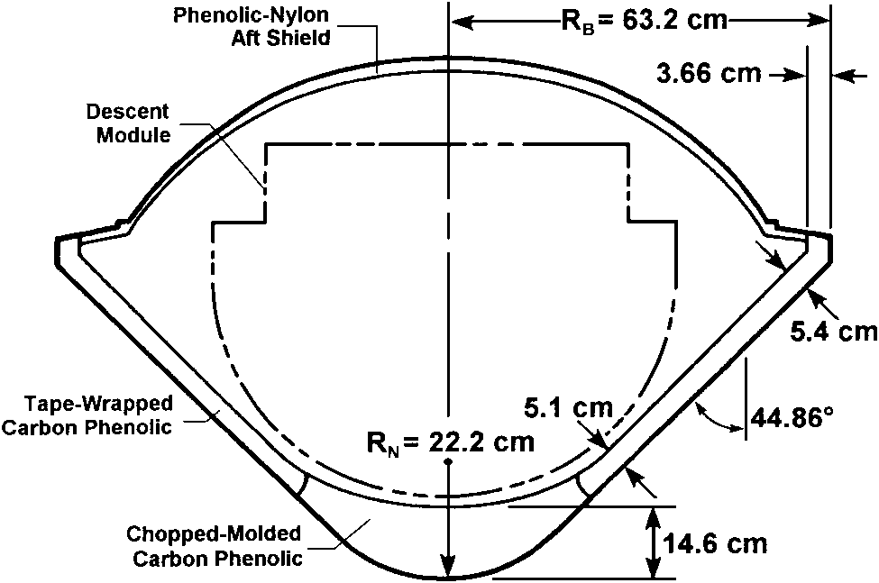

Figure 1. Galileo Probe Schematic and TPS

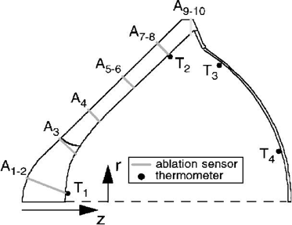

Figure 2. Location of the Recession Sensors
Galileo probe ¹ was instrumented with recession sensors ² and the measurements provided an assessment of the heatshield design adequacy³.
Figure 3. TPS Thickness (Design) and the Measured Recession (Refs. 2 and 3).

The Galileo probe design utilized the best available flight proven, material carbon-phenolic, the best test capabilities, an arc jet with H₂/He test gas as well as laser test capabilities, and the state-of-the art modeling and simulation tools available in the 1970’s and early 1980’s, that were physics based but limited by computational power (ref 4). The design uncertainties and assumptions played into the margin.
The post flight recession comparison showed the inadequacy in TPS design (Ref 2). The design thickness was non-conservative on the flank and overly conservative on the nose region. If one were to redesign today, based on post-flight comparison, the mass of the heatshield would be close to 70% rather than 50%. In the mid 1980s, the only certified fiber manufacturing facility in the US needed to make heritage carbon phenolic was destroyed in a fire and was never replaced or rebuilt. Post Galileo, NASA decided to decommission the Giant Planet (arc jet with H₂/He) and the laser facilities. As a result of both events NASA could not make carbon-phenolic using the heritage material and process, and even if one chose to use an alternate material, the test facility was retired.
In early 2000, when the scientific community was contemplating missions to the outer planets, especially Jupiter, we evaluated the national ability to manufacture, and test carbon phenolic. A design effort indicated to repeat a mission such as Galileo from lessons learned was a mass challenge. All this led to the scientific community advocating for an Orbiter alone mission and that resulted Juno, a successful second New Frontier Mission.

Motivation: The Juno mission continues to make significant discoveries and it has also raised complex questions that will require in-situ measurements in the future. Since 2000 the science communities believe we have lost the capability to engineer another aeroshell capable of delivering a science probe at Jupiter. Given the gravity of Jupiter, slowing down to deliver a probe without a capable TPS is not feasible. For the science community to address fundamental questions that can only be answered by in-situ probe(s) mission, it will require them to understand the progress in TPS and entry system design, over the past decade and know the feasibility of engineering the aeroshell is nearly here.

Focus of the Presentation: There have been significant advancements in modeling and simulations (ref 5), in testing at conditions relevant for Jupiter entry, and recent advancement that has led to innovative TPS materials that point to exciting potential for a future Jupiter Probes mission. This presentation intends to inform and excite the science community, and initiate discussions that can prepare and guide studies and make the case for returning to Jupiter in the future.
In modeling and simulation, there are advancements made with analysis tools that can better predict the aerothermal environment. These tools have been applied to reevaluate the heatshield performance including uncertainty quantification. The recession predictions match very well with what the Galileo probe experienced without resorting to complex material failure or spallation.
In terms of testing, the arc jet complex at Ames, now includes a 200 KW laser capable of combined testing. This upgrade was done to support Orion heatshield certification. Exploratory tests have been performed with a variety of materials including heritage like carbon-phenolic, and 3-D Woven carbon phenolic – with future testing on 3-D Carbon-Carbon at very high heat fluxes being planned.
The development of 3-D Woven TPS that led to HEEET (Heatshield for extreme entry environment technology), 3MDCP (the TPS baselined for MSR EES) and other 3-D Woven Carbon-Carbon architectures providing a variety of new TPS options. Also, NASA Ames still has the heritage carbon fabric and processes to make the heritage carbon-phenolic heatshield (both tape-wrapped and chop molded) flown on Galileo. The current state-of-the art tools, test capabilities and choice of TPS is a very different situation than in 2000.
This talk is intended to inform our community on the advances happening in multiple fronts including the interest in exploring Jupiter in the coming decades and engaging the community so we tackle one of the greatest challenges of enabling in-situ measurements at Jupiter with Probes. The Future of Planetary Probes depends on this community.
References:
- Givens, et. al., “Galileo Atmospheric Entry Probe System: Design, Development and Test,” AIAA Paper 83-0098, AIAA 21st Aerospace Sciences Meeting, Reno, Nevada, 1983.
- Milos, F., “Galileo Probe Heat Shield Ablation Experiment,” Journal of Spacecraft and Rockets, Vol 34, No.6, Nov.-Dec. 1997
- Meltzer, M., “Mission to Jupiter: A History of Galileo Project,” NASA SP-2007-4321, 2007.
- Howe, J.T., et. al., “Survey of the Supporting Research and Technology for Thermal Protection of the Galileo Probe,” AIAA-81-1068, AIAA 16th Thermophysics Conference, Palo Alto, CA, June 1981.
- Erb, A. J., et. Al., “Investigation of Galileo Probe Entry Heating with Coupled Radiation and Ablation,” Journal of Spacecraft and Rockets, Vol 57, No.4, July - August 2020.

