

Dose error impacts on a collection of realistic dose-response curves based on a NASA sonic boom community noise survey

William J. Doebler, Kathryn M. Ballard, Aaron B. Vaughn, and Peter A. Parker
NASA Langley Research Center
2 N Dryden St., MS 463, Hampton, VA 23681, USA

ABSTRACT
The National Aeronautics and Space Administration (NASA) plans to conduct surveys of community response to quiet supersonic flight to collect dose-response data for international regulators. Previous models of noise dose versus annoyance response ignored uncertainty in the noise dose experienced by survey respondents. This dose error causes attenuation bias and results in inaccurate dose-response relationships. The impacts of dose errors can be explored by introducing error into the dose estimates of a simulated community noise survey. The simulated population annoyance response is determined by specific noise response characteristics, including the onset of annoyance intercept, rate of increasing annoyance, participant intercept variability, and response rates. This paper explores the effects of dose errors on notional populations created by perturbing the noise response characteristics observed in participants in a recent NASA flight test, QSF18. The QSF18-based population parameters were shifted up to ±20% to create the study populations. For the anticipated dose range of the X-59, changes to the onset of annoyance intercept have the greatest impact on erroneous model results. Quantifying point estimate errors illustrates the impact of dose error, with errors up to 14 dB observed for a fixed high annoyance percentage.

1. INTRODUCTION
In community noise surveys, noise doses are paired with annoyance responses from survey participants. The noise doses and annoyance responses are then modeled as a dose-response relationship. Noise dose measurements made by noise monitors placed throughout a community are subject to error from various sources, e.g., self-noise and ambient noise. The noise dose may need to be estimated for participants as it may not be feasible to make a measurement at their location. Thus, to estimate the noise doses, the measurements may be supplemented by physics-based noise predictions, which are also subject to error.
Previous work has shown that measurement error in or misestimation of the noise dose results in biased estimated coefficients of the dose-response model, namely in attenuation of the slope, or rate of increasing annoyance [–]. Erroneous dose-response models can have impactful consequences for the development of noise regulations.
Methods to account for dose error are available [1, , ], but it is of interest to understand when these methods need to be implemented for dose-response modeling. For its Quesst mission, NASA will provide dose-response data to regulatory agencies to inform the development of potential new supersonic aircraft noise certification standards. These dose-response data will be collected in communities overflown by the X-59 supersonic aircraft. Planning for the X-59 community noise surveys is currently underway []. An initial simulation analysis of the effects of dose error in the context of the X-59 community noise surveys was conducted []. Simulated dose-response data enables direct comparison of estimated dose-response relationships to the true dose-response relationship of the simulation populations. In the previous work, dose-response simulations were conducted using a simulated survey participant population based on results of a previous NASA sonic boom community noise survey, QSF18 [], and utilized the anticipated noise dose design of the X-59 []. Results suggest that for the simulated population, reasonably small sampling variability and reasonable precision in the dose-response model (±2 dB around the dose that elicits 1% high annoyance or ±0.2% high annoyance at 75 dB) are achieved with between 500 and 2500 target survey participants. Additionally, the results demonstrated that if the dose error standard deviation is greater than 2 dB, the estimated dose-response curve begins to deviate from the true dose-response curve of the underlying population due to the attenuation effect. This threshold likely depends on the underlying simulation population and its interaction with the true noise dose range.
The goal of this paper is to use a broader set of underlying populations to confirm or refute the conclusions from the previous study to highlight scenarios where the mitigation techniques will be needed as the noise-annoyance response of communities across the country and world may differ from that of the population used in the previous simulation. In the current paper, the previous dose-response simulations are extended by shifting parameters of the previous population model by ±10% and ±20%. These values were chosen arbitrarily as it is currently not known how population responses will vary for shaped sonic booms. For reference, another NASA sonic boom community noise survey [] population differed from the QSF18 model population parameters by only 3% []. This contrasts a recent subsonic aircraft noise survey near 20 airports whose populations were more variable []. Ten of the 20 populations varying by more than 25% from the median population parameters, though the noise source and modeling methods differ from QSF18.
The paper is formatted as follows. Section 2 describes the baseline population model used in the previous study, which serves as the starting point for this work. Section 3 describes the 24 additional populations studied. Section 4 describes the simulated noise doses and error in the doses to which the simulated participants were subjected. Section 5 describes the multilevel logistic regression model that was fit to simulated datasets for each population. Section 6 includes the modeling results that compare the estimated dose-response function to the true underlying population dose-response function. Finally, Section 7 summarizes the conclusions, limitations, and opportunities for future work.

2. Baseline Population Dose-Response Model
This section outlines the baseline (BL) dose-response model that is used to generate the simulation population of survey participants. It is based on the multilevel logistic regression (MLR) results first described in Lee et al. [] for the NASA Quiet Supersonic Flights 2018 (QSF18) community noise survey risk reduction activity [8]. Rationale for selection of the model is described in Ref. [11], with the assumption of a longitudinal survey in which each participant responds to more than one survey event. The model assumes that the probability $p_{ij}$ that participant $i$ would be highly annoyed to boom $j$ whose dose was ${Dose}_{ij}$ can be described by a logistic function. The model uses a shared slope $β_{1}$ describing the rate of increase of annoyance for all participants and a random intercept $β_{0i}$ for each participant describing the onset of annoyance intercept. The distribution of random intercepts was assumed to be normal with mean $β_{0}$ and standard deviation $σ_{RE}$:
$p_{ij}=\frac{1}{1+e^{-\left(β_{0i}+β_{1}Dose_{ij}\right)}}$ with $β_{0i} \sim Normal\left(β_{0},σ_{RE}\right).$
To arrive at the population summary dose-response curve, which yields the percentage of the population highly annoyed %HA by a given noise dose, one must integrate over the normally distributed random intercepts []:
$$\%HA\left(Dose\right)=100\%\int_{-∞}^{∞}{\left(\frac{1}{1+e^{-\left(β_{0i}+β_{1} Dose\right)}}\right)\left(\frac{1}{σ_{RE}\sqrt{2π}}e^{-\frac{1}{2}{\left(\frac{β_{0i}-β_{0}}{σ_{RE}}\right)}^{2}}\right)}dβ_{0i} .$$

Additional parameters are needed to simulate a realistic community noise survey. This includes a target number of participants $N_{P}$ and an actual number of participants $N_{P,A}$, which may be less than the target based on a specified participant withdrawal rate $W$. Those that do participate may not respond to every survey, and the probability they do respond to a noise dose is described by the participation rate $P$. For the simulations in this work, withdrawn participants and missing responses are missing completely at random, and thus affect only the precision of the dose-response curve and amount of sampling variability rather than bias. The values of these parameters for the BL population are denoted by the bold values in Table 1. The number of participants in the BL simulations was varied from 50 to 10,000 with selected values shown within the [brackets] in Table 1.
There are two noise perception categories of interest for supersonic aircraft noise regulations and operational considerations. The first is the “single event” response, which corresponds to the annoyance elicited by the noise of a single supersonic flyover. The second is the “cumulative” response, which corresponds to the annoyance elicited by all supersonic flyover exposures throughout a day. The assumed BL population parameters for both response types are given as separate columns in Table 1 with the single event values from Lee et al. [13] and the cumulative values from Vaughn et al. []. These parameters result in the dose-response curves shown in Fig. 1 along with the dose range that the X-59 can produce. Figure 1a shows the dose-response curve for the single event dose metric, and Fig. 1b shows the cumulative dose-response curve. For the single event BL population, the top of the dose range elicits high annoyance (HA) in 3.1% of the population, i.e., 3.1%HA. For the cumulative BL population, the top of the dose range elicits 2.8%HA. It should be noted that the BL population parameters from the QSF18 tests are not considered generally representative of the US or global population, which is one reason why it is of interest to explore the additional populations in this work.

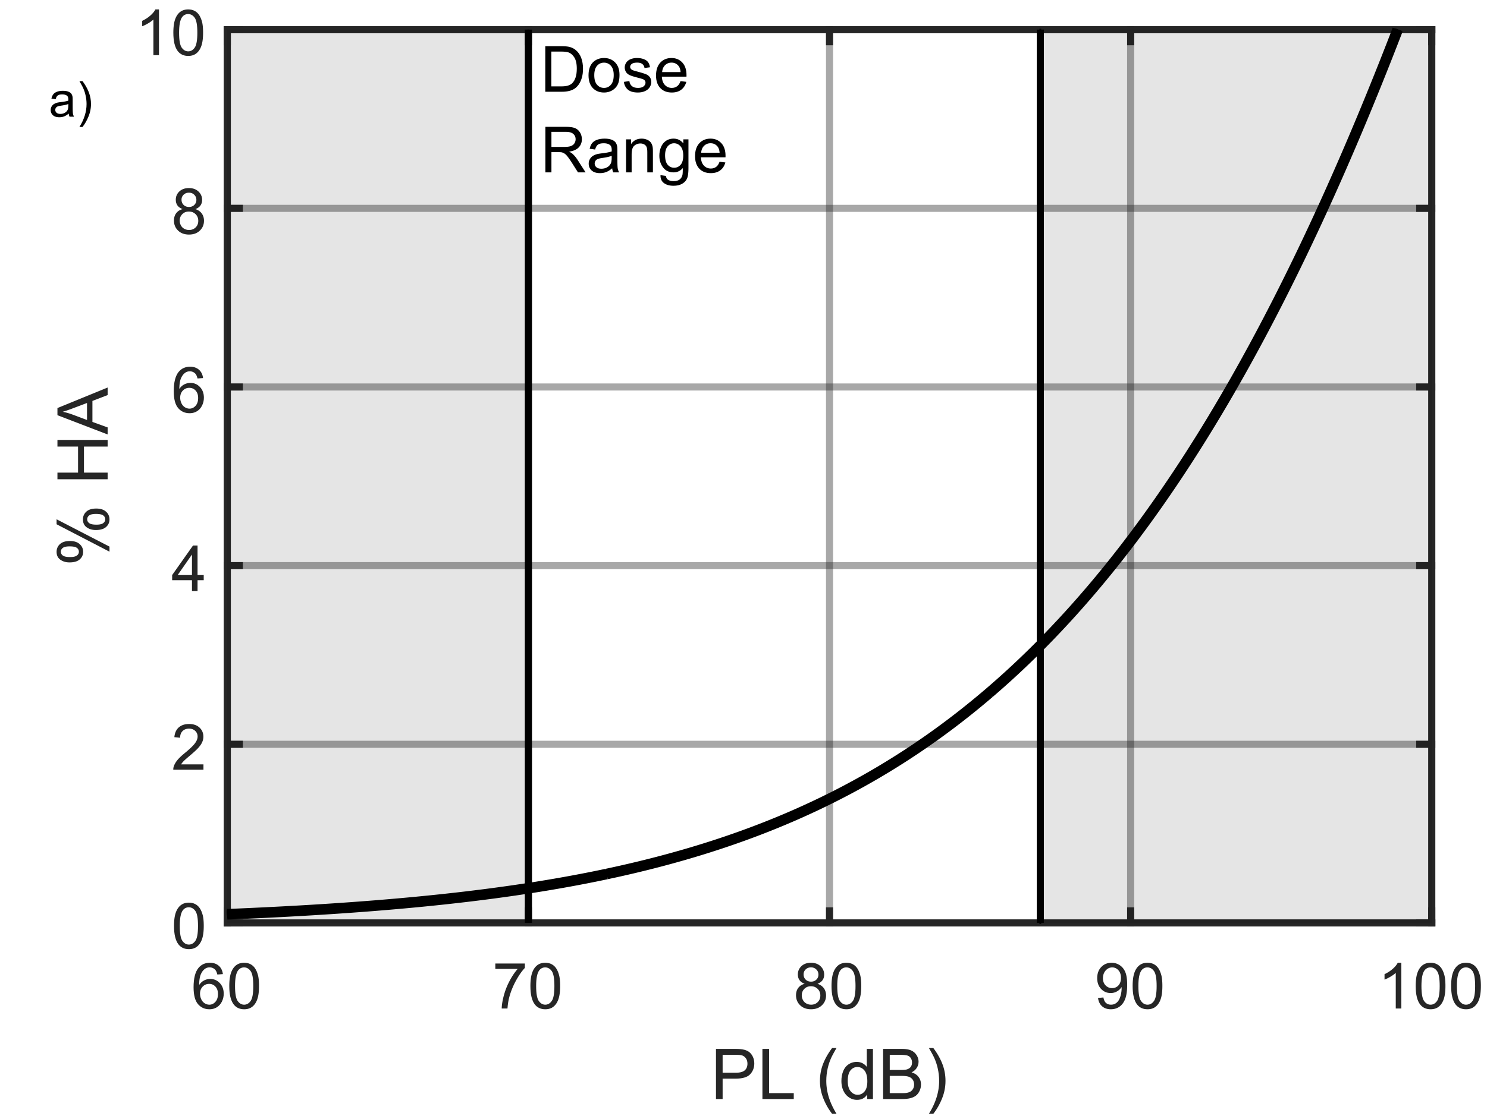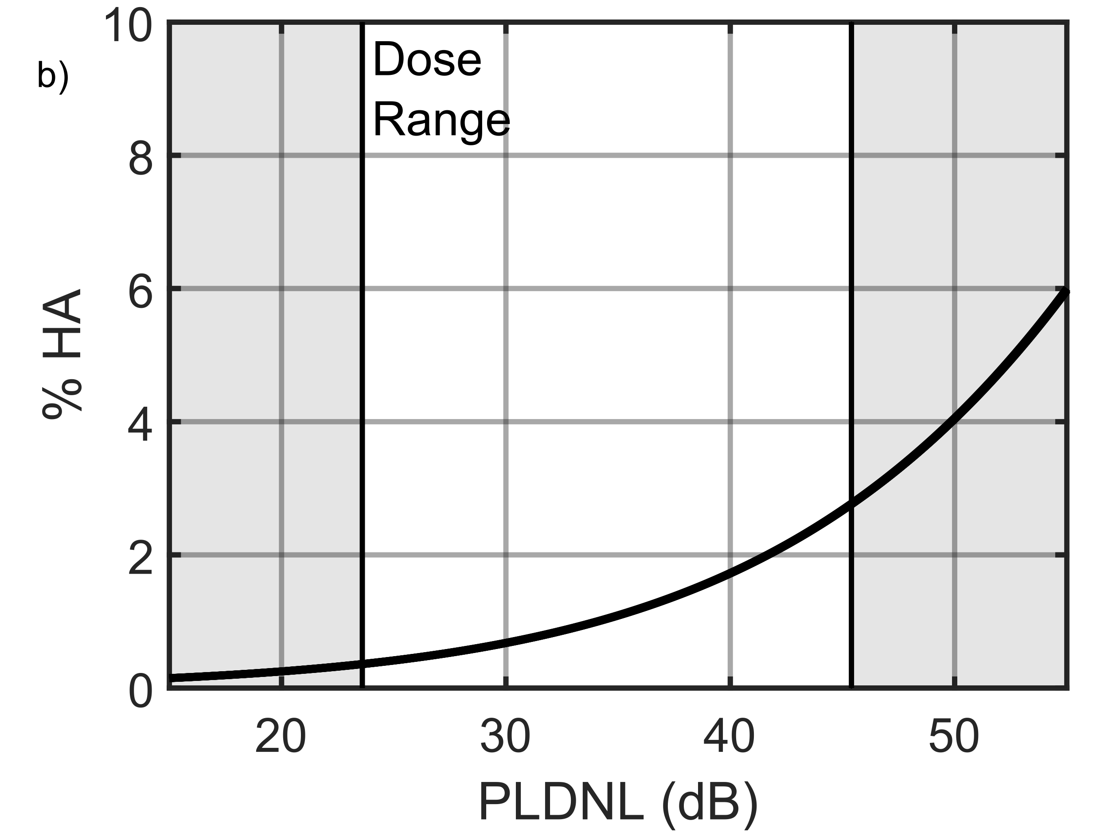
Figure 1: Single event (a) and cumulative (b) dose-response curves of the baseline population with the X-59 dose range.

The simulated error in estimating the dose for each participant response is assumed to be additive and normally distributed with zero mean and standard deviation $σ_{D}$. For the BL simulations, the value of $σ_{D}$ was varied from 0 to 8 dB in increments of 2 dB. More details on the doses and simulated error are provided in Section 3.
In order to quantify sampling variability due to the random nature of the simulated survey data, dose-response modeling and analysis was completed for 30 replicate datasets for each combination of $N_{P}$ and $σ_{D}$. X-59 tests will not be replicated at each community test site location, hence low sampling variability is desirable. A dose-response model was fit to each replicate dataset (additional details are in Section 4), and estimated model parameters, population dose-response curves, and quantities of interest on the dose-response curves were compared to those of the true population.

3. Expanded Population Models
To provide a more robust assessment of the effect of dose error on the noise-annoyance response of communities across the country and world, 24 population models beyond the BL population were explored for both single event and cumulative responses. This section describes parameters for these additional population models. Descriptions and values of the population parameters are given in Table 1. Most models were obtained by adjusting a single BL parameter by ±10 and ±20% while holding all other parameters constant with two exceptions.
The first exception is the $β_{0}$ parameter, which shifts the dose-response curve to the left when it is increased and shifts it to the right when it is decreased. This parameter was adjusted such that it shifted the curve left or right by ±10 and ±20 dB. The dose that elicits annoyance 50% of the time for the average participant is given by $-β_{0}/β_{1}$, which is 124.2 dB for the BL single event population and 94.5 dB for BL cumulative population. Shifting by 20 dB to the left puts the 50%HA point at 104.2 dB, which is roughly the loudness of a traditional N-wave sonic boom. In the analyses and plots that follow, a shift to the left of 10 dB corresponds to the abbreviation “SL10,” and a shift to the right of 20 dB is “SR20.”
The second exception is that adjustments had to be made to $β_{0}$ and $β_{1}$ together in order to adjust the rate of increase of annoyance without shifting the dose-response curve. To avoid shifting the curve, one must vary $β_{0}$ and $β_{1}$ such that the ratio $-β_{0}/β_{1}$ is held constant. To make the dose-response curve steeper, the $β_{1}$ parameter is increased by 10 or 20% compared to the BL, with the same adjustment made to $β_{0}$ to keep their ratio constant. To make the dose-response curve slope shallower, the $β_{1}$ parameter is reduced by 10 or 20% compared to the BL, with the same adjustment to $β_{0}$ to keep their ratio constant. In the analyses and plots that follow, dose-response curves with a fixed 50%HA point that are steepened by 10% corresponds to the abbreviation “FSt10” and that are shallower by 20% is “FSh20.”
Reducing $β_{1}$ causes the curve to be shallower and shifted right, while increasing it causes the curve to be steeper and shifted left. In the analyses and plots that follow, dose-response curves that are steepened by 10% correspond to the abbreviation “St10” and that are shallower by 20% is “Sh20.”
Reducing $σ_{RE}$ reduces the variability of participant intercepts $β_{0i}$ about the mean participant intercept $β_{0}$. This causes the population dose-response curve to “rotate” about its 50%HA point similar to the “FSh” populations, but to a lesser extent. In the analyses and plots that follow, dose-response curves whose $σ_{RE}$ variability is adjusted by +10% corresponds to the abbreviation “Vp10” and that is adjusted by -20% is “Vm20.”
Reductions in the withdrawal rate $W$ and participation rate $P$ only impact the total number of responses and therefore, reduce the precision in the modeled dose-response curve. In the analyses and plots that follow, populations with $W$ or $P$ adjusted by +10% correspond to the abbreviation “Wp10” or “Rp10” and those adjusted by -20% are “Wm20” or “Rm20.”
Figure 2 shows the BL and adjusted population dose-response curves. Overlaid on the plots is a box indicating the anticipated dose range from the X-59 aircraft, and thus the portion of the population curve sampled by the simulated data. It is apparent that ±10 and ±20% for some parameters have greater impact on the shape and position of the dose-response curve. Populations with greater annoyance at lower doses will have a greater range of responses over the limited and fixed practical dose range of the X-59. These correspond to the “SL,” “St,” “FSh,” and “Vp” populations. Additionally, populations with low withdrawal rates and high participation rates will have more responses and model estimates will have better precision, i.e., “Wm” and “Rp.” The populations with lower annoyance at lower doses are harder to estimate given the fixed dose range of the X-59. These are the “SR,” “Sh,” “FSt,” and “Vm” populations. Those with fewer observations, i.e., the “Wp” and “Rm,” are harder to estimate and have worse precision. The results of this work in Section 6 quantify these trends.
In order to quantify sampling variability due to the random nature of the simulated survey data, dose-response modeling and analysis were completed for 30 replicate datasets for each of the 24 populations with 500 and 2500 participants and 0, 2, and 4 dB dose error. X-59 tests will not be replicated at each community test site location, hence low sampling variability is desirable.

4. Dose Design and Injecting Dose Error
This section outlines the true doses to which the simulated populations were subjected and how errors were introduced into the dose estimates assigned to survey participants. True doses were assigned based on the practical dose range of the X-59 aircraft, and a notional dose schedule for the community surveys [9], shown in Fig. 3. The dose schedule is based on the capability of the aircraft to fly over the community up to six times per day for about one-month. In this paper, the single event doses are given in Perceived Level (PL) [, ], and the cumulative doses are given in Day-Night-Average Perceived Level (PLDNL) (see page 85 of Ref. [8]). Recently, the practical dose range was quantified to be between 70 and 87 dB for the single event dose in PL and 23.6 and 45.4 dB for cumulative dose in PLDNL.
Following the dose design suggestion of Horonjeff [2], a uniform distribution of doses was targeted. Because the cumulative dose is linked to the single event doses of each day by a logarithmic summation, it is not possible to achieve a uniform distribution of both. The cumulative design was prioritized to be more uniform because it has fewer test point observations $N=26$ (one per test day) versus the single event design where the number of flyover test points is $N=86$ (up to six per test day).
In the simulated dose-response datasets, each simulated participant responds to the true doses of Fig. 3. The true doses do not attempt to include additional real-world dose effects that may be expected in the field such as lateral loudness variability or variability from real piloting or turbulence, etc. To simulate dose error, the estimated doses are true doses plus a random draw from a normal

Table 1: Description and values of baseline (bold) and shifted population parameters.

Parameter | Description of impact compared to baseline (BL) population | Single Event Values | Cumulative Values | Name Abbreviation
$$β_{0}$$ | Shifted Right or Left | [-22.06, -20.53, -19,  -17.47, -15.90] | [-12.48, -11.39, -10.3,  -9.21, -8.12] | [SR20, SR10, BL,  SL10, SL20]
$$β_{1}$$ | Shallower and shifted right or steeper and shifted left | [0.122, 0.138, 0.153,  0.168, 0.184] | [0.087, 0.098, 0.109,  0.120, 0.131] | [Sh20, Sh10, BL,  St10, St20]
$$σ_{RE}$$ | Distribution of random intercepts is less or more variable | [1.9608, 2.2059,  2.451,  2.6961, 2.9412] | [1.6894, 1.9005,  2.1117,  2.3229, 2.5340] | [Vm20, Vm10, BL,  Vp10, Vp20]
$$-β_{0}/β_{1}$$ | Steeper and Shallower with fixed dose that elicits annoyance 50% of the time for the average participant | - [-22.8/0.1836, -20.9/0.1683,  -19/0.153,  -17.1/0.1377,  -15.2/0.1224] = 124.2 dB | -[-12.36/0.1308, -11.33/0.1199,  -10.3/0.109,  -9.27/0.0981,  -8.24/0.0872] = 94.5 dB | [FSt20,  FSt10,  BL,  FSh10,  FSh20]=  BL
$$W$$ | Withdraw  Rate (%) | [20.64, 23.22,  25.8,  28.38, 30.96] | [12.00, 13.50,  15,  16.50, 18.00] | [Wm20, Wm10,  BL,  Wp10, Wp20]
$$P$$ | Participation  Rate (%) | [37.52, 42.21,  46.9,  51.59, 56.28] | [52.93, 59.54,  66.16,  72.78, 79.39] | [Rm20, Rm10,  BL,  Rp10, Rp20]
$$σ_{D}$$ | Dose Error Standard Deviation (dB) | [0, 2, 4]* | [0, 2, 4]* | -
$$N_{P}$$ | Target Number of Participants | [500, 2500]† | [500, 2500]† | -
$$R$$ | Replicates | 30 | 30 | -
*The baseline simulations also included $σ_{D}$ of 6 and 8 dB.
†The baseline simulations also included 50, 3000, 5000, 7500, and 10000 participants

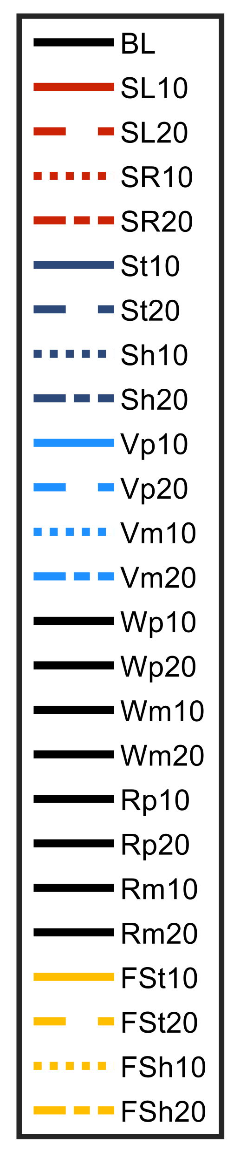

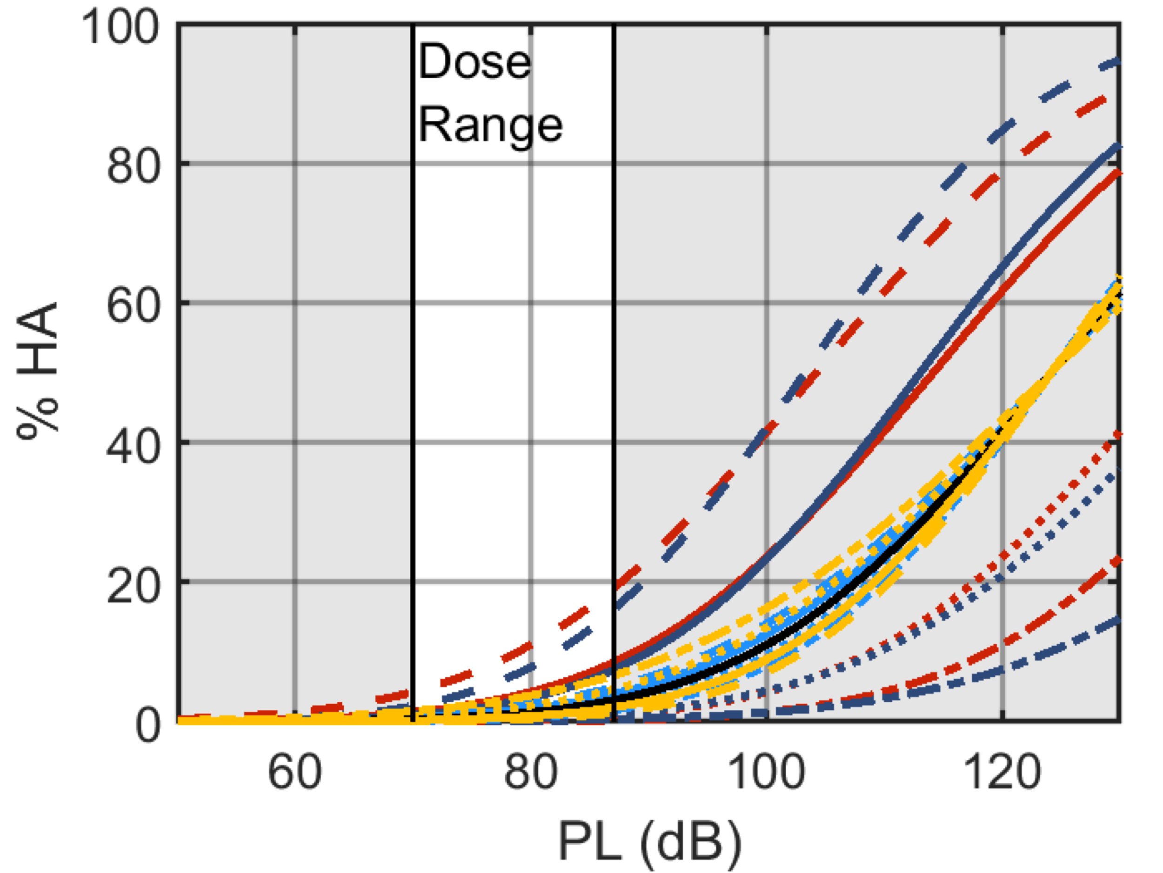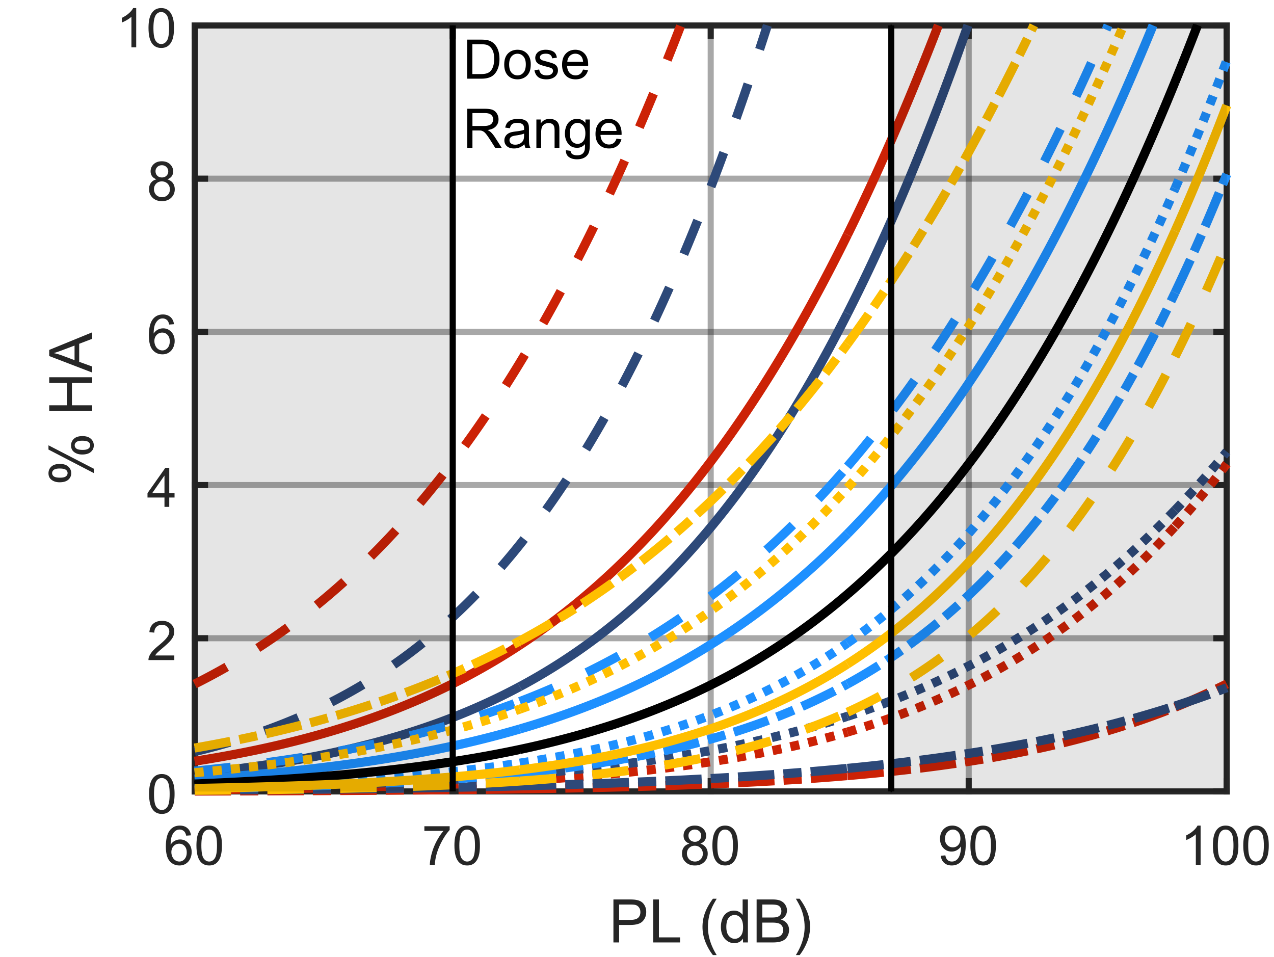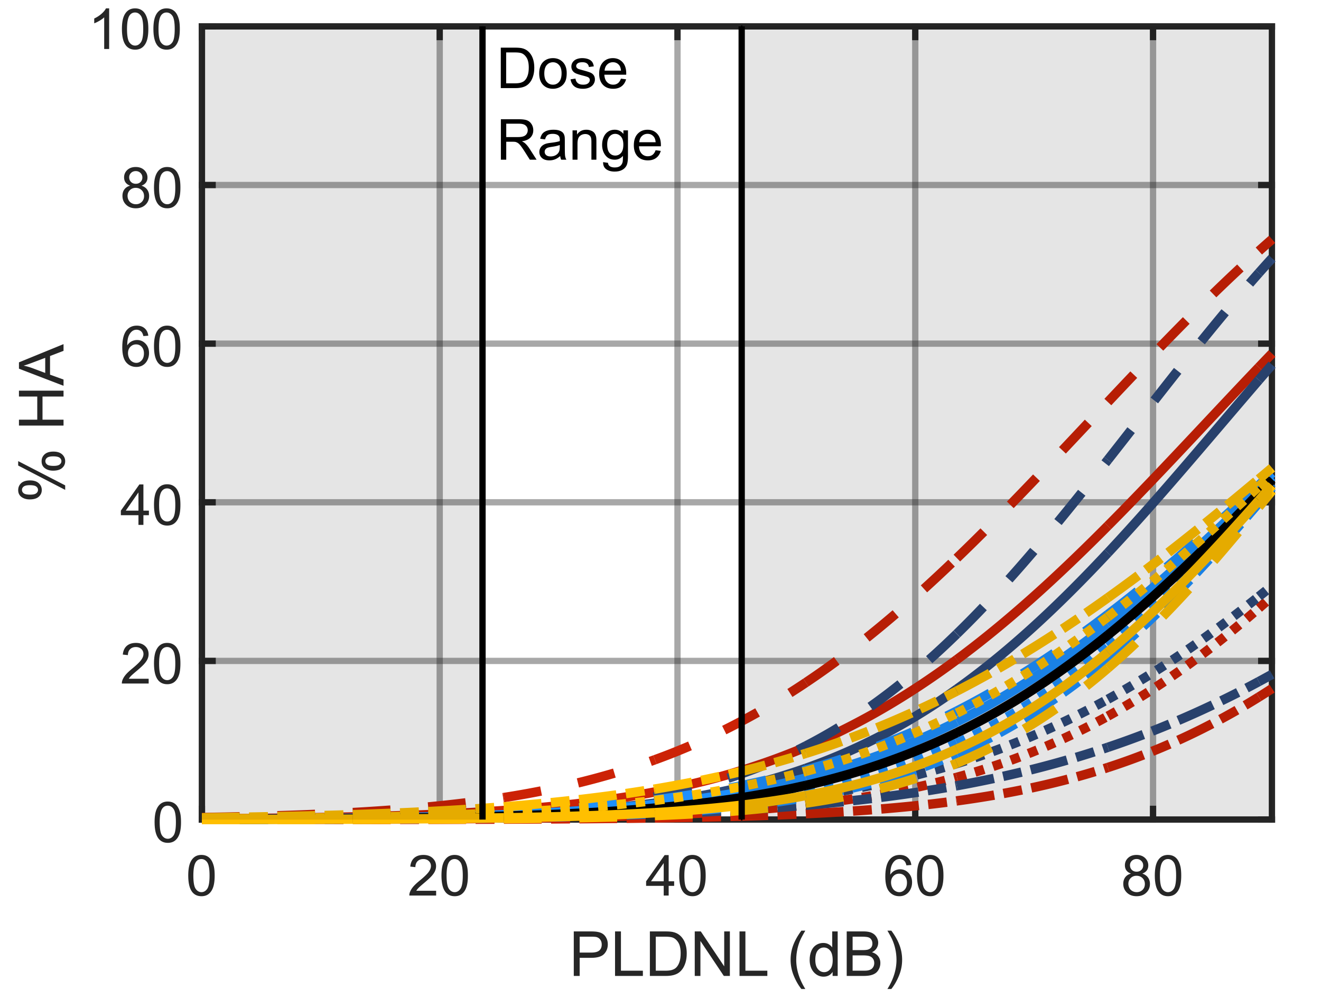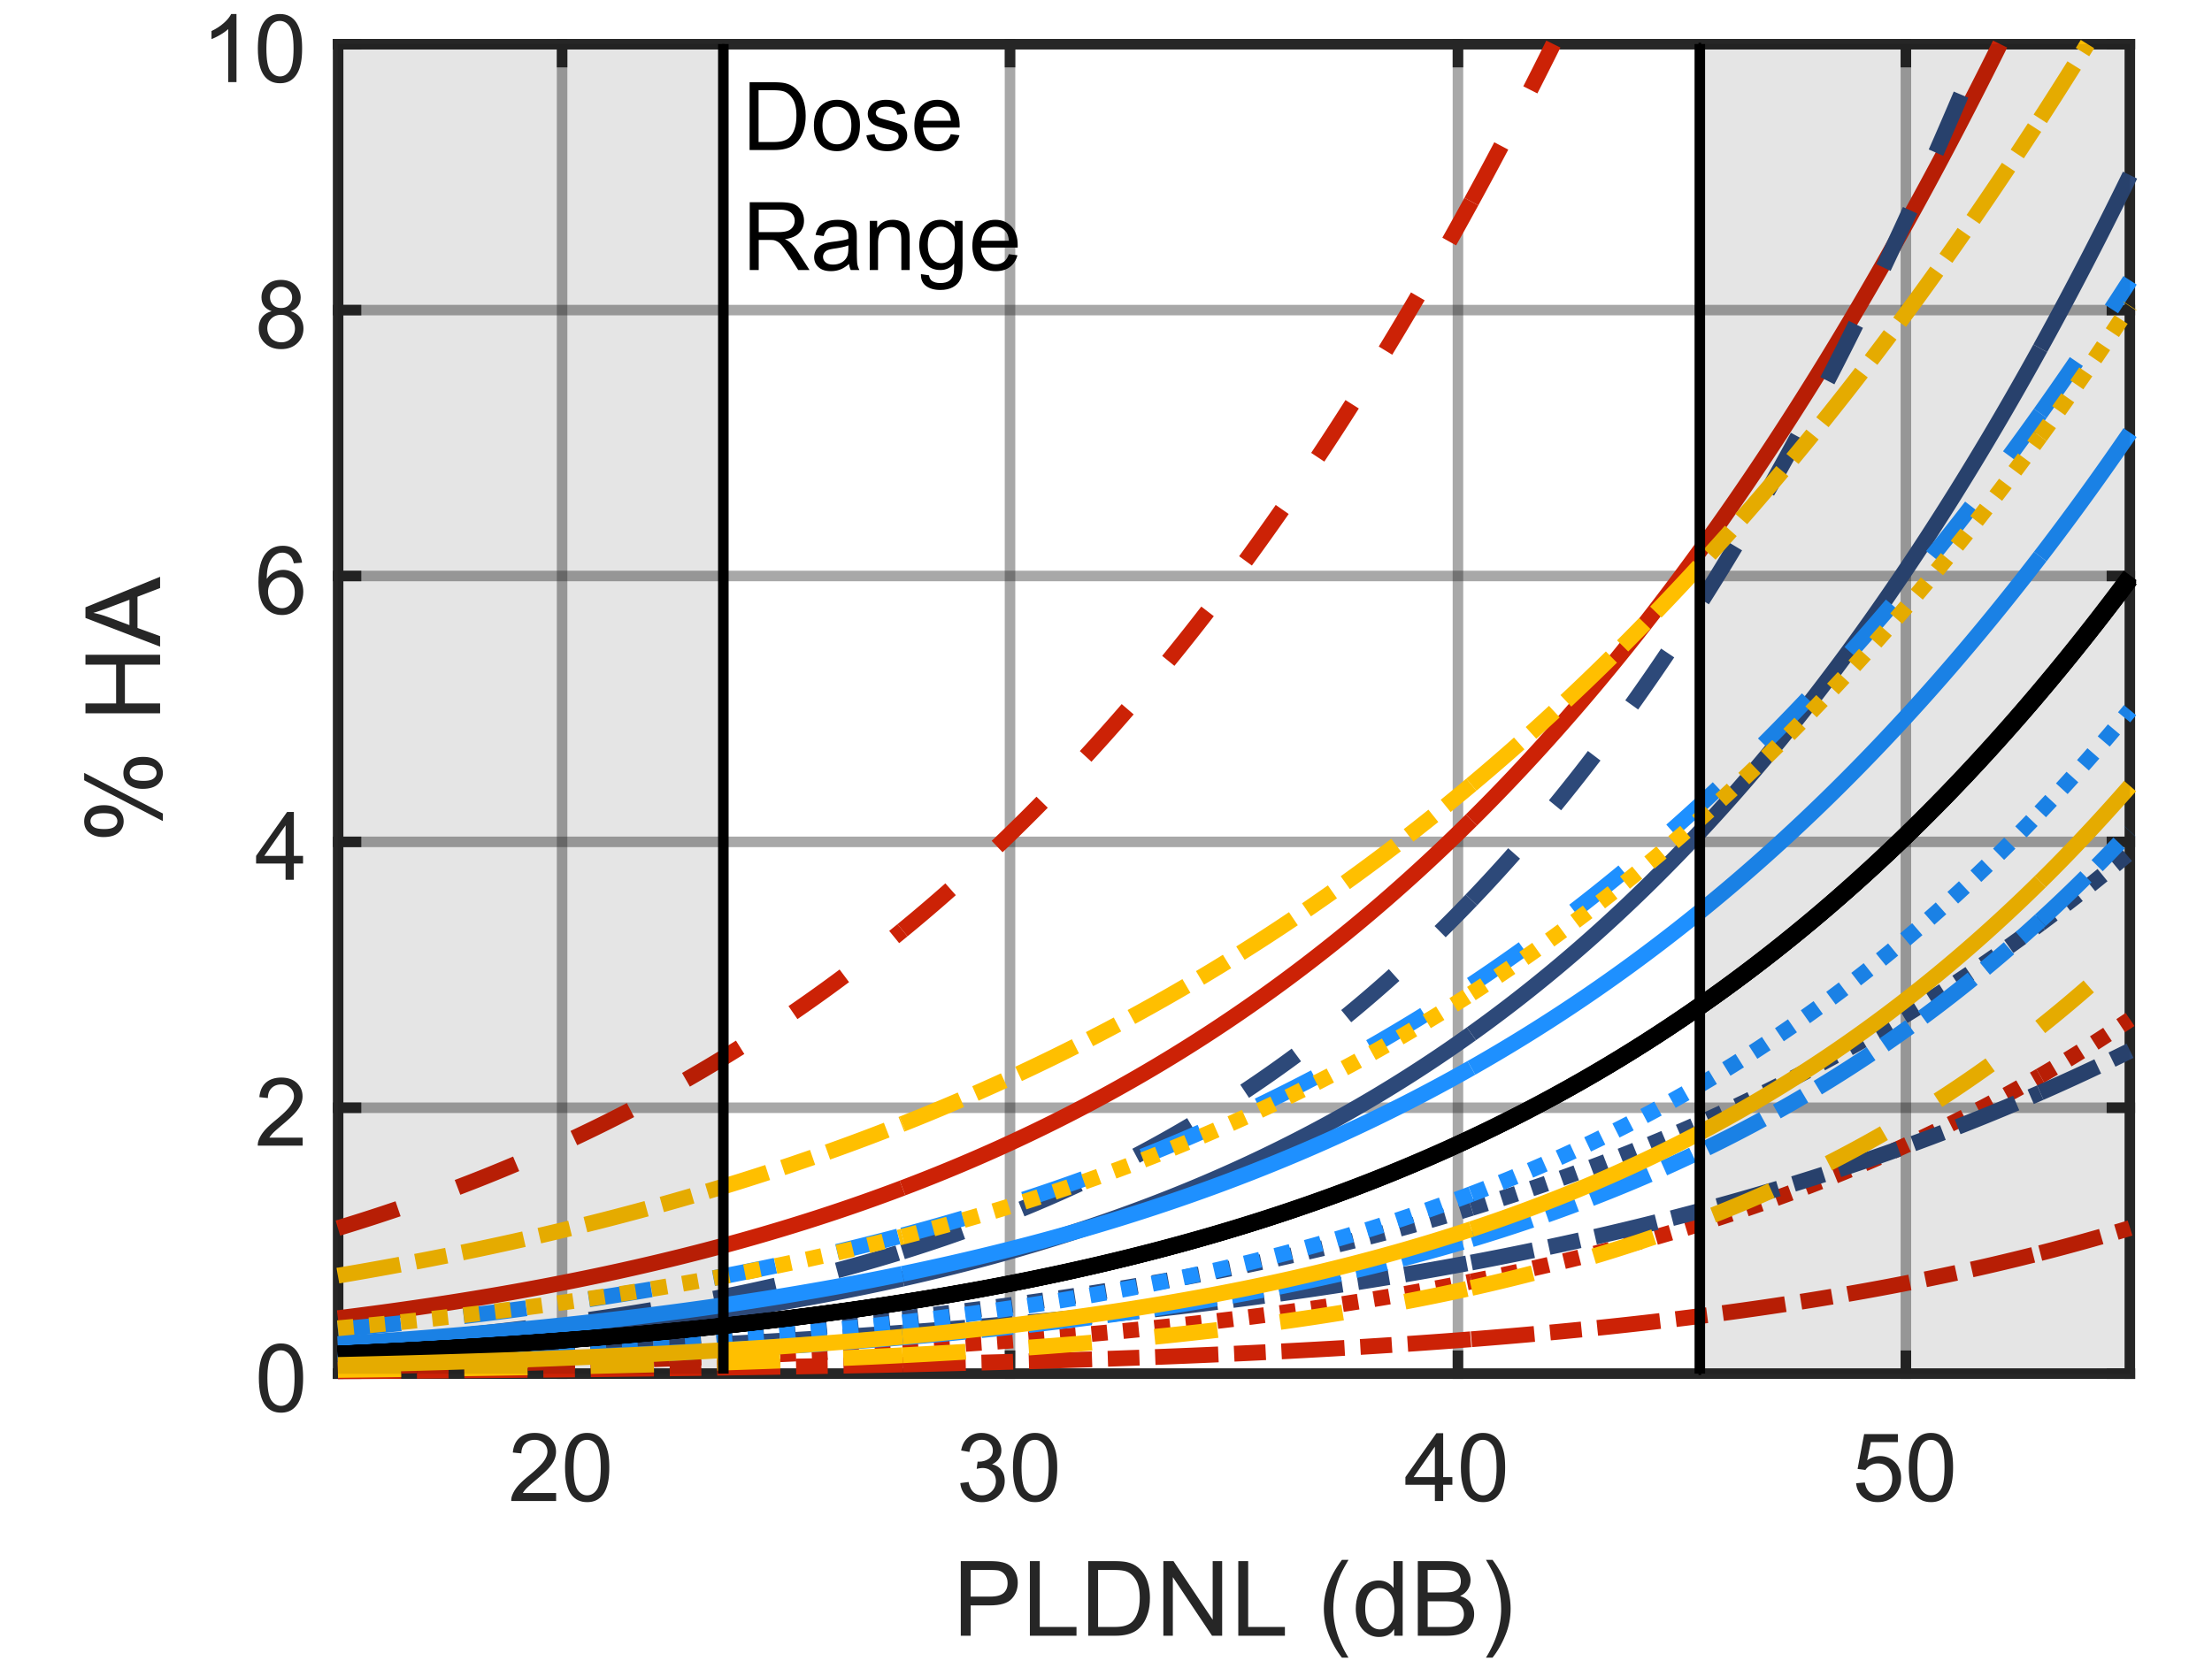
Figure 2: Single event (top row) and cumulative (bottom row) population dose-response curves of the baseline and shifted simulation populations. The right column shows the same data as the left, but it is zoomed in on the vertical axis. The black “W” and “R” curves overlay the baseline because these cases only change the likelihood of responding and not the shape of the curve.

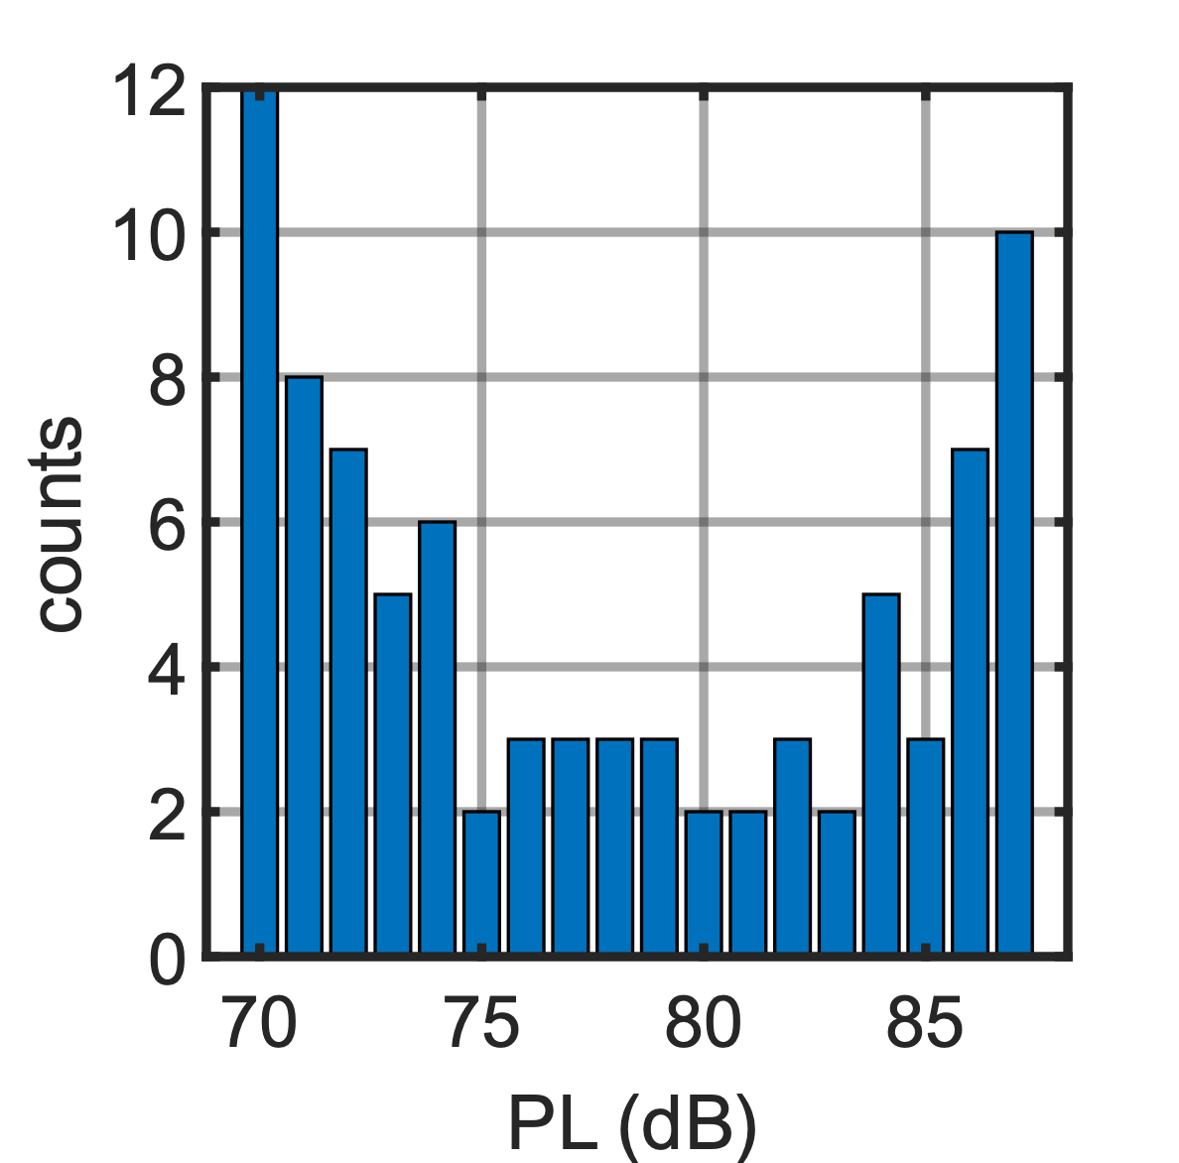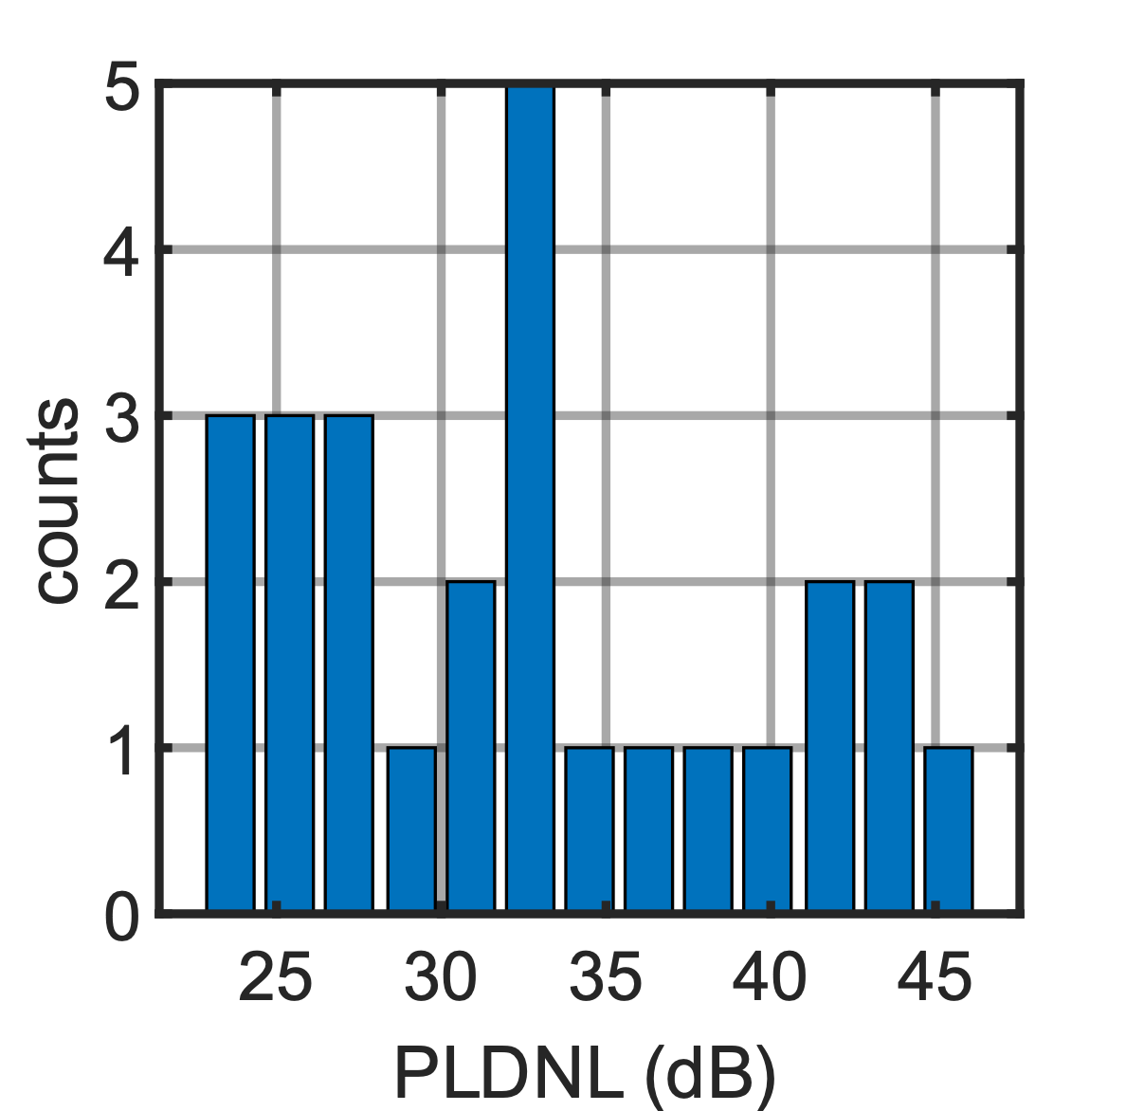
Figure 3: X-59 single event (left) (N=86) and cumulative (right) (N=26) baseline noise dose design.

distribution with mean zero and standard deviation $σ_{D}$. The responses are unchanged, so models are fit to the estimated dose and true response data of each population. Also note that the simulated single event and cumulative datasets were generated independently with no attempt to link the single event doses, their error, or participants to the cumulative doses, errors, or participants.

5. Modeling Of Simulated Datasets
An MLR model matching the form of the underlying population model of Sections 2 and 3 was fit to each simulated dose-response dataset []. The glmer function from the lme4 package in the R programming language was used to fit the model to each dataset [, ]. The model estimates the population parameters $β_{0}$, $β_{1}$, and $σ_{RE}$. The standard error in and correlation between $β_{0}$ and $β_{1}$ are also provided, which are used to compute confidence intervals about each estimated dose-response curve. The population dose-response curve results from integrating over the distribution of random effects [] while accounting for the uncertainty in and correlation between $β_{0}$ and $β_{1}$ as presented in Ref. [7].

6. Accuracy and Precision of Models
Accuracy and precision of models and quantities of interest on the dose-response curves in the presence of dose error for the various populations are quantified in the subsections that follow. The data are presented as the mean over the 30 replicates for various metrics. The accuracy metric for assessing the model parameters is the absolute percent difference between the estimated and true model parameters in Section 6.1. The difference in dose that elicits 1 or 5%HA is also quantified in Section 6.2. For precision, the margin of error in the dose that elicits 1 or 5%HA is quantified in Section 6.3. Finally, the sampling variability is quantified by the normalized standard deviation of percent difference between estimated and true model parameters in Section 6.4.

6.1 Accuracy in Model parameters
This section compares the estimates of the modeled population parameters to the true population using the mean absolute percent difference (MA%D). It is given by

$$\text{MA\%D}=100\%\frac{1}{30}\sum_{R=1}^{30}{\left|\frac{β_{0,R}^{model fit}-β_{0}^{true}}{β_{0}^{true}}\right|}$$

where $β_{0}^{true}$ is the true population parameter given Table 1, $R$ is the dataset replicate index, and $β_{0,R}^{model fit}$ is the model estimate of the population parameter. $β_{0}$ can be replaced with the other population parameters, $β_{1}$ and $σ_{RE}$.
The MA%D for each parameter for the single event and cumulative populations is shown in Fig. 4. The 2500 target participant case with either 0-, 2-, or 4-dB dose error standard deviation is shown. The trends in the accuracy of the estimated parameter follow the discussion from Section 3, where populations poorly sampled by the X-59 dose range are more difficult to model accurately. There is a large jump in the estimation error between the 2- and 4-dB dose error cases for $β_{0}$ and $β_{1}$ , but nearly no difference in the estimate of $σ_{RE}$. $β_{1}$ is the most sensitive followed by $β_{0}$ then $σ_{RE}$. The “SR” and “Sh” populations have the highest error even when there is no dose error, which shows the limitations of using the MLR model when the data fall along the lower tail of the curve, i.e., if a population is significantly less annoyed by X-59 flyovers than those of the BL population.

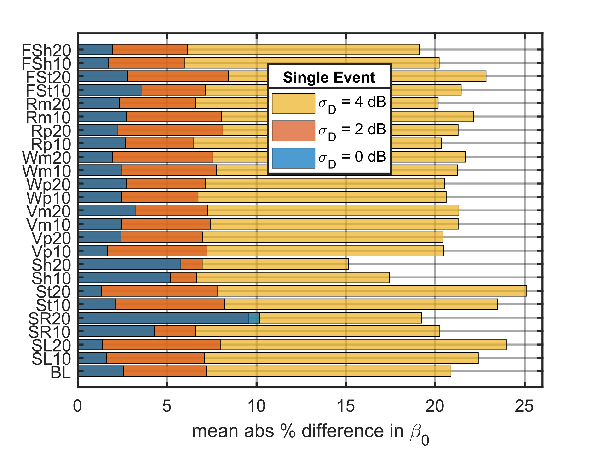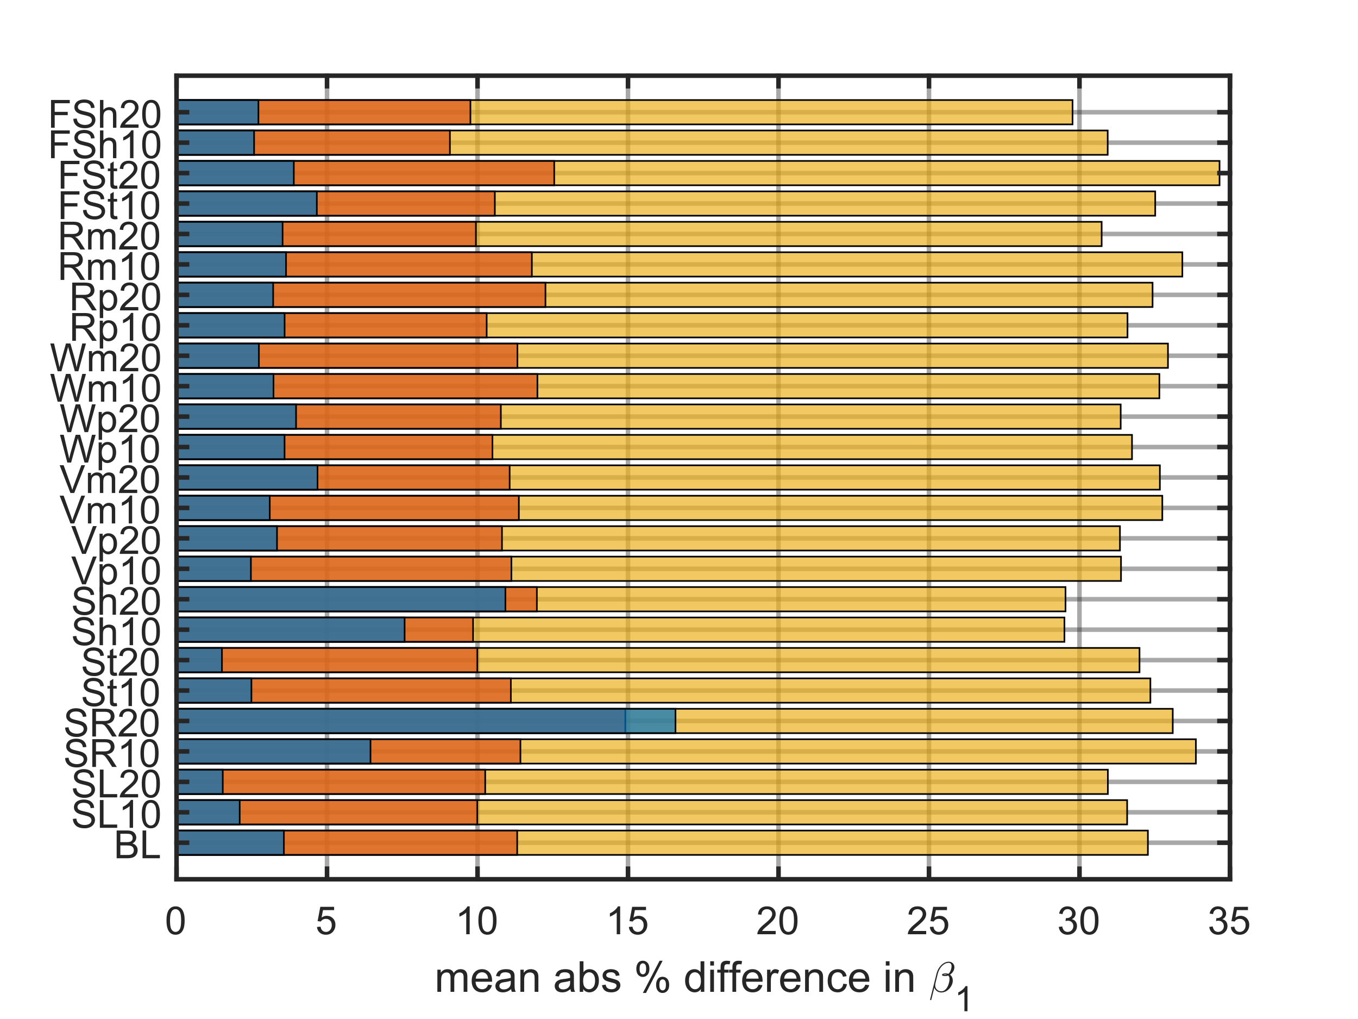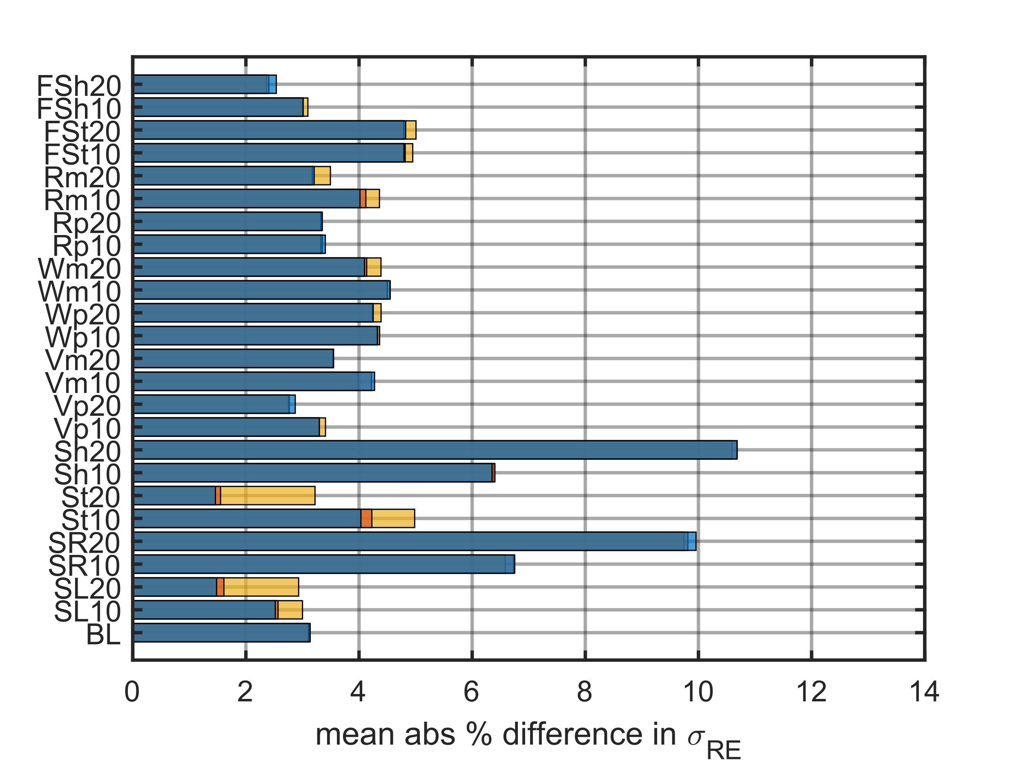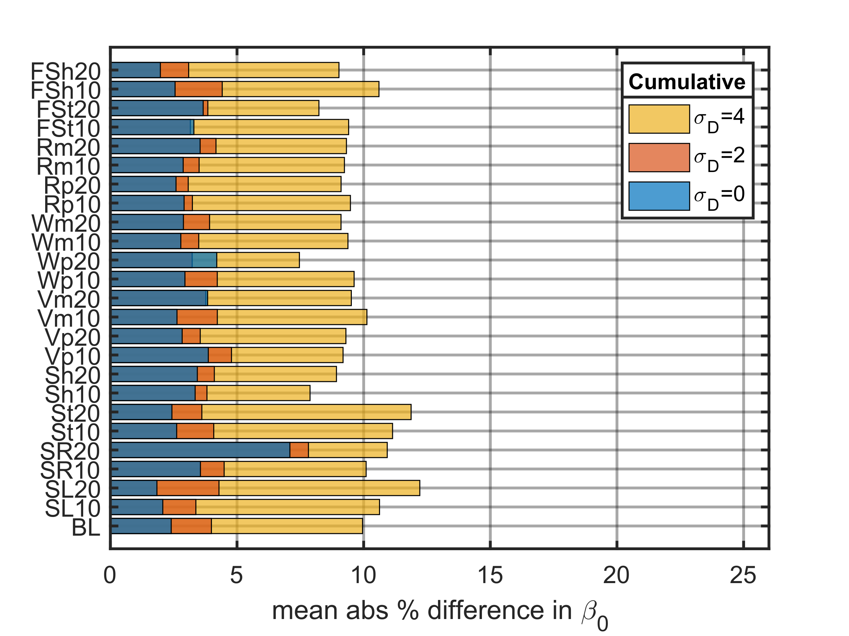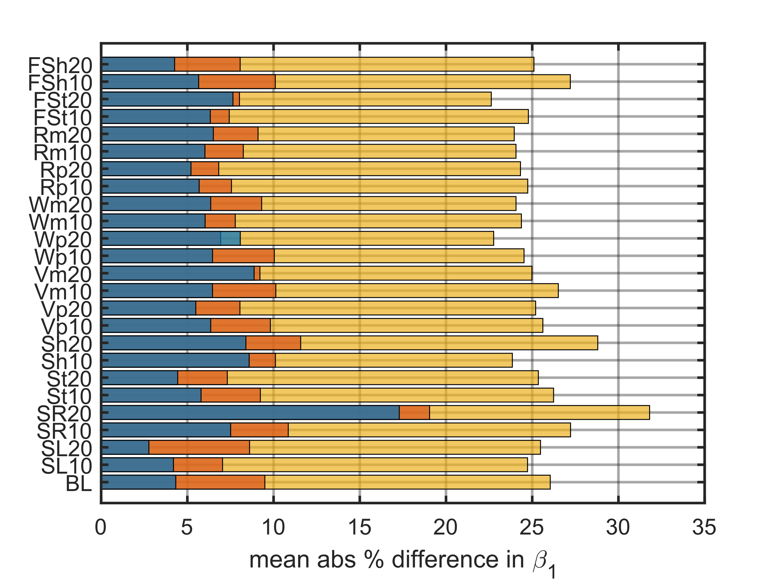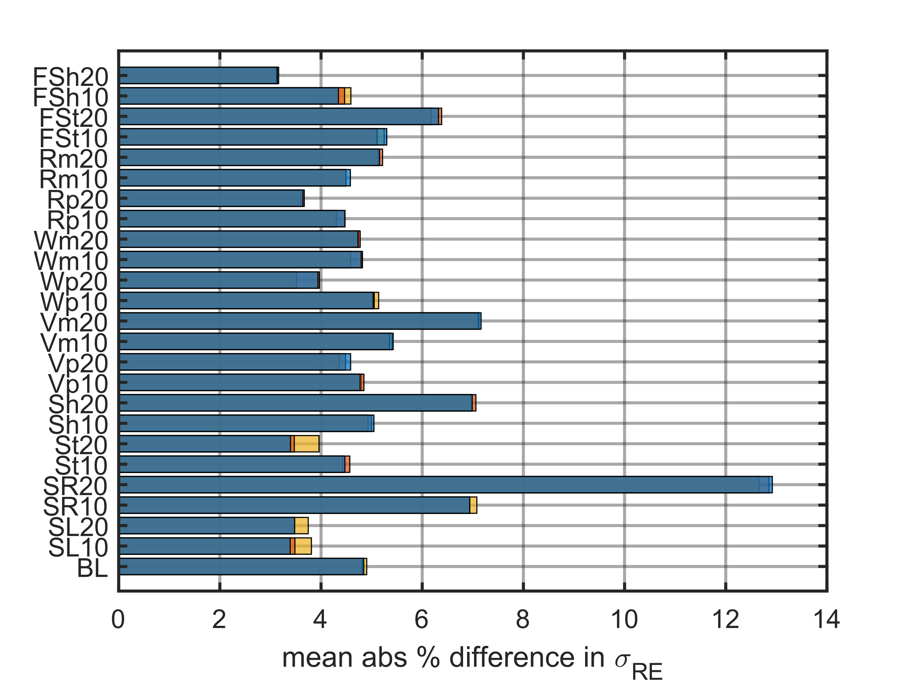
Figure 4: Mean absolute % difference between estimated and true single event model parameters for the 2500 target participant populations with 0 to 4 dB dose error.

6.2 Accuracy of Quantities of Interest
The previous section quantified the error in the model parameter estimates. This section quantifies the impact of the error on the population curve in practical units by assessing accuracy in point estimates for specific quantities along the dose-response curves. Due to the effects of dose error the point estimates can be both over and underestimated, and the position of the true population curve impacts the over and underestimation.
The left plot of Fig. 5 shows three of the population true curves and the point estimates for the dose that elicits 1 to 5%HA when there is 4 dB dose error with 2500 target participants. For the BL estimate, the dose that elicits 1%HA is underestimated, but the doses eliciting 2, 3, 4, and 5% are overestimated. There is a crossover point between the estimated dose that elicits 1 and 2%HA that is estimated perfectly accurately. For the SL10 estimate, the doses that elicit 1, 2, and 3%HA are underestimated, and the dose that elicits 5%HA is overestimated. The dose that elicits 4%HA is nearly perfectly accurate. Finally, for the SR10 estimate, the doses eliciting 1 through 5%HA are all overestimated. Noise regulations set using a model with overestimation of the dose that elicits some %HA would result in annoyance above what was expected.
The middle and right plots of Fig. 5 quantify the misestimation of the dose that elicit 1 and 5%HA for the 0, 2, and 4 dB dose error cases with 2500 target participants for all study populations. When there is 2 dB dose error, the point estimate errors for all the populations are less than 3 dB. When the dose error increases to 4 dB, there is up to 14 dB error in estimating the dose that elicits 5%HA for the worst-case populations, “SR20” and “Sh20.” This shows again that methods to account for dose error should be considered when the dose error exceeds 2 dB.
Similar results were observed for the cumulative populations, but not shown. For 2 dB dose error, the point estimate errors for all populations are less than 2 dB. When the dose error increases to 4 dB, the point estimate error increases to 12 dB for the worst-case populations “SR20” and “Sh20.”
One additional observation from the left plot of Fig. 5 is that in the presence of dose error, the estimated curve will always intersect the true curve within the true dose range. It could be of interest to mathematically determine this crossover point because it is the dose/%HA point that is always accurate regardless of dose error. An approach to identify this “pivot” point could be to further perturb the doses, refit the model, and observe the point on the overlain curves that does not move. This would correspond to the point that is perfectly accurate, but this is left for future work. This pivot point represents the best estimate, and as one moves away from this point, the accuracy of the estimated dose-response curve decreases.

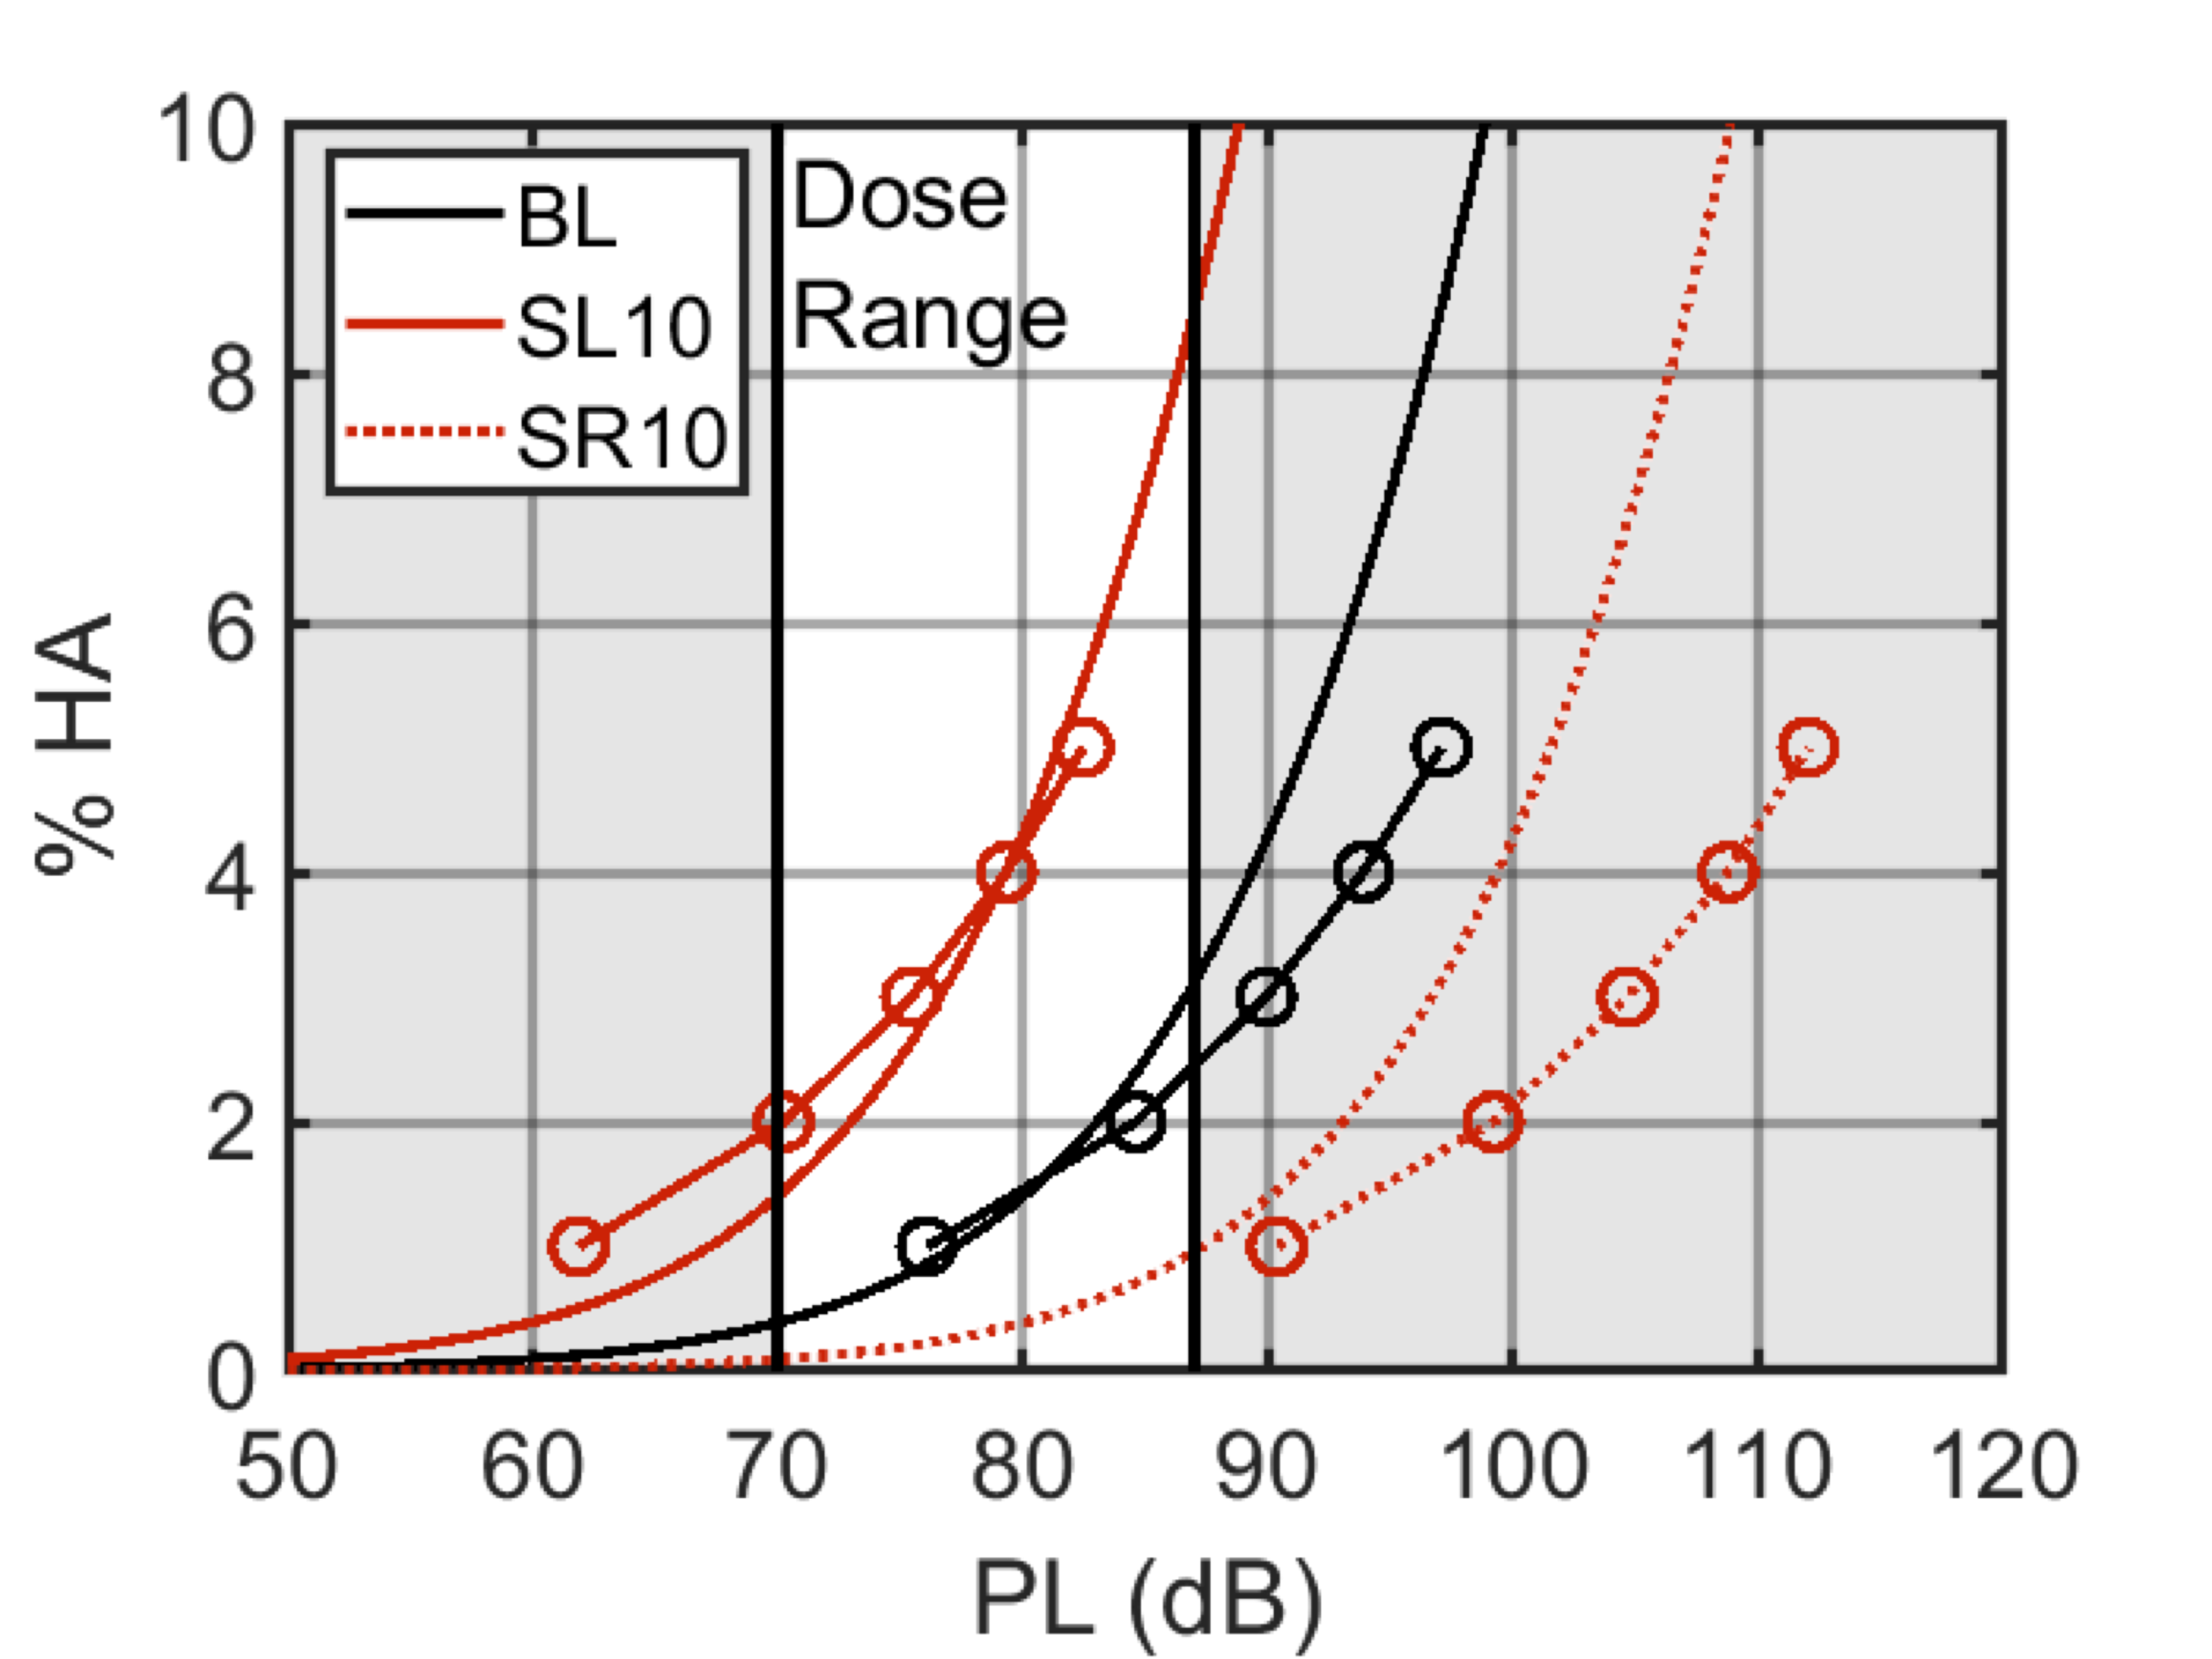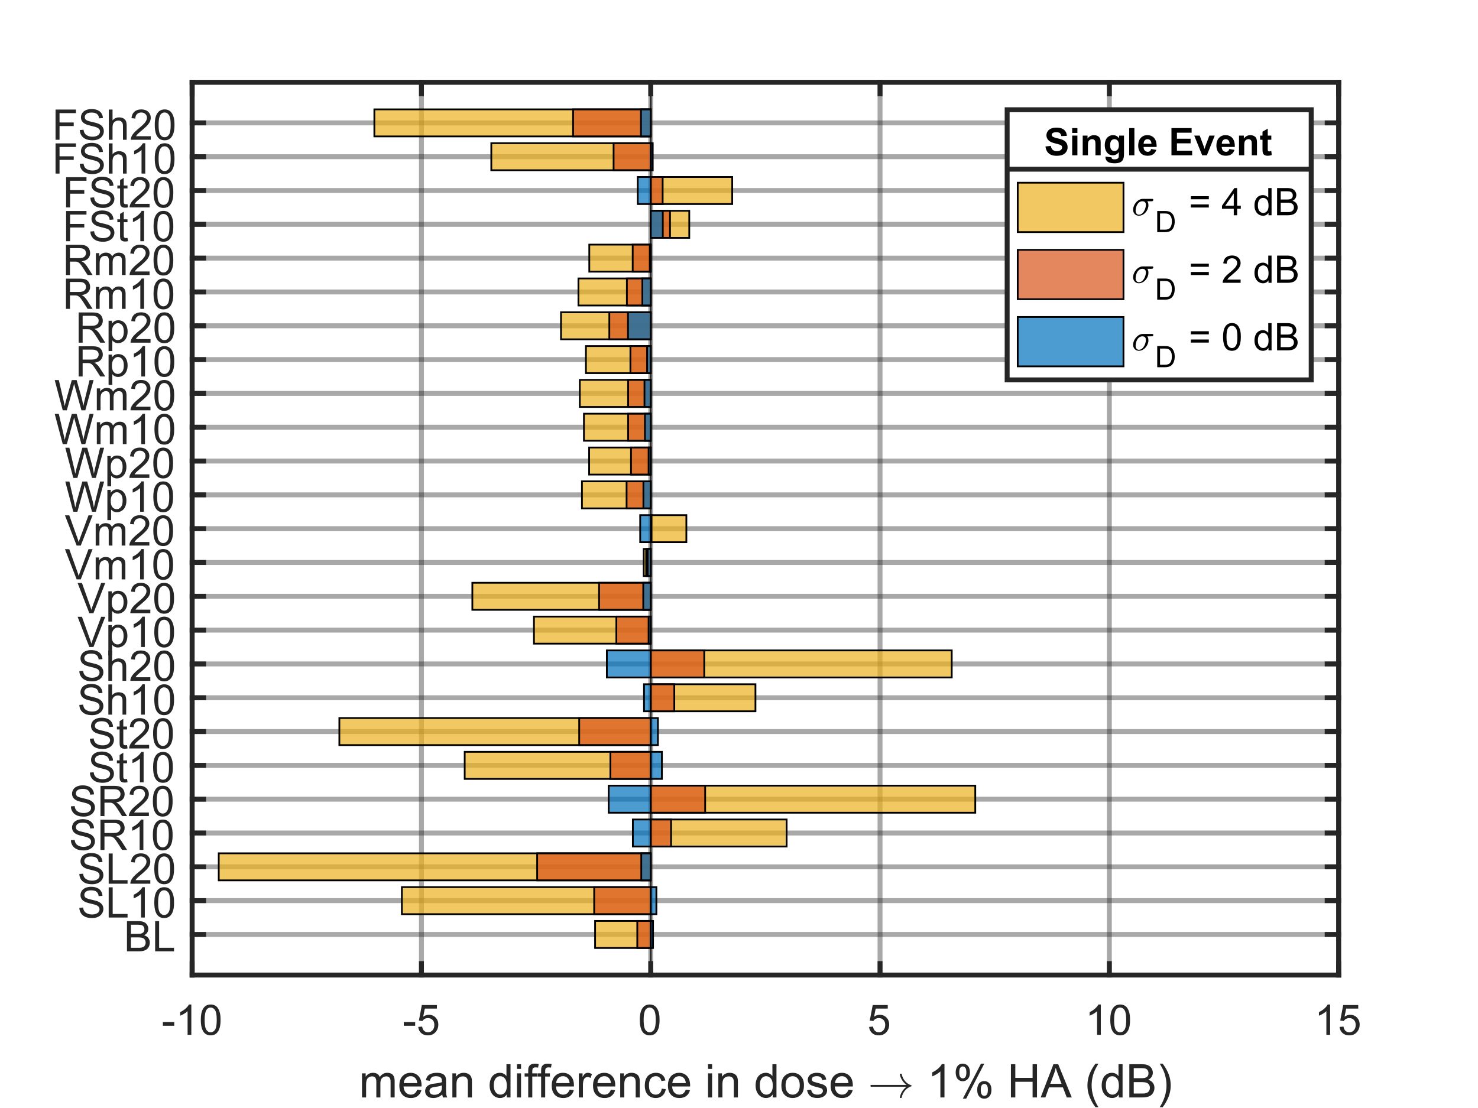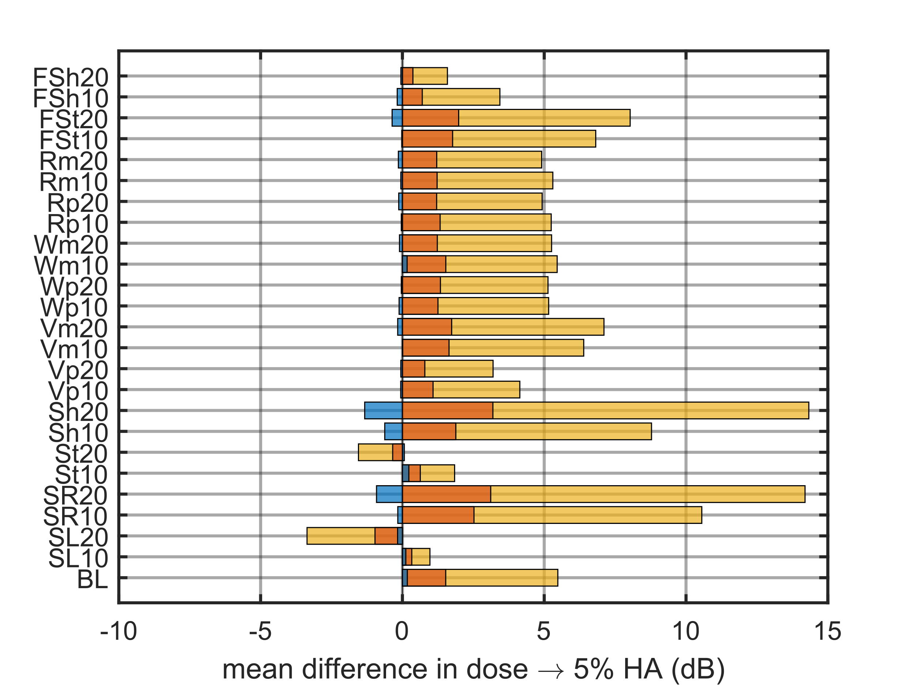
Figure 5: (Left) True single event dose-response curves and MLR point estimates of 1 to 5%HA with 4 dB dose error (circles). Mean difference in estimated and true dose that elicit (middle) 1%HA or (right) 5%HA for the 0 to 4 dB dose error cases and 2500 target participant case.

6.3 Precision of Quantities of Interest
The precision in the dose that elicits some percentage of high annoyance may be of interest for setting noise regulations. For example, consider the hypothetical case where a noise regulation was decided by selecting the estimated dose that elicits some %HA from community test data. If that dose was estimated with poor precision, the population could be significantly more or less annoyed by that dose than expected. Here, the precision is quantified as the margin of error (MOE) in the point estimate of a quantity of interest, i.e., dose that elicits X%HA ± MOE (dB). Figure 6 shows the margin of errors for the dose that elicits 1% and 5%HA for the single event (left) and cumulative (right) populations for the 2500 target participants case with 0 dB dose error. The 0 dB dose error is the best cast scenario as it represents the least amount of flattening. For these quantities of interest, the single event MOE are typically around 2 dB, except for the “SR” and “Sh” populations, which have higher MOE. The cumulative MOE are typically around 4 dB except for the “SR,” “Sh,” and “FSh” populations, which have higher MOE. These populations challenge the MLR modeling approach, leading to poor precision in the estimated dose.

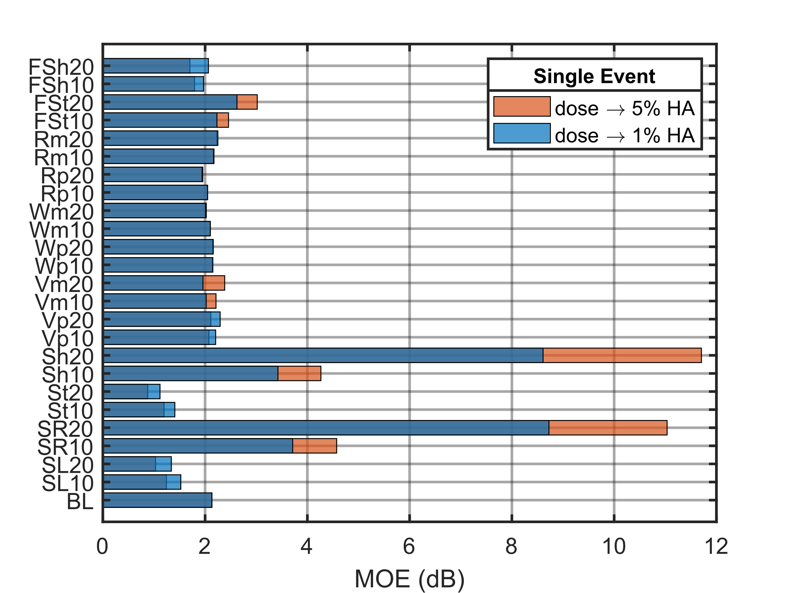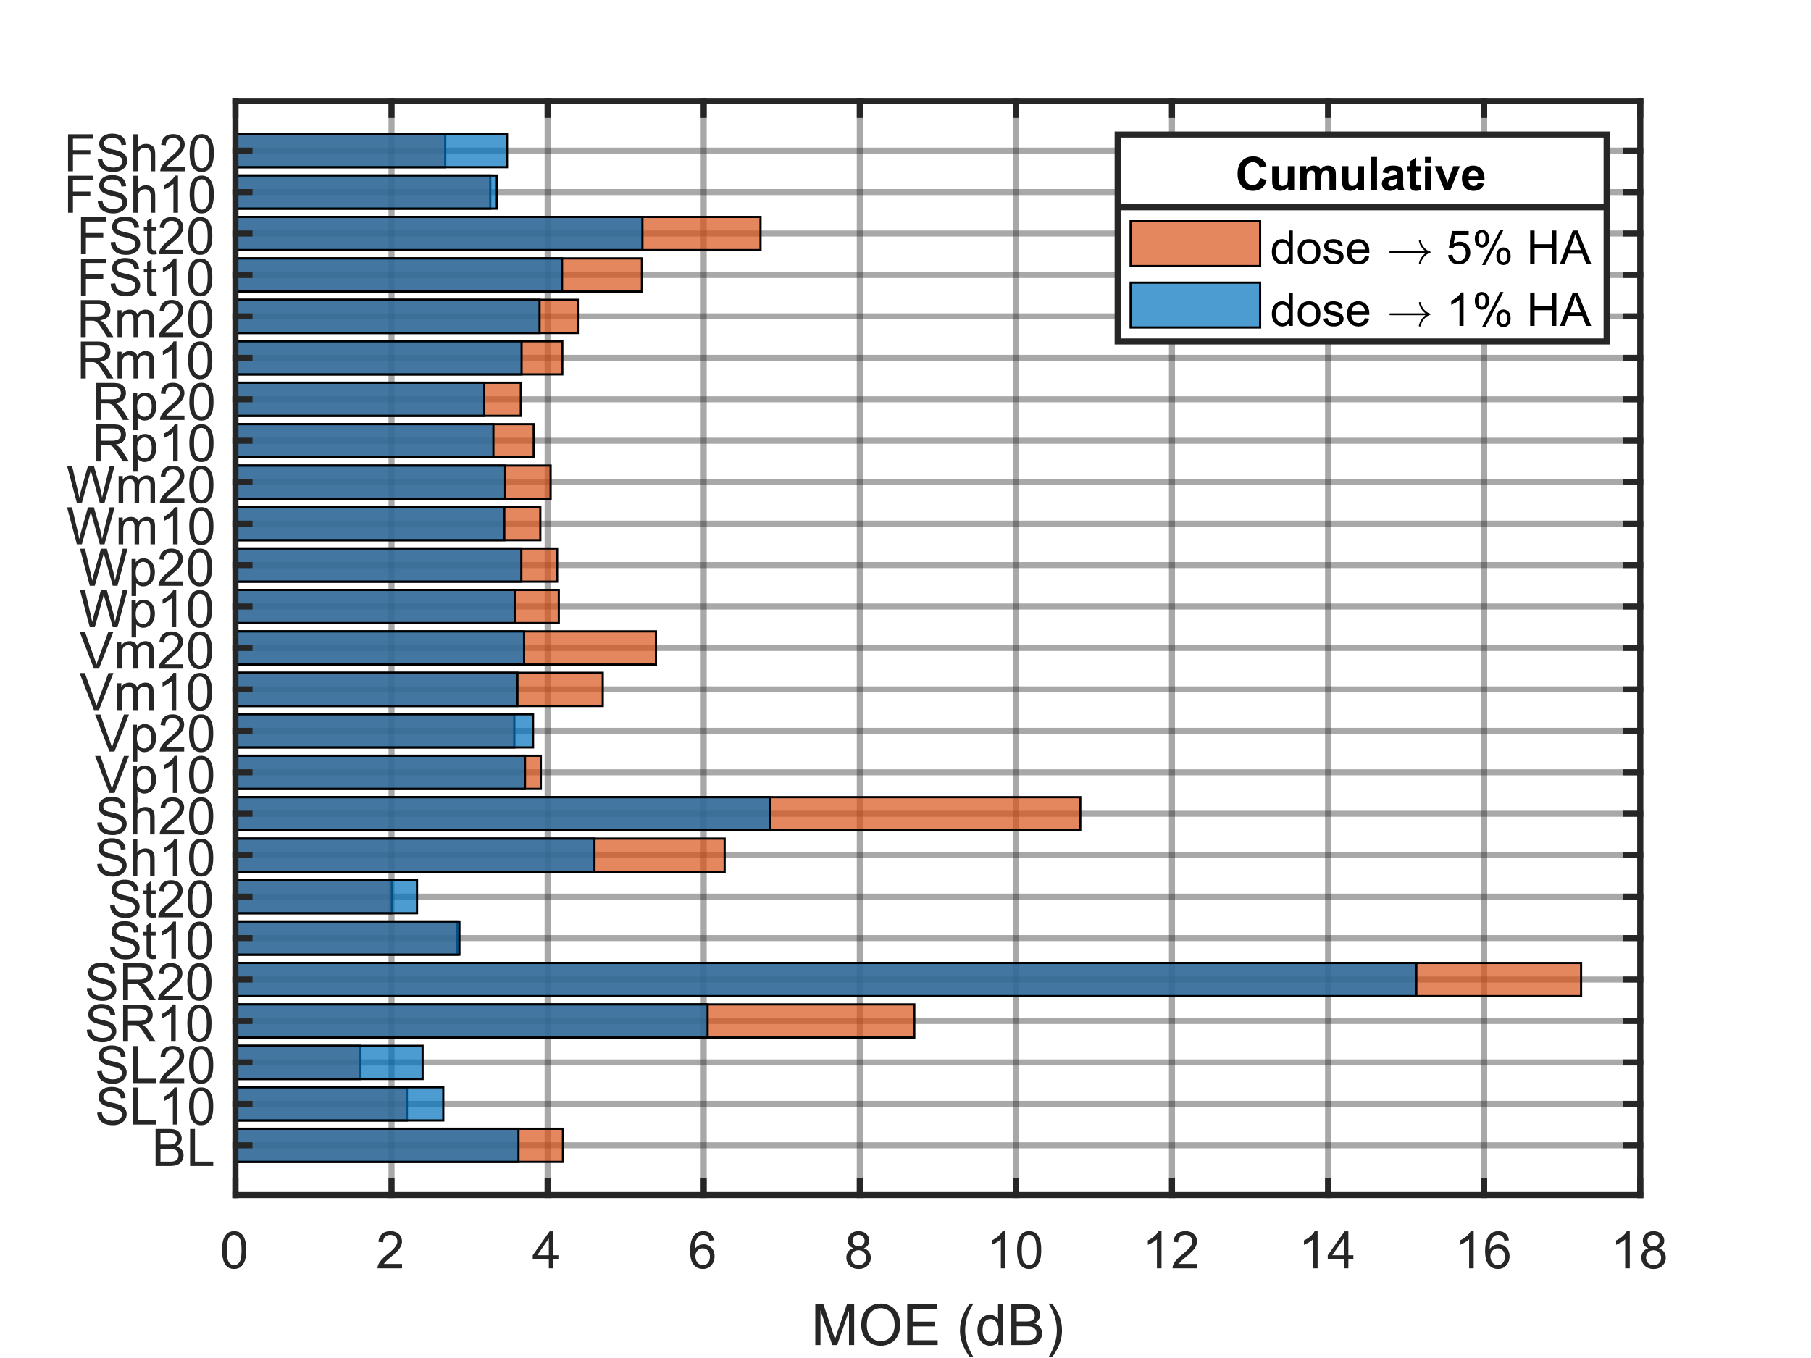
Figure 6: Mean margin of errors for the dose that elicits 1% and 5%HA for the single event (left) and cumulative (right) populations.

6.4 Sampling Variability
Thirty replicate datasets were generated and modeled for each of the populations studied, and this section illustrates the sampling variability between the replicates. The standard deviation of percent difference (SD%D) between the estimated and true population parameters was computed, and Fig. 7 shows SD%D for each parameter normalized to the SD%D of the BL population with 2500 target participants. Normalizing this way allows the sampling variability to be interpreted with respect to the BL case.
For the 2500 target participants case (red), many of the populations have estimated parameters that are near or below the BL case. The “SR20” and “Sh” populations are typically more than twice the sampling variability of the BL case. More than 2500 participants may be desirable if these populations are expected. Many of the populations for the 500-participant case are also greater than twice the sampling variability of the BL case.

8. Conclusions
This work expands previous work that explored the impact of dose error on the shape of estimated dose-response curves using a simulated survey population in the context of the NASA Quesst mission and the noise dose capabilities of the X-59 aircraft. The current work expands the range of populations considered. In that work, the modeled population from the NASA QSF18 community noise survey was considered as a baseline (BL). It was observed that dose errors with a standard deviation greater than 2 dB caused excessive attenuation in the dose-response curve.
In this work, 24 additional population models corresponding to dose-response curves were defined by modifying the BL population parameters by ±10% and ±20% or to shift the dose response curve ±10 or ±20 dB to the left or right. Thirty replicate datasets were generated for each population and for 500 and 2500 target participants with 0-, 2-, or 4-dB dose error standard deviation. A MLR model was fit to each dataset, and model estimates were compared to the true parameters and quantities of interest. It was desirable to assess if the same observations as the BL population would emerge for these additional populations. Most of the populations had similar observations, but in particular the estimated dose-response curves for populations that were significantly less annoyed by sonic booms than the BL population were poorly estimated. Such populations pose a challenge to the MLR modeling approach as the X-59 dose range was too unlikely to elicit high annoyance responses. Errors in estimates of quantities of interest steeply increased as dose error exceeded 2 dB and were as high as 14 dB.
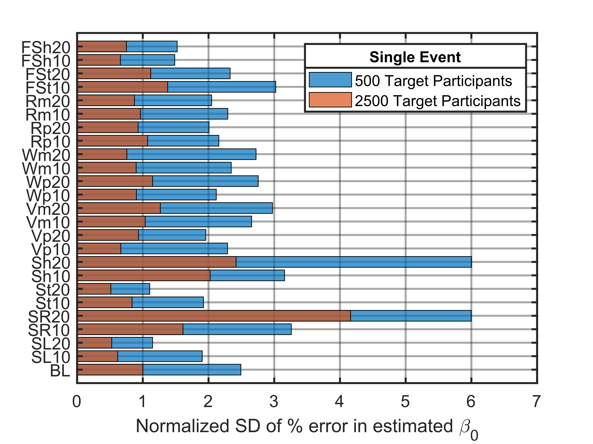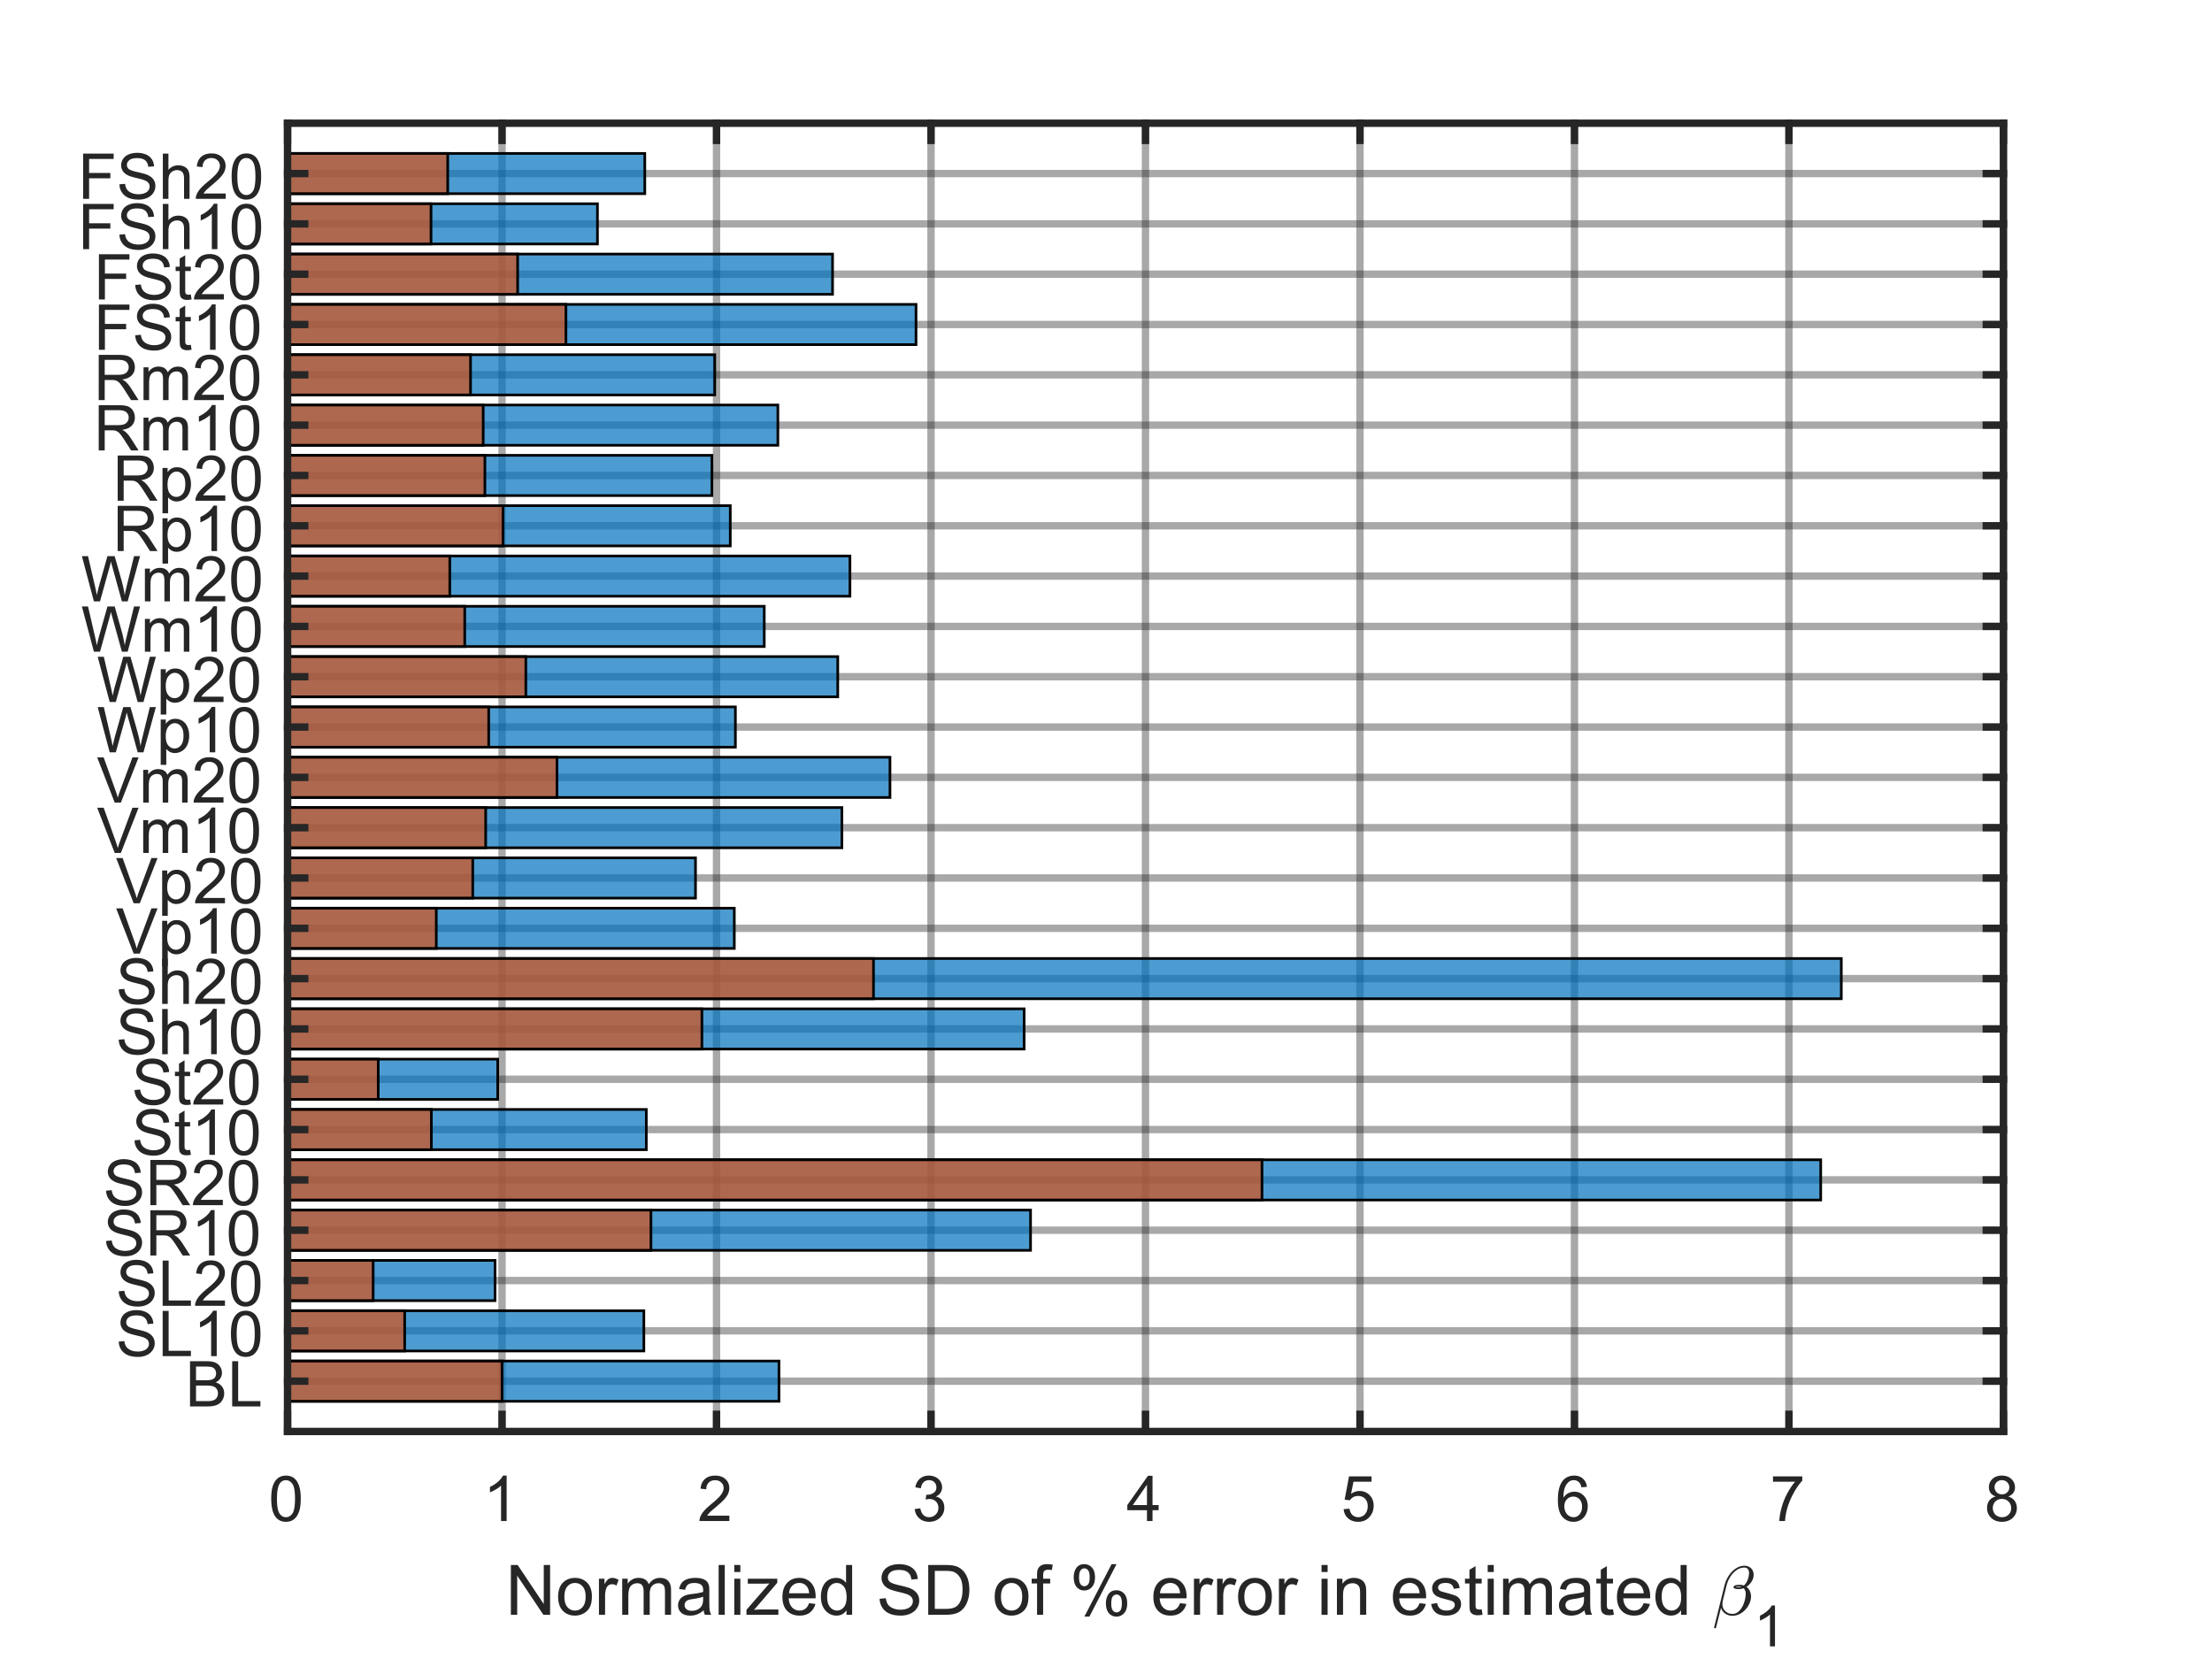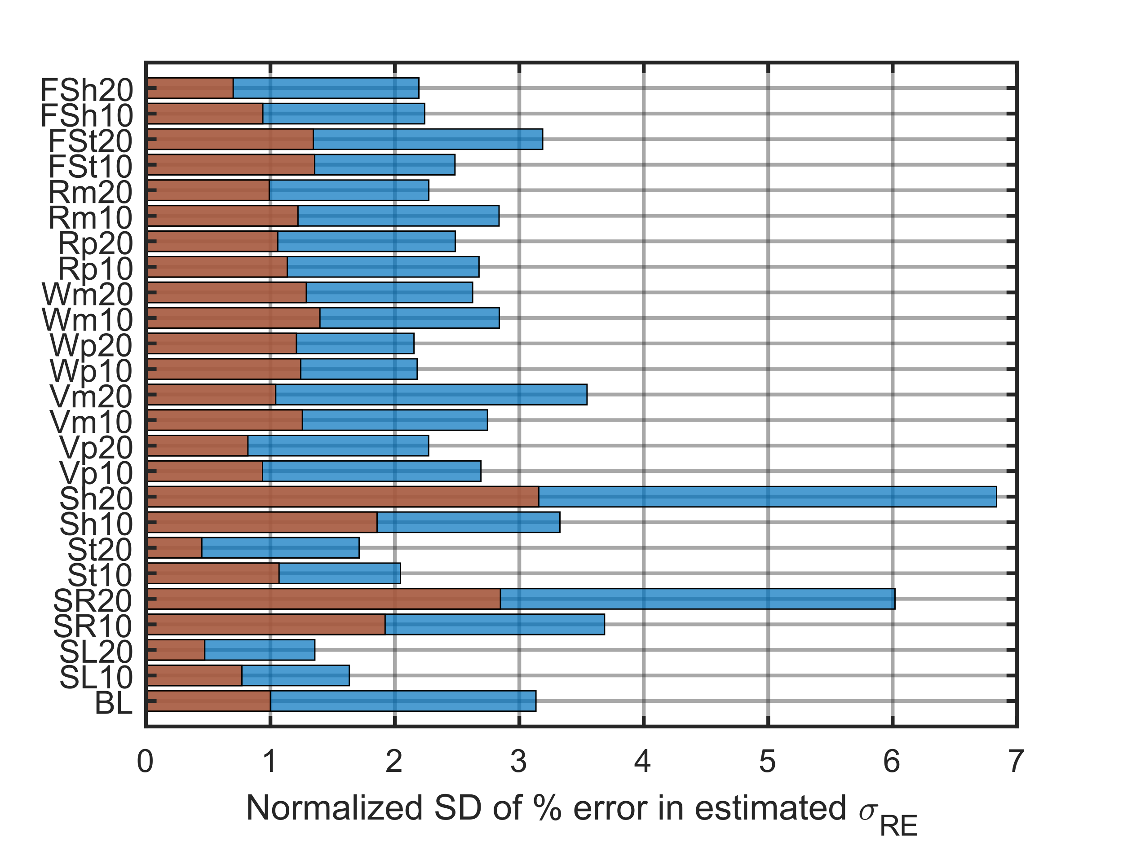
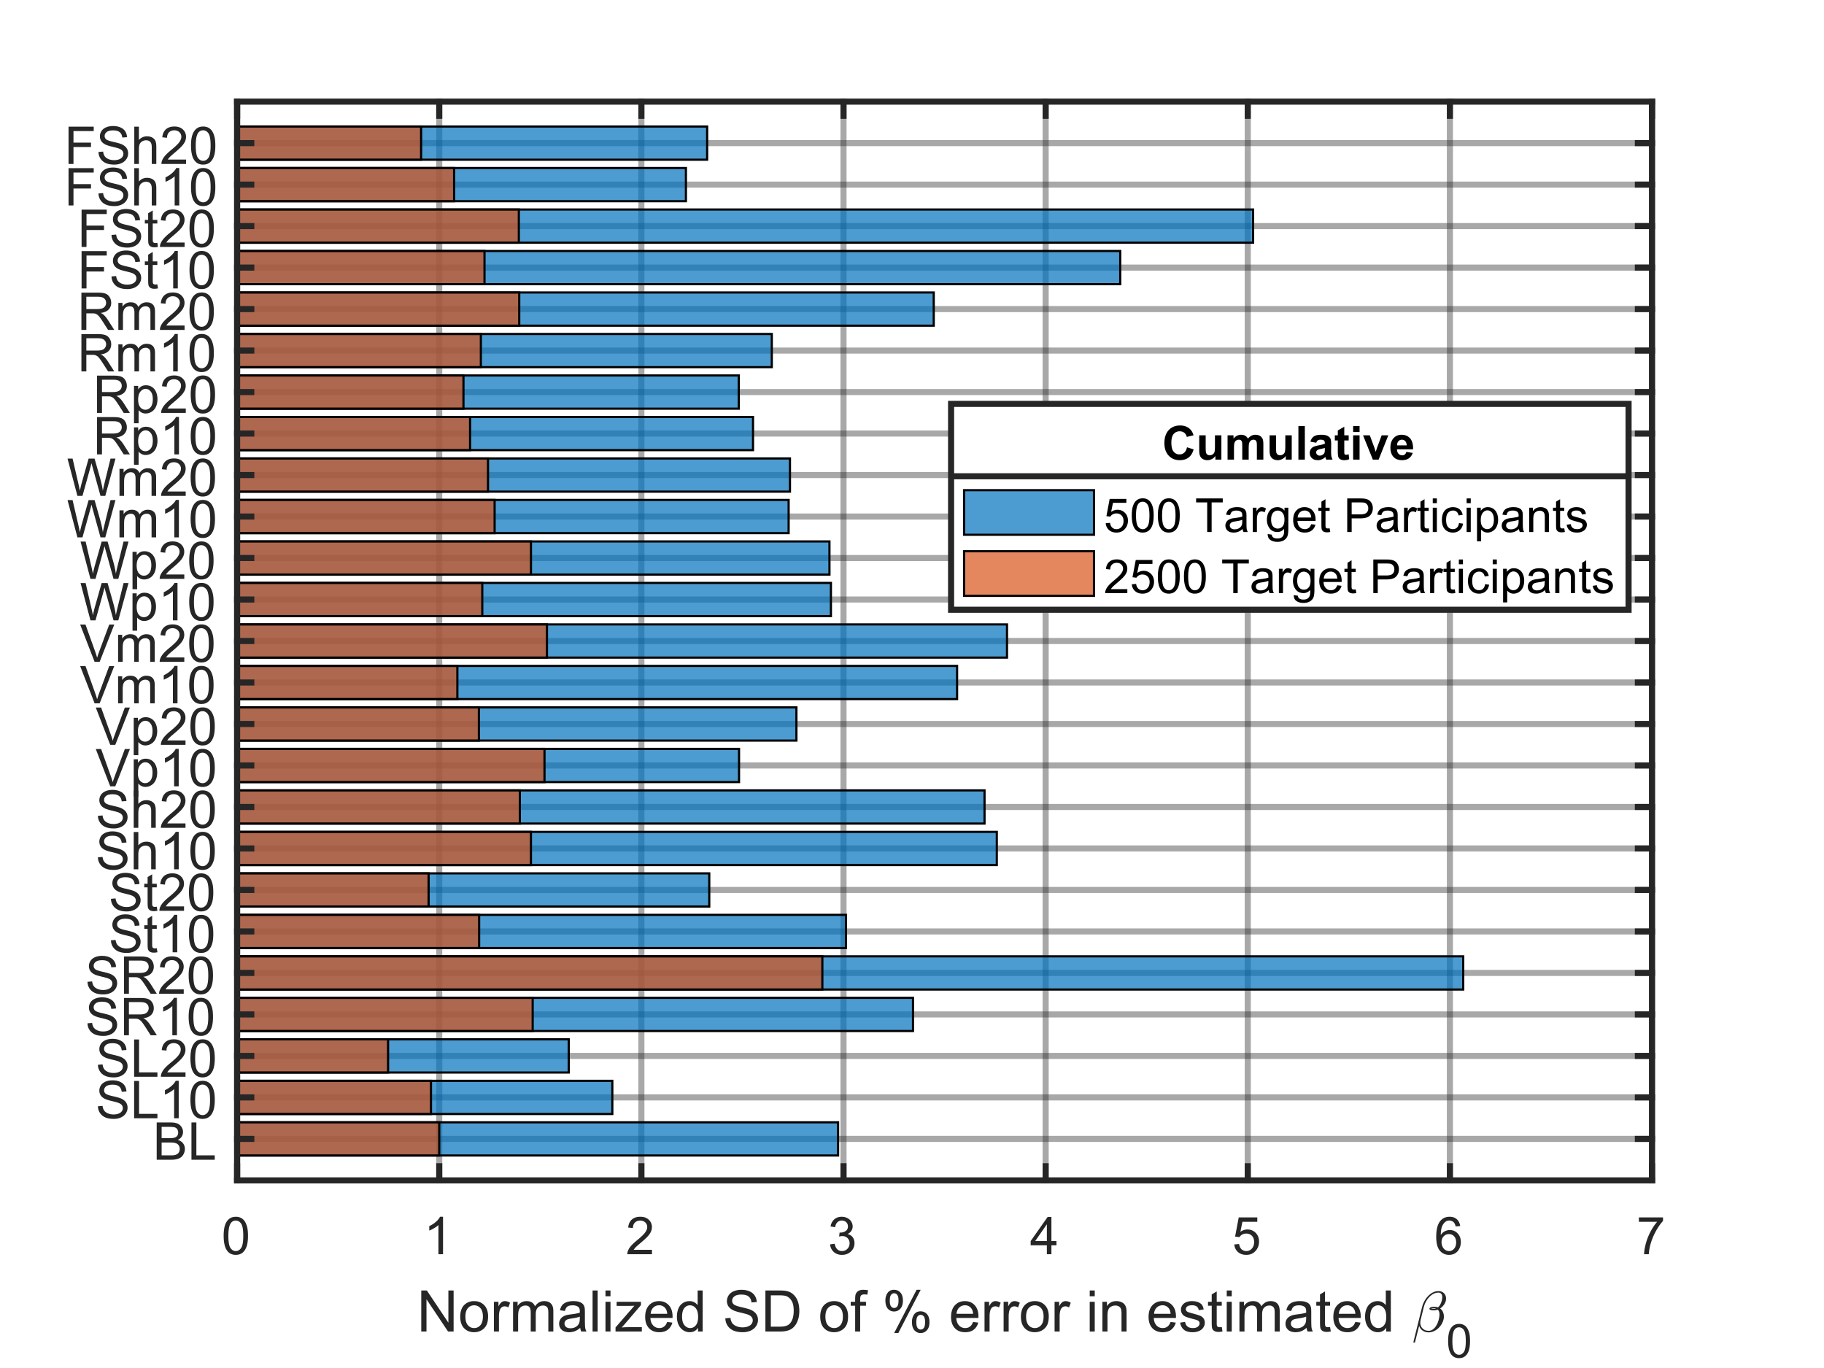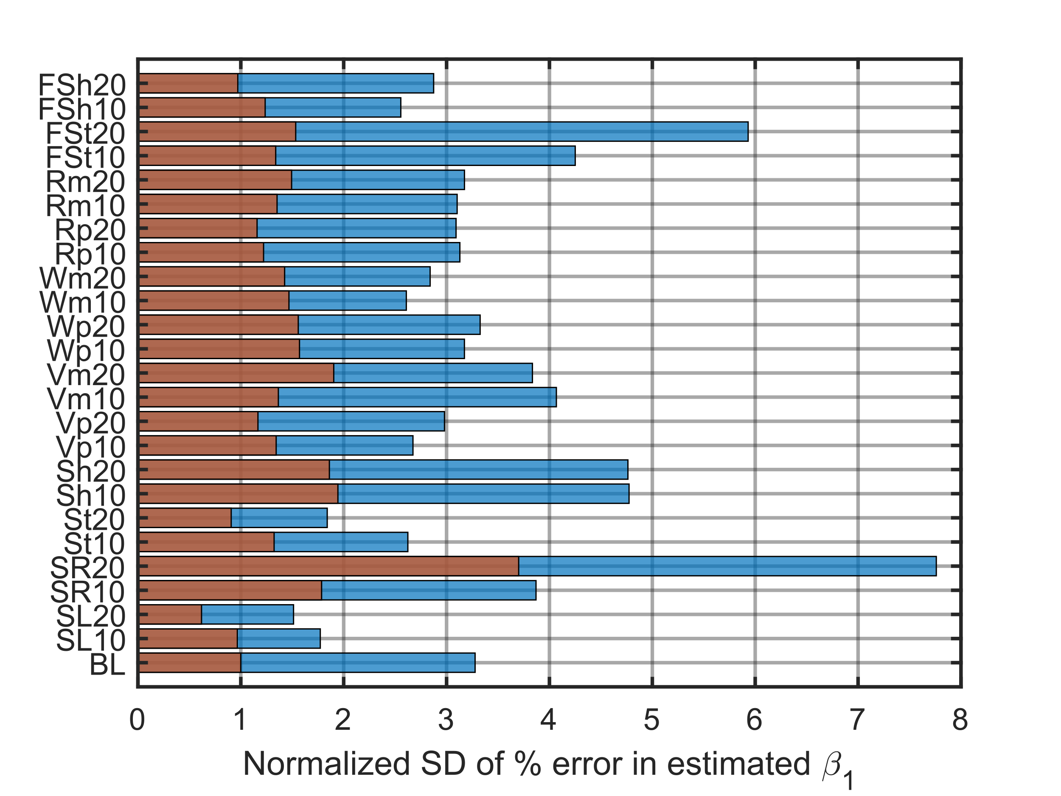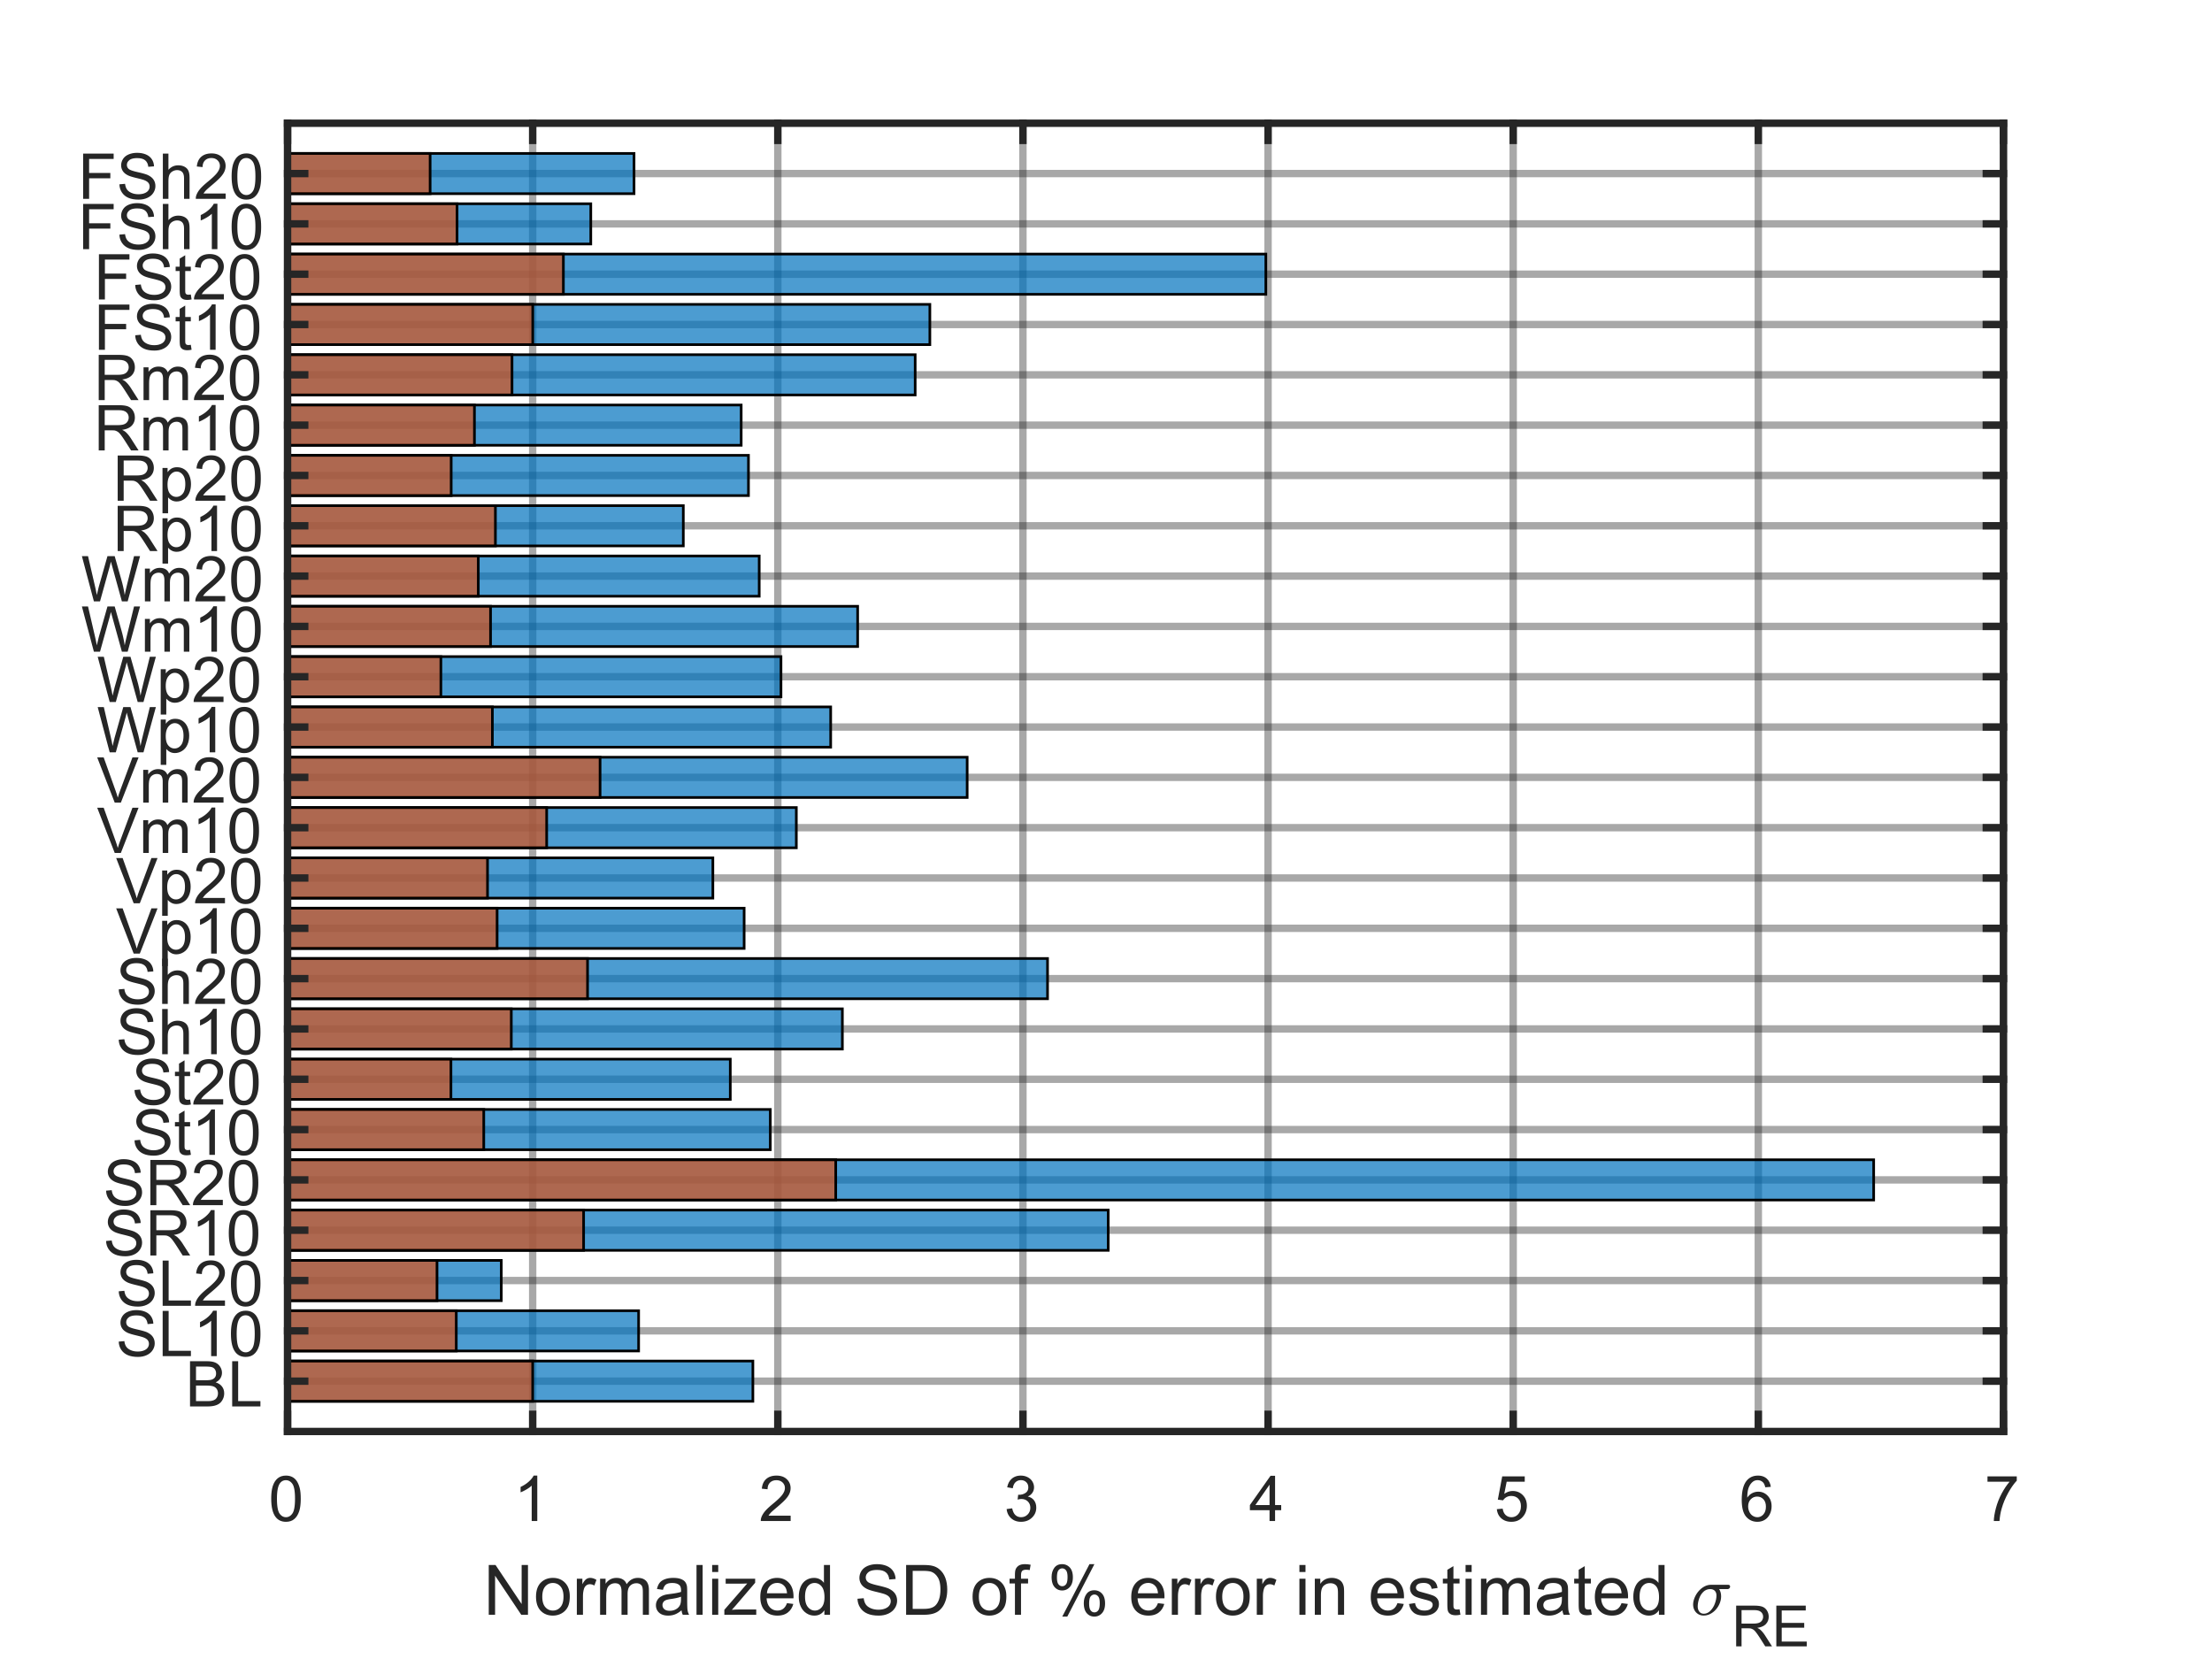
Figure 7: The standard deviation of the percent difference between estimated and true parameters normalized to the baseline for the single event populations (top) and cumulative populations (bottom) for the 0 dB dose error case.

8.1 Limitations
There are several notable limitations to this work. Each participant received the same set of true doses, and no attempt was made to model realism due to lateral differences in exposure or variability in exposure due to microscopic atmospheric effects like turbulence or their environment. The simulated dose error was normal with zero mean, but it may be the case that lower loudness events have higher dose error due to signal-to-noise considerations. Participants and their responses were missing completely at random, but it may be expected that participants respond less often to lower loudness events.

8.2 Future Work
There are several ongoing and future activities to extend this work. First, there is a need to collapse the results to decouple the descriptor terms such as “SL10” with the results. This could perhaps be done using the area under the dose-response curve or the maximum annoyance. NASA is also assessing methods to account for dose error. These include SIMEX (Ch. 5 of [1]), Regression Calibration (Ch. 4 of Ref. [1] and [4]), Data Cloning [], and Bayesian methods (Ch. 9 of Ref. [1] and [5]). Additionally, it is still undecided how dose-response data from multiple community surveys will be combined to create a nationally representative dose-response relationship. The datasets generated in this work could be used as “what if” scenarios, e.g., what if the population of the first community test looked like SR10, but the population of the second community test looked like SL10. Finally, given the extensive amount of time it can take to fit models to the thousands of datasets generated for the BL and extended populations, a metamodel can be fit that outputs expected model parameter and quantities of interest for any population and amount of dose error. The metamodel lends insight into the model factors that have the biggest role in model bias and precision in the estimated dose that elicit a given %HA. The metamodel can be used for multi-function optimization to help determine an optimal number of participants that minimizes the survey cost, minimizes the confidence interval, and minimizes the bias.

Acknowledgements
The authors thank the NASA Commercial Supersonic Technology Project for support of this work. In addition, we thank those with input to the conception of the work including J. Rathsam and N. Cruze of NASA Langley Research Center. We acknowledge J. Opsomer, J. Wivagg, E. Jodts, R. Ferb, A. Erciulescu (Westat), P. Stollery (HMMH), S. Lympany, and J. Page (BRRC) for providing the preliminary modeling recommendations and the baseline noise exposure design.

References

william.j.doebler@nasa.gov
kathryn.ballard@nasa.gov
aaron.b.vaughn@nasa.gov
peter.a.parker@nasa.gov
. R. Carroll, D. Ruppert, L. Stefanski, and C. Crainiceanu, Measurement Error in Nonlinear Models: A Modern Perspective (2nd ed.), Chapman and Hall/CRC, (2006); doi: 10.1201/9781420010138. Last accessed 2023-05-09
. R. D. Horonjeff, “Mathematical characterization of dose uncertainty effects on functions summarizing findings of community noise attitudinal surveys,” J. Acoust. Soc. Am. 151, p. 2739-2750, (2022); doi: 10.1121/10.0010311. Last accessed 2023-05-09.
. W. J. Doebler, A. B. Vaughn, N. B. Cruze, K. M. Ballard, J. Rathsam, and P. Parker, “Effects of dose error and sample size on sonic boom dose-response curves,” 152(4), A126 (2022); doi: 10.1121/10.0015769. Presentation materials https://ntrs.nasa.gov/citations/20220017468. Last accessed 2023-05-09.
. R. D. Horonjeff, “Exposure uncertainty effects on regression parameter values,” J. Acoust. Soc. Am. 152, (2022); doi: 10.1121/10.0015770. Last accessed 2023-05-09.
. W. J. Doebler, A. B. Vaughn, K. Ballard, and J. Rathsam, “Simulation and application of Bayesian dose uncertainty modeling for low-boom community noise surveys,” Proc. Mtgs. Acoust. 45, 040004 (2022); doi: 10.1121/2.0001592. Last accessed 2023-05-09.
. J. Rathsam, P.G. Coen, A. Loubeau, L. Ozoroski, and G. Shah. Scope and goals of NASA’s Quesst Community Test Campaign with the X-59 aircraft. 14th ICBEN Congress on Noise as a Public Health Problem, June 2023.
. W. J. Doebler, A. B. Vaughn, N. B. Cruze, K. M. Ballard, J. Rathsam, and P. Parker, “Simulating effects of dose error and sample size on sonic boom dose-response models,” To Appear.
. J. A. Page, et al., “Quiet Supersonic Flights 2018 (QSF18) Test: Galveston, Texas Risk Reduction for Future Community Testing with a Low-Boom Flight Demonstration Vehicle,” NASA/ CR–2020-220589/Volume I, (2020); https://ntrs.nasa.gov/citations/20200003224. Last accessed 2023-05-09.
. J. Page, S. Lympany, and B. Harker, “DRD NE-01 Noise Exposure Planning Report (Preliminary),” HMMH Report No. 312430.001.001, (2021).
. J. A. Page, et al., “Waveforms and sonic boom perception and response (WSPR): low-boom community response program pilot test design, execution, and analysis,” NASA/CR-2014-218180, p. 85 (2014); https://ntrs.nasa.gov/citations/20140002785. Last accessed 2023-05-09.
. J. Lee, J. Rathsam, and A. Wilson, “Statistical Modeling of Quiet Sonic Boom Community Response Survey Data,” NASA/TM-2019-220427, (2019); https://ntrs.nasa.gov/citations/20190033466. Last accessed 2023-05-09.
. Miller, N. P., et al., “Analysis of the Neighborhood Environmental Survey,” DOT/FAA/TC-21/4, (2021); https://www.regulations.gov/document/FAA-2021-0037-0001. Last accessed 2023-05-09.
. J. Lee, J. Rathsam, and A. Wilson, “Bayesian statistical models for community annoyance survey data,” J. Acoust. Soc. Am. 147, p. 2222-2234, (2020); doi: 10.1121/10.0001021. Last Accessed 2023-05-09.
. M. Pavlou, G. Ambler, S. Seaman, and R. Z. Omar, “A note on obtaining correct marginal predictions from a random intercepts model for binary outcomes,” BMC Med. Res. Meth. 15, (2015); doi: 10.1186/s12874-015-0046-6. Last accessed 2023-05-09.
. A. B. Vaughn, J. Rathsam, W. J. Doebler, and K. M. Ballard, “Comparison of two statistical models for low boom dose-response relationships with correlated responses,” Proc. Mtgs. Acoust. 45, 040001, (2022); doi: 10.1121/2.0001541. Last accessed 2023-05-09.
. S. S. Stevens, “Perceived level of noise by Mark VII and decibels (E),” J. Acoust. Soc. Am. 51, p. 575-601, (1972); doi: 10.1121/1.1912880. Last accessed 2023-05-09.
. K. P. Shepherd and B. M Sullivan, “A loudness calculation procedure applied to shaped sonic booms,” NASA/TP-3134, (1991); https://ntrs.nasa.gov/citations/19920002547. Last accessed 2023-05-09.
. G. M. Fitzmaurice, N. M. Laird, and J. H. Ware, Applied Longitudinal Analysis, John Wiley & Sons, (2012).
. D. Bates, et al., “Package ‘lme4’: Linear mixed-effects modelsusing ‘Eigen’ and S4,” (2022); https://cran.r-project.org/web/packages/lme4/lme4.pdf. Last accessed 2023-05-09.
. R Core Team, “R: A language and environment for statistical computing,” R Foundation for Statistical Computing, Vienna, Austria, (2021); https://www.R-project.org/. Last accessed 2023-05-09.
. M. Pavlou, G. Ambler, S. Seaman, and R. Z. Omar, “A note on obtaining correct marginal predictions from a random intercepts model for binary outcomes,” BMC Med. Res. Meth. 15, (2015); doi: 10.1186/s12874-015-0046-6. Last accessed 2023-05-09.
. M. Torabi, “Likelihood inference in generalized linear mixed measurement error models,” Comp. Stat. and Data Analysis 57, p. 549-557; doi: 10.1016/j.csda.2012.07.018. Last accessed 2023-05-09.

