**A BRIEF REVIEW OF CHAOTROPIC VS. KOSMOTROPIC SALTS ON THE DEGREE OF SATURATION OF MEMBRANE FATTY ACIDS: IMPLICATIONS FOR PRESERVATION OF ENVIRONMENTAL BIOMARKERS.** M. B. Wilhelm,1 F. Nichols,2 C. H. Lee,3 P. J. Boston1; 1NASA Ames Research Center, Space Science and Astrobiology Division, Moffett Field, CA 94035 (marybeth.wilhelm@nasa.gov), 2Northwestern University, Earth and Planetary Sciences Department, Evanston, IL 60208 (floydnichols2025@u.northwestern.edu), 3Texas State University, Jacobs JETS II/NASA Johnson Space Center, Houston TX 77058 (carina.h.lee@nasa.gov).

**Introduction:** Water activity is well known to have a significant impact on habitability, due to the presence of salts [1]. However, salt composition is also important for habitability, as it can impact microbial activity and biomolecular interactions since certain salts are known to disrupt hydrogen bonding. *Chaotropic* agents disrupt hydrogen bonding in aqueous solutions leading to increased entropy (*chaos*) whereas kosmotropic agents are compounds that promote hydrogen bonding (*order*) [2]. The Hofmeister series (**Fig. 1**) shows the ordering of ions in terms of their ability to stabilize and induce precipitation or aggregation of proteins [5].

**Figure 1:** Figure taken from [5] shows the modern Hofmeister series and relative physical and chemical properties associated with ions. Kosmotropic ions are shown on the left and chaotropic ions are on the right.

A few studies have focused on the chemistry of labile biomolecules (e.g., mRNA, rRNA, and DNA) in chao- and kosmotropic agents. Significantly, weak chaotropes such as Cl- have been shown to inhibit enzyme and cellular functions [2] and the chaotropic ion (Mg2+) binds to DNA due to its attraction to the negatively charged phosphate backbone [2]. In one study, chaotropic salts were shown to increase the production of unsaturated fatty acids in *E. coli* due to decreased hydrophobic interactions [3]. Modulation of the ratio of unsaturated to saturated fatty acids in membrane bound lipids is a well-known response to environmental stressors such as changing temperature and nutrient conditions [2,4]. The effect of chaotropicity on lipid membranes in naturally occurring ecosystems has been largely understudied.

**Review Goal:** We hypothesize that the ratio of membrane-bound unsaturated to saturated fatty acids extracted from bulk environmental samples could be reflective of chaotropic versus kosmotropic salt presence due to increasingly chaotropic solutions limiting hydrophobic interactions. To begin to address this hypothesis, we reviewed a small number of studies in hypersaline systems that report both salt ion chemistry and the total unsaturated and saturated fatty acids that occur in a given environment.

**Results/Discussion:** Using data gathered from previously published literature in hypersaline environments [6-8], **we show preliminarily that the ratio of unsaturated to saturated fatty acids increases with increasing chaotropicity in hypersaline settings** (**Fig. 2**). If this trend holds with a greater number of data points from other hypersaline settings (*see Future Work section*), this could indicate that salt composition has a measurable effect on lipid membranes in natural systems.

**Figure 2:** Ratio of unsaturated to saturated fatty acids in hypersaline environments from Central Interior British Columbia, Canada including Clinton Lake, Basque Lake 2, and Basque Lake 1 [6], the Dead Sea [7] and Lake Vanda in Antarctica [8]. Lakes are ordered left to right with respect to their potential chaotropicity based on the Hofmeister series (**Fig. 1**).

**Implications for Biomarker Preservation from Hypersaline Environments:** There seems to be great potential for lipid biomarker preservation from hypersaline systems (**Fig. 3**). It has been shown recently that lipids are rapidly (~years) transformed to recalcitrant geolipids and sequestered into geologically-stable insoluble macromolecular organic matter (IMOM) in hypersaline settings [9, 10]. Additionally, ancient hypersaline environments up to 0.25 billion years old can contain preserved lipid biomarkers [11].

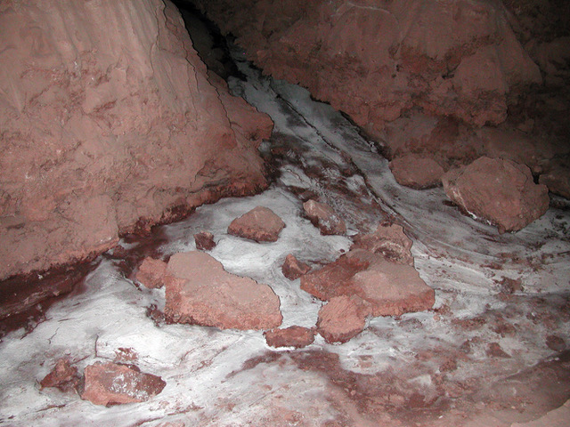

**Figure 3:** An example of a low-moisture but microbially-rich hypersaline cave environment that is giving rise to active halite precipitation in the Atacama Desert, Chile.  The cave itself is dissolved out of halite as the speleogenetic bedrock. Due to interference from halite, mirabilite, thenardite and other salts, DNA was difficult to extract. A fatty acid approach could be invaluable in environments like this where other biomolecular analyses are greatly inhibited by salt composition.  *Courtesy P.J. Boston, unpublished work 2006-2007.*

There are a number of potential contributions that salt composition and brine chemistry could make during early diagenesis that would enhance long-term preservation of lipid biomarkers in hypersaline environments. In such settings, if the degree of saturation of fatty acids is decreased with increasingly chaotropicity (**Fig. 2**), the pool of more recalcitrant lipids will then decrease, because unsaturated fatty acids are less stable over geological timescales than saturated fatty acids. However, enzyme activity would be minimized, which in turn would limit biomarker degradation by microbial action and exoenzymes, which process typically accounts for the majority of organic matter degradation in aqueous settings. IMOM formation is also likely to be greatly impacted by increasing chaotropicity, as hydrogen bonding (involved in stabilization of kerogen macromolecules) would also be disrupted.

In order to best inform the search for biosignatures in extraterrestrial environments, it is critical that we better understand not only the end-member precursor biomolecules and their corresponding preserved products, but also their stable or unstable intermediates by tracking transformation pathways at the molecular level. End-member biomarker products will be strongly influenced by the salt composition and brine chemistry during early diagenetic processes.

**Future Work:** Can the degree of unsaturation of fatty acids be broadly used as a depositional indicator of the strength of chao/kosmotropicity? How does bulk lipid membrane composition change in response to increasingly chaotropic salts? How do lipids generated in hypersaline settings transform over time? We would like to gather more existing data to investigate these topics. If you have data that you would like to contribute, we welcome you to contact the authors.

**References:** **[1]** Stevens, A.H. and Cockell, C.S., (2023) *The Planetary Science Journal, 4.1.* **[2]** Fisher, L., *et al.* (2021) *Environmental Microbiology,* 23(7)*,* 3360-3369. **[3]** Ingram, L.O. (1982). *Journal of Bacteriology*, 149(1), 166-172. **[4]** Kawamura, K. and Ishiwatari, R. (1981). *Geochimica et Cosmochimica Acta*, 45(2), 149-155. **[5]** Okur, H.I., *et al.* (2017). *The Journal of Physical Chemistry B,* 121(9), 1997-2014. **[6]** Nichols, F., *et al.* (2023), *in prep.* **[7]** Nissenbaum, A., *et al.* (1972). *Geochimica et Cosmochimica*, 36(7), 709-727. **[8]** Matsumoto, .*G, Torii, T.,and Hanya, T..* (1984). Matsumoto, G., Torii, T., & Hanya, T. (1984). *Hydrobiologia*, *111*, 119-126. **[9]** Lee. C., *et al.* (2021) *Organic Geochemistry, 153*. **[10]** Lee, C. et al., (2019) *Organic Geochemistry, 132* **[11]** Cockell *et al.* (2020). Astrobiology, 20(7), 864-877.