Heat Flux and Pressure Envelope Expansion Tests of Phenolic Impregnated Carbon Ablator (PICA). J. D. Williams¹, B. J. Libben², J. D. Morgan², and T. Gökçen¹, ¹Analytical Mechanics Associates at NASA Ames Research Center, joseph.d.williams@nasa.gov, ²NASA Ames Research Center.

Brief Presenter Biography: Joseph Williams is an EDL system engineer in the Entry Systems and Vehicle Development Branch at NASA Ames. Joseph has dedicated 7 years to EDL technology development, testing, and TPS sizing for NASA flight missions.

Introduction: Phenolic Impregnated Carbon Ablator (PICA) is a frequently employed thermal protection system (TPS) material in the space flight community. First flown on the forebody of Stardust, which re-entered in January of 2006, PICA has been the go-to material system for each successive Martian rover mission. This legacy continues with PICA domestic (PICA-D) baselined for the Mars Sample Retrieval Lander (SRL) and Dragonfly, a mission to Titan’s surface.
In mission planning, the capability of a TPS material system is restricted to environments that are proven through ground testing or flight missions. Despite the range of destinations from Earth return to Mars entry to Saturn moons, PICA’s demonstrated capability currently covers heating rates less than 1800 W/cm² and surface pressures less than 150 kPa [1]. These recognized limitations prevent PICA for consideration in direct entry applications at Venus, the outer planets, and high mass return missions at Earth, thus requiring selecting higher density materials [2].
Capability Expanding Testing: During a recent Mars Sample Return Earth Entry System (MSR EES) arc-jet test in the Interaction Heating Facility (IHF) at NASA Ames, PICA was exposed to flow conditions typically reserved for mid or high density ablative materials. This effort, using the facility’s 3-in nozzle, was an expedition to identify the failure boundary of PICA in stagnation. Six 1-in iso-q stagnation PICA models, shown in Figure 1, were tested at five new conditions. These models correspond to acreage TPS on a flight aeroshell and do not assess a gap filler system which is required on larger entry vehicles.

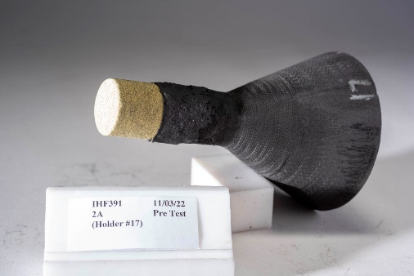
Figure 1 1-in iso-q stagnation PICA model
At each tested condition, high speed video captured the recession response and showed controlled material ablation. Figure 2 is a frame of this video at the most extreme environment to which PICA-D was exposed. Throughout testing, the original model curvature is largely retained and there is no indication of run-away or catastrophic failure. Predicted stagnation point hot-wall heat flux ranged from ~2400 – 3500 W/cm² (cold-wall heat flux ranged from ~3100 – 5000 W/cm²) and pressure from 252 – 532 kPa, which represents a near doubling of the quoted heat flux capability and a factor of 3.5x for pressure. Remarkably, the failure boundary of PICA in pressure and heat flux space is still not established.

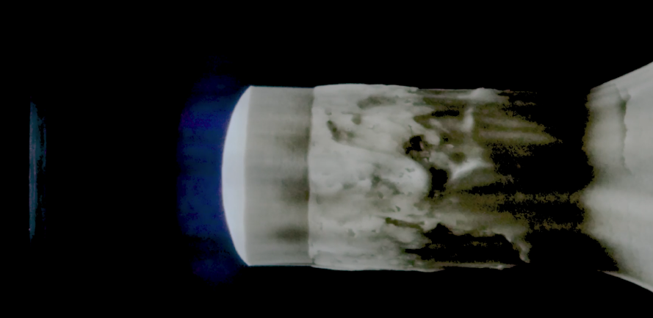
Figure 2 PICA-D under test @ 3490 W/cm² hot wall and 5.25 atm
Test Data: Test data to support evaluation of material performance and model validation is obtained from various sources. Calorimeters swept through the arc-heater flow measured cold-wall heat fluxes and pressure. Laser scans taken of the model before and after the test provided estimates of material recession (Figure 3). Video captured qualitative knowledge of model under test and supporting tools converted this into estimates of recession rates. A spectrometer measured surface temperature and chemical species in the freestream.

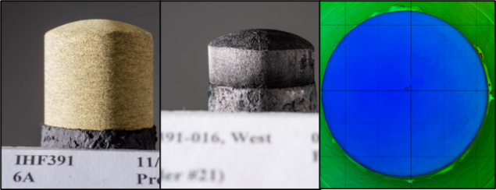
Figure 3 Pre-test image, post-test image, laser scan recession of PICA-D Model 6A.
Thermal Response Model Implications: Material response simulations were performed using Fully Implicit Ablation and Thermal response program (FIAT) which relies on CFD predictions that incorporate calorimeter measurements. Comparisons of the stagnation point recession performance in FIAT simulations against test measurements yielded better agreement as heating and pressure increased. This presentation will include a comprehensive assessment between simulation and experiment and the tuning of the PICA FIAT model, if necessary.
Mission Design Implications: Mission studies such as the Common Probe Study and flight programs like MSR EES have often eliminated PICA as a forebody TPS option for spacecraft and probes performing planetary re-entry. The substantial expansion of demonstrated capability makes PICA viable in an increased scope of missions and offers potential TPS mass savings in these applications. However, PICA requires evaluation at shear levels commensurate with the expanded heat flux and pressure regime tested in stagnation. Additionally, without screening gap filler systems, at these new environments PICA is constrained to small entry vehicles that enable monolith heatshields. Other parameters, such as micrometeoroid vulnerability, will need to be considered by mission designers, but material selection becomes driven by risk posture instead of a lack of knowledge.
References: [1] White, T., et al, (2020). Thermal Protection System Materials for Sample Return Missions. Planetary Science Decadal Community White Papers. [2] Hwang, H. H. (2019). Common Probe Design Study and Follow-On Activities. In Workshop on In Situ Exploration of the Ice Giants (No. ARC-E-DAA-TN65864).

