Title: The Effect of Fiber-angle Fidelity on the Linear Response of Tow-steered Composite Plates

Authors: Cyrus J. R. Kosztowny, Ph. D.
Lauren M. Simmons

Paper Number: 004420
FILE NAME: 004420_Kosztowny.docx

(FIRST PAGE OF ARTICLE)

ABSTRACT

Composite laminate tailoring is traditionally performed by uniformly changing the in-plane ply orientation to obtain the desired mechanical performance. The emergence of tow-steered plies, where the fibers follow a prescribed curvilinear path, have increased the tailorability of composite laminates. However, characterizing the behavior of tow-steered laminates using finite element analysis is challenging because additional, and often numerous, orientation definitions may be required. The additional orientation definitions detrimentally increase the computational cost and hinder the use of advanced analysis techniques, such as Monte Carlo or uncertainty quantification, in the design process.
To reduce computational cost without adversely affecting mechanics-based performance, the results of a parametric study that was used to investigate the effects of fiber-angle fidelity, element size, and tow-steered radius-of-curvature on various loading scenarios for tow-steered composite plates are presented. The three loading scenarios that were analyzed using finite element analysis included an axial tension load, an applied constant through-thickness-direction pressure load, and an axial compression load. Results for mechanics-based metrics of interest are presented and discussed for each loading scenario. Little sensitivity (less than one percent difference) to the effect of fiber-angle fidelity is observed in the mechanics-based metrics until the coarse-end of the considered range. Sensitivity to element size generally dominates the observed results for the mechanics-based metrics.
Notable reductions in the preprocessing time are observed for increasingly coarse element size and fiber-rounding parameters. The preprocessing times decreased up to three orders of magnitude from a few thousand seconds to a few seconds without loss of accuracy in the mechanics-based metrics. Such increased computational performance is of particular interest to the structural design and analysis communities that may be conducting large counts of finite-element analyses, such as in other parametric studies, Monte-Carlo analyses, uncertainty quantification, or tow-steered optimization.

INTRODUCTION

Carbon-fiber-reinforced polymer composite materials have advantageous properties such as specific strength and stiffness compared to metallic materials. Such properties can lead to structural mass reduction if a structure is designed well. Unidirectional-fiber composite materials have an inherent directional dependency that creates opportunities for designers to tailor the structural response of a composite laminate [1]. The design space is large when considering possible combinations of ply orientations. Even when layers are placed at a constant orientation, fiber angles are often restricted to just several common orientations. The angle of the unidirectional fibers can also be changed within a given layer. Variable fiber angles in the form of tow-steering, via automated fiber placement processes, expand the composite structure design space even further [2–5].
Variable-angle designs are generally difficult to analyze with closed-form solutions unless specific assumptions and conditions are satisfied [6, 7]. As such, finite element methods are commonly used to numerically analyze complex structures such as tow-steered composites [8]. Mesh refinement studies and the establishment of convergence criteria are standard practices for general finite element analysis (FEA), but variable-angle designs introduce another consideration to model refinement – the fidelity with which fiber angles are defined. In this study, one aspect of model fidelity being considered is the degree of exactness with which the fiber angle is specified in each element within the finite element model. A large body of published literature regarding design methods for tow-steered composites exists [5, 9–12], but little investigation into fundamental considerations of analysis tools such as the effect of fiber-angle fidelity in finite element methods has been conducted. Two approaches introducing variable-angle fibers into FEA are often used. One approach is to use defined fields where orientation definitions are directly specified to nodal- or element-based input tables. A second approach is to map variable-fiber angles element-by-element and use composite section definitions to specify fiber angles.
One concern with the second approach is that generating unique section definitions for each element increases computational expense during preprocessing. During a design phase, many numerical analyses may be performed. Whether those analyses are part of parametric studies like the one in this effort or using methods such as optimization, Monte-Carlo (MC), and other uncertainty quantification (UQ) studies, all entail large counts of analyses to be conducted. Optimization, MC, and UQ methods may call objective and constraint functions (in this case a FEA model) numerous times. Hundreds or thousands of design points are commonly used in some gradient-based optimization techniques [13], and tens or hundreds of thousands of design points are typically used in MC and UQ techniques. Such methods are computationally expensive, and improved numerical methods to reduce computational expense are active research fields [14]. Regardless of the method or use case, ensuring the relevant physics in the predicted response are captured by the FEA is important. There is strong motivation, however, to reduce computational expense and understand the trade-off between runtime and accuracy.
The focus of this study is to explore the second approach whereby fiber angles are specified at the section definition. Investigation of the effect of fiber-angle fidelity and establishment of potential interactions with mesh refinement is important because FEA is a primary analysis tool used to evaluate tow-steered composite designs. Examples of tow-steered flat-plate designs ranging from large- to small-radius-of-curvature tow paths are considered where each design has constant radius of curvature (RC) for the tow-steered fiber paths. The effect of fiber-angle fidelity is studied by using two parameters: a fiber-rounding parameter and element size. The influence of the fiber-rounding and element size parameters on design metrics such as force, displacement, stress, and analysis preprocessing time are assessed by performing linear elastic analyses of a composite plate subjected to simple loading conditions (tension, pressure, and compression). The methodology is discussed in the next section. Results from the analyses are then presented and discussed. Finally, concluding remarks are given at the end.

METHODOLOGY

The methodology used to investigate possible interaction between parameters is styled after a simple parametric study whereby one parameter is changed while all others remain unchanged. The parameters investigated in this study include three loading scenarios, RC, element sizes, and fiber-rounding. Each parameter is described in subsections that follow.
The general-purpose commercial FEA software Abaqus [15] is used to perform the analysis. The plate used in this study has dimensions of 36-in. in length and 24-in. in width, and a planform view depicting a representative tow-steered ply is shown in Figure 1.

Loading Scenarios

The three loading scenarios considered in this study were an axial tension load, an applied constant through-thickness-direction pressure load, and an axial compression load. The implemented boundary conditions for each loading scenario are provided in Figure 1. The tensile and pressure scenarios were analyzed using a static analysis, and the compression scenario was analyzed using an eigenvalue approach.
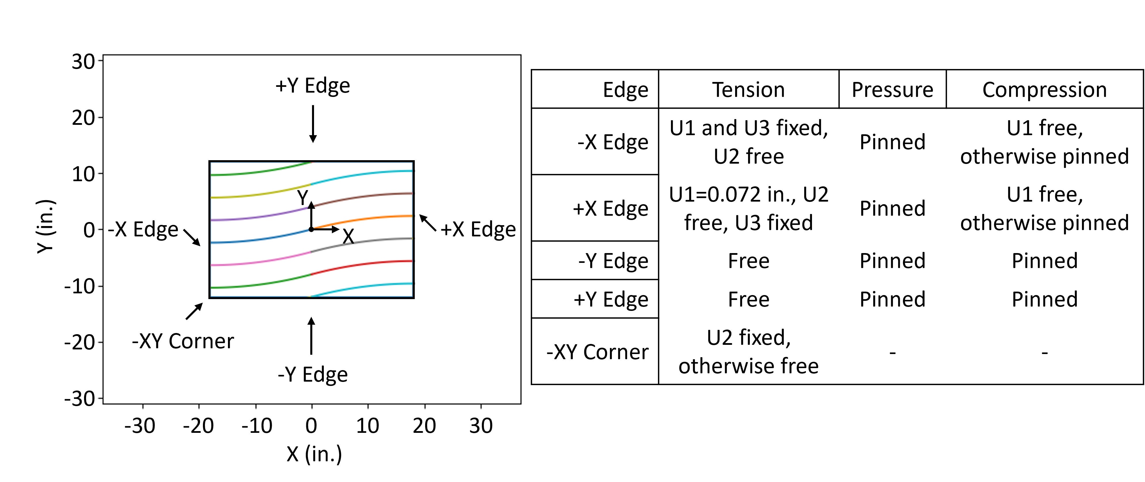
Axial tension is imparted to the plate as a specified constant 0.072-in. displacement in the global X-direction. Metrics used to evaluate the tension analyses are total resultant force in the extension direction, maximum centroid shell section average stress in the extension direction, and maximum Tsai-Hill failure index.
Figure 1: Tow-steered plate with boundary conditions.
The pressure load is applied as a constant through-thickness-direction pressure of 1.0 psi applied to the positive-Z surface of the plate, which results in a total applied load of 864 lb. Metrics used to evaluate the pressure analyses are minimum (i.e., most negative) Z-direction displacement, maximum shell-section average stress in the
X-direction, and maximum Tsai-Hill failure index.
For the axial compression scenario, an applied constant shell edge loading of
1.0 lb/in. is applied to the short edges of the plate resulting in a total applied load of
24 lb. Metrics used to evaluate the compression analyses are the first three predicted buckling loads.

Radius-of-curvature and Plate Designs

Five tow-steered designs were analyzed in this study. Each design is a combination of unidirectional and tow-steered plies. The tow-steered patterns varied among the five designs to study a range of tow-steering RCs. The RC ranged from 69.55 in. to 20.87 in. This range was selected because it spans from approximately twice (at 69.55 in.) to slightly-less-than (at 20.78 in.) the approximate 35-in. minimum steering radius at the NASA Langley Research Center Integrated Structural Assembly for Advanced Composite (ISAAC) automated fiber placement (AFP) facility. The specific RC values used in this study are 69.55 in. for design A, 56.00 in. for design B, 47.04 in. for
design C, 36.00 in. for design D, and 20.78 in. for design E. The tow-steered plies used a constant RC within each design, but tow path designs varied across plies by altering initial and terminal angles. A design tool called Automated Tool for Steered COmposite Optimizable Laminates (ATSCOOL) [16] is used to define the tow-steered layups and map the composite shell section definitions to the finite element meshes used in this study. Layups, with ply angles given in the global coordinate system for designs A-E, are provided in TABLE I. Localized gaps and overlaps resulting from tow steering are included in the designs of the panels. Observed overlaps (no gaps were observed) ranged from a maximum of four additional plies in design A to a maximum of ten additional plies in design E. The convention in this study for the steered ply design is as follows: The first angle is the direction of the ply at the center of the plate, and the second angle is the direction of the ply by the edge of the plate in the positive-X direction. A
tow-steered ply is denoted with a pipe character “|” to distinguish the first and second angles of a ply. An example of the tow-steered fiber paths for ply 3 of design A are shown in Figure 1.

Element-size Refinement and Material Properties

Five square-element side lengths are considered in this study. Meshes are varied so that element sizes are 3.0, 1.0, 0.5, 0.25, and 0.1-in. side lengths. Elements are kept a constant size for each of the refinement sizes. Four-node, reduced-integration, finite-strain, general-purpose S4R shell elements are used in all analyses. An IM7-8552 carbon-fiber reinforce polymer material system is used throughout all analyses. Elastic moduli and in-plane Poisson’s ratio are provided in the top row in TABLE II [17], and ply thickness and material strengths are provided in the bottom row of properties.
TABLE I: TOW-STEERED DESIGNS.
 |  | Design A | Design B | Design C | Design D | Design E
Radius of Curvature |  | 69.55 in. | 56.00 in. | 47.04 in. | 36.00 in. | 20.78 in.
Ply | Straight or Steered | Angle (deg)
1 | Straight | +45 | +45 | +45 | +45 | +45
2 | Straight | -45 | -45 | -45 | -45 | -45
3 | Steered | +15|0 | +18.75|0 | +22.5|0 | +30|0 | +60|0
4 | Steered | -15|0 | -18.75|0 | -22.5|0 | -30|0 | -60|0
5 | Steered | -75|90 | -71.25|90 | -67.5|90 | -60|90 | -30|90
6 | Steered | +75|90 | +71.25|90 | +67.5|90 | +60|90 | +30|90
7 | Steered | 0|+15 | 0|+18.75 | 0|+22.5 | 0|+30 | 0|+60
8 | Steered | 0|-15 | 0|-18.75 | 0|-22.5 | 0|-30 | 0|-60
9 | Straight | +75 | +71.25 | +67.5 | +60 | +30
10 | Straight | -75 | -71.25 | -67.5 | -60 | -30
11 | Straight | 0 | 0 | 0 | 0 | 0
12 | Straight | 90 | 90 | 90 | 90 | 90
… | Symmetric | Yes | Yes | Yes | Yes | Yes

TABLE II: MATERIAL PROPERTIES.
Property | E₁ | E₂ | ν₁₂ | G₁₂ | G₁₂ | G₂₃
Unit | msi | msi | - | msi | msi | msi
Values | 20.430 | 1.330 | 0.345 | 0.680 | 0.680 | 0.330
 | t | X_{t} | X_{c} | Y_{t} | Y_{c} | S
 | in. | msi | msi | msi | msi | msi
 | 0.0072 | 0.3546 | 0.2292 | 0.1550 | 0.3430 | 0.1420

Fiber-angle Fidelity

The output of the ATSCOOL tool is considered the Baseline (B) case when no further modifications were performed to the shell-section definitions or the fiber-orientation angles. As part of the fiber-rounding portion of the parametric study, a Python script was created to 1) remove duplicate shell section definitions from the ATSCOOL output B, and 2) enable rounding and grouping of fiber orientation angles into specifiable intervals. One output of the Python script is a version of the tow-steered design where duplicate shell section definitions were removed, but no alteration to the fiber angles was made, which kept the fiber angles identical to B. This version is called the Grouped (G) case. An additional output of the Python script included rounding to a specified base and precision. Rounding is a common term, but two components, precision and base, were used in this study when specifying the rounding operation. Precision is the number of decimals to which a value may be specified. Base is the interval to which a value will be determined closest. The rounding bases and precisions considered in this study are given as the column headings in TABLE III. Example fiber angles are the row headings and their result after rounding are provided in TABLE III.

TABLE III: FIBER-ROUNDING INTERVAL EXAMPLES.
 | Result after rounding using interval
Baseline (deg) | 0.01 (deg) | 0.1 (deg) | 1.0 (deg) | 2.5 (deg) | 7.5 (deg)
0.12345 | 0.12 | 0.1 | 0.0 | 0.0 | 0.0
-89.98765 | -89.99 | -90.0 | -90.0 | -90.0 | -90.0
2.1 | 2.10 | 2.1 | 2.0 | 2.5 | 0.0
45.01234 | 45.01 | 45.0 | 45.0 | 45.0 | 45.0
45.98765 | 45.99 | 46.0 | 46.0 | 45.0 | 45.0
83.546 | 83.55 | 83.5 | 84.0 | 82.5 | 82.5
86.36 | 86.36 | 86.4 | 86.0 | 87.5 | 90.0

RESULTS

Results of the parametric study are presented in the following sections for the tension, pressure, and compression loading scenarios. The results are visualized through three-dimensional wireframe plots. While specific values may be inferred from the wireframe plots, the overall intent is to visualize general trends as the element size and fiber-rounding parameters vary. The results are consistently structured across loading scenarios. Results for design A with RC of 69.55 in. are provided in the first row of plots, results for design B with 56.00-in. RC are provided in the second row, etc., concluding with results for design E with 20.78-in. RC provided in the fifth row. Each plot contains fiber-rounding parameters on the lower-left axis and element sizes on the lower-right axis. The vertical axis provides value ranges for the metrics of interest for each loading scenario.
The fiber-rounding parameter starts with the ATSCOOL output B, herein considered the highest-fidelity, and proceeds to the G output before moving on to decreasing-fidelity fiber-rounding parameters of 0.01, 0.1, 1.0, 2.5, and 7.5 deg intervals. The element size parameter starts with the smallest element size (most refined mesh) at the 0.1-in. size and transitions to the largest element size (most coarse mesh) at the 3.0-in. label. The combined highest-fidelity analyses are with fiber-rounding parameters=B and G and element size parameter=0.1 in. Conversely, the combined lowest-fidelity analyses are with the fiber-rounding parameter=7.5 deg and element size parameter=3.0 in.
One example wireframe plot for total reaction force of design A (RC=69.55 in.) subjected to tension loading is shown in Figure 2. While metrics vary for each loading scenario, the same metric is shown in a single column of plots. Comparing the magnitude of results along the column direction may be considered equivalent to comparing the magnitude of the metric as a function of RC due to the changing designs.

Tension Scenario

Analysis results for the uniaxial tensile load scenario are shown in Figure 3. Metrics of interest for the tension loading scenario include the node-based summed reaction force in the global X-direction (RF1), the element-based maximum shell section average stress in the global X-direction (SSAVG1), and the section point-based maximum Tsai-Hill failure index. The reaction force is shown in the left column, the stress is shown in the center column, and the failure index is shown in the right column.
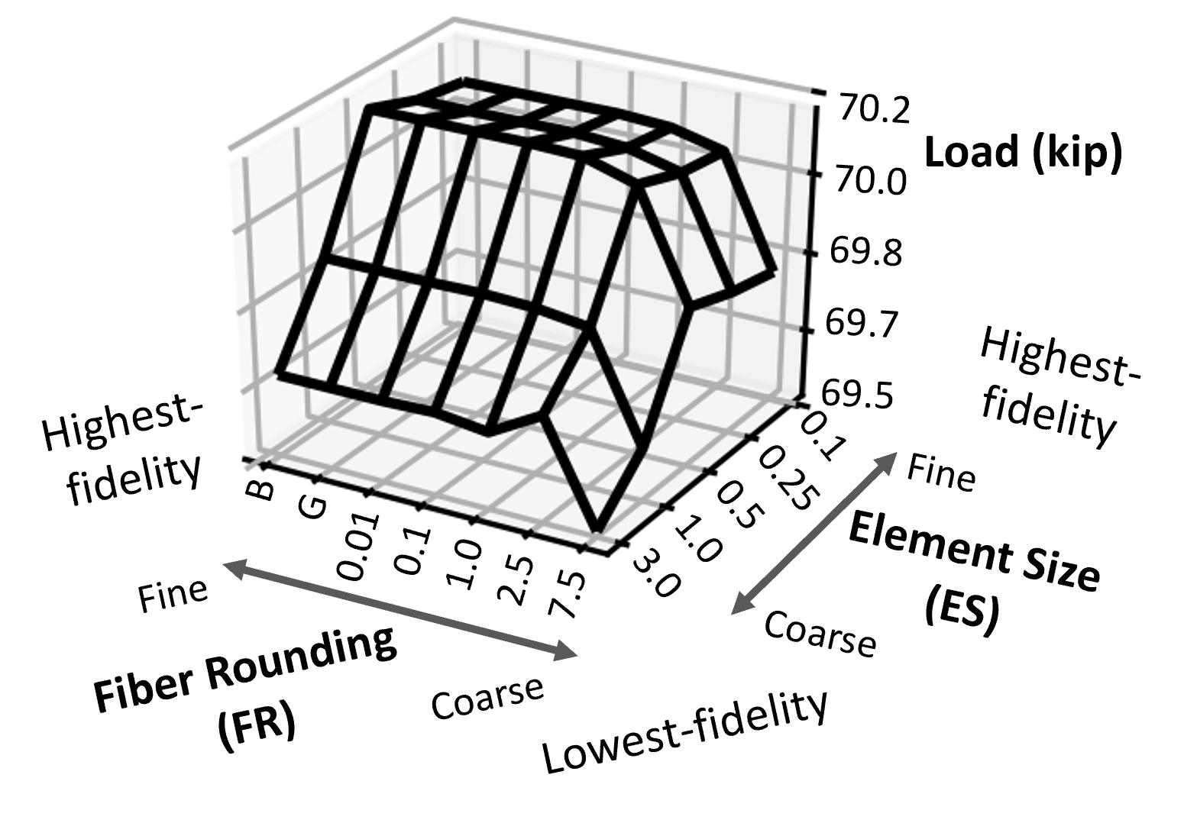
Figure 2: Example wireframe plot for a plate subjected to tensile loading.

Pressure Scenario

Analysis results for the applied constant pressure load scenario are shown in
Figure 4. Metrics of interest for the constant through-thickness-direction pressure loading scenario include the node-based minimum (or most negative) out-of-plane displacement (U3), the element-based maximum shell section average stress in the global X-direction (SSAVG1), and the section point-based maximum Tsai-Hill failure index. The displacement is shown in the left column, the stress is shown in the center column, and the failure index is shown in the right column.

Compression Scenario

Analysis results for the axial compression buckling load scenario in the form of eigenvalue analyses are shown in Figure 5. Metrics of interest for the axial compression loading scenario include the first three converged, estimated buckling loads as calculated from the predicted eigenvalues. The estimated buckling loads are obtained by taking the product of the applied compressive shell edge load of 1.0 lb/in., the length of the edge over which the load is applied, 24 in., and the predicted eigenvalue. The first estimated buckling load, P_{cr1}, is shown in the left column, the second estimated buckling load, P_{cr2}, is shown in the center column, and the third estimated buckling load, P_{cr3}, is shown in the right column.

Computational Efficiency

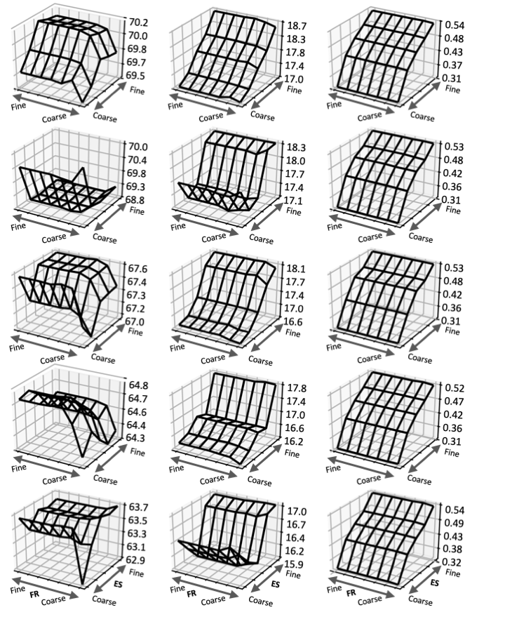
The number of seconds each analysis took to complete the preprocessing step is shown in Figure 6. The plot is consistent with the previous loading scenario plots with fiber-rounding and element-size parameters on the horizontal axes. All vertical axes are the same metric of preprocessing time in seconds, but the data are shown in a logarithmic scale due to its nonlinear nature. The preprocessing time in seconds for the tensile loading scenario is shown in the left column, for the applied constant pressure loading scenario in the center column, and for the axial compression buckling load scenario in the right column. An expected change in preprocessing time due to the element-size refinement is observed, and a change in the preprocessing time due to the fiber-rounding was also observed.
Figure 3: Axial tension loading results.
Reaction Force (kip) Stress (ksi) Index
Design E Design D Design C Design B Design A
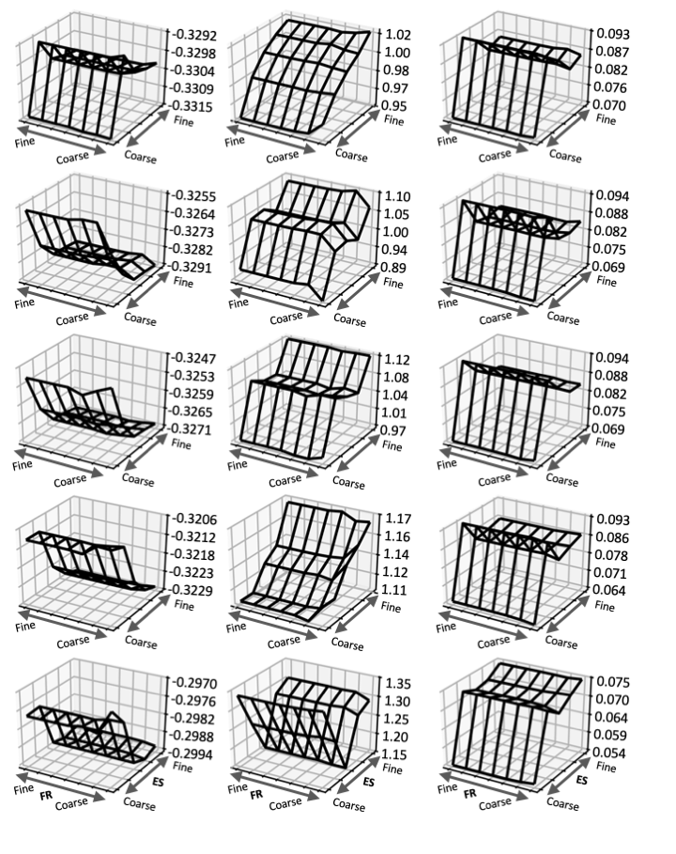
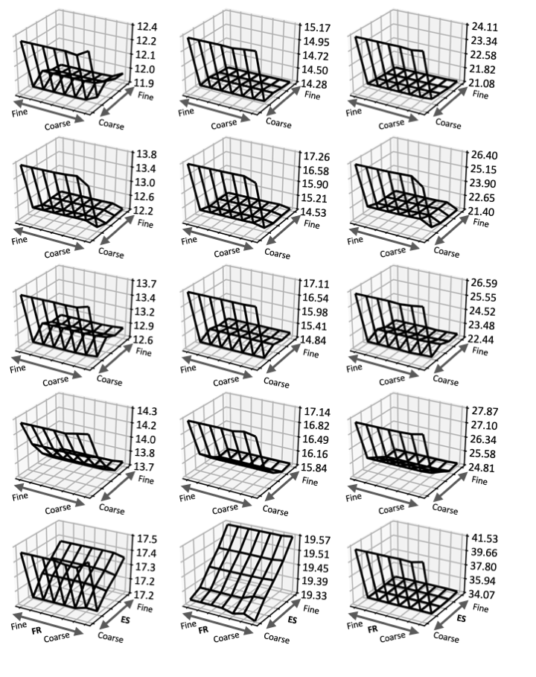
In addition to the grouping of fiber angles, the Python script used to conduct the fiber-rounding was also used to remove duplicate shell section definitions from the output of ATSCOOL. As the preprocessing step in Abaqus is conducted on a single computer processing unit (CPU) regardless of the number of CPUs specified for the solver, a bottleneck in the computational efficiency at preprocessing was discovered. Reducing the number of unique shell section definitions from the ATSCOOL output B whether the fiber angles are rounded to certain values (as in the results for 0.01, 0.1, 1.0, 2.5, and 7.5 deg) or unmodified (as in the result for G) by removing duplicate shell section definitions results in dramatically reduced time spent at the preprocessing step. Data for the number of unique shell section definitions and the ratio of modified-to-total shell section definitions are shown in Figure 7. The count of unique shell section definitions is shown in the left column, and the ratio of modified-to-total shell section definitions is shown in the right column. Since the B analyses have zero modified shell section definitions, the ratio is equal to zero in the right column.
Figure 4: Constant through-thickness-direction pressure loading results.
Displacement (in.) Stress (ksi) Index
Design E Design D Design C Design B Design A
Figure 5: Axial compression results.
P_{cr1} (kip) P_{cr2} (kip) P_{cr3} (kip)
Design E Design D Design C Design B Design A

DISCUSSION

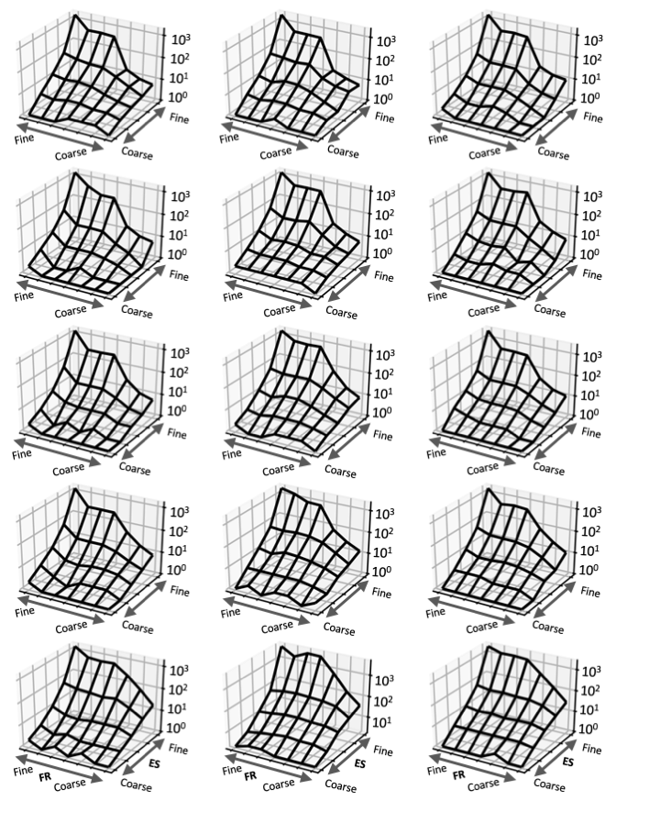
While specific values may be inferred from the results, the overall intent of the discussion is focused on general trends as the element size, fiber-rounding, and RC parameters vary. Fairly consistent trends are observed both within individual loading scenarios as well as across loading scenarios and designs. A few outliers were observed within the selected metrics for a given loading scenario, and the observed trends and outliers are described in the following sections.
Figure 6: Preprocessing time for tension, pressure, and compression analyses.
Tension (s) Pressure (s) Compression (s)
Design E Design D Design C Design B Design A

Tension Scenario

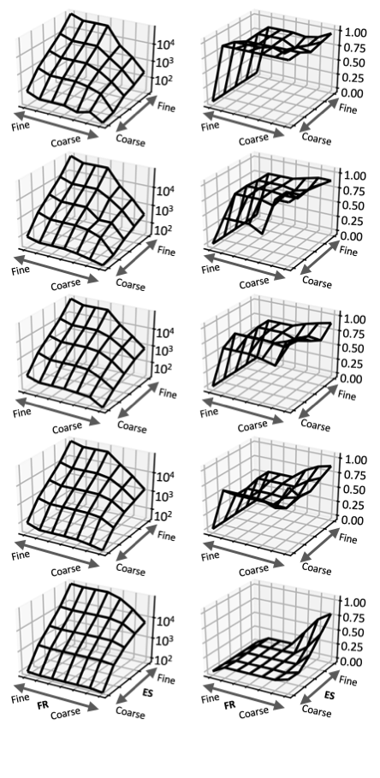
Across all three tension-scenario metrics of interest shown in Figure 3, varying the fiber-rounding parameter from B to 2.5 deg does not significantly influence the predicted responses. The chosen metrics may not be sensitive to most of the fiber-rounding range investigated in this study. Higher values of the fiber-rounding parameter may need to be investigated in the future to determine when fiber-rounding parameters significantly influence the results. More variability is observed in the element-size parameter as the results generally approach consistent values as the 0.5-, 0.25-, and
0.1-in. element sizes are reaching a plateau-like region. Inconsistent concavity (whether concave up/down or sloped) in the resultant force metric is observed across designs. The stress-based metrics are shown to generally increase as smaller element sizes are used, although occurrences in designs B (RC=56 in.) and E (RC=20.78 in.) at the 3.0-in. element size exist where the stress-based metrics are higher than the values from the 1.0- and 0.5-in. element size before being exceeded by the 0.25-in. element size values.
Figure 7: Total shell section definitions (left) and ratio of modified-to-total shell section definitions (right) after rounding and grouping.
Design E Design D Design C Design B Design A
Total Shell
Section Definitions
Ratio of Modified-to-total Definitions

Pressure Scenario

All three metrics of interest in the applied constant through-thickness-direction pressure loading scenario are broadly consistent in behavior across the RCs, fiber-rounding, and element-size parameters except in two specific instances as shown in Figure 4. The minimum displacements exhibit little variability across the fiber-rounding parameter with only a slight change at the largest fiber-rounding label of 7.5 deg. The displacements exhibit a relative plateau-like behavior at the 0.5-in. element size and smaller. The first instance of deviation from the trend is in design A (RC=69.55 in.) where the displacement exhibits a plateau that is less negative than the values at the
3.0-in. element size. All other designs exhibit a plateau that is lower than the plateau for the 3.0-in. element size. The stress-based metrics show similar insensitivity to all but the largest fiber-rounding group of 7.5 deg. The stress metric does not exhibit plateau-like trends but instead continues to increase as element sizes are reduced. The magnitudes, however, are generally varying less than 5% at element sizes smaller than 1.0 in. A plateau is reached at the 0.5-in. element size for the failure index across all designs.

Compression Scenario

All three metrics of interest in the axial compression loading scenario, as shown in Figure 5, exhibit the most consistent behavior of all the loading scenarios in this study. All estimated buckling loads generally plateau at the 1.0-in. element size or smaller for all fiber-rounding parameters. Two exceptions exist for design E (RC=20.78 in.) for P_{cr1} and P_{cr2}. Results for design E P_{cr1} exhibit an initial drop in estimated buckling load between element sizes of 3.0 and 1.0 in. but exhibit a steady rise for element sizes 0.5 in., 0.25 in, and 0.1 in. The first mode shape for design E is two half-waves along the global X-direction and one half-wave in the transverse direction. The same mode shape is observed for P_{cr1} in all other designs as well. Again, at design E, P_{cr2} exhibits a steadily increasing estimated buckling load as the element size is reduced. The second mode shape for design E, however, differs from the second modes of all other designs. This change could be one reason why the plateau-like behavior is absent for the second mode in design E.

Computational Efficiency

The metrics of interest from a structural-mechanics perspective are broadly insensitive to the fiber-rounding parameter at all but the largest parameter of 7.5 deg. The computational efficiency metric of interest, preprocessing time, exhibits strong sensitivity to the effect of fiber-angle rounding in addition to element sizes. Smaller element sizes result in a nonlinearly larger preprocessing time. The sensitivity to element sizes is understandable because the size of the computational problem generally scales with the size of the finite element mesh. The effect of mesh size to computational size is well understood.
Larger fiber-rounding parameters can result in dramatically smaller preprocessing times. Preprocessing times were shown to decrease between the B and the G analyses, although moderate variability was observed across the analyses. For larger values of the element-size parameter, the decrease in preprocessing time was proportionally smaller and on the order of one to tens of seconds than for the smaller element size parameters, in which decreases on the order of hundreds or thousands of seconds were observed. The only difference between the B and G formats, as previously discussed, was the removal of duplicate shell section definitions from the Abaqus input file. Almost all preprocessing times were shown to decrease beyond the grouped analyses as fiber-rounding intervals were increased. The sole meaningful exception is design E (RC=20.78 in.) for the applied constant pressure loading scenario (center column in Figure 6) where an increase in preprocessing time between the G and 0.01 deg fiber-rounding labels for the 0.1-in. element size occurred. Any increases in preprocessing times shown for the 3.0-in. value of the element-size parameter was for a difference between one and two total seconds.
One encouraging result from this study is highlighted by the fact that reasonably similar metrics (i.e., reducing the preprocessing time up to two orders of magnitude) could be obtained when using any fiber-rounding parameter smaller than 7.5 deg as long as the element size was no larger than 1.0 in. A trend across designs is also observed in Figure 6 where larger-RC designs (i.e., A and B at RC=69.55 in. and 56.00 in., respectively) benefit from fiber-rounding more than smaller-RC designs (i.e., design E at RC=20.78 in.). The reason why larger-RC designs benefit more than smaller-RC designs is observed in Figure 7 in the count of total shell section definitions shown in the left column. The larger-RC designs exhibit greater changes as functions of both element size and fiber-rounding parameters. The smaller-RC designs, however, while still sensitive to element size, exhibit reduced sensitivity to fiber-rounding than larger-RC designs due to the flatter response across the fiber-rounding parameter as shown for design E (RC=20.78 in.).
Another way to observe the change in sensitivity from large-to-small RC designs is in the ratio of modified-to-total shell sections resulting from the fiber-rounding process. The ratio is shown in the right column in Figure 7. For the large-RC designs, a broadly flat slope along the fiber-rounding parameter from G to 7.5 deg for any element size, but especially for smaller element sizes, was observed. One interpretation could be that as fiber-rounding parameters become larger, the ratios of modified-to-total shell section definitions are approximately the same. As smaller-RC designs are observed, the slope trends positive along the fiber-rounding parameter direction. This trend across RC indicates fiber-rounding has a greater effect on large-RC designs than on small-RC designs because more shell section definitions are grouped together at large RC designs than at small RC designs. As a result, the benefit of reduced preprocessing time is reduced at a point in the RC space for the range of fiber-rounding parameters studied. Additional reduction of preprocessing time may be realized at fiber-rounding parameters larger than 7.5 deg, but may come at the cost of model accuracy.

CONCLUDING REMARKS

The results of a parametric study that was used to study the effects of fiber-angle fidelity, element size, and radius-of-curvature on various loading scenarios for tow-steered composite plates have been presented. The loading scenarios include a uniaxial tensile load via prescribed end-displacement, an applied constant pressure load, and an axial compression buckling load via an eigenvalue analysis. The radius-of-curvature ranged from 69.55 in. to 20.78 in., which spans from approximately-twice to slightly-less-than the approximate 35-in. minimum steering radius at the NASA Langley Research Center Integrated Structural Assembly for Advanced Composite automated fiber placement facility. The element sizes range from 0.1 in. to 3.0 in. on a structural plate 36-in. long by 24-in. wide. The fiber-angle rounding parameters range from increments of 0.01 to 7.5 deg. Results for structural metrics of interest are presented and discussed with little sensitivity shown to the fiber-rounding parameter until the 7.5 deg increment. Sensitivity to element size generally dominated the observed results for the structural metrics.
Notable reductions in preprocessing time were observed for increasingly coarse element size and fiber-rounding parameters. The preprocessing times decreased up to three orders of magnitude from a few thousand seconds to a few seconds without loss of accuracy in the mechanics-based metrics. Such increased computational performance is of particular interest to the structural design and analysis communities that may be conducting large counts of finite-element analyses, such as in other parametric studies, Monte-Carlo analyses, uncertainty quantification, or tow-steered optimization.

ACKNOWLEDGEMENTS

The authors thank Brian Mason for his assistance and helpful conversations about ATSCOOL and tow-steering design tools. The primary author also thanks Heather Kosztowny, Ph.D., for her insight and suggestions on Python-based plotting methods.

REFERENCES

[1] Jones, R. M. 1999. Mechanics of Composite Materials. Taylor & Francis Group,
pp. 371-381.
[2] Hyer, M. W. and H. H. Lee. 1991. “The Use of Curvilinear Fiber Format to Improve Buckling Resistance of Composite Plates with Central Circular Holes,” Compos. Struct., 18(3):239–261.
[3] Tatting, B. F. and Z. Gurdal. 2002. “Design and Manufacture Tow Placed Plates of Elastically Tailored Tow Placed Plates,” NASA/CR-2002-211919.
[4] Hyer, M. W. and R. F. Charette. 1991. “Use of Curvilinear Fiber Format in Composite Structure Design,” AIAA J., 29(6):1011–1015.
[5] Tatting, B. F., Setoodeh, S., and Z. Gürdal. 2005. "Enhancements of Tow-Steering Design Techniques: Design of Rectangular Panel Under Combined Loads," NASA/CR-2005-213911.
[6] Gürdal, Z. and R. Olmedo. 1993. “In-Plane Response of Laminates with Spatially Varying Fiber Orientations: Variable Stiffness Concept,” AIAA J., 31(4):751–758.
[7] Olmedo, R. and Z. Gurdal. 1993. “Buckling Response of Laminates with Spatially Varying Fiber Orientations,” presented at the 34th Structures, Structural Dynamics, and Materials Conference, April 19-22, 1993.
[8] Wu, K. C., Turpin, J. D., Stanford, B. K., and R. A. Martin. 2014. “Structural Performance of Advanced Composite Tow-Steered Shells with Cutouts,” presented at the 55th AIAA/ASMe/ASCE/AHS/SC Structures, Structural Dynamics, and Materials Conference, January 13-17, 2014.
[9] Nagendra, S., Kodiyalam, S., Davis, J. E., and V. N. Parthasarathy. 1995. “Optimization of Tow Fiber Paths for Composite Design,” presented at the 36th Structures, Structural Dynamics and Materials Conference, April 10-13, 1995.
[10] Gürdal, Z., Tatting, B. F., and C. K. Wu. 2008. “Variable Stiffness Composite Panels: Effects of Stiffness Variation on the in-Plane and Buckling Response,” Compos. Part A: App. Sci. and Manuf., 39(5):911–922.
[11] Lopes, C. S., Gürdal, Z., and P. P. Camanho. 2010. “Tailoring for Strength of Composite Steered-Fibre Panels with Cutouts,” Compos. Part A: App. Sci. and Manuf.,
41(12):1760–1767.
[12] Setoodeh, S., Abdalla, M. M., and Z. Gürdal. 2005. “Design of Variable-Stiffness Laminates Using Lamination Parameters,” Compos. Part B: Eng., 37(4–5):301–309.
[13] Brooks, T. R., Martins, J. R. R. A., and G. J. Kennedy. 2017. “High-Fidelity Multipoint Aerostructural Optimization of a High Aspect Ratio Tow-Steered Composite Wing,” presented at the 58th AIAA/ASCE/AHS/ASC Structures, Structural Dynamics, and Materials Conference, January 9-13, 2017.
[14] Torres, A. P., Warner, J. E., Aguiló, M. A., and J. K. Guest. 2021. “Robust Topology Optimization under Loading Uncertainties via Stochastic Reduced Order Models,” Int. J. for Num. Meth. in Eng., 122(20):5718–5743.
[15] Abaqus Standard, Version 6.18, Dassault Systemes Simulia Corp., Johnston, Rhode Island, USA, 2017.
[16] Mason, B. H., Cardona, A. M., Anderson, E. K., and D. C. Jegley. "ATSCOOL, a Tool for Defining Tow Steered Laminates for Finite Element Grids," NASA/TM to be published.
[17] Przekop, A., Schultz, M. R., Kosztowny, C. J. R., Song, K., Lindell, M. C., Hilburger, M. W., and M. T. Rudd. 2020. "Design and Analysis of Buckling-Critical Large-Scale Sandwich Composite Cylindrical Test Articles," NASA/TM-2020-5008667.

Cyrus J. R. Kosztowny and Lauren M. Simmons, Structural Mechanics and Concepts Branch, NASA Langley Research Center, Hampton, Virginia 23681-2199, U.S.A.
The use of trademarks or names of manufacturers in this report is for accurate reporting and does not constitute an official endorsement, either expressed or implied, of such products or manufacturers by the National Aeronautics and Space Administration.

